Surge Pressure Testing of Flight-Like Components
SP2024_259

SPACE PROPULSION 2024

GLASGOW, SCOTLAND | 20 – 23 MAY 2024
Wanyi Ng

NASA, Greenbelt, MD, USA, wanyi.ng@nasa.gov

KEYWORDS: propulsion components, surge pressure, waterhammer, in-space, chemical

ABSTRACT:
This project studies the transient surge pressure effects (such as those observed during propulsion system priming) on flight components. A water flow setup was used to impart transient surge pressures on flight-like components. The project compared the point of component failure for transient surge pressures versus static proof pressures. Results showed that designing to keep surge pressures below component proof pressures is overly conservative, because the components can handle higher transient pressures. The tests performed on burst discs showed that the rupture pressure under a transient surge pressure was at least 20% above the static rupture pressure. A tested pressure transducer remained fully functional and accurate after surge pressures 60% above its specified proof pressure. A thruster valve was exposed to transient surge pressures four times its specified proof pressure and showed no indications of damage.

Introduction
The primary objective of this project was to improve the understanding of the effects of surge events on flight components. This will improve engineers’ ability to optimize propulsion subsystem designs and respond to failures and anomalies.

Surge pressures are transient, high-pressure events that occur when priming the propulsion system after launch vehicle separation [1]. The transient pressure measured during a typical priming event is shown in Figure 3. The close-up view in the lower plot shows the peak pressure during a surge event, which will henceforth be referred to as the “surge pressure”.
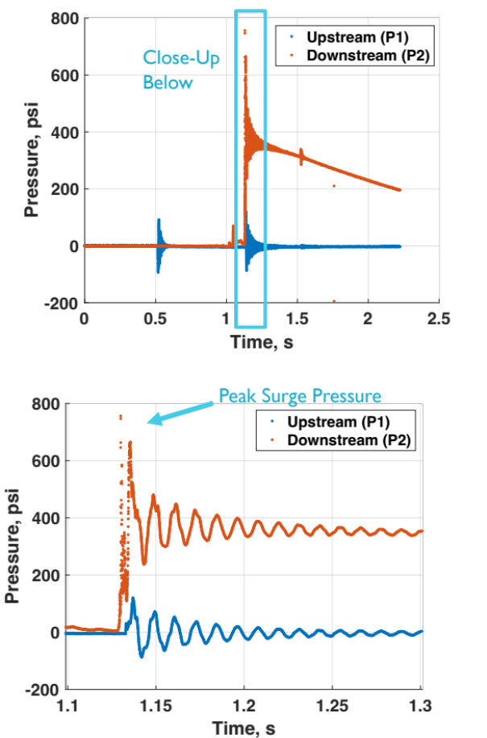
Figure 3. Sample raw data from surge event – (top) plots showing pressures measured upstream and downstream of a valve that opens during priming; (bottom) close-up of surge event showing peak pressure and decay

These surge events can damage propulsion subsystem components, drive component pressure ratings, and impact subsystem performance by requiring surge suppressing hardware. The sudden change in the fluid’s momentum causes a pressure spike to propagate back up the lines. This is often the highest pressure that the subsystem will be exposed to over the course of the mission. It is much higher than the maximum expected operating pressure (MEOP) during static and steady flow conditions. As a result, this single priming event drives the pressure ratings of flight components. Additionally, flow limiting devices (cavitating venturis or orifices) must be placed in line to limit the propellant flow rate. These flow limiting devices account for the largest pressure drop over the flow path of propellant from the tanks to the thrusters. This pressure drop can increase the required tank pressure and/or volume and may result in reduced thruster performance. Testing to size the flow limiting device requires several months of lab space and personnel time. Analytical modelling to predict surge pressures in propellant manifolds is very complex [2].

Presently, the NASA Goddard Space Flight Center (GSFC) Propulsion Branch’s practice is to empirically size the flow limiting device using bench top water flow testing such that surge pressures stay below the proof pressure of each component in the system. However, this could be an overly constraining criterion. A NASA failure investigation of pyrotechnic valves in 2008 [3] found that pressure spikes do not affect components in the same manner as static pressures do. During the failure investigation, the transient pressures measured in the valve’s Primer Chamber Assembly exceeded the static stress analysis limits [4] by an order of magnitude. Despite this, no fracture or leak was detected in the valve.

The work described in this following paper collected additional data on the effects of transient versus static pressures on propulsion flight hardware. It empirically determined the threshold of component failure under transient surge pressures. These failure pressures were compared to the static proof pressures and empirical data on static pressure failure where available. To accomplish this, a setup was designed and assembled to impart transient surge pressures on flight-like components. The component’s performance was assessed between each progressively higher surge pressure.

Test Setup
A test setup was designed and constructed to generate pressure surges. The setup needed to be capable of producing surge pressures between 300-2000 psi with accuracy and precision. The setup is shown in Figure 1.

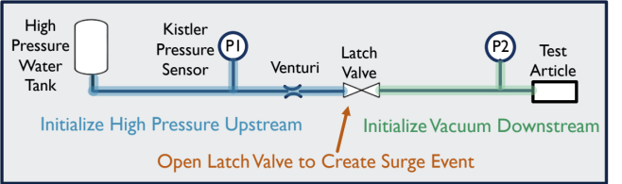
Figure 1. Simplified diagram of test setup

A summary of the typical workflow is as follows:

- Flow water through the entire system to fully wet the upstream section.
- Close the latch valve.
- Purge water out of the downstream section using low pressure nitrogen.
- Pull vacuum on the downstream section using a vacuum pump.
- Set the upstream pressure by pressurizing the water tank.
- Enable data collection.
- Open the latch valve to a generate surge event.
- Close the latch valve.
- Save data.
- Repeat steps 3 through 9 for the next surge test.

Figure 1 excludes periphery pieces of hardware, including a gaseous nitrogen bottle and a pressure control panel upstream of the water tank. A secondary gaseous nitrogen source is connected just downstream of the latch valve. A vacuum pump is connected to the downstream portion. A power supply and pulse box are connected to the latch valve to open and close it. A Data Acquisition (DAQ) system is connected to the Kistler pressure sensors and latch valve. A more complete representation of the test setup is shown in Figure 2.

Figure 2. Full schematic of test setup

System Calibration
The first phase of testing was a series of calibration tests. The test conductor needed to control the surge pressure by adjusting the initial upstream pressure and venturi throat diameter. The purpose of the calibration tests was to characterize this relationship. These tests also verified whether the location of P2 was appropriate to measure the pressures at the test articles. Figure 3 shows the test setup for the calibration tests.

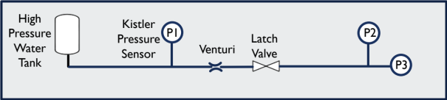
Figure 3. Simplified diagram of setup for system calibration tests

The results of the system calibration are shown in Figure 4. The trend in the upper plot was used to set up each test for a specific target surge pressure. The lower plot shows that the pressure sensor placed at P2 is an accurate observer of the pressure at the test article (replaces P3 during testing) to within 20% of the surge pressure.
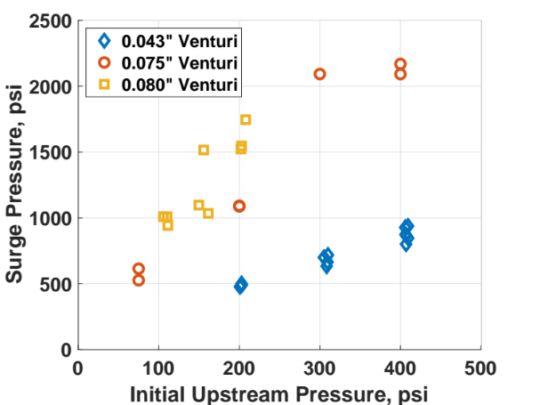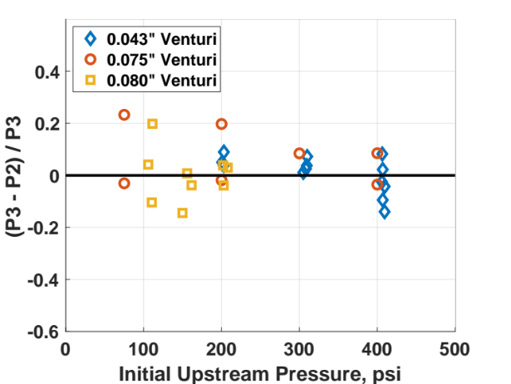
Figure 4. Results of system calibration – (top) surge pressure at P3 as a function of initial upstream pressure and venturi throat diameter; (bottom) fractional difference in pressure measured at P2 and P3

Analytical Predictions
Complex flow paths in propellant system are difficult to model. The most high-level method is a straight-line analysis [5] [6]. Surge pressure is calculated as,
$P_{wh}=ρva$ Eq. 1

Where $ρ$ is the density of the working fluid, $v$ is the velocity of the working fluid, and $a$ is the compressive wave speed of the working fluid. The velocity of the working fluid is calculated iteratively using an incompressible flow equation and includes loss coefficients for each component of the straight flow path,
$v= \sqrt{\frac{2(P_{up}-P_{down})}{ρ\left(\frac{fL}{D}+ΣK\right)}}$ Eq. 2

Where $P_{up}$ is the upstream pressure, $P_{down}$ is the downstream pressure, $f$ is the friction factor, $L$ is the length of the pipe, $D$ is the diameter of the pipe, and $K$ is the loss coefficient of each component. The compressive wave speed is,
$a=\frac{a_{0}}{\sqrt{1+\frac{ρa_{0}^{2}}{gE}\left(\frac{D}{δ}\right)}}$ Eq. 3

Where $a_{0}$ is the acoustic speed of the working fluid, $g$ is the gravitational constant, $E$ is the elastic modulus of the pipe, and $δ$ is the thickness of the pipe.

The calculated surge pressure for different combinations of upstream pressure and venturi size is plotted as solid lines in Figure 5. The analysis accurately predicted the surge pressures for the 0.043” venturi. However, it was not accurate for the 0.075” and 0.080” venturis. This may be due to a larger variance in the experimental results. This illustrates why straight-line analysis alone is insufficient for sizing venturis in system designs, and experimental validation is required. This is exacerbated in flight systems, which have much more complex branching of flow, and therefore are less like a straight-line flow.

In addition to straight-line analysis, a computational modelling software called GT-SUITE was used and evaluated. It is a multiphase flow modelling software that uses a 1D solver. It allows the user to build a representation of the physical system by linking standard or custom components. The customization included a venturi loss coefficient based on experimental testing and a latch valve flow area equation based on the latch valve vendor’s specifications. The initial condition was imposed on the system and pressures were recorded at each of the Kistler locations shown in Figure 3. The peak surge pressure for combinations of upstream pressure and venturi size are shown as solid squares in Figure 5. Both the straight-line and GT-SUITE models predicted similar values to the experimental surge pressures for the 0.043” diameter venturi. However, in a flight mission, the worst-case experimental results would be used to size the final flight venturis.
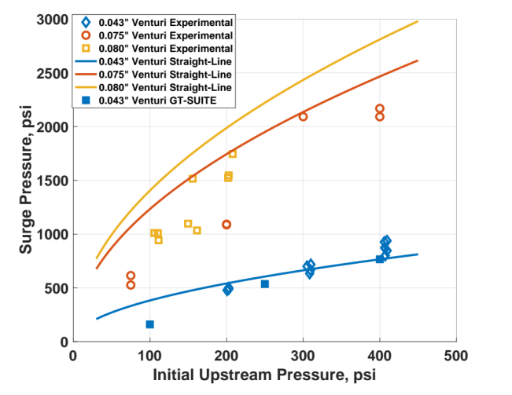
Figure 5. Experimental results and analytical predictions of setup calibration

Methodology
After the calibration phase, each flight-like component was systematically tested to determine its failure point under surge pressures. Three items were selected for testing:

- A burst disc was selected for the first set of tests. Burst discs give several advantages: they have simple geometries with similarities to complex flight components such as pressure transducers, they are available commercially off the shelf at a wide variety of pressure ranges, they are manufactured to tight tolerances for static actuation pressure, and they are inexpensive to test to failure compared to flight components. The burst discs used for this project were LaMot brand provided by Continental Disc Corporation.

- A pressure transducer was selected because it often has the lowest proof pressure of the components affected during priming, and therefore is the limiting component when designing to keep surge pressure below component proof pressures. Additionally, pressure transducers can be placed on the thruster manifold, which is a location that historically experiences higher pressure surges than other parts of the lines.

- A thruster valve was selected because thrusters are typically placed in locations that experience high surge pressures.

Burst Disc
A burst disc was installed as shown in Figure 6. Five burst discs were tested to identify the transient rupture pressure and compare it to the static rupture pressure. The target surge pressure at the burst disc is achieved by setting up the experiment as informed by the calibration curves from the calibration phase of the project.

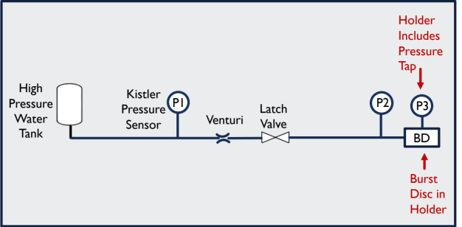
Figure 6. Simplified diagram of burst disc surge setup

The first test on each disc was run with a target surge pressure near the static rupture pressure, except that for subsequent burst discs the initial surge pressure was adjusted based on the failure pressure of the previous discs. If the disc did not rupture after the first test, the test was re-run at a slightly higher target surge pressure until the disc failed.

One burst disc was selected for a 3D scan inspection after one surge pressure impact to show whether any static deformation occurred prior to rupture. The shape of the impacted disc was compared to that of a new, unimpacted disc.

Pressure Transducer
The pressure transducer was installed as shown in Figure 7. Like the burst disc, the pressure transducer was impacted by progressively higher magnitude surge pressures until failure.

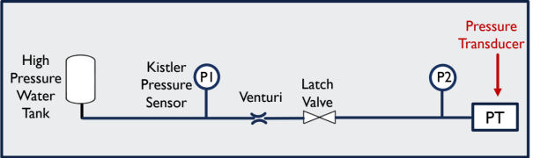
Figure 7. Simplified diagram of pressure transducer surge setup

Between each surge test, to determine whether the pressure transducer had failed, a calibration was performed on the pressure transducer. The setup is shown in Figure 8. The pressure transducer was pressurized to a series of known pressures. The resulting voltage signal output was recorded. A substantial deviation from the initial calibration was taken as indication that the transducer had failed. If the calibration was unchanged, a higher magnitude surge pressure was imparted on the pressure transducer.

Figure 8. Simplified diagram of pressure transducer calibration setup

Additionally, an X-ray computerized tomography (CT) scan was taken of the pressure transducer before testing and after failure to help diagnose the mode of failure.

Thruster Valve
The thruster valve was installed as shown in Figure 9. It was impacted by progressively higher magnitude surge pressures until failure.

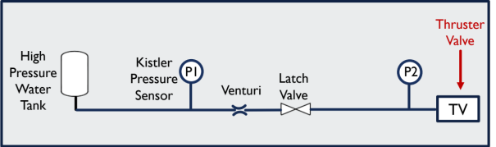
Figure 9. Simplified diagram of thruster valve surge setup

Between each surge test, to determine whether the thruster valve had failed, several standard valve diagnostics were performed.

The first was an internal leak test. The setup for this test is shown in Figure 10. The thruster valve was pressurized to its maximum expected operating pressure (MEOP). A Norquist leak detector was plumbed into the outlet of the thruster valve. The Norquist is a horizontal graduated cylinder with a drop of oil in it that would get pushed down the cylinder by any gas that leaks through the valve. Since the thruster valve has two valve seats in series, the downstream seat was held open for the leak test to determine the seal integrity of the first seat. If the valve leaked beyond the valve specification requirement of 1 scc per hour, it was considered damaged.

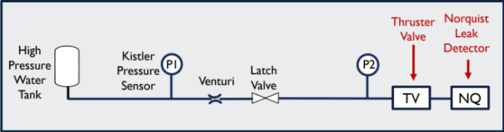
Figure 10. Simplified diagram of internal leak test setup

The second diagnostic test was a pull-in and drop-out voltage test. This identifies the minimum voltage required to open the valve. The setup for this test is shown in Figure 11. The MEOP is applied upstream of the thruster valve. A low voltage is applied to the valve. The voltage is slowly increased until the valve opens. Then, as water flows through the valve, the voltage is slowly reduced until the valve closes. These two threshold voltages are recorded. If the threshold voltage changed significantly after a surge pressure test, the valve was considered damaged.

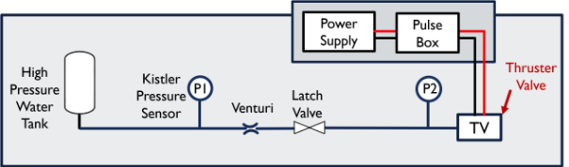
Figure 11. Simplified diagram of pull-in and drop-out voltage test setup

The third diagnostic test was a response time test. This is a measurement of how long it takes the valve to fully open or close. The setup for this test is shown in Figure 12. The MEOP is applied upstream of the thruster valve. The nominal operating voltage is applied to the valve to open it. An oscilloscope is used to record the current and voltage traces (see Figure 13). From the current trace, the opening response time was calculated. The same operation was repeated for removing the voltage to close the valve. If the response time changed significantly after a surge pressure test, the valve was considered damaged.

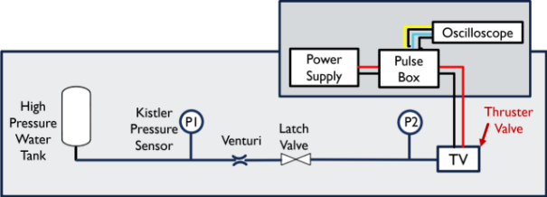
Figure 12. Simplified diagram of response time test setup

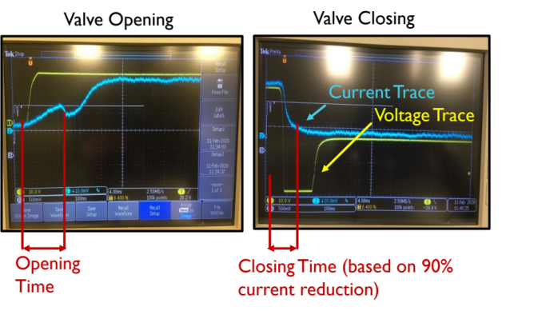
Figure 13. Sample oscilloscope reading used to measure response time

The fourth and final diagnostic was a flow impedance test. This measures the pressure drop across the valve for a given flowrate. The setup for this test is shown in Figure 14. The valve was held open. The MEOP was applied to the flow path up to the closed metering valve. The metering valve was slowly opened. At specific flowrates measured by the flow meter, the differential pressure across the valve was measured. If the differential pressure at each flowrate changed after a surge pressure test, the valve was considered damaged.

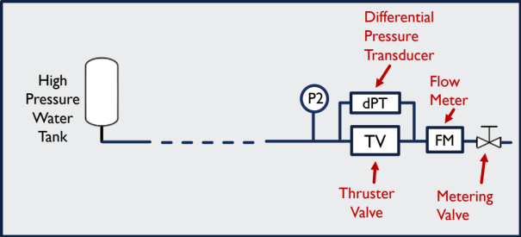
Figure 14. Simplified diagram of flow impedance test setup
After testing, a borescope was used to inspect the inlet filter of the thruster valve for damage.

Results

Burst Disc
The burst disc was rated to a static rupture pressure of 535 psig at 72 °F with a manufacturing range of 519 to 567 psig at 72 °F. The transient rupture pressures found during this project are shown in Figure 15. The results showed that the rupture pressure under a transient surge pressure was at least 20% above the static rupture pressure of the discs. Disc 6 was not tested and therefore has no data shown.
Figure 15. Results of burst disc surge testing – surge pressures endured and rupture pressure for each disc

The tests were performed at ambient temperature. While pulling vacuum to initialize the test, the burst disc holder would get cold, and a heat gun was used to bring the temperature back up to ambient temperature. Figure 15 shows that even if the temperature of the disc had been reduced to 40 °F while pulling vacuum, and did not heat back up to ambient when the heat gun was used, the transient rupture pressure was well above the temperature-corrected static rupture pressure.

The 3D scans of an untested and surge pressure tested burst disc are shown in Figure 16. The “Baseline” was a scan of Disc 6 that was never tested and the “Loaded” was a scan of Disc 4. The scans show that the disc deformed by 20% during the surge event, despite the disc not rupturing. This may indicate that while the transient surge pressure introduces stresses large enough to cause plastic deformation, they are at a short enough duration that full rupture does not occur. The actual rupture pressure of the disc could have changed after being exposed to a pressure surge. This could include an increase in failure pressure due to strain hardening or a decrease in failure pressure due to thinning of the disc material.

Figure 16. 3D scans of burst disc with and without surge pressure impact

Pressure Transducer
The pressure transducer was rated to a proof pressure of 488 psi and a burst pressure of 813 psi. The results of pressure transducer calibration after each surge event is shown in Figure 17. The plot shows that the pressure transducer remained in calibration after a 784 psi pressure surge and failed after a 1135 psi pressure surge. Thus, the pressure transducer was fully functional and accurate after surge pressures 60% above its specified proof pressure. This indicates that requiring surge pressure to stay below proof pressure may be overly conservative.
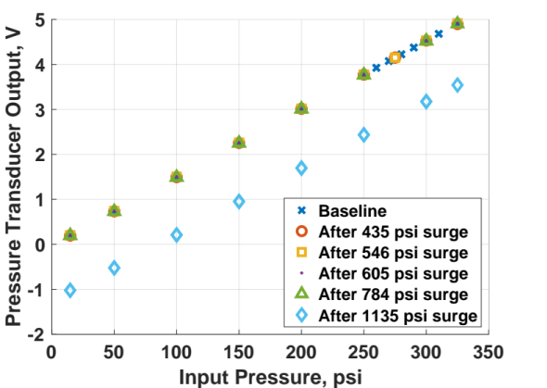
Figure 17. Pressure transducer calibration results after each surge event of increasing magnitudes

Since the failure was a constant offset of the calibration curve, this pressure transducer could still be useable after re-calibration. However, since the priming event happens after separation from the launch vehicle, it would not be possible to perform a re-calibration if the offset occurred during priming.

A computerized tomography (CT) scan was taken of the pressure transducer before testing and after failure. The axial cross section is proprietary and cannot be shown but exhibited no visible deformation. Figure 18 shows the radial cross section, the top and bottom surfaces of the diaphragm, which also show no physical difference. The calibration offset observed after the 1135 psi surge may have been due to plastic deformation in the diaphragm, but the deformation was too small to be detectable in the CT scan.

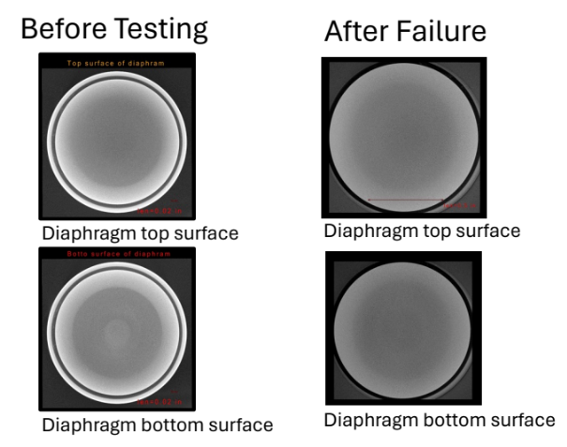
Figure 18. X-ray computerized tomography (CT) scan of pressure transducer shows no change to the diaphragm before testing and after failure.

In an attempt to compare this to a static pressure failure, historical anomalies were considered. An identical pressure transducer on a previous mission was exposed to a static pressure of 788 psi during ground testing and went out of calibration with a constant offset. Since this event was not a slow ramp up in pressure, the exact static failure point could have been 788 or lower. For comparison, the pressure transducer from this paper failed somewhere between 784 psi and 1135 psi surge pressure. Unfortunately, these data do not support definitive conclusions about the actual failure pressures, but do show potential for future testing.

Thruster Valve
The thruster valve had a specified proof pressure of 525 psi and a burst pressure of 875 psi. This specification also included a requirement to withstand waterhammer pressures up to 1200 psi. (Waterhammer is also a transient pressure spike, which occurs when a valve is closed during liquid flow.) The vendor reported that it had proof pressure tested identical units up to 1510 psi. The results of the thruster valve diagnostics tests are summarized in Table 1.
Table 1. Summary of thruster valve diagnostics results after each surge test
 | Base  line | After  1100 psi Surge | After  1500 psi Surge | After  2200 psi Surge | Significant Change
Internal Leakage
Leak rate, GN2 400 psi (scch) | 0 | 0.24¹ | 0.24 | -0.06 | No
Response Time
Opening time (ms) | 10.32 | 10.4 | 10.24 | 10.12 | No
Closing time (ms) | 2.72 | 2.16 | 2.92 | 2.32 | No
Pull-In / Drop-Out Voltage
Pull-In (V) | 12.40 | 12.52 | 12.55 | 12.17 | No
Drop-Out (V) | 2.38 | 2.03 | 2.18 | 2.32 | No
Flow Impedance
Flowrate at 0 psid (GPM) | 0.00 | 0.00 | 0.00 | 0.00 | No
Flowrate at ~10 psid (GPM) | 0.102 | 0.107 | 0.106 | 0.102 | No
- Verified no leakage using helium sniffer. Concluded that this measurement was due to thermal expansion. Specification is 1 scch at 350 psi.

The filter was inspected with a borescope. A representative image is shown in Figure 19. The borescope was swept across the entire area of the filter and no damage was observed.

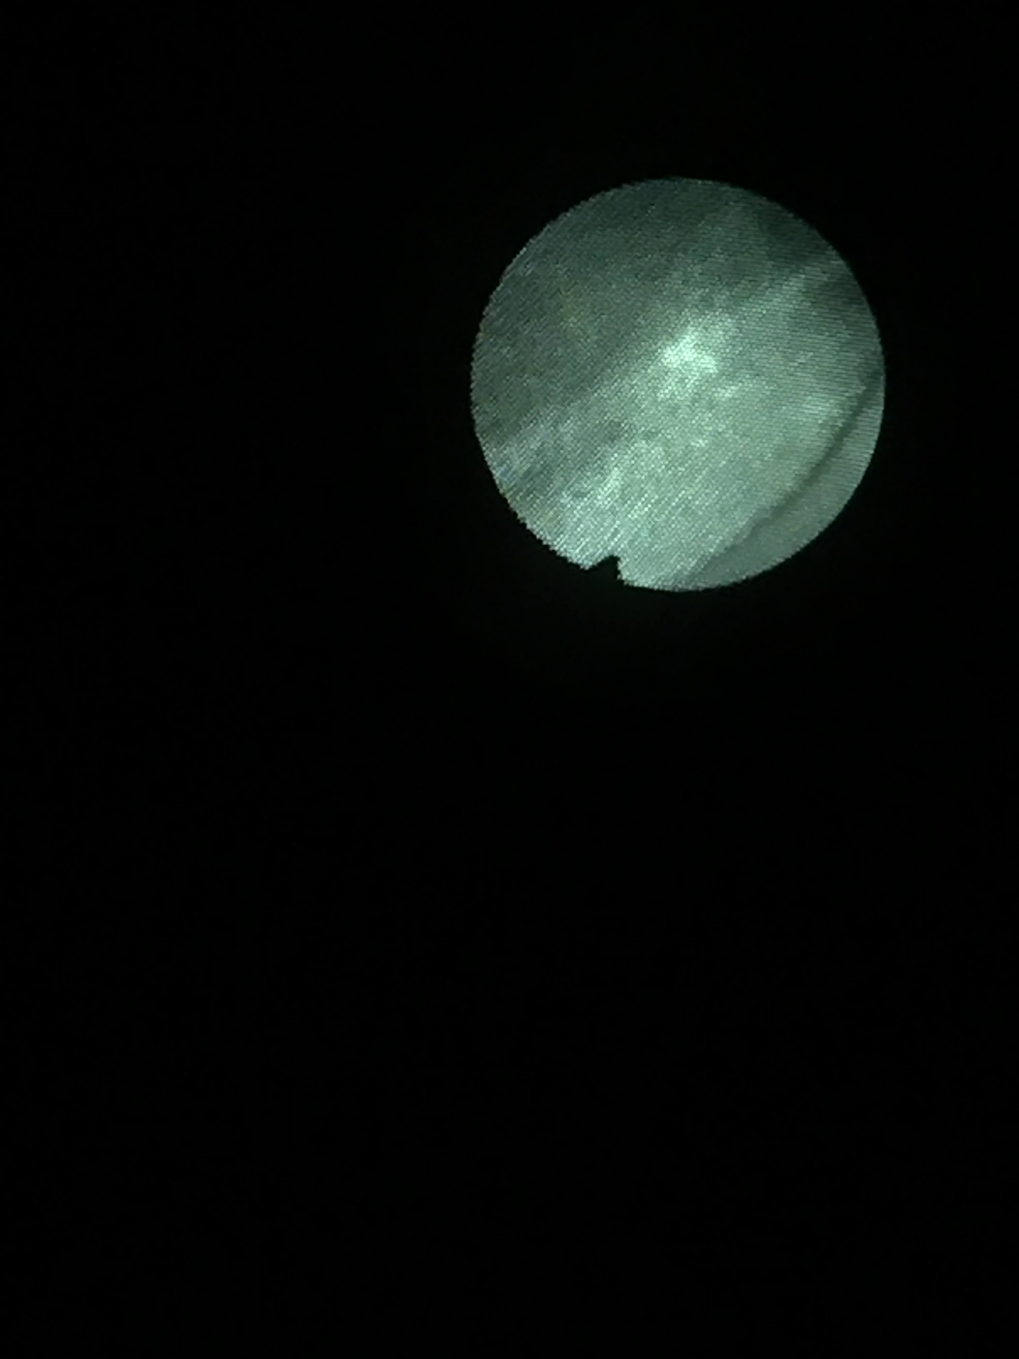
Figure 19. Sample borescope image of thruster valve inlet filter

The results indicated no damage even after a 2200 psi surge pressure. This surge pressure was over four times the specified proof pressure, 2.5 times the specified the burst pressure, and 45% above the tested proof pressure of the thruster valve. This indicates that the existing branch practices of requiring surge pressure to stay below proof pressure may be overly conservative. Surge pressure beyond 2200 psi were not attempted due to concerns about damaging other components in the system.

This testing also revealed an unintended observation - replacing a Kistler pressure sensor (geometrically a dead-end tube) with a thruster valve reduced surge pressure, despite all other conditions remaining identical. These data are shown in Figure 20. Potential sources of the change were systematically eliminated, including,

- Filling the water tank to the same level as in other tests
- Ensuring the tees and adapters in the flow path were identical in both test setups
- Elevating the Kistler so it was the same height as the thruster valve
- Replicating the volume at the inlet of the thruster valve with a reducer and cap
- Placing the Norquist leak detector downstream during the surge pressure to ensure no flow was passing through the thruster valve

The results indicate that the presence of the thruster valve reduces the surge pressures in the system by about 25%. This is significant because flight missions’ surge test campaigns are conducted with Kistlers instead of thruster valves in the system, and the measured pressure is assumed to be identical to the pressures experienced with a thruster valve in the system. The 25% reduction in surge pressure in the flight configuration could allow for less conservative sizing of the flow limiting device.

The hypothesis to explain this phenomenon is that the thruster valve filter acts as a secondary flow limiter as it reaches the end of the flow path.

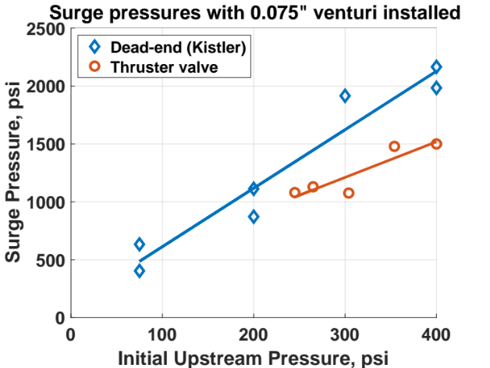

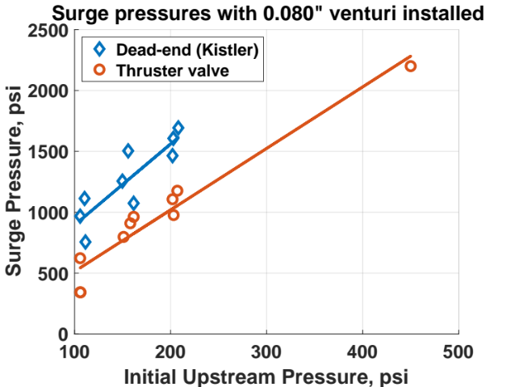
Figure 20. Surge pressures with dead-end tube versus thruster valve at end of flow path – (top) results for 0.075” venturi; (bottom) results for 0.080” venturi

Conclusions
The conclusions of this project are as follows.

Designing to keep surge pressures below component proof pressures is unnecessarily conservative.

Adding a separate vendor specification for surge or waterhammer pressures is warranted when improved system performance justifies the higher component testing costs. A higher allowable surge pressure would allow for a flow limiter (venturi or otherwise) with a lower pressure drop in the propulsion system.

Short-duration pressure spikes result in reduced deformation compared to deformation from a static pressure.

The actual failure point of a component may change after being exposed to a pressure surge, even if it does not fail.

The presence of a thruster valve in the system inherently reduces surge pressures compared to standard surge test conditions.

Acknowledgements
Thank you to my technical mentors Alison Rao (NASA GSFC) and Eric Cardiff (NASA GSFC). Thank you to my propulsion engineer and technician colleagues for help with the surge testing – Hal Baesch, Justin Brumley, Sean Fitzsimmons, and Jacob Stahl (all NASA GSFC). Thank you to the materials engineering team for performing the test article imaging – Bruno Munoz, Charles He, and Justin Jones (all NASA GSFC). Thank you to David Benson, Nikesha Davis, David Ward (all NASA GSFC) and Zac Regan (Continetal Disc) for paper review. Finally, thank you to Continental Disc Corporation for providing the burst discs and custom holder at no cost and providing input on testing.

References
[1] | A. Scroggins and M. Fiebig, "Surge Pressure Mitigation in the Global Precipitation Measurement Mission Core Propulsion System," 50th AIAA/ASME/SAE/ASEE Joint Propulsion Conference, 2014.
[2] | C. Bombardieri, T. Traudt and C. Manflett, "Experimental and Numerical Analysis of Water Hammer During the Filling Process of Pipelines," Space Propulsion Conference, 2014.
[3] | M. Hagopian and A. Dibbern, "Conax Pyrotechnic Valve Failures Investigation," NASA, 2008.
[4] | P. Schamell, "Stress Analysis Report for Pyrotechnic Valve 1/4" Normally Closed," Conax, St. Petersburg, FL, 2006.
[5] | R. P. Prickett, E. Mayer and J. Hermel, "Water Hammer in a Spacecraft Propellant Feed System," Journal of Propulsion and Power, vol. 8, no. 3, pp. 592-597, 1992.
[6] | E. J. Shaughnessy, I. M. Katz and J. P. Schaffer, Introduction to Fluid Mechanics, Oxford University Press, 2005.

