Modular Interface for CLPS-scale Excavators (MICE) – Feasibility testing of a modular disconnect system for regolith manipulation implements focused on excavation and site preparation activies. E. A. Bell¹, N. J. Gelino², M. A. Gudino³, B. H. Burdess⁴, ¹NE-L6, Kennedy Space Center, National Aeronautics & Space Administration (NASA), KSC, FL. 32899, USA, evan.a.bell@nasa.gov, ²UB-E, Kennedy Space Center, National Aeronautics & Space Administration (NASA), KSC, FL. 32899, USA, nathan.j.gelino@nasa.gov, ³NE-L6, Kennedy Space Center, National Aeronautics & Space Administration (NASA), KSC, FL. 32899, USA, marco.a.gudino@nasa.gov, ⁴NE-L6, Kennedy Space Center, National Aeronautics & Space Administration (NASA), KSC, FL. 32899, USA, Benjamin.h.burdess@nasa.gov.

The Artemis Program seeks to establish a sustained lunar presence and robust economy driven by resources available on the Moon and enabled by supporting infrastructure. This will require robotic manipulation of tens of thousands of metric tons of regolith. Excavation and site preparation tasks in the unforgiving lunar environment will inevitably lead to component wear and necessitate periodic maintenance and repair. System modularity and standard interfaces are key components of enabling robotic repair and maintenance.
The Modular Interface for CLPS (Commercial Lunar Payloads Services) -scale Excavators (MICE) project is a funded fiscal year 2024 Internal Research and Development (IRAD) project at NASA KSC. The MICE project seeks to test concepts for modular reconfiguration of a CLPS-scale excavation and site preparation rover. These concepts, henceforth referred to as Modular Disconnect Systems (MDS), allow a mobility platform to interface with regolith manipulation implements such as a bucket drum excavator or compactor. The MDS concepts allow the mobility platform to detect one implement and swap to another implement in-situ. Power and communications is fed through a dust-tolerant electrical connection on the MDS to the implement’s actuator(s) and sensors.
Figure 1 shows an example of a terrestrial MDS system. One mobility platform is able to utilize an array of implements via reconfiguration in-situ. Figure 2 shows a block diagram with the Clearpath Husky mobility platform that is being used on MICE to demonstrate the MDS concepts in ambient conditions.

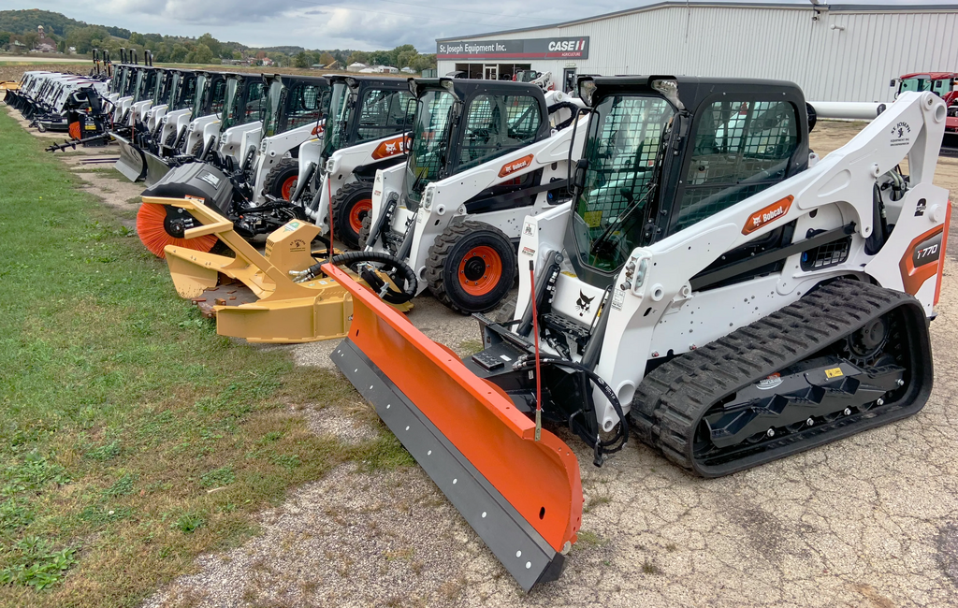
Figure 1. Terrestrial example of a modular disconnect system that allows the exchange of implements for a single mobility platform in-situ. [1]

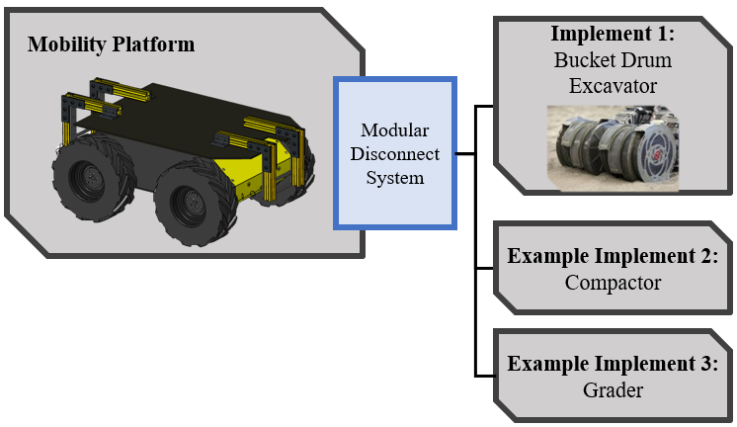
Figure 2. MDS concept block diagram.

The MDS concepts are being tested at a Technology Readiness Level of 3 to 4. These conecpts will be tested and reviewed for their dust tolerance, misalignment tolerance, and the robustness of the connection structurally. Testing will occur at ambient conditions on the Husky mobility platform in April to May. In July to August the MDS concepts will be tested in dusty vacuum conditions and perform a mate/demate test using a vacuum rated 3-dof gantry system [2] as a simulated mobility platform.
The lessons learned and MDS concepts developed as part of MICE will be leveraged on future NASA modularity projects in the Kenney Space Center Swamp Works. MDS concepts and current MICE results will be shared for industry feedback at Space Resources Roundtable 2024.
[1]“Skid-steers with different attachements,” (Accessed 2024) https://en.wikipedia.org/wiki/Bobcat_Company [2] Gelino N. J. and Bell E. A (2023) AIAA ASCEND, 2023-4796.

