Advanced Composite Solar Sail System (ACS3):

Mechanisms and Lessons Learned from a CubeSat Solar Sail Deployer

  - Nigel R. Schneider, Gregory D. Dean, Olive R. Stohlman, Jerry E. Warren, Juan M. Fernandez, W. Keats Wilkie, Todd C. Denkins
NASA Langley Research Center, Hampton Virginia, 23681, USA

Abstract

This is an overview of the National Aeronautics and Space Administration (NASA) Advanced Composite Solar Sail System (ACS3) technology demonstration project mechanisms, their development, the testing they underwent, as well as the lessons learned in those activities. This overview includes an overall description of the primary deployment mechanisms and ground support equipment (GSE) needed for packaging the solar sail system.

Introduction

The ACS3 project is a technology demonstration mission utilizing 7 m rollable composite booms, provided by the Deployable Composite Boom (DCB) Project, to deploy an 81 m² reflective solar sail [1], the solar sail system, shown in Figure 1. Critical elements of the spacecraft are shown in Figure 2. This project is a joint effort between NASA Langley Research Center (LaRC) and NASA Ames Research Center (ARC). The Sail Boom Subsystem (SBS) is the payload of the ACS3 spacecraft, a 12U CubeSat. The SBS uses several traditional mechanisms in combination to deploy the composite booms simultaneously with a solar sail on orbit in one smooth motion. These mechanisms were designed and tested over a 5-year period and were preceded by an earlier potential drop-in replacement design for the Near Earth Asteroid Scout (NEA Scout) mission utilizing the composite booms that was brought to a qualification level, but not selected for the final flight design of that mission [2]. Similar work at a lower technology readiness level (TRL) has been published by Deutsches Zentrum für Luft- und Raumfahrt (DLR, German Aerospace Center) [3].

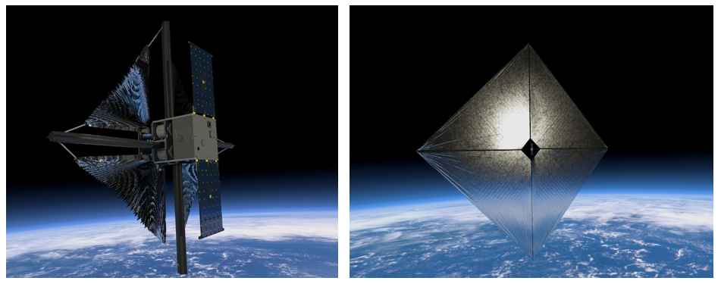
Figure 1: Artist rendered image of the beginning of sail deployment (left) and fully deployed 81 m² sail (right).
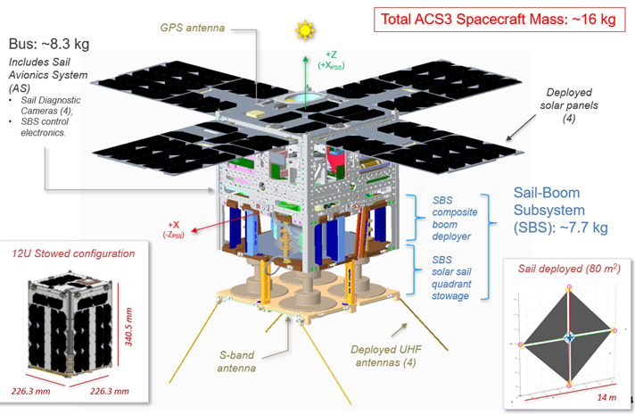
Figure 2: Essential elements of the bus of the ACS3 Spacecraft.
Solar sails are propelled by solar radiation pressure. Despite being massless, photons of light have momentum and energy. The photon imparts some of this momentum to the sail upon impact. The sail is reflective so that momentum is gained from the reflected light as well. By angling the sail relative to the sun, the resultant vector can be used to increase or slow the orbital velocity, raising or lowering the orbit. A common misconception is that solar sails gain thrust from solar wind, which is made up of the ejected electrons and protons. By the time these low mass particles reach Earth’s orbit, the particle flux is low and they are relatively slow, making their contribution to changes in momentum negligible.
The ACS3 mission is designed around the deployment and in-flight validation of lenticular composite booms, described by Fernandez [4], used to deploy and support a solar sail. The lenticular closed cross-section results in a low mass boom with good bending, torsional stiffness, and buckling capacity. This lenticular shape is set when the layered carbon fiber fabric reinforced epoxy prepreg is cured. The partially developed shape can be seen at the end of the stowed boom in Figure 3. The boom wall is only 2 layers thick per side, with dropped ply regions to reduce strain in storage. The thin/flexible walls of the boom enable the cross-section to be flattened, which in turn allows the booms to be tightly coiled on a hub.
There are complexities involved in deploying the booms in this state because the thin flattened cross-section can easily buckle and fold due to the low bending stiffness. This is especially while snaking around other parts in the SBS composite boom deployer, or simply “deployer”, called out in Figure 2, as each change in direction offers a new chance for buckling to occur. Additionally, the internal strain energy of the boom coil pushes to expand to its straightened length and fully formed lenticular cross section. The combined effect can result in the booms failing to deploy by becoming internally bound up if not properly constrained, an effect commonly called blossoming [5]. The blossoming problem is exacerbated when the hub is driven directly, pushing the flattened boom outward and loosening the coil from the inside. The solution, as developed by DLR [3], is to co-wind the booms around the hub alongside thin steel tapes. During deployment these tapes are taken up onto their respective spools, which are driven by the motor through the geartrain. Being taken up on the spools causes tension in the steel tape causing the hub to rotate. This rotation pulls the booms off the hub. The departure angle of the steel tapes, and the boom pressing against them as it expands, helps direct the booms towards the boom guides. Furthermore, the tapes act to constrain the strain energy of the coiled booms that cause them to blossom in storage and deployment. This is only true if the hub is not free spinning. Therefore, hub rotation from self-deployment strain energy is resisted by a spring or brake.
The drivetrain, including steel tape, boom exit guides, and nominal operation, are shown in Figure 3. The brushless direct current (DC) motor has a planetary gearhead offering a significant mechanical reduction. The output shaft is connected to the tape spools by a gear train with no mechanical advantage. The tape acts as a belt drive. However, the diameter of the wheels the “belt” act upon change over the course of deployment. The boom hub diameter shrinks as the booms are deployed, and the spools that the tape is taken up on increases in diameter. This does not happen in a linear relationship because there are four booms on the central hub, but only one tape per spool, as well as the difference between the thickness of the flattened booms and the steel tape. The belt ratio changes from approximately 18:1 to 6:1 as the diameters change during deployment. The inner diameter (ID) of the boom coil was fixed, the outer diameter (OD) was whatever could be best achieved in packaging the booms, and the size and location of the tape spool was designed to be the smallest size possible.

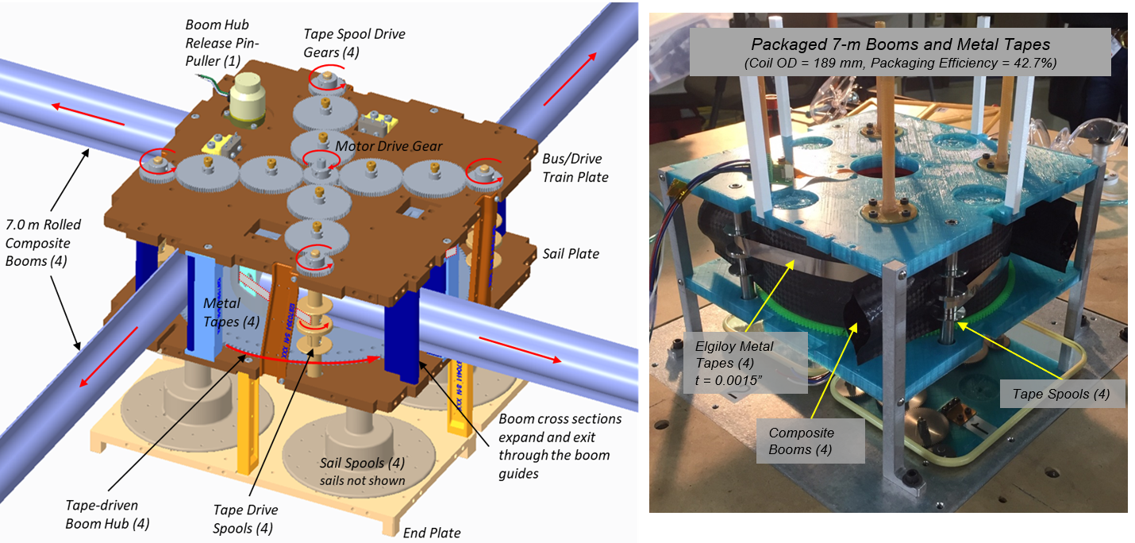
Figure 3: Annotated CAD representation of the ACS3 deployment mechanism, and early prototype mechanism with packaged composite booms (inverted relative to CAD).
For ease of fabrication, ground handling, and reduced complexity in deployment, the sail was divided into quadrants. Each quadrant is supported by two adjoining booms at their outboard vertices, shown in Figure 1, and fixed at the root onto its individual spool, labeled in Figure 3. This simplified fabrication and packaging because the sail was divided into four smaller triangular quadrants that could be fabricated and folded independently, and then rolled onto four individual spools. Additionally, the simplified folding geometry, along with the open corners of the sail stowage section, meant that the sail deployment was less topologically complex, making it less prone to snagging in deployment. A quadrant sail is compatible with deploying around structural supports at the perimeter of the SBS that would have obstructed the deployment of a singular square sail. These structural supports were also necessary to transfer load to the main chassis. This contributed to the design of the SBS being more like a “layer cake” than a traditional CubeSat payload with continuous rails. The sail is also fixed to the tip of the booms, which means it is pulled out by the booms as they are pushed out of the SBS. This greatly simplifies the design over other systems that deploy the structure and then “hoist” the sail. However, with this simultaneous boom and membrane deployment, and the inability to retract the sail, deployment is in one direction only. If the booms were to be retracted, the un-tensioned sail becomes an unconstrained entanglement around the spacecraft.
The sail is made of polyethylene naphthalate (PEN, 2.5 µm) which is aluminized (Al. 100 nm thick) on the sun facing side to create a reflective surface and coated with chromium (Cr. 15 nm thick) on the anti-sunward side for thermal management and to reduce degradation from atomic oxygen and solar particles. The two metallic sides are electrically shorted to prevent charged particle buildup on one side that could discharge to the opposite side, and electrically and mechanically grounded to their stowage spools. These spools then use a graphite brush to create a chassis ground to their respective spindles attached to the main structure. Stohlman et al [6] documented further details of the membrane. These spools also have a soft brake on them to prevent free spinning pre-deployment. The sail was constrained pre-deployment with a tab-and-slot belt made of polyimide.
Compared with previous versions, the final ACS3 mechanism improved the packaging efficiency, simplified fabrication and assembly processes, increased accuracy of the final boom hub deployed position, and reduced the time required to perform and cycle operational tests. This optimization and refinement was achieved by improvements in the deployment mechanisms and packaging solution, where most of the useful lessons have been learned. The total system addresses the combined needs of the project and results in a system that is not used elsewhere, largely due to the unique requirements of an ultra-low-volume and -mass solar sail system. The deployment mechanism was volume- and mass-constrained by the requirements of a CubeSat payload, leading to a drive to reduce the complexity and mass of the mechanical systems. Mass was of further critical importance to the overall mission due to the impact it would have on ability to demonstrate orbit raising of the solar sail.

Design History
NEA Scout was a mission beyond low earth orbit that would have approached and imaged asteroids, to help determine their composition for future asteroid research missions. During the development of the NEA Scout mission, analysis showed that there were potential problems with their 6.8 m long metallic Triangular Rollable and Collapsible (TRAC) booms, where they could potentially twist, contort, and cause the sail to collapse in the anticipated thermal environment of that mission. While analyzing thermal management solutions for the existing design, the NEA Scout project supported an alternate design study of the lenticular composite booms being manufactured at NASA Langley Research Center [4]. This led to the development of a drop-in replacement prototype deployer that used the size and mass constraints of the metallic TRAC boom as a baseline. The size constraint meant a boom with a 45 mm flattened height needed to be developed. This Langley NEA Scout analogous prototype was successfully designed and tested [2]. The NEA Scout project ultimately chose to use the more mature baseline metallic TRAC boom design, with alterations to the sail membrane configuration for thermal control.
With a working prototype in hand, NASA chose to develop an independent low earth orbit (LEO) demonstration mission. This mission would have no scientific payload and would only further the Technology Readiness Level (TRL) of the composite booms and their deployer for potential future missions. This project was titled the Advanced Composite Solar Sail System and was approved with a two-year budget through the Small Spacecraft Technology program within the Space Technology Mission Directorate. Spacecraft payloads developed under this program are designed before bus providers, dispenser providers or launch providers are identified, which poses its own technical challenges.
The NEA Scout drop-in replacement was designed and built on an accelerated schedule, leading to several compromises. Necessary components were added on an ad hoc basis, with whatever hardware was minimally acceptable to fit within the volume. The 45 mm booms developed for that payload in the time frame allotted were of marginal strength. With the independence of a dedicated parallel technology development effort, the NASA DCB project and ACS3 project, these compromises could be addressed. The DCB Project was to focus on the design and manufacturing of the booms, and ACS3 would develop the hardware for the booms use on a solar sail mission.
The first modification was the development of larger cross-section and stiffer booms with a 65 mm flattened height. These booms were tested on the NEA Scout hardware, which was modified as necessary [7]. Several challenges became apparent quickly. Early estimates of boom packaging efficiency were done with individual 1 m long boom segments. These segments were wrapped tightly around rigid cores and the outer diameter measurement was extrapolated to a packaging efficiency for the total co-wound 7 m boom length. This is done by approximating the coil as an Archimedean Spiral of constant volume fraction. However, the 6U deployer had booms that were wound in pairs, and of longer length. During packaging, the engineers working by hand were unable to compress the booms as tightly, or maintain proper or consistent compression, especially over the whole duration of packaging. Total packaging efficiency varied based on the personnel carrying out the operation and from one packaging session to another. These combined effects resulted in a much larger outer diameter than anticipated.
Additionally, the inner diameter of the boom spool was too small. The strain placed on the boom by forcing to wrap it around a small diameter caused cracks to form and propagate at the root. The inner diameter grew through several iterations, which increased the outer diameter as well. This led to one of the first redesign efforts. The already delicate pieces of the Langley NEA Scout design were too fine to take the additional loads produced by the larger and stiffer 65 mm booms. There was also no room to move existing parts to where they now needed to be due to existing features. As such, a new design was started. Fastener sizes, shapes and lengths were consolidated, which allowed for the deployer to be refreshed and repackaged much more quickly between runs.
The outer diameter of the boom package was further increased by a decision to increase the sail area and boom length beyond the baseline requirement. The fully packaged 7 m 6U design exceeded the planform area allotted by the CubeSat standards. Additionally, the reaction wheels that could fit in the remaining volume allotted for the 6U bus could not guarantee control authority for pointing to handle the aerodynamic drag forces on a solar sail at the minimum planned altitude of 500 km. Because the project was to be a secondary payload on a launch of opportunity, there was a possibility but not a guarantee of a higher orbit.
It therefore became necessary to create a new design with a 12U size CubeSat form factor. This came with several technical challenges. It was possible to use four independent spools with one boom on each, in a mirror of the 6U design, or a single hub with the four booms co-coiled, which could allow for a larger spool diameter and potentially eliminate root cracking. In order to complete the redesign in as short a time as possible, it was decided to first mirror the 6U design. With a single boom per hub, rather than the 6U design’s two booms, it was possible to increase the hubs’ inner diameter while maintaining the same outer diameter. One additional difficulty with the 6U design was that the co-coiled tapes from two separate hubs were reeled onto a single tape spool during deployment. Minor differences in tape length, boom length, and packaging efficiency meant that the end of deployment did not happen at the same time for both hubs. However, since a pair of booms was on each hub, a pair of booms was guaranteed to be at the correct orientation, and the other to be close. Because it was based on the 6U design, the 12U 4-hub had: four hubs, four tapes, and two tape spools. These two configurations are shown side by side in Figure 4. Minor differences in boom packaging efficiency now meant that only one boom would be sure to be in the correct position at the end of deployment. This can lead to two potentially serious problems. The first is that some of the booms could over-deploy and be pried off their respective hubs. The second is that some of the booms could under-deploy and their respective boom cross sections cannot fully open at the root, resulting in reduced structural integrity.
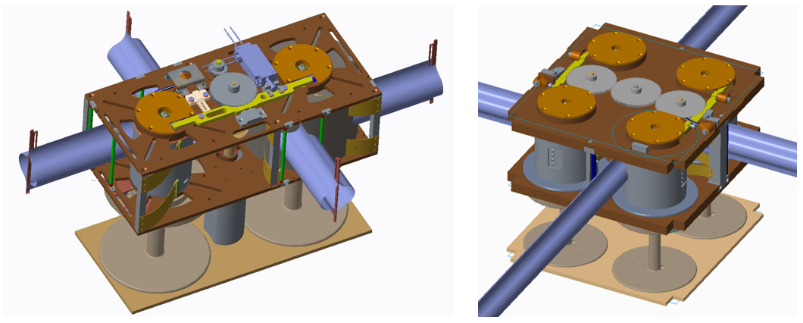
Figure 4: 6U configuration (left) vs. 12U 4-hub configuration (right)
This challenge was presented at a Technical Readiness Review before production of parts and final testing. Because the nature of this challenge could have resulted in the failure of the mission, it was the unanimous decision of the review board that the SBS should be redesigned to the monohub configuration, shown in Figure 3. The single large hub, in addition to reducing or eliminating coiling-strain-produced cracks, had all the boom roots fixed at known locations, which meant that the end of deployment would occur at the same time for all booms, regardless of packaging efficiency. There was still one steel tape per boom, so that each boom would always be constrained as much as possible to prevent blossoming. In testing, it was found that there were differences in the packaging efficiency of the steel tape being taken up onto their individual spools. This caused the tapes to lead and lag one another in cycles as the tapes were taken up. However, this never caused any problems with deployment.
The bus contract went out for bid while the 12U 4-hub design was still the baseline. From a mechanical perspective this meant that a significant portion of design had happened without guarantee of being able to find a bus that could achieve the requirements in the remaining volume, and the mechanical interface was undefined, but assumed to be a part of the continuous corner rails typical of CubeSats. There were few companies who made 12U buses at this time, fewer still who’s business model was to sell a fully tested bus to be integrated, commissioned and flown by outside entities. Despite these challenges a functional bus was delivered and, with careful coordination of the interface control document (ICD) the mechanical interface worked perfectly.
The CubeSat dispenser contract and launch provider contract did not go out for bid until the protoflight unit was in testing. There were several technical challenges because of this. The first was with procuring a dispenser. ACS3 does not have the typical continuous corner rails of a CubeSat due to the sail stowage area and the way the sail is joined to each boom. To create a continuous load path into the payload, the sail spool spindles were made structural, and a boss added to the end plate. This required the dispenser provider to custom modify the doors of their dispenser with corresponding load bearing locations. Furthermore, without a launch provider on contract up to this point, there was not a defined launch envelope or environment. This meant that the design needed to be more robust than was necessary, designed for as close to full General Environmental Verification Standard (GEVS) levels as possible. A contracted launch provider would have been able to provide reduced launch load data, and some dispensers provide attenuation. Once the launch provider was on contract, the launch was still unknown, as was the launch configuration. This meant that the altitude and inclination were unknown, which meant there were a wide range of potential thermal environments, including outside of the operational limits of some components.
Uncertainty in launch loads, dispenser orientation on the launch vehicle, and orbit parameters caused the mass of the SBS to be much higher than needed to survive the final launch loads as provided by the launch provider. This additional mass is detrimental to the performance of any propulsion system, but especially detrimental to the performance of a solar sail due to how small the resultant force of solar radiation pressure is. Future efforts could have more optimized mass characteristics if the launch environment can be detailed earlier.

Testing and Lessons Learned
Rapid Prototyping
One strategy for improving functionality and reducing mass was the use of additively manufactured parts in early prototypes of the SBS. Rapid prototyping allowed multiple design iterations to be tested before final production of a protoflight unit. Motor current data was recorded from the additively manufactured prototypes and compared between runs to find areas of improvement. Even the belt retaining the coiled sail went through several iterations, with several other intermediate retention methods of polyimide rapidly prototyped by cutting out on a laser computer numerical control (CNC) cutter. Testing these rapid prototype parts also revealed that some components from previous designs provided no observable benefit, and these were subsequently removed. Removing these components also resulted in the reduction of mass and complexity of the total system.
The prototype SBS was printed in primarily polylactide (PLA) while some parts which were found to require additional strength were printed in polyetherimide (PEI). The final rapid prototype test configuration can be seen in Figure 5. Additive manufacturing was not without drawbacks, however. Some parts printed in plastic broke so frequently in testing that prototype metal components were made or commercial-off-the-shelf (COTS) parts purchased. This included the tape spools, which were particularly weak due to their cross-section and the direction of the print layers. Some parts that were cycled repeatedly needed to be reprinted because the threaded inserts wore out the parent material. When packaging the 7 m booms for the first time, strain in the bus plate holding the gears caused the plate to bend so much that gears began to slip. A replacement aluminum plate was procured from a CNC rapid prototyping service. This aluminum plate eliminated the flexure issues and allowed full scale testing until the protoflight hardware was delivered. The constant refinements of the model, primarily in plastic, and demonstration in testing, worked deceptively well, as there were problems on the first test run of the completed flight components that had not been anticipated, some of which persisted for the remainder of the project.
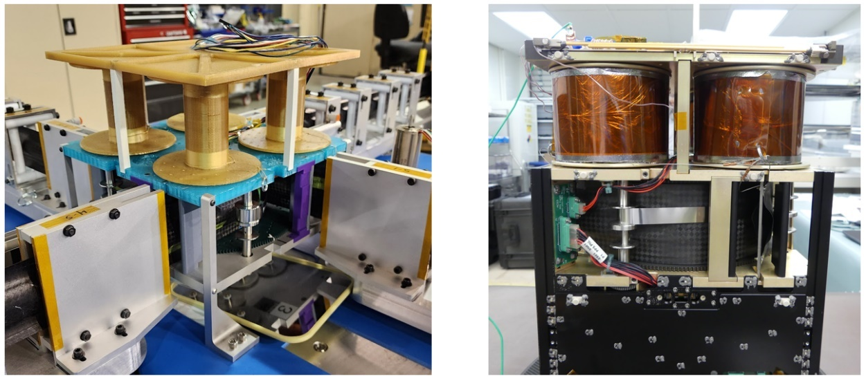
Figure 5: Final configuration of the plastic/metal rapid prototype test article (left), and the final assembly and packaging for flight (right)
Because of the number of parts that were printed, modified, and reprinted, press-in threaded inserts were used extensively for expediency in the plastic rapid prototyped parts. These press-in inserts did wear out the parent material faster through repeated cycling, and in some instances the extra time was taken to use melt-in inserts to prolong the plastic components usability. None of the threaded inserts for plastic had locking features and given that the inserts were brass instead of steel, and the parent material was plastic instead of aluminum, no data was collected for running torque, only to refine the design and assembly procedure. Press in inserts are more likely to spin in place, and many of the final torque values had to be lowered for testing in plastic.
Transitioning to Metal Parts
There were several instances where the change to metal resulted in problems. The thread on the shoulder bolts for the idler gears, shown in Figure 3, did not have enough length to engage the locking feature of their respective insert. Because the view of the shoulder was obscured by the gear, the shoulder contacting the plate was thought to be the locking feature being engaged in the threaded insert. The bolt was torqued until it sheared off, and the threaded portion of the shoulder bolt needed to be extracted from the plate. The problem was identified to be twofold. First, was the mistaken thread engagement. The second was that the strength of the brass material was lower than stated from the supplier, resulting in the fastener shearing at a lower torque than anticipated once the shoulder contacted the plate. These shoulder bolts fell out of the range of sizes covered in their governing standard and were sourced from a bulk distribution center with unknown manufacturer due to repackaging. The brass, chosen for its lubricity and non-galling properties, was found to be of lower strength than indicated by the supplier. With this information the torque was recalculated, and the procedure was modified. Because the idler gears rotate alternately clockwise and counterclockwise for packaging and deployment, these shoulder bolts were already planned to be cross drilled and wire-tied to prevent backing out. From the same supplier, titanium nitride coated stainless shoulder bolts of the same size were also procured and tested. The titanium nitride coating should have resisted wear and prevented galling. This was also found to be substandard as the tested shoulder bolts of this type galled on the first run and were not used again.
Boom Hub Counter-torque
The 6U and 4-hub designs used clock springs to provide the counter torque to resist the self-deployment forces, which has been common to many of the boom deployment mechanisms to date. One of the potential benefits of a clock spring is the counter torque could be large enough to provide a way to repackage the booms if the deployment motor were run backwards. However, these springs were COTS items that were not suited for the task in this design. The spring needed to fit within the volume of the hub, Figure 6, which limited the size of spring that could be used. The spring also needed to be preloaded a few turns. Most springs that met these initial requirements were already at or just beyond the limit of the maximum permissible number of turns per the manufacturer. Other design considerations for these springs are the OD of the spring coil, which is the ID of the housing, and the ID, which is the arbor the spring wraps around. As packaging efficiency increases, so does the number of revolutions. This meant that the springs were rotated well beyond the suggested maximum number of rotations. The springs were also dangerous to work with, where injuries were not uncommon installing the spring in the housing, preloading it, or releasing the preload during disassembly. The range of forces provided varied considerably even within a manufacturing lot, up to 20% according to the manufacturer. The number of rotations can be increased by linking the springs in series, and torque can be adjusted by linking the springs in parallel. However, due to the small size of these hubs, the cutouts for the roots of the booms, and the absolute rotation encoder at one end, there was no room to do this in these designs.
To save mass on the monohub design, the core of the hub was hollowed out. To provide structure between the two main plates, and a bearing running surface for the hub, a stationary cylindrical tube was placed at the center. This stationary element precluded the use of the earlier designs' clock-spring counter-torque method. However, something was necessary to resist the blossoming forces, and the boom axial loads generated while stretching the sail flat. Therefore, a simple friction brake was made utilizing a wave spring, shown in Figure 6. The wave spring bears against the flanges of the rotating hub, and a pocket in the main plates. If necessary, it would have been possible to shim the pocket to increase the normal force. This works in this application because deployment of the booms and sail is in one direction. This is because the sail spools also use a friction brake, but more so because the sail membrane cannot be refolded passively by simply rewinding the spool. However, a friction break does not provide any ability to repackage the booms, only to arrest movement. In this application, there is no way to furl and restow the sail, so there is no need, or possibility of retracting the booms. Additional critical elements and changes are shown side-by-side in Figure 6. The change to a stationary cylindrical tube also prevented the use of a shaft encoder. This was replaced by a pair of limit switches that acted in eight equidistant cam pockets on the flanges of the hub. The switches were located at 90 degrees to and co-witnessed one another.
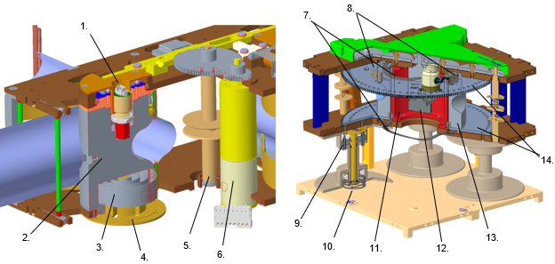
Figure 6: Side by side comparison of the 6U dual-hub (one shown for clarity) and 12U monohub configuration cross sections: 1) Shaft encoder; 2) Small diameter two-boom hub; 3) Clock spring; 4) Clock spring arbor; 5) Two-tape tape spool; 6) Brushless DC motor; 7) Wave spring brake for boom hub; 8) Limit switches acting as encoders; 9) Graphite grounding brush; 10) Wave spring brake for sail spool; 11) Stator (staionary hub support); 12) Brushless DC motor; 13) Four-boom hub; 14) Hub flanges
Tolerancing Issues
A series of problems with clearances and friction in the boom hub were discovered during early testing of the metal prototype unit. It was believed that this wave spring would also keep the hub adequately centered between the two main plates and running in plane. However, the wave springs did not properly pre-load the bearings, which had more play than usual to prevent binding in an unknown thermal environment. This meant that the flanges did not run parallel to the plates, nor in plane at the center of the plates. There are teeth on the rim edge of the hub flange to interface with the GSE, detailed in the next section. The flanges not running parallel caused the teeth at the rim of the flanges to scour the plates. This had not been noticed, nor was it a problem in the plastic prototypes due to a combination of the tolerance of the parts, the flexibility of the structure, and the soft material rubbing on soft material which left no mark. The increased rigidity and accuracy of the remaining features that had previously been plastic meant that the switches were not offset properly from the flanges, which were also not running true to their plane. In consequence, the lever arm of the switch dug into the soft aluminum, and one of the switches was also irreparably damaged. The pocket for the switches had been meant to be shimmed. However, because it had never been an issue with the plastic models, this detail had been forgotten at the time of the assembly of the protoflight unit. The wave spring brakes also scoured the surfaces of the soft aluminum on the main plates and the flanges of the hub. It had not been noticed that the crests of the wave spring had sharp corners that did not run in plane. It was also bearing against soft Iridite chemical conversion coating, which scratched easily.
These problems were solved with modifications to the existing protoflight hardware. The aluminum parts were skim cut to remove the worst of the scratches and the running surfaces had a hard anodization coating applied. Because the inserts had only been cycled once, the inserts were left in place and the holes were plugged. Several of the plugs failed and inserts were corroded by the electro-chemical process and needed to be replaced. The wave spring was hand worked to break the sharp edges, and on future assemblies was lightly lubricated. Delrin spacer plugs were added to the main plates in order to keep the flanges of the hub running in plane, and the switches were shimmed as necessary. Despite these improvements, it was common for one of the two switches to miss a count during a deployment. Due to vertical height constraints, optional lever arm extensions were left off that would have increased the active region and stroke of the switch, increased the accuracy, and proper positioning of this longer lever arm may have eliminated the need for shimming. The switches could have also been oriented differently, into the axis of the rotating hub, a more rigid and precise dimension. The process used to mitigate these missed switch counts is discussed in the section Ground Support Equipment.
Fastener Retention
Helical inserts commonly get carried back out of the base material when fasteners are removed. Because of the large number of cycles of assembly and disassembly for repackaging the payload, the decision was made to use key locking inserts extensively from the onset. These key locking inserts were all made of A286. Some helical inserts were still used due to the wall thickness of the small components. These were made of A286, Nitronic 60, and 304 stainless steel (SS). The plan had been to replace all inserts before the final environmental and functional tests, which would be followed by the final repackaging for flight. However, once the parts were in hand, the fabrication cost of the parts and the lack of spare hardware became a serious concern to project management over the additional cost and risk associated with replacing the inserts. The M2 key locking insert with locking feature also fell outside of the governing standard for that part but could be procured through a reputable manufacturer of key locking inserts. Therefore, a test was performed to determine the life cycle of all inserts used in the project to ascertain the likelihood that any given insert would fall out of the acceptable running torque range of their associated standards and accepted practices. Ten samples of each insert were installed in an aluminum test plate, shown in Figure 7, and tested ten times each. Of these 60 total inserts: three M3 helical inserts (the only inserts made of 304 SS) did back out with the fastener on the first cycle; one M3 helical (Nitronic 60) had high, but within range, running torque and then damaged the threads of the test fastener after the first cycle rendering it unusable; and one M2 helical insert was found to be installed incorrectly and was not tested. None of these anomalies were corrected. These findings were noted when presenting the findings, and the data set for the affected inserts was simply reduced.
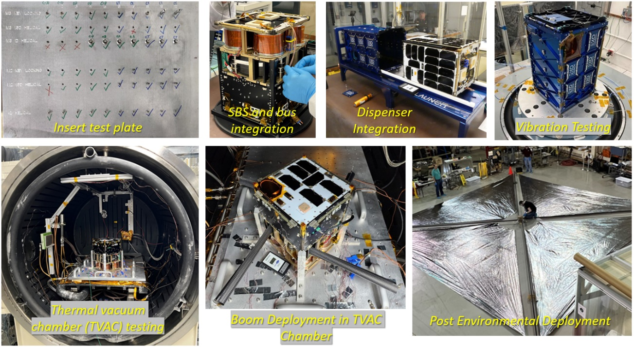
Figure 7: Insert testing, spacecraft integration, environmental- and post-environmental testing.
At this time, due to the time, cost and risk of damage of flight hardware associated with a full teardown and refurbishment of inserts across all parts, a management decision was made to not replace any of the inserts unless an insert became damaged and unable to perform. Based on the insert test performed, it was presumed that all of the inserts would be cycled more than the average number of times for the running torque of the locking feature to fall out of an acceptable range in the scheduled test campaign. Therefore, alternate methods of retention were investigated. All fasteners were subsequently prepared with VC-3 thread doping compound. The fasteners were prepared before every assembly, so that the fasteners were always retained by the thread locking compound and final torque. In the end, all fastener heads, with the exception of the lock wired shoulder bolts, were also staked with epoxy at final assembly.
Flat-Sat Differences
It is beyond the scope of this paper to detail the specific differences between the flight hardware of the bus and the hardware provided as a flat-sat for deployer programming and con-ops testing. However, there were subtle differences in model numbers provided for key hardware that presented a project risk. During one test, an error that could not be reproduced on the flat-sat nearly caused damage to the flight hardware due to malfunction. It was only through preparedness and rehearsal for emergency stop procedures that the test was stopped with no damage to the hardware. Additionally, the previously detailed problem of switch count was difficult to reproduce on the flat-sat due to the hardware differences. This is believed to be in part due to the reduced complexity of the flat-sat.
Environmental Testing
Thermal and Vacuum testing (TVAC), shown in Figure 7, was complicated by the layer cake design and the circuitous path heat would need to travel to fully soak the spacecraft. However, because the first motions of deployment were to be done in TVAC at both a high and low temperature, it was necessary to have the spacecraft in an upright configuration on the platen in the chamber. A horizontal configuration would have increased the contact area with the platen but would not have allowed for the deployment of the booms in the TVAC environment. The minimal contact area was mitigated in part by having vertical rails, like those in a dispenser, that would touch the continuous corner rails of the spacecraft as much as possible to assist in transferring heat. It was necessary from a schedule and cost standpoint to operate in a reduced thermal environment and fewer cycles than typically recommended. Deployment of the first 30 cm of the booms at hot and cold (approximately 15 cm each) was performed successfully, with no noticeable increase in recorded motor current data as compared to ambient tests in atmosphere.

Ground Support Equipment
The design of the spacecraft GSE was primarily based on the difficulty of assembling the deployer and packaging the four 7 m booms. The packaging and handling of the booms was so physically demanding that the design became linked to the ground support equipment for packaging, which was designed around similar needs for reduction of complexity and man hours. The GSE for boom packaging became its own mechanism, as shown in Figure 8. Improved packaging, reducing the area required for packaging, and the reduction of personnel necessary is especially important for tentative future missions that could use similar composite booms of up to 30 m in length, resulting in a 1600 m² sail [8] [9].
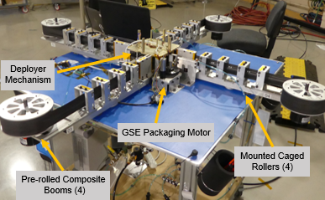
Figure 8: Boom packaging GSE at the beginning of the packaging operation.
Since the tape is reel-to-reel and not a complete belt, it is impossible to utilize the deployment motor to run the system backwards under its own power. Therefore, a GSE packaging motor is used to rotate the hub in the packaging direction. This packaging motor acts on the teeth on the edge of the boom hub flange. This was originally done with no power provided to the SBS deployment motor. This did mean that the deployment motor would need to be back-driven through its high reduction gearhead, which provided ample resistance to keep the steel tapes taut against the tightly coiled boom coil. The switches were powered and the switch counts for packaging were counted by a data acquisition system. The number of switch counts for packaging was then set in the bus software as the stop motor count to end deployment. Due to intermittent discrepancies between the switch counts, an additional method to co-witness would need to be devised.
The original boom packaging process required a large area because the booms were fully extended prior to packaging. Each boom was supported by two people, one at the free end and one at the mid span. Another person had to compress each boom to flatten it and push it tight onto the hub, while pulling it slightly, all to try to get a tight coil for improved packaging efficiency. It was also necessary to have one person running the GSE for packaging, and one person running the procedure and observing. In all, the original packaging process required 14-15 people. The four people at the midspan could be dismissed partway through packaging once enough of the boom was stowed. This still required a dozen people for a whole hour, and the additional four for half an hour, which made coordinating this effort difficult. The people supporting the free length of the boom were responsible for holding it at the same height for the whole time so that the booms would not rub excessively against the hub flanges. Despite the small mass of the booms, this is difficult and uncomfortable to maintain over an hour. The personnel responsible for compressing the boom to flat and pressing it into the hub experienced hand cramps and an unacceptable risk of carbon fiber splinters. Often, people would swap positions to gain some temporary relief from the strain of one position for the other. It was impossible to apply identical compressive forces among different individuals, or run to run, and packaging efficiency varied widely between tests.
The first major process improvement was to reduce the number of people required. The booms were directed through caged rollers which transitioned the booms from their lenticular deployed shape to their flattened cross-section. This reduced the number of people by four immediately and eliminated four of the most physically demanding positions along with their associated safety risk. The next improvement was to have the booms pre-rolled individually onto their own storage spools mounted to the end of the arms supporting the caged rollers. This eliminated the need for the eight people who would support the boom during the packaging process. These pre-rolled booms were mounted on magnetic hysteresis brakes, which provided even tension to all four booms. Additionally, the booms could be individually pre-rolled in advance of packaging into the ACS3 deployer. This process required only two to three people. The rollers were also adjusted to keep the boom flat, reducing the effort of the packaging motor required to package the booms. This also reduced the number of flattening to formed cross-section cycles of the booms, which are the single highest strain inducing event for the booms.
Finally, pneumatic linear actuators with rollers were added to compress the flattened boom to the hub. The pneumatic actuators were all linked through the same pressure manifold with a pressure release valve. This ensured that the compressive force on the booms at the hub was even and consistent throughout the packaging process. By making minor changes to the pressure and the torque of the magnetic hysteresis brake, the packaging efficiency was improved drastically and became very consistent between runs.
The torque required by the packaging motor increased through all these changes. There was a desire to keep the packaging speed low, taking approximately 20 minutes, so that the booms could be carefully observed. To achieve this low speed, the packaging motor had to be run slowly. A brief trial in running the deployment motor backwards during packaging so that the packaging motor did not have to back drive the high reduction planetary gear was attempted. This was done with the deployment motor at a lower relative speed than the packaging motor so that the tapes remained taut. However, there was a fundamental misunderstanding about how a brushless DC motor works when doing this. A brushless DC motor works on the Hall effect and require a motor controller card to control speed by varying the duty cycle of each coil at the time and position it can act. These controller cards are set for speed and will increase or decrease the duty cycle to achieve this speed, regardless of input. The deployment motor became more difficult to back drive with the coils energized and trying to achieve their target speed. However, it was necessary to power the deployment motor’s Hall sensor circuit to record the number of motor rotations during packaging.
Brushless DC motors also have a minimum speed that they can be run at under load before they will start to stutter. This is due to the impulse during the duty cycle being too small to overcome the torque. The next impulse would be larger and exceed the speed setting, causing the next impulse to be short and not drive forward. It was possible to assist the motor by turning the hub by hand, however, that defeated the purpose of the GSE setup. A different motor should have been used for packaging, but one was not available. The speed was adjusted into a range where packaging was smooth but still slow enough to be acceptable.
It is difficult to track the incremental improvement of all the GSE modifications and their individual contributions. The initial metric for comparison was the number of switch counts and the measurement of the outer diameter. The measurement of the outer diameter was difficult to make precisely. In the 6U configuration structural features, as well as the boom tip end and steel tape, obstructed direct measurement, and the coiled boom was easily deformed by calipers due to its low packaging efficiency. Additionally, there were several changes to the inner diameter of the coil as the hub diameter was incrementally increased to reduce the stress on the stiffer booms, which was causing cracks to form and propagate. Once the design shifted to a 12U monohub, the inner diameter dimension became fixed. Furthermore, as the packaging efficiency improved, the coiled boom became less compliant and this outer diameter measurement became more consistent. The limit switch count became consistent to ±1. The clearest indicator of how consistent the packaging efficiency became was the highly repeatable number of motor revolutions achieved from run to run towards the end of the test campaign.
This repeatable motor Hall sensor count was achieved despite the high gear reduction of the planetary gearhead, the variable belt ratio, and the now minorly variable packaging efficiency. Therefore, motor count was selected to co-witness the switch counts to determine end of deployment final position. Motor count would get to the final rotation, the Hall sensor and switch count data compared to the numbers recorded during packaging, and if the switch count was determined to be accurate, the switches would determine final position. Fiducial marks were added in a regular repeating patter for the first 650 mm of the boom root area, which can be seen by cameras on the bus. If the switch count recorded during deployment was found to be questionable, the motor hall sensor count could be used to get within the final anticipated range. Pictures from a nominal ground deployment could then be compared to returned images to confirm correct final position or drive forward more as necessary to complete deployment.

Conclusions and Remarks
COTS hardware and inserts can be found that fall outside the ranges covered by their usual governing standards that can be of good quality, depending on the source and quality of their manufacturer. This hardware scale is particularly important for CubeSats given their small nature, as well as the miniaturization of other parts for mass and volume savings in other form factors. Nitronic 60 inserts were noted to be of above average quality for repeatable and reliable use when multiple cycles were needed. A286 key locking inserts held up well over repeated cycles and did maintain good thread form for continued use as “free running” inserts after the locking feature becomes worn. However, all of these should be tested on a case-by-case basis since they may be non-standard parts. Additionally, none of the inserts installed in the flight article exhibited anomalous behavior shown in testing. Unifying the size and number of fasteners greatly reduced the complexity of assembly and improved the time necessary from a week to two days. The additively manufactured prototypes were invaluable but did not reveal all of the problems with the design, some of which caused damage to the flight unit.
The largest problem for the mechanism at the end of the project remained the limit switches. The very narrow active region of the switch plagued what should have been a reliable system. The limit switches should have faced into the axis of rotation. An optical encoder, or a shaft encoder working on a pinion gear in the teeth of the hub flanges, would have provided even greater positional accuracy.
Only one protoflight unit of the SBS was ever constructed. Because a portion of cost is in programming CNC machines, tooling, and fixturing, a second unit is often less expensive. With two units, one could have been an Engineering Development Unit (EDU) to go through a more extensive test campaign. Lessons learned could have been collected into single modifications of flight unit parts. A pristine flight unit could have been used for final verification testing and use on orbit. ACS3 also did not have an EDU bus, and while it did have similar components used in a flat sat configuration for testing of the control software for the payload, the dissimilarities were significant enough to cause problems in testing. Because of the protoflight nature of the ACS3 payload, the test campaign (shown in Figure 7) was more limited and was approached with great caution due to the lack of backup hardware. The cost of the slower and more thorough nature of testing with a protoflight unit would have been partially, if not completely, absorbed by the cost of duplicate EDU hardware. An EDU SBS combined with a full EDU bus would have provided a true-to-flight article for troubleshooting on-orbit problems on the ground, as well as a second chance at the cost of a new dispenser and launch in the event of an irreparable failure.
Removing as many people from the packaging process as possible improved repeatability, reduced cycle time for repackaging, and reduced labor costs significantly. This process also reduced the cumulative damage imparted to the thin-shell deformable booms generated during the packaging process. This solution for packaging the booms is scalable to much larger configurations. In contrast, the sail membrane packaging process remained an inefficient hand-folding procedure. Due to the delicate nature of the
sail membrane, as well as the number and non-repeating shape of the folds [6], no mechanized assistance was able to be developed for ACS3. This resulted in the boom deployment being tested many more times than the sail membrane deployment.

References

[1] | W. K. Wilkie, J. M. Fernandez, O. R. Stohlman, N. R. Schneider, G. D. Dean, J. H. Kang, J. E. Warren, S. M. Cook, P. L. Brown and T. C. Denkins, "An Overview of the NASA Advanced Composite Solar Sail (ACS3) Technology Demonstration Project," in AIAA Scitech, Virtual, 2021.
[2] | J. M. Fernandez, G. K. Rose, C. J. Younger, G. D. Dean, J. E. Warren, O. R. Stohlman and W. K. Wilkie, "NASA's advanced solar sail propulsion system for low-cost deep space exploration and science missions that uses high performance rollable composite booms," in International Symposium on Solar Sailing, Kyoto, Japan, 2017.
[3] | M. Hillebrandt, S. Meyer, M. E. Zander and C. Hühne, "Deployment Testing of the De-Orbit Sail Flight Hardware," in AIAA Spacecraft Structures Conference, Kissimmee, Florida, 2015.
[4] | J. M. Fernandez, "Advanced Deployable Shell-Based Composite Booms for Small Satellite Structureal Applications Including Solar Sails," in International Symposium on Solar Sailing, Kyoto, Japan, 2017.
[5] | A. Hoskin, A. Viquerat and G. S. Aglietti, "Tip Force during Blossoming of Coiled Deployable Booms," International Journal of Solids and Structures, pp. 58-69, 2017.
[6] | O. R. Stohlman, J. M. Fernandez, G. Dean, N. Schneider, J. H. Kang, R. Barfield, T. Herndon and P. Stokes, "Advances in Low-Cost Manufacturing and Folding of Solar Sail Membranes," in AIAA Scitech, Orlando, Florida, 2020.
[7] | J. M. Fernandez, G. K. Rose, O. R. Stohlman, C. J. Younger, G. D. Dean, J. E. Warren, J. H. Kang, R. G. Bryant and W. K. Wilkie, "An Advanced Composites-Based Solar Sail System for Interplanetary Small Satellite Missions," in AIAA Scitech, Kissimmee, Florida, 2018.
[8] | J. M. Fernandez and C. E. Volle, "Corrugated Rollable Tubular Booms," in AIAA Scitech, Virtual, 2021.
[9] | L. Nguyen, Z. McConnel, K. A. Medina and M. S. Lake, "Solar Cruiser TRAC Boom Development," in AIAA SciTech, National Harbor, MD, 2023.

Mechanical Design Engineer, Analytical Services & Materials Inc. (RSES), Structural Dynamics Branch
Research Aerospace Engineer, NASA Langley Research Center, Structural Dynamics Branch
Research Aerospace Engineer, NASA Langley Research Center, Structural Dynamics Branch
SBS Chief Engineer, NASA Langley Research Center, Structural & Thermal Systems Branch
Principal Investigator: DCB Project, NASA Langley Research Center, Structural Dynamics Branch
Principal Investigator: ACS3 Project, NASA Langley Research Center, Structural Dynamics Branch
SBS Systems Engineer, NASA Langley Research Center, Chief Engineer Office Proceedings of the 47th Aerospace Mechanisms Symposium, Virginia Beach, Virginia, USA, May 15-17, 2024
https://www.planetary.org/articles/what-is-solar-sailing
https://www.nasa.gov/smallspacecraft/what-is-acs3/
ISO 17770
https://www.nasa.gov/centers-and-facilities/langley/deployable-composite-booms-dcb/
ISO 7379
NAS NA0147

