Deep-space Conjunction Assessment: Recent Developments and Future Evolution
Zahi B. Tarzi⁽¹⁾, David S. Berry⁽¹⁾, Zach Kaufman⁽¹⁾, Jin Ma⁽¹⁾, Lauri K. Newman⁽²⁾

⁽¹⁾California Institute of Technology, Jet Propulsion Laboratory
Pasadena, USA
Email: zahi.b.tarzi@jpl.nasa,gov, david.s.berry@jpl.nasa.gov, zachary.a.kaufman@jpl.nasa.gov, jin.h.ma@jpl.nasa.gov

⁽²⁾NASA Headquarters
Washington D.C., USA
Email: lauri.k.newman@nasa.gov

Abstract – The Multi-mission Automated Deep-space Conjunction Assessment Process (MADCAP) is a NASA Jet Propulsion Laboratory (JPL) capability used to perform conjunction assessment in shared deep-space environments. MADCAP began performing conjunction assessment at Mars and the Moon in 2011, with the Sun/Earth libration points added to its functionality in 2020. There has been an increasing number of missions operating in these environments in recent years, leading to an elevated frequency of close conjunction events, especially in the Lunar orbital environment. MADCAP provides this service not only to NASA missions, but to any operator who is willing to share ephemerides. Since there is no space surveillance network for deep space environments, ephemeris sharing is the only way in which spacecraft operators can ensure the safety of their spacecraft from collision in these orbit regimes.

NASA published a set of conjunction assessment best practices in 2020 that cover the MADCAP process.

This paper details recent MADCAP operational experience in the deep space environments, including statistics and process improvements. Updates to the MADCAP software and automation framework implemented to handle the recent growth in the number of deep space missions are also discussed. Future enhancements planned in anticipation of increasingly crowded deep-space environments, such as non-standard runs based on exploratory scenarios, are also discussed.

Introduction
There is a well-documented ongoing issue with space debris in the Earth orbital regime. Although there are currently no known debris fields at the Moon and Mars, the creation of such debris fields would be highly undesirable due to the current infeasibility of tracking such objects from Earth. There are a growing number of missions in the Martian and Lunar orbital environments, with many more planned in the near future, especially at the Moon. Missions designed for scientific sensing or communication relay purposes tend to choose similar orbits, creating crowding in those regimes. The creation of debris fields in these environments would greatly jeopardize future operations in those orbital regimes for both robotic and human missions. Preventing such debris fields is imperative to safely continue spacecraft operations.

NASA currently expends resources to monitor the Earth's orbital debris environment via its Conjunction Assessment Risk Analysis (CARA) program located at the Goddard Space Flight Center (GSFC) [1] [2] [3]. The Multi-mission Automated Deep-space Conjunction Assessment Process (MADCAP) has been used at the Jet Propulsion Laboratory to perform conjunction assessment at Mars and the Moon since 2011, and Sun/Earth libration points since 2020. The MADCAP process has been described in previous publications [4] [5] [6] [7].

NASA requires all of its spacecraft to utilize the CARA and MADCAP services, as documented in NASA Procedural Requirement (NPR) 8079.1. In order to share best practices used within NASA with the broader community, NASA published the “NASA Spacecraft Conjunction Assessment and Collision Avoidance Best Practices Handbook”. This document, as well as information about the MADCAP process, are available at https://www.nasa.gov/cara/.

The general MADCAP process is reviewed here, before providing a history of recent events in deep-space conjunction assessment. The impact of new conjunction assessment requirements published by NASA in 2023 will also be discussed [12]. The latest updates to the MADCAP software will be reviewed, and planned future upgrades will be presented, with some enhancements already in progress. Finally, the MADCAP Team proposes the initiation of an international working group focusing on common interagency operational issues which would allow for the continuation of robust conjunction analysis for the large quantity of diverse missions expected in shared deep-space environments in the coming years.

MADCAP General Description
The MADCAP software utilizes the JPL MONTE (Mission Design and Operations Navigation Toolkit Environment) Python library [9]. MONTE is JPL's signature astrodynamics computing platform, used for space mission design and in-flight navigation, with over 15 years of operational use supporting NASA’s deep space missions. The MADCAP design has not fundamentally changed since its conception in 2011. Conjunction analyses in any orbital environment is possible without modifying the underlying MADCAP software through the use of a unique input parameter file for each environment. The parameters fall into a few general classes: environment (central body, coordinate system); bodies within the environment (active spacecraft, inactive spacecraft, natural bodies); thresholds used to classify conjunction events and control report generation; options for detailed reports and plots; and email lists for report participants. The main parameters that establish the orbital environment are the specification of the central body and a list of at least two spacecraft (or other bodies including natural satellites or inactive spacecraft) orbiting that body.

Obtaining Ephemeris Files
MADCAP requires information about the trajectory of the orbiting bodies in order to find close conjunctions between them, and information about the uncertainty of those trajectories in order to evaluate the risk of collision. Passive ground-based tracking of objects at lunar distances and beyond is not currently possible. Thus, the ephemerides of spacecraft in such environments must be obtained from the project’s ground-based navigation orbit determination process based on active tracking methods. The number of antennas that can perform such tracking is limited; the primary ones used by NASA are those of the Deep Space Network (DSN). At the time of MADCAP’s conception, all spacecraft in these environments used DSN tracking data. Thus, the navigation teams for these spacecraft regularly uploaded updated trajectory ephemeris files to the DSN Service Preparation Subsystem (SPS) portal; a central repository for the DSN and other users to easily access the orbital information. The SPS portal also allows for autonomous downloads of these files, which makes it a convenient place for MADCAP to collect these files in order to conduct conjunction assessment. In cases where SPS is not used, trajectory information can be loaded into MADCAP manually. Automated methods of retrieving ephemeris files for non-DSN tracked spacecraft are in planning and discussed further in Section VI.

In addition to the ephemerides of the spacecraft involved, it is important for calculating collision risks to include the uncertainty associated with the position estimates stored in the ephemeris files. This uncertainty is normally computed by the spacecraft’s navigation team as part of the orbit determination (OD) process. Ideally, MADCAP would use this uncertainty estimate as it represents the best estimate of the position errors, represented by a 3x3 position covariance matrix which can be evaluated at any time along the orbit. However, because the DSN does not utilize this information, navigation teams do not regularly include it in the files submitted to SPS. When the formal covariance data is not available, an approximation of the uncertainty can be computed using time-varying polynomials of orbit radial and timing uncertainties relative to the trajectory creation time. These are also specified by spacecraft navigation teams, with assistance from the MADCAP Team, and used to determine the uncertainties of the state for a given conjunction. The formal covariance information is preferred because it is a more accurate representation of the true errors. However, to date, covariance information has not been consistently delivered, so polynomials are generally being used to evaluate collision risk. NASA now requires all missions to provide covariance information (NPR 8079.1, which should increase the number of missions providing this data.

Trajectory Comparisons
For two orbits which are not coplanar, a collision can only occur where the two orbit planes intersect. Therefore, the impact risk can be characterized by two uncertainties: that of the time at which the primary spacecraft crosses the orbit plane of the secondary spacecraft, and that of the radius from the central point of the orbit at the time of that orbit plane crossing. With a known time and radius of both spacecraft at that point, the potential for an impact can be determined based on whether the difference in timing and the difference in radius are within a certain number of standard deviations of the uncertainty, typically three. Given this information, there are three main close approach event attributes used to analyse the event risk: close approach distance (CAD), orbit crossing distance (OXD), and orbit crossing timing (OXT). The CAD is the relative distance between the two bodies at the time of the closest approach ($t_{CA}$). The OXD is the minimum distance between the orbits of the two bodies. For non-coplanar orbits, this occurs at the two points where the orbits cross each other. Since the orbits are slowly changing over time, the orbit crossings that are within one orbital period of the $t_{CA}$ are evaluated, and the one with the higher risk of collision is reported as the close approach event that MADCAP reports to users. The OXD value can be represented by the following equation.

$OXD=r_{1}\left(t_{OX1}\right)-r_{2}\left(t_{OX2}\right)$ (1)

Where $r(t_{OX})$ represents the orbital radius of each body evaluated at the time it is at the orbit crossing location. The “sign” of this number conveys information about which orbit is higher at the point at which the orbits cross. So, for a “Primary-Secondary” body pairing, if the orbit crossing distance is positive, then the primary orbit is above the secondary orbit at the crossing time. If it is negative, then the primary orbit is below the secondary orbit. A visual representation of CAD and OXD is shown in Figure 1, where ${\overset{⃑}{r}}_{OX}$ represents the body’s orbit radial direction at the time of the crossing. The third attribute, OXT, is defined as the difference between the times that the two bodies are at the crossing. This can be represented as:

$OXT=t_{OX1}-t_{OX2}$ (2)

If the value is positive, then the primary arrives later than the secondary; if it is negative then the reverse is true.

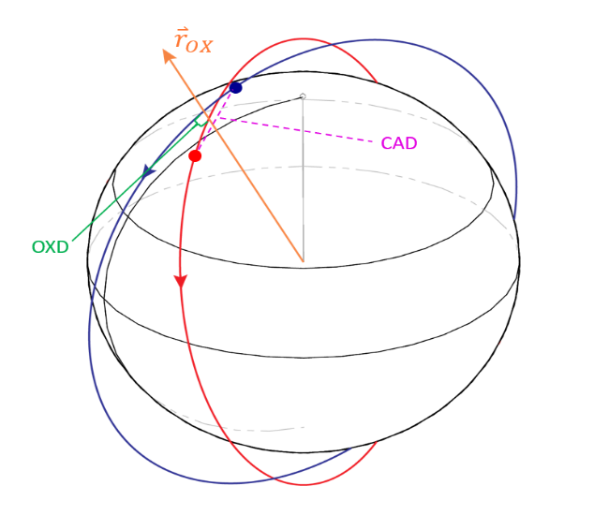
Fig. 1. Main Close Approach Attributes

Setting Thresholds
The close approach attributes mentioned in the previous section are checked against thresholds to place events into two categories: ‘Red’ and ‘All’. The ‘Red’ event list is comprised of significant near-term events which may require further investigation, while the ‘All’ event list is composed of any future events which may be of interest. These thresholds are specified by the individual spacecraft navigation teams and are discussed in depth in [7]. The Red thresholds may be derived [automatically by MADCAP] from formal covariance data delivered by the navigation teams or specified as nominally expected 3-sigma uncertainties as a quadratic function of time to the event. The All thresholds are constant values specified by the navigation teams.

Output Reports
A summary report is generated for each MADCAP run which highlights important results from the conjunction analysis. The report is generated in HTML (Hyper Text Markup Language) format and sent out via email to stakeholders. Text messages which highlight conjunctions of concern can also be sent to the MADCAP Team. More detailed plots and tables of the close approach events are also generated and can be sent out via email for each body pairing.

Response to High Risk Events
In the event of a high-risk event (also termed Red event) the MADCAP process calls for contacting both involved parties and recommending next steps. In some cases, e.g., conjunctions that do not "naturally" resolve, or teams that cannot agree on a mitigation maneuver plan, the MADCAP team will facilitate discussions with telecons, and may make special runs with ephemerides modelling planned mitigation maneuvers to ensure that the conjunction is mitigated by the maneuver and new conjunctions are not created. This process is documented for Mars in [14], and the process is similar for the Moon.

Recent Experience
This section will cover recent events in deep-space conjunction assessment.

Mars
MADCAP analysis began at Mars in 2011 when there were three active spacecraft operating in the Martian orbital environment: Mars Odyssey (ODY), Mars Express (MEX), and Mars Reconnaissance Orbiter (MRO). These spacecraft were in stable, well characterized orbits which rarely produced close conjunctions. They were joined in 2014 by the Mars Atmosphere and Volatile Evolution (MAVEN) and Mars Orbiting Mission (MOM) spacecraft. MAVEN performed “deep dips” into the Martian atmosphere in order to measure its properties. These deep dips meant that the MAVEN orbit was more variable with larger uncertainties due to imperfect prediction of the Martian atmospheric density. Prior to MAVEN’s arrival at Mars, MADCAP had relied on Close Approach Distance (CAD) to categorize the risk of conjunctions. Constant thresholds on CAD were checked for Red Events, which was sufficient when the environment consisted of three spacecraft in stable, well-characterized orbits. MAVEN’s large downtrack uncertainties led to the adoption of Orbit Crossing Distance (OXD) and Orbit Crossing Timing (OXT) as the attributes used to categorize risk. In this way, radial and downtrack errors could be separated and conjunction risk could be better assessed. The MOM spacecraft operated in a much large elliptic orbit than existing missions and did not produce many close conjuntions.

The next spacecraft to arrive at Mars was the Trace Gas Orbiter (TGO) in late 2016. Figure 2 shows the number of active spacecraft and natural bodies in the MADCAP Mars catalogue and conjunctions requiring response (per month) since 2016. A Response case is defined as a Red event or set of Red events for a pair of spacecraft that was reported at the same time, and thus only required one response. At the beginning of 2016, MADCAP analysed 7 objects, excluding inactive spacecraft: ODY, MEX, MRO, MAVEN, MOM, Phobos, and Deimos. After TGO, the Mars Insight lander was briefly added to MADCAP in 2018 during its entry to landing. The Mars 2020 rover was similarly added in 2021 on its approach to the planet. No close conjunctions were found for either mission. The Emirates Mars Mission (EMM) and Tianwen-1 spacecraft also both arrived at Mars and were added to the MADCAP analysis in 2021. In early 2023, the MOM spacecraft was moved to the list of inactive spacecraft due to no longer being tracked.

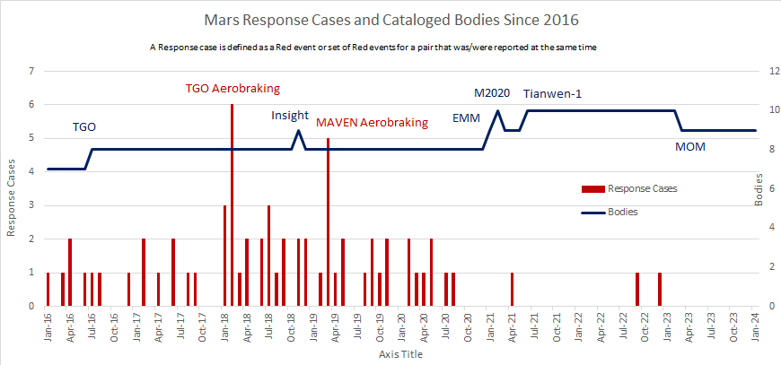
Fig. 2. Mars Response Cases and Catalogued Bodies Since 2016

TGO conducted aerobraking from March 2017 to February 2018. The greater uncertainties imparted by using the Martian atmosphere to change the spacecraft’s orbit contributed to a spike in Red Events toward the end of this period when the TGO orbit became closer to the existing orbiters. Another spike in events can be seen in the spring of 2018 when the MAVEN spacecraft was conducting aerobraking to shift its orbit to no longer perform deep dips into the atmosphere. In both cases, aerobraking resulting in higher uncertainties and more variation in the orbits of the spacecraft, leading to more conjunctions of concern.

Figure 3 shows the same MADCAP response cases since 2016 as Fig 2, but broken out by year and which spacecraft were involved. The periods of MAVEN deep dips and TGO and MAVEN aerobraking can be noted in the plot by the spike in cases involving those missions. There have been many fewer close conjunctions at Mars since MAVEN completed aerobraking and deep dips, with no response cases occurring in 2023.

In 2018-2019, when the MADCAP Team became aware that China was planning a Mars orbiter, the MADCAP team worked through NASA's Office of International and Interagency Relations (OIIR) to establish an ephemeris exchange for what became the Tianwen-1 mission. NASA/OIIR is the authorized office empowered to negotiate cooperative NASA agreements with foreign space partners. MADCAP successfully received the first ephemeris from the China National Space Administration (CNSA) on Jun 21, 2021. JPL now receives Tianwen-1 ephemeris weekly, and provides the ephemerides for ODY, MRO, and MAVEN to CNSA; also provided are the daily MADCAP Summary Reports. Like MADCAP operations with SPS, the NASA uploads and downloads these files to/from an Amazon Web Services (AWS) server established for this purpose via automated processes.

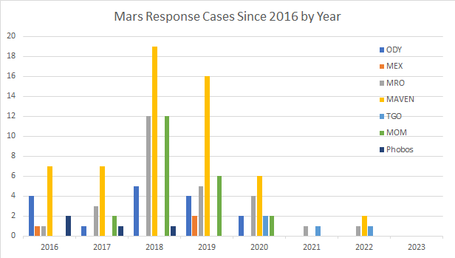
Fig. 3. Mars Response Cases Since 2016 by Year

In addition to active spacecraft and natural bodies, MADCAP performs some limited analysis for inactive spacecraft. Ephemerides for inactive spacecraft are produced by orbit determination experts at JPL using the last known states of the body and best available dynamic models to generate long-term predicted trajectory estimations. Although the orbit phasing information quickly degrades, the orbit geometry knowledge can make the orbit crossing data produced by MADCAP useful. The inactive spacecraft are not included in risk categorization, but tables of close approach attributes are produced and sent out to interested parties. MADCAP currently analyses five inactive spacecraft in the Martian environment: Mariner 9, Viking 1, Viking 2, Mars Global Surveyor (MGS), and MOM.

Moon
MADCAP analysis for the Lunar environment began in late 2011 when the Gravity Recovery and Internal Laboratory (GRAIL) spacecraft were arriving at the Moon. Five spacecraft were included in the analysis: Lunar Reconnaissance Orbiter (LRO), Acceleration Reconnection Turbulence and Electrodynamics of Moon's Interaction with the Sun (ARTEMIS-P1 and ARTEMIS-P2), GRAIL-A, and GRAIL-B. After the GRAIL spacecraft ended operations by impacting the lunar surface, MADCAP was left with three active spacecraft until the arrival of the Lunar Atmosphere and Dust Environment Explorer (LADEE) spacecraft in late 2013. In February of 2014 a close conjunction between the LADEE and LRO spacecraft resulted in multiple special MADCAP runs which enabled the re-design of a LADEE maneuver to reduce the risk of collision. This event is discussed in more detail in [6].

After the LADEE end of mission. There were very few close conjunctions in the lunar environment until the arrival of the Chandrayaan 2 Orbiter (CH2O) and Lander (CH2L) in 2019. Earlier in 2019, MADCAP added the SpaceIL (SPIL) Beresheet lander to its analysis with no close conjunctions detected. The initial Red thresholds used for the CH2 spacecraft were too conservative and resulted in a large number of response cases when the spacecraft first entered Lunar orbit. The MADCAP Team worked with ISRO to specify more accurate thresholds which greatly reduced the number of Red Events for cases that were not of concern. This can be seen in Fig 4 which shows the number of active spacecraft and natural bodies in the MADCAP Mars catalogue and conjunctions requiring response (per month) since 2016.

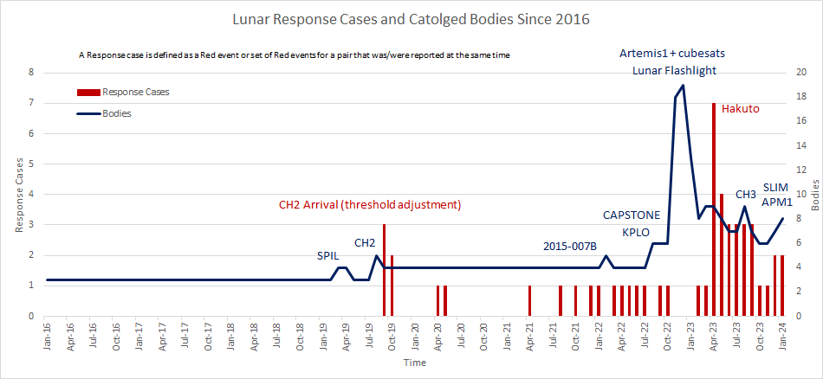
Fig. 4. Lunar Response Cases and Catalogued Bodies Since 2016

In 2021, it was determined from ground observations that space object 2015-007B (likely an upper stage rocket booster) would impact the Moon, so its estimated ephemeris was added to MADCAP analysis, though no close conjunctions were predicted. In 2022, the Cislunar Autonomous Positioning System Technology Operations and Navigation Experiment (CAPSTONE) and Korea Pathfinder Lunar Orbiter (KPLO) both arrived into the Lunar environment and were added to MADCAP analysis. The CAPSTONE spacecraft entered into a distant Lunar orbit which does not come very close to the other spacecraft at the Moon. However, KPLO would eventually settle into a low polar lunar orbit similar to CH2O and LRO, which has caused many response cases between these three spacecraft beginning in early 2023. In a few cases, momentum wheel desaturation maneuvers have been moved or altered by the CH2O and LRO teams in order to reduce the risk of collision. Collision Avoidance (CA) maneuvers were also performed a few times, such as in October 2021 when a Red conjunction was flagged by MADCAP between LRO and CH2O with OXD 8m, OXT 0.08s, CAD 110m. The MADCAP team facilitated several meetings between the LRO and CH2O teams which resulted in a CA maneuver performed by CH2O which resolved the conjunction [15].

The Artemis-1 Orion capsule was launched into a Lunar flyby trajectory in late 2022, deploying ten CubeSats along the way and also releasing the Interim Cryogenic Propulsion Stage (ICPS) into the lunar environment. Although no Red events were detected for any of these objects, the addition of so many new objects into the MADCAP analysis, requests by the Artemis team for special runs, and the multiple launch slips all led to significant effort by the MADCAP Team to support these missions. Unfortunately, many of the CubeSat missions encountered issues and failed or led short operational lives, with none staying in the Lunar environment past 2023. The Lunar Flashlight spacecraft launched just after Artemis-1 and was briefly included in the MADCAP analysis, though it never entered the Lunar environment.

The iSpace Hakuto-R Mission 1 lander arrived into Lunar orbit in April of 2023 and produced many Red events requiring responses by the MADCAP Team. Meetings were facilitated by the MADCAP Team between the CH2O, LRO, KPLO, and Hakuto teams. Discussion between the teams led to increased ephemeris sharing and decisions to wait for multiple teams' scheduled maneuvers to determine the risk. The close conjunctions resolved after these maneuvers. The Chandrayaan 3 lander (CH3) and propulsion unit (CH3P) were added to the MADCAP analysis in August 2023, but did not encounter any close conjunctions while in the Lunar orbital environment.

Figure 5 shows the same MADCAP response cases since 2016 as Fig 4, but grouped by year. A sharp increase in cases can be seen in the last year with the many new arrivals and three spacecraft in similar low lunar orbits (LRO, CH2O, KPLO). This increase in response cases is expected to continue as more Lunar missions are planned for the upcoming years.

In January 2024, the Smart Lander for Investigating Moon (SLIM) and Astrobotics Peregrine 1 (APM1) landers arrived into the lunar environment and were added to MADCAP analysis. Although the APM1 spacecraft did not encounter any close conjunctions, the MADCAP analysis showed that the SLIM spacecraft had a Red conjunction with the KPLO spacecraft just before its landing attempt. A meeting was facilitated by the MADCAP Team and both spacecraft teams provided covariance data for analysis of a Probability of Collision (Pc) by MADCAP. Although the Pc was low (1.5e-07), the KPLO team decided to perform a Collision Avoidance (CA) maneuver. The manenuver was designed to increase the OXT separation between the two spacecraft since the SLIM spacecraft was to perform a maneuver just before the conjunction, resulting in a large covariance uncertainty at the conjunction. The CA maneuver was successful, adding minutes of separation time between the two spacecraft and decreasing the Pc to zero.

The Intuitive Machines Lunar Lander (IM-1) was added to the MADCAP Lunar analysis during its brief period operating in the Moon’s orbit. This required more coordination to setup due to IM-1 not being tracked by the DSN. A file transfer process was established to manually check for new ephemerides and add them to the MADCAP analysis. No close conjunctions or Red Events were encountered with IM-1.

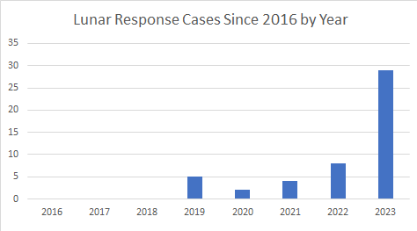
Fig. 5. Lunar Response Cases Since 2016 by Year

In addition to the active spacecraft in the Lunar orbital environment, MADCAP has included two inactive spacecraft in its Lunar analysis: Chandrayaan 1 (CH1) and Ouna. The ephemerides for these spacecraft were produced in the same manner as those discussed for Mars. However, in 2016 a campaign to find these spacecraft using ground based radar and best estimates of their orbits was conducted [8]. The CH1 spacecraft was found and an updated ephemeris produced for it based on these results. However, the Ouna spacecraft was not detected, and it was eventually dropped from MADCAP analysis in early 2023 after analysis predicted it had impacted the Moon.

In the past few years, the space press has published numerous articles regarding China's plans for the continuation and expansion of its Lunar activities. The MADCAP Team hopes to receive ephemerides from future Chinese lunar missions to use within the MADCAP process to ensure safety of all mission in the lunar environment.

Sun-Earth L1/L2
MADCAP analysis for the Sun-Earth L1 Lagrange point began in March of 2020 with four spacecraft: Advanced Composition Explorer (ACE), Solar & Heliospheric Observatory (SOHO), Wind, and Deep Space Climate Observatory (DSCOVR). The Aditya-L1 spacecraft arrived in the environment and was added to the MADCAP analysis in January of 2024.

The MADCAP analysis for the Sun-Earth L2 Lagrange point began in January of 2022 with two spacecraft: Gaia and James Web Space Telescope (JWST). The Euclid spacecraft arrived in the L2 environment and was added to MADCAP analysis in August of 2023.

There has not been a Red event in either the Sun-Earth L1 or L2 environments since MADCAP analysis began. Close conjunctions have not appeared so far, but MADCAP will continue to monitor this shared space as more missions arrive in the environment.

Recent Software Updates
Over the last two years, MADCAP has gone through extensive enhancements in functionality and algorithms, as well as anomaly fixes, sustainment updates, and code refactoring.

Input Changes
Recent updates to the MADCAP input parameter file have enabled tailoring of runs to specific circumstances. For example, the option has been added to limit analysis to only pairs involving bodies specified by a new parameter. This allows for faster runs without having to analyse each unique pair when only certain bodies are of interest for a special run. Other new parameters allow for the specification of a “worst case” Pc limit (which had previously been hardcoded), ability to request Pc calculation per body since some bodies do not have accurate covariance data, and specifying the ephemeris portal location for testing purposes.

Algorithm Updates
The MADCAP search algorithms have been updated to increase accuracy and efficiency. Several improvements to the handling of hyperbolic coplanar orbits were recently implemented to better handle spacecraft which transition from hyperbolic to elliptic orbits or do not enter the central body sphere of influence. The orbit crossing search algorithm was also updated to shift from reporting the minimum orbit crossing found, to reporting crossings that are higher risk, which sometimes involves reporting a crossing with a larger OXD if the timing difference is smaller. These updates have allowed the MADCAP scripts to return more useful results to users in shared deep space environments.

Output Changes
Minor updates have been made to the MADCAP output products in order to provide clear information about the analysis. The MADCAP output tables have recently added the option to print the angular separation between the orbit planes of the analysed pair of spacecraft. This is important since a different algorithm is used when the two orbits are close to coplanar. It allows the user to pinpoint when a minimum orbit distance is being reported in place of orbit crossing distance and is useful when performing algorithm tests. The names of the tables have also been updated to include the run time in addition to the calendar day of the run, and the summary report was modified to increase visibility of the MADCAP software version used.

Planned Enhancements

Ephemeris Exchange Server
Many new missions to deep-space environments do not plan to use the DSN for tracking and thus do not plan to upload ephemeris files to SPS. There is currently no way for MADCAP to automatically download and use ephemeris files outside of SPS. Current inclusion of such missions requires receiving files via email and manually including them in MADCAP runs. This is not sustainable with the increasing number of non-DSN tracked missions. A server, similar to the server used for CNSA ephemeris exchange discussed above, is planned to be established and maintained by the MADCAP Team for the exchange of ephemerides of spacecraft not tracked by the DSN. Spacecraft tracked by the DSN could also use this server if they prefer. Some missions may want to upload trajectories that are slightly different from those sent to the DSN for tracking purposes. An ephemeris server whose primary purpose is conjunction assessment may help missions become aware of the need to upload files with covariance data.

User Requested Special Run
During times around critical events, especially critical maneuvers, certain missions require special MADCAP runs outside of the nominal daily runs. It is work-intensive for the MADCAP Team to initiate these runs manually, especially if they fall outside of normal work hours. It would be more flexible and convenient for missions using MADCAP to be able to request special runs that can be initiated automatically without intervention by MADCAP Team members. This automation can be accomplished in conjunction with the “non-DSN Ephemeris server” proposed in V.A above. The server can be monitored for new files and a new run triggered by the upload of such files in a specified category.

Visualizing Reported Red Events
Visualizing Red Events has long been a goal of the MADCAP team, as such a feature would facilitate an improved understanding of the geometry associated with a particular conjunction. Automated visualization of Red Events has not been possible for most of MADCAP’s existence due to constraints imposed by the operating system of the server on which MADCAP runs. Recent upgrades to this server have eliminated these constraints, opening the door for such visualizations. Images produced by MADCAP would show various angles of the close approach with a text overlay box displaying information about the event. These images would be attached to the report email sent out when Red Events are encountered. An example of images which would be attached to the report is shown in Figure 6.

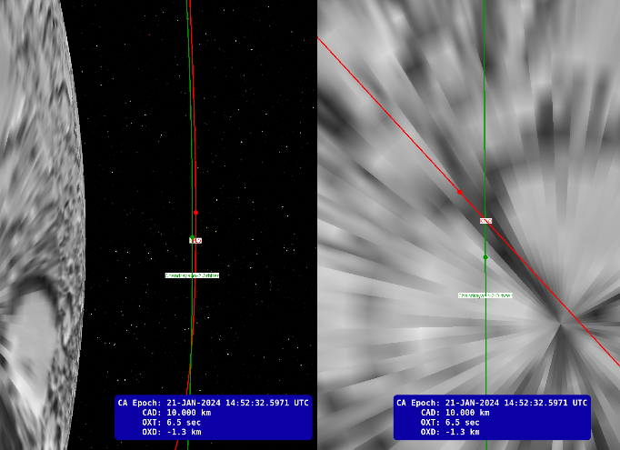
Fig. 6. Example Red Event Between CH2O & KPLO

Coplanar Algorithm Update
The algorithm used by MADCAP to find Minimum Orbit Distance (MOD) when two orbits are Coplanar is a brute force search. While this method has produced accurate results, it is time-intensive and inefficient. MADCAP could benefit from existing geometric algorithms which solve the problem faster and possibly more accurately [10] [11].

CAD Only Mode
MADCAP currently uses thresholds on Orbit Crossing Distance and Timing (OXD & OXT) to categorize conjunction events. However, there are some environments and trajectories for which these values are not as useful. The spacecraft at Sun-Earth L1 and L2 are in heliocentric orbits with periods of about one year. The next orbit crossing can be many months away, outside of the covered time span of the ephemeris analysed. It is not useful to use the orbit crossing attributes in this case, and it would be more beneficial to categorize conjunctions based on CAD only, and not consider the crossings. Such a CAD-only check would also make more sense for spacecraft in hyperbolic trajectories or in Near Rectilinear Halo Orbits (NRHO). In these cases, implementation would require a “smart” check of the situation to determine if OXD/OXT should be used or not.

Ephemeris Quality Checks
MADCAP has occasionally received ephemeris files that did not represent the trajectory of the spacecraft for which they were submitted, typically as the result of an upload error. This has produced errors in the MADCAP run, or unreasonable output data. A quality check to ensure that the ephemeris file contains data expected for the intended spacecraft would aid in alerting the MADCAP Team of these issues.

Additionally, MADCAP could compare the Ephemeris history of a spacecraft against the reported uncertainties to ensure that the changes are within the expected range. For example, if the spacecraft radius at a specific time were to change from one submitted ephemeris to the next by more than what the covariance (or uncertainty polynomials) predicted, then detecting this change could indicate that the reported uncertainties are too small (especially if this behaviour is consistently repeated). The opposite effect would indicate that reported uncertainties are too conservative. Any trends or drifts in the data could also be noted and may indicate an unmodeled force perturbing the orbit.

Risk Assessment
MADCAP does not currently perform quantitative risk assessment of collisions outside of reporting Pc when covariance data is available. It would be beneficial for users if MADCAP were able to assess the conjunction risks in a more formal way, using actual covariance data to recommended actions to mitigate risk.

Pre-launch risk assessment could also be performed to indicate to missions the likelihood of collisions or Red events based on their planned orbits. MADCAP could even recommend a slight change to the orbit to reduce risk of collision. The NASA CARA program performs this type of pre-launch recommendations, and it makes sense for MADCAP to perform this function for other orbit regimes.

Assessment for Inactive Spacecraft
Inactive spacecraft have been included in the MADCAP analysis since its inception, but conjunction events involving them are not categorized by risk due to the high uncertainties in their predicted ephemerides, especially in orbit phasing. Inactive spacecraft could begin to be categorized by risk if analysed in an “orbit only” fashion where only OXD (and radial uncertainty) is considered. Alternatively, a long-term Pc can be calculated based on phasing probabilities and crossings over many years. These proposals require further investigation.

I. Additional Shared Orbital Environments
In MADCAP's long-range forecast there are several missions planned for operations at Venus and Jupiter in the 2030+ time frame (e.g. VERITAS, DaVinci, and Envision at Venus; Juno, Clipper, and JUICE at Jupiter). As with other shared orbital environments, no major changes to the MADCAP software are anticipated merely because a new environment is added. MADCAP will only require a new parameter file and an operations schedule for the new environments.

Conclusion
Deep space shared environments are growing increasingly crowded, especially the Lunar environment, with many more missions on the way in the coming years. Many missions are interested in similar orbits about a given body due to scientific instrument constraints, which leads to large numbers of close conjunctions. Due to the lack of passive tracking capability in deep space, keeping these environments safe is reliant on self-reported ephemeris and uncertainty data from mission teams. NASA has required spacecraft operating in these environments to work with MADCAP to plan for conjunction assessment in deep space shared environments. However, many missions operating and planned in these areas are led by international space agencies and commercial companies. Thus, international cooperation is crucial to ensuring the safety of shared deep space environments. The MADCAP Team proposes the establishment of an international working group modelled on existing international groups and focusing on common interagency operational issues which would allow for the continuation of robust conjunction analysis for the large quantity of diverse missions expected in shared deep-space environments in the coming years.

Acknowledgements
The research was carried out at the Jet Propulsion Laboratory, California Institute of Technology, under a contract with the National Aeronautics and Space Administration. All rights reserved. Reference herein to any specific commercial product, process, or service by trade name, trade-mark, manufacturer, or otherwise, does not constitute or imply its endorsement by the United States Government or the Jet Propulsion Laboratory, California Institute of Technology. © 2024. California Institute of Technology. Government sponsor-ship acknowledged.

References

[1] NASA Conjunction Assessment Risk Analysis, URL: https://satellitesafety.gsfc.nasa.gov/CARA.html
[2] Newman, L.K. "Conjunction Assessment Risk Analysis (CARA) Program Overview" https://foiaelibrary.gsfc.nasa.gov/_assets/doclibBidder/tech_docs/CARA%20overview%20briefing.pdf, 7 August 2013
[3] Newman, Lauri Kraft, "The NASA Robotic Conjunction Assessment Process: Overview and Operational Experiences", Proceedings of the 59th International Astronautical Congress 2008, IAC-08-A.6.2.6
[4] Berry, D. S., Guinn, J. R., Tarzi, Z. B., & Demcak, S. W., “Automated Spacecraft Conjunction at Mars and the Moon” Paper 1262983, 12th International Conference on Space Operations, Stockholm, Sweden, June 2012
[5] Tarzi, Z., Berry, D., Roncoli, R., “An Updated Process for Automated Deepspace Conjunction Assessment” Paper AAS 14-373, 25th International Symposium on Space Flight Dynamics, Munich, Germany, October 2015
[6] Berry, D., Tarzi, Z., Roncoli, R., Wilson, R., “Automated Spacecraft Conjunction Assessment at Mars and the Moon-A Five Year Update” Paper 2810036, 14th International Conference on Space Operations, Marseille, France, May 2018
[7] Tarzi, Zahi B., Young, Brian T., Berry, David S., “Deriving Event Thresholds and Collision Probability for Automated Conjunction Assessment at Mars and the Moon”, AAS 22-042, 2022 AAS/AIAA Astrodynamics Specialist Conference, Charlotte, NC, August, 2022
[8] Brozović, Marina, et al. "Radar observations of spacecraft in lunar orbit." International Symposium on Space Technology and Science. 2017
[9] Evans, S., Monte: The Next Generation of Mission Design & Navigation Software, The 6th International Conference on Astrodynamics Tools and Techniques (ICATT) proceedings 2016, Darmstadt, Germany. https://indico.esa.int/event/111/contributions/330/attachments/466/511/MontePaper_done.pdf
[10] Wiśniowski, T., and H. Rickman. "Fast Geometric Method for Calculating Accurate Minimum Orbit Intersection Distances (MOIDs)." Acta Astronomica 63.2 (2013): 293-307.
[11] Gronchi, Giovanni F. "An algebraic method to compute the critical points of the distance function between two Keplerian orbits." Celestial Mechanics and Dynamical Astronomy 93 (2005): 295-329.
[12] NASA Spacecraft Conjunction Analysis and Collision Avoidance for Space Environment Protection, NASA NPR-8079.1, June 27, 2023.
[13] MADCAP website, https://nasa.gov/cara/madcap
[14] Conjunction Assessment Process for Mars Orbiters, https://www.nasa.gov/wp-content/uploads/2022/08/mars_conjunction_assess_process_rev3-urs309986.pdf?emrc=6833e9
[15] Space News Article, https://spacenews.com/indias-chandrayaan-2-maneuvered-to-avoid-close-approach-to-nasas-lunar-reconnaissance-orbiter/

