Sample Processing Instrumentation to Enable Lab-like Analysis of Lipids, Hydrocarbons, and Kerogen in situ
Mary Beth Wilhelm1, Tony Ricco^{2,1}, Denise Buckner3,4, Carina Lee^{5,6}, Travis Boone^{7,1}, Jared Shimada^{7,1}, Abraham Rademacher^{7,1}, Morgan Anderson^{7,1}, Luke Idziak^{7,1}, Walt Alverado¹, Jennifer Eigenbrode⁸
¹NASA Ames Research Center, Moffett Field, CA 94035 (marybeth.wilhelm@nasa.gov), ²Stanford University, ³University of Florida, ⁴Blue Marble Space Institute for Science, ⁵Jacobs, ⁶NASA Johnson Space Center, ⁷Axient

Introduction: Over the last decade, our team based out of NASA Ames Research Center has made advances in fluidic technologies to enable laboratory-grade processes in space environments. More recently, we have designed and developed two instruments that utilize sample processing steps to extract and purify organic molecules that are key targets in the search for life. The first instrument targets soluble lipids and hydrocarbons that have been preserved in soil or rock material for millions to billions of years called ExCALiBR (Extractor for Chemical Analysis of Lipid Biomarkers in Regolith). The second instrument called KAMELOT (Kerogen and Macromolecule Extractor Liberating Organics Thermolytically) targets kerogen or insoluble macromolecular material that reside in the residue left behind after solvent extraction. Together, these instruments can be coupled to existing flight sample acquisition and analytical instrumentation (e.g., mass spectrometers) to achieve our overall science goal of identifying molecular patterns and features that are diagnostic of how the organic matter was synthesized, either through biological or non-biological processes.
Targeting Origin-Diagnostic Molecular Information: Our instrument development effort is driven by a desire to provide analytical instrumentation with unaltered molecules that have retained molecular features and patterns that are diagnostic of lipid and hydrocarbon origin (Buckner et al., 2024), and ultimately dictate window of polarity and molecular weight for expected molecules that drives our instrument requirements. We have also demonstrated that the diagnostic features are additive in separating biological and nonbiological sample, and in the example of carboxylic acids/fatty acids is shown in Fig. 1.
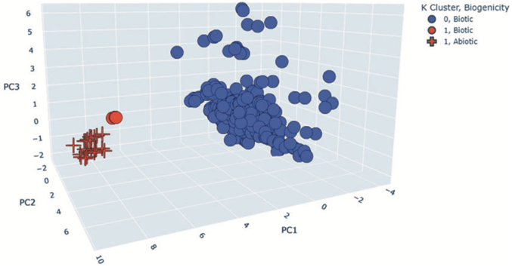
Figure 1: 3-D visualization of a 16-parameter principal component analysis of 381 terrestrial (circles) and 31 meteoritic (crosses) samples containing carboxylic acids. Our results suggest that the two leading principal components derived from molecular features of carboxylic acids can be used to distinguish a sample’s origin as biogenic or abiogenic (Buckner et al., 2024).
ExCALiBR & KAMELOT: Our instruments translate laboratory-like techniques demonstrated on tens of thousands of terrestrial and meteorite samples that range in age, mineralogy and organic type, utlizing a time-tested approach effective at overcoming the common analytical challenges to detection of organic material. ExCALiBR uses a combination of comminution, organic solvent, sonication, filtration, and concentration in order to extract and purify lipids from soil and rock. The TRL-4 breadboard (Fig. 2) has a >90% recovery rate for fatty acid and hydrocarbon standards and successfully matches the extraction efficiency of benchtop-version of the technique using analog samples such as Atacama soil, ancient shales, and carbonaceous chondrites. KAMELOT (TRL-3) builds on the ExCALiBR processing steps but includes a thermolytic step on the washed and dried filtrate in order to break kerogenous material into smaller, analyzable pieces.
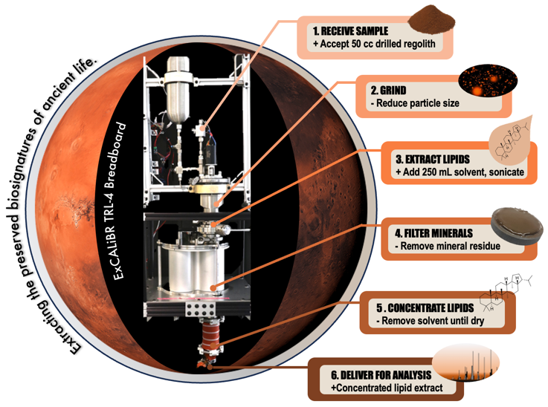
Figure 2: ExCALiBR (TRL-4) integrates the key steps of comminution, solvent extraction and sonication, mineral filtration, and concentration to achieve orders-of-magnitude concentration of signal.
References:
Buckner, D.K et al., (2024) Astrobiology, 24:1, DOI: 10.1089/ast.2023.0012

