An Integrated Architecture Study for Autonomous Lunar Construction

Sarah Triana, Thomas Brooks¹, Krystofer Dudzinski¹, Mike Zanetti, Alex Summers, Evan Anzalone, Michael Fritzinger⁴
Marshall Space Flight Center, Huntsville, AL, 35812, USA
Cameron Bradley¹, Leo Fabisinski¹, Pete Capizzo¹
Jacobs Space Exploration Group, Huntsville, AL, 35812, USA

Lunar construction is an expanding field within NASA’s Moon to Mars objectives that presents many challenges and requires innovative and reliable forms of autonomous operations on the surface of the Moon to further the technologies needed for human space exploration. Marshal Space Flight Center’s (MSFC) Advanced Concepts Office (ACO) addressed Lunar Infrastructure Objective LI-4^{l} by developing a Pre-Phase A, integrated architecture to inform a demonstration for lunar construction operations. The ACO study traded three architectures that would survey and prepare a construction area to build a landing pad out of lunar regolith using MMPACT (Moon-to-Mars Planetary Autonomous Construction Technology) platforms, rovers, and navigation outposts. The main trades examined navigation for the system/architecture, options for rover navigation, battery vs continuous tether power for the MMPACT robotic arm, and assigning site prep functionality to the rovers vs the platforms. Results of the study determined that the best options for the scenario provided would be local navigation (more accurate and continuous), a combination of Light Detection and Ranging (LiDAR) for initial site mapping with subsequent Smart Video Guidance Sensors (SVGS) to save power for construction, and using tethered power to decrease mission duration. The team also concluded that assigning site prep functionality to either the rovers or the platforms has benefits and challenges; future studies could explore having that functionality on both the rovers and platforms. Lastly, the team provided a Concept of Operations (ConOps) timeline that can be used in real-time ground demonstrations to explore the mission timeline, construction processes, autonomous operations, and communication systems that can be tested using MSFC’s lunar regolith field and Lunar Utilization Control Area (LUCA).

- Study Overview and Concept of Operations
The purpose of this study was to develop an integrated architecture for autonomous lunar construction operations that could build a landing pad out of lunar regolith using MMPACT (Moon-to-Mars Planetary Autonomous Construction Technology), rovers, and navigation outposts. The analysis done by the study team addressed mission operations – including real-time human inputs in the decision loop – as well as a detailed concept of operations and a plan for a ground demonstration of key technologies demonstration at Marshall Space Flight Center’s (MSFC) Lunar Utilization Control Area (LUCA).
The Concept of Operations (ConOps), shown in Fig. 1, for this study assumed successful deployment of assets to the lunar surface. For the architectures using local navigation, after deployment and checkout of assets the rovers would use trailers to move the local navigation harpoons to the four corners of the site area. Next, rover/harpoon communications would be initialized. For site prep, the study team needed to first conduct a site survey using the LiDAR rover to determine the best location to construct the landing pad. Upon selection of the landing pad site, the rovers or platforms, depending on selected architecture, would find and remove any rocks, then grade the landing pad area. If during grading it was found that there were obstructions that could not be resolved, the site prep cycle would iterate until a suitable landing pad area could be prepped.
Next, construction operations would begin. First, the rovers or platforms would excavate regolith into piles, mix it and inspect the pile for mineralogical composition. Then the MMPACT arms would calibrate the laser VMX (Vitreous Material Transformation). After calibration, the rovers would haul the regolith via trailers to the construction area and the platforms would I begin building tiles to make up the landing pad. Tile building would consist of laying down regolith, grading it, compacting it, laser VMX operations, and verification as needed. The batteries for the rovers and/or laser VMX would be re-charged as needed throughout the construction process.

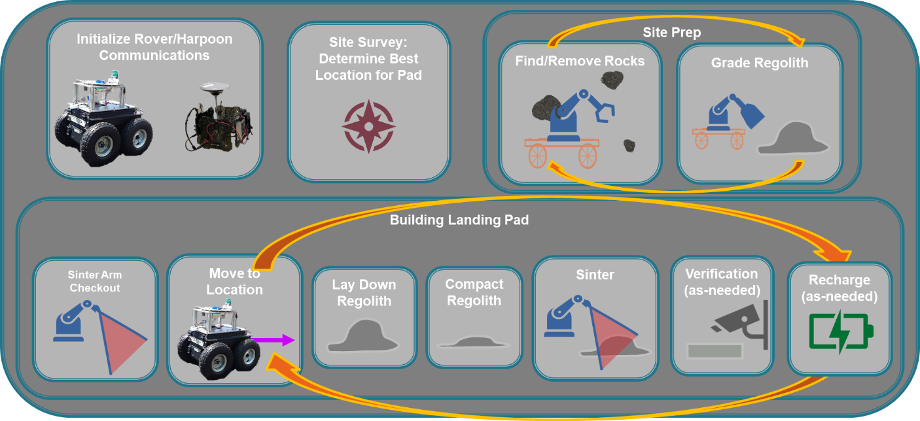
Fig. 1 Visual overview of ConOps process

- Architecture Summaries
Three Architecture options were explored in this study. Table 1 below presents an overview of each of these options. For all Architectures, 3 rovers and four MMPACT platforms were selected. Power requirements for the rovers would be intermittent (i.e. battery-powered) for each architecture. Rover navigation configurations were varied between each of the architectures. Architectures 1 and 2 explored configurations using a combination of LiDAR and SVGS on the rovers, while Architecture 3 was traded with LiDAR on all three rovers. LiDAR is very accurate, but requires more power, while SVGS requires less power, but needs targets deployed in the field or on assets to navigate the area and/or dock with assets. For the first two Architectures, the rover would perform mapping and relocate-ability, while the third architecture would also do these operations plus prepping the site area. Across all Architectures, the MSFC rovers (and their associated trailers for hauling regolith and/or harpoons) were not intended to be downscaled lunar demo vehicles, but rather mobile testbeds for testing and verifying avionics, power, autonomous mobility operations, and communication systems as part of overall integration in a timed plan for landing pad construction.
For Position, Navigation, and Time (PNT) the first architecture traded global navigation, and the 2nd and 3rd analyzed local navigation. Local navigation would be completed by lunar harpoons deployed at the four corners of the site area, approximately 40 m apart (suited to the current perimeter of the MSFC regolith field). Analysis of navigation options found that local navigation would be favorable to global navigation. With local navigation, the assets would have continuous accurate location measurements, while global navigation on the moon would have less accuracy and less frequent availability with the likelihood that the first mission would only have one positioning satellite in place by DM-2.
Power to the platform used for the MMPACT arm was traded as continuous (i.e. tethered) in the first two architectures. For the purpose of evaluating construction timing, the arm was assumed to perform both laser VMX operations and site prep in the MSFC demo as actual laser VMX operations would not take place during such a demonstration. In the third architecture, the platforms were traded with intermittent (batter-powered) power and were intended to perform only laser VMX operations activities. Similarly to the rovers, the MSFC platforms were intended to be testbeds for the avionics, comms, and navigation systems, as well as integrated assets within the pad construction plan. This would give a better assessment of building times since they would not necessarily be the same as what would be used in a lunar demonstration.
Table 1: Architecture Summaries
 | Architecture 1 | Architecture 2 | Architecture 3
Number of Rovers | 3 | 3 | 3
Rover Power | Intermittent | Intermittent | Intermittent
Rover Navigation | LiDAR on 1  SVGS on 2 | LiDAR on 1  SVGS on 2 | LiDAR on 3  SVGS on 0
Rover Functionalities | Mapping Relocate-ability | Mapping Relocate-ability | Mapping Relocate-ability Site Prep
PNT/Comm | Global | Local | Local
Harpoons | 0 | 4 | 4
Platforms (MMPACT Arm) | 4 | 4 | 4
Platform Power | Continuous | Continuous | Intermittent
Platform Functions | Laser VMX operations Site Prep, Etc. | Laser VMX operations Site Prep, Etc. | Laser VMX operations

Architectures 1 & 2 Summary
The surface assets for Architectures 1 and 2 included four MMPACT platforms, three rovers, and four rover trailers (not including the four harpoon tripods deployed in Architecture 2 specifically). Two of the rovers would be equipped with SVGS for detecting and guiding the rover to link with platforms, trailers, and the charging station that each have SVGS targets attached. The third rover in Architectures 1 and 2 would be equipped with a LiDAR sensor for guiding its movements. All four platforms in both Architectures would be equipped with a robotic arm with a multi-tool end effector that includes a scoop, regolith sieve, laser head, and flat plates for compacting.
The process for constructing the landing pad would involve several steps with each of the surface assets. In Architectures 1 and 2, the MMPACT platforms would have multi-tool end effectors for their robotic arms that could conduct excavating, sieving, grading, and laser VMX operations. Construction would involve these platforms first being deployed away from the pad site to excavate and sieve regolith down to the desired grain size before dumping it into the trailer beds. When these trailers are filled, they would be hauled to the pad site where redeployed platforms could scoop the material out, pour it, and compact it in 2.5 mm thick, ~0.61 m wide hexagonal layers. Once compacted, the same platforms would then use their laser heads to sinter up to 20 stacked layers into a solid tile. The first five layers would be entirely sintered, with the next 10 being sintered only around the edge of the tile (a roughly 6.3 cm thick edge). The interior of these layers would remain as compacted regolith. The last five layers on top would be sintered in the same manner as the bottom five. After completing several tiles (dependent on the reach of the robotic arm), the platform would be redeployed via a rover to an adjacent space to generate the next tile.

Architecture 3 Summary
The surface assets for Architecture 3 included four MMPACT laser VMX operations platforms, three rovers, four rover trailers, and four harpoon tripods for site mapping. All three rovers would be equipped with LiDAR sensors for guiding their movements and with robotic arms that would have multi-tool end effectors for site preparation operations (excavation, compaction, and regolith sieving). All four platforms in Architecture 3 would be equipped with a robotic arm that would have a laser head for laser VMX operations. These four platforms also differ from their counterparts in Architectures 1 and 2 in that they would be powered by large, underslung batteries as opposed to tethered power cables. These batteries are intended to be removable by the rovers, which could haul them to a recharge station and return a fresh battery.
In Architecture 3, both the MMPACT platforms and rovers would have robotic arms. The platform arms would be equipped with only a laser head for laser VMX operations, while the rovers have multi-tools for site prep on theirs. The rovers would bring the trailers away from the pad site to excavate and sieve regolith down to the desired grain size before storing it in the trailer beds. Once these trailers were filled, they would be hauled to the pad site where the rovers could then scoop the material out, pour it, and compact it in 2.5 mm thick, ~0.61 m wide hexagonal layers with their multi-tools. As each layer was being compacted and prepared, the deployed platforms would use their laser heads to sinter them, with this dual operation occurring until 20 stacked layers were produced to form the solid tile.
The first five layers would be entirely sintered, with the next 10 being sintered only around the edge of the tile (a roughly 6.3 cm thick edge). The interior of these layers would remain as compacted regolith. The last five layers on top would be sintered in the same manner as the bottom five. After completing a tile, the platform would be redeployed via a rover to an adjacent space to generate the next tile.

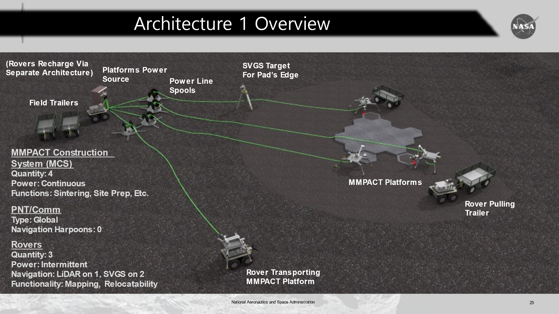
Architecture 2 PNT/Comm
Type: Local
Navigation Harpoons: 4
Harpoon 1
Harpoon 2
Harpoon 4
Harpoon 3

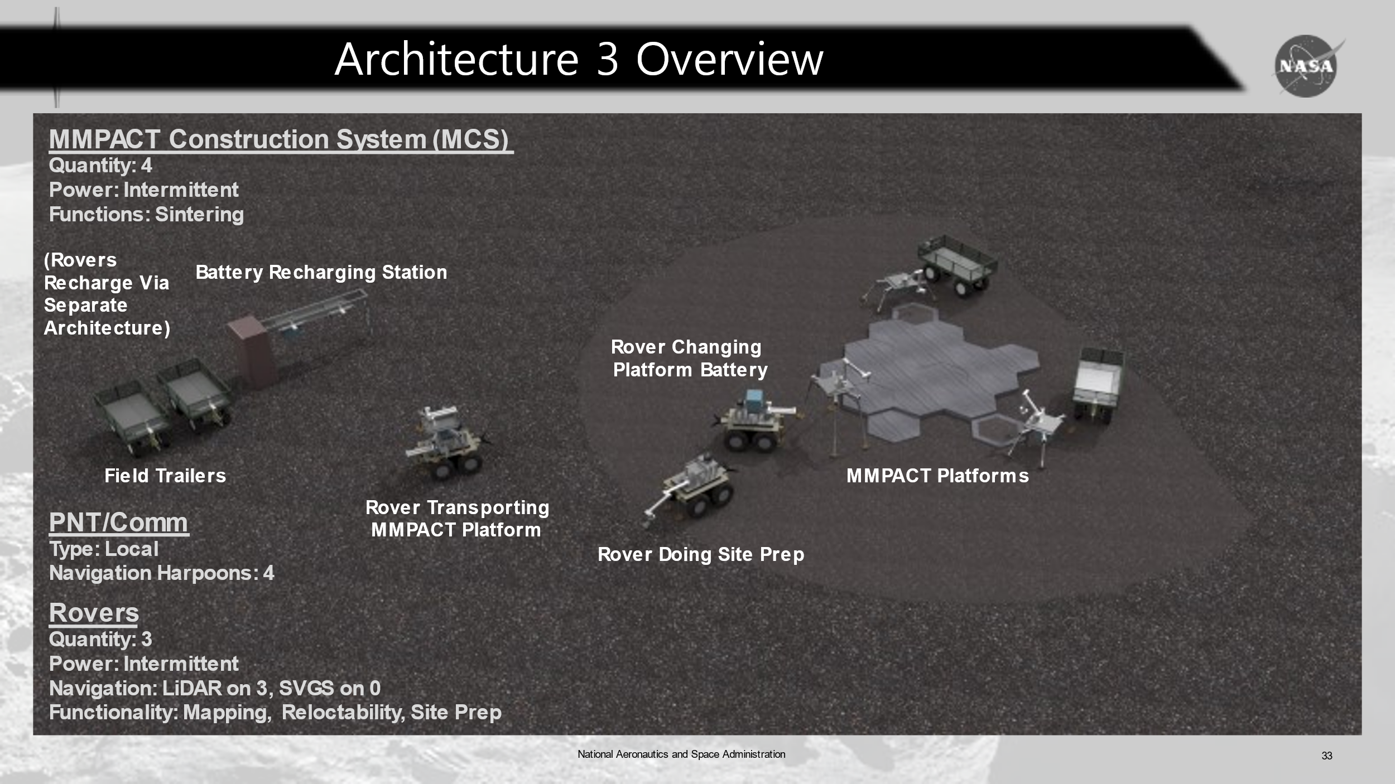
Fig. 2 Design concept of Architectures 1&2 Configuration (shows lunar harpoons) placed at the 4 corners)

Fig. 3 Design concept of Architecture 3 Configuration

Architecture Assets

Landing Pad
The landing pad for the lunar autonomous construction demo would have a 25-foot diameter and be 2-4” thick. For the demonstration on MSFC’s lunar regolith field, the study team selected a 2” thickness and used hexagon-shaped tiles approximately two feet in diameter while planning for the overall pad diameter to match that of the lunar demo.

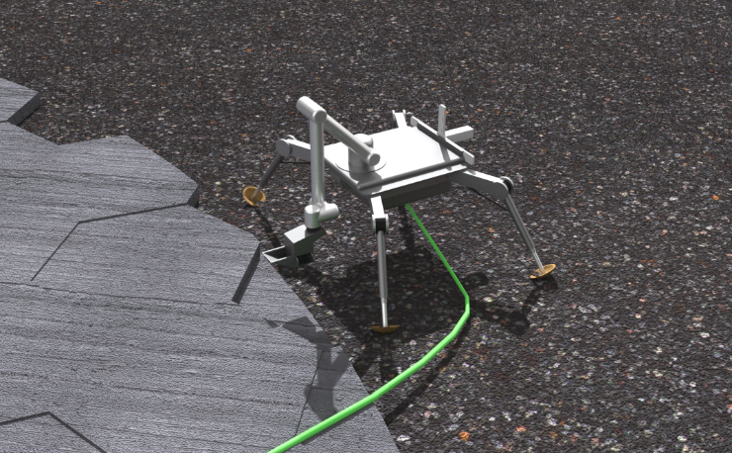
MMPACT Platform
Fig. 4 MMPACT Arm and Platform Constructing Landing Pad
The MMPACT Platforms are composed of the platform with extendable legs, and the robotic arm with an end-effector that contains the laser VMX system, and in Architectures 1 &2, the site prep tool for scooping, sieving, grading, and compacting.
For the demonstration at MSFC, platform functions systems will be stand-ins and the functions of integration and communication with the MMPACT Platform and operating the robotic arm. The MMPACT platform focus for the demonstration at the lunar regolith field is not laser VMX operations/site prep, but rather to serve as a testbed for integration with the avionics, power systems, and overall timing of building the landing pad with other site assets.

Lunar Harpoon
A Lunar Harpoon was used for our local navigation solution for some of the Architectures. The Harpoon is a rapidly deployable, medium range GPS-denied relative navigation and communication solution for autonomous lunar surface operations and astronaut wayfinding. This navigation system can accommodate a wide range of surface missions.
For real lunar operations, the Lunar Harpoon network would be on tripods, wheels or another base and be deployed by an autonomous vehicle. The autonomous vehicle would map “drop off” locations of harpoon nodes and inform them of node positions within area of interest. The autonomous vehicles would use these nodes as a localized positioning system, reducing reliance on computationally intensive LiDAR, while also opening the doors for less intelligent vehicles to operate.
Fig. 5 Lunar Harpoon Mockup

Design
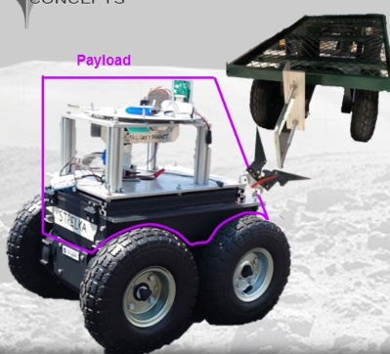
For the MSFC demonstration scenario, a 4WD Rover Pro from Rover Robotics will be used for rover testbed designs. Several additions to the rover are necessary, including a carrying “tower,” for moving MMPACT platforms, another tower for LiDAR (or SVGS) sensors, and a hitch (designed by ST13) for attaching to field trailers. Additionally in Architecture 3, extendable legs would be mounted on each end for support during site prep operations as well as a robotic arm on the rover’s flat-top. In the same way, the robotic arms on the MMPACT platforms (themselves merely testbed designs for power and mobility system verification) are likely to be props. The field trailers are modified garden utility carts with an attached c-shape handle for the rover hitches to attach to as well as basic avionics and navigation sensor additions. Like the rovers, these are intended to be testbeds, not lunar demo assets.
Fig. 6 Demonstration Rover
The rover towers are intended to be built out of 80/20 channels with thin sheet metal tops and would serve as a “shelf,” for installing either the navigation sensors, or for the MMPACT platform to rest upon via its underslung battery. The battery’s underside has a trapezoidal-shaped base for sliding onto and connecting with angled guides on the top edges of the rover’s carrying tower. This requires the rover to drive under the platform from behind (once the platform’s legs are fully raised) in order to smoothly link with the battery connected to the platform, thus allowing the platform’s legs to retract and rest its weight on the carrying tower.
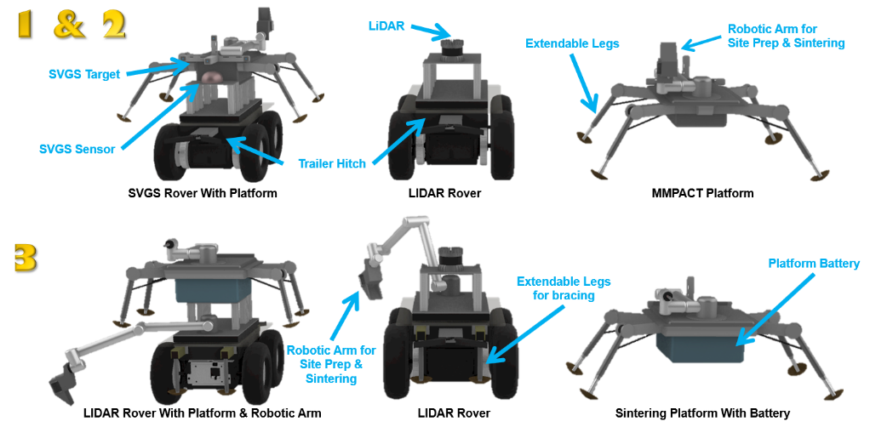
Fig. 7 Rover imaging for Architectures 1 and 2 (top) and Architecture 3 (bottom)

Power Systems

Overview
Power systems were made to be as similar as possible between the lunar surface demo and the lunar demonstration at Marshall. The conceptual power designs for the Architectures were developed using off the shelf components where possible, and easily fabricated components when not. The power levels may be different for the MSFC demonstration, but design features are otherwise functionally and operationally analogous (e.g., small battery is used in the same way that a larger battery would be used in the lunar demo). Also, while demo elements may be scaled, operation times in the MSFC demo are as close as possible to the lunar demo operation times (e.g., mock laser VMX operation take the same amount of time as the real laser VMX would on the Lunar surface). For the lunar demo, the mass of the cable-based power system for Architectures 1 & 2 is similar to the battery-based system for Architecture 3. However, the cable-based system will complete the mission faster and with less risk.

Configurable Common Power Elements
In the conceptual design of the power system, the team meticulously designed flexible power elements that could be easily reconfigured to serve the needs of a wide variety of lunar construction architectures. This would allow the MSFC demonstration area to be reconfigured to simulate different construction scenarios and quickly altered during a construction study to explore alternative solutions. In architectures with SVGS and Navigation Harpoons, a rechargeable battery pack would power the small electronics for those field navigation and sensing systems. The voltage of this pack may be adjusted from 4V to 25V using a set screw. The pack could deliver 2A at any voltage, and at 50% Depth of Discharge (DoD) could deliver 150 W-Hrs over many charge cycles. The output connector could be changed to accommodate most tip/ring plug types.

Robot-Swappable High-Current Battery Connection
In Architecture 3, batteries would be required to power principal construction machinery (laserss, regolith graders, etc). This would require a battery interface that allows an autonomous rover to easily swap a battery with minimal mechanism complexity.

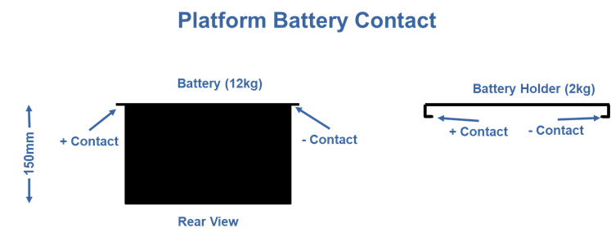
To accomplish this, the battery would have a lip that protrudes from either side of the top surface. Underneath this lip are contacts that run the length of the lip from the front of the battery to the back. One of the contacts is connected to the battery ground terminal while the other is connected to the battery + terminal. The battery holder on the platform (and charge stations) has a shelf on each side on which the lips rest. Each shelf has a contact the runs its entire length and mates with the battery’s contact when the battery is resting in the holder.
This interface may accommodate batteries across a wide range of voltage and energy levels in a way that makes swapping very simple for a rover.
Fig. 8 Platform Battery Contact Diagram

Cable Reel Mechanism
Architectures that use cables to power principal construction machinery require a rover to move the construction platform (attached to the main power source by the cable) over its designated operation area. To prevent the cable from becoming tangled or snagged by other equipment, it must be dispensed with a cable reel capable of eliminating slack and assuring that there is no excess cable on the ground.

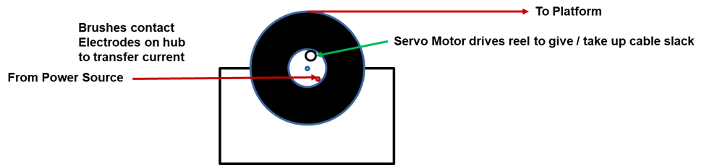
Fig. 9 Cable Reel Mechanism

This is a detail of the cable reel mechanism. A servo motor drives the reel from an inner hub. The inner hub has 2 copper tracks (+ and -) that are attached to the conductors in the cable. Brushes connected to the power source contact the track as the reel turns and supplies current to the cable. In an actual Lunar demo, the cable would consist of a number of different DC circuits, each powering a specific construction element (LASER, grader, etc). For the MSFC field demo, a 120VAC cable (single circuit) is used, and the necessary DC circuits are converted at the construction platform. This affords the use of a number of different construction equipment alternatives without requiring the construction of a different cable for each.

Avionics

Overview
The strategy for avionics in this study was to look at real lunar operations and then translate those operations to a Marshall demonstration using low-cost commercial components. Space-qualified components would be represented where applicable. Avionics for the rovers and platforms will perform command and control of rover mobility, robotic arm/end-effector on platforms and rovers (architecture three), control power and thermal systems, and provide instrumentation and monitoring of operations. The main difference between the three architectures is that the site prep robotic arm is on the rovers for architecture three, versus having the platform robotic arm perform site prep in architectures one and two. For a complete overview of differences, see Table 1. The robotic arm operations will be autonomous for the various mission task with real-time manual overrides possible, to stop/start operations.
The biggest stressors on the avionics system are the computation processing for the LiDAR and SVGS navigation, along with operations video. Video cameras will be provided on end-effectors to record and observe autonomous operations, allowing manual interaction of operations if necessary.
There will be common software development between rovers and platforms, which will help reduce software development cost. Software development will include integrating LiDAR mapping and SVGS data for best maneuvering accuracy. For navigation, using local Harpoons for lunar missions might be less risk than depending on a global navigation solution. Harpoons should provide better accuracy for rover position and docking operations. However, the Harpoon’s extended battery power will need to be addressed. General use of Wi-Fi communications for lunar mission appears viable based on current the current Artemis architecture.

Real Lunar Operations
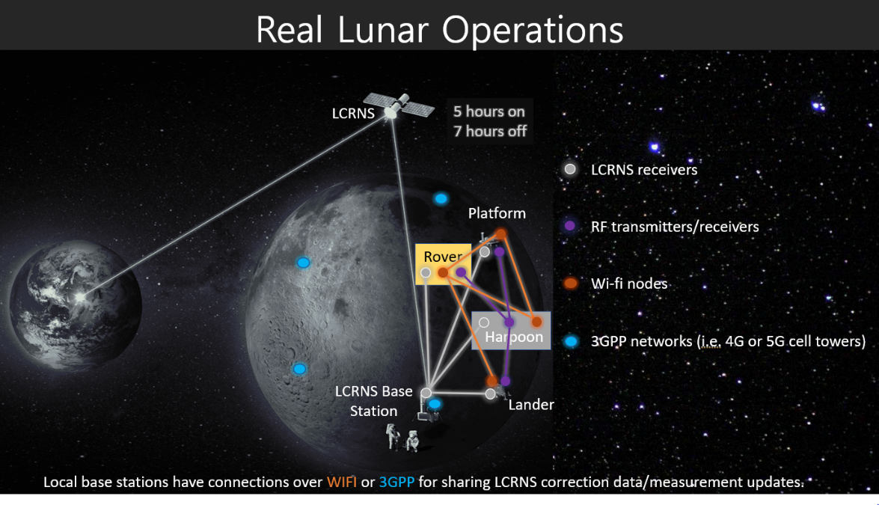
Real lunar operations will use mission control, ground stations, the lunar communications relay and navigation systems (LCRNS) satellite, and a lunar base station or lander for communicating with the lunar surface assets, as seen in Figure 10. The LCRNS is used as the global navigation solution, but the initial LCRNS configuration has only one orbiting satellite, so the access time may be restricted to 5 hours on and seven hours off. Also, the accuracy may only be 10 meters, so a local navigation solution is desirable, which is being developed at MSFC.
Fig. 10 Communications Diagram for Real Lunar Operations

As seen in Figure 10, wi-fi and 3GPP will be available on the lunar surface, but we will utilize the wi-fi nodes for these architectures.

MSFC Demonstration Avionics Operations
Real lunar communications are simulated in the MSFC demo to capture the signal transmission path, time delays, and data formatting. Simulating communications time delays for the demo will provide real mission con-ops scenarios. While the baseline is autonomous, operators will be able to monitor and send commands to assets as needed to control demo operations. Avionics required will be mostly low cost commercially available components. These components are typically designed for air cooling of the electronics. It is expected that the rovers and platforms will at least provide a rain/weather protective encloser for these avionics' components. There will be no avionics technology development required for the MSFC demo.
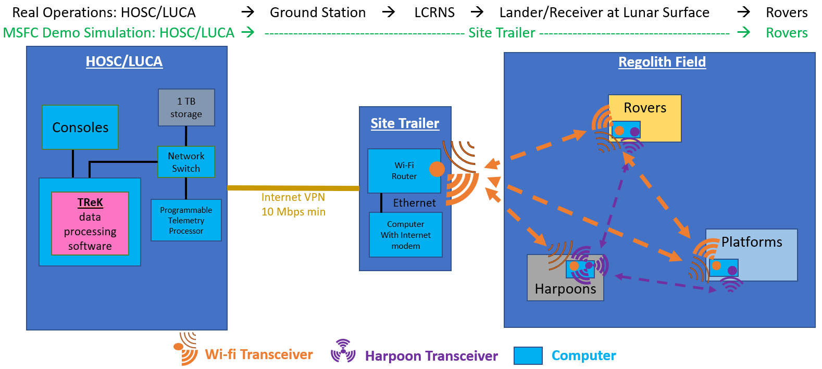
The MSFC demonstration will utilize HOSC and LUCA for demo mission operations. LUCA Lunar Utilization Control Area provides a telemetry processing computer for CCSDS formatting and 1TB of data storage, as well as consoles for demo operations. Then, data will be passed via VPN to the Site Trailer. The MSFC site trailer provides a communications link between the MSFC regolith field assets and the LUCA stations in the HOSC building. This link is an important part of the demo since it simulates three parts of the lunar mission, the ground station (DSN or NEN), the LCRNS satellite, and the Lander/Comm station. The site trailer includes a computer for Telecommand and Telemetry Format Packet Standard data formatting and time delays, and a Wi-Fi router to communicate with the assets.
Fig. 11 Communications Diagram for MSFC Demo
MSFC Demonstration Operations
The typical data rate planned for lunar communications across surface assets and between cis-lunar space and ground is 10 Mbps. This rate is easily achieved with Wi-Fi/Internet, but for simulation purposes will be the minimum rate used between Platforms, Rovers, Site Trailer, and LUCA. Transmitted data includes topography maps, navigation/locations, Health and Status (H&S) (battery, temps, states, etc.), and video. Video will be the greatest data volume transmitted and will dominate data management.
A set of 4 harpoons are to broadcast Wi-Fi DGPS/RTK navigation data to Rovers at 2.4GHz. The harpoon system, along with standard 2.4 GHz communications, will have an additional UWB ranging beacon signal broadcast two times per second at 9 GHz to Rover and Platform receivers. This is to be a 2-way ranging signal to achieve greatest accuracy in less time, with the rover and platforms having a transponder included for this navigation signal.

Thermal Analysis

Thermal Analysis
The Thermal Analysis addressed impacts to the Concept of Operations, the operating and survival temperatures, environmental heat loads, and thermal survivability. The thermal analyst determined that the thermal subsystem for the lunar system will need to be sized such that it does not limit MMPACT’s duty cycle or affect the overall Concept of Operations in any way.
Since this study focused on demo operations, the thermal system analysis was minimal. The solution to control thermal needs is to operate when the weather allows. In Alabama, the high temperature summer period is the greatest concern. Current demonstrations work around extreme temperatures, running demos in the early morning or at night; this will be the same approach for this demo. Some suggestions to operate the rover at higher air temperatures are to: 1) place the electronics such that air can easily flow around them, 2) install a small fan to blow air past the electronics, 3) add heat sink fins to high-power chips, 4) monitor board thermistor telemetry, and 4) provide a white shade cover for the electronics.
Conclusion

ConOps and Timeline Validation
The results of the study were three detailed ConOps, one for each Architecture that is then used as a guide to the demonstration operations. The demo operations will help validate the timeline of the mission as well as the communication relays between the HOSC and lunar regolith field. In addition to the timeline, the study team determined additional hardware and infrastructure needed to complete the demonstration.

Mission Duration
The mission duration between Architecture 1 & 2 was approximately 24 days, not including off-nominal events. These two Architectures have a similar duration because they both have continuous power for the laser VMX, which is the biggest power draw for the mission. Architecture 3 will take 31 days due to the frequent battery exchanges, which are the biggest time sink for the mission. The reason the mission durations do not have huge differences between Architectures 1 & 2 and Architecture 3 is due to the use of four platforms to build the landing pad. If you decrease the number of platforms or increase the size of the landing pad, the difference in time will increase drastically.

Power
Using tethered power in Architectures 1 & 2 would help significantly with the large power requirements of the laser VMX operations process and would decrease the mission time, but mobility complexity would be increased. Tethered power requires more upfront planning on how the platforms need to be maneuvered to prevent crossing tethers or getting tangled. Construction Operations also need to address the extra functionality needed to reel/unreel and move the tethers without placing extra burden on the rovers. Battery power does not have these issues, but again they will have to be exchanged frequently due to the power draw of the laser.

Navigation
When looking at the navigation system on the lunar surface, local navigation is highly appealing because it can be set up wherever needed, it is always available, and it is more precise than global navigation. Global navigation is not deployed at the moon currently, and at the time of the mission will likely only have one satellite. Because of this, it will not be available 100% of the time; it will cycle on for 7 hours, off for 5 hours. Although local navigation is the more appealing option, the current systems are still under development. Analysis by the team concluded that without harpoon navigation, GPS navigation would be required for site demo accuracy in position and docking operations for recharging the batteries. Looking at the rover navigation, either SVGS or LiDAR can be used. The SVGS is beneficial because it requires less power than LiDAR but does require targets to be deployed or placed on assets. The LiDAR will still be needed to do the initial mapping of the site area. The lunar harpoons (local navigation) and SVGS are still under development, and the lunar regolith field will help test and validate these technologies as part of a lunar Architecture mission.

Rover Site Prep
Finally, rovers or the platforms can do the site prep. Platforms doing site prep mean the rovers are freed up to do other tasks, but without additional capabilities, there is not much else it can do beside move assets around. Rover site prep allows for more lunar construction, but then rovers are not freed up to do additional tasks besides staying next to the platforms the entire time to help with scooping, sieving, grading, and compacting the regolith for the platforms to sinter. In conclusion, these assets and functionalities are still under development, as well as the integrated autonomous lunar construction operations of a lunar Architecture. MSFC’s test bed will help develop these concepts and integration of the assets on the lunar surface autonomously and with communication between the HOSC, ground stations, lunar bases/landers, and lunar assets.

Acknowledgments
The Advanced Concepts Office would like to thank ICON, Corky Clinton, Jennifer Edmunson, Shawn Maynor and Sonny Mitchell at NASA MSFC.

ED04
ST13
EV41
EV42

