Cislunar Autonomous Positioning System Technology Operations and Navigation Experiment (CAPSTONE) Pathfinder for Artemis Gateway
Elwood Agasid ⁽¹⁾, Roger Hunter ⁽²⁾, Bradley Cheetham ⁽³⁾
⁽¹⁾ NASA Ames Research Center, Mail Stop 244-19, Moffett Field, CA 94035, P 650.604.0558, Elwood.F.Agasid@nasa.gov
⁽²⁾ NASA Ames Research Center, Mail Stop 244-20, Moffett Field, CA 94035, P 650.604.5004, Roger.C.Hunter@nasa.gov
⁽³⁾ Advanced Space, LLC, 1400 West 122nd Ave, Suite 200, Westminster, CO 80234,
P 720.545.9191, cheetham@advancedspace.com

Abstract

The Cislunar Autonomous Positioning System Technology Operations and Navigation Experiment (CAPSTONE) mission was developed by NASA in collaboration with Advanced Space, LLC of Westminster, Colorado. This technology demonstration mission serves as a pathfinder for near rectilinear halo orbit (NHRO) operations around the Moon. The NHRO, (Perilune = 3,200 km; Apolune = 70,000 km) is the intended orbit for NASA’s Artemis Gateway, a small, human-tended space station planned for lunar orbit. The CAPSTONE mission will validate simulations and confirm operational planning for Gateway while also validating performance of navigation and stationkeeping requirements for Gateway’s Power and Propulsion Element. Therefore, this mission will provide operational experience to NASA, commercial, and international missions for operations in a demanding orbital regime.

The CAPSTONE mission consists of a 12-unit (U)+ CubeSat developed, integrated, and tested by the Terran Orbital Corporation that carries a payload communications system capable of crosslink ranging with NASA’s Lunar Reconnaissance Orbiter (LRO). CAPSTONE contains a chip-scale atomic clock (CSAC) for a one-way ranging experiment with NASA’s Deep Space Network, a dedicated payload flight computer for software demonstration, and a camera. The launch, coordinated by NASA’s Launch Services Program, was provided by Rocket Lab on its Electron launch vehicle using their Photon upper stage to deploy the CAPSTONE spacecraft. The mission launched June 28, 2022. The CAPSTONE spacecraft deployed from the Photon stage and traversed an approximately 4-month, highly fuel-efficient transfer phase entering the NRHO November 13, 2022, for a six-month primary mission phase. The mission is currently in a twelve-month technology enhancement operations phase.

The CAPSTONE technology demonstration mission is led by Advanced Space, LLC. Spacecraft development and mission operations are conducted by Terran Orbital Corporation of Irvine, California. Noted accomplishments for the CAPSTONE mission include demonstrating the accessibility of NHROs; validating key operational concepts in the NHRO environment; laying the foundation for commercial support of future lunar operations; and accelerating the availability of peer-to-peer navigation capabilities provided by the Cislunar Autonomous Positioning System (CAPS).

The CAPSTONE mission is funded through NASA’s Small Spacecraft Technology (SST) program, which is one of several programs within NASA’s Space Technology Mission Directorate. The program is chartered to develop and demonstrate technologies to enhance and expand the capabilities of small spacecraft with a particular focus on enabling new mission architectures through the use of small spacecraft, expanding the reach of small spacecraft to new destinations, and augmenting future missions with supporting small spacecraft. The CAPSTONE mission launch was provided by NASA’s Exploration Systems Development Missions Directorate’s Advanced Exploration Systems Division. Coordination and acquisition of the launch was managed by NASA’s Launch Services Program. The CAPSTONE mission and project status will be presented.

- INTRODUCTION

The National Aeronautics and Space Administration (NASA) established the Artemis program in 2017 via Space Policy Directive 1. The Artemis program is intended to reestablish the first human presence on the Moon since the Apollo program. In preparation of establishing operations at the Moon, NASA awarded a pathfinder technology demonstration mission known as the Cislunar Autonomous Positioning System Technology Operations and Navigation Experiment (CAPSTONE). This mission serves as a pathfinder for the planned operations in the Near Rectilinear Halo Orbit (NRHO) cislunar environment. The NRHO is the orbit chosen for the lunar space station known as Gateway. The CAPSTONE mission provides valuable operational experience to NASA, commercial, and international missions by demonstrating the accessibility of NRHOs, validating key operational considerations for operations in NRHOs, lays a foundation for commercial support of future lunar operations. The mission also provided the opportunity to test and accelerate the development of the peer-to-peer navigation capabilities provided by the Cislunar Autonomous Positioning System (CAPS).

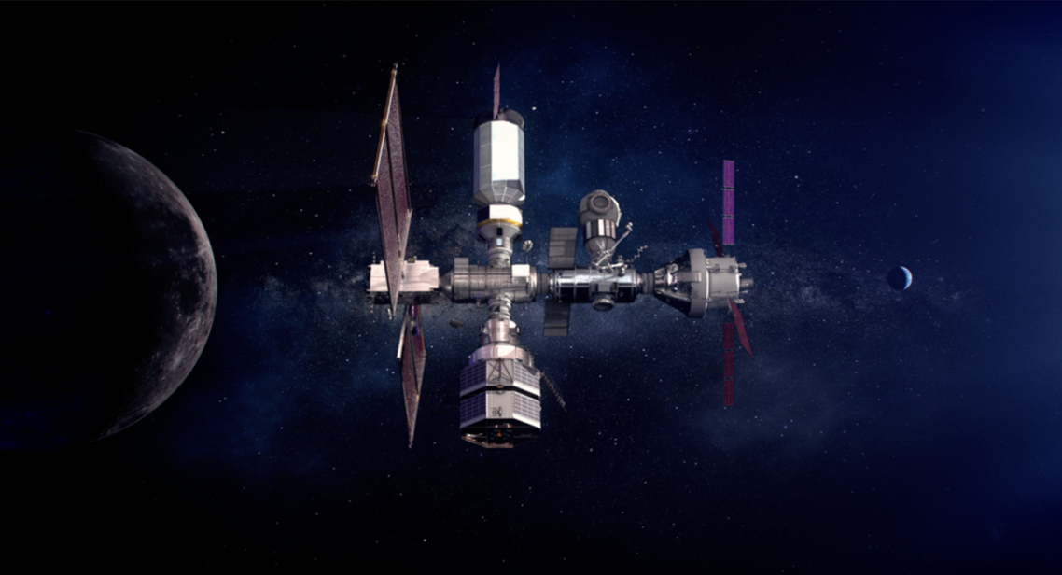
As a pathfinder, CAPSTONE will validate orbit stationkeeping simulations and confirm operational planning for the Gateway while also specifically validating performance of navigation and station keeping for the upcoming Power and Propulsion Element.
Figure 1. Artemis Gateway Image Credit: NASA

- CAPSTONE OVERVIEW

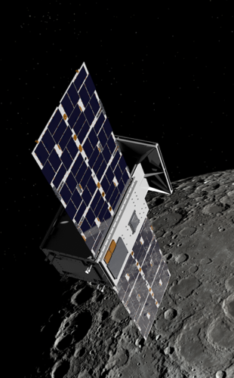
The CAPSTONE Mission concept was created out of a NASA Small Business Innovation Research (SBIR) project known as the Cislunar Autonomous Positioning System (CAPS). The research and development of CAPS resulted in a peer-to-peer navigation solution that can process inter-spacecraft range and range-rate measurements between multiple spacecraft in cislunar space to determine absolute position estimates for all participating spacecraft. CAPS was integrated into the overall CAPSTONE mission. The mission is led and managed by Advanced Space, LLC in Westminster, Colorado with support from NASA. The mission leverages the expanding small satellite government and commercial services using commercially available small spacecraft systems, commercial small spacecraft launch vehicle services, commercial payload and mission operations centers, and NASA’s Deep Space Network to successfully execute the mission. Figure 2 is a depiction of CAPSTONE in NRHO
Figure 2. CAPSTONE
Image Credit: NASA

  - Mission Objectives
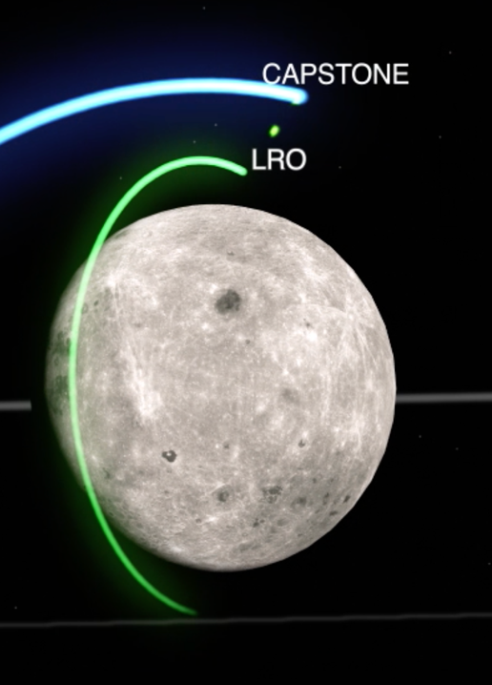
In support of the NASA’s Artemis Program as well as future deep space missions, CAPSTONE fulfilled the following objectives:

- Serve as a pathfinder mission for NASA’s Gateway Operations team at NASA’s Johnson Space Center. The mission will inform the requirements and mission operations approach necessary to operate in the NRHO.
- Demonstrate inter-spacecraft ranging between the CAPSTONE spacecraft and NASA’s Lunar Reconnaissance Orbiter (LRO), which has orbited the Moon since 2009.
- Validate the CAPS navigation software system that was developed in a Small Business Innovation Research task.
  - Conduct One-Way Ranging experiments. The experiments provide the opportunity to compare one-way measurement data with traditional two-way ranging and allows operators to perform one-way ranging while simultaneously getting measurements on the ground. The tests also presents an excellent opportunity to characterize one-way measurement accuracies, gathers one-way data for every track during an NRHO revolution and compares one-way navigation results with traditional navigation approach.
Figure 3. Depiction of CAPSTONE to LRO Crosslink or 2-way Ranging Test Image Credit: NASA

- Lays a foundation for commercial support of future lunar operations.
- Gains experience with small, dedicated launches of CubeSats beyond low-Earth orbit, to the Moon.
- Make use of NASA SBIR investments to conduct rapid mission planning and execution.

  - Mission Space, Mission Operations and Ground Systems Overview

The CAPSTONE Technology Demonstration Mission leverages a combination of commercial technologies and government assets to support and manage the mission. The following section provides information of the make up and integration of capabilities of the commercial and government sectors.

    - Space Systems

      - Spacecraft

A 12U+ Tyvak Nanosatellites (now Terran Orbital) bus, Figure 4, was selected for the mission. The spacecraft uses heritage Tyvak avionics and incorporated an S-Band radio for the crosslink ranging experiment; an Iris X-band radio for telemetry, tracking, and command (TT&C); main communications and to conduct the one-way ranging experiment with the NASA Deep Space Network (DSN) and a hydrazine-based propulsion system. The specifications are provided in Table 1.
Table 1. CAPSTONE Specifications
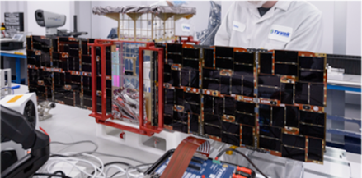
Figure 4. CAPSTONE Spacecraft
Image Credit: NASA

A Tethers Unlimited, Inc. S-band software-defined radio was selected to conduct the two-way or peer-to-peer ranging experiment with the Lunar Reconnaissance Orbiter (LRO). The main communication system used for TT&C and one-way ranging tests employed the Iris X-band radio. The propulsion system utilized for the spacecraft is a hydrazine-based monopropellant thruster from Stellar Explorations, Inc.

      - Launch Vehicle & Launch Systems

Launch vehicle for the mission was coordinated by NASA Launch Services Program via competitive solicitation process. Rocket Lab was selected for this mission utilizing Rocket Lab’s 2 Stage Electron rocket combined with their new Photon upper stage. The Photon stage placed the CAPSTONE spacecraft in a transfer orbit that allowed the spacecraft to transition into the desired Near Rectilinear Halo Orbit. See Figure 5.

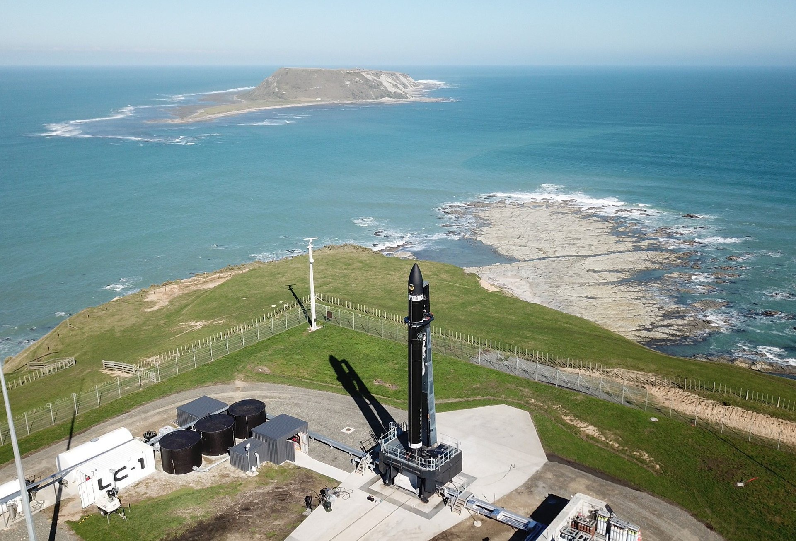
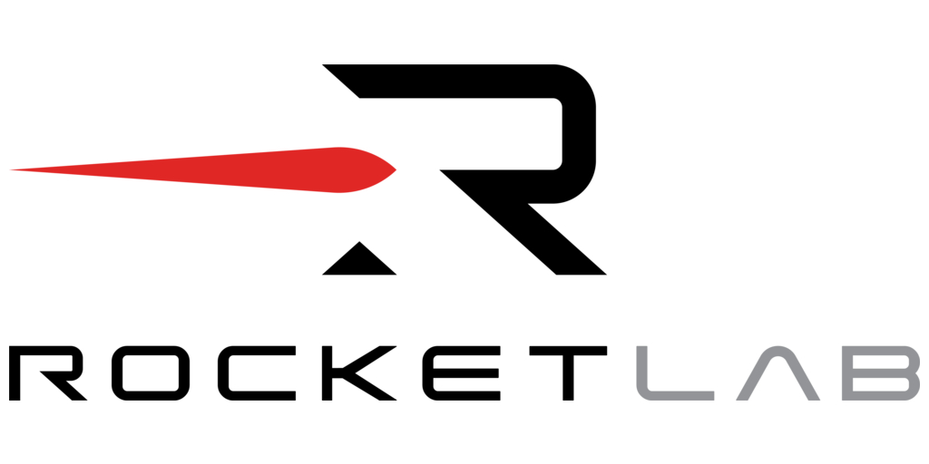
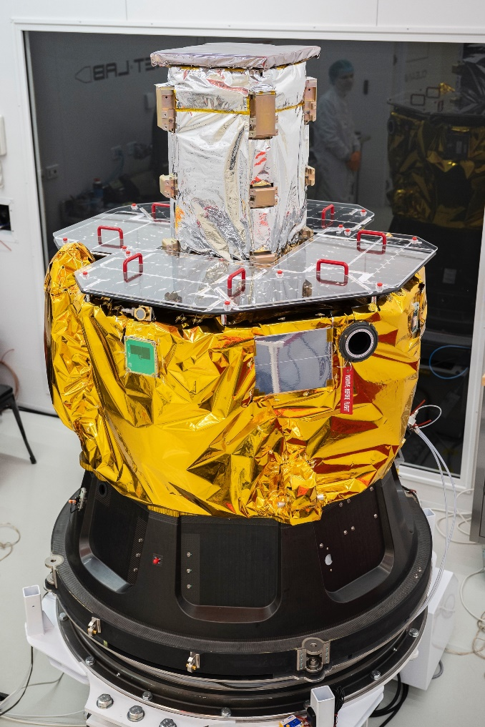
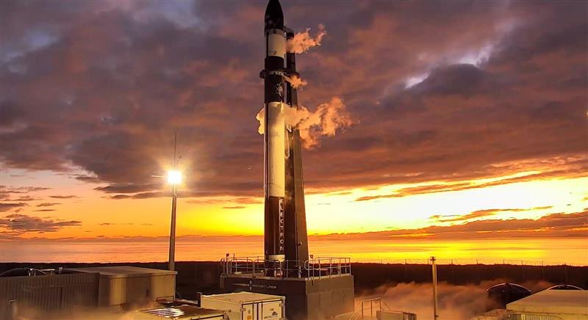

Figure 5. Rocket Launch Complex 1. Upper left photo launch pad pre-launch activities. Upper right photo is the CAPSTONE spacecraft integrated to Rocket Lab Photon upper stage. Image Credit: Rocket Lab

    - Mission Operations & Ground Stations

A combination of NASA ground assets and commercial mission operations centers are used to support mission operations. The project used NASA’s DSN for communications, guidance, navigation, and control as well as the for the one-way ranging experiment. The two-way ranging experiment with LRO is supported by NASA Goddard Space Flight Center. Mission and spacecraft operations are supported by the Tyvak Missions Operation Center in Irvine, California. The flight dynamics system and the CAPS experiment are supported and managed by Advanced Space Payload Operations Center in Westminster, Colorado. See Figure 6.
Figure 6. CAPSTONE Mission Operation Centers and of DSN Ground Stations Locations
Advanced Spc. Westminster, CO

3.0 MISSION HISTORY

3.1 Mission Profile

The overall plan for the CAPSTONE technology demonstration mission is approximately 24 months and will occur in three phases.

3.1.1 Phase 1, or transfer period. This phase consisted of 3 to 4 months for launch, transit to the Moon, insertion into lunar orbit, and commissioning. After deployment from the Photon upper stage, the CAPSTONE spacecraft booted up and prepared for the first maneuver to approach the Moon. The spacecraft leveraged the Ballistic Lunar Transfer1^{(1,2,3)} utilizing solar gravity to travel 1.5 million km from the Earth then utilize subsequent Trajectory Correction Maneuvers (TCMs) to approach the Moon. BLT ⁽¹⁾ is an energy-efficient transfer that significantly reduces fuel requirements.

    - Phase 2 comprised 6 months of primary mission with the following operations:During this phase, the CAPSTONE mission operations team collected and analyzed operational data to understand the requirements of maintaining spacecraft in this orbit. The data will be shared with the Artemis Gateway Operations team. The CAPSTONE team engaged with the LRO spacecraft team to implement the two-way ranging experiment. The CAPS navigation system used the crosslink radio signal to determine the position between the two spacecraft. One-way ranging tests with the DSN ground stations was also conducted. A Chip Scale Atomic Clock (CSAC) was added to the Iris X-band radio in order to support this experiment. This test provides an additional navigation capability for spacecraft for determining spacecraft position.

    - Phase 3, the extended mission phase, CAPSTONE will conduct technology enhancement activities. The team continued to capture additional NRHO operations and autonomous system evaluation data. The additional CAPSTONE-to-LRO ranging experiments allowed the project to increase the fidelity of the CAPS system demonstration. The project continued to perform detailed demonstration of a one-way ranging experiment with the Chip Scale Atomic Clock (CSAC) that is integrated into the Iris radio system. Preparation of the End of Mission (EOM) and spacecraft disposal are also planned.

3.2 Milestone Flight Operations Reports & Status

    - Launch to Near Rectilinear Halo Orbit Maneuver Report, 9 August 2022

CAPSTONE was deployed on its lunar transfer trajectory on July 4th. The spacecraft completed its first three of six trajectory correction maneuvers and executed the largest of these on July 25th to target the lunar orbit insertion. The spacecraft experienced a communications anomaly on July 4th ~10 hours after separation from the Lunar Photon. Communications were interrupted for ~43 hours but were automatically recovered by the spacecraft software system and communication was restored on July 6th. The spacecraft experienced an attitude control anomaly at the completion of TCM-3 on September 8th. The Mission Operations and the Flight Dynamics teams worked together to recover from this anomaly and the completion the commissioning phase of the spacecraft systems. No impact to the mission is expected due to this anomaly or the recovery operations. The Deep Space Network (DSN) actively communicated on a regular basis with spacecraft for commanding, telemetry and tracking activities. NRHO insertion occurred on Nov 13th. The operations plan for LRO ranging after the lunar orbit insertion was approved and timelines were planned.

3.2.2 Flight Operations Report & Status #1, 15 November 2022

CAPSTONE was successfully inserted into the NRHO on 11/13/22 as planned. CAPSTONE took 137 days to arrive in the NRHO (Separation – ICM-2) while executing 31 propulsive events, 9 of which were planned maneuvers. Overall deployment to NRHO Insertion Maneuver events consisted of 12 desaturation maneuvers; 6 additional maneuvers due to the stuck thruster valve; 3 thruster commissioning maneuvers; and 1 detumble following separation from the launch vehicle. See Figure 7. After the successful TCM-3, axial thruster #3 of the propulsion system experienced an anomaly, a stuck open valve, which led to a spin-up to ~110 deg/sec of the spacecraft and put the vehicle into a flat spin, BUT, very fortunately, at a fixed attitude that allowed power generation and communications with Earth. After 4 weeks of temperature management, several tests on the S/C propulsion system, and a redesign of the TCM ACS controller by the Terran GNC team, the vehicle was successfully de-spun. The updated controller was then used to execute TCM-4 successfully and then the NIM.
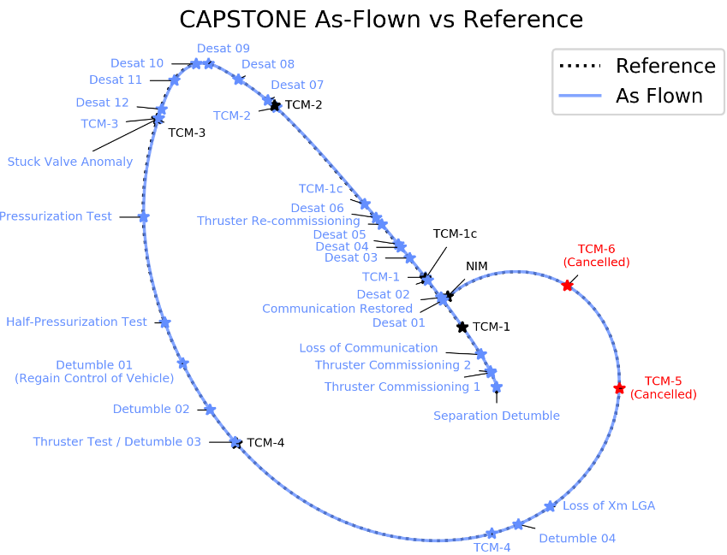
Figure 7. CAPSTONE Trajectory Mapping post deployment from Photon to NRHO.
Credit: Advanced Space, LLC

    - Flight Operations Status Report #2, 15 February 2023

CAPSTONE successfully operating in the NRHO since 11/13/22 (92 days). Orbital Maintenance Maneuvers (OMMs) 5, 10, and 13 all successfully executed as planned. OMM’s 1-4, 6-9, 11-12 cancelled due to low DV (below threshold). OMM cadence reduced due to minimum OMM DV based on the updated Terran controller implemented for the post-TCM-3 valve anomaly. Due to updated maneuver performance, further threshold reductions are expected to reduce the minimum OMM < 9.5 cm/sec. One anomaly occurred since NRHO insertion resulting in a loss of commanding on uplink occurred on ~Jan. 26th. Suspect SEU on the Iris firmware as the root cause. Commanding restored on Feb 6th when Command Loss Timer reset the spacecraft. The first CAPS pass attempt occurred on 1/18/23. LRO received a signal, but no ranging data was observed nor was any return telemetry received by CAPSTONE. The team planned for the next CAPS pass attempt (lower range to LRO) is planned for 2/20/23.

    - Flight Operations Status Report #3, 9 August 2023

CAPSTONE successfully operating in the NRHO for 269 days, completing 40 NRHO revolutions and 11 OMMs. On May 9, 2023, a successful CAPSTONE-to-LRO ranging test was accomplished. The CAPSTONE spacecraft sent a navigation signal to LRO, which was subsequently sent back to CAPSTONE. The returned signal allowed CAPSTONE to compute its range and trajectory, which can be used to determine the positioning of both the LRO and CAPSTONE spacecraft. This event allowed the mission to meet a primary objective which sought to demonstrate its CAPS technology which provides autonomous onboard navigation. 2 One-Way ranging tests with DSN were accomplished. The mission achieved new maximum up time of 1300+ hours.

    - Flight Operations Status Report # 4, 15 November 2023

CAPSTONE successfully operating in the NRHO for 363 days. 1 Successful Crosslink Attempt was performed. The One-way ranging data was gathered on 18 DSN passes. The spacecraft survived 12 Eclipses. Earth and Moon imaging campaigns since last report consisted of 3 Earth imaging campaigns and 1 Lunar imaging campaign.

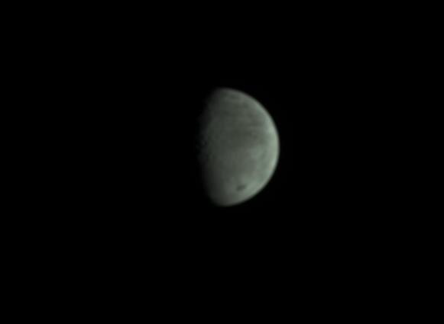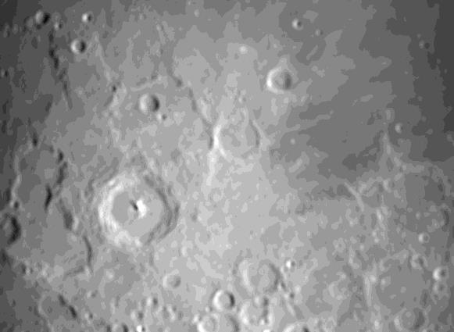
Figure 8. Images of Earth and Moon taken with camera on CAPSTONE. Image Credit: Advanced Space, LLC

    - Flight Operations Review & Status #5, 21 February 2024

At the time of this report, CAPSTONE has been operating in the NRHO successfully for 453 days, carrying out all the planned objectives of this technology demonstration mission.
Since Flight Operations Report #4 the mission the following activities were accomplished. 1 Earth imaging campaign and 2 Lunar imaging campaigns completed. 2 successful CAPSTONE to LRO two way ranging tests were completed. January 7, 2024, the longest CAPS pass with 66 minutes of tracking was accomplished. All ranging components successfully extracted from crosslink radio. February 3, 2024, the first consecutive CAPS crosslink a success. One-way ranging tests with DSN accomplished on every DSN pass. Successful demonstration of regenerative ranging. An additional Advanced Space Software, called Sigma 0, was successfully uploaded to the spacecraft in preparation for testing.

    - Mission Summary to Date

CAPSTONE has been successfully operating for over 500 days since launch. The following activities have been tracked since the start of the mission. Over 70 completed NRHO revolutions. 21 OMMs have been completed. 4 of 5 Operational Objectives have been met. 15 Crosslink attempts total with 4 Successful Crosslink Attempts. All tracking passes now yield one-way ranging data with DSN. Survived 16 Eclipses Had longest mission eclipse: ~75 minutes 152 images have been collected.
Figure 9. Image of Earth taken with camera on CAPSTONE. Image Credit: Advanced Space, LLC
Figure 9. Picture taken during Perilune Flyby Sequence

- PLANNED ACTIVITIES to END of MISSION

  - The CAPSTONE mission currently has a planned End of Mission date of September 30, 2024. The spacecraft has more than sufficient propellant to operate beyond this date, which allows NASA and Advanced Space to consider further extensions to the mission.

Near-term plans for CAPSTONE include the continuation of the 2-way ranging experiments with LRO to gather as much crosslink data as possible with improved operations processes for crosslink success. Extended ground testing to verify and improve on-orbit behavior. Take additional images of interesting lunar features near perilune. Investigate regenerative ranging and compare it to turnaround ranging performance. Work with the DSN to demonstrate new technologies and improve capabilities for future Artemis missions such as Pseudo Noise Delta Differential One Way Ranging (PN-Delta DOR), Multiple Uplinks per Antenna (MUPA) Opportunistic Multiple Spacecraft Per Aperture (OMSPA). Demonstrate additional Advanced Space developed software to raise TRL Sigma0 – Onboard machine learning algorithm to characterize navigation residuals (nominal, maneuver execution, outgassing, etc.) Initial demonstration objectives are nearly completed but investing follow up opportunities to test new Advanced Space technologies such as Neural Networks for Easy Planning (NNEP) – Onboard neural net to plan station keeping maneuvers. Explore extended mission opportunities with other government and commercial companies.

REFERENCES

[1] Nathan L. Parrish, Ethan Kayser, Shreya Udupa, Jeffrey S. Parker, Bradley W. Cheetham, and Diane C. Davis. (AAS 19-740) Survey of Ballistic Lunar Transfers to Near Rectilinear Halo Orbit. [Conference Presentation} AAS/AIAA Conference.

[2] Nathan L. Parrish, Ethan W. Kayser, Matthew J. Bolliger, Michael R. Thompson, Jeffrey S. Parker, Bradley W. Cheetham, Diane Davis, Daniel J. Sweeney. Ballistic Lunar Transfers to Near Rectilinear Halo Orbit: Operational Considerations [Conference Presentation]. AAS/AIAA Conference.

[3] Nathan L. Parrish, Matthew J. Bolliger, Ethan Kayser, Michael R. Thompson, Jeffrey S. Parker, Bradley W. Cheetham, Diane C. Davis, Daniel Sweeney. Near Rectilinear Halo Orbit Determination with Simulated DSN Observations. [Conference Presentation] AAS/AIAA Conference.

