Supplementary Information

Observational constraint on a feedback from supercooled clouds reduces projected warming uncertainty
Grégory V. Cesana^{1,2,} Andrew S. Ackerman², Ann M. Fridlind², Israel Silber³, Anthony D. Del Genio^{2,4}, Mark D. Zelinka⁵, Hélène Chepfer⁶, Théodore Khadir⁷ and Romain Roehrig⁸
¹ Center for Climate Systems Research, Columbia University, New York, NY
² NASA Goddard Institute for Space Studies, New York, NY
³ Pennsylvania State University, University Park, PA
⁴ Department of Applied Physics and Applied Mathematics, Columbia University, New York, NY
⁵ LLNL, Livermore, CA
⁶ LMD, Sorbonne Université, Paris, France
⁷ Department of Environmental Science and Bolin Centre for Climate Research, Stockholm University, Stockholm, Sweden
⁸ CNRM, Université de Toulouse, Météo-France, CNRS, Toulouse, France

Corresponding author: Grégory V. Cesana (gregory.cesana@columbia.edu)

Supplementary Notes

Supplementary Note 1: Choice of observations in Fig. 1b
In Fig. 1b, we use a diverse set of satellite, ground-based and in situ observations to highlight the relative diversity of the different observational datasets, which depends on the instrument, platform, geographic region, cloud and LPR definitions, and type of clouds sample. For these reasons, it is not consistent to compare all these observational datasets among themselves. The choice of observations shown in this figure is somewhat subjective and based on the authors’ knowledge of the literature, their platforms, methods and instruments, and public availability.

Satellite datasets
The Cesana et al.¹ frequency LPR is based on CALIPSO-GOCCP observations that are described in Section 1 of the Methods section.

The Hu et al.² hybrid LPR is computed from a combination of liquid and ice cloud frequencies from CALIPSO polarization-sensitive lidar and liquid and ice water paths from MODIS with temperatures from CALIPSO infrared imaging radiometer. In this dataset, broken fractional clouds (e.g., shallow Cu) and optically thin but relatively warm (T > -40˚C) cirrus are ignored. The curve in Fig. 1b follows equation 1 from Hu et al.².

The Stubenrauch et al.³ frequency LPR is computed from the average of five passive-sensor satellite liquid and ice cloud-top frequencies and cloud-top temperatures as described in Cesana et al.¹. The data points needed to produce this curve can be downloaded here: https://zenodo.org/records/10767855. However, one can reproduce the same curve using the ice and liquid cloud amount and cloud-top temperatures (CAI, CAW and CTT) from the Global Energy and Water cycle Experiment (GEWEX) Cloud Assessment AIRS-LMD, ISCCP, MODIS-CE MODIS-ST and PATMOS-X datasets (https://climserv.ipsl.polytechnique.fr/gewexca/index-2.html).

Ground-based datasets
The Naud et al.⁴ frequency LPR is computed from liquid and ice cloud frequencies from two different ground-based polarization-sensitive lidar at middle latitudes (Southern Great Plains site and the Site Instrumental de Recherche par Télédétection Atmosphérique in France) and temperatures from radiosonde profiles.

The Shupe⁵ frequency LPR is computed from liquid and ice cloud frequencies from a combination of lidar, radar and microwave measurements with temperature from radiosonde profiles at two Arctic observatory sites (North Slope of Alaska and Eureka) as well as during a ship-based measurement campaign Surface Heat Budget of the Arctic (SHEBA). We note that solid precipitation (snow) is included in the computations.

The Silber et al.⁶ frequency LPR is computed from liquid and ice cloud frequencies retrieved using an original method based on temperature-dependent relative humidity (radiosonde profiles) above a fixed threshold (100% minus ∆RH, where ∆RH is the relative humidity measurement uncertainty in %) to detect supercooled layers and radar echoes above the noise floor combined with RH with respect to ice considerations to determine ice layers at the ARM North Slope of Alaska (Utqiagvik) site. We note that solid precipitation (snow) is included in the computations. All the above ground-based observations were provided by their author.

In situ datasets
The Korolev et al.⁷ relationship represents a mass LPR from measurements that were performed by Environment Canada in mid- and high-latitude continental and maritime air masses during the period 1994–2001. The total length of sampled clouds is 61 765 km. Since the equation and data points used in their Fig. 13b is not available in their publication, we have extracted the data points using an online tool (https://apps.automeris.io/wpd/) and further derived a 4th degree polynomial fit (Eq. 1), which closely matches theirs.

${LPR}_{mass}\left(T\right)=1.634×{10}^{-6}T^{4}+1.1658×{10}^{-4}T^{3}+5.654×{10}^{-3}T^{2}+8.348×{10}^{-2}T+0.7333$ (1)

The Moss and Johnson⁸ relationship is a mass LPR computed from aircraft measurements of the C-130 of the U.K. Meteorological Research Flight using eleven flights made in various types of clouds (Sc, Cu, St, As, Ns, Ci) over land and ocean across the United Kingdom (UK). We have extracted the data points from their Fig. 9 using an online tool (https://apps.automeris.io/wpd/) and further derived a 4th degree polynomial fit (Eq. 2), which accounts for the data points at temperatures lower than -15˚C, rather than the linear equation given in their study (Eq. 6). We note that this dataset carries larger uncertainties than Korolev et al.⁷ and C16-J10-M17 measurements, which both use relatively more recent aircrafts, instruments, and retrieval methods, yet not the newest ones.

${LPR}_{mass}\left(T\right)=1.206×{10}^{-5}T^{4}+9.176×{10}^{-4}T^{3}+2.341×{10}^{-2}T^{2}+0.2363T+1.012$ (2)

The C16-J10-M17 Arctic MPCs relationship is a mass LPR computed from aircraft measurements from 40 Arctic flights documenting mixed-phase cloud (MPC) properties across 4 European campaigns (ASTAR 2004 and 2007, POLARCAT 2008 and SORPIC 2010) using similar instruments (a polar nephelometer) onboard different aircraft to derive liquid and ice water contents (Cesana et al.¹; Jourdan et al.⁹; Mioche et al.¹⁰). We also derive the same relationship for 5 flights of the CIRCLE-2 (2007) campaign targeting high clouds in the NH mid-latitudes. We have averaged the data over 5˚C temperature bins and used it to derive the best fit – based on a cubic equation – that is shown in Fig. 1b for MPCs and the actual data for high clouds. The data points needed to produce these curves can be downloaded here: https://zenodo.org/records/10767855.

Supplementary Note 2: Observational uncertainty
The observational uncertainty of CALIPSO-GOCCP is computed as in Cesana et al.¹¹. To derive an observational uncertainty, estimate for the LPR as a function of temperature (liquid/[liquid+ice] cloud frequency), we use error estimates from a CALIPSO-GOCCP validation study against in situ aircraft measurements (Cesana et al.¹) as well as the undefined-phase cloud fraction. Cesana et al.¹ show that the maximum disagreement fraction between CALIPSO-GOCCP and five co-located in situ aircraft flights is ~ 11.8 % (their Table 3). We pick a conservative threshold about twice as large as the maximum disagreement fraction, 20 %, which we apply uniformly to the CALIPSO-GOCCP liquid phase ratio, although Cesana et al.¹ showed that the ice clouds in high and cold clouds were rarely misdiagnosed. In addition, we use the undefined-phase cloud fraction to derive a second uncertainty estimate range of possible LPR as a function of the temperature by considering the undefined-phase clouds as being either all liquid or all ice. Finally, we assume that both uncertainty sources – from applying the 20 % disagreement fraction and from considering all undefined-phase clouds as being either liquid or ice – are independent and add them in quadrature to derive the final uncertainty estimate.

Supplementary Note 3: Inferred future cloud change in observations and models
Although we cannot diagnose future change in liquid and ice cloud fractions in observations and in CMIP6 models, because the lidar cloud phase outputs for the relevant simulations are not available, we can still infer some rough estimates using a novel approach based on present-day cloud sensitivity to cloud controlling factors^{12–14}. Following the method used in Cesana and Del Genio¹², we compute interannual sensitivities of liquid and ice clouds to SST and estimated inversion strength (EIS) for the 55˚S to 75˚S latitudinal band (Supplementary Figure 9b-c), assuming that these are the two main cloud-controlling factors. We then multiply them by the corresponding future change of SST and EIS, defined as the difference between 4xCO2 and piControl simulations, derived from 40 CMIP6 models¹², to compute inferred estimates of future liquid and ice cloud changes (Supplementary Figure 9d), as summarized in equation (3):

$\frac{dCF}{dT}=\sum_{type=1}^{2}{\left(\frac{∂{CF}_{type}}{∂SST} \frac{dSST}{dT}+\frac{∂{CF}_{type}}{∂EIS} \frac{dEIS}{dT}\right) }$ (3)
Where type is either liquid or ice.

Consistent with GISS-ModelE3 and CMIP6 results (Fig. 5 and Supplementary Figure 7), both the observed and simulated inferred extratropical cloud change are positive and driven by liquid cloud below 4 km, while ice cloud changes are negligible. These changes are well captured by CMIP6 models although with smaller amplitude. A complementary analysis of observations indicates that the increase is driven by opaque clouds (Supplementary Figure 9e), suggesting that both the amount and opacity should increase with warming, generating negative cloud feedback.

Supplementary Tables

Supplementary Table 1: List of ten CMIP6 models as well as their ECS, T_{50/50} and extratropical feedbacks. The ECS are from Cesana and Del Genio¹². Original T_{50/50} are derived from LPR_{mass}, using model original outputs of liquid and ice water contents, while lidar T_{50/50} comes from LPR_{freq} using the lidar simulator outputs of liquid and ice cloud fraction. The cloud feedbacks are averaged over the extratropics, defined as between 55˚ and 75˚N/S, consistent with Fig. 4. The models marked with a plus sign partition liquid and ice hydrometeors using complex microphysics schemes while the other rely mainly on temperature-dependent relationships. Note that the T_{50/50} multimodel means do not correspond to the average of the values in the T_{50/50} column. Instead, T_{50/50} multimodel means were obtained by computing the multimodel means of the LPR first and then by applying the method (Methods). The bias corresponds to simulations minus CALIPSO-GOCCP observations (T_{50/50} = -$19.6±1.6$˚C).

Model name  (Center) | ECS (˚C) | T_{50/50} (˚C)
Model name  (Center) | ECS (˚C) |  |  |  | SW cloud feedback (Wm²K⁻¹)
Model name  (Center) | ECS (˚C) |  |  |  | Low-cloud optical depth | Optical depth | Amount
Model name  (Center) | ECS (˚C) | Original | Lidar | Bias | Low-cloud optical depth | Optical depth | Amount
BCC-CSM2-MR (BCC) | 3.02 | -22.9 | -35.4 | -15.8 | -0.01 | -0.14 | -0.39
CanESM5⁺ (Can) | 5.64 | -13.4 | -15.4 | 4.2 | -0.05 | -0.52 | -0.11
CESM2⁺ (NCAR) | 5.15 | -18.7 | -23.4 | -3.8 | -0.03 | -0.22 | 0.21
CNRM-CM6-1 (CNRM) | 4.9 | -15.2 | -24.8 | -5.2 | -0.03 | -0.34 | 0.12
GFDL-CM4⁺ (GFDL) | 3.89 | -9.5 | -23.4 | -3.8 | 0.04 | -0.15 | 0.61
GISS-E2-1-G (GISS) | 2.71 | -32.0 | -32.4 | -12.8 | -0.09 | -0.46 | -0.15
HadGEM3-GC31-LL⁺ (MOHC) | 5.55 | -5.8 | -9.1 | 10.5 | 0.04 | -0.15 | 0.46
IPSL-CM6A-LR (IPSL) | 4.56 | -23.2 | -29.0 | -9.4 | -0.11 | -0.62 | 0.46
MIROC6⁺ (MIROC) | 2.6 | -6.8 | -14.3 | 5.3 | -0.16 | -0.47 | -0.18
MRI-ESM2-0 (MRI) | 3.13 | -25.9 | -28.8 | -9.2 | 0.02 | -0.19 | -0.31
Mean 10 models | 4.1 | -16.2 | -25.4 | -5.8 | -0.04 | -0.33 | 0.07

Supplementary Table 2: Same as Supplementary Table 1 (except for T_{50/50} bias) for CMIP5 models. The method to derive T_{50/50} lidar is described in the Methods section.
Model name (Center) | ECS (˚C) | T_{50/50} (˚C) |  | SW cloud feedback (Wm²K⁻¹)
Model name (Center) | ECS (˚C) |  |  | Low-cloud optical depth | Optical depth | Amount
Model name (Center) | ECS (˚C) | Original | Lidar | Low-cloud optical depth | Optical depth | Amount
bcc-csm1-1-m (BCC) | 2.89 | -28.3 | -40.8 | -0.12 | -0.40 | -0.65
CanESM2 (Can) | 3.7 | -13.8 | -15.9 | -0.13 | -0.66 | -0.15
CCSM4 (NCAR) | 2.94 | -30.1 | -34.7 | 0.08 | -0.03 | -0.59
CNRM-CM5 (CNRM) | 3.25 | -15.0 | -24.7 | -0.28 | -0.56 | -0.01
GFDL-CM3 (GFDL) | 3.99 | -6.4 | -20.3 | 0.01 | -0.28 | 0.31
GISS-E2-H (GISS) | 2.12 | -16.2 | -16.6 | -0.63 | -1.25 | -0.07
HadGEM2-ES (MOHC) | 4.58 | -2.3 | -5.6 | -0.03 | -0.32 | 0.22
IPSL-CM5B-LR (IPSL) | 2.61 | -6.7 | -12.4 | -0.18 | -0.61 | 0.52
MIROC5 (MIROC) | 2.71 | -3.9 | -11.5 | -0.16 | -0.38 | -0.34
MRI-CGCM3 (MRI) | 2.61 | -13.1 | -16.0 | -0.04 | 0.01 | -0.53
Mean 10 models | 3.14 | -14 | -22.9 | -0.15 | -0.45 | -0.13

Supplementary Table 3: List of CMIP3 models as well as T_{50/50} and additional information.

Model name (Center) | Method to derive T_{50/50} | T_{50/50} (˚C) | Reference
CCSM3 (NCAR) | Computed from the relationship in Boville et al. (2006) | -25 | Boville et al.¹⁵
CNRM-CM3 (CNRM) | Computed from: LPR = (1 - exp(-(T-T_{t})²/(2*dT²)); dT = 11.82 K and  T_{t} = 273.16 K | -14 | Voldoire et al.¹⁶
GFDL-CM2 (GFDL) | Read from Tsushima et al. (2006) | -12.5 | Rotstayn et al.¹⁷
GISS-ModelE (GISS) | Read from Del Genio (1996) | -12.5 | Del Genio¹⁸
HadGEM (MOHC) | Read from Tushima et al. (2006) | -11 | Webb et al.¹⁹
IPSL-CM4 (IPSL) | Computed from the relationship in Le Treut and Li (1991) | -1.6 | Le Treut and Li²⁰
MIROC3.2 (MIROC) | Read from Tsushima et al. (2006) | -14.2 | K-1 model developers ²¹

Supplementary Table 4: List of observational datasets used in Fig. 1b as well as T_{50/50} and additional information. CALIPSO-GOCCP, shown in bold in the table, is the observational dataset used to evaluate the climate models in this study. More details about the observational datasets are given in Supplementary Note 1.
Platform | Instrument | Location | type of LPR | T_{50/50} (˚C) | Reference
Satellite | lidar | 82˚S/N | hybrid combination of frequency and volume | -23.31 | Hu et al.²
Satellite | CALIPSO-GOCCP lidar | 82˚S/N | frequency of occurrence | -19.61 | Cesana et al.¹
Satellite | radiometer, spectrometer | 90˚S/N | frequency of occurrence | -16.49 | Stubenrauch et al.³; Cesana et al. ¹
Ground-based sites | lidar | Mid latitudes, 2 sites | frequency of occurrence | -21.78 | Naud et al.⁴
Ground-based sites | lidar, radar and radiometer | Arctic, 3 sites | frequency of occurrence | -13.4 | Shupe⁵
Ground-based sites | Radar and soundings | Arctic, 1 site | frequency of occurrence | -9.67 | Silber et al.⁶
Aircrafts | In situ probe (Nephelometer) | Arctic mixed-phase clouds (MPCs) | mass | -24.86 | Cesana et al.¹; Jourdan et al.⁹; Mioche et al.¹⁰
Aircrafts | In situ probe (Nephelometer) | Mid-latitude high clouds | mass | -8.68 | Cesana et al.¹; Jourdan et al.⁹; Mioche et al.¹⁰
Aircrafts | In situ probe  (Various probes) | Mid and high latitude | mass | -3.65 | Korolev et al.⁷
Aircrafts | In situ probe | United Kingdom | mass | -2.92 | Moss and Johnson⁸

Supplementary Table 5: Effect of constraining T_{50/50} on ECS from ten CMIP6 models. The corrected bias corresponds to simulations minus the closest value of CALIPSO-GOCCP observational range (T_{50/50} = -$19.6±1.6$˚C). The constrained ECS are computed by adding the effect of correcting T_{50/50} bias to the original ECS (see Methods).

Model name | ECS (˚C) | T_{50/50} (˚C)
Model name | ECS (˚C) | T_{50/50} (˚C) | Constrained ECS (˚C) |  | Constrained – original ECS (˚C)

 |  | Lidar | Corrected bias
BCC-CSM2-MR (BCC) | 3.02 | -35.4 | -14.2 | 4.01 | 0.99
CanESM5 (Can) | 5.64 | -15.4 | 2.6 | 5.46 | -0.18
CESM2 (NCAR) | 5.15 | -23.4 | -2.2 | 5.30 | 0.15
CNRM-CM6-1 (CNRM) | 4.9 | -24.8 | -3.6 | 5.15 | 0.25
GFDL-CM4 (GFDL) | 3.89 | -23.4 | -2.2 | 4.04 | 0.15
GISS-E2-1-G (GISS) | 2.71 | -32.4 | -11.2 | 3.49 | 0.78
HadGEM3-GC31-LL (MOHC) | 5.55 | -9.1 | 8.9 | 4.93 | -0.62
IPSL-CM6A-LR (IPSL) | 4.56 | -29.0 | -7.8 | 5.11 | 0.55
MIROC6 (MIROC) | 2.6 | -14.3 | 3.7 | 2.34 | -0.26
MRI-ESM2-0 (MRI) | 3.13 | -28.8 | -7.6 | 3.66 | 0.53
Mean 10 models | 4.1 | -25.4 | -4.2 | 4.4 | 0.3
Standard deviation 10 models | 1.19 | 8.41 | 7.11 | 1.01 | 0.18
Supplementary Table 6: Effect of constraining T_{50/50} on ECS from GISS-ModelE3 configurations. Same as Supplementary Table 5 for GISS-ModelE3.
Model name | ECS (˚C) | T_{50/50} (˚C)
Model name | ECS (˚C) | T_{50/50} (˚C) | Constrained ECS (˚C) |  | Constrained – original ECS (˚C)
 |  | Lidar | Corrected bias

Tun1 | 3.84 | -20.76 | -20.76 | 3.84 | 0.00
Tun2 | 3.26 | -23.52 | -21.2 | 3.92 | 0.66
Tun3 | 3.3 | -21.78 | -21.2 | 3.46 | 0.16
Tun4 | 3.59 | -21.59 | -21.2 | 3.70 | 0.11
Tun5 | 3.87 | -21.15 | -21.15 | 3.87 | 0.00
Phys | 4.2 | -20.35 | -20.35 | 4.20 | 0.00
Mean | 3.68 | -21.53 | -20.98 | 3.83 | 0.16

Supplementary Figures

Supplementary Figure 1: Relationship between temperature and LPR_{freq} in CMIP6 models against CALIPSO-GOCCP observations. The global frequency of occurrences (%) of liquid phase ratio (LPR) as a function of the temperature (°C) for CALIPSO-GOCCP observations¹ (2007-2015 Nighttime v2.9) and the bias of ten CMIP6 models using the lidar simulator and the multimodel mean. The black and red lines correspond to the mean frequency LPR as shown in Fig. 2 for CALIPSO-GOCCP observations and the models, respectively. The dash-dotted and dotted red lines in the bottom right plot correspond to temperature-dependent (n=5) and complex-microphysics (marked with a +, n=5) model means (Table 1), respectively. Note that GISS-ModelE3 multimodel mean (n=6) is not used in the multimodel mean analysis from the main manuscript.

Supplementary Figure2: Evaluation of CMIP6 cloud phase profiles against CALIPSO-GOCCP observations. Zonal profiles of LPR_{freq} (left column), ice cloud fraction (middle column), and liquid cloud fraction (right column) for CALIPSO-GOCCP (2007-2016 Nighttime v2.9, top row), the average of ten CMIP6 models (Supplementary Table 1, middle row) using the lidar simulator and the bias (model-mean minus observations, bottom row). Note that the red and blue shadings correspond to grid boxes dominated by liquid (LPR = 1) and ice (LPR = 0) phase, respectively. The 2% contour of the liquid and ice cloud fraction for observations and simulations are shown in a, d and g.

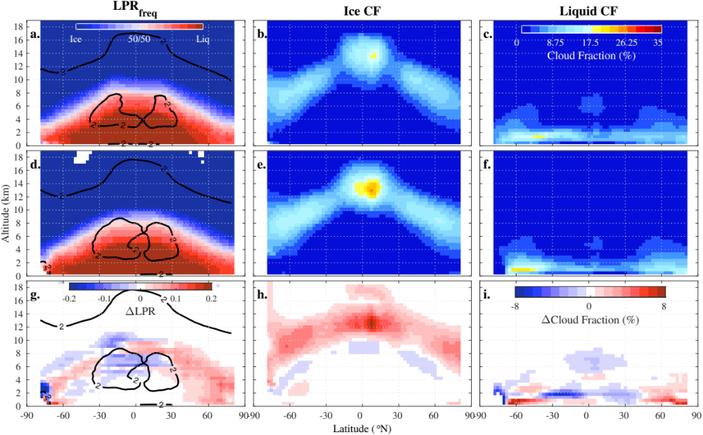

Supplementary Figure 3: Effect of the precipitation on the relation between temperature (°C) and frequency liquid phase ratio (LPR_{freq}). Calculated LPR in four different configurations of GISS-ModelE3¹¹, CESM2, and MIROC6 ESMs is systematically reduced when including the effect of precipitation (solid) versus neglecting it (dotted), but by variable degrees depending on the model (see legend).

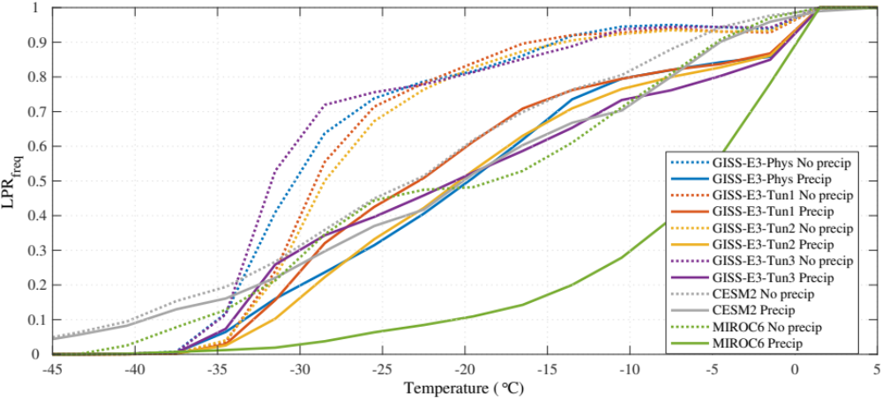

Supplementary Figure 4: Zonal low-level SW cloud feedbacks in CMIP6 and CMIP5 models. Low-level total, scattering (equivalent to optical depth) and cloud amount feedback in CMIP6 (red, n=46) and CMIP5 (blue, n=29) models from Zelinka et al.²² (solid) and for the subset of ten CMIP5 and CMIP6 models used in our analysis (dotted). The vertical dotted lines show the 75˚S/N to 55˚S/N latitudinal bands used to define the extratropics.

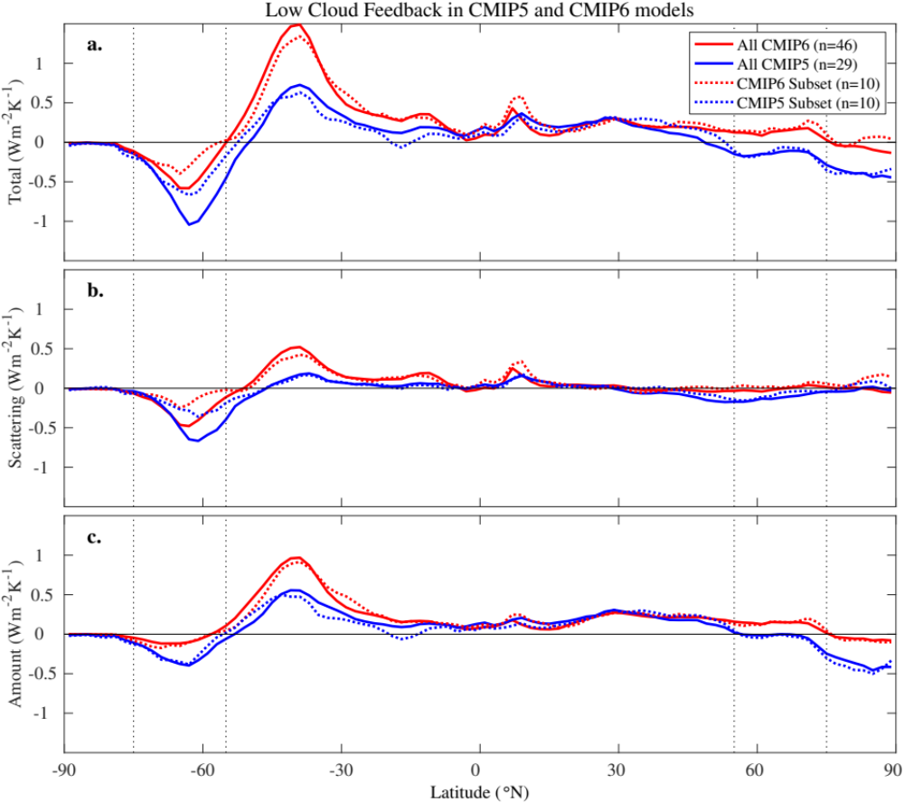

Supplementary Figure 5: Same as Fig. 4a but for optical depth feedback from low clouds . The relationship is not statistically significant and the correlation is small when considering all clouds, meaning that it can go either way. On the contrary, the correlation between optical depth feedback of low clouds and T_{50/50} is larger, yet still not statistically significant.

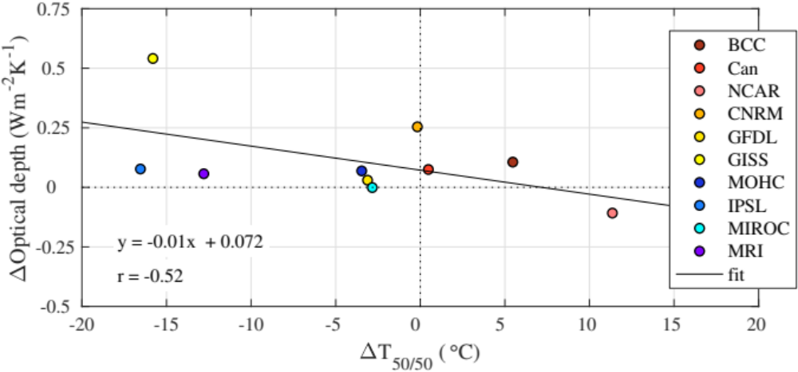

Supplementary Figure 6: Relationship between cloud phase and feedback in GISS-ModelE3. The left column shows the optical depth feedback from low-level clouds and from all clouds, the cloud amount feedback, the total extratropical SW cloud feedback and the global net (SW+LW) feedback from all-level clouds (from top to bottom; Methods) as a function of T_{50/50} in six configurations of GISS-ModelE3 (Methods) while the right column shows the feedback as a function of 1 minus the mean of the LPR between -40 and 0˚C (Methods).

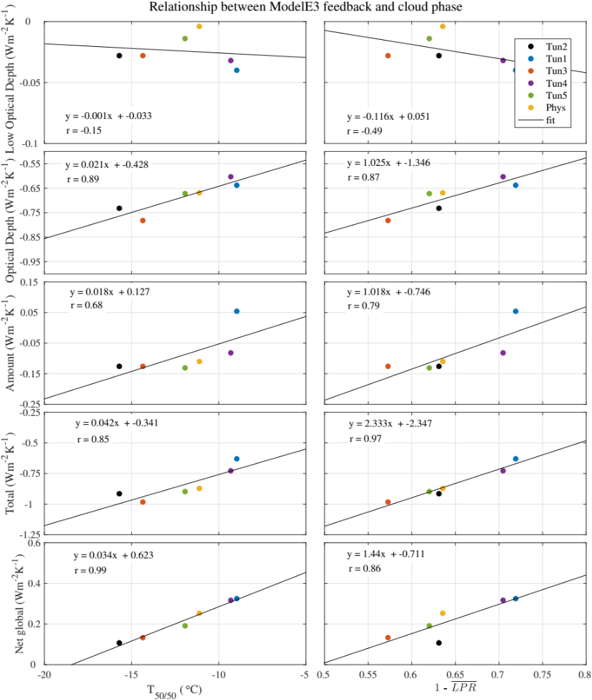
Supplementary Figure 7: Sensitivity of liquid and ice cloud profiles to LPR in GISS-ModelE3. Vertical profiles of ice and liquid cloud fractions (a, d; CF in %) and their corresponding future cloud fraction changes in response to a uniform 4 K surface temperature increase (AMIP4K – AMIP; b, e; %) as simulated by the GISS-ModelE3 Tun1, Tun2 and their modified configurations with greater (Tun1 LPR+) and fewer (Tun2 LPR-) supercooled clouds, using the lidar simulator. We use dashed lines (minus symbol) to indicate that the model (Tun1 and Tun2 LPR-) has a smaller present-day LPR (fewer supercooled clouds) compared to its counterpart configuration (Tun1 LPR+ and Tun2). (c, f) Same as (b, e) but for six CMIP6 models (the ones that provided simulator outputs for the AMIP4K experiment) and for the mean of the six GISS-ModelE3 configurations.

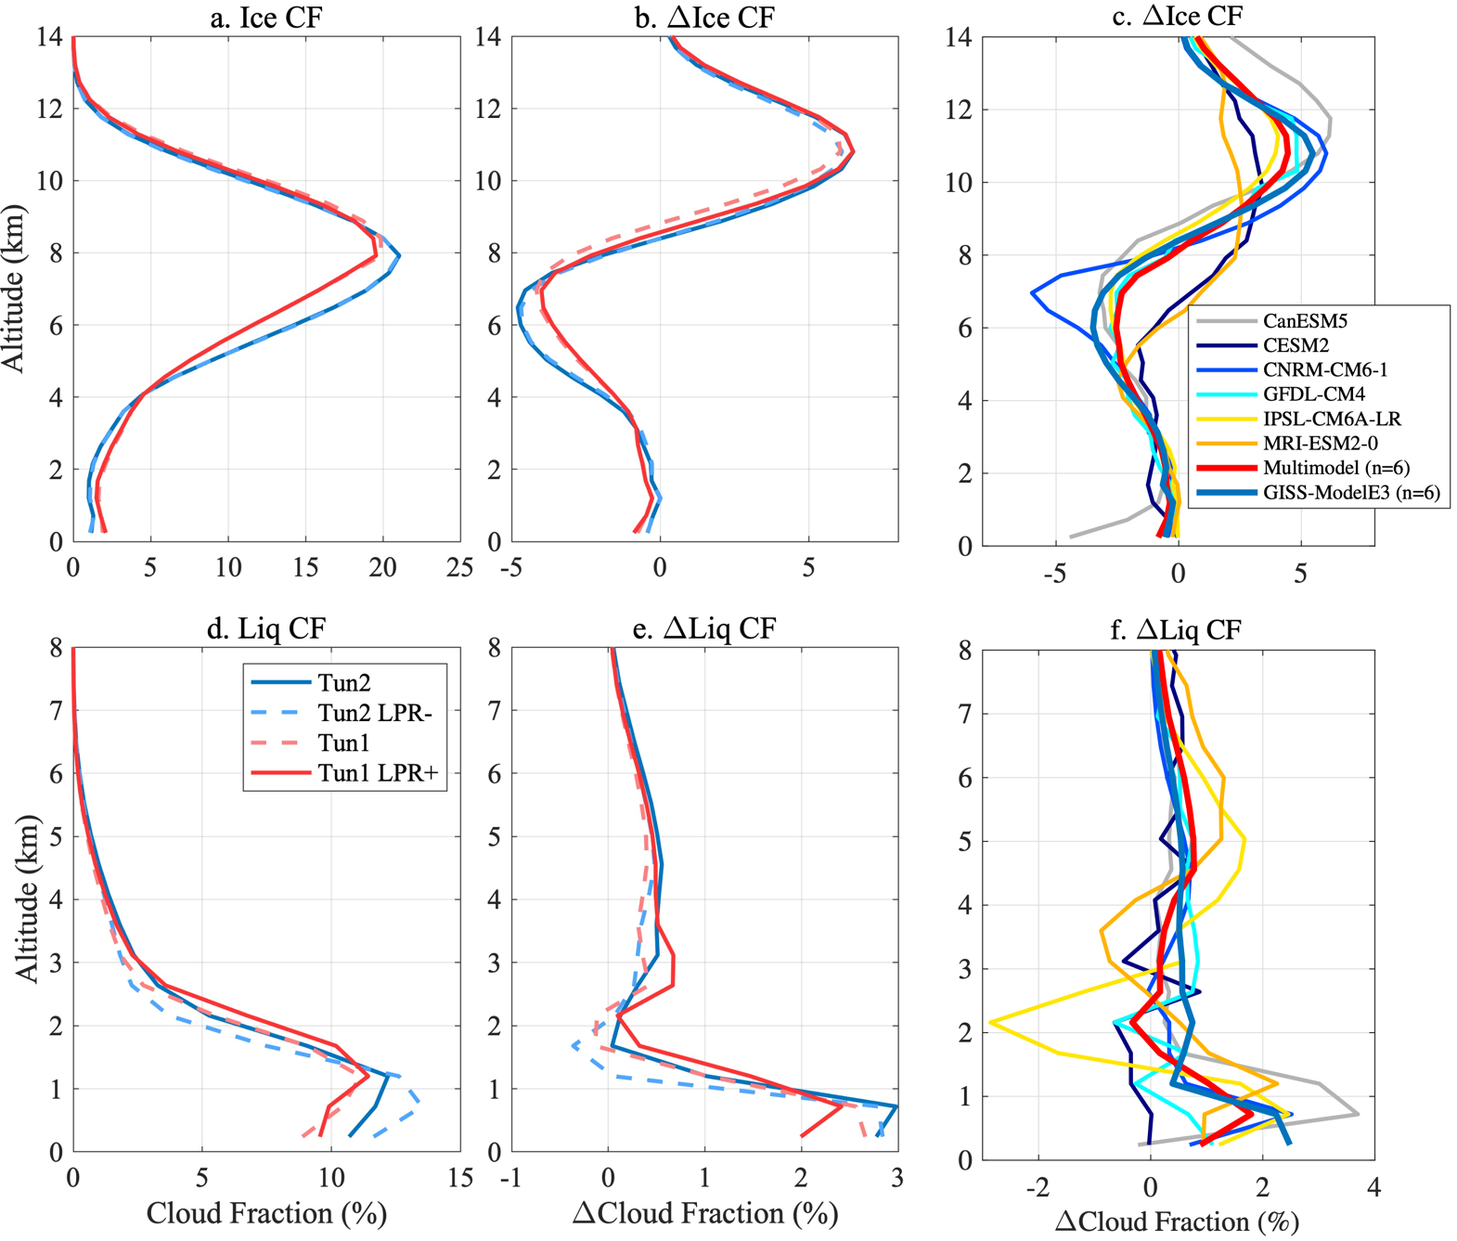

Supplementary Figure 8: Sensitivity of cloud feedbacks to LPR in GISS-ModelE3. From top to bottom, zonal mean of total (W m⁻² K⁻¹), amount and optical depth cloud feedbacks (Methods) as simulated by the GISS-ModelE3 Tun1, Tun2 and their modified configurations with greater (Tun1 LPR+) and fewer (Tun2 LPR-) supercooled clouds. We use dashed lines (minus symbol) to indicate that the model (Tun1 and Tun2 LPR-) has a smaller present-day LPR (fewer supercooled clouds) compared to its counterpart configuration (Tun1 LPR+ and Tun2). The mean extratropical feedbacks are shown in the legend.

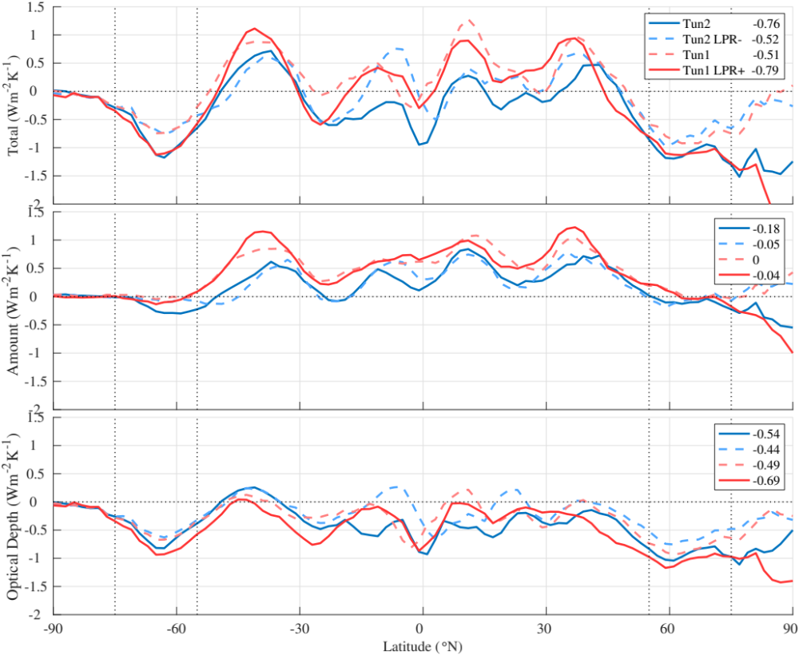

Supplementary Figure 9: Sensitivity of liquid and ice cloud profiles to climate change in the extratropics (Supplementary Note 3). a, Ice and liquid cloud fractions (%) in CALIPSO-GOCCP observations (v2.9; solid), ten CMIP6 models (dark dots) and GISS-ModelE3 (ensemble mean; light dots, n=6) using the lidar simulator. b, Interannual change per kelvin of SST warming with Estimated Inversion Strength held constant (%/K). c, Same as b for EIS with SST held constant. d, Inferred cloud change (%/K; Methods). e, Observed inferred cloud change contribution from opaque and non-opaque clouds (CALIPSO-GOCCP v3.1.2²³, same as v2.9 but with added opacity diagnostics).

Supplementary Figure 10: Relationship between global, extratropical cloud feedback and ECS. (top) The difference in area-weighted global SW cloud feedback between the ten CMIP6 and CMIP5 versions of each modeling center (i.e., over the whole globe and from all-level clouds) as a function of the corresponding extratropical mean SW cloud feedback (bottom) and as a function of the corresponding ECS difference.

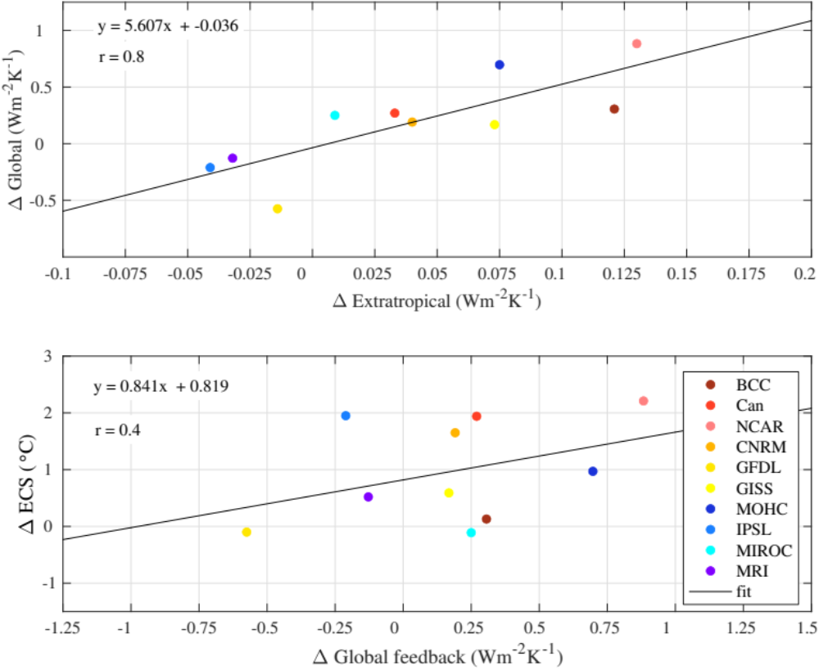

Supplementary Figure 11: Relationship between liquid-to-ice transition temperature (T_{50/50}) and the optical depth feedback from low-level clouds over the extratropics in the ten CMIP5 and CMIP6 models (open and solid circles, respectively).

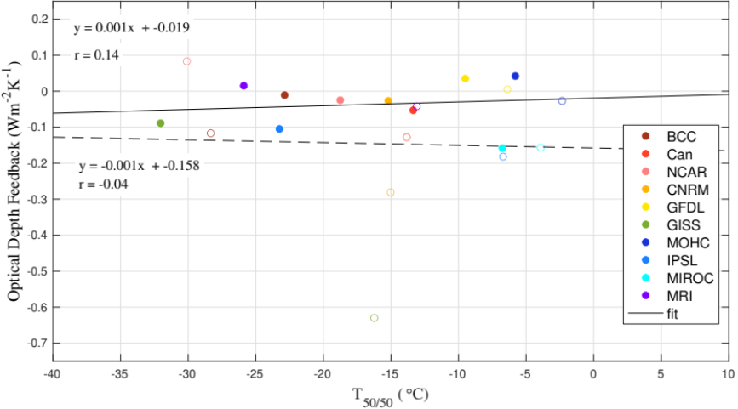

Supplementary References
1. Cesana, G. et al. Using in situ airborne measurements to evaluate three cloud phase products derived from CALIPSO. J Geophys Res 121, 5788–5808 (2016).
2. Hu, Y. et al. Occurrence, liquid water content, and fraction of supercooled water clouds from combined CALIOP/IIR/MODIS measurements. Journal of Geophysical Research Atmospheres 115, 1–13 (2010).
3. Stubenrauch, C. J. et al. Assessment of global cloud datasets from satellites. Bull Am Meteorol Soc 94, 1031–1049 (2013).
4. Naud, C. M. et al. Thermodynamic phase profiles of optically thin midlatitude clouds and their relation to temperature. 115, 1–14 (2010).
5. Shupe, M. D. Clouds at Arctic Atmospheric Observatories. Part II: Thermodynamic Phase Characteristics. J Appl Meteorol Climatol 50, 645–661 (2011).
6. Silber, I. et al. The prevalence of precipitation from polar supercooled clouds. Atmos Chem Phys 21, 3949–3971 (2021).
7. Korolev, A. et al. Mixed-Phase Clouds: Progress and Challenges. Meteorological Monographs 58, 5.1-5.50 (2017).
8. Moss, S. J. & Johnson, D. W. Aircraft measurements to validate and improve numerical model parametrisations of ice to water ratios in clouds. Atmos Res 34, 1–25 (1994).
9. Jourdan, O. et al. Coupling of the microphysical and optical properties of an Arctic nimbostratus cloud during the ASTAR 2004 experiment : Implications for light ‐ scattering modeling. 115, 1–16 (2010).
10. Mioche, G. et al. Vertical distribution of microphysical properties of Arctic springtime low-level mixed-phase clouds over the Greenland and Norwegian seas. Atmos Chem Phys 17, 12845–12869 (2017).
11. Cesana, G. V., Ackerman, A. S., Fridlind, A. M., Silber, I. & Kelley, M. Snow Reconciles Observed and Simulated Phase Partitioning and Increases Cloud Feedback. Geophys Res Lett 48, 1–11 (2021).
12. Cesana, G. V. & Del Genio, A. D. Observational constraint on cloud feedbacks suggests moderate climate sensitivity. Nat Clim Chang 11, 213–218 (2021).
13. Klein, S. A., Hall, A., Norris, J. R. & Pincus, R. Low-Cloud Feedbacks from Cloud-Controlling Factors: A Review. Surv Geophys 38, 1307–1329 (2017).
14. Myers, T. A. et al. Observational constraints on low cloud feedback reduce uncertainty of climate sensitivity. Nat Clim Chang 11, 501–507 (2021).
15. Boville, B. A., Rasch, P. J., Hack, J. J. & Mccaa, J. R. Representation of Clouds and Precipitation Processes in the Community Atmosphere Model Version 3 (CAM3). (2006).
16. Voldoire, A. et al. The CNRM-CM5.1 global climate model: Description and basic evaluation. Clim Dyn 40, 2091–2121 (2013).
17. Rotstayn, L. D., Ryan, B. F. & Katzfey, J. J. A Scheme for Calculation of the Liquid Fraction in Mixed-Phase Stratiform Clouds in Large-Scale Models.
18. del Genio, A. D., Yao, M.-S., Kovari, W. & Lo, K. K.-W. A Prognostic Cloud Water Parameterization for Global Climate Models. J Clim 9, 270–304 (1996).
19. Webb, M., Senior, C., Bony, S. & Morcrette, J. J. Combining ERBE and ISCCP data to assess clouds in the Hadley Centre, ECMWF and LMD atmospheric climate models. Clim Dyn 17, 905–922 (2001).
20. le Treut, H. & Li, Z.-X. Sensitivity of an Atmospheric General Circulation Model to Prescribed SST Changes: Feedback Effects Associated with the Simulation of Cloud Optical Properties*. Climate Dynamics vol. 5 (1991).
21. K-1 Coupled GCM (MIROC) Description K-1 Model Developers.
22. Zelinka, M. D. et al. Causes of Higher Climate Sensitivity in CMIP6 Models. Geophys Res Lett 47, 1–12 (2020).
23. Guzman, R. et al. Direct atmosphere opacity observations from CALIPSO provide new constraints on cloud-radiation interactions. J Geophys Res 122, 1066–1085 (2017).

