Thermal Design for the New Era of Lunar Instruments: Lessons Learned from NASA Goddard Space Flight Center’s Instrument Design Laboratory
Kan Yang, Liz Matson, Hume Peabody, Michael Choi, David Steinfeld, Brian Ottens
NASA Goddard Space Flight Center, Greenbelt, MD, 20771
Patrick Coronado
Technology Project Managers, Inc. Silver Spring, MD 20910

and
Scott Appelbaum
KBR Inc., Greenbelt, MD 20770
As NASA enters the Age of Artemis, the resurgence of interest in the Moon has not only contributed to rapid development of crewed vehicles and habitats, it has also inspired a design renaissance for robotic and astronaut-deployed instrumentation for the lunar surface. NASA Goddard Space Flight Center’s Instrument Design Laboratory (IDL) has been at the forefront of lunar instrument concept design, and in recent years has used its collaborative and concurrent process to design instruments ranging from small devices held or worn by astronauts to large lander-mounted or rover-mounted instruments with multiple scientific or technical functions. This paper explores the wide spectrum of lunar instruments studied by the IDL within the past few years and their thermal design nuances. A series of lessons learned will be used to categorize the general trends prevalent across lunar-specific design and the thermal and systems-level drivers for instrumentation on the surface of the Moon. While the instruments investigated in this work are not named due to their competition sensitivity and proprietary nature, it is hoped that the lessons learned captured here will help identify specific design drivers and areas of focus for the thermal and systems engineers designing the next generation of lunar instrumentation.

Nomenclature
ALSEP = Apollo Lunar Surface Experiments Package
A/L = Cross-sectional area over length
CLPS = Commercial Lunar Payload Services
ESA = European Space Agency
EVA = Extra-vehicular Activity
GSFC = Goddard Space Flight Center
IDC = Integrated Design Center
IDL = Instrument Design Laboratory
NASA = National Aeronautics and Space Administration
PI = Principal Investigator
PLSS = Primary Life Support System
RTG = Radioisotope Thermoelectric Generator
TMG = Thermal Micrometeoroid Garment
VIPER = Volatiles Investigating Polar Exploration Rover
xEMU = Exploration Extravehicular Mobility Unit

Introduction
T
HE Age of Artemis has produced a resurgence of interest in science instrumentation for the lunar surface. Announcements of opportunities for human-deployed instruments on Artemis III and IV, as well as opportunities for surface instrumentation on the Volatiles Investigating Polar Exploration Rover (VIPER) and numerous commercial landers have generated a flurry of activity in instrument design. The European Space Agency (ESA) estimates that there are more than 100 planned missions to the Moon by governmental and private entities by 2030¹. The lunar surface is also one of the most challenging environments to design for, with scorching lunar days and frigid nights that last for up to 14 Earth days. This has required robust application of spaceflight engineering best practices, engineering creativity, and incorporation of lessons learned from previously flown surface instrumentation dating to the Apollo Lunar Surface Experiments Package (ALSEP), first flown on Apollo 12.
The National Aeronautics and Space Administration (NASA) maintains multiple design laboratories across its field centers to conceptualize instruments which make measurements across the electromagnetic spectrum. At Goddard Space Flight Center (GSFC)’s Integrated Design Center (IDC), the Instrument Design Laboratory (IDL) uses a collaborative and concurrent design process developed and continuously refined since 1997 to rapidly generate instrument solutions. Thermal engineers are an integral part of this process, performing rapid analysis and identifying thermal control methods over the course of a one-to-two-week-long study to facilitate the design team’s progress towards a closed solution.
Since 2003, The IDL has performed 19 lunar instrument studies, with 10 of those studies being within the last five years. The current work explores lessons learned from the conceptualization of these instruments and summarizes considerations for lunar-specific design as well as the thermal and systems-level drivers for engineering resources, such as mass, volume, and power. For the thermal design of each studied instrument architecture, work was performed by a mid-career or senior thermal engineer who documented their resource estimates and listed their risks and concerns. The trends and themes observed in these studies are consolidated in the lessons learned presented in the next section.

Lessons Learned
The top six high-level lessons learned are listed below. These themes were consistently observed through successive IDL lunar instrument studies, and are discussed in detail in the following subsections:
- Instrument design is landing-site-dependent, especially at polar or near-polar locations.
- Instrument power consumption directly impacts mass and its ability to be accommodated for flight opportunities.
- Instrument power required for operation through lunar night may be comparable to that required for survival through lunar night.
- Astronaut-deployed or astronaut-operated instruments require design for astronaut touch temperature requirements and other interdisciplinary considerations.
- For astronaut-operated instruments, the concept of operations and duration of usage are the primary drivers for power systems and thermal design.
- All mission scenarios, including when the instrument is powered off during transport to the Moon or during stowage on the lunar surface, must be considered in the thermal design.

- Instrument design is landing-site-dependent, especially at polar or near-polar locations.

Illumination from the Sun and Earth vary greatly based on landing location. Near the lunar equator, an assumption of 14 Earth days per lunar day and 14 Earth nights per lunar night is consistent with actual illumination conditions; daytime illumination may have some variance based on local topography and shadowing. However, this assumption does not hold true at polar and near-polar sites. Figure 1 from Mazarico et al.² shows the average percent illumination at the lunar south pole over four lunar node precession cycles, each 18.6 years long, spanning the years between 1970-2044. As seen from the figure, the low position of the sun on the horizon near the lunar south pole causes average illumination to be largely dependent upon topography. At ridges, illumination may approach 100%, whereas basins may be permanently shadowed. Thus, the thermal and power systems designs are highly dependent on their intended landing environment. At sites of greater illumination, a traditional power system design may allow for smaller solar arrays and smaller batteries, as less power storage is needed through shorter lunar nights to keep sensitive components warm. However, with areas of less than average illumination, large solar arrays may be needed for power generation, and larger batteries may be needed to survive longer duration lunar nights, which also drives greater thermal heater power as batteries tend to have strict thermal limits to ensure longevity. If multiple landing sites are being explored for scientific potential, even at the conceptual design stage, separate power systems and thermal control solutions may be required for each site. Instrument designers cannot simply expect that one thermal design optimized for a particular polar site can perform similarly when transplanted to another site. In each scenario, illumination modeling needs to be performed accounting for the positions of the Sun and Earth relative to the lunar terrain by a flight dynamicist, then the design solution can be iterated between the power systems and thermal disciplines, accounting for the local direction and intensity of solar illumination and temperatures of the local environment. Design margin also requires careful consideration from the thermal engineer. Two important considerations are degradation due to lunar dust on sensitive thermal surfaces and the precision of landing at the intended site. For the former, descent engines can perturb large amounts of lunar dust upon landing; this dust can deposit upon the radiators and degrade the thermo-optical properties of their coating, as well as the solar arrays which affect power generation. Dust is also known to be electrostatically suspended in the lunar exosphere, and the passing of the day-to-night or night-to-day terminator over the landing site may cause additional dust to deposit on lander surfaces. For the lunar north or south poles, one additional area of concern is the precision of lunar landing: if the lander does not precisely touch down at the desired landing site or at the optimal attitude, illumination conditions may be different than desired or intended for in the instrument design. To mitigate some of the thermal impacts of this scenario, the thermal engineer may consider designing for greater margins to ensure survival or may need to design for the worst-case in the geographic landing ellipse, which can extend beyond margins. However, the engineer needs to maintain a delicate balance between designing for contingency and engineering resource growth, which can impact opportunities for flight.
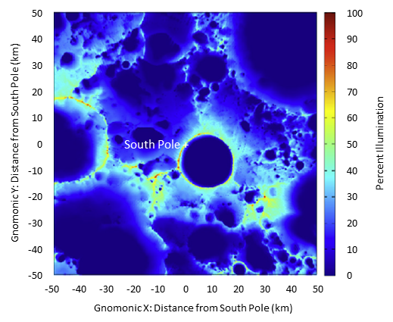
Figure 1. Lunar South Pole average illumination over four 18.6-year cycles, from Mazarico et al². The projection is gnomonic.

One final design distinction for long-surviving instruments concerns the range of temperatures between day and night at the landing location. As shown by Figure 2, there is a significant temperature variation between maximum at lunar noon and minimum at lunar 5:00 AM for the equator (0° latitude); average surface temperature at noon is as high as 390 K, whereas at night is as low as 100 K, a difference of 290 K. The variation at the 85° latitude near-polar location is much less: average surface temperatures are 150 K at lunar noon versus 65 K at lunar 5:00 AM. Design for the equator requires greater engineering robustness than the poles. Large radiators are needed to reject heat to the warmest environments during lunar day, whereas despite best efforts for isolation at night, the heat losses to the environment from those large radiators can drive heater power consumption. At the equator, it is also much more difficult to find a direction to point flat radiators for a consistent cold view, as almost every direction will have a view to the sun or warm regolith at some point in the lunar day, although O’Connor and Abel have investigated some unique radiator shapes to provide greater heat rejection capacity and help address this problem³. For near-polar locations, where daytime-to-nighttime temperature variability is not as high, smaller radiators can be used for daytime rejection, leading to conservation in heater power for lunar night. The sun angle is also low, allowing for more directions to point the radiator for a consistent cold view, and the smaller temperature variation makes these locations more attractive for long-surviving instruments.

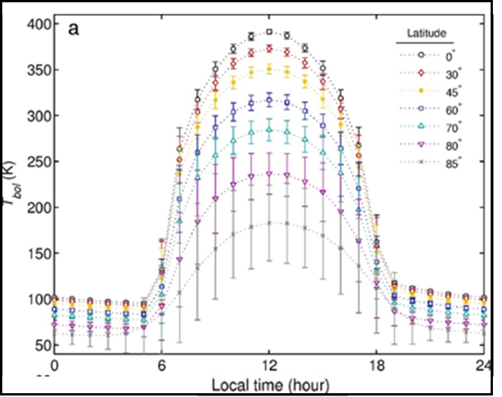
Figure 2. Lunar surface temperature variation based on latitude and local time, from Williams et al.⁴

- Instrument power consumption directly impacts mass and its ability to be accommodated for flight opportunities.

On the lunar surface, oftentimes the most precious engineering resource is power. Power generation and storage through traditional solar arrays and batteries is currently suitable for short-lived low-power instruments on the Moon. Longer mission lifetimes require survival through one or more cycles of lunar day and night; these typically require large power storage capacity, with battery mass as a high percentage of total mass. Larger instruments require successively higher survival power demands, and after a certain threshold, battery mass and volume can become impractical. However, despite other power generation methods being available at various technological maturity levels, such as radioisotope thermoelectric generators (RTG) and spaceborne nuclear fission reactors, as of this writing, solar arrays and batteries are still the most mature technology for instruments which require high levels of power consumption on the lunar surface. Although RTGs have ample flight heritage, procurement of multiple RTGs for high-power instruments can prove to be difficult both politically and with regards to schedule.
A survey of the 19 previous IDL lunar instrument designs to explore the relationship between instrument and battery mass and nominal operational power is shown in Figure 3. Operational power is defined as operational dissipations of the onboard electronics, mechanisms, heaters, and other power-consuming components at a nominal duty cycle. In this figure, different symbols are used to denote three separate categories of instruments: those which are designed for long-term survival (multiple lunar day/night cycles) at a polar or near-polar landing site, those which are designed for long-term survival at a near-equatorial landing site, and those which are used for short deployments at a polar landing site. There were no IDL studies that focused on short-term use at an equatorial landing site. A few instrument designs also did not have a battery mass calculated as part of the design study, but rather held liens on the rovers or landers on which they were mounted to provide power. For this exercise, a first-order mass estimate for an external battery was calculated based on the survival power needs estimated for that instrument from the study.

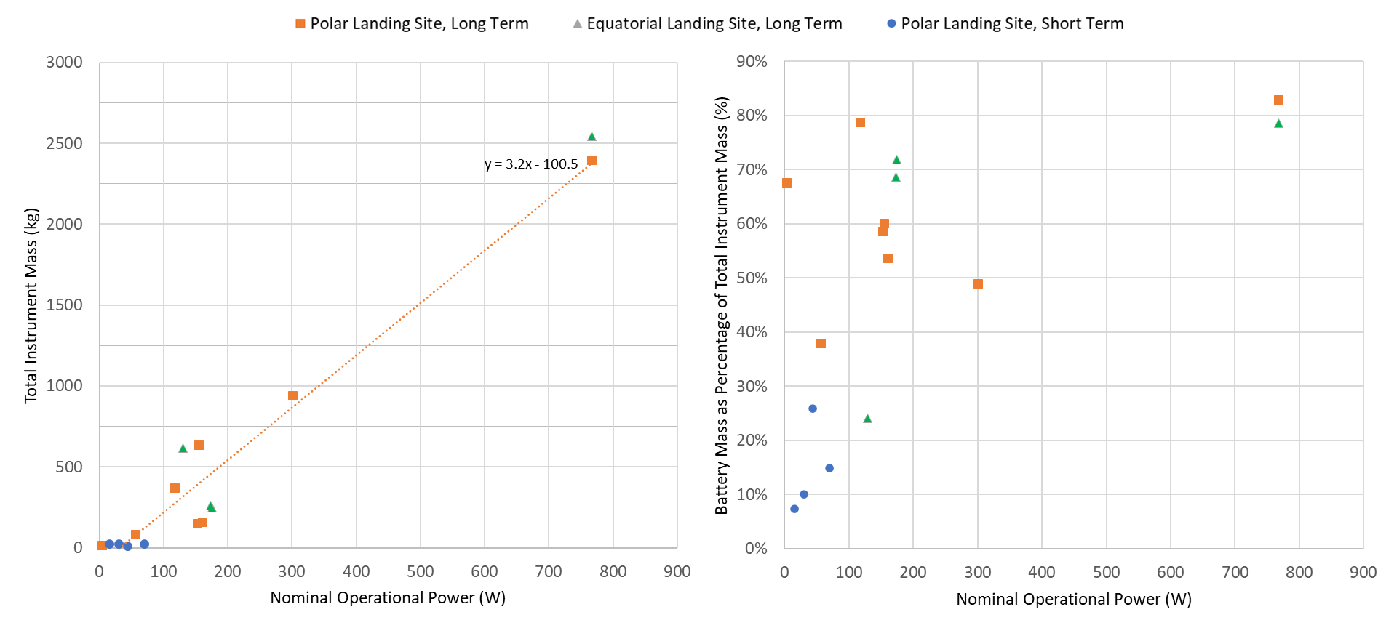
- (b)
Figure 3. Survey of IDL lunar instrument designs for (a) total instrument mass versus nominal operational power, (b) battery mass as a percentage of total instrument mass versus nominal operational power

Reviewing Figure 3(a), a few trends become apparent. For the long-term instruments, one can observe linear growth of the instrument mass as the nominal operational power increases. This is to be expected, as greater instrument mass typically implies greater complexity and functionality of the instrument architecture, which in turn leads to greater power consumption. A trend line was added for the long-term polar landing site instruments, showing the general adherence of these instrument point designs to the relationship of mass versus power. For most of the instruments surveyed here, their power is assumed to be at survival values during lunar night, although a few are designed to operate through night periodically or continuously. A surprising revelation is that long-term instruments for equatorial landing sites are not dramatically more massive than those for polar or near-polar sites; from the previous section, it was expected that the larger temperature swings for equatorial sites would always drive greater battery masses. However, the long-term equatorial landing site instruments follow relatively closely to the general trend of the polar/near-polar landing site instruments, implying that duration of lunar night, rather than parasitic heat loss at any given time, are what drive battery size. Indeed, lunar instruments are generally designed to be as isolative as possible between temperature sensitive components and the surrounding environment for nighttime survival. Another observation of note concerns the short-term polar landing site instruments: these short-lived instruments have their designs driven much more by their concept of operations rather than survivability through lunar night. As a result, power and specifically power storage do not seem to be a large driver for mass, although in this respect, IDL studies may provide too small of a sample size to determine trend.
Figure 3(b), which compares battery mass as a percentage of total instrument mass to nominal operational power, provides a starker divide between the three categories of instruments studied. Short-term polar landing site instruments generally have battery masses ranging from 7% to 26% of the total instrument mass, with an average of 15%, since these batteries are only sized for daytime operations. Long-term polar landing site instruments have battery masses around ranging from 38% to 83% of total instrument mass; although there is significant scatter in these results, the average is 61%. For long-term equatorial landing site instruments, battery mass is ranging from 69% to 79% of total instrument mass, with one very notable exception: as seen from the plot, there is an instrument with 615 kg mass and only 24% of its total mass devoted to the battery. This particular instrument study focused on a large astronaut-deployed radio interferometer for the lunar surface, with three long antenna arms extending from a central hub. The structural mass of these arms contributed to over 1/3 of the mass of the entire instrument, but these did not require any active power or thermal control. As such, the battery mass required to provide component operational power and thermal heater power solely within the central hub volume was a smaller proportion of total mass.
These observed trends between power and mass emphasize the criticality of minimizing power for long-surviving lunar surface instrumentation to improve likelihood of selection for flight. Science instruments that hope to operate or survive through lunar night should aim to minimize power consumption, parasitic heat loss, and exposed radiative surfaces, as the trendline effectively indicates that mass (kg) has a factor-of-three scaling with respect to power (W). Current planned Commercial Lunar Payload Services (CLPS) delivery capabilities have payload mass constraints between 50 kg on the smallest lander and 625 kg on the largest lander, with most landers averaging around 130 kg capacity. Interpolating from the trendline, this would indicate that a long-surviving instrument should be designed to less than 225 W of nominal power to fit within the 625 kg box, and less than 70 W to fit within the 130 kg average lander payload mass capacity. For ease of accommodation, the instrument should also aim to minimize liens on a rover or lander, as they may either be encountering the same thermal and power challenges, or only be designed to survive through lunar day.

- Instrument power required for operation through lunar night may be comparable to that required for survival through lunar night.

A common desire for instruments placed on the lunar surface, whether residing on a lander or rover, or placed by an astronaut, is the periodic gathering of data through lunar night. Data acquisition in lunar night is attractive for science, as many surface and sub-surface properties change with transition to darkness and frigid temperatures. The request for periodic data acquisition, as opposed to continuous acquisition, is often due to the consideration from the Principal Investigator (PI) for power savings: survival up to 14 Earth days of lunar night is extremely demanding on battery power, and conventional wisdom would suggest that reduced number higher-power data acquisition operations, peppered periodically through long periods of survival, would reduce overall load on the battery. However, the studies in the IDL which have explored long-term survival on the lunar surface have consistently shown that full operation through lunar night is nearly as power-demanding as survival through lunar night.
For the thermal design of long-term instruments on the lunar surface, its radiator is sized to be able to reject the full heat load from daytime operations to a harshly warm environmental sink. Indeed, during lunar day, the surface temperature may be so high and provide so much backload that it would be preferable to position the radiator directly to zenith, despite the Sun’s heat flux directly impinging upon the radiator. However, during lunar night, a large radiator sized for worst-case hot lunar day operations is hugely disadvantageous to conserving thermal heat and battery power: this radiator promotes heat loss to the sink, whereas the goal for thermal design in lunar night is to retain as much heat as possible.
To address this problem, thermal control systems are often designed to transition into one that is as isolative as possible in lunar night. This may be achieved through a heat switch that disengages the conductive link between the sensitive electronics and the radiator at the lunar day-to-night terminator, or a loop heat pipe that switches off and minimizes transport of heat during lunar night. This can also be achieved with louvers on the radiator, or a combination of the above methods. However, even with this isolation, the amount of heat required to counter parasitic heat flow and ensure instrument survival may not be very different for operational versus survival temperatures, since the survival heater needs to make up heat in amounts that may be similar to that dissipated by the onboard instrumentation during operations. As a simple thought experiment, consider the thermal design example in Figure 4, where instrument electronics are tied to a radiator exposed to the lunar environment via the following conductive path: a copper heat strap, a heat switch, and another copper heat strap.
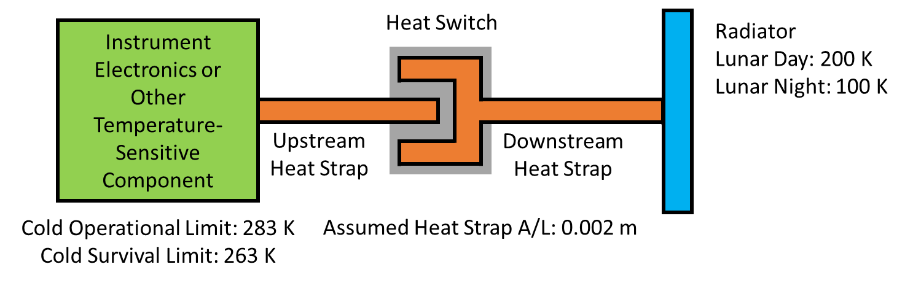
Figure 4. Thermal Design Example for Conductive Linkage on Long-Term Lunar Instrument

In this example, it is assumed that the cold operational temperature limit for the electronics box on the left-hand side is 283 K (10°C), whereas the cold survival temperature limit is 263 K (-10°C). The cross-sectional area over length (A/L) of the heat strap is 0.002 m. During lunar day, when the heat switch is engaged, if we assume that the heat switch allows perfect heat conductance between the two ends of the heat strap and the radiator is at 200 K thermal equilibrium with its surrounding environment, the amount of heat required to maintain the cold operational limit at the electronics box interface to the heat strap is 67 W, versus 50 W to maintain at the survival limit. However, at lunar night, the heat switch is disengaged. If we assume that the open heat switch results in a conductive path from the electronics box to the radiator that is a 10:1 turn down ratio from its daytime conductance, and the radiator settles to a 100 K equilibrium temperature, this results in 15 W and 13.4 W to maintain the electronics box interface to the heat strap at its operational and survival limit, respectively. This implies that there is only a 1.6 W difference to operate the electronics box versus keep it at survival in lunar night. Heat switch performance to conductance has a linear relationship: at 5% of its daytime conductance, the gap between heat required to keep at operational and survival temperatures narrows to only 0.8 W. Therefore, if operation through lunar night requires similar power draw to maintaining a survival heater, it may be logical from a resource standpoint to continue active operations through lunar night. However, this should be evaluated on a case-by-case basis per instrument; if there is a large temperature difference between allowable operational and survival limits, or if operating through night results in unacceptable battery size growth, it may be more sensible to survive through lunar night.
A few additional design nuances unique to thermal survival in lunar night were observed over the series of IDL studies. One of these concerns exposed mechanisms, such as those that activate gimbals for antenna pointing. These mechanisms are mostly exposed to the environment and often do not include volumetric accommodations to include a heat switch or other active isolation. To conserve heater power, the most effective thermal approach is to make the mechanism as conductively isolated as possible to its adjacent components, and as well-blanketed as possible for radiative isolation to the environment. There is also ample reason to avoid mechanism actuation during lunar night: often, lubricants drive the temperature at which the mechanisms can operate, and this may require heating from cold survival to operational temperatures, a difference that may be greater than 100 K depending on the lubricant. Additionally, heat leaks through harness penetrations and waveguides may be large sources of parasitic heat loss. This applies more broadly beyond mechanisms and requires detailed thermal assessment to determine their impact to the overall heat flow of the system. In recent planetary instrumentation, use of lower effective emissivity thermal blanketing, such has integrated multi-layer insulation (IMLI), has proven successful in reducing the radiative parasitic heat loss.

- Astronaut-deployed or astronaut-operated instruments require design for astronaut touch temperature requirements and other interdisciplinary considerations.

For design of instruments that require astronaut deployment and placement on the lunar surface or active astronaut interaction for data acquisition, any surfaces that the astronaut’s Exploration Extravehicular Mobility Unit (xEMU) suit may come into contact with requires strict adherence to the touch temperature requirements defined by NASA’s “EVA Office Exploration EVA System Compatibility” document (EVA-EXP-0035)⁵ and shown in Figure 5 for reference.

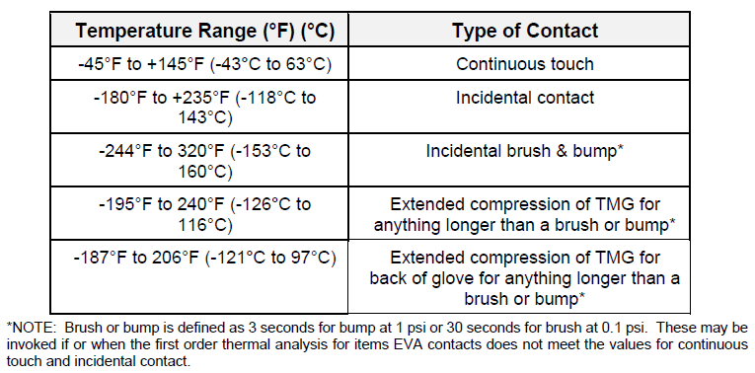
Figure 5. Touch temperature requirements for astronaut xEMU suit, as defined in Table 3.9.11-1 of NASA document EVA-EXP-0035 “EVA Office Exploration EVA System Compatibility” ⁵

For design of surfaces for astronaut interaction, these touch temperature requirements have multiple implications for thermal design. First, continuous touch surfaces such as handles may require active heating if their passive equilibrium temperature with the surrounding environment is below the lower bound of the touch temperature requirement. Conversely, they may require a larger radiative surface if their worst-case hot temperatures extend beyond the upper bound touch temperature requirement. Instrumentation panels, which may include display panels or switches, are equally subject to the temperature range requirements in Figure 5, the exact range depending on type of contact. These instrumentation panels are also exposed surfaces and act as effective radiators. Such surfaces require careful thermal analysis and design to ensure that heat flows to and from the environment via these surfaces are acceptable with regards to the overall thermal design, or liens on astronaut handling regarding placement or orientation with respect to the environment.
Astronaut-worn items require additional considerations beyond instruments handled with gloves. The focus of a prior IDL study concerned an astronaut-worn backpack with magnetometers mounted on telescoping booms, extending upwards from the backpack. Astronaut-worn items must be lightweight: if their mass contributes to a significant percentage of the total suit mass, they risk offsetting the astronaut center of gravity. Thermally, they must be isolative: depending on where the instrument attaches, the xEMU suit and the Primary Life Support System (PLSS) both have external temperature requirements and do not permit transfer of heat from an attached component across its attachment interface.
For this specific instrument case, the telescoping booms greatly increased astronaut profile. Thermal impacts from shadowing of the xEMU suit due to these booms required careful thermal analysis and consideration and encompassed a wide range of illumination scenarios. In an emergency ingress scenario, where the astronaut would immediately need to enter a lander or habitat due to any challenges with an EVA, if this worn instrument extends the astronaut’s profile beyond any ingress dimension, there would need to be a method for emergency release of the instrument from the astronaut suit. The addition of a release mechanism may also add complexity to the mechanical and thermal designs: apart from adding mass, mechanisms often require active heating for actuation and survival heat for maintenance of lubricant temperatures in the harsh lunar environment. Finally, any external surfaces for
astronaut-worn or astronaut-deployed instruments require usage of beta cloth to prevent glint from specular surface reflections. Beta cloth is not as effective in radiative isolation as conventional multi-layer insulation (MLI); losses through external surfaces must be accurately captured in the thermal analysis, or a selective combination of MLI and beta cloth or other approved diffuse outer layer material can be used to minimize heat leaks.

- For astronaut-operated instruments, the concept of operations and duration of usage are the primary driver for power systems and thermal design.

Astronaut-operated instruments are often designed for a single use or at most a few uses during planned EVAs. Astronaut time on the lunar surface is often the most precious resource; for Artemis Phase 1 (Artemis III and IV), EVAs will be between 4 to 8 hours, which includes transport time to the location of interest. Artemis III only plans for 2 to 5 EVAs total, with an even smaller subset devoted to science tasks⁶. If time spent with a single instrument requires a large fraction of the total EVA time, it makes the instrument less attractive for selection. From an engineering perspective, it also behooves the instrument team to minimize the instrument’s complexity and longevity and make its design very task-specific: the greater the robustness and versatility needed for the thermal design, the greater the mass and power consumption.
For lunar astronaut-operated instrument designs in the IDL, significant focus has been placed on understanding the concept of operations and its relation to required instrument operational power and thermal heater power. For multiple weeks prior to the start of any study, the systems, thermal, and power systems engineers will iterate and optimize the power profile, ensuring that the concept of operations will allow the instrument to meet its baseline science goals while echoing the earlier emphasis on minimizing mass and power for improved likelihood of selection. Power systems design for these instruments relies heavily on how often high-powered components are used for each scientific observation and what thermal operational or survival power is needed when the instrument is not actively acquiring science data. Often, the power system is sized to meet its exact intended power requirement during its mission lifetime plus margin: if a primary battery without the need for recharge can meet all power requirements, then the need for mass devoted to recharge architecture can be saved. Therefore, accurate understanding of power consumption and thermal behavior is essential to optimize the design, and the number and duration of high-power operations, such as those required to drive a communications system, laser, or x-ray source, should be minimized. Figure 6 shows an example instrument concept of operations for an astronaut sortie; in this example, instrument operations consume about 15 Watt-hours over the entire sortie.

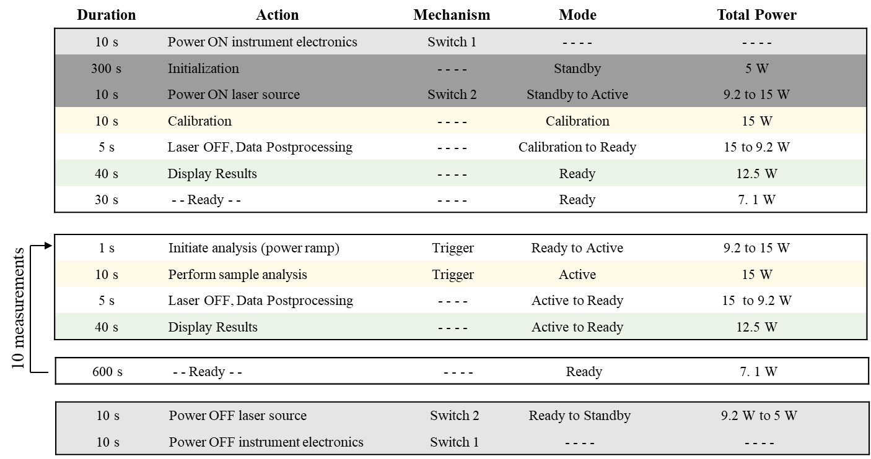
Figure 6. Example concept of operations for instrument usage on a 4-hour astronaut sortie with 2 hours of science acquisition and a sample analyzed every 10 minutes

From a thermal perspective, while the concept of operations dictates the overall heat dissipations and duration of usage for the instrument, there should be sufficient margin within the design to account for variability in environment. This variability may be due to changes in the astronaut’s motion or orientation, which could result in changes in angle with respect to heat sources and sinks, as well as local shadowing by natural lunar features (e.g., ridges, boulders) or from man-made lunar infrastructure (e.g., lunar habitat, lander), which may result in cooler environments. The assumption of the lunar surface temperature within thermal models may also not be accurate; typically, a model assumes a uniform surface temperature depending on latitude. However, there is ample spatial and temporal variation of surface temperature based on local topography. The thermal engineer may need to add additional margins depending on assumed worst-case environmental conditions to these surface temperature estimates to encompass the bounding cases for thermal design.

- All mission scenarios, including when the instrument is powered off during transport to the Moon or during stowage on the lunar surface, must be considered in the thermal design.

Instrument operations through lunar day and survival through lunar night are often considered to be the driving cases for worst-case hot and cold thermal designs. Yet, when the instrument is powered off for transport and stowage, thermal considerations may be as critical as when the instrument is in its main science operation, and these may be easily missed since they are non-operational cases.
During transit and landing, prior to initial instrument power-on on the lunar surface, the thermal design
worst-cases should be driven by whether the instrument resides internally to a temperature-controlled volume, or if the instrument is exposed to the external environment. If the instrument is internal to the spacecraft or lander, the full range of internal temperatures that the instrument is subject to during transport should be considered; if the storage temperature range extends beyond the survival temperatures of the instrument, especially as the instrument is powered off, a lien must be placed on the spacecraft or lander to keep the storage enclosure within acceptable temperatures. Otherwise, one or multiple survival heaters could also be sized within the instrument, with a lien on the spacecraft to provide power. If the instrument is external to the spacecraft and exposed to the environment in transit, this instrument must undergo the same thermal design considerations as orbiting spacecraft-mounted instruments, including considerations of worst-case orientations in transit with respect to heat flux from celestial objects. This may also involve liens on the spacecraft as to orientations, interfaces, and surrounding hardware that the instrument views.
For astronaut-deployed instruments used for multiple EVAs, storage conditions between EVAs also need to be fully understood. Since contamination from lunar dust and other considerations typically prohibit lunar surface instrumentation from entering a lunar habitat, instruments may be stored in a passive or active temperature-controlled compartment external to the habitat, or simply left on the lunar surface. For storage within a compartment, thermal designs will need to account for the full range of temperatures that the instrument will experience within, and whether additional survival heater power is required. When left on the lunar surface, power for survival heat during dormant periods must be provided by the onboard instrument battery or an external power source.

Conclusion
Six top-level lessons learned have been presented in this work as a summary of recurring themes from lunar surface instrument designs spanning more than two decades in the IDL. The paper places focus on the drivers for engineering resources in the instrument design, with emphasis that the following design decisions will improve the possibility to be selected for flight:
- Minimizing instrument power
- Designing for the specific landing environment
- Incorporating astronaut accommodations and touch temperature requirements
- Designing for all mission scenarios, including those for transport and stowage
- Avoiding survival though lunar night if possible
- Creating an isolative design that minimizes parasitic heat loss and exposed radiative surfaces if survival through lunar night is necessary.
The Artemis Program is a grand endeavor that will revolutionize humankind’s technical ability to live for long durations on another celestial body and our collective scientific understanding about our natural satellite. Scientific instruments are a critical element in that vision: the technological returns from their development as well as the meaningful scientific data from their use on the lunar surface will have long-lasting benefits for humanity. As instrument design and selection for lunar missions intensifies, it is hoped that these lessons learned will help engineers avoid design pitfalls, understand specific thermal design drivers and focus areas, and design purpose-built and prioritized lunar instrumentation.

Acknowledgments
We would like to thank Liz Matson for her leadership and encouragement of this work. The authors would also like to acknowledge the contributions of the previous IDC Manager, Jennifer Bracken, and the previous Team Leads of the Instrument Design Laboratory, Rachel Rivera and Tammy Brown, under which a majority of this study work was completed. We would finally like to acknowledge all the contributions of the PIs, scientists, and engineers over the IDL’s history who defined the requirements and executed the technical implementation of these studies.

References
¹ESA Newsroom and Media Relations. N° 25–2023: Europe is aiming for the Moon. 3 June 2023. Accessed 28 March 2024. URL: https://www.esa.int/Newsroom/Press_Releases/Europe_is_aiming_for_the_Moon.
²Mazarico, Erwan, et al. "Illumination conditions of the lunar polar regions using LOLA topography." Icarus Vol. 211 (2011): 1066-1081.
³O'Connor, B. and Abel, E. "Radiator Study for Stationary Lunar Landers." NASA's Thermal and Fluids Analysis Workshop. Houston, TX, 2010.
⁴Willams, J.P. et al. "The global surface temperatures of the Moon as measured by the Diviner Lunar Radiometer Experiment." Icarus, Vol. 283 (2017): 300-325.
⁵NASA EVA Office. Exploration EVA System Compatibility, EVA-EXP-0035. Houston, TX: National Aeronautics and Space Administration, Johnson Space Center, 2018.
⁶Exploration EVA System Concept of Operations, EVA-EXP-0042 Rev. B. Houston, TX: National Aeronautics and Space Administration, 2020.

Team Lead, Instrument Design Laboratory, NASA/GSFC, Code 550.
Integrated Design Center Manager, Engineering and Technology Directorate, NASA/GSFC, Code 500.
Senior Thermal Engineer, Thermal Engineering Branch, NASA/GSFC, Code 545.
Senior Thermal Engineer, Thermal Engineering Branch, NASA/GSFC, Code 545.
Chief Engineer, Thermal Engineering Branch, NASA/GSFC, Code 545
Instrument Systems Engineer, Systems Engineering Services and Advanced Concepts Branch, NASA/GSFC, Code 592.
Instrument Systems Engineer, Technology Project Managers, Inc.
Instrument Systems Engineer, KBR, Inc.

