Evaluation of the Interference of Tenax®TA Adsorbent with Dimethylformamide Dimethyl Acetal Reagent for Gas Chromatography-Dragonfly Mass Spectrometry and Future Gas Chromatography-Mass Spectrometry in situ Analysis.
D. Boulesteix^{1,*}, A. Buch^{1,*}, N. Ruscassier¹, C. Freissinet², M. G. Trainer³, D. Coscia², S. Teinturier³, J. C. Stern³, Y. He¹, M. Guzman¹, C. Szopa²
¹ Laboratoire Génie des Procédés et Matériaux, CentraleSupélec, University Paris-Saclay, 8-10 rue Joliot-Curie, 91190, Gif-sur-Yvette, France
² LATMOS/IPSL, UVSQ University Paris-Saclay, Sorbonne University, CNRS, 11 Bd d’Alembert, 78280, Guyancourt, France
³ Solar System Exploration Division (Code 690), NASA, Goddard Space Flight Center, Greenbelt, MD, 20771, USA
* Corresponding co-authors. E-mail addresses: david.boulesteix@centralesupelec.fr (David Boulesteix), and arnaud.buch@centralesupelec.fr (Arnaud Buch)
Abstract
Among future space missions, national aeronautics and space administration (NASA) selected two of them to analyze the diversity in organic content within Martian and Titan soil samples using a gas chromatograph – mass spectrometer (GC-MS) instrument. The Dragonfly space mission is planned to be launched in 2027 to Titan’s surface and explore the Shangri-La surface region for years. One of the main goals of this mission is to understand the past and actual abundant prebiotic chemistry on Titan, which is not well characterized yet. The ExoMars space mission is planned to be launched in 2028 to Mars’ surface and explore the Oxia Planum and Mawrth Vallis region for years. The main objectives focus on the exploration of the subsurface soil samples, potentially richer in organics, that might be relevant for the search of past life traces on Mars where irradiation does not impact the matrices and organics. One recently used sample pre-treatment for gas chromatography – mass spectrometry analysis is planned on both space missions to detect refractory organic molecules of interest for astrobiology. This pre-treatment is called derivatization and uses a chemical reagent – called dimethylformamide dimethyl acetal (DMF-DMA) – to sublimate organic compounds keeping them safe from thermal degradation and conserving the chirality of the molecules extracted from Titan or Mars’ matrices. Indeed, the detection of building blocks of life or enantiomeric excess of some organics (e.g. amino acids) after DMF-DMA pre-treatment and GC-MS analyses would be both bioindicators. The main results highlighted by our work on DMF-DMA and Tenax®TA interaction and efficiency to detect organic compounds at ppb levels in a fast and single preparation are first that Tenax®TA did not show the onset of degradation until after 150 experiments – a 120 h at 300 °C experiment – which greatly exceeds the experimental lifetimes for the DraMS and GC-space in situ investigations. Tenax®TA polymer and DMF-DMA produce many by-products (about 70 and 46, respectively, depending on the activation temperature). Further, the interaction between the two leads to the production of 22 additional by-products from DMF-DMA degradation, but these listed by-products do not prevent the detection of trace-level organic molecules after their efficient derivatization and volatilization by DMF-DMA in the oven ahead the GC-MS trap and column.

Keywords: DraMS-Dragonfly mission, in situ environmental analyses, GC-MS, Tenax®TA trap, DMF-DMA reagent robustness and ageing.
- Introduction
  - Gas chromatography-space analysis
Exploration missions centered on an astrobiology purpose look for a potential past trace of life (Mars), a potential present trace of life (Europa and Enceladus), or a prebiotic chemistry (Titan). This prebiotic chemistry consists of the complexification of the organic matter in contact with a solvent, such as (ammonia)-water to produce polymers essential to form primitive cells similar to Earth 3.7 billion years ago. Future space explorations (e.g. Dragonfly mission to Titan and ExoMars mission to Mars) will detect and quantify complex organics relevant to understand the mechanisms implied in the first steps of life formation and evolution. For instance, amino acids are one of the targets as they constitute proteins necessary for life [1]. Hence, astrobiological missions carry out scientific instruments to reach a complementarity in the results and interpret data with robustness. Among these analytical techniques, the gas chromatography – mass spectrometry (GC-MS) instrument enables the identification of the organic bulk from a complex matrix.
GC-MS analysis has primarily been selected for Mars missions (the current Mars Science Laboratory (MSL) mission with its Sample Analysis at Mars (SAM) instrument [2,3] and the future ExoMars mission with its Mars Organic Molecule Analyzer (MOMA) instrument [4–6], for instance). Current and future missions boarding a GC-MS device have a similar path flow for sample analysis. First, the drilling system will collect powdered samples. These samples are transferred into GC cups that can see different sample pre-treatments: i) pyrolysis (up to 850 °C for SAM), ii) wet chemistry derivatizations/thermochemolysis (using dimethylformamide dimethyl acetal (DMF-DMA) by MOMA and DraMS (Dragonfly mass spectrometer) [7–9], N-tert-butyldimethylsilyl-N-methyltrifluoroacetamide (MTBSTFA) by SAM and MOMA [10], tetramethylammonium hydroxide (TMAH) by SAM, MOMA, and DraMS, or trimethylsulfonium hydroxide (TMSH) potentially by DraMS and future space missions) [11]. During the treatment of the (polar or refractory) organic molecules in the cups, the volatiles are continuously trapped into chemical adsorbent trap(s) to be pre-concentrated at cold temperature (0-40 °C) before their instantaneous release at 300 °C in the GC-MS device.
On Earth and beyond, temperature, meteorite or particle impacts and irradiation degrade organic compounds. These energy sources allow atoms and molecules to recombine (modify molecular or organo-mineral bonds). On extraterrestrial surfaces, the sample pre-treatments and Pyr-GC-MS analyses will behave similarly to laboratory experiments in space-like devices because the physical-chemical parameters are kept under Earth atmosphere (~25 °C at 1 bar for the pyrolyzer and 25-300 °C for the GC oven and transfer lines). Therefore, the off-Earth physical and chemical environments will not differ from Earth experiments and will not affect the processes evaluated in this study.
  - Dragonfly mission and DraMS instrument specific case
Dragonfly is a National Aeronautics and Space Administration (NASA) New Frontiers mission exploring Titan. Dragonfly is expected to be launched in 2027 [12] to reach Titan in the mid-2030s. The Dragonfly rotorcraft will explore Titan, the largest moon of Saturn, first visited in the 2000s by Cassini-Huygens, a combined orbiter and probe analyzing the physical and chemical characteristics of the dense atmosphere of Titan. Dragonfly will explore different surface locations within the Shangri-La region and the Selk impact crater [12,13]. Dragonfly science objectives are described in full by Barnes et al. [12]. The mission’s main scientific goals will be to investigate Titan's prebiotic chemistry, habitability, and search for potential chemical bioindicators and biosignatures. These indicators include building blocks of life, such as amino acids, fatty acids, sugars, nucleobases, or any degradation products coming from potential life as metabolites [12,14,15].
The Dragonfly rotorcraft carries four instruments in its scientific payload. Among these, the DraMS will be the chemical analyzer of the mission, primarily dedicated to determining the molecular composition of surface samples that will be collected at different locations by the pneumatic sampling system, called Drill for Acquisition of Complex Organics (DrACO) [14,16]. DraMS is an ion trap mass spectrometer, and it will perform measurements of the molecular composition of atmospheric, dune, inter-dune, or icy samples, using either a Laser Desorption ionization – Mass Spectrometry mode (LD-MS) [14] or a Gas Chromatography – Mass Spectrometry mode (GC-MS) [12]. These analytical approaches and the DraMS implementation have a high heritage derived from current and planned surface missions on Mars [3,4] and the Huygens probe [17]. Organic molecules DraMS analyses will be supported by measurements of the bulk surface composition, characterization of the local environment, and contextual imaging of the landing site region and sampling area, provided by the Dragonfly Gamma Ray and Neutron Spectrometer (DraGNS), the Dragonfly Geophysics and Meteorological package (DraGMet), and the Dragonfly Camera Suite (DragonCam), respectively [12].
DraMS will perform analytical investigations on solid samples by three complementary modes (LD-MS and GC-MS modes). The DraMS atmospheric mode will enrich atmospheric samples to measure relative abundances of noble gases (Ne, Ar, Kr, Xe), and is not addressed in this work. The LD-MS mode uses laser desorption-ionization to measure the high molecular weight organics present at the surface of sandy/icy Titan samples with the minimal sample processing [14]. In contrast, the DraMS GC-MS analysis mode begins with a sample pre-treatment that volatilizes/sublimates organics, using either pyrolysis or a wet chemistry process with DMF-DMA or tetra/trimethyl ammonium/sulfonium hydroxide (TMAH/TMSH) derivatization reagents. The volatile analytes are then transferred to a gas chromatograph to separate organics via one of two GC columns [18]. Finally, the volatilized and separated organics are analyzed by the MS instrument. The chemical derivatization reagents are stored in capsules that release their content once the capsules in the oven reach a pre-determined eutectic point (here, 145 °C). The capsules and delivery of the agent to the sample within the oven are based on Mars Organic Molecule Analyzer (MOMA) design [4].
  - Challenges using DMF-DMA derivatization for in situ space analyses
On future GC-space instruments (such as DraMS), once the derivatization step is complete, volatile compounds present in the oven flow into a thermal-desorption trap that concentrates the analytes of interest. After trapping, the trap is rapidly heated to desorb the compounds and inject them into the GC column as fast as possible to get an optimal separation. This technique was successfully implemented in the Sample Analysis at Mars (SAM) experiment onboard the Curiosity rover (MSL mission), and will be repeated for the MOMA and DraMS experiments. For SAM and MOMA experiments, Tenax® adsorbents were selected as packing materials for the traps because of their capability to efficiently adsorb and desorb a wide range of organic compounds [19,20]. This is the reason why Tenax® is also considered to be used in the DraMS experiment. However, the polymer composing the Tenax® adsorbents, poly(2,6-diphenylphenylene oxide) [20,21], is known to release volatile organic molecules as a result of thermal degradation. Even though these compounds are produced in low amounts, it is important to characterize the by-products so that these can be distinguished from the Mars or Titan analyte molecules. Obviously, the presence of a chemical reactant as the derivatization agent, among the adsorbed species in the trap, can induce additional degradation of the adsorbent material and thus lead to the production of additional by-products [20,22]. This effect was investigated using MTBSTFA as the derivatization agent because it is used in the SAM experiment [20]. However, there is no information regarding the potential by-products of DMF-DMA thermal desorption from Tenax® adsorbent.
The operational sequence and thermal conditions for the sample volatilization and transfer process present a challenge in the preservation and interpretation of the original organic molecular composition, given that heating processes in the capsules, the oven, or the Tenax® trap (with the presence of oxidants coming from samples) might degrade or complexify the Titan or Martian organics. The reaction with the derivatization reagents adds further complexity. Thus, it is critical to (i) understand how processing influences the stability of reagents and the efficiency of the required derivatization step, and (ii) characterize the product analyte and by-products that may arise when undergoing flight-like processing.
The objective of this article is to address these questions regarding the use of DMF-DMA in a spaceflight instrument dedicated to the in situ analysis of Titan or Mars surface samples. Thus, the objectives are focused specifically on the scientific requirements for the DraMS and future GC-space instruments and the implementation of the DMF-DMA pre-treatment. First, we will determine the possible effects of the interaction between DMF-DMA reagent and Tenax®TA adsorbent, assessing the production of new by-products (additional to the DMF-DMA or Tenax®TA by-products heated separately). We must ensure that the DMF-DMA and Tenax®TA interaction will not produce a highly intense background and noise because of possible new by-products, which would prevent the detection of trace-level species, or could interfere with molecules of interest in the GC-MS. Second, DMF-DMA has been selected to derivatize carboxylic acid and amine functional groups, while preserving the chiral conformation of refractory molecules. We will confirm the efficiency of these conversions through recovery yield studies that include each chemical and thermal stresses applied prior to and during DMF-DMA organic derivatizations.

- Materials and methods
  - Instrumentation
In this study, we performed sample preparation and GC-MS analysis in very close and space-compatible conditions. The experiments were performed with a TRACE GC ultra gas chromatograph (GC) coupled with a DSQ II quadrupole mass spectrometer (Thermo Scientific). The energy of the electrons of the electronic impact ionization source was 70 eV. The ions produced were analyzed in the 40 to 500 u range. Analyses were performed in full scan mode (m/z ± 0.1 u) without selecting a specific ion mass for the MS analysis. The transfer line between the gas chromatograph and the mass spectrometer were set at 300 °C. Helium (purity>99.9995%, Air Liquide) was used as the carrier gas.
Most of the chromatographic analyses were performed with a Zebron ZB-5MSplus capillary column (L = 30 m × i.d. = 0.25 mm × dt = 0.25 μm) supplied by Phenomenex. For analyses requiring the separation of organic enantiomers, a CP Chirasil-Dex capillary column (L = 25 m × i.d. = 0.25 mm × dt = 0.25 μm) supplied by Agilent was used.
All GC-MS analyses to identify and quantify molecular species were processed by comparison to the National Institute of Standards and Technology (NIST) reference mass spectra library and using the XCalibur 2.0 software with its peak attribution function. Data interpretation was careful to only take into account molecular matches with an RSI (Reversed Search Index) and SI (Similarity Index) greater than 700 – corresponding and inverse research corresponding factors. In all experiments, DMF-DMA was used in excess compared to amino acids, at least 10 molecules of DMF-DMA for each labile H function of an amino acid.
Injections were done through an Optic 4 multimode GC inlet Injector (GL Science). In the injector, a liner was introduced and remained empty or filled in with glass wool and Tenax®TA while non-trapping or organic trap experiments where conducted, respectively. The injections were done in a split mode with a 1:25 ratio. On GC-space instruments, the Tenax®TA trap will undergo a backflush step after the heating and desorption of molecules in the GC column. This backflush helps to release more adsorbed molecules from the chemical trap. However, the backflush step was not used in this laboratory study because the industrial instrument was not equipped with a backflush system. The injector was heated at 270 °C if not mentioned in the results. For both chromatographic columns, the temperature program started at 70 °C, held for 3 min, and then heated up to 190 °C at 3 °C.min⁻¹. At 190 °C, the isotherm was held for 5 min. This final temperature was chosen because the stationary phase of the CP Chirasil-Dex column starts degrading at 200 °C. The carrier gas flow rate was set constant to 1.2 mL.min⁻¹ in the GC column.
  - Reagents and adsorbent
Derivatization on targeted labile organic molecules is performed using DMF-DMA reagent from Sigma-Aldrich (>95% purity). DMF-DMA is also a solvent. It mostly degrades through time into dimethylformamide (DMF), which is an inert, universal solvent.
We chose amino acid standards that are the target of the DMF-DMA derivatization in the DraMS experiments: D-threonine (99%, Fluka), α-aminoisobutyric acid (99%, Fluka), L-alanine (99%, Fluka), glycine (98%, Aldrich), D-valine (99%, Fluka), D-aspartic acid (99%, Fluka), L-aspartic acid (98%, Aldrich), L-cysteine (99,5%, Fluka), and D-phenylalanine (99%, Fluka). We chose six pure L or D amino acids to observe the conservation of the chiral center. For aspartic acid, we introduced both enantiomeric forms to test the enantiomeric separation with the Chirasil-Dex capillary column to be used in DraMS. It is essential to study the homochirality of the amino acids because on Earth, the enantiomeric excess of the levogyre form for amino acids (and dextrogyre form for sugars for most of the organisms) is a biosignature because abiotic processes always produce a racemic mixture of amino acid (e.g. meteorites). Thus, if we detect several homochiral amino acids on extraterrestrial surfaces, we might hypothesize that life is produced or has been present. Each enantiomer was diluted into pure milli-Q grade water to prepare each amino acid solution. The concentration of each amino acid solution as well as the mixture used in this study are given in Supplementary Material 1 (Table A). Supplementary Material 1 (Table B) lists the chemical structures of derivatized or non-derivatized amino acids found in the NIST library. Methyl laurate (97% purity, Fluka) diluted into pure ethyl acetate (99.9% purity, Sigma-Aldrich) was used as an internal standard for quantitative comparison and to determine the yield of recovery for every amino acid. Methyl laurate is not derivatized by DMF-DMA, and so is not impacted by the chemical process of the derivatization. The standard is not degraded when heated to 145 °C for 3 minutes.
To test the possible interaction of Tenax®TA with DMF-DMA during thermal desorption, Tenax®TA and/or Tenax®GR (Interchim, France) with a particle size distribution of 60-80 mesh was used because it is the main adsorbent used in the SAM and MOMA instruments. Prior to analysis, to remove trapped contaminants, Tenax®TA was conditioned at 270 °C under a 25 mL.min⁻¹ helium flow for 24 h. Tenax®GR is made of 70% of PPPO (called Tenax®TA) and 30% graphitic carbon (not degraded and do not chemically degrade or transform the trapped organic molecules). Tenax®GR which is efficient to trap C₇-C₃₀ (compared to pure Tenax®TA trapping C₆‐C₂₆) organic molecules that is why we used it for SAM and MOMA experiments compared to pure Tenax®TA.
  - Sample preparation and gas chromatographic analyses
Each experiment testing the amino acid recovery and trap desorption has been conducted as following, first we added the organic mixture in a 2 mL vial, then we evaporated the water to not react with the DMF-DMA reagent using a 99.999% nitrogen flux. After the complete solvent evaporation, we added 20 µL of DMF-DMA and 1 µL of methyl laurate internal standard. We heated the mixture on a hot plate for 3 minutes at 145 ± 5 °C. Finally, we used a GC syringe to collect 1µL of this derivatized solution and introduce it in the Optic 4 injector where the injector liner, was or not, fill in with Tenax®TA. For experiments without organic derivatization, the DMF-DMA was heated in a borosilicate ampoule and 1 µL of this solution was injected in the Optic 4 multimode GC inlet Injector. All quantitative results have been performed in six replicates to get rid of the inter and intra-day analytical deviation due to reagent or instrumental variations.
DMF-DMA was used in different solutions: i) as a pure reagent solution to determine the trapping and desorption efficiencies of Tenax®TA, ii) as a pre-heated pure reagent mimicking spaceflight constraints, meaning DMF-DMA solution was heated before a GC-MS analysis, and iii) as a derivatization reagent to transform polar and refractory organics in volatile analytes (145 °C – 3 min reaction with organics) before GC-MS analysis.
Experiments were designed to assess the nature of the by-products coming from DMF-DMA and/or Tenax®TA when performing the trapping and desorption processes, and to assess the influence of thermal desorption with Tenax®TA on organics. In previous works, we listed DMF-DMA by-products without Tenax®TA (22) and by-products generated from the Tenax®TA trap at 270 °C (18). In the current study, we identified by-products coming from the DMF-DMA and Tenax®TA interaction while the trapping and desorption steps were conducted on different Tenax®TA amounts (10, 20, and 40 mg), or different activation temperatures (from 50 °C to 300 °C). Between each experiment, blanks were completed to ensure the cleanliness of our adsorbent and GC columns. These blanks helped observe the number of clean-ups required after the injection of 1 µL pure DMF-DMA, or 1 µL derivatized amino acids.
The primary aim of these experiments is to list by-products, then to test the desorption efficiency of the Tenax®TA trap at different temperatures and masses of Tenax®TA. The experimental 40 mg trap (cylindrical Tenax®TA trap of 5 cm long and 3 mm of diameter (instead of 1 mm for space traps)) is the most relevant geometry to compare with DraMS traps. The 40 mg experimental and space traps have similar geometry that generates specific trap and desorption efficiencies. Hence, without backflush and a bigger diameter (accentuated thermal heterogeneity in the trap), we are in the worst case in terms of desorption of organics as only a fast flow conducts organics to the GC column.
Complementary physical characterization was done before and after several GC-MS injections. For this characterization, we conducted a scanning electron microscopy (SEM) analyses comparing a fresh mass of Tenax®TA with a Tenax®TA heated over 3 weeks with respect of thermal cycles DraMS traps will know on Titan from 0 to 270 °C (and representing 120 h of continuous activation at 270 °C). A few particles of each were deposited on a double-sided tape composed of carbon to ensure the electric conduction required for performing SEM measurements. The adsorbents were analyzed in low vacuum mode at a 0.75 Torr pressure with an acceleration voltage of 15 kV. The particles of Tenax®TA (60-80 mesh) were observed in an environmental scanning electron microscope (ESEM FEI Quanta 200).

- Results and discussion
In DraMS, Tenax®TA adsorbent is a candidate to concentrate volatile compounds produced in the oven (including DMF-DMA and its derivatives) prior to injection into the GC-MS via thermal desorption. We explored DMF-DMA chemical and thermal stability during its interaction with Tenax®TA, in which both are heated up to 300 °C for a few seconds. The list of the by-products released by pure Tenax®TA heated from 400 °C to 800 °C has been conducted in a previous study by A. Buch et al. [20]. However, it has never been studied at lower temperatures (from 50 to 300 °C), nor has it been studied in the presence of this highly reactive reagent.
  - Effects of thermal and chemical stress on DMF-DMA stability in Tenax®TA trap.
To study the potential interaction of DMF-DMA with Tenax®TA, we used 10 mg of Tenax®TA to trap 1 µL pure DMF-DMA injected in the liner and hold for 3 min at 0 °C then released at high temperature (50 – 300 °C range studied in Fig. 1.a). This experiment was repeated for different desorption temperatures to observe whether and at what temperatures DMF-DMA is degraded in the trap and also to observe the percentage of DMF-DMA desorbed for each selected activation temperature. As a reference for 100% transfer, we also injected DMF-DMA directly into the column without Tenax®TA in the liner (Figs. 1 and 3). In Fig. 1.b, we studied the worst-case DraMS heating pre-processes (before GC-MS sample preparation or analysis) on a pure DMF-DMA solution (145 °C – 3 min mimicking DMF-DMA derivatization and 250 °C – 2h mimicking ExoMars sterilization worst case) under optimal (and minimum) activation temperature of the trap (270 °C).
Fig. 1. Concentration in DMF and DMF-DMA (determined by calibration curves) at a) different temperature of activation for the Tenax®TA trap compared to a control without Tenax®TA (270 °C for the temperature of activation) and b) to different thermal stress DMF-DMA will see for space applications.
We first looked at the DMF-DMA degradation into DMF (the main by-product during the DMF-DMA degradation process, see Figs. 3-5) over the range of activation temperatures (50 °C to 300 °C) necessary to desorb all volatile compounds from Tenax®TA trap (Fig. 1.a). We conducted calibrations on DMF and DMF-DMA (Figs. 2.a and b) to quantify the trap and desorption efficiencies (Fig. 1.a). The calibration curves helped quantify the loss in DMF-DMA after a thermal derivatization or sterilization step as well (Fig. 1.b). We measured and calculated the following DMF-DMA calibration curve equation: y = 3E+07x - 2E+08 and DMF calibration curve equation: y = 3E+07x + 7E+08, where y is the peak area (A.U.) and x is the concentration (in µM).

Fig. 2. a) DMF and b) DMF-DMA calibration curves determined by the injection of different concentrations of the reagents in GC-MS at 270 °C and measured based on their integrated peak area.
In Figure 1.a, for a fresh and not pre-heated DMF-DMA solution, we reported the results of DMF-DMA-Tenax®TA interactions where the full release of the trapped content was not observed for all activation temperatures. Without Tenax®TA a very low quantity of DMF was measured and this is assumed to be the amount of DMF already present in the industrial DMF-DMA bottle used for experiments. At 50 °C, in addition to the DMF quantity present in industrial bottles, we observed an additional minor DMF amount (about 18%) produced. We also observed that the DMF-DMA quantity is lower than the subtraction of the produced DMF quantity to the DMF-DMA control, which can be explained by the partial desorption of volatiles from the trap at such a low activation temperature. Indeed, a series of additional activation tests (without injecting additional DMF-DMA) revealed that five activations are needed for a complete release of all DMF-DMA and its by-products. At 100 °C, DMF-DMA degraded two times higher into DMF than the control (without Tenax®TA). Between 100 °C and 250 °C, no significant differences are detected between conditions with a degradation yield of ~20% due to the DMF-DMA and Tenax®TA interactions and higher temperatures during the residence time in the trap (few seconds). At 270-300 °C, the DMF/DMF-DMA ratio reached ~30-35% compared to the control (Fig. 1a and Fig. S2 in Supplementary Material 2). A quantitative production of other DMF-DMA by-products (Fig. 3) explained the difference in the total amount of DMF-DMA + DMF at 300 °C and the control.
The incomplete desorption of volatiles from the Tenax®TA trap up to 200 °C leads to a required activation temperature in the range from 200 °C to 300 °C. Any of the targeted organic compounds in Mars and Titan samples will need a higher temperature than 300 °C to fully desorb from the Tenax®TA trap. At 300 °C, the production rate of DMF and other DMF-DMA by-products increased relative to 200 to 270 °C conditions, becoming significant with a loss of ~30% of DMF-DMA (Figs. 1.a and 3). Thus, the excess of reagent that will not interact with Titan or Martian matrices during in situ spaceflight analyses will produce abundant and diverse by-products. The reagent products will raise the limit of detection and convolute the identification of targeted organic compounds due to the increased background level and the risk of by-products coeluting with analyte molecules. In particular, the issue will stand from by-products that have similar fragment ions in the mass spectrum and/or are present in greater (~100x) quantities than the targeted analytes. It is observed that from 200 to 270 °C, the temperature was sufficient to desorb all volatiles with the fewest DMF or other DMF-DMA by-products. Thus, as shown in Figure 1, it was determined that the acceptable range of activation temperature for Tenax®TA trap is between 200 °C and 270 °C.
During an in situ derivatization experiment, the DMF-DMA solution will be heated prior to interaction with the sample. By design, this includes heating the capsule to a necessary to open the eutectic lid to release the agent, anticipated to be at 145 °C. There may also be a requirement for the sterilization of all capsules prior to launch (worst case up to 250 °C). Here we observed that a pre-heating process increases by two the amount of DMF greater than the initial DMF-DMA solution (Fig. 1.b). In addition to the total ~25-40% loss of the DMF-DMA solution (see Supplementary Material 2) within derivatization capsules before any interaction with the Titan or Martian samples, we also observed a 5-minute DMF peak on the GC spectrum. Hopefully, for the prebiotic molecules of interest, most of the coeluted organics will have mass-to-charge values different from DMF and DMF-DMA, such that Single Ion Extraction (SIE) can be used to differentiate and quantify them. However, for some amines or acids (such as benzoic acid), the retention time and the molecular ion or major fragment ions are the same as DMF, DMF-DMA, or its derivatives. Therefore, for low molecular weight organics within Titan and Martian samples, the identification of organics will be challenging given these interferences.
For missions such as ExoMars that require sterilization at 115 °C for 48h, only 75% of the original DMF-DMA solution would remain available for derivatization. For the Dragonfly mission, without the requirement of a sterilization step, we expect at a minimum that 90% of the DMF-DMA will remain for the derivatization of the sample within the oven. This remaining 90% of DMF-DMA available for reaction equates to a concentration of ~6.77 mol.L⁻¹ in DMF-DMA. When comparing to the detection of organics at 100 ppb - 100 ppm levels in micrometeorites, or 50-100 nmol in Martian soils according to different explored sites by SAM-MSL [23], we expect to detect the full range of organics because there will be sufficient DMF-DMA to react with (even for few mmol of organics on Titan surface).
  - By-products from the Interaction of DMF-DMA with Tenax®TA.
Complementary experiments on DMF-DMA (then with derivatized organic) were conducted to explore the influence of two parameters: the mass of Tenax®TA (10 mg, 20 mg, and 30/40 mg) and the activation temperature (50, 100, 150, 200, 250, 270, 300 °C) of the Tenax®TA trap. These tests assessed the efficiency of the release of the injected organic material, which is needed to support the best separation performance by the GC. The resulting data allows for the optimization of these coupled parameters - mass of Tenax®TA and activation temperature - at DraMS and extrapolated for MOMA conditions Tenax®GR (containing 70% of Tenax®TA). To perform these tests, a chromatographic liner (3 mm diameter and 5 cm high) was filled with Tenax®TA. Although there was no backflush during the trap desorption step, resembling a worst-case performance relative to flight implementation, we observed efficient desorption of the Tenax®TA trap at temperatures above 200 °C. Therefore, we can estimate that a complete desorption would occur on DraMS if Tenax®TA chosen, in which a thinner trap (2 mm diameter and 10 cm high) and a backflush process will be used.

Fig. 3. Evolution of the by-products (panels a to n) resulting from DMF-DMA (not pre-heated) and/or its interaction with the 10 mg Tenax®TA trap as a function of activation temperatures in the GC-MS injector (blue traces), as compared to the same activation temperature range without Tenax®TA trap (orange traces).

Fig. 4. Chromatogram obtained from the DMF-DMA analyses (pre-heated DMF-DMA at 145 °C – 3 min then trapped into a liner for 3 minutes at 0 °C containing 25 mg Tenax®TA, and finally released into the GC at 270 °C. The numbers correspond to those presented in Table 1 and Figure 5.

Fig. 5. Proposed mechanism for the thermal degradation of the DMF-DMA reagent at temperatures up to 300 °C by the following processes: Hoffman elimination, side chain elimination, random chain scission, heterolytic rupture, interactions between DMF-DMA molecules, or random substitutions of ethyl and ethanol groups. The numbers assigned to molecules in the schematic correspond to those used as labels in the chromatogram in Figure 4, and referenced in Table 1.
Table 1. List of pre-heated at 145 °C – 3 min (or 250 °C – 2 h) and not-pre-heated DMF-DMA by-products, comparing without and with Tenax®TA, after analyses by GC-MS with a 270 °C injection for a DMF-DMA solution stored in ambient air. The same by-products were found with an analysis of DMF-DMA kept under N₂ storage, as well as for the control of fresh DMF-DMA stored at 2 °C in a fridge. Stars (*) represent the compounds that appeared only under one condition, and crosses (X) are compounds found at multiple conditions. The bolded entries are by-products also reported in Buch et al. [20].
Figure 3 showed that the same main DMF-DMA by-products are observed with and without 10 mg of Tenax®TA. A more detailed list of by-products is presented in Table 1 with an experimental quantitative factor (signal over noise value (S/N)). The measured by-products are shown in the schematic (Figure 5) with proposed formation mechanisms. The primary mechanisms are driven using the thermal energy during the derivatization or the desorption processes, including transesterification, addition/elimination, and simple substitution or intra-molecular rearrangement.
For every main DMF-DMA by-product (Fig. 3), a shift was observed in presence of Tenax®TA showing an increase in the produced by-product quantity at a lower temperature of activation compared to the condition without Tenax®TA.
At activation temperatures up to 100 °C, we did not observe significant differences between the product evolution with or without Tenax®TA. Compared 50 °C to 100 °C results, we did observe the detection of new by-products in the case of a DMF-DMA injection into the Tenax®TA trap, such as N, N-dimethylformamide, methylmalonic acid, and methyl 2,3,4-tri-O-methyl-à-D-xylopyranoside (Fig. 3.f, j, and g, respectively).
Between 100 °C and 270 °C, the amount of released by-products increased with the activation temperature. Further, additional peaks corresponding to methyl 2,3,4-tri-O-methyl-à-D-xylopyranoside and methylmalonic acid (Fig. 3.g and j) appeared in the chromatograms. At 300 °C, some of the observed by-products degraded and were no longer detected (S/N<3); this includes methylmalonic acid, betaine, methyl 2,3,4-tri-O-methyl-à-D-xylopyranoside, and an unknown compound (Fig. 3.j, d, g, and l, respectively). Instead, at 300°C three new by-products are detected, namely N,N-dimethylacetamide, 5-aminovaleric acid, and triethanolamine (Fig. 3.c, m, and Table 1 No.60, respectively). These are likely secondary products from the degradation and recombination of the degraded DMF-DMA by-products.
The data presented in Figures 1, 3, 4, and Table 1 revealed that 270 °C is the maximum activation temperature that could be used to properly analyze GC chromatograms and identify targeted volatile organics without risk of coelution of quantitatively significant interferences resulting from the DMF-DMA degradation, either in the presence or in absence of Tenax®TA. Furthermore, the comparison between experiments in which DMF-DMA is directly injected into the GC column and experiments in which it is first trapped in the Tenax®TA indicate that DMF-DMA interacts physically with the adsorbent, thus increasing the residence time of DMF-DMA and its by-products in the heated trap. This increased residence time leads to an increase in the quantity of by-products at lower temperatures as compared to a condition without Tenax®TA. In addition, it did appear that the DMF-DMA interacted chemically with the trap, as new by-products close to the limit of detection arise in the Tenax®TA experiments (Table 1 comparing the conditions DMF-DMA pre-heated with and without Tenax®TA with longer alkyl chain attached to the DMF-DMA ether functions).
Increasing the mass of Tenax®TA (20 and 40 mg) leads to the formation of new by-products as compared to 10 mg (Supplementary Material 3). These new products include benzoic acid, hydrazide, carbamic acid, ethyl-, ethyl ester, methanol, methylmalonic acid, tetramethylhydrazine, glycine, N,N-dimethyl-, methyl ester (Table C). Glycine, N,N-dimethyl-, methyl ester came from the DMF-DMA rearrangement and was not the product of a derivatized glycine contamination because no amino acids were observed in the followed blanks/clean-ups GC-MS runs. There are an additional ten unknown by-products detected, but these are not identified here as the matches did not meet the standard of > 700 for SI and RSI indices with the NIST library. The detection of these additional by-products is likely a result of the fact that the residence time in the trap is longer when the mass is increased, as a higher density leads to a larger volume for the volatile molecules to transfer through. In addition to these DMF-DMA by-products, nine specific Tenax®TA by-products usually found at low temperatures [20] are visible in the Total Ion Count (TIC) mode, including benzene, benzoic acid, and naphthalene, most notably for a Tenax®TA trap of 40 mg (Table C).
Furthermore, no changes in the types of by-products are observed for 10 mg, 20 mg, and 40 mg of Tenax®TA after 70 injections over one week, or 180 injections over three weeks. DraMS instruments will not be used with the same constancy as in the laboratory and will be exposed to much fewer than 180 samples (equivalent to the three weeks of the experiment, or 120 h of analyses). Thus, over 30 mg of Tenax®TA, three activations are needed to clean the Tenax®TA trap without backflush at 270-300 °C. Additional cleanups should not be necessary for DraMS due to the thinner adsorbent trap and the backflush He flow. However, the by-product diversity and quantity might be as critical as in these laboratory conditions.
To verify that there was no degradation of the trap over the continuous 70 or 180 injections, we examined the physical characteristics of the degraded Tenax®TA using scanning electron microscopy. We observed an onset of degradation that presents as a general flattening of the particulates and a decrease in diameters (see Supplementary Material 4), which was not critical after 70 injections (a higher number than expected for the DraMS GC-MS baseline).
  - Optimization of the Tenax®TA trap desorption parameters for derivatized amino acids
A major focus of the DraMS investigation is the measurement of amino acids if they are present in Titan surface samples. The instrument's operational parameters must enable sensitive detection of these trace molecules, with minimal interferences or losses during transfer through the GC. The trapping and desorption steps are an integral part of this optimization. Here, we determined the optimal combination of activation temperature and Tenax®TA mass that can be implemented for Martian and Titan space applications using the DMF-DMA reagent and derivatized amino acids. We tested the variation in Tenax®TA mass and activation temperature, similar to studies of pure DMF-DMA reported in Sections 3.1 and 3.2. A 1 µL derivatized amino acids’ solution, with abundances ranging from 0.92-2.34 nmol, was injected into the Tenax®TA traps. The only difference between the pure DMF-DMA and the derivatized amino acid protocols is that the masses of Tenax®TA studied were 10, 20.9, and 33.5 mg, instead of 10, 20, and 40 mg because we wanted to reduce the range size, the mass for future spaceflight missions, and add a measurement at ~30 mg that seemed the best compromise, according to the previous results in the study. The results calculated from triplicate runs are presented in Figures 6 and 7. Amino acids are listed with abbreviations, concentrations, and structures in Supplementary Material 1.

Fig. 6. DMF-DMA derivatization of amino acids (a and b graphics, according to the amino acid peak area) injected without (control, green bars) and with Tenax®TA (blue gradient bars). The 10 mg Tenax®TA was heated for 120 h before the experiments (corresponding to 180 injections). We measured the integrated derivatized amino acid peak area in function of different activation temperatures (from 150 to 300°C) maintained for three minutes.

Fig. 7. Histogram of the GC-MS integrated peak areas comparing the control without Tenax®TA to different masses of Tenax®TA following the injection of 1 µL of derivatized amino acids at 0 °C, and an activation at 270 °C for three minutes. Panels a and b correspond to the peak area of amino acids injected in a 0 or 10.1 mg trap, and panels c and d for a trap of 20.9 or 33.5 mg of Tenax®TA.
Our results (Fig. 6) showed that below 100 °C, the derivatized amino acids are not detected by GC-MS, and thus must not be desorbed from Tenax®TA. It is necessary to reach 150 °C to be partially desorbed. Above 200°C, all amino acids are fully desorbed after one activation. Therefore, from the results in Fig. 6, we can choose any temperature between 200 °C and 300 °C for activating the 10 mg Tenax®TA trap.
We then fixed the activation temperature at 270 °C, and varied the Tenax®TA mass between 10 and 30 mg. Figure 7 shows that there is an optimal release for the 10 mg trap, and a lower recovery of amino acids at 20 mg and 30 mg after a single trap activation (without backflush). It should be noted that the MOMA instrument has a 25 mg Tenax®GR trap (thus 17.5 mg of Tenax®TA), and to ensure that there would be efficient release we conducted a single test with a 300 °C activation (results not shown). This test yielded a full release of all amino acids as compared to the control, and similar to the 10 mg Tenax®TA and 270 °C condition (Figs. 6 and 7).
Thus, we can either use 10 mg of Tenax®TA to trap organic molecules and achieve a full release at a 270 °C activation temperature with the fewest DMF-DMA by-products, or use as for MOMA (25 mg) Tenax® trap with a 300 °C activation temperature and future GC-space missions. However, at 300 °C we have to keep in mind that we observed an increase in the DMF-DMA by-products list in diversity and abundance (Figs. 1 and 3). For GC-spaceflight missions, we are also able to implement the backflush mode, which will more effectively desorb volatiles trapped on the bottom of the Tenax®TA during the first process, then release the higher molecular weight volatiles trapped in the head of the trap. This is expected to improve performance even for the 270 °C activation temperature and 25 mg of Tenax®TA.
Within these identified optimal conditions, we noted a difference in trapping and desorption efficiencies of organic molecules between a 1 µL derivatized amino acid injection in a fresh 10 mg Tenax®TA trap and an injection in a Tenax®TA trap heated for three weeks (120 h at 270 °C). The difference was a factor of 2.5, which means a loss of trapped organic molecules of 40%. This reduction has been verified on two different 10 mg Tenax®TA traps. We did note however that after the 180 injections there were no observed retention shifts of amino acids, alkanes, and other organic compounds, such as methyl laurate, our internal standard. We also observed, as mentioned in the previous section, the appearance in TIC mode of many by-products, such as naphthalene, 1,1-dimethyl-1H-indene, and other aromatic compounds due to a significant Tenax®TA degradation. These products are listed in Table 1. They do not coelute with our target organic analytes.
Given these results, we concluded that the combination of 25 mg of Tenax®TA and a 300 °C activation temperature would be optimal for pmol to hundreds of µmol of organics. Even though the lower Tenax®TA mass showed better performance, we need to ensure there is sufficient trapping capacity in DraMS, for which the sample mass may be as high as 100(-200) mg (as well as for MOMA). The test conducted on a 100 mg sample with a 30 and 40 mg Tenax®TA trap showed a full trap and desorption of injected volatile analytes. In tests that most closely resembled the in situ DraMS conditions, with a relatively similar geometry (5 cm long and 1 mm diameter for DraMS), activation temperature (300 °C), and the same mass and compactness of the Tenax®TA in the trap (25 mg), we had efficient desorption of all organics compared to the control without Tenax®TA trap, and no clean-up is necessary for 1 µL injected sample. If we injected 40 µL, as on DraMS, the backflush capability and the optimized trap geometry with a relatively homogeneous thermal gradient are expected to be sufficient to clean-up in one trap activation. To confirm this expectation, we tested an injection of 10 and 20 µL of derivatized amino acids with a split after injection (and before the GC column introduction) under the DraMS conditions (1/40 sample split), and we did not need a clean-up step after the injection to desorb all organics from the trap heated for 3 minutes at 300 °C, including DMF-DMA and its by-products (without a backflush).
Finally, DMF-DMA is used to derivatized organics and observe whether they possess a chiral center and under which enantiomeric forms and enantiomeric excess they are present. DMF-DMA is essential to preserve the chiral conformation during the derivatization process so that any enantiomeric excesses that may be present can be detected. We observed in Fig. 8 that homochirality is conserved for all amino acids. Thus, DMF-DMA is still efficient regardless of the temperature of Tenax®TA trap activation tested: 270 °C and 300 °C gave the same results. The derivatized organics do not appear to interact with the Tenax®TA trap, and do not change in conformation after exposure to high temperature while retained in the trap prior to their full release into the GC column.
Fig. 8. Abundances in amino acids (relative to an internal standard) after trapping for 3 minutes at 0 °C, and an activation temperature set at 270 °C for 3 minutes. The same results were obtained at activation temperatures of 250 °C and 300 °C. The full orange bars are the injected homochiral amino acids, and the hatched red bars are the non-injected enantiomers (produced during the trapping and desorption processes, according to previous studies showing no production of them during the DMF-DMA derivatization).

- Conclusions
To conclude on the conducted work, we recommend for future spaceflight GC-MS applications to trap organics within 30-40 mg of Tenax®TA, activated at 270(-300) °C to ensure a full trap and desorption of volatile compounds with the lowest DMF-DMA by-products diversity and abundance.
For Tenax®TA, interacting with DMF-DMA reagent, we did not notice any differences in quantity or presence of new by-products comparing an air, or N₂, and 2 °C storage conditions. However, as expected, using a polymer as a chemical adsorbent, we saw a significant rise in by-product diversity compared to a DMF-DMA analysis without Tenax®TA. This work and that of A. Buch et al. [20] provide the catalog of degradation products, along with expected quantities and activation conditions under which the by-products will appear. Thus, it will be possible to differentiate the internal contaminants from the indigenous compounds in the original samples. For Titan, surface samples will likely contain abundant, and the DMF-DMA should fully react with organics in the DraMS experiments. Therefore, by-products present a lower risk of detection and precise quantification of the targeted organic molecules of astrobiological interest.
Here we also show that a full release of the derivatized amino acids can be achieved and that the trap efficiency remains acceptable even after multiple activations. The Tenax®TA studied did not show the onset of degradation until after 150 experiments – a 120 h at 300 °C experiment – which greatly exceeds the experimental lifetimes for the DraMS and GC-space in situ investigations. Ultimately, after 250 injections, a high graphitization of the trap was observed, which lead to a significant decrease in trapping and releasing organics.
Finally, this study reveals the limitations of using the Tenax®TA polymer and DMF-DMA reagent together, as they each produce many by-products (about 70 and 46, respectively, depending on the activation temperature). Further, the interaction between the two leads to the production of 22 additional by-products from DMF-DMA degradation. These by-products present an obvious challenge in detecting the wider range of unknown organic compounds. Follow on work is needed to seek to identify new adsorbents and chemical reagents that could similarly fulfill the scientific objectives but with fewer degradation by-products. In particular, alternate strategies to analyze homochiral organic molecules without racemization, despite the presence of water or salts in samples, would be a priority.

Acknowledgments
The authors thank all LGPM team for help in technical issue resolutions, especially Corinne Roussel, Sébastien Gauthier, Joel Casalinho, Jamila El Bekri. Then, we would like to acknowledge all the work of the LATMOS team, working in collaboration on the project.
We acknowledge all the Dragonfly team, for its support and during science meetings bringing up new ideas once results were obtained and presented.
Dragonfly and DraMS development is currently supported by the NASA New Frontiers program.

References
[1] C. Brassé, A. Buch, P. Coll, F. Raulin, Low-Temperature Alkaline pH Hydrolysis of Oxygen-Free Titan Tholins: Carbonates’ Impact, Astrobiology. 17 (2017) 8–26. https://doi.org/10.1089/ast.2016.1524.
[2] J.P. Grotzinger et al., Mars Science Laboratory Mission and Science Investigation, Space Sci. Rev. 170 (2012) 5–56. https://doi.org/10.1007/s11214-012-9892-2.
[3] P.R. Mahaffy et al., The Sample Analysis at Mars Investigation and Instrument Suite, Space Sci. Rev. 170 (2012) 401–478. https://doi.org/10.1007/s11214-012-9879-z.
[4] F. Goesmann et al., the MOMA Science Team, The Mars Organic Molecule Analyzer (MOMA) Instrument: Characterization of Organic Material in Martian Sediments, Astrobiology. 17 (2017) 655–685. https://doi.org/10.1089/ast.2016.1551.
[5] J.L. Vago et al., the ExoMars Project Team, Habitability on Early Mars and the Search for Biosignatures with the ExoMars Rover, Astrobiology. 17 (2017) 471–510. https://doi.org/10.1089/ast.2016.1533.
[6] E. Sefton-Nash et al., The ExoMars Rosalind Franklin Rover: Continuing Mission Preparations, 2022.
[7] D. Boulesteix et al., Using Derivatization with DMF-DMA Reagent for in situ Chiral Analyses of Organic
Molecules on Titan with the DraMS Space Instrument, submitted in JACS journal the 22nd of June 2023.
[8] C. Freissinet, A. Buch, R. Sternberg, C. Szopa, C. Geffroy-Rodier, C. Jelinek, M. Stambouli, Search for evidence of life in space: Analysis of enantiomeric organic molecules by N,N-dimethylformamide dimethylacetal derivative dependant Gas Chromatography–Mass Spectrometry, J. Chromatogr. A. 1217 (2010) 731–740. https://doi.org/10.1016/j.chroma.2009.11.009.
[9] C. Freissinet, A. Buch, C. Szopa, R. Sternberg, Enantiomeric separation of volatile organics by gas chromatography for the in situ analysis of extraterrestrial materials: Kinetics and thermodynamics investigation of various chiral stationary phases, J. Chromatogr. A. 1306 (2013) 59–71. https://doi.org/10.1016/j.chroma.2013.07.058.
[10] Y. He et al., Influence of Calcium Perchlorate on the Search for Martian Organic Compounds with MTBSTFA/DMF Derivatization, Astrobiology. (2021). https://doi.org/10.1089/ast.2020.2393.
[11] D. Boulesteix, A. Buch, A.J. Williams, Y. He, C. Freissinet, M.G. Trainer, J.C. Stern, C. Szopa, Comparison of tetramethylammonium hydroxide (TMAH), trimethylsulfonium hydroxide (TMSH), and trimethylphenylammonium hydroxide (TMPAH) thermochemolysis for in situ space analysis of organic molecules in planetary environments, Talanta. 257 (2023) 124283. https://doi.org/10.1016/j.talanta.2023.124283.
[12] J.W. Barnes et al., Science Goals and Objectives for the Dragonfly Titan Rotorcraft Relocatable Lander, Planet. Sci. J. 2 (2021) 130. https://doi.org/10.3847/PSJ/abfdcf.
[13] R.D. Lorenz et al., Selection and Characteristics of the Dragonfly Landing Site near Selk Crater, Titan, Planet. Sci. J. 2 (2021) 24. https://doi.org/10.3847/PSJ/abd08f.
[14] A. Grubisic et al., Laser Desorption Mass Spectrometry at Saturn’s moon Titan, Int. J. Mass Spectrom. 470 (2021) 116707. https://doi.org/10.1016/j.ijms.2021.116707.
[15] M. Neveu, L.E. Hays, M.A. Voytek, M.H. New, M.D. Schulte, The Ladder of Life Detection, Astrobiology. 18 (2018) 1375–1402. https://doi.org/10.1089/ast.2017.1773.
[16] R.D. Lorenz, E.P. Turtle, J.W. Barnes, M.G. Trainer, Dragonfly: A Rotorcraft Lander Concept for Scientific Exploration at Titan, Johns Hopkins APL Tech. Dig. 34 (2018) 14.
[17] H.B. Niemann et al., The Gas Chromatograph Mass Spectrometer for the Huygens Probe, in: C.T. Russell (Ed.), Cassini-Huygens Mission Overv. Object. Huygens Instrumentarium Vol. 1, Springer Netherlands, Dordrecht, 2003: pp. 553–591. https://doi.org/10.1007/978-94-017-3251-2_14.
[18] V. Moulay et al., Selection and Analytical Performances of the Dragonfly Mass Spectrometer Gas Chromatographic Columns to Support the Search for Organic Molecules of Astrobiological Interest on Titan, Astrobiology. (2022). https://doi.org/10.1089/ast.2022.0038.
[19] C. Szopa, D. Coscia, M. Cabane, A. Buch, Miniaturized gas chromatography for space exploration: A 50 years history, in: 2017 Symp. Des. Test Integr. Packag. MEMSMOEMS DTIP, IEEE, Bordeaux, France, 2017: pp. 1–4. https://doi.org/10.1109/DTIP.2017.7984486.
[20] A. Buch et al., Role of the Tenax® Adsorbent in the Interpretation of the EGA and GC‐MS Analyses Performed With the Sample Analysis at Mars in Gale Crater, J. Geophys. Res. Planets. 124 (2019) 2819–2851. https://doi.org/10.1029/2019JE005973.
[21] L. Bouchra, C. Szopa, A. Buch, D. Coscia, Thermal stability of adsorbents used for gas chromatography in space exploration, J. Chromatogr. A. 1644 (2021) 462087. https://doi.org/10.1016/j.chroma.2021.462087.
[22] K.E. Miller et al., Evaluation of the Tenax trap in the Sample Analysis at Mars instrument suite on the Curiosity rover as a potential hydrocarbon source for chlorinated organics detected in Gale Crater: SAM TRAP AS SOURCE OF ORGANICS ON MARS, J. Geophys. Res. Planets. 120 (2015) 1446–1459. https://doi.org/10.1002/2015JE004825.
[23] J.L. Eigenbrode et al., Organic matter preserved in 3-billion-year-old mudstones at Gale crater, Mars, Science. 360 (2018) 1096–1101. https://doi.org/10.1126/science.aas9185.

Figures

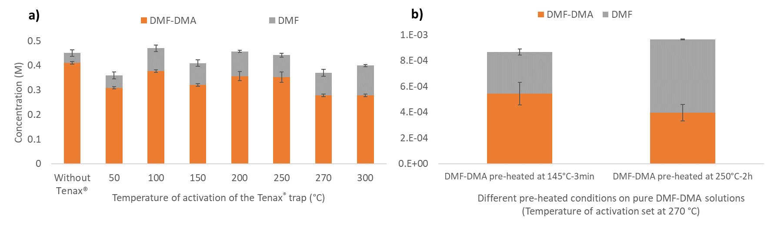
Fig. 1. Concentration in DMF and DMF-DMA (determined by calibration curves) at a) different temperature of activation for the Tenax®TA trap compared to a control without Tenax®TA (270 °C for the temperature of activation) and b) to different thermal stress DMF-DMA will see for space applications.
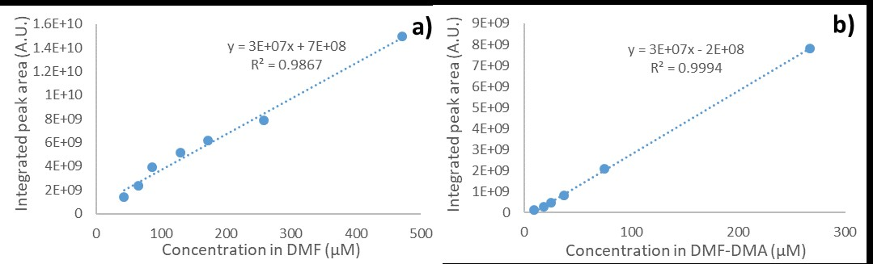
Fig. 2. a) DMF and b) DMF-DMA calibration curves determined by the injection of different concentrations of the reagents in GC-MS at 270 °C and measured based on their integrated peak area.
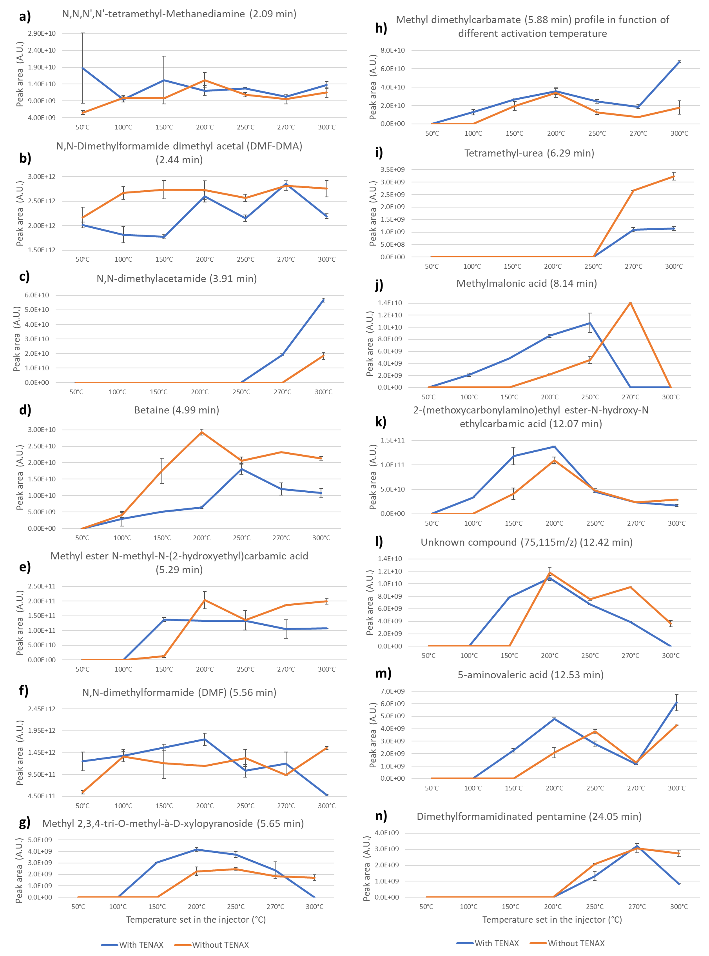
Fig. 3. Evolution of the by-products (panels a to n) resulting from DMF-DMA (not pre-heated) and/or its interaction with the 10 mg Tenax®TA trap as a function of activation temperatures in the GC-MS injector (blue traces), as compared to the same activation temperature range without Tenax®TA trap (orange traces).
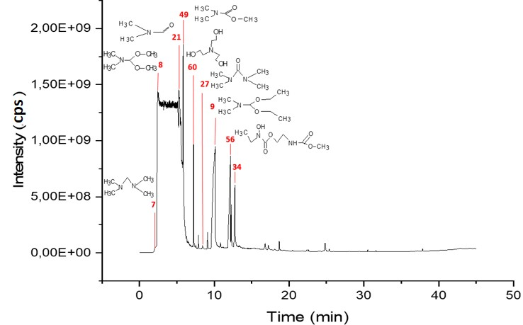
Fig. 4. Chromatogram obtained from the DMF-DMA analyses (pre-heated DMF-DMA at 145 °C – 3 min then trapped into a liner for 3 minutes at 0 °C containing 25 mg Tenax®TA, and finally released into the GC at 270 °C. The numbers correspond to those presented in Table 1 and Figure 5.
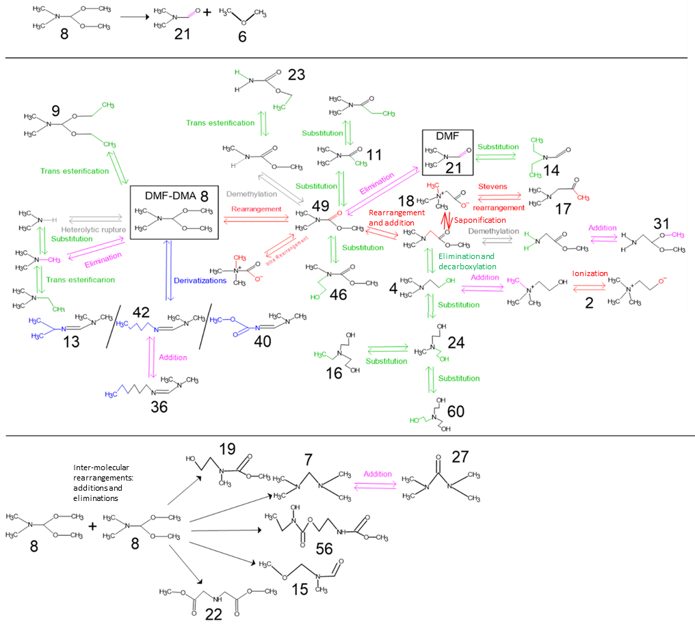
Fig. 5. Proposed mechanism for the thermal degradation of the DMF-DMA reagent at temperatures up to 300 °C by the following processes: Hoffman elimination, side chain elimination, random chain scission, heterolytic rupture, interactions between DMF-DMA molecules, or random substitutions of ethyl and ethanol groups. The numbers assigned to molecules in the schematic correspond to those used as labels in the chromatogram in Figure 4, and referenced in Table 1.
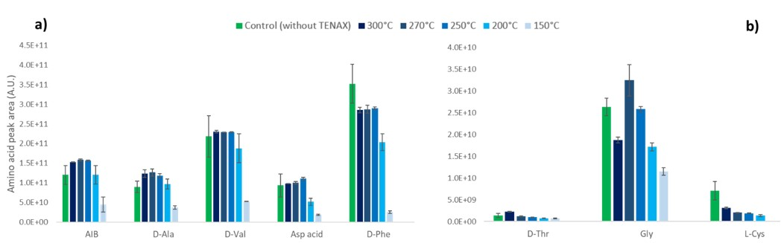
Fig. 6. DMF-DMA derivatization of amino acids (a and b graphics, according to the amino acid peak area) injected without (control, green bars) and with Tenax®TA (blue gradient bars). The 10 mg Tenax®TA was heated for 120 h before the experiments (corresponding to 180 injections). We measured the integrated derivatized amino acid peak area in function of different activation temperatures (from 150 to 300°C) maintained for three minutes.
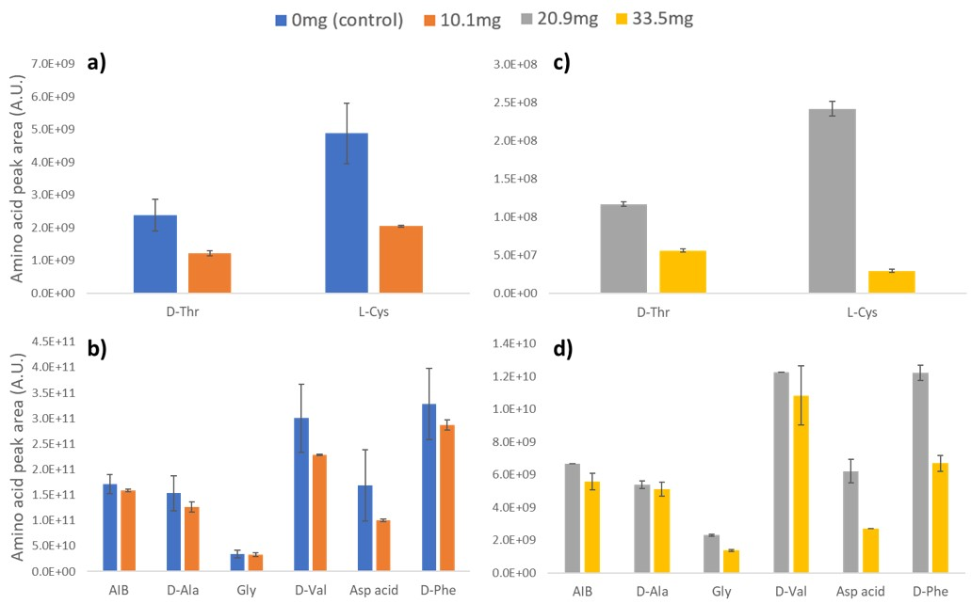
Fig. 7. Histogram of the GC-MS integrated peak areas comparing the control without Tenax®TA to different masses of Tenax®TA following the injection of 1 µL of derivatized amino acids at 0 °C, and an activation at 270 °C for three minutes. Panels a and b correspond to the peak area of amino acids injected in a 0 or 10.1 mg trap, and panels c and d for a trap of 20.9 or 33.5 mg of Tenax®TA.
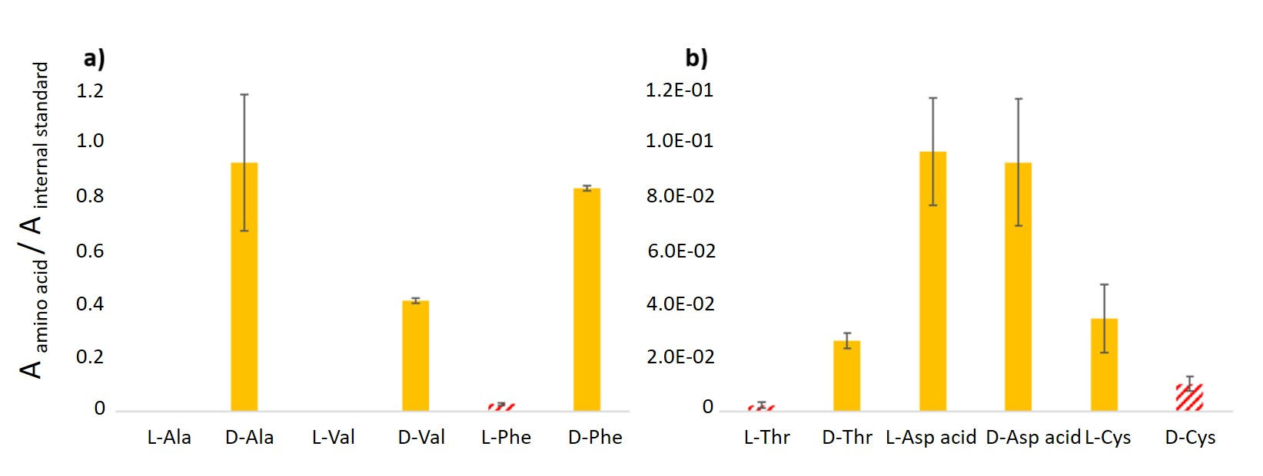
Fig. 8. Abundances in amino acids (relative to an internal standard) after trapping for 3 minutes at 0 °C, and an activation temperature set at 270 °C for 3 minutes. The same results were obtained at activation temperatures of 250 °C and 300 °C. The full orange bars are the injected homochiral amino acids, and the hatched red bars are the non-injected enantiomers (produced during the trapping and desorption processes, according to previous studies showing no production of them during the DMF-DMA derivatization).
Table
No | By-product name | Retention  time (min) | DMF-DMA pre-heated (without Tenax®) | DMF-DMA unheated (with Tenax®) | DMF-DMA pre-heated (with Tenax®) | S/N value
2 | Choline | 1.3 | * | N.D. | N.D. | <3
3 | Acetaldehyde, O-methyloxime | 1.37 | * | N.D. | N.D. | <3
4 | N,N-dimethylaminoethanol | 1.52 | * | N.D. | N.D. | <3
5 | trimethoxy-methane | 1.72 | * | N.D. | N.D. | <3
44 | Benzene | 1.82 | N.D. | X | X | >3
45 | Carnitine | 1.9 | N.D. | * | N.D. | <3
6 | Dimethyl ether | 2.04 | X | X | X | <3
7 | N,N,N',N'-tetramethyl-methanediamine | 2.09 | X | X | X | >3
8 | DMF-DMA/1,1-dimethoxy-N,N-dimethyl-methanamine | 2.44 | X | X | X | >3
9 | N,N-dimethylformamide diethylacetal | 3.09 | N.D. | * | N.D. | >3
46 | N-(2-methoxyethyl)carbamic acid methyl ester | 3.46 | N.D. | x | X | <3
10 | 2,3,4-tri-o-methyl-d-galactopyranose | 3.,5 | N.D. | * | N.D. | <3
47 | Methyl 2-methylhexanoate | 3.75 | N.D. | x | X | <3
11 | N,N-dimethylacetamide | 3.91 | N.D. | * | N.D. | >3
12 | Propanoic acid, 2-methyl-2-(acetylamino)-, methyl ester | 4.01 | * | N.D. | N.D. | <3
14 | N,N-diethyl-formamide | 4.39 | N.D. | * | N.D. | >3
15 | N-methoxymethyl-N-methylformamide | 4.49 | * | N.D. | N.D. | <3
16 | Ethyldiethanolamine | 4.66 | * | N.D. | N.D. | <3
18 | Betaine | 4.99 | X | X | X | >3
19 | Methyl ester N-methyl-N-(2-hydroxyethyl)carbamic acid | 5.29 | X | X | X | >3
21 | DMF/N,N-dimethylformamide | 5.56 | X | X | X | >3
22 | Methyl-2-(methyl-methoxymethyl-amino)acetate | 5.6 | * | N.D. | N.D. | <3
48 | Methyl 2,3,4-tri-o-methyl-à-D-xylopyranoside | 5.65 | X | X | X | >3
49 | Methyl dimethylcarbamate | 5.88 | X | X | X | >3
25 | methyldiethanolamine | 5.97 | * | N.D. | N.D. | <3
27 | Tetramethyl-urea | 6.29 | * | N.D. | N.D. | >3
50 | Tetramethyl-2-tetrazene | 6.44 | N.D. | X | X | <3
51 | 1-methyl-4-(4-methyl-4-pentenyl)-benzene | 6.61 | N.D. | * | N.D. | >3
52 | 1-methyl-2-pyrrolidinone | 6.83 | N.D. | N.D. | * | <3
53 | Tetronic acid | 6.93 | N.D. | * | N.D. | <3
28 | N,N,N',N'-tetramethyl-1,3-propanediamine | 7.29 | * | N.D. | N.D. | <3
54 | Naphtalene | 7.39 | N.D. | N.D. | * | <3
55 | 1,1-dimethyl-1H-indene | 7.44 | N.D. | N.D. | * | >3
56 | Methylmalonic acid | 7.49 | * | N.D. | N.D. | >3
57 | Methyl-2-methyl-2-(methoxy)amino-propanoate | 8.22 | N.D. | X | X | >3
32 | 1,3,5-triazine, hexahydro-1,3,5-trimethyl | 8.61 | * | N.D. | N.D. | <3
58 | 1-methyl-3-hydroxymethylpiperidine | 9.35 | N.D. | X | X | <3
59 | N-methoxycarbonyl-2-aminocaprylic acid octyl ester | 10.82 | N.D. | * | N.D. | <3
60 | Triethanolamine | 10.86 | N.D. | X | X | >3
61 | 2,4,4,6-Tetramethyl-1,4-dihydropyridine-3,5-dicarbonitrile | 10.89 | N.D. | * | N.D. | <3
33 | 2-(methoxycarbonylamino)ethyl ester-N-hydroxy-N ethylcarbamic acid | 12.07 | X | X | X | >3
62 | Benzoic acid | 12.27 | N.D. | X | x | >3
35 | Formyltrimethyl-urea | 12.45 | * | N.D. | N.D. | <3
36 | 5-aminovaleric acid | 12.53 | X | X | X | >3
37 | Dimethylformamidinated hexylamine | 13.28 | * | N.D. | N.D. | <3
38 | 3-buten-2-one, 4-(dimethylamino) | 13.9 | * | N.D. | N.D. | <3
39 | Nonanoic acid, methyl ester | 15.05 | * | N.D. | N.D. | <3
40 | Urea, 1-1-dimethylethyl | 15.53 | * | N.D. | N.D. | <3
41 | Methyl carbamate dimethylformaminated | 16.76 | X | X | N.D. | <3
63 | N,N'-diethyl-ethanediamide | 19.61 | N.D. | * | N.D. | <3
64 | Cyclotetradecane | 22.53 | N.D. | X | X | >3
65 | Urea dimethylated dimethylformaminated | 22.61 | * | N.D. | N.D. | <3
43 | Dimethylformamidinated pentamine | 24.05 | * | N.D. | N.D. | >3
66 | N-(2-hydroxyethyl)-hexanamide | 24.73 | N.D. | * | N.D. | <3
N.D. : By-product Non Detected
In bold : By-products from Tenax (A. Buch et al., 2019)
S/N ratio: Signal over Noise ratio. If S/N < 3: molecule detected but not quantified (close to the Limit of Detection).
* : By-product detected in only one condition.
X : By-product detected in different conditions.

Supplementary material
Supplementary Material 1: Amino acid and internal standard used for experiments.
Table A. Concentration of amino acids in the original solution, and amount injected for GC-MS analyses; where D-Thr is an abbreviation for D-Threonine, AIB for α-aminoisobutyric acid, L-Ala for L-Alanine, Gly for Glycine, D-Val for D-Valine, D/L-Asp Acid for D/L-Aspartic acid, L-Cys for L-Cysteine, and D-Phe for D-Phenylalanine.
 | Concentration in the original solution (with HCl solvent) (mol.L⁻¹) | Quantity of amino-acid injected in the GC-MS (nmol)
D-Thr | 0.1 | 1.83
AIB | 0.05 | 0.92
L-Ala | 0.05 | 0.92
Gly | 0.05 | 0.92
D-Val | 0.05 | 0.92
D-Asp Acid | 0.05 | 2.75
L-Asp Acid | 0.05 | 2.75
L-Cys | 0.05 | 0.92
D-Phe | 0.05 | 0.92
Methyl Laurate | 0.01 | 2 .34

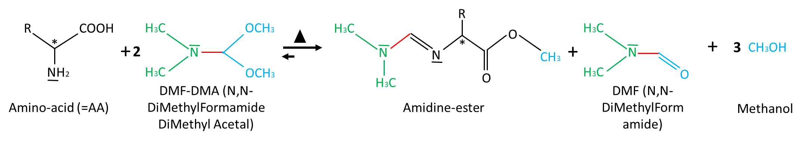
Figure S1. Derivatization reaction of amino-acids by DMF-DMA (145 °C – 3 min).

Table B. Amino acids and their DMF-DMA derivatized forms, determined from MS measurements and comparison with the NIST library spectra.
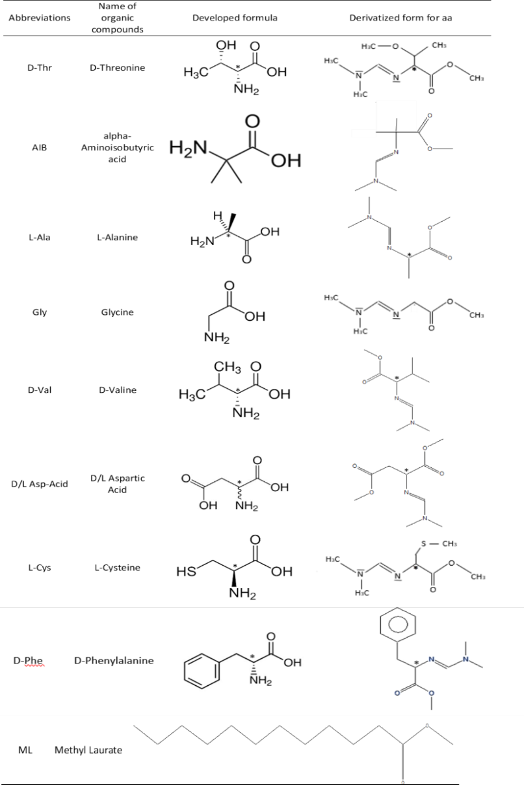

Supplementary Material 2: DMF/DMF-DMA ratio obtained after different DMF-DMA storage and GC-MS processes (with and without Tenax®TA trap) and analyses.
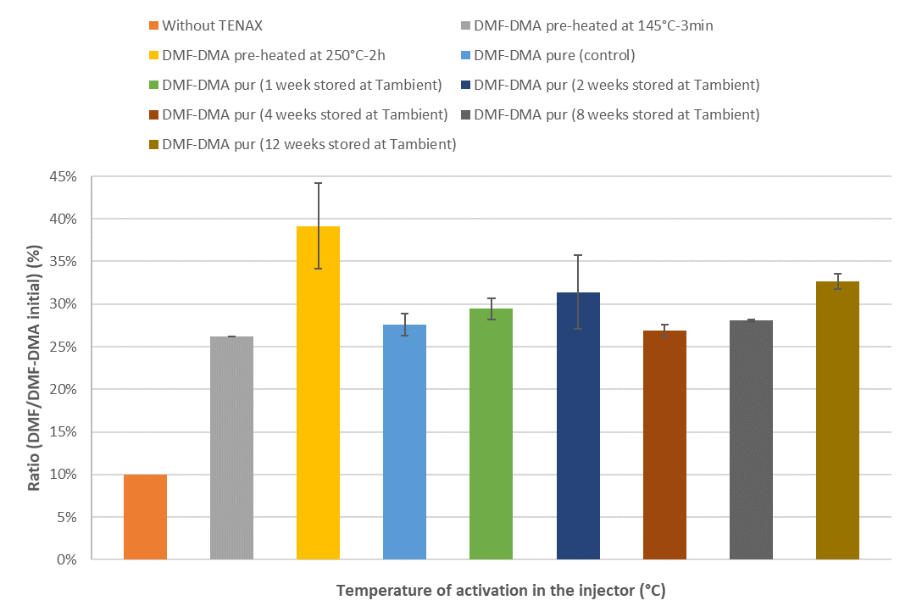
Figure S2. DMF/DMF-DMA ratio for DMF-DMA different pre-treatment and/or stocking time (with an activation temperature of the Tenax®TA trap at 270 °C) compared with the reference stocked in the fridge and injected without trapping process (in orange).
Figure S2 shows complementary results to those presented in Fig. 1 and 3 in the Results Section. We observed only 10% of the DMF-DMA is transformed into DMF without Tenax®TA present, and that conversion is largely due to the original water content present in the fresh DMF-DMA solution. When DMF-DMA is processed through the trap, at least 15% more of the DMF-DMA is converted to new by-products. The experimental conditions in which DMF-DMA is stored at ambient temperature between 1 and 12 weeks simulates the storage of reagent capsules on Earth before launch. These newly formed by-products can increase the background level, limiting the detection of trace organic compounds, could clog the MS source, or could coelute mostly with volatiles. If a fresh solution of DMF-DMA is heated at 145 °C for 3 minutes simulating a derivatization step, we observed the same results as a storage at ambient temperature. However, if we expose the DMF-DMA to a higher temperature, we observe additional loss of 10 to 15% of DMF-DMA with an increase in the quantity of the same by-products as observed at lower temperature.

Supplementary Material 3: List of DMF-DMA and Tenax®TA by-products generated at different conditions.
Table C. Comparison of degradation by-products from the interaction between an unheated DMF-DMA solution (1 µL injected) and a Tenax®TA (10, 20, and 40 mg) trap activated at 270 °C, DMF-DMA injections without Tenax®TA, and injection of air in a Tenax®TA trap without DMF-DMA or any chemical reagent. Note the same by-products are observed after 1 activation and 120 activations on the Tenax®TA traps. compared with DMF-DMA
 | 10 mg Tenax®TA |  | 20 mg Tenax®TA | 40 mg Tenax®TA | Not pre-heated DMF-DMA injection without Tenax®TA | Tenax®TA by-products without DMF-DMA injection
N,N,N',N'-tetramethyl-Methanediamine |  | x | x |  | x
Methane, trimethoxy- |  | x | x | x | x
DMF-DMA |  | x | x | x | x
Methyl dimethylcarbamate |  | x | x | x | x
2-(methoxycarbonylamino)ethyl ester-N-hydroxy-N ethylcarbamic acid |  | x | x |  | x
N,N-diethyl-formamide |  | x |  |  | x
DMF/N,N-dimethylformamide |  | x | x | x | x
1,4-Dioxane |  | x | x | x
Methyldiethanolamine |  | x | x
5-aminovaleric acid |  | x | x |  | x
Methylmalonic acid |  | x
Unknown (83,101m/z, 7.03min) |  | x | x
Unknown (75,115m/z, 12.64min) |  | x | x |  | x
Methyl 2,3,4-tri-O-methyl-à-D-xylopyranoside |  | x |  | x
Ethanolamine |  |  |  | x
Methanol |  |  |  | x
Triethanomaline |  | x | x
Trimethylamine |  |  |  | x
Betaine |  |  | x | x | x
Tetramethylhydrazine |  |  |  | x
Aminoacetaldehyde dimethyl acetal |  |  |  | x | x
Glycine, N,N-dimethyl-, methyl ester |  |  |  | x
1,2-ethanediamine,N,N-dimethyl |  |  |  | x | x
N,N-dimethylacetamide |  |  |  | x | x
1,3,5-triazine, hexahydro-1,3,5-trimethyl |  |  |  | x
Benzoic acid, methyl ester |  |  | x | x |  | x
Benzene, 1,2,3-trimethyl |  |  | x | x |  | x
Benzene |  |  | x | x |  | x
Ethylbenzene |  |  | x | x |  | x
Benzene, 1,3,5-trimethyl |  |  | x | x |  | x
Toluene |  |  | x | x |  | x
Naphtalene, 1,2-dihydro-3-methyl |  |  | x | x |  | x
1H-indene, 2,3-dihydro-1,1,4,5-tetramethyl- |  |  | x | x |  | x
o-Xylene or p-Xylene |  |  | x | x |  | x
Ethanone, 2,2-dihydroxy-1-phenyl OR Benzoic acid, hydrazide |  |  |  | x
N,N-dimethylformamide diethylacetal |  |  | x | x | x
Carbamic acid, ethyl-, ethyl ester |  |  |  | x | x
Methyldiethanolamine |  |  |  | x

Supplementary Material 4: Physical characterization of the Tenax®TA particles.
To verify the observations that the trap was not significantly degraded over time, the Tenax®TA underwent a physical characterization using Scanning Electron Microscopy (SEM). We examined the Tenax®TA before introduction in the liner of the injector, and after 180 injections (120 h at 270 °C).
Prior to the SEM analyses, we weighed the liner containing the used 10 mg of Tenax®TA, and we did not observe a significant decrease in mass after continuous activations at 270 °C for 120 h. Then, we extracted the Tenax®TA particles and analyzed them with the SEM, and compared the images with fresh Tenax®TA particles that were unheated. Figure S4 displays the SEM images at three different magnifications to first give an overview of the particles and determine the range of diameters before and after repeated heating at 270 °C. The middle column shows a close-up on one particle, or in the case of the used Tenax®TA an aggregate that appeared after heating. The right-hand column shows the surface features of single particle to characterize changes at finer scale.
The Tenax®TA particle sizes appear to range from 202.4 µm to 345.2 µm (average of about 268.3 µm), and decrease in size after repeated heating at 270 °C to sizes ranging from 125 µm to 321.4 µm (average of about 201.9 µm). Moreover, aggregates of two to more than nine or ten particles form. In addition to the aggregation, it also appears the Tenax®TA particles are fracturing; this is best observed in the middle column of images comparing the higher resolution images. This fracturing explains the decrease in size of 1.5x, as reported in previous papers (18). This last publication demonstrates the decrease in mass using TGA and EGA measurements, showing a similar loss with a factor of about 1.5x (and as high as 2x). Indeed, Tenax®TA degraded after 250 injections (Tenax®TA graphitized with a final particle loss in mass and size of about two).
The highest magnification images in the right-hand column show that there is increase porosity with larger cracks in the unheated Tenax®TA (upper right) as compared to the heated samples (bottom right). The surface is initially highly porous and sinuous, and becomes flattened with repeated use. These observations provide evidence of visible degradation, and explain observations of lower trapping efficiency of organic molecules in the Tenax®TA trap (Part 3.3 of the Results), There also appears to be a visual graphitization of the Tenax®TA after 120 h at 270 °C (blackening of material, not shown here), and a high graphitization rate after 160 h (250 injections). Despite these changes, the particles globally kept the same shape because the graphitization rate was low compared to a full degradation after 250 injections, which means that Tenax®TA can still be used for 40 h.
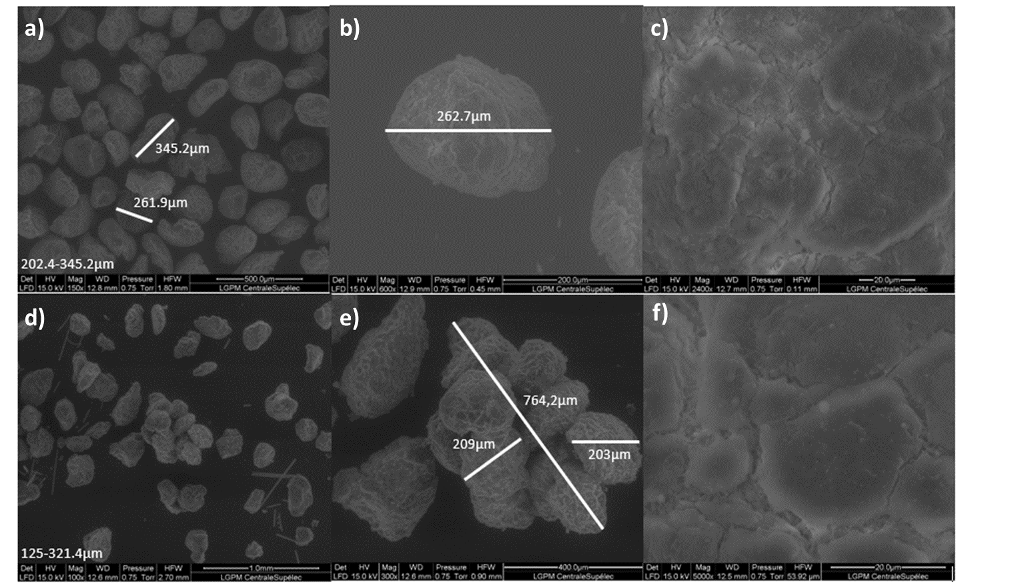
Fig S4. SEM analyses on Tenax®TA particles (60-80 mesh), before chemical interactions or thermal interactions in the Optic 4 injector (panels a, b, and c) and after 120 h at 270 °C with about 180 injections of 1 µL solution (panels d, e, and f). We presented three zoom on Tenax®TA (1 mm for a and d, 400 µm for b and e, and 20 µm for c and f) particles. We detailed the range diameter of the particles in the sample (bottom left-corner of each picture). We focused on one particle or aggregate of particles (panels b and e), and a close-up of the particle surface (panels c and f) to note the shape transformations with the different activation conditions. SEM pictures were analyzed using the ImageJ software.

Supplementary Material 5: TIC of the homochiral amino acid and racemic aspartic acid mixture separation introduced at ppb (nmol Table A SM1) levels using the Chirasil-Dex column.
