Technological developments of NexGen Micro-Shutter Array (NGMSA) for the future Habitable Worlds Observatory (HWO) flagship mission

Kyowon Kim*^{a, b}, Meng-Ping Chang^{b}, Alexander S. Kutyrev^{b, c}, Paul A. Scowen^{b}, Regis P. Brekosky^{b}, Ron Hu^{a, b}, Carl A. Kotecki^{b}, Ming Ke^{b}, Suryakanthi Srinivas Rachamadugu^{a, b}, Frederick H. Wang^{b}, Nicholas P. Costen^{b}, Felipe A. Colazo Petit^{b, d}, Samelys Rodriguez^{b}, Vorachai Kluengpho^{a, b}, Ian Schrock^{b, d}, Rainer Fettig^{b}, Stephan R. McCandliss^{e}, Ed Aguayo^{f}, Beth M. Paquette^{b}

ªScience Systems and Applications, Inc., Lanham, MD 20706, USA
^{b}NASA Goddard Space Flight Center, Greenbelt, MD 20771, USA
^{c}University of Maryland, College Park, MD 20742, USA
^{d}Teltrium Inc., Greenbelt, MD 20770, USA
^{e}Johns Hopkins University, Baltimore, MD 21218, USA
^{f}Newton LLC, Riverdale, MD 20737, USA

Abstract
We present the most up to date advancements in production, design, and performance of the NexGen Micro-Shutter Array (NGMSA) for Multi-object Spectroscopy (MOS), intended for the future Habitable Worlds Observatory (HWO) Flagship. A microshutter array functions as a programmable slit mask, to generate slits corresponding to sparsely distributed sources in the field of view of a telescope. In contrast to the magnetic/electrostatic microshutter arrays used in the James Webb Space Telescope (JWST), the NGMSA is fully operated by electrostatics, simplifying overall system. Our small pilot array proved its capability from the FORTIS sounding rocket mission in 2019. As we are switching to a larger HWO flight size array process, we are encountering multiple processing related issues. Also, there has been individual shutter level issue that impairs operation and performance. We will discuss those problems and strategies to overcome the challenges to achieve an on/off contrast of >1e5 with near 100% shutter operability.

Keywords: Microshutter, multi-object, spectroscopy, HWO, JWST, 3D print, FORTIS

INTRODUCTION
Microshutter array (MSA) is a programmable slit mask which enables multi-object spectroscopy by generating an arbitrary open and close patten. It enables simultaneous spectra acquisition of hundreds of different target objects within the telescope's field of view. James Webb Space Telescope (JWST) equipped with Near-Infrared Spectrograph (NIRSpec) with original MSA has been demonstrating excellent performance since the telescope operation was started.¹ The original MSA, however, requires bulky and heavy mechanism for moving magnet and its operation to generate 2D slit pattern is complex. Next Generation Microshutter Array (NGMSA) is being developed to simplify the JWST MSA by employing all-electrostatic operation. NGMSA inherited overall architecture from original JWST microshutter with modification to enable electrostatic actuation. Figure 1 shows the NGMSA design and structure. Shutter blades are made of silicon nitride layer patterned by photolithography and etching processes. The shutter blades are suspended to the surrounding silicon frame by torsion bars made by the same process. An aluminum layer deposited on top of blades and torsion bars work as front (row) electrodes. Back side “egg-crate” structure is formed by deep reactive ion etching (DRIE) process to make cavities for shutter blade motion. Bare silicon egg-crate surface is electrically passivated by aluminum oxide by an atomic layer deposition (ALD) process to create robust insulation layer. Back (column) electrodes are angle deposited on the torsion bar side egg-crate wall. Major modifications from the original JWST MSA include thinner silicon nitride layer to reduce stiffness of the torsion bar structures, ALD oxide deposition process to withstand higher voltages for electrostatic actuation, and a recently introduced keystone shape shutter blade to further optimize electrostatic actuation force interaction. We have been developing this technology in a small (64 rows x 128 columns) format, and this pilot size array was flown on the Far-UV Off Rowland-Circle Telescope for Imaging and Spectroscopy (FORTIS) sounding rocket mission in 2018 to successfully demonstrate its performance.²
NGMSA is listed as a baseline technology of LOUVIR and HabEx flagship mission concept recommended by Astro2020 decadal survey, which is now named Habitable World Observatory (HWO). In recent years, we have been developing the fabrication process for larger (384 rows x 736 columns) HWO pilot-size array on 6-inch wafers based on FORTIS size array fabrication experience. Increased device size also requires new testing and packaging methods. Specifically, the actuation testing setup we had previously been using was not able to accommodate the large HWO size devices whose active MSA area was 36 times larger. The packaging method and components that have been used for FORTIS size array do not scale well for HWO size array. To overcome these testing and packaging challenges, we have been developing new solutions. In this report, we present most recent HWO-size NGMSA development focused on functional testing and HWO pilot module design.
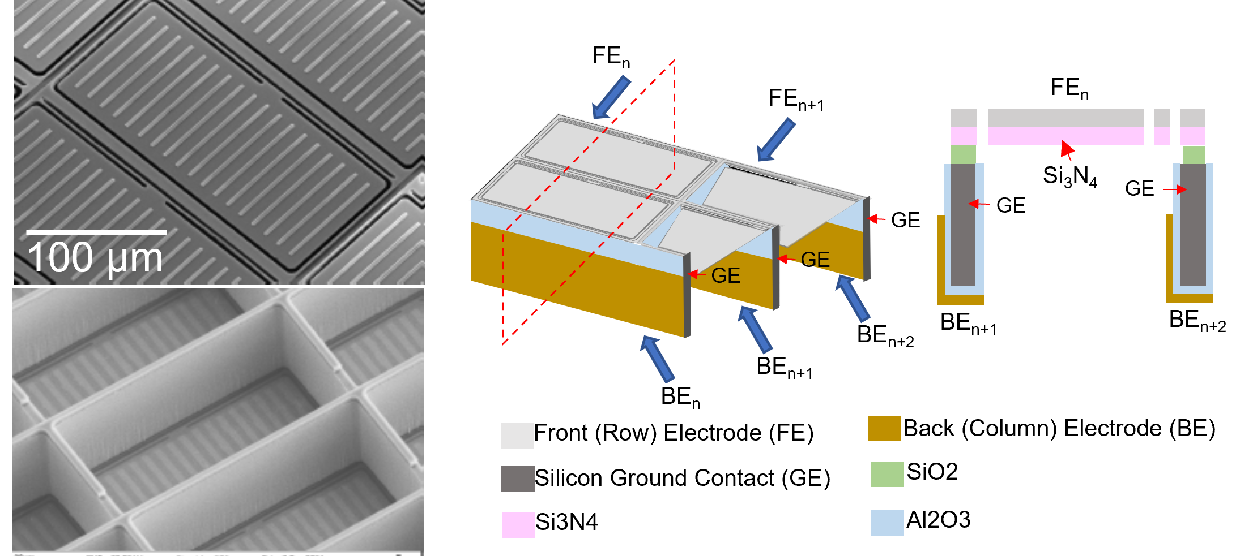
Figure 1. (Left) Scanning electron micrograph of a NGMSA, front (top) and back (bottom) side, (Right) Diagram of the NGMSA structure.

INstrumentation for msa actuation test
Actuation test is the most important test for the MSA development and processing because the actuation operability is a key indicator directly related to the overall device performance. While several different tests and inspections are done during the fabrication process of MSAs, including electrical isolation and continuity tests, optical and scanning electron microscopy imaging, and vacuum pulling for shutter blade release, those tests do not provide as definitive result as the actuation test. Moreover, a proper actuation test will provide not only the general performance measure for each device but also important device characteristics and data of unexpected operational behavior, so that the result will be fed back to design or processing to improve the next iteration of devices.

Before actuation test setup
The NGMSA needs electrical interconnect on each electrode to apply electric voltage for actuation. Because of its design with electrodes on both front and back sides of the device, making electrical contacts with a conventional probing station is extremely difficult. Initially, there was no method to test actuation without complete packaging to make a module which can be easily connected to external electronics or controllers (Figure 2 left). Each device was visually inspected and tested for electrical isolation and continuity for quality screening, then packaged for testing only if the inspection result looks reasonable. However, the test modules prepared in such a procedure show huge variation of performance. Also, the packaging process is irreversible, therefore potentially good arrays for production modules cannot be tested.
After multiple tests and simulation efforts, we learned that actuation and latching can be done without back (column) electrodes. The electrostatic shutter simulation^{3,4} shows that the electrostatic interaction between a shutter blade (row) electrode and the surrounding silicon frame is a dominating force. This finding opened a path for NGMSA actuation testing for bare devices without further preparation.

Simple first actuation test setup
Once we realize the possibility of actuation test using only front (row) electrodes, a probe station-like system is used for a simple actuation test (figure 2 right). This setup uses four probes - one for actuation electrode, other two for setting adjacent electrodes to a known voltage level, and the other one for silicon frame. By applying high-voltage actuation signal, shutters on the corresponding electrode (row) are actuated. While this simple test setup works, manually repositioning three probes for each electrode was extremely time consuming. Also, a manually positioned single imaging assembly with a zoom lens is used for both taking actuation image data and positioning the probes, therefore the FOV of the series of actuation data is not consistent, and it prohibits efficient data analysis. Because of the limitations, most devices were tested by picking a portion of front (row) electrodes, limited to a single set of actuation parameters. Only small number of FORTIS flight candidate devices went through whole-electrode tests. Regardless of the efficiency, this was an important step of NGMSA project that allowed us actual shutter actuation and latching of devices without going through time consuming and labor-intensive packaging process.
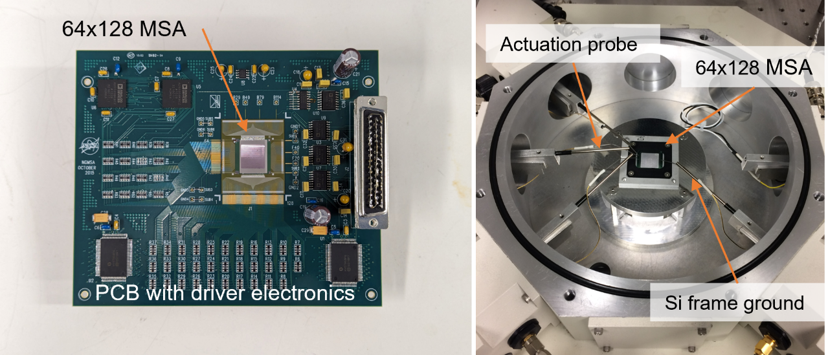 Figure 2. (Left) A fully packaged NGMSA on a PCB with driver electronics, (Right) First manual actuation test setup.

Automated test system
Current HWO pilot size array has about 36x larger active area compared to the FORTIS-sized array. Because of the much larger size, the simple manual actuation test setup is not able to probe the entire electrodes of HWO array. Even if the probing is doable, manually testing all 384 electrodes would be nearly impossible, not to mention the intensive labor required for data analysis. Therefore, a new test setup that can effectively test HWO-size array became essential for further HWO array development. The major aims of the prospective system were simultaneous large number of electrical interconnects, an automated test procedure to minimize the time to take measurement and ensure data consistency, and a reliable data processing routine for further analysis. Figure 3 (top) shows the automated actuation test setup we have developed. A probe card is employed to make contacts to multiple electrodes simultaneously. A probe card with relatively small number of contacts was used initially, and we recently came up with a 64-pin configuration which can probe a FORTIS size (64 front electrodes) array without changing the probing area. The probe card is mounted on a Z-directional motorized stage to allow automated contact and release actions. A driver electronics is developed to send actuation signals to all the probe contacts. The driver electronics utilize AD5535B 32-channel high-voltage DACs which we have been using for NGMSA actuation including test assembly and FORTIS flight assembly. Custom vacuum device chucks were made to securely hold the MSAs under test during tests. The chuck is mounted on a Y-directional motorized translation stage to allow probing on the different areas of a HWO size arrays. The imaging scope assembly is also mounted on a gantry-style XY-motorized stage to allow repeatable and accurate positioning. The imaging scope assembly consists of a 12x zoom lens and a machine vision camera that can zoom-in enough for probe pins alignment and able to show an entire pilot size array. An LED surface illuminator is mounted on the bottom of the device chuck to clearly identify the shutter open and close status. The test setup is operated by a custom LabVIEW code which controls all the components including shutter actuation, stages motion, illumination, and image acquisition.
This new automated test system enables much faster and efficient actuation test compared to the old manual system. A session of row-by-row test of a FORTIS size array only takes about 5 minutes compared to 4 hours with the old setup. Speed is not the only advantage of the new system. First, image data with consistent and accurate field of view enabled easy data analysis by applying basic image processing techniques (figure 3 bottom). Secondly, entire-array data acquisition with varying actuation conditions provides a complete picture of actuation characteristics that corelated with actuation parameters, device designs, processing, and other device specific properties.
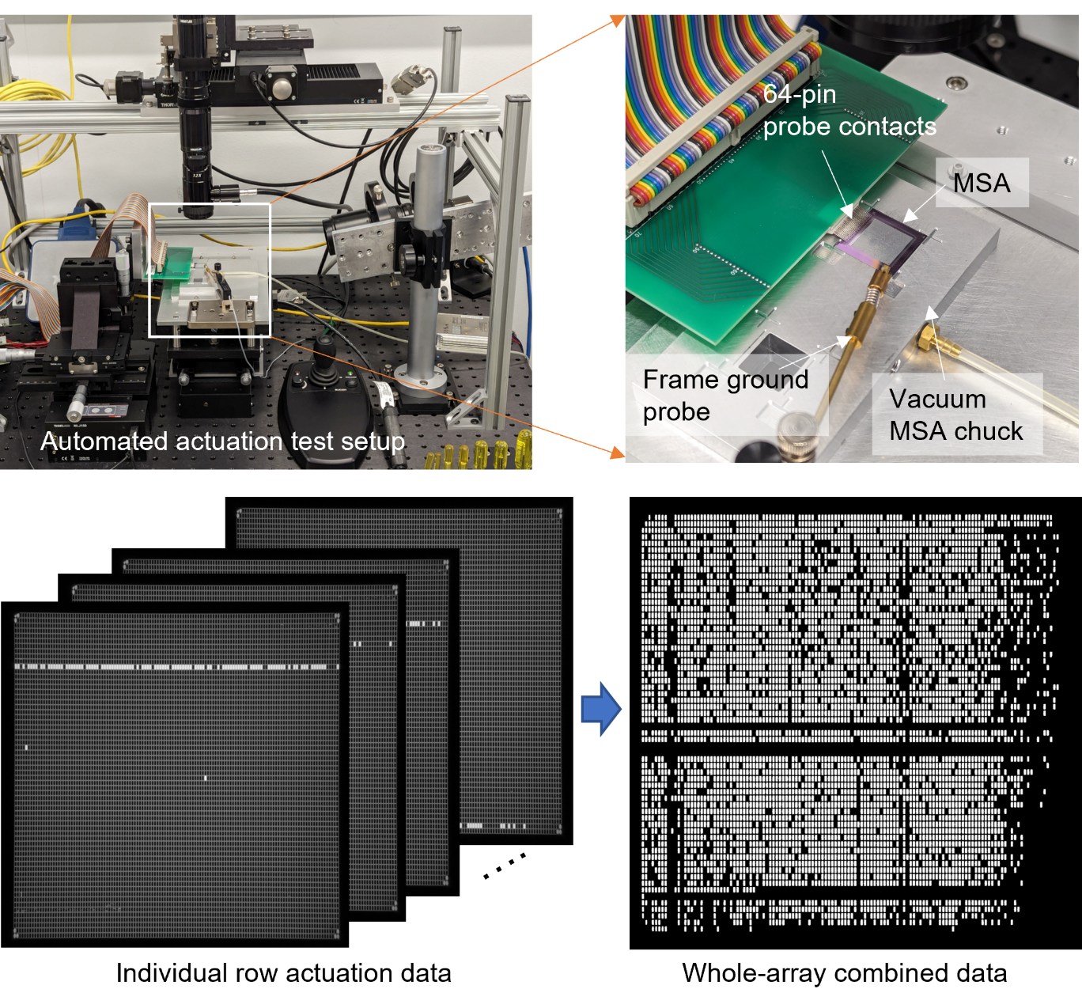 Figure 3. (Top) Automated NGMSA actuation test setup, Top-left pane shows close-up details of MSA mounted on a custom vacuum chuck and a 64-position probe card, (Bottom) A set of individual row actuation image data and a combined whole-array actuation data by the image processing routine.

Double-side probing actuation system
The automated actuation test system enabled us to perform much more efficient test and data acquisition that used to be impossible. However, test system modification is necessary to address the differences between the test and actual device operating condition. In the test environment, the back electrodes are electrically floating. In actual NGMSA operation, all front and back electrodes are connected to the driver outputs, therefore all electrodes including back electrodes voltages are always well defined. Back electrode electrical condition decides whether the corresponding shutter be latched (open) or not (closed), and this is related to open/close selectivity of the device. Some devices have good selectivity margin while some others have very narrow optimal range. We observed a couple of cases that certain arrays do not operate quite well for 2D pattern generation even with good actuation test result. Also, accurate actuation motion characterization is difficult without well-defined back electrode voltages.
A double-side probing actuation test setup is being developed to address the back electrode floating issue during the test. Once the setup is complete, it will be possible to test the array's operation in a condition identical to the post-packaged module even before going through time consuming packaging process, therefore effectively increasing the throughput of functional modules. The biggest challenge of this system is establishing probe contacts on both front and back side of a MSA because the MSA’s row and column pads are located on opposite sides of the device. The main difference from the current automated actuation test setup mentioned above is one more set of probe card and its manipulation stages located on an adjacent edge of the MSA, and a MSA device vacuum chuck with one open edge to allow access of the back electrode probes (figure 4). The MSA mounting chuck design is being tested currently for FORTIS size array and will be expanded to the HWO size device once the working design is confirmed.
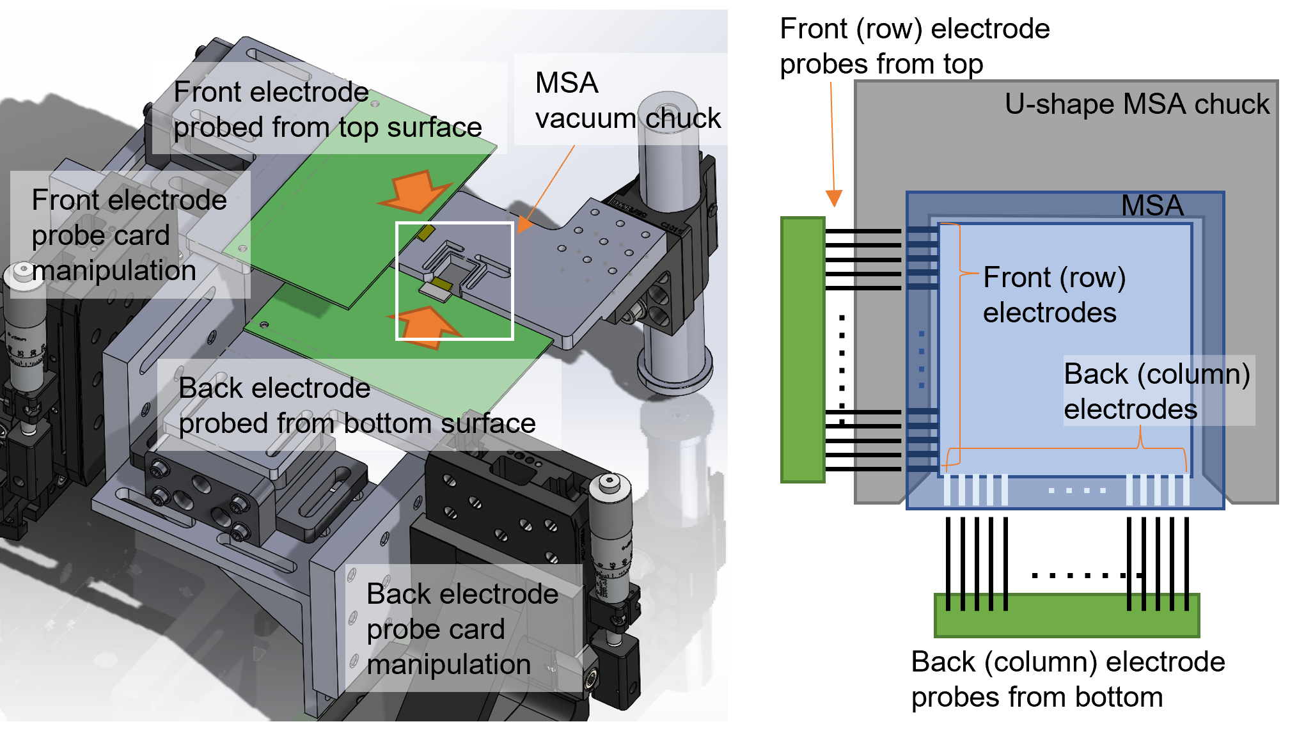
Figure 4. (Left) A preliminary 3D model concept of a double-side probing MSA actuation test setup, (Right) A schematic of the MSA probing area, marked as white box on the left.

HWO-size pilot MSA module development
MSA must be packaged into a functional assembly composed of MSAs, driver electronics and supporting mechanical structure to be integrated into the prospective HWO telescope or a target instrument. MSA specs for HWO has not been decided now. However, by referencing to LUVOIR and HabEx proposed concepts, it is a reasonable expectation that HWO will need approximately a 2 x 2 mosaic configuration of currently developed HWO candidate arrays. Since JWST MSA assembly successfully utilizes four-quads configuration which is consists of four unit-MSAs in 2 x 2 mosaic arrangement, we decided to develop a similarly configured pilot NGMSA quad with a HWO candidate device that will be a baseline design for HWO flight assembly. A current design concept of HWO pilot MSA quad we are developing is shown on figure 5.

Fan-out board and mechanical structure
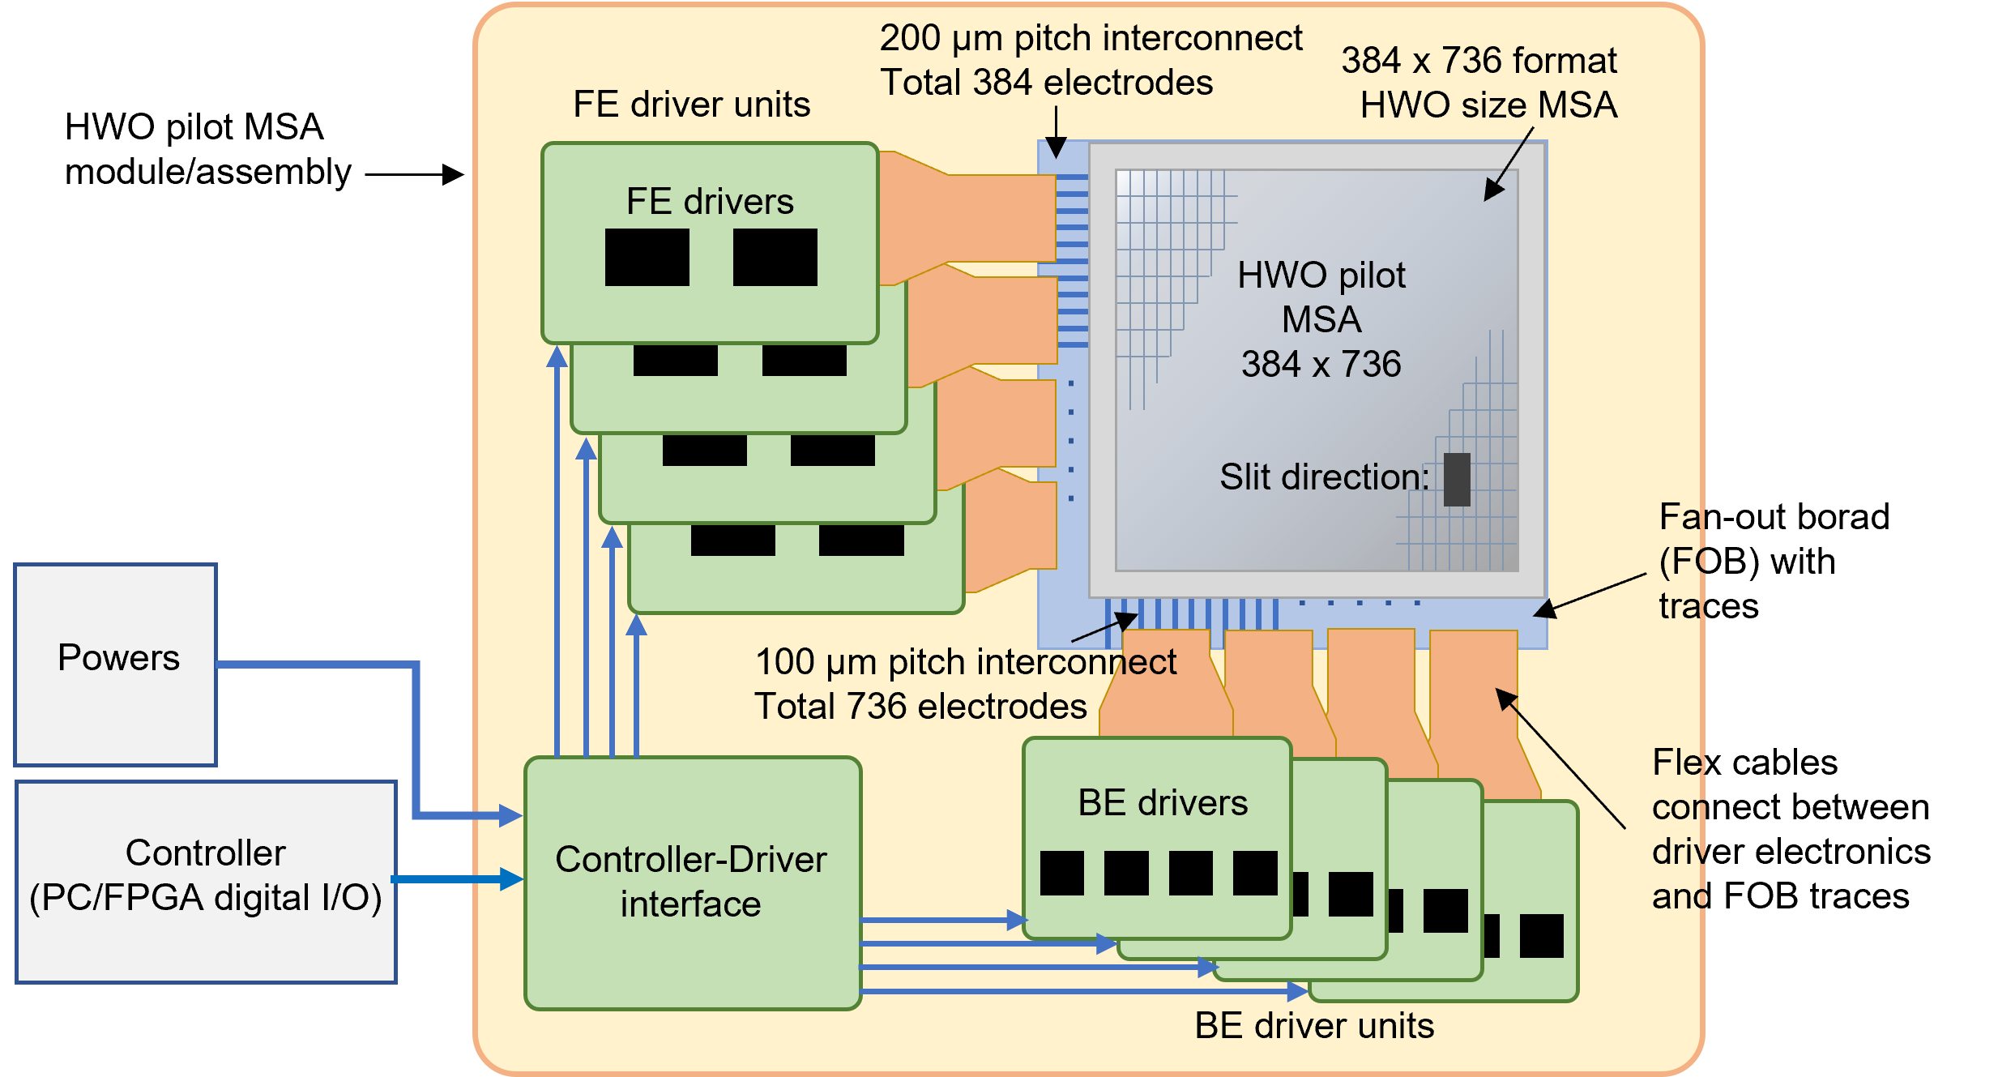
Figure 5. Concept diagram of a HWO pilot array functional module.
Bare NGMSA devices are quite flimsy because they are made of only 100 µm thick crystalline silicon and a large portion of the material is etched through. To make a working MSA module, a bare MSA is attached onto a mechanical supporting structure to increase its rigidity. The supporting structure directly attached to the MSA is called a fan out board (FOB) because it has patterned electrical traces to connect MSA electrodes to external driver circuits. For current pilot module design concept, a MSA is attached to a FOB fabricated from a silicon wafer via indium bump bonding (IBB), which is the design we have been using for JWST, FORTIS, and other test modules.
At the early stage of HWO pilot array development, we investigated using a thick (~1.5mm) ceramic sheet as a FOB because silicon FOB of JWST quad had serious shorting issues during its development stage. A simulation study was performed to figure out a working configuration of the MSA and the ceramic structure. (Figure 6 left and center) Methods to machine, pattern electrical traces, bond MSA were studied, and actual alumina FOB samples were machined using water-jet method. A HWO pilot MSA was bonded with an epoxy and went through a random vibration test. The mechanical rigidity turned out to be good enough to prevent MSA damages by vibration. In the meantime, difficulties in implementing electrical traces and interconnect method persist with the ceramic FOB. We are evaluating the advantages and disadvantages of both ceramic and silicon FOBs, and working on the solutions to overcome the ceramic FOB processing issues including 3D printing, which will be discussed in the following section.
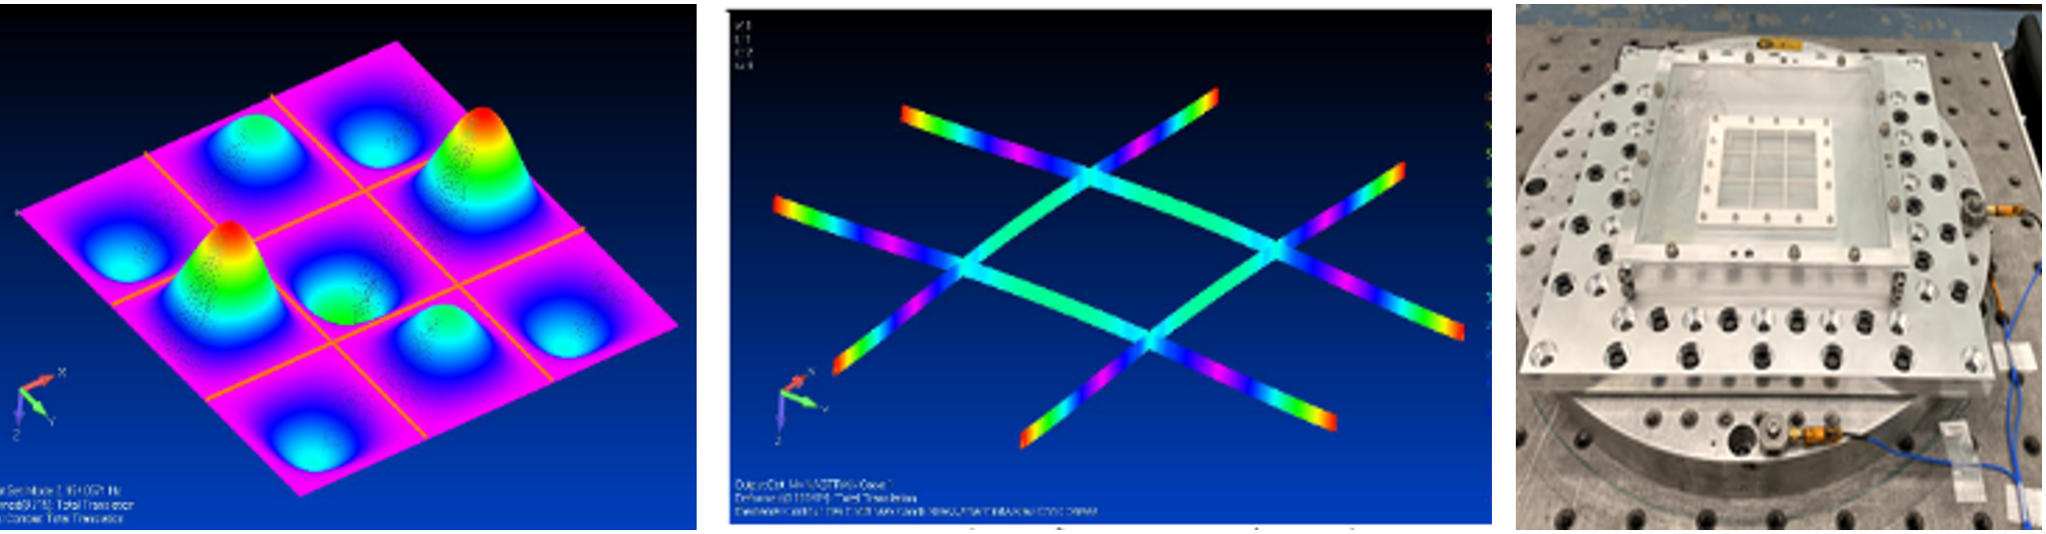
Figure 6. (Left) The simulation result of the first vibration mode of HWO pilot array, (Center) A vibration simulation result of alumina ceramic beam to support the MSA, (Right) The vibration test fixture setup.
The MSA-FOB assembly (usually called “hybrid”) needs to be mounted on a secondary structure to be integrated with driver electronics and establish a robust module. Our plan it to use INVAR to reinforce the MSA hybrid and mount it to the external structure. A random vibration simulation is recently done to evaluate the effectiveness of the candidate structure.

High-density electrical interconnect
The concept diagram on Figure 5 shows that each MSA electrode is connected to a driver output via a FOB trace and flex cable. Interconnects for the transition interfaces are one of the biggest challenges for HWO candidate quad module because of high density. NGMSA has electrode pads pitch of 200 µm on front (row) electrodes and 100 µm on back (column) electrodes. On MSA to FOB interface, front electrodes are connected to FOB traces using IBB while back electrodes are wire bonded, maintaining MSA's native electrode pitches.
Wire bonding is a mature interconnect method and generally very reliable. However, we observed bonding issues especially on the MSA back electrode due to the unique fabrication process used. The back electrode aluminum layer is angle deposited to put electrode material on a sidewall of egg-crates. The angle deposited layer is not as robust as normally deposited layer and prone to surface contaminations during the subsequent processes, which lead to wire bonding failures.
As an alternative interconnect method to overcome the difficulty of wire bonding, we have been developing 3D-printed traces using electrically conductive printing materials. This method was successfully demonstrated to make interconnect between MSA back electrode and FOB trace (figure 7, right). We have been trying to expand the capability of 3D printed traces to pattern traces on the ceramic FOB because of the patterning process difficulty mentioned in the previous section. We have successfully demonstrated the 3D printed gold trace on the HWO-pilot array’s ceramic FOB (figure 7, left & center).
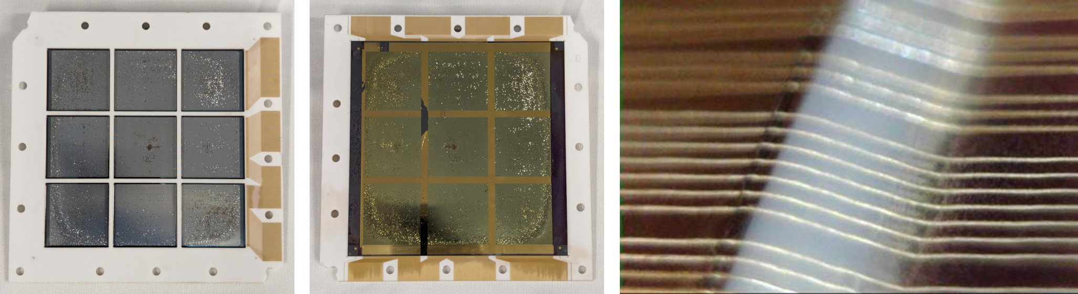
Figure 7. (Left) Back side (MSA front) of a alumina FOB with 3D printed traces for front electrodes, (Center) Front side (MSA back) of a alumina MSA hybrid with 3D printed traces for back electrodes, (Right) A microscopy picture of 3D printed traces over 100µm step height with epoxy fillet.

Flex cable and driver electronics configuration
Our initial plan for interfacing driver electronics was directly butt the FOB pads and driver PCB pads then wire bond each other. This initial design idea derived from JWST quad design that all the driver electronics are integrated into a single silicon fanout board. With preliminary driver board design, we found it is not an optimal solution to integrate all the electronics for a unit array into a single board because such a design takes up a large amount of real estate of the driver board. Another problem is that typical pad pitch of printed circuit board cannot be as small as the MSA’s back electrode pitch. We came up with a new design plan that divides the electronics into several units and connect them to the FOB with flex cables, therefore the total packaging will be more compact, flexible, and easily scalable.

Driver components
Front electrodes driver should supply 100V – 120V range pulse-like voltage signal to actuate the shutter blades. A high-voltage 32-channel DAC (AD5535B) has been used for FORTIS size array. Preliminary actuation tests with the driver shows evidence that the power output of this driver IC is not enough for six-times larger capacitance of HWO pilot size array front electrodes. Also, the driver is being phased out by the manufacture. Currently we are testing alternative combinations of drivers to replace AD5535B.
Back electrode can function with a shift register type driver with a moderate voltage range. HV57908 has been used for recent applications including FORTIS. A limitation of these shift-register drivers is that they typically provide positive voltage only, while negative voltage supply is preferred for the back electrode operation. We are currently phasing out HV57908 and started using another driver, HV2801, that can supply negative voltages to the back electrode, and continue to explore better alternatives.

Future development
Current automated actuation test system has enabled capability of taking actuation data of any bare arrays in massive scale with varying parameters, therefore have provided invaluable insight on the NGMSA operation characteristics. However, there is still more to be improved because of back electrodes floating and front (row) only actuation. The concept of double-side probing actuation test setup is being developed to prove the possibility of true full-functional test using small FORTIS size devices. We will complete this task soon and will continue to expand the system to be able to handle the large HWO-size array with automated manipulation capability.

There are number of challenges in developing a working flight-like module of HWO pilot array, which includes the FOB and mechanical structure, high-density electrical interconnect, and driver electronics components and configuration. We will continue to investigate the possible options and improve the current concept as needed. One thing that has not been investigated seriously until recently is the driver component. Based on our research, there is only a small number of components which satisfy the functions for front electrode drivers, and they possibly suffer similar power issue as AD5535B. Also, the drivers need to be radiation-hardened to be flight qualified. We are planning to work with the components manufactures to source working driver component for future HWO flight module.

Acknowledgements
This work was supported by NASA Headquarter under Strategic Astrophysics Technology grant NNH22ZDA001N-SAT and Astrophysics Research and Analysis grant NNH21ZDA001N-APRA.”

References
- T. Böker, T. L. Beck, S. M. Birkmann, G. Giardino, C. Keyes, N. Kumari, J. Muzerolle, T. Rawle, P. Zeidler, Y. Abul-Huda, C. Alves de Oliveira, S. Arribas, K. Bechtold, R. Bhatawdekar, N. Bonaventura, A. J. Bunker, A. J. Cameron, S. Carniani, S. Charlot, M. Curti, N. Espinoza, P. Ferruit, M. Franx, P. Jakobsen, D. Karakla, M. López-Caniego, N. Lützgendorf, R. Maiolino, E. Manjavacas, A. P. Marston, S. H. Moseley, P. Ogle, M. Perna, M. Peña-Guerrero, N. Pirzkal, R. Plesha, C. R. Proffitt, B. J. Rauscher, H.-W. Rix, B. Rodríguez del Pino, Z. Rustamkulov, E. Sabbi, D. K. Sing, M. Sirianni, M. te Plate, L. Úbeda, G. M. Wahlgren, E. Wislowski, R. Wu, and Chris J. Willott, “In-orbit performance of the Near-Infrared Spectrograph NIRSpec on the James Webb Space Telescope,” PASP 135:038001(March 2023); https://doi.org/10.1088/1538-3873/acb846
- M. J. Li, E. Aguayo, R. P. Brekosky, D. E. Burns, A. Carter, M. P. Chang, N. P. Costen, R. K. Fettig, D. E. Franz, M. A. Greenhouse, G. Hu, K. Kim, D. P. Kelly, C. A. Kotecki, A. S. Kutyrev, S. R. McCandliss, T. M. Miller, S. H. Moseley, L. Oh, K. Ray, S. Rodriguez, F. Wang, and B. Welch, “Successful Demonstration of an Electrostatically Actuated Microshutter System for Space Telescope Flight Missions,” JMEMS. 29(5), 1079-1082 (5 Oct 2020). https://doi.org/10.1109/JMEMS.2020.3005585
- Kyowon Kim, Alexander S Kutyrev, Mary J Li and Matthew A Greenhouse, “Actuation force analysis and design optimization of microshutter array by numerical simulation method,” Eng. Res. Express 3(1), (11 Jan 2021); https://doi.org/10.1088/2631-8695/abd41f
- Ming Ke, Alexander S. Kutyrev, Carl A. Kotecki, Kyowon Kim, Matthew A. Greenhouse, Meng-Ping Chang, Rainer Fettig, Regis P. Brekosky, Yongjie Hu, “Modelling analysis for design of microshutters with new electrode configuration,” Sensor Actuat A-Phys 343, 113661 (16 Aug 2022); https://doi.org/10.1016/j.sna.2022.113661

