NASA/TM–20240005188

Study on Near Edge Impact Behavior of Sandwich Panels in Support of the SLS Payload Adaptor Fitting (PAF)

Alan T. Nettles
William E. Guin
James P. Mavo
Marshall Space Flight Center, Huntsville, Alabama

May 2024

NASA STI Program Report Series

The NASA STI Program collects, organizes, provides for archiving, and disseminates NASA’s STI. The NASA STI program provides access to the NTRS Registered and its public interface, the NASA Technical Reports Server, thus providing one of the largest collections of aeronautical and space science STI in the world. Results are published in both non-NASA channels and by NASA in the NASA STI Report Series, which includes the following report types:  - TECHNICAL PUBLICATION. Reports of completed research or a major significant phase of research that present the results of NASA Programs and include extensive data or theoretical analysis. Includes compila-  tions of significant scientific and technical data and information deemed to be of continuing reference value. NASA counter-part of peer-reviewed formal professional papers but has less stringent limitations on manuscript length and extent of graphic presentations.  - TECHNICAL MEMORANDUM.  Scientific and technical findings that are preliminary or of specialized interest,  e.g., quick release reports, working  papers, and bibliographies that contain minimal annotation. Does not contain extensive analysis.  - CONTRACTOR REPORT. Scientific and technical findings by NASA-sponsored contractors and grantees. | - CONFERENCE PUBLICATION.  Collected papers from scientific and technical conferences, symposia, seminars, or other meetings sponsored or  co-sponsored by NASA.  - SPECIAL PUBLICATION. Scientific, technical, or historical information from NASA programs, projects, and missions, often concerned with subjects having substantial public interest.  - TECHNICAL TRANSLATION.  English-language translations of foreign scientific and technical material pertinent to  NASA’s mission.  Specialized services also include organizing  and publishing research results, distributing specialized research announcements and feeds, providing information desk and personal search support, and enabling data exchange services.  For more information about the NASA STI program, see the following:  - Access the NASA STI program home page at http://www.sti.nasa.gov  - Help desk contact information:  https://www.sti.nasa.gov/sti-contact-form/  and select the “General” help request type.

NASA/TM–20240005188

Study on Near Edge Impact Behavior of Sandwich Panels in Support of the SLS Payload Adaptor Fitting (PAF)

Alan T. Nettles
William E. Guin
James P. Mavo
Marshall Space Flight Center, Huntsville, Alabama

National Aeronautics and
Space Administration

Marshall Space Flight Center
Huntsville, Alabama 35812

May 2024

This report is available in electronic form at
http://sti.nasa.gov

1.0 Introduction

A payload adaptor fitting (PAF) has been manufactured at NASA’s Marshall Space Flight Center (MSFC) in support of the Space Launch System (SLS) program. This structure is essentially a large cone made up of eight curved panels (called “lobes”) that are joined together to form the cone. The PAF will carry predominantly compressive loads and thus compression strength will be the focus of this study. The lobes are sandwich structure made with aluminum honeycomb core and carbon/epoxy face sheets laid up via automated fiber placement (AFP). The lobes will be inserted into metallic rings at the top and bottom to form the full cone. Both front and back exterior surfaces of each lobe have a plain weave fabric placed at ±45⁰ to the vertical direction.
Compression after impact (CAI) strength of sandwich structure is one of the leading metrics being used to evaluate suitability of the PAF for the SLS program, thus a comprehensive study has been undertaken to evaluate the compression strength of sections of acreage of the PAF that have been damaged by impact.
One aspect that needed to be addressed was where to evaluate impact damage on any of the lobes. Impacts near an edge of one of the lobes is a distinct possibility during manufacture of the full-scale cone and since CAI strength testing is typically performed by hitting a representative specimen at its center [1], the question arose as to what would be the effects of impact damage if it were near the edge of one of the panels. It was thought that the damage would interact with edge stresses and thus cause a lower CAI strength value for a given damage severity level. Thus, a series of tests were performed in which impacts close to the edge of CAI test specimens were examined.
A literature review revealed the phenomena of impact damage near the edge of a specimen (or “off-center” impacts) have not been examined for honeycomb sandwich structure to the authors’ knowledge and only a few studies have addressed the issue of near edge impact on monolithic laminates [2-6].
In two of these studies [2,3] the impacted plate was supported over a ring or square frame and the edge impacts were closer to the rigid support of the circle or square frame and thus stiffer than when hit in the center of the specimen. This tended to result in more damage since the specimens could not flex as much and absorb energy in the form of elastic deformation. No residual strength testing was conducted in these two studies.
Guild [4-6] impacted specimens near the free edge of laminates and also conducted residual strength testing. For glass/epoxy laminates. little difference was seen in the maximum load of impact from instrumented impact data for specimens hit in the center and those hit near the free edge. The CAI strength values did not vary except at the next to highest energy level used in which the near edge impact had a lower CAI strength. For thick (~0.79 inches) carbon/epoxy laminates near edge impacts led to lower CAI strength values across all impact energy levels. Thus, based on this limited data, it was thought that impacts close to the edge of a panel would cause lower CAI strength values in this study.
In the study presented in this paper, sandwich specimens were impacted at their geometric center (baseline), and at distances of 1.0, 0.5 and 0.25 inches from the edge. Instrumented impact data, nondestructive evaluation (NDE), cross-sectional examination of the damage zone and CAI strength were among the variables examined.

2.0 Materials

The sandwich structure used in this study was manufactured by co-curing the carbon/epoxy face sheets to aluminum honeycomb core. The core was 0.625 inches thick and had a density of 4.5 lb/ft³. All the face sheets were manufactured by automatic fiber placement (AFP) at NASA’s MSFC. The T1100/3690 carbon/epoxy prepreg tape that made up the face sheets had an areal weight of 190 g/m². The honeycomb sandwich structure was manufactured with the core ribbon (“L”) direction aligning with the 0° fiber direction. The face sheets had a lay-up of [±45_{f}/+45/0/-45/0/-45/0/+45]_{T}. The outer ply of fabric was a plain weave T1100/3690 that was hand laid up on the tool before the fiber placement of the tape began for the outer (tool side) surface of the cone. Another ply of the plain weave was placed on the inner surface of the cone (bag side) before bagging and cure. The sandwich structure had a layer of FM300-2M epoxy film adhesive placed between the core and face sheet before the AFP process used to manufacture the face sheets.
The sandwich structure was cured in an autoclave with a pressure of 40 psi and a temperature of 350°F. The flat sandwich panels made for use in this study were 24 inches by 48 inches in size. The sandwich structure showed good consolidation with very little porosity as shown in figure 1. Typical fiber waviness of the face sheets on the honeycomb core panels was noted. The thickness values of the face sheets on the honeycomb panels varied from a minimum at the cell walls (t_{min}) to a maximum between the cell walls (t_{max}) as shown in the top cross-sectional photomicrograph in figure 1. A nominal value for the face sheet thickness can be found based on the average of numerous random thickness measurements.
Using photomicroscopy and measuring tools contained within the software attached to the microscope, the nominal face sheet thicknesses of the specimens tested was measured and was found to be 0.050 inches.
The large 24 × 48-inch sandwich panel was cut into 6 inches tall (direction of loading) by 4 inches wide specimens using a diamond saw. The specimens were cut such that the loading direction was parallel to the core “L”-direction thus giving a sandwich layup of [±45_{f}/+45/0/-45/0/-45/0/+45/CORE]_{S}.

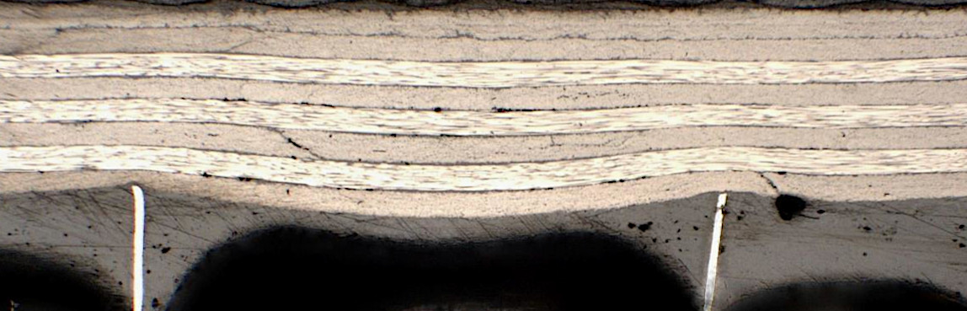
Cut in Lengthwise direction
±45_{f}
+45
+45
0
0
0
-45
-45

t_{min}
t_{max}

0.05 in

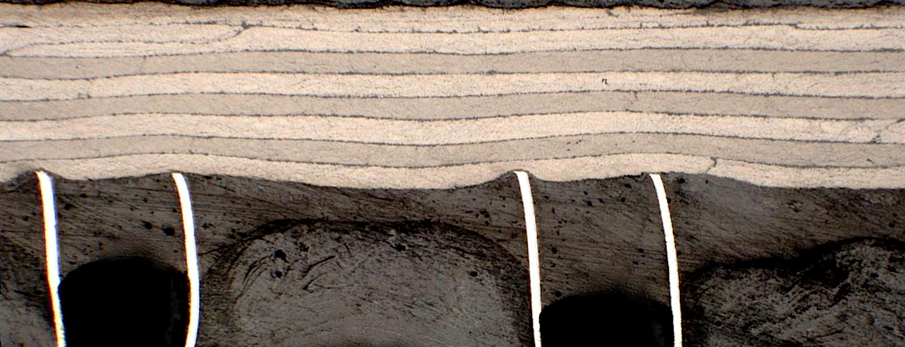
Cut in Widthwise direction
-45
-45
+45
+45
90
90
90
±45_{f}

0.05 in

Figure 1. Cross section photomicrographs showing face sheet waviness of inner plies (plies closest to the core) on honeycomb core specimens used in this study. Lengthwise and widthwise views shown. Ply angles with respect to cut direction labeled on right of photographs.

For the impacted specimens the ends needed to be potted to prevent end brooming during the compression after impact (CAI) tests that were to be performed. This was accomplished by crushing the core about 0.25 inch deep across the top and bottom of the specimen and filling these “channels” with paste epoxy resin as shown in figure 2. This prevented end brooming in most cases.

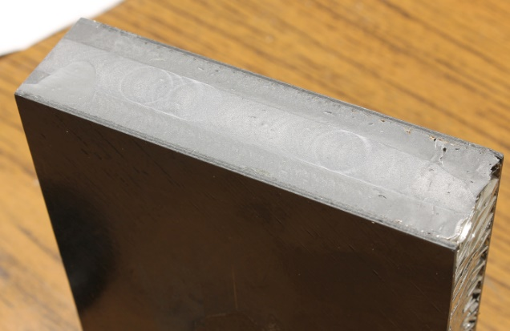
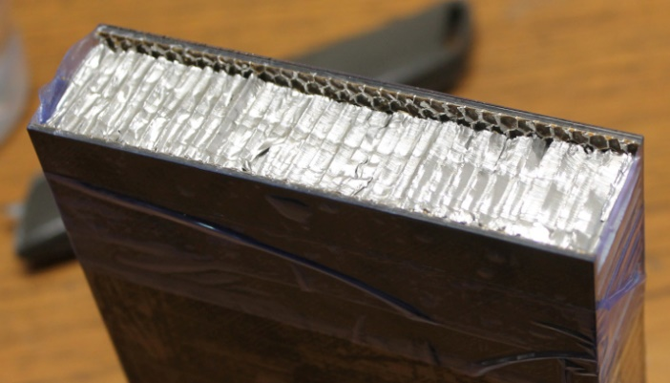

(b)
(a)

Figure 2. Photograph of the process to “pot” the ends of the specimens to prevent end brooming during compression testing. a) crush the core down about 0.25-inch on ends and b) fill the resulting channel with epoxy paste adhesive.

The “potted” ends were then machined to ±0.001-inch tolerance of parallelism using a vertical end mill with a solid carbide cutting tool (Onsrud 67-526 designed for carbon fiber machining). The side edges of the specimens were machined to be perpendicular to the top and bottom edges.
Undamaged strength testing of the sandwich structure was not pursued in this study since the undamaged specimens exhibited end-brooming despite the potted ends. This was deemed suitable since this study concerns damage tolerance testing and the differences between location of impacts and the resulting CAI strength and not the amount of compression strength loss from undamaged specimens.

3.0 Impact Damage Testing

An instrumented drop weight impact apparatus was used in this study. Each specimen was clamped between two steel plates during impact. The top steel plate had an opening to allow the impactor to pass through and hit the specimen. The bottom plate was solid with no cutout. The impactor had a rounded end and was 0.5 inches in diameter.
An impact energy of 12.0 ft-lbs, which was representative of barely visible impact damage (BVID), was the only impact damage level used in this study since the location of impact was the main variable being assessed in this study. Figure 3 is a schematic showing the four impact locations.

4.0

Dimensions in Inches
2.0

3.0
1.0

0.5
Loading Direction
0.25
6.0


Figure 3. Schematic showing the four impact locations used in this study.

At least five specimens were tested at each of the four impact locations.

3.1 Instrumented Impact Data
Sample load-deflection data from each impact location are shown in figure 4. Three random specimens are plotted for each location to demonstrate the better repeatability of data as the impact location approaches the center of the specimen. Note that, in general, the maximum load of impact appears smaller and the deflections larger for the specimens impacted closest (0.25 inch) to the edge. In addition, the specimens impacted at the center and 1-inch from the edge show a sudden drop in load after the maximum load of impact indicating more severe face sheet damage. The specimens hit 0.25 inches from the edge rarely showed these sudden drops in load and they were small if they occurred at all. The smoother nature of the load-deflection curves for specimens impacted closest to the edge of the specimen indicate core crushing rather than face sheet damage. Figure 5 plots the average maximum load of impact versus impact location for the specimens tested in this study with ± one standard deviation.

Large sudden drop in load indicative of face sheet damage

Sudden Load Drops are Small and infrequent

Figure 4. Load-deflection data of impacts on honeycomb core specimens used in this study.

Figure 5. Maximum load of impact versus impact location for the specimens tested in this study.

A trend of lower maximum load of impact as the impact location gets closer to the edge of the specimen in noticeable. It is postulated that this is due to less honeycomb being present to dent (crush) by the impact since an edge is encountered (no honeycomb) and thus more severe crushing occurs to the core that is available, relieving damage to the face sheet. (Damaging the face sheet requires higher loads than that to crush core of the density used in this study.) This can be seen in figure 4 in which the two impact locations closest to the edge do not have as large of a sudden drop from maximum load of impact indicating less face sheet damage.

3.2 Visual Damage
Examples of the visual damage caused at each of the four impact locations are shown in the photographs in figure 6. The damage appears the same except for the 0.25-inch from edge impact which shows less visual damage. This is not an unexpected result given that the maximum load of impact from the instrumented data in figures 4 and 5 show that the specimens impacted 0.25-inch from the edge had significantly less maximum load of impact indicating less face sheet damage.

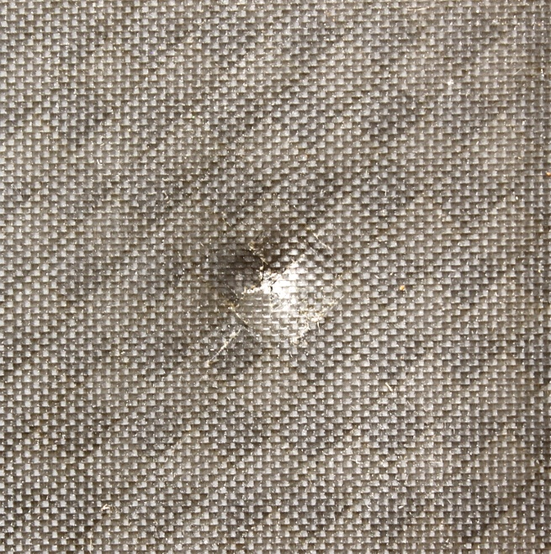
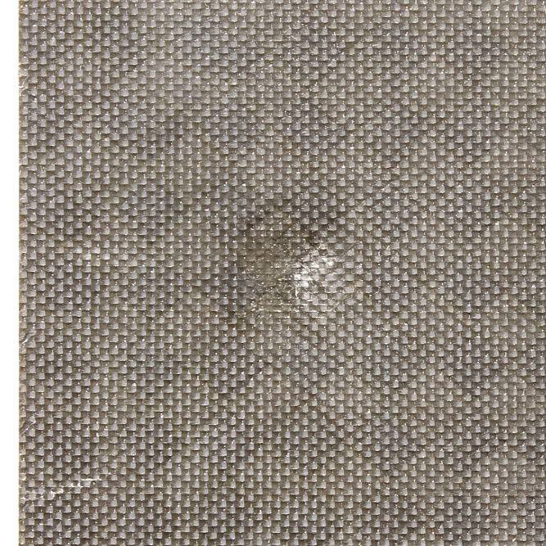
Center of Specimen J
1-inch from edge

1.0 in

1.0 in

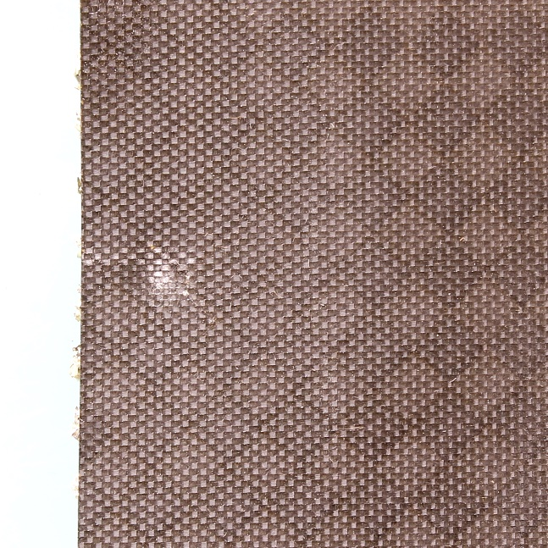
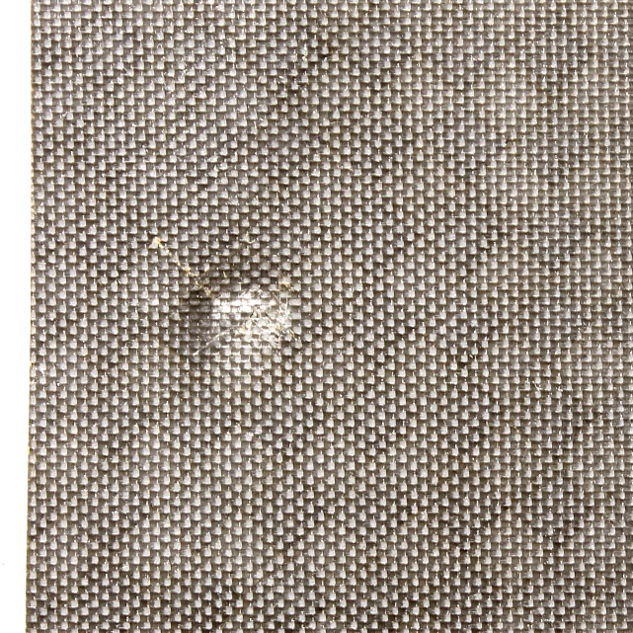
0.25-inch from edge
0.5-inch from edge

1.0 in

1.0 in

Figure 6. Examples of visual damage inflicted upon the specimens at each of the four impact locations tested. Loading direction is from top to bottom in these pictures. Impact energy = 12 ft-lbs.

3.3 Dent Depth Results

For each impacted specimen, the depth of the dent caused by the impact was measured at least 24 hours after the impact to allow for any “dent relaxation”. A dial gage was used to measure the dent depth. The results of average dent depth (± one standard deviation) versus impact location are plotted in figure 7.

Figure 7. Dent depth versus impact location for the specimens tested in this study.

The results in figure 7 show that the dent depth is about the same (considering the scatter) across all impact locations except at the edge where the dent measurements averaged slightly higher which is consistent with figure 4 which showed more deflection in the load/deflection impact curve. This is possibly due to more core crushing at the edge as postulated earlier.

3.4 Thermography Results

Non-destructive evaluation (NDE) in the form of thermography was performed on the impacted specimens and sample signatures from each of the four impact locations are presented in figure 8. The shape of the damage zone is basically circular for the specimens hit at the center and one-inch from the edge, and peanut shaped for impacts at one-half and one-fourth of an inch from the specimen edge. This usually indicates deeper face sheet damage for the circular damage zones and less through thickness damage for the peanut shaped zones.
Since it has been claimed that damage width as detected by thermography is a good indicator of CAI strength [7], the width of the damage zones in figure 8 were measured. What constitutes the “damage width” is noted in each of the thermography examples in figure 8.

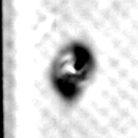
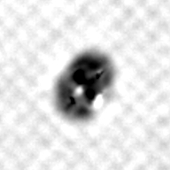
1-inch from edge
Center of Specimen J

Damage Width

Damage Width

1.0 in

1.0 in

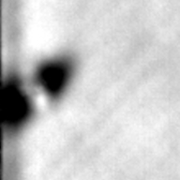
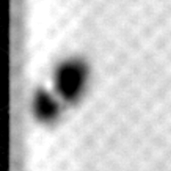
0.25-inch from edge
0.5-inch from edge

Damage Width
Damage Width

1.0 in

1.0 in

Figure 8. Examples of thermography images of the specimens at each of the four impact locations tested. Loading direction is from top to bottom in these pictures.

Average damage size (width) with ± one standard deviation as a function of impact location is plotted in figure 9.

Figure 9. Average damage size (width) versus location of impact for the specimens tested in this study.

Thus far it has been theorized that the face sheet damage should be less as the impact location approaches an edge from figures 4 and 5. Also the impacts closest to the edge had less visible damage as seen in figure 6. Figure 7 did show larger dent depths nearest the edge, but this was attributed to core crushing more than face sheet damage. Since the thermography results show about the same (or slightly larger for near edge impacts) areas of planar damage, specimens that have been impacted at the four locations were cross-sectioned through the damage zone to ascertain the through the thickness damage.

3.5 Widthwise Cross-Sectional Examination

Since the thermography results cannot ascertain with certainty the through thickness extent of damage, a few impacts from each of the four areas of impact were cross sectioned through the center of the impact location in the width and longitudinal directions of the specimen.
Photomicrographs are shown in figure 10 for the width direction cross-sections. The total damage width is noted in these photographs. The center and 1-inch from edge impacted specimens look quite similar in that complete penetration occurred for both. The specimen impacted 0.5-inch from the edge did not show complete penetration and the damage appears to be quite localized and did not extend to the edge (as was also seen in figure 7). Note that the core has crushed to the depth of the dent between the impact site and the edge of the specimen on the impact closest to the edge since there is no material to support the compressive loads once an edge is reached. The specimen impacted 0.25-inch from the edge also did not show complete penetration but did show more face sheet damage than the specimen impacted 0.5-inch from the edge, mainly because the damage in the face sheet propagated to the edge of the specimen.

Thus, the two specimens impacted closest to the edge showed less through thickness damage when sectioned in the width direction, but the overall damage length is comparable.

3.6 Shape and Size of Dent

The area of the dent and if it reaches the specimen edge can be seen by highlighting the size and shape of the dent caused by the impact event. The dents were highlighted by using a spackling compound and a large putty knife (just as one would with drywall) to fill in the dent with the white spackle thus showing the shape and size of the dent. Examples of the dent sizes and shapes are shown in figure 11 for the specimens impacted at the 4 different locations. Note that the dent from the impact at the center and 1-inch from the specimen edge do not reach the specimen edge. The dents formed by the two impacts closest to the edge do reach the edge of the specimen. This causes the dent to become less wide but also more elongated since the face sheet can deflect more along the free edge thus crushing more core in the lengthwise direction but not further damaging the face sheet.

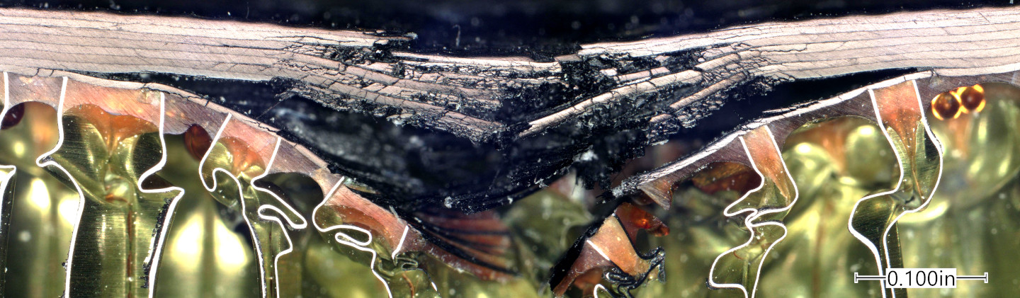

0.64 in

0.1 in
Center of Specimen J
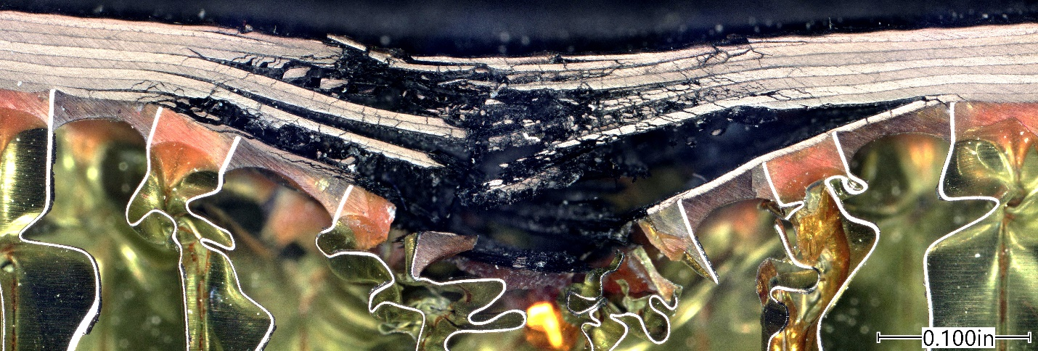

0.58 in

0.1 in
1-inch from edge

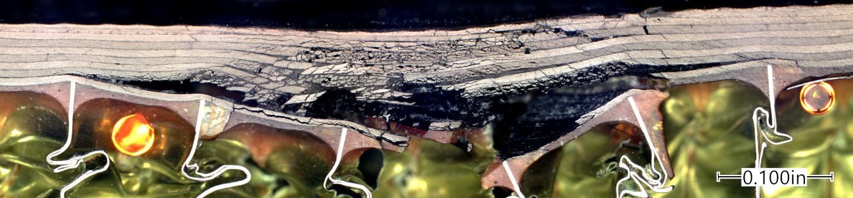

0.67 in

0.1 in
0.5-inch from edge

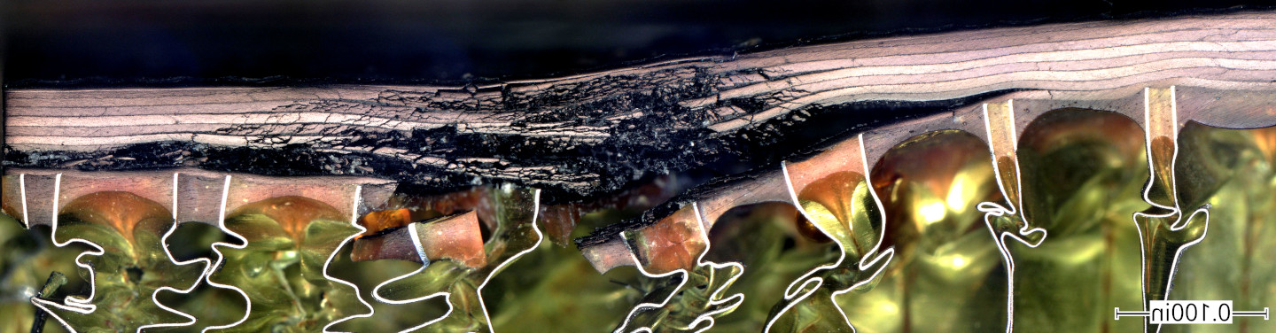

0.71 in

0.1 in
0.25-inch from edge

Figure 10. Example cross-sectional photomicroscopy of the specimens at each of the four impact locations tested. Specimens sectioned in the width direction.

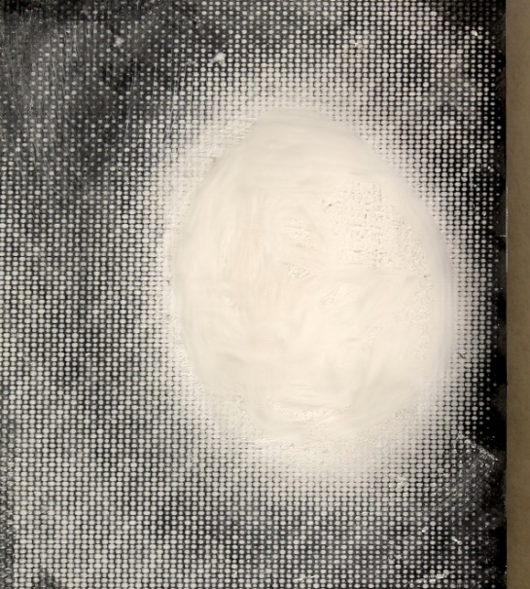
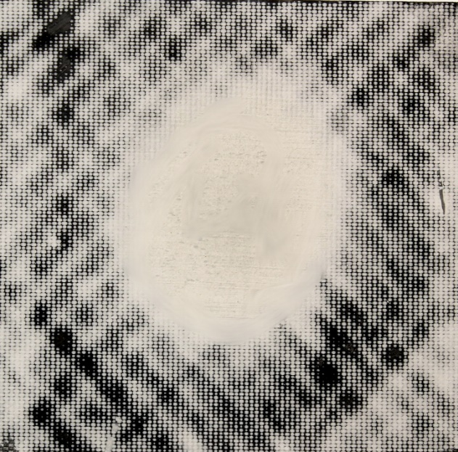
1-inch from edge
Center of Specimen J

1.5 inch
1.5 inch

1.8 inch

1.8 inch

0.25-inch from edge
0.5-inch from edge
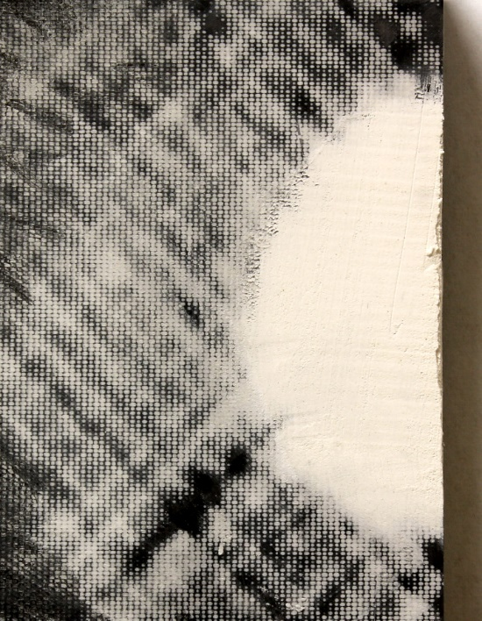
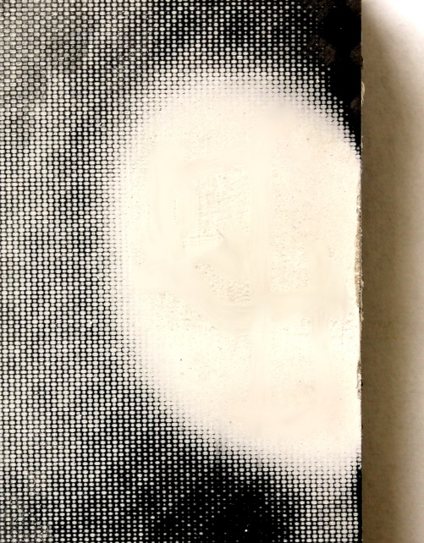

1.3 inch

1.0 inch

2.1 inch
2.4 inch

Figure 11. Spackling compound being used to mark off the dents formed by impacts at the four different locations from the specimen edge. Measurements taken with calipers.

3.7 Lengthwise Cross-Sectional Examination

Figure 12 shows examples of specimens sectioned through the damage zone in the longitudinal direction. The length of core crushing was measured with a caliper and are noted in each of the photographs in figure 12. These measurements should roughly correspond to the length of the dent as measured by the spackling compound in figure 11. The values are all within 0.1 inches except for the 1-inch from edge specimen. One tenth of an inch is about the maximum fidelity of measuring both the size of the dent as noted by the spackling compound and the length of core crushing.

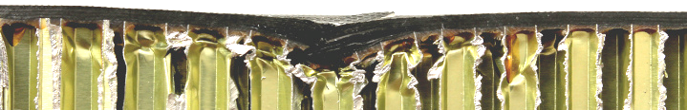

1.8-in

Center of Specimen J

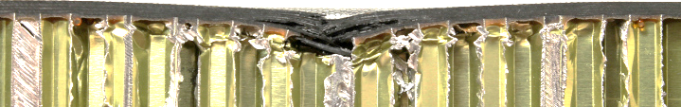

2.0-in

1-inch from edge

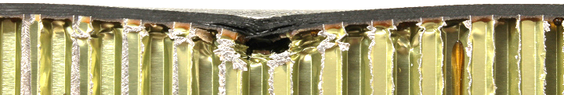

2.0-in
0.5-inch from edge

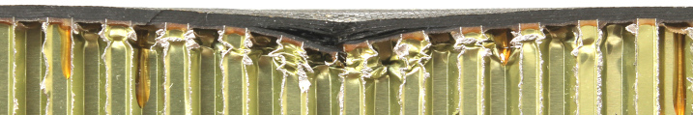

2.3-in
0.25-inch from edge

Figure 12. Example cross-sectional photomicroscopy of the specimens at each of the four impact locations tested to show core crushing. Specimens sectioned in the longitudinal direction and length of core crushing noted.

Figure 13 shows higher fidelity views of the face sheet damage in figure 12.

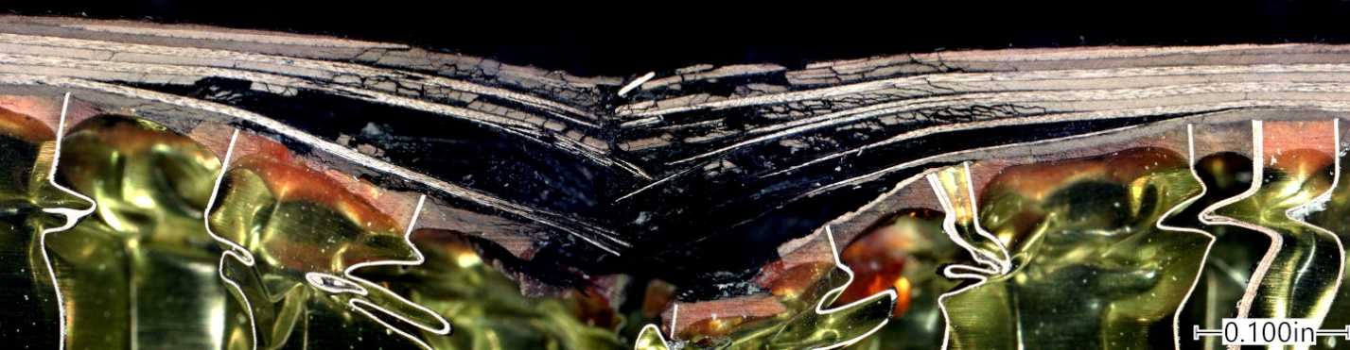

0.1 in
Center of Specimen J

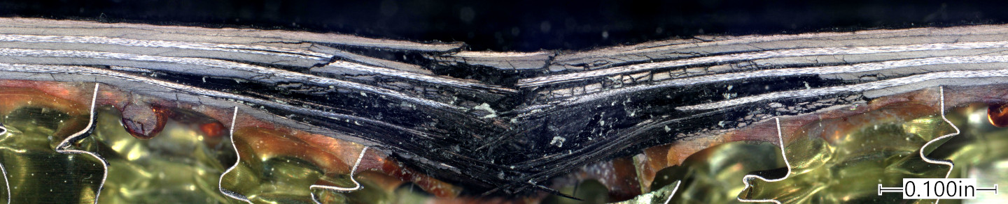

0.1 in
1-inch from edge

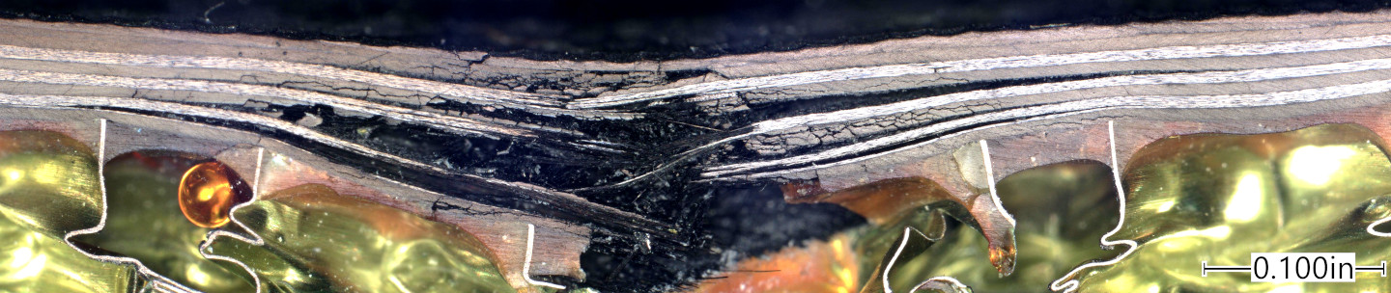

0.1 in
0.5-inch from edge

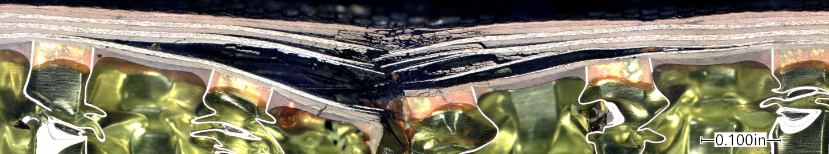

0.1 in
0.25-inch from edge

Figure 13. Example cross-sectional photomicroscopy of the specimens at each of the four impact locations tested to show face sheet damage. Specimens sectioned in the longitudinal direction.

From these cross-sections it appears that all 0⁰ load bearing fibers are broken and the face sheet damage in this view is more severe at the edge than the width-wise cross-sectional views. Thus the face sheet damage may be more severe for the edge impacts than thought thus far, however, the damage as viewed in the longitudinal direction may not be as important to CAI strength as damage in the width direction tends to be a better indicator of CAI strength [7].

4.0 Open Hole Compression Testing

While the impacted specimens were being prepared for compression testing, a series of open hole compression (OHC) tests with the hole offset from the center were performed on monolithic laminates of IM7/8552 carbon epoxy that was readily available. This was done to get a quick idea of the criticality of an “off-center” notch on the compression strength of carbon/epoxy laminates and, perhaps, what may be expected in the CAI tests. A “Northrop” fixture was used (shown in figure 14) since this fixture uses relatively small specimens (1-inch wide by 3-inches long). The holes were drilled to a diameter of 0.125-inch and then reamed to a final diameter of 0.130-inch. The holes were placed approximately at the center and 0.375, 0.25 and 0.125 -inch from the edge of the specimen.
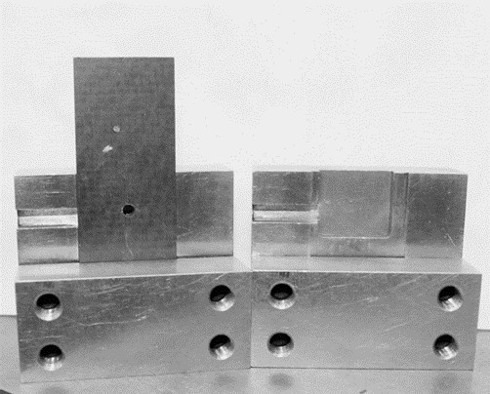

Figure 14. Photograph of OHC fixture used in this study.

Results of the off-center OHC tests are presented in figure 15. The results show that as the hole approaches the edge of the specimen, the compression strength drops. Thus it was expected that the impacts closest to the edge may also show a lower CAI strength based on this data.

Figure 15. Open hole compression (OHC) strength versus distance from hole to specimen edge.

5.0 Compression After Impact Testing

The impacted sandwich specimens were assessed for residual compression strength using the test fixture shown in figure 16. Three strain gages were placed on the specimen to ensure even loading of each of the face sheets. Two gages on the impact side were to ensure even loading across the specimen width and one gage in the center on the opposite (non-impacted) side to monitor for even loading across the specimen thickness. The specimens were taken to approximately 1000 microstrain compression and if one gage was lower than the others by more than 10%, shims were placed under the edge that was reading low until the gages were even. During compression testing the gages were monitored and if any deviation greater than 10% occurred, the test was stopped, and shims would be rearranged until the gages read within 10% of each other all the way until failure of the specimen.

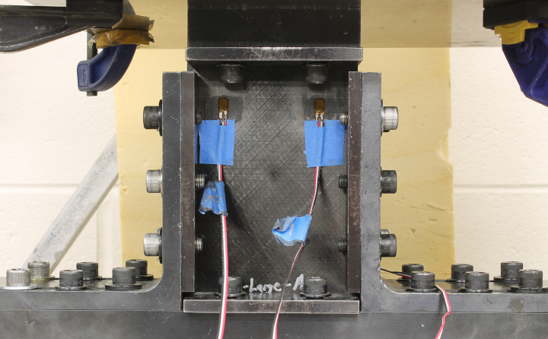

Figure 16. Fixture used in this study to assess compression after impact strength of sandwich specimens.

The average CAI strength results with ± one standard deviation are plotted versus damage location in figure 17.

Figure 17. Graphic representation of average CAI strength versus impact location results obtained in this study.

An examination of figure 17 indicates that there is not an obvious difference in average CAI values between the four impact locations given the amount of scatter in the data. It was thought that the impacts closest to the edge of the specimen would give the lowest values due to the impact damage interacting with the edges as it did for holes in the OHC tests (figure 15). However, the impacts closest to the edge may have had less damage per some of the data from the impact event, so these two phenomena (less damage to give higher strengths, and closer to an edge to cause lower strengths) may cancel each other out to give similar CAI strength values as a specimen impacted at its center.
Thus, from the CAI strength data in this study, for a given impact severity level, similar CAI strength results can be expected regardless of how close an impact is to the specimen edge.

6.0 Conclusions

For the compression after impact (CAI) specimens tested in this study, the following conclusions have been drawn with respect to near edge impacts.
- Instrumented impact testing showed less repeatability in the load/deflection curves as the impacts approached the specimen edge. In general, the maximum load of impact was less, and the deflection was greater for specimens impacted closest to the edge
- The visual damage was similar for the specimen impacted at 2-inches (center), 1-inch and 0.5-inch from the edge but was less for the specimens hit closest (0.25-inch) from the edge.
- The dent diameter reached the edge of the specimen at the two impacts closest to the edge as evidenced by the photos in figure 11.
- Dent depth was slightly larger for the specimen hit closest to the edge, probably due to more extensive core crushing since there is less core on one side of the impact to support the impacted face sheet.
- Thermography results showed little difference in the planar amount of damage in the face sheet, but cross-sectional examination showed more extensive (through thickness) face sheet damage for the specimens hit at the center and 1-inch from the edge when sectioned widthwise.
- The CAI strength values were not distinctly different given the scatter in the data.
- For practical purposes, a damage of a given severity level will yield similar CAI strength values whether it is impacted near an edge of a panel or father away from the edges.

7.0 References

- Nettles, AT, Guin, WE and Mavo, JP. Damage tolerance study of carbon fiber/epoxy sandwich structure in support of the SLS payload adapter fitting (PAF), NASA Technical Memorandum 20230014423, November 2023.
- Nassir, NA, Guan, ZW, Birch, RS and Cantwell, WJ. Damage initiation in composite materials under off-centre impact loading, Polymer Testing 2018; 69: 456-461.
- Lu, B, Zhang, J, Zheng, D, Zhang, T, and Xie, J. Study on off-center impact behavior and damage characterization of carbon fiber reinforced aluminum laminate, Composite Structures 2023; 304: 116404.
- Breen, C, Guild, F, and Pavier, M. Impact damage to thick carbon fibre reinforced plastic composite laminates, Journal of Materials Science 2006; 41: 6718-6724.
- Malhotra, A and Guild, FJ. Impact damage to composite laminates: Effect of impact location, Applied Composite Materials 2014; 21: 165-177.
- Malhotra, A, Guild, FJ and Pavier, MJ. Edge impact to composite laminates: experiments and simulations, Journal of Materials Science 2008; 43: 6661-6667.
- Nettles AT and Jackson JJ. Compression after impact testing of sandwich composites for usage on expendable launch vehicles, Journal of Composite Materials 2010, 44: 707-738.

