Author: Sergey Semenov
NASA Goddard Space Flight Center

Contribution to the LHP section of Chapter 14 – Heat Pipes (Spacecraft Thermal Control Handbook - STCH)

LHP Components
A conventional LHP consists of five major components and working fluid. These components are:
- Evaporator
- Vapor Line
- Condenser/Radiator
- Liquid Line
- Compensation Chamber
Figure 14.1 shows a schematic diagram of a classical LHP with a condenser line attached to a radiator panel.
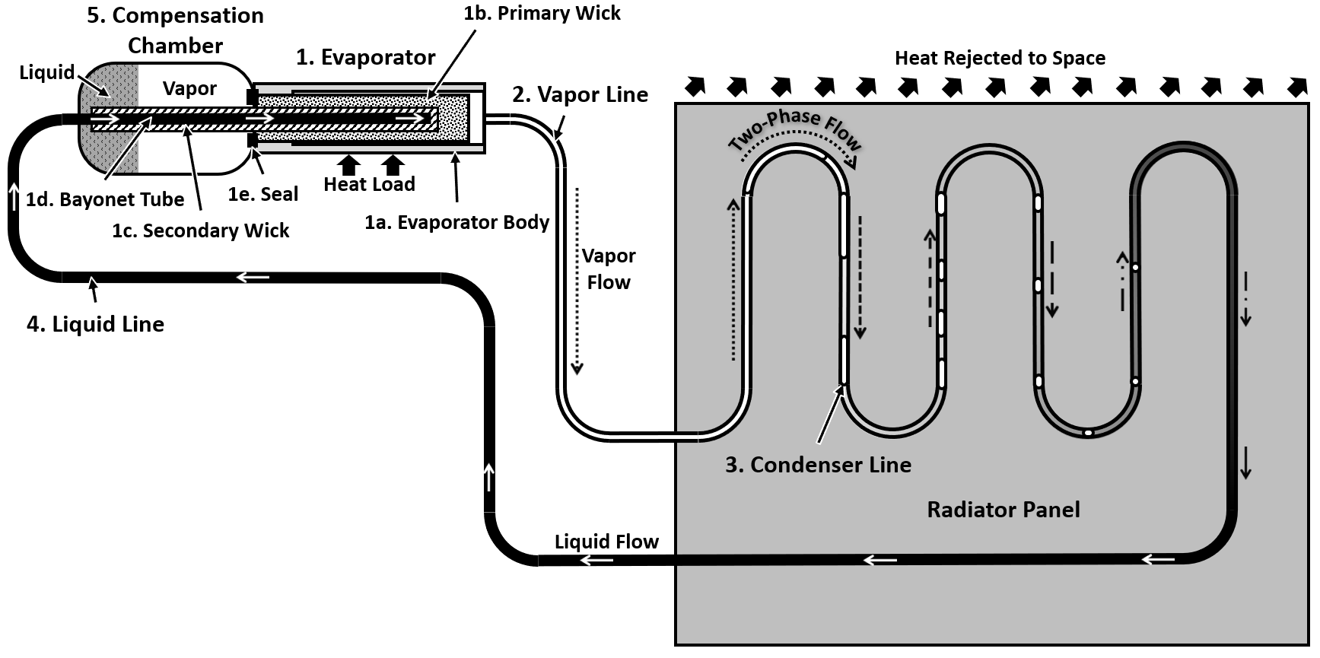
Figure 14.1. Classical LHP Components
Each of these five components and their constituencies is described below.
- Evaporator
An evaporator is the most sophisticated part of the LHP. A typical LHP evaporator includes:
- An evaporator body. An evaporator body contains all internal elements, conducts heat to the primary wick and provides hermeticity. Other names for an evaporator body include “evaporator case” and “evaporator envelope”. The evaporator body is designed to interface with the heat acquisition surface and commonly has provisions for startup heaters. The most common materials used for evaporator body fabrication are aluminum alloys, stainless steel, titanium, nickel, and copper.
- A primary wick is a porous structure that is located inside of the evaporator body. It is in direct contact with the inner surface of the evaporator body. The primary wick delivers liquid to the evaporator body inner surface by capillary action. The liquid is vaporized in the primary wick when the heat load is applied to the evaporator. Generated vapor flows through an array of vapor channels (a.k.a. grooves) toward the vapor line. A capillary pressure head is provided by the primary wick to circulate working fluid as liquid is evaporated from its surface. Table 14.1 list typical materials and characteristics used for primary wicks.
Table 14.1. Typical Characteristics of LHP Primary Wicks
Material | Effective Pore Radius, µm | Permeability, ×10¹³, m² | Porosity, % | Thermal Conductivity, W/(m K)
Stainless Steel | 0.8 – 5 | 0.1 – 20 | 40 – 50 | 0.8 – 1.6
Titanium | 1 – 10 | 2 – 20 | 55 – 70 | 0.6 – 1.5
Nickel | 0.7 – 10 | 0.1 – 20 | 60 – 75 | 5 – 10
Polyethylene | 10 – 20 | >10 | < 40 | < 0.3
Copper | 3 – 20 | >100 | 55 – 75 | 30 – 50
In most cases, primary wick is cylindrical in shape. It is installed in a cylindrical evaporator body that has external features which couple to a heat load. Flat evaporators have also been used in some applications with rectangular and disk shape primary wicks.
- The secondary wick is another key element in a typical LHP space application. The secondary wick is partially located in the evaporator. It is hydraulically coupled to the primary wick and extends into the compensation chamber. The purpose of the secondary wick is to transport liquid phase from the compensation chamber to the primary wick when the liquid supply from the liquid return line is inadequate. Secondary wick designs and fabrication materials are proprietary to their manufacturers.
- The bayonet tube is also partially occupying evaporator. The bayonet tube is an extension of the liquid return line that runs through compensation chamber and ends inside of the primary wick.
- The seal is an important element of the evaporator which prevents vapor penetration to the compensation chamber.
Based on the size LHP evaporators can be divided into:
- Miniature – when Outside Diameter (OD) or thickness is less than 10mm. Ref. 14.5, 14.6
- Medium – OD or thickness is in the range from 10mm to 20mm.
- Large – OD or thickness is over 20mm and the evaporator length is over 200mm.

- Vapor Line
A vapor line connects the vapor side of the evaporator to the condenser. It is necessary for transporting vapor to the condenser. A typical vapor line is a metal tube formed to comply with available volume for it. Vapor lines could be equipped with flexible sections for deployable radiators.
- Condenser and Radiator
Vapor enters condenser line where it is condensed into liquid. Typically, in space applications condenser line is routed in a serpentine pattern or arranged as a parallel leg network as shown in Figure 2 below.
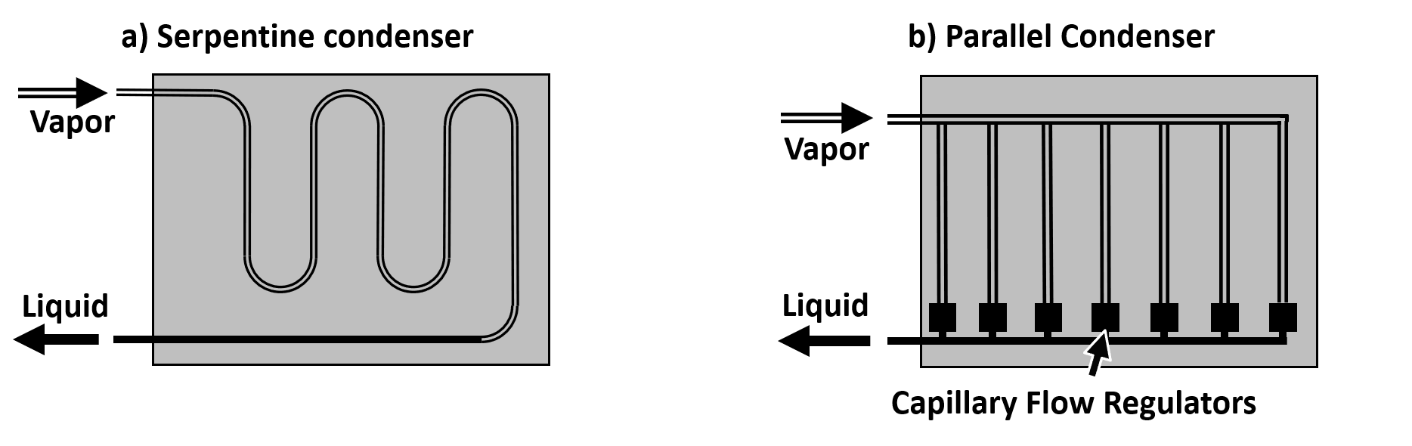
Figure 14.2. Serpentine and Parallel Condensers
When a condenser line is directly attached to the radiator panel it is called a direct condensation type condenser. As an alternative a condenser line could be coupled to heat pipes that spread heat across a radiator panel. This approach reduces the risk of condenser line damage from meteoroidal impact, and it is called an indirect condensation type.
The radiator shall be sized to reject the maximum heat load at the end of life worst hot case. An area margin of 20% and 10ºC of subcooling are recommended.
- Liquid Line
The condensed liquid flows back to the evaporator via liquid line. A typical liquid line is like a vapor line of the same or smaller diameter. Flexible sections can be implemented into liquid lines for systems with deployable radiators.
- Compensation Chamber
The Compensation Chamber (CC) provides a volume for balancing the liquid fraction of the working fluid in the LHP. It is sized to contain some amount of liquid fraction under all operating conditions as well as over the entire survival temperature range. A classical LHP design employs a single CC that is integrated with a LHP evaporator as shown in Figure 14.1. The orientation of the evaporator/CC assembly during ground testing is limited by the secondary wick capacity. Thus, in gravity field the secondary wick elevates liquid from the CC to the primary wick when CC is lower than the evaporator. The LHP operation is ceased when the secondary wick is unable to supply the required amount of liquid to the primary wick. To overcome this limitation a double-sided and cavity-type designs shown in Figure 14.3 have been developed.
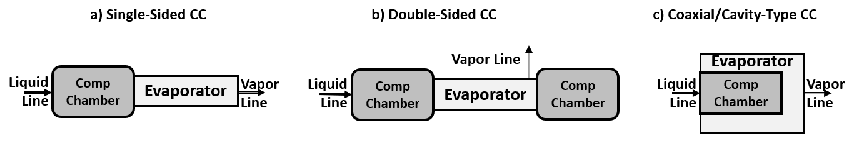
Figure 14.3. CC Design Types: a) Single-Sided, b) Double-Sided and c) Cavity in the Evaporator
The evaporator-CC assembly is also called a two-phase pump. In addition to the components described above a fill tube shall be implemented into the LHP for processing.
Based on the operating temperature range LHPs can be divided into three groups:
- Cryogenic LHPs, operating below 120K. Typical working fluids Oxygen, Nitrogen, Argon, Hydrogen, Helium, Neon.
- Low-to-Medium Temperature LHPs operate from 120K to 400K. Typical working fluids: Ammonia, Propylene, Ethane, Methane, Acetone, Water. Ammonia and propylene are the most common working fluids for space applications due to their excellent thermal properties and operating temperature ranges.
- High Temperature LHPs designed to operate above 400K. Typical working fluids: Potassium, Sodium.

Operating Principles and Performance Characteristics of LHPs
The operating principle of Loop Heat Pipes (LHP) and their performance characteristics were studied by several authors (Ref. 14.1, 14.2, 14.19).
Steady-State Operation
The primary driving force that causes a LHP to operate is an externally applied heat load to the evaporator and a heat removal from the condenser.
Major Performance Characteristics of LHPs
The two most important parameters that characterize performance of a LHP are thermal conductance and heat transport capacity. Other characteristics such as minimum startup and shutdown power levels, maximum tilt of the evaporator, sensitivity to the control power applied to the CC heater could be important in a particular application.
LHP Thermal Conductance
In general, the LHP thermal conductance is the ratio of the applied heat load to the temperature difference between the evaporator and the condenser:
C_{LHP} = Q_{evaporator} / (T_{evaporator} – T_{condenser}) (14.1)
or between evaporator and radiator in cases where radiator is an integral part of the LHP.
C_{LHP} = Q_{evaporator} / (T_{evaporator} – T_{radiator}) (14.2)
The conductance is typically measured in W/ºC or in W/K. The reported conductance values could vary significantly due to temperature gradients in the LHP evaporator and the condenser sections. When a radiator is an integral part of the LHP the effective radiator temperature can be used for a LHP conductance calculation. Thus, the formula 14.2 can be written as:
C_{LHP} = Q_{evaporator} / (T_{evaporator} – T_{radiator_effective}) (14.3)
In a case where the sink temperature, T_{sink} is known, the effective radiator temperature, T_{radiator_effective} can be found from the net radiation heat exchange:
Q_{radiator} = A_{radiator} ε σ (T⁴_{radiator_effective} – T⁴_{sink}) (14.4)
where, A_{radiator} is the radiator heat emitting area, ε is the emissivity of the radiating surface, σ is the Stefan–Boltzmann constant and the Q_{radiator} is the net heat exchange between the radiator and the sink.
A LHP thermal conductance is affected by conductances of each element in the heat flow path. A Rough Order of Magnitude (ROM) estimate of the evaporator thermal conductance can be made based on its size. Thus, neglecting thermal resistance of the evaporator body the evaporator conductance can be calculated as a product of the evaporation heat transfer coefficient, h_{evap} and the area of the where evaporation takes place, A_{primary_wick}.
C_{evaporator} = h_{evap} A_{primary_wick} (14.5)
The h_{evap} primarily depends on the working fluid properties. A value of h_{evap_ammonia} = 5,000 W/(m² K) can be used as a conservative value for ammonia. The A_{primary_wick} can be calculated based on the primary wick outside diameter, OD_{primary_wick} and its length L_{primary_wick} as following:
A_{primary_wick} = π·OD_{primary_wick} ·L_{primary_wick} (14.6)
An assessment of the thermal conductance of the LHP condenser is an elaborate task that is typically accomplished by numerical modeling.
Power capacity
The LHP power capacity is the maximum heat load that the LHP can transport at a particular operating temperature. The limitation of a LHP heat transport in 0-g is typically due to either a size of an evaporator or a condenser/radiator.
The LHP power capacity is directly proportional to the evaporator size (length and diameter) when evaporator is the limiting factor. In addition to size the evaporator internal design and materials as well as the working fluid affect the LHP power capacity and thermal conductance. The length of the evaporator is typically matched to the payload size when the evaporator is directly attached to it. LHP manufacturers qualified several evaporator sizes and offer them as their standard sizes. Typical power capacities of the LHP evaporators listed in the Table 14.2.
Table 14.2. Typical Power Capacities of LHP Evaporators
Parameter | Evaporator Size
 | Miniature | Medium | Large
Outside diameter | <10mm | 10mm to 20mm | >20mm
Length | <50mm | 50mm to 200mm | >200mm
Power capacity with ammonia | <200W | 200W to 2kW | >2kW
Power capacity with propylene | <50W | 50W to 500W | >500W

LHP Startup
A typical LHP startup occurs when heat is applied to the evaporator that contains a liquid-filled primary wick. The heating enables evaporation of the working fluid from the outer surface of the wick. Superheating occurs if the vapor grooves were initially filled with liquid. As evaporator temperature continues to increase, a temperature difference between the inner and the outer wick surfaces will be growing. The liquid-vapor menisci will be formed on the outer wick surface. As a result, the vapor pressure will be increasing on the vapor side of the evaporator and a working fluid circulation begins due to the pressure difference created by the meniscus’ capillary pressure.
The LHP startup scenarios and risk mitigation options were summarized in Ref. 14.12. A simple and effective approach to enhance LHP startup is a localized heat source called startup heater that is typically attached directly to the evaporator body. The startup heater provides a concentrated heat flux to initiate nucleate boiling of the working fluid on the vapor side of the primary wick with minimal heat leak to the compensation chamber.
LHP Shutdown
The LHP shutdown is performed to terminate heat transfer from the evaporator to condenser. It is accomplished by deactivating the payload and maintaining CC slightly warmer than the evaporator. The fluid circulation is terminated and the LHP placed in a non-operational mode also called a survival mode. The LHP shutdown process is described in Ref. 14.2 and 14.12. The key principles are:
- No net heat load to evaporator.
- The CC temperature must be higher than the evaporator temperature.

Temperature Oscillations
Temperature oscillations in LHP could be induced by a control heater cycling or by internal mechanisms under a constant heat load. The induced oscillations can be addressed by modifying the temperature control scheme. The natural oscillations can be divided into three categories, as described in Ref 14.24.
- Ultra-High Frequency Temperature Oscillations.
- Periods less than 1 second.
- Related to two-phase flow characteristics.
- No published experimental data.
- Not important in spacecraft thermal control.
- High Frequency, Low Amplitude Temperature Oscillations.
- Periods on the order of seconds to minutes.
- Amplitudes on the order of one Kelvin.
- Caused by vapor front movement near condenser inlet or exit.
- Low Frequency, High Amplitude Temperature Oscillations.
- Periods on the order of hours.
- Amplitudes on the order of tens of Kelvin.
The Low Frequency, High Amplitude temperature oscillations may occur in space applications when the evaporator is attached to a massive payload. Typical approaches to mitigate temperature oscillations include:
- Active control of the CC temperature.
- Reduction of the heat leak from the evaporator to CC.
- Reduction of heat leak from ambient to the liquid line.
- Vapor line heating for preventing vapor condensation in the vapor line.
LHP Applications
LHPs are well suited for space applications due to a unique combination of their characteristics. Below are some examples to illustrate how a LHP can be utilized for thermal management in space applications.
Thermal Diode Feature and Passive Operation
A LHP will passively transfers heat from a payload (heat source) to a radiator once the payload is activated (see Figure 14.4.a). The LHP will also provide a high thermal resistance between the payload and radiator when the payload is inactive (see Figure 14.4.b). Typically, a small amount of heat to the CC is necessary to prevent LHP self-start under this condition. This capability of the LHP can be used to prevent overcooling of the payload during lunar nights or interplanetary cruise phases.
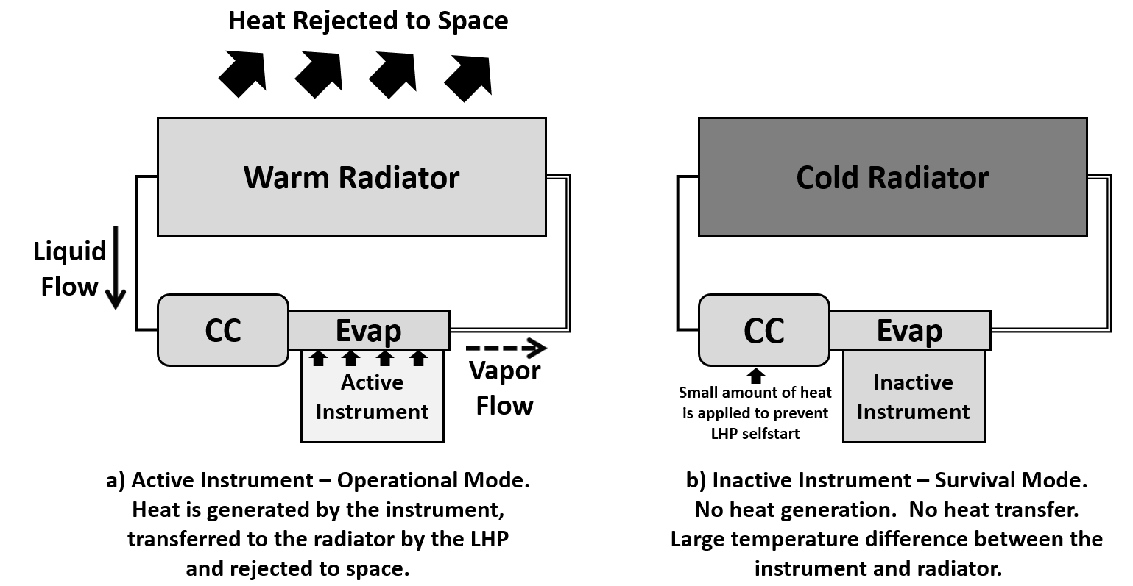
Figure 14.4. Operational and Survival Modes with LHP

Passive Switching Between Radiators
Another usage of the LHP diode-like capability can be illustrated when there is a need to switch heat rejection from one radiator to another. Figure 14.5 shows a spacecraft with an instrument coupled to a pair of LHPs. The LHP 1 transfers heat to the Radiator 1 when it is looking into deep space while the other side of the spacecraft is facing the sun. During this phase the Radiator 2 can be warmer that the instrument. However, LHP 2 does not transfer heat from the Radiator 2 to the instrument. The situation is reversed when the spacecraft is oriented with the Radiator 2 facing the deep space and the Radiator 1 exposed to the solar flux (load).
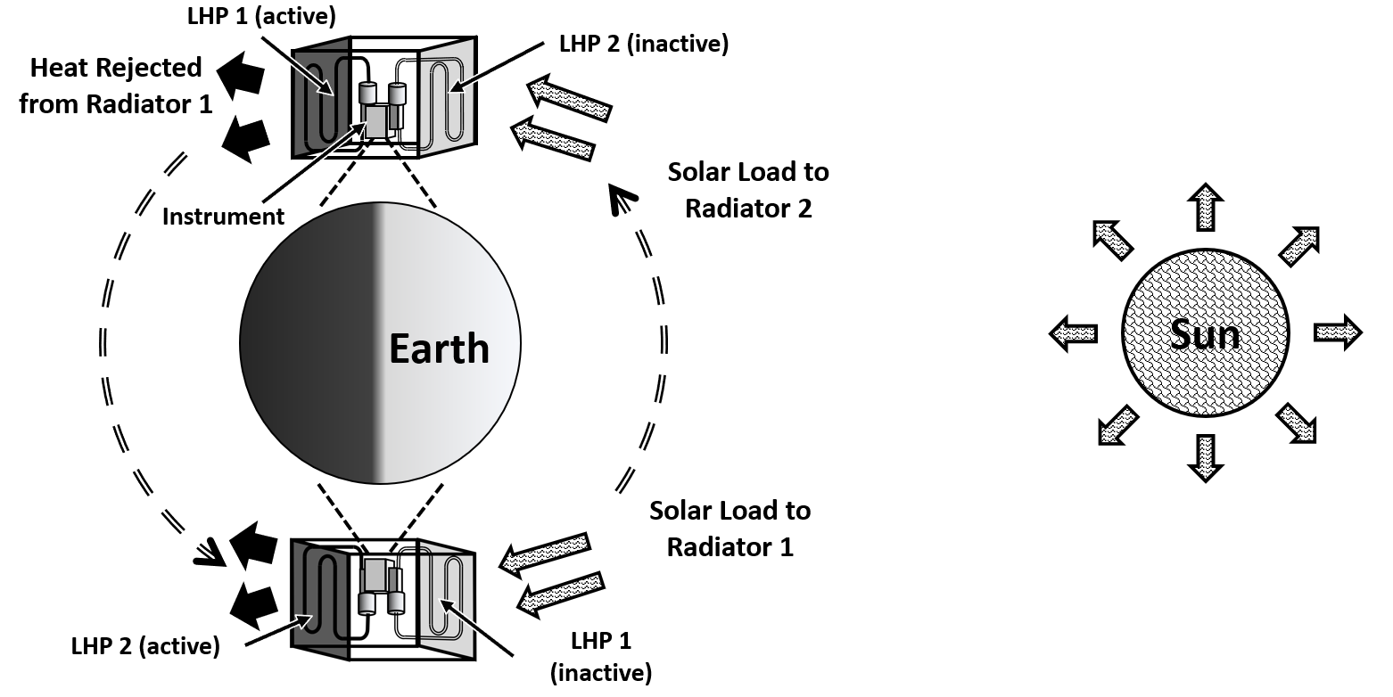
Figure 14.5. LHPs for Passive Switching Between Radiators

Temperature Control Methods using LHPs.
LHPs are well suited for controlling temperatures of various payloads such as instrument sensors (FPA, CCD, etc.), cryocoolers, batteries and other electronic components. They can also provide a high temperature stability for samples acquired from celestial bodies. Several approaches have been developed to adjust the LHP conductance so that the payload temperature is maintained at a constant value while the sink temperature and/or heat load is changing.
Heating Compensation Chamber and/or Liquid Return Line
The direct heating of the compensation chamber as shown in Figure 14.6 below is one of the most used methods to control the LHP operating temperature (Ref. 14.18, 14.19). The heat applied with a control heater attached to the compensation chamber elevates the temperature of liquid returning to the evaporator. As a result, the LHP operates at a higher temperature and payload become warmer. Under this condition the LHP will naturally produce an equivalent amount of liquid subcooling in the condenser. The same effect can be achieved by heating the liquid return line.
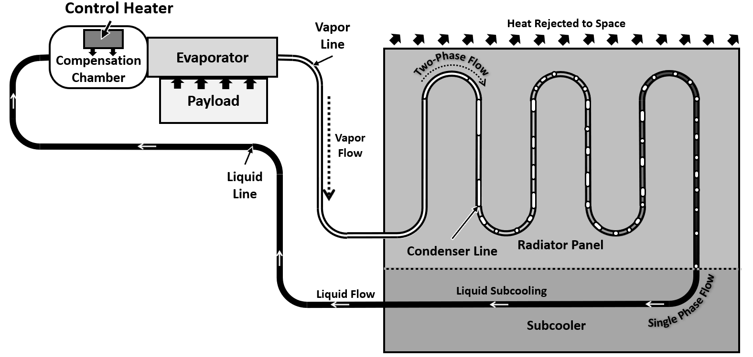
Figure 14.6. Temperature Control with Heater on the Compensation Chamber
The radiator must be sized to account for the required subcooler section. The amount of control heater power is proportional to the evaporator heat load. The advantage of using LHPs over conventional heat pipes is that the required control power is only a small fraction of the evaporator heat load. The control power level required to raise the operating temperature by a certain amount increases with the LHP operating temperature. For example, only about 3W of heat is needed to raise the operating temperature from -40ºC to -30ºC when an ammonia LHP is carrying 100W of heat. For the same LHP the required control power will increase by about 1W in order to change its operating temperature from +20ºC to +30ºC.

LHP with a three-way pressure regulating valve.
One of the first flight qualified passive temperature control of the LHP was a three-way pressure regulating valve. Ref.14.13, 14.16. A schematic diagram of such valve integrated in a LHP is shown in Figure 14.8.
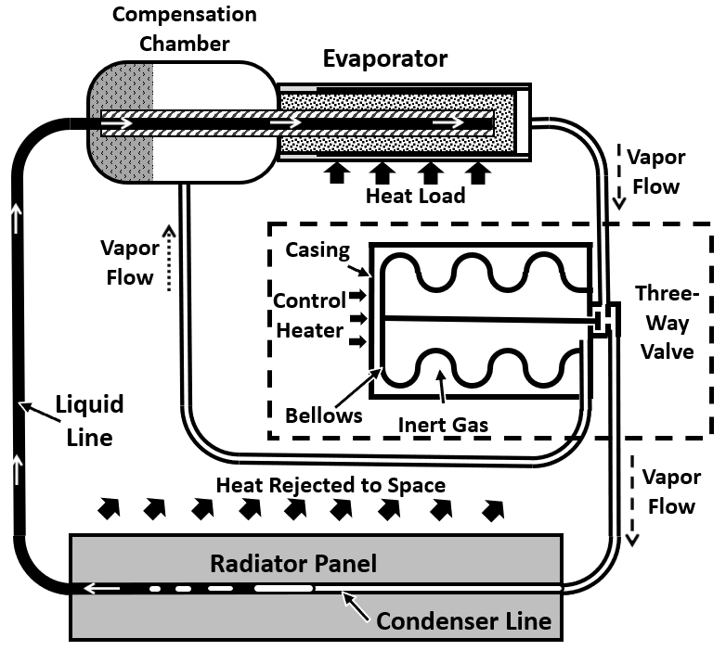
Figure 14.8. LHP with Three-Way Valve
The three-way pressure regulating valve can be designed to operate in passive or active mode. For a passive mode operation, pressure of the inert gas between casing and bellows shall be equal to the saturation pressure of the working fluid at the operational setpoint. The valve is actuated by a pressure difference between inert gas and vapor in the vapor line. The temperature control is accomplished by directing some amount of vapor to flow into the CC bypassing condenser when vapor temperature drops below the setpoint. The passive mode operation demonstrated ±3ºC temperature stability (Ref. 14.13). Adding a heater to the valve casing and working fluid to the inert gas improves temperature stability to ±0.5ºC (Ref. 14.16).

LHPs Compared to other Heat Transfer Systems
Table X. Comparison of technology limits (LHP vs other types of heat transfer systems)
 | LHP  (NH₃) | CPL  (NH₃) | AGHP  (NH₃) | Cu-H₂O HPs | Straps | Mech. Pump Single Phase
Length of the heat acquisition surface, m | < 0.5 | < 0.5 | < 2 | < 0.3 | < 0.3 | > 1
Length of heat rejections surface, m | < 10 | < 10 | < 2 | < 0.5 | < 0.3 | > 10
Heat transport distance (0-g), m | < 20 | < 20 | < 4 | < 1 | < 1.5 | > 20
Power capacity, kW | < 10 | < 10 | < 0.5 | < 1 | < 1 | < 20
Heat flux at the heat acquisition surface, W/cm² | < 50 | < 50 | < 5 | < 100 | No limit | < 50
Operation against gravity, m | < 5 | < 5 | < 0.02 | < 0.5 | No limit | > 5
Suitability for temperature control | High | High | Limited | Limited | Limited | High
Startup assistance | Preferred | Required | Not required | Not required | Not required | Pump startup
External power for operation | Not required | Not required | Not required | Not required | Not required | Required
External power for temperature control | Small | Small | Large | Large | Large | Small

LHP Advantages
The benefits of LHPs are most evident in applications where:
- Tight temperature control with minimum power consumption.
- Diode feature.
- High power capacity over large heat transport distances.
- Ground testing with large adverse tilts.

Numerical Simulation of LHP Systems
As LHP systems become more diversified to meet requirements of the most challenging missions, their numerical simulation is advancing as well. Harsh and dynamic environmental conditions often require elaborate modeling of the thermal-fluid transients inside LHPs. The currently commercial software, such as Thermal Desktop with fluid dynamic add-on module – FloCad demonstrated to simulate some complex transients in LHPs, Ref 14.23

References

14.1 Yuri Maydanik, “Loop Heat Pipes,” Journal of Applied Thermal Engineering, Volume 25, Issues 5–6, April 2005, Pages 635-657.
14.2 Jentung Ku, “Operating Characteristics of Loop Heat Pipes,” SAE 1999 Transactions - Journal of Aerospace-V108-1, 1999
14.3 H. Hustaix, T. Maciaszek, C. Puillet, “Experimental and analytical study of a reversible two-phase capillary pumped loop,” in: Proc. of 6th European Symp. on Space Envoronmental Control Systems, Noordwijk, The Netherlands, 20–22 May 1997, pp. 411–417.
14.4 R.G. Sudakov, Yu.F. Maydanik, J.M. Ochterbeck, S.-W. Choi, “Development and investigation of an ammonia reversible loop heat pipe,” in: Proc. of 12th Int. Heat Pipe Conference, Moscow, Russia, 19–24 May 2002, pp. 177–181.
14.5 Jentung Ku, Laura Ottenstein, Donya Douglas, Triem Hoang, “Multi-Evaporator Miniature Loop Heat Pipe for Small Spacecraft Thermal Control – Part 1: New Technologies and Validation Approach,” April 2008, 49th AIAA/ASME/ASCE/AHS/ASC Structures, Structural Dynamics, and Materials Conference, AIAA 2008-1960
14.6 Khrustalev, D. and Semenov, S. “Advances in Low-Temperature, Cryogenic, and Miniature Loop Heat Pipes,” Presentation at the 12th Annual Spacecraft Thermal Control Technology Workshop, El Segundo, March 2003.
14.7 D. Khrustalev, “Cryogenic Loop Heat Pipes as Flexible Thermal Links for Cryocoolers,” Cryocoolers 12, Proc. Of the 12 Int. Cryocooler Conference, June 18-20, 2002, Cambridge, MA, USA, pp. 709-716.
14.8 D. Khrustalev, Test Data for a Cryogenic Loop Heat Pipe Operating in the Temperature Range from 65 k to 140 K, Presentation at the International Two-Phase Thermal Control Technology Workshop, Mitcheville, MD, September 24-26, 2002.
14.9 Hoang., T., O’Connell, T., Khrustalev, D., Ku, J., “Cryogenic Advanced Loop Heat Pipe in Temperature Range of 20-30 K,” International Heat Pipe Conference, Moscow, Russia, May 2002.
14.10 Khrustalev, D., Rosenfeld, J., Stanley, S., and Gerhart, C., “Cascaded Oxygen/Ethane Loop Heat Pipes,” International Heat Pipe Conference, Tokyo, Japan, September 1999.
14.11 Hoang, T., T. O’Connell, and D. Khrustalev, “Development of a Flexible Advanced Loop Heat Pipe for Across-Gimbal Cryocooling,” Paper No. AM03-AM125-7, Cryogenic Optical Systems and Instrumentation X, Conference 5172, The International Symposium on Optical Science and Technology, SPIE 48th Annual Meeting, 3–8 August 2003, San Diego, California, USA.
14.12 Jentung Ku, “Loop Heat Pipe Startup Behaviors,” 46th International Conference on Environmental Systems, 10-14 July 2016, Vienna, Austria, ICES-2016-24

  - LHP Temperature Regulation
Passive
Three-way Valve
14.13 Goncharov K., Kochetkov A., Buz V. Development of loop heat pipe with pressure regulator // Int. Two-Phase Thermal Control Technology Workshop, LA, USA, March 7–9, 2005.

Two-way Valve
14.14 Romera F., Mishkinis D., Kulakov A., Torres A. “Control of LHP operation temperature by a pressure regulating valve // 15th Int. Heat Pipe Conf., Clemson, USA, April 25-30, 2010.
14.15 D. Mishkinis, A. Kulakov, F. Romera, C. Gregori, A. Torres, “Thermal Control of Loop Heat Pipes with Pressure Regulating Valve,” VIII Minsk International Seminar “Heat Pipes, Heat Pumps, Refrigerators, Power Sources”, Minsk, Belarus, September 12–15, 2011
High Precision Temperature Control
14.16 K. Goncharov, V. Buz, U. Hildebrand, O. Romberg, F. Bodendieck, R. Schlitt “LOOP HEAT PIPE FOR HIGH-PRECISION SATELLITE THERMAL CONTROL,” Aerospace congress, Vancouver, September 2004
14.17 S. Semenov, D. Patel, T Hoang, C. Stull, “Thermal Ground Testing of Loop Heat Pipes for PACE OCI,” 51st International Conference on Environmental Systems, 10-14 July 2022, St. Paul, Minnesota, ICES-2022-412

14.18 M. Nikitkin, D. Wolf, “Control Power Reduction in LHPs. Three Generations of design,” International Two-Phase Workshop Laurel, Maryland, September 2006
14.19 S. Semenov, “Introduction to Loop Heat Pipes,” TFAWS 2023 Technical Course, August 2023, College Park, MD
14.20 D. Khrustalev, T. Holman, R. Baldauff, “Operational Principles of a Pump-Augmented Loop Heat Pipe with Auxiliary Evaporators,” AIAA Propulsion and Energy Forum, August 24-28, 2020
14.21 D. Khrustalev, T. Holman, E. Hyde, R. Baldauff, “Operational Verification of a P ump Augmented Loop Heat Pipe with Auxiliary Evaporators,” ???

LHP startup
14.22 Z. Hongxing, L. Guiping, D. Ting, Y Wei, S Xingguo, R. Sudakov, Y. Maidanik, “Investigation of Startup Behaviors of a Loop Heat Pipe,” Journal of Thermophysics and Heat Transfer, Vol. 19, No. 4, pp 509-518, October–December 2005

LHP Modeling

14.23 T. Holman, R. Baldauff, D. Khrustalev, “Stabilized Loop Heat Pipe Architecture for Reliable Operation Under High-Power Transients,” Journal of Thermophysics and Heat Transfer, Vol. 34, No 3, July-September 2020

LHP Temperature Oscillations
14.24 Ku, J., Rodriguez, J., “Low Frequency High Amplitude Temperature Oscillations in Loop Heat Pipe Operation”, International Two-Phase Thermal Control Technology Workshop 2003, Noordwijk, Netherlands, September 2003

