SSC24-XI-07

Development of Advanced Ablative Carbon Phenolic TPS for
Future NASA Missions and Commercial Space

Matthew Gasch, Keith Peterson, Mairead Stackpoole and Ethiraj Venkatapathy
NASA Ames Research Center
NASA ARC, Moffett Field, CA 94035; 650.604.5377 matthew.j.gasch@nasa.gov, 650.604.4810 keith.h.peterson@nasa.gov, 650.604.6199 margaret.m.stackpoole@nasa.gov,
650.604.4282 ethiraj.venkatapathy-1@nasa.gov

Greg Gonzales and Kyle Hendrickson
Analytical Mechanics Associates (AMA)
AMA-NASA ARC, Moffett Field, CA 94035; 650.604.1650 gregory.l.gonzales@nasa.gov,
650.604.5184 kyle.m.hendrickson@nasa.gov

ABSTRACT
Phenolic Impregnated Carbon Ablator (PICA) is a low-density carbon phenolic ablator that has been used as the planetary entry heatshield for several NASA missions since the late 90’s. Its low density and efficient performance characteristics have proven effective for use from Discovery to Flagship class missions, from Sample Return missions such as Stardust, OSIRIS-REx to large Mars lander missions such as MSL and Mars 2020.
Continued development of a mass efficient, compliant version of PICA that use a carbon felt as the substrate will be presented. The felt based versions of PICA known as Conformal PICA (C-PICA) and Soft PICA (S-PICA) are comparable in terms of peak heat-flux capabilities compared to standard PICA. Additionally, a novel all felt PICA-Flex offers further reductions in density, with higher thermal protection efficiency resulting in additional mass savings beyond C-PICA. Furthermore, the compliant nature of these materials allows for application without a Strain Isolation Pad to a wide variety of substrates, making attractive for commercial low earth orbit missions as well as NASA’s aerocapture missions to Ice Giants. NASA is currently working with several commercial partners (Varda Space Industries and Inversion Space) to technology transfer C/S-PICA variants for commercial LEO missions. Preliminary thermal and mechanical tests have been conducted comparing the performance of C/S-PICA and PICA-Flex materials.

introduction
Phenolic Impregnated Carbon Ablator (PICA) is the current state of the art (SoA) in low-density high-performance thermal protection system (TPS) materials.¹ Standard PICA uses a porous rigid carbon-fiber substrate impregnated with a dispersed phenolic polymer. The composite is somewhat brittle with low strain to failure; consequently, heatshields larger than about 1 m must be assembled from multiple PICA pieces (“tiles”) that are bonded together. Such tiled heatshields have a history of success: for example, Mars Science Laboratory (MSL), Mars 2020, and the SpaceX Dragon capsule.²⁻³
More recently, the conformal variant (C-PICA) and soft variant (S-PICA) of PICA are proving to provide additional benefits beyond the traditional rigid PICA for entry environments below 1000 W/cm². A conformal thermal protection material is characterized by the following: 1) it is based on a flexible reinforcement like felt; 2) it allows for large geometry segments because the reinforcement is delivered as broad goods (in wide, long rolls); 3) it is drape-able or formable during processing for easy integration; 4) the formability provides for lower thermal conductivity in complex curved regions; and 5) it has better strain-to-failure properties than rigid TPS materials. A conformal TPS over a rigid aeroshell has the potential to solve several challenges faced by traditional rigid TPS materials such as tiled rigid PICA.

Both C-PICA and S-PICA materials use a carbon felt substrate with a polymer matrix similar to that of PICA. These felt-based versions of PICA have been shown to offer much higher thermal protection efficiency over rigid PICA and hence provide opportunities for mass savings.⁴ The compliant nature of these materials allows for use on a wide variety of substrates and therefore
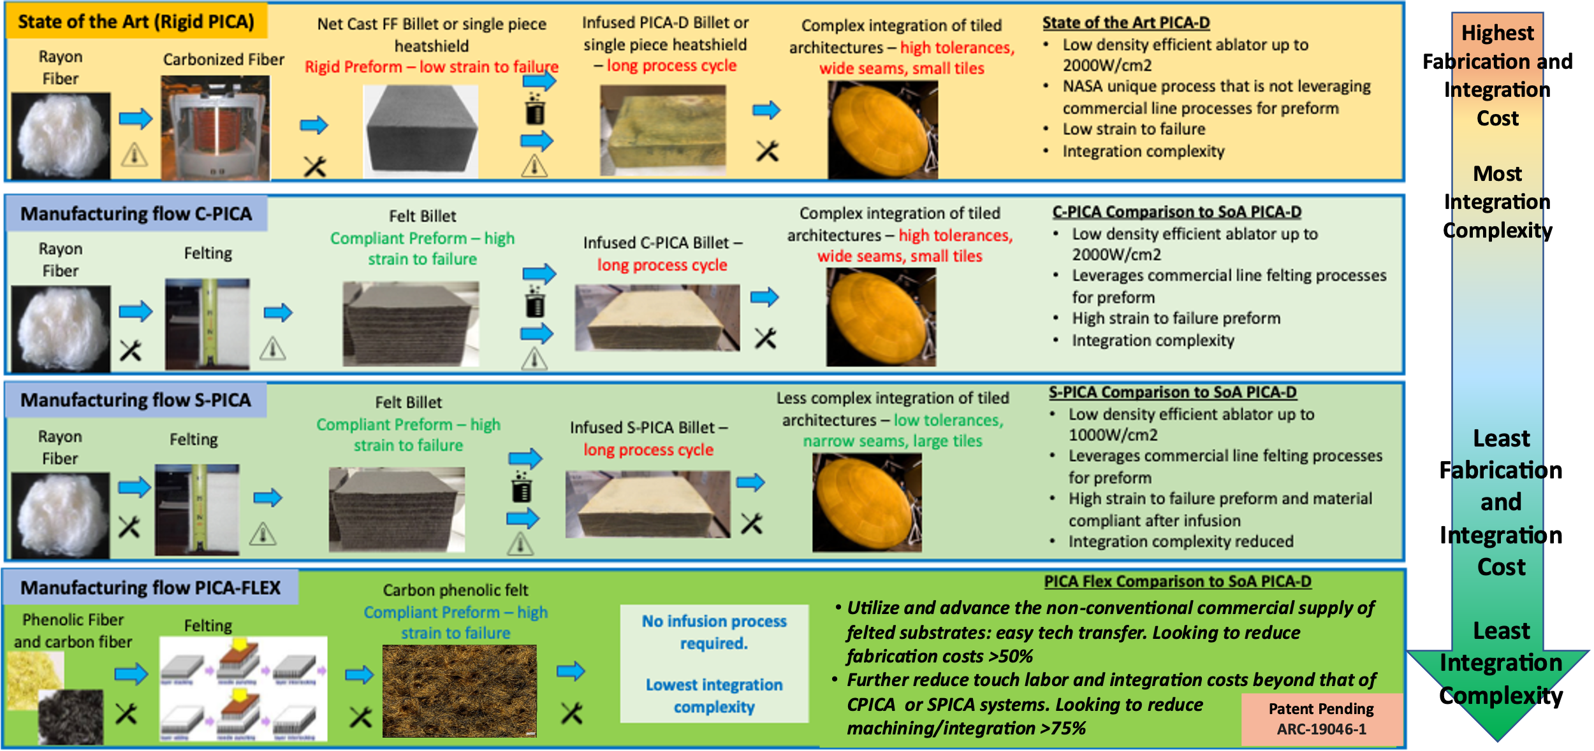
Figure 1: Comparison of fabrication/integration complexity of rigid PICA, Conformal PICA and PICA-Flex.

makes it very attractive for commercial low Earth orbit (LEO) missions, Mars missions, as well as NASA’s proposed aerocapture missions to Ice Giants.

As shown in Figure 1, the main difference between rigid PICA and the conformal versions of PICA (C-PICA and S-PICA) are the carbon substrate. All these materials subsequently require a lengthy infusion process followed by complex machining and integration techniques. So, while the conformal and soft versions of PICA do offer improved thermal performance, these systems are still costly to fabricate and integrate which is not conducive to lowering the cost for future NASA missions or commercial space.

Emerging commercial space companies are seeking very low-cost, rapidly producible, and easily integrated ablative (and reusable) TPS solutions. Reduced material and integration costs eliminate barriers facing emerging commercial space companies that desire to return payloads to Earth or send payloads to other planets. In addition to low-cost, NASA and commercial space companies desire materials with environmentally low-footprint manufacturing. The Thermal Protection Materials Branch at NASA Ames Research Center has developed and fabricated a new ablative TPS hybrid blanket material that addresses these needs. This material is called Flexible Phenolic Intermingled Carbon Ablator (PICA-Flex), and it is one of many new materials in a family of materials referred to as MERINO, or Materials Engineered for Re-entry using Innovative Needling Operations.
Unlike traditional rigid ablative tiles that require costly and time intensive infusion processes, PICA-Flex intermingles carbon and phenolic fiber to create a
nonwoven felt material that is more akin to a blanket than a rigid TPS. This ablative blanket significantly reduces manufacturing and integration complexity. While likely not as capable as other rigid materials, there are a significant number of missions for which this material is suitable as shown in Figure 2.
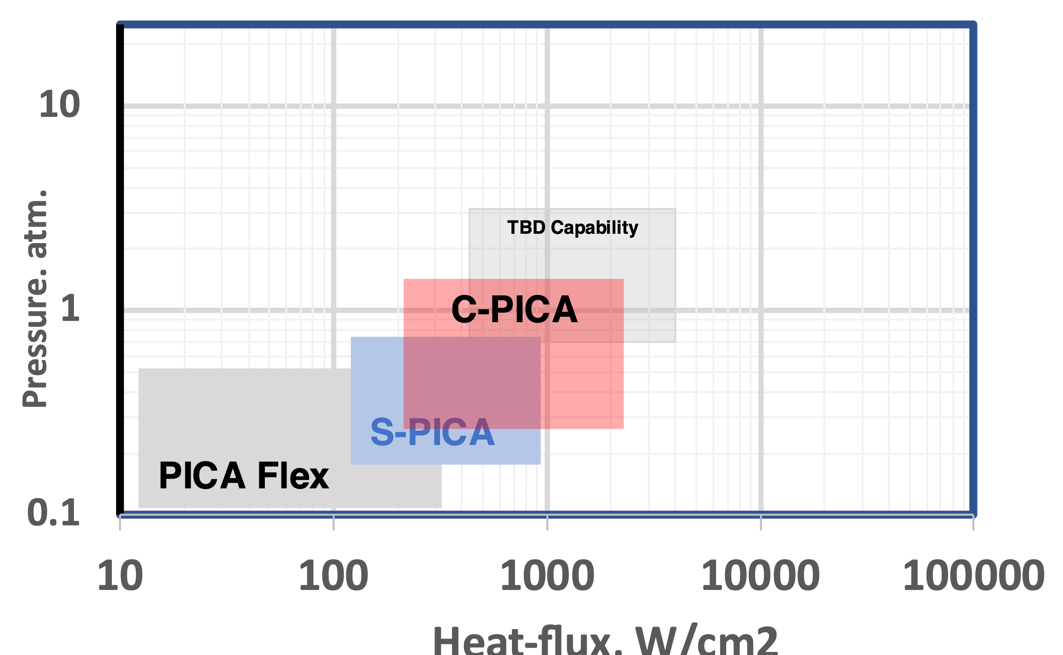
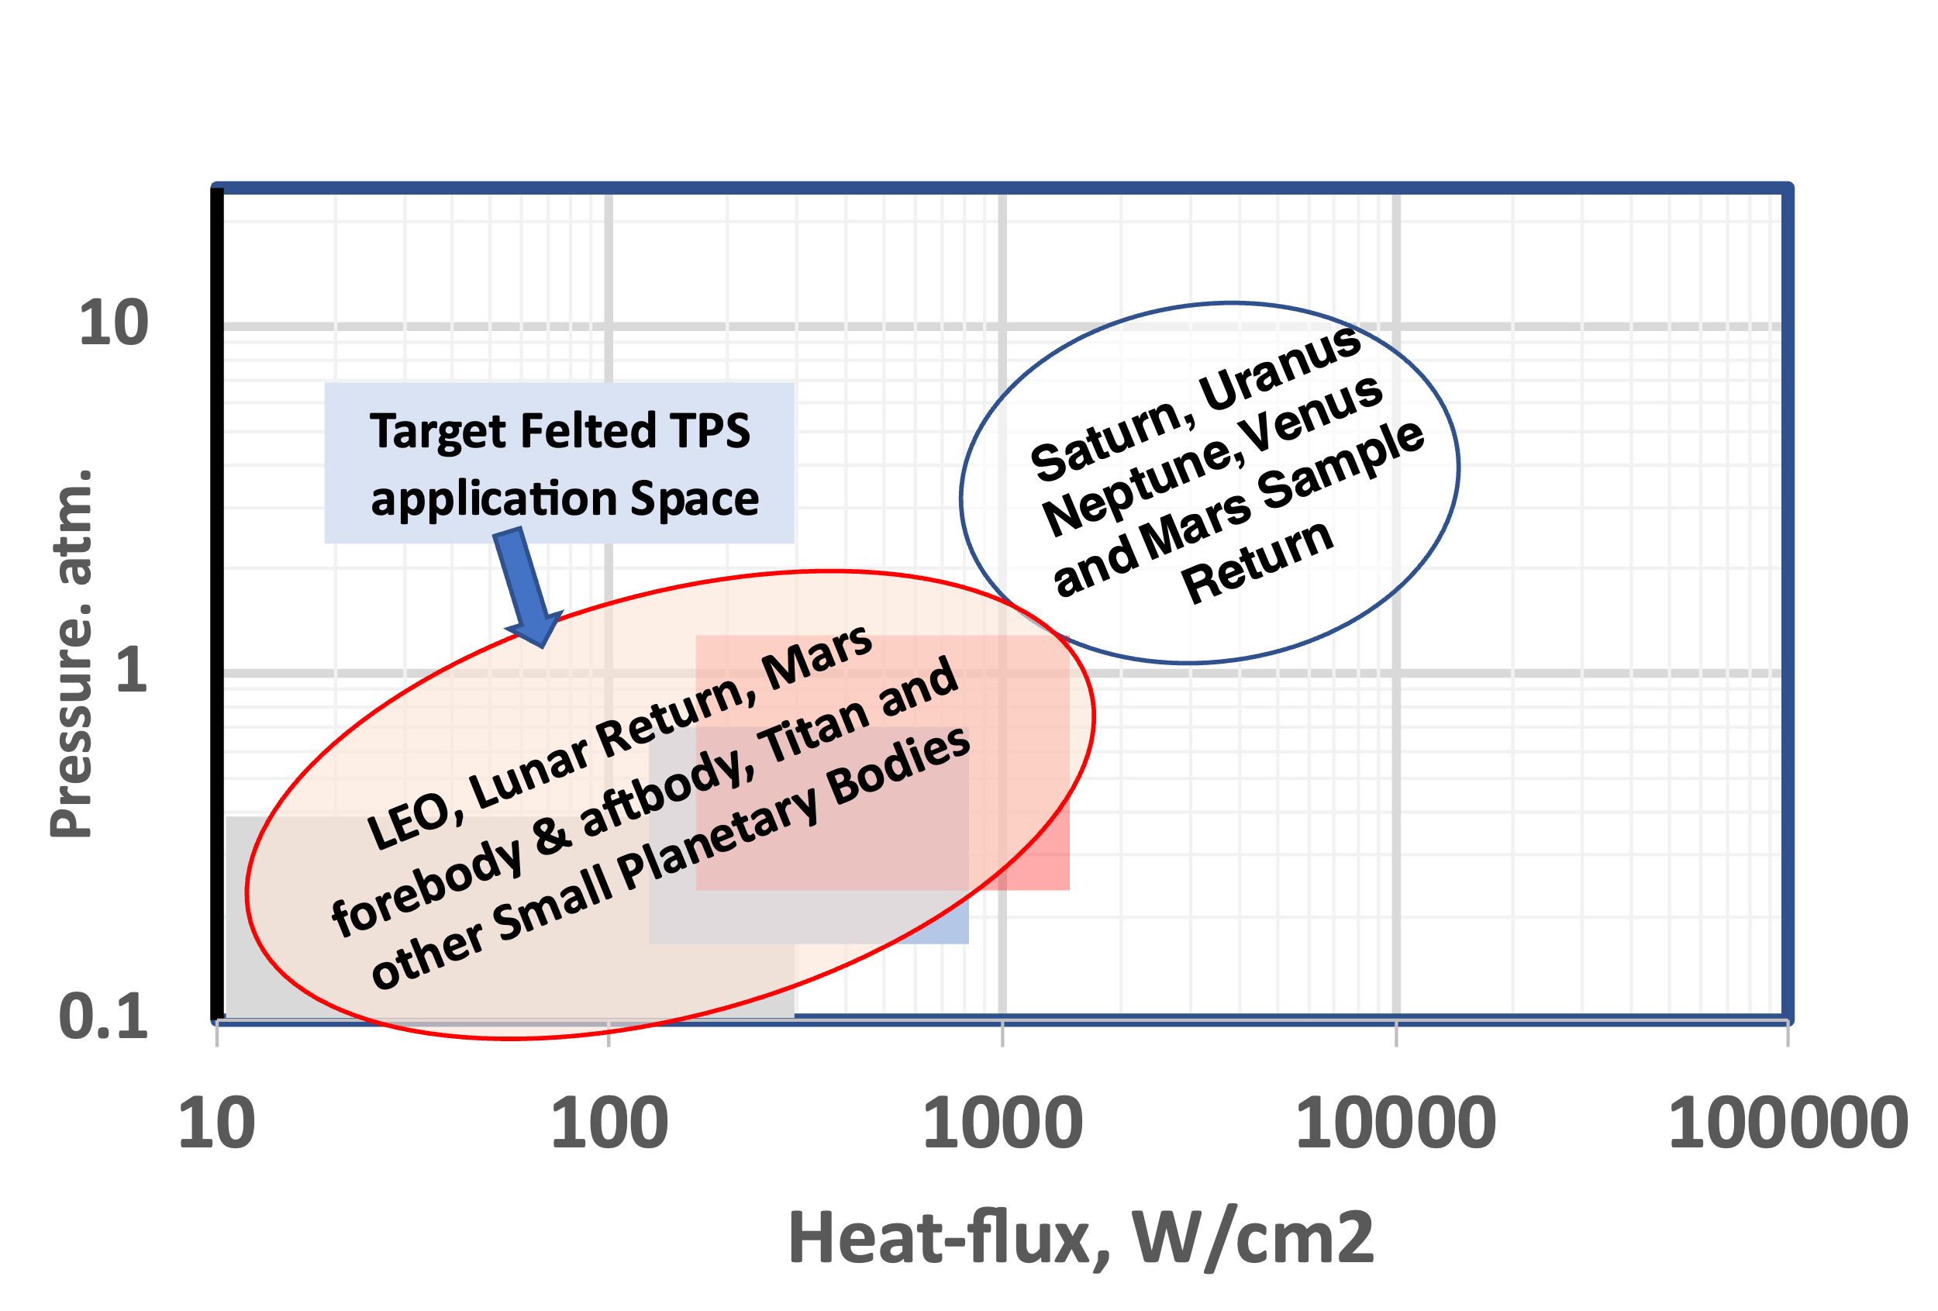
Figure 2: Targeted environments and potential mission space for C/S- PICA and PICA-Flex.
Laboratory testing of the baseline C-PICA, S-PICA, and PICA-Flex materials was conducted to determine basic material properties, and material response models for each were developed. This paper documents this initial material modeling, and results are presented comparing performance against SoA rigid PICA. In support of STMD’s strategic framework which recognizes a gap in low-cost TPS for heatshield and back shell applications, PICA-Flex has the potential to be game changing.

Material Fabrication
The process for fabricating PICA-Flex begins by intermingling carbon and phenolic fiber to create a batting layer. These layers of batting are then needle punched together to produce a nonwoven felt as shown in Figure 3. This process is conducive to creating a dual layer, or functionally graded material.
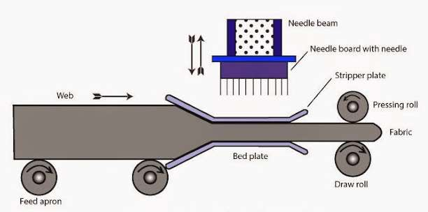
Figure 3: Illustration of the felting process which involves needling together layers of batting.

In partnership with industry, NASA Ames fabricated 4 PICA-Flex materials that were 24x24-inch and 1.5-inch thick - two samples were 50% carbon and 50% phenolic, and two samples were 75% carbon and 25% phenolic.

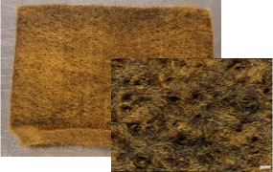
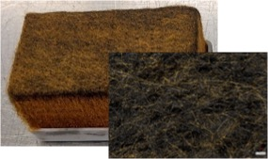
Figure 4: Photos of recently fabricated PICA-Flex materials. (Top) 50/50 C/Ph, (Bottom) 75/24 C/Ph.

All samples had densities ranging from 0.16-0.20 g/cm³. Photos of sample PICA-Flex materials and the microstructure are show in Figure 4. The remarkable flexibility of PICA-Flex is further demonstrated in Figure 5 where a strip of the composite TPS was bent over a standard 1.5-inch PVC pipe.

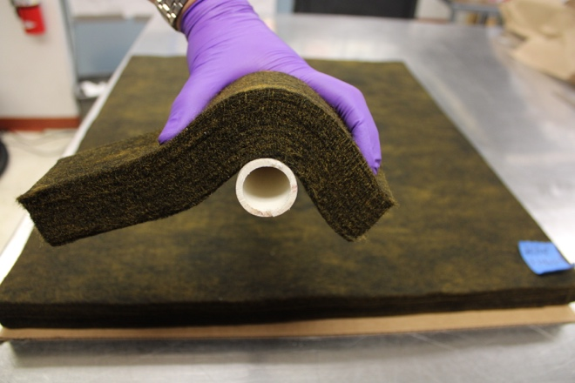
Figure 5: PICA-Flex material shown formed over a very tight radius PVC pipe.

Material Evaluation
For standard rigid PICA and C-PICA, NASA conducted extensive thermal, mechanical, and other material property testing. Based on test results, PICA and C-PICA material property models were developed specifically for use with the fully implicit ablation and thermal-response (FIAT) code that calculates ablation, pyrolysis, and thermal conduction in one dimension.⁵⁻⁷
Testing for PICA-Flex has been less comprehensive and covered a smaller temperature range. Thus far, data were obtained for density, elemental composition, virgin, and char thermal conductivity of virgin and char at 1 atm. Comparison of Through-The-Thickness (TTT) conductivities of rigid PICA, C-PICA, S-PICA and PICA-Flex is shown in Figure 6. Of particular note is the reduction in conductivity, which for missions where TPS sizing is driven by bondline temperature constraints will yield a reduced areal mass of the TPS.

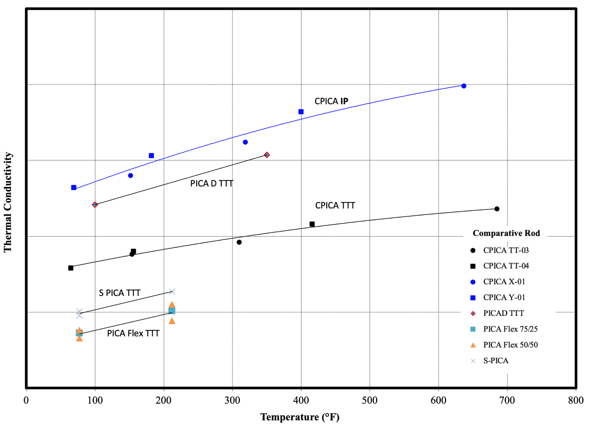
Figure 6: Comparison of Through-The-Thickness (TTT) conductivities of
1) Rigid PICA-Domestic, 2) C-PICA, 3) S-PICA and 4) PICA-Flex.

NEXT STEPS / Conclusions
Pending successful advancement in the near-term, two R&D flight opportunities from LEO are available. NASA is currently partnered with various DoD entities under the Strategic Funding Increase (STRATFI) program where Varda Space Industries, an in-space additive manufacturing company, will fly two re-entry missions from LEO. NASA is supplying TPS technologies for both the first and second mission, and PICA-Flex has an opportunity to be demonstrated in the second flight. This would rapidly advance the TRL given a successful flight demonstration and ensuing TPS recovery. Similarly, NASA is partnered with the University of Kentucky on the KREPE (Kentucky Re-Entry Probe Experiment) missions and has an opportunity to provide TPS to be instrumented and tested for these flights. The final opportunity is through STMD ACOs and potential space act agreements with commercial partners once the PICA-Flex is matured to TRL 4.
Many companies look to NASA for starting point technologies or solutions outside of their competency, including TPS. Government investment with industry partnerships allows the sustainable development of transformative technologies that enable future NASA as well as commercial missions.

Acknowledgments
This work was supported by.an FY23 NASA Ames Internal Research and Development (IRAD) award.

References
- Tran, H., Johnson, C., Rasky, D., Hui, F., Chen, Y.-K., and Hsu, M., “Phenolic Impregnated Carbon Ablators (PICA) for Discovery Class Missions,” AIAA Paper 1996-1911, June 1996.
- Beck, R. A. S., Driver, D. M., Wright, M. J., Hwang, H. H., Edquist, K. T., and Sepka, S. A., “Development of the Mars Science Laboratory Heatshield Thermal Protection System,” Journal of Spacecraft and Rockets, Vol. 51, No. 4, 2014, pp. 1139–1150. doi:10.2514/1.A32635
- “PICA Heat Shield,” SpaceX, 4 April 2013, http://www.spacex.com/news/2013/04/04/pica-heat-shield [retrieved 17 Nov. 2014].
- Milos, Frank S, Gasch, Matthew J and Prabhu, Dinesh K., “Conformal Phenolic Impregnated Carbon Ablator Arcjet Testing, Ablation and Thermal Response,” Journal of Spacecraft and Rockets, 52, No. 3, May–June 2015, pp. 804-812. Doi: DOI: 10.2514/1.A33216.
- Milos, F. S., and Chen, Y.-K., “Ablation and Thermal Response Property Model Validation for Phenolic Impregnated Carbon Ablator,” Journal of Spacecraft and Rockets, Vol. 47, No. 5, 2010, pp. 786–805. doi:10.2514/1.42949
- Chen, Y.-K., and Milos, F. S., “Ablation and Thermal Response Program for Spacecraft Heatshield Analysis,” Journal of Spacecraft and Rockets, Vol. 36, No. 3, 1999, pp. 475–483. doi:10.2514/2.3469
- Milos, F. S., and Chen, Y.-K., “Ablation, Thermal Response, and Chemistry Program for Analysis of Thermal Protection Systems,” Journal of Spacecraft and Rockets, Vol. 50, No. 1, 2013, pp. 137–149. doi:10.2514/1.A32302

