Linking strategic astrophysics missions, technology gaps, and technology maturation investments

Opher Ganelª, Pin Chen ^{b}, Brendan Crill ^{b}, Jason Derleth ª, Omid Noroozian ^{c}, Mario Perez ^{c},

Rachel Rivera ª, and Nicholas Siegler ^{b}
ª Physics of the Cosmos and Cosmic Origins Program Office, NASA Goddard Space Flight Center, 8800 Greenbelt Rd., Greenbelt, MD 20771, USA ^{b} Exoplanet Exploration Program Office, NASA Jet Propulsion Laboratory, 4800 Oak Grove Dr., Pasadena, CA 91109, USA ^{c} Astrophysics Division, NASA Headquarters, 300 Hidden Figures Way SW, Washington DC 20546, USA

Abstract
The National Aeronautics and Space Administration’s (NASA) Astrophysics Division (APD) funds the development of cutting-edge technologies through multiple programs to enable its strategic missions to achieve ambitious and groundbreaking science goals. These technology development efforts are managed by the Cosmic Origins (COR), Exoplanet Exploration (ExE), and Physics of the Cosmos (PhysCOS) programs. The 2020 Astronomy and Astrophysics Decadal Survey, “Pathways to Discovery in Astronomy and Astrophysics for the 2020s,” (Astro2020) recommended a pan-chromatic set of missions, including three Great Observatories (GO) and three Probe-class missions that could collect unprecedented data over the coming decades. We show the correlation between these strategic missions and the current Astrophysics technology gaps, as well as recent and current technology maturation projects funded to help close these technology gaps. We also cover how these investments advanced their Technology Readiness Levels (TRLs) [1] and where they have been infused into missions and projects.

Keywords: NASA, astrophysics, technology development, optics, telescope, detector, PhysCOS/COR, ExEP

- INTRODUCTION
NASA’s Science Mission Directorate seeks to expand our knowledge and understanding of our planet, sun, solar system, and the universe we live in. NASA’s APD is responsible for enabling and carrying out observations and measurements, focusing on the universe. Through three thematic programs, COR, ExEP, and PhysCOS, APD seeks to answer three fundamental questions: “How did we get here?” (COR), “Are we alone?” (ExEP), and “How does the universe work?” (PhysCOS). Each decade, APD’s priorities are informed by a new Astronomy and Astrophysics Decadal Survey from the National Academies of Sciences, Engineering, and Medicine. The latest Decadal Survey, “Pathways to Discovery in Astronomy and Astrophysics for the 2020s” [2], recommended three GOs – an Infrared (IR)/Optical/Ultraviolet (UV) mission to identify and characterize habitable exoplanets dubbed the Habitable Worlds Observatory (HWO), a far-IR GO, and an X-ray GO; and three Probe missions – a far-IR Probe, an X-ray Probe, and an Early Universe Cosmology and Fundamental Physics Probe to study the Cosmic Microwave Background (CMB). The Survey also recommended making Time Domain and Multi-Messenger (TDAMM) astrophysics the top sustaining Astrophysics activities priority. Supported by the science and technology community, APD identifies and prioritizes the technology gaps between the current state of the art and what is needed to fly these ever-more-challenging strategic missions. In the following, we show how the current technology gaps correlate to the Decadal Survey priorities and the APD-funded maturation efforts (Section 2), the current portfolios of projects maturing strategic technologies (Section 3), TRL advances resulting from these investments (Section 4), and infusions of APD-funded technologies into missions and projects (Section 5).
- TECHNOLOGY GAPS, STRATEGIC PRIORITIES, AND INVESTMENTS

Strategic Astrophysics missions
Strategic Astrophysics missions are agency-led missions or concepts that APD is developing, participating in, or interested in, which are intended to respond to high-priority science questions. Astro2020 recommended launching an ambitious set of panchromatic missions – three GOs and three Probes over the coming decades. These include HWO, to be launched in the early 2040s to observe ~25 exo-Earths and carry out general astrophysics measurements; a far-IR GO and an X-ray GO, to be launched at least a decade after HWO; a far-IR Probe and an X-ray Probe, one of which should launch early next decade; and a CMB Probe, to compete for a 2040s launch slot with the remaining Probe that did not launch in the 2030s.

Strategic Astrophysics technology gaps
The COR, ExE, and PhysCOS Program Offices manage for APD strategic technology development efforts within their respective Programs. The three Offices collaborate and coordinate the technology gap prioritization process, including soliciting community inputs, updating the unified prioritization process as needed, prioritizing gaps (done separately but with technologists from the three Offices participate in all three efforts), and reporting the prioritized strategic Astrophysics technology gaps to APD and the community. The 2022 prioritization cycle, informed by the Astro2020 recommendations, resulted in a prioritized list of 57 gaps in five priority tiers (Table 1). Gaps in Tiers 1 – 4 are automatically included in the ongoing 2024 prioritization. Tier 5 gaps, deemed non-strategic, are excluded from the current cycle.
Table 1. 2022 Technology gaps (COR/ExEP/PhysCOS) alphabetized within priority each tier (Acronyms: IR, Infrared; FUV, Far Ultraviolet; NIR, Near IR; Vis, Visible; QE, Quantum Efficiency; GW Gravitational Wave). Affected missions and activities denoted by “×.” Gaps with recent and/or ongoing investment denoted by shaded mission/activity area.
Tier | Technology Gap | HWO | X-ray GO/Probe | Far-IR GO/Probe | CMB Probe | TDAMM
1 | Advanced Cryocoolers |  | × | ×
1 | Coronagraph Contrast and Efficiency | ×
1 | Coronagraph Stability | ×
1 | Cryogenic Readouts for Large-Format Far-IR Detectors |  |  | × | ×
1 | Heterodyne Far-IR Detector Systems |  |  | ×
1 | High-Throughput Large-Format Object Sel. Tech for Multi-Object & Integ. Field Spectroscopy | ×
1 | High-Performance, Sub-Kelvin Coolers |  | × | × | ×
1 | High-Reflectivity Broadband FUV-to-NIR Mirror Coatings | ×
1 | High-Resolution, Large-Area, Lightweight X-Ray Optics |  | ×
1 | High-Throughput Bandpass Selection for UV/VIS | ×
1 | Large Cryogenic Optics for the Mid IR to Far IR |  |  | ×
1 | Large-Format, High-Resolution Focal Plane Arrays | ×
1 | Large-Format, Low-Darkrate, High Eff., Photon-Counting, Solar-blind, Far- & Near-UV Detectors | ×
1 | Large-Format, Low-Noise and Ultralow-Noise Far-IR Direct Detectors |  |  | ×
1 | Low-stress, High-Stability, X-Ray Reflective Coatings |  | ×
1 | Mirror Technologies for High Angular Resolution in the UV/Vis/NIR | ×
1 | Optical Blocking Filters for X-ray Instruments |  | ×
1 | Stellar Reflex Motion Sensitivity: Extreme Precision Radial Velocity (EPRV) | ×
1 | Stellar Reflex Motion Sensitivity: Astrometry | ×
1 | Vis/NIR Detection Sensitivity | ×
2 | Broadband X-Ray Detectors |  | ×
2 | Compact, Integrated Spectrometers for 100 to 1000 µm |  |  | ×
2 | Far-IR Imaging Interferometer for High-Resolution Spectroscopy |  |  | ×
2 | Far-IR Spatio-Spectral Interferometry |  |  | ×
2 | Fast, Low-Noise, Megapixel X-Ray Imaging Arrays with Moderate Spectral Resolution |  | ×
2 | High-Efficiency X-Ray Grating Arrays for High-Resolution Spectroscopy |  | ×
2 | High-resolution Direct-Detection Spectrometers for Far-IR Wavelengths |  |  | ×
2 | Improving the Calibration of Far-IR Heterodyne Measurements |  |  | ×
2 | Large-Aperture Deployable Antennas for FIR/THz/Sub-mm Astr. for Freq’s >100 GHz |  |  | ×
2 | Large-Format, High-Spectral-Resolution, Small-Pixel X-Ray Focal-Plane Arrays |  | ×
2 | Polarization-Preserving Millimeter-Wave Optical Elements |  |  | × | ×
2 | Precision Timing for Space-Based Astrophysics |  |  | ×
2 | Rapid Readout Electronics for X-Ray Detectors |  | ×
2 | Starshade Deployment and Shape Stability | ×
2 | Starshade Starlight Suppression and Model Validation | ×
2 | UV Detection Sensitivity | ×
3 | Advancement of X-Ray Polarimeter Sensitivity |  | ×
3 | Detection Stability in the Mid-IR |  |  | ×
3 | Far-UV Imaging Bandpass Filters | ×
3 | High Efficiency Far-UV Mirror | ×
3 | High-Eff. Low-Scatter, High- & Low-Ruling-Density, High- & Low-Blaze-Angle UV Gratings | ×
3 | High-QE, Solar-Blind, Broadband NUV Detector | ×
3 | Photon-Counting, Large-Format UV Detectors | ×
3 | Short-Wave UV Coatings | ×
3 | Warm Readout Electronics for Large-Format Far-IR Detectors |  |  | ×
4 | Advanced Millimeter-Wave Focal-Plane Arrays for CMB Polarimetry |  |  |  | ×
4 | Improving Photometric/Spectrophotometric Precision of Time-Domain & Time-Series Measur. |  |  |  |  | ×
4 | UV/Optical/NIR Tunable Narrow-Band Imaging Capability | ×
4 | Very-Wide-Field Focusing Instrument for Time-Domain X-Ray Astronomy |  | × |  |  | ×
5 | Complex ultra-stable structures for future GW missions | None
5 | Disturbance Reduction for GW Missions
5 | Gravitational Reference Sensor (GRS)
5 | High-Performance Spectral Dispersion Component/Device
5 | High-Power, High-Stability Laser for GW Missions
5 | Laser Phase Measurement Chain for a Decihertz GW Mission
5 | Micro-Newton Thrusters for GW Missions
5 | Stable Telescopes for GW Missions
As shown in the table, recent and ongoing strategic technology development investments have been made to address 16 of the 20 Tier-1 gaps (80 percent), nine of the 16 Tier-2 gaps (56 percent), seven of the nine Tier-3 gaps (78 percent), and one of the four Tier-4 gaps (25 percent), for an overall 33 of 49 gaps (67 percent) with investments.
- CURRENT TECHNOLOGY INVESTMENTS
The current portfolio of strategic Astrophysics technology maturation investments comprises 55 active awards.
COR focuses primarily on understanding when the first stars formed and how they influenced the environments around them; how the pervasive and mysterious dark matter clumped up early in the life of the universe, pulling gas along with it into dense concentrations that eventually became galaxies; how galaxies evolved from the very first systems to the types we can observe, such as our Milky Way; and understanding when in the early universe supermassive black holes first formed and how they have affected the galaxies in which they reside. This requires mostly technologies for collecting and measuring photons in the UV, visible, and IR. The current COR portfolio comprises 18 active awards (Table 2).
Table 2. The current COR strategic technology portfolio comprises 18 awards (Acronyms: PI, Principal Investigator; KID, Kinetic Inductance Detector; NIST, National Institute of Standards and Technology; IR, Infrared; NIR, Near Infrared; LmAPD, Linear-mode Avalanche Photodiode; JPL, Jet Propulsion Lab; CMOS, Complementary Metal-Oxide Semiconductor; RIT, Rochester Institute of Technology; Caltech, California Institute of Technology; ALD, Atomic Layer Deposition; FUV, Far UV; NUV, Near UV; GSFC, Goddard Spaceflight Center; TES, Transition-Edge Sensor; JHU, Johns Hopkins University; MSFC, Marshall Spaceflight Center; MCP, Multi-Channel Plate; UCB, University of California Berkeley).
Project Title | PI | PI Org | Tech Type
Low-Noise, Large-Format, Direct-Absorption Far-IR KID Arrays | Austermann, J | NIST | Detector
Four Megapixel Sensor for Ultra-Low-Background Shortwave IR Astronomy | Bottom, M | U Hawaii | Detector
Ultrasensitive Far-IR KID Arrays: Maturation for Flight | Bradford, CM | JPL | Detector
Characterizing Single-Photon Sensing CMOS Image Sensors for NASA Missions | Figer, D | RIT | Detector
Ultrasensitive Far-IR KID Arrays for Space | Hailey-Dunsheath, S | Caltech | Detector
High Performance, Stable, and Scalable UV Al Mirror Coatings Using ALD | Hennessy, J | JPL | Coating
High-Performance FUV, NUV, and UV/Optical CMOS Imagers | Hoenk, M | JPL | Detector
High-Eff. Continuous Cooling for Cryogenic Instruments and sub-Kelvin Detectors | Kimball, M | GSFC | Cooling Sys.
UV Spectroscopy for the Next Decade Through Nanofabrication Techniques | McEntaffer, R | PSU | Optics
High-Perf. UV Photon Counting Detector for Strategic Astrophysics Missions | Nikzad, S | JPL | Detector
Large Format, High Efficiency, UV/Optical/NIR Photon Counting Detectors | Nikzad, S | JPL | Detector
Adv. Al Mirrors w/Passivated LiF for Env. Stable Meter-Class UV Space Telescopes | Quijada, M | GSFC | Coating
Advancing Readout of Large-Format Far-IR TES Arrays | Rostem, K | GSFC | Electronics
Scalable Microshutter Systems for Multi-object Spectroscopy | Scowen, P | GSFC | Optics
Large Low Noise Transition Edge Sensor Arrays for Future FIR Space Missions | Staguhn, J | JHU | Detector
Ultra-Stable Structures Dev. & Characterization Using Spatial Dynamic Metrology | Saif, B | GSFC | Metr./Struct.
UV/Optical to Far-IR Mirror & Telescope Technology Development | Stahl, HP | MSFC | Optics
Large-Format, High-Dyn.-Range UV Detector Using MCPs & Timepix4 Readouts | Vallerga, J | UCB | Detector
ExEP focuses on the detection and characterization of planets around nearby stars, especially Earth-like planets in the habitable zones of their respective stars and searching for signatures of life. ExEP’s current technology needs include ultra-stable space-telescopes, starshades, coronagraphs, detectors enabling direct imaging and characterization of exo-Earths, and EPRV measurements. There are 21 active awards currently pursuing these (Table 3).
Table 3. The current ExEP strategic technology portfolio comprises 21 technology maturation awards (Acronyms: ARC, Ames Research Center; MIT, Massachusetts Institute of Technology; STScI, Space Telescope Science Institute; HW, Hardware).
Title | PI | PI Org | Tech Type
Development of a Method for Exoplanet Imaging in Multi-Star Systems | Belikov, R | ARC | Coronagraph
Laboratory Demonstration of High Contrast Using Phase-Induced Amplitude Apodization Complex Mask Coronagraph on a Segmented Aperture | Belikov, R | ARC | Coronagraph
Laboratory Demonstration of Multi-Star Wavefront Control in Vacuum | Belikov, R | ARC | Coronagraph
Starshade Large-Structure Precision Deployment and Stability | Aaron, K | JPL | Starshade
Starshade Starlight Suppression | Aaron, K | JPL | Starshade
Adaptive High-Order Wavefront Control Algorithms for High-Contrast Imaging on the Decadal Survey Testbed | Cahoy, K | MIT | Coronagraph
Segmented Coronagraph Design and Analysis study | Chen, P | JPL | Coronagraph
Linear Wavefront Control for High-Contrast Imaging | Guyon, O | U Arizona | Coronagraph
Robust Deep-Contrast Imaging with Self-Calibrating Coronagraph Systems | Guyon, O | U Arizona | Coronagraph
Colloid Thruster Life Testing and Modeling | Marrese-Reading, C | JPL | µ-Propulsion
Optimal Spectrograph and Wavefront Control Architectures for High-Contrast Exoplanet Characterization | Mawet, D | Caltech | Coronagraph
Radiation-Tolerant, Photon-Counting, Vis/Near-IR Detectors for Coronagraphs and Starshades | Rauscher, B | GSFC | Detector
Laboratory Demonstrations of High Contrast with Black Si Coronagraph Masks | Riggs, AJ | JPL | Coronagraph
Vortex Coronagraph High-Contrast Demonstrations | Serabyn, E | JPL | Coronagraph
System-level Demonstration of High Contrast for Segmented Space Telescopes | Soummer, R | STScI | Coronagraph
Ultra-Stable Mid-IR Detector Array for Space-Based Exoplanet Transit Spectroscopy | Staguhn, J | JHU | Detector
Demonstration of Adv. Wavefront Control for Segmented Aperture Telescopes | Tesch, J | JPL | Coronagraph
Super Lyot ExoEarth Coronagraph | Trauger, J | JPL | Coronagraph
Low-Order HW Implementation for Sensing and Control in Exoplanet Imaging | Trauger, J | JPL | Coronagraph
A Novel Optical Etalon for Precision Radial Velocity Measurements | Vasisht, G | JPL | EPRV
Dual-Purpose Coronagraph Masks for Enabling High-Contrast Imaging with an IR/Optical/UV Flagship Mission | Wallace, K | JPL | Coronagraph
PhysCOS focuses primarily on understanding the nature of spacetime, the behavior of matter and energy in extreme environments, the cosmological parameters governing inflation and the evolution of the universe, and the nature of dark matter and dark energy. The relevant technologies include those needed to measure GWs, microwaves, and X rays. The current PhysCOS portfolio comprises 14 technology maturation awards (Table 4).
Table 4. The current PhysCOS strategic technology portfolio comprises 14 technology maturation awards (Acronyms: SQUID, Superconducting Quantum Interference Device; SAO, Smithsonian Astrophysical Observatory; LL, Lincoln Laboratory).
Title | PI | PI Org | Tech Type
Magnetically Coupled Calorimeters | Bandler, S | GSFC | Detector
Extremely Low-noise, High Frame-rate X-ray Image Sensors | Bautz, M | MIT | Detector
Microwave SQUID Readout Technology to Enable Lynx and Other GOs | Bennett, D | NIST | Electronics
Mounting and Alignment of Full-Shell X-Ray Mirrors | Bongiorno, S | MSFC | Optics
Metrology Development for Full-Shell X-Ray Mirrors | Davis, J | MSFC | Metr./Struct.
Rapid Electron-Beam Lithography Patterning for Customized Reflection Gratings | DeRoo, C | U Iowa | Optics
Thin Film Coatings for Full-Shell X-Ray Mirrors | Gurgew, D | MSFC | Coating
Advanced Pixelated Si Sensors for the Next Generation of X-ray Observatories | Kenter, A. | SAO | Detector
Polishing Mandrels and Optics for Full-Shell X-Ray Mirrors | Kolodziejczak, J | MSFC | Optics
Optimized Soft X-ray Sensors for Strategic X-ray Astrophysics Missions | Leitz, C | MIT/LL | Detector
High-Sensitivity and High-Resolving-Power X-ray Spectrometer | Schattenburg, M | MIT | Optics
Replication Studies for Full-Shell X-ray Mirrors | Singam, P | MSFC | Optics
Advanced X-Ray Microcalorimeters | Smith, S | GSFC | Detector
Next-Generation X-ray Optics: High Resolution, Light Weight, and Low Cost | Zhang, W | GSFC | Optics
Information on technology investigations is available via a searchable Astrophysics database [3] or NASA’s TechPort [4].
- TECHNOLOGY READINESS LEVEL ADVANCEMENTS
One of the main measures of return on technology investment is the maturation of technologies to higher TRL. To assess that return, we analyze the 166 current and past Strategic Astrophysics Technology (SAT) and Internal Scientist Funding Model (ISFM) awards funded by APD for technology maturation (excluding eight grants awarded less than a year ago).

4.1 Technology maturation grants and projects
Since many grants are follow-on awards for maturing the same technology, usually but not always awarded to the same PI, we merge such follow-on awards, leaving us with 98 unique projects with at least one full year of work completed. These projects began between 2009 and 2023. Figure 1 shows the distribution of number of awards per project, with 61.2 percent having just one award, 17.3 percent with two, 14.3 percent with three, 5.1 percent with four, and 2.0 percent with five, resulting in an average of 1.7 per project. Since these awards may be as short as one year and up to four or five years, Figure 2 shows the distribution of project length in years. The most common duration is three years (typical SAT duration), while the longest project’s duration was 13 years, with an average of 5.2 years. Note that APD also invests in technology-related facilities, software, and TDAMM-related activities through ISFM awards and Roman Technology Fellowships (RTF). Since these are not direct technology-maturation investments they are not included in the analyses reported here.
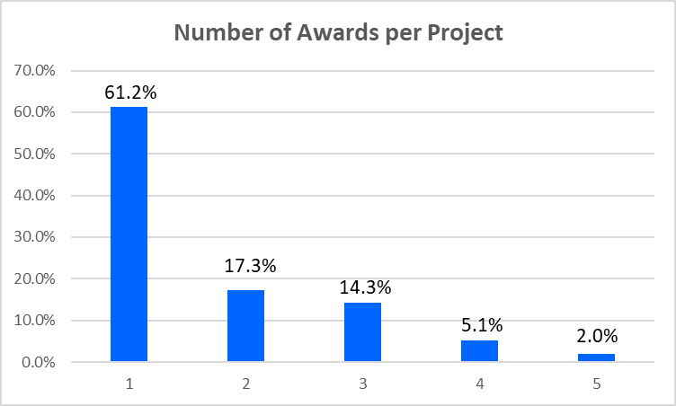
Figure 1. Distribution of projects by number of awards.
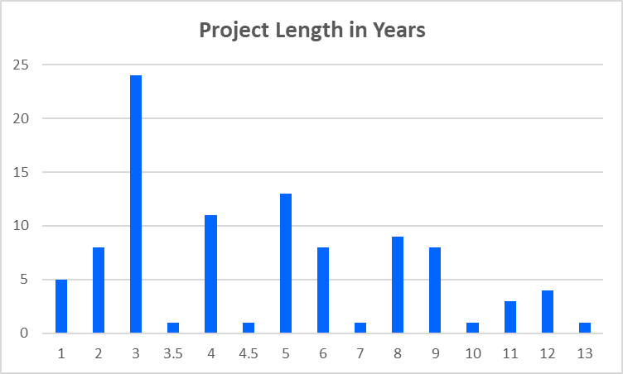
Figure 2. Distribution of projects duration in years.

4.2 Technology maturation projects by technology type
Figure 3 shows the distribution of technology maturation projects by the technology type they address. Given their important roles in Astrophysics missions, the five most common categories – detectors, optics, coronagraphs, coatings, and electronics account for 84 of the 98 projects (86 percent).
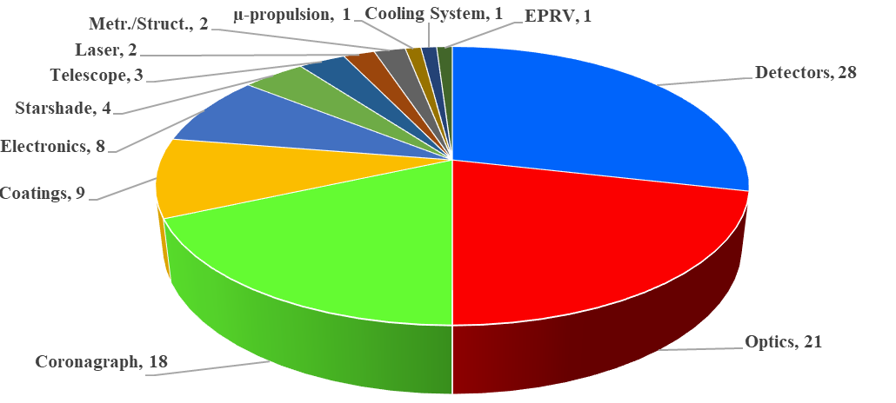
Figure 3. Distribution of technology maturation projects by technology type. The most common are detectors (28), optics (21), coronagraphs (18), coatings (9), and electronics (8).

4.3 Projects supporting strategic missions
Of course, there is a close connection between technology maturation projects, the gaps they address, and the strategic missions they can enable or enhance. Figure 4 shows the number of technology maturation projects that have or may enable or enhance strategic missions. Note that since these projects began as far back as 2009, some of these strategic projects are no longer in our current set of strategic missions.
Figure 4 shows how many technology maturation projects affect (or have affected) strategic Astrophysics missions. Some of these missions, e.g., the Roman Space Telescope (RST) [5], are nearing launch; some are already funded and expected to launch in the coming decade, e.g., the European Space Agency’s Advanced Telescope for High-Energy Astrophysics (ATHENA) [6] and Laser Interferometer Space Antenna (LISA) missions [7]. The remaining six are the set of strategic Astrophysics missions recommended by Astro2020. As shown, the mission with the largest number of supporting projects is HWO (53 projects), unsurprising given its level of complexity and challenge.
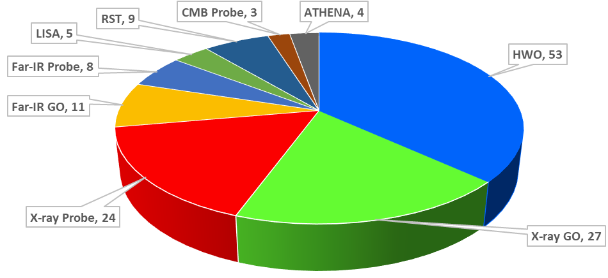
Figure 4. Distribution of technology maturation projects by strategic mission(s) affected. Note that the total, 134, is higher than the number of projects, 98. This is due to the fact that some technologies affect more than one mission.

4.4 Projects advancing TRL
Table 5 shows that of 98 projects, 44 (45 percent) advanced by at least one TRL, with 12 of these (12 percent) advancing by two levels. The remaining 54 projects (55 percent) made significant progress but did not meet all the requirements for the next TRL. Unsurprisingly, the fraction of projects advancing their TRL was highest for the lowest entry TRL, 2, with the advance fractions dropping as the entry TRL increased. The table also shows that the most common entry TRL by far was 3 (74 projects), followed by projects entering at TRL 4 (15 projects).
Table 5. Projects by entry TRL that achieved TRL advances.
Entry TRL | Number of Projects | Number Advancing | Fraction Advancing
2 | 8 | 5 | 63 percent
3 | 74 | 35 | 47 percent
4 | 15 | 4 | 27 percent
5 | 1 | 0 | 0 percent
Total | 98 | 44 | 45 percent
- TECHNOLOGY INFUSIONS
The second metric of return on technology investment is infusion into missions or projects. Here, we define infusion as a mission, project, or funded study concept that implemented or baselined the technology in question. These have resulted from APD funding from 2009 to 2023 through SATs, ISFMs, and Astrophysics Research and Analysis (APRA) grants received by SAT/ISFM PIs (we did not include APRA projects with PIs who have not also received SAT and/or SAT funding as that information was not readily available).
We subdivide infusions into these categories:
- Implemented in a past or current flight mission or ground-based project (e.g., Hitomi, X-Ray Imaging and Spectroscopy Mission, Ionospheric Connection Explorer, Solar Orbiter).
- Upcoming flight mission or ground project (e.g., RST, LISA, ATHENA, Sprite CubeSat) baselined the technology.
- Concept or reference design of an APD-funded large-mission study (Large UV/Optical/IR Surveyor, Habitable Exoplanet Observatory, Lynx, Origins); Probe (e.g., Probe of Inflation and Cosmic Origins, Galaxy Evolution Probe, Cosmic Evolution Through UV Surveys); or Phase-1 Explorer or Mission of Opportunity study (e.g., Survey and Time-domain Astrophysical Research Explorer) baselined the technology.
- Infusion-ready at TRL 5 but not yet included in any of the above categories, likely due to lack of opportunity.
We consider the first two of these categories as having been infused, the third as a concept infusion, and the last as ready for infusion but not yet infused.
Figure 5 summarizes the first two infusion categories divided by mission/project type. We see a total of 158 infusions (50 spaceflight, 34 sounding rocket missions, 19 stratospheric balloon missions, four airborne missions, and 51 ground-based projects). Of these, 93 (59 percent) have already flown or been implemented. Figure 6 similarly summarizes potential infusions, with 60 technologies baselined by APD-funded mission concepts/studies and three more technologies at TRL 5 that have not yet been infused or baselined.
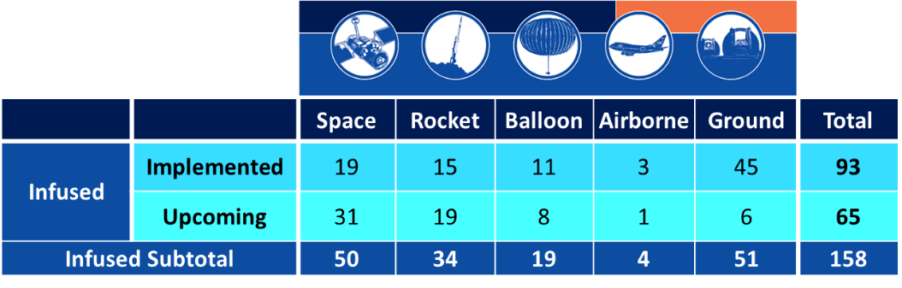
Figure 5. Distribution of 93 implemented and 65 upcoming infusions by mission/project type.
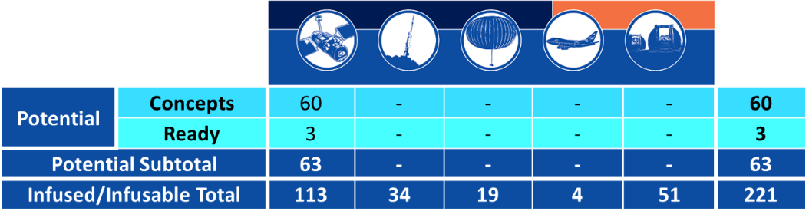
Figure 6. Distribution of 63 potential infusions by mission/project type.
An independent study conducted by the Aerospace Corporation [8] found that 62 percent of APD-funded technology development projects led to technology infusions, of which 12 percent were for spaceflight mission and 31 percent suborbital. This study included all APRA technology development projects, explaining the somewhat higher infusion rate.
- SUMMARY
We presented the prioritized set of 57 strategic Astrophysics technology gaps and the strategic missions/activities affected by each. We then listed the 55 current technology maturation investigations divided by the managing Program Office (COR, ExEP, and PhysCOS). We analyzed 166 SAT, ISFM, and other technology maturation grants awarded by APD, merging them into 98 unique technology projects. For these, we showed the distribution of the number of awards and duration in years of each project, as well as their distribution by technology type and strategic missions affected. Finally, we demonstrated the impressive impact of APD’s technology maturation investments. Of 98 projects, 44 (45 percent) achieved TRL advances (the remaining 54 advanced their technologies significantly but have not yet met all requirements of their next TRL). In addition, 42 of these investments (43 percent) resulted in 158 technology infusions into past and upcoming missions/projects along, 60 potential infusions based on APD-funded concept studies, and three infusion-ready technologies at TRL 5. Some technologies were infused into multiple missions/projects, and some projects resulted in multiple technologies being infused into one or more missions/projects. It’s worth noting that in addition to direct investments in technology maturation projects, APD invests in technology-related facilities, software, and TDAMM-related activities through both ISFM awards and RTFs.
References
- https://nodis3.gsfc.nasa.gov/displayDir.cfm?Internal_ID=N_PR_7123_001D_&page_name=AppendixE
- National Academies of Sciences, Engineering, and Medicine, “Pathways to Discovery in Astronomy and Astrophysics for the 2020s,” Washington, DC: The National Academies Press, (2021) https://doi.org/10.17226/26141
- https://www.astrostrategictech.us/
- https://techport.nasa.gov/dashboards
- https://roman.gsfc.nasa.gov/
- https://sci.esa.int/web/athena
- https://lisa.nasa.gov/
- Marc Hayhurst, Kimberlee Sakai Alvarez, Mario Perez, “NASA Astrophysics Division Technology Heritage Study,” NASA Technical Report (2024)

opher.ganel@nasa.gov; phone 1 410 440 8029; apd440.gsfc.nasa.gov/tech

