Sub-kW Class Hall-Effect Thruster Power Processing Unit for Wide Output Range Applications
IEPC-2024-331

Presented at the 38th International Electric Propulsion Conference
Pierre Baudis Convention Center • Toulouse, France
June 23-28, 2024

Corey R. Rhodes, Gabriel F. Benavides and Luis R. Piñero
NASA Glenn Research Center, Cleveland, OH, 44135, USA
The National Aeronautics and Space Administration (NASA) Small Spacecraft Electric Propulsion (SSEP) project is maturing high-propellant throughput sub-kilowatt Hall-effect thruster technologies to enable small spacecraft deep space science and exploration missions with high delta-v requirements. In support of this effort, development of a power processing unit (PPU) capable of providing discharge power of up to 1 kW continues to be pursued at the NASA Glenn Research Center (GRC). Previous reported work included a successful integrated test of a scalable, modular breadboard discharge power supply with the NASA-H64M laboratory model Hall-effect thruster and presentation of notional designs for the various auxiliary power supplies needed for thruster operation. Since that time, auxiliary power supply designs have been completed and fabricated, with the cathode heater and keeper power supplies being successfully tested with a hollow cathode assembly (HCA) in the NASA GRC Vacuum Facility 56 (VF-56). The desire for a lower mass, higher efficiency, and more versatile PPU to maximize performance of power and mass-limited small spacecraft has led to the exploration of a discharge power supply based on a series-parallel (LCC) resonant topology. This topology has enabled the discharge power supply to operate over a wider output range at switching frequencies 4-5 times higher than previous design iterations. Simulation models of the topology have been developed and a breadboard of the topology has been fabricated and evaluated on both resistive loads and an integrated Hall thruster test. This paper will present collected performance and integrated test data from both the fabricated auxiliary and resonant discharge power supplies. Advantages of the resonant converter architecture over more traditional pulse-width modulated (PWM) techniques in Hall-effect thruster discharge power supply applications will also be described.

Introduction
T
he National Aeronautics and Space Administration (NASA) regularly invests in new propulsion technologies that support a strategic goal¹ to increase the use of low-cost small spacecraft to conduct science and exploration missions. Decades of past NASA in-space propulsion investments have already supported the maturation of many chemical, cold-gas, and electric propulsion technologies presently enabling commercial, academic, and Government small spacecraft missions.² Some of these technologies may also prove extensible to certain NASA deep space small spacecraft missions with modest propulsive requirements. However, a technology gap persists for high total impulse sub-kW electric propulsion systems qualified for wide output operating ranges, which can support future NASA deep space small spacecraft missions.
While the number of commercial sub-kW electric propulsion products has grown considerably in recent years², most of these systems have been optimized for the low-Earth orbit (LEO) market. In just the last five years, the number of small spacecraft deployed in LEO with electric propulsion systems has exceeded all prior years combined. Unfortunately, the notable disparity in requirements between a typical commercial LEO and NASA deep space small spacecraft mission means the typical capabilities of propulsion products gaining flight heritage in LEO are inadequate for most NASA deep space missions. Furthermore, higher performance, and consequently more expensive, sub-kW electric propulsion products that might meet NASA’s deep space needs have been slow to progress towards spaceflight³⁻⁷.
The NASA Small Spacecraft Electric Propulsion (SSEP) project performed at NASA Glenn Research Center (GRC) aims to close the capability gap between electric propulsion systems that have been developed primarily for Earth orbits and systems that will meet NASA’s deep space needs by maturing cost-conscious high total impulse, sub-kW electric propulsion technologies (e.g., thruster and power processing technologies). The SSEP project seeks to mature and transfer these technologies to commercial vendors where overlap exists between commercial and NASA mission requirements (e.g., geosynchronous Earth orbit (GEO) and medium Earth orbit (MEO) high total impulse small spacecraft applications). For this reason, the SSEP project routinely considers and emphasizes the perspectives and concerns of its commercial stakeholders in addition to its NASA stakeholders to maximize the potential for successful technology infusions into commercial missions.
This paper specifically focuses on recent progress at NASA GRC towards the development of a commercially viable 1-kW Hall-effect thruster power processing unit (PPU) for NASA deep space applications requiring wide input and output range. Commercial electric propulsion users that may benefit from this technology may include vendors needing a single PPU compatible with a range of spacecraft buses, Hall thrusters, and/or propellants. This paper will review the current SSEP PPU architecture (i.e., discharge supply, auxiliary supplies, and telemetry circuits), trades considered during its development, and test data demonstrating the design approach.

System Architecture
The SSEP 1-kW PPU requirements were initially derived from the operating requirements of the SSEP H71M Hall-effect thruster⁸. The H71M thruster requirements were determined based on feedback from NASA and commercial stakeholders. However, it became clear some years ago that a successful PPU commercialization would require a more far-reaching requirements set than strictly necessary for implementation of the H71M. While a purpose built PPU designed for a high production rate environment, such as supporting a constellation of LEO spacecraft, optimizes around a mission’s highly specific requirements, the same is not necessarily true for a low production rate PPU. A low production rate PPU might support niche markets requiring highly specific or complex propulsion requirements. It is in these niche markets that the SSEP project looks to identify and has found opportunities for commercial and Government alignment that supports infusion of the advanced propulsion technologies. This section provides a high-level description of the SSEP 1-kW PPU architecture and discusses some of the key factors that influenced its selection. Table 1 summarizes the designed input and output capabilities for the latest iteration of the SSEP PPU discharge and auxiliary supplies.
The only PPU subsystem not addressed in this paper is the DCIU. While each of the power supplies has undergone at least one revision to date, the DCIU is still the design phase and has not yet had a prototype manufactured. Before the end of calendar year 2024, it is anticipated that the first generation of the DCIU will be manufactured.

Discharge Power Supply
The SSEP 1-kW PPU design supports a wide input voltage range of 24 to 34 V to accommodate the most common small spacecraft bus (unregulated 28 V). The discharge power supply can operate at a peak power of 1 kW over its full voltage (200 – 500 V) and current (1 – 5 A) range. High voltage and low current operation support missions requiring high specific impulse, while low voltage and high current operation supports missions requiring high thrust. In some cases, a single mission may require multiple operating conditions to accommodate different mission phases (e.g., orbit raising, collision avoidance, station keeping). Furthermore, while Hall-effect thrusters historically operated uniquely on xenon propellant, commercial preference has begun veering towards the lower cost krypton propellant for missions not requiring xenon’s better storage density and thruster efficiency. This is consequential since krypton’s efficiency optimizes at considerably higher current density than xenon. So, a single PPU capable of pivoting between missions using xenon, krypton, or even argon, needs to be able to operate efficiently over a considerable voltage and current range, while retaining its peak output power. The discharge supply’s power range (200 - 1,000 W) also supports a variety of commercially available sub-kW thrusters, while also allowing for deep throttling with degraded solar panel efficiency and/or increased distance from the sun. A trade study of various discharge power supply topologies conducted in support of the SSEP project is discussed in Section III.

Table 1. Designed input and output capabilities for the SSEP PPU power supplies.

Parameter | Cathode Keeper | Electromagnets | Cathode Heater | Discharge
Input Voltage [V] | 24 – 34 | 24 – 34 | 24 – 34 | 24 – 34
Output Current [A] | 0.5 – 1 | 1 – 5 | 1 – 8 | 1 – 5
Output Voltage [V] | 5 – 40* | 1 – 12 | 1 – 12 | 200 – 500
Maximum Output Power [W] | 25 | 60 | 80 | 1000
Line/Load Regulation Performance [%] | ≤ 2 | ≤ 2 | ≤ 2 | ≤ 2
Phase Margin [degrees] | ≥ 45 | ≥ 45 | ≥ 45 | ≥ 45
Gain Margin [dB] | ≥ 10 | ≥ 10 | ≥ 10 | ≥ 10
*after ignition

Auxiliary Power Supplies
The flexibility of the PPU to accommodate Hall-effect thrusters of multiple manufacturers is determined largely by the auxiliary supplies. This flexibility is sought-after such that bus manufacturers can develop a more robust thruster supply chain and make last minute substitutions when necessary. Attempting to accommodate a wide range of production Hall thrusters creates several challenges. First, a decision needed to be made regarding whether to baseline a PPU architecture that supported either a heated or heaterless cathode. Heaterless cathodes eliminate a common Hall thruster component (and associated power supply), the cathode heater, which is a single point of failure in center-mounted cathode designs. Some Hall thrusters with externally mounted cathodes include dual cathodes for redundancy. However, modern cathode heaters and handling practices have proven that well designed and handled cathode heaters are highly reliable. The H71M cathode heaters were thermally cycled to greater than 30,000 cycles with few issues.⁸ Furthermore, ignition of heaterless cathodes typically requires a high keeper voltage and a more complex feed system to generate a burst of pressure upon cathode start-up. As such, heaterless cathodes tend to shift cost from one subsystem to another, rather than resulting in simple cost savings. Given the relative immaturity of heaterless cathodes and uncertain cost advantages, the decision was made to baseline a PPU architecture supporting a cathode heater. Once this decision was made, the cathode heater supply design requirements were specified to capture both common cathode emitter compositions, barium oxide (BaO) and lanthanum hexaboride (LaB₆). Hall thruster suppliers typically favor one composition over the other, so the heater current range needed to be flexible enough to allow for either.
Next, the electromagnet power supply needed to be sized to capture the electromagnet current requirements of a variety of commercial sub-kW Hall thrusters. While most Hall thrusters include both an inner and outer magnet coil, the SSEP PPU includes only a single magnet power supply, which is not uncommon. To minimize PPU complexity and cost, the inner and outer electromagnet coils are often wired in series. Furthermore, since the magnet and heater power supply capabilities are ultimately similar, a common design utilizing a two-switch forward topology for each application was selected to minimize the number of unique components and thus the PPU fabrication cost.
While it can be desirable from a cost perspective to implement PPU architectures that employ multi-purpose auxiliary power supply designs, where a single power supply accomplishes two or three different functions (e.g., heater-keeper-magnet or heater-ignitor-keeper)^{9,10} in a single power stage, it was determined that the additional flexibility of independent power stages to perform each function was preferred for this particular development. There are circumstances where operating both the cathode heater and magnet coils simultaneously are desirable for either normal operations or to address a thruster anomaly. While these thruster operating scenarios can be avoided, doing so may complicate other subsystems or mission operations, and increase the risk of premature loss of the propulsion string. As such, while making the heater and magnet power supplies identical designs as a cost mitigation measure was determined appropriate, combining the functions into a single power stage did not trade favorably.
Similar rationales can lead to combining other auxiliary supplies, such as the heater and keeper. For this PPU development, the keeper power supply was retained as an independent circuit based on a flyback topology to allow for operating states requiring continuous keeper power to address normal mission operations or common thruster anomalies. Under a no-load condition, the keeper output can achieve a high voltage output from the flyback topology configuration that is typically sufficient to achieve cathode ignition. If for whatever reason the open-circuit voltage of the keeper stage is insufficient to achieve cathode ignition, a parallel DC ignitor circuit based on a half-wave Cockcroft-Walton voltage multiplier can be activated to further boost the keeper voltage. Unlike many heritage PPU designs, this PPU architecture forgoes the common pulsed ignitor in favor of a simpler DC ignition. A schematic of the overall PPU architecture is shown in Fig. 1.
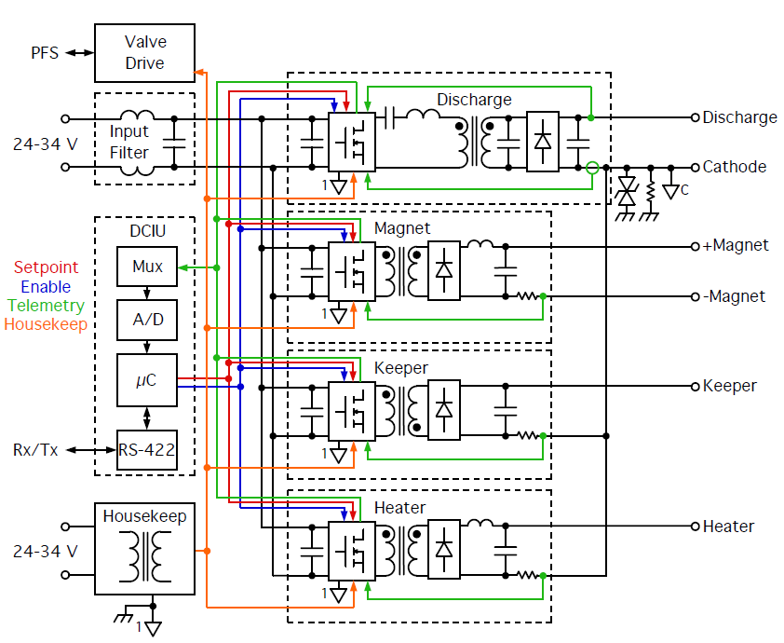
Figure 1. High-level schematic of the SSEP PPU architecture.

Discharge Power Supply Topology Selection

Heritage Discharge Power Supply Topologies
There are two switching power supply topologies that have traditionally been used in Hall thruster discharge supply applications. These topologies include the full-bridge employing either pulse-width modulation (PWM)^{11,12}, or phase-shift control^{13,14} and the flyback-current-fed push-pull topology (typically called the Weinberg converter).^{15,16} Each of these topologies has advantages and drawbacks that must be overcome in design. The full-bridge converter with PWM control is easy to design and has minimal voltage stress on the input bridge switches, however it suffers from a limited maximum frequency of operation due to hard-switching on the input bridge switches and the output side rectifiers. Additionally, in small spacecraft applications where typically only a 28 V bus is available, a very high voltage gain is required to produce the high voltage output necessary for Hall thruster operation. Since the standard full-bridge implementation uses an inductor in the output filter, the voltage gain of the topology itself will always be less than unity, relying only on the transformer turns ratio to boost the output voltage to operational levels. The turns ratio required to achieve the necessary output voltage levels can exceed 1:20, which makes controlling the parasitic elements of the transformer more challenging. The transformer parasitic elements in combination with reverse recovery effects associated with hard switching of the output rectifiers makes selection of suitable output rectifiers difficult. A schematic depiction of the full-bridge power stage is shown in Fig. 2
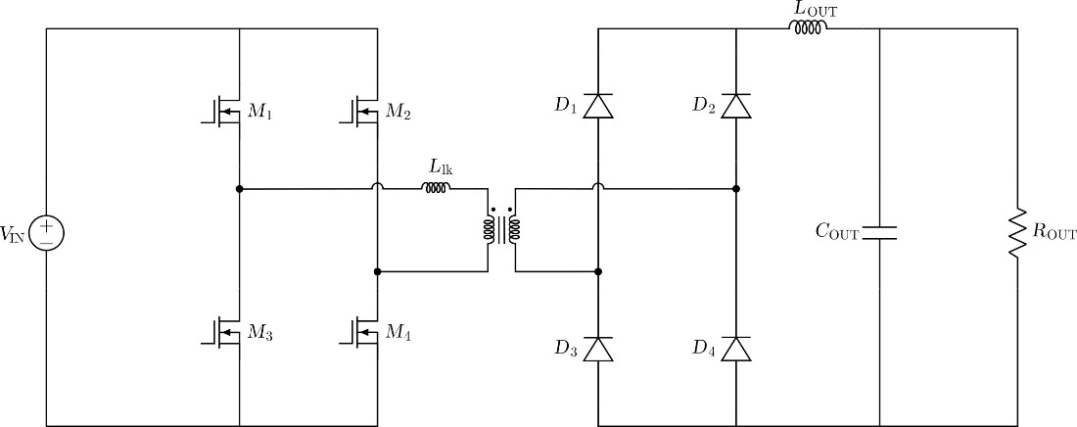

Figure 2. Schematic for a full-bridge power stage employing a full-bridge output rectification stage.

In the full-bridge converter employing phase-shift control, zero-voltage switching (ZVS) of the input bridge switches can be achieved by using the energy stored in the leakage inductance of the main transformer along with the output filter (Llk and L_{OUT} in Fig. 2) to resonantly discharge the parasitic capacitance of the input switches M1-M4. This approach works particularly well in step-down applications where this topology can achieve high switching frequencies at high efficiency. For a Hall thruster discharge supply application where a large step-up ratio is required, this strategy is much less effective, as while the bridge switches can achieve soft-switching, the output rectifiers still operate under hard-switching conditions. The high voltage output either requires output diode rectifiers with voltage ratings greater than 600 V, which typically have poor switching parameters in terms of reverse recovery charge and time, or using multiple output rectifier stages connected in series which also degrades the converter efficiency by adding more diode voltage drops to the rectifying stage. In combination with the higher leakage inductance needed to achieve ZVS, large voltage transients are created that require large snubber circuits to keep the output rectifier reverse voltage stress within acceptable deratings. Usage of silicon carbide (SiC) Schottky diode rectifiers could alleviate issues encountered when using high voltage silicon rectifiers in this topology due to their extremely low reverse recovery times at voltage ratings of 1200 V or greater, however their susceptibility to heavy ion induced damage from galactic cosmic rays precludes their use in space power applications¹⁷. In practice, the efficiency and operating frequency of this topology is limited in high step-up applications due to the limitations of the output diode rectifiers.
Weinberg type converters offer several advantages over the full-bridge topology, which include easy gate drive requirements in the case of MOSFET switching devices, as only low-side gate drive is required; output rectifier reverse voltage stress is clamped to the output voltage; and it is robust against cross conduction damage since the flyback transformer impedance on the input stage will limit the rise time of any fault currents from the input voltage bus. The main drawbacks of this topology include high-voltage transients on the input switches M1 and M2 at turn-off due to the leakage inductance of the primary and flyback transformers, high-voltage spikes present on the flyback transformer rectifier diodes D3 and D4 in certain operating modes, and complex implementation of soft-switching to achieve high frequency operation. For a small satellite application where a 28 V input bus is assumed, the topology is best optimized by operating in the “boost” mode of operation where the input switches M1 and M2 have overlapping conduction periods. This reduces the maximum turns ratio required from the transformer and it reduces input filtering requirements as the input current draw will be continuous. However, operating in this mode creates challenges as the out-of-phase 0-100% duty cycle gating waveforms required to operate in this mode are not supported by any of the standard space qualified PWM controllers. A schematic of the Weinberg converter is shown in Fig. 3.
Most of the previous literature in using these topologies as a Hall thruster discharge supply are targeted at large spacecraft using a multi-kilowatt propulsion system with a nominal input bus voltage of 100 V.¹¹⁻¹⁶ The requirements of the larger satellites tend to differ from small satellites, where there is much more emphasis on controlling costs, mass, and volume of the overall system. To meet aggressive cost and mass targets for the PPU, the full 1 kW of discharge power needs to be processed in one power stage at high efficiency across the entire operating 200 – 500 V range. These requirements combined with the lower voltage unregulated 28 V input bus and consideration for small spacecraft needs create significant challenges for any of these topologies to meet requirements with satisfactory performance.

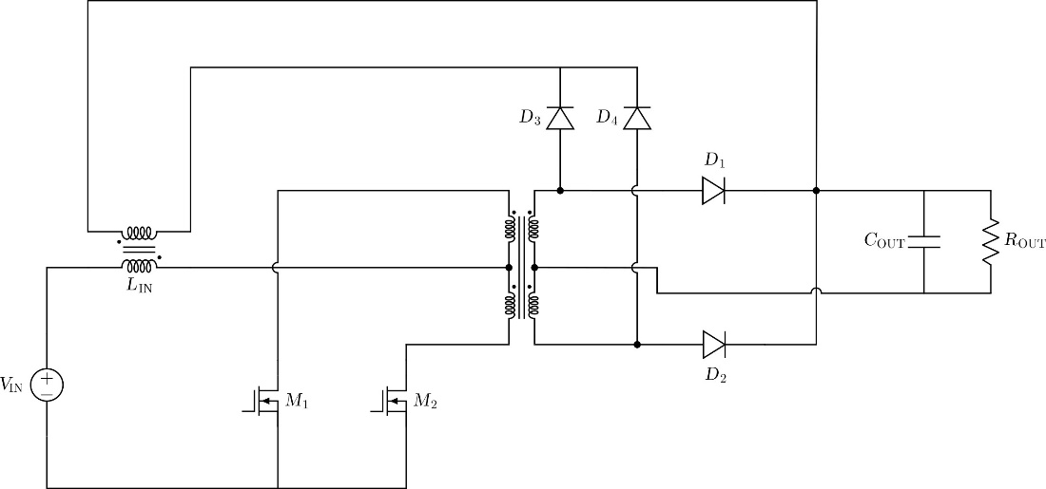

Figure 3. Schematic for a Weinberg power stage employing a full-wave output rectification stage.

Resonant Converter Topology Approaches
Resonant power converters possess useful qualities in this application due to both ZVS operation of the input switches and zero-current switching (ZCS) of the output rectifier diodes. ZCS operation of the output rectifiers is of particular importance in high voltage power supplies as it greatly mitigates the reverse recovery issues encountered when trying to operate diode rectifiers at high frequency. This class of power supply topology works on a different principle of power transfer from the previously discussed PWM topologies. PWM topologies typically vary the duty cycle of its switching elements to convert an input voltage to a high frequency square waveform, at which point it is applied to a low-pass filter to be averaged to generate the output voltage. The average output voltage can then be controlled by varying the duty cycle of the switching elements in the topology. Resonant converters on the other hand generally operate with a constant 50% duty cycle and instead vary their switching frequency to regulate the output. These topologies have a resonant tank network that forms a variable voltage divider with the output load. By varying the switching frequency, the effective impedance of the resonant tank network will also vary. Regulation of the output is then achieved by varying the switching frequency to change the effective resonant tank impedance which will affect the overall voltage gain of the circuit. Among the resonant converter topologies, the two most popular options are three element topologies either employing two inductors and one capacitor (LLC), or two capacitors and one inductor (LCC). A schematic of the full-bridge LLC and LCC converter are shown in Fig. 4.
The mathematics behind describing the input-to-output relationship for resonant converters is more complex than for PWM controlled power stages. This is because for PWM based converters, the time constants of the filters are much longer than a switching period. This allows for a technique called the small-ripple approximation to be used to linearize the normally non-linear behavior of a switching power topology. In resonant converters, the switching period is very near the time constants of the resonant tank circuit, and therefore this approximation is no longer valid.¹⁸ Another consequence of using a resonant mode topology is that the input-to-output voltage gain varies depending on the loading condition. By contrast, most high power PWM power converter designs operate in continuous-current mode (CCM), and therefore have an input-to-output voltage conversion ratio that is independent of the loading condition. Solutions to the input-to-output voltage conversion ratio for resonant topologies is generally found through fundamental harmonic analysis (FHA) (also called sinusoidal analysis). Details on the derivation of the FHA based approximation are given in Ref. 18 and 19, along with the solution to the voltage conversion ratio from FHA for the LLC converter. From this solution, a family of curves can be plotted for the voltage conversion ratio versus normalized switching frequency for the various loading conditions. Figure 5 shows a family of these solution curves, where the output loading condition is represented as the overall quality factor or Q of the resonant tank. Many families of solution curves exist depending on the resonant tank parameters, and the curves in Fig. 5 only represent one example.

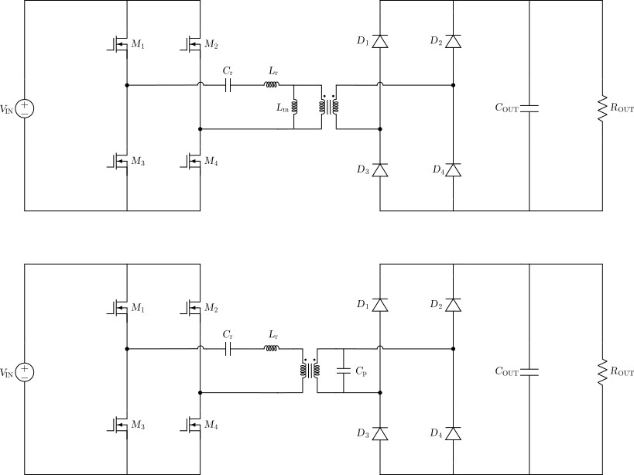

Figure 4. (Top) Schematic of the full-bridge LLC converter. (Bottom) Schematic of the full-bridge LCC converter.
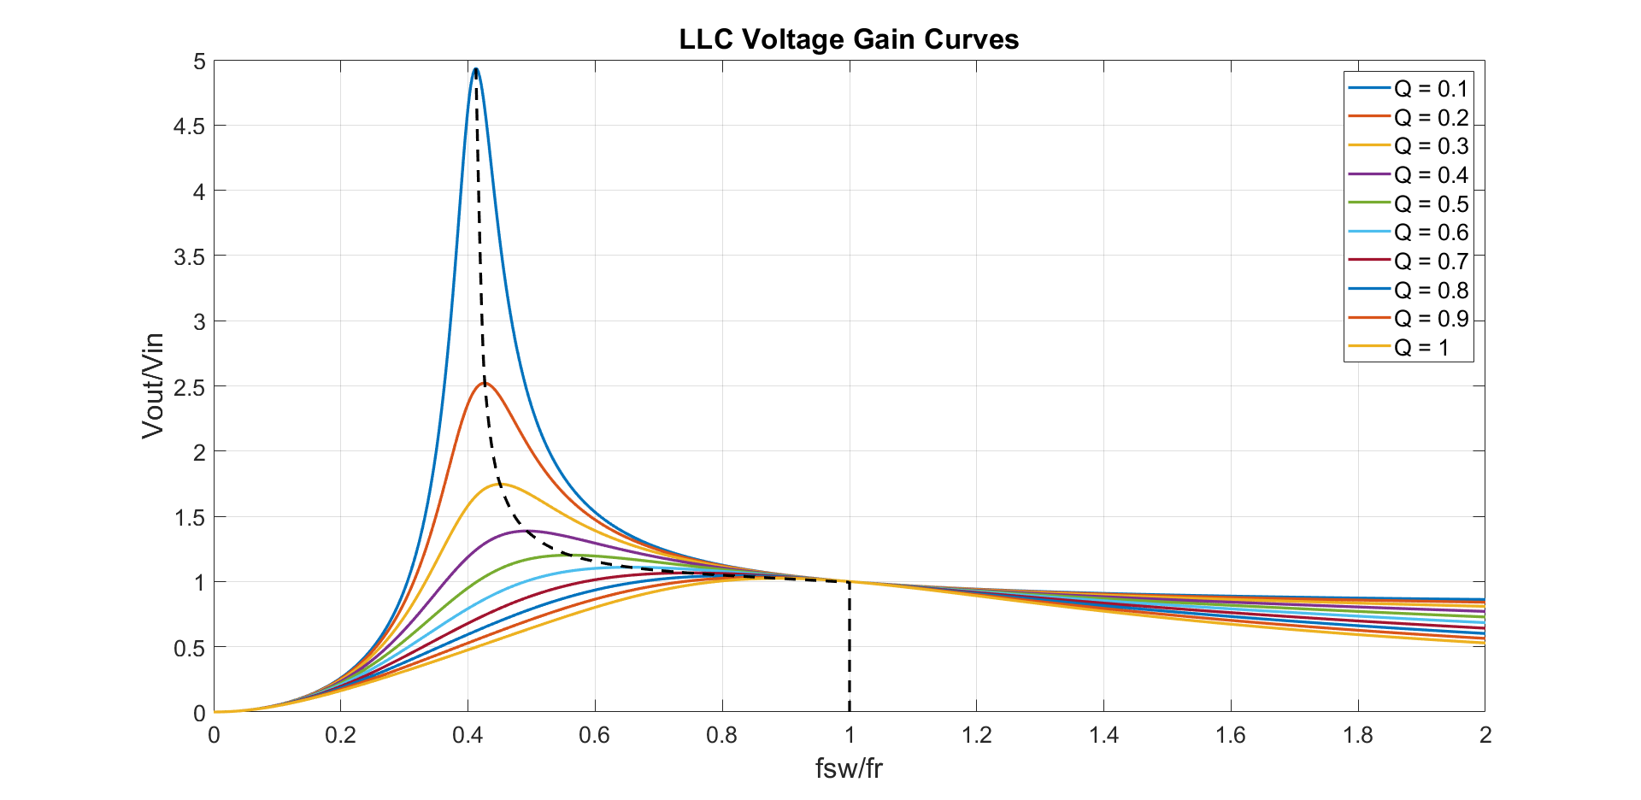
Figure 5. Family of solution curves for the input-to-output voltage gain of the LLC converter vs normalized switching frequency, where fsw represents the switching frequency and fr represents the series resonant frequency of the tank circuit.

The dotted line in Fig. 5 represents the boundary between ZVS and zero current switching (ZCS) operation for the input switches M1-M4. ZCS operation will occur to the left of the dotted line while ZVS operation will occur on the right side of the dotted line. For power supplies based on MOSFETs as the switching elements, ZVS is preferred over ZCS operation to maximize efficiency.
When considering this topology for wide input-output range applications, examination of the Fig.5 solution curves will show that the LLC topology is not well suited for this application. While the voltage gain of the topology can vary over a large range, achieving this wide gain range requires a large switching frequency variation to regulate the output. This makes optimization of the magnetics for the topology difficult and will cause low efficiency when operating at the low end of the output voltage range, as the frequency will need to be much higher than the resonant frequency point. Additionally, operation at frequencies higher than fr is generally not desirable in this topology due to the minimal change in gain with frequency and loss of ZCS for the output rectifiers.
By exchanging the parallel inductive resonant element Lm from the LLC for a capacitive element Cp as depicted in Fig. 4, the circuit is converted to a LCC topology. Like the previously discussed LLC topology, the LCC can achieve ZVS operation of the input MOSFETs and ZCS operation of the output rectifiers over the entire operating range. This topology can be operated with either a LC output filter like that of the full-bridge in Fig. 2, or with a capacitor only output filter as shown in Fig. 4. Due to the high voltage output requirements of a discharge supply, it is more advantageous to operate the topology with a capacitor only output filter as shown in Fig. 4 to clamp the voltage stress on the output rectifier diodes to the output voltage. Analysis of the LCC converter voltage conversion ratio when a capacitor only output filter is used requires additional modification to the FHA method used previously for the LLC converter.^{20,21} In Ref. 20, an equation for an approximation of the family of gain curves for the LCC topology versus normalized switching frequency and output load condition is derived, and this approximation can be used to plot gain curve families for the topology based on resonant tank parameters. One example of a family of LCC gain curves are shown in Fig. 6.
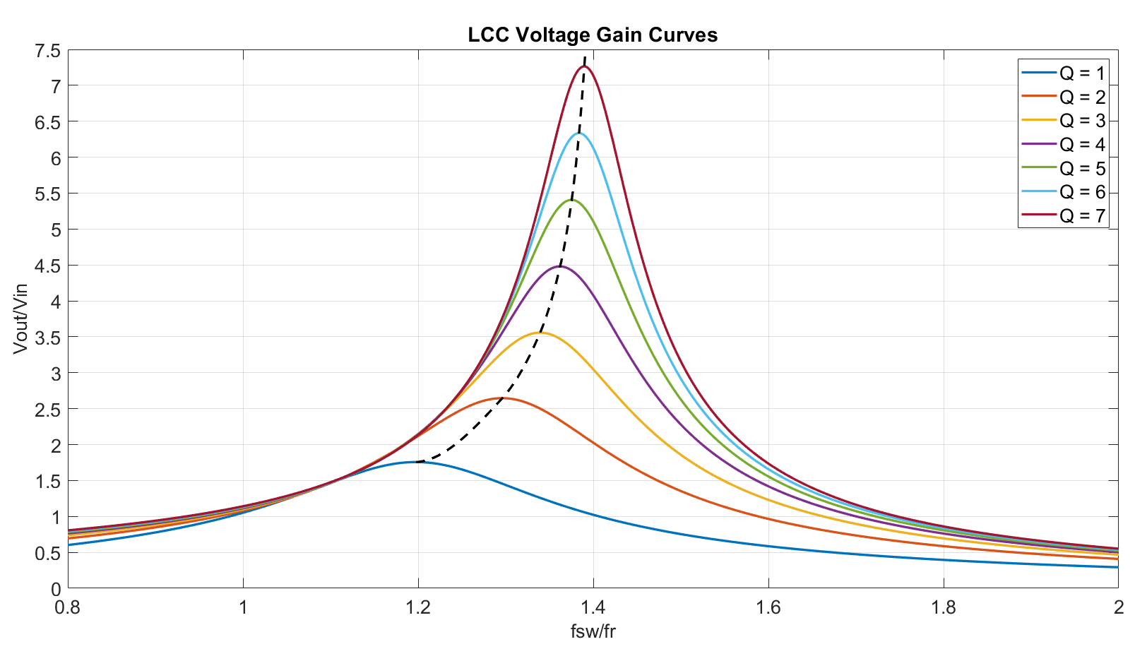
Figure 6. Family of approximated gain curves for the input-to-output voltage gain of the LCC converter vs normalized switching frequency, where fsw represents the switching frequency and fr represents the series resonant frequency of the tank circuit.

The dotted line in Fig. 6 has an equivalent meaning to that of Fig. 5. When examining the gain curves of the LCC converter, the slopes of the gain curves are steeper and converge to a gain of zero more quickly than those of the LLC converter when operating above the resonant frequency point, which allows wide gain regulation of the topology with a much smaller overall operating frequency range.
Unlike the standard PWM or phase-shifted full-bridge, the voltage gain of the LCC topology can be greater than unity, which significantly reduces the needed turns ratio required to boost the output voltage to operational levels. The fact that the output gain varies with the output loading condition can be taken advantage of in a synergistic way with how Hall thrusters are typically operated to achieve high efficiency over a very wide range of output voltages. Hall thrusters are typically power limited devices, that may operate at a range of output voltages and currents if the power limit is respected. This requirement is challenging to meet for the traditional PWM topologies, that will always optimize at one end of the output voltage range. For the full-bridge topology with an output inductor, it will operate most efficiently under maximum duty cycle conditions, and therefore at the highest designed output voltage condition. Operating at a lower output voltage at the full power level requires the same energy be transferred to the output in less time, since the duty cycle must decrease to maintain the appropriate output voltage. This leads to sharp increases in the effective RMS current in the power stage that ultimately leads to reduced efficiency. Since the gain of the LCC circuit shifts with the output loading condition, the LCC resonant tank can be designed such that the supply will always be operating near the optimal resonant point for the full range of output voltages at the maximum design power. This reduces variation in the RMS current in the topology, which is critical to processing 1 kW in one power stage from a 28 V input bus over a wide output voltage range, as the overall efficiency becomes driven by conduction related losses at these current levels.
To illustrate this point, Fig. 7 shows a simulation output of the primary transformer current waveform for a phase-shifted full-bridge topology designed for this application for maximum output voltage of 400 V from a 28 V bus. At the maximum designed output voltage, the topology will operate optimally with minimal RMS currents for the operating condition. However, when the operating condition is changed to 250 V at 1 kW, the overall duty cycle must decrease to satisfy the output voltage requirement. This results in a large increase in the primary RMS current, and an overall substantial decrease in efficiency at this operating point. When compared to primary current waveforms of the LCC converter designed to meet equivalent input and output requirements shown in Fig. 8, the RMS current is stable across different output conditions. The ability to ensure soft-switching of both the input MOSFETs and output rectifier diodes across the entire operating range, in combination with a variable gain characteristic that shifts with loading condition in a synergistic way with how Hall thrusters are typically operated, minimal component stresses from the input full-bridge MOSFET arrangement, and a capacitor only output filter ultimately led to the full-bridge LCC topology to selected for the SSEP PPU wide output range discharge supply.

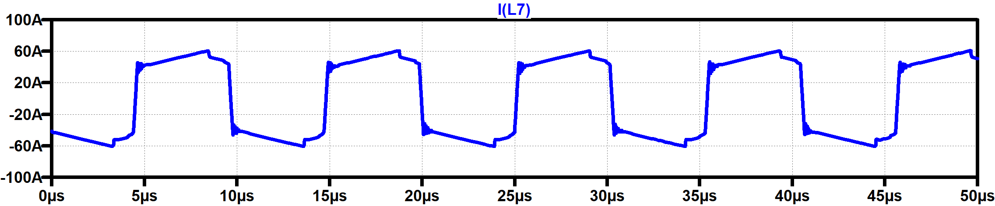

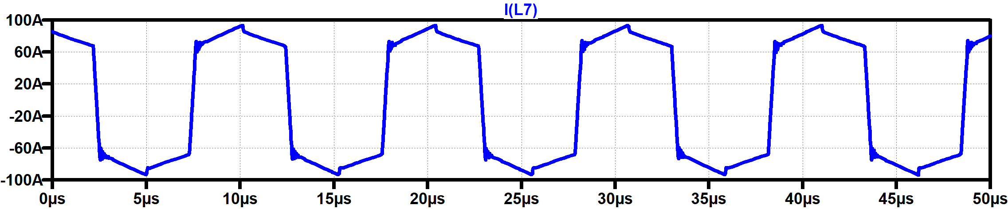

Figure 7. (Top) Phase-shifted full-bridge primary transformer current at a 400 V, 1 kW operating condition with an RMS value of 49.8 A. (Bottom) Phase-shifted full-bridge primary transformer current at a 250 V, 1 kW operating condition with an RMS value of 76.7 A.

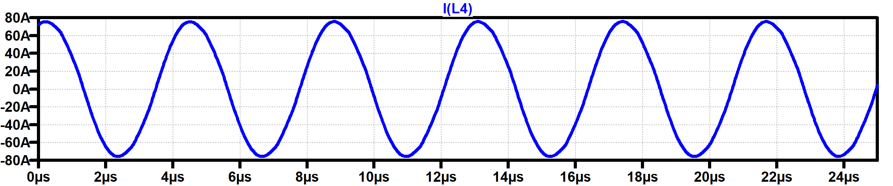

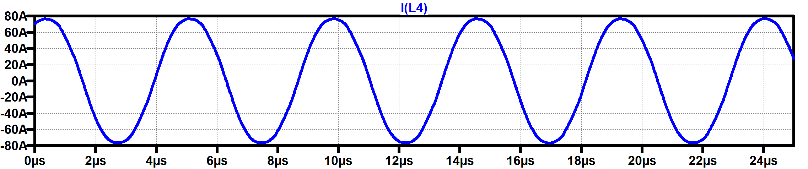

Figure 8. (Top) Full-bridge LCC primary transformer current at a 400 V, 1 kW operating condition with an RMS value of 54.1 A. (Bottom) Full-bridge LCC primary transformer current at a 250 V, 1 kW operating condition with an RMS value of 56.6 A.

Telemetry Needs for Electric Propulsion PPUs
For reliable operation of Hall-effect thruster electric propulsion strings, adequate telemetry is needed to properly monitor the thruster’s operation and manage anomalies. In wide output range applications, where the thruster may be operating over a large range of output voltage and current, having sufficient telemetry to differentiate between nominal and off-nominal thruster operation is critical. Of particular importance for Hall thruster systems, is telemetry relating to the discharge oscillation behavior of the thruster’s discharge current. Monitoring of the AC component of this current is critical to ensuring that the thruster is operating in a nominal way. Past approaches to telemetry for monitoring the AC behavior of this current includes some form of RMS or averaging detection circuit that will give an indication of the oscillation amplitude under nominal conditions. However, an RMS or averaging circuit alone for discharge oscillation current telemetry is not sufficient to distinguish between a nominal or off-nominal mode of operation for the thruster. Figure 9 details example cases where RMS or average discharge current telemetry is not sufficient information to determine if the thruster is operating in a stable mode.
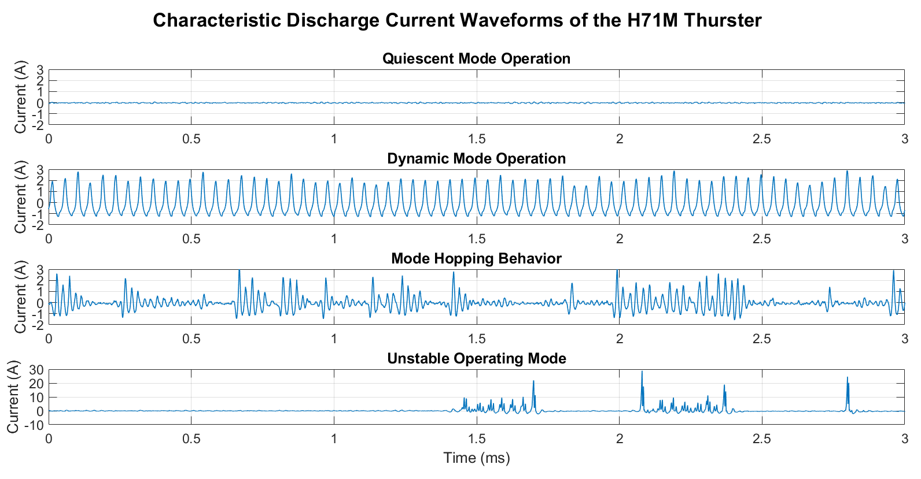
Figure 9. Overview of potential discharge current oscillation behaviors of the H71M thruster.

In general, it is desirable to operate the thruster with a stable discharge current oscillation profile, like the top two waveforms of Fig. 9, referred to here as the quiescent or dynamic oscillation modes. The third waveform of Fig. 9 illustrates a stable but undesirable operating mode known as mode-hopping, which is generally characterized by periods of oscillation behavior with a peak-to-peak value consistent with the dynamic mode and periods of oscillation behavior with a peak-to-peak value consistent with the quiescent mode. The bottom waveform of Fig. 9 indicates an unstable mode, which could cause damage to the thruster if it is operating in this state for prolonged periods of time. The RMS and peak-to-peak values for the waveforms of Fig. 9 are tabulated in Table 2. When analyzing the waveforms in Fig. 9, the dynamic mode waveform has an RMS value of 1.1 A, while the mode-hopping waveform has an RMS value of only 0.60 A, which can be mistaken for a quiescent mode. Similarly, the unstable mode has an RMS value of 2.0 A, which is within the nominal variance for operation in the normal dynamic mode, however the peak-to-peak value for this waveform is many times higher than the typical dynamic operation mode at 31.3 A. For a PPU employing only an RMS or average type of discharge current oscillation telemetry, it would be difficult to resolve between desirable or undesirable modes of operation. For this reason, PPUs should be equipped with both an RMS or averaging telemetry circuit and a peak or a peak-to-peak detector. With two pieces of information about the discharge current oscillation behavior, it becomes much more straightforward to resolve differences between nominal and off-nominal modes. In Fig. 9, the dynamic mode waveform has a peak-to-peak value of 4.2 A, while the mode-hopping waveform has a peak-to-peak value of 4.9 A. When looking at these two pieces of information together, while the mode-hopping waveform has a lower RMS value, its peak-to-peak value is higher than that of the dynamic waveform. This is indicative of a waveform with a high crest factor, which means that the peak amplitudes in the waveform are large compared to the RMS value. With these two pieces of telemetry information allowing insight into what the crest factor of the discharge current waveform is, it provides the operator with much more information into the oscillation behavior than either piece of telemetry data alone.
For the SSEP wide output range PPU design, three distinct telemetry circuits are being evaluated for inclusion. The first is a circuit that calculates the rectified average value of the discharge current oscillations, which gives information on the oscillation behavior over long timescales. The second is a peak-to-peak detection circuit that will output a DC voltage proportional to the peak-to-peak value of the discharge current waveform. The peak-to-peak circuit is more difficult to implement in practice, as the spacecraft telemetry system may not operate at a sufficient speed to properly sample the output of the circuit. For this reason, a third circuit is being investigated that will set a digital signal high or low if the measured peak discharge current exceeds a certain threshold. Evaluation and refinement of these telemetry circuits is an ongoing effort within the PPU development.

Table 2. Summary of RMS and peak-to-peak values for the discharge current waveforms of Fig. 9.

Mode | RMS Value [A] | Peak-to-Peak Value [A]
Quiescent | 0.04 | 0.21
Dynamic | 1.1 | 4.2
Mode-Hopping | 0.60 | 4.9
Unstable | 2.0 | 31.3

PPU Breadboard Test Results
The PPU is currently at a breadboard level of maturity, with functional prototypes of all the previously discussed power supplies using commercial off-the-shelf (COTS) electrical components. Due to the difficulty in properly simulating the thruster discharge or cathode plasma loads, emphasis has been placed on performing integrated testing of the various PPU power supplies with both a hollow cathode assembly (HCA) and the NASA GRC H71M pathfinder model Hall thruster to validate the power supply designs. Two integrated tests have been performed to date on this iteration of the PPU, with the cathode heater and keeper power supplies tested with a H71M HCA at NASA GRC’s vacuum facility 56 (VF-56) and full integrated testing of the complete breadboard PPU with the H71M thruster at NASA GRC’s vacuum facility 8 (VF-8).

VF-56 Cathode Testing
The primary objective of the integrated cathode testing was to validate the approach of using the open circuit voltage of the keeper power supply output with a supplementary DC ignitor output to initiate and sustain a cathode discharge. Figure 10 shows pictures of the test setup.

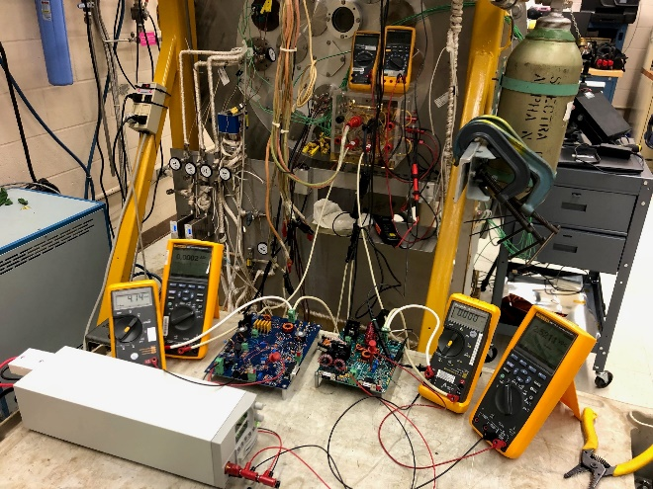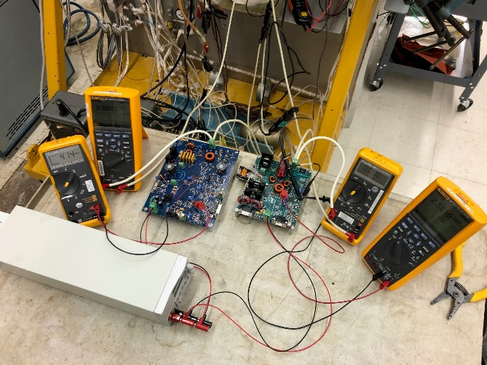

Figure 10. Photos of the cathode subassembly integrated test setup. The cathode keeper and DC ignitor circuit are contained on the blue circuit board on the left while the cathode heater supply is circuit board on the right.

Cathode ignition was performed at input bus voltage conditions of 24, 28, and 34 V to simulate the expected low-line, nominal, and high-line input bus conditions at both the expected keeper current setpoints of 0.5 A and 1.0 A. This test was conducted with xenon at a flow rate of 2.0 sccm to simulate an expected cathode flow rate during nominal thruster operation. In most cases, a discharge can be initiated in a healthy BaO-based HCA with applied keeper voltages of less than 50 V once a sufficient emitter temperature has been reached. This ignition voltage is well within the capability of the cathode keeper power supply alone. To stress the capabilities of the keeper power supply and to validate the functionality of the supplemental DC ignitor circuit, attempted ignitions with reduced cathode heating times were also performed to make initiating a cathode discharge require higher keeper voltages. This simulates off-nominal cases that can be encountered where hundreds of volts may be required to initiate the cathode discharge. Figure 11 shows two oscilloscope captures from this testing.

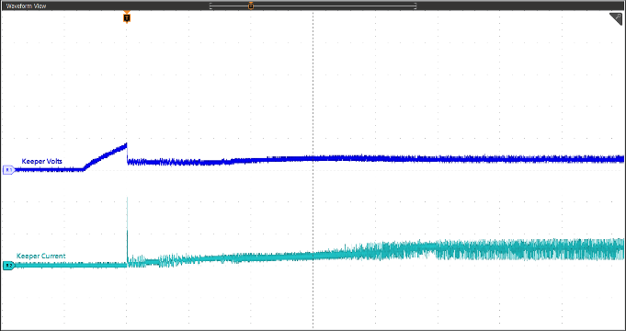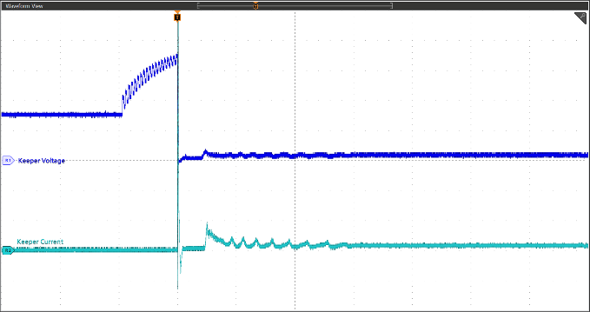
CH.1: Keeper Voltage, 50 V/div
CH.2: Keeper Current, 1 A/div
10 ms/div
CH.1: Keeper Voltage, 100 V/div
CH.2: Keeper Current, 5 A/div
400us/div

Figure 11. (Left) Oscilloscope capture of cathode discharge ignition with nominal cathode heating time.
(Right) Oscilloscope capture of cathode discharge ignition with reduced cathode heating time.

When the cathode was heated for a nominal duration, cathode discharge ignition was observed to occur at keeper voltages less than 100 V. Since this is within the 150 V open-circuit voltage capability of the keeper power supply, cathode ignition occurs and then subsequently transitions directly into sustaining keeper mode without the need to activate the supplemental DC ignitor circuit. When the cathode heating time is reduced, the keeper power supply output rises to its maximum output of 150 V but is insufficient for cathode ignition. At this this point, the supplemental DC ignitor circuit is enabled, which will allow the total voltage on the keeper to rise to 300 V. For the case shown by the right plot on Fig. 11, this was sufficient for cathode ignition, at which point logic circuitry in the keeper power supply automatically disables the DC ignitor and transitions to operating in the normal sustaining keeper mode. The designed keeper power supply could ignite and sustain a cathode discharge at all nominal input and output conditions and when combined with the additional DC ignitor circuit, adequate voltage margin is provided to support cathode ignition in the most common off-nominal scenarios.

LCC Discharge Supply Bench Testing
The first iteration of the 1 kW LCC discharge breadboard uses both silicon MOSFETs and output rectifier diodes with custom magnetics made in house at NASA GRC. Since there are no space-qualified integrated circuit controllers that directly support resonant mode power supplies, the controller is implemented with discrete digital logic. The breadboard design was evaluated for efficiency, dynamic performance, and startup behavior. Figure 12 shows oscilloscope captures that demonstrate the transient performance to load steps. Figure 13 illustrates the performance of the soft-start implementation, and Fig. 14 shows plots of the power conversion efficiency at three different input bus voltages at two different output voltage settings.

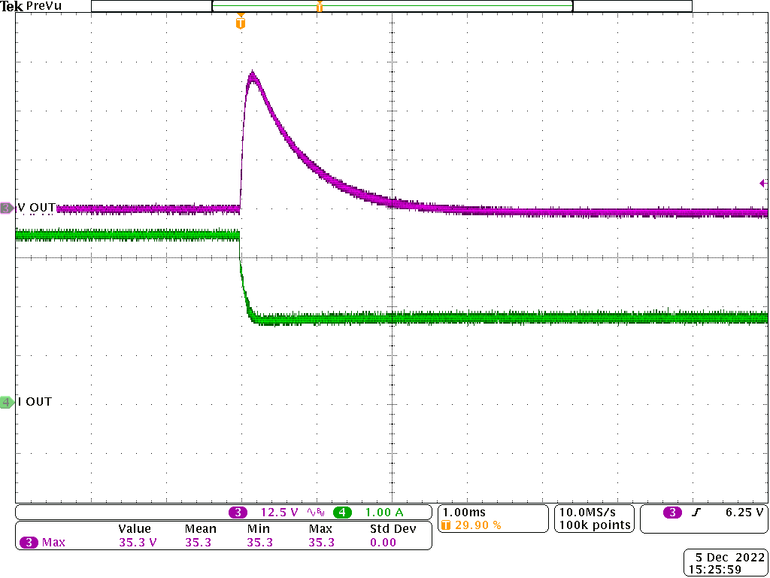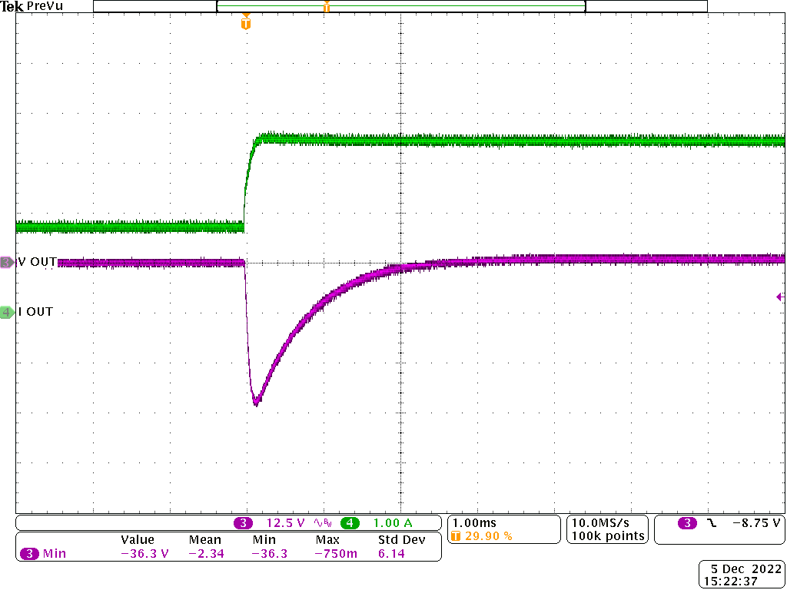
Figure 12. (Left) Output response to load step-down from 1 kW to 500 W at a 300 V operating condition.
(Right) Output response to load step-up from 500 W to 1 kW at a 300 V operating condition.

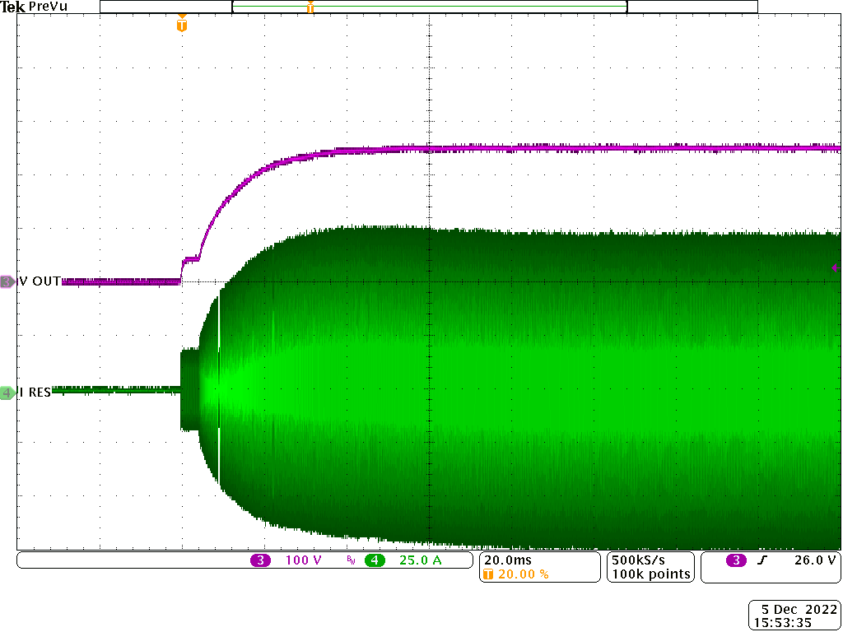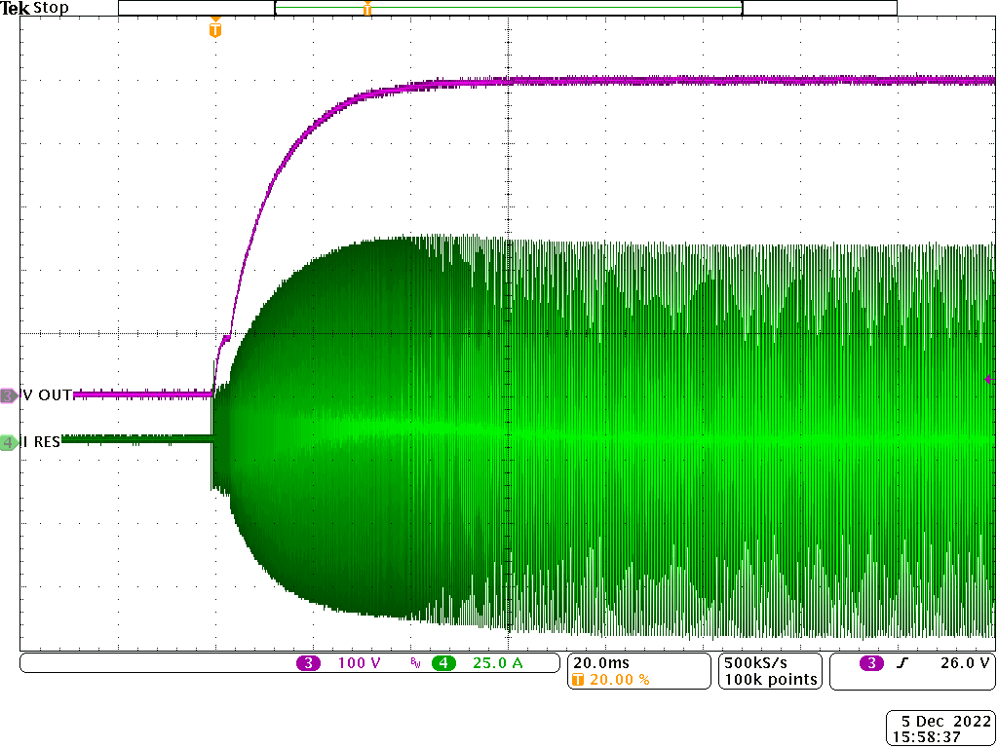
Figure 13. (Left) Output voltage and primary resonant current ramp-up to a 300 V, 1 kW operating condition.
(Right) Output voltage and primary resonant current ramp-up to a 500 V, 1 kW operating condition.

Figure 14. (Left) Discharge power supply efficiency with a 250 V output. (Right) Discharge power supply efficiency with a 400 V output.

Load step testing to validate the transient response was performed using an electronic load with a current slew rate of 0.6 A/µs. With a 50% step load, the maximum voltage overshoot was measured to be less than 40 V with a 2% settling time of less than 3 ms. The response is well damped with minimal ringing which indicates adequate phase margin in the power supply’s loop gain. Startup of resonant converters can often present a challenge, as the switching frequency needs to be controlled well above the resonant frequency and slowly brought down to avoid large inrush currents into the resonant tank circuit before the output voltage is established. This issue is less prevalent in the LCC topology due to the gain curves rolling off to zero gain rapidly at frequencies above resonance, however precautions still need to be made in the control circuit to safely control inrush currents. The soft-start circuitry within the controller is designed to control the switching frequency in a way that allows a slow ramp up of the resonant current for the first 10’s milliseconds of operation, resulting in the controlled ramp of resonant tank current without overshoot shown in Fig. 13. Efficiency plots are shown for 250 V and 400 V operation in Fig. 14, as most Hall thrusters in this power class operate within this output voltage range. Resonant converters will operate the most efficiently when the switching frequency is very close to the effective resonant frequency of the tank circuit. Since the optimal operating point also corresponds to the point of maximum gain in the LCC topology, the efficiency of this topology tends to maximize near full designed power output. This aspect is desirable for a small spacecraft application, since the spacecraft itself tends to be power limited. PPU efficiency near the maximum design power needs to be maximized to both provide sufficient headroom against the spacecraft’s capability to provide power to the propulsion string and to minimize heat that needs to be rejected from the PPU by the spacecraft. This topology will tend to be lower efficiency than PWM converter approaches at lighter loads due to increased reactive power that will be present in the resonant tank circuit. This characteristic can be mitigated by reducing the output voltage as the power is decreased as shown in Fig. 14. This also aligns well with how Hall thrusters are typically operated. Since Hall thruster efficiency is strongly correlated with the current density of the device, a reduction in the thruster power generally requires a reduction in the discharge voltage setpoint for the Hall thruster to maintain its efficiency at acceptable levels. It is expected that the efficiency for this design can be improved with a few changes in the design that will be discussed in the conclusion.

VF-8 Integrated Testing
A full integrated test with all the auxiliary power supplies along with the LCC discharge power supply was conducted with the H71M thruster on xenon to validate the capability of the current design iterations to operate a Hall thruster and demonstrate their robustness to operating a plasma load. Figure 15 depicts a photo of the test setup with all the breadboard power supplies set up by VF-8.

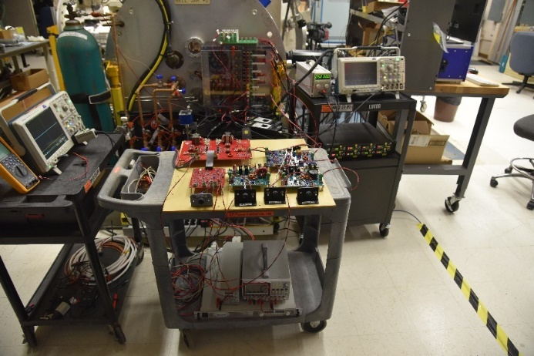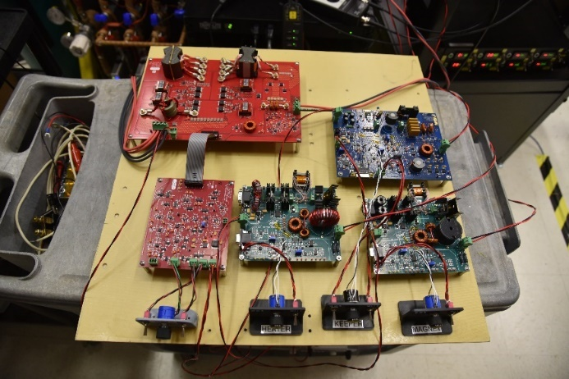
LCC Discharge Power Stage
LCC Controller
Keeper Supply
Heater Supply
Electromagnet Supply

Figure 15. Test setup photos from the integrated breadboard PPU test.

The testing primarily revolved around thruster startups, as this tends to be one of the most challenging aspects for PPU and thruster compatibility during integration testing. A glow-mode thruster startup profile was used for this PPU integrating testing, which consists of first starting a cathode discharge using the keeper power supply. From here, the discharge supply is turned on with the electromagnets powered off. This will initiate a glow discharge plasma to the main thruster anode and the discharge supply will be operating in a low output voltage, current limited state. At this point, the electromagnet power supply is enabled, and as the magnetic field comes on the thruster will transition to its nominal steady-state Hall discharge operating mode. A proportional flow control valve (PFCV) was not in place for this test, so xenon flow control to the thruster was managed by the VF-8 facility support equipment and not by the PPU. The input voltage to the PPU power supplies was set to 28 V for the duration of this testing. Figure 16 shows sample oscilloscope captures of a thruster startup and steady-state operation at a 600 W condition.
The PPU was able to successfully start the H71M Hall thruster in glow-mode and then operate the thruster at steady-state throughout the duration of the test. The setpoint range for the test covered an operating range from 200 V to 350 V at output powers from 400 W up to 900 W. There was some instability in the discharge supply control circuit during start up and can be seen by the large amplitude voltage and current spikes seen on the glow-mode period of the startup profile in the oscilloscope waveforms from Fig. 16. This instability subsided as the electromagnets were enabled and the thruster plasma transitioned to its nominal impedance. Additional output filtering and tuning of the current limiting control circuit will be pursued in the next design iteration to mitigate this issue.

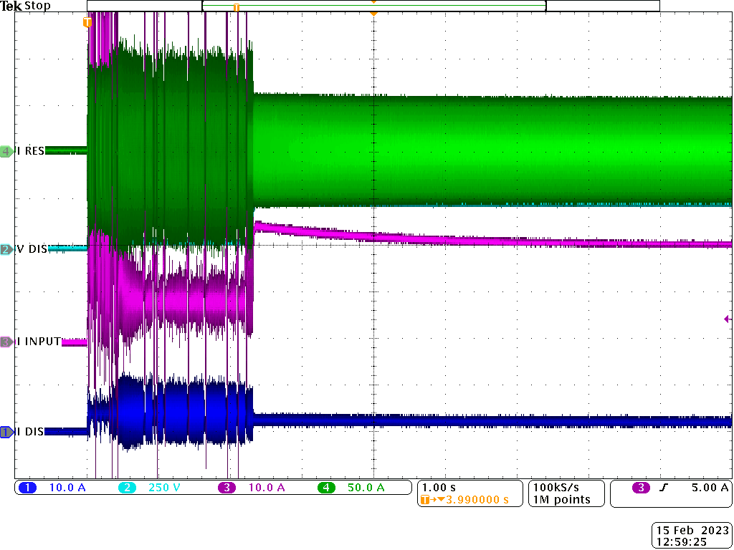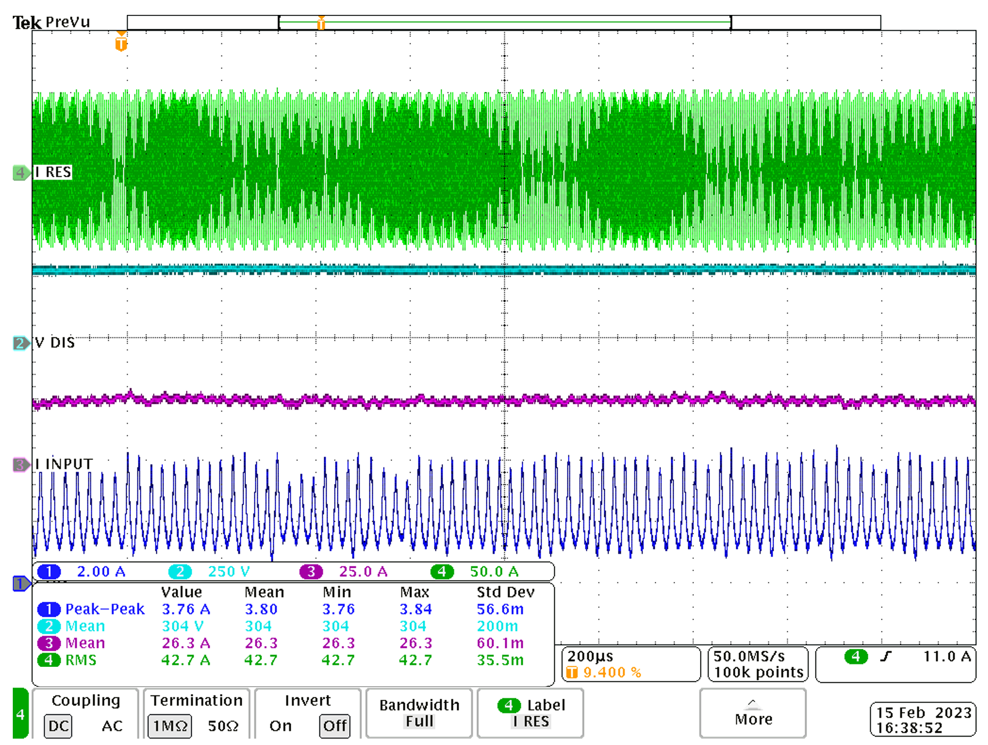
Glow-Mode Region
Hall-Mode Region

Figure 16. (Left) Oscilloscope waveforms for thruster startup to a 300 V, 600 W condition. (Right) Oscilloscope waveforms with thruster operating in steady-state at a 300 V, 600 W condition. CH. 1: Discharge Current, CH.2: Discharge Voltage, CH. 3: Discharge Supply Input Current, CH. 4: Resonant Tank Current

Conclusion
The SSEP project at NASA GRC continues to work toward technology maturation of a wide output range 1 kW Hall thruster PPU capable of meeting NASA performance requirements for deep space missions while also supporting niche commercial applications where similar capabilities are needed. The wide output range capability of the PPU can support a variety of mission needs, spacecraft buses, Hall thrusters, and propellants. The challenge of creating a discharge power supply that can operate over such a wide output range has led to the exploration and ultimate selection of a resonant LCC topology that has characteristics that allow it to function well in this application. Telemetry circuits for the PPU continue to be evaluated to ensure that sufficient monitoring of a thruster exists within the PPU to be capable of operating and diagnosing a thruster over wide throttling ranges over its full life. The PPU is currently at a breadboard level of maturity, and all the various supplies within the PPU have successfully completed integrated testing with NASA’s H71M Hall thruster. The SSEP project is currently in the process of designing second iterations for all these power supply breadboards that will further close the gap to what is needed for a flight implementation. The next revision of the LCC discharge supply will incorporate radiation hardened gallium nitride (GaN) high electron mobility transistors (HEMTs) and an integrated planar magnetic that is expected to substantially improve the power conversion efficiency from the current iteration of the design. The next iteration of the auxiliary power supplies seeks to further refine the designs and to incorporate them onto a single printed circuit card assembly for better packaging. The new discharge and auxiliary power supply revisions, along with a first prototype of the DCIU card are expected to be completed by the end of this fiscal year. In the following fiscal year, an engineering development model of this PPU is sought that will have proper form, fit, and function complete with worst-case analyses to aid in transferring the technology to U.S. commercial partners.

Acknowledgments
The authors would like to thank Scott Metzger, Nicholas Purpera, Scott Panko, and Eric Anderson for their vast circuit board layout expertise and for performing much of the layout activities for the each of the power supplies tested as a part of this work; Joseph Samrani for his work in maturing the DCIU portion of the PPU and for his expertise in EEE parts selection; Jon Mackey for his help with destructive part analysis that has been very useful in informing component selections; and Mike Arnett, James Sadey, and Tom Ralys for the significant support preparing, maintaining, and operating the test facilities.

References
¹NASA, “NASA 2018 Strategic Plan,” NASA Headquarters, 2018.
²NASA, “NASA State-of-the-art Small Spacecraft Technology Report,” NASA/TP-20210021263.
³Chaplin, V., Simmonds, J., Bryne, M., Goebel, D., Ortega, A., Lobbia, R., Mikellides, I., Hofer, R., Zhu, B., Ratliff, J., and Conversano, R., “Extended Life Qualification of the Magnetically Shielded Miniature (MaSMi) Hall Thruster,” 37th Small Satellite Conference, Logan, UT, Aug 2023, SSC23-VI-01.
⁴Vaudolon, J., Vial, V., Cornu, N., and Habbassi, I. “PPS-X00 Thruster Development Status at Safran.” 36th International Electric Propulsion Conference, Vienna, Austria, 2019.
⁵Szabo, J., Byrne, L., Strain, M., Paintal, S., Sawyer, S., Yu, T., Kolencik, G., and Hruby, V., “One Million Newton-Second Duration Test of a 600 Watt Hall Effect Thruster Fueled By Xenon,” 2020 AIAA Propulsion and Energy Forum, Virtual Event, August 24-28, 2020.
⁶Tinge, W., Chien, K., and Spears, R., “XIPS Ion Thrusters for Small Satellite Applications,” 21st Annual AIAA/USU Conference on Small Satellites, 2007, SSC07-III-11.
⁷Foust, J., “Apollo Fusion obtains Hall thruster technology from JPL,” SpaceNews, 7 May 2019.
⁸Benavides, G., Kamhawi, H., Verhey, T., Rhodes, C., Baird, M., and Mackey, J., “High-Propellant Throughput Sub-kW Electric Propulsion System for Deep Space Science and Exploration,” 37th International Electric Propulsion Conference, Cambridge, MA, 19-23 June 2022, IEPC-2022-343.
⁹Meyer, S. D., “Method and apparatus for selectively distributing power in a thruster system,” U.S. Patent and Trademark Office, U.S. Patent No. 6031334, 2000.
¹⁰Fu M., Zhang D., and Li T., “A Novel Coupling Method of Power Supplies With High Power Density, Efficiency, and Fast Dynamic Response for Spacecraft Hollow Cathode Power Supply Applications,” IEEE Transactions on Power Electronics, vol. 32, no. 7, pp. 5377–5387, Jul. 2017, doi: 10.1109/TPEL.2016.2610442.
¹¹Santiago W. et al., “High Input Voltage, Power Processing Unit Performance Demonstration,” 52nd AIAA/SAE/ASEE Joint Propulsion Conference, Salt Lake City, UT, 2016. doi: 10.2514/6.2016-5033.
¹²Piñero, L., Scheidegger R., Aulisio, M., and Birchenough, A., “High Input Voltage Discharge Supply for High Power
Hall Thrusters Using Silicon Carbide Devices,” 33rd International Electric Propulsion Conference, Washington, D.C., 2013, IEPC-2013-388
¹³Piñero L. and Bowers G., “High Performance Power Module for Hall Effect Thrusters,” 38th AIAA/ASME/SAE/ASEE Joint Propulsion Conference & Exhibit, Indianapolis, IN, 2002. doi: 10.2514/6.2002-3947.
¹⁴Piñero L. and Bowers G., “Multi-Kilowatt Power Module for High Power Hall Thrusters,” 40th AIAA/ASME/SAE/ASEE Joint Propulsion Conference and Exhibit, Fort Lauderdale, FL, 2004. doi: 10.2514/6.2004-3973.
¹⁵Tomescu B. et al., “High Efficiency, Versatile Power Processing Units for Hall-Effect Plasma Thrusters,” 2018 Joint Propulsion Conference, Cincinnati, OH, 2018. doi: 10.2514/6.2018-4642.
¹⁶Malone, S. et al., “Deep Space Power Processing Unit for the Psyche Mission,” 36th International Electric Propulsion Conference, Vienna, Austria, 2019.
¹⁷Lauenstein, J.-M., Casey, M. C., Ladbury, R. L., Kim, H. S., Phan, A. M., and Topper, A. D., “Space Radiation Effects on SiC Power Device Reliability,” 2021 IEEE International Reliability Physics Symposium (IRPS), Monterey, CA, USA, 2021, pp. 1–8. doi: 10.1109/IRPS46558.2021.9405180.
¹⁸Erickson, R. W. and Maksimovic D., Fundamentals of Power Electronics, 3rd ed., Springer Nature, Switzerland, 2020, pp. 19, 933, 938-949.
¹⁹Yu, S.-Y., Chen, R., and Viswanathan A., “Survey of Resonant Converter Topologies,” Texas Instruments Application Note SLUP376, 2018.
²⁰Ivensky, G., Kats, A., and Ben-Yaakov, S., “An RC load model of parallel and series-parallel resonant DC-DC converters with capacitive output filter,” IEEE Transactions on Power Electronics, May 1999, pp. 515 – 521, doi: 10.1109/63.761695.
²¹Gilbert, A. J., Bingham, C. M., Stone, D. A., and Foster, M. P., “Normalized Analysis and Design of LCC Resonant Converters,” IEEE Transactions on Power Electronics, November 2007, vol. 22, no. 6, pp. 2386–2402, doi: 10.1109/TPEL.2007.909243.

Research AST, Electric Propulsion Systems Branch, corey.r.rhodes@nasa.gov.
Senior Research AST, Electric Propulsion Systems Branch, gabriel.f.benavides@nasa.gov.
Senior Research AST, Electric Propulsion Systems Branch, luis.r.pinero@nasa.gov.

