Computational Fluid Dynamics Simulation of the Swordfish Oxygen/Methane Rotating Detonation Rocket Engine
Brian R. Richardson
NASA Marshall Space Flight Center, Huntsville, AL
Summary Abstract:
Rotating Detonation Rocket Engines (RDREs) provide several theoretical performance benefits over traditional deflagration combustion rocket engines. RDREs can potentially generate higher specific impulse (ISP) for a given propellant combination enabling significant consumable mass savings for a spaceflight vehicle. Conversely, RDREs are a relatively new technology with a shallower analytical modeling base compared to traditional combustion engine architectures. In this work, we utilize time-accurate, Computational Fluid Dynamics (CFD) modeling to simulate the complex fluid environment inside an RDRE combustion chamber and propellant manifolds. The selected engine of study is the Swordfish RDRE which was developed and tested and at the National Aeronautics and Space Administration (NASA) Marshall Space Flight Center (MSFC). CFD simulations were conducted using the as-tested Swordfish geometry and conditions to facilitate comparison between the analytical predictions and experimental results.

- Introduction

NASA is pursuing the development of RDRE propulsion systems because they offer significant potential propellant mass savings over traditional combustion engines. These propellant mass savings are critical for revolutionizing spacecraft travel especially for desired Lunar and Mars missions. However, RDREs provide significant technical challenges including high vibrational and thermal loads to the structure and the technology demonstration maturity lags other traditional deflagration combustion engines.
In traditional deflagration combustion engines, the reaction of fuel and oxidizer occurs at a relatively constant pressure and low Mach number. A significant portion of the development effort of a deflagration combustion thrust chamber assembly (TCA) is focused on the design of the propellant injectors. The injectors are designed to produce stable combustion of the fuel and oxidizer inside the TCA at time scales that avoid coupling burning instabilities with the natural acoustic modes in the chamber. The hardware is designed to produce spatially anchored combustion flames. Pressure oscillations and rough combustion are purposefully mitigated to avoid exciting a combustion instability which can cause significant damage to the TCA hardware. Regions of unburned, premixed of fuel and oxidizer are minimized to reduce ignition pops and large amplitude pressure combustion events.
Unlike traditional deflagration combustion engines, RDREs harness large amplitude pressure oscillations for increased combustion efficiency and performance. In RDREs, premixed regions of unburned fuel and oxidizer are purposefully generated. A moving detonation wave is produced to achieve combustion of the unburned propellants inside the chamber. As the detonation wave travels through the premixed fuel and oxidizer regions, the propellants combust and release energy. Peak combustion wave speed and energy release occurs within premixed regions that are near the stoichiometric proportions of fuel and oxidizer.
As the name RDRE implies, the detonation wave or waves rotate through the combustion domain. Most RDRE combustion chambers are annular shaped and during engine operation, detonation waves travel around this annulus. Propellants are constantly injected into the annulus region. The annulus size, detonation wave speed and injector scheme must all be designed to achieve the proper RDRE periodic operational cycle: 1) initial unburned propellant injection and mixing, 2) detonation induced combustion, 3) combustion product exhaust, 4) refill of unburned propellant mixture.
Here we see the physics of interest when constructing the CFD model of the RDRE chamber. The model must simulate the time-accurate response of the propellant injectors and manifold to the transient and moving pressure wave produced by the rotating detonation wave. Additionally, the CFD model should capture the combustion of the propellant mixture inside the chamber to provide an accurate prediction of the combustion gas exhaust behavior from the TCA.

- Swordfish RDRE Hardware

Figure 1 shows a cross-section through the Swordfish RDRE computer aided design model. Figure 1 shows the annular combustion chamber between the nozzle wall and center body of the engine. The exterior nozzle extension can be modified to optimize engine performance at different target operating conditions.
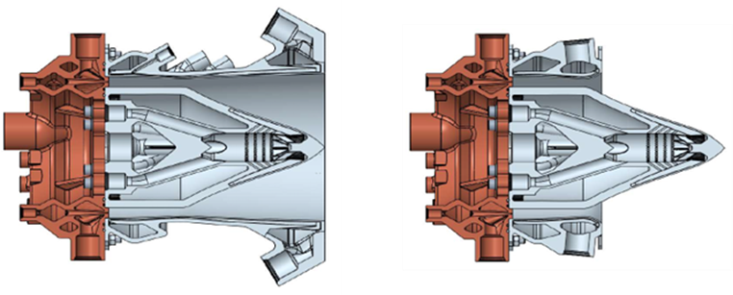
Figure 1: Cross-section through the Swordfish CAD with two different nozzle extensions.

Figure 2 shows an image of a Swordfish RDRE hot fire test at MSFC. In the test image shown, the engine is operating using supercritical oxygen and methane propellants. CFD simulations will be conducted at engine conditions corresponding to those from the test campaign to facilitate comparisons between the test data and CFD results. The two images on the right side of Fig. 2 show a single rotating combustion wave and two co-rotating combustion waves (far right) taken at two different Swordfish test conditions[1].
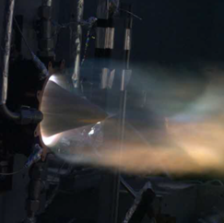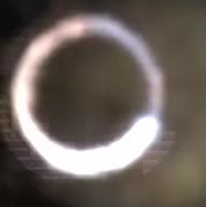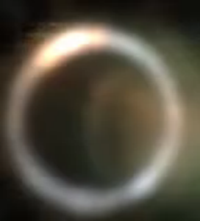
Figure 2:Photographs of a Swordfish hot-fire test showing the exhaust plume (left), a single rotating combustion wave in the chamber (middle) and two co-rotating combustion waves (right).

- Computational Model and Simulation Approach

Loci/CHEM, a density-based Navier Stokes flow solver with finite-rate chemistry modeling capability was used to conduct three-dimensional, time accurate CFD simulations of flow within the Swordfish RDRE [2]. Several types of simulations were conducted as part of the CFD modeling effort. Inert mixing of oxygen and methane propellants was simulated to assess injector behavior and computational mesh suitability. Boundary-generated pressure waves were applied to the inert domain to quantify the injector response induced by pressure oscillations of the magnitude produced during the test. Finally, chemically reacting flow is planned to be modeled in the final paper.

Figure 3 shows a 30 degree wedge of the full Swordfish combustion chamber geometry and propellant manifolds. For traditional deflagration combustion flow CFD modeling, neglecting the manifold volume can produce reasonable results in the combustion chamber. However, previous experience with RDRE injectors has shown strong coupling between the high pressure waves in the chamber and the pressure response in the propellant manifolds. Thus, the manifolds are included in the RDRE computational domain to capture the coupled response. Figure 3 shows that the injector elements are pentad type injectors with an oxidizer core flow surrounded by four methane injection ports.
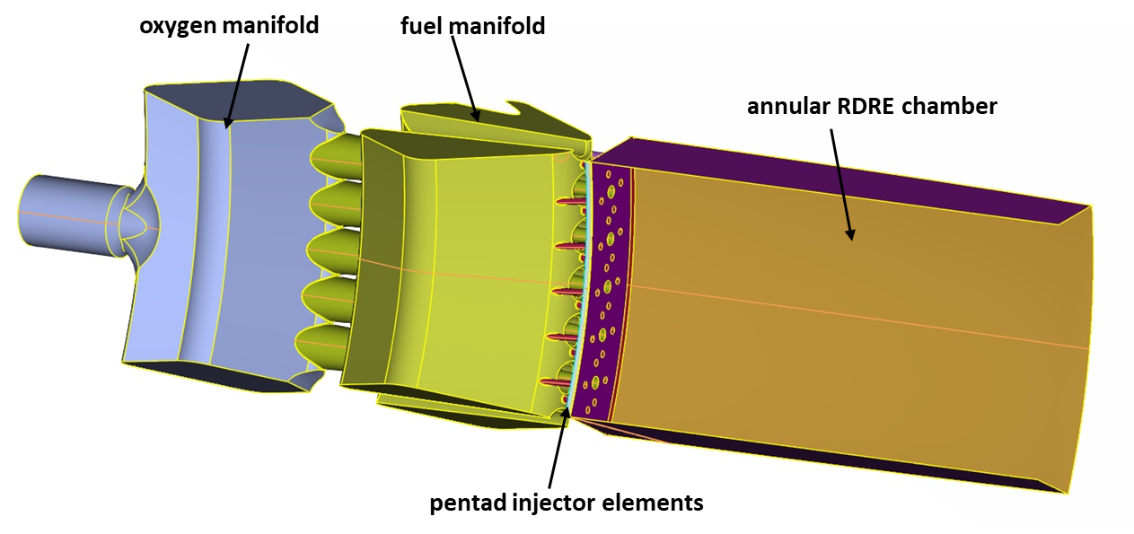
Figure 3: CFD computational domain, a 30 degree wedge of the Swordfish RDRE including propellant manifolds and combustion chamber.

The complex computational domain was discretized using a hybrid-unstructured mesh approach. A combination of triangular and rectangular elements were used to discretize the surface mesh using the ANSA pre-processing software [3]. The volume of the domain is discretized by extruding prism and quadrilateral elements from the solid walls to resolve the fluid boundary layer using AFLR3 [4]. The remainder of the mesh is filled in with unstructured pyramid and tetrahedral volume cells.
The supercritical oxygen and methane propellants were modeled using the Soave-Redlich-Kwong [5] cubic equation of state. Propellant and combustion product transport properties were sourced from NIST-REFPROP [6]. For the combustion model results to be shown in the final paper, an 11 species, 20 reaction, oxygen-methane chemistry mechanism model was used [7].

- Preliminary CFD Simulation Results

Figure 4 shows two time-averaged results to quantify the RDRE injector mixing performance and feed system behavior. The left panel image in Fig. 4 shows methane (red) and oxygen (green) jet cores, represented by iso-surfaces inside the 30 degree wedge model of the Swordfish RDRE chamber. There is evidence of manifold induced flow biasing both in the oxidizer and fuel jets as the length pf the jets vary significantly over just a small portion of the total manifold ring.
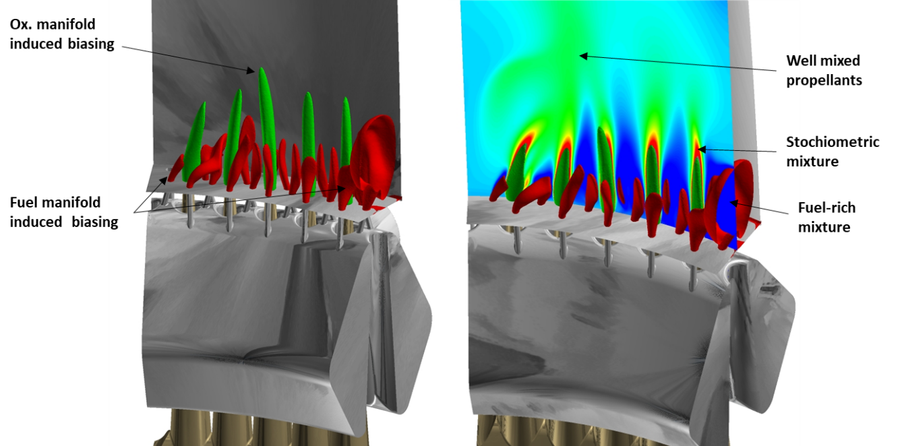
Figure 4: Plots describing the inert mixing behavior in the Swordfish chamber showing fuel jet cores (red iso-surface), oxidizer jet cores (green iso-surface) and mixture ratio (contours).

The right panel image again shows the propellant jet iso-surfaces and includes a radial contour plot surface showing unburned oxygen and fuel mixture by mass. For these modeled conditions, the RDRE was operating at a fuel rich mixture ratio of ~2.8. Stochiometric mixture regions of oxygen and methane (red contours) were only observed around the oxygen jet. The medium green contours indicate well mixed fuel and oxidizer at the overall injected ratio.
Figure 5 shows normalized mass flow rate recovery time through the fuel and oxidizer injector ports following an induced pressure wave at ~10 times the chamber operating pressure. The pressure wave was enforced using a transient boundary condition in the chamber domain, oriented normal to the injector faceplate. Applying this contrived pressure wave to the inert mixing domain approximates a passing rotating detonation wave and provides an evaluation of the injector behavior to the transient overpressure wave in the combustion chamber. The various lines in the plots in Fig. 5 are at different axial stations inside the fuel and oxidizer injector passages. Figure 5 shows that mass flow through the shorter methane injector ports fully recovered faster than through the longer oxidizer injector ports.

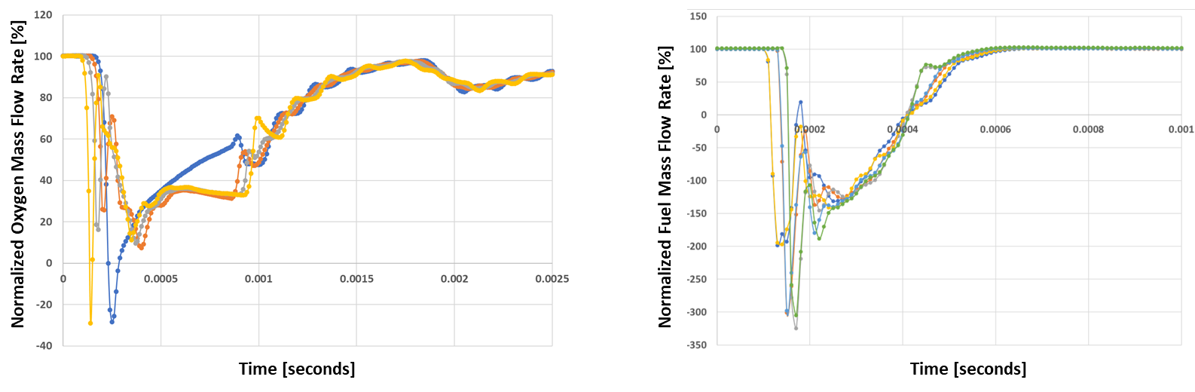
Figure 5: Mass flow rate recovery through an oxidizer injector (left) and methane (injector) following a passing pressure wave.
The final paper will include CFD simulation results for the full 360 degree Swordfish domain. Reacting flow CFD simulations are in progress and will also be included in the final paper submission.

- References

[1] Eberhart C., Fischbach S., Teasley T., “Combustion Dynamics Characteristics From Testing of a Dual-Regen Cycle LOX/LCH4 RDRE.” 71st JANNAF Propulsion Meeting, May 2024.
[2] Luke, Ed, et. al, “CHEM 4.0 A Finite-Rate Viscous Chemistry Solver – The User Guide” April 11, 2018.
[3] ANSA v13.2.3., May. 2012, User's Guide. BETA CAE Systems S.A.
[4] Marcum, D. L. AFLR3 Unstructured Grid Generator. (Simcenter) Retrieved from Solidmesh Web Site: http://www.simcenter.msstate.edu/docs/solidmesh/
[5] Soave, Giorgio "Equilibrium constants from a modified Redlich–Kwong equation of state". Chemical Engineering Science. 27 (6): 1197–1203. June 1972.
[6] NIST Reference Fluid Thermodynamic and Transport Properties Database (REFPROP): Version 10. www.nist.gov/srd/refprop .
[7] Wang, Ten-See. “Axisymmetric Computational Fluid Dynamics Analysis of an ISTAR/GTE thruster.” NASA Memo TD64(03-16), Oct. 27, 2003.

Computational Fluid Dynamicist, Fluid Dynamics Branch (ER42), NASA MSFC.

