National Aeronautics and Space Administration 

Speckle Pattern for Woven Softgood Habitats Photogrammetry Testing
Rylee Cardon and Malik Thompson
NASA, Huntsville, AL, 35812, USA
Daniel Stephens
Jacobs, Huntsville, AL, 35812, USA
Elizabeth Schofield
Jacobs, Huntsville, AL, 35812, USA
- Abstract

Space habitation is becoming more accessible and commercially available which is driving the development and testing of inflatable softgoods habitats that can be both lighter and more volume-efficient than heritage metallic pressure vessels. Photogrammetry test methods are used on new materials and larger inflatable softgood test articles to measure material displacement and strain during pressurization. A speckle pattern must be applied to the surface of interest for testing when using photogrammetry which is typically a very labor and time intensive process. Two methods were tested as options for a faster and more effective application to hand painting and temporary tattoos, which are the current application methods for the structural/restraint layer. One approach was to mix a plastic additive with a matte clear coat to create a speckle pattern that could be applied to the article. The second method uses a speckle paint gun to speckle the article after a white base coat is applied. Both methods adhered well to the Kevlar test sample materials and showed up well when examined with photogrammetry cameras. On the woven test samples the additive in a clear coat method could be applied evenly as was the paint gun method.
- Introduction
Inflatable softgoods habitats, when fully expanded, can have a larger internal volume per unit mass compared to a metallic habitat structure. When developing inflatable softgoods habitats, being able to observe displacement and measure strain during pressurization and expansion is critical to identify strain concentrations. Concentrations in strain may lead to accelerated degradation, and ideally strain would be consistent across the entire restraint layer. The restraint layer of an inflatable is the primary load bearing layer for the article. uniform stress and strain is desired to not allow for one component to fail faster than another. Additional layers are then added on top of the restraint layer provide protection for micrometeoroids, atomic oxygen, thermal and radiation protection. The strains measured by photogrammetry are used to determine if there is excessive strain in a particular area of the inflatable habitat, or if different layers are pulling on each other thus causing undesired strain and loading in the restraint layer. To determine the strain on a test article, photogrammetry is used. Photogrammetry uses two stereo cameras to track the deformation of the dot pattern on the article. Ground tests for inflatable habitat articles (burst and creep testing) have involved the use of photogrammetry to gather data. By using photogrammetry, strain concentrations can be detected in different configurations, and adjustments can be made to future articles to achieve a consistent strain throughout the article.

To carry out a photogrammetry measurement, it is necessary to draw or apply a pattern of random circles, hexagons, or squares on the soft goods for the cameras to use as a reference. In order to achieve maximum contrast, the targets are typically applied in black against a white base layer. The VIC-3D, photogrammetry image processing software, testing guide [1] recommends that the pattern be as close to 50% white and 50% black as possible for the best detection by the cameras. In addition, the cameras can better identify the pattern when light reflections are reduced by using matte paint or clear matte spray paint, cameras can better identify the pattern.

Although there are multiple pattern application methods for small flat metallic surfaces, such as hand painting, temporary tattooing, stenciling, or spray painting appear to be less effective for large woven softgoods. When some of these methods are used on large woven softgoods articles, problems may arise such as blurred dots or dots that are too fine to be detected by the cameras. Application of the pattern may be time consumeing and labor intensive and require significant processing time. When stencils were used on woven articles, the paint would leak out around the edges of the stencil where there were gaps under the stencil, due to the woven pattern. When commercial off the shelf (COTS) spray paint was used in an attempt to mist small droplets over the article, the droplets were too fine for a larger test article, so while it worked for the small test article anything larger would need larger speckles (See Figure 1).
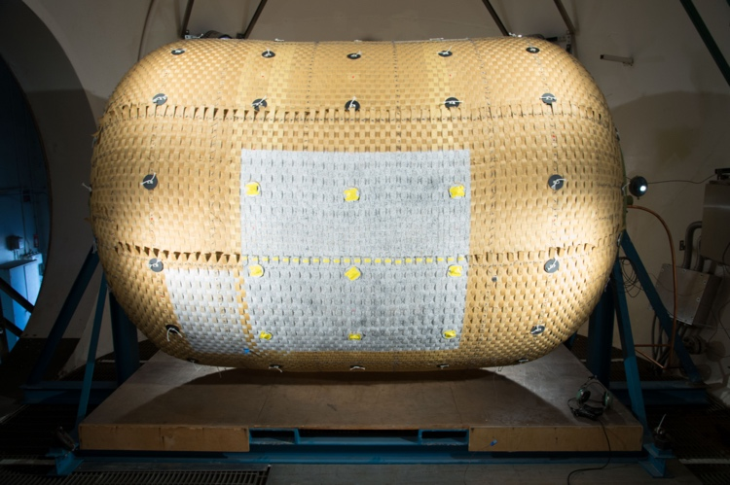
Figure 1: Spray paint was used to mist dots onto a NASA test article.[2]
These issues led to a search for a new method for applying a speckle pattern to softgoods articles. The greater the area that needs to be covered, the more time it takes to apply the pattern, which is why a more time-efficient application is important.

While both hand painting dot-by-dot and temporary tattooing are known application methods for softgoods, each method takes considerable amounts of time and labor and they only cover small areas at a time. These methods only cover small areas at a time, making application to larger test articles highly time and labor intensive. The process of hand painting larger articles can take weeks (See Figure 2). Another method, using temporary tattoos typically come in 8 ½” x 11” sheets when bought off the shelf and must be applied by hand using a time-intensive application method. When using temporary tattoos, there is a membrane that must be carefully broken between each strap, so while it can be less labor intensive than hand painting the article, it still takes several days minimum to achieve coverage of a larger article. Additionally, there are spots on the edges that peel and don’t adhere well when the membrane isn’t cut.
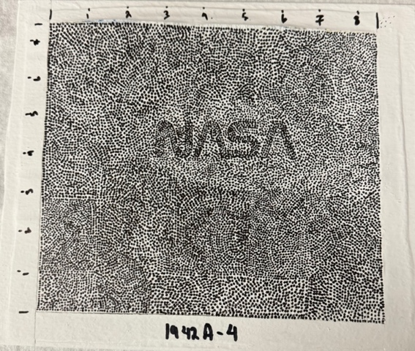
Figure 2: This test article was made by using a fine tipped marker to draw each dot individually, which took 5 hours.
Two application alternatives are being evaluated to enhance efficiency. The first method is uses a 2.5 mm hexagonal plastic additive dot with a matte clear coat applied to a basecoat of white paint. The necessary pattern is created by the plastic additive, while the matte clear coat reduces the additive’s shine and adheres the additive to the article. The second alternative is a paint spray gun that continuously sprays 2 to 4 mm dots onto the article, again on top of a white base coat.

Method
Each method was subjected to two rounds of testing. For the first round, test samples made of Kevlar fabric were cut into 10”x 8 ½” rectangles with the edges taped for safety. Kevlar was used due to its similarity to Vectren which is often used to make the restraint layer of softgoods and it was cheaper and easier to obtain. To make it easier to apply and transfer the pattern, the test samples are taped to a piece of 1/8" 6061 aluminum. Flat white commercial interior laytex paint was used to create a white background for testing different methods of application to the softgoods. The second round of testing was done on woven test samples made with 2” polypropylene straps due to there availability and lower cost. The straps were taped to a metal plate, woven into a 2’x2’ article, painted white, and then used to test each application method (See Figure 3). Each method was tested on the Kevlar to determine its applicability to similar softgoods. Additionally, the technique was tested on woven polypropylene straps to determine how it applies to historical inconsistencies such as in the creases and curves of a woven article.
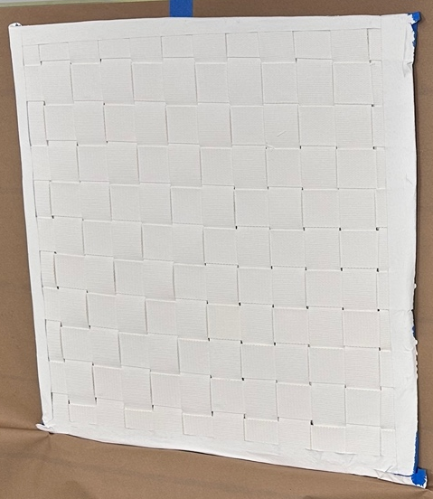
Figure 3: Woven polypropylene straps painted white attached to a metal backing plate.
The initial application method was evaluated to adjust the quantity of additives, clear coat, and application tools to determine a solution that both provides a paintable coating and achieves appropriate coverage with the additive. The tools used for testing were paint brushes, sponges, or rollers.

Applying the coating with a paint brush did not provide enough coverage during the first round of tests. The brush tended move the additive towards the side with each stroke instead of spreading it out evenly as intended. Even though a paint roller didn't pick up much of the additive when dipped, it was found to be effective in removing any excess clear coat from the test sample. The most efficient method of application and coverage during the first round of tests was found to be using a sponge to dab on the coating, then using a dry roller to absorb any excess clear coat while also spreading out and flattening any additive clumps (See Figure 4). The optimal ratio of additive to clear coat was found to be 75g of additive to 100g of clear coat. One hundred grams of additive to 100g clear coat was too thick to paint, and 50g of additive to 100g of clear coat was too runny and tended to drip off the test article when applied vertically. After the first layer with additive had dried, adding a second layer of only clear coat sealed everything in and created a matte finish. Using this method took approximately 1 ½ minutes, while applying dots by hand for a test sample of the same size took approximately 5 hours, showing that this method significantly decreases processing time.
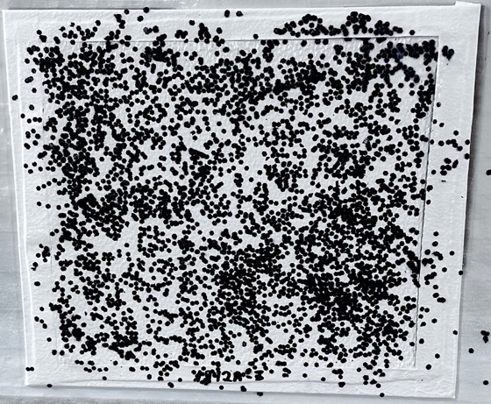
Figure 4: This article was created using the sponging method and 75G additive to 100G clear coat. A roller was used to remove any extra clear coat.
Using a pressured paint gun to spray black dots on the article with black paint (See Figure 5) is the second approach. By atomizing the paint into larger droplets, the paint gun is able to deposit larger droplets of paint than are possible with other techniques, which makes it easier to apply the desired dot size appropriate to the article. The size of the dots can be altered by adjusting pressures and needle sizes, and the distance of the spray gun from the sample. The relevant parameters were modified until a method that approximates the ideal ratio of 50% white, 50% black, and a dot size of around 1-3mm was found. Testing took place on Kevlar fabric sheets, with the best methods applied to woven polypropylene straps to determine suitability of the method for use on woven softgoods.
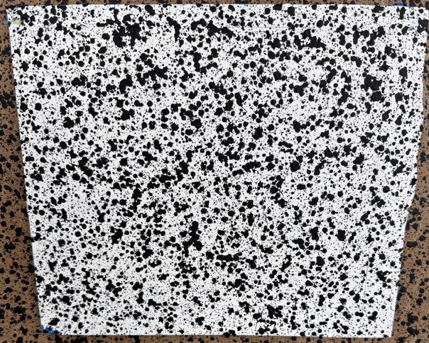
Figure 5: Medium spray pattern made with the paint spray gun.

The camera images were analyzed to determine if they could detect the contrast on the test article and the accuracy of the strain through a tensile test. Before using the paint spray gun on test samples, the spray gun is first tested on paper to ensure the settings are correct. Atomizing air adjustments affected the size of dots and was optimized to give the speckle size desired. Set-up time for this method of dot application, plus application of the dots to the surface took 1 hour of prep time and 30 seconds to apply to the larger woven test samples that are 2x2 feet, a decrease in processing time compared to dot application by hand (5 hours) for the same size application area.

Results
The preliminary tests done on Kevlar showed promise when they were scanned, and interpreted by the VIC-3D photogrammetry software program that detects dots during the testing. After applying dots using the additive method, every dot on the article was detected properly, and the entire area of the article was acceptable for photogrammetry measurements during pressure testing, (See Figure 6).
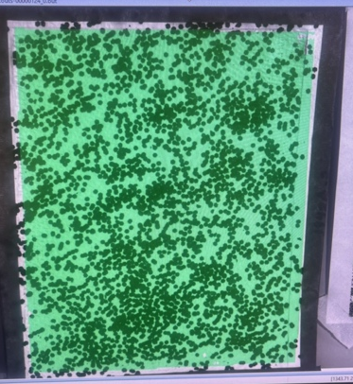
Figure 6: Additive application method as assessed by the Vic-3D photogrammetry cameras.
For the spray gun method, the dot application area was also picked up well by the camera with low noise, namely 0.4 Mils in the left and right directions, which are acceptable noise levels (See Figure 7). Both application methods adhered well to the Kevlar and were able to be easily picked up by the cameras where green is on the pictures the pattern was detected successfully.
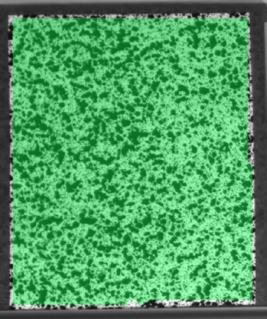
Figure 7: Paint spray gun application method checked with the VIC-3D photogrammetry cameras.
When the additive method of dot application was applied to the woven test samples, it covered the woven pattern with little effort. Even coverage was obtained when the dots were dabbed on with a sponge, followed by rolling of the surface to remove excess clear coat and flatten the additive. A final layer of clear coat was then used to create a more matte effect (See Figure 8).
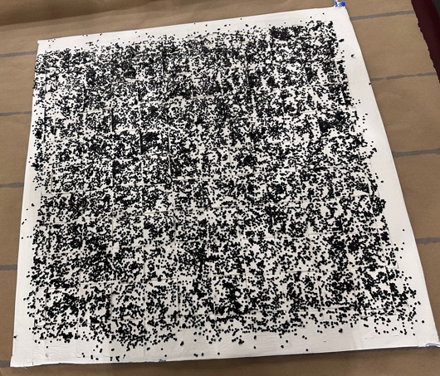
Figure 8: Woven test article with additive method of dot application.
The most effective way to apply the additive in a clear coat was to use the side of the sponge and brush the larger area. This allowed for the speckles/dots to be added quickly and effectively dabbed onto the test article. When spraying the woven test samples with a consistent spray about one foot away from the article while overlapping each pass by roughly half had the most successful results in application time (See Figure 9).
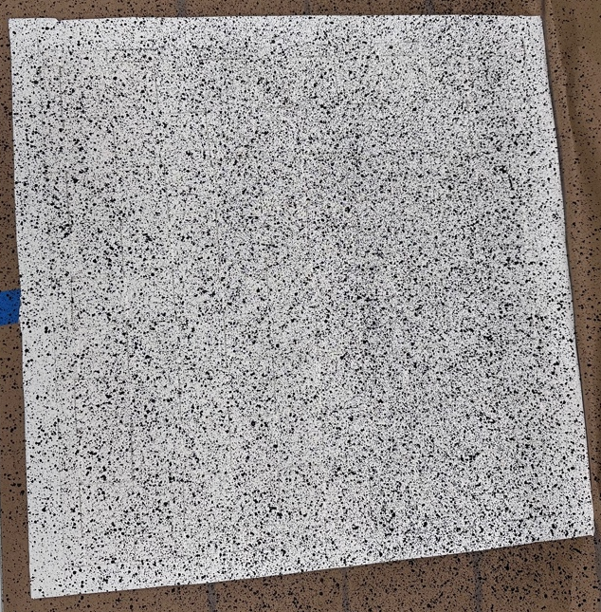
Figure 9: Spray gun speckle pattern on the woven test article.

Although using the paint spray gun to apply a speckle pattern was the fastest method, the additive method was still quicker and more effective than previous methods based on analysis done on the samples and on the images taken by the VIC cameras.

Conclusion

Utilizing a hand-applied clear coat with an additive or a paint spray gun to apply a speckle pattern to woven test articles significantly speeds up the process of speckle pattern application compared to current methods. As test articles increase in size, rapid and efficient methods for applying speckle patterns will be essential for reducing test setup and prep time for photogrammetry. Current methods of speckle pattern application are slow and difficult to apply to the uneven surfaces of woven softgoods, making them impractical and time-intensive for larger scale inflatable softgoods modules. The application of speckle pattern by hand (current state of the art) can take hours, and some hand-application methods, such as temporary tattoos, only stick properly to flat portions of test articles. The additive method of speckle pattern application is effective and rapid compared to hand application methods and is recommended when test articles require speckling in areas where spray gun application is difficult. Spray gun usage is limited by the need to have and maintain a consistant a proper stand-off distance, and have a clear line of sight on complex geometries. Additionally there may be areas where use of a paint spray gun is not allowed due to ventilation or environmental concerns. However the paint spray gun application method is the most effective method for applying a speckle pattern to small, medium, or large areas with clear line-of-sight, has the fastest application time, and can easily be used on flat and woven surfaces. Paint spray gun speckle pattern application can be performed anywhere where the use of a paint spray gun is allowed. As demonstrated in this testing both the additive method and paint spray gun method of speckle pattern application work well on woven test articles and cover a wide range of use cases needed when performing photogrammetry on inflatable habitation test articles.

References
- Adkins, I., “Vic-3D 9 manual and testing guide,” Correlated Solutions, Inc. Available: https://correlated.kayako.com/article/60-vic-3d-9-manual-and-testing-guide.
- Selig, M. M., Valle, G., James, G. H., Oliveras, O., Jones, T. C., and Doggett, W., “Creep burst testing of a woven inflatable module,” 2nd AIAA Spacecraft Structures Conference, Jan. 2015.

AST Structural Materials Engineer, Non-Metallic Materials Team.
AST Aerospace Materials Engineer, Non-Metallic Materials Team.
High Temp Composite Tech, Non-Metallic Materials Team.
SR Ceramics and Ablatives Engineer, Non-Metallic Materials Team.

