Appendix
Appendix A.
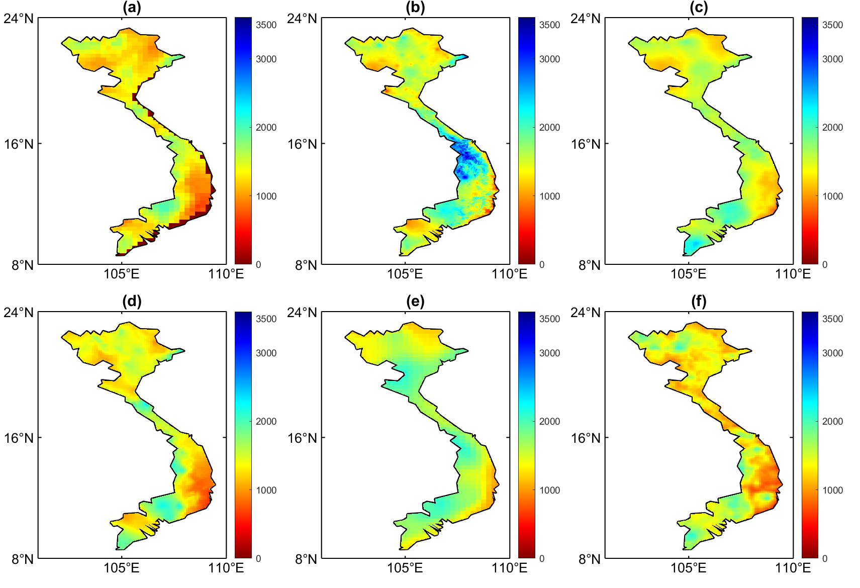
Fig. A1. Plots of precipitation during the wet season for a) APHRODITE; b) CHIRPS; c) IMERGF–V6; d) MSWEP; e) PERSIANN–CDR; and f) SM2RAIN–ASCAT.
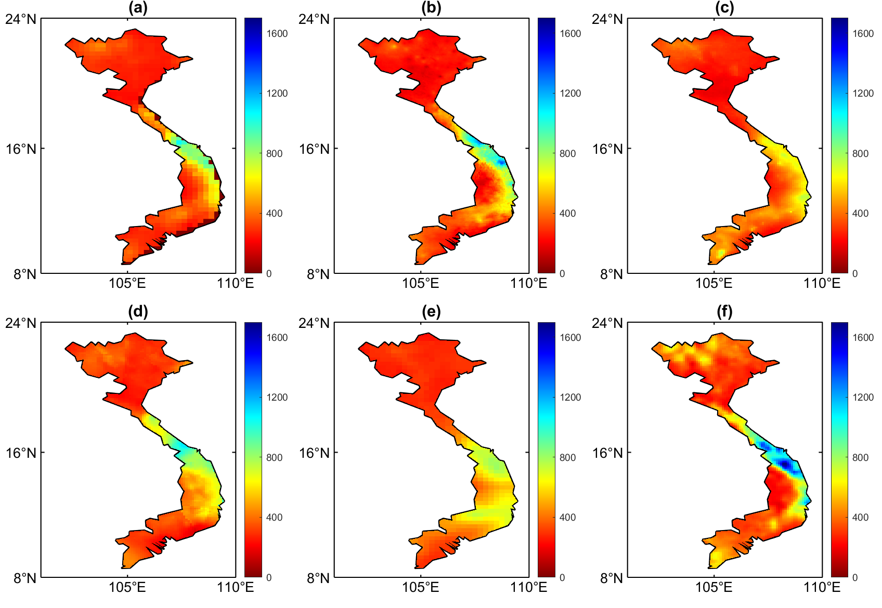
Fig. A2. Plots of precipitation during the dry season for a) APHRODITE; b) CHIRPS; c) IMERGF–V6; d) MSWEP; e) PERSIANN–CDR; and f) SM2RAIN–ASCAT.
Suplementary Data S1
Table S1.
SWAT–CUP parameters for calibration.
ID | Parameter | Method | Description | Range
1 | CN2.mgt | Relative | SCS runoff curve number f | – 0.25 – 0.25
2 | ALPHA_BF.gw | Replace | Baseflow alpha factor for bank storage | 0 – 1
3 | GW_DELAY.gw | Replace | Groundwater delay (days) | 0 – 500
4 | GWQMN.gw | Replace | Threshold depth of water in the shallow aquifer required for return flow to occur (mm) | 0 – 5000
5 | GWHT.gw | Replace | Initial groundwater height (m) | 0 – 1
6 | RCHRG_DP.gw | Replace | Deep aquifer percolation fraction | 0 – 1
7 | GW_REVAP.gw | Replace | Groundwater “revap” coefficient | 0.02 – 0.2
8 | REVAPMN.gw | Replace | Percolation to the deep aquifer to occur (mm. H2O) | 0 – 1000
9 | ESCO.hru | Replace | Soil evaporation compensation factor | 0 – 1
10 | EPCO.hru | Replace | Plant uptake compensation factor | 0 – 1
11 | HRU_SLP.hru | Relative | Average slope steepness | – 0.25 – 0.25
12 | SLSUBBSN.hru | Relative | Average slope length | – 0.25 – 0.25
13 | CANMX.hru | Replace | Maximum canopy storage | 0 – 25
14 | OV_N.hru | Replace | Manning’s “n” value for overland flow | 0.01 – 1
15 | LAT_TTIME.hru | Replace | Lateral flow travel time | 0 – 180
16 | CH_N2.rte | Replace | Manning’s “n” value for the main channel | 0 – 0.3
17 | CH_K2.rte | Replace | Effective hydraulic conductivity in main channel alluvium | 0 – 500
18 | ALPHA_BNK.rte | Replace | Baseflow alpha factor for bank storage | 0 – 1
19 | SOL_AWC(.).sol | Relative | Available water capacity of the soil layer | – 0.25 – 0.25
20 | SOL_K(.).sol | Relative | Saturated hydraulic conductivity | – 0.25 – 0.25
21 | SOL_BD(.).sol | Relative | Moist bulk density | – 0.25 – 0.25
22 | SOL_Z(.).sol | Relative | Depth from soil surface to bottom of layer | – 0.5 – 0.5
23 | SURLAG.bsn | Replace | Surface runoff lag time | 0 – 25

Suplementary Data S2
Table S2.
Characteristics of sub–climatic zones in Vietnam (Nguyen, 2004).
Sub–climatic zone | S1 | S2 | S3 | S4 | S5 | S6 | S7
Wet season | April– September | April–October | May–October | August–December | August–December | May– October | May– October
Highest–rainfall months | June– August | June– August | July– September | August–October | September–November | July–September | August–October

