Cryocooler Technology Opportunities within Space Exploration
B.T. Nugent¹, W.L. Johnson¹, R.J. Grotenrath¹, J.R. Stephens², S.M. Kenny²

¹NASA Glenn Research Center, Cleveland, OH 44135

²NASA Marshall Space Flight Center, Huntsville, AL 35808
Abstract
As the demands for extended space missions and sustained lunar and Martian presence grow, the need for power and mass-efficient cryogenic fluid production and storage becomes paramount. The exploration and advancement of space technologies necessitate the development of innovative cryogenic storage solutions to ensure reliable, long-term production and preservation of cryogens in space environments for propulsion, life-support, and power applications. This paper covers an analysis of the challenges posed by long-duration cryogen storage and production for in-space and surface applications for NASA’s upcoming missions, as well as highlighting cryocooler technology opportunities and gaps to encourage industry stakeholders to contribute innovative solutions to advance the field of cryogenic storage for space applications.

Introduction
Over the past decade, NASA has demonstrated an increased confidence and reliance on cryogenic storage technology in the design of long-duration space missions, as well as Lunar and Martian surface operations [1]. The emerging growth of space applications for cryogenic storage technologies allows for the development of new innovative approaches to system design and the optimization of existing technologies to achieve mission objectives.
Among the subset of optimization capabilities for cryogenic storage, we have completed analyses on three topics: cryocooler compressor heat rejection temperature, shield temperatures for two-stage cooling of tanks, and neon/helium composites as a working fluid in cryocoolers. These trades are intended to provide a zero/first-order level approach to the design of cryogenic systems, with the understanding that they can be expanded and improved upon for specific designs and applications.

Trades
Compressor Heat Rejection Temperature

One of the unique aspects of cryocoolers in space is the ability to change heat rejection temperatures. If dedicated radiators are used, the temperature of those radiators and therefore the compressors on the warm end of the cryocooler cycle can be cooled to temperatures below the normal heat rejection temperature of 300 K. Mass effects were only determined for differences in the power and heat rejection systems, it does not include any reduction in cryocooler recuperator or regenerator mass due to lower temperature difference between compressor and turbine. This is due to the cryocooler mass being much lower than the power and radiator masses, but in situations where minimum temperatures are separated by only a few kilograms, this may suggest that operating at the lower temperature would be desired to minimize the recuperator or regenerator mass.
Table 1. Power Source Options with Specific Power [4][5][6] and Resulting Compressor Temperature
Power Source | Specific Power (kg/Wpower) | Min mass compressor temperature (K)
Fission Surface Power (Lunar / Martian Surface) | 0.178 | ~200 K
NRHO – Photovoltaic + Li-ion battery | 0.052 | ~275 K
LEO – Photovoltaic + Li-ion battery | 0.058 | 250 – 275 K

To investigate this trade, we look at the process of liquefying 0.3 kg/hr of hydrogen as previously explored by Nugent and Johnson [2][3]. Multiple trades of power source efficiency have been done in the past in various space environments [4][5][6]. As shown in Table 1, two different power sources were considered, each of which, according to Mason [7] is preferred for four different locations of interest: Fission Surface Power for the Lunar and Martian Surface and Photovoltaic power supplemented with Li-ion batteries for periods of eclipse for orbital operations in Low Earth Orbit (LEO) and Near Rectilinear Halo Orbit (NRHO, the orbit NASA is using to stage Lunar operations for Artemis [9]). The amount of eclipse time for the two orbits is different, driving different battery sizing requirements resulting in the different mass specific powers. All power systems include a 90% power management and distribution (PMAD) efficiency assumption with a mass of 100 W/kg. For the radiator, Colozza’s estimate of 3.86 kg/m2 was used [8] with an additional 25% margin added to it as required for flight systems per SMC-S-016 [10] with the understanding that the density used grows more uncertain as the temperature of operation decreases.
Results show that the increased specific power of the fission surface power (Figure 1) systems drive the minimum mass heat rejection temperature lower than the NRHO photovoltaic (Figure 2) which is slightly warmer than the LEO photovoltaic (Figure 2). Results show that the general shape and minimum temperature is independent of intermediate cryocooler temperature operation point. Figure 4 shows that the general shape of the temperature dependent curves is not very sensitive to cryocooler efficiency, but as would be expected, a decrease in cryocooler efficiency requires more power and heat rejection, increasing the system mass.
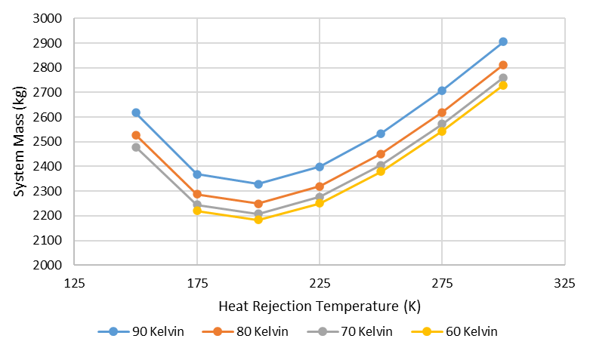
Figure 1. Comparison system mass of intermediate temperature cooling at a range of heat rejection temperatures for Lunar and Martian surface based fission surface power systems.

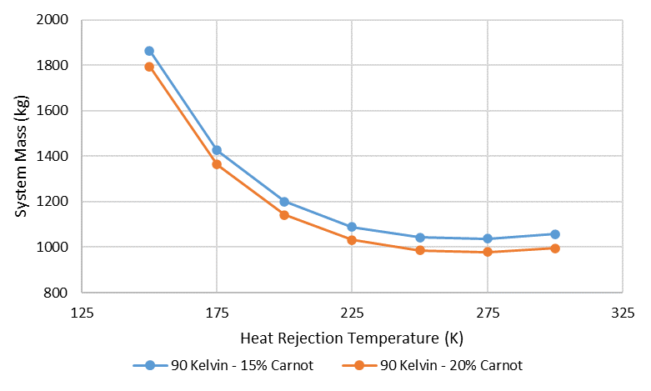
Figure 3. Comparison of 15% and 20% Carnot efficient refrigeration systems

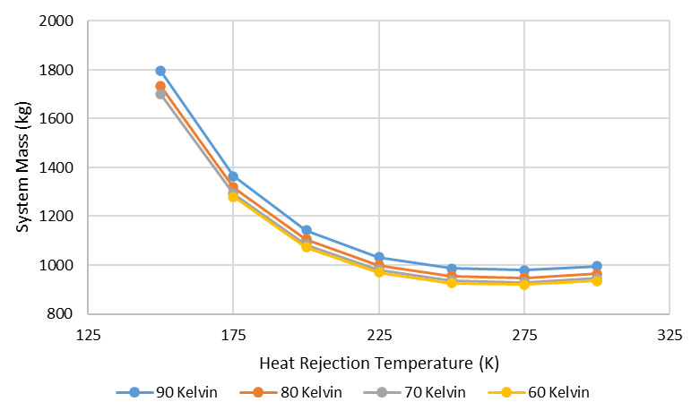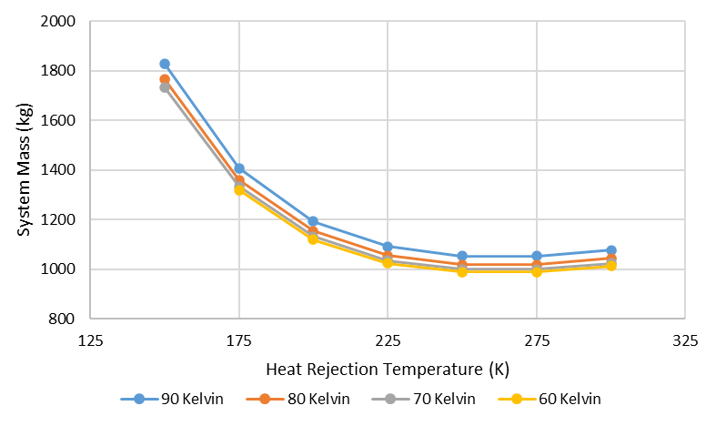
Figure 2. Comparison system mass of intermediate temperature cooling at a range of heat rejection temperatures for NRHO (left) and LEO (right) based photovoltaic plus Li-ion battery power systems.
Intermediate heat Rejection Temperature for Multiple Stage Cooling of LH₂ Applications

Reduced Boil-Off testing by Plachta and Johnson [11][12][13] demonstrated the effectiveness of utilizing a two-stage cooling system versus a single stage cooling system in reducing the overall system mass for a liquid hydrogen system. Using insights from this data along with MLI and structural performance expectations, Equations 1 and 2 were generated to estimate the tank (${\dot{Q}}_{Cold})$ and shield (${\dot{Q}}_{Shield}$) heat loads at variable shield temperatures. While these are an oversimplification of the thermal balance of the system, which needs to be fully analyzed out for a given application [14], this does give initial assumptions to work with for system sizing.

 | $${\dot{Q}}_{Cold}= 0.5*{\dot{Q}}_{passive}\frac{T_{Shield}-20}{70}$$ | (1)
 | $${\dot{Q}}_{Shield}= 2*{\dot{Q}}_{passive}\left(1+0.1\left[\frac{90-T_{Shield}}{70}\right]\right)$$ | (2)

A trade study was completed to determine what the optimal shield temperature would be as a function of boundary temperature and cycle efficiency for the intermediate cryocooler in order to minimize power consumption. Data from Nugent [15] was used to generate a power curve as a function of required heat removal for the 20 K lift. Carnot efficiency (η) and coefficient of performance were used to calculate the cryocooler power requirements to remove the shield heat load at variable shield temperature. Figure 4 shows an output from the trade, demonstrating a peak
power savings capability of 17.2% for a system with a 10 Watt passive heat load at a shield temperature of 70.5 K, 200 K boundary temperature, and 18% Carnot efficiency for the shield cryocooler. As the Carnot efficiency decreases, the temperature of the peak power savings increases.

Figure 4. Comparison of power savings at different shield temperatures and Carnot efficiencies for a passive 10 Watt at 20 K heat load.

Given the assumptions above, Equation 3 provides the optimal shield temperature for maximum power savings in this two-stage liquid hydrogen cooling system.

$$T_{Shield}=\sqrt{\frac{12640*T_{boundary}}{2733*η+16}}$$ | (3)

Mixed Gas Refrigerant Composition (Neon/Helium)

Previous calculations by Quack [16] and Dhillon [17] investigated the applicability of mixtures of helium and neon as refrigerants for Reverse Turbo-Brayton (RTB) cycle refrigeration. Between the two calculations, temperature ranges from 40 K-70 K for terrestrial refrigeration were evaluated. To further probe the potential application of mixtures of helium and neon as a RTB cycle refrigerant, a simplified RTB cryocooler model was constructed in Excel to explore how refrigerant mixtures could impact the design of future RTB cryocoolers for space applications. A cold temperature range from 50 K to 150 K was selected to encompass boiling points of liquid oxygen (97.61 K) and liquid methane (121.10 K) stored at 206.8 kPa (30 psia). It should be noted that a similar trade can and should be performed from 15 K to 40 K to cover the boiling point of liquid hydrogen (23.05 K) at 206.8 kPa (30 psia). The range of mixtures for a hydrogen trade would be limited as neon’s boiling point (29.69 K) at 206.8 kPa (30 psia) is above that of liquid hydrogen.
The following trade was performed by modelling a simplified RTB cycle cryocooler and assuming fixed system inputs for each case as depicted in Figure 5. The model consists of a high and low pressure region between the isentropic compressor and turbo-alternator that neglects pressure losses between cycle components. The heat load imposed on this model is bound to the propellant tank. A heat load of 60 W was assumed to be removed from the propellant tank via broad-area-cooling (BAC). Heat rejection to a vacuum environment at 300 K was also assumed through the use of a radiator following the compressor. A real RTB cryocooler would remove heat directly from the compressor(s) housing. The hot and cold sides of the model are separated at the

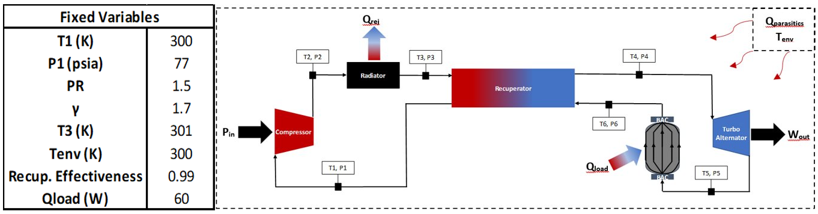
Figure 5. Simplified RTB cryocooler model fixed assumptions and flow diagram.

recuperator which is assumed to have a heat exchanger effectiveness of 99%. The net input power of the model is detailed in Equation 4.

$$P_{net}=P_{in}-W_{out}$$ | (4)

Figures 6, 7, and 8 contain the RTB cryocooler model results using pure helium, pure neon, and three mixtures of the helium and neon gases as refrigerants. The model indicates in Figure 7 that at lower RTB cycle cold temperatures (T6), the greater the reduction of net input power when trading mixtures from pure helium to pure neon. This trend is similar across a fixed RTB cycle cold temperature when increasing the concentration of neon in the refrigerant. This doesn’t mean that pure neon is the superior choice of refrigerant as Figure 7 shows how the thermal size (UA) of the recuperator changes with respect to the RTB cycle cold temperature as its other assumed boundary conditions were held constant for both pure helium and pure neon. Assuming a heat exchanger area (m²) to trade the recuperator’s overall heat transfer coefficient (W/m²/K) between pure helium and pure neon as refrigerants in this model, pure helium would have roughly five times the heat transfer rate when compared to pure neon due to helium’s large specific heat capacity. Figure 8 captures the model’s predicted cycle efficiency for each pure or mixture refrigerant as a function of the RTB cycle cold temperature. The maximum cycle efficiency at 110K is applicable to the assumed 60 W of lift required. The more significant trend from this sensitivity is that higher concentrations of neon in the refrigerant lead to higher cycle efficiencies. This is tied to the compressor design as neon is more compressible than helium. Additional trades of refrigeration system and subsystem components response to mixtures require investigation to further improve cycle efficiency and reduce system mass of future space cryocoolers.
Figure 6. Cryocooler performance at different BAC exit temperatures with respect to helium and neon mixtures

Figure 8. Cycle efficiency with respect to helium and neon mixtures
Figure 7. Recuperator thermal size (UA) as a function of BAC exit temperature for pure helium and pure neon

Gaps and opportunities:
While the trades above highlight a few opportunities to optimize cryogenic fluid management systems, these are just a subset of the challenges posed by long-duration cryogenic storage and production for space and surface applications. Highlighted below are other cryocooler technology opportunities and gaps to encourage industry stakeholders to contribute innovative solutions. Table 2 also lists these gaps with priority rankings.

Table 2. Gaps and opportunities identified for space cryocooler technology advancement

Gaps | Priority
Cold Compressor Design | 3
Reliability/Life Testing | 1
Modular Cryocooler Design | 3
Hydrogen Liquefaction Cryocooler | 4
Broad Area Cooling Loop Design | 4
Turndown Efficiency | 4
Non-RTB Cryocoolers for Space | 3
Fault Tolerance | 3
Failure Mitigation | 4

Cold compressor development

As demonstrated in the trade above, being able to operate a compressor at cold temperatures (175K – 225 K) allows for a substantial increase in overall system efficiency and decrease in system mass. The development of a cold compressor is a critical gap that would allow for immediate integration into existing cryocooler systems.

Reliability and Life Testing
Cryocooler development efforts currently underway for NASA include the design, build, and testing of “flight like” Engineering Model units. With the goal of advancing the Technology Readiness Level to 6, the unit is tested in a relevant environment, exposed to an operational environment, then retested to verify that the operational environment did not adversely affect the cryocooler performance. Upon successful testing, the unit is then delivered to NASA as a “flight like” prototype. One significant gap to be addressed is the demonstration of reliability through endurance and life testing. The path to technology advancement as previously described proves the technology, correct assembly, and provides performance data before and after exposure to the operational environment. However, any unknown issues are likely to surface through a long duration test campaign where demonstrations include both nominal and off-nominal operations, start and stop transients, restarts, losses of electrical power, and any other off-nominal conditions that the cryocooler may be exposed to during a mission. The Technology Readiness Level can be advanced further via a flight demonstration, but a vigorous Flight Qualification test program must be completed prior to implementation on a manned space vehicle.

Modular Cryocooler Design and Integration

A necessity for future cryocooler space applications is the ability to incorporate modularity into the system design. From changing operation requirements, mass distribution limitations, and the desire for increased fault tolerance, there are many factors that could drive a cryocooler system to require flexibility in how components are integrated and the ability to add or remove components.
A critical factor with modular cryocooler designs is the ability to predict system efficiencies, as well as parasitic and integration heat losses. The optimization of a modular design to maximize system efficiency while being able to accurately quantify losses on a modular level would enable greater flexibility in future space cryogenic mission designs.

Hydrogen Liquefaction Cryocooler Development

Current state-of-the-art liquid hydrogen class space cryocoolers are sized for Lunar and Martian transport vehicles to enable zero boil-off conditions [2][11]. In order to build a sustainable architecture on planetary surfaces however, in-situ resource utilization (ISRU) will require significantly higher heat removal capacity for liquefaction of hydrogen. Analysis performed on a 0.3 kg/hr hydrogen flow rate (equating to 10,000 kg per year of total LOx/LH₂ propellant) by Nugent and Johnson [2][3] demonstrated resulting lift requirements between 70-100W at 20 K (Figure 9).

To coincide with the need for a higher capacity liquid hydrogen class cryocooler, Equation 3 can be used with a 250 K boundary temperature [2] and 0.18 Carnot efficiency to determine an intermediate shield temperature of 79 K. This also demonstrated the need for a liquid oxygen class cryocooler, with a high-efficiency turndown capability, capable of removing approximately 250 W of heat at 80 K.
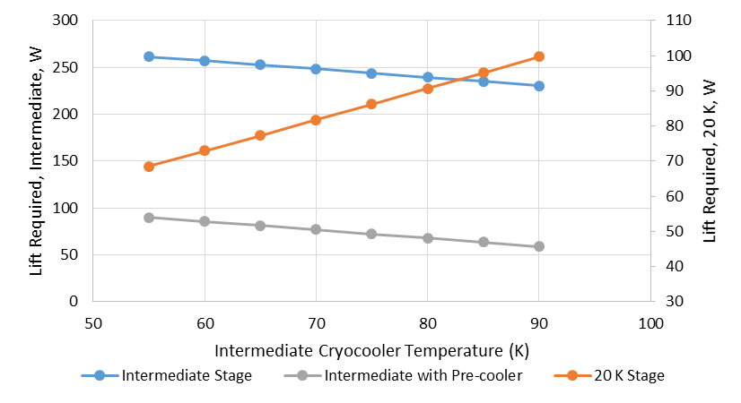
Figure 9. Cryocooler heat removal requirements for hydrogen liquefaction at a rate of 0.3 kg/hr assuming a 300 K entry temperature.

Broad Area Cooling Tank Design
Testing by Johnson for the CryoFILL project successfully demonstrated broad area cooling (BAC) oxygen liquefaction production with the integration of a cryocooler circulation loop and tube-on-tank design [18]. RTB cryocooler efficiencies are limited by the pressure-drop through the BAC loop. An optimization of an advanced upper stage sized tube-on-tank design that maximizes the lift capacity of the system while staying within the pressure drop limitations of the cryocooler would allow for an increased liquefaction production on the Lunar and Martian surfaces.

Improved Turndown Efficiency
Turndown efficiency (the ability to operate a cryocooler below the design point) is a key optimization parameter to enable the reuse of a flight qualified cryocooler design into different mission applications. The current state-of-the-art for a liquid hydrogen class cryocooler has a specific power of 91.6 W_{power}/W_{thermal} while operating at 20 Watts of heat removal and has a specific power of 281.2 W_{power}/W_{thermal} while operating at 3 Watts of heat removal [13] By increasing the efficiency with which the system can operate outside of the design conditions, a system may be used for several missions with varying thermal requirements.

Non-RTB Cryocooler for High Capacity Space Application
Reverse turbo-Brayton cycle cryocoolers are baselined for most NASA cryogenic fluid management missions due to their low vibration generation and ability to distribute cooling through a circulation loop. The trade space on cryocooler cycle design is not closed, however. Several other thermodynamic cycles, such as Stirling or pulse tubes, offer unique benefits and capabilities that could be utilized for mission design. The design of a non-RTB, high-capacity cryocooler with cooling distribution capability for space applications would resolve a major gap in NASA’s cryogenic technology portfolio.

Fault Tolerance
Future long-term storage applications using cryocoolers will be required to be tolerant of cryocooler failure, meaning at least one redundant cryocooler is needed in the event that the primary cryocooler fails. Two or more cryocoolers may share the same fluid networks and heat rejection system, but it must be integrated such that the presence of one cryocooler does not adversely affect the performance of the other, and that the redundant cryocooler can seamlessly “take over” in the event that the primary cryocooler fails. The design, integration, and demonstration of multiple units configured for fault tolerance is an existing gap that must be addressed prior to the utilization of cryocoolers on manned space vehicles.

Failure Mitigation
In the event of a cryocooler failure, a mitigation approach must be taken to enable continuous active cooling. Mitigation approach could involve isolating the failed cryocooler from the fluid network and heat rejection system, then starting the redundant cryocooler. Another approach could be having two cryocoolers running together at a reduced capacity and in the event of a failure, the failed unit is isolated while the other is increased to full capacity. There are risks associated with each approach and those risk, along with mass and power, must be traded to determine which is the more feasible approach. As previously stated, the design, integration, and demonstration of multiple units configured for fault tolerance and the approach to failure mitigation is an existing gap that must be addressed prior to the utilization of cryocoolers on manned space vehicles.

References
- https://www.nasa.gov/wp-content/uploads/2024/01/cryogenicfluidmanagement-factsheet.pdf
- Nugent, B.N, Johnson, W.L., Guzik, M.G., Stephens, J. “Space Exploration Applications for Development of High Capacity Cryocoolers”, International Cryocooler Conference 21 (2020).
- Johnson, W.L., “Concepts for the Liquefaction of Hydrogen for In-Situ Operations on the Lunar or Martian Surface” presented at ASCEND 2023, AIAA 2023-4624, 2023.​
- Mason, L.S., “A Comparison of Fission Power System Options for Lunar and Mars Surface Applications”, NASA TM-2006-214120, 2006.​
- Mason, L.S. and Poston, D.I., “A Summary of NASA Architecture Studies Utilizing Fission Surface Power Technology”, NASA TM-2011-216819, 2011.​
- Mason, L.S., Gibson, M., and Poston, D., “Kilowatt-Class Fission Power Systems for Science and Human Precursor Missions”, NASA TM-2013-216541, 2013.​
- Personal communications with Lee Mason, EZ-Power.xlsx spreadsheet​
- Colozza, A.J., “Small Lunar Base Camp and In-Situ Resource Utilization Oxygen Production Facility Power System Comparison.”, NASA TM-20200001622, 2020.​
- https://www.nasa.gov/wp-content/uploads/2023/10/nrho-artemis-orbit.pdf
- Space and Missile Systems Center Standard, “Test Requirements for Launch, Upper-Stage, and Space Vehicles, SMC-S-016, 5 September 2014.
- Plachta, D.W., Feller, J.R., and Guzik, M.C. “In-Space Cryogenic Propellant Storage Applications for a 20 W at 20 K Cryocooler, Cryocoolers 19, ed. Miller, S.D. and Ross Jr, R.G., Boulder, CO, 2016.
- Plachta, D.W., Feller, J., Johnson, W.L., and Robinson, C., Liquid Nitrogen Zero Boiloff Testing, NASA TP-2017-219389, 2017.
- Plachta, D.W., Christie, R.J., et.al. “Cryogenic Boil-off Reduction System Testing”, presented at the 2014 AIAA Propulsion and Energy Forum, Cleveland, OH, AIAA paper 2014-3579, 2014.
- Johnson, W. Tests at NASA Glenn Illustrate Thermodynamic Effects of Heat Intercept and Heat Reduction in Real Systems, Cold Facts, Vol 37, No 2, 2021, pp.20-21.
- Nugent, B.T., Grotenrath, R.J., Johnson, W.L. “20 Watt 20 Kelvin Reverse Turbo-Brayton Cycle Cryocooler Testing and Applications”, Cryocoolers 22, R.G. Ross et. al. editors, pp 327, 2022
- Quack, C. Haberstroh, I. Seemann, M. Klaus; “Nelium, a Refrigerant with High Potential for the Temperature Range between 27 and 70 K”, Phys Procedia, 67 (2015), pp. 176-182
- A.K. Dhillon, P. Ghosh; “Study of reverse Brayton cryocooler with Helium-Neon mixture for HTS cable”, Materials Science and Engineering, Vol. 278 (2017)
- Johnson, W.L., Grotenrath, R.J., Balasubramaniam, R., Chan, H.M., Smith, J.W., Giddens, P.A. “Cryogenic Fluid In-Situ Liquefaction for Landers: Prototype Demonstration”, presented at ASCEND 2023, AIAA 2023-4748, 2023

