Intelligent Change Detection System: Autonomous Intelligent Machine Agent Model Development

Vincent E. Houston
NASA Langley Research Center, Hampton, VA, 23681

David J. Degaraff ²
Virginia Polytechnic Institute & University, Blacksburg, VA 24061

NASA’s significant role in facilitating the harmonious integration of unmanned aircraft systems (UAS), with other aerial vehicles operating in the National Airspace System (NAS), has revealed a need for more advanced technological tools than are being utilized currently. This technology would lend itself to significantly assisting Direct-Action Aviation Personnel (DAAP) with the ingress and egress of UAS operations within the NAS. Providing research findings that would reduce technical barriers associated with UAS-NAS integration has been a persistent effort by both NASA and the FAA. One such research effort, pursued by NASA’s Transformative Tools and Technologies – Revolutionary Aviation Mobility (T³-RAM) project, is the development of an autonomous intelligent machine (AIM) agent that would aid DAAP functioning as implemented in remote ground control stations (RGCS).
This evolution of the “human-machine” symbiosis within the aviation environment is necessary for many reasons. For example, there are projections of large increases to the 864,000 registered UAS and 45,000 aviation operations taking place in the NAS each day. With a data output range of 1 to 20 terabytes per flight for each aerial vehicle the expectation is that the amount of data present in the NAS will become more than challenging. It is evident that due to the projected increase of UASs and their generated data, the human-agent’s data managing capabilities will be quickly overwhelmed by the enormous amounts of data emanating in the NAS. The research efforts presented in this paper put forward results from the development, assessment, and verification of a previously conceptualized AIM-agent. That intelligent machine agent combats actionable-data (information) errors resulting from the visual perception phenomenon known as “change blindness” (CB). CB has been identified as a culprit of information erroring encountered within the ground control station operator (GCSO) community.
- Introduction
T

he proliferation of data worldwide is increasing at an average rate of 20% per year. Data production is expected to generate ≈177 zettabytes of data during 2025, an 80% increase from 2022’s data production of 97 zettabytes [1-5], according to the International Data Corporation (IDC). Not all the data generated during this continuous influx will be available or used in the aviation community. However, the National Airspace System (NAS) has already begun to experience a paralleled increase in the production of aviation data, and this increase is expected to continue into the foreseeable future. Data proliferation is quickly becoming problematic for Direct-Action Aviation Personnel (DAAP) or human-agents, in general, as they manage aviation operations from the more traditional Air Traffic Control (ATC) environment to the remote ground control station (RGCS) environment.
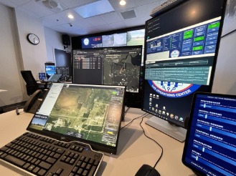
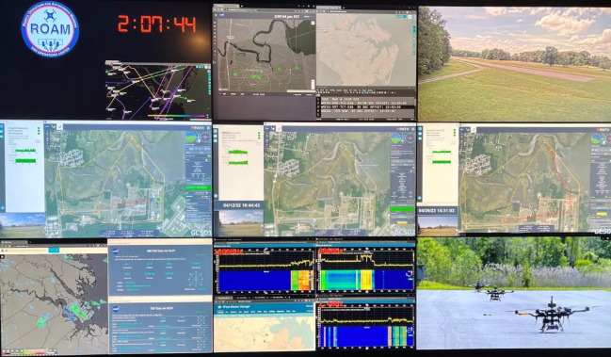
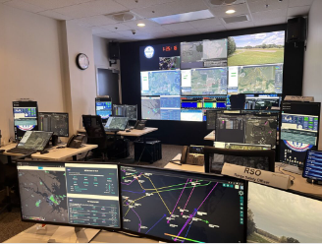
In particular, Urban Air Mobility (UAM), a subset activity of Advanced Air Mobility (AAM), is taking place within an urban environment that is governed by DAAP functioning in a RGCS. The observational infrastructure of an RGCS is inherently compromising to the visual performance of DAAP operating within it. An example of a RGCS is shown in Fig. 1, which presents typical displays within the Remote Operations for Autonomous Missions (ROAM) unmanned aircraft systems (UAS) Operations Center at NASA’s Langley Research Center [6]. The combination of data proliferation and visual compromise creates a phenomenon of visual perception know as change blindness (CB), which result in potentially catastrophic safety issues.
Fig. 1 ROAM (Remote Operations for Autonomous Missions) UAS Operations Center
CB occurs when an observer fails to detect an event change has occurred in the environment around them [7]. CB manifests when an observer fails to notice a visual change because they are distracted by something incidental such as an eye blink [8], a screen flicker [9], head or eye movement [10, 11]. An example of CB is illustrated in what is referred to as the “the door study.” Within this study design, a person (i.e., experimenter-1) asks for directions from a stranger (i.e., the participant-subject). During the conversation between the experimenter and the participant-subject, two other persons carrying a door comes between them and, as the door passes, experimenter-1 is replaced by a different experimenter (i.e., experimenter-2) of which the experimenter switch goes unnoticed by the participant-subject who was asked to provide the directions [12].
The pervasiveness of CB in RGCSs is problematic to GCSOs properly performing their tasks. The presence of CB is strong indicator of a human-agent’s inability to manage data due to an RGCS environment, data proliferation, visual compromise, and/or human fatigue. As part of the ever-expanding GCSO community, the RGCS is the primary component to data collection and distribution and operator action. It essentially serves as the hub for aircraft telemetry and operational mission data, as well as any intelligence, surveillance, and reconnaissance (ISR) generated by a UAS payload.
Researchers at the NASA Langley Research Center have developed the ROAM UAS Operations Center which offers the command and control of UAS operations and facilitates the evaluation of GCSOs in a RGCS environment. Within ROAM, it was noted that NASA GCSOs were falling victim to CB. Given that ROAM was designed to be a microcosm of the larger NAS RGCS ecosystem, the empirical results make known the exigent concerns that increased uncrewed aircraft operations (e.g., Advanced Air Mobility/Urban Air Mobility) may concomitantly increase the prevalence of CB amongst GCSOs, requiring research and technology development to mitigate. To therefore address the problem, NASA research efforts have focused on understanding the concept of CB and formulate ways to significantly reduce, if not completely remove its risk. This would then enable better teaming between humans and AIM-Agents. This symbiotic relationship would equip GCSOs with tools to help the human-agent manage data generated from UAS operations safely, efficiently, and effectively. The remaining sections of this paper will detail the ICDS design and its components which include RISDDA followed by the system’s Dataset Design, its ML model development, test, and verification process and results.

- Intelligent Change Detection System Design
The Intelligent Change Detection System (ICDS) is an autonomous data-partitioning system comprised of a real-time intelligent streaming distributed data architecture (RISDDA) and an AIM-Agent. The two applications are designed to collaborate in provisioning a CB-affected DAAP with both the relevant and pertinent UAS state data that has been missed during the loss of visual focus.
The purpose of this paper is to detail the ICDS operational viability once the integration of the two technologies, RISDDA and the AIM-agent has taken place, as specified in the system’s proof-of-concept [13]. The objective in this development and test process was to establish the data pipeline through the configuration of RISDDA and to offer the best performing AIM-agent through model selection, which was based on accuracy comparison of multiple machine learning models. The work completed in the development, test, and verification of ICDS marks the completion of Phase II prototyping and signifies the start of human-agent system verification via the complete system’s integration into the Visual Imaging Simulation for Transport Aircraft Systems (VISTAS) lab and ROAM.
- ICDS Architecture Overview
The operation of UAS in the NAS is becoming much more prevalent. This means that remote GCSO functional capabilities would be compromised, resulting in poor data management and operational continuity. This type of functional degradation is unacceptable if the NAS processes of entry and egress are to continue, or improve, in their standard of safety, efficiency, and effectiveness. However, the implementation of advanced digital data to improve traffic management and other aviation capabilities within the NAS has created a network centered system or Net-Centric-Architecture (NCA) as a byproduct. NCA aviation at its core has the advantage of manufacturing enormous amounts of all-encompassing data necessary for operations in the NAS. This proliferation of data within the NAS also poses a threat to the GCSO’s performance during remote UAS operations. To combat any impairment of GCSO operational abilities due to data proliferation, new technological techniques are being introduced to provide the human agents with the ability to manage data in a NCA environment. See Fig.2 for a depiction of the ICS, which depicts the system’s data source ingestion capabilities, the intelligent data management structure, data repositories, and the AIM-agent used to determine the relevance of lost data. The ICDS will assist in making GCSOs impervious to the pitfalls of Big Data’s Three-Vs (volume, velocity, variety) while offering an improved means of mitigation and contingency management.

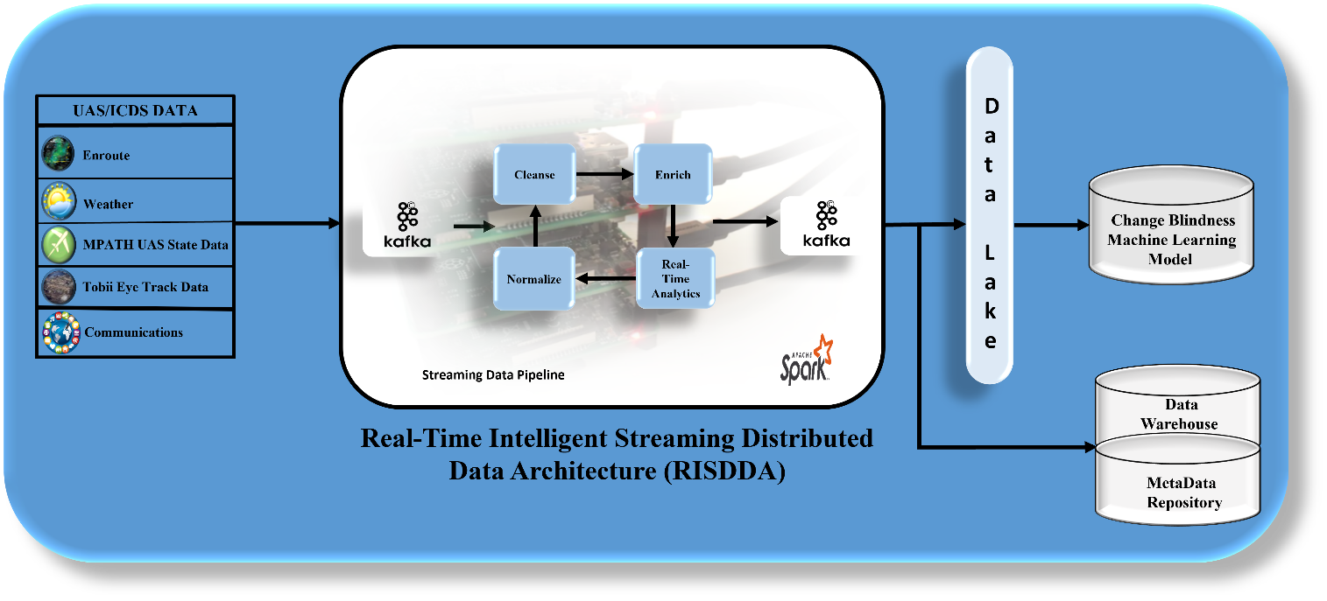
Fig. 2 Intelligent Changes Detection System Overview
Aviation operations in a Net-Centric Architecture and a complex visual observation environment provides more opportunities for CB to affect GCSOs. Implementing machine learning (ML) techniques toward the development of AIM-agents that would notify human-agents in real-time when they succumb to CB is the premise of ICDS. Also, the technology presents to the human-agent in real-time any relevant information lost during the occurrence of CB. This assures that critical efforts and decisions made by GCSOs are not undermined by physical, physiological, and psychological imperfections, and that safety, effectiveness, and efficiency; at minimum, are maintained. The development and test of the ICDS has provided a first step in understanding how a trusted, and symbiotic relationship between human and AIM-agents might be established within the remote UAS community.
The system design of ICDS was developed in a way that mimics the human process of ingesting data and determining its relevancy. Relevant data then takes on an actionable status when it is put forth to the GCSO so that decisions can be made to recover from the loss of critical meta data because of CB.
Within the ingested data stream, ICDS is focused on potential information from two different data sources MAVProxy and a Tobii Eye Tracker. MAVProxy, a fully functioning UAS Ground Control Station (GCS), is designed to be a minimal, portable, and extendable tool for autonomous systems that support the MAVLink protocol. MAVLink is a protocol used for communicating with small UAS. The protocoled data generated by MAVProxy streams a complete complement of UAS state data to the ICDS (see Table 1 for an abbreviated list of MAVProxy state parameters). All data streamed from MAVProxy are not submitted for feature extraction because all parameters generating from it were deemed relevant [14].
Designed for fixation-based research and development, the Tobii Eye Tracker was used to capture useful data points including presence, attention, and gaze points, as well as other specifications, such as GCSO ocular characteristics. The time frame capture rate was set to occur every 16.67 ms. Since explicit software instructions were not part of the implementation of the Tobii Eye Tracker, this ICDS data source was defined as the system’s “autonomous trigger,” which discerns the conditions present that would indicate the occurrence of CB. Extracted features from the autonomous trigger allow for the timestamp synchronization of streamed data transmitted and received to and from a UAS and a GCSO.

Table 1: Abbreviated MAVProxy Parameter List
Parameter | Typical Value | Units
Ground Speed | 20 | Knots
Vertical Speed | -2 | Feet/Second
Position Change | +1024 | Feet
Distanced Traveled | +1400 | Feet
Flight Time | +15 | Seconds
Altitude | +3200 | Feet
Battery Time Remaining | +7.5 | Hours
Battery Percentage | 71 | Percent
- Real-Time Intelligent Streaming Distributed Data Architecture
ICDS’ proof-of-concept development placed significant emphasis on data wrangling, i.e., data source connection to the system, data ingest, operational access to the ingested data, and data dissemination to the proper intelligent application. The determination to provide equal priority to the area of data engineering assures that future research, which includes human-in-the-loop (HITL) testing, will not have concerns with the data’s quality or the system’s ability to govern vast amounts of data when needed. This approach offered a significantly more robust infrastructure to ICDS’ architecture.
During the development of the ICDS ML model, consideration was given to the characteristics that cause a ML model to make highly accurate predictions when a model’s data features are mixed in with other irrelevant data. In this case, intelligently addressing data acquisition, dissemination, and storage was viewed as an approach that would have the greatest impact on ICDS’ ML model’s ability to provide inferences with consistently high accuracy.
That being stated, the construction of an ICDS data pipeline with intelligent capabilities was required. This needed the pipeline to be more complex than one instantiated with the often-used data warehouse design. A data pipeline featuring a data warehouse element is frequently chosen due to its regimented data architecture, and carefully structed data typing and schemas. However, when considering the speed at which CB can affect a GCSO environment, and subsequently a UAS operational environment, priority was given to data engineering a pipeline architecture that would be inherently scalable, flexible, fault tolerant, human-fault-tolerant, and has a low-cost data storage framework for distributed data systems. Therefore, a Lambda Data Architecture, framed on Apache Kafka and Spark platforms, was selected as the system architecture for RISDDA. In accordance with that structure, RISDDA has a tri-layered system architecture which consists of Batch, Speed, and Servicing layers. See Fig. 3 for the Lambda data architecture.

Data Source
Data Source
Data Source

Real-Time-View
Recent
Data
Speed Layer
Real-Time-View
Batch Layer
All
Data
Serving Layer
Batch View
Batch View
Data
Lake
Query
Fig. 3 RISDDA Lambda Data Architecture
The overall operational functionality for each layer is as follows:
- Batch Layer – Saves all ingested data as batch views for indexing preparation.
- Servicing Layer – In preparation for data consumption by end users this layer performs incremental indexing
of the last batch views.
- Speed Layer – Indexes the most recently added data that is not fully indexed by the servicing layer.
The benefit to this type of pipeline is based on its ability to handle massive data quantities, of all data types, through the application of both batch and stream-processing. Applying a Lambda Data Architecture to the ICDS development provides it with the balance of latency, throughput, and fault-tolerance by offering extensive and precise batch views along with simultaneous real-time stream views of non-historical data. This pipeline architecture equips the ICDS with an extremely scalable, highly available, and fault-tolerant system architecture, giving it the ability to contiguously perform mathematical or statistical analysis within the stream itself [15]. Implementing RISDDA with this type of architectural design assures that the ICDS will have the following capabilities:

- Operational decision making is available
- The ICDS ML model can be applied to both prescriptive and pre-existing models
- Historical and current data are available
- System triggers can be established from any number of previous or current relevant parameters
- Real-time monitoring of constantly changing DataFrames is provided.
In the ICDS ML model development phase, RISDDA ingested and disseminated approximately 88,000 data points per minute. It will be noted that although equal emphasis was given to the development of RISDDA during this research effort, its complete structure and performance is not detailed in this paper. The remainder of the paper presents the results of the development, test, and verification of the ML algorithms that were evaluated in the best performance process.
- ICDS Dataset Design
To select the best performing ML model from a list of eleven candidates, strategic consideration was given to how UAS data would be generated and sourced to RISDDA for its proper dissemination to the requisite ML algorithms hooked to ICDS. Acquiring large amounts of small-UAS (sUAS) data proved challenging since physical access to a sUAS was not available during the time frame of this technological development period. However, NASA Langley’s ROAM UAS Operations Center provided sUAS state data from recently conducted flight operations. Though this data would prove very useful later, the amount of data provided from these flights did not meet the magnitude threshold deemed necessary to train and test the prospective ML algorithms or use this process to select the best performing ML model.
Therefore, the determination was made to utilize the collected data provided by ROAM to generate groups of data streams, which would lead to the creation of a sUAS data simulator. MATLAB was the platform of choice for creating this application. The simulated data consisted of twenty-two columns, representing the full complement of MAVProxy vehicle parameters. Recording ten thousand rows of input data for the twenty-two UAS parameters, every 15 seconds, produced eighty-eight thousand data points per minute, which meant that the ML magnitude training and testing guideline set forth by NASA researchers was achieved.
Data generation required random value starts for each parameter. Each generated value was held within the parameter’s respective minimum-maximum range. However, any variation to a parameter’s normal flight value settings were recorded in the “Jump-Parameter-Data” column, which included parameter name, timestamp, normal setting value, and off-normal value. In addition, Tobii Eye Tracker data was recorded as part of the ICDS dataset, along with its timestamp. All data recorded in the dataset were time synchronized to one another. The complete UAS simulated dataset consisted of timestamped and time synchronized output data that provided the ICDS model, being considered for selection, with the features and data magnitude to demonstrate performance capabilities in determining the occurrence of CB and identifying which parameter encountered data and its relevancy.

- ICDS Model Selection (AIM-Agent) and Enhanced Feature Engineering
ICDS integration of the best performing ML model required evaluating multiple ML algorithms. Initial algorithm testing revealed that most of the algorithms considered for evaluation were not well suited for interpreting time-series data and were abandoned. Those that remained, Neural Networks, K-Nearest Neighbor, and Ensemble ML algorithms, proved more effective in handling sequential data. During this development phase, eleven algorithms were trained and tested with the ICDS dataset so a fair evaluation comparison between algorithms could be carried out.
To improve the initial performance of the selected ML algorithms, and allow the capturing of relevant patterns, the application of feature engineering was undertaken to determine whether all or a reduced number of UAS state data parameters would be needed to improve model accuracy and enhance computational efficiency. This would permit the best performing model(s), which are the outputs of the algorithms comprised of the data and the ML algorithms prediction, to surface to the top of the list of selectees. The feature selection process revealed seven UAS parameters that improved ICDS ML accuracy from the initial 40% to 70-74%. These features were Altitude, Heading, Ground Speed, Vertical Speed, Pitch, Roll, and Battery Percentage. The selection of these parameter-features as ICDS ML algorithm input values set two algorithms (RUSBoosted Trees and Ensemble Boosted Trees) apart from the remaining nine algorithms, which resulted in an increase of each algorithm’s performance accuracy to 71% and 74% percent, respectively.
Both algorithms are ensemble decision tree algorithms that are supervised learning algorithms that combine multiple models in a hierarchical tree structure to improve overall performance and predictive capabilities. The ensemble decision tree algorithm offered ICDS the ability to increase its predictive power by combining the predictive abilities of multiple decision trees, based on their superior performance with the selected features, to offer a unified relevant prediction of data loss of GCSO due to CB. These algorithms worked recursively to split the ICDS dataset into subsets based on the features, extracted during the feature engineering process, at each node of the tree [16]. The difference between the RUSBoosted and the Ensemble Boosted algorithm is the performance the RUSBoosted algorithm has on classifying imbalanced datasets, which means that training data may have a class with a great deal less class members than another class. With RUSBoosted, classes with less members are sampled more than those with a greater number of members. This is followed by the application of the Adaptive Boosting for Multiclass Classification process, which reweights and constructs the Ensemble RUSBoosted algorithm.
In order to improve the performance of the eleven selected algorithms an additional process of implementing a register to the ICDS dataset of Generated-Data Change calculations was included. This entry would record changes to the enhanced features, obtained during the feature engineering phase, from the earliest data entry to the most current. With the addition of the Generated-Data-Change classification step, 82% of the selected model’s accuracy performance bonded to above the 80% range, Ensemble RUSBoosted and Boosted Trees algorithms had superior accuracy performances of 86.2% each. See Table 2 for the list of evaluated ML algorithms and their overall accuracy performance.

Table 2: Evaluated Machine Learning Algorithms
Machine Learning Algorithm Type | Machine Learning Model | Model Feature Selection  Count | Accuracy  (Validation)
Neural Network | Narrow | 7 | 84.0%
Neural Network | Medium | 7 | 85.8%
Neural Network | Wide | 7 | 84.7%
Neural Network | Bi-Layered | 7 | 84.5%
K-Nearest Neighbor | Cubic | 7 | 82.2%
K-Nearest Neighbor | Weighted | 7 | 82.0%
Ensemble | Boosted Trees | 7 | 86.2%
Ensemble | RUSBoosted Trees | 7 | 86.2%
Ensemble | Bagged Trees | 7 | 85.8%
Ensemble | Subspace Discriminant | 7 | 23.1%
Ensemble | Subspace KNN | 7 | 79.4%
- Results and Discussion
The technological tool conceived, designed, and developed to provide a resolution to the CB affecting GCSOs is the Intelligent Change Detection System (ICDS), as shown in fig 1. The ICDS is comprised of three components:
- Real-Time Streaming Data Architecture (RTDA) built on Apache Kafka for data ingestion.
- Lambda Data Architecture designed with Apache Spark and Kafka to provide dual data processing.
- Machine Learning Models developed on a MATLAB platform.
The ICDS’ design enables it to autonomously aid GCSOs with processing visual information and the increasing amounts of data being relayed by UAS. A design goal is to optimize the data/information presentation, but also detect and help assuage/prevent the onset of CB and other types of operator attentional degradations possible with these types of aviation operations. ICDS takes advantage of RISDDA which is configured on an Apache Spark and Apache Kafka Lambda Data Architecture in order to ingest all communication and sensor data that are being transmitted to the displays within an RGCS environment. ICDS then pipelines that ingested data to the AIM-agent once RGCS conditions have indicated there is a very high probability that CB is taking place.
An evaluation process, consisting of eleven different structured ML algorithms, was conducted to determine the best performing ML algorithm and model. The Ensemble RUSBoosted Trees model was selected as best performer, even though the Ensemble Boosted had the same accuracy performance. The Ensemble RUSBoosted model was selected for its unique design for handling the unequal distribution of class labels or features elegantly and robustly. Additionally, the Ensemble RUSBoosted model carries out accurate predictions of relevant UAS data loss of parameters regardless of even or uneven feature distribution in the ICDS dataset. Determined as the best performer from that the ML algorithm selection process, Ensemble RUSBoosted will be used as the primary CB ML model for ICDS implementation, thus, offering a high degree of accurate predictions on relevant information missed by DAAP when observational acuity has been lost or degraded due to CB. Repropagation of that lost and relevant information is provided to DAAP in real-time for review.

- Conclusion

The paper presented NASA Langley Research Center’s verification and validation efforts focused on the performance of an AIM-agent (RUSBoost ML Model 2.26). A detailed presentation of NASA Langley researchers’ findings concerning the ICDS design and development were offered toward the system’s area ML model selection, the model’s feature enhancement process, its dataset design, and its ingestion of data through the RISDDA pipeline.
The ICDS technology has extensive application potential due to its intelligent and autonomous system design. Its innovative technological design fits extremely well toward other applications of highly automated/increasingly autonomous operations that require human oversight and supervisory control. Examples of such operations, where complex user interface and display structures increase the propensity for operator CB, include motor vehicle operation, medical procedures, and security.
During the future Phase III research stage of this system’s development, a full and complete integration of ICDS into ROAM and the VISTAS lab will take place, followed by both a survey study, to assess the desire of this technology by DAAP, and a HITL study to determine the system’s impact on the prevention, or reduction of CB on RGCSO and in the RGCS environment.

Acknowledgements
The authors would like to thank Dr. Eric T. Chancey Ph.D. (Transformative Tools and Technologies – Revolutionary Aviation Mobility (T3-RAM), Lead), Mr. Michael S. Politowicz (Senior Researcher at NASA Langley Research Center), and Mr. Bill K. Buck (Senior Researcher at NASA Langley Research Center)

References
[1] FAA Air Traffic By The Numbers
https://www.faa.gov/air_traffic/by_the_numbers

[2] Read, B, “Digital Takeover”, March 2018
https://www.aerosociety.com/news/digital- takeover/#:~:text=According%20to%20GE%2C%20each%20of,terabyte%20of%20data%20per%20flight.

[3] Wilson R., “Pick a number: Big Data, Artificial Intelligence and Aviation”, May 2020
https://www.flightsafetyaustralia.com/2020/05/pick-a-number-big-data-artificial-intelligence-and-aviation/

[4] Woodie A., “Big Growth Forecasted for Big Data”, January 2022
https://www.networkworld.com/article/966746/idc-expect-175-zettabytes-of-data-worldwide-by-2025.html

[5] Patrizio A. , “IDC: Expect 175 Zettabytes of Data Worldwide By 2025”, December 2018
https://www.networkworld.com/article/966746/idc-expect-175-zettabytes-of-data-worldwide-by-2025.html

[6] Buck, B. K., Chancey, E. T., Politowicz, M. S., Unverricht, J. R., and Geuther, S. C., "A Remote Vehicle Operations Center's
Role in Collecting Human Factors Data," AIAA-2023-2526, AIAA SciTech 2023, National Harbor, MD, 2023.
doi: 10.2514/6.2023-2526

[7] Attwood J.E., Kennard C., Harris J., Humphreys G., Antoniades C.A., “A Comparison of Change
Blindness in Real-World and On-Screen Viewing of Museum Artefacts “,
https://www.frontiersin.org/articles/10.3389/fpsyg.2018.00151/full, 16Feb2018

[8] Regan K., Deubel H., Clark J.J., Rensink R.A., “Picture changes during blinks: looking
without seeing and seeing without looking.”, 2000

[9] Rensink, R. A., O’Regan, J. K., Clark, J. J, “To see or not to see: the need for attention to perceive
changes in scenes.”, Psychol. Sci. 8, 368–373. doi: 10.1111/j.1467-9280.1997.tb00427.x, 1997

[10] Simons, D. J, “In sight, Out of Mind: When Object Representations Fail”,
Psychological Science Vol. 7, No. 5 (Sep., 1996), pp. 301-305 (5 pages), Published By: Sage Publications, Inc.

[11] Simons, D. J. & Levin, D. T. (1998). Failure to detect changes to people during real-world interaction. Psychonomic Bulletin
and Review, 5 (4), 644-649.

[12] Simons, D. J. & Levin, D. T., Change blindness, Trends in Cognitive Sciences, Volume 1, Issue 7, 1997, Pages 261-
267

[13] Houston, V.E., Chancey, E.T., Politowicz, M.S., “A Preliminary Development of the Intelligent Change Detection System
(ICDS): Using Machine Learning to Combat Change Blindness in Remote Operation Environments”, AIAA SciTech Forum
And Exposition 2023, January 2023
[14] MAVProxy documentation – ArduPilot, https://ardupilot.org/mavproxy/

[15] MathWorks MATLAB Help Center
https://www.mathworks.com/help/stats/ensemble-algorithms.html#btfwpd3

[16] IBM Help Center
https://www.ibm.com/topics/decision-trees

Senior Machine Intelligence and Data Systems Researcher, Crew Systems Aviation and Operations ² Undergraduate Computer Engineering Student/NASA Intern

