  - Commercially-viable Hydrogen Aircraft for Reduction of Greenhouse Emissions
Vadim F. Lvovich1, H. Douglas Perkins1, Thomas M. Lavelle1, Patrick A. Hanlon1, Hashmatullah Hasseeb1, Ezra O. McNichols1, Jessica L. Cashman1, F. David Koci1, Wesley L. Johnson1, Sandi G. Miller1, Stephanie L. Vivod1, Sadeq Malakooti1, Zhimin Zhong1, Ian J. Jakupca1, Joshua Stuckner1, Brandon L. Hearley1, Frederic A. Holland1
Contact: vadim.f.lvovich@nasa.gov
NASA Glenn Research Center,
Cleveland, Ohio
USA

Christopher L. Hartman2, Thomas J. Hallock2
NASA Langley Research Center,
Hampton, Virginia
USA

Abstract
NASA assembled a cross-organizational multidisciplinary “radical” project team combining a diverse set of skills including aircraft architecture modelling and optimization, advanced material science, and engineering of high performance cryogenic, thermal management and fuel cell systems components and subsystems to tackle the challenging problem of development of commercially viable mid-size aircraft that would radically transform air transportation. Our team is developing an integrated conceptual and experimental methodology to realize a medium-range hydrogen aircraft design based on fuel cells, hydrogen burning engines, advanced power management and distribution, cryogenic hydrogen storage systems, and novel thermal management systems combined with an integrated aircraft concept of operations both during the flight and at the airports. The resulting analyses suggested the aircraft architecture options, sizes and layouts for the propulsion subsystem and cryogenic liquid hydrogen (LH2) tankage to verify the weight-scaling relationships for a medium-range aircraft carrying 100-200 passengers flying 1000 - 5000 km. Hydrogen - based distributed electric propulsion and cryogenic systems were further analysed, and more detailed study identified systems goals for a viable overall system weight for missions of various lengths. The developed aircraft architecture is being optimized by total specific energy density, specific power, size and mission profiles.
Keywords: aircraft architecture, liquid hydrogen, fuel cells

Introduction

NASA aeronautics goals include pioneering new technology to reduce emissions, noise, and carbon footprint from air travel. As world emissions are further scrutinized to identify areas for improvement, aviation’s contribution to the problem can no longer be ignored. Hydrogen power has gained attention in the European Union (EU) and in several aircraft industry start-ups and is expected to be one of the enabling technologies to meet national emission reduction goals for aviation. Growing emphasis on zero emission air transportation resulted in the development of strategic programs on hydrogen aviation, including developing new capabilities at the airports, expansion of hydrogen infrastructure, and fuel cells manufacturing both in the US and EU [1-2]. The feasibility of using fuel cells and on-board cryogenic liquid hydrogen (LH2) systems in combination with electric motors for zero emission commercial transport aircraft has been examined in the past by NASA [3-4], and in the broader aircraft industry [5-6]. Roughly two-thirds of today’s CO2 aviation emissions originate from flights operated with short- and medium-range aircraft (fewer than 250 PAX) that account for 70 % of the global fleet [5-6], therefore becoming primary target of transition to hydrogen propulsion effort to reduce global aviation emissions.

Development of aviation hydrogen propulsion presents a unique challenge that has not been addressed by space technology nor commercial ground transportation. The primary issues unique to aviation hydrogen propulsion revolve around the challenging transition from space propulsion applications having short lives (1 - 20 hours) and very low occupancy (0 - 4 passengers) to commercial transport applications requiring much longer service lives (5,000 – 15,000 hours) and greater occupancy (80 – 250 passengers) departing at a higher take-off rate from commercial airports. These technical challenges include cryo-fuel storage and handling, thermal management systems, hydrogen combustion in turbine engines, and electro-chemical reactions in fuel cells. LH2 fueled propulsion systems will be required to safely operate in occupied vehicles that are used several times a day, yet not dissembled and manually inspected between each flight. Systems for detecting and mitigating hydrogen leakage would have to be automated and redundant beyond current baseline operational procedures for space systems. Mean times between failure (MTBF) suitable for practical aviation propulsion life cycles will have to be demonstrated through actual testing of brassboard and production systems, and they will be required to meet FAA safety and certification requirements no less stringent than those for current commercial aircraft. Other subjects that need to be addressed in combination with the above technical challenges are the development of an encompassing Hydrogen Aircraft architecture and optimal system integration making the commercial exploitation of a novel aircraft concept viable, as well as the development of relevant safety regulations and certification standards for the aircraft and its major components.
There are numerous challenges for implementing hydrogen based aviation with cryogenic fuel storage systems and propulsion. Initial challenge includes variabilities in turbine engines and fuel cells considered for integration into commercial aviation propulsion, each with expansive unknowns. Cryogenic tank design, manufacturing, insulation, and integration into airframes will be challenging because of the lower density of the fuel requiring larger tanks for equivalent field length metrics. Safety and certification requirements for airframes with these large integrated cryogenic tanks need to be defined in partnership with the Federal Aviation Administration (FAA) to increase the likelihood of passenger survival in the event of a crash. Liquid cryogenic fuels’ maximum handling maximum temperature and density significantly diverge from baseline Jet A fuel (kerosene) at 182 °C and 807 kg/m3 with liquid NH3 (ammonia) at -36.3 °C and 675 kg/m3, liquid CH4 (natural gas, methane) at -160 °C and 424 kg/m3, and LH2 at -253 °C and 71 kg/m3. LH2 low temperature, low density, low viscosity, low lubricity, small molecular size (harder to control leakage), wide flammability range (between 4% and 75% in air), and potential for diffusion into or reaction with other materials increases the challenge of the design of systems that can simultaneously accommodate all these characteristics for a long (and highly cyclic) design life, in a lightweight, volumetrically efficient form factor. While many of these attributes have been successfully dealt with in ground systems, where weight is not a primary driver, or in space flight systems, where cryogenic systems are typically designed for short life (< 1 hour) and a low number of thermal and pressure cycles, there are several identified technology gaps with respect to the specific characteristics needed in an aviation application, including the requirement of sufficient durability for thousands of cycles and hours. Similar to the cryogenic systems, the state-of-the-art fuel cell technology is validated for automotive applications and is too heavy for aeronautics. Fuel cells for space applications are at low scale and designed to operate over a limited number of cycles. The fuel cell technology for aeronautical applications requires extensive technology maturation and scale up that achieves high specific energy at the system level and will require significant long-term investments to develop the technology and integrate it into hydrogen aircraft architecture. Combustion in turbine engines of various potential cryogenic fuels produces significant changes in performance, efficiency, stability, and emissions in comparison with current aviation fuels. Aerospace propulsion applications will require durable, reliable combustor designs and materials tailored for integrated systems to extract optimal performance. In addition to that, fuel cell propulsion applications require durable, reliable heat exchanger structures, tailored for promising integrated systems to extract optimal performance. The commercial aeronautical environment also uniquely challenges thermal/cryo-compatible joints, linkages, actuators and heat exchanger interfaces with repetitive thermal cycles and cumulative durations orders of magnitude over that of space propulsion experience. Challenges associated with cryo-fuel leakage detection, containment, and utilization, including the development of sensors, will be critical hurdles, and essential for safe operation of commercial aircraft in commercial airports and airspace. Lastly, and beyond the scope of the current paper, are significant issues such as aircraft safety, increased challenges for ground operations, aircraft inspection and maintenance (amount and accessibility) that all need to be considered up front.
Ultimately, the reliability, durability, and operational life of cryo-fuel propulsion systems for commercial aviation applications will hinge on the materials used in cryogenic tanks, components (such as valves and pumps), heat exchangers, turbine engines and fuel cell components. Extensive thermal, fluidic, mechanical and performance testing in relevant conditions, life modeling and prediction, inspection interval trials, and management of the associated supply chains are required. Although a full transition to hydrogen fuel may not be realized for decades as the ground systems for producing, storing, and handling hydrogen for airports and other modes of transportation are not yet developed, an investment in cryogenic hydrogen technologies suitable for commercial aviation needs to be made now to allow for integration into aircraft entering service in the 2050s. The resulting technologies would be applicable to other cryogenic fuels such as methane or liquid natural gas, should an alternative to cryogenic hydrogen emerge as a more suitable alternative to fossil fuels. The new sensors, materials, and fuel cells developed for the purpose of making cryogenic fuels viable in commercial aviation would not only contribute to the safety and durability of cryogenic space systems but would also help to enable the use of renewable cryogenic fuels in other transportation and energy applications of the future.

- Hydrogen Aircraft Architecture considerations and analysis

This paper addresses the initial stage of systematic hydrogen aircraft architecture and novel propulsion system trade studies. Such studies in exploration of alternative configurations and technologies are needed as an integrated action to the overall hydrogen aircraft development effort. These studies focus on hydrogen turbine engines, fuel cells, electric motors, and hybrid-electric cycles integrated with LH2 using consistent metrics of aircraft efficiency and emission improvements. Along with optimal end-points, these studies could also identify technology development paths that have early off-ramps to enable improved efficiency and lower emissions within existing fleets.
Interest generated by the higher potential efficiency and reduced emissions of cryogenic hydrogen fuel and fuel cell power and propulsion systems over traditional gas-turbine engines for aviation was the impetus for developing analysis capability for performance and sizing of these systems. Using NASA Flight Optimization System (FLOPS), Open Vehicle Sketch Pad (OpenVSP) and National Propulsion System Simulator (NPSS) multidisciplinary system of computer programs, numerous parameters are being explored for conceptual preliminary design and evaluation of several modifications of mid-size aircraft architecture. These parameters include power train specific power, conversion efficiency of hydrogen to thrust, electrical efficiency and relative location of major subsystems, and thermal management for the fuel cell system. The analysis produces a range of mission-specific characteristics including aircraft weight, aerodynamics, engine cycle analysis, mission performance, takeoff and landing, noise, and cost analysis. FLOPS and VSP are incorporated into Phoenix Integration’s Modelcenter® (MC) multidisciplinary design, analysis, and optimization software. MC allows a variety of programs running on different platforms to communicate. OpenVSP uses aircraft geometry inputs to generate a conceptual model of the aircraft as seen in figure 1. This geometry is then utilized to compute aircraft surface areas for FLOPS aerodynamics analysis.
FLOPS is an aircraft design and analysis software. In this work, FLOPS provides both aircraft weight estimation and trajectory performance analyses. MC provides the external parameter variation and optimization of the aircraft. VSP calculates available fuel volume, mass, and boil-off based on the tank sizes, allowing to compute the mission available fuel weight. FLOPS updates the vehicle aerodynamic characteristics based on the geometry, flies the mission, and calculates the required fuel, the Take Off Gross Weight (TOGW), fuselage sizes for the lowest drag and/or fuselage weight, and many other performance parameters.
Transition to hydrogen fuel requires a major reassessment of tube-and-wing aircraft design that has been fundamental for many decades. While hydrogen is gravimetrically energy dense, the volumetric energy density is considerably less than conventional fuel. Hydrogen must be stored under pressure, and cryogenically, for best energy density. This leads to an overall larger and heavier aircraft required to handle the increased weight and volume of hydrogen fuel systems.
An external optimizer was used to vary propulsion system size and wing area in FLOPS and the tank lengths in VSP to minimize the TOGW subject to the following constraints: takeoff and landing field lengths, approach velocity, and an excess fuel requirement for alternate airport diversion. This requires several variations of the optimizer settings and/or the initial guesses of the design variables. Several assumptions for the conventional tube-and-wing airframe, such as the hydrogen fuel in the fuselage and the wing volume are being used. Transition to hydrogen fuel requires a major reassessment of tube-and-wing aircraft design that has been fundamental for many decades. Hydrogen fuel lowers TOGW, but fuel systems increase the empty vehicle weight due to larger fuel tankage, and potentially due to thermal management of fuel cell based propulsion.
The study initially concentrated on development of vehicle concepts for a medium-range aircraft (150 PAX) single aisle class of commercial passenger aircraft (Fig. 2a). These concepts were designed to meet the “basic” mission requirements typical of this class (3500 nmi range, Mach 0.8 cruise, 43000 ft altitude, 154 passengers generating 30,800 lb payload weight). The vehicle is optimized for the “economic” mission (900 n. mi.range, Mach 0.78 cruise, and 43,000 ft. cruise altitude, operating at a maximum payload weight of 52,000 lbs). Several basic configurations (Figs. 2b, 2c and 2d) emerged as a subject of this study, initially configured and evaluated using Hydrogen Turbofan engine models.
Figure 2b shows a modified hybrid wing-body type configuration with internal LH2 tanks. This configuration gives superior aerodynamic performance for the vehicle, minimizing the drag penalty associated with carrying the extra fuel volume required for LH2 operation. The LH2 tank(s) are not integral to the aircraft body, and provision would be made to access the fuel tank(s) through a door/ramp in the tail. It is assumed that the LH2 tanks will require frequent inspection and service between flight operations and may be replaced entirely multiple times during the life of the aircraft. Figure 2c shows an alternate configuration with external fuel carriage mated to the typical 150 PAX aircraft tube-and-wing. This configuration is somewhat less desirable in terms of aerodynamics and weight but provides easy access to the LH2 tanks for inspection and maintenance and eliminates any possibility of hydrogen leakage into the fuselage. With a standard interface to the aircraft, the LH2 tanks can be made modular and easily exchanged. It would also be possible to swap in smaller tanks where the full design range is not required to improve efficiency. It may further be possible to separate the tanks from the aircraft in emergency situations to greatly increase crash survivability. Weight breakdown and comparison of these Hydrogen Turbofan concepts and their modifications (variable payloads, engines positioning, tanks positioning) on the basis of 737-800 NASA equivalent model are summarized in Figure 3 and Table 1.
Expanding on these concepts, possible modifications of three basic designs would be a hydrogen wing body (HWB) concepts with both internal (analogous to Fig 2b) and external (analogous to Fig 2c) hydrogen fuel tanks presented in Fig. 4a and 4b, respectively. For the HWB concept the engines options can also be considered, as the wider fuselage allows for implementation of aft location of both fuel tanks and power / propulsion systems without excessive fuselage elongation. The engines can be positioned on the fuselage (Fig 5a) or on the wings (Fig. 5b).
As it has been mentioned above, an internal LH2 storage concept (Fig. 4a) provides overall superior aerodynamic performance for the vehicle by minimizing total wetted surface of aircraft, reducing vehicle weight and total drag. However, this configuration potentially results in additional trim penalty (estimated at ~ 5%) due to stability concern resulting from moving center of gravity during flight forward for the aircraft. Fuel storage on the wings (Fig. 4b), although resulting in a larger drag, is worth exploring due to enhanced safety due to location of the fuel away from the fuselage, mission flexibility with easily replaceable tanks sized to the next mission, enabling distributed electric prolusion and weight across the wing span, and being conducive to aircraft enhancing technologies such as truss brace wing and boundary layer ingestion.
A detailed summary of comparative performance projections for the HWB concepts for the “basic” and “economic” missions with both internal and external hydrogen fuel tanks are presented in Tables 2 and 3, respectively.
Analysis of the data in Fig. 3 and Table 1 reveals that for comparable missions, the liquid hydrogen aircraft empty weight is between 5% and 17% more than jet fuel N3CC reference aircraft. The additional weight is driven primarily by the increased system volume required to handle LH2 fuel. The fuel systems increase vehicle empty weight with external tank drag increasing fuel requirements, fuselage length and / or other structural weights to accommodate LH2 fuel system, while the wing weight remain surprisingly consistent across concepts. On the other hand, hydrogen fuel lowers the fuel weight fraction on of the aircraft. This results in a generally lower aircraft gross weight. The N3CC Baseline shown in Fig. 3, and Table 3 shows the decrease of conventionally fueled aircraft weight with projected improvements in structures and aerodynamic technologies. This next generation concept may be more practical baseline for comparing potential hydrogen concepts. There is also an apparent need to improved future “baseline” Boeing 737 model for referencing hydrogen fuel impact. HWB designs show best performance in minimizing fuel requirements, but this architecture also increases aircraft down time due to tank maintenance and introducing stability concerns.

- Ongoing and future work
It is essential to note that advances in operations and structural materials may become enabling the potential for LH2 fuel adoption. Although hydrogen fuel has a relatively high energy content per pound, its low energy per volume, even at cryogenic liquid conditions, is problematic for aircraft. Even though LH2 is roughly three times denser than very high pressure, gaseous hydrogen, it still requires four times the volume of the equivalent kerosene fuel. LH2 also must be stored at 20 K (–423.67 °F), requiring specialized insulation to reduce fuel boiloff and condensation on the tank surface. Requirements for components/subsystems of LH2 aircraft will be highly coupled to the selected architecture, concept of operations, and associated safety configurations. Among the drivers are aircraft body type, location of fuel storage, number and shape of the tanks, type of propulsion system, materials for the tanks and insulation, as well as pumps, valves, heat exchangers, and refueling and service at the airports. Additionally, for practical implementations further development is needed for transfer lines, insulation, slosh control, and instrumentation.
While this paper attempted an initial analysis of alternative aircraft architecture configurations to enable hydrogen aircraft, our team continues separate efforts to evaluate impact of fuel, fuel cells, thermal management systems, and alternative propulsion systems.
The mission and sizing analysis used the same assumptions for tank weight, insulation thickness, and fuel boiloff as previous studies [7]. In order to ensure the design that met the highest number of requirements, several tank configurations are being investigated iteratively to determine the optimum configuration for the aircraft. Enabling composite materials and cryogenic management approaches were identified to enable viable, reliable, affordable, lightweight on-board aircraft cryogenic fluid systems with variable pressure/thermal cycle capability high thermal performance insulations. A cryogenic tank modeling tool was employed to perform parametric analysis for the LH2 tank(s) for the passenger aircraft application. The program performs preliminary structural and thermal analysis on spherical or cylindrical tanks based on the weight of fuel required, tank pressure, number of tanks, ambient temperature, and mission length.
Another fundamental effort is to further define the hydrogen fuel cell propulsion system components and their performance characteristics. Laying out representative systems helps identify subsystems to analyze, defines individual levels of performance needed for reasonable overall system performance, and guides the focus of future analysis and research. This analysis could also serve to anchor the previous, simpler-weight models that were based on scaling up ground-based systems with some weight reductions, assuming aviation-based systems. Initial results demonstrated a significant, necessary reductions in overall weight, predominantly on the commercially available fuel cell stacks, and power management and distribution subsystems to achieve reasonable overall aircraft sizes and weights. A dedicated power system analysis modeling tool was employed to provide mass and performance calculations for power and prolusion systems [8]. Our future publications will provide mode details on these research efforts.
A major technical challenge for PEM fuel application to large scale aircraft is the rejection of the waste heat from the energy conversion process. Nominally half the fuel energy must be rejected, approaching 10 MW of heat at maximum power conditions for the whole aircraft. The most likely location for the heat rejection system is in the propulsor duct, aft of the propulsor itself. In this location, the airflow needed for heat rejection is directly coupled to the fuel usage, and there is relatively high flow velocity at all times the propulsion system is operating, even during ground operations. An iterative conceptual design study study is currently underway to determine the required fuel cell operating temperature that will allow this system to reject all the necessary heat. An initial study showed that the current SOA operating temperature for low temperature PEM fuel cells is too low to allow rejection of the maximum waste heat load of the fuel cell stacks. This concept needs as input parameters the volume, weight and performance outputs of the fuel cell stacks (thermodynamic efficiency, power output per weight and volume, level of “hybridization with batteries for takeoff and landing assistance), location and number of fuel tanks, fuel cell stacks, and other propulsors, and the thermal management hardware associated with fuel cell heat rejection methodology, to complete the sizing of the initial aircraft concepts. Variability in power/propulsion and fuel storage component integration and technology performance levels becomes a change parameter until design closure is reached.
High temperature PEM fuel cell operating at the temperature range of 150 ~ 350 °C will significantly improve the efficiency for heat rejection than the low temperature counterpart. It will result in a smaller radiator, less parasitical cooling power consumption, and a simplified balance of plant. The fuel cell chemical reaction at 150 ~ 350 °C will be faster and improves the power density and efficiency of fuel cell stack. The water management and removal from fuel cell becomes easier. A combination of a fuel cell with hydrogen fuel promises to eliminate carbon dioxide emissions and combustion byproducts that cause air pollution and dramatically reduce contrails [9].
Parametric studies were also performed to determine the thermal management system size and shape as well as to assess the radiator and compressor weight and volume. Our team is currently developing and validating a system-level design tool that will enable to generate a thermal management system for a fuel-cell powered aircraft using both traditional and advanced thermal techniques. The tool will enable conducting multiple trade studies centered on low-temperature and high-temperature PEM fuel cells in order to converge upon optimal configurations. At the end of this effort, the work will help determine technology gaps and shortfalls in the state-of-the-art.
As a result of this investigation, a more advanced aircraft concepts, such as the one shown in Fig. 1d, will also emerge to take advantage of possible aerodynamic and structural synergies involving the LH2 storage, heat rejection, and fuel cell hardware the rest of the aircraft configuration.

4. CONCLUSIONS
This paper outlines how the NASA team is using a combination of systems and components engineering, computational modeling, and enabling materials to develop radically advanced fuel cell propulsion and cryogenic technology, demonstrating a pathway to creating scalable, lighter-weight, more compact, and powerful components and subsystems. This creative approach is capable of identifying performance shortfalls, new system configurations, and required further technological breakthroughs for such systems to be viable for commercial applications, while suggesting more specific areas for additional research and development. Identifying these possible shortfalls was the major focus of the effort of this study.
The analysis suggested potential designs that could mitigate drag penalties at certain flight conditions (such as cruise) with only a small drag penalty during other parts of a standard mission. The goal of this approach was to achieve a broad spectrum of data that could show how feasibility varies across the different possible mid-size aircraft architectures. Ongoing studies are concentrated on maturing the fuel cell technology that presents the potential to create several possible “closed” designs for the targeted mid-size passenger aircraft class. However, many challenges remain, including development of enabling materials and technologies for cryogenic hydrogen systems, next generation fuel cells and thermal management systems, significant changes in the aircraft architecture and power architecture.

Figures and Tables
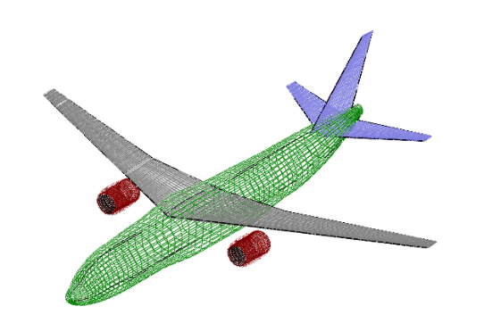
Fig. 1- OpenVSP Geometry of base aircraft planform.

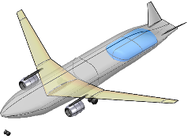
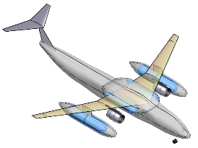
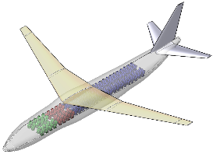

Fig. 2b – Internal LH2 Carriage Aircraft
Fig. 2d – Advanced Aircraft for Future Study
Fig. 2c – External LH2 Carriage Aircraft
Fig. 2a – Baseline Aircraft
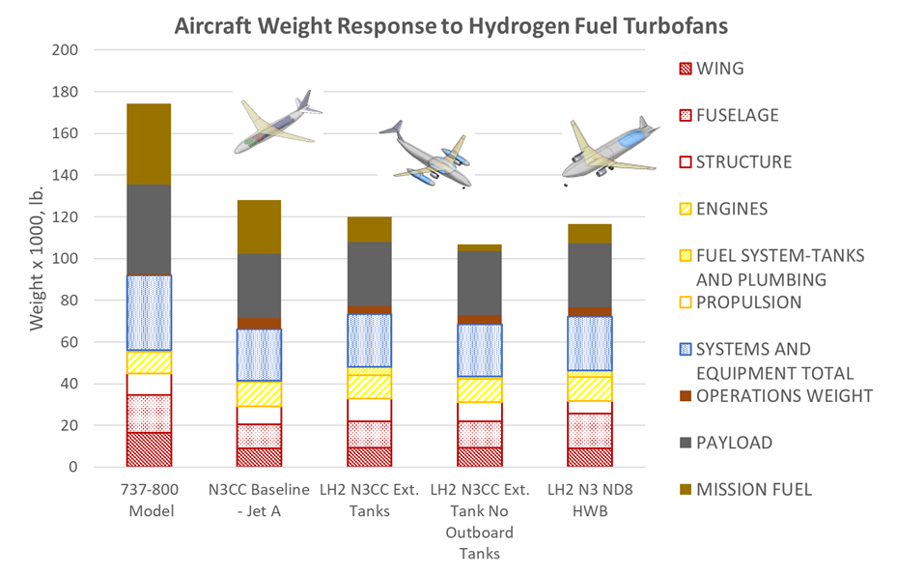
Fig 3 – Weight breakdown and comparison of Hydrogen Turbofan concepts to Boeing 737-800 model and N3CC Baseline representing updates Narrow Body design mission with N+3 technology improvements on structures and aerodynamics.



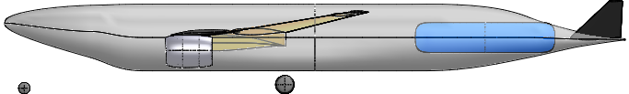

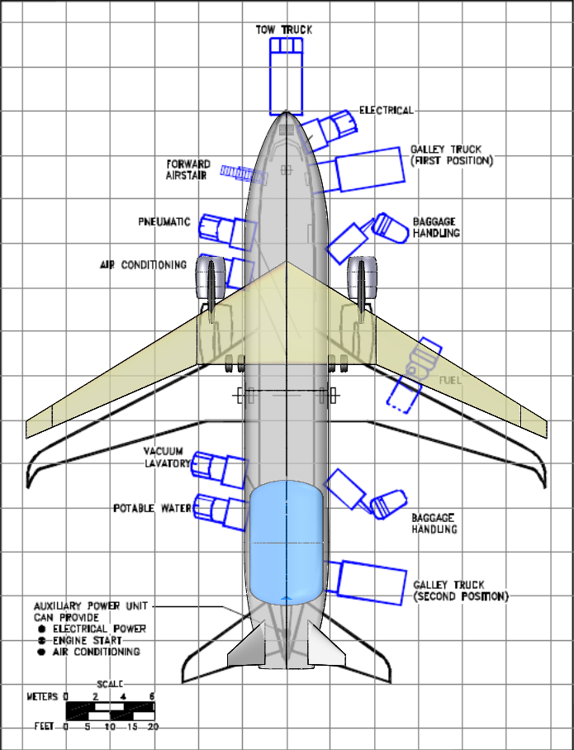

Figure 4a Hydrogen hybrid wing body concept, internal tank

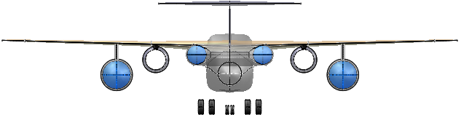
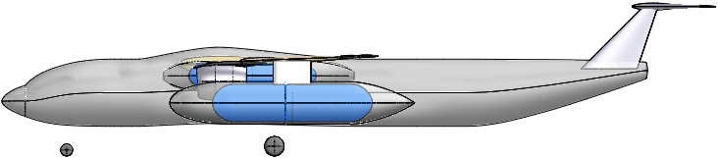

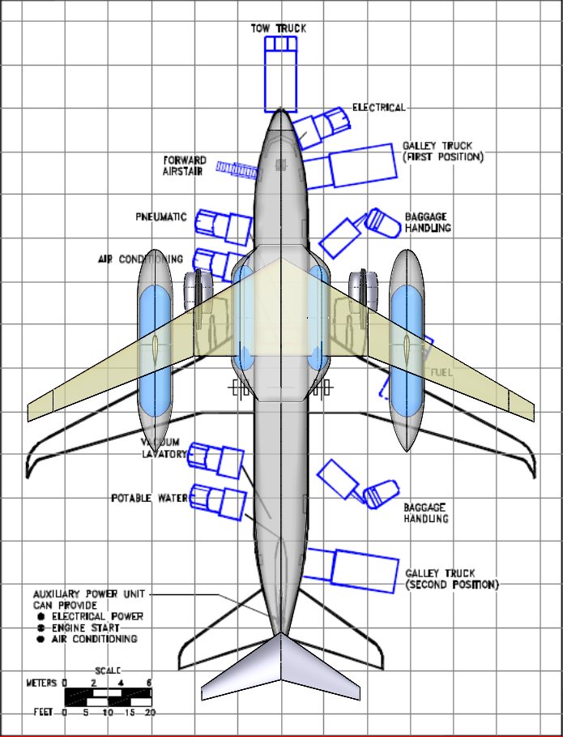
Figure 4b Hydrogen hybrid wing body concept, external tank

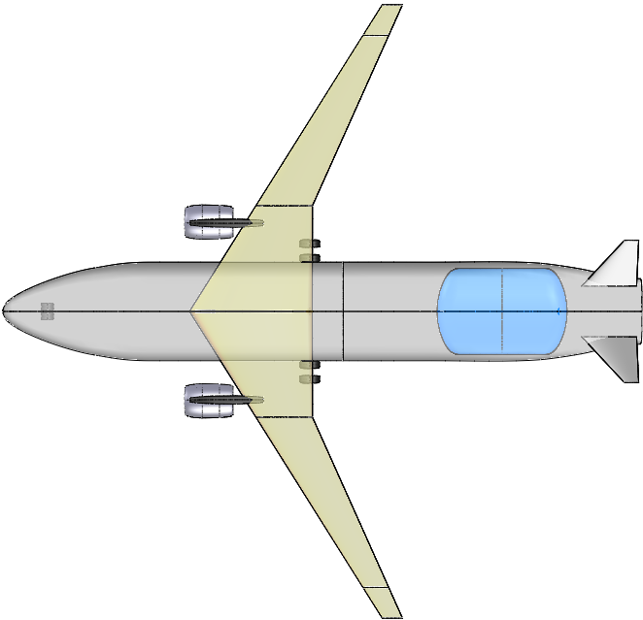
APU
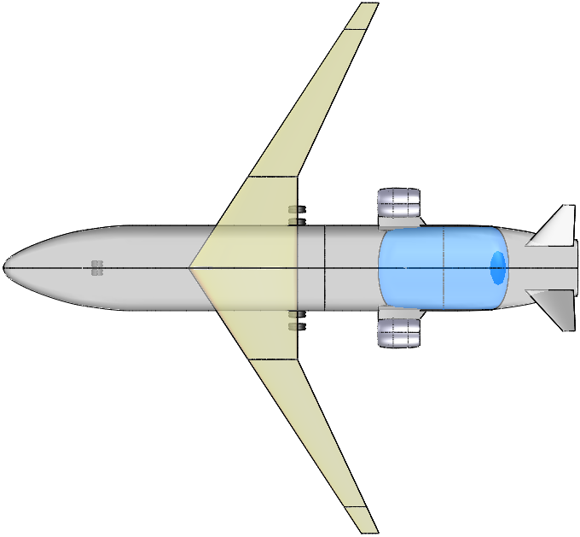
APU

Fig. 5b – Hybrid Wing Body concept, engines on the wings
Fig. 5a – Hybrid Wing Body concept, engines on the fuselage

Table 1
Summary of Hydrogen Concepts Explored
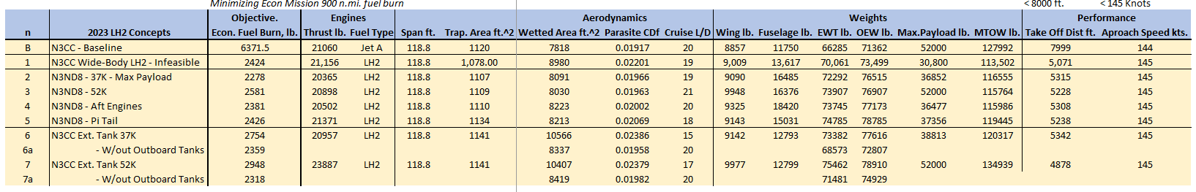

Table 2
A summary of comparative performance projections for the HWB concepts with internal hydrogen fuel tanks
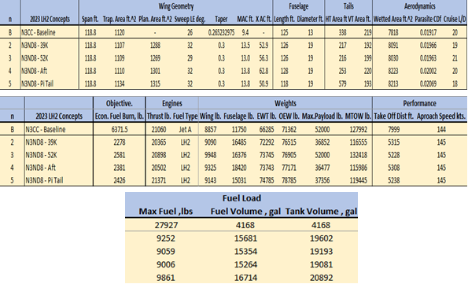

Table 3
A summary of comparative performance projections for the HWB concepts with external hydrogen fuel tanks
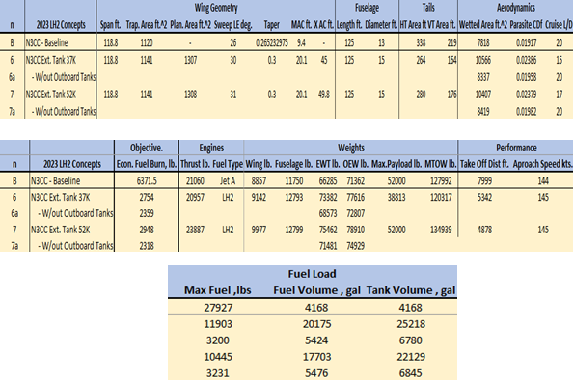

Acknowledgments
The authors would like to acknowledge the Convergent Aeronautics Project, the University Leadership Initiative project, and Transformational Tools and Technologies project, which are all integral parts of the Transformational Aeronautics Concepts Program in the NASA Aeronautics Mission Directorate for providing funding for this project.

References

[1] C. A. Snyder, J. J. Berton, G. V. Brown, J. L. Dolce, N. V. Dravid, D. J. Eichenberg, J. E. Freeh, C. A. Gallo, S. M. Jones, K. P. Kundu, C. J. Marek, M. G. Millis, P. L. Murthy, T. M. Roach, T. D. Smith, G. L. Stefko, R. M. Sullivan, R. T. Tornabene, K. A. Geiselhart, A. F. Kascak, “Propulsion Investigation for Zero and Near-Zero Emissions Aircraft”, NASA/TM—2009-215487, 2019.

[2] T. Y. J. Druot, N. Peteilh, P. Roches, N. Monrolin, “Hydrogen Powered Airplanes, an exploration of possible architectures leveraging boundary layer ingestion and hybridization”, AIAA SciTech Forum, 2022, San Diego, CA.

[3] L. W. Kohlman, M. D. Patterson, B. E. Raabe, “Urban Air Mobility Network and Vehicle Type—Modeling and Assessment”, NASA/TM—2019–220072, 2019.

[4] S. K. Mital, J. Z. Gyekenyesi, S. M. Arnold, R. M. Sullivan, J. M. Manderscheild, P. L. Murthy, “Review of Current State of the Art and Key Design Issues With Potential Solutions for Liquid Hydrogen Cryogenic Storage Tank Structures for Aircraft Applications”, NASA/TM—2006-214346, 2006.

[5] “Hydrogen-powered aviation | A fact-based study of hydrogen technology, economics, and climate impact by 2050”, EU publication, 2020 euractiv.com/wp-content/uploads/sites/2/2020/06/20200507_Hydrogen-Powered-Aviation-report_FINAL-web-ID-8706035.pdf

[6] S. Satyapal, P. Devlin, “U.S. DOE National Clean Hydrogen Strategy and Roadmap”, US Department of Energy, 2023 U.S. National Clean Hydrogen Strategy and Roadmap : DOE Hydrogen Program (energy.gov).

[7] W. L. Johnson, E. Baltman, F. D. Koci, “Assessment of Insulation Systems for Aircraft Liquid Hydrogen Tanks”, 2023 Cryogenic Engineering Conference, Honolulu, HI, 2023.
[8] P. A. Hanlon, J. L. Cashman, Z. Zhong, I. Jakupca, H. Hasseeb, V. F. Lvovich, “Modeling and Trade Space for Fuel Cell Powered Aircraft”, 2024 AIAA Aviation Forum, 2024.
[9] K. Gierens, “Theory of Contrail Formation for Fuel Cells”, Aerospace, vol. 8, no. 164, 2021.

