EXPANDING ACCESS TO SPACEFLIGHT
A preliminary assessment of accommodations for specific disabilities on spacecraft design and operations to enable spaceflight
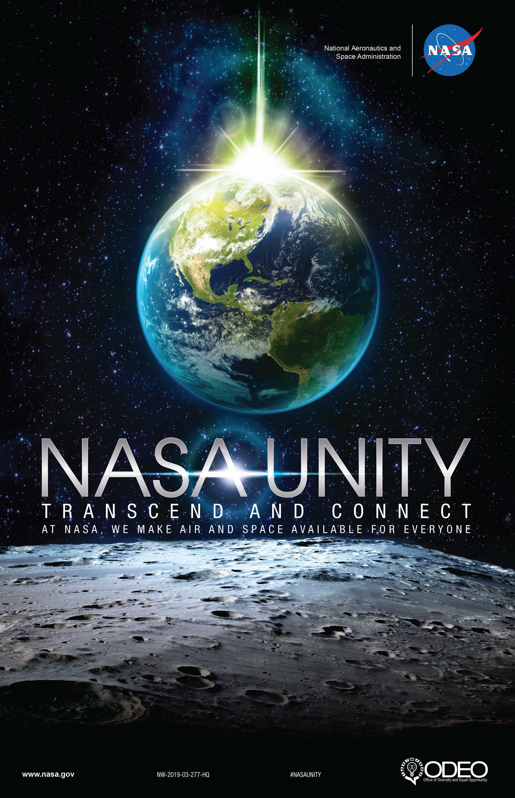

Prepared by NASA Office of the Chief Health and Medical Officer (OCHMO)
2024
Table of Contents
Purpose 3
Disability Policy and Regulations 3
People with Disabilities @NASA 4
Human Spaceflight and Disability 6
Astronaut Selection Process 6
What needs to be considered to enable an astronaut with a physical disability to fly? 7
General Prosthetic Considerations 7
Single- or Double-Foot Deficiency through Ankle 8
Single or Double Leg Deficiency Below the Knee 9
Persons who Have a >4 cm Leg Length Difference with Intact Feet 10
Persons of Short Stature (<130 cm) 11
Single Upper Limb Deficiency at Elbow 12
Reference Data 13
ESA Parastronaut Feasibility Project 13
Federal Aviation Administration (FAA) 14
Military 16
References 21

Purpose
NASA is seeking to address potential changes to the spaceflight system in order to accommodate persons with specific types of disabilities. The goal of this paper is to:
Provide a preliminary assessment of needed accommodations for specific disabilities on spacecraft design and operations to ensure appropriate changes are made prior to flight.

Disability Policy and Regulations
A summary of key regulations and policies regarding people with disabilities
The Americans with Disabilities Act of 1990 (Pub. L. 101-336) (ADA)
The Rehabilitation Act of 1973 (Pub. L. 93-112) (Rehab. Act)
Section 501: Federal agencies may not discriminate in employment on the basis of disability. Further, Federal agencies are required to establish and implement programs that affirmatively advance the employment of qualified people with disabilities.
Section 504: Prohibits discrimination in federally conducted programs on the basis of disability. For example, public hearings on rulemaking must be accessible to people with disabilities. Also, Federal facilities must be accessible to members of the public and Federal employees with disabilities.
Section 508: Requires Federal agencies to make electronic and information technology accessible to members of the public and federal employees with disabilities. This includes computers, copying machines, phones, websites, and more.
Definition of Disability Terms
Disability: The term "disability" means, with respect to an individual (A) a physical or mental impairment that substantially limits one or more major life activities of such individual; (B) a record of such an impairment; or (C) being regarded as having such an impairment (reference: American Disability Act of 1990).
Major Life Activities: Major life activities include, but are not limited to, caring for oneself, performing manual tasks, seeing, hearing, eating, sleeping, walking, standing, lifting, bending, speaking, breathing, learning, reading, concentrating, thinking, communicating, and working. Major life activities also include the operation of major bodily functions, including but not limited to, functions of the immune system, normal cell growth, digestive, bowel, bladder, neurological, brain, respiratory, circulatory, endocrine, and reproductive functions.
Reasonable Accommodation: Reasonable accommodations are changes or modifications to a job or work environment that make it possible for an employee with a disability to perform the essential functions of that job. Reasonable accommodations create equal access and opportunities in the workplace so that people with disabilities can be productive team players whose unique perspectives promote the development of successful programs. Under the Rehabilitation Act of 1973, managers and supervisors are required to provide reasonable accommodations to qualified Federal employees and applicants. Examples of reasonable accommodations include, but are not limited to, sign language interpreters for people who are deaf, screen readers for people who are blind, accessible workstations for people who use wheelchairs, and more.

People with Disabilities @NASA
NASA is dedicated to enhancing its recruitment, promotion, and retention of qualified persons with disabilities by providing the information and resources necessary to support them and to accomplish the Agency’s mission.
In order to implement the requirements of the Rehabilitation Act of 1973, as amended, NASA provides reasonable accommodations to qualified employees and applicants.
Who is an Individual with a Disability?
An individual with a Disability is one who:
- Has a physical or mental impairment that substantially limits one or more major life activities;
- Has a record of such an impairment; or
- Is generally regarded as having such an impairment.
Who is a Qualified Individual with a Disability?
A qualified individual with a disability is a person who, with or without a reasonable accommodation, can perform the essential functions of the job in question.
What is a Reasonable Accommodation?
A reasonable accommodation is any modification or adjustment to a job, an employment practice, or the work environment that makes it possible for a qualified individual with a disability to enjoy equal employment opportunities.
There are three categories of reasonable accommodations implemented @NASA:
- Modifications or adjustments to a job application process to permit an individual with a disability to be considered for a job (such as providing application forms in alternative formats like large print or Braille);
- Modifications or adjustments necessary to enable a qualified individual with a disability to perform the essential functions of the job (such as providing sign language interpreters); and
- Modifications or adjustments that enable employees with disabilities to enjoy equal benefits and privileges of employment (such as removing physical barriers in an office cafeteria).
NASA also provides Personal Assistance Services (PAS) to individuals who need them because of certain disabilities. PAS are services that help individuals who, because of targeted disabilities, require assistance to perform basic activities of daily living, like eating and using the restroom. PAS is specifically for Individuals with Targeted Disabilities. The individual must be able to perform the essential functions of the job, once PAS and any required Reasonable Accommodations have been provided.
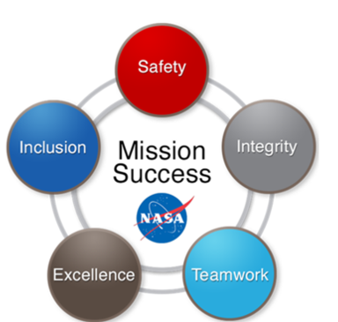

Human Spaceflight and Disability

Astronaut Selection Process
- Application:
- Discipline Fields: Pilot-Flight test engineers, Biological/Medical scientists, Engineers, Physical scientists
- Screening questions
- Competency-based assessment battery
- Initial Review: Check basic qualifications/complete application package
- Initial rating: Astronaut rating panels determine if the applicant is qualified or highly qualified
- Review of highly qualified people:
- Astronaut selection panel reviews highly qualified applicants
- Conduct reference checks
- Interviews and Medical Assessments
- Final ranking and selection

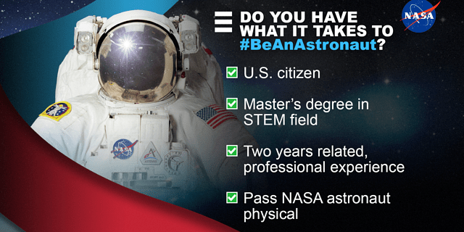
From: NASA Astronaut Requirements (March 2020) https://www.nasa.gov/humans-in-space/astronauts/astronaut-requirements/

What needs to be considered to enable an astronaut with a physical disability to fly?
Many tools can be used to clarify the prerequisites of a safe mission and identify the necessary system adaptations to enable an astronaut with a disability to fly in space: technical studies, space simulations, analog missions, and discussions with international partners and spaceflight providers.
The following tables are a preliminary assessment of potential considerations to enable differently enabled individuals to fly in space.

General Prosthetic Considerations
 | VA | OS | Comments
Prosthetic Materials Assessment |  |  | flammability, off-gassing, environmental compatibility (100% O₂ if performing EVA)
Shock Hazard Assessment
Vehicle interface Assessment |  |  | Footholds, handholds, mobility aids, restraints
Human Factors Assessment |  |  | Operability and usability, anthropometric considerations
Padding Needs to Protect Others and the Vehicle
Prosthetic Adjustability | √ |  | To account for physical changes in microgravity
NASA-provided prosthetic microgravity EVA | √ |  | To ensure safe and proper operation including microgravity EVAs
NASA-provided prosthetic partial gravity EVA | √√ |  | To ensure safe and proper operation including partial gravity EVAs
Required Tools In-Flight |  |  | Tools required for adjustments and/or repairs
Required Consumables

VA: Vehicle Assessment OS: Operational Success
No check: minor/no modifications √ Requires assessment/modifications √√ requires significant assessment/modifications

Single- or Double-Foot Deficiency through Ankle
 | VA | OS | Comments
Astronaut Training |  |  | Minor accommodations.
LEA Suits |  |  | Likely only boot modification.
Hatch Size and Shape |  |  | No accommodations required.
Launch/Landing Nominal Ingress/Egress |  |  | No special accommodations assuming prosthetic is worn.
Launch/Landing Emergency Egress |  |  | Need handholds, mobility aids.
Ingress, Egress, and Escape Translation Paths to a different vehicle/module |  |  | Need to assess the use of mobility aids with the prosthetic and without for translation.
Seats and Seat Restraints |  |  | If LEA suit is unchanged then the seat is unaffected.
Crew Task/Stability Restraints |  |  | Foot restraints would need to be assessed based on using a prosthetic or not. Especially during operations requiring the use of both hands.
Body waste accommodation |  |  | Foot restraints would need to be assessed based on using a prosthetic or not.
Personal Hygiene Capability |  |  | Foot restraints would need to be assessed based on using a prosthetic or not.
Conducting science and vehicle operations |  |  | Foot restraints would need to be assessed based on using a prosthetic or not.
Food preparation and consumption |  |  | Foot restraints would need to be assessed based on using a prosthetic or not.
Sleeping accommodations
Waste management
Trash Receptacle Accessibility
Volume Accommodations
Medical Capability |  |  | Additional medications/supplies for prosthetic use injuries.
Stowage Location |  |  | May need to accommodate additional supplies and consumables.
Safety and Comfort (clothing) |  |  | Some modifications may be required to clothing.
Windows
Exercise | √ |  | Modify exercise device(s) and/or the prosthetic. May require more exercise time and/or more set-up/teardown time.
EVA Prebreathe
EVA Suit | √√ |  | Prosthetic must be compatible with 100% O₂ environment. Likely only boot modification.
EVA Ops | √√ | √ | Foot restraint assessment for compatibility with prosthetic. Impact to operational timeline due to additional time for foot restraints in microgravity and translation speed in reduced gravity.
VA: Vehicle Assessment OS: Operational Success
No check: minor/no modifications √ Requires assessment/modifications √√ requires significant assessment/modifications

Single or Double Leg Deficiency Below the Knee
 | VA | OS | Comments
Astronaut Training |  |  | Minor accommodations.
LEA Suits | √ |  | Likely only boot modification.
Hatch Size and Shape |  |  | No accommodations required.
Launch/Landing Nominal Ingress/Egress |  |  | No special accommodations, assuming prosthetic is worn.
Launch/Landing Emergency Egress | √ | √ | Need handholds, mobility aids.
Ingress, Egress, and Escape Translation Paths to a different vehicle/module |  |  | Need to assess the use of mobility aids with the prosthetic and without for translation.
Seats and Seat Restraints |  |  | If LEA suit is unchanged then the seat is unaffected.
Crew Task/Stability Restraints | √ |  | Foot restraints would need to be assessed based on using a prosthetic or not. Especially during operations requiring the use of both hands.
Body waste accommodation | √ |  | Foot restraints would need to be assessed based on using a prosthetic or not.
Personal Hygiene Capability | √ |  | Foot restraints would need to be assessed based on using a prosthetic or not.
Conducting science and vehicle operations | √ |  | Foot restraints would need to be assessed based on using a prosthetic or not.
Food preparation and consumption | √ |  | Foot restraints would need to be assessed based on using a prosthetic or not.
Sleeping accommodations
Waste management
Trash Receptacle Accessibility
Volume Accommodations
Medical Capability |  |  | Additional medications/supplies for prosthetic use injuries.
Stowage Location |  |  | May need to accommodate additional supplies and consumables.
Safety and Comfort (clothing)
Windows
Exercise | √ |  | Modify exercise device(s) and/or the prosthetic. May require more exercise time and/or more set-up/teardown time.
EVA Prebreathe
EVA Suit | √√ |  | Prosthetic must be compatible with 100% O₂ environment. Likely only boot modification.
EVA Ops | √√ |  | Foot restraint assessment for compatibility with prosthetic. Impact to operational timeline due to additional time for foot restraints in microgravity and translation speed in reduced gravity.
VA: Vehicle Assessment OS: Operational Success
No check: minor/no modifications √ Requires assessment/modifications √√ requires significant assessment/modifications

Persons who Have a >4 cm Leg Length Difference with Intact Feet
 | VA | OS | Comments
Astronaut Training |  |  | Minor accommodations.
LEA Suits | √ |  | Likely only boot modification.
Hatch Size and Shape |  |  | No accommodations required.
Launch/Landing Nominal Ingress/Egress |  |  | No special accommodations, assuming orthotic is worn.
Launch/Landing Emergency Egress | √ | √√ | Need handholds, mobility aids.
Ingress, Egress, and Escape Translation Paths to a different vehicle/module |  |  | Need to assess the use of mobility aids with the orthotic and without for translation.
Seats and Seat Restraints |  |  | If LEA suit is unchanged then the seat is unaffected.
Crew Task/Stability Restraints | √ |  | Foot restraints would need to be assessed based on using an orthotic or not. Especially during operations requiring the use of both hands.
Body waste accommodation | √ |  | Foot restraints would need to be assessed based on using an orthotic or not.
Personal Hygiene Capability | √ |  | Foot restraints would need to be assessed based on using an orthotic or not.
Conducting science and vehicle operations | √ |  | Foot restraints would need to be assessed based on using an orthotic or not.
Food preparation and consumption | √ |  | Foot restraints would need to be assessed based on using an orthotic or not.
Sleeping accommodations
Waste management
Trash Receptacle Accessibility
Volume Accommodations
Medical Capability
Stowage Location
Safety and Comfort (clothing)
Windows
Exercise | √ | √√ | Modify exercise device(s) and/or the orthotic. May require more exercise time and/or more set-up/teardown time. Other serious physical effects possible due to diminished exercise effectiveness.
EVA Prebreathe
EVA Suit | √√ |  | Likely only boot modification.
EVA Ops Microgravity | √ |  | Foot restraint assessment for compatibility with modified boot.
EVA Ops Partial gravity | √ | √√ | Impacts to mobility.
VA: Vehicle Assessment OS: Operational Success
No check: minor/no modifications √ Requires assessment/modifications √√ requires significant assessment/modifications

Persons of Short Stature (<130 cm)
 | VA | OS | Comments
Astronaut Training |  |  | Minor accommodations.
LEA Suits | √√ |  | Could require completely custom suit.
Hatch Size and Shape | √√ | √√ | May not be able to operate hatch.
Launch/Landing Nominal Ingress/Egress |  |  | Minor accommodations (e.g., step stool).
Launch/Landing Emergency Egress | √√ | √√ | May need handholds, may be slower to egress, may not be able to operate emergency egress systems.
Ingress, Egress, and Escape Translation Paths to a different vehicle/module |  |  | May need additional mobility aids.
Seats and Seat Restraints | √√ |  | Could require custom seat.
Crew Task/Stability Restraints |  |  | May need additional restraints, different height work platform.
Body waste accommodation |  |  | May need additional restraints, may require special accommodations to use body waste facility.
Personal Hygiene Capability |  |  | May need additional restraints.
Conducting science and vehicle operations |  |  | May need additional restraints, different height work platform, may not be able to conduct some science.
Food preparation and consumption |  |  | May need additional restraints.
Sleeping accommodations |  |  | May need a smaller sleeping bag and different restraints.
Waste management
Trash Receptacle Accessibility
Volume Accommodations
Medical Capability |  |  | May require smaller size medical hardware, may require smaller medicine dosage.
Stowage Location
Safety and Comfort (clothing) |  |  | May require smaller size clothing.
Windows
Exercise | √√ |  | May not be able to reach/use current exercise devices. May require modification(s) to exercise device(s). May require more exercise time and/or more set-up/teardown time.
EVA Prebreathe
EVA Suit | √√ |  | Could require completely custom suit.
EVA Ops | √√ |  | May require additional foot restraints/mobility aids. May require additional translation time.
VA: Vehicle Assessment OS: Operational Success
No check: minor/no modifications √ Requires assessment/modifications √√ requires significant assessment/modifications

Single Upper Limb Deficiency at Elbow
 | T | OS | Comments
Astronaut Training |  | √√ | Additional time accommodations – may limit ability to perform numerous functions, health ops, vehicle systems.
LEA Suits | √√ | √√ | Arm/glove modifications, don/doff considerations, zipper operation, metal fingers – suit tearing considerations.
Hatch Size, Shape and Operation |  |  | Hatch Operations may be difficult. MPEV ops, Hatch handles.
Launch/Landing Nominal Ingress/Egress |  |  | Assisted – no impact.
Launch/Landing Emergency Egress |  |  | Need special handholds, mobility aids.
Ingress, Egress, and Escape Translation Paths to a different vehicle/module |  |  | Need to assess the use of mobility aids.
Seats and Seat Restraints |  |  | Buckles, arm rest controls operation, connectors consideration.
Crew Task/Stability Restraints |  |  | Hand restraints would need to be assessed. Especially during operations requiring the use of both hands.
Body waste accommodation |  |  | Assessment of operations.
Personal Hygiene Capability |  |  | Assessment of operations.
Conducting science and vehicle operations |  |  | Glovebox ops, control panels, touch screen accuracy.
Food preparation and consumption |  |  | Assessment of operations.
Sleeping accommodations
Waste management
Trash Receptacle Accessibility
Volume Accommodations
Medical Capability |  |  | Additional medications/supplies for prosthetic use injuries.
Stowage Location
Safety and Comfort (clothing)
Windows
Exercise |  | √√ | Modify exercise device(s) and/or the orthotic. May require more exercise time and/or more set-up/teardown time. Other serious physical effects possible due to diminished exercise effectiveness.
EVA Prebreathe
EVA Suit | √√ | √√ | Arm/glove modifications, don/doff considerations, metal fingers – suit tearing considerations.
EVA Ops Microgravity |  | √√ | Ability to use both arms to translate and operate h/w
EVA Ops Partial gravity |  | √√ | Impacts ability to operate hardware, drilling, etc.
VA: Vehicle Assessment OS: Operational Success
No check: minor/no modifications √ Requires assessment/modifications √√ requires significant assessment/modifications

Reference Data

ESA Parastronaut Feasibility Project
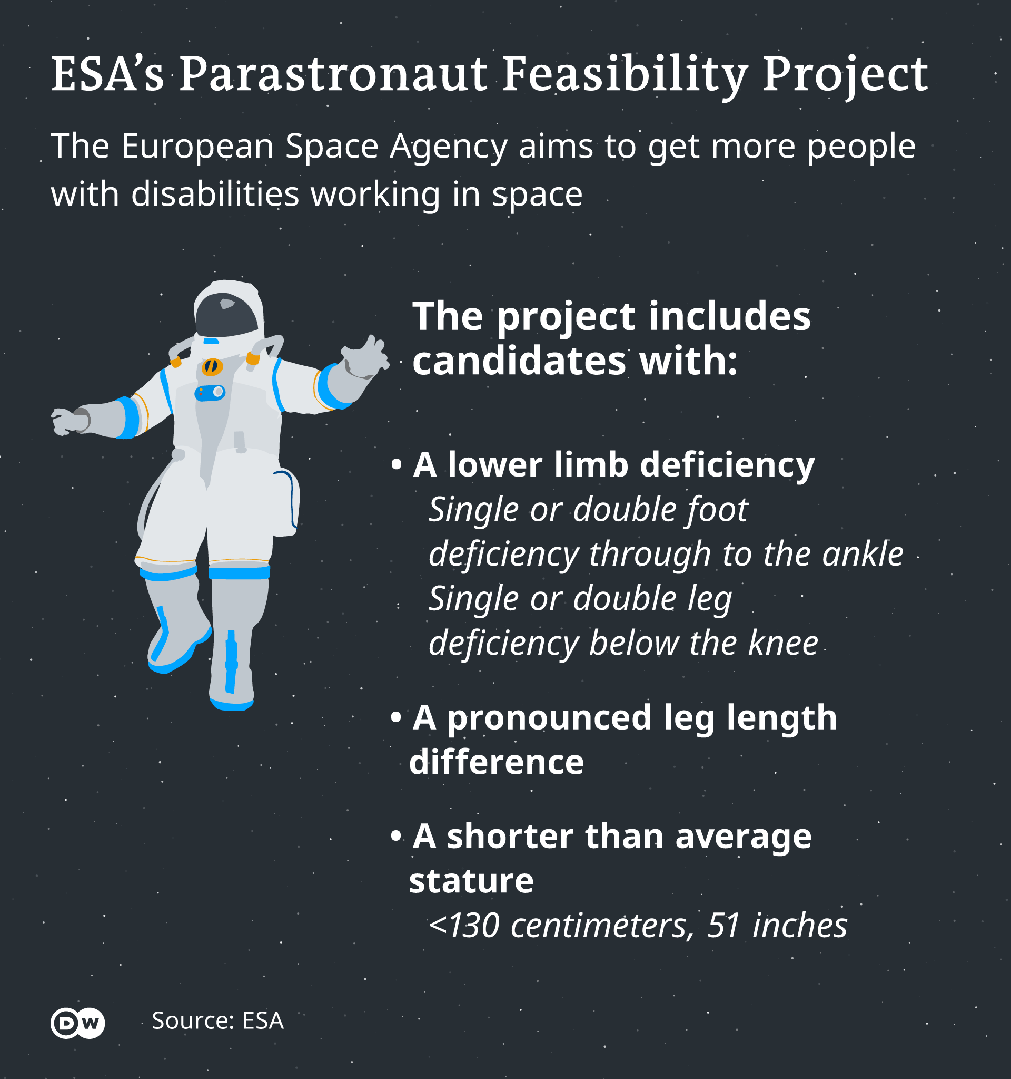
For its 2022 Astronaut Group, the European space agency (ESA) envisions recruiting an astronaut with a physical disability, a category they called "parastronauts". Individuals with a lower limb deficiency or who have
restricted growth are encouraged to
apply. The selected individual would be
part of a feasibility project to understand
the requirements, such as on safety and
technical support. The successful
candidate that has a disability will join
the reserve crew while ESA works with
partners to find a safe way to travel. The
plan is to work with ISS partners to find a
way to send someone with physical
disabilities to space since ESA does not
have its own crewed vehicles.

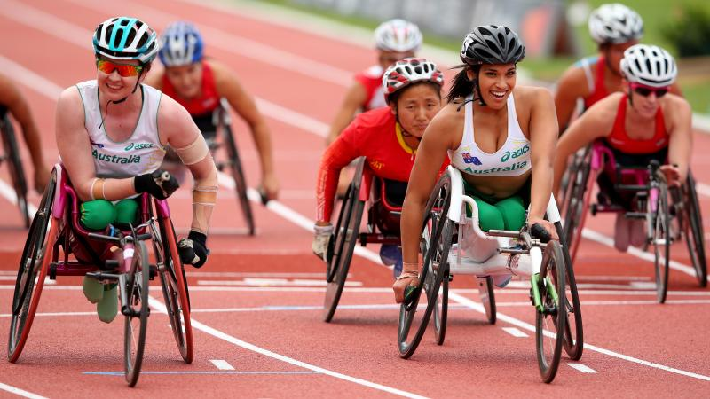
ESA is looking for individual(s) who are psychologically, cognitively, technically, and professionally qualified to be an astronaut but have a physical disability that would normally prevent them from being selected due to the requirements imposed by the use of current space hardware. The agency has asked the International Paralympic Committee to advise on selection. The Paralympic Movement offers sport opportunities for athletes that have an impairment that belongs to one of ten Eligible Impairment types. (Chapter 3.13 IPC Handbook)

ESA used the table developed by the committee to categorize the different kinds and degrees of impairments – especially the list of eligible impairments. ESA developed based on that table three types of marks:
- Red: the kind and degree of disability are not safely compatible with the task.
- Green: the kind and degree of disability can be compatible with the task.
- Yellow: the kind and degree of disability could become fully compatible with the task with some adjustments, modifications, or innovations.
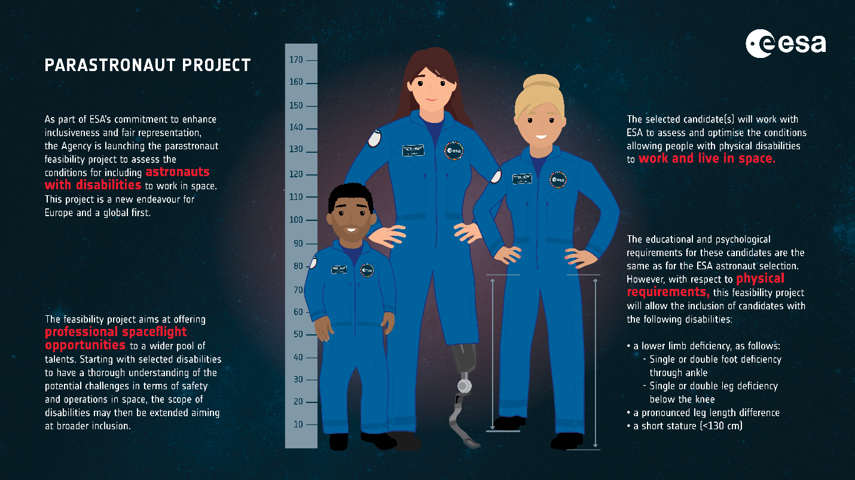
Dr. David Parker, the director of ESA's robotics and human spaceflight program explained that the candidate “would do a meaningful space mission. So, they would need to do the science; they too participate in all the normal operations of the International Space Station (ISS).”

Federal Aviation Administration (FAA)
The FAA actively recruits, hires, promotes, retains, develops, and advances people with disabilities. The People with Disabilities Program (PWD) ensures that people with disabilities have equal Federal employment opportunities. In 2019, the FAA has announced a pilot program to help prepare people with disabilities for careers in air traffic operations. Participants in the program receive up to one year of experience in an Air Route Traffic Control Center (ARTCC) with the potential to be appointed to a temporary ATCS position at the FAA Academy.
Targeted Disabilities
The Secretary of Transportation has set a hiring goal of three (3) percent per fiscal year for individuals with targeted (severe) disabilities.
Targeted disabilities are those disabilities that the federal government, as a matter of policy, has identified for special emphasis in recruitment and hiring. The targeted disabilities are:
- Vision (Blind)
- Hearing (total deafness in both ears)
- Missing Extremities
- Partial Paralysis
- Complete Paralysis, Epilepsy
- Severe intellectual disability
- Psychiatric disability
- Dwarfism
Individuals with targeted disabilities have the greatest difficulty obtaining employment. This is the only protected group for which Federal agencies may have a hiring goal.
On-the-Spot Hiring Information
The "On-the-Spot" special appointment authority is a non-competitive hiring method for filling vacancies for people with disabilities. Full benefits are awarded to the non-competitive appointee.
Managers can choose to fill an open position through the On-the-Spot hiring process. The Office of Civil Rights National People with Disabilities Program Manager and Human Resource Management Selective Placement Coordinators share non-competitive position descriptions with a broad network of disability employment collaborators to recruit qualified applicants with disabilities.
Required Documentation for On-the-Spot Hiring
An applicant wishing to be hired through the non-competitive process should be prepared to provide their résumé, references, and academic transcripts. They are also required to provide documentation pertaining to the existence of a disability.
This documentation is similar to the Proof of Disability/Certification of Job Readiness required for Schedule A Employment policies used by other Federal Government agencies. Certification of Job Readiness states that the applicant is likely to succeed in the performance of the duties of the position for which he or she is applying.
The disability certification and job readiness certification must be on the author's professional letterhead stationery, and can come from:
- A licensed physician or other medical practitioners
- A licensed vocational rehabilitation (VR) specialist (public or private)
- Any federal agency, state agency, or agency of the District of Columbia, or a U.S. territory that issues or provides disability benefits, such as the U.S. Department of Veterans Affairs
The official disability and job readiness certification letter must state the following:
- The applicant is disabled as defined in the Rehabilitation Act of 1973, as amended. In addition, the condition is professionally recognized and is relatively permanent and not fully corrected by medical treatment, replacement, or surgical means.
- This disability and limitation qualify this applicant to be hired non-competitively under the FAA On-the-Spot hiring authority for persons with disabilities (also known as Schedule A within the competitive services).
- The applicant has the ability to perform the essential functions of the job with reasonable accommodations, if appropriate.
- The applicant is physically qualified to do the work without hazard to self or others.

Becoming a Pilot
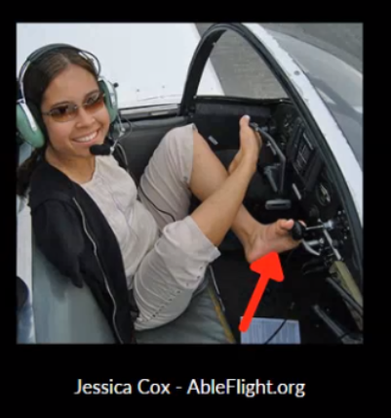
In the U.S., the FAA issues pilot licenses and the associated medical certificates to pilots in the general aviation (recreational), transport, and commercial arenas. To become a professional pilot, a person needs a 2nd class medical certificate or higher. The FAA has a system in place to evaluate, and where possible medically certify, pilots with certain disabilities, including orthopedic-based ones such as amputations. The process is initiated by the Aviation Medical Examiner (AME) and requires submission of all medical documents to the FAA’s Aerospace Medical Certification Division. After review of all medical data, the FAA may authorize a special medical flight test. Pilots who successfully pass the medical flight test and whose disability is static or non-progressive (such as the case with amputations or congenital absence of limbs), and who have been found capable of performing flight duties without risk to public safety, may be granted a Statement of Demonstrated Ability (SODA). A SODA then authorizes the AME to issue a medical certificate for the class of flying specified on the SODA, as long as the AME’s evaluation finds that the condition described on the SODA has not adversely changed.

Military
The United States military has clear, strict physical requirements for enlistment. People with physical disabilities are generally not allowed to enlist in the military. We have few cases of military amputee pilots who were able to get back in the cockpit of transport aircraft after injury. Andrew Lourake’s successful history is one of those few cases. He is the first pilot in the history of the U.S. Department of Defense with an above-the-knee amputation to be able to return to flying duties; he also holds an FAA medical certificate to fly.
Army Disability Evaluation System (DES)
Title 10, United States Code, Chapter 61 (10 USC Chapter 61) and DODD 1332.18 establish the Army Disability Evaluation System (DES). The DES is the Department of Defense’s (DoD) mechanism for determining whether a Service member will return to duty, medically separate, or medically retire due to disability.
Section I: Disability Evaluation System Overview
The DES process contains four key elements:
- Medical Evaluation Board (MEB): The MEB documents the medical status and duty limitations of Service members referred for disability evaluation. It determines whether Service members have a medical condition or conditions that may prevent them from reasonably performing the duties of their office, grade, rank, or rating (failure to meet Service-specific medical retention standards).
- Physical Evaluation Board (PEB): The PEB determines whether Service members are fit for continued military service. If determined unfit, the PEB determines the Service member’s eligibility for and/or level of disability benefits.
- Service member counseling: Service member counseling informs Service members about the disability process, possible outcomes, the significance and consequences of the determinations being made, as well as associated rights, benefits, and entitlements.
- Final disposition: Involves a Service Secretary designee reviewing and finalizing the PEB’s determination.
The DES consists of three systems:
- Legacy Disability Evaluation System: Under the legacy system, for cases referred under the duty-related process, the PEB determines fitness and determines the disability rating percentages using the Veteran’s Administration Schedule for Rating Disabilities (VASRD). The legacy process also includes the Reserve Component (RC) non-duty-related referral process. No disability ratings are assigned for non-duty-related cases.
- Integrated Disability Evaluation System: The IDES features:
(a) A single set of disability medical examinations that may assist the DES in identifying conditions that may render the Soldier unfit.
(b) A single set of disability ratings provided by VA for use by both departments. The DES applies these ratings to the conditions it determines to be unfitting and compensable. The Soldier receives preliminary ratings for their VA compensation before the Soldier is separated or retired for disability.
- Expedited Disability Evaluation System: A voluntary process for Soldiers unfit for catastrophic injuries or diseases in which U.S. Army Physical Disability Agency (USAPDA) may permanently retire the Soldier for disability without referral to the PEB based on the military treatment facility’s medical narrative summary (NARSUM).
The DES concludes for Soldiers as set forth below:
- For Soldiers determined by the MEB to meet medical retention standards and a Military Occupational Specialty Administrative Retention Review (MAR2) did not refer the Soldier to the DES, the DES concludes the date the MEB returned the Soldier to duty (if referral to MEB resulted from MAR2 evaluation, referral to the PEB may be mandatory).
- For Soldiers referred to the PEB and determined fit, the DES concludes as of the date of USAPDA’s memorandum approving the finding of fit.
- For Soldiers referred to the DES under a Legacy Disability Evaluation System (LDES) process and determined unfit, the DES concludes on the date of the Soldier’s separation or retirement for disability.
- For Soldiers referred to the DES under the Integrated Disability Evaluation System (IDES) process and determined unfit, the DES concludes on the date of the Soldier’s notification of the VA’s benefits decision. However, the Soldier’s military status as a member of the Active Army or RC, as applicable, ends on the date of the Soldier’s disability separation or retirement.
Section II: Medical Evaluation Board
An MEB is convened to determine whether a Soldier’s medical condition(s) meets medical retention standards per AR 40 – 501. With the exception of cases referred by MAR2, an MEB may determine that a Soldier’s condition(s) meet medical retention standards and recommend the Soldier be returned to duty.
The MEB must not provide conclusions or recommendations regarding fitness determinations.
Reasonable performance of duties
General. With the exception of cases adjudicated under the presumption of fitness rule, determining whether a Soldier’s medical impairments preclude the Soldier from reasonably performing their duties will be determined based on the factors below.
Congenital and developmental defects not ratable under the VASRD. A PEB will not consider conditions and circumstances not ratable under the VASRD.
Common military tasks. The PEB considers whether the Soldier can perform the common military tasks required for the Soldier’s office, grade, rank, or rating, including those duties during a remaining period of Reserve obligation.
- As a minimum standard, the functional tasks listed on DA Form 3349 will be considered common military tasks required of all Soldiers.
- The PEB will request the MEB clarify MEB case file inconsistencies relating to recorded DA Form 3349 limitations when such inconsistencies prevent the PEB from rendering a fitness finding. The PEB request and MEB response will be added to the Soldier’s case file.
Army Physical Fitness Test. The PEB considers whether the Soldier is medically prohibited from taking the Army Physical Fitness Test (APFT).
- Generally, when the Soldier’s DA Form 3349 precludes all aerobic events of the APFT, the Soldier will be determined unfit. However, when a finding of fit is warranted, the inability of the Soldier to pass the APFT will not form the basis for administrative separation of the Soldier.
- Inability of the Soldier to perform all the required events of the standard APFT or to participate in local physical training requirements that exceed Army standards for a record APFT are inappropriate criteria on which to solely base an unfit determination.
Ability to deploy. The PEB considers whether the Soldier (Active Army and RC) is deployable individually or as part of a unit, with or without prior notification, to any location specified by the Army.
(1) The provisions in this paragraph concerning the ability to deploy do not apply to the following DES cases:
(a) General and MC officers.
(b) When the presumption of fitness rule applies.
(2) With the exception of the cases identified in paragraphs 5–4e(1)(a) and 5–4e(1)(b), the PEB will find Soldiers unfit who are medically disqualified for worldwide deployment in a field or austere environment.
(3) Worldwide deployment means a deployment for 30 days or more to any environment in which the Army is operating or is likely to operate, including:
- Areas that regularly experience significant environmental hazards (for example, heat, cold, altitude, aerosol particles) that would exacerbate existing medical conditions.
- Areas that have limited access to a reliable source of electricity.
- Areas where force protection levels mandate prolonged use of body armor and/or chemical or biological protection equipment.
- Areas requiring immunization or force health protection prescription products. Areas with limited medical services.
(4) The medical conditions listed in Department of Defense Instruction (DODI) 6490.07, enclosure 3, represent the minimum medical conditions that may cause a Soldier to be medically nondeployable. A PEB will find a Soldier with these listed conditions unfit, provided the medical condition is one that does not meet the medical retention standards of AR 40 – 501.
Special qualifications. For Soldiers whose medical condition causes loss of qualification for specialized duties, the PEB will consider whether the specialized duties comprise the Soldier's current duty assignment, the Soldier has an alternate branch or specialty, or reclassification or reassignment is feasible.
Overall or combined effect. A Soldier may be determined unfit as a result of the overall effect of two or more impairments even though each of them, standing alone, would not cause the Soldier to be found unfit because of physical disability. Further, unfitness due to overall or combined effect may include one or more conditions determined to be unfitting in combination with an independently unfitting condition.
Standards for determining permanence and stability for permanent or temporary retirement
- A disability will be determined stable when the preponderance of medical evidence indicates the severity of the conditions will probably not change enough within the next five years to increase or decrease the disability rating percentage.
- Notwithstanding paragraph 5–7a, when a Soldier has a combined rating of 80 percent or greater for a permanent and stable condition (or conditions) not related to a diagnosis of a mental disorder due to traumatic stress, the Soldier will be permanently retired. In this situation, the Soldier’s disabilities are deemed permanent and stable because the provisions of 10 USC 1401 caps the disability rating percentage at 75 percent for purposes of calculation of the Soldier’s retired pay.
- With the exception of mental disorder due to traumatic stress, unfitting conditions will be presumed stable in the absence of medical evidence that they are not stable. For cases that initially received ratings from D – RAS, the PEB will use the future examination requirements set by the D – RAS as an indicator of stability when making the PEB’s recommendations of stability determinations and case disposition.
- The SECARMY will abide by 10 USC 1216a and Title 38 Code of Federal Regulations (38 CFR) for disposition of Soldiers found unfit because of a mental disorder due to traumatic stress.
- For Soldiers found unfit with a rating of 80 percent or greater for a permanent and stable condition (or conditions) not related to diagnosis of the mental disorder due to traumatic stress, the Soldier will be permanently retired.
All other such Soldiers will be placed on the TDRL and re-evaluated within a timeframe that is not less than 90 days but consistent with the maximum timeframes stipulated by 38 CFR or other applicable statutes.

References
- Wiedmann, I., Weerts, G., Brixius, K., Seemuller, A., Mittelstadt, J., Herssens, N., and Webser, T. (2023). The ESA Parastronaut Feasibility Project: Investigating the Need and Contents of Physical Performance Tests for an Inclusive European Astronaut Corps. Sports Medicine, 53(11): 2267-2280.
- International Paralympic Committee Classification: https://www.paralympic.org/classification
- FAA National Outreach Program for Diversity and Inclusion: https://www.faa.gov/about/office_org/headquarters_offices/acr/outreach/pwd/
- Disability Policy and Regulations, U.S. Department of Transportation: https://www.transportation.gov/careers/disability-policy-and-regulations
- Definition of Disability Terms, U.S. Department of Transportation: https://www.transportation.gov/careers/definition-disability-terms
- Providing Accommodations, U.S. Office of Personnel Management: https://www.opm.gov/policy-data-oversight/disability-employment/providing-accommodations/
- NASA Disability Employment Program, Office of Diversity and Equal Opportunity: https://www.nasa.gov/offices/odeo/disability-employment-program
- Code of Federal Regulations Part 91 – General Operating and Flight Rules: https://www.ecfr.gov/current/title-14/chapter-I/subchapter-F/part-91
- DoD Instruction 6130.03, Volume 1 – Medical Standards for Military Service: Appointment, Enlistment, or Induction: https://www.esd.whs.mil/Portals/54/Documents/DD/issuances/dodi/613003_vol1.PDF?ver=7fhqacc0jGX_R9_1iexudA%3D%3D
- Ricaurte, E.M., and Mahmoud, N. (2018). Medical Certification Strategies in Response to Technologically Advanced Prosthetic Devices. Federal Aviation Administration: DOT/FAA/AM-18/7: https://rosap.ntl.bts.gov/view/dot/57209
- New Horizons: Information for the Air Traveler with a Disability, U.S. Department of Transportation: https://www.transportation.gov/sites/dot.gov/files/docs/Horizons_2009_Final_0.pdf
- The Americans with Disabilities Act of 1990 (Pub. L. 101-336) (ADA): https://www.ada.gov/law-and-regs/ada/
- The Rehabilitation Act of 1973 (Pub. L. 93-112) (Rehab. Act): https://www.dor.ca.gov/Home/RehabilitationAct

