Holey Silicon-based Thermopiles for High-Sensitivity Broadband Thermal Detection in Space

Jiahui Caoª, Ari D. Brown^{b}, Jaeho Leeª
ªUniversity of California, Irvine, CA, USA
^{b}NASA Goddard Space Flight Center, Greenbelt, MD, USA

Abstract
Future planetary missions call for thermal detectors with high sensitivity over a wide range of temperature or wavelength. Conventional approaches based upon photon detectors are limited to a narrow and material-selective range of wavelength, and they often require cryogenic cooling for measurements of far-infrared (FIR) radiation or very low-temperature objects, which result in a significant increase in the system’s size, weight, and power (SWaP). While thermal detectors based upon thermopiles are uncooled and sensitive to a wide range of wavelengths including FIR radiation, their sensitivity, limited by the material’s thermoelectric response and heat losses, is an order of magnitude lower than photon detectors. To address the sensitivity requirements for future planetary science missions that target very cold objects such as ice giant planets, icy regoliths, planetary satellites, and primitive bodies, we introduce a high-sensitive broadband thermopile concept using holey silicon – a thin membrane of silicon with a microfabricated arrangement of pores that can be optimized to minimize heat losses and enable breakthrough thermoelectric performance. In this paper, we present our analytical model for the holey silicon-based thermopile, its performance expectations, and its performance comparisons with the state-of-the-art thermopile technology. We will investigate the roles of thermal conductance in holey silicon-based thermopile performance, the impact of thermal conduction and thermal radiation at different temperature limits, and the performance trade-off between the responsivity and noises.

Keywords: thermopiles, infrared detectors, thermal detectors, holey silicon

- INTRODUCTION
Future planetary missions call for thermal detectors that can measure not only hot but also cold objects with high sensitivity over a wide range of temperatures. For instance, ice giant planets such as Uranus and Neptune or icy regolith at the lunar poles may require measurements of cold objects with temperatures below 60 K, in which much of thermal emission takes place at wavelengths greater than 50 μm according to Wien’s displacement law. However, conventional approaches based upon photon detectors are limited to a narrow and material-selective range of wavelengths and require active cooling for measurements of long-wavelength radiation. To measure thermal emission at wavelengths 50 μm and greater, photon detectors must be cryogenically cooled below 10 K, which results in significant increases in the size, weight, and power (SWaP) of the system. On the other hand, thermal detectors are sensitive to a wide range of wavelengths including far-infrared radiation and do not require active cooling or cryogenic operations. Amongst the different thermal detector types, thermopiles have been identified as the preferred technology for these missions because of their unique signal transduction characteristics. Thermopiles are: (1) Broadband (λ ~ 0.1 - 200 µm) and cover the full range of interest for albedo and thermal emission from cold objects; (2) insensitive to instrument temperature drifts, which is important when looking at faint signals from cold surfaces; (3) highly linear to incident radiation, which results in better radiometry; thermopiles have (4) negligible 1/f noise so that the SNR from cold bodies can be improved by frame averaging and time-delay and integration (TDI), and (5) lower power consumption compared to microbolometers as they are entirely passive detectors and do not require any form of electrical biasing.

While thermopiles are favorable for measurements of long-wavelength radiation or thermal emission by cold objects, their detectivity is limited by the material’s thermoelectric response and heat losses and is an order of magnitude lower than photon detectors. Here, we present a high-sensitive broadband thermal detector concept for hot and cold objects in space using a novel thermopile technology based on holey silicon. Holey silicon is a thin membrane of silicon with a microfabricated arrangement of pores that can be optimized to minimize heat losses and enable breakthrough performance (Figure 1). With holey silicon, the proposed thermal detector is expected to outperform the state-of-the-art by significant margins. In terms of the specific detectivity ($D^{*}$), a representative figure of merit capturing the signal-to-noise ratio (SNR), the holey silicon-based thermopile can be ~ an order of magnitude higher than the previously flown instruments (MCS, Diviner) [2-4] and four times higher than the state-of-art instrument (PREFIRE) [5] that has yet to launch (Tables 1). Furthermore, the proposed use of silicon for thermopiles, instead of bismuth telluride compounds that are used in conventional state-of-the-art thermopiles, offers significant advantages in terms of ease of fabrication, compatibility with novel broadband absorbers [7], and robustness to extreme environments.

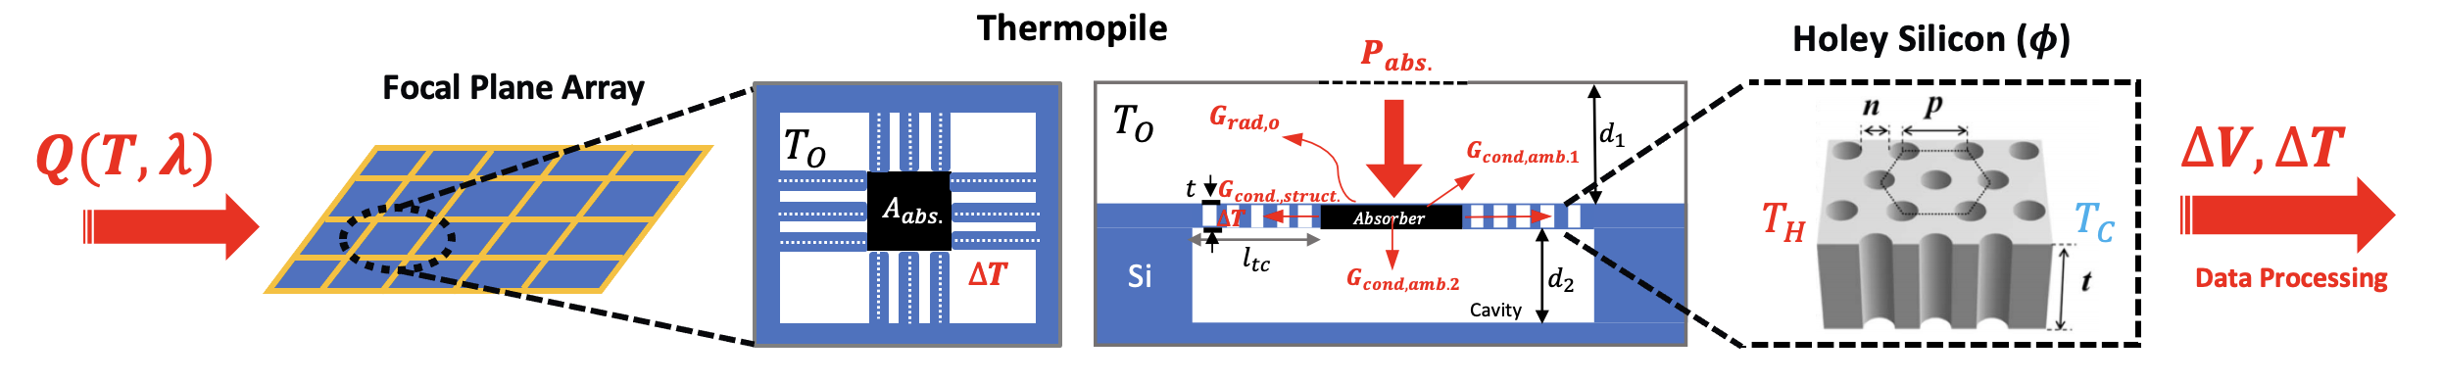

Figure 1. Holey silicon-based thermopile concept. The major difference is in replacing the combined use of bismuth telluride (BiTe)-based thermocouples and silicon nitride (SiN) support beams with holey silicon thermocouples that provide excellent thermal, electrical, and mechanical properties on their own without requiring additional support beams, which could lead to parasitic heat losses. The inset on the right illustrates the holey silicon and its dimensions pitch (p), neck (n), porosity (𝜙), and thickness (t) that govern thermal, electrical, and thermoelectric properties.

Table 1: Comparison of Thermopile Detector’s Specific Detectivity ${ D}^{*}$ [$cmHz^{1/2}/W$]
Mission (Launch Year) | Instrument | Specific Detectivity,${ D}^{*}$ @ 300K
Mars Reconnaissance Orbiter (2005) | MCS | $8.00×{10}^{8}$ [2] [3]
Lunar Reconnaissance Orbiter (2009) | Diviner | $8.00×{10}^{8}$ [2] [4]
CubeSats (2023) | PREFIRE | $1.69×{10}^{9}$ [3]
 | This Work | $$7.10×{10}^{9}$$

- Holey Silicon Thermopile Modeling

  - Thermopile Figure of Merit
The thermopile responsivity is defined as the output voltage signal of the detector produced in response to a given incident radiative power falling on the absorber, $R_{s}=V_{out}/P_{rad}=\frac{ηN\left(α_{p}-α_{n}\right)}{G_{th}(ϕ)\sqrt{1+(2πfτ)}}$, where 𝜂 is the absorption efficiency, 𝑁 is the total number of thermocouples/thermoelectric lines, 𝛼 is the Seebeck coefficient, 𝑓 is the operational frequency, 𝜏 is the thermal response time, and $G_{th}$ is the thermal conductance, which depends on geometry, thermal conductivity $(k)$, and the porosity (𝜙) of the holey silicon membrane. The responsivity reflects the gain of the detector or how sensitively the system responds to a thermal signal. The noise equivalent power (NEP) is the minimum radiant flux measured by the detector per unit of bandwidth, $NEP=V_{noise}{/R}_{s}=\frac{1}{η}\sqrt{4k_{B}T^{2}G_{th}(ϕ)}\sqrt{1+\frac{1+{\left(2πfτ\right)}^{2}}{\overline{ZT}}}$, where $\overline{ZT}$ is the effective thermoelectric figure of merit of the thermal detector and $k_{B}$ is the Stefan-Boltzmann constant. There are two dominant contributions of NEP given by its equivalent form in terms of the noise spectral density, $S_{noise}=\frac{NEP}{R_{s}}=\sqrt{S_{TF}^{2}+S_{Johnson}^{2} }$, where $S_{TF}$ is the phonon and photon noise due to temperature fluctuations across the thermal leg and $S_{Johnson}$ is the electronic noise generated by thermal excitation of the charge carriers from equilibrium. The most important figure of merit we propose to advance is the specific detectivity, $D^{*} =\frac{\sqrt{A∙Δf}}{NEP}=\frac{R_{s}\sqrt{A}}{S_{noise}}$ , which relates the absorber area, responsivity, and the noise spectral density. The higher the specific detectivity, the more responsive and sensitive the detector is. Based on these equations, reducing the thermal conductance, $G_{th}(ϕ)$, is the most effective way to improve the performance of thermopiles. A reduction in the thermal conductance results in a higher responsivity, translating to a higher specific detectivity.

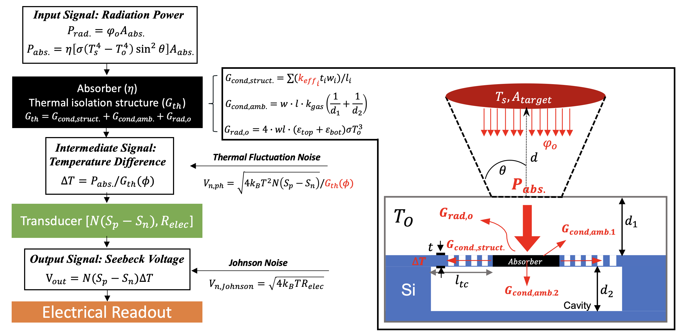
Figure 2. Flow diagram of the analytical model for holey silicon-based thermopile; the flow diagram shows the two signal transduction stages and the underlying noises within each stage. The inset illustrates the different heat transfer paths that take place in a thermopile pixel.

  - Analytical Modeling
Thermopile detectors are based on two signal transduction stages: Radiation to thermal, and thermal to electrical. In the first stage, the input radiation power is converted into heat by an absorber, which creates a temperature gradient in a thermal isolation structure. In the second stage, this intermediate signal is converted into the electrical voltage signal using a temperature difference transducer [11], $∆V=N(α_{p}-α_{n})∆T$. The inset in Figure 2 illustrates the heat transfer paths taken place in a thermopile pixel. The incident radiant power density, which depends on the field of view ($θ$) and the distance ($d$) between the source and absorber, are given by the Stefan Boltzmann law of radiation, $φ_{o}=σ\left(T_{s}^{4}-T_{o}^{4}\right)\sin^{2}{θ}$. The amount of heat absorbed, $P_{abs.}=ηφ_{o}A_{abs.}$, will diffuse through the holey Si membranes into the surrounding, as indicated by the red arrows. To analytically determine the responsivity, we compute the equivalent thermal conductance of the system, $G_{th}=P_{abs}/∆T=G_{cond,struct.}+G_{cond,amb.}+G_{rad,o}$, which sums up three major components: (1) conduction of the thermal isolation structure, including thermocouples (BiTe or doped Holey-Si) and SiN support beams (for conventional thermopiles design), $G_{cond,struct.}=∑({k_{eff}}_{i}t_{i}w_{i})/l_{i }$; (2) conduction of the static ambient gas, $G_{cond,amb.}=w_{abs.}l_{abs.}k_{gas}\left(1/d_{1}+1/d_{2}\right)$; (3) radiation between the absorber and the surrounding at background/operating temperature $T_{o}$, $G_{rad,o}≈4w_{abs.}l_{abs.}∙εσT_{o}^{3}$ (assuming $ΔT≪T_{o}$). In order to calculate the thermal conductance of Holey Si, we apply corrections on the effective thermal conductivity, $k_{eff}=\left(\frac{1-ϕ}{1+ϕ}\right)k_{holey Si}$, due to the porosity effect [with a correction factor of $\left(\frac{1-ϕ}{1+ϕ}\right)$ given by effective medium theory and the size effect at the micro-and nanoscales [12].

- Performance Predictions and comparisions
To have a fair performance comparison, we first benchmark the established design and system-level understanding from the state-of-the-art thermopile technology such as the Polar Radiant Energy in the Far-InfraRed Experiment (PREFIRE), in which a thermopile consists of a gold-black-based absorber and a series array of BiTe-based thermocouples and SiN support beams connecting the absorber to a substrate. Since the thermopile performance metrics strongly depend on the materials’ heat losses or their thermal conductivity, the holey silicon-based thermopile will simply use holey silicon in place of conventional BiTe-based thermocouples and SiN support beams without changing the overall dimension of the thermal isolation structure. We can also consider polysilicon (a special case where the neck size of holey silicon approaches infinity) in comparisons. The unique advantage of holey silicon lies in its low thermal conductivity which is strongly dependent on the size and the pore arrangement. With holey silicon, a significant reduction in thermal conductance is possible by unique interactions between phonons and boundaries that are defined by nanoscale pore designs.

3.1 Predicted Result
Figure 3(a) shows the effective thermal conductivity of a 300 nm-thick holey silicon membrane decreases with increasing porosity. For a constant pitch size of 100 nm (red curve), the holey silicon membrane with a neck size of 10 nm yields a porosity of 73% and an effective thermal conductivity of 0.3 W/mK, which is four times smaller than the thermal conductivity of BiTe compounds used in the PREFIRE (1.2 W/mK) and seven times smaller than the thermal conductivity of SiN (2.1 W/mK). For a different pitch size (e.g., the blue curve), the effective thermal conductivity exhibits high tunability for different neck sizes and porosity. Using the predicted thermal conductivity values for holey silicon, we compute the thermal conductance of the holey silicon-based thermopiles as a function of porosity. As indicated by the red curve in Figure 3(b), the conductive thermal conductance of thermoelectric lines, $G_{cond,TE}$ decreases from $4× {10}^{-7}$to $1.78 × {10}^{-8} W/K$ with increasing porosity from 3% to 73%. We can further optimize the holey silicon design and pore arrangement such that $G_{cond,TE}$ can be reduced to the point where the radiative thermal conductance (primary from the radiative heat loss of the absorber, also see the green-dash line) dominates.

Figure 3(c) shows the predicted specific detectivity versus thermal conductance (magenta curve). The magenta diamond shows the performance of poly-silicon-based thermopiles, and we normalized the x-axis by its total thermal conductance. The red star corresponds to the performance of the PREFIRE detector, which has a $D^{*}$ of $1.69 × {10}^{9}$ cm$Hz^{1/2}$/W. The blue dash-line shows the performance of the MSC detector, which has a $D^{*}$ of $8 × {10}^{8}$ cm$Hz^{1/2}$/W, and the rest of the scatter points represent different polysilicon-based thermopiles from literature [13]. Due to the highly tunable thermal conductivity of holey silicon, the pink-shaded area illustrates all the possible $D^{*}$ values for holey silicon-based thermopiles that have a similar geometrical configuration as the PREFIRE. The holey silicon-based thermopile can reach the same performance as the MCS and PREFIRE by reducing the thermal conductance (i.e., tuning the pitch, neck size, and porosity). Further geometric optimization of the thermoelectric lines using the analytical model shows that the holey silicon-based thermopile can outperform the PREFIRE by a factor of 4 (see Table 2.2 and the orange cross in the figure).

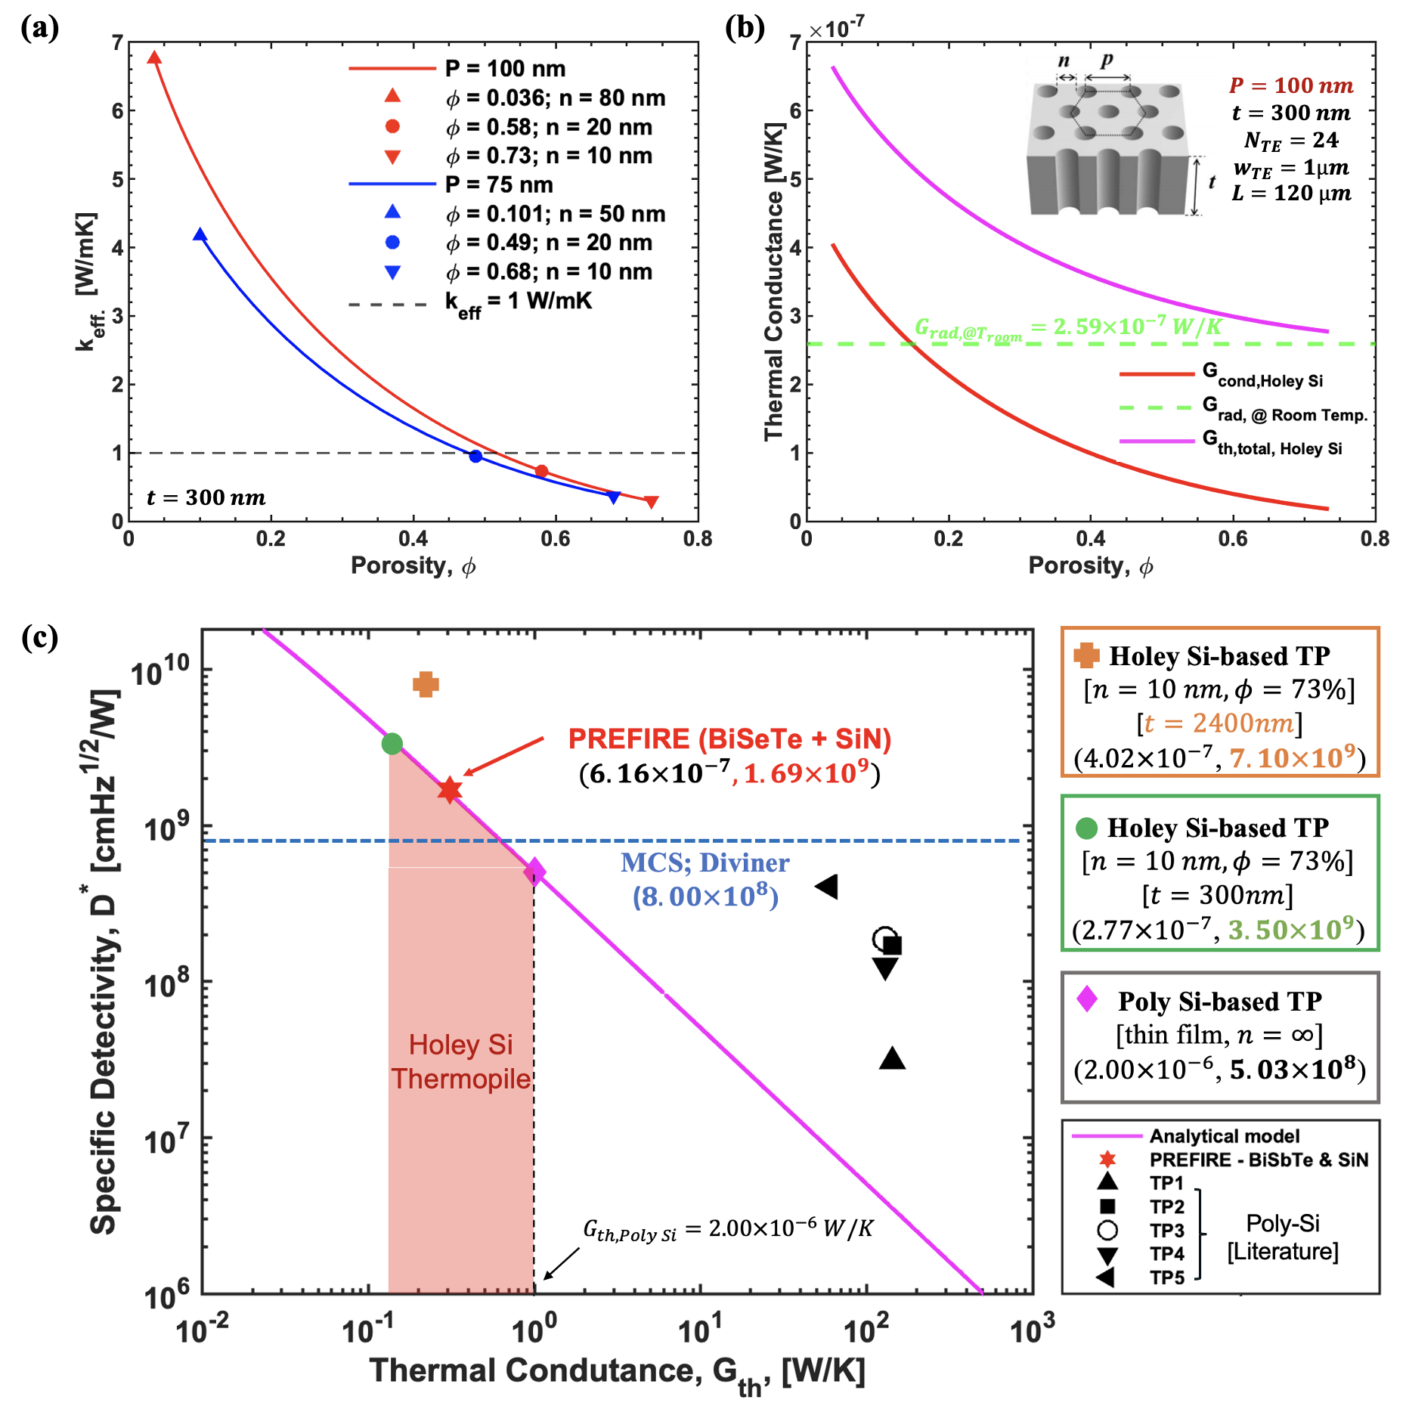
Figure 3. (a) Size and porosity effects on the effective thermal conductivity of holey silicon; (b) Conductive and radiative thermal conductance of holey silicon-based thermopile versus porosity. (c) Design space for thermopiles of different material selections and configurations.

Table 2.1: Comparison of Thermal Properties for Different Material Choices
Configuration/Material Selection | $$k_{eff}\left[W/mK\right]$$ | $$G_{cond,TE} \left[W/K\right]$$ | $$G_{th,total }\left[W/K\right]$$
BiTe + SiN  (PREFIRE in CubeSats 2023) | $$1.2 (BiTe)$$  $2.1 (SiN$) | 8.40 E-8 $(BiTe$)  2.52 E-8$(SiN$) | 6.16 E-7
Poly-Silicon (Reference Material)  ($ϕ=0\% ;n= ∞ nm;P=100 nm$ )  $$t_{TE}=0.3 μm;w_{TE}=1μm;L_{TE}=120 μm$$ | $$29$$ | 1.74 E-6 | 2.00 E-6
Holey Silicon (This Project)  ($ϕ=73\%;n=10 nm;P=100 nm$)  $$t_{TE}=0.3 μm;w_{TE}=1μm;L_{TE}=120 μm$$ | $$0.30$$ | 1.80 E-8 | 2.77 E-7

Table 2.2: Comparison of Thermopile Figures of Merit for Different Material Choices
Configuration/Material Selections | $$R_{el}$$  $$[Ω]$$ | $$S_{Johnson}$$  [$V/\sqrt{Hz}$] | $$G_{th,total}$$  $$[W/K]$$ | $$S_{Thermal}$$  [$V/\sqrt{Hz}$] | $$Rs$$  [$V/W$] | $$M_{2}$$ | $$D^{*}$$  $$\left[\frac{cm\sqrt{Hz}}{W}\right]$$
BiTe + SiN  (PREFIRE in CubeSats 2023)  $k_{BiTe}=1.2\frac{W}{mK}$; $k_{SiN}=2.1\frac{W}{mK}$  $$N_{TE}=24; L_{TE}=120 μm$$  $t_{TE}=0.35 μm$; $w_{TE}=1μm$  $t_{SiN}=0.3 μm$; $w_{SiN}=2μm$ | 1.23E+5 | 4.52E-8 | 6.16E-7 | 9.20E-9 | 4.34E+3 | 0.79 | 1.69E+9
Poly-Silicon  (Reference Material)  ($k=29\frac{W}{mK}$)  $$N_{TE}=24; L_{TE}=120 μm$$  $t_{TE}=0.3 μm$; $w_{TE}=1μm$ | 1.08E+5 | 4.23E-8 | 2.00E-6 | 4.54E-9 | 1.19E+3 | 0.50 | 5.02E+8
Holey Silicon  (This Project)  ($ϕ=73\% and k=0.30\frac{W}{mK}$)  $$N_{TE}=24; L_{TE}=120 μm$$  $t_{TE}=2.4 μm$; $w_{TE}=1μm$ | 3.76E+4 | 2.50E-8 | 4.02E-7 | 2.28E-9 | 1.33E+4 | 1.15 | 7.10E+9

3.2 Temperature-dependent performance
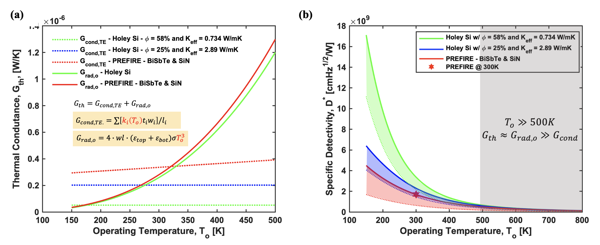
Figure 4. Effect of operating temperature on (a) thermal conductance and (b) specific detectivity $D^{*}$

While the predictions above are based on room temperature operation (300K), the performance of holey silicon-based thermopiles at various operating temperatures (e.g. extremely cold environments) is equally important. In order to investigate the effect of background/operating temperature, $T_{o}$, on the specific detectivity, $D^{*}$, we evaluated the temperature-dependent radiative thermal conductance ($G_{rad,o}∝T_{o}^{3}$) and made several assumptions on the temperature-dependent thermal conductivities of BiSbTe, SiN, and Holey-Si based on literature reported values [14-15]. We found that Holey Si-based thermopiles show significant improvement in $D^{*}$ for $T_{O}<300K.$ The improvement is more prominent at low temperature and high porosity because the contribution from $G_{rad,o}$ is small at low-temperature and we can further reduce $G_{cond,TE}$(e.g. using the porosity effect) to the point where $G_{rad,o}$ becomes dominant, as illustrated on Figure 4(a). As shown by the green curve in Figure 4(b) that corresponds to a holey silicon membrane with a porosity of 58%, the $D^{*}$ approaches the background limit of 1.8 $×{10}^{10}$as the temperature drops to 150K. Nevertheless, for $T_{o}> 500K$, the total thermal conductance is dominated by radiation, $G_{th,total}≈G_{rad,o}≫G_{cond,TE}$, and the reduction on $G_{cond,TE}$ using holey silicon plays a negligible role in $D^{*}$ improvement.

- EXPECTED SIGNIFICANCE

According to the Planetary Science and Astrobiology Decadal Survey 2023-2032 [7], the highest priority for a Flagship mission was given to a robotic mission that would explore Uranus. This mission would deliver an in-situ atmospheric probe into Uranus’ atmosphere and conduct a multi-year orbital tour to study the ice giant and its system. This mission is known as the Uranus Orbiter and Probe (UOP), whose scientific objectives would include the study of Uranus’ interior, atmosphere, magnetosphere, satellites, and rings. Ice giants are the least studied planets in our solar system and an important analog for exoplanets because a large fraction of exoplanets fall in the size-range of sub-Neptunes (e.g., [8]). One of our most serious knowledge gaps is our understanding of the atmospheres of ice giants. While zonal circulation is evident in imagery of cloud belts, the meridional circulation that continually overturns these belt systems in the North-South direction is much less accessible. Hence our understanding of the circulation of various parts of the atmosphere is limited, and the coupling between these parts is not understood [9]. Atmospheric temperature measurements have been used to constrain vertical motions in the atmospheres of terrestrial planets such as Earth and Mars (e.g., [10]). At the ice giants such measurements would be enabled by nadir sounding of the flank of the collision-induced absorption of H₂ over a wavelength range between 26 and 43 μm, providing temperature information from the upper troposphere (~1 bar) at the longer end to the lower stratosphere (~30 mbar) at the shorter end of the wavelength range. An instrument with established thermopile technology such as COBRA would require integration times around 100 seconds to achieve a suitable signal-to-noise ratio (SNR) at shorter wavelengths. Given a typical orbit for an ice giant orbiter mission [11] this would translate to a ground sample distance (GSD) of ~2000 km, or 5º latitude, near periapsis, much larger than the expected footprint of ~100 km. The increased specific detectivity of the proposed technology would decrease the required integration time to 5 seconds, and the GSD to 100 km, comparable to the size of the actual footprint. This way, small-scale motions such as traveling waves or convective systems could be observed, not only in temperature but in tracers of atmospheric motion such as the ortho-/para hydrogen ratio. In addition, the increased sensitivity would allow limb sounding around periapsis of the highly elliptical orbit of an ice giant orbiter, which would extend the vertical range of temperature measurements to ~2 mbar and allow simultaneous profile measurements of C₂H₂, providing a direct picture of the large-scale circulation in ice giant atmospheres.

Infrared observations of icy satellites have revealed unconsolidated or porous regolith covering their surfaces [12]. Thermal inertia is a measure for this porosity and can be derived by observing thermal emission at multiple times of the day. Thermal emission measurements of the satellites of ice giants would be predominantly made at wavelengths between 50 and 100 μm, covering the peak of the Planck function at low temperatures. A proposed tour for measurements of the Uranus system includes flybys of the Uranian satellites in close proximity [11] so that thermal inertia and potential thermal anomalies could be measured. Trajectories would dictate integration times of order 0.1 s in order to achieve GSDs of 1 km. For typical daytime surface temperatures of 60 K this can be achieved using established thermopile technology with a noise equivalent temperature difference (NEdT) of well below 1 K. However, for daytime surface temperatures of the Neptunian satellite Triton (~38 K [13]) as well as nighttime temperatures, a higher detectivity is required. The increased specific detectivity of the proposed technology would yield NEdTs of ~1 K at temperatures as low as 25 K, enabling temperature measurements of the Neptunian satellites, at icy satellites with large ranges of times of day to obtain thermal inertia, as well as in the cold, permanently shaded areas of Earth’s moon.
- CONCLUSION

Holey silicon-based thermopiles can be designed to address the sensitivity requirements for future planetary science missions that are targeting very cold objects such as ice giant planets, icy regoliths, planetary satellites, and primitive bodies. Compared to previous thermopile designs, the proposed design is expected to offer a significantly better sensitivity (nine times better than the previously flown instruments and 4 times better than the state-of-the-art instrument), and the major difference is in replacing the combined use of bismuth telluride (BiTe)-based thermocouples and silicon nitride (SiN) support beams with holey silicon thermocouples that provide excellent thermal, electrical, and mechanical properties on its own without requiring additional support beams. The holey silicon-based thermopiles will enable breakthroughs in spectroscopy and multispectral measurements and help scientists discover new information about the ice giants. We are currently designing a fabrication flow for the prototype holey silicon-based thermopiles and planning to carry out optical characterization of these detectors to confirm our proof-of-concept design and analysis.

ACKNOWLEDGMENTS

The authors gratefully acknowledge funding support for this work provided by the NASA Space Technology Graduate Research Opportunities (NSTGRO – Grant number 80NSSC23K1221).

References
[1] | M. Foote* and M. Kenyon, "Thermopile Detector Arrays for Space Science Applications," International Thermal Detectors Workshop (TDW), 2003.
[2] | D. J. McCleese and et. al., "Mars Climate Sounder: An investigation of thermal and water vapor structure, dust and condensate distributions in the atmosphere, and energy balance of the polar regions," J. Geophys. Res., Vols. 112, E05S06, 2007.
[3] | D. A. Paige and et al., "The Lunar Reconnaissance Orbiter Diviner Lunar Radiometer Experiment," Space Sci. Rev., Vols. 150, 125-160, 2010.
[4] | B. J. Fulton and E. A. Petigura, "The California-Kepler Survey. VII. Precise Planet Radii Leveraging Gaia DR2 Reveal the Stellar Mass Dependence of the Planet Radius Gap," Astron. J., Vols. 156, 264, 2018.
[5] | L. N. Fletcher and et al., "Ice giant circulation patterns: Implications for atmospheric probes," Space Sci. Rev., Vols. 216, 21, 2020.
[6] | D. J. McCleese and et al., "Intense polar temperature inversion in the middle atmosphere on Mars," Nature Geosci., Vols. 1, 745-749, 2008.
[7] | M. Hofstadter and et al., "Ice giants pre-decadal survey mission study report," NASA, 2017.
[8] | C. Ferrari, "Thermal properties of icy surfaces in the outer solar system," Space Sci. Rev., Vols. 214, 111, 2018.
[9] | B. Conrath and et al., "Infrared Observations of the Neptunian System," Science, Vols. 246, 1454-1459, 1989.
[10] | U. Dillner, E. Kessler and H. Meyer, "Figures of merit of thermoelectric and bolometric thermal radiation sensors," J. Sens. Sens. Syst., Vols. 2, 85–94, 2013.
[11] | A. I. Hochbaum, "Enhanced thermoelectric performance of rough silicon nanowires," Nature, vol. 451, 2008.
[12] | A. Boukai, "Silicon nanowires as efficient thermoelectric materials," Nature, Vols. 451, 168–171, 2008.
[13] | Z. Ren and J. Lee, "Thermal conductivity anisotropy in holey silicon nanostructures and its impact on thermoelectric cooling," Nanotechnology, vol. 26;29(4):045404, 2018.
[14] | M. Holland, "Analysis of lattice thermal conductivity," Phys. Rev., vol. 132 2461–71, 1963.
[15] | C.-N. Chen, "Fully quantitative characterization of CMOS–MEMS polysilicon/titanium thermopile infrared sensors," Sensors and Actuators B: Chemical, Vols. 892-900, 2012.
[16] | M. Kenyon, "2D-Thermopile Model".
[17] | R. Sultan, A. D. Avery, G. Stiehl and B. L. Zink, "Thermal conductivity of micromachined low-stress silicon-nitride beams from 77 to 325 K," Journal of Applied Physics , Vols. 105, 043501, 2009.
[18] | J. Tang, "Holey Silicon as an Efficient Thermoelectric Material," Nano Lett., Vols. 10, 10, 4279–4283 , 2010.
[19] | VV2011, "Vision and Voyages from planetary science in the decade 2013-2022," The National Academies Press, Washington, D. C., 2011.

