Current usage of sounding rockets to study the upper atmosphere

Scott E. Heatwole
NASA Goddard Space Flight Center’s Wallops Flight Facility
Email: scott.e.heatwole@nasa.gov

Abstract
Soundings rockets have played and continue to play a key role in the modeling of the upper atmosphere and predicting weather. Dr. Goddard's insight into the usefulness of rockets for this application came at a time when measurements had not been made above the troposphere. Present-day developments in sounding rockets have allowed more elaborate experiments to make measurements with multiple rockets and ejected sub-payloads allowing for in situ spatial and temporal measurements of the upper atmosphere, thus contributing to our understanding of both terrestrial weather and space weather.

Introduction

In his note, "The Possibilities of the Rocket in Weather Forecasting"(1), Robert H. Goddard envisioned possibilities that would take over three decades to come to fruition.

Insert Figure 1 about here

The key insight in Dr. Goddard's paper was that rockets could be used to sample the atmosphere providing information to forecast weather. At the time of its writing, the troposphere was the highest in the atmosphere that measurements had been taken but it was apparent that the upper atmosphere had a key influence on weather. His vision was for multiple rockets at separate stations to make simultaneous soundings of the atmosphere to give a better picture of current conditions and thus enhance the ability to model the atmosphere and thus forecast the weather.

The atmosphere consists of six layers (see Table 1). The lowest is the troposphere and is the densest. It is followed by the stratosphere where the ozone layer is located, and solar ultraviolet radiation is absorbed. The mesosphere is next and here air glow and clouds of ice particles (noctilucent clouds) are found. Above the mesosphere is the thermosphere where auroras form. This layer’s thickness depends on ebbs and flows of the solar cycle. The ionosphere exists in the mesosphere up past the thermosphere to the edge of space and consists of a layer electrons and ionized atoms and molecules. This layer grows and shrinks based on solar conditions. Lastly is the exosphere, which extends up to 10,000 km, and is where Earth's magnetic field interacts with solar particles.

Table 1. Layers of the atmosphere and rough altitude range

Layer | Rough Altitude Range (km)
Troposphere | 8 - 14.5
Stratosphere | 14.5 – 50
Mesosphere | 50 – 85
Thermosphere | 85 - 600
Ionosphere | 48 – 965
Exosphere | 600 – 10,000

Dr. Goddard envisioned sounding rockets, which carry a payload suborbitally along a parabolic trajectory. Since the writing of Dr. Goddard’s paper, sounding rockets have been used to make in situ measurements of every atmospheric layer. Current sounding rockets allow for complex investigations of the dynamics in the atmosphere and provide an understanding that cannot come from remote sensing via ground-based or space-based assets alone. This article will survey some of the initial applications of sounding rockets for meteorological study but focus on the use of sounding rockets in geospace research (research of Earth’s upper atmosphere and nearby outer space, including space weather) during the last decade since 2013.

Early Weather Rockets

The troposphere and stratosphere were the first layers where sounding rockets made meteorological measurements. Many of these meteorological observations were conducted with a small-diameter Loki anti-aircraft rocket (developed in the late 1950’s) using the Dart payload.(2) The Loki - Dart could reach 65km with a chaff payload which was tracked by ground-based radar (3). The Loki - Dart eventually evolved into the Super Loki - Dart capable of altitudes as high as 85km. Various versions of the Dart carrying different measurement devices were developed including the PWN-12 (4) carrying a ROBINSphere. The ROBINSphere is very like the idea proposed by Dr. Charles Abbot mentioned in Dr. Goddard's paper. A one-meter diameter sphere was fabricated of 1/2-mil mylar and had a built-in, aluminized 1/4-mil mylar corner reflector. After ejection from the rocket, at a height of about 70 km, the sphere was inflated to a super-pressure of 10-12 millibar via vaporization of 35 cc of isopentane which was carried within it in a small capsule. Radar was then used to track the falling ROBINSphere and position data thus obtained could be reduced to determine density, temperature, and wind velocity versus altitude (5).

Measurements like these played a large role in the empirical data that contributed to the creation of models for the upper atmosphere in the US standard atmospheric models in the 1950’s, 1960’s and 1970’s (6,7). Hundreds of rockets a year were launched across the world in support of this effort very similar to that envisioned by Dr. Goddard.

Current Geospace Sounding Rockets

Since the inception of the NASA sounding rocket program (NSRP) in 1959, some 3,000 missions have flown (8). The program provides low-cost quick access to scientific and technology demonstration investigations. Science includes investigations of the upper atmosphere, plasma physics, solar physics, planetary atmospheres, galactic astronomy, high energy astrophysics, and microgravity research. In the mid-1980s, the NSRP was consolidated at the Wallops Flight Facility of NASA’s Goddard Space Flight Center.

NSRP relies heavily on surplus military rockets to keep costs low. Utilizing between one to four stages, with a mix of military surplus booster and commercial sustainer motors, payloads can reach altitudes as high as 1600km with times above 100km on the order of 5-20 minutes. Figure 2 shows the current stable of vehicles utilized by NSRP. There are currently 12 different vehicles allowing scientists a range of mission profiles. Figure 3 shows the varying altitudes and times above 100km versus payload weight.

Insert Figure 2 about here

Insert Figure 3 about here

Over the last decade, NSRP has launched 57 atmospheric science rockets from 6 different launch ranges. Roughly 5 rockets per year have been launched with a 93% success rate. Table 2 shows the different launch ranges and the number of rockets launched from each. Launch ranges nearest the pole are utilized the most since they provide access to the polar region where the ionosphere interacts with solar particles.

Table 2. Launch ranges and number of flights flown in support of geospace science by NSRP in the last decade (2013-2023)

Launch Range | Missions Flown
Wallops Island, Virginia | 7
White Sands, New Mexico | 6
Fairbanks, Alaska | 20
Andøya, Norway | 13
Kwajalein, Marshall Islands | 6
Svalbard, Norway | 5

To support the mission goals in the geospace science area, the rockets flown have utilized most of the launch vehicles in the current NSRP stable. Table 3 shows the vehicle and number of geospace missions launched using that vehicle.

Table 3. Vehicles and number of flights flown in support of geospace science by NSRP in the last decade (2013-2023)

Vehicle | Missions Flown
Black Brant (BBV) | 1
Terrier – Malemute (no longer flown) | 1
Terrier – Black Brant – Nihka (BBX) | 2
Terrier – Black Brant (BBIX) | 24
Terrier – Improved Orion | 7
Terrier - Oriole | 2
Terrier – Improved Malemute | 7
Terrier – Oriole - Nihka | 1
Talos – Terrier – Oriole | 0
Talos – Terrier – Oriole - Nihka | 4
Talos – Terrier – Brant | 2
Talos – Terrier – Brant - Nihka | 7

Table 4 shows the atmospheric layer that these missions have investigated. Some missions look at multiple layers or interactions between layers. Fifteen missions have been dedicated to study phenomena related to auroras.

Table 4. Layers of the atmosphere and number of missions flown to sample it (some missions looked at multiple layers)

Layer | Missions Flown
Stratosphere | 0
Mesosphere | 12
Thermosphere | 41
Ionosphere | 32
Exosphere | 3

The key advantage to sounding rockets for atmospheric measurements is that they can directly sample the mesosphere and thermosphere. Balloons and aircraft cannot get above the stratosphere and satellites fly above these layers. Most of the geospace investigation with sounding rockets have been in the region of the mesosphere and thermosphere. Due to their inaccessibility, these atmospheric layers are the least understood, and sounding rockets provide a unique way to make measurements. In the last decade, 12 rockets have been flown by NSRP investigating the mesosphere and another 41 missions investigated the thermosphere.

Studies that incorporate the study of solar particles and interaction with the magnetosphere and atmosphere are also important as they better help to model space weather which has a direct impact on satellites and radio signals. Recent geomagnetic storms in 2024 have greatly increased the size of the thermosphere and decreased the lifespans of many low earth orbit spacecraft as well as increasing ionospheric activity which has interrupted GPS signals on the ground.

Sounding rockets provide a platform where unique experiments can be undertaken that couldn’t not be done via any other method. NSRP has launched 58 rockets in the support of 39 different missions. There have been more than 17 multiple rocket missions that help to make spatial and short-term temporal measurements in the atmosphere. This number does not account for missions with multiple sub-payloads or micro payloads that are ejected to gain larger spatial measurements in a particular region.

Recently, the Swarm system was developed intended to enable several dozen very small sub-payloads to be ejected at once from a single main payload. Each Swarm payload is 3.4" diameter and 13.2" long, weighing roughly 5 lbm. They can be spring-launched, or rocket-propelled. The experiment section is 3.4” diameter and 5.85” long. Swarm contains a transmitter allowing science data to be sent back to the main payload and telemetered to the ground. What makes Swarm unique is that it allows for many small sensor packages or chemical dispersals to be used on a single rocket payload. Telemetry rates on the order of 1 Mbps are possible and distances of up to 35km from the main payload can be achieved. The Swarm system allows for complex measurements of turbulence, plasmas, magnetic fields, and particle densities over larger areas and at different layers simultaneously. Figure 4 shows the Swarm payloads that were flown on the KINET-X mission aboard a Black Brant XII-a rocket. These four Swarm sub-payloads made measurements of magnetic field and ion flux over several kilometers observing atmospheric interaction with the main payload’s release of barium.

Insert Figure 4 about here

One mission, C-REX, had 24 sub-payloads. Each payload contained a barium/cupric oxide mixture with a small amount of strontium, or a barium cupric oxide mixture with a small amount of lithium divided into sets of four, which were deployed over an altitude range of 150 - 400 km at 50 km intervals. Small commercial rocket motors propelled the ampules up to 30km from the main payload. The chemical releases fluoresced with different colors depending on the chemical mixture and allowed for ground-based optics at multiple locations to observe the dispersal via neutral winds.

Conclusion

Geoscience research via the NSRP is actively seeking to better understand how the Sun interacts with Earth’s atmosphere and mechanisms within the atmosphere. This research will help to better forecast weather on the surface all the way up to space. Over the last decade, NSRP has facilitated new instruments for studying the upper atmosphere in new and innovative ways. Whether solar particles interacting with the magnetosphere or solar radiation driving mixing in different layers of the atmosphere, sounding rockets are providing new insights into how the atmosphere works over 100 years after Dr. Goddard's paper describing how rockets could be used for weather prediction.

References Cited

- R. H. Goddard, “The Possibilities of the Rocket in Weather Forecasting.” Proceedings of the National Academy of Sciences of the United States of America 6(8): 493–95 (1920).
- E. Charlton, C. Bjork, R. Lewis, P. Newman, “LOKI Antiaircraft Free-Flight Rocket December 1947 - November 1955”, Redstone Arsenal (1957).
- B. Bollermann, R. Walker, “Super Loki Dart Meteorological Rocket System”, Space Data Corporation SDC TM-310 (1968).
- B. Bollermann, R. Walker, “Design, Development and Flight Test of the Super Loki Stable Booster Rocket System”, AFCRL-TR-73-0412 (1973).
- R. Leviton, J. Wright, “Accuracy of Density from the ROBIN Falling Sphere”, AFCRL 1095, GRD Research Notes No. 73 (1961).
- US Standard Atmosphere, NOAA/NASA/USAF, pg. 20-21 (1962).
- US Standard Atmosphere, NOAA/NASA/USAF, pg. 21 (1976).
- R. Burth, et. al., NASA Sounding Rocket User Handbook, NASA/TP-20230006855 (2023).

Figure Legends
Figure 2. Current NSRP vehicle stable.
Figure 3. Carpet plot of apogee altitude and time above 100km for the various vehicles used by NSRP.
Figure 4. Swarm payload that flew on the KINET-X mission.

Figures and Tables

Figure 2. Current NSRP vehicle stable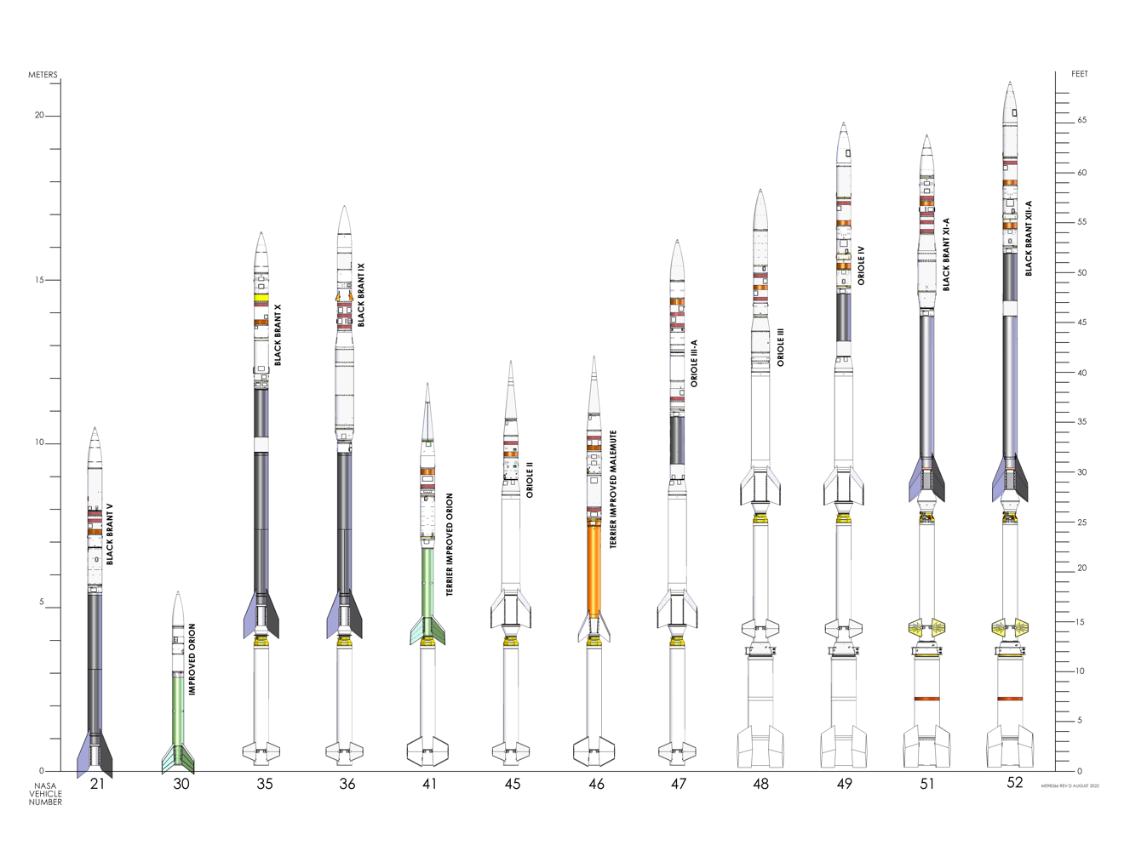

Figure 3. Carpet plot of apogee altitude and time above 100km for the various vehicles used by NSRP

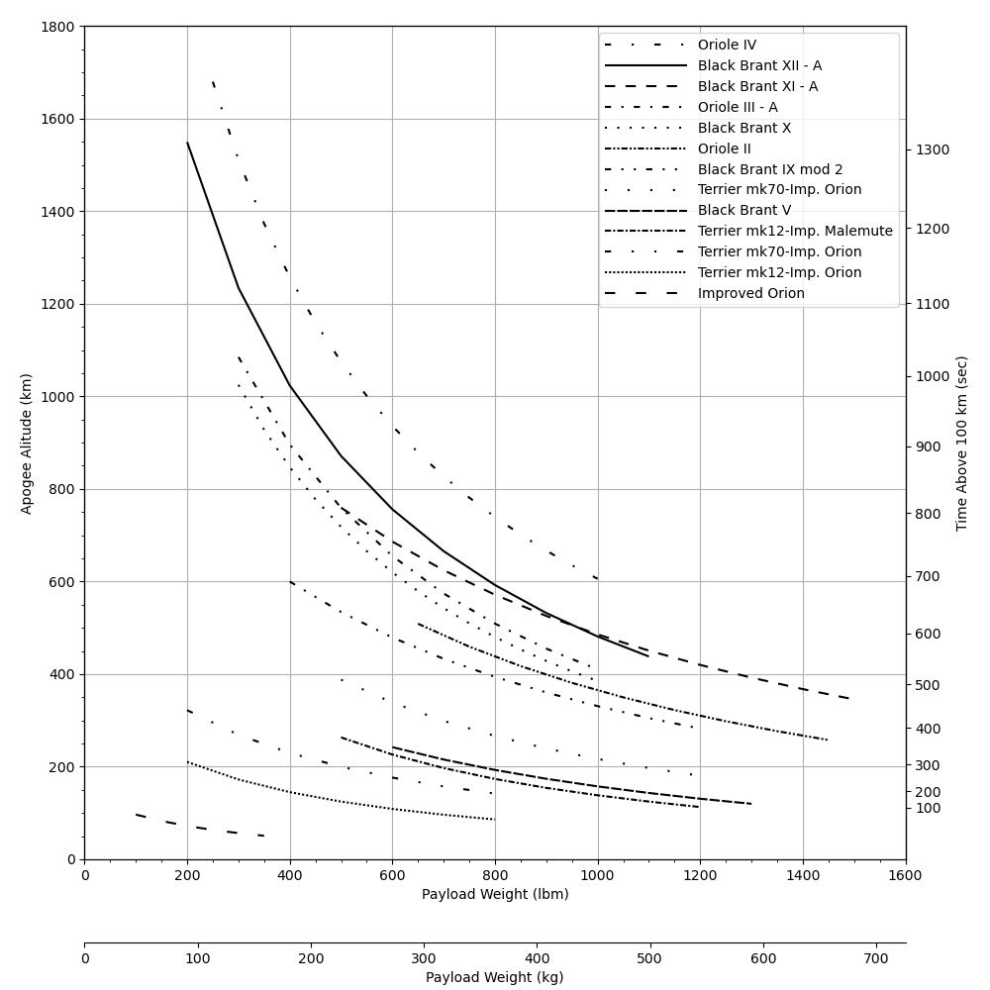

Figure 4. Swarm payload that flew on the KINET-X mission

