Peri-flight NMSK Injuries

Review of Peri-flight Neuromusculoskeletal Injuries in Astronauts

Abstract Word Count: 249

Word Count for Manuscript: 6721

Number of References: 81

Number of Tables: 3

Number of Figures: 6

**Abstract**

**Introduction:** The space sector is growing remarkably fast. Its value is expected to increase from $447 billion in 2022 to $2.7 trillion by 2040.The demand for astronauts and astro-civilians is growing and there will be an increased need for experts who understand the effects of spaceflight on the neuromusculoskeletal (NMSK) system. Orthopedic specialists in space medicine are sparsely reported in the literature and standards of care for astro-civilians are not well established. This review discusses the current prevalence of peri-flight NMSK injuries in astronauts, the role of orthopedic specialists, and considerations for standards of care for astro-civilians. **Methods:** A systematic review using PubMed, MEDLINE, and National Aeronautics and Space Administration Technical Report Server was performed to identify original research containing NMSK injuries in astronauts. **Results:** Twenty-nine studies were included in the review. The prevalence in 2388 documented injuries during pre-flight is 46.5%, in-flight is 37.0%, and post-flight is 16.5%. The prevalence in 2081 documented injury locations of the upper extremity is 32.4%, shoulder is 31.4%, back is 26.4%, lower extremity is 5.5%, and neck is 2.3%. **Discussion:** Common peri-flight injuries involve the shoulder, back, and hand such as shoulder tendonitis, space adaptation back pain, and herniated nucleus pulposus. It is critical to consider NMSK injuries for the growing space sector. As public interest grows, costs related to space are expected to decrease. Decreased costs increase accessibility to space and consequently the risk of NMSK injuries, increasing the demand for medical standards and experts in orthopedics and space medicine.

**Key Words:** Pre-flight, in-flight, post-flight, astro-civilians, orthopedic

**Introduction**

The role of orthopedists in space medicine is sparsely reported in literature and public data documenting orthopedic consults of astronauts is limited. A need of orthopedic specialists for astronaut health is highlighted by 247 individual orthopedic consults from 2012 to 2016 at the National Aeronautics and Space Administration (NASA) for orthopedic related injuries.1 Of these consults, 180 were new and 66 were follow-ups. Neuromusculoskeletal (NMSK) injuries obtained by astronauts are of unique mechanisms and may occur during pre-flight training, in-flight operations, and post-flight reconditioning.2

Pre-flight NMSK injuries occur in a variety of locations and environments including: pre-flight pressure training, vacuum chambers, the Weightless Environment Training Facility, the Neutral Buoyancy Laboratory (NBL), T-38 flight operations, parabolic flight, analog environments, extracurricular activities and physical fitness training.1,2 The most common injury involves the shoulder during extravehicular activity (EVA) training complicated by the central component of spacesuits.1 Complications of the shoulder include strain, tendonitis, rotator cuff overuse, bursitis, acromioclavicular joint pain, glenohumeral joint pain, anterior impingement of the subscapularis, and tenosynovitis.1,2 Other injuries include cervical, thoracic strain, and lumbar spasm of the spine, lateral epicondylitis and cubital tunnel syndrome of the elbow, carpal tunnel syndrome and Dequervan’s tenosynovitis of the wrist and forearm, onycholysis of the fingers due to excess glove moisture, and peripheral nerve impingement.

The most common NMSK problem is space adaptation back pain seen in the early phase of space flight and has been documented at an occurrence rate of 52%.3 Hand injuries are common in-flight and most are manifestations of abrasions and small lacerations due to in-cabin crew activities such as aerobic and resistance exercise and translating between modules. EVA suit components are the most common causes of NMSK injuries.4 Muscle volume atrophy and strength decrease have been reported at rates between 4-16% and 9-11%, respectively, during 5-to-17-day Space Shuttle missions5,6,7 and muscle atrophy between 12-20% during 16-to-28-week flights.8 Astronauts may lose up to 1 to 2.4% bone mineral density in the hip and lumbar spine per month.9,10

Post-flight NMSK injuries in astronauts include nucleus pulposus herniation with an incidence rate of 4.3 times compared to individuals who have not undergone spaceflight.11 Interestingly, a case of a rare occurrence of a cervical spine intervertebral disc herniation in-flight and led to the development of a novel NMSK treatment program designed for that astronaut.12

As of 2022 the space market is worth approximately $447 billion and is estimated to be worth $2.7 trillion by 2040.13,14 As the space sector continues to expand and become more accessible, the demand for astronauts and civilians going to space will increase. Astronauts are at risk for unique mechanisms of orthopedic related injuries that may be obtained pre-flight, in-flight, and post-flight. Increased demand for astronauts and astro-civilians will increase the demand for orthopedic specialists in aerospace and space medicine due to a probable increase in incidence of NMSK injuries.

Orthopedic standards of care for astro-civilians are not well established. With the continued progress of NASA’s Artemis campaign and goals of commercial space travel via the private sector, there is a growing need to establish standards of care for astro-civilians. Moreover, considerations should be made for a sports medicine team concept that aims to care specifically for astronauts and astro-civilians during peri-flight operations.

**Methods**

The authors of this review strictly adhered to the Preferred Reporting Items for Systematic Reviews and Meta-Analyses guidelines (Fig. 1). A literature search of the electronic databases PubMed, MEDLINE, and NASA Technical Report Server Publicly Available Content was performed to identify articles eligible for inclusion. Primary search terms used were “musculoskeletal,” “orthopedic”, “astronaut”, and “injuries”. Eligible articles were filtered through exclusion and inclusion criteria set. There were no restrictions on date, age, or patient sex. Article reference lists were further examined to identify additional eligible articles. The last systematic review conducted on pre-flight, in-flight, and post-flight MSK injuries in astronauts by Ramachandran et al.2 was used to identify additional references. The data from the Longitudinal Study of Astronaut Helath (NASA) was cited via Ramachandran et al.2 as the article could not be found using the search criteria.The search took place from August 2023 to October 2023.

**Procedure**

Review exclusion criteria included 1) review papers, 2) did not discuss neuromusculoskeletal or orthopedic injuries in astronauts, 3) gathered data via non-human subjects, 4) utilized simulated microgravity, 5) not available in English, 6) commentary papers, 7) not available in full text, 8) were duplications. Studies were included if they contained enumerated data concerning NMSK or orthopedic injuries in astronauts during pre-flight, in-flight, or post-flight conditions. Data that met exclusion and inclusion criteria was gathered via original research articles, conference papers, conference posters, conference presentations, technical reports, and unpublished data.

Initial searches yielded a total of 628 results. Using keywords “musculoskeletal”, “orthopedic”, “astronaut” and “injuries” on PubMed yielded 70 results. Using keywords “musculoskeletal OR orthopedic astronaut injuries” on MEDLINE yielded 32 results. Using keywords “musculoskeletal astronaut injuries” on NASA Technical Report Servers Publicly Available Content yielded 526 results. Results from the three electronic databases were filtered via exclusion criteria. A total of 84 reports were assessed for eligibility via inclusion criteria and for duplication and 18 reports were eligible for this review. A total of 11 reports were assessed for eligibility via a prior systematic review by Ramachandran et al.2 and references from eligible reports and all 11 were eligible for this review. A total of 29 reports are used in this review.

One investigator independently reviewed the titles and abstracts of search results from PubMed, MEDLINE, and NASA Technical Report Servers and filtered eligible papers via exclusion criteria. Articles that met exclusion criteria were assessed as full manuscripts for inclusion criteria. Eligible articles references were assessed. A previous systematic review’s references were assessed. Eligible articles containing pre-flight, in-flight, and post-flight NMSK injuries in astronauts had their data containing astronaut sample sizes, number of injuries, and injury types extracted into Microsoft Excel.

**Statistical Analysis**

All eligible study’s data was extracted as astronaut sample size and categorized as pre-flight, in-flight, and post-flight injuries. The prevalence of each category of number of documented injuries in pre-flight, in-flight, and post-flight was calculated using Microsoft Excel. Eligible study’s documented number of injury locations was extracted, and the prevalence was calculated using Microsoft Excel. Injury location categories include head and face, neck (cervical), back (thoracic, lumbar, sacral, coccyx), shoulder, upper extremity (arm, elbow, wrist, hand, fingers), hip (pelvis and proximal femur), groin, lower extremity (thigh, knee, lower leg, ankle, foot), and general.

**Results**

NMSK injuries are the most common type of injury sustained in astronauts. With the creation of the International Space Station (ISS) and average space missions’ length increasing to 6-months, NMSK injuries sustained from long-term spaceflight during in-flight operations and post-flight became more apparent.2 Eligible articles containing data for NMSK injuries in astronauts were categorized as pre-flight, in-flight, and/ or post-flight types in Table I. The sample size of astronauts, type of article paper, year of publication, and authors were documented. The prevalence of documented pre-flight, in-flight, and post-flight injuries and injury locations were calculated from the data extracted from the systematic review.

Pre-flight NMSK injuries occur during recreational and training operations involved in the NBL, Weightless Environment Training Facility, pressure chamber, vacuum chamber, EVA training, and T-38 flying.1,2 Unpublished pre-flight injury data by Scheuring1 documented 17 shoulder injuries including rotator cuff tear-full and partial thickness, superior labrum anterior and posterior lesions, biceps tendon tear, acromioclavicular joint; and 21 knee injuries including medial collateral ligament sprain, medial and lateral meniscus tears, anterior cruciate ligament partial and complete tears, osteoarthritis with and without replacements. These injuries occurred during T-38 and NBL training. Hand injuries documented by McFarland et al.22 reported 115 pre-flight injuries from EVA training between 1981 and 2010. The hand injuries include pain, muscle fatigue, abrasions, lacerations, and onycholysis (delamination injury).

Roughly every one hour an astronaut will spend during EVA in space, they train 11.6 hours in NBL.23 A hypothesized cause of injury during EVA training is due to design of the space suit hard upper torso (HUT) and predisposes astronauts to shoulder injuries. Anderson et al.23 reported 35 shoulder injuries due to the space suit or NBL training environment. The rates of surgery injuries during pre-flight training has increased over the years likely due to the expectation that astronauts are to be EVA certified before flying.24 Additionally, the number of EVA training runs has increased from 1.96 runs per year from 1982 to 1996 to 5.8 runs per year from 2003 to 2009. Laughlin et al.24 reported 40 shoulder injuries due to EVA training. Major shoulder injuries have led to surgery due to limitations in normal shoulder mechanics in the planar HUT, frequent NBL runs that last between 6 to 10 hours per run, using heavy tools, repetitive movements, inverted bodily positions, and overhead tasks.25 The shoulder injuries due to planar HUT increases strain to the rotator cuff, predisposing to impingement and tears. However, shoulder injuries occurring due to pivoted HUT have been documented leading to surgery when both planar and pivoted HUTs were used. The planar HUT has 1 scye opening versus 2 scye openings with the pivoted HUT. Scheuring et al.25 reported 24 shoulder surgeries due to injuries induced by planar and pivoted HUTs during EVA training.

Gloves can harbor moisture during NBL training sessions by restricting the cooling and ventilation system from the EVA suit and predisposes astronauts to subungual redness, finger pain, and onycholysis (Fig. 2).29 A conference paper by Jones et al.29 reported 8 cases of fingernail injuries from NBL training due to suit gloves. Strauss et al.31 reported 352 suit related injuries in which 166 were in hands due to hard glove contacts and moisture, 73 were in shoulders due to hard contact with suit components and strains, and 40 were in feet due to hard boot contact.32 The remaining documented injuries involved the legs, arms, trunk, groin, and head. A journal article by Viegas et al.33 documented 202 upper extremity problems where 122 involved the hand, 66 involved the shoulder, and 14 involved the elbows. Issues arose due to suit fit problems and included issues with fingernails such as onycholysis, glove contact, and hand fatigue; shoulders such as strain, contact pressure from HUT, and harness pressure complaints; and elbows such as suit contact, lateral epicondylitis, and medial epicondylitis.

Due to reported shoulder injuries resulting from the NBL, the Shoulder Injury Tiger Team was developed to investigate these issues from December 2002 to June 2003.34,35 The prevalence of shoulder pain during EVA training was 64% and 14 cases of shoulder pain.35 The last record of pre-flight injuries is from the Longitudinal Study of Astronaut Health (NASA)2 documenting injuries from 1981 to 1998 seen in neck, back, shoulder, hip, knee and ankle.However, a limitation of their study is the lack of a sample size of astronauts and number of injuries.

The most recent documented in-flight NMSK injury in 2023 is 1 cervical disc herniation (Fig. 3) on board the ISS.12 A NMSK rehabilitation program, that had not existed prior, was developed by the affiliated medical team for the astronaut to undergo while on the ISS. Diagnosis was made from consultations with neurosurgery, orthopedic surgery, and physical therapy and from the inclusion of serial ultrasound imaging on board the ISS. Strock et al.15 documented 17 NMSK related injuries in-flight with the majority being muscle strain or sprain. Interestingly, male astronauts made up most of the injuries, however, females had a higher prevalence.

Hand injuries documented by McFarland et al.22 reported 100 in-flight injuries from EVA operations between 1981 and 2010. The hand injuries include pain, muscle fatigue, abrasions, lacerations, and onycholysis (delamination injury). Onycholysis is more common in EVA training environments compared to in-flight operations. For in-flight operations, finger injuries are more common and may occur in 19.6% in astronauts with a hand circumference of over 22.86 cm.26 Anderson et al.23 reported 62 shoulder injuries during Active-Duty in-flight operations due to the space suit and EVA (Fig. 4).

Space adaptation back pain occurs at the highest incidence for any in-flight injury. Kerstman at al.3 documented space adaptation back pain to have an incidence of 52% in a sample size of 728. Of those astronauts affected, 86% experienced mild pain, 11% experienced moderate pain, and only 3% experienced severe pain. Most cases are self-limited, however, in cases of moderate and severe pain there is risk of functional impairment and mission impact. As missions to the ISS become longer, the risk for significant amounts of bone loss increases. Kayak et al.27 recorded proximal femur bone strength loss in 13 astronauts aged between 40 to 55 years who spent between 4.3 to 6.5 months on the ISS. Under stance and loading, astronauts lost approximately 2.6% and 2.0%, respectively, of proximal femur bone strength per month in space. This increases the risk for age-related hip fractures.

Scheuring et al.4 documented 219 in-flight NMSK injuries and 198 occurred in men and 21 in women. The most common in-flight injuries documented involved the hand such as abrasions and small lacerations. The leading causes of NMSK injuries involved the EVA suit components, activities in the spacecraft cabin, and aerobic and resistive exercise. Exercise-related injuries were the most common cause of injuries in astronauts living on the ISS. Scheuring et al.30 conducted a survey from the 22 living Apollo astronauts at the time and documented injuries in 14 involving the shoulders, wrist, hands, fingers, and lower back. Lastly, Wing et al.36 documented back pain and spinal changes that could influence sensory and autonomic dysfunction in a sample of 58 astronauts.

Most data on NMSK injuries occurring post-flight has been documented since 2016. Before 2016, only three documents have recorded post-flight injuries in astronauts since 1991. Strock et al.15 documented 260 post-flight injuries and as most common compared to in-flight injuries. They occurred more commonly in male astronauts. The most common injuries in order were muscle sprain and strains, tendonitis and tendinopathy, fracture, and low bone mineral density (BMD). Approximately 49.6% of post-flight injuries occurred within 1-year of landing.

Most post-flight injuries are associated with the spine. Bailey et al.16 conducted a prospective longitudinal study in 12 NASA astronauts who spent approximately 6-months in space and measured biomechanical changes in the lumbar spine. New symptoms associated with new or previously asymptomatic lumbar disc herniation was experienced by 6 of the astronauts. Additionally, they experienced a decrease in lean muscle mass by 6.2% around L4 and L5 vertebrae and 7.0% around L5 and S1 vertebrae. Lastly, disc herniation was associated with a decrease in range of motion by 24.1% around L1, L2 and L3 vertebrae. Another prospective study by Bailey et al.17 followed 6 astronauts who spent 6-months on the ISS documented lower back pain and instability and found supine lumbar lordosis decreased by approximately 11%. In 5 astronauts, the multifidus and erector spinae spinal muscles functional cross-sectional areas decreased by 20%. The changes in lordosis and range of motion associated with the multifidus were seen in all 6 astronauts. However, only 2 astronauts experienced post-flight lumbar symptoms such as chronic low back pain or disc herniation.

Chang et al.16 found that astronauts have 4.3 times higher risk of intervertebral disc herniations compared to military aviator and general populations. A total of 6 astronauts who underwent a 6-month space mission experienced a decrease from 86% of the total paraspinal muscle mass cross-sectional area to 72% of paraspinal lean muscle mass around the lumbar spine. Intervertebral disc heights were not appreciably different pre-flight versus post-flight. Johnston et al.11 found a higher risk of cervical disc herniation in astronauts (18 of 44) compared to the general population (3 of 35). Laughlin et al.19 documented cases of post-flight back pain in a sample size of 45 astronauts and found 13 cases of back pain by 45 days post-flight were reported and 5 reported at 1-year. Kim28 documented one case of post-flight back pain from a South Korean astronaut requiring hospitalization.

Laughlin et al.20 compared rates of orthopedic shoulder consults between a NASA post-flight population of 338 astronauts and general population of 347,540. They found that male astronauts had a 94% increased hazard of an orthopedic shoulder consult compared to the general population. Women did not display differences and they hypothesize it is due to the small number of female NASA astronaut population of 52 in the study. Lastly, research presented in the Longitudinal Study of Astronaut Health (NASA)2 documented injuries in astronauts post-flight involving the neck, back, shoulder, hip, knee, and ankle.

The total number of documented NMSK injuries in astronauts during pre-flight, in-flight, and post-flight conditions is 2388 (Table II). The prevalence of pre-flight NMSK injuries is 46.5% (1111/2388) from an astronaut sample size of 1374. The most common pre-flight injury locations are the shoulder and hand. The prevalence of in-flight NMSK injuries is 37.0% (884/2388) from an astronaut sample size of 1780. The most common in-flight injury locations are the back and hand. The prevalence of post-flight NMSK injuries is 16.5% (393/2388) from an astronaut sample size of 880. The most common post-flight injury locations are the back and shoulder.

The total number of documented NMSK injury locations in astronauts during pre-flight, in-flight, and post-flight conditions is 2081 (Table III). The prevalence of head and face injuries is 0.6% (12/2081); neck (cervical) is 2.3% (48/2081); back (thoracic, lumbar, sacral, and coccyx) is 26.4% (550/2081); shoulder is 31.4% (654/2081); upper extremity (arm, elbow, wrist, hand, fingers) is 32.4% (675/2081); hip (pelvis and proximal femur) is 0.8% (17/2081); groin is 0.2% (4/2081); lower extremity (thigh, knee, lower leg, ankle, and foot) is 5.5% (115/2081); and general is 0.3% (6/2081). Pre-flight, in-flight, and post-flight injuries and injury locations in astronauts affect various parts of the NMSK system ranging from minor to severe injuries (Fig. 5).

Identical data sets found in multiple publications were counted once when calculating the prevalence. Studies that did not include a known sample size were left out of the analysis.

**Discussion**

Discussing the history of astronautics and NASA cannot be done without first discussing the history of the aviation sector between the 1920s and 1950s and the development of NASA in 1958. The future of space travel and the growth of the space sector may resemble that of the aviation sector between 1920 and 1950.13 In the early 1920s, the aviation sector was limited to planes made of lightweight material such as wood and canvas, open fields as airports, and mail delivery as its commercial capacity.13,37 However, the development of aircrafts being made of lightweight metals, increasing cargo capacity, enclosed cockpits, and increased range in the 1920s laid the foundation for incredible growth in the 1930s. Commercial airline passengers in the United States rose from 6,000, to more than 450,000, and to more than 1 million from the 1920s, 1930s, and by 1940, respectively.38 The costs of airline tickets decreased as major airline companies were established, therefore increasing the availability of airline travel.39 When World War II erupted, this inspired military investment into the aviation sector leading to the making of jets and defense-driven development.40 The space sector may follow a similar course due to the increasing interest in commercial space travel, accessibility to space, and reusable rockets; and decreasing costs of heavy launch vehicles and mass production.

In 1957, the Soviets launched Sputnik 1, the first artificial satellite.41 This negatively affected the American public opinion on the United States’ technological advancements and inspired a need to increase spending in the aerospace sector. In 1958, NASA was established by the Congress and President of the United States due to influences of national defense. NASA soon became a dominant player in the space sector with Project Mercury by sending its first astronaut to space to study human survival in space, only 6-weeks after the Soviet Union sent its first astronaut.41,42 Project Gemini sent two astronauts to space from 1965 to 1966 to practice space operations including docking a spacecraft and EVA spacewalks. Finally, in 1969 under the Apollo missions of 1968 to 1972, the Apollo 11 crew sent the first man to the moon, establishing NASA as the leader of the space sector.

In 1975, NASA launched the first international spaceflight with the cooperation of the Soviet Union.41 With the advent of the Space Shuttle, NASA returned to space in 1981 and flew 135 crews, including the Challenger and Columbia crews.41,42 In 1998, the construction of the ISS began and permanent crews were established onboard as soon as 2000.42 NASA has funded the first commercial crewed spacecrafts for the ISS of SpaceX’s Crew Dragon and Boeing’s Starliner and allowed them to continue using the technology for future projects, establishing the significance and rise in commercial space companies and travel. In 2020, SpaceX’s Crew Dragon landed onboard the ISS. Finally, with the establishment of the Artemis campaign, NASA has flown an unmanned spacecraft around the moon with Artemis 1 in 2022, will fly a manned spacecraft around the moon with Artemis 2 in 2024, and bring a landing mission on the moon’s South Pole with Artemis 3 in 2025 or 2026.42,43

As the leader of scientific research, NASA has focused on projects such as aerodynamic studies, propulsion technologies, human survivability in space, and space medicine.41,44 Focus on space medicine started after John F. Kennedy declared, in 1961, that man would reach the moon and questions arose regarding the effects of CO2, cabin pressure, acceleration, vibration, and the effects of microgravity on humans.44

In 2007 and 2011, NASA initially released NASA Spaceflight Human-System Standard Volume 1 and Volume 2, respectively, covering astronaut health standards.45,46 Volume 1 focuses on Crew Health and Revision C was published in 2023.45 Volume 2 focuses on Human Factors, Habitability, and Environmental Health and Revision D was published in 2023.46 These technical standards are available to the public and cite current astronautic standards related to training and spaceflight. Our manuscript focuses on health standards published relevant to the NMSK system.

Sensorimotor function is impacted by transitions in gravitational fields and include balance, locomotion, eye-hand coordination, gaze control, tactile perception, and spatial orientation.45 Pre-flight sensorimotor standards have to be within clinical values for age and sex that are normal in the astronaut population; in-flight fitness requirements is based on the nature of operations such as EVAs and include task specific metrics and are operationally defined; and post-flight reconditioning is aimed at returning sensorimotor function to baseline. Optimal nutrition is important to mission performance and success and needs are based on age, sex, body mass, height, and activity factor. Nutritional status is determined, and possible nutritional deficiencies are mitigated in the pre-flight setting. Each crew member is provided with their entire calculated nutrient requirements for the in-flight setting and post-flight nutritional assessment is aimed at returning the astronaut to their pre-flight baseline.

Skeletal muscle mass and strength may be lost during spaceflight microgravity environments.46 Skeletal muscle is critical for successful mission tasks, emergencies, and function. In-flight exercise devices such as Advanced Resistive Exercise Device, treadmill, and cycle ergometer device serve as counter measures to prevent skeletal muscle loss but also have inherent risks such as risk for muscle tears (Fig. 6).1 Astronauts must have sufficient skeletal muscle strength to complete in-flight and post-flight tasks, minimize loss of mission objections, and maintain operational efficiency. Pre-flight skeletal muscle strength requirements and physical conditioning training provide standards for missions. Muscle strength standards are determined by deadlift and bench press capabilities based on their body weight and strength required to execute microgravity and extraterrestrial surface EVAs and unaided terrestrial egress. Countermeasures in-flight aim to maintain skeletal muscle strength at or above 80% compared to pre-flight strength. Based on historical data, including ISS data, 20% loss in skeletal muscle strength does not impair mission objections and during post-flight reconditioning it is able to return to pre-flight baseline. Moreover, astronauts may experience a decrease in BMD during long-duration spaceflight. This increases the risk of fracture and early onset osteoporosis and fracture risk in the post-flight setting as not all BMD is recovered. Pre-flight BMD is monitored via T-scores for total hip and lumbar spine (L1 to L4) measured via mass dual energy X-ray absorptiometry scan. The T-scores are compared to an age, sex, gender, and ethnic-matched population. In-flight countermeasures aim to preserve 95% of BMD in the hip and spine and 90% BMD in the femoral neck. Post-flight reconditioning aims to return astronaut’s BMD to pre-flight baselines.

Physical crew interfaces must be visible and within functional reach and account for body mass, volume, and surface area.46 The crew have to be able to perform tasks efficiently and effectively such as completing within the appropriate time limit and degree of accuracy. System interfaces account for minimum and maximum anticipated strengths, body mass, volume, surface area, and muscle fatigue of crewmembers.

To mitigate in-flight back pain, protocols should incorporate core stabilization programs, optimize sleep positions, better evaluate pain and objective assessments of pain site, and perform pre- and post-flight magnetic resonance imaging for assessing disk herniation.47 Pre-flight operations should avoid overuse injuries with exercise and train with regards to the microgravity environment. In-flight operations should optimize exercise prescriptions and astronauts should exercise as soon as possible. In-flight injury rehabilitation should follow current terrestrial guidelines such as limited range of motion without weight bearing, aircasting, and introduce weight bearing exercise using splinting. Fracture management in-flight should be treated with a splint and analgesics as required for simple fractures and add appropriate wound care and antibiotics for open fractures. It is important to initially compress a joint to manage fluid accumulation without elevation because microgravity decreases peripheral fluid volume. Candidates should be evaluated for Vitamin D status. Orthopedic implants such as those associated with shoulder replacement, knee replacement, and hip replacement, may increase the risk of osteoporosis or other problems as the effects of microgravity on orthopedic implants are unknown. In-flight measures of bone changes should be analyzed such as measuring isometric, concentric, and eccentric MSK forces. There is a need for future research of pharmacological countermeasures such as anabolic drugs, bisphosphonates, and statins.

The current standards and recommendations for astronauts should be taken under consideration when establishing standards for astro-civilians. Astro-civilians are not likely to be operating mission specific tasks and will more likely be involved in astro-tourism. However, standards involving pre-flight training, muscle density and strength, BMD, NMSK injuries, sensorimotor function, nutrition, in-flight countermeasures, and post-flight reconditioning should be considered in astro-civilians to best prepare them for spaceflight, the effects of microgravity, and how to return them to their baseline health when returning to Earth. Considerations in astro-civilians that must be employed are additional comorbidities that may not be considered in astronauts.

The most common complication of spaceflight is space adaptation back pain occurring at a rate of 52%.3,48 Space adaptation back pain is mostly self-limiting, lasting between one to two days after take-off. However, rarely, it can lead to more serious and lasting complications leading to functional impairment and mission impact. Space adaptation back pain occurs due to spine elongation by 1-2% in microgravity.49 Treatment options include analgesics such as nonsteroid anti-inflammatory drugs and fetal positioning. In prolonged spaceflight 6-months or longer, back pain is usually lower and in the lumbar region associated with the paraspinal muscles, resulting in decreased active flexion and extension of the lumbar spine.48,50,51

In 2023, there was a rare case of a cervical disc herniation in-flight onboard the ISS, requiring the development of a new NMSK rehabilitation program prescribed on-orbit via the Astronaut Strength Conditioning and Rehabilitation Specialists (ASCR) team.12 Serial ultrasound imaging was conducted in-flight until post-flight magnetic resonance imaging could be obtained. Ultrasound imaging was first documented onboard the ISS in 2005 for the use of evaluating shoulder integrity.52 Since then, ultrasound imaging onboard the ISS has been used to diagnose and guide treatment plans for recurrent knee pain, hamstring strains and tear, finger dislocations, foot trauma related to exercise countermeasures, low back pain and injury, and cervical spine pain.53 Sprains, strains, and contusions occur at a rate of 3.34 events per person-year. Complications with onboard medical care include limited training from the onboard Crew Medical Officer, limited resources onboard the ISS, and communication limitations from air-to-ground. Spaceflight imposes challenges in providing medical care onboard and the integration of ultrasound imaging onboard the ISS allows diagnostic capabilities during spaceflight.

Astronauts may lose up to 1 to 2.4% bone mineral density in the hip and lumbar spine per month and muscle volume between 4-20% from 5 day to 28 week long flights.9,10,54 Other studies have tried comparing muscle and bone atrophy via tilted bed rest to spaceflight,55,56,57 however, their critical limitation is they do not simulate real microgravity. Bone and muscle atrophy increase the risk for bone fractures and therefore the Bone Fracture Risk Module was developed to assess astronaut risks to fractures based on mission input parameters, load applied to the bone, incidence rates, and fracture risk index.58

EVA in-flight and during pre-flight training is a dangerous and hazardous activity an astronaut performs, exposing them to decompression sickness and NMSK injuries.59,60,61 The in-flight incidence rate for NMSK injuries is 1.21 per day and 0.26 per EVA.61 The most common sites of injury in EVA suits are the hands, feet, and shoulders.62,63 NASA is developing a new suit for astronauts to prevent NMSK injuries by increasing the range of motion and mobility at the shoulders, hips, and knees.

The physically demanding training and preparation for space exploration and the multisystem physiologic effect of microgravity induces an increased risk of injury throughout all mission phases for professional astronauts. Exercise countermeasures, programmed by the ASCRs, a team consisting of strength and conditioning coaches, athletic trainers, and a physical therapist, are a vital component to optimizing physical performance through all mission phases and reducing the risk of injury.64,65,66 The ASCRs programmatic goals are targeted to minimize the adverse health outcomes associated with spaceflight, optimize in-flight performance and safety, provide a progressive and functional return to a terrestrial environment, promote an optimal rate of post-flight recovery, and minimize the lifetime health risks associated with space flight. During the inflight mission phase, the primary countermeasures to mitigate microgravity effects on the NMSK system, cardiovascular system, and neurovestibular system are the Advanced Resistive Exercise Device, the Treadmill 2 with vibration isolation system (T2), and the Cycle Ergometer with Vibration Isolation System.67 Non-exercise countermeasures include behavioral interventions and pharmacotherapy, such as nonsteroid anti-inflammatory drugs, as needed.68 EVA is a very dangerous element of space travel and countermeasures specific to in-flight EVA include spacesuit design and concept of operations such as psychological wellbeing, fatigue, and operational challenges.69 Every long duration astronaut is scheduled 2.5 hours per day of aerobic and resistive exercise, 6 days a week.65,66 The ASCRs provide progressive, individualized, protocols which has resulted in the ability to preserve aerobic performance and maintain moderate strength to an operationally and performance capable level. Even with these robust countermeasures, maintaining flexibility, spinal and pelvic stabilizers, and proprioception are challenges faced by the environment and engineering constraints on the exercise devices and limitations of frequent recruitment on these systems. Upon return to the 1G environment, professional astronauts receive 45 days of progressive one-on-one reconditioning with the ASCR team that focuses on returning the neuromuscular, neurovestibular, and cardiovascular systems back to preflight status.

It is vital that these exercise strategies target multisensory integration, by gradually increasing difficulty, to reduce the risk of injury and return the astronaut to optimal performance. In addition to a robust physical optimization program through all mission phases, professional astronauts have access to same day NMSK evaluation from the licensed athletic trainers and physical therapists in the ASCR group. This access allows for quick identification of injury, ability to initiate conservative treatment, and expedite services to orthopedic surgeons where indicated.

Orthopedic surgeons may be consulted based on individual needs of astronauts with NMSK injuries that may or may not require surgery. Data documenting the amount of orthopedic surgery consults for astronauts is extremely limited. Total documented orthopedic consults for astronauts seen from 2012 to 2016 is 246 total estimated visits where 180 were new and 66 were follow-up visits.1 The time astronauts spent in these consults ranged between 832 and 1248 hours. The total cost of these consultations was over an estimated amount of $140,000. Currently, there is an in-house Doctor of Physical Therapy, who is the first and only one, at NASA focusing care on fitness, injury prevention, and rehabilitation.70 Additionally, there is an in-house flight surgeon specialized in aerospace medicine and sports medicine who is the lead crew surgeon for the Artemis II mission.71,72

As of 2022, the space market is worth approximately $447 billion and is estimated to be worth $2.7 trillion by 2040.13,14 The future growth of the space sector by 2030 compared to 2022 includes annual private funding of over $20 billion from $12 billion, countries with space agencies at over 100 from 70, number of space start-ups at over 1,000 from over 600, active satellites at approximately 15,000 from 4,850, and space launches per year at over 200 from 145. Approximate costs related to space are expected to continue to decrease by 2030 from 2022 such as space station costs at $5 billion to $10 billion from $110 billion, heavy launch costs at $100 per kilogram from $1,500 per kilogram, and satellite costs at less than $50,000 from $100,000.13 Private companies aim toward making space travel commercially available and public interest in commercial space travel continues to grow.14 Deceased costs increases the accessibility to the space sector. With greater accessibility and increase in satellites, space launches, private funding, space start-ups, and interest in commercial space travel, there will be an increased demand for orthopedic specialists due to a probable increase in NMSK injuries in astronauts and astro-civilians surrounding spaceflight.

The Artemis campaign is made up of Artemis I, Artemis II, and Artemis III.73 Artemis I is an unmanned flight test of the Space Launch System and Orion spacecraft around the moon launched in 2022. The flight test aims to demonstrate the performance of the Space Launch System rocket while conducting science and technology research of deep space and the lunar environment.74 Artemis II was originally set to take place in 2023 but is currently on track for 2024. It is the first crewed flight test of the Space Launch System rocket that will slingshot around the moon taking mankind the farthest into deep space in history at 7,400 kilometers past the moon.73,74 Artemis III will bring mankind back to the moon, but will be the first time exploring the South Pole of the moon. The South Pole has more extreme conditions than mankind has experienced before on the moon.43 The landing sites will be more challenging and offer rich scientific conditions such as more numerous craters, areas of extremely low or high temperatures, and deposits of water ice. The Artemis campaign aims to establish long term lunar surface operations and learn how humans may work and live on another world with commercial and international partners as NASA prepares humans for Mars.73 Important considerations regarding increased risk to NMSK injuries include long-term presence on the moon and exposing humans to harsher space conditions than ever before. This may predispose humans to additional mechanisms of injury regarding space travel. Additionally, as commercial partners become involved, additional considerations for astro-civilians potentially traveling to the moon and deep space need to be established. Predictions indicate that millions of civilians could be in space in the future orbiting the Earth, traveling to the moon, and into deeper space and with comorbidities and potential disabilities that professional astronauts do not have.75 In relation to NMSK injuries, this presents many challenges to various orthopedic specialists. Considerations should be made regarding food optimization before launch and security during deep space travels accounting for MSK deconditioning.76 Additionally, medication nonadherence is common amongst civilians with chronic diseases, occurring at rates between 40-50%, and factoring possible medication nonadherence during space travel should be explored in the future.77

NASA launched their Commercial Crew Program partnering with the American private industry to plan safe, reliable, and cost-effective commercial space travel to and from the ISS from the United States of America.78 NASA used Space Act Agreements to partner with domestic partners such as SpaceX, Boeing, Blue Origin, Sierra Nevada Corporation, United Launch Alliance, and Paragon Space Development Corporation. Under the Space Act Agreements, NASA has awarded over $8.2 billion dollars between 2010 and 2014 to minimize the gap in spaceflight capabilities and accelerate growth.79

Commercial space travel includes space tourism. The first paid experience to travel to space was $20 million for one person to travel to the ISS in 2001.80 The access to space tourism was widened when Virgin Galactic pre-sold 600 tickets to suborbital space for $250,000 per ticket sold in the previous decade. However, additional sales were made in 2022 pre-selling tickets at $450,000 per seat.81 Younger generations have increased interest in spaceflight to experience the emotions and feelings of a unique experience, specifically regarding spacewalking and the launch acceleration phase.80 The demand for suborbital and orbital space travel is expected to increase up to $215 billion by 2030.14 The desire for space hotels began in 1999 when Hilton considered investing $25 billion in a space hotel for a 2-week vacation initial costing $2 million per ticket but fell to $415,000 per ticket over 5-years. The exponential growth of space start-ups and interest in space tourism have increased demand and decreased costs. The Voyager Station stated it could potentially accommodate 280 tourists to space with its first commercial space flight in 2027. NASA established a space hotel costing $55 million for each entrepreneur-astronaut. However, the expected cost in the future is estimated to become $100,000 per night in space. Billionaire entrepreneurs such as Jeff Bezos of Blue Origin, Elon Musk of SpaceX, and Richard Branson of Virgin Galactic, aim to make space the future of tourism and for 5 million tourists to reach space by 2030.80

Astronauts are highly skilled, professional assets serving in a physically demanding training environment and the extreme environment of space. An interdisciplinary team, utilizing experts in all domains of the physical and cognitive pillar, are vital to optimizing performance and reducing the risk of injury that astronauts may experience throughout their career. There is currently no in-house orthopedic surgeon at NASA and considerations should be made to enhance the interdisciplinary team to effectively provide support across the full continuum of human performance and neuromuscular health care. Considerations should be made for a sports medicine team concept: including an orthopedic surgeon, physical therapist, athletic trainer and strength coach as the space sector continues to grow.

Articles utilized in this review are all available to the public via the global internet, PubMed, MEDLINE, and NASA Technical Report Server databases. Therefore, readers can access all citations in this review. However, data and documents not available to the public were not utilized in this review. Additionally, only English language articles were analyzed. These factors could be limitations to the breadth and depth of this review and possible key information could have been excluded.

Future research should continue documenting NMSK injuries in astronauts in pre-flight, in-flight, and post-flight settings as its relevance continues to grow. Studies should focus on the implications of NMSK injuries in astro-civilians as the space sector continues to expand. Possibilities to document NMSK injuries in civilians related to spaceflight should be made as civilians continue to venture into space. Appropriate physical and training standards should be explored for civilians related to spaceflight and should take into consideration comorbidities. Standards of care regarding the NMSK system in astro-civilians should begin to be established and in relation to current standards of care for astronauts.

As the space sector continues to rapidly grow, the prevalence, risks, and rate of NMSK injuries will rise. NASA’s Artemis campaign aims to establish a long-term presence on the lunar surface starting with Artemis III. The private space companies want to make spaceflight commercial for civilians with the aim of sending millions of civilians to space. NMSK injuries are well documented in astronauts. However, there is no literature that documents NSMK injuries in astro-civilians. When considering comorbidities in astro-civilians compared to astronauts, there is a need to address orthopedic standards of care for astro-civilians. As the space sector continues to grow and related costs decrease, the demand for orthopedic specialists in space medicine will become greater. Considerations should be made for a sports medicine team concept and standards of care for astro-civilians.

**References**

1. Scheuring R. Musculoskeletal Injuries in US Astronauts: Injury prevention strategies, including pre-flight EVA fitness training, return to flight following injuries, and post-flight reconditioning. 2018. University of California San Diego, San Diego, CA, USA.
2. Ramachandran V, Dalal S, Scheuring RA, Jones JA. Musculoskeletal Injuries in Astronauts: Review of Pre-flight, In-flight, Post-flight, and Extravehicular Activity Injuries. Curr Pathobiol Rep. 2018;6:149-158. doi: <https://doi.org/10.1007/s40139-018-0172-z>.
3. Kerstman EL, Scheuring RA, Barnes MG, DeKorse TB, Saile LG. Space adaptation back pain: a retrospective study. 2012;83(1):2-7. doi: 10.3357/asem.2876.2012.
4. Scheuring RA, Mathers CH, Jones JA, Wear ML. Musculoskeletal injuries and minor trauma in space: incidence and injury mechanisms in U.S. astronauts. Aviat Space Environ Med. 2009;80(2):117-124. doi: 10.3357/asem.2270.2009.
5. Akima H, Kawakami Y, Kubo K, Sekiguchi C, Ohshima H, Miyamoto A, et al. Effect of short-duration spaceflight on thigh and leg muscle volume. Med Sci Sports Exerc. 2000;32(10):1743-7. doi: 10.1097/00005768-200010000-00013.
6. LeBlanc A, Rowe R, Schneider V, Evans H, Hedrick T. Regional muscle loss after short duration spaceflight. Aviat Space Environ Med. 1995;66(12):1151-4. pmid: 8747608.
7. Tesch PA, Berg HE, Bring D, Evans HJ, LeBlanc AD. Effects of 17- day spacefl ight on knee extensor muscle function and size. Eur J Appl Physiol. 2005;93(4):463-8. pmid: 15517339.
8. LeBlanc A, Lin C, Shackelford L, Sinitsyn V, Evans H, Belichenko O, et al. (2000) Muscle volume, MRI relaxation times (T2), and body composition after spaceflight. J Appl Physiol. 2000;89(6):2158-64. doi: 10.1152/jappl.2000.89.6.2158.
9. Shiba N, Matsuse H, Takano Y, Yoshimitsu K, Omoto M et al. Electrically Stimulated Antagonist Muscle Contraction Increased Muscle Mass and Bone Mineral Density of One Astronaut - Initial Verification on the International Space Station. PLoS One. 2015;10(8):e0134736. doi: 10.1371/journal.pone.0134736.
10. Scheuring RA. 2010. Musculoskeletal Changes, Injuries and Rehabilitation Associated with Spaceflight. American Osteopathic Academy of Sports Medicine, Anaheim, CA, USA.
11. Johnston SL, Campbell MR, Scheuring R, Feiveson AH. Risk of herniated nucleus pulposus among U.S. astronauts. Aviat Space Envrion Med. 2010;81(6):566-574. doi: 10.3357/asem.2427.2010.
12. Scheuring R, Effenhauser R, Anderson D, Holman P, Helgeson M et al. Cervical spine intervertebral disc herniation on board the international space station: Panel overview. 2023. Aerospace Medical Association Annual Scientific Meeting, New Orleans, LA, USA.
13. Brukardt R, Klempner J, Pacthod D, Stokes B. 2022. The role of space in driving sustainability, security, and development on Earth. Mckinsey & Company, USA. 1-44.
14. Mehran J, Olya H, Han H. Psychology of space tourism marketing, technology, and sustainable development: From a literature review to an integrative framework. Psychol Mark. 2023;40:1130-1151. doi: 10.1002/mar.21795.
15. Strock N, Rivas E, Marshall-Goebel K. 2023. The Effects of Spaceflight Microgravity Exposure on Female Astronaut Health and Performance. IEEE Aerospace Conference, Big Sky, MT, USA.
16. Bailey JF, Nyayapati P, Johnson GTA, Dziesinski L, Scheffler AW, et al. Biomechanical changes in the lumbar spine following spaceflight and factors associated with post spaceflight disc herniation. Spine J. 2022;22(2):197-206. doi: 10.1016/j.spinee.2021.07.021.
17. Bailey JF, Miller SL, Khieu K, O'Neill CW, Healey RM, et al. From the international space station to the clinic: how prolonged unloading may disrupt lumbar spine stability. Spine J. 2018;18(1):7-14. doi: 10.1016/j.spinee.2017.08.261.
18. Chang DG, Healey RM, Snyder AJ, Sayson JV, Macias BR, et al. Lumbar Spine Paraspinal Muscle and Intervertebral Disc Height Changes in Astronauts After Long-Duration Spaceflight on the International Space Station. Spine (Phila Pa 1976). 2016;41(24):1917-1924. doi: 10.1097/BRS.0000000000001873.
19. Laughlin MS, Murray JD, Wear ML, Van Baalen M. 2016. Post-Flight Back Pain Following International Space Station Missions: Evaluation of Spaceflight Risk Factors. 2016 NASA Human Research Program Investigators’ Workshop (HRP IWS 2016), Galveston, TX, USA.
20. Laughlin MS, Murray JD, Young M, Wear ML, Tarver WJ. 2016. Do Astronauts have a Higher Rate of Orthopedic Shoulder Conditions than a Cohort of Working Professionals? 2016 NASA Human Research Program Investigators’ Workshop (HRP IWS 2016), Galveston, TX, USA.
21. Scheuring R. 2016. Sports Injuries and Space Injuries: Prevention and Treatment. NASA Educators Webinar, Houston, TX, USA.
22. McFarland SM, Reid CR, Norcross J, Charvat JM. 2015. Spacesuit Glove-Induced Hand Trauma and Analysis of Potentially Related Risk Variables. International Conference on Environmental Systems (ICES), Bellevue, WA, USA.
23. Anderson AP, Newman DJ, Welsch RE. Statistical Evaluation of Causal Factors Associated with Astronaut Shoulder Injury in Space Suits. Aerosp Med Hum Perform. 2015;86(7):606-13. doi: 10.3357/AMHP.4220.2015.
24. Laughlin MS, Murray JD, Foy M, Wear ML, Van Baalen M. 2014. Shoulder Injury Incidence Rates in NASA Astronauts. 2014 NASA Human Research Program Investigators’ Workshop (HRP IWS 2014), Galveston, TX, USA.
25. Scheuring RA, McCulloch P, Van Baalen M, Minard C, Watson R, et al. 2011. Shoulder Injuries in US Astronauts Related to EVA Suit Design. 83rd Annual Aerospace Medical Association Meeting, Atlanta, GA, USA.
26. Opperman RA, Waldie JM, Natapoff A, Newman DJ, Jones JA. Probability of spacesuit-induced fingernail trauma is associated with hand circumference. Aviat Space Environ Med. 2010;81(10):907-13. doi: 10.3357/asem.2810.2010.
27. Keyak JH, Koyama AK, LeBlanc A, Lu Y, Lang TF. Reduction in proximal femoral strength due to long-duration spaceflight. Bone. 2009;44(3):449-53. doi: 10.1016/j.bone.2008.11.014.
28. Kim HJ. South Korea’s first astronaut hospitalized with back pain. In: Space.com. https://www.space.com/5301-south-korea-astronaut-hospitalized-pain.html. 30 April 2008. Accessed 11 October 2023.
29. Jones JAH. 2007. Risk reduction and measures of injury for EVA associated upper extremity medical issues: extended vent tube study. Humans in Space, Beijing, China.
30. Scheuring RA, Jones JA, Novak JD, Polk JD, Gillis DB, et al. The Apollo Medical Operations Project: Recommendations to Improve Crew Health and Performance for Future Exploration Missions and Lunar Surface Operations. NASA Technical Memorandum. 2007. <https://ntrs.nasa.gov/api/citations/20070030109/downloads/20070030109.pdf>.
31. Strauss S, Krog RL, Feiveson AH. Extravehicular mobility unit training and astronaut injuries. Aviat Space Environ Med. 2005;76(5):469-74. pmid: 15892545.
32. Strauss S. Extravehicular Mobility Unit Training Suit Symptom Study Report. NASA Technical Publication. 2004. <https://ntrs.nasa.gov/api/citations/20060017061/downloads/20060017061.pdf>.
33. Viegas SF, Williams D, Jones J, Strauss S, Clark J. Physical demands and injuries to the upper extremity associated with the space program. J Hand Surg Am. 2004;29(3):359-66. doi: 10.1016/j.jhsa.2004.01.015.
34. Johnson BJ, William DR. 2004. Results from an Investigation into Extra-Vehicular Activity (EVA) Training Related Shoulder Injuries. AIAA Space 2004 Conference and Expo, San Diego, CA, USA.
35. Williams DR, Johnson BJ. EMU Shoulder Injury Tiger Team Report. NASA Technical Memorandum. 2003. <https://ntrs.nasa.gov/api/citations/20040200968/downloads/20040200968.pdf>.
36. Wing PC, Tsang IK, Susak L, Gagnon F, Gagnon R, et al. Back pain and spinal changes in microgravity. Orthop Clin North Am. 1991;22(2):255-62. pmid: 1826549.
37. Timeline of Aviation. 1920 - 1950. <https://timeline-of-aviation.webnode.es/a1920-1950/>. 2015. Accessed 1 January 2024.
38. National Air and Space Museum. Early Commercial Aviation 1914 - 1941. <https://airandspace.si.edu/explore/stories/early-commercial-aviation>. Accessed 1 January 2024.
39. Federal Aviation Administration. A Brief History of the FAA. <https://www.faa.gov/about/history/brief_history>. 15 November 2021. Accessed 1 January 2024.
40. National Air and Space Museum. World War II Aviation. <https://airandspace.si.edu/exhibitions/world-war-ii-aviation-uh>. Accessed 1 January 2024.
41. NASA. NASA History Fact Sheet. <https://history.nasa.gov/factsheet.htm>l. Accessed 1 January 2024.
42. Howell E. What is NASA? Exploring the universe for 65 years. <https://www.space.com/38700-nasa-history.html>. 23 June 2023. Accessed 1 January 2024.
43. Creech S, Guidi J, Elburn D. Artemis: An Overview of NASA’s Activities to Return Humans to the Moon. IEEE Aerospace Conference (AERO). 2022;1-7. doi: 10.1109/AERO53065.2022.9843277.
44. Berry CA, Hoffler GW, Jernigan CA, Kerwin JP, Mohler SR. History of space medicine: the formative years at NASA. Aviat Space Environ Med. 2009;80(4):345-52. Doi: 10.3357/asem.2463.2009.
45. National Aeronautics and Space Administration. NASA Spaceflight Human-System Standard Volume 1, Revision C: Crew Health. NASA Technical Standard. 2023. <https://www.nasa.gov/directorates/esdmd/hhp/human-spaceflight-and-aviation-standards/>.
46. National Aeronautics and Space Administration. NASA Spaceflight Human-System Standard Volume 2, Revision D: Human Factors, Habitability, and Environmental Health. NASA Technical Standard. 2023. <https://www.nasa.gov/directorates/esdmd/hhp/human-spaceflight-and-aviation-standards/>.
47. Scheuring RA, Walton M, Davis-Street J, Smaka TJ, Griffin D. 2013. Operational and Research Musculoskeletal Summit: Summit Recommendations. Operational and Research Musculoskeletal Summit: Summit Recommendations, Houston, TX, USA.
48. Penchev R, Scheuring RA, Soto AT, Miletich DM, Kerstman E, et al. Back Pain in Outer Space. *Anesthesiology* 2021; 135:384-395 doi: [10.1097/ALN.0000000000003812](https://doi.org/10.1097/ALN.0000000000003812).
49. National Aeronautics and Space Administration Human Research Roadmap. In nasa.gov. <https://humanresearchroadmap.nasa.gov/Evidence/medicalConditions/Back_Pain_(Space_Adaptation).pdf>. Back Pain (Space Adaptation). 14 June 2016. Accessed 3 November 2023.
50. Torres-Espin A, Keller A, Johnson GTA, Fields AJ, Krug R, et al. Using hierarchical unsupervised learning to integrate and reduce multi-level and multi-paraspinal muscle MRI data in relation to low back pain. Eur Spine J. 2022;31(8):2046-2056. doi: 10.1007/s00586-022-07169-z.
51. Edgerton VR, Roy RR, Hodgson JA, Day MK, Weiss J, Harkema SJ, Dobkin B, Garfinkel A, Konigsberg E, Koslovskaya I. How the science and engineering of spaceflight contribute to understanding the plasticity of spinal cord injury. Acta Astronaut. 2000;47(1):51-62. doi: 10.1016/s0094-5765(00)00009-6.
52. Fincke EM, Padalka G, Lee D, van Holsbeeck M, Sargsyan AE et al. Evaluation of shoulder integrity in space: first report of musculoskeletal US on the International Space Station. Radiology. 2005;234(2):319-22. doi: 10.1148/radiol.2342041680.
53. Scheuring R. 2022. Musculoskeletal Ultrasound (MSK US) in Space. 30th Annual Meeting of the Musculoskeletal Ultrasound Society (MUSOC), Toledo, OH, USA.
54. Scott JM, Warburton DE, Williams D, Whelan S, Krassioukov A. Challenges, concerns and common problems: physiological consequences of spinal cord injury and microgravity. Spinal Cord. 2011;49(1):4-16. doi: 10.1038/sc.2010.53.
55. Tran V, De Martino E, Hides J, Cable G, Elliott JM, et al. Gluteal Muscle Atrophy and Increased Intramuscular Lipid Concentration Are Not Mitigated by Daily Artificial Gravity Following 60-Day Head-Down Tilt Bed Rest. Front Physiol. 2021;12:745811. doi: 10.3389/fphys.2021.745811.
56. Holt JA, Macias BR, Schneider SM, Watenpaugh DE, Lee SM, et al. WISE 2005: Aerobic and resistive countermeasures prevent paraspinal muscle deconditioning during 60-day bed rest in women. J Appl Physiol (1985). 2016;120(10):1215-22. doi: 10.1152/japplphysiol.00532.2015.
57. De Martino E, Hides J, Elliott JM, Hoggarth M, Zange J, et al. Lumbar muscle atrophy and increased relative intramuscular lipid concentration are not mitigated by daily artificial gravity after 60-day head-down tilt bed rest. J Appl Physiol (1985). 2021;131(1):356-368. doi: 10.1152/japplphysiol.00990.2020.
58. Lewandowski BE, Myers JG, Nelson Emily S, Griffin D. 2008. Risk Assessment of Bone Fracture During Space Exploration Missions to the Moon and Mars. Space Systems Engineering and Risk Management Symposium, Los Angeles, CA, USA.
59. Laughlin MS, Murray JD, Lee LR, Wear ML, Van Baalen M. 2016. Compiling a Comprehensive EVA Training Dataset for NASA Astronauts. 2016 NASA Human Research Program Investigators’ Workshop (HRP IWS 2016), Galveston, TX, USA.
60. Stirling L, Arezes P, Anderson A. Implications of Space Suit Injury Risk for Developing Computational Performance Models. Aerosp Med Hum Perform. 2019;90(6):553-565. doi: 10.3357/AMHP.5221.2019. pmid: 31101141.
61. Dunn J, Benson E, Norcross J, Newby N. Evidence Report: Risk of Injury Compromised Performance due to EVA Operations. NASA Technical Management. 2022. <https://humanresearchroadmap.nasa.gov/Evidence/reports/EVA.pdf>.
62. Reiber T, Newby N, Scheuring R, Walton M, Norcross J et al. 2022. Development of the Suited Injury Modes and Effects Analysis for Identification of Top Injury Risks in Lunar Missions and Training. Suited Injury Summit, Virtual.
63. Reiber T, Newby N, Scheuring R, Walton M, Norcross J et al. Development of the Suited Injury Modes and Effects Analysis for Identification of Top Injury Risks in Lunar Missions and Training. Texas, USA: NASA; 2022.
64. Kerstman E, Scheuring R. 2011. NASA Musculoskeletal Space Medicine and Reconditioning Program. 83rd AsMA Annual Scientific Meeting, Atlanta, GA, USA.
65. Barratt MR, Baker ES, Pool SL. Principles of Clinical Medicine for Space Flight. 2nd ed. New York, USA: Springer; 2020. Doi: 10.1007/978-1-4939-9889-0.
66. Gaffney FA, Bagian JP. Medical Aspects of Harsh Environments, Volume 2. Vol. 2. Texas, USA: Borden Institute;2002. Chapter 34, Military Spaceflight;1028-1047.
67. Swaffield TP, Neviaser AS, Lehnhardt K. Fracture Risk in Spaceflight and Potential Treatment Options. Aerosp Med Hum Perform. 2018;89(12):1060-1067. doi: 10.3357/AMHP.5007.2018.
68. O'Conor DK, Dalal S, Ramachandran V, Shivers B, Shender BS et al. Crew-Friendly Countermeasures Against Musculoskeletal Injuries in Aviation and Spaceflight. Front Physiol. 2020;11:837. doi: 10.3389/fphys.2020.00837.
69. Belobrajdic B, Melone K, Diaz-Artiles A. Planetary extravehicular activity (EVA) risk mitigation strategies for long-duration space missions. NPJ Microgravity. 2021;7(1):16. doi: 10.1038/s41526-021-00144-w.
70. Knuth S. Regis alumnus helps astronauts return to Earth as NASA’s first physical therapist. Regis University Magazine. 2022;30(2):40.
71. Dr. Richard Scheuring - NESC Academy Biography. NASA. 2012. <https://www.nasa.gov/people/dr-richard-scheuring-nesc-academy-biography/>. Accessed 31 March, 2024.
72. USU External Affairs. USU Faculty Member to Become Lead Crew Surgeon for NASA Artemis II Mission. USU News. 2023. <https://news.usuhs.edu/2023/06/usu-faculty-member-to-become-lead-crew.html>. Accessed 31 March, 2024.
73. Artemis. NASA. 2024. <https://www.nasa.gov/humans-in-space/artemis/#missions>. Accessed 31 March, 2024.
74. National Aeronautics and Space Administration. Artemis Plan: NASA’s Lunar Exploration Program Overview. NASA. 2020. <https://www.nasa.gov/wp-content/uploads/2020/12/artemis_plan-20200921.pdf?emrc=f43185>. Accessed 1 January 2024.
75. Marge M. Preparing individuals with disabilities for space travel and habitation. *Disabil Health J*. 2022;15(2):101288. Doi: 10.1016/j.dhjo.2021.101228.
76. Briguglio M. Nutritional Orthopedics and Space Nutrition as Two Sides of the Same Coin: A Scoping Review. Nutrients. 2021;13(2):483. doi: 10.3390/nu13020483.
77. Kleinsinger F. The Unmet Challenge of Medication Nonadherence. *Perm J.* 2018;22:18-33. Doi: 10.7812/TPP/18-033.
78. National Aeronautics and Space Administration. In nasa.gov. https://www.nasa.gov/humans-in-space/commercial-space/commercial-crew-program/commercial-crew-program-essentials/. Commercial Crew Program Essentials. 26 July 2023. Accessed 12 October 2023.
79. National Aeronautics and Space Administration. In nasa.gov. https://www.nasa.gov/humans-in-space/commercial-space/commercial-crew-program/commercial-crew-program-overview/. What is Commercial Crew? 26 July 2023. Accessed 12 October 2023.
80. Giachino C, Pucciarelli F, Bollani L, Bonadonna A. Is Generation Z ready to fly into the space? The future of tourism is coming. Futures. 2023;145:103064. doi: 10.1016/j.futures.2022.103064.
81. Hood B. You Can Now Buy a Ticket for a Virgin Galactic Space Flight-for $450,000. Robb Report. 2022. <https://robbreport.com/motors/aviation/you-can-now-reserve-a-seat-on-virgin-galactics-space-flight-for-1234664075/>. Accessed 31 March, 2024.

Table I: A summary of original research presenting pre-flight, in-flight, and post-flight neuromusculoskeletal injuries in astronauts.

|  |  |  |  |  |  |  |  |  |
| --- | --- | --- | --- | --- | --- | --- | --- | --- |
| Number | Author | Type of Paper | Year | N Size | Injuries | Pre-flight | In-flight | Post-flight |
| 1 | Scheuring et al.12 | Conference paper | 2023 | 1 | Cervical disc herniation |  | ✩ |  |
| 2 | Strock et al.15 | Conference presentation | 2023 | 151 | Muscle sprains and strains, fracture, tendon-related, low bone mineral density |  | ✩ | ✩ |
| 3 | Bailey et al.16 | Journal article | 2022 | 12 | Lumbar disc herniations |  |  | ✩ |
| 4 | Bailey et al.17 | Journal article | 2018 | 6 | Low back pain and instability |  |  | ✩ |
| 5 | Scheuring et al.1 | Conference presentation | 2017 | 38 | Rotator cuff tear, superior labrum anterior and posterior lesion, biceps tendon tear, acromioclavicular joint, medial cruciate ligament sprain, medial and lateral meniscus tears, anterior cruciate ligament tear, osteoarthritis | ✩ |  |  |
| 6 | Chang et al.18 | Journal article | 2016 | 6 | Lumbar spine paraspinal lean muscle mass decrease |  |  | ✩ |
| 7 | Laughlin et al.19 | Conference poster | 2016 | 45 | Back pain |  |  | ✩ |
| 8 | Laughlin et al.20 | Conference paper | 2016 | 338 | Shoulder consults |  |  | ✩ |
| 9 | Scheuring et al.21 | Conference presentation | 2016 | 233 | Hand trauma, hand abrasions, hand lacerations, back, shoulder, wrist, fingers, low back pain |  | ✩ |  |
| 10 | McFarland et al.22 | Conference paper | 2015 | 275 | Hand trauma | ✩ | ✩ |  |
| 11 | Anderson et al.23 | Journal article | 2015 | 278 | Shoulder | ✩ | ✩ |  |
| 12 | Laughlin et al.24 | Conference poster | 2014 | 330 | Shoulder | ✩ |  |  |
| 13 | Kerstman et al.3 | Journal article | 2012 | 778 | Space adaptation back pain |  | ✩ |  |
| 14 | Scheuring et al.25 | Conference presentation | 2012 | 330 | Shoulder | ✩ |  |  |
| 15 | Johnston et al.11 | Journal article | 2010 | 321 | Cervical and lumbar herniated discs |  |  | ✩ |
| 16 | Opperman et al.26 | Journal article | 2010 | 232 | Fingernail |  | ✩ |  |
| 17 | Scheuring et al.10 | Conference presentation | 2010 | 233 | Hand trauma, hand abrasions, hand lacerations, back, shoulder, wrist, fingers, low back pain |  | ✩ |  |
| 18 | Keyak et al.27 | Journal article | 2009 | 13 | Proximal femur bone strength loss |  | ✩ |  |
| 19 | Scheuring et al.4 | Journal article | 2009 | 219 | Hand trauma, hand abrasions, hand lacerations, back, shoulder |  | ✩ |  |
| 20 | Kim28 | Website article | 2008 | 1 | Back pain |  |  | ✩ |
| 21 | Jones et al.29 | Conference paper | 2007 | 8 | Fingernails | ✩ |  |  |
| 22 | Scheuring et al.30 | NASA Technical Memorandum | 2007 | 14 | Shoulder, wrist, hands, fingers, low back pain |  | ✩ |  |
| 23 | Strauss et al.31 | Journal article | 2005 | 86 | Hands, shoulders, feet, legs, arms, trunk, groin, head | ✩ |  |  |
| 24 | Strauss32 | NASA Technical Publication | 2004 | 86 | Hands, shoulders, feet, legs, arms, trunk, groin, head | ✩ |  |  |
| 25 | Viegas et al.33 | Journal article | 2004 | 83 | Shoulder suit contact problems, shoulder strain, elbow suit contact problems, medial and lateral epicondylitis, hand suit contact problems, hand fatigue, fingernails | ✩ |  |  |
| 26 | Johnson et al.34 | Conference paper | 2004 | 22 | Shoulder pain and injury | ✩ |  |  |
| 27 | Williams et al.35 | NASA Technical Memorandum | 2003 | 22 | Shoulder pain and injury | ✩ |  |  |
| 28 | Longitudinal Study of Astronaut Health (NASA)2 | NASA Newsletter | 1999 | N/A | Neck, back, shoulder, hip, knee, ankle | ✩ |  | ✩ |
| 29 | Wing et al.36 | Journal article | 1991 | 58 | Back pain |  | ✩ |  |

Table II: Analysis of available injury type data from review. Studies 1-8, 10-16, 18-22, 24, 25, 27, and 29 used.

|  |  |  |  |  |
| --- | --- | --- | --- | --- |
| Astronaut Sample Size (N) | Injury Sample Size (N) | Injury Type | Most Common Injury Locations | Prevalence |
| 1374 | 1111 | Pre-flight | Shoulder, Hand | 46.5% (1111/2388) |
| 1780 | 884 | In-flight | Back, Hand | 37.0% (884/2388) |
| 880 | 393 | Post-flight | Back, Shoulder | 16.5% (393/2388) |

Table III: Analysis of available injury location data from review. Studies 1, 3-8, 10-16, 18-21, 24, 25, 27, and 29 used.

|  |  |  |
| --- | --- | --- |
| Injury Location | Injury Sample Size (N) | Prevalence |
| Head and Face | 12 | 0.6% (12/2081) |
| Neck (Cervical) | 48 | 2.3% (48/2081) |
| Back (Thoracic, Lumbar, Sacral, Coccyx) | 550 | 26.4% (550/2081) |
| Shoulder | 654 | 31.4% (654/2081) |
| Upper Extremity (Arm, Elbow, Wrist, Hand, Fingers) | 675 | 32.4% (675/2081) |
| Hip (Pelvis and Proximal Femur) | 17 | 0.8%(17/2081) |
| Groin | 4 | 0.20% (4/2081) |
| Lower Extremity (Thigh, Knee, Lower Leg, Ankle, Foot) | 115 | 5.5% (115/2081) |
| General | 6 | 0.3% (6/2081) |

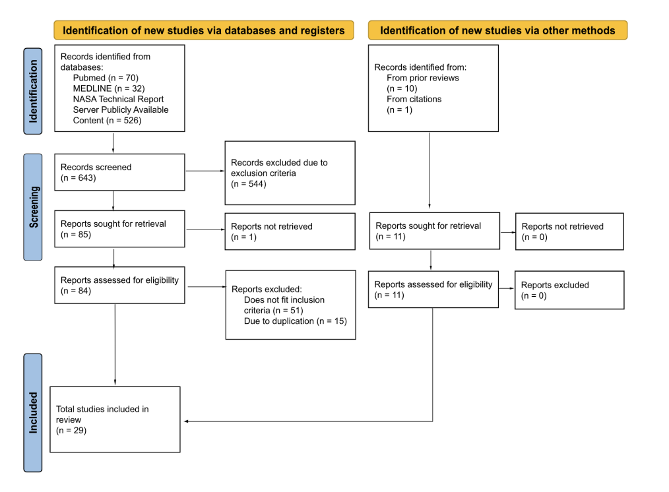

Figure 1: Preferred Reporting Items for Systematic Reviews and Meta-Analyses flow diagram delineating neuromusculoskeletal or orthopedic astronaut injuries in pre-flight, in-flight, and post-flight conditions article selection.

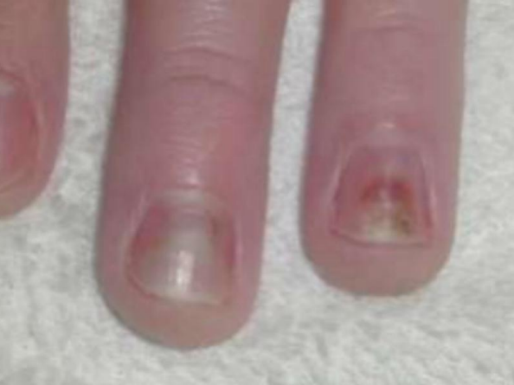

Figure 2: Onycholysis of the second and third hand digits due to spacesuit glove moisture.29

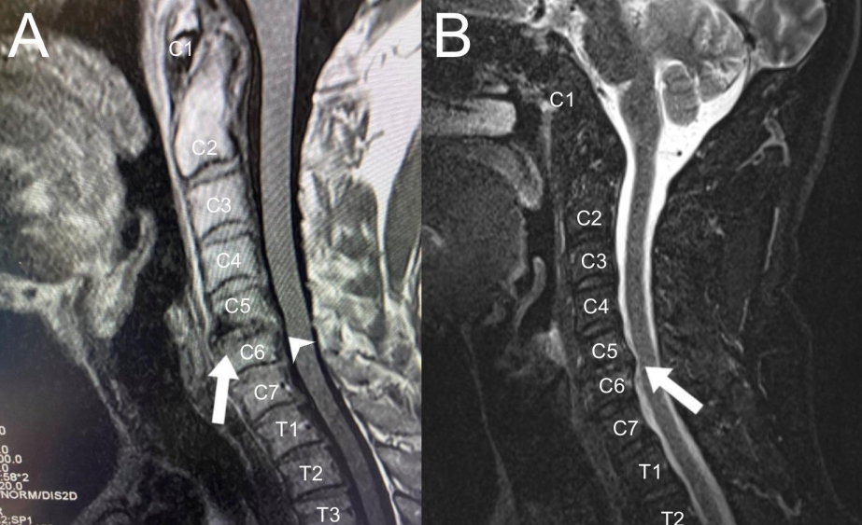

Figure 3: Cervical spine magnetic resonance imaging of symptomatic C7 radiculopathy on the left A) immediately postflight with disc herniation (arrowhead) and damage (arrow) and B) 7-months post-flight with disc herniation (arrow) and no longer symptomatic.12

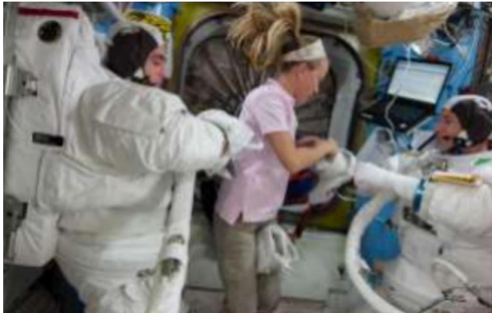

Figure 4: EVA 32, ISS EXP 35/56, July 2013; EVAs in space; injuries primarily in the hands and feet due to compression mechanisms; less common incident of a superior labrum anterior and posterior lesion from traction style movement.23

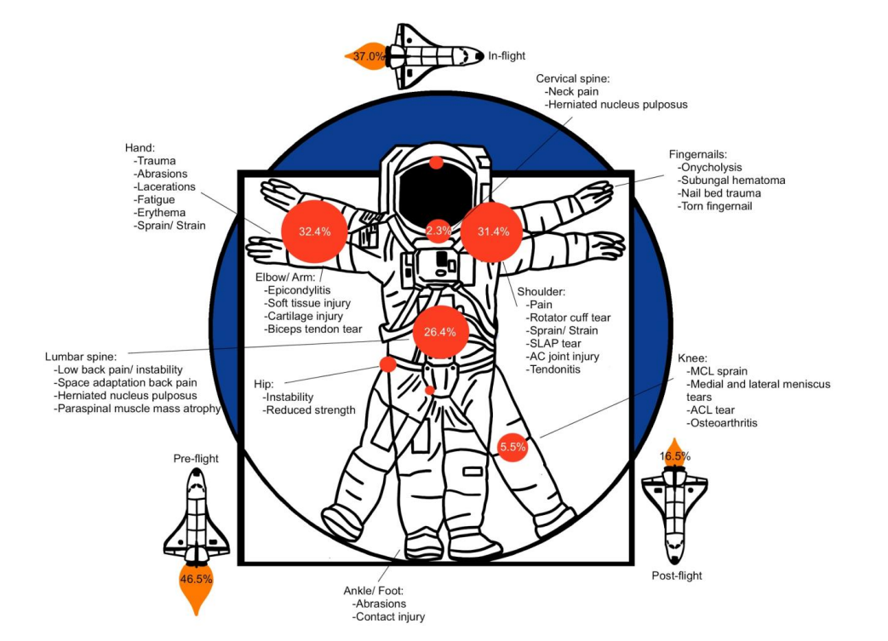

Figure 5: Depiction delineating common documented neuromusculoskeletal injuries in astronauts and the calculated prevalence of documented data for pre-flight, in-flight, and post-flight injuries and injury locations.

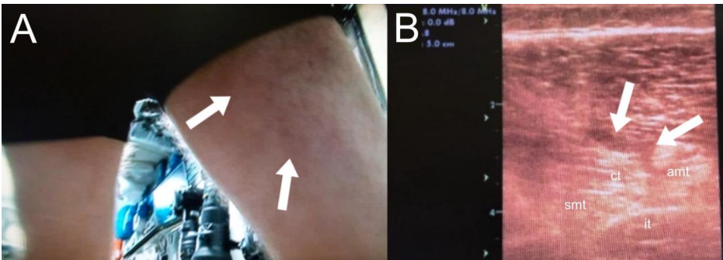

Figure 6: Hamstring tear while performing Advanced Resistive Exercise Device presenting A) clinically as a Grade II tear (arrows) and B) as a Grade I tear under ultrasound (arrows): amt, adductor magnus tendon; ct, conjoint tendon; it, ischial tuberosity; smt, semimembranosus tendon.1