Electronic Supplementary Material
Estuaries and Coasts

A Decade of Salt Marsh Elevation Change in New York City’s Coastal Urban Parks

Ellen Kracauer Hartig^{1,2}, Christopher Haight¹, Michael Hsu¹, Novem Auyeung¹, Rebecca Swadek¹, Jamie Ong¹, Vivien Gornitz³, Rebecca Boger⁴

Corresponding Author: Ellen Kracauer Hartig; email: ellen.hartig@parks.nyc.gov; mobile: 646-522-8085

Submission date: 1 August 2023 / Revised: 14 May 2024 / Accepted: 15 May 2024

City of New York Parks and Recreation (NYC Parks), 1234 Fifth Avenue, New York, NY 10029
2 The Graduate Center, City University of New York (CUNY), 365 Fifth Avenue, New York, NY 10016
3 NASA Goddard Institute of Space Studies (GISS)/Autonomic Integra LLC, 2880 Broadway, New York, NY 10025
4 Brooklyn College, City University of New York (CUNY), 2900 Bedford Avenue, Brooklyn, NY 11210

Table S1. Average rate of vertical accretion surface elevation change, subsidence, and wetland relative sea level rise
SET-MH Site | Station | Elevation (m) NAVD88ª | Vertical Accretion (VA) (mm yr⁻¹) | SE | VLM_{w} (mm yr⁻¹)  (n=36) | SE | Subsidence^{b} | RSLR_{wet}  (mm yr⁻¹)^{b} | Elevation Capital
Pelham Cove | 1 | 1.18 | 2.75 | 0.24 | 2.95 | 1.52 | -0.20 | 1.28 | Deficit
 | 2 | 1.15 | 2.10 | 0.13 | 3.38 | 0.86 | -1.28 | 0.85 | Deficit
 | 3 | 1.15 | 2.72 | 0.14 | 3.02 | 1.66 | -0.30 | 1.21 | Deficit
 | Av | 1.16 | 2.52 | 0.37 | 3.12 | 0.23 | -0.59 | 1.11 | Deficit
Pelham Hutch | 1 | 1.14 | 4.91 | 0.38 | 9.02 | 4.66 | -4.11 | -4.97 | Surplus
 | 2 | 1.17 | 3.76 | 0.21 | 0.93 | 2.04 | 2.83 | 3.30 | Deficit
 | 3 | 1.16 | 3.32 | 0.39 | -5.42 | 4.88 | 8.74 | 9.65 | Deficit
 | Av | 1.16 | 4.00 | 0.82 | 1.51 | 7.24 | 2.49 | 2.72 | Deficit
Udalls Cove | 1 | 0.98 | 7.42 | 0.28 | 5.28 | 2.87 | 2.14 | -1.05 | Surplus
 | 2 | 0.94 | 5.87 | 0.19 | 0.60 | 2.15 | 5.27 | 3.63 | Deficit
 | 3 | 0.98 | 6.01 | 0.15 | 4.32 | 1.80 | 1.69 | -0.09 | Surplus
 | Av | 0.97 | 6.43 | 0.86 | 3.40 | 2.47 | 3.03 | 0.83 | Deficit
Saw Mill Creek | 1 | 0.90 | 2.52 | 0.14 | 2.67 | 1.74 | -0.15 | 1.56 | Deficit
 | 2 | 0.86 | 3.63 | 0.14 | 0.42 | 1.13 | 3.21 | 3.81 | Deficit
 | 3 | 0.89 | 3.36 | 0.26 | 3.69 | 1.11 | -0.33 | 0.54 | Deficit
 | Av | 0.88 | 3.17 | 0.58 | 2.26 | 1.67 | 0.91 | 1.97 | Deficit
Spring Creek | 1 | 0.71 | 3.98 | 0.10 | 4.79 | 0.63 | -0.81 | -0.56 | Surplus
 | 2 | 0.72 | 3.08 | 0.10 | 4.10 | 1.15 | -1.02 | 0.13 | Deficit
 | 3 | 0.71 | 4.65 | 0.13 | 5.56 | 1.06 | -0.91 | -1.33 | Surplus
 | Av | 0.71 | 3.90 | 0.79 | 4.82 | 0.73 | -0.91 | -0.59 | Surplus
Idlewild | 1 | 0.60 | 9.34 | 0.83 | 5.01 | 1.47 | 4.33 | -0.78 | Surplus
 | 2 | 0.57 | 8.63 | 0.36 | 5.36 | 1.11 | 3.27 | -1.13 | Surplus
 | 3 | 0.64 | 10.53 | 0.57 | 3.88 | 1.72 | 6.65 | 0.35 | Deficit
 | Av | 0.60 | 9.50 | 0.96 | 4.75 | 0.78 | 4.75 | -0.52 | Surplus
Citywide | Av |  | 4.92 | 2.61 | 3.31 | 1.32 | 1.61 | 0.92 | Deficit
ªReal-time Kinematic Global Positioning System (RTK GPS) elevation (NAVD88) surveys were conducted at Pelham Cove, Pelham Hutch and Udalls Cove on 13 August 2013, at Spring Creek and Idlewild on 14 August 2013, and at Saw Mill Creek on 3 March 2014.
^{b}Approach is based on Cahoon (2014) whereby: 1) Subsidence=VA-VLM_{w} (mm yr⁻¹) where VLM_{w} is Vertical Land Motion based on the surface elevation change trend. A negative value for subsidence indicates subsurface shallow expansion. 2) RSLR_{wet}=4.23 -VLM_{w}
(mm yr⁻¹) where RSLR_{wet} is the wetland’s Relative Sea Level Rise, and 4.23 mm yr⁻¹ is the near-term 30-year time interval of November 1990
to November 2020 from The Battery, NY, tide gauge station (RSLR_{N}) ​(NOAA 2022)​. A negative value for RSLR_{wet} indicates an elevation capital surplus

Table S2. Salt marsh conditions index for the SET-MH study areas included in the citywide salt marsh conditions assessment. Field work was mainly conducted from 2012 to 2014
Salt Marsh  Condition Metric | Metric unit/  z-score* | Pelham Cove | Pelham Hutch | Udalls Cove | Saw Mill Creek | Spring Creek | Idlewild | Year(s) of data collection
Watershed | N/A | LIS | LIS | LIS | Arthur Kill | Jamaica Bay | Jamaica Bay
Salt Marsh Study Area | Hectares | 11 | 20 | 3.6 | 26.3 | 8.1 | 33.2 | 2014
Salt Marsh Study Area | Z-score | -0.3 | 0.2 | -0.8 | 0.6 | -0.5 | 1.0
Developed Land Within 200m | Percent | 10% | 20% | 30% | 10% | 40% | 30% | 2014
Developed Land Within 200m | Z-score | 1.4 | 0.0 | -0.2 | 1.2 | -1.1 | -0.9
No. of Native Species | Richness | 12 | 10 | 15 | 7 | 6 | 7 | 2014
No. of Native Species | Z-score | 0.8 | 0.0 | 1.9 | -1.1 | -1.5 | -1.1
Percent Vegetation Cover | Percent | 57% | 65% | 67% | 82% | 59% | 53% | 2014
Percent Vegetation Cover | Z-score | -1.4 | -0.6 | -0.4 | 1.0 | -1.2 | -1.8
Soil Shear Vane Strength in low marsh zone | Kilopascals | 24 | 16 | 24 | 16 | 18 | 15 | 2014
Soil Shear Vane Strength in low marsh zone | Z-score | 1.1 | -0.6 | 1.0 | -0.6 | -0.2 | -1.0
Breeding Bird Species Count | Count | 5 | 3 | 1 | 5 | 4 | 5 | 2000 - 2014
Breeding Bird Species Count | Z-score | 1.3 | 0.05 | -1.2 | 1.3 | 0.7 | 1.3
Bare Ground Cover | Percent | 15% | 26% | 9% | 7% | 26% | 41% | 2014
Bare Ground Cover | Z-score | 0.6 | -0.5 | 1.1 | 1.4 | -0.6 | -2.0
Change in Pool Area | Percent | 0.00% | -0.44% | -0.17% | 0.04% | -0.28% | -0.18% | 1974 - 2012
Change in Pool Area | Z-Score | 0.4 | -0.4 | 0.1 | 0.5 | -0.1 | 0.1
Ditch Density | Meters/hectare | 134 | 55 | 335 | 291 | 118 | 400 | 2014
Ditch Density | Z-score | 0.5 | 1.1 | -1.0 | -0.7 | 0.7 | -1.5
Salt Marsh Conditions Assessment | Total Score | 4.4 | -0.7 | 0.5 | 3.6 | -3.8 | -5.8
Salt Marsh Conditions Assessment | Rank | 1 | 4 | 3 | 2 | 5 | 6
*Indicators were standardized by z-scores or “standard scores,” which transforms the data by centering the values on zero by
subtracting the mean from each value and standardizing the range of values by dividing those values by the standard deviation. The equation
is represented by 𝑧=(𝑥 − μ)/σ where x is the raw value, μ is the mean of the raw values, and σ is the standard deviation. Source—US EPA Wetland Program Development Grant (WPDG) report (NYC Parks 2016)

Figures S1a to S1f

Fig. S1a to S1f. Mean marsh surface elevation change (filled squares) and vertical accretion (open squares) at each SET-MH study site. Error bars represent ±1 standard error for measurements on each monitoring date. A vertical grey bar indicates the landfall date of Hurricane Sandy (29 October 2012) where the SET record covers the storm event
c
b
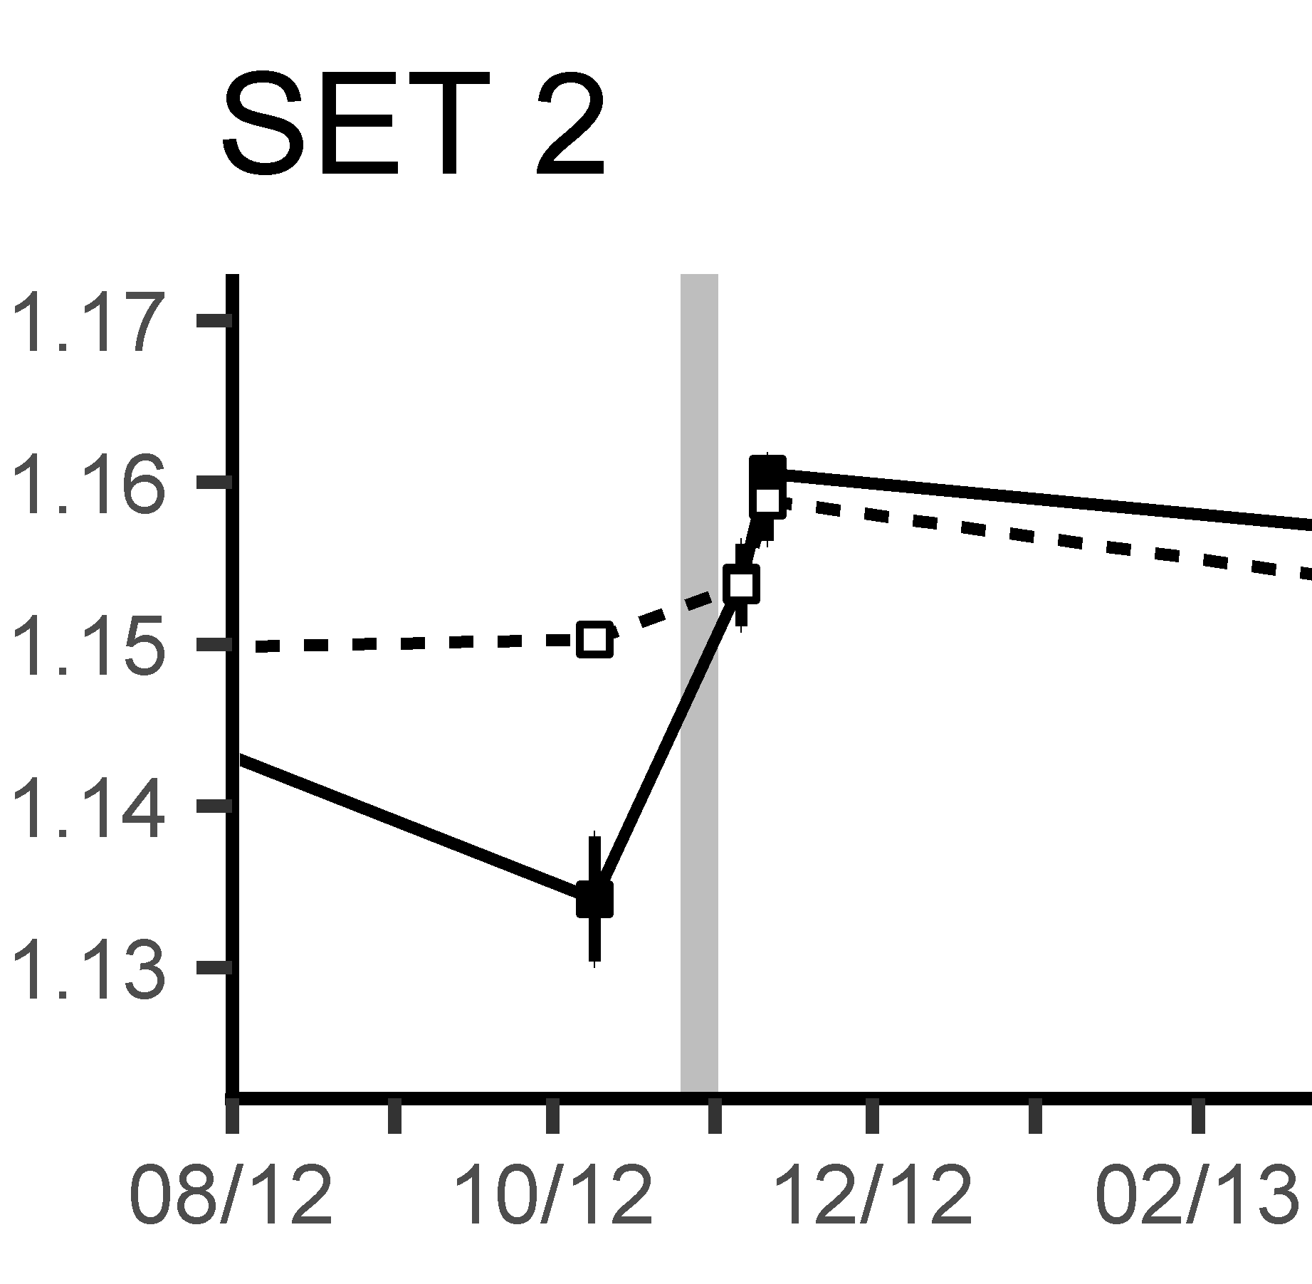
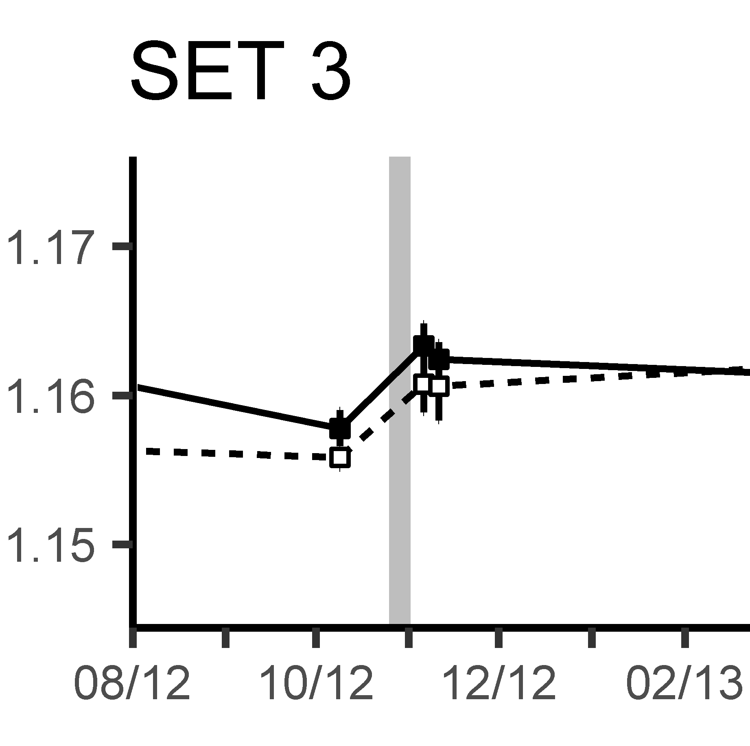
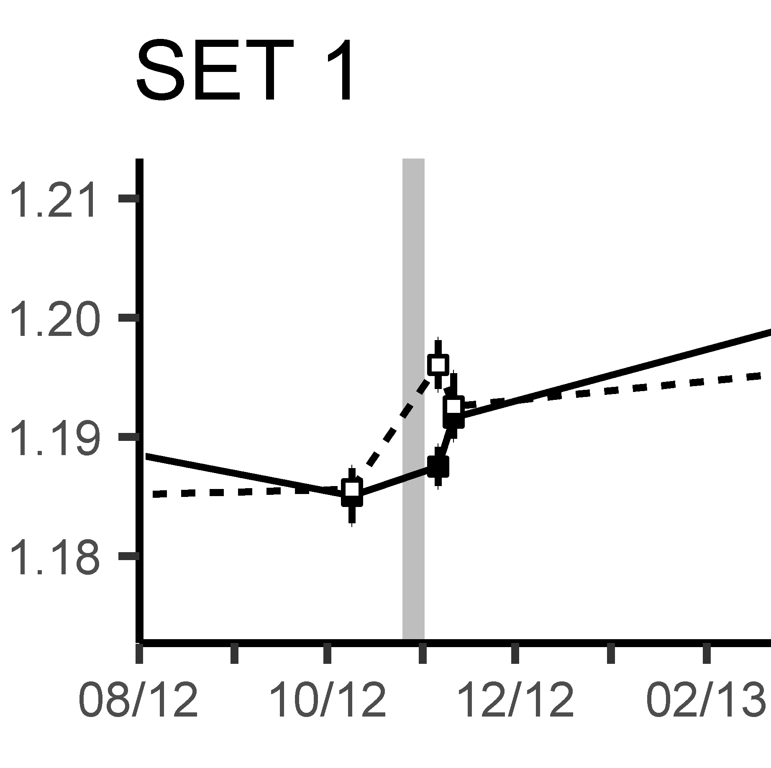
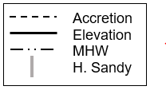
Year
E 3.0 ± 1.7

A 2.7 ± 0.1

A 2.1 ± 0.1

E 3.4 ± 1.0

E 3.0 ± 1.5

A 2.8 ± 0.2

Fig. S1a Results for SET-MH stations at Pelham Cove (Pelham Bay Park, Bronx, NY). Note that while there was a dip in elevation just prior to Hurricane Sandy, there was an immediate boost that held for years in elevation and vertical accretion (framed sections enlarged in insets)
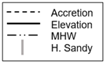
E -5.4 ± 4.9

A 3.3 ± 0.4

E 9.0 ± 4.7

E 0.9 ± 2.0

A 3.8 ± 0.2

A 4.9 ± 0.4

Fig. S1b Results for SET-MH stations at Pelham Hutch (Pelham Bay Park, Bronx, NY). Note how SET 3 elevation subsided following Hurricane Sandy, and though there were some gains since then, it has yet to regain its pre-Sandy elevation. Conversely SET 1 gained in elevation in the immediate aftermath of the hurricane; however, since then elevation change remained relatively flat while accretion is on an upward trend
Elevation (m, NAVD88)
A 6.0 ± 0.2

E 4.3 ± 1.8

A 5.9 ± 0.2
E 0.6 ± 2.2

E 5.3 ± 2.9

A 6.01 ± 0.15

E 4.32 ± 1.80

A 5.87 ± 0.19

E 0.60 ± 2.15

E 5.28 ± 2.87

A 7.42 ± 0.28

Fig. S1c Results for SET-MH stations at Udalls Cove (Udalls Cove Park Preserve, Queens, NY). Note that accretion mainly tops elevation. At SET 2 (middle) elevation change is relatively flat while vertical accretion is on an upward trend
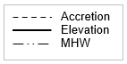
A 3.4 ± 0.3

E 3.7 ± 1.1

A 3.6 ± 0.1

E 0.4 ± 1.1

E 2.7 ± 1.7

A 2.5 ± 0.1

Fig. S1d Results for SET-MH stations at Saw Mill Creek (Saw Mill Creek Marsh, Staten Island, NY). SET 2, nearest the water’s edge, shows little net elevation gain despite vertical accretion
E 5.6 ± 1.1

A 4.7 ± 0.1

E 4.1 ± 1.1

A 3.1 ± 0.1

E 4.8 ± 0.6

A 4.0 ± 0.1

Fig. S1e Results for SET-MH stations at Spring Creek (Spring Creek Park, Queens, NY). Overall net elevation change is greater than vertical accretion; however, both experienced upward trends

E 5.0 ± 1.5

A 10.5 ± 0.6

E 3.9 ± 1.7

A 8.6 ± 0.4

E 5.4 ± 1.1

A 9.3 ± 0.8

Fig. S1f Results for SET-MH stations at Idlewild (Hook Creek Park, Queens, NY). Overall vertical accretion is greater than net elevation change; however, both experience upward trends

