NASA/SP-20240010473



Assessment of Patent Foramen Ovale (PFO) as Related to Decompression Sickness (DCS)
in the Spaceflight Environment and During Ground Testing

Compiled by:
Sarah D. Childress, Office of the Chief Health and Medical Officer, JES Tech, Houston, Texas
Kristin M. Coffey, Office of the Chief Health and Medical Officer, KBR Systems, Houston, Texas
David R. Francisco, Office of the Chief Health and Medical Officer, NASA, Houston, Texas

Since its founding, NASA has been dedicated to the advancement of aeronautics and space science. The NASA scientific and technical information (STI) program plays a key part in helping NASA maintain this important role.  The NASA STI program operates under the auspices of the Agency Chief Information Officer. It collects, organizes, provides for archiving, and disseminates NASA’s STI. The NASA STI program provides access to the NTRS Registered and its public interface, the NASA Technical Reports Server, thus providing one of the largest collections of aeronautical and space science STI in the world. Results are published in both non-NASA channels and by NASA in the NASA STI Report Series, which includes the following report types:  - TECHNICAL PUBLICATION. Reports of completed research or a major significant phase of research that present the results of NASA Programs and include extensive data or theoretical analysis. Includes compilations of significant scientific and technical data and information deemed to be of continuing reference value. NASA counterpart of peer-reviewed formal professional papers but has less stringent limitations on manuscript length and extent of graphic presentations.  - TECHNICAL MEMORANDUM.  Scientific and technical findings that are preliminary or of specialized interest,  e.g., quick release reports, working  papers, and bibliographies that contain minimal annotation. Does not contain extensive analysis.  - CONTRACTOR REPORT. Scientific and technical findings by NASA-sponsored contractors and grantees. | - CONFERENCE PUBLICATION.  Collected papers from scientific and technical conferences, symposia, seminars, or other meetings sponsored or  co-sponsored by NASA.  - SPECIAL PUBLICATION. Scientific, technical, or historical information from NASA programs, projects, and missions, often concerned with subjects having substantial public interest.  - TECHNICAL TRANSLATION.  English-language translations of foreign scientific and technical material pertinent to  NASA’s mission.  Specialized services also include organizing  and publishing research results, distributing specialized research announcements and feeds, providing information desk and personal search support, and enabling data exchange services.  For more information about the NASA STI program, see the following:  - Access the NASA STI program home page at http://www.sti.nasa.gov  .

The use of trademarks or names of manufacturers in this report is for accurate reporting and does not constitute an official endorsement, either expressed or implied, of such products or manufacturers by the National Aeronautics and Space Administration.

Patent Foramen Ovale (PFO) as related to Decompression Sickness (DCS)

Introduction
NASA’s Office of the Chief Health and Medical Officer (OCHMO) initiated a working group to review the status and progress of research and clinical activities intended to mitigate the risk of DCS issues related to PFO during spaceflight and associated ground testing and human subject studies. The working group took place over two days at NASA’s Johnson Space Center in June 2024.

Working Group Members:
NASA Participants
Dave Francisco – Technical Fellow for Human Spaceflight Standards, Office of the Chief Health & Medical Officer (OCHMO)
Dr. Alejandro Garbino – EVA Scientist, Human Physiology, Performance, Protection & Operations (H-3PO) Laboratory
Dr. Robert Sanders – Flight Surgeon & Program Medical Officer, EVA and Human Surface Mobility Program
Dr. Joseph Dervay – Flight Surgeon, Space Medicine Operations Division
Dr. Kristi Ray – Deputy Medical Director, Neutral Buoyance Lab (NBL)
Jason Norcross – Senior Scientist, Biomedical Research and Environmental Sciences
Dr. Shannan Moynihan – Deputy Chief Medical Officer, NASA/Johnson Space Center

Subject Matter Expert Participants at Working Group
Dr. Tony Alleman – Medical Director, Regional One Health Wound Care Center
Dr. Jon Clark – Medical Lead, C2 Space Tech LLC
Dr. Eddie Davenport – Cardiologist, Medical Aerospace Cardiology & Human Performance Institute; United States Air Force
Dr. Bruce Derrick – Hyperbaric Medicine Specialist, Duke University
Dr. Joy Dierks – Program Manager, United States Navy - Deep Submergence Biomedical Development Program
Dr. Douglas Ebersole – Interventional Cardiologist, Watson Clinic LLP
Dr. Caroline Fife – Professor of Geriatrics, Baylor College of Medicine; Chief Medical Officer, Intellicure LLC
Dr. Mike Gernhardt – Retired Astronaut, NASA
Dr. Sean Hardy – Assistant Professor of Clinical Medicine, Louisiana State University Medical Center New Orleans
Dr. Richard Moon – Professor of Anesthesiology and Medicine/Medical Director, Duke University Hyperbaric Center
Dr. Joan Saary – Occupational Medicine Specialist; Consultant, Canadian Forces Environmental Medicine Establishment and Canadian Space Agency; Associate Professor & Director, Division of Occupational Medicine, University of Toronto
Dr. David Southerland – Diving Medicine, United States Navy - Naval Sea Systems Command

Stakeholder Participants

NASA:
Rebecca Blue
Becky Brocato
Carisa Champion
Doug Ebert
Patrick Estep
Amanda Hogan
Emma Hwang
Joanne Kaouk
Steven Laurie
Stuart Lee
Kim Lowe
Karina Marshall-Goebel
Shannan Moynihan

Axiom:
Ed Powers

SpaceX:
Amran Asadi
Jaime Mateus
Kaleigh Stabeneau
Brandon Trapp

UTMB:
Matthew Makowski

Mayo Clinic:
Jan Stepanek

Contents
Background 7
Summary of Findings 8
1.0 Potential Risk of PFO 8
2.0 PFO Detection 9
3.0 PFO Closure 11
4.0 PFO and Cryptogenic Ischemic Stroke 12
5.0 PFOs and the Diving Community 12
6.0 PFO and High Altitude 14
7.0 Other Physiological Factors 16
Overall Conclusion 17
Working Group Goals 18
Goal 1 Overview 18
Goal 2 Overview 19
Goal 3 Overview 20
Goal 4 Overview 21
Other Points of Discussion 21
Meeting Minutes 23
Bibliography 28

Background
Decompression sickness (DCS) is a condition which results from dissolved gases (primarily nitrogen) forming bubbles in the bloodstream and tissues. It is usually experienced in conditions where there are rapid decreases in ambient pressure, such as in scuba divers, high-altitude aviation, or other pressurized environments. The evolved gas bubbles have various physiological effects and can obstruct the blood vessels, trigger inflammation, and damage tissue, resulting in symptoms of DCS. NASA presently classifies DCS into two categories: Type I DCS, which is less severe, typically leads to musculoskeletal symptoms including pain in the joints or muscles, or skin rash. Type II DCS is more severe and commonly results in neurological, inner ear, and cardiopulmonary symptoms. Neurological symptoms may include numbness; paresthesia, or an altered sensation, such as tingling; muscle weakness; an impaired gait, or difficulty walking; problems with physical coordination or bladder control; paralysis; or a change in mental status, such as confusion or lack of alertness. Inner-ear symptoms may include ringing in the ears, known as “tinnitus”; hearing loss; vertigo or dizziness; nausea; vomiting; and impaired balance. Cardiopulmonary symptoms, include a dry cough; chest pain behind the sternum, or breastbone; and breathing difficulty, also known as “dyspnea.” (Denoble & Holm, 2015). The risk of DCS in spaceflight presents during extravehicular activities (EVAs) in which astronauts perform mission tasks outside the spaceflight vehicle while wearing a pressurized suit at a lower pressure than the cabin pressure. DCS mitigation protocols based on strategies to reduce systemic nitrogen load are implemented through the combination of habitat environmental parameters, EVA suit pressure, and breathing gas procedures (prebreathe protocols) to achieve safe and effective mission operations. Reference OCHMO-TB-037 Decompression Sickness (DCS) Risk Mitigation technical brief for additional information.
The NASA Spaceflight Human-System Standard (NASA-STD-3001), Volume 2: Human Factors, Habitability, and Environmental Health technical standard requires human spaceflight programs to limit the risk of DCS within 95% statistical confidence to:
- DCS <15% (includes Type I or isolated cutis marmorata).
- Grade IV venous gas emboli (VGE) <20%
- Prevent Type II DCS.
The pathophysiology of DCS has still not been fully elucidated since cases occur despite the absence of detected gas bubbles but includes right to left shunting of venous gas emboli (VGE) via several potential mechanisms, one of which is a Patent Foramen Ovale (PFO). The purpose of this working group was to review and provide analysis on the status and progress of research and clinical activities intended to mitigate the risk of PFO and DCS issues during spaceflight. The working group was assembled from internal NASA subject matter experts, the NASA OCHMO Standards Team, NASA stakeholders, and external subject matter experts including cardiology, hypobaric medicine, spaceflight medicine, and military occupational health experts. The working group was asked to review past reports and evidence related to PFOs and risk of DCS, receive materials and information regarding NASA’s current experience and practices, present case studies and subsequent decision-making processes, and participate in an open-forum discussion. More details of the goals can be found in the Working Group Goals section.

Summary of Findings
Below is a summary of the findings with additional context and conclusion statements from the meeting as compiled by OCHMO members, Sarah D. Childress, Kristin M. Coffey, and David R. Francisco, and reviewed by and agreed to by the subject matter expert working group participants. Details of the working group discussions can be found in the Meeting Minutes Section.

1.0 Potential Risk of PFO
- A patent foramen ovale (PFO) is a shunt between the right atrium and the left atrium of the heart, which is a persisting remnant of a physiological communication present in the fetal heart. Post-natal increases in left atrial pressure usually force the inter-septal valve against the septum secundum and within the first 2 years of life, the septae permanently fuse due to the development of fibrous adhesions (Saary & Gray, 2001). Thus, all humans are born with a PFO and approximately 75% of PFOs fuse following childbirth (Steiner, 1998). For the 25% of the population’s whose PFOs do not fuse, ~6% have what is considered by some to be a large PFO (> 2 mm). PFO diameter can increase with age (Hagen, 1984).
- The concern with PFOs is that with a right to left shunt between the atria, venous emboli gas may pass from the right atrium (venous) to the left atrium (arterial) (“shunt”), thus by-passing the normal lung filtration of venous emboli which prevent passage to the arterial system. Without filtration, bubbles in the arterial system may lead to a neurological event such as a stroke.
- Any activity that increases the right atrium/venous pressure over the left atrium/arterial pressure (such as a Valsalva maneuver, abdominal compression) may further enable blood and/or emboli across a PFO/shunt.

2.0 PFO Detection
- PFOs often go undetected until an incident such as stroke or DCS occurs. Most people with PFO are asymptomatic but PFOs have been linked to other medical conditions including but not limited to stroke, sleep apnea, and migraine headaches (Van der Giessen, 2020). If an event or symptoms occur and PFO is suspected, or for other diagnostic purposes, the patient would be assessed with physical examination and including, but not limited to one or more of the following tests:
- Transthoracic echocardiogram (TTE) — A noninvasive method using a probe on the skin of the chest. Sound waves are used to image blood flowing through the heart and heart valves. TTE can be used with contrast and/or agitated saline injection to detect if bubbles traverse from the right atrium to left atrium, confirming PFO presence. The patient may need to perform Valsalva maneuver if bubbles are not detected at rest. TTE can identify PFO or other cardiac pathologies that may lead to a stroke, however views may be limited due to distance from transducer and image quality may be suboptimal in some patients. The TTE test result sensitivity may be limited in patients with high BMI compared to a transcranial doppler (TCD) (Liou, 2015). The risk of TTE procedure is low, and the most common adverse effects is discomfort from the IV/injection and potential skin irritation from the transducer transmission gel. TTE is most often used by cardiologists as the initial diagnostic test due to low risk, ease of use, low cost, and diagnostic ability (Van der Giessen, 2020; Fordyce, 2022).
- Transcranial Doppler (TCD) — A noninvasive measure of cerebrovascular function using a portable doppler ultrasound transducer held in place with a headband over the temporal window used to measure blood flow to and within the brain (Van der Giessen, 2020). A PFO can be detected with TCD by injecting agitated saline in a peripheral vein and observing if any microbubbles appear either at rest or during a Valsalva maneuver (Van der Giessen, 2020). Patients with absent temporal bone window may not be able to use TCD as an effective diagnostic tool (Van der Giessen, 2020). TCD is low risk, with potential side effects including mild discomfort during testing, discomfort from the IV/injection, skin irritation from transducer transmission gel, and/or dizziness.
- Transesophageal echocardiogram (TEE) — An invasive echocardiography test which places a probe with an ultrasound transducer into the esophagus to assess structure and function of the heart. The transducer is located closer to the atria, allowing higher frequency ultrasound than TTE and results in higher resolution imaging, enabling improved identification of PFO and other cardiovascular defects. TEE, like TTE or TCD, may use agitated saline injection and Valsalva maneuver to assist with PFO identification. One limitation is that the transducer may interfere with the patient’s ability to perform an adequate Valsalva maneuver which can help identify a PFO. TEE may require light sedation. TEE is considered a more invasive procedure with increased risk compared to TTE or TCD, including risk of esophageal tear during procedure (0.03-0.09%) and risk of reaction to sedating medication. TEE has been considered the diagnostic modality of choice for many institutions to more definitively rule out or further characterize a PFO after an initial assessment via TTE. But the overall TEE procedure is time consuming, more costly, and more invasive compared to either TCD or TTE.
- See Table 1 below for a summary of studies comparing imaging modalities. TCD and TTE, if performed well, can easily diagnose a PFO and continues to be the most common referral to echocardiography departments (Van der Giessen, 2020). Cautions with all tests include the fact that other shunts (e.g., pulmonary) may be detected/present, the Valsalva maneuver can be difficult for patients to perform (especially sedated) which can limit PFO detection, and all detection is subject to the skill of the practitioner.
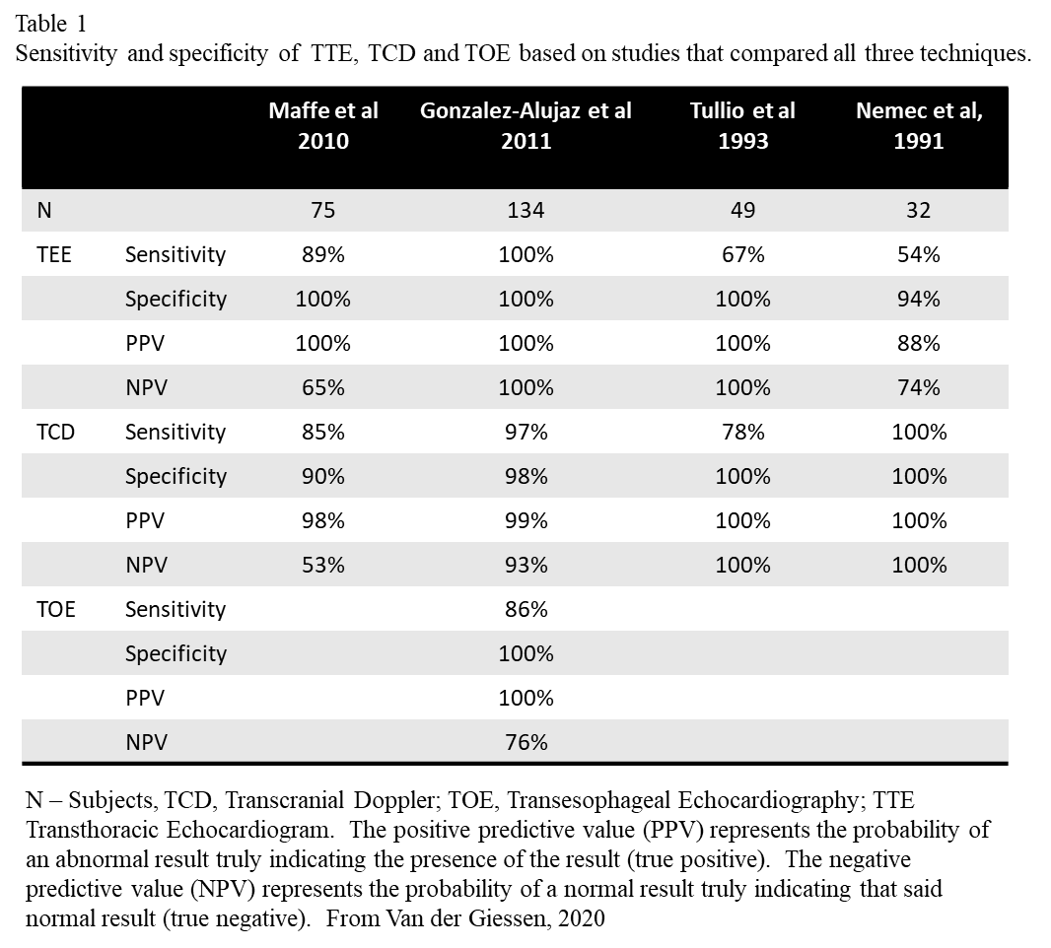

PFO Closure
- Closure of PFOs is an outpatient procedure. Closure is performed using a transcatheter device fed into the heart via the femoral vein. During this procedure, a transeptal sheath travels through the PFO into the left atrium before it is deployed. An umbrella‐like structure opens first on the left atrium side of the septum, and then the right atrium side, creating a seal over the PFO so blood can no longer traverse the septum after the sheath is removed (the closure device does not create a seal immediately after the procedure, the endothelium must migrate over the device to accomplish a true seal). The patient is usually prescribed oral anticoagulation for 3 – 6 months post-closure.
- Complication rates with PFO closure are dependent on the device utilized and skill of the clinician. Risk of serious complication is approximately 1% (complications may include damage to blood vessels, blood clots, infection, and development of atrial fibrillation). Other complications reported by various trials include cardiac tamponade (0.4%), device migration/embolization (0.5%), infective endocarditis (0.2%), and stroke (0.4%). These potential complications are rare, but all should be mentioned in the patient consent process for device closure (Gonnah, 2022). U.S. Food and Drug Administration (FDA) approval and insurance funding is currently written that PFO closure is considered for patients with prior stroke and no other risk factors (not approved for DCS risk) (Maxwell, 2020; Percutaneous Patent Foramen Ovale (PFO) Closure).

4.0 PFO and Cryptogenic Ischemic Stroke
- In a randomized open-label trial of 980 patients with PFO and history of cryptogenic ischemic stroke, long-term (>5 years) follow-up found that closure of PFO was associated with a 45% lower rate of recurrent ischemic strokes than among patients who received medical therapy alone; and PFO closure reduced the relative risk of recurrent cryptogenic stroke by 70% compared to medical therapy (Saver, 2017).
- Closure of PFOs has shown to decrease cryptogenic stokes in multiple trials, with 62% relative risk reduction in favor of PFO closure (Saver, 2017; Turc, 2018).

5.0 PFOs and the Diving Community
- The overall risk of experiencing a DCS event in divers regardless of PFO status is approximately 2.5 episodes per 10,000 dives; but with a PFO is estimated at 5 episodes per 10,00 dives (an approximately 5-fold increase in risk over divers without a PFO) (Koopsen, 2018; Torti, 2004).
- Divers who have PFO have 2.5 times greater overall risk of DCS and four times greater risk of neurological DCS. The absolute incidence of neurological DCS in divers with PFO is estimated at by Denoble at 4.7 cases per 10,000 dives, which correlates with that of Torti. The greatest risk of DCS among divers is among those with large PFO (Denoble, 2015).
- In a study of 65 divers, closure of PFO resulted in a nearly five-fold decrease in confirmed cases of DCS, compared to divers who chose to continue diving conservatively without closure, which resulted in a two-fold reduction. Of the divers who were classified to have large PFO, relative risk of DCS was 0.2 in those who received a closure compared to a relative risk of 9.7 in those who chose to dive conservatively. (Anderson, 2019).
- A case-control study found that in a group of divers who had experienced DCS, the median PFO size was 10mm, which is twice as large as the average PFO size of the general population (5mm). The authors concluded that the risk of a diver experiencing DCS is related to the size of the PFO rather than just the presence of the defect. (Wilmshurst, 2015).
- Most standard guidelines available have a stratified approach that generally suggest that recreational and commercial divers do not need to be screened for PFO, as serious DCS is rare and the link between PFOs and DCS is not clear. The Divers Alert Network (DAN) Guidelines for Patent Foramen Ovale and Fitness recommend “Routine screening for PFO at the time of dive medical fitness assessment (either initial or periodic) is not indicated. Consideration should be given to testing for PFO when there is a history of more than one episode of decompression sickness (DCS) with cerebral, spinal, vestibulocochlear or cutaneous manifestations.” (Skyes, 2013; Denoble, 2015).
- PFOs are not routinely screened in the diving community, except for within the Canadian Armed Forces (CAF) Clearance Divers. Beginning in 2009, CAF Clearance Diver applicants were screened for PFO. Guidelines were to disqualify candidates if found to have a PFO, however reassessment of the disqualifying condition in 2013 found the absolute risk was low. CAF Clearance Divers continue to be screened for PFO at selection, but now are permitted to proceed with training with informed consent if found to have a PFO, and subsequent development of DCS leads to ‘beaching’, re-evaluation of fitness to dive, and consideration of referral for cardiology assessment to determine whether closure is clinically indicated. DCS risk mitigation in CAF diving includes validated decompression tables, standardized dive procedures, rigorous training, dive fitness standards, and requirements for onsite recompression chambers during deep dives (Brett, Vallee, & Saary, 2023).
- At the NASA Neutral Buoyance Laboratory (NBL), astronauts are trained to conduct suited/pressurized extravehicular activities (EVA) underwater to simulate a microgravity environment. Support divers also participate in underwater activities to observe and assist astronauts during training. Since 2015, 79,568 dive hours (including astronauts and support divers) have been conducted with a total of 5 events of DCS recorded.

6.0 PFO and High Altitude/Hypoxia
- NASA has observed the following occurrences of DCS in altitude ground research studies and hardware development and verification activities:
  - NASA has observed five Type II DCS cases (2 known to have PFO) and 92 cases of Type I DCS (including three cases of cutis marmorata, one of which confirmed PFO) during 51 ground research studies on prebreathe studies with a total of 677 exposures from 1983 to 2023 (Prebreathe Reduction Program – 34 cases of DCS/271 exposures; Nucleation Study – 6 cases of DCS/62 exposures; Shuttle Prebreathe Testing – 57 cases of DCS/345 exposures; (Gernhardt, 2016. Altitude decompression: Past, present, and future. Presented at the Naval Sea Systems Command (NAVSEA) 2016 Annual Review), and Exploration Atmosphere Chamber Testing (as of 2023) - 5 DCS cases/126 exposures). Recent testing (2022-2023) for exploration atmospheres has observed one Type II DCS case and four Type I cases. The one Type II case was confirmed to have a PFO (Garbino, 2024. Exploration Atmosphere: Path to Artemis & DCS/LVGE Experience. Presented at the NASA PFO & DCS Working Group June 4, 2024).
  - NASA has observed 6 Type II DCS cases and six Type I DCS cases during 1,650 exposures in altitude physiological chamber tests (altitude refresher) since 2015.
  - NASA has observed 3 Type I DCS events and 1 Type II DCS event in research and hardware development activities during approximately 225 exposures (Sanders, 2024. Diving in Space: Extravehicular Activity Parallels Technical Diving. Presented at the NASA PFO & DCS Working Group June 4, 2024). It should be noted that these cases were reported after implementation of a NASA DCS disposition policy, which encouraged subjects to report DCS. It is possible that there were other DCS cases which were not reported.
  - NASA has not observed a Type I or Type II DCS case in spaceflight utilizing 4 different prebreathe protocols (4-hr in suit, CEVIS with exercise, CAMPOUT and in-suit light exercise (ISLE) in over 170 EVAs with 340 crewmembers on the International Space Station as of 2023 (Dervay, 2024. Prebreathe Protocol Reduction Historical Perspectives: PFO and DCS Aspects. Presented at the NASA PFO & DCS Working Group June 4, 2024).
- NASA has never performed routine screening or evaluation for PFOs.
- Central nervous system (CNS) DCS may occur both with and without venous gas emboli (VGE), which indicates that not all CNS DCS cases are directly related to VGE detections (Webb, 2004).
- In a small study of altitude-induced decompression sickness, “unreported left ventricular gas emboli were observed with echo imaging in six subjects at altitude. In all six cases, at the time of arterial gas emboli onset, the venous gas emboli scores were high from all monitored sites. Three subjects had no septal defect, another had a small sinus venosus defect, a third had a PFO, and one was not available for evaluation.” (Webb, 2004).
- “Despite this high prevalence of PFO in the general population (approximately 25%), and the relatively common occurrence of venous gas bubbles in diving and altitude exposures, the incidence of Type II DCS in diving or with altitude is remarkably low.” (Saary & Gray, 2001).
- Altitude decompression exposures typically result in higher VGE loads than diving because at lower pressures, the metabolic gases (O₂, CO₂, and H₂O vapor), which have an infinite half-time, make a greater contribution to bubble formation and growth. However, the pathophysiological effects of those bubbles are generally less than in diving decompressions. This is because NASA prebreathe protocols utilize O₂ prebreathe prior to decompression to lower pressures. The neurological tissues, including the brain and spinal cord, have high perfusion rates and fast nitrogen elimination half-times, resulting in those tissues being undersaturated during the EVA exposure. Therefore, should bubbles enter the arterial circulation, they would encounter an undersaturated environment where the partial pressure of nitrogen in the bubbles is higher than the tension of nitrogen in the tissues, resulting in bubble size reduction by diffusion of the nitrogen form the bubbles into the tissues. In diving decompression, the opposite occurs. After surfacing from a hyperbaric exposure, the neurological tissues are supersaturated and if bubbles enter the arterial circulation they would encounter a supersaturated environment and increase in size, resulting in a greater risk of neurological symptoms. (Moon, 2024. Patent Foramen Ovale and Decompression Illness in Space. Presented at the NASA PFO & DCS Working Group June 4, 2024).

7.0 Other Physiological Factors
- Many other physiological factors contribute to risk of DCS, such as other arteriovenous shunts, age (higher risk due to right atrial pressure increases and PFOs enlarge with aging), sex (males at greater risk), body composition (high fat content = higher risk), and time of menstrual cycle (Lee & St. Leger Dowse, 2010). These other risk factors may contribute to DCS occurrence equal to or greater than PFOs and should be considered in parallel to PFOs (Webb, 2004).

Overall Conclusion
The following key points as summarized by the OCHMO Standards Team are the main take-aways from the PFO/DCS working group discussions:
- In an extreme exposure/high-risk scenario, excluding individuals with a PFO and treating PFOs does not necessarily decrease the risk of DCS or create a ‘safe’ environment. It may create incremental differences and slightly reduce overall risk but does not make the risk zero. There are other physiological factors that also contribute to the risk of DCS that may have a larger impact (see 7.0 Other Physiological Factors in the findings section).
- Based on the available evidence and the risk of current decompression exposures (based on current NASA protocols and NASA-STD-3001 requirements to limit the risk of DCS), it is not recommended to screen for PFOs in any spaceflight or ground testing participants. The best strategy to reduce the risk of DCS is to create as safe an environment as possible in every scenario, through effective prebreathe protocols, safety, and the capability to rapidly treat DCS should symptoms occur.
- Based on opinion, no specific research is required at this time to further characterize PFOs with DCS and altitude exposure, due to the low risk and preference to institute adequate safe protocols and ensuring treatment availability both on the ground and in spaceflight.
- For engineering protocols conducted on the ground, it should be ensured that the same level of treatment capability (treatment chamber in the immediate vicinity of the testing) is provided as during research protocols. The ability to immediately treat a DCS case is critical in ensuring the safety of the test subjects.

Working Group Goals
Pre-defined goals of the working group included:
Goal 1: Quantification of any increased risk associated with the presence of a PFO during decompression protocols utilized in ground testing and spaceflight EVAs, as well as unplanned decompressions (e.g., cabin depressurization, EVA suit leak).
- Does the presence of a PFO increase the risk of serious DCS?
- Do some forms of PFO increase DCS risk more than others?
- Do specific aspects of EVA or ground testing profiles (e.g., physical exertion) affect PFO-related risk?
- Do anticipated increases in EVA frequency and workload during exploration missions (vs. ISS) affect PFO-related risk?
Goal 2: Describe risks and benefits of PFO screening in astronaut candidates, current crewmembers, and chamber test subjects.
- What screening method(s) would be most appropriate?
- What are the sensitivity and specificity of the method(s)?
- What are the risks to the patient of the screening procedure itself?
- How should results be characterized in terms of type and magnitude of PFO?
Goal 3: What are potential risk reduction measures that could be considered if a person was believed to be at increased risk of DCS due to a PFO?
Goal 4: What research and/or technology development is recommended that could help inform and/or mitigate PFO-related DCS risk?
The following sections provide main highlights of feedback and brainstorming from the working group proceedings for each goal.

Goal 1 Overview
Quantification of any increased risk associated with the presence of a PFO during decompression protocols utilized in ground testing and spaceflight EVAs, as well as unplanned decompressions (e.g., cabin depressurization, EVA suit leak).
  - Does the presence of a PFO increase the risk of serious DCS?
    - We do not have compelling data or data with acceptable protocol from human trials that supports an increased risk at altitude. The amount of literature is quite lacking in the area of altitude DCS incidence).
  - Do some forms of PFO increase DCS risk more than others?
    - The evidence is currently derived from cryptogenic stroke and diving literature; there are no data in this specific topic.
  - Do specific aspects of EVA or ground testing profiles (e.g., physical exertion) affect PFO-related risk?
    - There are data that suggests increased physical activity increases doppler-detectable bubbles which could potentially lead to increased risk of DCS.
  - Do anticipated increases in EVA frequency and workload during exploration missions (vs. ISS) affect PFO-related risk?
    - If PFO is identified as a risk then it is likely higher EVA frequency and workload would increase the risk of PFO-mediated DCS.

Goal 2 Overview
Describe risks and benefits of PFO screening in astronaut candidates, current crewmembers, and chamber test subjects.
  - What screening method(s) would be most appropriate?
    - Transthoracic Echo (TTE) with a bubble study/injection of agitated saline; specific provocative maneuvers protocol (Valsalva, hypoxic stress).
    - TEE offers more detail if TTE images are not conclusive, or results do not match symptomology. Provocative maneuvers (Valsalva, abdominal pressure, lower limb lifting) assist with bubble shunting.
    - Grading: negative – no significant PFO detected < 9 bubbles, positive/large > 20 bubbles or bubbles present with no provocative maneuvers.
  - What are the sensitivity and specificity of the method(s)?
    - A metanalysis published by Mojadidi et al. in 2014 suggests transthoracic echo with agitated saline has a lower sensitivity for PFO compared to TEE; but carries less risk. Transesophageal echoes are a medical procedure and should not be used for 'screening' purposes.
    - Screening is not always accurate in predicting the size of a PFO – the hole can seem small in screening tests but can be found to be much larger during surgery/procedures.
  - What are the risks to the patient of the screening procedure itself?
    - No significant recognized risk to transthoracic screening aside from those typically associated with IV insertion.
    - Considerations for potential career risks – negative selection impact regardless of confidentiality.
  - How should results be characterized in terms of type and magnitude of PFO?
    - The characterization is only relevant if you are going to use the information proactively for clinical reasons (i.e., ‘screen’ individuals out, recommend closure, etc.), or for documenting a baseline for surveillance or awareness in the event of a DCS hit.
    - Large PFOs may be closed, but shunting from other pathways cannot be easily addressed – and the significance of a shunt resulting in Type II DCS is unknown.

Goal 3 Overview
What are potential risk reduction measures that could be considered if a person found to have a PFO?
  - No data for people in hypobaric/altitude exposure. In diving DCS, only after a neurological/’undeserved’ event.
  - Does closure reduce risk if this is the case? What are the risks of closing a PFO?
    - Severe bleeding, embolization, stroke (combined under 1%) serious complications.
    - Bruise or small hematoma (1-2%) minor complications.
    - No heavy lifting 3 to 4 days; anti-platelet therapy 3 months post-op; then do a reassessment.
    - Requirement for a period of post-op anti-coagulation.
  - Benefits in the diving world?
    - Limited data on closure of PFO in divers, but appears to be of benefit (Brett, Vallee, & Saary, 2023).

Goal 4 Overview
What research and/or technology development is recommended that could help inform and/or mitigate PFO-related DCS risk?
  - Discuss further if there is any value in screening for and documenting PFO in case an 'event' was to occur, and having such information at that time may be useful.
  - How many neurological DCS cases would you need to have to establish a relationship between PFO and Type II DCS? If you see even one case of Type II then the protocol is going to change and there will never be enough data collected to establish a relationship.

Other Points of Discussion
- Push towards a “no DCS”/“low VGE” protocol vs. a “shunt/PFO-safe” protocol
  - ISS effectively implements this through conservative prebreathe protocol
  - (ISS prebreathe protocol effectively operates at ~1/10th the ‘ground tested/accepted’ risk)
  - Montecarlo for total EVAs over program
- Screening these populations will most likely have downstream effects.
  - Need to add to considerations what would be the concerns to the individuals and organization if screening is undertaken.
- High altitude is intrinsically more stressful on VGE generation than diving.
- It is very reasonable to evaluate for a PFO if there is a 'serious undeserved hit'. But at this point it is considered a diagnostic test and not screening - screening is without a clinical indication.
  - The issue is that you have a 1 in 3 chance of being PFO positive if screened so now you need to decide how can you tell whether it's related to a neurological hit?
- Left-sided bubbles (LVGE) are not always related to a PFO/shunt.
  - No data to support that left-sided bubbles automatically lead to an increased risk of DCS, so why do we bother testing and terminate protocol if left sided bubbles are found? Recommended to maintain LVGE as a test termination criteria for now due to lack of data either way.
  - Always concerned from my perspective if I see left-sided bubbles but if there are no symptoms then not sure if it matters (Alleman).
- Other factors have more impact on DCS risk than PFOs – men’s age, women’s time of menstrual cycle, and body fat, for example, may increase risk.
- Lower saturation in altitude: altitude decompression intrinsically has higher VGE than diving because metabolic gases make a greater contribution to bubbles than in diving (Gernhardt, 2022. Bubble dynamics from sea to space [Plenary presentation]. Presented at the Aerospace Medical Association (AsMA)/Undersea & Hyperbaric Medical Society (UHMS) 2022 Annual Scientific Meeting). However, in altitude decompression, arterialized bubbles enter an undersaturated (denitrogenated) environment compared to diving where they enter a supersaturated environment – i.e., the bubbles would have a tendency to diffuse nitrogen out (shrink) in altitude exposures, whereas in diving exposures nitrogen would diffuse into the bubbles (stabilize/grow the bubbles). Specifically, this suggests that brain tissue would be nitrogen depleted (under saturated) in high altitude exposures vs. divers; in whom the brain/spinal cord is saturated with nitrogen, favoring bubble growth.

Meeting Minutes
The following meeting minutes were recorded during the working group discussions in a collaborative effort with all attendees and a collective consensus was reached on the content recorded in the following charts.
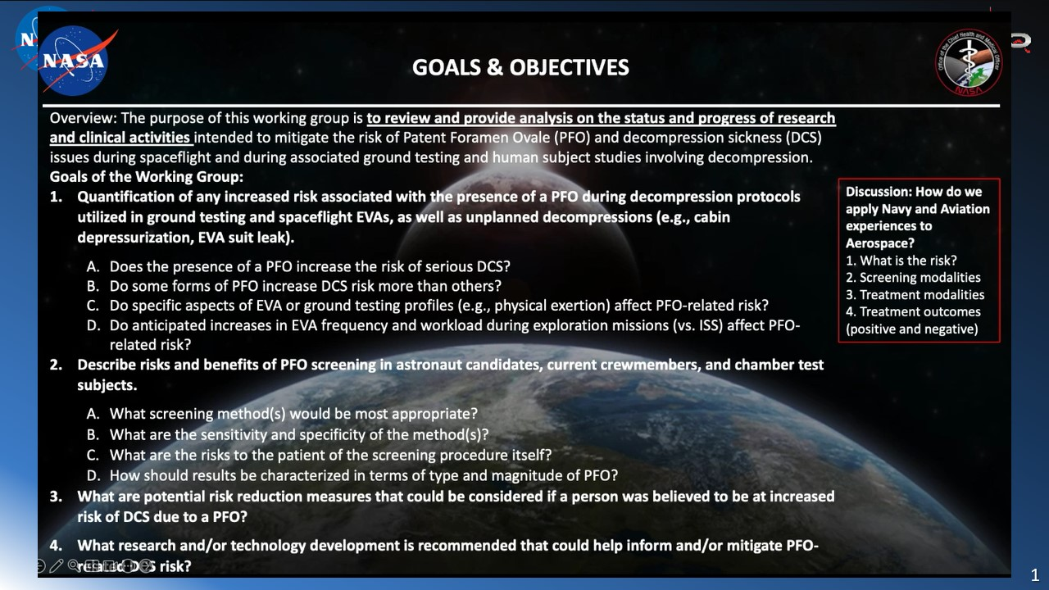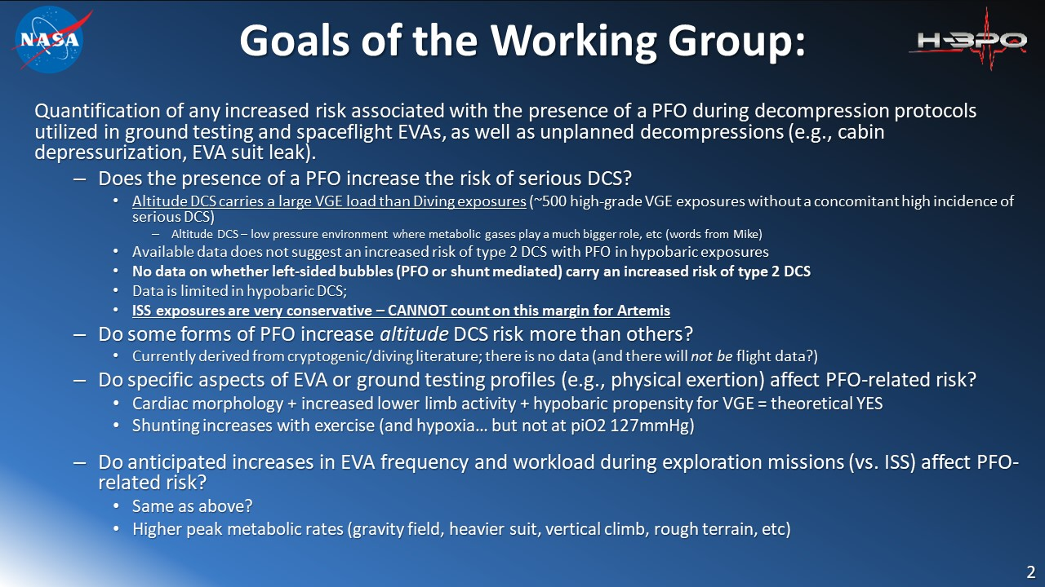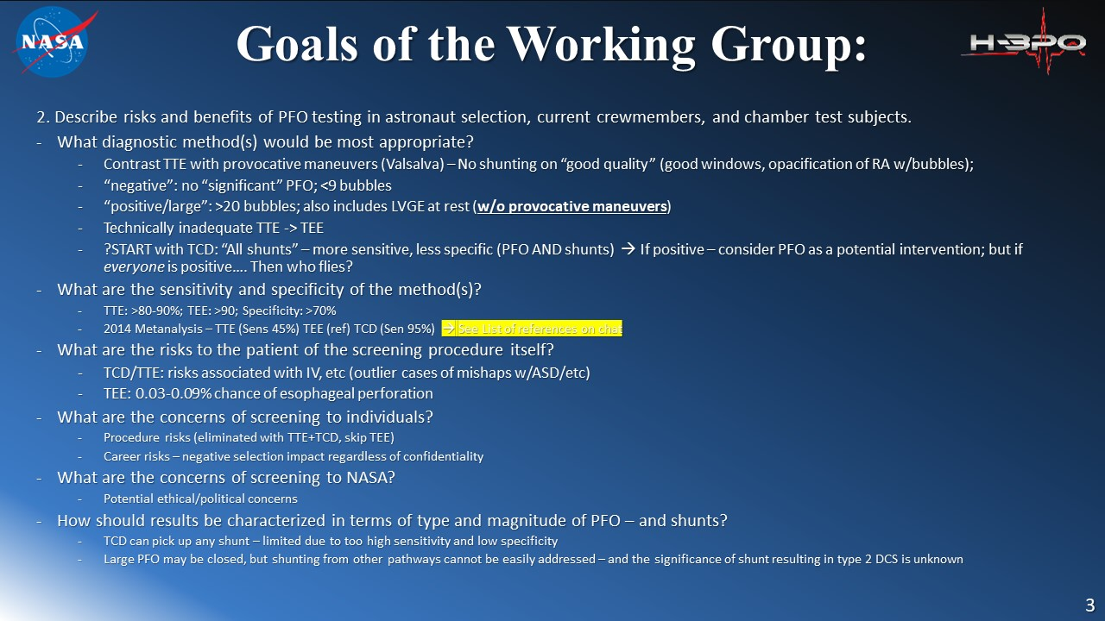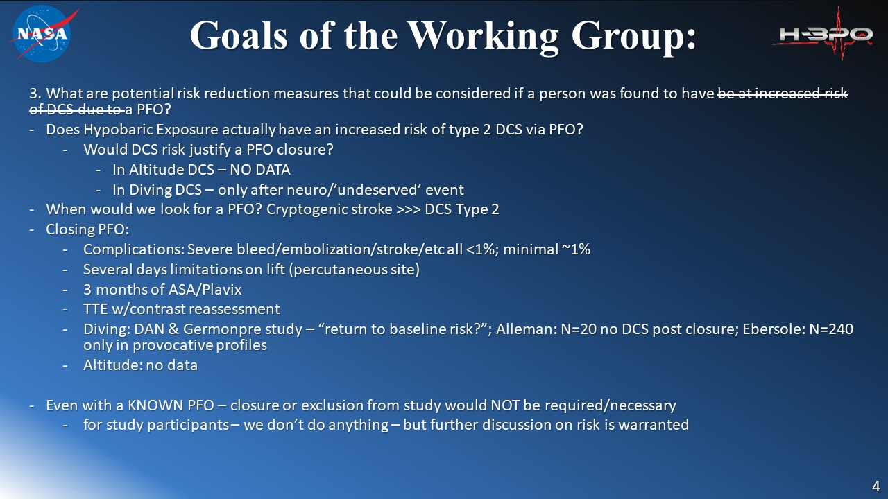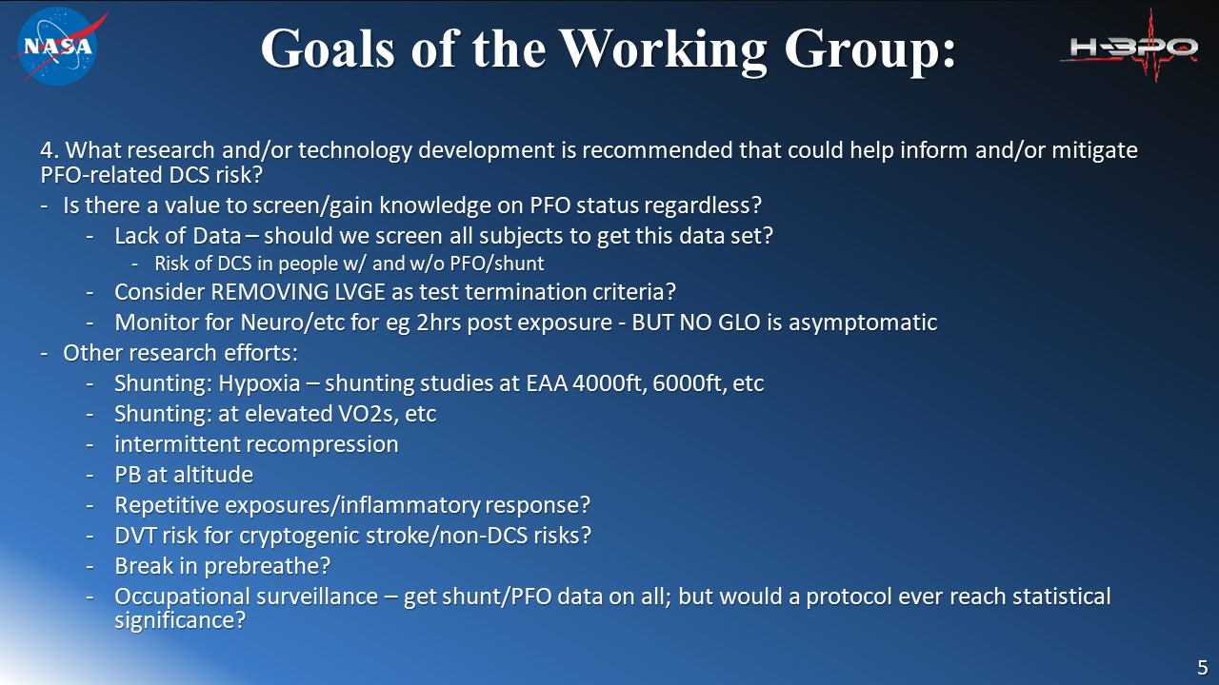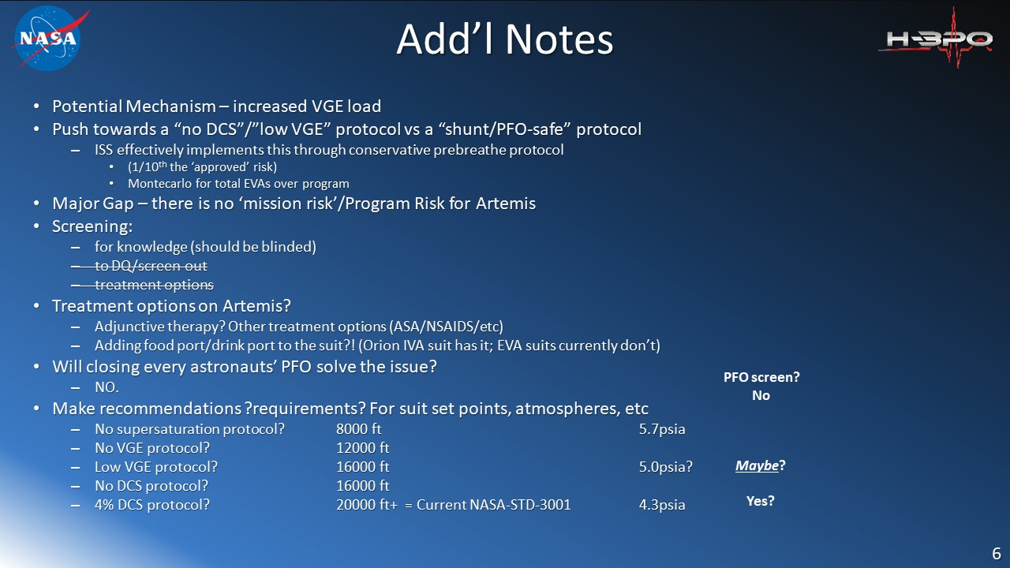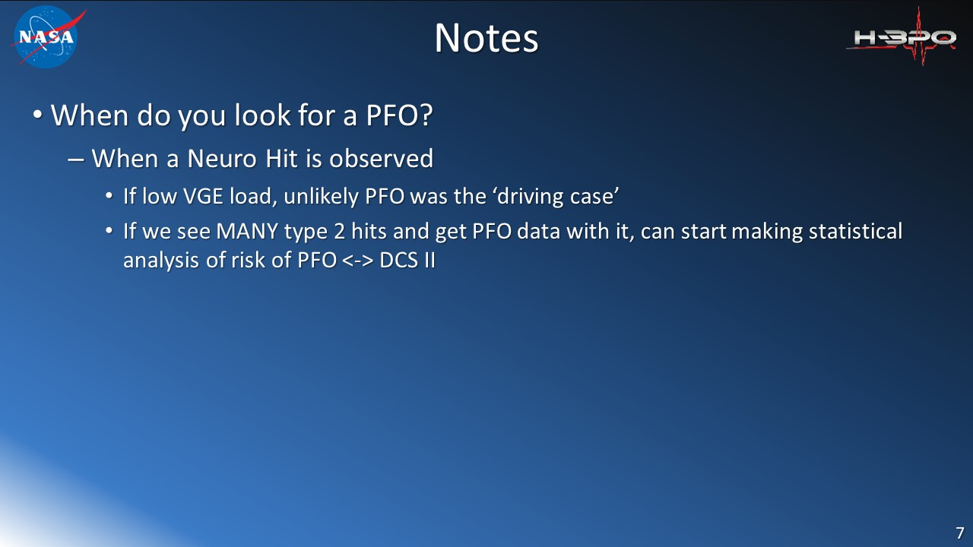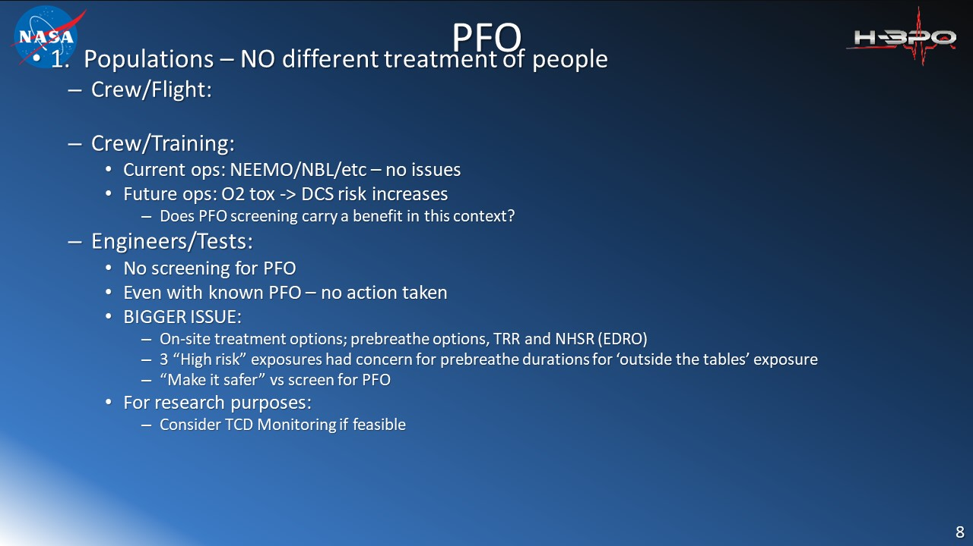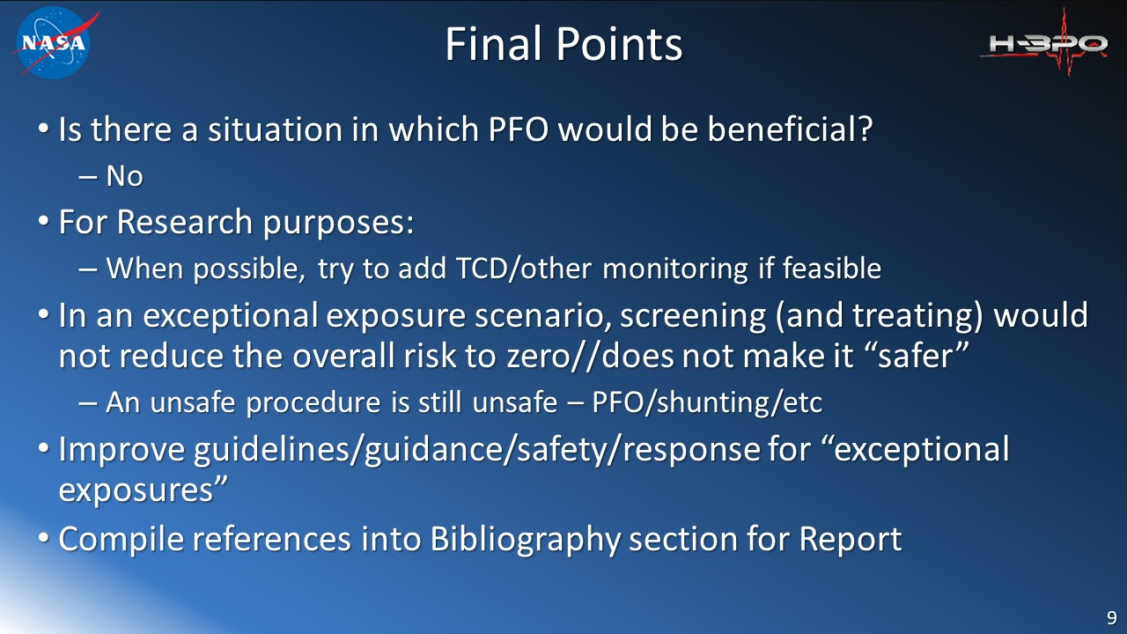

Bibliography
Akhondi A, Gevorgyan R, Tseng CH, Slavin L, Dao C, Liebeskind DS, & Tobis JM. (2010). The association of patent foramen ovale morphology and stroke size in patients with paradoxical embolism. Circ Cardiovas Interv, 4(5): 506-510.
Anderson G, Ebersole D, Covington D, & Denoble PJ. (2019). The effectiveness of risk mitigation interventions in divers with persistent (patent) foramen ovale. Diving Hyperb Med, 49(2): 80-87
Barker M, Muthuppalaniappan A, Abrahamyan L, Osten M, Benson L, Bach Y, et al. (2020).
Periprocedural Outcomes of Fluoroscopy-Guided Patent Foramen Ovale Closure with Selective Use of Intracardiac Echocardiography. Can J Cardiol, 36:1608-1615.
Bosi D, Lu Y, He S, Li B, Li Y, Lai Q, et al. (2023). Multisite and multitimepoint proteomics reveal that patent foramen ovale closure improves migraine and epilepsy by reducing right-to-left shunt-induced hypoxia. MedComm, 4(4): e334.
Bove AA. (1998). Risk of decompression sickness with patent foramen ovale. Undersea and Hyperbaric Medical Society, 175-178.
Bove AA. (2014). The PFO Gets Blamed Again…Perhaps This Time it Is Real. JACC Cardiovascular Interventions, 7(4): 409-410.
Brett, KD, Vallee, I, Saary, J. Case Report: PFO Closure in an Occupational Diver after Type II DCS. Presented at 2023 UHMS Annual Scientific Meeting. June 16-18, 2023
Church Committee Report. (December 2000). The NASA Medical Policy Board Advisory Committee Executive Summary: Review of the NASA Decompression Sickness Risk Mitigation Program; Tommie G. Church, David Johanson, David Cruess, Russell Raymon, James Hickman, Jr. Alfred Bove.
Conkin J. (2011). Decompression Sickness After Air Break in Prebreathe Described with a Survival Model. Aviat Space Environ Med, 82: 589-598.
Decompression Sickness (DCS) Prebreathe Reference Library. NASA Office of the Chief Health and Medical Officer. https://www.nasa.gov/organizations/ochmo/decompression-sickness-dcs-prebreathe-reference-library/
Denoble PJ, Holm JR, eds. Patent Foramen Ovale and Fitness to Dive Consensus Workshop Proceedings. Durham, NC, Divers Alert Network, 2015, 146 pp. ISBN 978-1-941027-32-5.
Fordyce AM, Whalley GA, Coffey S, & Wilson LC. (2022). Adjunct Methods for the Detection of Patent Foramen Ovale: The Contribution of Transcranial Doppler and the Valsalva Manoeuvre. Heart, Lung and Circulation. 31(11): 1471-1481.
Gernhardt, M. (2016). Altitude decompression: Past, present, and future. Naval Sea Systems Command (NAVSEA) 2016 Annual Review, Arlington, VA, United States.
Gernhardt, M. (2022). Bubble dynamics from sea to space. [Plenary presentation]. Aerospace Medical Association (AsMA)/Undersea & Hyperbaric Medical Society (UHMS) 2022 Annual Scientific Meeting, Reno, NV, United States.
Gernhardt, M. (2022). Decompression from sea to space: Subsea and space decompression were driven by operational needs. [Panel: Overcoming barriers on the pressure spectrum from the past to the future]. Aerospace Medical Association (AsMA)/Undersea & Hyperbaric Medical Society (UHMS) 2022 Annual Scientific Meeting, Reno, NV, United States.
Gonnah AR, Bharadwaj MS, Nassar H, Abdelaziz HK, & Roberts DH. (2022). Patent foramen ovale: diagnostic evaluation and the role of device closure. Clin Med (Lond), 22(5): 441-448.
González-Alujas T, Evangelista A, Santamarina E, Rubiera M, Go ́mez-Bosch Z, Rodrı ́guez-Palomares JF, et al. (2011). Diagnosis and Quantification of Patent Foramen Ovale. Which Is the Reference Technique? Simultaneous Study With Transcranial Doppler, Transthoracic and Transesophageal Echocardiography. Rev Esp Cardiol, 64(2): 133-139.
Hagen PT, Scholz DG, Edwards WD. (1984). Incidence and size of patent foramen ovale during the first 10 decades of life: an autopsy study of 965 normal hearts. Mayo Clin Proc, 59(1): 17–20.
Honěk J, Šefc L, Honěk T, Šrámek M, Horváth M, & Veselka J. (2015). Patent foramen ovale in recreational and professional divers: an important and largely unrecognized
problem. Can J Cardiol, 31(8): 1061-1066.
Honěk J, Šrámek M, Šefc L, et al. (2019). High-grade patent foramen ovale is a risk factor of
unprovoked decompression sickness in recreational divers. J Cardiol, 74(6): 519-23.
Koopsen R, Stella PR, Thijs KM, & Rienks R. (2018). Persistent foramen ovale closure in divers with a history of decompression sickness. Neth Heart J, 26(11): 535-539
Law J, & Watkins S. (2009). Individual Susceptibility to Hypobaric Environments: An Update. NASA-TP-2010-216123. https://humanresearchroadmap.nasa.gov/gaps/closureDocumentation/Law-J_TP-2010-216123.pdf?rnd=0.935669551107879
Lee V, St. Leger Dowse M. (2010). Decompression Ilness and the Menstrual Cycle. In C E Fife & M St. Leger Dowse (Eds.), Women and Pressure, Diving and Altitude (1st ed. pp 71- 79). Best Publishing.
Maxwell YL. (2020). PFO Closure May Prevent Decompression Sickness in Divers with Large Shunts. tctMD. https://www.tctmd.com/news/pfo-closure-may-prevent-decompression-sickness-divers-large-shunts
Mojadidi MK, Winoker JS, Roberts SC, Msaouel P, Zaman MO, Gevorgyan R, & Tobis JM. (2014). Accuracy of Conventional Transthoracic Echocardiography for the Diagnosis of Intracardiac Right-to-Left Shunt: A Meta-Analysis of Prospective Studies. Echocardiography, 31(9): 1036-1048.
Moon RE, Camporesi EM, & Kisslo JA. (1989). Patent Foramen Ovale and Decompression Sickness in Divers. The Lancet, March 11, 1989.
Ntaios G, Papavasileiou V, Sagris D, Makaritsis K, Vemmos K, Steiner T, & Michel P. (2018). Closure of Patent Foramen Ovale Versus Medical Therapy in Patients With Cryptogenic Stroke or Transient Ischemic Attack Updated Systematic Review and Meta-Analysis. Stroke, 49: 412-418.
Oliva L, Huszti E, Hall R, Abrahamyan L, & Horlick E. (2022). Incidence of new-onset atrial fibrillation after transcatheter patent foramen ovale closure using 15 years of Ontario administrative health data. Hearth Rhythm, 19(9): 1414-1420. 9.
Palazzo P, Ingrand P, Aguis P, Chaidi RB, & Neau JP. (2019). Transcranial Doppler to detect right‐to‐left shunt in cryptogenic acute ischemic stroke. Brain Behav, 9(1): e01091.
Percutaneous Patent Foramen Ovale (PFO) Closure. United Healthcare Community Plan. https://www.uhcprovider.com/content/dam/provider/docs/public/policies/medicaid-comm-plan/percutaneous-patent-foramen-ovale-closure-cs.pdf
Pilmanis AA, Webb JT, Balldin UI, Conkin J, & Fischer JR. (2010). Air Break During Preoxygenation and Risk of Altitude Decompression Sickness. Aviation, Space, and Environmental Medicine, 81(10): 944-950.
Pristipino C, Germonpre P, Toni D, Sievert H, Mejer B, Ascenzo FD, et al. (2021). European position paper on the management of patients with patent foramen ovale. Part II - Decompression sickness, migraine, arterial deoxygenation syndromes and select high-risk clinical conditions. EuroIntervention, 17: e367-e375.
Ramakrishna H, Patel PA, Gutsche JT, Kohl BA, Savino JS, & Augoustides JGT. (2014). Incidental patent foramen ovale in adult cardiac surgery: recent evidence and management options for the perioperative echocardiographer. J Cardiothorac Vasc Anesth, 28(6): 1691-1695.
Ravellette K & Tobis JM. (2022). B-29 Incidence of Atrial Fibrillation and Arrhythmias in Six Closure Devices for Patent Foramen Ovale [abstract]. JSCAI, 1(3) Supplement:14.
Rubin MN, Shah R, Devlin T, Youn TS, Waters MF, Volpi JJ. (2023). Robot-Assisted Transcranial Doppler Versus Transthoracic Echocardiography for Right to Left Shunt Detection. Stroke, 54(11): 2842-2850.
Saary MJ & Gray GW. (2001). A review of the relationship between patent foramen ovale and Type II decompression sickness. Aviat Space Environ Med, 72: 1113-1120.
Saver JL, Caroll JD, Thaler DE, Smalling RW, MacDonald LA, Marks DS, et al. (2017). Long-Term Outcomes of Patent Foramen Ovale Closure or Medical Therapy after Stroke. NEJM, 377(11): 1022-1032.
Skyes O & Clark JE. (2013). Patent foramen ovale and scuba diving: a practical guide for physicians on when to refer for screening. Extrem Physiol Med, 2: 10.
Steiner MM, Di Tullio MR, Rundek T, Gan R, Chen X, Liguori C, et al. (1998). Patent foramen ovale size and embolic brain imaging findings among patients with ischemic stroke. Stroke, 29(5): 944–8.
Stepanek J, Farina JM, Mahmoud AK, Chao CJ, Alsidawi S, Ayoub C, et al. (2024). Identifying the Causes of Unexplained Dyspnea at High Altitude Using Normobaric Hypoxia with Echocardiography. Journal of Imaging, 10(38).
Sullivan PJ, Gray G, & Nishi RY. (2000). Patent Foramen Ovale as a Risk Factor for Altitude Decompression Illness. Paper presented at the RTO HFM Symposium on "Operational Medical Issues in Hypo- and Hyperbaric Conditions ", held in Toronto, Canada, 16-19 October 2000, and published in RTO MP-062.
Tan Z, Lee PT, Manohararaj N, Tan JL, & Chang HM. (2024). Comparison of Simultaneously Performed Transcranial Doppler and Transthoracic Echocardiogram in Patients with Suspected Patent Foramen Ovale. Journal of Asian Pacific Society of Cardiology, 3: e17.
Torti SR, Billinger M, Schwerzmann M, Vogel R, Zbinden R, Windecker S, & Seiler C. (2004). Risk of decompression illness among 230 divers in relation to the presence and size of patent foramen ovale. European Heart Journal, 25: 1014-1020.
Turc G, Calvet D, Guerin P, Sroussi M, Chatellier G, & Mas JL. (2018). Closure, Anticoagulation, or Antiplatelet Therapy for Cryptogenic Stroke With Patent Foramen Ovale: Systematic Review of Randomized Trials, Sequential Meta‐Analysis, and New Insights From the CLOSE Study. J Am Heart Assoc, 7(12): e008356.
Van der Giessen H, Wilson LC, Coffey S, & Whalley GA. (2020). Australian Journal of Ultrasound in Medicine, 23(4): 210-219.
Webb JT, Pilmanis AA, & Balldin UI. (2004). Altitude decompression sickness at 7620 m following prebreathe enhanced with exercise periods. Aviat Space Environ Med, 75(10): 859-64.
Wilmshurst PT, Byrne JC, & Webb-Peploe MM. (1989). Relation Between Interatrial Shunt and Decompression Sickness in Divers. The Lancet, December 2, 1989.
Wilmshurt PT, Morrison WL, & Walsh KP. (2015). Comparison of the size of persistent foramen ovale and atrial septal defects in divers with shunt-related decompression illness and in the general population. Diving Hyper Med, 45(2): 89-93.

