FULL LUNAR SURFACE VISUALIZATION AND SIMULATION PLATFORM
Terry Mayes ⁽¹⁾, Tom Duncavage ⁽²⁾, Tom Diegelman ⁽³⁾

⁽¹⁾ Safety & Mission Assurance, SAIC, Johnson Space Center, Email: terrence.j.mayes@saic.com
⁽²⁾ Engineering & Robotics, ER711, Johnson Space Center, Email: tom.c.duncavage@nasa.gov
⁽³⁾ Safety & Mission Assurance, NE311, Johnson Space Center, Email: thomas.e.diegelman@nasa.gov

ABSTRACT
This paper reports the results of the innovative work completed to facilitate the creation of a lunar surface visualization and simulation platform for the entire surface of the moon as a design, test, training, verification, and mission support environment. The mathematical approach to the visualization of the data sets utilizes fractal mathematics to generate not only the highest possible detail that the Lunar Reconnaissance Orbiter (LRO) data [1] can provide, but it also additionally supplies an estimation of surface reflectivity and lighting based upon location on the lunar surface. This level of detail and accuracy is required to conduct accurate integrated crew / vehicle risk assessment throughout the design-to-disposal life cycle of vehicles and their supporting procedures and mission priorities. This process starts with safety assessments of integrated hardware / software / crew/ and support environments. Unlike the Apollo Program, the Artemis Program is not risk tolerant.

CHAOS THEORY BASICS

Chaos, in general, is the science of surprises. It can be nonlinear and unpredictable, but not random. It's described by fractal mathematics, which can capture the infinite complexity of the universe. Chaos theory tells us that diverse systems like economic, social, natural and biological can be interconnected. Chaos can be found everywhere: turbulence, the weather, the stock market, our brain states, spoken language, etc. A simple example is that of the single vs. double pendulum. Single pendulums are so predictable that they've been used to record time for centuries. Adding another link to a single pendulum makes the location of the free swinging end less and less predictable over time.

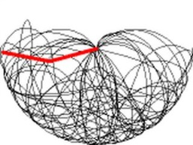

Figure 1, Path of swinging double pendulum
An Iterated Function System (IFS) is a recursive dynamical system that involves the repeated application of a rule or procedure to successive results. IFS are used to model all types of natural phenomena mountains, clouds, reproduction, music, cell phone antennas, etc. Fractals and IFS possess statistical self-similarity. Parts of their structure exhibit the same properties at any scale with respect to space or time. There are several examples of this in nature: plants, animals (golden ratio), geology, weather phenomena, etc.
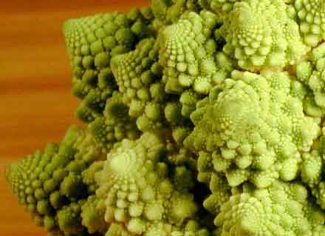
Figure 2, Cauliflower showing self-similarity

FRACTIONAL DIMENSION
A metric space is a set for which distances between all members of the set are defined (measureable).

(1)
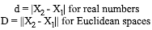
A space filling curve is a curve whose range contains the entire 2D unit square (or any general n-dimension hypercube). Ex: Peano curves, Hilbert surfaces, etc. The fractal dimension is a statistical index of how an object's complexity varies with scale. It is also a measure of how space filling it is.
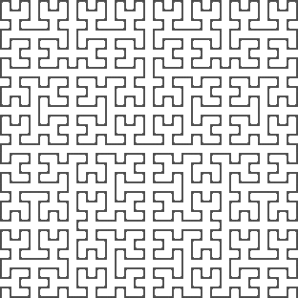
Figure 3, Peano curve

The Hausdorff-Besicovitch equation revolutionized mathematics by proposing dimensions with non-integer values (fractional). Many curves have an "in-between" dimension related to the varying amounts of information they contain (space filling). The Hausdorff-Besicovitch measurement equation includes a scale dimension d, which is 1 for line, 2 for square, 3 for cube, etc. and can be real valued.

(2)

Where N = segments, s = segment scale, and d = the dimension. The formal fractional dimension equation:
(3)

Some examples of calculated fractional dimensions include: broccoli cross section = 2.66, surface of human brain = 2.79, and lightening discharge = 1.51.

RICHARDSON METHOD
The Richardson method estimates an object's dimension by measuring it with rulers of different length, graphing the results, and determining the slope. Objects with fractional dimension will appear to have greater length as measurement precision increases. This was observed when neighboring countries calculated substantially different length estimates for their common border based on their chosen unit of measure. For instance, in the 1950's, Spain claimed its border with Portugal was 987 km, whereas Portugal claimed it was 1214 km.

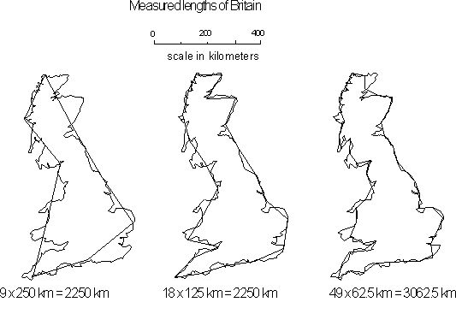
Figure 4, Measured British coast with different scales

Benoit Mandelbrot used the Richardson method to estimate that the eastern British coast had an approximate dimension of 1.26. Plotting the log of the scale vs. the log of the total length yields a graph showing how fractal or space filling different geometries are. The steeper the slope, the more fractal the curve is. The flatter the slope, the less fractal it is.

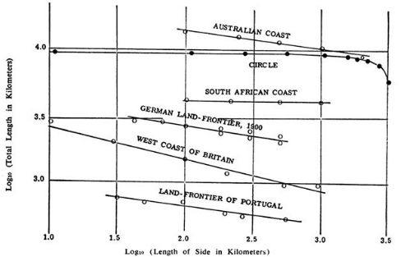
Figure 5, Fractal dimensions of various coastlines

BOX-COUNTING
The box-counting method can produce an estimated dimension for any object (small or large) that can be mathematically contained within grids or boxes. Grids of different resolutions can be used to model the unit of measurement for Richardson based methods to determine fractal dimension. Coarse grids simulate low-resolution measurements, while finer grids produce higher resolution measurements. Grids can have any dimension: 2-D, 3-D, etc. The measurement equation for the box-counting method involves calculating the number of cells containing the object, and the scale of the grid.

(4)
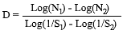

N_{i} = number of cells containing the object, S_{i} = grid scale, and D is a slope.

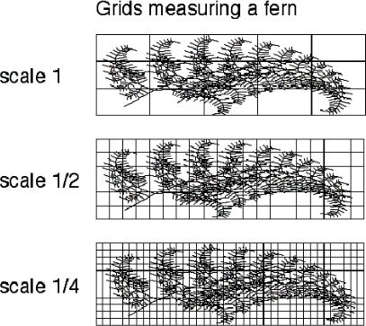
Figure 6, Box-counting a fern at 3 scales

Slopes that result in integral numbers represent non-fractional curves or surfaces, while real-valued slopes represent fractals.

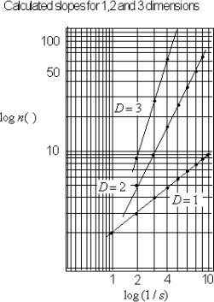
Figure 7, Calculated slopes for 1, 2, and 3 dimensions

LRO DATA SETS
In 2009, NASA put the Lunar Reconnaissance Orbiter into orbit around the moon. Its primary goal was to map the lunar surface and identify landing sites and potential resources in support of future automated and human missions. Some teams utilizing public domain LRO data lacked the tools needed to refine the terrain and imagery to the fidelity they needed. Others teams have developed refinement approaches that are proprietary, preventing them from being shared collaboratively. Our work was undertaken to assist those groups in generating higher resolution imagery and terrain elevation from LRO data in a mathematically credible way. To do this, we started by acquiring as much publically available, full surface, LRO data as possible. These data sets included:

- Lunar LRO-WAC Mosaic global 100m cylindrical projection imagery, an image with 109164 x 54582 pixel resolution.
- Lunar LRO-LOLA cylindrical projection terrain elevation data sampled at 4, 8, 16, 64, 256, & 512 (15 km to 50 m) posts per degree.
- Lunar LRO-LOLA polar projection terrain elevation data sampled at 100m, 60m, 30m, 20m, 10m, and 5m spacing.

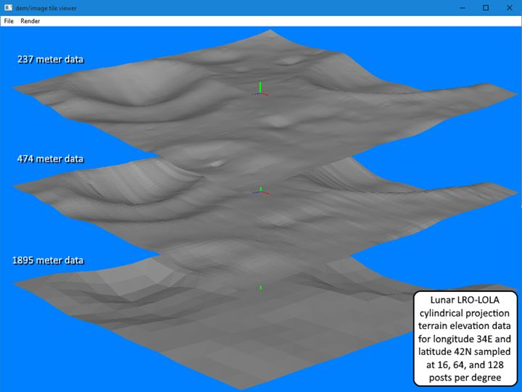
Figure 8, Stack of assorted LRO elevation models

Cylindrical elevation data for 32 posts per degree (960m) was generated algorithmically due to its unavailability online.

TERRAIN REFINEMENT
Natural objects exist in fractional dimensions (turbulent fluids, gaseous phenomena, geologic formations). These manifest as systems that show more fidelity, or convey more information, as you magnify them (observe them at higher scale factors).

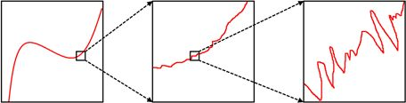
Figure 9, Fractal objects under magnification

For terrain elevation models, this can be seen as an increase in surface area as the number of samples / resolution increases (doubling in the example below).

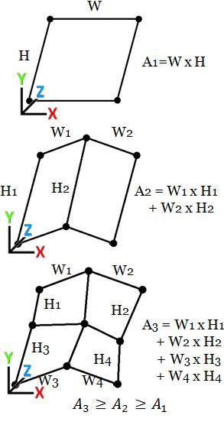
Figure 10, Increase in surface area with resolution
One way to estimate the degree of chaos/fractional dimensionality is to calculate a fractal exponent. For discrete models, such as terrain elevation data sets, one method is the Hausdorff dimension described earlier. For LRO digital elevation maps, which are already sampled at multiple resolutions, the Richardson method is used to calculate the Hausdorff dimension. This technique uses the slope of the regression line computed from a plot of log₁₀(resolution) vs. log₁₀(measured area). The resolution is in posts/samples per degree (latitude/longitude) and the measured area is in km². Below is the calculated Hausdorff dimension for the LRO elevation data (from 8 to 512 posts per degree) at longitude=214, latitude=132.

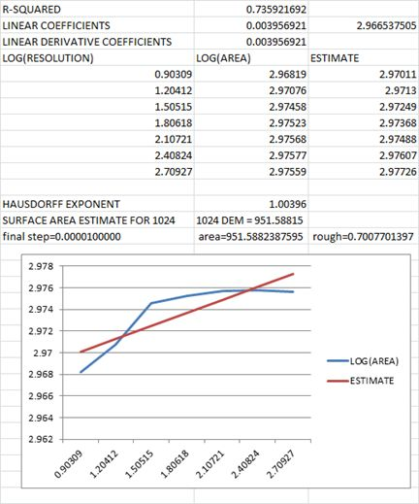
Figure 11, Richardson estimation of Hausdorff dimension for lat=132 / lon=214
As can be seen in the graph, the slope of the regression line (red) is non-zero (surface is fractal) and the linear fit is good (R²=0.736). This implies that the total surface area for the next higher resolution (1024 posts per degree) should be approximately 981.588 km². The flattening of the blue line in the chart at 512 posts per degree implies that the elevation data at that resolution may be interpolated or smoothed.

TERRAIN REFINEMENT ALGORITHM
The basic algorithm for the refinement of LRO terrain elevation maps is as follows (summarized in figure below):

- Read in initial map from disk.
- Generate midpoint samples using averaging.
- Apply fractal surface subdivision. Use the Hausdorff exponent as a guess for the initial roughness coefficient.
- Iterate by searching for the best roughness coefficient value that results in the desired surface area.
- Write the new refined (2x) elevation map to disk.

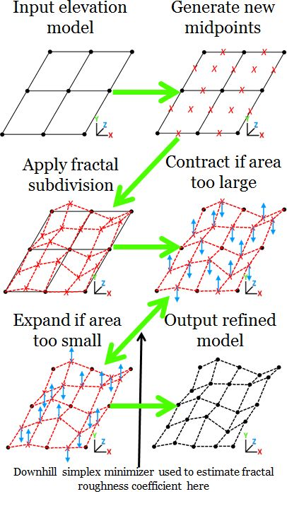
Figure 12, Terrain refinement algorithm

In our implementation, a downhill simplex minimizer was used to choose between expansion and contraction during fractal roughness coefficient estimation. Note that the roughness coefficient is a surface property, and can be reused to generate repeatedly higher and higher resolutions without re-computation. The output generated from three consecutive runs for lat=132, lon=214 is presented in the figure below. Note that, in this case, the final roughness coefficient was determined to be 0.7008. It can be reused to synthesize the next higher resolution, and so on.

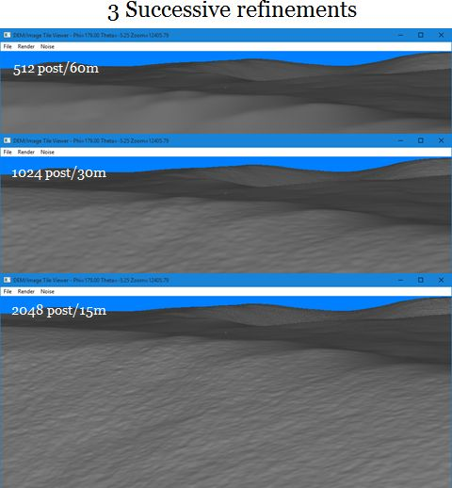
Figure 13, 3 successive terrain refinements

8. TERRAIN IMAGE REFINEMENT

Our primary goal in using LRO data was to develop a full lunar surface simulation platform (like Google earth) that runs on low-cost hardware. One problem with publically available LRO data is that the resolution of terrain imagery is lower than the resolution of terrain elevation data. To rectify this, an effort was undertaken to determine if lighting properties (reflectance and direction) could be estimated from current LRO imagery. The method that was discovered allows mathematically credible, high resolution, images to be synthesized from high resolution terrain elevation. Given that the terrains can be refined indefinitely (through the use of fractal surface subdivision), the imagery can be as well. The diffuse lighting model used in most consumer level 3-D video cards is based off of Lambertian reflection.

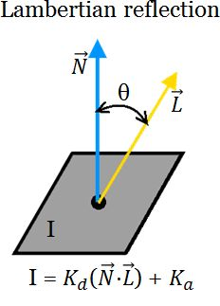
Figure 14, Lambertian reflection model

Here, I = the intensity (color) at the surface, K_{d} = the diffuse reflectivity, and K_{a} = the ambient reflectivity {0 ≤ I, K_{d}, K_{a} ≤ 1}. The vector N represents the unit normal at the surface being illuminated, and the unit vector L represents the lighting direction. For the lunar surface, the ambient reflectivity K_{a} = 0. This is due to the fact that the moon has no atmosphere to cause ambient light scatter. Groups of four neighboring pixels from terrain imagery can be combined with four calculated normals from the corresponding terrain elevation map.

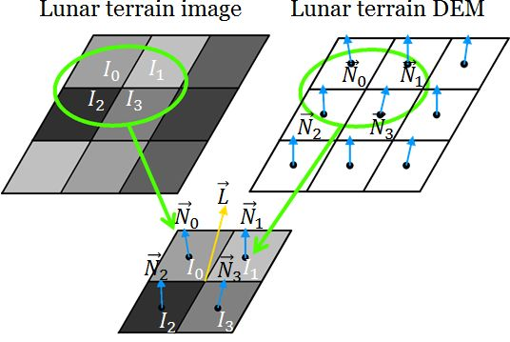
Figure 15, Combine image pixels with terrain normals

This allows for the construction of a set of four equations which can be used to solve for the local lighting direction vector L. Since there are only three unknowns, the system is over-determined and must be solved via pseudo-inversion. The Moore-Penrose method was the approach chosen.

(5)

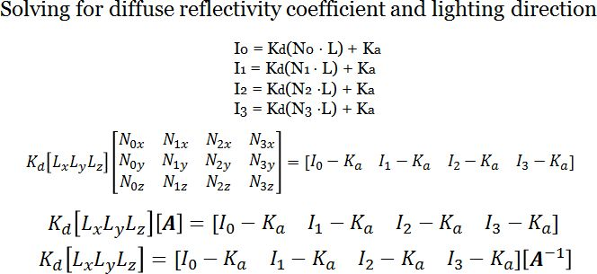
Solving this system yields a vector L that represents the best-fit lighting direction for this pixel group. The magnitude of this vector L gives an approximation of the diffuse reflection coefficient K_{d} for the pixel cluster. To find the best candidate L for the entire image, a search can be performed over all pixel group L vectors that have a magnitude less than 1. These will be all vectors which have 0 ≤ K_{d} ≤ 1, which is defined strictly by the Lambertian reflection equation. Experimentation with LRO imagery has shown that roughly 30% of pixel group L vectors have appropriate K_{d} values. When these clustered L vectors are averaged, they yield a very mathematically credible estimate for the overall lighting direction of the entire image.
(6)

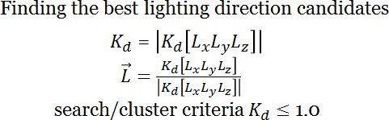

9. IMAGE REFINEMENT ALGORITHM

Once lighting direction is determined (either local or entire image), it can be used to estimate the intensity I, of an image pixel at a higher resolution. Doing so only requires the estimated diffuse coefficient for the pixel group K_{d}, and the normal vector N, from the higher resolution elevation model. The basic algorithm for the refinement of LRO terrain image maps is as follows (summarized in figure below):

- Read in initial image from disk.
- Read in the corresponding elevation map from disk.
- Compute best fit lighting direction vectors L, and diffuse reflection coefficients K_{d}, for each 4 by 4 pixel group using the equations above.
- Create a new image that is twice the size of the initial image in both width and height.
- Copy the old image pixels into the odd numbered (both x & y) cells in the new image. This will create a grid of missing pixels to be filled in.
- Read in the elevation map that corresponds to the new image just created, and calculate surface normals N. It should also be twice the size.
- Calculate missing pixel intensities I, using the new surface normals N, the estimated lighting direction L, and calculated diffuse reflectance K_{d}.
- Save the new, double resolution image to disk.

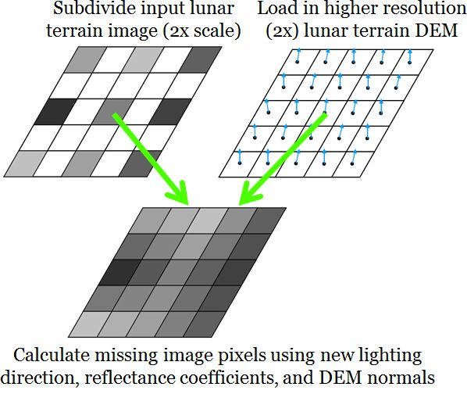
Figure 16, Image refinement algorithm

The new pixel intensity I, is calculated using the Lambertian reflection equation and K_{d} can be determined by rewriting the terms of the equation.

(7)

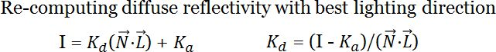

The output generated from three consecutive runs for lat=132, lon=214 is presented in the figure below.

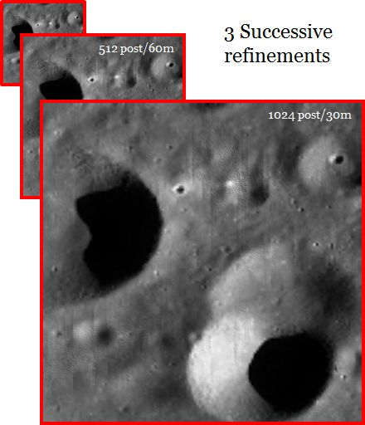
Figure 17, 3 successive image refinements

This process was used to create an image map of the entire lunar surface at 512 by 512 posts per degree resolution for the full lunar surface simulator. The previous publically available LRO image data set was only a quarter of that resolution at 256 posts by 256 posts per degree.

9. USE CASES

Using these techniques, a full lunar surface simulator was created that supports 60m resolution and runs from USB drives on COTS H/W (laptops). The compressed LRO image and terrain elevation models created by fractal techniques fit in only 99GB and can be accessed without an internet connection.

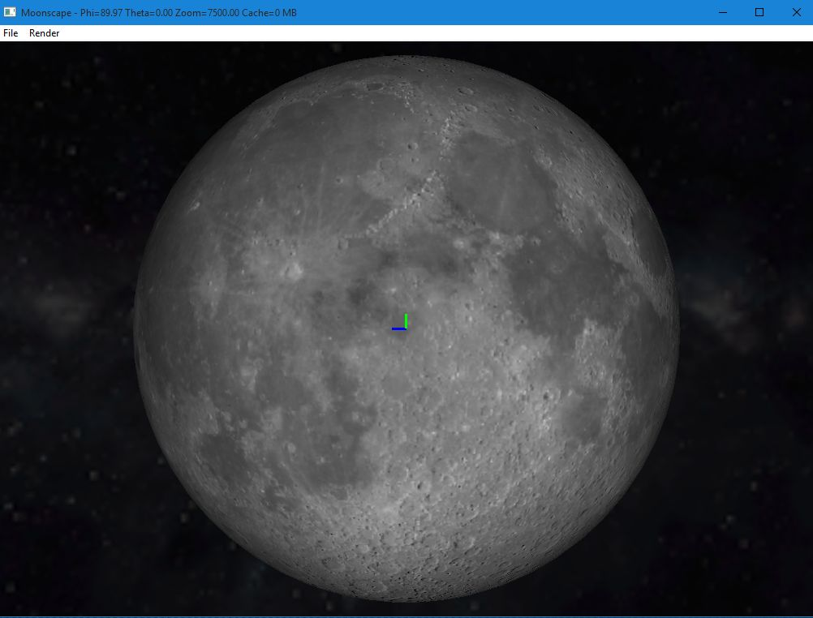
Figure 18, Full lunar surface simulator

To test the visual accuracy of the refined terrain data, a reconstructed tranquility base visualization was created. 3.5m resolution refined terrains were synthesized and paired with historic imagery and multiple 1960's era spacecraft models.

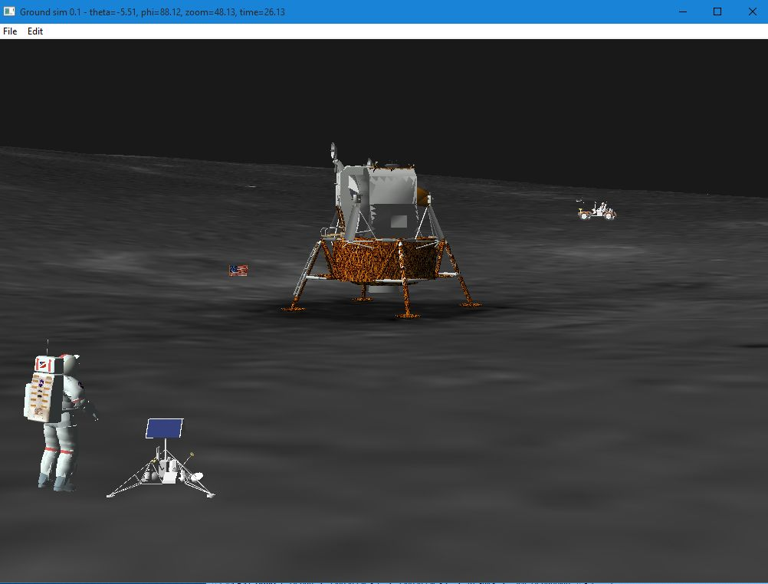
Figure 19, Tranquility base reconstruction

The proposed Amundsen rim lunar landing site was generated at 0.625m. It was used to assess lander topple risks for the commercial crew program. A 3-D simulation of the Space-X lander was built that visually depicts the lean angle at a variety of locations in a 5km region around the target site.

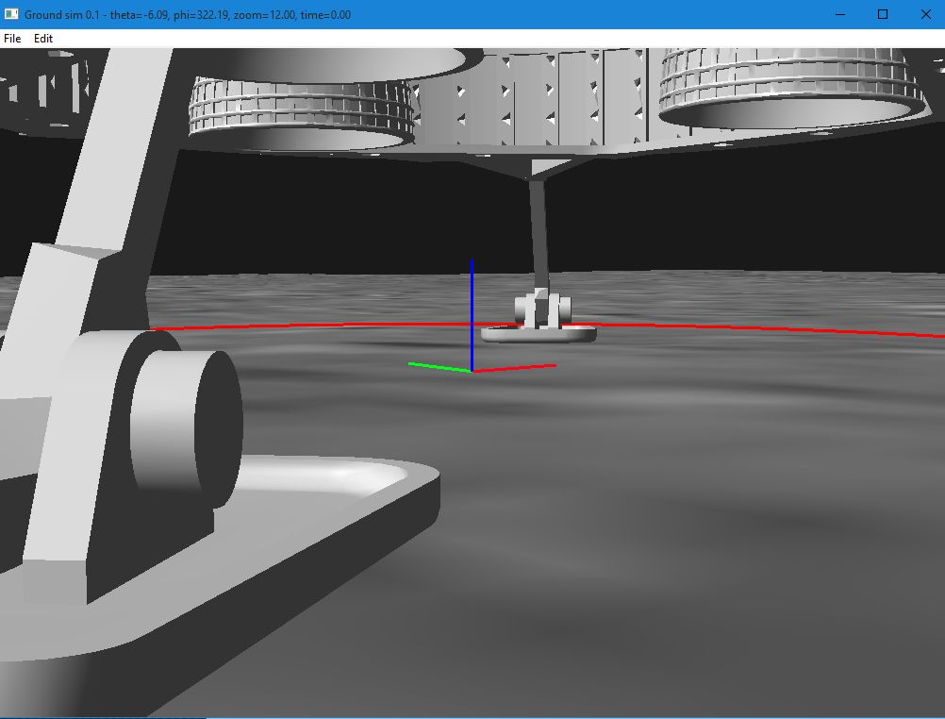
Figure 20, Amundsen rim topple study

Links to videos demonstrating each of these use cases can be found in the references section of this paper.

10. FUTURE WORK

Due to the way the instrument is designed and operated, LRO gridded topography data products are known to contain visual artifacts. These include interpolated pixels between discreet laser shot locations, and other issues related to perturbations in the spacecraft orbit. Smoothly interpolated and noisy terrain samples can impact the accuracy and performance of ground based simulations: rovers, landers, lighting studies, etc. Because of this, the development of automated algorithms to detect and extract these erroneous samples will be investigated. If successful, a tool will be created to allow a user to replace bad samples with mathematically appropriate, fractally generated alternatives.

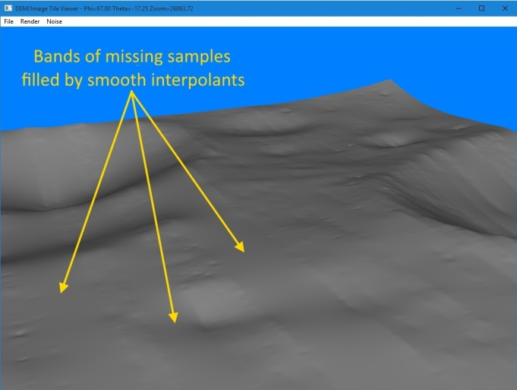
Figure 21, Missing terrain elevation samples

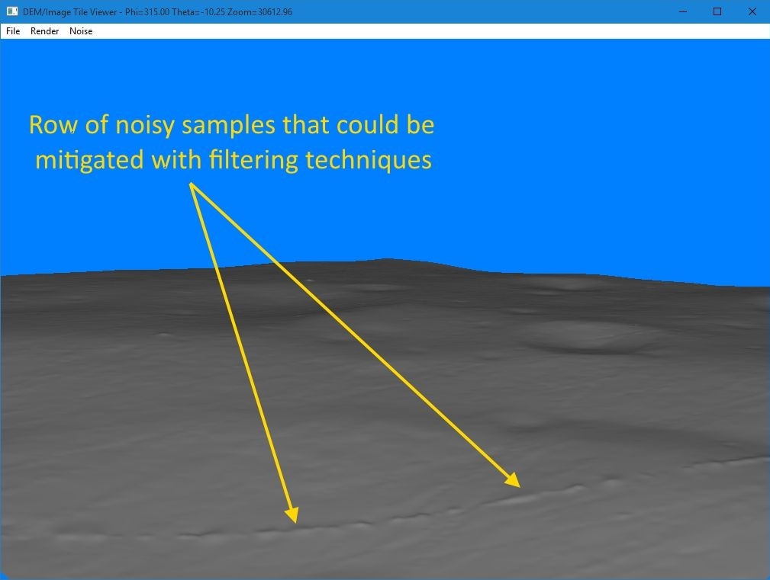
Figure 22, Noisy terrain elevation samples

11. DISCUSSION

The sheer number of diverse Artemis players, contributors, and stakeholders leads to the inevitable divergence of criterion and standards. Because each commercial entity, international partner, and culture is different - So too are the processes, standards, and difficulty of integration into this extremely complex program arrangement, something largely lacking in the Apollo, due to NASA controlling the design phase through the mission execution.

The critical point being made is the overall integrated process for system development, testing, and delivery must reflect an ability to protect crew, avoid a fatality, given the constraining Artemis Program attributes. It requires the SMA function to take a leading role in the life cycle stages. Moreover, it requires the integration and testing function, core functions of SMA, to be executed in a manner that continuously drives down the aggregate risk during the safety certification process. Clearly, risk is managed at the element, system, and deliverable end item levels, but that is insufficient to guarantee crew, vehicle, and mission safety.

How is this accomplished? It must start with common tools, and a unified environment that is certified as the standard for validation of deliverable goods and services. The full lunar surface simulation platform (these fractal techniques were developed for) potentially provides this during the entire life cycle process once it is fully tested and certified as a standard. To date, that has not been done. This paper illustrates the advantages of such a unified approach.

This is not a new idea. Common environment was tried on the Space Station Freedom Program in the early 1990's by NASA, the Station Software Environment (SSE). The problem then was simple: the technology, the culture and the tools did not exist and required budget, calendar time and commitment to developing these tools, techniques, and platform [2]. Although the Space Station Freedom evolved into the current International Space Station (ISS), the attempt to bring this concept forward failed to materialize on ISS because of the same reasons it failed previously, no business case for a short program, given ISS was to be a 10-year project. That would make a very difficult business decision with respect to return-on-investment (ROI). Artemis, being "open ended" as to duration, does not have that constraint. The ROI over a longer timeframe makes the business case significantly more positive, especially given the full lunar surface simulation prototype has been shown to function as anticipated, supporting lander "topple studies" [3] already.

NASA is committed to the environment and sharing concept for Artemis. The current tool collection platform is called "Project Luna" [4], which is a NASA Headquarters funded I.T. Modernization for Transformation (ITMX) Fund project. Clearly, NASA is committed to making this transition to a more rigorous testing and risk management approach through development and use of digital tools.

13. REFERENCES

1. Lunar Reconnaissance Orbiter, https://science.nasa.gov/mission/lro

2. Space Station Freedom Software Support Environment (1990), Susan J. Voigt Space Station Technology Office, NASA Langley Research Center

3. Sturgis, J.R. (2024), Using Available Lunar Surface Elevation Data to Characterize Risk of Human Lander System Stable Landing, FY2023 Innovation Charge Account

4. Vernon, L. (202X), Project Luna

13.1 Video Link References

Fractal terrain refinement algorithm demonstration
https://www.youtube.com/watch/9IUiIRnp4PU

Terrain image refinement algorithm demonstration
https://www.youtube.com/watch/4ogOEIMGuG0

Full lunar surface simulation platform
https://www.youtube.com/watch/Y_uGQH0qMbg

Tranquility base reconstruction test case
https://www.youtube.com/watch/BfjONDHigSs

Commercial crew lander topple study
https://www.youtube.com/watch/QNpx0qw8IfQ

