BEHAVIORAL HEALTH BENEFITS OF THE ISS PICK-AND-EAT CROP GROWTH SYSTEM
L.B. Landon¹, S.R. Begerowski¹, S.E. Whiting², C.A. Spencer³, S.T. Bell⁴, P.G. Roma⁵, & G.D. Massa⁶
¹KBR, Behavioral Health & Performance Laboratory, Johnson Space Center; ²NASA, Research Operations and Integration Element, JSC; ³JESTech, Behavioral Health & Performance Laboratory, JSC; ⁴NASA, Behavioral Health & Performance Laboratory, JSC; ⁵Leidos, Naval Health Research Center; ⁶NASA, KSC; (lauren.landon@nasa.gov)

BACKGROUND
Plants are a potential countermeasure for the stresses of living in space. Caring for plants and eating fresh food have been shown to serve as a psychological benefit for previous astronauts and for others in analogous environments such as Antarctica [1,2]. Gardening can be therapeutic in terrestrial settings [3]. These effects may carry over or be more pronounced in austere environments such as spaceflight. It can reduce stress and increase sensory stimulation and enjoyment [2]. Growing crops may offer astronauts meaningful and engaging work as they care for living things in an austere environment away from Earth’s nature and as they provide sustenance for their crew. We examined the extent to which interacting with plants (e.g., tending to, consuming) was related to behavioral health outcomes in long-duration space missions.
METHOD
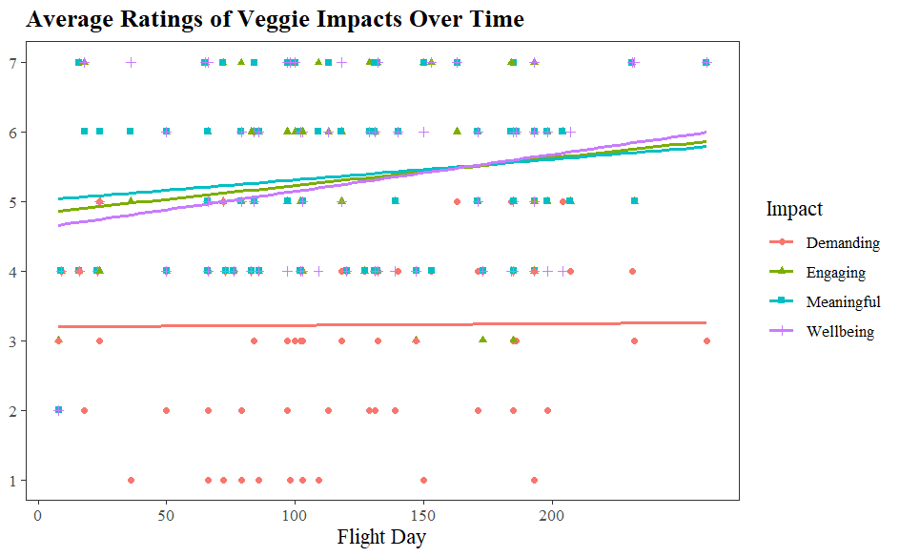
Participants were 27 astronauts that interacted with the plant system VEG-04, VEG-05, and HRF-VEG (VEG-03 I-L, PH-04). In total, there were 106 in-flight observations. Participants completed monthly measures of mood and well-being, enjoyment and time spent performing specific crop growth and consuming the plants, meaningfulness, performance, connections with others and the Earth, desire to work with and eat plants, and experiences with struggling or dying plants. Higher ends of the 7-point Likert scale indicated more positive outcomes, lower ends of the scale were anchored with more negative outcomes, and the scale midpoints indicated neutral positions. Participants selected a specific survey version based on whether they interacted with the plant system(s) or not, and we included only the scores from the crewmembers that participated in any given activity.
RESULTS & DISCUSSION
Results indicated that participants generally rated tasks related to the plants and crop growth as enjoyable. Consuming the harvested plants and voluntary viewing were the most enjoyable activities. Tending to the plants was reported as moderately enjoyable, indicating BHP benefits from this work task. The BHP impacts of whether the task was engaging, meaningful, supported well-being, or was demanding for a crewmember were generally positive and increased over time. As shown in the Figure, working with plants was reported as more engaging, meaningful, and beneficial to well-being over time, while the demand from the task was moderate to low and consistent over time. Engaging, meaningful, and supporting well-being were strongly, positively correlated with each other, which is consistent with research that suggests engaging and meaningful work can support well-being. Plant activities such as voluntary viewing, watering, harvesting, and consuming, were positively related to task engagement and meaning, and enjoyment and well-being. Findings suggest that working with plants and consuming them can be a behavioral health countermeasure for long-duration spaceflight.
REFERENCES
[1] Schlacht I, et al. (2020) Impact of plants in isolation: The EDEN-ISS…in Antarctica. In Advances in Human Factors of Transportation, Washington DC. [2] Vessel E, Russo S (2015) Effects of reduced sensory stimulation and…countermeasures…. NASA/TM-2015-218576. [3] Odeh R, Guy C (2017) Gardening for therapeutic people-plant interactions during LDSM. Open Agriculture, 2(1), 1-13.
ACKNOWLEDGEMENTS
This research was supported by the Human Health and Performance Contract NNJ15HK11B, and NASA grant MTL #1075 (PI G.D. Massa).

Summary: We summarize findings related to assessing the pick-and-eat salad-crop productivity and acceptability of the ISS food system as a countermeasure to maintain behavioral health in long-duration spaceflight.

