i-SAIRAS 2024

Integrated Systems and Operational Autonomy for Gateway

¹*Badger, J.M., ²Barron, L.E., ²Cullen, P.J. & ²Dvorsky, K.M.
*lead presenter
¹julia.m.badger@nasa.gov, NASA-Johnson Space Center, USA
² NASA-Johnson Space Center, USA
Abstract: The Lunar Gateway space station will be operated with less human oversight and control than any human spacecraft thus far. An autonomous software control architecture has been developed to allow the spacecraft to maintain safe operations of the vehicle during times of no human involvement. The development of these autonomous control functionalities has been both technical and process driven. Given that the Gateway will be built modularly with contributions from all over the world, the systems engineering processes had to be shaped to fit with the contractual and political realities of the construction of the international lunar habitat. This paper will describe these challenges and contributions to the development of human spacecraft for sustainable deep space missions.
1.0 Introduction
Gateway, built with international and commercial partner contributions, will be humanity’s first space station to orbit the moon, serving as a vital component to NASA’s Artemis campaign, deep space exploration, sustained lunar surface access, and missions to Mars and beyond. The operational complexity of the Artemis campaign has driven the need for integrated systems and autonomous operation on board the Gateway, relieving ground operations staff of full-time support of the spacecraft. The concept of operations for Gateway once it has been fully commissioned is for the ground operations team to spend one shift on console per week dedicated to Gateway command and control. Since the systems onboard Gateway, which will include payloads, life support, and a robotic manipulator (CanadaArm3), are not appreciably different than those on board the International Space Station, this concept of operations represents a significant paradigm shift in daily operations.
A system named the Vehicle Systems Manager (VSM) will manage the day-to-day operations of the Gateway in situ, through technologies that enable resource management, fault management, mission management, and timeline execution. The VSM functionalities are designed to be data driven and will operate as requested by ground operators through the development and use of data products such as goals, tasks, fault diagnosis models, and fault actions that are specific to Gateway’s current mission and configuration. The VSM will be a tool for ground operators to operate Gateway using supervisory control inputs (instead of direct command and control inputs).
While the design of the VSM functionalities is interesting, this paper will focus on the systems engineering and contract management practices that have been necessary to pull operational and systems data forward in the development life cycle to enable the development and testing of this autonomous spacecraft management functionality on the Gateway. Section 2 will give a technical description of the VSM and the Autonomous Systems Management Architecture (ASMA) that Gateway uses. Section 3 will provide context for how current space station operations are conducted, along with an assessment of the way operations will change with Gateway. Section 4 will provide a detailed description of the data needed by the VSM and the processes by which this data is solicited, developed, integrated, and verified. Section 5 will discuss the complexities of this data development process induced by organizational structure and pressures derived from the typical program management process, with a focus on Gateway’s implementation. Finally, Section 6 will list lessons learned and forward work faced by the team towards the deployment of the VSM on Gateway.
2.0 Background
Human exploration of Mars has been a dream and goal of the space program since at least the days of Apollo. The logistical, technological, and economical challenges of this venture have required a measured approach to development towards a Mars mission with astronauts. Lessons can be learned from all human space missions thus far, including (and maybe especially) the International Space Station (ISS). The ability for humans to live and work in space over missions that last over a year has greatly advanced the technologies needed to achieve a Mars mission. However, the gaps in capabilities are still significant. A design reference mission assessment of the technology and operations gaps between the ISS and what would be needed for a crewed Martian mission that required dormancy of the crew transit spacecraft found several areas of focus to make the mission possible [1]. In particular, the need for an on-board controller that could manage the vehicle and its systems was a main conclusion for the study.
As the Gateway lunar space station was being conceived, a specific intention of the program was to develop Gateway looking forward towards technologies needed for Mars exploration. To that end, Gateway has several autonomy requirements that derive from Mars needs, for example, Gateway must be operational for up to three years without human visits. The requirement most pertinent to this paper is the 21-day autonomous operations requirement, which is meant to cover the solar conjunction period between Earth and Mars which inhibits all direct-line communication between the planets. As such, a Vehicle Systems Manager was planned to cover the day-to-day operations of the vehicle, as the head of a distributed and hierarchical architecture of autonomous control entities. Because the Gateway is being developed in pieces that will be integrated in orbit around the room (called “modules”), Module System Managers play an important role in controlling the systems within their modules to support the VSM in vehicle management.
The roles that VSM plays in the day-to-day operation of the Gateway include the following:
- Mission Management and Timeline Execution – Commands for maintenance of vehicle, operation of payloads and systems, and configuration of functions are sent from the ground to control the ISS daily. Onboard Gateway, the VSM will collect tasks and procedures meant to achieve goals on a timeline. These tasks and procedures will be executed in accordance to their scheduled time and also with respect to any encoded constraints (vehicle state values that must be true before/during the execution of a task). Success of the goals are monitored to ensure that human intent is achieved.
- Resource Management – Because resources such as power and data bandwidth are limited onboard the Gateway spacecraft, the VSM plays a key role in ensuring that they are protected. For example, the VSM plans and constrains time lined tasks so that the vehicle safely stays power positive and protects for appropriate power draw during eclipses to preserve battery health.
- Vehicle Control and Operations – In some cases, systems are distributed across modules, and the control of those systems must be coordinated across Module System Managers. In these cases, it is VSM that closes the loop on the control of the function or plays a large role in system configuration to ensure proper integrated behavior.
- Fault Management – For most faults and failures, local behaviors to contain the event and recover necessary functionality are sufficient. For certain faults and failures, a vehicle-wide response is necessary. Faults that happen at module boundaries need VSM support to diagnose. Failures that propagate across module boundaries or that impact vehicle functions across the vehicle require a VSM response. The VSM is also responsible for reporting out failure conditions to crew and ground operators indicating the urgency of the human response, if any, to that incident through alerting.
- Human Interfaces – VSM is the entry point for command and control of the Gateway, and since much of the commanding will be done remotely (from the ground), situational awareness is especially important. VSM will provide consequence guidance, decision aiding, and command arbitration to support human operators’ understanding of the impacts of their requested actions.
Operation of the Gateway through VSM will be through the configuration of data that VSM will use to monitor, react, and execute the control needed. Data configuration and timeline planning is expected to happen about weekly to support the Gateway’s uncrewed operations cadence.
3.0 Vehicle Operations Changes
The International Space Station is primarily controlled by Flight Controllers in Mission Control and on-board Crew members, which makes interactions between humans and the onboard systems nearly continuous. To prepare for this type of support, Flight Controllers go through a rigorous training process to learn about the systems, operational concepts and constraints. In addition to training, the Flight Controllers are also responsible for generating and maintaining the operational products such as procedures and flight rules which dictate exactly how the operators will interact with the systems. When it comes time to manage the onboard systems, Flight Controllers will execute pre-planned activities based on a pre-coordinated timeline; off-nominal signatures are an exception to this. The timeline is meticulously planned and adjusted based on real time system statuses and priorities and is only a representation of the activities that need to be performed, so all actions must be executed manually. Most systems on the International Space Station were designed and delivered without any input from those that would be operating them. This causes the Flight Control Team to spend a lot of time in tests or simulations learning how to operate the system, what operational constraints need to apply, and then developing the operational products.
Gateway operations will be much more autonomous and include the flexibility to turn the autonomy up or down depending on the level of human operator control desired. Initially the control will be more manual, but the intent is that when Gateway is in quiescent operations, the Flight Control Team will only need to support for roughly 20 hours per week. Given the variability in the use of the autonomy, it is important to have an understanding of how the Flight Controllers and Crew will interact with and operate the systems earlier in the design phase. This is because VSM will nominally operate systems based on tasks on a timeline. The tasks will autonomously command systems in the same way that a human would manually control them and therefore need to account for any operational constraints. By considering system operation and human interaction in the design phase, risk of significant design changes due to unforeseen operational issues can be mitigated. This also allows for the operations team to learn about the systems much earlier in the program timeline and therefore start development on operations products such as flight rules, procedures, and displays.
4.0 Data Design
4.1 Mission Management Data
The VSM Mission Management Model (MMM) is composed primarily of Goals, Tasks, Procedures, and Constraints. These are the data products required to operate the vehicle autonomously through timeline execution. Goals are high-level activities which describe a set of Tasks or end states to achieve, when to achieve them, and how important it is to achieve them. A state is a value derived from real-time system telemetry. An example of a state is cabin temperature. A Task is an individual activity used to achieve Goals, or Goal states. Tasks contain meta-data needed for autonomous execution including constraints such as pre-conditions: conditions that must hold prior to the start of a task, invariant constraints: constraints that must hold throughout the duration of a task, post-conditions: end states which are used to evaluate the success of a Task, and are used by the autonomous planner to achieve Goals which describe state targets. Tasks also contain meta-data associated with resource consumption or production, execution time, and parameters for Procedures or sequences. Tasks may invoke VSM Procedures, or module-level sequences. VSM Procedures are the executable code that send commands to modules and perform logic.
Development of this Mission Management Model data for nominal timeline execution and procedure development requires the following information:
  - Detailed use cases including:
    - Description of the activity
    - Roles and responsibility of actors (VSM, MSM, Ground, etc.)
    - Activity sequencing or logic
    - Activity requirements (e.g. requires ground communication)
  - Well defined interfaces, including commands and telemetry

The Gateway VSM Mission Management Working Group (MMWG) develops the Mission Management Model data. This working group helps refine use cases into Goals, model Tasks, author Procedures, and review all generated products. As the VSM timeline operations span a wide range of vehicle systems, a large set of stakeholders participate in the MMWG. Key participants of the MMWG include NASA engineering system managers, NASA Flight Operations Directorate (FOD), Safety and Mission Assurance (S&MA), and commercial and international partners providing Gateway modules and software.
Mission Management Model flight data development is separated into three sub-phases: the pre-production phase, the pre-flight phase, and the flight phase. The pre-production phase is a period of change, with data being developed and updated often. Formal configuration management is not used during this phase. The pre-flight phase occurs after Verification and Validation. At this point formal configuration management of the model begins and any new data, or changes to data, require a change request. The final phase, the flight phase, is when the data is actively used for the Gateway in flight. NASA Flight Operations Directorate becomes responsible for configuration management and updates to the model during this phase.
The development process for MMM data in the pre-production phase can be seen in Figure 1. In this phase there are 3 sub-phases which include data development, and software verification and validation activities. Phase 1 encompasses the development and refinement of data through the MMWG. Stakeholders and their roles in the process are shown on the left most side. Participation of the key stakeholders is critical for developing correct and accurate data products for VSM.

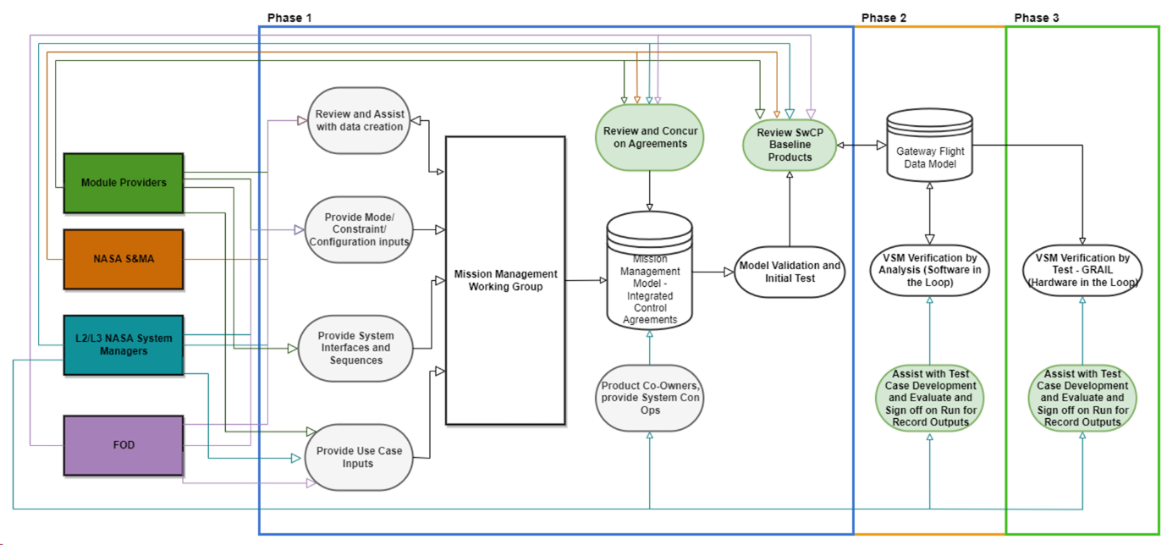Figure 1: Mission Management Model Data Development Process
  - Fault Management Data
VSM handles off-nominal conditions using monitors for system health that are distributed across the vehicle. These monitors cover conditions that include faults and failures of individual components up to functional failures that could affect crew and vehicle safety. Components, in this context, are defined as the smallest unit of hardware or software that individually affects the overall vehicle health. A component could mean an individual heater or a set of heaters, depending on system design and control options. Functions are similarly dependent on modeling and the design of the system. Functions are chosen to be actions that the systems can take that affect vehicle control, operation, and crew safety.
This fault management functionality is based on a model-based inference engine. Fault diagnosis occurs due to a linked model of the components of the vehicle and modes of the vehicle are considered for the assessment of health state of the components. Component health is built from tests. Test failure/acceptance feed into diagnosis of several components, based on vehicle mode. This allows for the continuous diagnosis of multiple faults, which can happen concurrently or cumulatively over the lifetime of the spacecraft.
Functional health state determination is called impact reasoning. Impact reasoning is built via inference on the component health model. Fault trees that determine impacts to redundancy of functions are provided by the model and are also based on mode and configuration of the vehicle (e.g., power or thermal cross-strapping will affect the redundancy of power and thermal management functions). Both the component and the functional health states models are driven by module telemetry, including sensor telemetry, command responses, module FDIR monitors, thresholds, and triggers, and derived software values.
Fault impacts, then, are used to determine autonomous safing and recovery actions at the vehicle level. The function health states are fed into several tables. The first table is the vehicle safing actions. These are rare and only involve critical events that affect the whole vehicle, such as power load sheds, leak, and fire responses. The second table is the recovery actions. These actions are also constrained to failure events that have vehicle or mission level impacts, and include things like Earth communication recovery, thermal failure recovery, and others. These functional health states are also used to determine Emergency, Warning, Caution, and Advisory (EWCA) alerts, which directly correspond to human reactions to faults and failure. When crew is on board the Gateway, Emergency alerts include fire, leak, and toxic atmosphere. Warnings are events that need timely responses of the crew or ground controllers, and would trigger the flight operations team that is “on call” to need to report in. Cautions have less urgent human responses, typically corresponding to future debugging or logistics needs, and advisories are for information only.
The Fault Management Working Group (FMWG) is responsible for developing the Fault Model based on the physical system architecture, known failure modes of components and functions, hazard and safety analysis and the assessment of desired safing and recovery actions. This information is provided directly by the system designers at various levels (subsystem, system, vehicle integration, etc.) in collaboration with the operations team to consider how the operation of the system, specifically when there has been a fault, may need to influence the model. The FMWG works iteratively to refine the Fault Model as the technical design and operations concepts change to make sure it is accurate.
The process followed by the FMWG to determine the desired response to a fault and ensure VSM data products are in place to allow for that response is shown in Figure 2. The process relies on input from all participants of the FMWG and is run iteratively as each piece of data becomes available. Following this process also allows the FMWG to identify any conflicts which could produce unwanted results as multiple systems may be managed by multiple sources at the same time. In addition, the FMWG can remove those conflicts prior to delivering the final design. The process is started by having an outline of the desired actions to be taken in response to a fault, when they need taken, and if they will be taken autonomously or by a Flight Controller or Crew member. The team then evaluates that the Fault Model and VSM data products are capable of supporting these actions. If not, an assessment is done to determine what alternatives exist that are supported by the autonomy. Once the response is defined, the team evaluates what EWCA alerts are needed to prompt the Crew or Flight Controllers to take any manual action required to safe and recover impacted systems or provide awareness to the current state of the vehicle. This information is relevant to developing the VSM data products used to operate the Gateway systems as well as allow the ground operations team to develop the operations products.

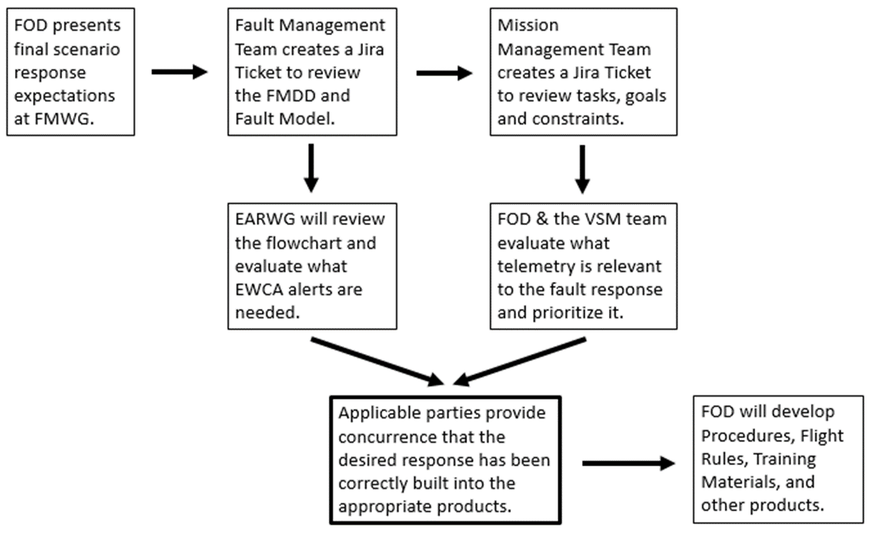 Figure 2: Fault Response Agreement Process

The validation of the fault models for diagnosis, safing and recovery actions, and alerting is a significant effort. The use of Subject Matter Experts (SME) is an important first step to ensuring that the proper behavior is captured. Once this has happened, Test Like You Fly (TLYF) scenarios can be developed that include both traditional tests and Monte Carlo (MC) analysis. These scenarios are then run on testbeds and tools of varying fidelity (low fidelity tools like Gateway in a Box (GiaB) Linux-based software simulations all the way to high fidelity Gateway Avionics Integrated Laboratory (GRAIL) with flight-like hardware). Figure 3 depicts a flow chart for model validation.
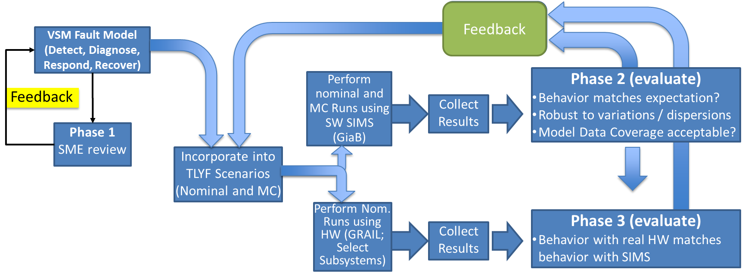
Figure 3: Fault Model Validation Flow Chart
5.0 Organizational Complexities
5.1 Contractual Considerations
The Gateway is an essential element of NASA’s Artemis mission to return humans to the lunar surface for scientific discovery and chart a path for the first human missions to Mars. The Gateway is being developed in a manner that will allow future capabilities and collaborations with other NASA programs, commercial companies, and international partners.

As with all human spaceflight, there is inherent complexity and risk that exists, not only across the technical and engineering framework, but also across the procurement approach. NASA’s procurement authority is quite broad and is intended to afford flexibility and responsiveness to the often-unique acquisition environment of human spaceflight. NASA, more than most Federal agencies, utilizes its transactional authority to access sources of innovation. NASA procurements are guided by the Federal Acquisition Regulation (FAR) and are tailored by the NASA FAR Supplement (NFS). In addition, the National Aeronautics and Space Act of 1958, as amended, in Section 203 (C) (5) authorizes NASA to “enter into and perform such contracts, leases, cooperative agreements, or other transactions as may be necessary in the conduct of its work and on such terms as it may deem appropriate.” Gateway embraced innovation and flexibility in its acquisition strategy, and as such, incorporated a hybrid mix of development contracts and international partnerships that impacted the entire portfolio’s life cycle, from design and analysis through production, assembly, integration and testing, launch, logistics, and operations. [2]

With afforded flexibilities comes unforeseen hierarchical organizational barriers. NASA has been directing the use of firm-fixed price contracts (FFP) for all new contract awards in an effort to reduce cost and risk to the government. However, building a spacecraft and associated hardware for human spaceflight is difficult to propose against in a FFP environment. Requirements are never fully known, new requirements get levied throughout the build process, and unforeseen changes occur that add additional cost. Most contractors prefer cost-plus contracts for human spaceflight, because they do not own the risk.

For Gateway, when developing its acquisition strategy for the Habitation and Logistics Outpost (HALO), NASA mandated the use of a FFP contract. When Gateway received the initial FFP proposal, it far exceeded government expectations, and NASA modified its acquisition strategy to pursue a cost-plus type contract. Use of cost-plus was only granted through HALO’s Preliminary Design Review (PDR) though and then would transition to a FFP contract. The thought was requirements were firm after PDR; however, Gateway strongly recommended cost-plus through HALO’s Critical Design Review (CDR), because they knew requirements would change during the early development of the human rated spacecraft, and they did. HALO, once under a FFP contract, saw significant requirements changes between PDR and CDR due to scope and specification updates, which resulted in a notable cost increase and pending contract restructure, which is now needed in order to complete the build of the HALO. There can be benefit in using FFP contracts, but for building human rated spacecraft, there needs to be the understanding that FFP is not always cheaper.

Besides the HALO, where astronauts will live, exercise, prepare meals, rest, prepare for lunar surface missions, and conduct research while visiting Gateway, NASA also procured the Power and Propulsion Element (PPE) through a FFP contract. The PPE will integrate to the HALO and power Gateway and its solar electric propulsion (SEP) system to keep the station in orbit around the Moon. Most recently, NASA awarded the Gateway Logistics Services (GLS) contract through a FFP contract to provide logistics services to and from the Gateway.

Following the launch of PPE and HALO, the Gateway will expand its capabilities through its global community. While NASA is leading the Artemis missions, international partnerships will play a key role in achieving a presence on and around the Moon. NASA uses multiple Memorandum of Understanding (MOU) agreements between the United States government and respective foreign country governments to manage international partner requirements. Each international partner operates differently, and the MOU outlines the basis for cooperation between the Parties and the other Gateway partners in the detailed design, development, operation, and utilization of the Gateway. NASA and its international partners will add modules and capabilities to the Gateway, evolving into a sustainable and robust orbiting laboratory and a home away from home for astronauts on their way to and from the lunar surface (See Figure 4). Space agencies making significant contributions to the Gateway:

- Canadian Space Agency (CSA) is providing the next-generation external Canadarm3 robotic arm and advanced robotic interfaces to host payloads and provide base points on Gateway.
- European Space Agency (ESA) is providing:
  - the International Habitat (I-Hab), one of two habitation elements where Artemis crew will live, conduct research, and prepare for lunar surface activities.
  - the ESPRIT Refueling Module (ERM) that will provide refueling for PPE, cargo logistics and windows for Moon, Earth and deep space viewing.
  - the HALO lunar communications system (HLCS) to enable high-data-rate communications between the lunar surface and Gateway.
- Japan Aerospace Exploration Agency (JAXA) is providing:
  - critical components of the I-Hab module that will provide the heart of the space station’s life support capabilities such as the Environmental Control and Life Support System (ECLSS), thermal control system functions, and cameras.
  - batteries to power HALO, I-Hab, and ERM.
  - HTV-XG spacecraft for launch and delivery of a logistics resupply mission for Gateway.
- United Arab Emirates-Mohammed Bin Rashid Space Centre (UAE-MBRSC) is providing the Crew and Science Airlock module to permit crew and science payload transfers.
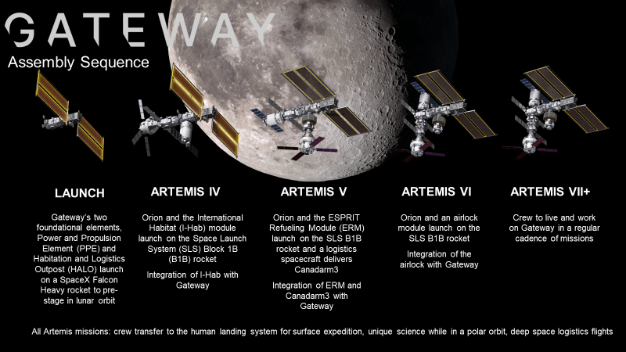Figure 4: Gateway Assembly Sequence
While human spaceflight is a difficult and risky endeavour, the acquisition approach to enable can be just as complex. With NASA encouraging affordability and innovation, acquisition and contracting mechanisms should be appropriately tailored to meet the demands of the procurement activity being pursued.
5.2 Systems Engineering Considerations
The Gateway will be operated as a whole vehicle using a federated approach. Each module is responsible for controlling what it can without support from other modules or the VSM. Module requirements are set up to describe the module as a stand-alone vehicle for the systems that will be provided on that module. Interface requirements cover the functions and systems that are not present on the module. For the autonomous software control systems on each module, requirements for the Module System Manager describe the necessary functionality needed on the module to successfully interface between the module’s systems and the VSM.
Because the VSM is playing the role of human operators for most day-to-day tactical vehicle control and operations, the data needed for the VSM to use is essentially the same data as is pulled for the development of operations products. VSM is also software that resides on board the Gateway, so the schedule needs for the VSM to have the proper data products is necessarily pulled forward from what typical operations products needs are – but not significantly due to the data driven architecture. The main challenge is understanding the autonomy concept of operations – what types of operations are suitable for autonomous control. A detailed understanding of how the modules’ systems work is needed to make this assessment.
The modules on Gateway are being developed by different vendors across the world using various contract mechanisms. This adds complexity to the software control system design, which favors similarity in interactions. As such, timing of module data availability is important to understanding what the vehicle level control needs to be. What has so far been the case is that the VSM data production has been finding significant integration issues as the modules develop in their separate project management offices. This early integration support has the potential to find issues earlier in the lifecycle than they would have been discovered, which could reduce delays and issues during the assembly, integration, and testing phases of the project. Due to this potential, the VSM data production team has taken a rigorous model-based systems engineering approach to their work in order to effectively communicate plans, models, and disconnects to the Gateway community.
Even this approach has not been without struggle as the development processes (e.g., Agile versus waterfall) and modeling approaches have differed across the Gateway. Effective communication on very detailed design with multiple vendors considering export controlled and proprietary information makes data sharing complex. Tight integration is the key to making this concept a reality and has been accomplished so far using a government-led integration approach.
6.0 Lessons Learned and Forward Work
Many lessons have been learned through the development of the Gateway VSM thus far. First, clear interface requirements, including definitions of data that will be necessary to produced and timelines for the data’s production are incredibly important. Second, a dedicated team devoted to software integration and commonality to ensure that critical functions are handled similarly across the spacecraft allows for common interfaces and software reuse in a distributed control system. Third, the Agile development process occurring on both the micro (module) and macro (vehicle/integration) level across all participants helps to coordinate software development, data deliverables, and provides risk reduction throughout the process. Invariably, data and software production hinges on system design, since both support the control of the systems, so allowing an iterative approach to maturing both as system design mature supports interface development and risk reduction.
Overall, the process to fly the first two elements of Gateway is reaching a close as final feature complete software builds are delivered. The verification and validation campaign is ramping up and are expected to introduce new challenges as this novel system is tested in an integrated manner. Beyond the first launch, several more modules are looming and ready to start integration into the autonomous architecture. Lessons learned have already been and will continue to be applied as the Gateway grows. Processes developed through this effort are likely applicable to other integrated projects, and that should also be explored.
References
[1] J. Badger and J. D. Frank, “Spacecraft dormancy operational design for a crewed Martian reference mission,” in 2018 AIAA SPACE and Astronautics Forum and Exposition, 2018, p. 5117.
[2] E. Lehnhardt, C. Zavrel, N. Herrmann, “Gateway Program Acquisition Strategy Overview,” 70th International Astronautical Congress (IAC), Washington D.C., October 2019.

