Trace Oxygen Measurements of Asteroid Sample Storage Desiccators

M. Montoya¹, C. J. Snead², F.M. McCubbin², R. Resendez¹, F. Cantu¹, J. Ponce¹
¹JETS II, NASA Johnson Space Center, Houston, TX 77058, USA.
²NASA Johnson Space Center, Houston, TX 77058, USA.

The Astromaterials Curation facility at the NASA Johnson Space Center is currently curating more than 120 g of carbonaceous asteroid Bennu material as well as over 500 mg of asteroid Ryugu [1 and 2]. These astromaterials are stored in isolating desiccators and gloveboxes under a continuous purge of pure (<1 ppm O₂) gaseous nitrogen. The oxygen and moisture concentrations in our OSIRIS-REx sample processing gloveboxes are continuously monitored via integrated sensors; however, our sample storage desiccators lack integrated oxygen and humidity sensors. In previous studies, we used PreSens Fibox 4 trace oxygen meters and optochemical PSt9 spot sensors to measure the oxygen concentrations in candidate asteroid sample containers that had been sealed in nitrogen; we determined that Eagle stainless steel containers inhibit the ingress of external oxygen for several weeks [3]. This optochemical sensor technology allowed us to take precise, contactless measurements within a trace range of 0 to 200 ppmv O₂. The effectiveness of the trace oxygen sensors in our container experiments inspired us to utilize them to assess the performance of our desiccators that previously lacked trace oxygen monitoring.
In this study, our goal was to determine the quality of the nitrogen purge in the isolating desiccator under normal operating conditions by measuring the trace oxygen content. Utilizing optochemical sensor technology, we determined how long the oxygen concentration takes to reach an equilibrium in the desiccator; that is, determine the rate at which the oxygen diffusion into the desiccator equals the rate at which oxygen diffuses out of the desiccator via N₂ purge. Additionally, we wanted to determine the oxygen concentration at this equilibrium, the state in which our desiccators are in during normal operating conditions.
We tested a custom three chamber desiccator manufactured by Germfree using a PSt9 trace oxygen sensor spot that was mounted into a ¼” National Pipe Tapered (NPT) metal flow-through cell and attached it to the desiccator exhaust. The desiccator consists of top, middle, and bottom isolating chambers. The top chamber door was opened for several minutes to simulate a sample exchange, it was sealed, and then purged ~15 Standard Cubic Feet per Hour (SCFH). Oxygen measurements were automatically recorded via the Fibox 4 trace oxygen meter in 5-minute intervals over the course of a 24-hour period.
Our results indicate the desiccator reached an equilibrium value of 10-15 ppm O₂ after ~5 hours (Fig. 1). This data allows us to explore standards for purging and exchange protocols that can be applied to similar types of desiccators in Hayabusa2, OSIRIS-REx, and for sample return collections. The assessment of the internal gaseous compositions of desiccators also allows us to share with the community the N₂ environment in which many of our asteroid samples and hardware are securely curated. Future measurements will include other nitrogen flow rates and measuring the trace oxygen concentration as a function of time for the levels of the previous commercial desiccator in which the Hayabusa2 sample collection was stored. We will also analyze how long the desiccators hold N₂ after being disconnected from their N₂ source, an extended measurement for sample security reassurance.

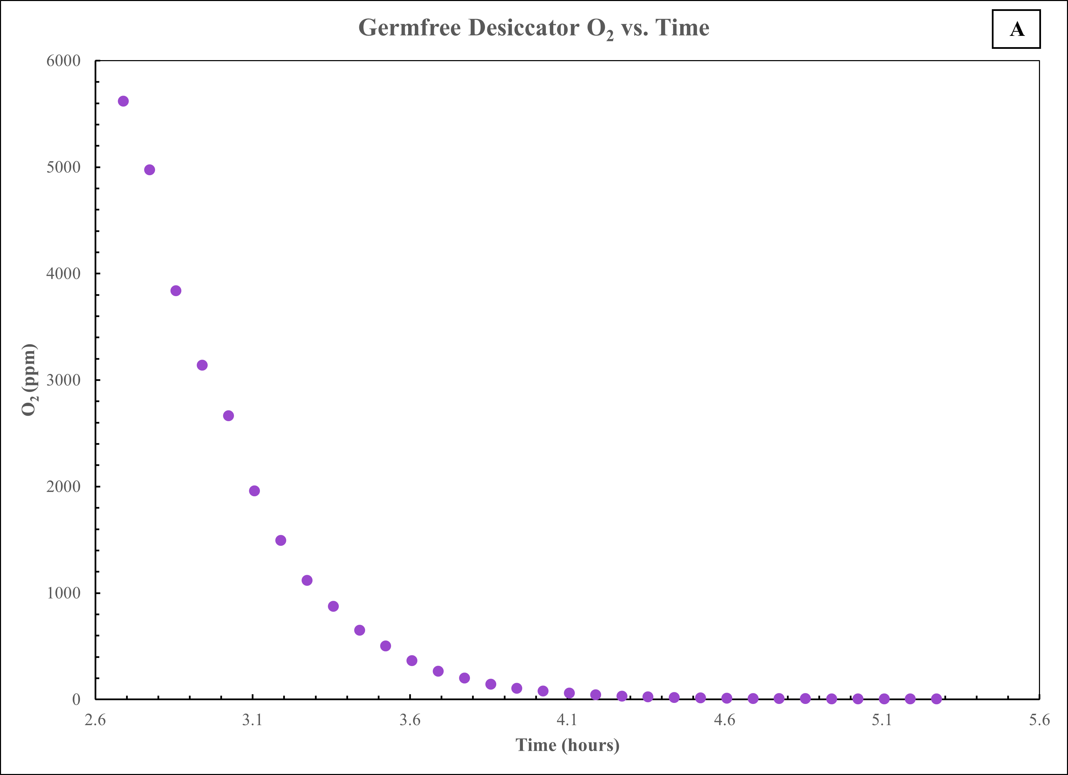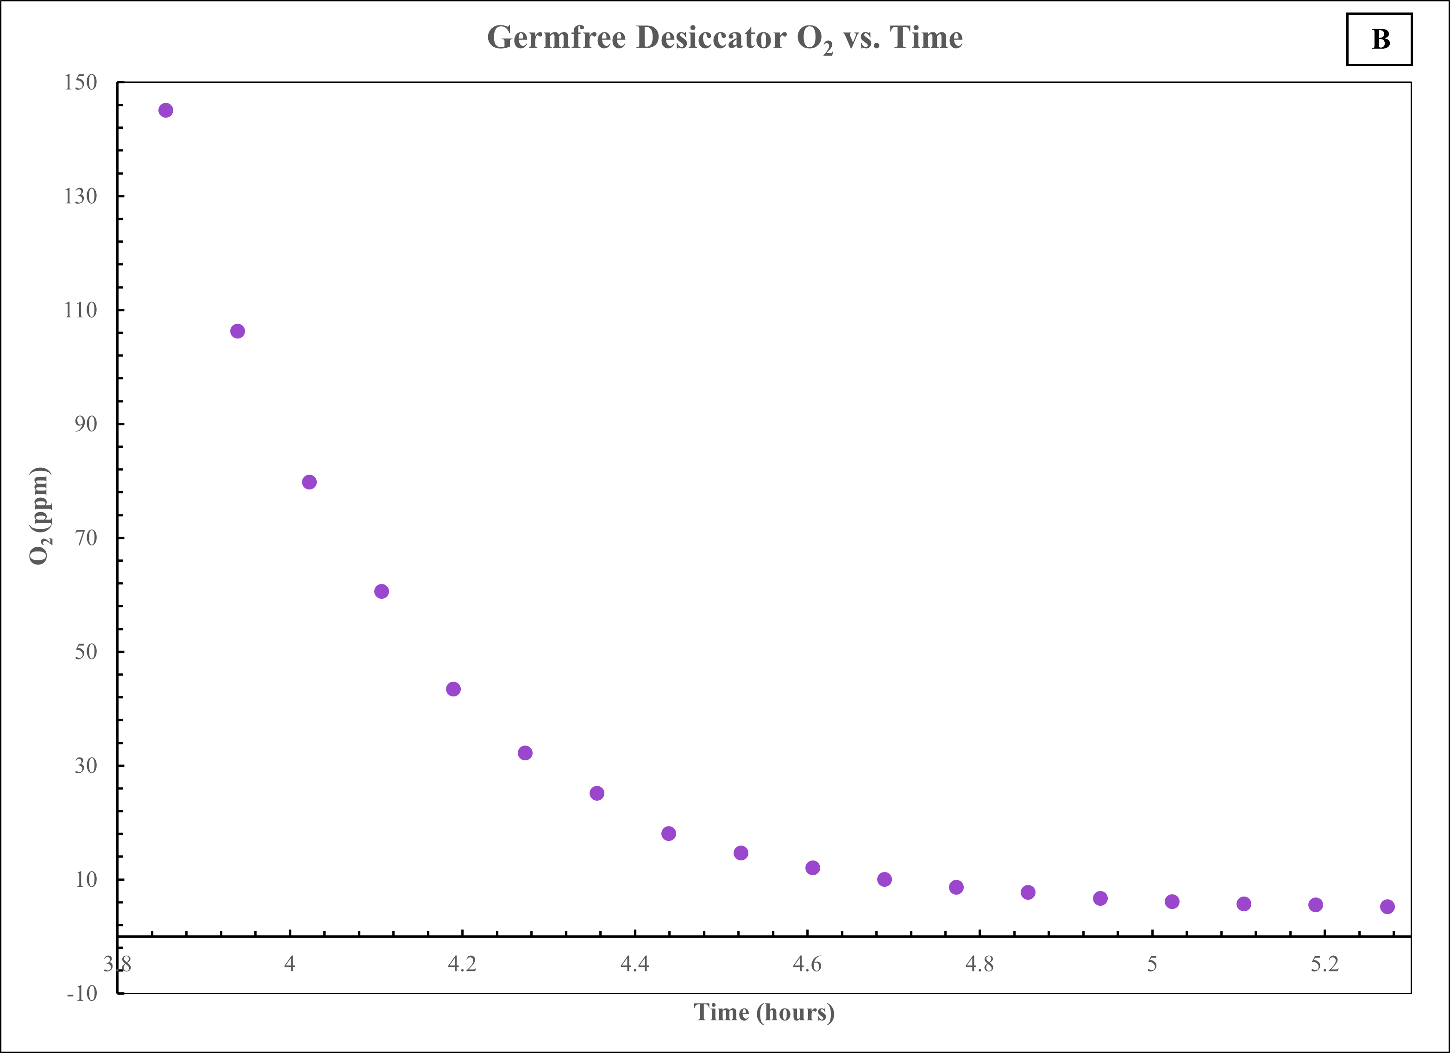
Fig 1: Chart A and B display O₂ ppm vs. time of a Germfree desiccator.

References
[1] Lauretta D. S. (2017) Space Sciences Reviews, 212, p. 925-984. [2] Watanabe S. (2017) Space Sciences Reviews, 208, p. 3-16. [3] Snead, C.J. (2024). LPSC LV, Abstract #2555. [4] FTM-PSt3/PSt6/PSt9 Metal Flow-Through Cell with Oxygen Sensor Instruction Manual, PreSens., Regenburg, Germany, p. 1-21.

