Exploring the Effectiveness of Maneuvering Guidelines for Space Traffic Management

Mariel Borowitz

Georgia Institute of Technology, School of International Affairs

Brian C. Gunter, Alaric C. Gregoire, Clifford Stueck, Surya Venkatram

Georgia Institute of Technology, School of Aerospace Engineering

Lauri Newman

NASA Headquarters, Science Mission Directorate

Abstract
The number of objects in space has been increasing rapidly, and the risk of collision has grown as well. Many spacecraft operators are now receiving multiple collision warnings a day. Despite this, systems to manage space traffic have been limited: there are no broadly agreed upon guidelines or rules governing the response to predicted potential collisions. Instead, spacecraft operators generally determine whether, when, and how to respond to these warnings on a manual and ad hoc basis. Coordination between operators, if it occurs, often requires repeated communication and negotiation. Some space actors have suggested that the space community should develop right of way rules, similar to those in the ground, sea, and air domains, to guide collision response decisions. However, it is unclear whether such rules would be effective, and it’s unknown whether such rules would have an equitable impact across various spacecraft operators. To address these issues, we developed the Virtual Environment for Space Traffic Analysis (VESTA), a software tool that was used to simulate the space environment with a recent catalog of objects obtained from the U.S. Space-Track.org system. We implemented multiple potential right of way rules within this model. The analysis confirmed that the choice of right of way rule makes a meaningful difference in terms of both efficiency and distributional effects in terms of collision avoidance maneuvers. For example, our analysis shows that rules in which the less massive satellite is required to maneuver results in a more equitable distribution of maneuver responsibility among space actors and also requires less fuel mass, compared to a rule in which the more massive satellite maneuvers.

Introduction and Background
The number of operational spacecraft increased from fewer than 2,000 in 2018 to more than 7,500 in 2023, and experts estimate that 20,000 more are likely to be launched by the end of the decade. Much of this growth is driven by large constellations in low Earth orbit. The first two SpaceX Starlink demonstration satellites were launched in 2018. By 2023, there were more than 4,000 operational Starlink satellites in orbit, and the complete first generation Starlink constellation is expected to include 12,000 spacecraft. OneWeb launched its first satellites in 2019, and by 2023, the constellation had grown to more than 500 satellites. However, while large constellation operators play an important role, overall participation in space has increased, as well. The number of countries involved in owning or operating a spacecraft increased from about 500 operators across 70 different countries in 2018 to more than 650 operators across 77 countries in 2023.

Growing Risk of Collisions
As the number of objects in space has increased, the risk of collisions among these objects has grown as well. The U.S. military monitors objects in space and produces warnings of potential collisions – referred to as Conjunction Data Messages CDMs) – that are shared with spacecraft operators around the world. One company estimated that the total number of conjunctions in which satellites came within one kilometer of each other (a common threshold for considering action), increased from 2,000 a month in 2017 to 4,000 a month in 2020. SpaceX FCC reports show that in the six-month period between December 2022 and May 2023, SpaceX Starlink satellites alone maneuvered more than 25,000 times. This is double the number of maneuvers carried out by Starlink in the previous six-month period. In March 2023, OneWeb stated that they typically receive about 53,000 CDMs each day and carry out about six to eight maneuvers daily, which equates to thousands of maneuvers a year.

These maneuvers typically require that operators expend fuel, decreasing the expected life of the spacecraft. The maneuvers may also diminish the spacecraft’s ability to perform its mission, impacting users on Earth. In the case of commercial spacecraft this can translate to lost revenue – for example, if a remote sensing satellite tasked to collect an image for a customer is unable to do so due to the need to maneuver outside its planned orbit. In the case of the International Space Station, potential collisions place astronauts’ lives at risk. Maneuvers of the football field-sized station, like the five that occurred in 2023, not only cost valuable fuel, but they may also negatively impact microgravity research experiments inside the station.

If a collision does occur, it can create thousands of pieces of debris that increase the risk to other spacecraft. An accidental collision between an operational Iridium spacecraft and a defunct Russian reconnaissance satellite in 2009 resulted in 2,000 pieces of debris larger than ten centimeters – large enough to destroy other objects in space. It was estimated that much of this debris will remain in orbit for decades or longer. Many worry that a sufficient number of collisions could result in a cascading effect that eventually makes space unusable, a phenomenon referred to as the Kessler effect.

Collision Avoidance Status Quo
Despite these growing risks, there are no broadly agreed upon guidelines on whether, when, or how spacecraft operators should take action in response to a CDM, and no requirement for spacecraft operators to take any action at all. Instead, collision avoidance among the hundreds of global operators flying thousands of objects in space is currently an optional, manual, and ad hoc process.

At present, CDMs are generated by the U.S. Space Defense Squadron based on data collected by the U.S. Space Surveillance Network. The warnings are shared free of charge with operators around the world. As of January 2023, operators may also receive free warnings from the European Union Space Surveillance and Tracking (EUSST) system. A growing number of commercial space situational awareness companies offer services, as well, and some nations provide services to select operators. However, it is important to note that there is no requirement that spacecraft operators make use of these services, so despite outreach on the part of the United States and others, some spacecraft operators may not receive CDMs at all.

When a spacecraft operator receives a CDM, they make their own determination on whether or not to undertake a collision avoidance maneuver and what type of maneuver to carry out. This may be done based on internal decision-making processes regarding the threshold for action and maneuver capabilities, or operators may engage commercial or government Space Situational Awareness (SSA) providers for further analysis and advice. Some operators may decide not to undertake a maneuver because they deem the risk to be insufficiently high or the cost of losing a satellite is acceptably low. Others may refrain from undertaking a maneuver because they don’t have the technical capability or necessary expertise to do so.

Communication with the other spacecraft operator involved in the conjunction is also left up to the discretion of the spacecraft operator. If a spacecraft operator decides to reach out to another operator to coordinate their response, this is typically done through an email or phone call from one operator to another. Contact information is generally available from the U.S. military, but if contact information isn’t available or isn’t up to date, operators must search for contact information on their own. Some entities, such as SpaceX and NASA, that regularly experience conjunctions between their spacecraft, have negotiated bilateral agreements to guide this process and simplify coordination.

The limitations of this ad hoc process have been demonstrated numerous times. In late August 2019, a potential collision was predicted between a SpaceX Starlink satellite and a large Earth Science satellite operated by the European Space Agency (ESA). About a week before the predicted collision, ESA reached out to SpaceX to see if the company was planning to maneuver. The company responded that due to the relatively low probability (about 1 in 50,000) it was not planning to do so. However, as the event grew nearer, the probability of collision increased, surpassing ESA’s threshold for action of 1 in 10,000. ESA contacted SpaceX again but did not receive a reply. Finally, after multiple attempts to communicate, ESA decided to unilaterally undertake a maneuver, and to announce the event via public media. SpaceX later replied that a bug in its email system had prevented its team from receiving the correspondence.

In December 2021, China lodged a formal complaint with the United Nations Office of Outer Space Affairs stating that SpaceX’s Starlink satellites had come dangerously close to its human space station on two occasions in 2021, resulting in preventative collision avoidance actions by China. A formal U.S. response stated that the U.S. SSA system had not estimated a significant probability of collision between the Chinese Space Station and the Starlink spacecraft. Furthermore, the U.S. noted that it was not aware of any attempt on the part of China to communicate with SpaceX or U.S. officials regarding their concern prior to the perceived potential conjunctions.

Space Traffic Coordination
These types of incidents have led to increased calls for improved Space Traffic Coordination (STC) and Space Traffic Management (STM) – coordination and management of activities in space that improve safety and sustainability. While these concepts have gained greater attention in recent years, discussion of this concept goes back decades.

One potentially important component of STM is the development of “right of way” rules. Just as we have clear rules regarding who has the right of way at traffic intersections, in busy ports, and in the air, many have suggested that similar rules should be developed for space. These would simplify coordination in the event of a predicted collision, because operators would know immediately which entity has the responsibility to maneuver. This would also make the implementation of automated collision avoidance systems simpler, as it would enable operators from different systems to have a clear agreement as to appropriate action. Short of binding rules, even broadly agreed-upon guidelines could be helpful by presenting operators with a starting place for making these decisions.

One of the missing elements of the existing debate on right of way rules is a technical analysis comparing the efficiency and distributional effects of these types of rules. It seems intuitive, for example, that a rule that requires satellites with lower mass to maneuver will be more efficient – in terms of overall fuel expended – than a rule in which higher mass satellites have the responsibility to maneuver. However, it is not clear whether such an effect would be large or small. Similarly, would the costs of such a rule fall disproportionately on particular operators, owner types, or nations? Similar questions could be asked for other potential right of way rules.

This paper contributes to this debate by identifying potential right of way rules and examining their political and technical implications. To conduct the quantitative analysis, we developed a simulation of the space environment and populated it with data on the locations and trajectories of operational satellites as of 2023. We then implemented the proposed right of way rules within this simulation and documented all conjunctions and maneuvers, as well as the delta-V and estimated fuel-mass associated with each maneuver. Using this information, we find that right of way rules can differ significantly in terms of their efficiency for the space sector as a whole, and that the distributional effects of these rules are even more pronounced. This suggests that decisionmakers should take into account the technical, not just political, impacts when determining guidelines and rules for right of way in space.

Developing Right of Way Rules for Space
To be effective, right of way rules must be relatively simple and easily observable. They should also take into account physical limitations. For example, at a four-way stop intersection in the United States, the vehicle that arrives at the intersection first has the right of way. At sea, smaller, more maneuverable vessels are expected to give way to larger vessels that are more difficult to maneuver quickly. Similarly, air traffic right of way also takes maneuverability and location into consideration. Movement and relative position in space are more complex, but there are other traits – such as satellite age, mass, or owner-type that are relatively straightforward. This section considers the practical and political implications of such rules.

Right of Way Based on Mass
Less Massive Satellite Must Maneuver: A rule in which the less massive satellite is required to maneuver is likely to be more efficient – smaller satellites require less fuel to carry out a maneuver. To the extent that more massive satellites also tend to be more valuable, this rule would be aligned with the idea that a large, expensive satellites should not be required to expend fuel to move out of the way for smaller, cheaper satellites.

More Massive Satellite Must Maneuver: By contrast, you could put in place the opposite rule. Operators of the more massive, expensive spacecraft may prefer to take the initiative to maneuver, since the presumed greater value of their spacecraft gives them a greater incentive to avoid a collision that could result in the loss of their satellite. In addition, one could argue that large spacecraft have a greater responsibility to actively avoid collisions, since they would cause relatively more debris than small satellites, and thus have a more significant negative impact on the space environment as a whole. Finally, a more massive satellite is arguably more likely to include thrusters and thus have the technical ability to maneuver. The types of organizations able to develop and launch large satellites may also be more likely to have the expertise necessary to carry out a maneuver. These considerations also make this rule attractive from a practical perspective.

Right of Way Based on Owner-Type, then Mass
Responsibility to Maneuver Assignment Order: Military, Civil Government, Commercial, University/ Other: Another possible rule would assign the responsibility to maneuver based on the owner-type for the satellite. In this case, if a military spacecraft is involved, it has responsibility to maneuver. If no military satellite is involved, then a civil government satellite would have responsibility, finally if no government (military or civil) satellites are involved, then the commercial spacecraft has the responsibility to maneuver. University or other (e.g. non-profit) spacecraft are always given the right of way.

Such a rule may be desirable because the government arguably has the greatest responsibility to invest in actions that support space sustainability. It is also reasonable that the entity responsible for putting in place the rules should bear the cost burden associated with such rules. This allocation of costs may also help secure the support of the commercial sector. Finally, as a provider of essential services, such as weather monitoring, the government has a significant interest in proactively taking actions – i.e. maneuvering – to ensure these assets are safe. This rule is also practical from the perspective that university satellites may be the least likely to have the technical and human resources necessary to maneuver.

Another challenge of implementing such a rule is that not all satellites have a clear institutional owner, and some may be co-owned. For example, multiple countries operate dual-use satellites that have both military and civilian applications. Similarly, universities or commercial entities may partner with governments, leading to a lack of clarify on this classification.

Responsibility to Maneuver Assignment Order: University/Other, Commercial, Civil Government, Military
A rule with the opposite order of responsibility – with responsibility falling first on university spacecraft operators, then commercial operators, followed by civil and military government operators – could also be put in place. The relatively high level of responsibility to maneuver of commercial spacecraft reflects the fact that these spacecraft are being operated to generate a profit, therefore they should internalize the costs associated with their presence in space, rather than expecting other spacecraft operators to expend fuel to maneuver to accommodate them.

One could argue that university spacecraft should be required to maneuver because they are typically experimental spacecraft, not providing vital services, and thus should maneuver so as not to interfere with spacecraft from more essential government and commercial owners. (We note there may be practical challenges with this implementation, as many university-built satellites do not host propulsion systems due to cost and safety issues.) This rule would be consistent with an argument that civil and military satellites, paid for by taxpayers and providing critical public services, should be given the right of way and not be required to expend costly fuel in order to maneuver around small, experimental or commercial craft. As above, this rule may face challenges in consistently determining owner-type.

Country-based Right-of-Way Rules (U.S. Accepts Responsibility to Maneuver)
Right of way guidelines could also potentially be established based on the country affiliation of the satellite. For example, the U.S. could put in place regulatory guidelines that require U.S. satellites to maneuver in the case of high-risk conjunctions. In this case, global spacecraft operators could assume that if a U.S. satellite is involved in the conjunction, that satellite will take the responsibility to maneuver. For non-U.S. on non-U.S. conjunctions, maneuver priority is based on Satellite Catalog ID, or NORAD ID (see below).

Tie-Breaker: NORAD ID/ Age
With rules based on mass, owner-type, or country, it is possible there will be incidences where the two satellites involved in a conjunction have the same mass, thus requiring a “tie-breaker” to assign responsibility. For the purposes of this analysis, we use NORAD ID, since this is, by definition, unique to each satellite. In the case of a ‘tie,’ the satellite with the lower NORAD ID maneuvers. Since NORAD IDs are assigned at launch, these are typically highly correlated to the age of the satellite, and thus, this tie-breaker method approximates a rule in which the older satellite is required to maneuver. One could argue that this is reasonable to ensure that newer spacecraft do not have to maneuver around aging satellites. (Although it could also be argued that older satellites should have precedence, and newer spacecraft should be required to maneuver around them.) In practice, this or other tie-breaker criteria could be considered.

Model of the Space Environment

Key to assessing the viability of any proposed rule is an accurate simulation environment. The simulations need to accurately represent the object population and dynamics of the space environment, implement the desired rules, and track key metrics over long timespans. This motivated the development of Georgia Tech’s VESTA. The simulation extends beyond pure orbit propagation, since the various rules directly alter the orbits of the satellites and subsequent conjunction history, resulting in a dynamic and evolving scenario for each case examined. VESTA has been developed with this complexity in mind and was used for the analysis in this study. While the technical details behind the development and validation of the simulation tool are described in [1][2][3][4], the primary elements that are pertinent to this study are summarized here.

VESTA was designed to work on high-performance computing platforms to model many tens of thousands of space objects over simulation timeframes of months to years. It is highly customizable, and can easily incorporate various propagators, maneuver strategies, and conjunction assessment methodologies, such as those involving different methods to compute probability of conjunction (Pc) or position covariance estimates. At each time step, potential conjunctions are checked for a given future time period, and maneuver actions are guided based on a set of predetermined guidelines. The details of each computed conjunction is included for follow-on analysis, and includes information on the position and velocity of the objects involved, as well as a range of meta-data such as mass, owner-type, and country of origin.

To limit the trade space of results, and to ensure that each rule set could be evaluated in a consistent manner, the following simulation settings were fixed for the cases run in this study.

- A simulation time frame of one year, starting January 1st, 2023
- An object catalog of 5,824 satellites, with two-line element (TLE) orbit information gathered from the 18th Space Defense Squadron (18 SDS) on January 3rd, 2023. The data was curated to include only active, operational satellites, and does not consider debris or analyst objects
- Pc calculations using Chan’s method [5] using a 25 km screening volume
- CDMs at Pc > 1e-5, computed at 72 hours prior to time of closest approach (TCA)
- Avoidance maneuvers, if enabled, would occur 24 hours prior to TCA, using either 1) a standard phasing maneuver, implemented as a small in-track impulse that creates an along-track offset each orbit, or 2) a low-thrust constant acceleration that would raise or lower apogee by the designated miss distance. The target miss distance is 10 km.
- Only one maneuver is done for each conjunction. The spacecraft then returns to its original orbit location after the conjunction mitigation maneuver through stationkeeping maneuvers.
- The instantaneous position covariance for each RSO is obtained through a randomized model based on historical orbit determination data [12], and is propagated across the notification window (72 hours in this study) prior to computing Pc’s.
- Orbit propagation dynamics included non-spherical gravity, solar radiation pressure, third-body forces, and atmospheric drag as implemented in SGP4 [6]
- All satellites are assumed maneuverable
- All operators are assumed to have perfect knowledge of relevant attributes to implement the rules, and there is 100% perfect compliance of the given guideline

Stationkeeping of the satellites was also implemented, and proved to be a critical component in maintaining a simulation environment that tracks more closely with historical CDM events [3]. Satellite operators do not typically allow their spacecraft to follow free-fall trajectories, but instead maintain relatively narrow operating bounds within a given orbit, especially for large constellation systems. To emulate this behavior, each object was kept to within +/- 10 km in altitude and within 1 degree of true anomaly with respect to the original TLE orbital elements. These stationkeeping maneuvers were performed independently from any collision avoidance maneuvers, with the required Delta velocity (dV) also logged separately.

Methodology
Evaluation Metrics
Effectiveness (Maneuver count and total fuel-mass required): In order to evaluate the relative efficiency of each rule, we examine the total fuel-mass associated with all maneuvers carried out over the course of the one-year simulation. We do this by logging each conjunction, computing the Delta-V associated with the resulting maneuver, and then calculating the estimated fuel-mass necessary for the assigned spacecraft to make the required change in velocity. The fuel-mass calculations rely on the basic relationship between mass and Delta-V

$$ΔV=gI_{sp}\ln\left(\frac{m_{o}}{m_{f}}\right)$$

Where m_{o} and m_{f} represent the initial and final spacecraft mass, respectively, g is the acceleration due to gravity at Earth’s surface (9.81 m/s), and Isp is the specific impulse of the propellant. Using an assumed value for Isp = 200 s for impulse maneuvers and an Isp = 5000 s for low-thrust maneuvers, the change in fuel-mass for a given dV becomes:
$$Δm=m_{o}*(1- e^{-\frac{ΔV}{gI_{sp}}})$$

The sum of these values across all maneuvers carried out in the one-year simulation gives the total fuel-mass associated with the rule. Computed in this way, the total fuel-mass of different rules can be compared to gain insight into the relative efficiency of each rule.

Distributional Effects (Maneuver count and fuel-mass per group of interest): In addition to determining the total fuel mass required for each rule, we can also calculate the total maneuvers and required fuel-mass associated with any subgroup within the model. We do this to understand the distributional effects of various rules on operators from different countries, different owner types, and large constellation operators.

Data and Descriptive Statistics
This model is populated with public two-line element (TLE) data from the U.S. Space Force’s Space Defense Squadron as of January 1, 2023. This provides a list of all operational spacecraft in orbit, excluding U.S. and allied classified objects, as well as the location and trajectory of the spacecraft. In total, this resulted in 5,824 operational spacecraft in low Earth orbit. This data also includes information on the country of ownership and the NORAD ID, as well. (Note that commercial spacecraft are represented in the total for the country in which they are based.)

However, in order to implement and analyze the proposed right of way rules, it was necessary to bring in additional information, beyond that included in the data from the 18 SDS. To do so, we used information from the Union of Concerned Scientists Satellite Database updated as of May 1, 2022. This database provided information on the owner country, which was cross-checked with the data from the 18 SDS to identify any data errors or other issues. We also used this database for information on the owner-type of each spacecraft. Satellite mass was also obtained from the ESA Database and Information System Characterising Objects in Space (DISCOS) if needed. It is worth noting that not all information was consistent between the two sources, so considerable effort was needed to ensure that the key attributes (mass, owner-type, country, etc.) of each spacecraft were correct for all 5,824 objects. There was also data that was not available from any of these three primary sources. In these cases, data was imputed based on publicly available information, typically from organization websites or news articles.

We also track whether each satellite is part of a large constellation, defined for the purposes of this analysis as a constellation including 100 or more operational spacecraft. Under this definition, as of January 1, 2023, there were five large constellations that together account for 4,383 satellites – 75% of total operational spacecraft in LEO. They are: Starlink (3,323), OneWeb (502), Planet (290), Spire (115), and Swarm (153).

Figure 1 shows the number and percentage of operational LEO satellites among the top five spacefaring nations. The United States is the largest operator, accounting for about 75% of all operational spacecraft in LEO. The United Kingdom (UK) is the next largest actor in this area with 9%, followed by China at 7% and Commonwealth of Independent States (CIS, which includes Russia, Belarus, and Ukraine) at 2%. All other nations represent the remaining 6%.

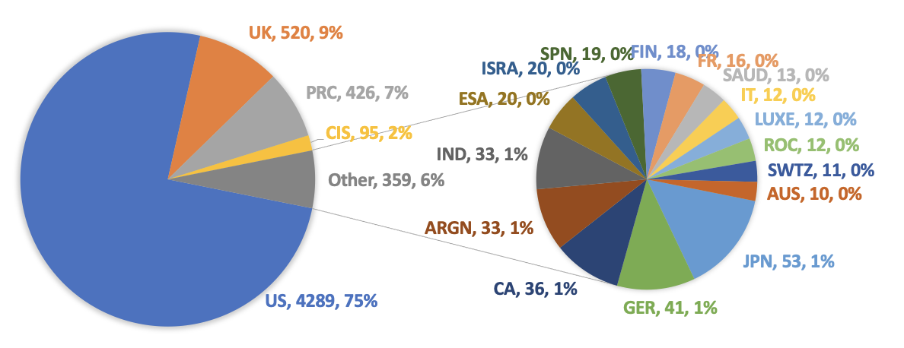
Figure 1: Operational LEO Satellites by Country (only top 20 shown)

The breakdown by owner-type is shown in Figure 2. This shows that commercial spacecraft account for the majority of all objects in space, 86%, and this category is dominated by large constellations. Civil government spacecraft account for 7%, military and dual-use (military and civil) spacecraft make up 4%, and university spacecraft are just 3%.

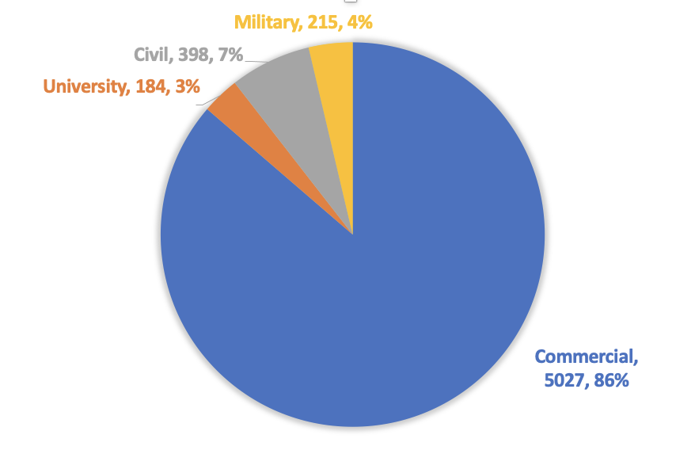
Figure 2. Operational LEO Satellites by Owner Type

Figure 3 combines this information, showing the distribution of satellites by user-type for the five nations with the largest number of operational spacecraft in LEO. In the United States and the United Kingdom, more than 97% of all spacecraft are commercially operated, while for Russia and China, this percentage is 21 and 35%, respectively. In both cases this is heavily affected by large constellations. In the United States, 3,323 out of the 4,289 total spacecraft belong to SpaceX’s Starlink. In the United Kingdom, OneWeb makes up 502 out of the total 520 spacecraft.

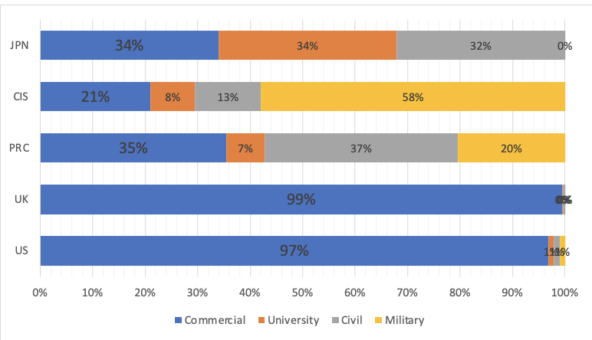
Figure 3. Satellite User-Type for Top Five Nations

Because we will examine a right of way rule based on mass, it is also useful to examine the distribution of mass among satellites in the database. This is shown in Figure 4. While there is significant variety in spacecraft mass, there are clearly some overlaps. SpaceX Starlink satellites form a cluster at 260 kg, and OneWeb forms a similar cluster at 148 kg. However, if these large constellations are excluded, there are only 122 cases where spacecraft have the exact same mass.

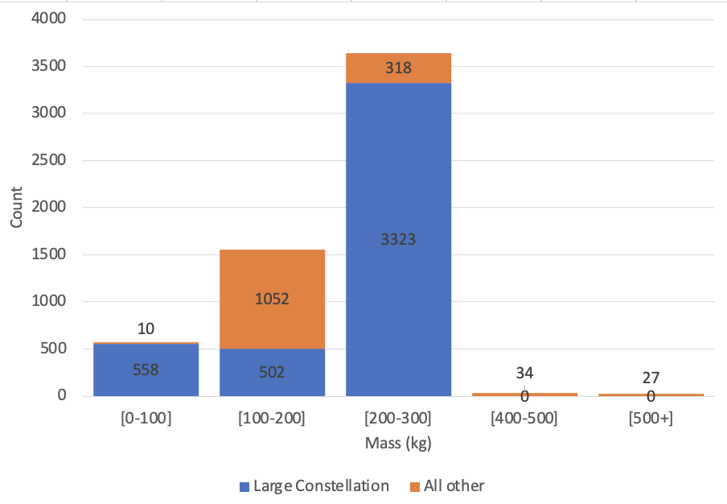
Figure 4. Distribution of Mass for Operational Satellites in LEO

These descriptive statistics suggest that although there is some overlap in the key variables used to motivate the rules evaluated here, there is sufficient variation that the rule is significant (rather than representing primarily the “tie-breaker” information of NORAD ID).

Analysis
In this section we review the outcomes of the five simulations representing different potential right of way rules. For the purposes of this analysis, we have removed intra-constellation conjunctions for the five large constellations noted above. It is unlikely that right of way rules will apply to intra-constellation conjunctions: in a Starlink-on-Starlink conjunction, for example, a regulator is unlikely to care which of the two spacecraft gets the right of way, and right of way would be instead based on internal constellation operator determinations.

Table 1 shows the number of conjunction events that fell into four risk categories, distinguished by the probability of collision. This demonstrates that while there are some natural variations due to the randomness in the time-varying covariance method that’s employed, each of the cases involves a similar number of conjunctions with a similar risk profile. One exception to this is the baseline case, in which no satellites maneuver, which experiences a higher number of conjunctions. This is because, in the model, when satellites maneuver, they choose a trajectory that avoids secondary collisions, and they return to their original orbital “bounding box” using stationkeeping. In the case where no satellites maneuver, spacecraft with intersecting orbits never adjust and may continue to have repeat conjunctions.

Table 1: Probability of Collision (Pc) Distribution
Right of Way Rule | 1E-2 | 1E-3 | 1E-4 | 1E-5 | Total
No Maneuvers (Baseline) | 0 | 62 | 1606 | 10143 | 11811
More massive satellite maneuvers | 0 | 28 | 1215 | 8510 | 9753
Less massive satellite maneuvers | 0 | 40 | 1247 | 8436 | 9723
Responsibility order: military, civil, university, commercial | 0 | 28 | 1162 | 8203 | 9393
Responsibility order: commercial, university, civil, military | 0 | 44 | 1374 | 8757 | 10175
U.S. Satellites maneuver | 0 | 43 | 1260 | 8507 | 9810

The difference in the distribution of responsibility, depending on the rule, is likely to be important when determining the political feasibility of the approach – actors that bear more of the burden of carrying out the maneuver may wish to play a more active role in this issue, for example. Table 2 shows the distribution of maneuvers by owner type. Across all five rules, we see that the Commercial sector will be responsible for more than 80% of all maneuvers. This is expected, given that commercial satellites make up 86% of all satellites on orbit.

Although we often think of commercial satellites as being relatively small, Figure 4 showed that many of the large constellation satellites are actually more massive than other satellites on orbit. For that reason, when the more massive satellite maneuvers, we see commercial spacecraft undertaking a relatively larger number of maneuvers. Under the rule where the less massive satellite maneuvers, commercial spacecraft still account for 82.6% of maneuvers, but now maneuvers are a bit more evenly spread across other types of users, with civilian satellites responsible for 11.5% maneuvers.

In a rule based on owner-type in which military satellites have the highest responsibility to maneuver, we see the military satellites maneuver almost twice as often as compared to rules determined by mass. For civil and university satellites, a rule in which military satellites maneuver first has a similar effect as a rule in which the most massive satellite maneuvers, however the number of commercial maneuvers is reduced. The distribution of maneuvers is similar in the case when the less massive satellite maneuvers and in the case where the U.S. satellite maneuvers. Overall, it could be argued that the rule in which the less massive satellite maneuvers and the rule in which the U.S. satellites maneuver are the most “fair,” since they most closely approximate the representation of each of these satellites in orbit.

Table 2: Distribution of maneuvers by owner type
Rule | University | Civilian | Military | Commercial | Total
Number of Satellites in orbit | 184 | 398 | 215 | 5027 | 5824
 | 3.2% | 6.8% | 3.7% | 86.3%
More massive satellite maneuvers | 0 | 849 | 306 | 8592 | 9747
 | 0.0% | 8.7% | 3.1% | 88.2%
Less massive satellite maneuvers | 207 | 1122 | 364 | 8023 | 9716
 | 2.1% | 11.5% | 3.7% | 82.6%
Responsibility order: military, civil, university, commercial | 17 | 788 | 576 | 8153 | 9534
 | 0.2% | 8.3% | 6.0% | 85.5%
Responsibility order: commercial, university, civil, military | 10 | 144 | 15 | 9999 | 10168
 | 0.1% | 1.4% | 0.1% | 98.3%
U.S. Satellites maneuver | 205 | 1178 | 389 | 8033 | 9805
 | 2.1% | 12.0% | 4.0% | 81.9%

Table 3: Distribution of dV (in km/s) by Owner type
Right of Way Rule | University | Civilian | Military | Commercial | Total
Number of Satellites | 184 | 398 | 215 | 5027 | 5824
 | 3.2% | 6.8% | 3.7% | 86.3%
More massive satellite maneuvers | 0.000 | 0.103 | 0.040 | 22.495 | 22.638
 | 0.0% | 0.5% | 0.2% | 99.4%
Less massive satellite maneuvers | 0.566 | 3.071 | 0.991 | 21.967 | 26.594
 | 2.1% | 11.5% | 3.7% | 82.6%
Responsibility order: military, civil, university, commercial | 0.003 | 0.097 | 0.077 | 21.316 | 21.493
 | 0.0% | 0.5% | 0.4% | 99.2%
Responsibility order: commercial, university, civil, military | 0.001 | 0.016 | 0.001 | 25.867 | 25.885
 | 0.0% | 0.1% | 0.0% | 99.9%
U.S. Satellites maneuver | 0.560 | 3.223 | 1.061 | 21.992 | 26.835
 | 2.1% | 12.0% | 4.0% | 82.0%

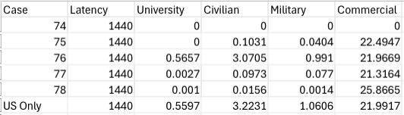

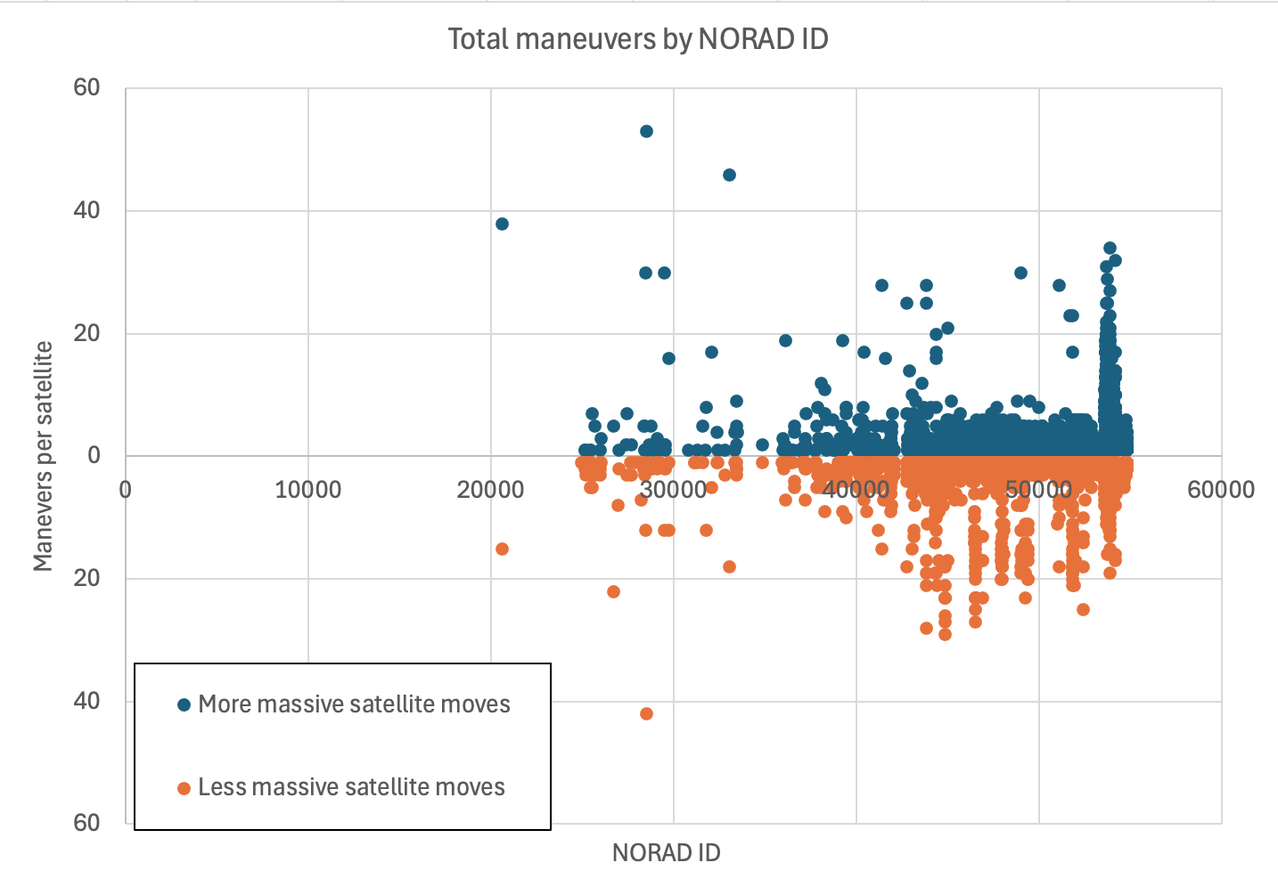
Figure 5. Distribution of maneuvers for the object catalog for the two mass-based maneuver cases

This effect is also demonstrated in Figure 5, which shows the number of maneuvers per satellite (with the x-axis representing NORAD ID). In the case where the more massive satellite moves, there is a clear spike of objects in the mid-50000 range carrying out many maneuvers – this represents a cluster of Starlink satellites repeatedly taking responsibility to maneuver. By contrast, if the right of way rule specifies that the less massive satellite moves, the distribution of maneuvers is spread more evenly across a range of NORAD IDs, representing that satellites from a variety of different owner/ operators are undertaking maneuvers.

This chart also demonstrates that there are some satellites that maneuver quite frequently, with more than 40 maneuvers carried out in a one-year time frame - nearly one maneuver per week. It also shows visually that some areas of orbit are much more crowded than others, requiring relatively large number of satellites to maneuver on a regular basis.

Table 3 shows how the rules affected the distribution of delta V, or the change in velocity, required to carry out the maneuvers. Generally, this is very closely related to the number of maneuvers. However, because some satellites use different methods of propulsion, there are some variations here. In particular, many commercial large constellations use low-velocity thrusters that maneuver by implementing small changes in velocity over longer time periods compared to impulse maneuvers used by traditional thrusters, which implement a significant change in velocity quite quickly. Ultimately, this results in greater delta V among commercial large constellation operators, since low-thrust maneuvers generally require approximately 20% more Delta-V than impulse maneuvers.

However, the variable of interest to most satellite operators is not delta V, but fuel use. Figure 6 shows the distribution of difference in estimated fuel mass expended in maneuvers in the less mass first vs. more mass first rules. Specifically, this chart takes the fuel mass expended by each satellite in the case where the more massive satellite maneuvers first and subtracts the fuel mass expended in the case where the less massive satellite maneuvers first. The x-axis is NORAD IDs for individual spacecraft. Therefore, positive values, in orange, represent cases in which more fuel was expended by the spacecraft under the ‘more massive satellite maneuvers’ rule, and negative values, in black, represent cases in which more fuel was expended under the ‘less massive satellite maneuvers’ rule.

A number of interesting results are demonstrated by this figure. First, this figure provides a clear visualization of how individual satellite operators may experience very different impacts as a result of different rules. In addition, at a system-level, the much taller orange bars in this figure show that requiring the more massive satellite to move will result in greater overall fuel use compared to having the less massive satellite move. This is largely driven by very large fuel expenditures by relatively older spacecraft (lower NORAD IDs toward the left of the chart). These spacecraft tend to have relatively less efficient propulsion capabilities (i.e., not low-thrust). By contrast, newer satellites in large constellations (toward the right of the figure) typically use highly efficient low-thrust propulsion, which keeps fuel use low, despite the many maneuvers undertaken.

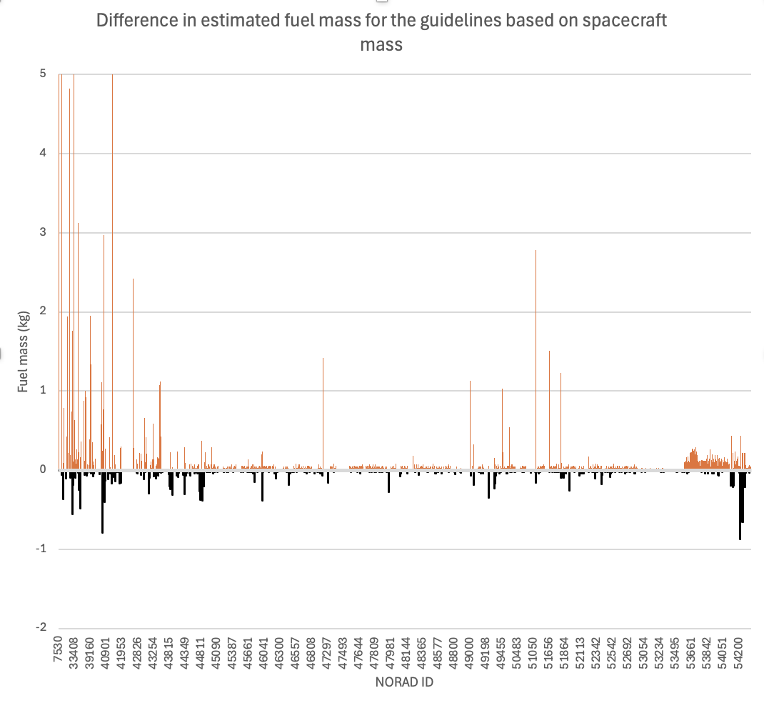
Figure 6. Difference in estimated fuel mass for the two mass-based maneuver cases. Positive values represent net increase in fuel required for the case in which the most massive satellite maneuvers. Note that the positive y-axis was cropped at 5 kg for visualization purposes, but there a number of satellites that exceeded this range.

Discussion
Overall, this analysis demonstrates that the choice of right of way rule will have meaningful distributional effects on spacecraft operators, and this distribution may not always be predictable a priori. For example, many people think of commercial satellites as being relatively small, but in fact, many of these satellites – particularly Starlink satellites – are relatively large compared to other spacecraft. Across the rules we tested, we found that, while commercial satellites undertake most maneuvers regardless of the rule, some rules result in a much more balanced distribution of maneuvers than others. Examination of the fuel use associated with these rules demonstrated that a rule requiring larger satellites to maneuver would require significantly more fuel use overall, making it less efficient from a system-wide perspective. This is particularly driven by older objects with less efficient, impulse maneuver systems.

Taking a step back, another important take-away from this analysis is the challenge of identifying rules that will be both straightforward to implement and result in meaningful variation. One could argue, for example, that a rule based on mass, owner-type, or country is too broad. With only four owner-types, for example, many conjunctions will not be fully determined by the rule, and instead are determined by a tie-breaker. Mass offers more variation, but it might be more meaningful to base a rule on the value of the satellite, so that the more valuable satellite has the responsibility to maneuver (or that other satellites are required to maneuver around these valuable satellites). However, gathering data for such a rule would likely pose a significant barrier to implementation.

We found that even with relatively straightforward rules based on mass, owner-type, and country, information was not readily available for all satellites, and in some cases, different information sources were in disagreement about these key variables. While we were able to remedy this for the purposes of our simulation by developing and using one authoritative spreadsheet, in practice, this missing and/or conflicting data could lead to uncertainty or differences of understanding of maneuver responsibility.

Conclusion
This analysis has demonstrated that there is value in considering the technical impact of potential right of way rules, including both their efficiency and their distributional effects. These considerations can inform, and add to, deliberation about the political desirability and feasibility of these rules. Future research should examine additional right of way rules and extend the analysis to include not only the impact on current spacecraft, but the impact on a potential future space environment.

In addition, we believe that Georgia Tech’s VESTA, and other technical approaches to analyzing space traffic, can play an important role in our understanding of the impact of compliance with right of way rules, variation in risk preferences among operators or national regulators, and the impact of changes in SSA data quality that could result from improvements in monitoring systems.

Space assets have become essential to the global economy, and as space activity continues to grow rapidly, more attention must be paid to traffic coordination. Right of way rules can play an important role in this process, providing clarity for operators involved in potential conjunctions, and speeding the coordination process among spacecraft operators. It is important that we ensure that the rules that are put in place are both effective and efficient.

- REFERENCES

- Macke, R. J., Gunter, B. C., Borowitz, M., and Birch, M., “Analysis of Potential Collision Maneuver Guidelines for Future Space Traffic Management,” Paper AAS, 2021, pp. 21–717.
- Borowitz, M., Gunter, B. C., Birch, M., and Macke, R. J., “An investigation into potential collision maneuver guidelines for future Space Traffic Management,” 22nd Advanced Maui Optical and Space Surveillance Technologies (AMOS) Conference, Maui, HI, Sept. 14-17, 2021.
- Gregoire, A., Gunter, B.C., Borowitz, M., Newman, L., Hejduk, M., “Validation of a Simulation Environment for Future Space Traffic Management,” 2023 AAS/AIAA Astrodynamics Specialist Conference, Big Sky, MT, Aug. 13-18, 2023.
- Gunter, B. C., Gregoire, A., Borowitz, M., Newman, L., “An investigation into transecting satellites in future space traffic management scenarios,” 24th Advanced Maui Optical and Space Surveillance Technologies (AMOS) Conference, Maui, HI, Sept. 19-22, 2023.
- Chan, K., “SPACECRAFT COLLISION PROBABILITY FOR LONG-TERM ENCOUNTERS,” 2020.
- Vallado, David A., Paul Crawford, Richard Hujsak, and T.S. Kelso, "Revisiting Spacetrack Report #3," 2006 AIAA/AAS Astrodynamics Specialist Conference, Keystone, CO, Aug. 21-24, 2006.
- Space Safety Coalition, “Best Practices for the Sustainability of Space Operations Version 2.00,” Apr. 2023
- Burgis, S., Rohrmüller, L., Michel, M., and Bertrand, R., “Simulation of satellites and constellations for the assessment of collision avoidance operations,” CEAS Space Journal, 2022, pp. 1–16.
- Riesbeck, L. and Oltrogge, D., “2023 Updated Space Safety Coalition Best Practices for the Sustainability of Space Operations,” 2nd Orbital Debris Conference, Sugar Land, TX, Dec. 4-7, 2023
- Shepperd, R. W. and DiOrio, K.C, “The Time for a Set of Traffic Rules has Arrived,” 2020 AAS/AIAA Astrodynamics Specialist Conference, Aug. 9-12, 2020.
- Stueck, C., Venkatram, S., Gregoire, A., Gunter, B. C., and Murphy, T. S., “Incorporating Low-Thrust Propagation and Improved Covariance Realism for Enhanced Simulation of Future Space Object Populations,” 2024 AAS/AIAA Astrodynamics Specialist Conference, Broomfield, CO, Aug. 11-15, 2024.
- Murphy, T. S., Auman, K., Hejduk, M., Coursey, Z. S. C., Hoskins, B. P., and Segerman, A., “Assessment of
Data Quality Requirements for US Space Traffic Management,” 2024 AAS/AIAA Astrodynamics Specialist Conference, Broomfield, CO, Aug. 11-15, 2024.

www.space-track.org
UCS Database (12/2018 and 05/2023) https://spacenews.com/industry-report-demand-for-satellites-is-rising-but-not-skyrocketing/
https://www.space.com/starlink-satellite-conjunction-increase-threatens-space-sustainability
UCS Database (12/2018 and 05/2023)
UCS Database (12/2018 and 05/2023)
https://spacenews.com/space-traffic-management-idling-in-first-gear/
https://www.space.com/starlink-satellite-conjunction-increase-threatens-space-sustainability
https://spacenews.com/industry-sees-missed-opportunity-in-deorbiting-iss/
https://nap.nationalacademies.org/read/5532/chapter/8 https://www.thestatesman.com/technology/international-space-station-yet-again-dodges-orbital-debris-report-1503239903.html https://www.npr.org/2022/10/26/1131374307/international-space-station-junk-debris-problem-satellite#:~:text=But%20if%20it's%20circling%20at,1%20cm%2C%20according%20to%20NASA.
https://swfound.org/media/6575/swf_iridium_cosmos_collision_fact_sheet_updated_2012.pdf
https://www.space.com/kessler-syndrome-space-debris
https://www.nasa.gov/news-release/nasa-spacex-sign-joint-spaceflight-safety-agreement/
https://www.theverge.com/2019/9/3/20847243/spacex-starlink-satellite-european-space-agency-aeolus-conjunction-space-debris
https://www.unoosa.org/res/oosadoc/data/documents/2021/aac_105/aac_1051262_0_html/AAC105_1262E.pdf
https://www.unoosa.org/oosa/en/oosadoc/data/documents/2022/aac.105/aac.1051265_0.html
Johnson, Nicholas L. "Space traffic management concepts and practices." Acta Astronautica 55.3-9 (2004): 803-809.
https://www.ucsusa.org/resources/satellite-database

