NASA/TM–20240012043

THE EFFECTS OF PEEL PLY ON THE DAMAGE TOLERANCE CHARACTERISTICS OF THE SPACE LAUNCH SYSTEM (SLS) PAYLOAD ADAPTOR FITTING (PAF)

Alan T. Nettles
Willian E. Guin
James P. Mavo
Marshall Space Flight Center, Huntsville, Alabama

October 2024

NASA STI Program Report Series

The NASA STI Program collects, organizes, provides for archiving, and disseminates NASA’s STI. The NASA STI program provides access to the NTRS Registered and its public interface, the NASA Technical Reports Server, thus providing one of the largest collections of aeronautical and space science STI in the world. Results are published in both non-NASA channels and by NASA in the NASA STI Report Series, which includes the following report types:  - TECHNICAL PUBLICATION. Reports of completed research or a major significant phase of research that present the results of NASA Programs and include extensive data or theoretical analysis. Includes compila-  tions of significant scientific and technical data and information deemed to be of continuing reference value. NASA counter-part of peer-reviewed formal professional papers but has less stringent limitations on manuscript length and extent of graphic presentations.  - TECHNICAL MEMORANDUM.  Scientific and technical findings that are preliminary or of specialized interest,  e.g., quick release reports, working  papers, and bibliographies that contain minimal annotation. Does not contain extensive analysis.  - CONTRACTOR REPORT. Scientific and technical findings by NASA-sponsored contractors and grantees. | - CONFERENCE PUBLICATION.  Collected papers from scientific and technical conferences, symposia, seminars, or other meetings sponsored or  co-sponsored by NASA.  - SPECIAL PUBLICATION. Scientific, technical, or historical information from NASA programs, projects, and missions, often concerned with subjects having substantial public interest.  - TECHNICAL TRANSLATION.  English-language translations of foreign scientific and technical material pertinent to  NASA’s mission.  Specialized services also include organizing  and publishing research results, distributing specialized research announcements and feeds, providing information desk and personal search support, and enabling data exchange services.  For more information about the NASA STI program, see the following:  - Access the NASA STI program home page at http://www.sti.nasa.gov  - Help desk contact information:  https://www.sti.nasa.gov/sti-contact-form/  and select the “General” help request type.

NASA/TM–202400123043

THE EFFECTS OF PEEL PLY ON THE DAMAGE TOLERANCE CHARACTERISTICS OF THE SPACE LAUNCH SYSTEM (SLS) PAYLOAD ADAPTOR FITTING (PAF)

Alan T. Nettles
Willian E. Guin
James P. Mavo
Marshall Space Flight Center, Huntsville, Alabama

National Aeronautics and
Space Administration

Marshall Space Flight Center
Huntsville, Alabama 35812

October 2024

This report is available in electronic form at
http:// sti.nasa.gov

1.0 INTRODUCTION

A payload adaptor fitting (PAF) has been manufactured at NASA’s Marshall Space Flight Center (MSFC) in support of the Space Launch System (SLS) program. This structure is essentially a large cone made up of eight curved “lobes” that are joined together to form the cone. The lobes were manufactured via automated fiber placement (AFP). The PAF will carry predominantly compressive loads thus compression strength will be the focus of this study. The lobes are sandwich structure made with aluminum honeycomb core and carbon/epoxy face sheets. The lobes will be inserted into metallic rings at the top and bottom of the cone to form the full cone. Both front and back exterior surfaces of each lobe have a plain weave fabric placed at ±45⁰ to the vertical direction to help prevent fiber “breakout” during drilling. The face sheet of each lobe is thickest at the top and plies are dropped as the cone reaches the main acreage in the bottom section of the cone.
The entire structure used resin impregnated peel ply that, once removed, supplies a good bonding surface for secondary bonding steps. The peel ply can be removed either directly after cure, or just before any bonding operation. Since foreign object impact can occur to the structure at any time during its life, damage tolerance of the PAF structure both with and without peel ply needed to be addressed because a previous study, albeit with limited data, showed some significant differences in damage tolerance whether the peel ply was present or not [1]. A literature search showed no results for comparing impact damage on composite laminates with and without peel ply.
Load versus deflection of impact curves, visual damage, dent depth, damage as ascertained by thermography and cross-sectional microscopy were evaluated as part of the damage resistance of the structure. Compression After Impact (CAI) was performed to assess damage tolerance. The impact tests were conducted on representative specimens both with and without the peel ply present.

2.0 MATERIALS

The sandwich structure used in this study was manufactured by co-curing the face sheets to aluminum honeycomb core. The core was 0.625 inches thick and had a density of 4.5 lb/ft³. All the face sheets were manufactured by automatic fiber placement (AFP) at NASA’s MSFC. The T1100/3690 carbon/epoxy prepreg tape that made up the face sheets had an areal weight of 190 g/m². The honeycomb sandwich structure was manufactured with the core ribbon (“L”) direction aligning with the 0° fiber direction. The 8 ply face sheets had a lay-up of [±45_{f}/+45/0/-45/0/-45/0/+45]_{T}. The outer ply of fabric was a plain weave T1100/3690 that was hand laid up on the tool before the fiber placement of the tape began for the outer (tool side) surface of the cone. Another ply of the plain weave was placed on the inner surface of the cone (bag side) before bagging and cure. The sandwich structure had a layer of FM300-2M epoxy film adhesive placed between the core and face sheet during the automated tape laying process used to manufacture the face sheets.
The sandwich structure was cured in an autoclave with a pressure of 40 psi and a temperature of 350°F. The flat sandwich panels made for use in this study were 24 inches by 48 inches in size. The sandwich structure showed good consolidation with very little porosity as shown in figure 1. Typical fiber waviness of the face sheets on the honeycomb core panels was noted. The thickness values of the face sheets on the honeycomb panels varied from a minimum at the cell walls (t_{min}) to a maximum between the cell walls (t_{max}) as shown in the top cross-sectional photomicrograph in figure 1. A nominal value for the face sheet thickness can be found based on the average of numerous random thickness measurements.
Using photomicroscopy and measuring tools contained within the software attached to the microscope, the nominal face sheet thicknesses (without the peel ply) of the specimens tested was measured and was found to be 0.050 inches. The peel ply added negligible thickness to the face sheets.
Cut in 0⁰ direction
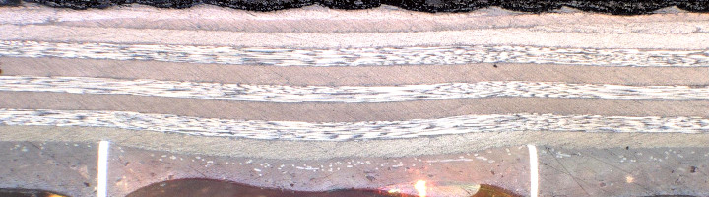
±45_{f}
+45
+45
0
0
0
-45
-45
t_{max}
t_{min}

0.05 in
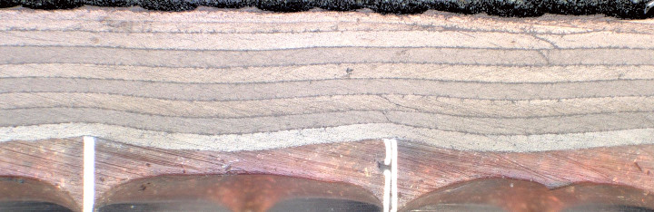
Cut in 90⁰ direction
-45
-45
+45
+45
90
90
90
±45_{f}

0.05 in

Figure 1. Cross section photomicrographs showing face sheet waviness of inner plies (plies closest to the core) on honeycomb core specimens used in this study. 0⁰ and 90⁰ views shown.
The large 24 × 48-inch sandwich panel was cut into 6 inches tall (direction of loading) by 4 inches wide specimens using a diamond saw. The specimens were cut such that the loading direction was parallel to the core “L”-direction thus giving a sandwich layup of [±45_{f}/+45/0/-45/0/-45/0/+45/CORE]_{S}.
For all specimens the ends needed to be “potted” to prevent end brooming during the compression after impact (CAI) tests that were to be performed. This was accomplished by crushing the core about ¼ inch deep across the top and bottom of the specimen and filling these “channels” with paste epoxy resin as shown in figure 2. This prevented end brooming.

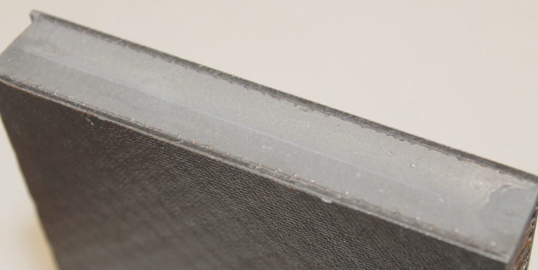
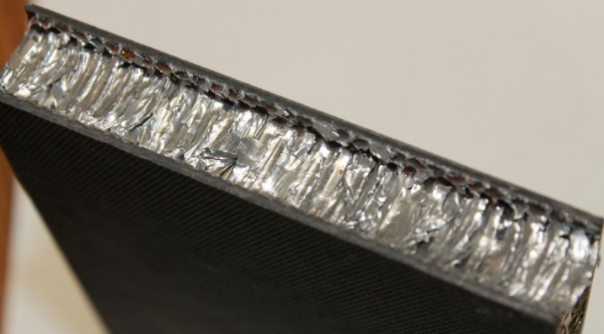

Channel Filled with Epoxy
Core Crushed at End to Created Channel

Figure 2. Picture of epoxy placed at end of sandwich specimen to prevent end brooming.

Once the epoxy had cured, the top and bottom edges of these specimens were machined to ±0.001-inch tolerance of parallelism using a vertical end mill with a solid carbide cutting tool (Onsrud 67-526 designed for carbon fiber machining). The side edges of the specimens were machined to be perpendicular to the top and bottom edges.
Undamaged strength and modulus testing of the honeycomb sandwich structure was performed on specimens to determine an upper bound strength. These undamaged specimens were potted in end frames in an attempt to eliminate end brooming (since the method in figure 2 still produced end brooming on undamaged specimens) and produce a valid failure mode. This undamaged strength testing was met with limited success and an upper bound strength of 73.0 ksi was obtained. The modulus of the specimens was measured to be 11.3 Msi. Since this study concerns damage tolerance testing and the effects of peel ply versus no peel ply, undamaged strength values were deemed not relevant to this study so further testing of undamaged specimens was halted.

3.0 IMPACT DAMAGE TESTING

Each sandwich specimen was impacted at its geometric center on the tool side face sheet since the tool side is to be the outer side of the PAF structure and thus the most prone to impact damage. The impactor had a diameter of 0.5 inches and each specimen was placed on a solid steel plate and clamped on top with a steel plate with a circular opening to allow the impactor to pass through and hit the specimen. Supporting the sandwich specimen on a rigid base (as opposed to a cut out) was selected since this boundary condition has been shown to give the most damage and thus a “worst case scenario” [2]. Attempting to replicate the boundary conditions of the actual PAF structure was not feasible with the small coupons and this study mainly concerned the effect of peel ply, thus the solid base boundary condition was chosen. A blunt tipped impactor was chosen over a sharp tipped impactor since an impact by a sharp object is more readily visible and thus a blunt impactor represents a worst-case scenario when BVID is governing the initial inspection process [3].

An instrumented drop weight impact apparatus was used to inflict damage to the specimens. A picture of the impact tester used is shown in figure 3. The selected impact energies were based on what was determined to be BVID (with the peel ply still on the surface) to the maximum impact energy obtainable by the tabletop instrumented impactor. Impact energy levels between these two extremes were chosen for the remainder of impacts on the sandwich specimens so that residual strength curves could be constructed. The five impact energies used were 6, 8, 10, 12 and 14 ft-lbs.

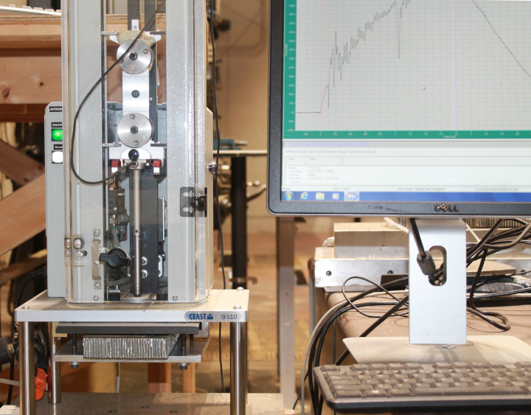
Solid Steel Plate
Specimen
Impactor (0.5-inch tip)
Weights
Digital Output
Figure 3. Photograph of instrumented impactor used in this study.

3.1 Visual Damage
It was found that the amount of visible damage is highly dependent upon the presence of the peel ply. Thus, there are two damage severity levels at which to define BVID, one with peel ply on the surface and one without peel ply. As will be seen, the peel ply greatly enhances the visibility of an impact event while removal of the peel ply leaves a matte black surface that tends to “hide” the damage.
Examples of the visual damage caused by each of the five impact energies are shown in the photographs in figure 4. Visual damage both with and without the outer layer of peel ply present are shown. These photographs were taken under normal indoor lighting conditions with no special “tweaking” of the lighting to better highlight the visible damage. This is to better represent “real world” conditions in which a walkaround of the hardware may be the only prelaunch NDE available. It should be noted that in practice the amount of visual damage in the field will vary depending upon such factors as the available lighting, the angle of the lighting and the surface finish of the specimen.

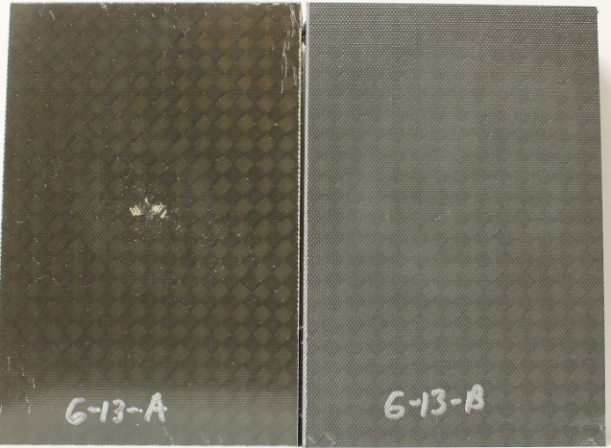
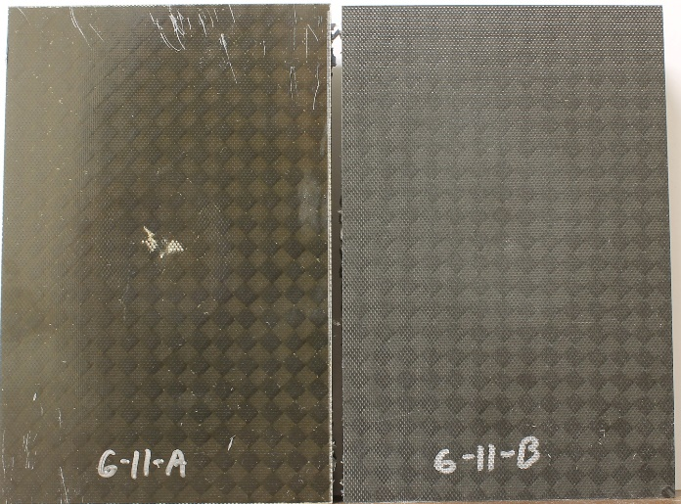
8 ft-lbs
6 ft-lbs

Without Peel Ply
With Peel Ply
Without Peel Ply
With Peel Ply
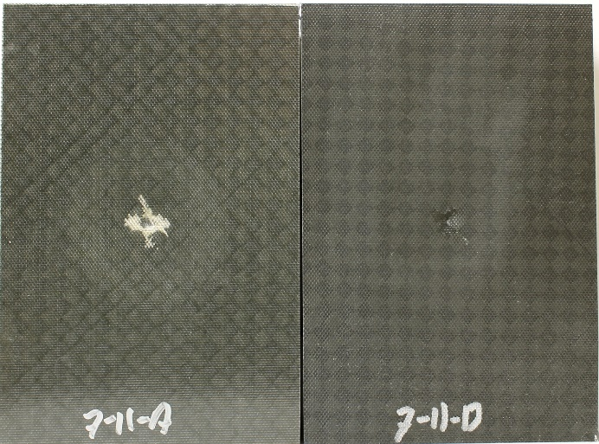
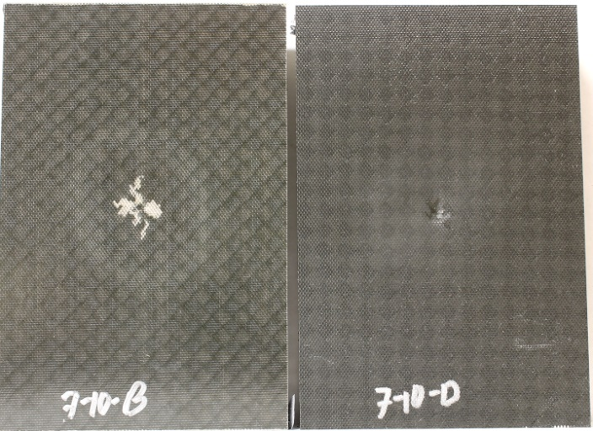
12 ft-lbs
10 ft-lbs

Without Peel Ply
With Peel Ply
Without Peel Ply
With Peel Ply

Figure 4. Photographs of impacts at each energy level tested in this study both with and without outer peel ply attached.

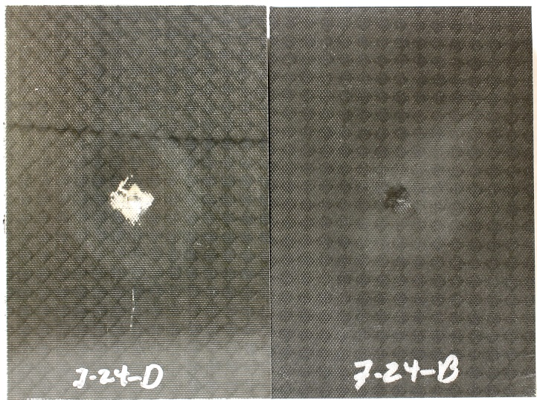
14 ft-lbs

With Peel Ply
Without Peel Ply

Figure 4. Photographs of impacts at each energy level tested in this study both with and without outer peel ply attached (Continued).

All the impacts with the peel ply present can be visually detected which will be beneficial in practice since even low energy impacts will be noted and can be dispositioned. However, when the peel ply is not present during the impact event, the damage is not “barely visible” until the 10 ft-lbs level of impact severity. The visibility of the damage on the specimens without the peel ply remains essentially the same for the 10,12 and 14 ft-lb energy levels. At these energy levels the specimens with the peel ply show the edge of the dent surrounding the impact location providing even more visibility. Thus, it is seen that the peel ply greatly enhances the visibility of the impact damage. Enhancing the visibility of impact on composite laminates has been studied before (see for example [4-5]) using color filled micro balloons that burst and deposit a colored “dye” to create a “bruise” that can easily be seen. The application of a secondary coating of micro balloons can be expensive and add unnecessary complexity to manufacture. The peel ply, which is already part of the process can be used to highlight any impact damage.

3.2 Instrumented Impact Data

Sample plots of load-deflection data from each impact energy level are shown in figure 5. One sample with peel ply and one sample without peel ply are presented in each plot for comparison. The load-deflection data of the specimens with peel ply present are in red. The maximum load of impact is the highest force reached during the impact event.

Red=Peel Ply
Black=No Peel Ply
6 ft-lbs
8 ft-lbs
Red=Peel Ply
Black=No Peel Ply

12 ft-lbs
10 ft-lbs
Red=Peel Ply
Black=No Peel Ply
Red=Peel Ply
Black=No Peel Ply

Figure 5. Load-deflection data of impacts on honeycomb core specimens used in this study.

Red=Peel Ply
Black=No Peel Ply
14 ft-lbs

Figure 5. Load-deflection data of impacts on honeycomb core specimens used in this study (Continued).

Except for the 10 ft-lb impacts there is little difference in the impact force-displacement curves. At the 10 ft-lb impact level, the peel ply covered samples give a smoother force-displacement curve indicating less fiber breakage. The maximum load of impact is slightly higher for the specimen with the peel ply present at the 10 ft-lb impact level. At the 12 and 14 ft-lb energy levels both specimens with and without peel ply show a large drop in force at maximum load indicating fiber breakage.
Thus, except at the 10 ft-lb energy level, little difference in the load versus displacement curves of impact are seen between peel ply covered and bare specimens.

3.3 Dent Depth Results
The depth of the dent caused by the impact event was measured using a digital dial gage as pictured on the left in figure 6. The tip of the depth gage consisted of a 0.12-inch diameter sphere (pictured on the right of figure 6). Thus, to make any correlations between the dent depths measured in this study and any subsequent ones (such as those made in the field) would necessitate the use of the same size tip. The gage was placed over the center of the dent and slowly moved around in small increments until a maximum reading was obtained. This maximum reading was then recorded as the dent depth. The results are presented a little later in table 1.

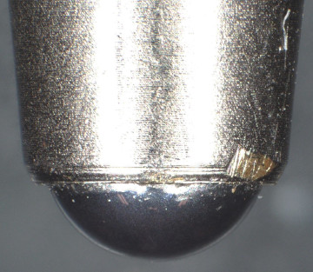
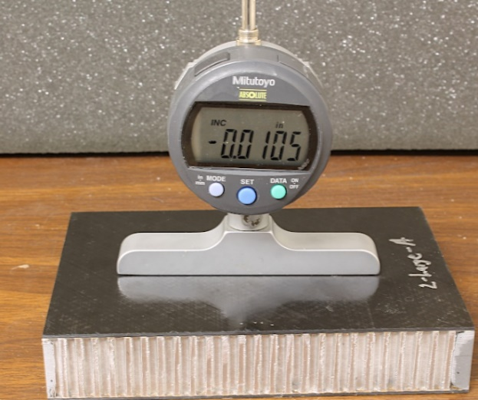

0.12 in

Figure 6. Picture of dial gage used to measure dent depth (left). Close up of gage tip (right).

3.4 Thermography Results
Non-Destructive Evaluation (NDE) in the form of flash thermography was performed on the impacted specimens. Samples from each impact energy level for both peel ply covered, and bare specimens (w/o peel ply) are presented in figure 7. The “damage width” is the maximum distance between two vertical lines from the farthest edges of the damage zone as shown on the first (6 ft-lbs without peel ply) NDE example. Damage width has been shown to be a good indicator of residual compression strength of an impact damaged sandwich structure as long as the impactor shape remains the same [3]. The second NDE example (6 ft-lbs with peel ply) indicates the location and direction of view for the photomicrographs shown later in figure 9.
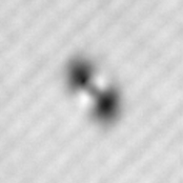
6 ft-lbs w/peel ply
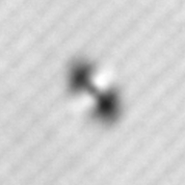
6 ft-lbs wo/peel ply
Damage Width

Cut location for microscopy

1.0 in
1.0 in

Figure 7. Sample thermography signatures of impacts at each energy level tested both with and without the peel ply present on honeycomb core specimens tested in this study.

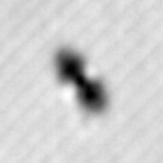
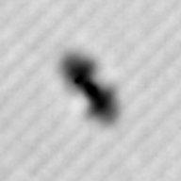
8 ft-lbs w/peel ply
8 ft-lbs wo/peel ply

1.0 in
1.0 in

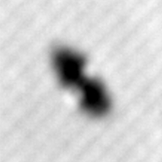
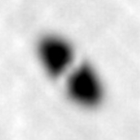
10 ft-lbs w/peel ply
10 ft-lbs wo/peel ply

1.0 in
1.0 in

Figure 7. Sample thermography signatures of impacts at each energy level tested both with and without the peel ply present on honeycomb core specimens tested in this study (Continued).

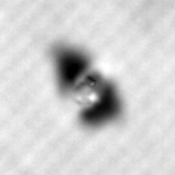
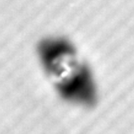
12 ft-lbs wo/peel ply
12 ft-lbs w/peel ply

1.0 in
1.0 in

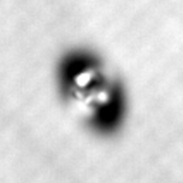
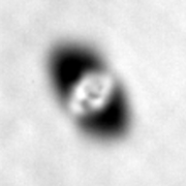
14 ft-lbs w/peel ply
14 ft-lbs wo/peel ply

1.0 in
1.0 in

Figure 7. Sample thermography signatures of impacts at each energy level tested both with and without the peel ply present on honeycomb core specimens tested in this study (Continued).

Thermography data is important as thermography can easily be performed in the field to disposition the severity of damage and can give a good indication of residual strength as was seen in [1] and [6]. The peel ply does not seem to change the thermography signature much for any given impact energy (except for the 10 ft-lb impact energy results which indicate less damage for the specimens with the peel ply present). As expected, as the impact energy increases, the thermography signatures become larger and darker indicating more damage.

3.5 Summary of Damage Resistance Results

Results of the impact tests showing the average width of damage as detected by thermography, the average dent depth formed and the average maximum load of impact on the specimens for both peel ply covered and bare at each impact energy used are summarized in table 1.

Table 1. Summary of results from impact testing on sandwich specimens used in this study.
Impact Energy (ft-lbs) | Specimens tested | Average Damage Width (in) | Average Dent Depth (mils) | Average Maximum Impact Load (lbs)
6.0 w/ Peel Ply | 6 | 0.53±0.03 | 31.4±0.82 | 979± 10
6.0 w/o Peel ply | 5 | 0.51±0.03 | 33.1±0.82 | 954±17
8.0 w/ Peel Ply | 6 | 0.65±0.05 | 36.9±2.1 | 1161±20
8.0 w/o Peel ply | 6 | 0.64±0.05 | 39.1±1.1 | 1152±22
10.0 w/ Peel Ply | 6 | 0.66±0.06 | 45.0±1.5 | 1286±27
10.0 w/o Peel ply | 6 | 0.82±0.11 | 64.3±2.2 | 1203±15
12.0 w/ Peel Ply | 6 | 0.87±0.14 | 73.6±6.2 | 1291±31
12.0 w/o Peel ply | 6 | 0.87±0.13 | 81.3±6.8 | 1238±60
14.0 w/ Peel Ply | 6 | 0.86±0.16 | 87.4±6.8 | 1290±32
14.0 w/o Peel ply | 6 | 0.93±0.13 | 95.1±4.2 | 1240±27

Figures 8, 9 and 10 show plots of the data shown table 1. In figure 8, the damage width appears to increase linearly with increasing impact energy levels. There appears to be no significant difference in damage width between specimens with or without peel ply present when impacted, except at the 10 ft-lb impact energy level, which corresponds to the thermography results in figure 7. At this impact energy level (10 ft-lbs), the peel ply covered specimens sustained a significantly smaller damage width.
In figure 9, the dent depth is lower for the specimens covered with the peel ply at each impact energy tested, although, with the exception of the 10 ft-lb level, the difference is small. It was expected that as the impact energy increased, the difference in dent depth between specimens covered with peel ply and those without would continue to get larger as it did at the 10 ft-lb impact energy level.
In figure 10, the peak impact force for the two lowest impact energy used are essentially the same for the specimens covered with the peel ply versus those with no peel ply. For the three highest impact energies used the maximum load of impact is notably higher for the peel ply covered specimens.
The large difference in damage width, dent depth and maximum load of impact between peel ply covered and bare specimens at the 10 ft-lb level can be explained by examining the load-displacement curve for the 10 ft-lb energy level in figure 5. The peel ply has a smooth curve indicating no fiber breakage, but the specimens without peel ply have a large drop in load after the peak force is reached indicating fiber breakage. This fiber breakage allows the impactor to penetrate deeper than when fibers are not broken. Earlier fiber breakage due to a lack of the peel ply will give smaller maximum loads of impact since the max load is reached at fiber breakage. It is theorized that the peel ply helps spread out the contact force thus delaying fiber breakage. At impact energies less than 10 ft-lbs the impact is too small for the peel ply to have any effect and at energy levels higher that 10 ft-lbs the impact is so severe that the peel ply has little effect.

No Peel Ply Peel Ply

Figure 8. Plot of damage width, versus impact energy from Table 1.

No Peel Ply Peel Ply

Figure 9. Plot of dent depth versus impact energy from Table 1.

No Peel Ply Peel Ply

Figure 10. Plot of maximum load of impact versus impact energy Table 1.

3.6 Cross-Sectional Microscopy
Since the thermography results cannot ascertain the through thickness extent of damage, one impact from each of the ten types of impact conditions (5 impact energies with peel ply and 5 impact energies without peel ply) was cross sectioned in the length direction of the specimen as indicated in the 6 ft-lbs sample in figure 7. These photomicrographs are shown in figure 11.

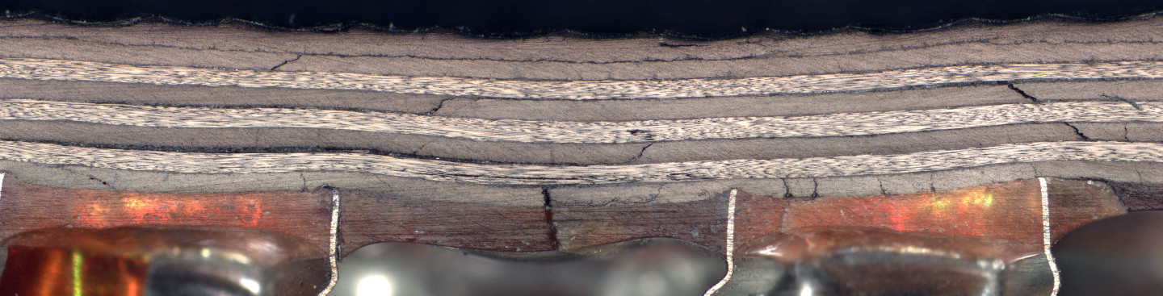

0.05 in in
6 ft-lbs w/o Peel Ply
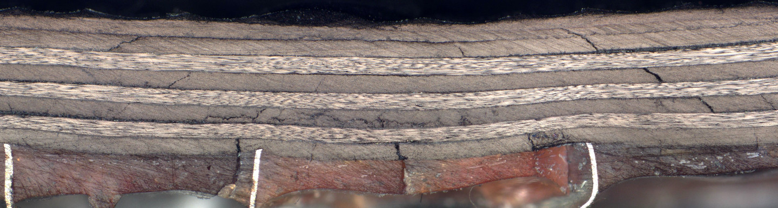

6 ft-lbs w/Peel Ply
0.05 in in

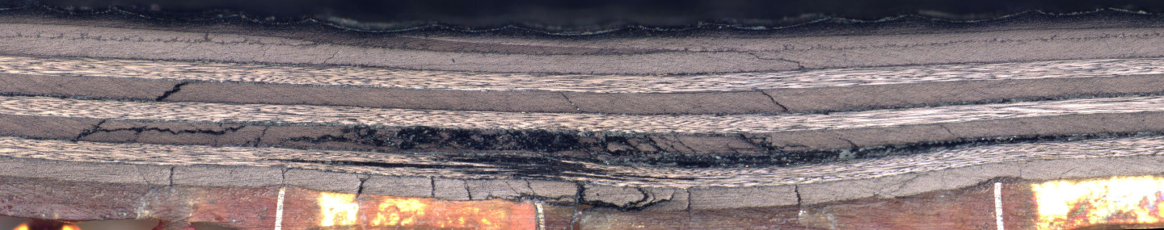

0.05 in
8 ft-lbs w/o Peel Ply
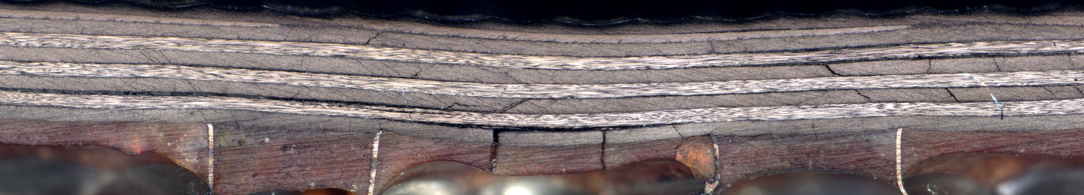

0.05 in in
8 ft-lbs w/Peel Ply

Figure 11. Sample cross-sectional microscopy of impacts at each energy level tested both with and without the peel ply present on honeycomb core specimens tested in this study.

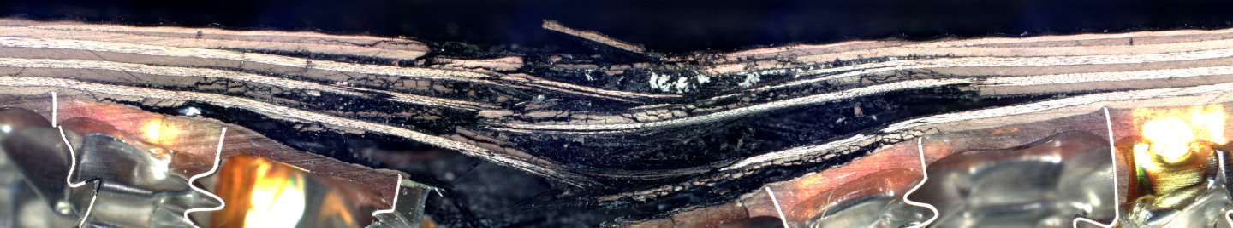

0.1 in in
10 ft-lbs w/o Peel Ply

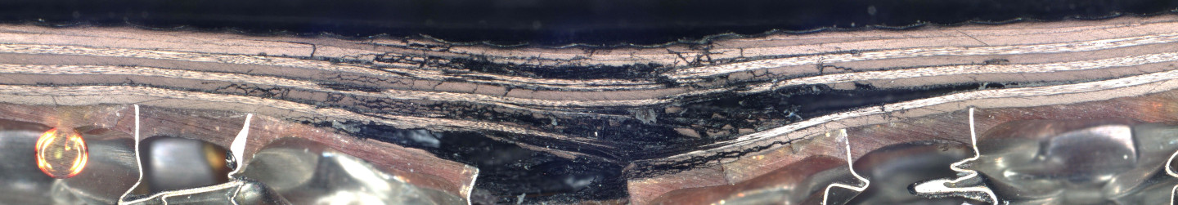

0.1 in in
10 ft-lbs w/Peel Ply

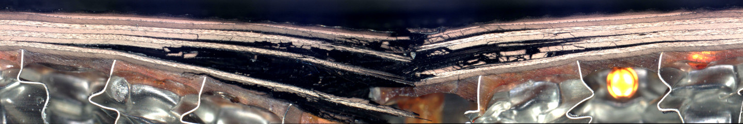

0.1 in in
12 ft-lbs w/o Peel Ply

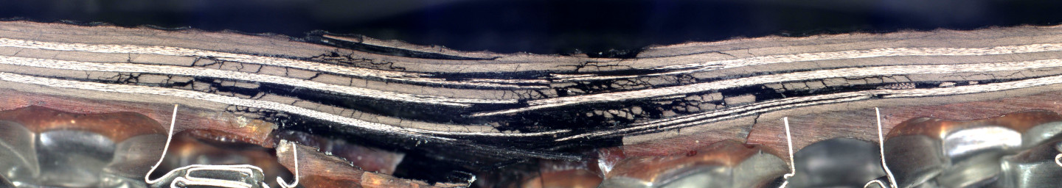

0.1 in in
12 ft-lbs w/Peel Ply

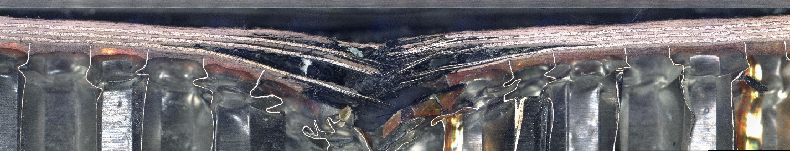

0.2 in in
14 ft-lbs w/o Peel Ply

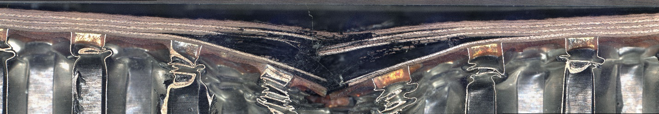

0.2 in in
14 ft-lbs w/Peel Ply

Figure 11. Sample cross-sectional microscopy of impacts at each energy level tested both with and without the peel ply present on honeycomb core specimens tested in this study (Continued).

The specimens with the peel ply may have a slightly higher damage resistance from observing the photographs in figure 11, which corresponds to the small decrease in dent depth that was seen earlier. The specimens impacted at 10 ft-lb are of interest because the load deflection data indicated that the peel ply tended to “protect” the face sheet (smoother load-deflection curve) and the dent depth and maximum load of impact data were notably different. From observing the cross-sections of the specimens impacted at the 10 ft-lb level it appears that the specimen without the peel ply had been completely penetrated whereas the specimen with the peel ply has not been completely penetrated despite some broken fibers.

4.0 COMPRESSION AFTER IMPACT TESTING

The impacted sandwich specimens were assessed for residual compression strength using the test fixture shown in figure 12. Three strain gages were placed on the specimen as diagramed in figure 13 to ensure even loading of each of the face sheets. The specimens were taken to approximately 1000 microstrain and if one gage was lower than the others by more than 10%, shims were placed under the edge that was reading low until the gages were even. During compression testing the gages were monitored and if any deviation greater than 10% occurred, the test was stopped, and shims would be rearranged until the gages read within 10% of each other all the way until failure of the specimen.

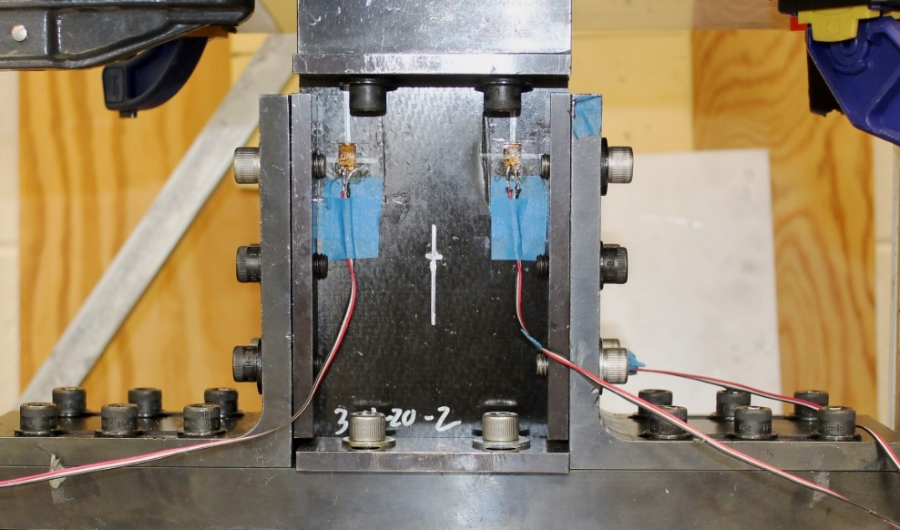
Figure 12. Photograph of fixture used for assessing CAI strength of sandwich specimens.

Front of Specimen
Back of Specimen
0.5
0.5
2.0
1.0
Impact Location
Dimensions in inches

Figure 13. Location of strain gages on front and back of each CAI specimen

The CAI strength results are presented in table 2.
Table 2. Summary of Average CAI results of the sandwich specimens tested in this study.
Impact Energy (ft-lbs) | Specimens tested | Average CAI Strength (ksi)
6.0 w/ Peel Ply | 6 | 63.1±3.4
6.0 w/o Peel ply | 5 | 69.2±2.6
8.0 w/ Peel Ply | 6 | 62.3±5.5
8.0 w/o Peel ply | 6 | 65.5±5.6
10.0 w/ Peel Ply | 6 | 62.3±4.8
10.0 w/o Peel ply | 6 | 60.0±6.8
12.0 w/ Peel Ply | 6 | 59.3±5.7
12.0 w/o Peel ply | 6 | 52.6±6.0
14.0 w/ Peel Ply | 6 | 58.9±5.3
14.0 w/o Peel ply | 6 | 47.8±2.7

Each individual CAI strength result (as opposed to the average) is plotted as a function of impact energy in figure 14. Quite a bit of “scatter” is evident in the data, which is not unusual for CAI strength data, however these data appear to have more “scatter” than usual. At the lower impact energies, the specimens without peel ply appear to have a higher CAI strength but at the higher impact energy levels, the specimens with peel ply appear to have a higher CAI strength.

No Peel Ply Peel Ply

Figure 14. CAI strength versus impact energy results for the sandwich specimens tested in this study.

By averaging the CAI Strength data (figure 15) for each impact energy, the difference in average CAI Strength values can more easily be seen despite the large standard deviations. The specimens with peel ply present during impact change very little across the impact energies tested. From figure 8, the difference in damage size between 8 and 10 ft-lbs and 12 and 14 ft-lbs are essentially the same, so this result is not so surprising. The specimens without peel ply appear to follow a negative linear trend with increasing impact energy. Typically, CAI strength versus impact energy plots follow a power curve fit [1-3,6], but for extremely tough laminates (PEEK for example) the CAI versus impact energy plot may show a linear trend [7] and the resin used in this study is a new generation formulation that is extremely tough.

No Peel Ply Peel Ply

Figure 15. Average CAI strength versus impact energy results for the sandwich specimens tested in this study.

Figure 16 plots the CAI strength versus damage width data for each specimen tested and the data demonstrates much scatter with the obvious general trend of larger damage area leads to a lower CAI strength. The specimens covered with peel ply do not vary as much in CAI strength as the specimens without peel ply which was seen in figure 15 when CAI strength was plotted versus impact energy.
This result is disappointing as damage width (or size in general) can be ascertained in the field and used to disposition the remaining compressive load carrying capability of the sandwich structure. CAI strength versus damage size plot has even been used for this fiber/resin system [1] with satisfactory results (not too much scatter).

No Peel Ply Peel Ply

Figure 16. CAI strength versus damage width results for the sandwich specimens tested in this study.

Another variable that can be measured in the field and attempted to be correlated with CAI strength is dent depth. Figure 17 plots CAI strength as a function of dent depth.

No Peel Ply Peel Ply

Figure 17. CAI strength versus dent depth results for the sandwich specimens tested in this study.

This plot also demonstrates an excessive amount of scatter, especially at the smaller damage sizes and thus no further analysis of the dent depth data will be made.

5.0 CONCLUSIONS

CAI strength versus impact energy and CAI strength versus damage size plots have been constructed to aid the PAF program office on decision making should the piece of hardware experience a foreign object impact. The data shows that the peel ply on the outer surface has a great effect on the amount of visible damage seen. The peel ply also influences the dent depth and CAI strength values. The peel ply causes a smaller dent depth but is easier to see than an equivalent impact on specimens without peel ply on the surface. The peel ply tends to give the impacted sandwich structure higher CAI strength values at the upper end of impact energies used in this study, which is probably a result of the shallower dent depth and thus less damage. However, at lower impact energies, the peel ply covered specimens gave lower CAI strength values. The reason for this is unknown.
With the high amount of scatter in the CAI strength data it is difficult to ascertain a valid CAI strength value based on any of the variables that can be measured post impact in the field (i.e., dent dept, damage size). A couple of reasons there was so much scatter in the data could have been the extreme toughness of the carbon fiber/epoxy system used and the fact that the lay-up of the face sheets was highly directional (more 0⁰ plies in the loading direction).
Thus, it is suggested as a conservative measure that a lower compressive strain limit of 4000 µɛ be used. With a modulus of 11.3 Msi, this corresponds to 45.2 ksi compressive stress which is about what some of the specimens with the lowest CAI strength values obtained.

6.0 REFERENCES

- Nettles AT, Guin, WE, Mavo, JP and Barnes, BW. Damage Tolerance Study of Carbon Fiber/Epoxy Sandwich Structure in Support of the SLS Payload Adapter Fitting (PAF). NASA-TM-202300014423 https://ntrs.nasa.gov/citations/20230014423

- Nettles AT and Jackson, JJ. Developing a Material Strength Design Value Based on Compression After Impact Damage for the ARES I Composite Interstage, NASA-TP-2009-215634.http://hdl.handle.net/2060/20090007473

- Nettles AT, Barnes, BW, Guin, WE and Mavo, JP. The Effects of Impactor Shape on the Compression After Impact Strength of Carbon/Epoxy Face Sheet Foam Core Sandwich Structure. Journal of Sandwich Structures and Materials 2023; https://doi.org/10.1177/10996362231199099

- Buslaeve OS, et.al. The new indicator coating to detect the place of barely visible impacts on aircraft composite structures. IOP Conference Series Materials Science and Engineering 2021; 1024: https://iopscience.iop.org/article/10.1088/1757-899X/1024/1/012002#:~:text=There%20was%20developed%20indicator%20coating,spheres%20in%20the%20contact%20area.

- Vidinejevs S, et.al. Smart polymeric coatings for damage visualization in substrate materials. Journal of Intelligent Material Systems and Structures 2012; 23: 1371-1377. https://journals.sagepub.com/doi/10.1177/1045389X12447289

- Nettles AT and Jackson JJ. Compression After Impact Testing of Sandwich Composites for Usage on Expendable Launch Vehicles. J Compos Mater 2010; 44: 707–738. https://journals.sagepub.com/doi/10.1177/0021998309349550?icid=int.sj-full-text.similar-articles.9

- Prichard JC and Hogg PJ. The Role of Impact Damage in Post-Impact Compression Testing. Composites 1990; 21; 503-511

- Nettles AT and Lance DG. On the enhancement of Impact Damage Tolerance of Composite Laminates. Composites Engineering 1993, 3, 383-394.

