SysML Success Tree for DAVINCI In-Situ Campaign Requirements Validation and Redundancy Assessment
Khary I. Parker, Leslie Hartz,
Colby Goodloe, Robin Ripley, Matthew Garrison
NASA Goddard Space Flight Center
8800 Greenbelt Rd.
Greenbelt, MD 20771
Khary.I.Parker@nasa.gov

Abstract—The DAVINCI mission will scientifically study the Venusian atmosphere to better understand the current state of the planet and its evolutionary history. This will be accomplished by deploying a descent probe to collect in-situ atmospheric dynamic and spectroscopic measurements, characterize ambient temperatures and pressures during descent, and surface imaging below the cloud layer. To better characterize the DAVINCI In-Situ Campaign, a success tree, developed in the SysML tool, MagicDraw, was created to define the events necessary to have a successful in-situ campaign, for each phase of the campaign. This success tree was also used to validate DAVINCI Program, Mission, and Element level requirements. In addition, because DAVINCI is a single-string mission, the success tree was also used to identify areas of redundancy and resiliency throughout the campaign. The initial redundancy assessment recommended further on-orbit evaluation of the probe’s communication system, as well as further evaluation of the ability of the mass spectrometer turbo-molecular pump to handle the expected decent environment. During the integration and test phase of the overall mission, the success tree will be used to guide the mission validation process, helping to ensure that the in-situ mission elements can perform in accordance with the DAVINCI In-Situ Concept of Operations document.

Table of Contents
1. Introduction 1
2. DISCO Success Tree Overview 3
3. Requirements Validation 4
4. Redundancy Assessment 5
5. Future Work 9
6. Summary 9
Appendix 9
A. Acronyms 9
Acknowledgements 10
References 10
Biography 10

1. Introduction
In-situ measurements of the Venusian atmosphere have not been taken since the Soviet-era Venera and Vega missions of the late 1960’s through the early 1980’s, and NASA’s own Pioneer Venus mission in 1978. Subsequent studies have come from orbital missions, flybys, or Earth-based observatories. Even still, Venus has been shrouded in mystery. From unknown cloud compositions, uncharted mountains, to unidentified volcanos and their lava flows. Venus can be considered as the nearest analog to an exoplanet, this close to Earth. Venus is ripe for scientific exploration, but those discoveries are not easy come by.
In 2021, DAVINCI, managed by Goddard Space Flight Center (GSFC) [1], was selected as one of the new series of missions to Earth’s twin sister, along with VERITAS (managed by JPL) and EnVision (managed by ESA). Whereas the latter two (2) missions will primarily study Venus from orbit, DAVINCI will inject a probe, called Zephyr, into the atmosphere to measure its chemical composition throughout its hour-long descent until it impacts in the Alpha Regio highlands. In addition to these measurements, Zephyr will take the first images of the Venus surface since Venera. These in-situ measurements and images will be pared with DAVINCI’s own orbital observations to help build a fuller understanding of the Venusian environment.
DAVINCI is a Risk Class C, per NPR 8705.4, meaning that it will be a single string mission with focused redundancy. It will be implemented through the Flight System (FS), shown in Figure 1, which is comprised of the Probe Flight System (PFS) and the Carrier, Relay, Imaging Spacecraft (CRIS) [2]. Lockheed Martin (LM) is developing and building the CRIS, which comprises the DAVINCI spacecraft bus plus its two (2) instruments: Venus Imaging System for Observational Reconnaissance (VISOR), and Compact Ultraviolet to Visible Imaging Spectrometer (CUVIS). LM is also developing and building the PFS Entry System (ES) in conjunction with NASA/Ames Research Center (ARC).
Figure 1. DAVINCI Flight System and Major Elements
The GSFC developed and built Zephyr atmospheric science probe is embedded within the LM ES, where Zephyr is the Descent Sphere (DS, i.e., the Zephyr “spacecraft bus”) plus a suite of five (5) instruments: Venus Mass Spectrometer (VMS), Venus Tunable Laser Spectrometer (VTLS), Venus Atmospheric Structure Investigation (VASI), Venus Descent Imager (VenDI), and the Venus Oxygen Fugacity (VfOx) sensor.
DAVINC has four (4) mission campaigns, and the Flight System’s main science gathering campaigns are the Remote Sensing and In-Situ. During the DAVINCI Remote Sensing Campaign (DRSC), the FS will perform two Venus flybys, ~7-months and ~17-months after launch. The first two flybys enable valuable science collection by performing dayside (UV cloud motions) and nightside imaging (NIR surface emissivity) of the planet.
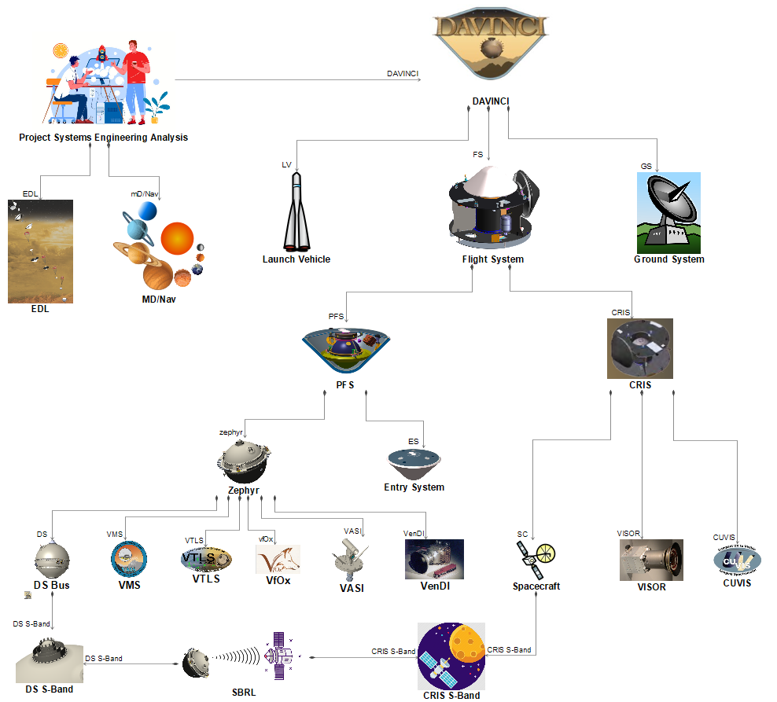
Figure 2. DAVINCI Architectural Decomposition

The DAVINCI In-Situ Campaign (DISC) consists of five (5) Phases: final Venus approach and PFS Separation, PFS Coast, PFS Entry, Descent, and Post-Touchdown. Note that DAVINCI does not have a requirement for Zephyr to survive landing. However, plans are being discussed about potential activities that could be performed after landing within the current capability of the probe. To maximize the focused redundancy incorporated throughout the whole mission, success trees were developed by both GSFC and LM to better understand the critical events and how the focused redundancy was employed during the campaign. Both organizations were very selective in the redundancy employed, given mission constraints, to maximize mission success. The LM success tree captured the events that occur during the Remote Sensing Campaign, and the CRIS-specific (i.e., spacecraft subsystem operations) events that occur during the DISC. The GSFC success tree captured all the events that occur during the DISC. This included FS operations that occur during preparation and release of the PFS, in addition to Zephyr operations through touchdown. The goal would be to use the information from the respective success trees to identify credible operational single point failures and develop plans to mitigate them.
The purpose of this paper is to describe the development and use of the GSFC generated DAVINCI In-Situ Concept of Operations (DISCO) Success Tree. The DISCO is DAVINCI configured document defining the concept of operations during the DISC, from which this success tree is based. In addition to describing all the events that lead to a successful DISC, the DISCO Success Tree was used to:
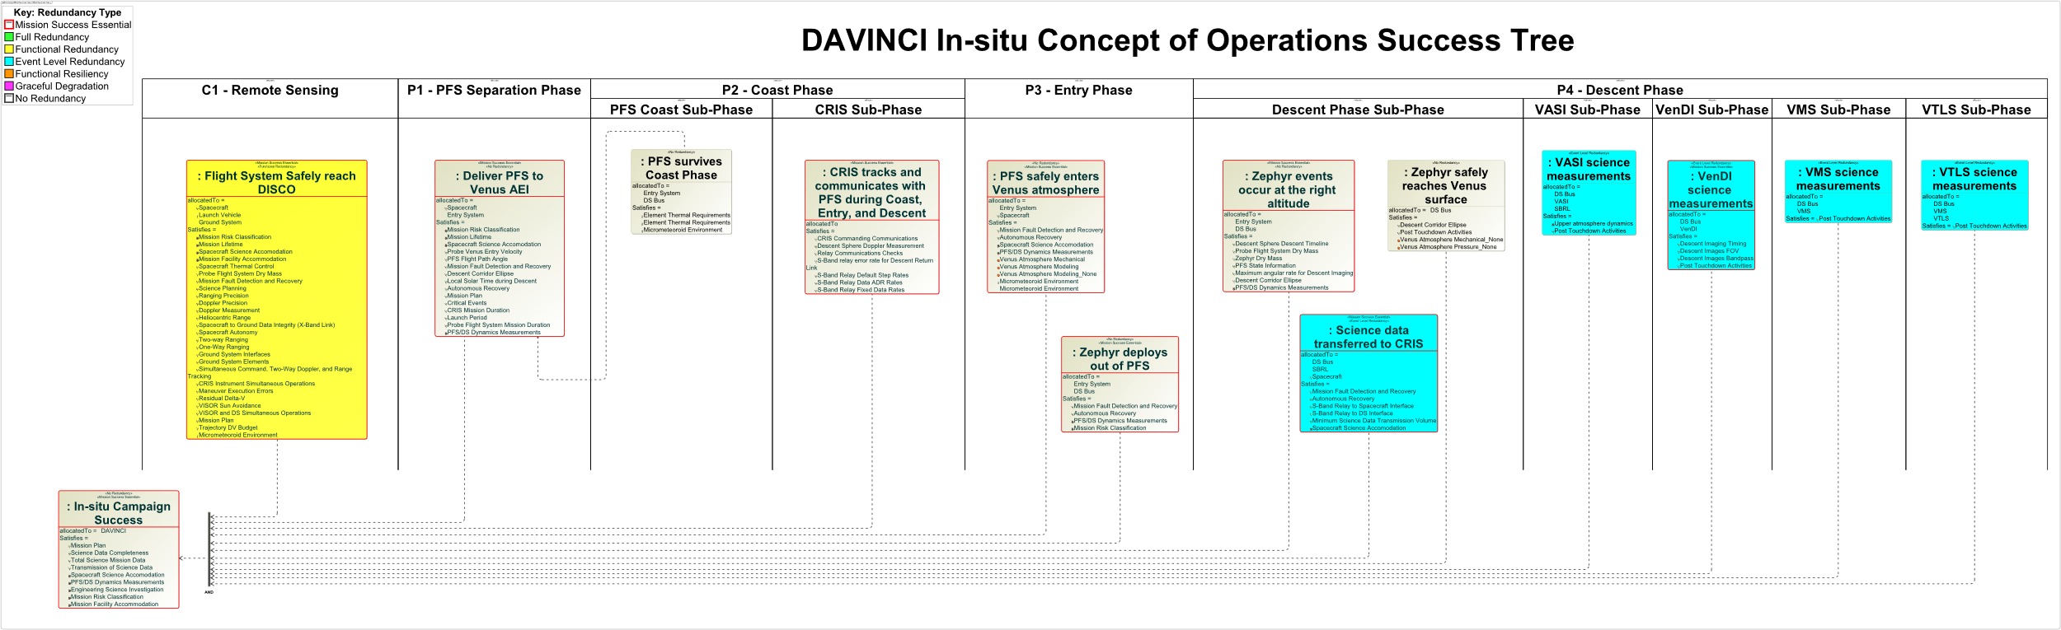
Figure 3. DAVINCI In-Situ Concept of Operations (DISCO) Success Tree - Top Level
- Identify the redundancy and/or resiliency that currently exists within the DISC.
- Identify high-risk, credible single point failures that could be mitigated through additional redundancy or resiliency.
- Validate that every event needed for a successful DISC is adequately described by requirements.
Within this paper, Section 2 will provide an overview of the DISCO Success Tree. Section 3 will discuss the requirements validation process using the DISCO Success Tree. Section 4 will discuss the redundancy assessment process using the DISCO Success Tree. This includes identifying any gaps in achieving mission success and redundancy opportunities found. Section 5 will discuss the current list of forward work.
2. DISCO Success Tree Overview
The critical event of the DAVINCI mission is the DISC, as detailed in the DAVINCI In-Situ Concept of Operations (DISCO) [3]. The DISC provides a single opportunity to collect critical scientific information about the various layers of the Venusian atmosphere. The DISCO Success Tree was developed to identify all the related events needed to have a successful in-situ campaign. It was developed using the Systems Modeling Language (SysML) tool [4], MagicDraw, to take advantage of the many capabilities that language has to offer. The Tree was used to validate requirements for each mission level to ensure that they addressed each in-situ event. Given the number of unknowns for this mission, it was necessary to lay out all the known in-situ events for each DAVINCI Element (see Figure 2) involved in this campaign, then determine if there were requirements that aligned with those events. This helped to determine if there were either missing events or missing requirements. The Tree was also used to assess the robustness and redundancy of the entire in-situ campaign, by evaluating each event. Given that DAVINCI is a single-string mission, it was necessary to understand the robustness and resiliency of each DISC event to faults and less than optimal conditions. Additionally, it was also necessary to understand where natural system redundancy (either in operationally or functionally) could be taken advantage of, and what changes could be made to the overall system while maintaining focused redundancy. The requirements validation and redundancy assessments are activities that will remain on-going as the Project moves towards Preliminary Design Review (PDR). Later in the DAVINCI mission life cycle, it is envisioned that the DISCO Success Tree will be used to help develop the Zephyr Fault Management Plan, and to help develop the DAVINCI System Validation ground tests.
The DISCO Success Tree model was developed as an Activity Diagram within MagicDraw, and swimlanes were used to represent each Phase/Sub-phase within the Tree. Figure 3 shows the top-level events from each swimlane all leading to a successful DISC. Each event was created within a given mission Phase or Sub-Phase and allocated to Elements within the DAVINCI mission shown in Figure 2, as well as to requirements at the Project, Mission, Element, or subsystem level (as necessary). In addition, it was assigned to one or more custom SysML stereotypes indicating a redundancy type (see Section 4). Each decomposed event is required to make the higher-level event successful. These lower-level groups of events need to, either, all occur for success of the upper level event (AND gate, Figure 4), or one of the
Table 1. Level 1 Requirements to DISC Events Validation Matrix

Figure 4. Use of AND Gate in DISCO Success Tree
events in the group need to be true for success of the upper-level event (OR gate, Figure 5).
Figure 5. Use of OR Gate in DISCO Success Tree
For Mission level use, events were decomposed to the point before hardware implementation, which allowed the DISCO team to focus on the events that were necessary for success. There were a few exceptions when certain hardware directly affected the result of an event or function, such as, the Zephyr battery being at maximum charge before PFS separation, the VMS turbo pump surviving shock events, or the Descent Sphere radio remaining operational during descent. For Element level use, events could include hardware implementation, and were decomposed to the point where a fault tree best represents what is needed to best represent their success. This allowed the Element to determine if operational, functional, or design changes were needed.

3. Requirements Validation
Requirements at various levels of the Project were evaluated against the DISCO Success Tree events. The purpose of the requirements validation was to 1) determine if the right requirements described the DISC events, 2) identify any missing requirements, and 3) identify any missing events. Only baselined requirements were incorporated as part of this validation. These included Project-level baseline science and mission requirements (i.e., Level 1 requirements), Mission-level and environmental requirements (i.e., Level 2 requirements), and Element-level requirements (i.e., DS, VTLS, VMS, VASI, and Mission Design/Navigation (MD/Nav) Level 3 requirements). Lower-level, Element subsystem requirements (i.e., Level 4 requirements and below) could be applied if an Element team chose to expand on the DISCO Success Tree, which was done by the Descent Sphere Element. Only the requirements directly pertaining to the DISC were evaluated in this validation process. Requirements such as Goddard’s mission design principles, industry standards, Project-level plans (i.e., Contamination Control Plan, Safety & Mission Assurance (SMA) Plan, etc.), or NASA/HQ levied requirements were not considered. In validating a requirement, each event was compared to each requirement. If a requirement was found to satisfy the event, it was allocated to that event through the SysML Satisfy relationship. To the greatest extent possible, each requirement was validated against the lowest possible event within a given branch on the Tree. The result is a full subset of requirements that specifically define the DAVINCI In-Situ Campaign.
Table 1 is an example of the validation matrix showing the relationship between events and their applicable requirements. At the time of this writing, all DAVINCI Elements had not completed their respective requirements reviews, and therefore do not have baselined requirements. The results shows that the as-written Level 1, Level 2, and the baselined Level 3 requirements correctly describe the DAVINCI In-Situ Campaign.
4. Redundancy Assessment
Philosophy and Principles
As a Risk Class C mission, per the NASA Procedural Requirement (NPR) 8705.4 Risk Classification for NASA Payloads, the baseline Flight System has a single string architecture based on heritage designs with focused redundancy, in addition to well-established and defined margin policies and requirements. From the robustness and resiliency model shown in Figure 7, robustness is a proactive process of increasing the strength and effectiveness of a system in the presence of adverse conditions to maintain performance.
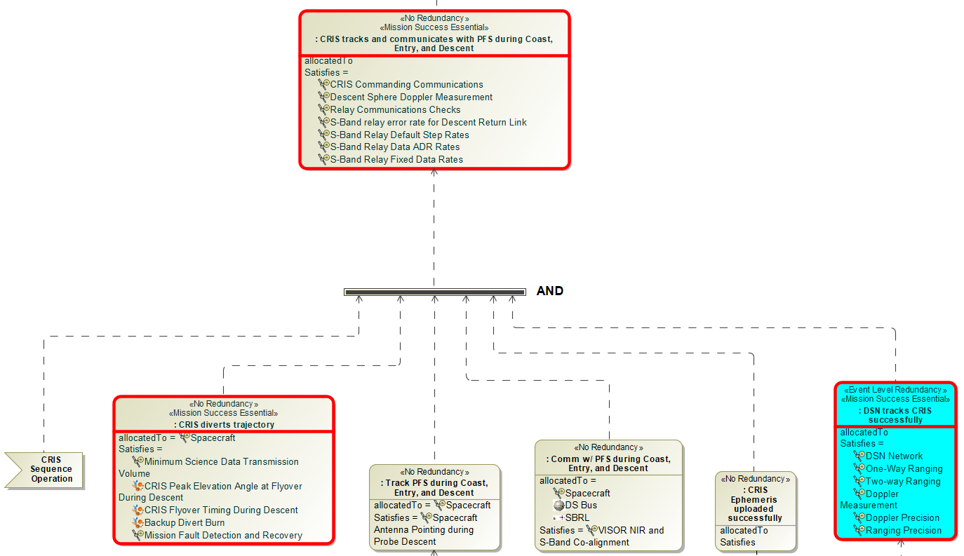
Figure 6. Example of Redundancy Type Inheritance

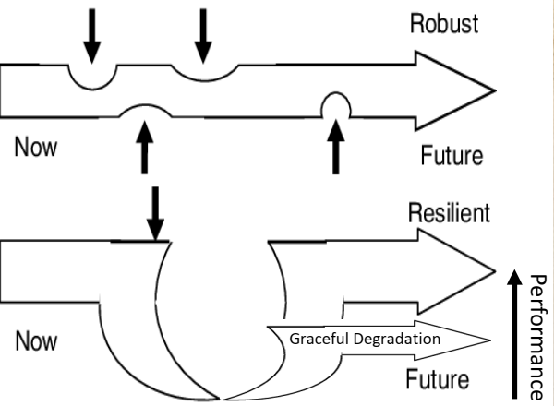
Figure 7. Robustness and Resiliency Model [5]
Resilience is a reactive process where a system shows the ability and timeliness to return to expected operations after disruption. Graceful degradation is also a reactive process where a system results in lower performance in the presence of adverse conditions.
For DAVINCI, robustness was incorporated into the initial baseline system architecture through the results of early risk reduction testing, conservatively defining the range of environmental conditions, and employing healthy technical margins. In addition, the architecture and the DISCO were developed to incorporate purposeful redundancy and graceful degradation across the hardware elements, system functions, and operational events.
The DISCO Success Tree was used to identify the DISC events that naturally incorporated redundancy or graceful degradation. Engineering teams from each system Element were consulted to better understand their associated DISC events and the redundancy they may have during the In-Situ Campaign. As an event was created, it was assessed against seven (7) redundancy types (Figure 9), each developed as custom SysML stereotypes that were allocated during the survey:
- Mission Success Essential (MSE) indicates an event that directly supports meeting the minimum mission success criteria, as defined in the DAVINCI Level 1 requirements. Given that DAVINCI is a single string mission, it could be argued that most events are MSE. So, assigning this category must be done judiciously.
- Full Redundancy (FullRed) indicates an event that employs both primary and redundant systems to perform a single function. At the mission level, none of the events fall in this category. However, the Hibernation Card within the DS does contain fully redundant systems.
- Functional Redundancy (FuncRed), according to the NASA Fault Management Handbook [6], “is the use of dissimilar hardware, software, or operations procedures to perform identical functions.” Within context of the tree, functional redundancy was applied to PFS command to release, and parachute separation.
- Event Level Redundancy (ELR) indicates multiple opportunities/events to complete a task using the same hardware. All DAVINCI instruments will be collecting more data that required by Level 1 baseline science requirements.
- Functional Resiliency (FuncRes) indicates any event that enables or incorporates fault protection to ensure system functionality. Examples of this are the events leading up to the start of the DISC, an Element being powered on, or the Zephyr detecting separation.
- Graceful Degradation (GD) indicates an event where it is expected the hardware to have reduced functionality while still meeting requirements. For example, it is expected the atmospheric density will be such that the link between Zephyr and CRIS will degrade during the descent.
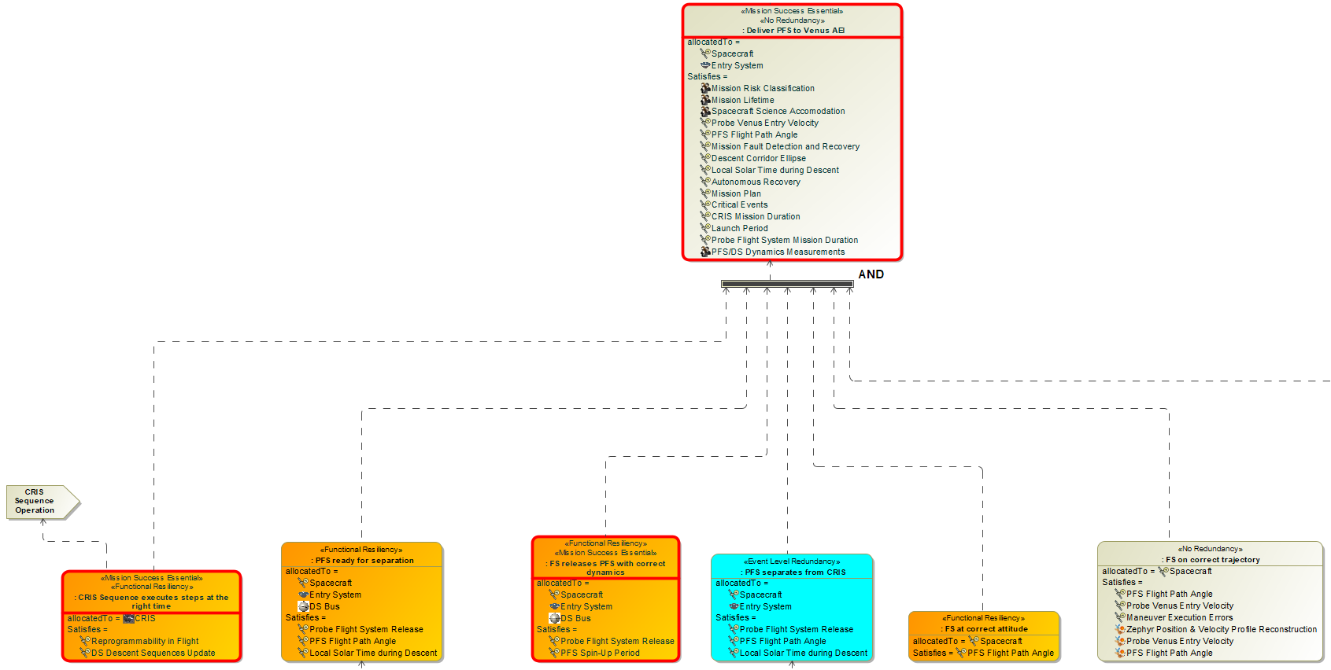
Figure 8. Example of Redundancy Type Non-Inheritance

- No Redundancy (NR) indicates a single-string event where none of the above redundancy types apply. Note that an event can have No Redundancy and be MSE. The purpose of using the DISC Success Tree for the Redundancy Assessment was to identify any single string event that was stereotyped as MSE, which includes critical events, then assess if it generated any additional risk to the Program that was not already accounted for.
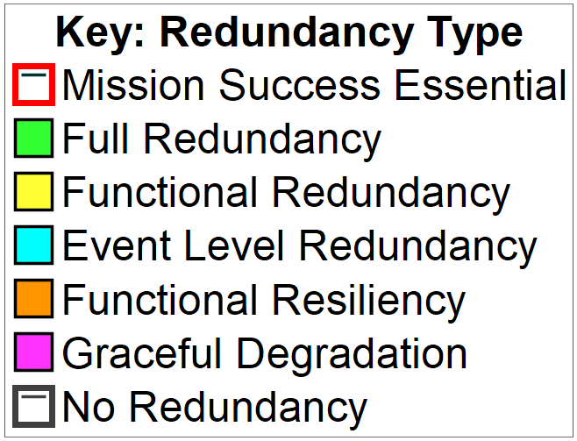
Figure 9. DISCO Success Tree – Redundancy Legend
As stated earlier, the redundancy type for each event is evaluated independently, regardless of branch level. A higher-level event can directly inherit the majority redundancy type of lower-level events (Figure 6). But this is not always the case, as shown in (Figure 8).
DISC Redundancy Assessment Results
The full DISC Redundancy Assessment was a table generated from information within the Success Tree model. A sample of this table is shown in Table 2. It sorts the events by DISC Phase and includes the allocated redundancy type (using the same colors from the model for quick identification), a description and rationale of the event and why it was stereotyped with its redundancy type (key in the redundancy assessment), the allocated Mission Element, and the requirements it was validated against. This information was used by the leads to understand the redundancy that currently exists for their Elements within the DISC. Additionally, this information was used to identify opportunities for increasing redundancy or resiliency. This could be done by adjusting system operation, system implementation, or changing the system. The DISCO Success Tree was used to assess the redundancy opportunities for the full DISC and for the Descent Sphere operation:
PFS Post-Separation Communication Checks—The S-band Relay Link (SBRL) between the CRIS and the PFS/Zephyr is the primary communication path from which all the scientific data collected on Venus will be extracted and ultimately sent to Earth. This is the backbone of the mission. While being thoroughly tested during ground testing, the SBRL can only be properly commissioned during the Coast Phase, after the PFS has separated from CRIS. This is because the relative positions of the Zephyr and CRIS S-band antennas, while in the integrated Flight System configuration, prevents testing during the Cruise Phase. The post-separation commissioning will be implemented as a set of communication checks (i.e., Comm Checks) and include:
- Operationally test the fixed rate/open loop and Adaptive Data Rate (ADR) modes of this link.
- Characterize & optimize CRIS receiver performance.
- Determine the health of the DS and ES avionics prior to entry.
Initially, the DISCO scheduled three (3) Comm Checks which would last about 20 minutes each. Within the Success Tree, the Comm Checks have been defined as “Functional Resiliency” (Figure 10) because it is expected that the CRIS and DS Fault Management Systems will work to establish the link between both vehicles.
Table 2. DISCO Success Tree Redundancy Assessment
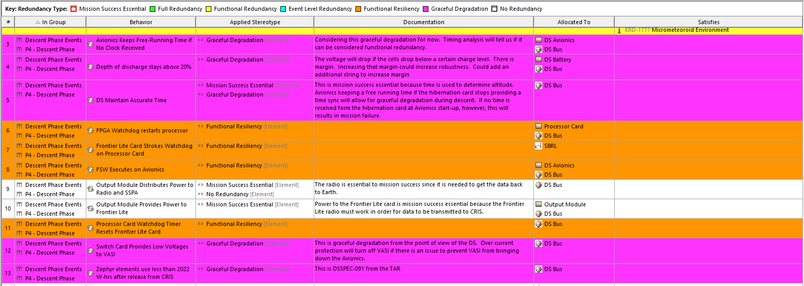

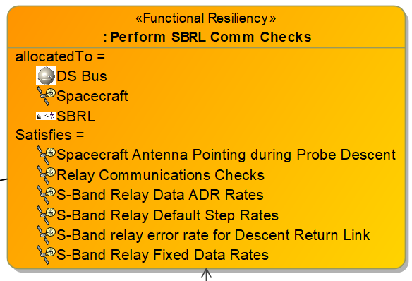
Figure 10. SBRL Comm Check Event Block
The DS Hibernation Card (HiC) would "wake up" the DS Avionics, which would activate the DS Radio, sending a signal to CRIS letting it know a communication check has started. The first and third Comm Checks would test the fixed rate/open loop and ADR modes, simulating the link between Zephyr and CRIS during the Descent Phase. The second communication check simulates the faulted condition of employing the predefined fixed rate stepping by the Zephyr and open loop record by the CRIS.
After assessing this operation within the Success Tree, the question was asked, "what other value-added capability could be employed during these communication check to assess the full health of the PFS and Zephyr?" As currently designed, the SBRL is designed for one-way data transfer from DS to CRIS. Hence, CRIS is not able to send commands to the DS, only receive data from the DS. In addition, the DS fault management system will be relied upon to autonomously correct any fault with the DS or the Zephyr instrument suite. The DAVINCI Fault Protection Working Group will produce a minimal list of potential faults that will be thoroughly tested.
The SBRL Element performed a trade study to determine if any additional, value-added functionality could occur during the communication checks based on current hardware design (e.g., evaluating/acting on instrument health). Working with the DS Element, it was determined that SBRL commissioning was the only activity that could be accomplished during the Comm Checks. If a fault was detected with any DS subsystem or the Zephyr instrument, the Zephyr fault management system would have to address it. From this trade, the number of Comm Checks was changed from three (3) to two (2). The first Comm Check would be as previously described. The second will be held as a backup as part of fault protection, through Mission PDR or unless battery margins force a descope of this functionality. If the first Comm Check proves to be successful or requires minimal changes to the CRIS S-band antenna operation, the loss of the second Comm Check would not add risk to the Project.
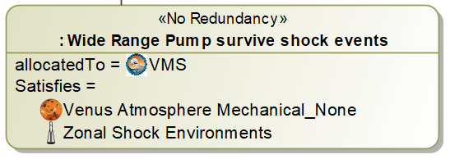
VMS Wide Range Pump (WRP)—The Venus Mass Spectrometer (VMS) WRP is a turbo-molecular drag vacuum pump whose rotor spins at 100,000 RPM, and is known to be highly shock and vibration sensitive. Within the Success Tree, the WRP event has been defined as “No Redundancy.” (Figure 11)
Figure 11. WRP Event Block
Heritage pump designs (e.g., MOMA and SAM) have not operated in extreme shock or vibration conditions. And the one that has, does not have the required pumping capability. However, within the Zephyr, this pump will see one shock event while operating (Main chute separation via cable cutter initiators), and three (3) when not operating (atmospheric entry, pilot/main chute deployment, jettison from ES). In addition, the pump could experience high rotational g-loads from parachute tip-off, and aeroacoustics noise during descent, all during operation. The parachute shock was a known issue during the proposal phase of the DAVINCI Project, but it was also highlighted within the Success Tree. The other two issues were discovered during baseline requirements development. VMS is evaluating the current design to understand its robustness against these events. In addition, the Project is working to characterize the shock, tip-off, and aeroacoustics environments, which will result in an update of the descent environmental requirements. VMS will incorporate the results of risk-reduction testing into an updated WRP design for use on this mission. In addition, the Project is considering revising the DISCO to power down the WRP during the parachute shock/tip-off events. However, it is known that pump power cycle time could be too long for it to useful for noble gas measurements, thereby affecting Level 1 baseline science.
Table 3. DISCO Success Tree NR/MSE Redundancy Assessment
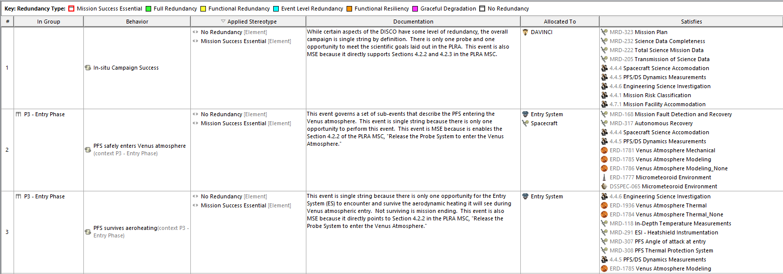

Descent Sphere Redundancy Assessment—The DS Team used the DISCO Success Tree to decompose their allocated DISC operational events that were critical to DS operation. Their assessment found:
- There were many dependencies on the DS Power subsystem, leading to Full Redundancy on the HiC.
- It is expected that the DS ability to execute its time sequence at the right time will gracefully degrade as time accuracy on their FPGA time oscillator will drift during the descent. The design does not have a backup timer or anyway to refresh the FPGA oscillator.
- The DS runs the Coast and Entry Sequence that is based on the time since the PFS separates from CRIS. This time-based sequence includes entry preparations for the DS and instrument suite. The Time Since Separation (TSS) clock event is Mission Success Essential because if it has drifted it would delay all subsequent events through descent, impacting retrieving the data required to meet Level 1 baseline science requirements.
The DS team determined these events would be further evaluated through a Fault Tree, which would be developed outside of the DISCO Success Tree and MagicDraw. This work is on-going.

Mission Success Gap Assessment
Mission Success Essential (MSE) events are those deemed essential to accomplishing the Mission Success Criteria (MSC) defined in the Level 1 requirements. The MSC are broadly written to ensure mission success, such as deploy Zephyr into the Venus atmosphere, image the Venus surface, and collect and send back Venus atmospheric data. As stated earlier, most of the events in the Success Tree could be considered MSE. However, an event must directly affect the MSC to be deemed Mission Success Essential. Those events that were stereotyped as MSE and NR are the those of the most importance and would need further evaluation. In this evaluation, one would ask, "why is this event single string?", and "is there any additional and credible risk to the Project if this event remains single string?"
After all the events were evaluated and stereotyped with a Redundancy Type, they were assessed again to determine their relation to the MSC. In the DISCO Success Tree model, they are denoted by a red outline around each event block, as shown in Figure 6. The Redundancy Gap Assessment was performed by identifying those single-string MSE events, as shown in sample table in Table 3. Their rationale is described in the Documentation column. Based on conversations with the DISCO Lead and other Element leads, the determination is that these single-string MSE events do not generate any additional credible risk to the DAVINCI Project.

5. Future Work
The DISCO Success Tree will be a living model of the DISC and a valuable tool for the Project. In the near term, it will continue to be used to validate any changes or updates to requirements and evaluate changes to the DISCO and their impacts on DAVINCI Elements. Later in the mission lifecycle, it can be used to help identify any single point failures that may have been previously missed, develop the Zephyr Fault Management Plan, and use the Tree events to guide the DAVINCI validation test plans and activities.

6. Summary
DAVINCI looks to unlock more of Venus’ mysteries by collecting critical atmospheric measurements that will help to better understand the exoplanet next door, but other exoplanets yet to be discovered. To accomplish this mission, the DAVINCI Project has developed a SysML-based success tree to, not only, better understand what is needed to have a successful campaign. In addition, it will help to validate requirements against the campaign events, quantify current and potential campaign redundancies, and be used during the system validation test campaign. This unique employment of SysML will aid in a successful DAVINCI In-Situ Campaign.
Appendix
A. Acronyms
ADR – Adaptive Data Rate
AEI – Atmospheric Entry Interface
APL – Applied Physics Laboratory
ARC – Ames Research Center
CRIS – Carrier, Relay, and Imaging Spacecraft
CUVIS – Compact Ultraviolet to Visible Imaging Spectrometer
DAVINCI – Deep Atmosphere Venus Investigation of Noble gases, Chemistry, and Imaging
DISC – DAVINCI In-Situ Campaign
DISCO – DAVINCI In-Situ Concept of Operations
DRSC – DAVINCI Remote Sensing Campaign
DS – Descent Sphere
EDL – Entry, Descent, and Landing
ELR – Event Level Redundancy
ES – Entry System
ESA – European Space Agency
FPGA – Field Programmable Gate Array
FS – Flight System
FullRed – Full Redundancy
FuncRed – Functional Redundancy
FuncRes – Functional Resiliency
GD - Graceful Degradation
GSFC – Goddard Space Flight Center
HiC – Hibernation Card
HQ – Headquarters
I&T – Integration & Test
JPL – Jet Propulsion Laboratory
LM – Lockheed Martin
MBSE – Model-Based Systems Engineering
MD/Nav – Mission Design/Navigation
MOMA – Mars Organic Molecule Analyser
MSC – Mission Success Criteria
MSE – Mission Success Essential
NASA – National Aeronautics and Space Administration
NIR – Near Infrared
NPR – NASA Procedural Requirement
NR – No Redundancy
PDR – Preliminary Design Review
PFS – Probe Flight System
SAM – Sample Analysis at Mars
SBRL – S-Band Relay Link
SMA – Safety & Mission Assurance
SysML – Systems Modeling Language
TSS – Time Since Separation
UV – Ultraviolet
VASI – Venus Atmospheric Structure Investigation
VenDI – Venus Descent Imager
VERITAS – Venus Emissivity, Radio Science, InSAR, Topography, and Spectroscopy
VfOx – Venus Oxygen Fugacity
VISOR – Venus Imaging System for Observational Reconnaissance
VMS – Venus Mass Spectrometer
VTLS – Venus Tunable Laser Spectrometer
WRP - Wide Range Pump

Acknowledgements
DAVINCI development support since 2011 has been provided by GSFC and LM leadership. Special thanks to the GSFC center leadership for the many Internal Research and Development (IRAD) efforts that contributed to the technical development and the teams who worked on those IRADs which were critical to the design maturation and success of DAVINCI.

Model-Based Systems Engineering (MBSE) is a system engineering methodology that finding its place in more flight projects across the Agency. Special thanks to the DAVINCI MBSE Working Group, GSFC MBSE Practitioners Group and the NASA Digital Engineering Community for their technical guidance and collaboration which set the foundation for this modeling effort.

References
[1] “NASA Selects 2 Missions to Study ‘Lost Habitable’ World of Venus,” NASA Press Release 21-073, June 2, 2021. https://www.nasa.gov/press-release/nasa-selects-2-missions-to-study-lost-habitable-world-of-venus
[2] Sekerak, M., et al, “The Deep Atmosphere Venus Investigation of Noble gases, Chemistry and Imaging (DAVINCI) Mission: Flight System Design Technical Overview,” 2021 IEEE Aerospace Conference, 2021.
[3] Garrison, M., et al, “The Big Plunge at Venus: The DAVINCI Descent Phase,” 2023 IEEE Aerospace Conference, 2023.
[4] Friedenthal, S., Moore, A., Steiner, R., A Practical Guide to SysML: The Systems Modeling Language, Third Edition, Amsterdam, Elsevier, 2015.
[5] Zhang, D., Dadkhah, P., and Ekwall, D., “How robustness and resilience support security business against antagonistic threats in transport network,” Journal of Transportation Security, no. 4 (2011): 201–219. https://doi.org/10.1007/s12198-011-0067-2
[6] NASA Fault Management Handbook, NASA-HDBK-1002.

Biography

Khary I. Parker received a dual B.S. in Aerospace Science Engineering and Physics from Tuskegee University in 1999. He has been with NASA for 25 years, starting at Glenn Research Center in 1999, then transferred to Goddard Space Flight Center in 2005. While at Goddard, he worked as a Propulsion Systems Engineer, supporting LRO, GOES N/O/P, MMS, Green Propellant Loading, SmallSat Propulsion Technology Development, PACE, and RST. He currently serves as the DAVINCI Payload Systems Engineer and Deputy DAVINCI In-Situ Campaign Lead.

Leslie Hartz is a Mission Systems Engineer at the NASA Goddard Space Flight Center. She worked for NASA for 38 years on a wide range of projects from the International Space Station to cubesats. She is currently the Phase Lead for the DAVINCI In-Situ Campaign.

Matthew Garrison is the DAVINCI Project Systems Engineer. He has worked at the NASA GSFC since 2005, first as a thermal engineer and then as a systems engineer. He has supported in-house flight hardware for Earth science, planetary science, and astrophysics missions, and also served as chief engineer of the Planetary Science Projects Division.
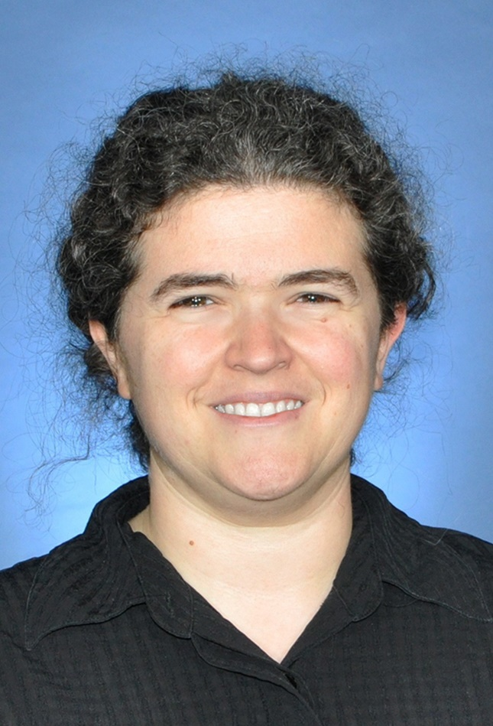
Robin Ripley started working for NASA as a contractor for Orbital Sciences Corporation in 2005, then joined NASA as a full-time employee in 2008. She spent 12 years in 587 supporting various versions of SpaceCube. She has experience with embedded software, FPGA design, board level testing, box integration and test, payload integration and test, environmental testing, and mission support. In the past few years, she has transitioned to systems engineering, including work on SmallSats and instrument platforms for airless bodies. She currently works on DAVINCI as the Deputy Systems Engineer for the Descent Sphere. Her BSEE is from Virginia Polytechnic Institute and State University and her MSEE is from Johns Hopkins University.
Colby Goodloe received a B.S. and M.S. in Electrical Engineering from University of Maryland in 2005 and 2008, respectively. He has worked for NASA Goddard Space Flight Center since 2002 and is the Descent Sphere Lead Engineer. Previously he was the Lead Spacecraft Engineer for Lucy and Project V&V engineer for OSIRIS-REx. He also worked on electronics for GNC components and instruments for several successful missions including SDO, GPM, FASTSAT, MMS, and 7-SEAS BASELInE and others still in development including ICESAT-2 and LCRD.

