Lunar Node – 1: Initial Flight Results and the Role of Surface Pseudolites in Lunar Navigation

Evan J. Anzalone, NASA/Marshall Space Flight Center
Tamara L. Statham, NASA/Marshall Space Flight Center

BIOGRAPHIES
Evan Anzalone is a Navigation Engineer at NASA’s Marshall Space Flight Center since 2010. He earned his PhD in Aerospace Engineering from Georgia Institute of Technology in 2013. Evan is the P.I. for Lunar Node -1 and currently primarily supports Moon to Mars Systems Engineering and Integration as Navigation Lead.
Tamara Statham is an Engineer at NASA’s Marshall Space Flight Center supporting Flight Mechanics since 2019. She is the Co-Investigator of Lunar Node -1 and primarily supports Moon to Mars Systems Engineering and Integration in the area of Analysis Integration.

ABSTRACT
On February 22, 2024, Intuitive Machines NOVA-C landed on the lunar surface, carrying a cadre of NASA scientific and technology demonstration payloads. This mission marked the first delivery of NASA instruments to operate from the lunar surface since Apollo. One of these payloads was Lunar Node -1 (LN-1), a navigation beacon demonstration that was designed and built by NASA’s Marshall Space Flight Center. The payload’s main goal was to demonstrate and provide insight into lunar surface-based radio navigation aids. LN-1 successfully conducted multiple one-way transmissions to Deep Space Network (DSN) ground receivers using its S-band transmitter, while being disciplined by an onboard Space Chip Scale Atomic Clock. LN-1 transmitted to DSN almost daily during lunar transit and during two surface passes. These passes evaluated two navigation approaches: performance and stability of ranging using time-based transfer techniques on a cubesat size and grade platform, as well as one-way pseudonoise ranging approaches. To assess performance, the measurements were compared to independent navigation solutions such as one-way and two-way Doppler tracking and visual verification of the landing location from orbital platforms. These results are compared with ground-based testing and continued evaluation of the flight-space platform using multiple grades of oscillators for maintaining clock and frequency stability. These focus on the timing stability of platform in deep-space and variations in state determination. Given these insights, this paper provides additional description and evaluation of applying this approach in a broader lunar navigation architecture. Analysis is provided to develop timing requirements and assessment of operational scenarios, such as orbit and surface location determination. Additionally, the results support discussion as to how surface pseudolites could best be used within standard signal definitions, such as defined in the LunaNet Interoperability Specifications. Lastly, the paper will discuss challenges and next steps of a follow-on payload to LN-1.

1. Introduction
With the recent heavy investment in missions targeting lunar space, both on the surface and in various orbits (Smith et al, 2020), cislunar space will be approaching a critical mass where the number of vehicles and support assets operating simultaneously is large enough that the desire for in-situ aids becomes preferable to independent fully Earth-centric operations. There have been studies previous in ideas of the Interplanetary Internet (Hooke, 2001) and concepts like LunaNet (Israel et al, 2020) which seeks to build out a more robust network to enable multi-user compatibility and a shared backbone of data to/from Earth. This is not only for communication and data transport, but also areas such as navigation. The baseline approach for long-term lunar orbiting assets and for the Apollo missions was to utilize ground-tracking assets on Earth to provide updates to vehicles of its position and velocity at a given time (Wollenhaupt, 1970; Nicholson et al, 2010). While this approach is understood and implemented, it is limited by the number of available ground stations and support observations. Scenarios such as multi-spacecraft in aperture help to alleviate this impact, but with increasing missions requiring high data simultaneously, alternate solutions are needed for long-term sustainability and growth. To address these limitations, there is a need for deployable local infrastructure that can provide an augmenting capabitliy to other in-situ resources. The goal of the Lunar Node – 1 payload is to demonstrate the first steps of this approach.

2. LUNAR NODE – 1
The Lunar Node 1 (LN-1) payload was designed, built, and tested at MSFC. LN-1 provides a modular design, made with commercial of the shelf (COTS) components, that could be integrated into a variety of host vehicles and, with adequate power generation/storage, be able to offer long-term operation. Figure 1 provides an over of the implementation and relative size of the payload relative to the host lander. The left image in the figure shows a view of the flight Intuitive Machines NOVA-C lander Odysseus. LN-1 is located near the top of the vehicle to enable an unencumbered view of flight of the payload’s antenna back to Earth. The middle image provides a zoomed-in view of LN-1 itself, wrapped in multi-layer insulation with its large radiator visible. The right images provide insight to its primary flight components: the controller board housing the controller and Space CSAC, the power/interface board with provides voltage regulation, electromagnetic interference protection and reverse voltage protection, as well as the Tethers Unlimited SWIFT-SLX S-band radio.

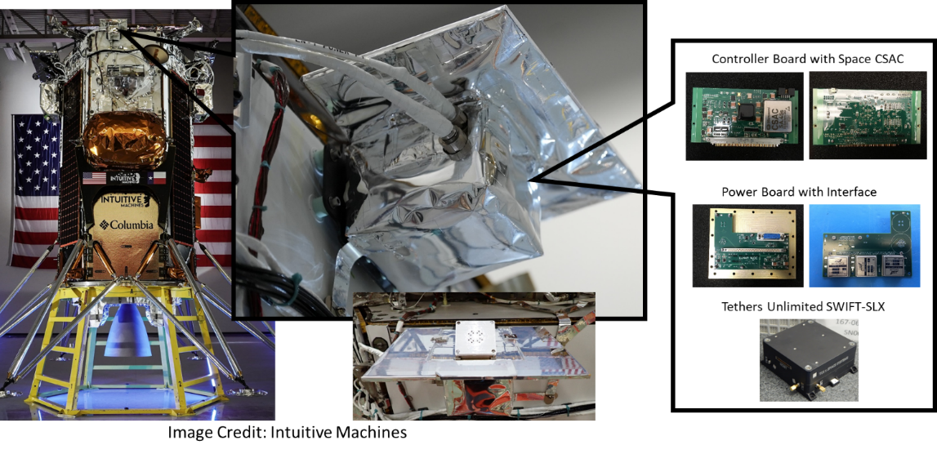
Figure 1. Lunar Node -1 Integration
The main function of the payload is to exercise multiple approaches to signals that would be used by lunar infrastructure. The navigation modes being tested included both the Multi-spacecraft Autonomous Positioning System (MAPS) and PN-based one-way non-coherent ranging and Doppler tracking to provide alternate approaches and comparisons for navigation performance. The MAPS Concept of Operations is shown below in Figure 2. These concepts are described in more detail in Anzalone et al (2015). In this concept, each spacecraft shares its timing and state knowledge as part of either system broadcasts or pre-programmed communication passes within the network. In this approach, the relays operating as trunks on each planetary network act as anchors, providing high accuracy timing and state references to other elements throughout the network. With this approach, digital information embedded into the communication packet standard allows for sharing of navigation information as part of every communication link between assets.

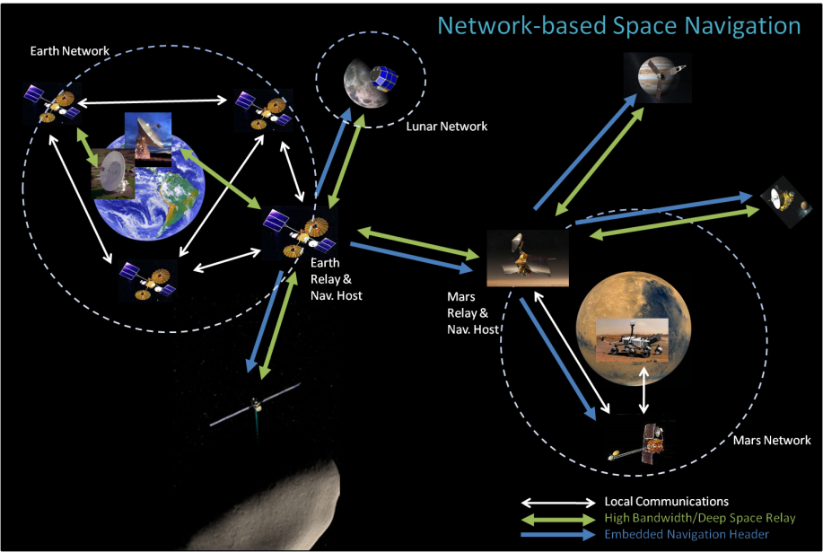
Figure 2. MAPS Concept of Operations

This concept has studied in paper studies as well as software testing using the Software Defined Radio Testbed was on the International Space Station (Anzalone et al, 2018). This technology and approach provide an opportunity to demonstrate and improve local navigation around the moon. This concept, along with influences from other navigation approaches forms the basis of the Lunar Node – 1 Payload.

2.1 Payload Description and Objectives

LN-1 will need to demonstrate that its packets can be successfully received and processed to determine the payload state. To do this, over the course of the 7-day trans-lunar cruise and planned 8 to 13.5 earth days of lunar surface operations, LN-1 will broadcast out its state and timing information back to Earth for several observation passes to the Deep Space Network (DSN). Upon reception of this data, high accuracy packet reception timestamps will be used (along with atmospheric data for induced delays) to assess a ranging observation. This data will be captured across multiple passes to compute a navigation state of the payload over the mission. In addition to demonstrating the MAPS payload, the radio will also be used in PN-based one-way non-coherent ranging and Doppler tracking to provide alternate approach for navigation performance. In anticipation of next year’s landing on the lunar surface, the team is also working to develop potential collaborations including cross-link demonstrations with potential VLBI-earth based observations. Further, the team is also working to bring additional ground stations online to get raw Radio Frequency observations to aid in development of one-way PN receivers.

An innovative aspect to LN-1 is that it provides a modular design, made with commercial of the shelf (COTS) components, that could be integrated into a variety of host vehicles and, with adequate power generation/storage, be able to offer long-term operation. Future host vehicles can include satellites, rovers, and landers that are part of a greater lunar architecture. Figure 3, which shows the flight payload, the compact size of the spacecraft can be identified. In terms of dimensions, the primary structure is approximately 175x220x300 cm in volume and ~2.8kg in mass. The dominating factor of the design is the large top surface which is the spacecraft’s radiator. To provide a clean interface with the host vehicle, LN-1 has designed a radiator to allow for heat dumping during operation. This is needed due to the hot environment on the lunar surface at lunar noon, combined with the heat generated by the power draw of the radio while transmitting.

The primary components of LN-1 can be identified in the cutaway drawing in the engineering drawing cutaway. The vertical board provides the primary interface and power regulation to the payload, with the remaining electrical components on the horizontal board. This package includes the ACTEL FPGA computing element, the Space-rated CSAC, and the interface to the radio. The SWIFT SLX transmitter is mounted underneath the radiator of the payload to allow for maximum heat dissipation during operations. The antenna is mounted on a 45-degree bracket to allow for improved pointing of the payload to the Earth with expected flight vehicle pointing and expected direction to Earth form the landing site.
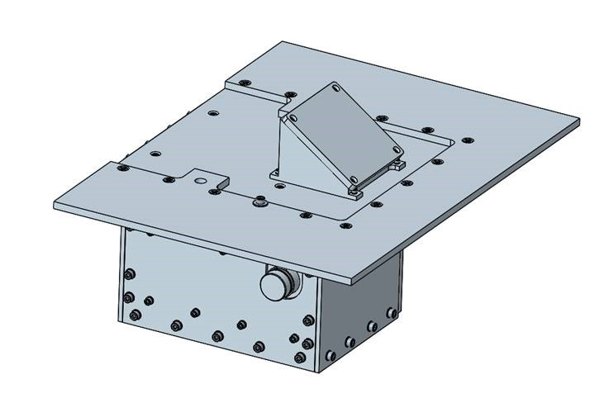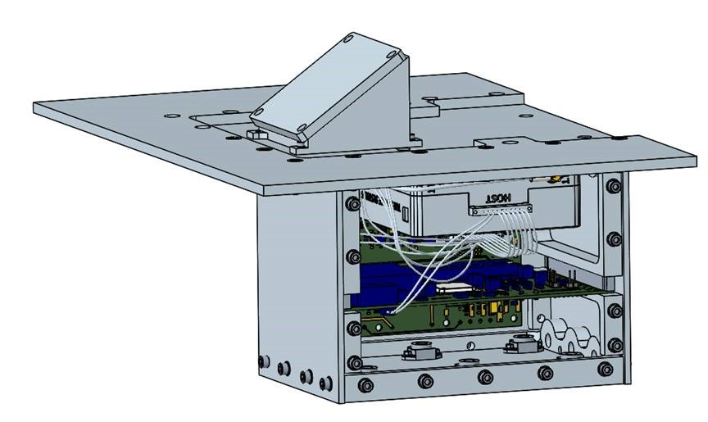
Figure 3. External and Cutaway View of LN-1

2.2 Flight Operations Plan
As part of the flight demonstration, LN-1 will operate as an independent radio transmitter on the host vehicle. For all navigation modes being tested, the payload will operate concurrently with transmission from the host vehicle. The connection between the payload and host lander is via RS-422 over the lander’s communication network. LN-1 will use this connection for payload commanding and tracking health and status. This interface will be used to track how well the payload can sync its clock and information to the onboard (and ground-corrected) timing information as well as verify transmission status and packet generation. Telemetry generated by the payload will be received by an independent set of ground stations that will perform data recording and processing. This includes timestamping of all telemetry data, Doppler observations, and one-way ranging measurements. For this application, the Deep Space Network was selected as the ground station to stand in for a notional user. The DSN was selected due to the need for large receive dishes to meet payload link margin requirements, as well as for the sophisticated and proven interface with flight navigation products for deep space. This will allow the team to process and perform orbit determination using standard DSN tools, such as the MONTE (Evans et al, 2018) package to provide a flight-like scenario and analysis backend.

A diagram of the LN-1 concept of operations is shown below in Figure 4. LN-1 will sync its internal time and state to that of the lander from its best estimate. All commanding and health and status will be relayed through primary payload telemetry. The payload includes an independent high stability oscillator and S-band radio to support communications back to Earth. Over the course of the trans-lunar cruise and lunar surface operations, LN-1 will broadcast out its state and timing information back to Earth for several observation passes to the DSN. Upon reception of this data, high accuracy packet reception timestamps will be used (along with atmospheric data for induced delays) to assess a ranging observation. This data will be captured across multiple passes to compute a navigation state of the payload over the mission. In addition to broadcasting telemetry, the payload will operate switch to a one-way PN ranging tone consistent with the JPL definition as in O’shea et al (2015) to capture long-term stability and performance. Similarly, there are plans to include potential VLBA observations to provide a completely independent navigation solution. As such, post-flight Lunar Node-1 will be able to compare performance across multiple methods: radiometric tracking based on the host vehicle and its landed state, LN-1 derived PN and Doppler observations, LN-1 time of flight measurements, and VLBI angular observations.

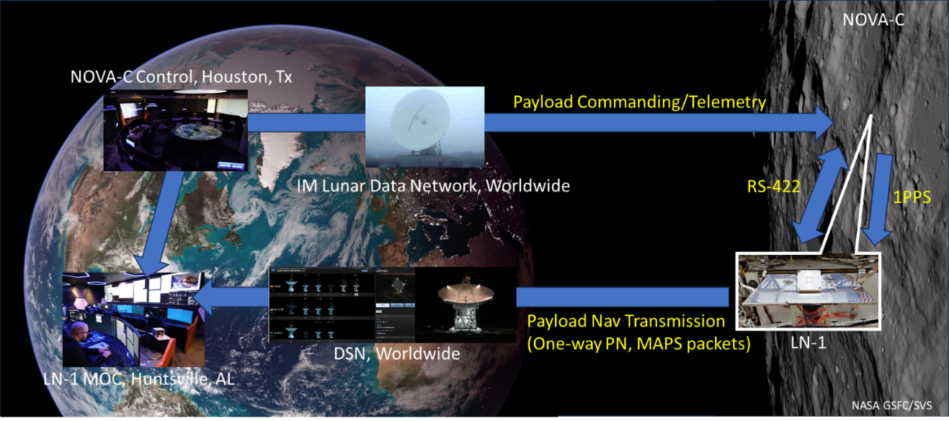
Figure 4. Lunar Node - 1 Concept of Operations

2. Summary of operations and passes
The operational plan for LN-1 was to operate for an extended period of time from the lunar surface in a constant on state. This was intended to allow for capture of long-term trends and evaluation of calibration capability and time keeping to inform the operational cadence needed for this grade of hardware as a navigation aid. Similarly, being at a fixed known location on the lunar surface, helps to provide a highly accurate truth model to calibrate timing delay, range, and Doppler observations. Originally, when the mission was planned for a mid-latitude landing site, it was expected the payload would be operational for nearly 14.5 days, assuming a landing near lunar dawn. As NASA contracted with Intuitive Machines to move the landing site to the South Pole region, hit was reduced down to 7 to 8 days, due to the local conditions and time of year at the landing site. In order to maximize scientific return, it was intended for the payload to be turned on soon after landing to allow an extended period to thermally equilibrate while landing checkout procedures were complete, prior to an initial pass 6 to 12 hours later. Given these desirements, the team negotiated with DSN schedulers to maximize ground coverage time for the mission. Being a limited duration mission helped to limit impact to other high value scientific mission. The final schedule negotiated for LN-1 is shown in Figure 5 (pass duration per day) and Figure 6 (individual passes).

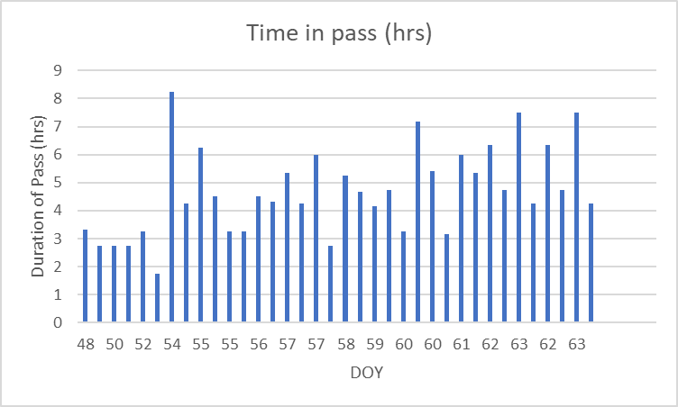
Figure 5. Duration per Planned Pass

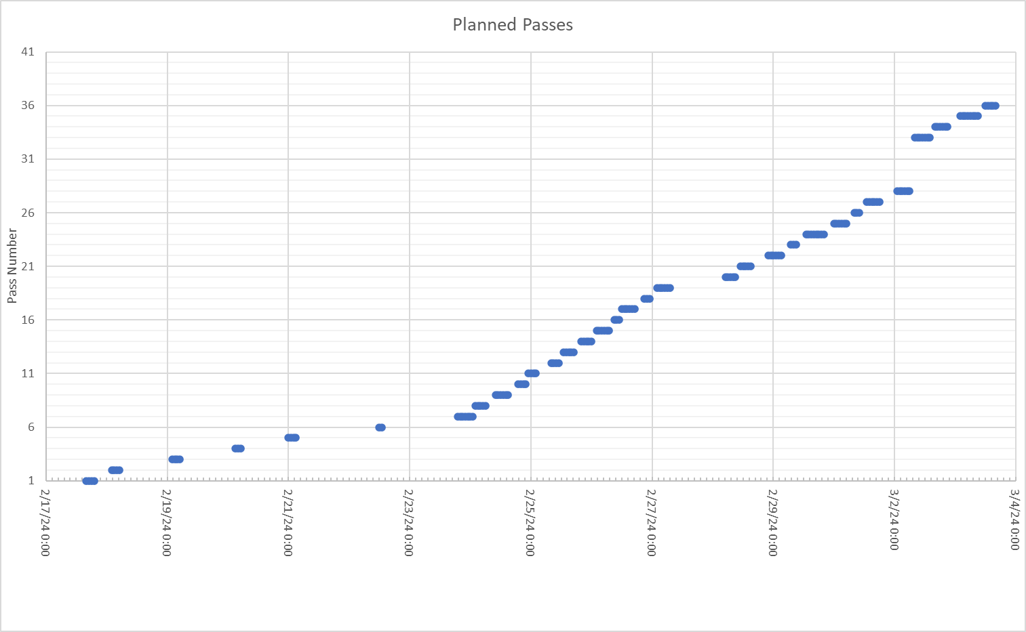
Figure 6. Planned Passes
As shown, LN-1 was able to negotiate very favorable passes, enabling upwards of 8 hours of observation per day once on the lunar solution. These were also fairly well spread out, such that the team could assess both long- and short-term behavior of the payload’s performance (principally timing and frequency stability). These passes were similarly split into PN and MAPS passes, to allow for demonstration and evaluation of both modes of operations. The team also negotiated with external researchers to conduct Very Long Baseline Interferometry Observations of the payload, which would have provided high accuracy measurements of the payload’s angular location relative to Earth (Ichikawa et al, 2004; Duev et al, 2012). In addition, the team worked with Morehead State University’s Space Science Center for use of DSS-17 (Pham et al, 2019) to capture raw observations of the LN-1 signal for evaluation of multi-path effects. Similarly, the team planned to collect raw RF observations during DSN passes as well. Lastly, the team was able to negotiate with Intuitive Machines for daily checkout passes during cruise on the way to the moon. These passes were required to be of limited duration (1-2 hours) to limit impact on the vehicle resources and operations during cruise. During these, the plan was to exercise MAPS and PN observations to provide a baseline observation of data and collect data prior to landing.

These passes were all negotiated, agree to, and in place prior to the mission’s launch. The cruise passes were essentially executed without issue (though one pass was removed due to conflict with primary vehicle operations) and the team was able to execute the MAPS mode for each of these. The pass canceled was the team’s plan checkout of PN ranging prior to landing (this was placed late in flight in order to maximize the observable range between the lander and Earth). Similarly, the team had been working towards a pass in Low Lunar Orbit to observe the unique dynamics, but this was not executed. The vehicle landed on the lunar surface on February 22, 2024. The landing site was verified by the Lunar Reconnaissance Orbiter and the surface imagery are shown in Figure 7. The surface operations were limited due to the landing configuration and time required to tweak the vehicle’s communication system, align assets, and adjust for ground weather conditions at the large receive dishes on Earth. During this time, the payload continued to operate its passes and support IM-1 operations. Once the vehicle was in a stable and known state with better information on power generation and usage, the lander allowed for operation of two LN-1 passes with ground sites. These occurred on February 27 and 28. To reduce operational burden and streamline commanding, a reduced command set was used to bypass normal procedures to quickly turn the payload on and enter a transmission state. Due to power constraints, each pass was limited to about 15 minutes each. This represented a minimum level of success that enabled operation of the payload from the lunar surface, both verifying that it survived and capturing observations (both raw RF and processed MAPS and one-way PN ranging). The results of these are discussed in the next section.

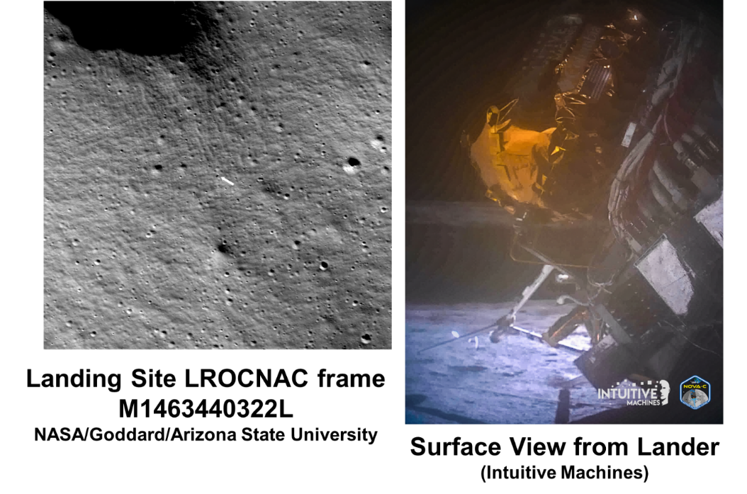
Figure 7. IM-1 Landing Location and Orientation

An overview of the passes is given in Table 1, which lays out which DSN dishes, type of pass, and mode of the payload. While these represent the total dish time allocated, they do not represent the total time of transmission from LN-1 for each, especially due to the real-time operational planning once on the lunar surface. The extended duration of each allowed for margin due to the dynamic nature of integrated vehicle and payload operations. Overall, the payload was able to capture > 200 MB of Tracking Data (one-way Doppler of IM-1 and LN-1, two-way Doppler of IM-1) across the entire mission (cruise/surface). For LN-1, this amounts to ~4.5 hours of MAPS packets transmission received by DSN across 4 cruise passes (>40K one-way MAPS packets), 15 minutes of MAPS packet transmission from Lunar Surface, 15 minutes of one-way PN Ranging from Lunar Surface, and multiple raw RF recordings of LN-1 transmissions by DSN to assess multipath and data processing. The team was not able to conduct RF recordings at Morehead State (due to the pass scheduling of when LN-1 was transmitting) nor VLBI observations due to the last-minute scheduling and limited pass duration. A detailed discussion of the integrated vehicle operations and experience can be found online and in future publications.

Table 1. Executed Passes
BOT (UTC) | EOT (UTC) | FACILITY | ACTIVITY | LN-1 Mode
2024-048T16:30:00 | 2024-048T18:30:00 | 56 | INITIAL ACQ | MAPS
2024-049T02:30:00 | 2024-049T04:30:00 | 54 | TKG PASS | MAPS
2024-049T21:30:00 | 2024-050T03:00:00 | 56 | IM1 Support | MAPS
2024-050T02:40:00 | 2024-050T04:40:00 | 24 | TKG PASS | MAPS
2024-050T21:25:00 | 2024-051T04:45:00 | 54 | IM1 SUPPORT | MAPS
2024-051T03:50:00 | 2024-051T04:45:00 | 56 | IM1 SUPPORT | MAPS
2024-058T02:55:00 | 2024-058T06:55:00 | 56 | IM1 SUPPORT | MAPS (Surface)
2024-059T11:50:00 | 2024-059T14:45:00 | 36 | IM1 SUPPORT | PN 1-way (Surface)

3. Performance of payload
While the mission did note conduct extensive operations from the lunar surface, the payload did conduct limited daily operations, primarily in the MAPS telemetry mode. This section will provide an overview of the available data in reference to the vehicle trajectory. For this analysis, a preliminary Best Estimated Trajectory (BET) was providing by Intuitive Machines while the final release is under review and updates. As identified in the previous section, the MAPS transmission mode is designed to provide a telemetry packet to any listening users that contains a complete state solution of the host vehicle (containing a consistent set of time, position, and velocity) as well as timestamp prior to transmission from the vehicle. During LN-1 operations, this packet was timestamped immediately prior to sending the packet to the radio for transmission. Once received, DSN stations would provide an Earth Receive Time (ERT) that identifies the reception time of the packet. For these test cases, comparing these two timestamps should correlate to a range measurement between the two assets. Using the BET, it is possible to provide an estimate of what this range measurement should be over the course of each pass. This data is provided in Figure 8, which shows that during cruise the vehicle is rapidly moving away from Earth. In these plots, the time axis is time from the start of the pass. The left plot shows the range increasing from ~3.25E5 km to ~4.1E5 km, and the range over each pass shows a change between 2000 – 3000 km over the course an hour. Translated in absolute time deltas given the speed of light this equates to 1.1 to 1.4 seconds total with changes over the pass on the order of 7 to 10 milliseconds. This provides insight that while there is motion over the pass, due to the limited time of each (~1 hour), it is likely that this delta may be larger than the inherent clock stability of the payload.

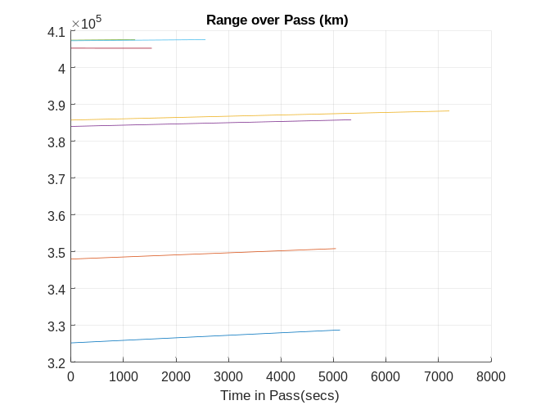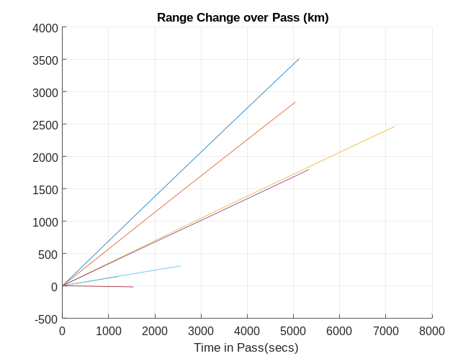
Figure 8. Range (L) and Delta Range (R) to Earth over each Pass
Before discussing the performance of the payload, the method for time management requires some discussion, including syncing to external clocks and to the vehicle. To provide a time sync to the payload upon power-on, a specific command is sent to the payload, which the lander essentially intercepts and places the time at next pulse-per-second (PPS) tick on the lander side into the packet and holds the packet until that tick is received, at which point the command is sent to the payload. At this point, the payload overwrites its current estimate of time with this new value as the total number of seconds and resets it’s sub-second timer. The payload controller is an FPGA and counts the numbers of ticks and compares this to the recorded ticks per PPS to both develop a count for ticks/seconds and microseconds per tick. By default, the payload utilizes a low stability 10 MHz crystal oscillator for its timekeeping and tracks input PPS’s from both the lander and the CSAC. The payload continually tracks ticks per PPS for each source and can be commanded to utilize either of these for primary timekeeping. Lastly, the payload had no memory or real-time clock, and its time was reset to 0 at each power on.
The plot below in Figure 19 shows the raw performance of this delta time measurement. For this, the onboard time (seconds past the GPS epoch) was converted to the same time basis as ERT, and a delta was calculated between the two. The x-axis shows the absolute time of the pass, and the y axis shows the DT in seconds. The red line is generated by the BET trajectory (though does not include any atmospheric corrections at this time) and the blue is that generated using the MAPS packet. Two effects stand out immediately: the variable bias at the start of the pass and the large drift over the course of each pass. The initial bias is due to using the onboard clock, and as such the initial timing is sensitive to the onboard accuracy as well as synchronization and latency at the time command. The payload expected a fixed bias to be prevalent in each pass, and being a fixed offset was intended to be removed via calibration that would account for initial and moving clock bias and drift. The drift though is larger than expected. As can be seen, over some passes the packets measured a DT that varied almost 250 seconds over an hour. When the data is fit to the truth estimate, this results in a .0217 seconds/second clock drift that was fairly repeatable across all the cruise passes.

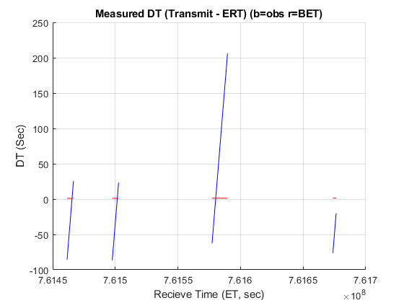
Figure 9. Onboard Time vs Earth Received Time (ERT) over Time
When applying the correction of bias per pass and drift per pass, it is possible to gain more insight into the short-term stability of measurement process. These results are shown in Figure 10. In this plot, the measured DTs are much more in line with the expected, though there is still a large noise floor, on the order of .06 to .08 seconds magnitude peak to peak, still an order of magnitude greater than the expected change over the passes. When looking in more detail at the passes, the trends do align with the general slope of the observation, but when zoomed in the high frequency noise is very apparent. This noise is likely from two sources. The first is the short-term stability of the oscillator itself under flight conditions. The second is the process by which the packet was timestamped. As mentioned, this was applied right as the data was transmitted from the controller board to the radio via RS-422. This data was generally very small, and there is a fixed latency of transmission over the connection (though the data rate was maximized to reduce this impact). The other transient effect is the process by the packet was prepared for downlink. The controller board provided a pre-packaged CCSDS Space Packet to the radio, which then applied additional encoding to enable data correction and operation at lower signal power levels at Earth. This was important due to the small patch antenna and limited power output of the radio (30 dBm). Before transmission the radio processed the data using encoding into a TM packet, Reed Solomon Encoding, and Randomization. Each packet was of a fixed size with the intention to minimize the uncertainty in processing time. Lastly, when no packets were available the radio would fill in with empty packets to ensure a constant transmission stream. These were of fixed size and would introduce additional uncertainty between the timestamp and transmission of the data. To negate this, the team optimized the rate of packet transmission to the radio in order to ensure there was always a packet in the outgoing buffer ready to go to avoid any latency. While these were intended to reduce uncertainties in radio processing, the overall noise of the clocks and short-term stability of the processing still resulted in a large noise term.
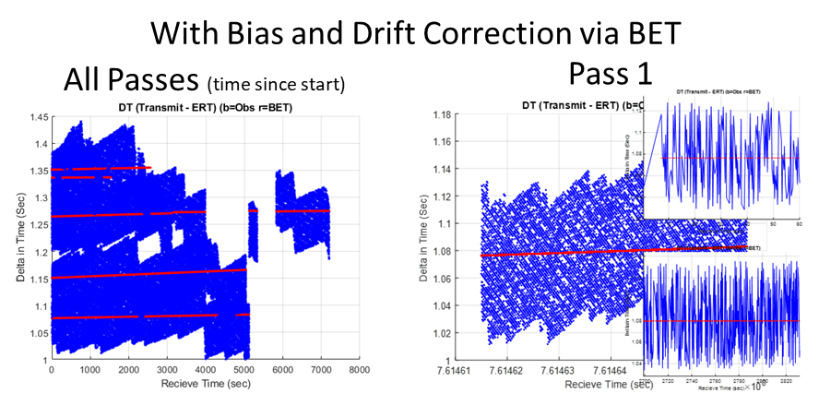
Figure 10. BET-Corrected DT for All(L) and Focused Passes (R)
To characterize this data, the number of ticks per PPS is shown in Figure 11. The base rate of the clock was set to 10 MHz. The plots capture time since the start of the pass on the x-axis and ticks per PPS on the y-axis. The blue plot is comparing the onboard oscillator to the CSAC, and the red is comparison to the vehicle’s PPS. The two results tend to follow each other fairly well, though a fixed offset can be seen between the two. This data was captured at lower rate (~ Hz) so does not show the high frequency noise as seen above. As shown, not only is there an offset between the onboard clock and reference sources, but it does change over the pass. And this change is different slope during cruise vs from the surface.

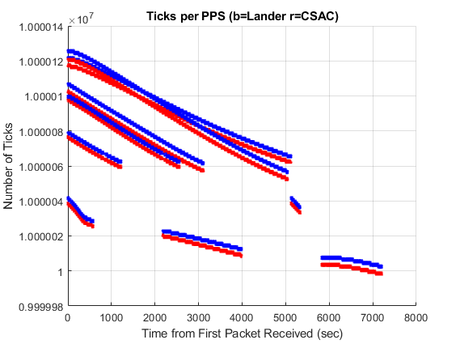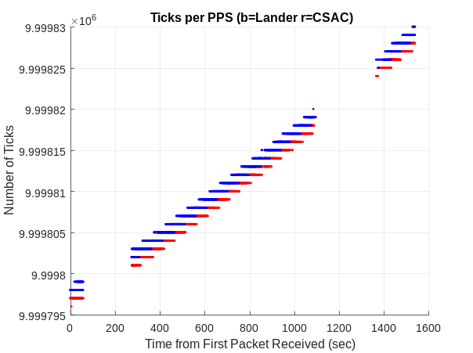
Figure 11. Ticks per PPS: (L) Cruise (R) Surface
To understand these results, the data must be reviewed at one level deeper. Prior to flight, it was known that the payload and CSAC require an extended period to thermally equilibrate. To provide insight to this behavior, the internal temperatures across the payload can be tracked over time. This is shown in Figure 12. During cruise, it can be seen that the payload was often on the cold end before being powered on. For these cases, the payload was initial warmed to low cold operational temperatures, turned on, and then commanding began. Once the radio was turned on and the power draw increased, the temperature across the payload rapidly increased. This correlates inversely to the observed ticks per PPS. As the temperature increased, the ticks also increased. This behavior was repeated over each test, providing insight into the observed time deltas. As shown, the payload never achieved thermal equilibrium, thought at the longer pass, the payload’s temperature gain did begin to slow.
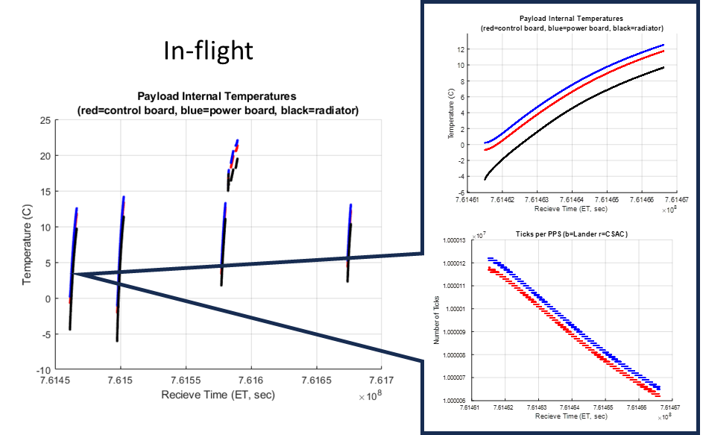
Figure 12. Time vs. Temperature of LN-1
These results can also be corroborated with pre-flight. Figure 13 provides observations collected during compatibility testing. During this test, the payload went through similar power on temperature transients, with the temperature quick increasing. The middle data (and highlighted in the sub-plot) shows data collected during an overnight run. In this case, the payload was left on in the EMI chamber overnight with the door closed. During this test, the temperature increased, leveled off, and once the door was closed, the temperature dropped to a stable level. Zooming in on this data, it can be seen that the clock ticks per PPS was fairly constant over the period. The negative is due to showing the delta between the reference frequency rate (10 MHz) and the observed. This occurred over 10 hours, several hours after the pass started. The main thing to note is the fixed environment on the payload. During cruise, the payload would have had variable temperature conditions due to vehicle attitude and other disturbances. As shown, longer warm-up times would have provided increased stability of the measurements, and mirrored planned extended operations from the lunar surface (being on for several days).

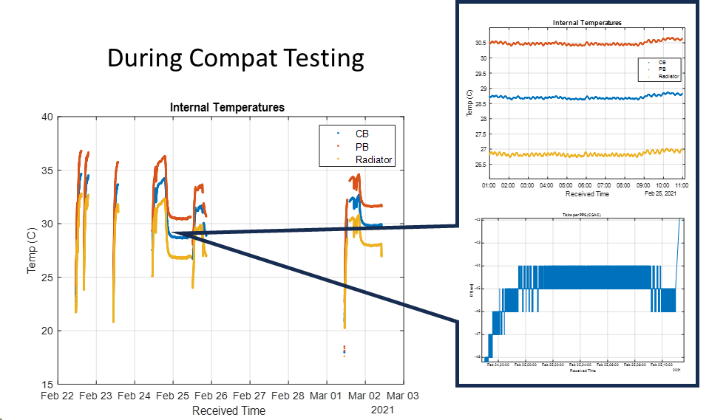
Figure 13. LN-1 Time vs Temperature During Compatibility Testing

4. Application of beacons For Lunar Exploration
With the expansion of and increasing funding supporting lunar navigation infrastructure by multiple government agencies as summarized in Scatteia and Perrot (2021) in addition to commercial investments, it is important to re-evaluate the role of a payload like Lunar Node-1 within the scope of the larger architecture. The government funded and supported variants are focused on rapidly enabling communication and navigation services for the South Pole region of the Moon. This is due to large scientific and sustainable exploration-enabling capabilities in this area. Primarily, this is around the potential availability of sub-surface water in various forms potentially accessible from the surface as described in Kleinhenz et al (2024). Hence the missions are focused on building up missions and capabilities in this region in order to lay out the ability to meet the suer needs as identified in architecture phases such as Foundational Exploration. These are laid out in detail from the NASA perspective in the Moon to Mars architecture documentation in Goodliff et al (2023). Being able to locate and utilize local resources such as water supports generation of breathable air, working fluids, rocket propellant, and binder to support fabrication of structures using lunar regolith. These capabilities all build out around and near the South Pole, due to its unique geology and terrain features. As such, it is envisioned that this region can support a vibrant sustainable economy where in-situ resources such as water, air, and electricity serve as the foundation for trade and activity. Given this environment, it is expected to be an active area of human and robotic activity, with each requiring precision navigation and communication locally and back to Earth.

For this reason, mission designers have proposed the development and use of highly elliptical frozen orbits such as in Sirbu et al (2023) in order to provide the ability to provide real-time navigation and communication to this region. At a high level, this can result in a minimization of the total number of assets required, allowing an efficient initial capability. An example of these orbits is shown below in Figure 14 which represents a 6 satellite configuration of 3 satellites phased in one orbital plane, with the other 3 spread across companion orbits and phased such that over a certain part of the orbit, a user on the South Pole will have coverage of 4 assets simultaneously. Given this, the user can then compute a point solution at high rate to update their navigation. Similarly, the three satellites phased in the same orbit also meet mission needs by enabling 24/7 communication coverages between the surface and Earth. While this is primarily meant to address initial requirements such as laid out in current proposals in NASA SCAN (2023a,2023b), it can be augmented to allow for increased coverage time and data bandwidth to Earth. In these early phases, international partners are working towards common interoperability standards to pool resources and enable a cooperative capability in this region by enforcing an open signal definition. This will help to ensure the needs of South Pole users are met. But this also leaves a gap over some percentage of the day (potentially) as well as limited coverage at non-South Pole locations.

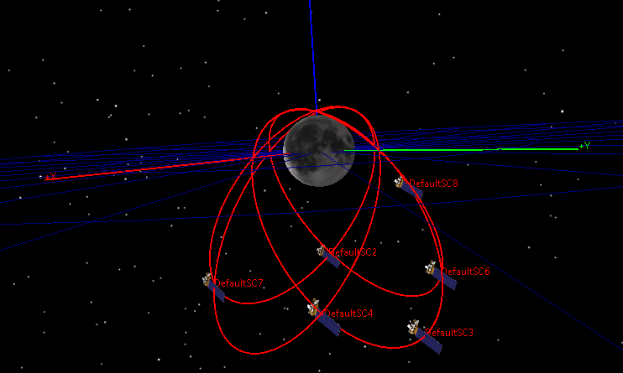
Figure 14 Notional 12 Hour Frozen Orbit Constellation
While the current international focus is at the South Pole, initial human exploration of the moon was focused more on the mid-latitude locations as seen in Figure 15. These areas are still of immense scientific value and posed a different set of challenges vs the South Pole The initial Apollo and Luna missions all landed in this area and placed surface assets such as reflector arrays that we still use to gain insight into the lunar internal geodesy and planetary motion as in Park et al (2021). There are also many areas beyond these landing sites that are of high value to lunar planetary science. The selection of landing sites for NASA CLPS across the lunar surface provides explicit evidence of this need.

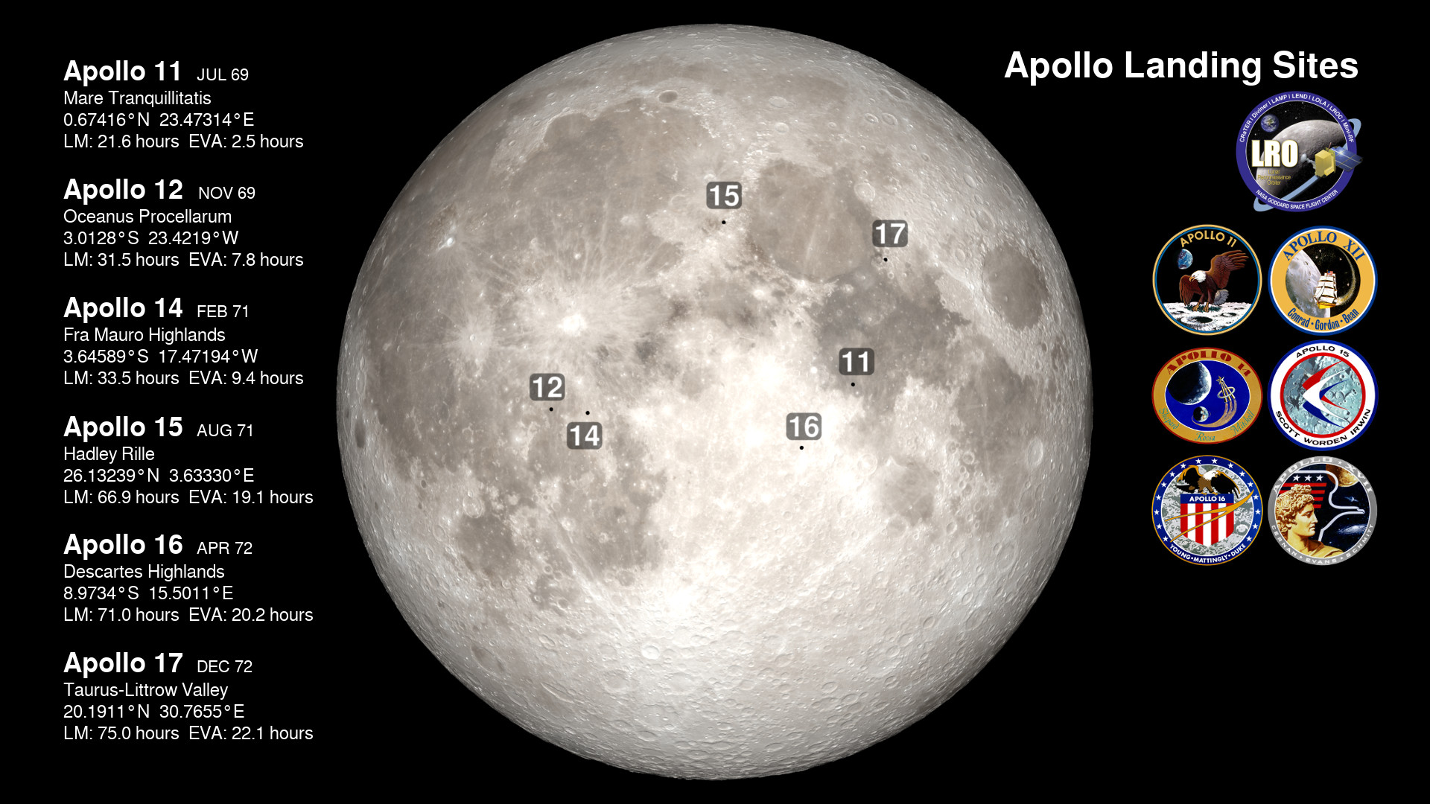
Figure 15. Lunar Landing Sites: Apollo (NASA)
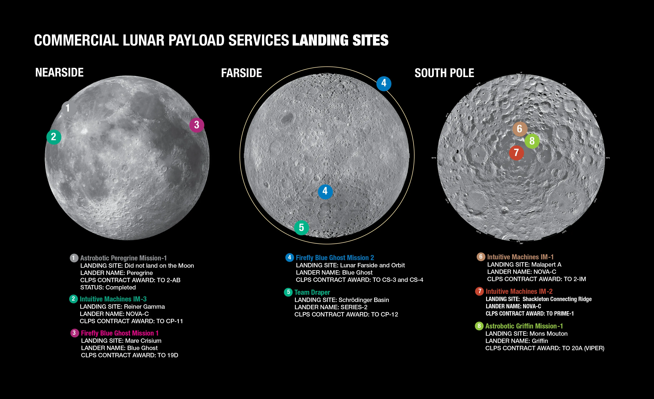
Figure 16. NASA CLPS Planned Landing Locations (NASA/CLPS)
Given these inputs, exploration will occur across the lunar surface, not just at the polar regions, and as times goes on, excursions into these areas will be increasingly likely due to large amount of science possible. Similarly, mission concept designers have also proposed a lunar far-side radio telescope, that would enable enhanced observation capability due to the moon inherently blocking signal interference from Earth. These also may be executed as one-off missions. In this case, it is not expected to build out global coverage of PNT for a short duration one-time mission. This scenario provides a key opportunity for aiding in-situ orbital signals to enable enhanced navigation capability.

In order to assess this, the orbits previously shown were used as a baseline initial deployed capability that would provide PNT and 24/7 communication to the South Pole region. These orbits where then propagated over an extended period (12-24 hours to capture one or two orbits of all assets) with coverage tracked to a grid of locations on the lunar surface. For this scenario, the DT used was 60 seconds, allowing for fine estimation of the coverage statistics when the vehicles are at perigee. The lunar surface was assumed to be a sphere of fixed radius with a 100 x 100 grid in terms of latitude and longitude. At each point in the simulation, the angle between each point and each satellite was captured. A conversation elevation constraint of 30 degrees off the horizon was used as well. The statistics where then built up for time with 0, 1, 2, 3, or 4 satellites in view. At the end of the simulation, these could be used to provide overall coverage numbers across the lunar surface.

The results for the baseline scenario of 6 satellites are given in Figure 17. As can be seen in the plots, the South Pole region has 4 satellites in view approximately 60% of the time. While this does not guarantee adequate dispersed geometry needed for a high precision navigation solution, it provides an initial insight into overall coverage. For regions at the mid latitudes, these sites regularly have access to one or two satellites at a time. Some regions may even have three in view a large percentage of the day (but very rarely 4 in view. Lastly, northern regions have periods of very limited coverage and may at most have one satellite in view less than 10% of the time. Comparing these graphs with the desired mid-latitude locations shows a gap where additional data can be used to provide augmentation.

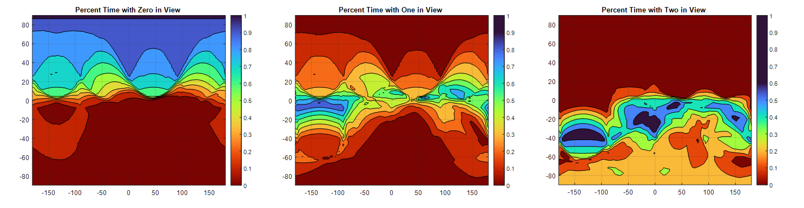
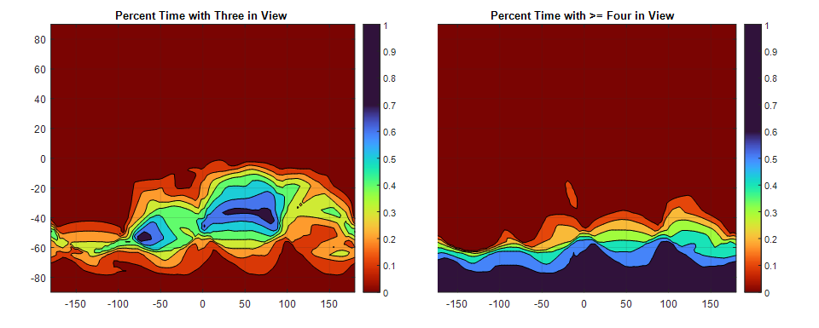
Figure 17. Coverage over 12 hrs for 6 Satellites with 30 deg elevation limit
In addition to the above assessments of an initial communication and navigation capability, it is also worthwhile to assess a partial constellation, focused only on navigation. In this scenario, the two satellites out of the phase with the others and spread in the same orbit as removed from the study. This mimics a scenario where only one of the satellites in that orbit provides nav and the other two only provide communication. The results for this case are shown in Figure 18. The primary results are reduction in capability across the surface. The region of 4 in view is reduced, and the impact of the three satellites in the phased orbit is removed, making the coverage more generic across latitudes and less dependent on longitude. This can be seen in the nonlinear nature of the previous plots, particularly in the one satellite in view plot, where the three phased in one orbit provide a high level of coverage. In the case of 4 satellites, their design and their relative orientations are readily apparent in the plots. Again, coverage in the mid-latitudes is limited, but overall, the need for augmentation is still there.

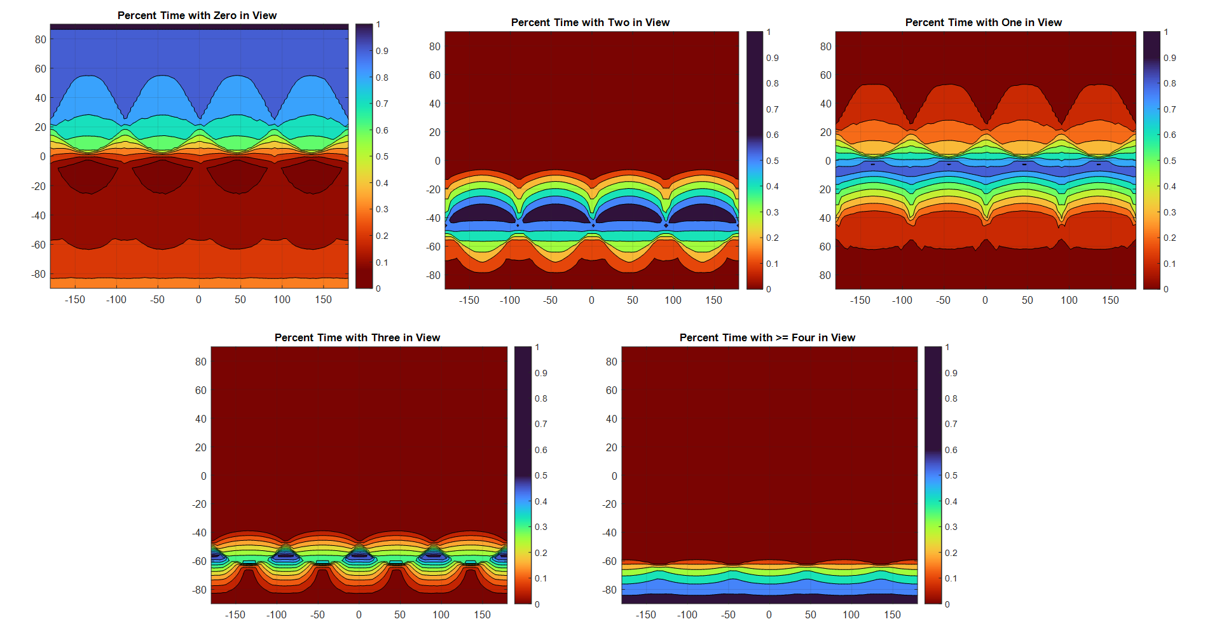
Figure 18. Coverage for 4 satellites Phase together over 12 hours with 30 deg elevation limit
While looking at various edge cases, another scenario that should be addressed is what if the relays were deployed initially to focus on 24/7 communication services where an early constellation would result in three satellites phased in the same orbit. This case was also run through the simulation to gather coverage statistics across the surface. For the analysis the results were combined where sites see between 1 and 3 in view. Again, the orientation of the orbit relative to the moon is clear in the areas of limited coverage. Due to the limited time each satellite spends at perigee, those areas do experience some outages and areas of limited coverage, if only due to the velocity of the spacecraft in that part of the orbit (which is designed to essentially spend most of its time over the South Pole. This is also visible in terms of the areas that have high coverage, which includes a swath of mid-latitude locations aligned with the orbital plane. While this orbit may be modified to move these wedges of coverage, it will simply create gaps in other places. Again, in this scenario, local infrastructure can be used to help augment and support any in-situ orbital signals.
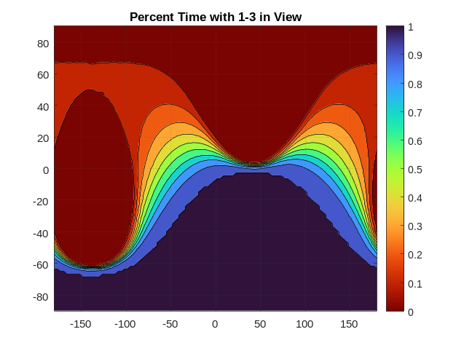
Figure 19. Coverage for 3 satellites Phased in Same Orbit (ensuring comm 24/7 at South Pole)
One last scenario worth considering is a constellation placed in polar low lunar orbits. These orbits have the benefit of aligning with potential approaches to the lunar south pole for landers, thus reducing the cost of deployment and allowing these to be placed as secondary payload with minimum additional propulsive capability needed. These orbits have a much shorter period, and thus more are needed in one orbit to provide constant coverage. The analysis here assumed 4 satellites (to align with previous assumptions) to assess coverage. These were all phased 90 degrees apart in a 100 x 100 km polar orbit. The results of this case are shown in Figure 20. As can be seen, even the coverage at the South Poles is limited to 20% of the time with one in view. Additionally, the sites will only ever see one in view at a time due to their distribution. Increasing the number of satellites can improve this metric. While this does provide coverage over both poles, it provides the least benefit to other mid-latitude regions as seen by the large area that never sees satellites. Over time, as the orbits precess, the coverage would shift across the surface, but this would take a very long to cover the whole surface.

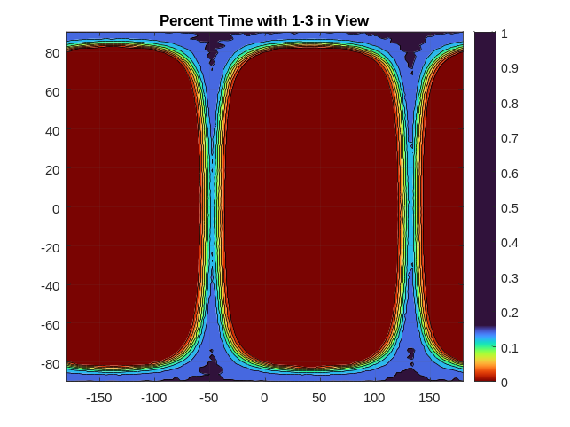
Figure 20. Coverage for 4 satellites phased in Polar LLO over 24 hours
As seen in all of these scenarios, there are opportunities to deploy surface infrastructure that may “ride along” with a surface lander to provide local coverage to help aid in navigation for surface elements. While other approaches can help to reduce the degrees of freedom in positioning and timing (i.e., having an external time update, assuming you are fixed to the lunar surface, or iterative solving for your location over extended observation), this paper will focus on how deployment and use of radio navigation techniques can be used to provide additional capability for these areas.

5. Mesaurement Approaches
With the above section providing examples of the use cases and scenarios where surface augmentation may be used to aid orbital signals to allow for high accuracy real-time timing and positioning, it is next important to discuss the various approaches to implementing signals to provide the additional measurements for ingestion into a centralized navigation algorithm. While Lunar Node -1 focused on one-way ranging via time transfer and PN, the field of GPS-denied navigation has undergone great growth since this project began. While a lot of extensive work has been done on using visual processing techniques such as in Giubilato et al (2018) to limit error growth, this paper will continue to focus on infrastructure approaches that support multiple users simultaneously. Four primary techniques (WIFI Round Trip Time, Ultra-Wide Band ranging, Two Way Ranging, and One Way ranging) will be discussed, along with their advantages and disadvantages.

Several projects have considered the use of Ultra Wide Band (UWB) ranging to support high precision navigation using low power and size, weight, and power (SWAP) components. One example application can be found in Ni et al (2010). This technology uses a burst of wide bandwidth, low power signals to do perform a two-way ranging approach. This technique can enable a range measurement with accuracy on the centimeter level, but due to its implementation, can typically only operate at a short distance with unique implementations allowing operation at up to 500 m. These components are available commercially with a wide user base in terms of indoor n avigation. This operational range limits its usefulness to areas close by a central hub. Similarly, this system can enable a full localization solution to that same accuracy level by deployment of a several reference hubs. While this does scale well to expanded operational areas that may stretch out to 10 or 20 km between elements, it can provide a high accuracy solution in a central work area allowing systems to conduct high precision surveying and coordinated manufacturing operations for example. An example implementation of this is the Lunar Harpoon platform as described in Triana et al (2024) enabling a localized network for navigation and communication. This demonstrates the advantageous use of this method for high precision across limited areas, rather than the focus here on long-distance exploration.

Another approach is to take advantage of the existing communication systems across each vehicle to take advantage of navigation standards being developed for these. A key example of this is 802.11mc and 802.11az , which describes the needed foundations to enable Round Trip Time ranging approach for WIFI networks. This method requires custom firmware at the modem level to support the algorithm to measure the range (primarily focused on limiting the latency of the response between elements). In this approach, a user can determine a range to a base station to meter level accuracy. This technique was primary developed for indoor navigation. To enable localization services, several hubs with known locations must be utilized. For the case of lunar surface navigation, it can be assumed that the locations of hubs are well known, but they are also expected to be sparse during initial campaigns. But given this measurement and/or a coarse time transfer over WIFI using NTP, the use can still be provided additional data to augment the orbital signals by reducing time uncertainty and providing a surface constraint. While WIFI will be used extensively across surface elements, this approach may require modifications to enable these services. Even though adaptation of these standards is rapidly increasing for terrestrial systems, the overlap between space-rated hardware is very limited. The other limitation will be the range applicability. Similar to UWB, these systems are designed to operate within close areas to enable broad support and non-interference among nearby users, and thus may not provide the range to support extended operation. With tweaks to firmware and updated antennas, for example, WIFI has been shown to operate over much longer distances such as described in Panigrahi and Raman (2009). While this approach does show feasibility over mid-range distances, it will require tight coordination between service providers to ensure compatibility, availability, and utilization of these services.

Terrestrial cellular systems can also provide a level of localization services as discussed in Shamaie (2020). While these systems may be able to operate over longer distances, several of the approaches are geared towards using a network of assets by either measuring angle of arrival or received power levels from multiple towers at once. Similar upgrades to the 5G specification, Neinavaie et all (2021), can enable one-way ranging to the individual towers. A key benefit of these systems is the inherent need for tight time synchronization. By tying a system to a global Lunar timing source, it is possible to provide a high accuracy timing solution to the user. With the proposed initial roll-out and testing of 3GPP systems for lunar surface comm, there is an opportunity to take advantage of these signals, though the ability to localize in real-time time will be dependent on the number of hubs, their location, and their visibility.

The approaches above all require modifications, updates, or introduction of new hardware solutions into the architecture to provide an opportunistic navigation aiding capability. Several approaches also exist within the existing proposed hardware and LunaNet standards that can be taken advantage of. The first of these is the utilization of two-way ranging over S-Band such as in Haskins et al (2012) and O’dea et al (2015). Similar to other approaches described above, this method enables a ranging measurement between two elements, but the operational distance is much larger, as it is designed around a link between a surface user and an orbital element (or between two orbital elements). Two-way ranging is well-used in space exploration systems and is similar to the same approach traditionally used for spacecraft navigation utilizing links between the asset and Earth ground stations. This system is very sensitive to timing stability, due to the need for the spacecraft (which generates the initial ranging signal and performs the measurement) to timestamp the measurement and provide it back to the user (also introducing latency between measurement and utilization within a local navigation algorithm). The other introduced sensitivity is the uncertainty in the knowledge of the orbiting element’s location, this will also limit the accuracy of the solution. This technique could also be employed by surface elements to perform ranging, though for many cases the measurement may be on the same level as time synchronization errors, limiting its usage. The other main limitation is the requirement for all elements to utilize S-band systems, typically requiring larger SWAP and power. While this may work well for small vehicles and rovers, it may push between what would work for an individual astronaut. Similarly, this method may also impact the ability to send data back to Earth due to the utilization of the communication system (where two-way ranging is typically implemented), also typically limiting data rate as well.

The last method to be discussed is an evolution of the PN-ranging that Lunar Node – 1 implemented. In this case, the ground assets would generate signals within specification for the one-way Augmented Forward Signal (AFS) as defined within the LunaNet Signals in Space Specification. In this way, the existing navigation receiver can be used to process one-more signal and directly interface with the navigation algorithms. In this approach, the surface element would operate as LunaNet Pseudolite. This provides limited impact to new hardware impacts on the user side. The main limitations are due to the power reception requirements. Due to the “near-far” aspects of the signals, the generated signal only be within specifications for a given ring around the transmitting element. This also may require very low transmission to stay within the specification, which may be outside of the range of off-the-shelf hardware solutions. Another operational constraint is that when generating this signal, the same receiver will be unable to perform navigation to synchronize itself with the constellation to ensure highly accurate timing. As such, this may place a burden for improved clock stability to allow for minimizing drift when transmitting the reference signal, and builds a case for a hybrid mode, where the transmitting element will switch between AFS User and Reference modes based on the operational conditions. Even given these constraints, this approach enables minimal impact to the user, allowing for seamless ingestion of additional navigation signals.

6. Implementation Challenges
The previous section introduces how surface payloads could help to fill in coverage gaps and provide additional information to enable precision navigation via multiple approaches. The primary application of this is to support landing sites and operational areas that may be outside of the current focus of communication and navigation services at the South Pole. There are several key challenges towards implementation of surface-based navigation augmentation approaches at the lunar south pole that require more discussion: Line of Sight, Transmission Role and Interference mitigation, and measurement method. Each of these will be discussed below in detail in terms of the limitations, constraints, and implementation concerns.

At a fundamental level the local terrain itself is a limiter for any potential surface user to receive an aiding signal from another surface asset. This is due to a combination of the shape of the moon itself and its mountainous landscape formed by ages of impact craters and other geologic activities. These provide limitations to how far a signal can travel over a surface. Due to lack of a charged ionosphere, it is not possible to “bounce” radio transmission over long distances via these reflections. Instead, closing a communication link between two surface assets is more limited by geometric lines of sight. This calculation is sensitive to three major terms: the radius of the planetary body, the elevation of the transmitter, and the elevation of the receiver. This leaves a limited trade space for long distance transmission. At some landing sites, where there may be very flat terrain, the signals can travel a long distance. But at most landing sites, the terrain is typically much more diverse. These areas also typically align with areas of increasing scientific interest. An example of this is given in Figure 21. This figure captures a notional vehicular traverse (identified by the red contour) from an initial point that is at the flat peak.

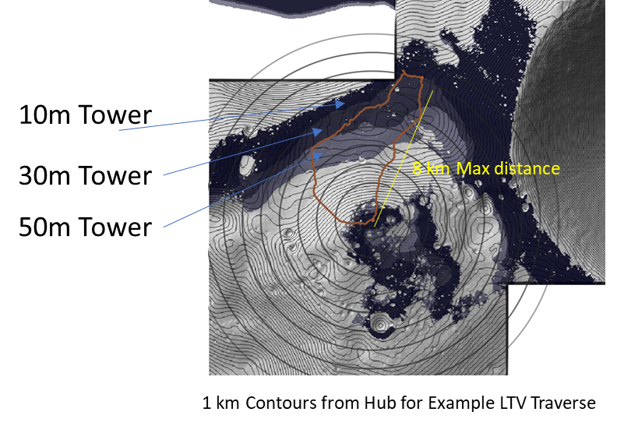
Figure 21. Notional Lines of Sight at South Pole Site (Connecting Ridge)
The geography at this site provides a unique limitation to the line of sight between the central hub and the vehicle. In this plot, the various counters are plot at 1-kilometer values, identifying a max 8 km distance between the two. As shown, placement and heigh of any communication aid will have a strong impact on its coverage. At this site, several elevations of antennas are plotted (10, 30, and 50 m tall antennas), with the lighter areas providing expanded coverage. In this area, the local hill around the landing site provides a limitation to near field reception, shown by the valley of coverage between the two sites. As the antenna as the base station is raised, more coverage is gained. But similarly at longer distances along the crater rim at the right of the image, the line of sight is favorable from ridge to crater edge. This analysis provides just one example of the sensitivity the local terrain plays in providing local augmentation systems and will require repeating at a site of interest. This alone doesn’t drive the overall solution though, as the transmitting power must also be adequate.

Ideally, transmission power could continue to be increased to allow for closing the aiding link at increasing distances. However, other constraints will reduce this capability. This is clearly seen in analysis of the “near-far problem”, where if you are too close to the source it can swamp out other signals, but too far off and the signal is too low. Hence there is a delicate balance to determine the power transmission to align with a desired range of operation. Another unique constraint here is the need for any pseudolite to maintain interoperability with the LunaNet signal specifications. This is to ensure that locally generated signals do not create interference with the existing signals from orbit. The specification calls out a defined range of power for reception at the surface. This ensures that all compatible constellations provide a common signal level to aid in the design of user equipment to be able to receive simultaneous navigation signals from multiple references. In the case of surface-based signal generator it places a constraint on the transmission power at the central location.

This can be modeled by analyzing the signal loss over distances as a function of the transmission power. Figure 22 shows a plot of this data, each line represents a different transmission power. For this plot, the range is between -10 and -60 dBm at 10 dBm intervals. While the data focuses on the path losses only, similar trends will be shown as the antenna gains, line losses, and other loses are assessed. For comparison to terrestrial systems, the lower end of Bluetooth transmissions is -20 dBm. The dashed lines represent the constraints defined by the standard, in decreasing levels, they represent max power at non-South Pole location, max power at South Pole, and min power at South Pole. Receptions below this level risks being overcome by orbital signals and signals above the upper limit risk overcoming the same orbital systems. Fundamentally, this results in the signal only being useful for users at some distance away from the source. For these low power levels, it can be seen that the window of usable signal may only be several kilometers wide.

One way to address this to limit the operational application of these signals to certain scenarios. For example, turning the signal on only once a user is some distance away from the reference. While this limits usability at nearby distances to the lander, it can provide the augmenting capability for mid- and fair-field operations providing the needed accuracy during certain parts of the mission. While not providing a complete solution, this can still provide targeted capability for certain parts of a traverse to maximize return for a science station or other focused application.

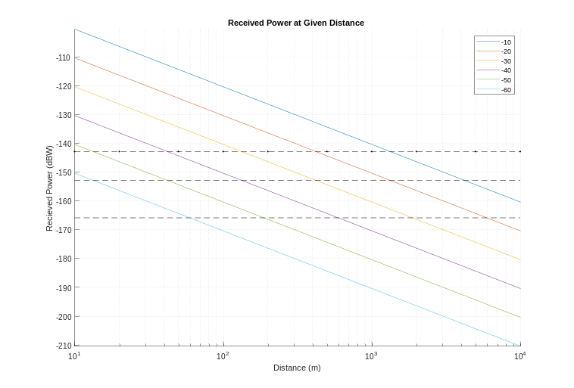
Figure 22. Reception Power over Distance
This can also be used as a way to integrate both com-based ranging methods (such as one-way ranging or time transfer to a host asset or vehicle). The diagram in Figure 23 provides an example of this. For this diagram the x-axis can be considered range between the elements. As user traverses between the two edge elements (in this case, the HLS and LTV), have a certain area of coverage to each’s communication system. While within this window, the user can maintain time synchronization or range to the host element and integrate this with any limited orbital signals available to maintain a high accuracy state estimate onboard. The gap between the two comm coverages utilize a specific area where a pseudolite could be used to provide that extra knowledge. Aligning with Figure 22 above, it is possible to design the RF transmission system such that the within-spec region covers the gap between comm system availability. This area is expected to be farther than the communication range due to the lower power levels needed to utilize the signal. This can help to provide the additional reference to allow the user to meet their needs. One implication of this is that once the user is within range of the host vehicle transmitting the signal, you are likely to quickly be within out-of-spec pseudolite signals. As such, the most likely approach would be for the host vehicle to turn off the signal as the user switches to com-based methods, while still being able to take advantage of multiple overhead signals. Additionally, this approach would likely swamp out the orbital navigation signals for other users near the host asset. For many early exploration scenarios this is likely acceptable, due to the limited number of crew and fixed location of the element. The crew, who are the primary users of the navigation signal, are likely to be out on the LTV or returning on foot. As such areas of limited coverage in far areas may not have a large impact on the overall mission at that time.

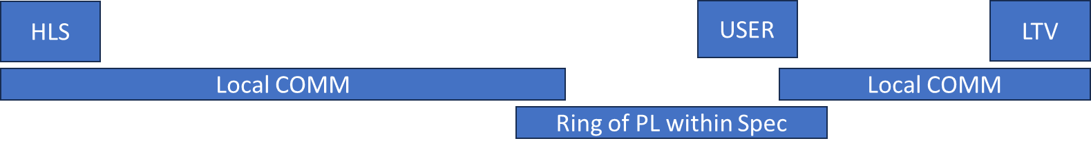
Figure 23. Operational Range for Integration Navigation Architecture
While this does provide insight into the opportunities for utilization of this approach, there will always be physical limitations due to the line of sight and local terrain as outlined above. And similarly, this implementation will be dependent on the exact mission needs as well as the current configuration and availability of orbital and other surface references. Key trade must be conducted considering the local terrain, RF design (and height of antennas), traverse design, localization needs, and how many augmenting elements to provide (for example, one at each far element with output power tuned to provide an overlapping ring of coverage. One last element not mentioned is the selection of a secondary frequency to use for any surface beacons. While this would eliminate the risk of overlapping orbital signals, the surface elements must still be assessed at the whole to capture cross-interference. These will all play a part in the use and deployment of pseudolite systems to augment navigation.

7. Paths to a Lunar Node – 2
LN-1 is a first step towards deploying surface navigation aids to support a variety of users and functions: providing landers with a precise well-known reference to aid in precision navigation, providing a capability to monitor and observe other in-situ navigation signals, provide a radiometric signal that can be used to “direction find” to a known location, and providing a psuedolite signal to increase coverage of robustness of signals generated by orbital assets. Multiple follow-on efforts are underway to continue to develop and mature the Lunar Node concept towards its next flight opportunity:
- Ongoing characterization to assess long-term stability as a function of temperature and clock reference.
- Implementation of a software-defined transmitter and receiver of the proposed LunaNet Augmented Forward Signal
- Flight EDU with an AFS receiver implementation to form the basis of a LCRNS monitor station to provide an early demo and verification of LCRNS PNT capability from the lunar surface.
- Support hardware, such as power management system, additional control board components, power storage
- Demonstration and usage of LN-1 beacon capability (one- and two-way in field demonstrations)
In addition to flight hardware upgrades, the team is also evaluating the optimal several opportunities where the payload may be used to help support surface operations. One approach, as shown in Figure 24, is to operate as independent instrument deployed to the lunar surface as part of a broader mission. In this scenario, one or two LN payloads would operate from the surface. These would provide cross-link signals to each other and perform reception and two-way ranging with any deployed LunaNet-compatible orbital elements. This would provide an early demonstration and evaluation of the in-situ signals and provide an approach to enable high accuracy time keeping. In this scenario, the functions of the instruments would need to be balanced with power generation and storage capabilities.
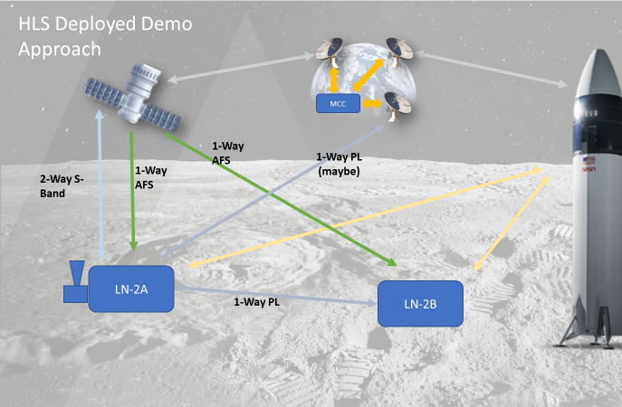
Figure 24. Surface Deployed Approach
An alternate approach would be to take the same approach as LN-1 and operate as a hosted payload on a future landed assets as in Figure 25. In this scenario, the payload would again be hosted by a lander providing power and thermal control. With a two-way capabitliy, the payload would be supported by lander-commanded and direct form ground commands. This operational mode would perform many of the same operations as the previous demo approach but may include additional communication direct to Earth to provide additional observation and direct time synchronization. This would allow for a direct comparison between timing being provided by in-situ resources and direct to high fidelity clocks on the terrestrial surface. The team continues to evaluate both approaches to guide technical implementation and testing to focus towards future potential flight opportunities.
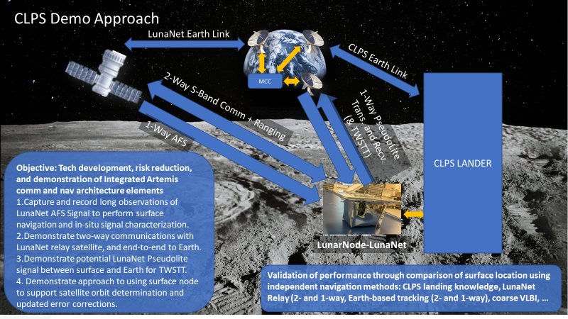
Figure 25. Lunar Node CLPS Demo Approach

8. Forward work
Given the potential approaches and design updates needed for a future Lunar Node revision, the team continues to make progress across a variety of efforts to mature and advance its capability. At a fundamental level, this is focused on long-term ground testing and evaluation of the flight-like radio procured post compatibility testing. This radio provides upgraded capability to address challenges identified in testing, as described in Anzalone et al (2022), as well as the similar PN transmission mode. The team is developing a ground test infrastructure to enable validation of the observed results seen in-flight to better document the interaction between temperature and clock stability. As part of this study, the payload will remain on for extended periods of time to mimic the planned surface operations to provide insight into the long-term behavior of the payload using the flight spare hardware. Additionally, several advanced timing sources are under evaluation for future payloads. These will also be evaluated, providing a reference PPS (similar to the signal provided by the lander) to allow for comparison between these sources, the onboard oscillator, and the Space CSAC. For all of these scenarios, stability will be tracked over several days. While the fundamental approach to packet timestamping is limited due to the designed interface with the radio, the team will continue to assess alternate methods for providing data to the radio to reduce the uncertainty in this latency.
Lastly, the team has active procurements with vendors to provide the next level of capability. At a low level, this includes power generation, storage, and distribution hardware to enable a fully autonomous payload in order to support future lunar surface deployed payload calls. Additionally, the team is pursuing multiple paths towards development of capabilities that are compatible with the merging LunaNet Interoperability Specification (principally, the AFS signal definition). One method is the push towards in-house development of algorithms to implement AFS both from a transmitter and receiver perspective. This is being implemented using low-cost hardware and is intended to provide a capability for ground testing and initial field testing to allow for characterization of the signal and deployment on low fidelity hardware (i.e., enthusiast-grade software designed radios). In addition, this approach will implement a PN ranging transmission and reception modes consistent with the JPL PN code to enable stability and evaluation of the Lunar Node -1 flight spare. In parallel, the team is pursuing a commercial implementation of a AFS transmitter/receiver pair using flight-like hardware being designed for lunar applications. This will be used for field testing as well as laboratory evaluation and will accelerate the deployment of this capability both within NASA and the commercial market.

9. Conclusion
This paper has provided an overview of the Lunar Node – 1 payload, its results, and the near-term application and use case for pseudolites as part of a broader integration lunar navigation architecture. With the current investments being made in orbital relays, the highest priority need for this type of hardware is to augment and provide additional coverage to enable real-time navigation architecture in a focused region of interest. This is particularly of need of missions focused on non-South Pole missions, where multiple interoperable constellations are being deployed to support. These additional references can be deployed as part of the lander or other mobility systems and can use multiple approaches to provide augmentation. The ideal approach would be to provide LunaNet-compatible signals, though these will have limitations due to received power limitations. These constraints can be optimized through the use of focused area of operations and tight integration with mission planning (i.e., a scenario where there is a limited number of users requiring support, thus accepting near-field interference from local signals for real-time navigation within some pre-defined ring). This paper has also addressed and captured several approaches that can be used to augment these signals through the clever utilization of local communication systems to provide near-field navigation support.
In addition to the long-term navigation needs and architectural role of systems like Lunar Node-1. This paper has provided an overview of the payload, planned, and executed flight operations, in addition to insight into its limited operations during cruise to the moon and from the lunar surface. Due to the constrained operational durations, the payload exhibited a large drift rate over the course of its passes, limiting the ability to provide a calibrated signal for navigation references. The payload team has taken key lesson learned to continue towards future ground and flight demonstrations, including upgrades to modern LunaNet signal specifications (AFS) and the ability for two-way time transfers to enable a higher rate time synchronization to Earth-based clocks. With these upgrades, the team continues to work towards the next iteration of Lunar Node and helping to augment and support the deployment of lunar orbital navigation constellations, to enable precision time transfer and navigation across the lunar surface.

ACKNOWLEDGMENTS
Funding provided by NASA-provided Lunar Payloads from NASA/SMD, with Ryan Stephan acting as PEO. Integration with Intuitive Machines led by the CLPS Project Scientist Office by Susan Lederer, Frank Moreno, and John Gruener. Flight ground networks provided by DSN through our Mission Integration Manager, Kathleen Harmon with extensive support by JPL and Peraton staff for testing, integration, and operations. Operations conducted out of the HOSC in the LUCA lab with primary support from Sarah Watkins, Brandyn Rolling, and Geoff Lochmaier. Our appreciation is due to all of the staff who keep the HOSC and operational flight networks running. LN-1 was designed, built, assembled, and tested by NASA/MSFC. The flight would not have been possible without the incredible support of the electrical, mechanical, and assembly shops as well as the on-site testing capabilities (EMI, Vibe, TVAC). The team is grateful to all of those who have supported LN-1 and previous SNS and MAPS efforts that laid the groundwork for this mission, including management and prior partners and collaborators.

REFERENCES
Anzalone, E., et al. (2015). "Multi-Spacecraft Autonomous Positioning System: Low Earth Orbit Demo Development and Hardware-in-the-Loop Simulation." Annual AIAA/USU Conference on Small Satellites. No. M15-4828.

Anzalone, E., Becker, C., and Sims, H.. (2018). "Initial Results of the Software-driven Navigation for Station Experiment." 2018 AIAA SPACE and Astronautics Forum and Exposition. 2018.

Anzalone, Evan J., Jensen, Jacob, Statham, Tamara L., Bryant, Scott H., Harmon, Kathleen A., Lee, Greg, Abbod, Mike G., Barter, Randy E., Ibarra, Albert, Hoffman, Timothy J., Morgan, Lorenzo L., Overcash, Ricky D., Rokke, Collin J. (2022). "Ground-testing of One-way Ranging from a Lunar Beacon Demonstrator Payload (Lunar Node -1)," Proceedings of the 2022 International Technical Meeting of The Institute of Navigation, Long Beach, California, January 2022, pp. 565-581. https://doi.org/10.33012/2022.18216

Duev, D. A., Calvés, G. M., Pogrebenko, S. V., Gurvits, L. I., Cimo, G., & Bahamon, T. B. (2012). Spacecraft VLBI and Doppler tracking: algorithms and implementation. Astronomy & Astrophysics, 541, A43.
Evans, S., et al. (2018). "MONTE: The next generation of mission design and navigation software." CEAS Space Journal 10.1 (2018): 79-86.

Giubilato, R., Chiodini, S., Pertile, M., & Debei, S. (2018, June). An experimental comparison of ros-compatible stereo visual slam methods for planetary rovers. In 2018 5th IEEE International Workshop on Metrology for AeroSpace (MetroAeroSpace) (pp. 386-391). IEEE.

Goodliff, K. E., Merancy, N. F., Bhakta, S. S., Rucker, M. A., Chai, P. R. P., Ashurst, T. E., & Stromgren, C. (2023). Exploration Systems Development Mission Directorate (ESDMD) Moon-to-Mars Architecture Definition Document (No. ESDMD-001). National Aeronautics and Space Administration.

Haskins, C. B., Duven, D. J., DeBoy, C. C., & Jensen, J. R. (2012, March). First deep-space flight demonstration of regenerative pseudo-noise ranging. In 2012 IEEE Aerospace Conference (pp. 1-6). IEEE.

Hooke, A. (2001). "The interplanetary internet." Communications of the ACM 44.9 (2001): 38-40.

Ichikawa, R., Sekido, M., Osaki, H., Koyama, Y., Kondo, T., Ohnishi, T., ... & NOZOMI DVLBI GROUP. (2004). “An evaluation of VLBI observations for the deep space tracking of the interplanetary spacecrafts”. International VLBI Service for Geodesy and Astrometry, 253-257.

Israel, D. J., et al. (2020). "Lunanet: a flexible and extensible lunar exploration communications and navigation infrastructure." 2020 IEEE Aerospace Conference.

Kleinhenz, J., Quinn, J. W., Colaprete, A., Captain, J. E., Ennico-Smith, K., Lim, D. S. S., ... & Vendiola, V. R. (2024, June). Lunar Surface Missions for Resource Reconnaissance: NASA's PRIME-1 and VIPER. In Space Resources Round Table.
NASA Space Communications and Navigation Program. (2023a, August). LunaNet Interoperability Specification Document (Draft Version 5 No. LNIS V005). NASA. https://www.nasa.gov/wp-content/uploads/2023/09/lunanet-interoperability-specification-v5-draft.pdf?emrc=6f4483.

NASA Space Communications and Navigation Program. (2023b, August). LunaNet Signal-In-Space Recommended Standard -Augmented Forward Signal (LSIS) (Draft Version 1 No. LSIS V1.0 Draft). NASA. https://www.nasa.gov/wp-content/uploads/2023/09/lsis-afs-v1-draft-.pdf?emrc=33f92a .

Neinavaie, M., Khalife, J., & Kassas, Z. M. (2021). Cognitive opportunistic navigation in private networks with 5G signals and beyond. IEEE Journal of Selected Topics in Signal Processing, 16(1), 129-143.

Ni, J., Arndt, D., Ngo, P., Phan, C., Dekome, K., & Dusl, J. (2010, May). Ultra-wideband time-difference-of-arrival high resolution 3D proximity tracking system. In IEEE/ION Position, Location and Navigation Symposium (pp. 37-43). IEEE.

Nicholson, A., et al. (2010). "NASA GSFC lunar reconnaissance orbiter (LRO) orbit estimation and prediction." SpaceOps 2010 Conference Delivering on the Dream Hosted by NASA Marshall Space Flight Center and Organized by AIAA.

O’Dea, Andrew, et al. (2015) 214 Pseudo-Noise and Regenerative Ranging. Jet Propulsion Laboratory, California Institute of Technology, 810-005 214 Rev A, 2015.

Panigrahi, D., & Raman, B. (2009, April). TDMA scheduling in long-distance WiFi networks. In IEEE INFOCOM 2009 (pp. 2931-2935). IEEE.

Park, R. S., Folkner, W. M., Williams, J. G., & Boggs, D. H. (2021). The JPL planetary and lunar ephemerides DE440 and DE441. The Astronomical Journal, 161(3), 105.

Pham, T., Liao, J., Wyatt, E. J., Malphrus, B., Kruth, J., Kroll, R., ... & Hart, C. (2019, March). System development and spacecraft testing of the morehead state university ground station. In Proc. 11th Int. Conf. Adv. Satellite Space Commun. (pp. 1-6).

Scatteia, L, and Perrot, Y, (2021). “Lunar market assessment: market trends and challenges in the development of a lunar eceonomy”. PWC, September 2021. https://www.pwc.com.au/industry/space-industry/lunar-market-assessment-2021.pdf

Shamaei, K. (2020). “Exploiting cellular signals for navigation: 4G to 5G”. University of California, Irvine.

Sirbu, G., Leonardi, M., Stallo, C., Di Lauro, C., & Carosi, M. (2023). Evaluation of different satellite navigation methods for the Moon in the future exploration age. Acta Astronautica, 208, 205-218.

Smith, Marshall, et al. (2020). "The Artemis Program: An Overview of NASA’s Activities to Return Humans to the Moon." 2020 IEEE Aerospace Conference.

Triana, S., Brooks, T., Dudzinski, K., Zanetti, M., Summers, A., Anzalone, E., ... & Capizzo, P. (2024, April). An Integrated Architecture Study for Autonomous Lunar Construction. In Lunar Surface Innovation Consortium Spring Meeting.

Wollenhaupt, W. (1970). "Apollo orbit determination and navigation." 8th Aerospace Sciences Meeting.

https://www.cnn.com/2024/02/28/world/odysseus-spacecraft-first-images-moon-surface-scn/index.html
https://www.analysysmason.com/research/content/articles/moon-economy-space-nsi015/
https://www.darpa.mil/program/ten-year-lunar-architecture-luna-10-capability-study
https://www.nasa.gov/commercial-lunar-payload-services/
https://source.android.com/docs/core/connect/wifi-rtt
https://nspires.nasaprs.com/external/solicitations/summary.do?solId=%7b76053627-8933-47CD-B627-C5DCDD474076%7d&path=&method=init
https://www.axiomspace.com/news/axiom-space-and-nokia-partner-to-enable-high-speed-cellular-network-capabilities-in-next-gen-lunar-spacesuits
https://www.cesiumastro.com/press-release/cesiumastro-to-power-lunar-navigation-with-nasa-contract-for-lunanet-technology

