Herpesviruses in Saliva and their clinical significance

for ‘Viruses’ Journal

Douglass Diak
Brian Crucian
Satish Mehta

Introduction
Saliva has been used as a source of biological markers for a wide spectrum of normal and disease states for a long time. It is a non-invasive, easily accessible, and self-collected body fluid that contains a variety of measurable biological substances. While mostly water, saliva also contains ions, carbohydrates, proteins and peptides, exfoliated cells, nucleic acids, and microorganisms [1] . Saliva can reflect tissue levels of some natural substances and a large variety of molecules introduced for therapeutic use, emotional status; hormonal status, immunological status, neurological effects, and nutritional and metabolic status. It can also be used to monitor a variety of drugs including marijuana, cocaine, and alcohol [2]. It is the most cost-effective approach for screening large population in community mass screening programs and for longitudinal sampling of hospitalized individuals aimed at monitoring viral load dynamics and treatment response.

During the COVID-19 pandemic, scientific evidence emerged indicating that molecular tests performed on saliva have diagnostic sensitivity and specificity comparable to those observed with nasopharyngeal swabs for SARS-CoV-2 RNA detection. The presence of IgA and IgG antibodies at the mucosal level has been demonstrated to influence the progression of viral infection and the severity of clinical manifestation. As saliva contains both respiratory secretions and immunological components, it has wide applications, ranging from clinical diagnostics to post-vaccine disease burden and immunity surveillance.
Advantage of saliva over plasma or serum

As a research and clinical diagnostoc tool, saliva has many advantages over blood. It is easy to collect, store, and ship, and it can be obtained at low cost and in sufficient quantities for analysis. For patients, the noninvasive collecting techniques dramatically reduce anxiety and discomfort and simplify the gathering of repeated samples for longitudinal monitoring over time. Saliva does not clot, thus lessening the manipulations required. Saliva-based diagnostics are, therefore more accessible, accurate, and less expensive than current methodologies. Numerous studies have shown correlations between serum / plasma and saliva levels. Both diurnal and monthly profiles of hormone levels parallel traditional serum patterns. Multiple specimens for steroid hormone analysis can be easily collected by the patient, at home, to monitor fertility cycles, menopausal fluctuations, stress, and other diurnal variations. Drug doses can be monitored without inconvenient and costly visits to blood-drawing facilities. Antibody levels can be determined to screen for infectious diseases.
A major drawback of using saliva as a diagnostic fluid has been that the analytes (substances undergoing analysis) are generally present in lower amounts in saliva than in blood. However, with new and highly sensitive techniques, the lower levels of analytes in saliva are no longer a limitation. Many substances measured in blood are also present in very small quantity. However, with new and highly sensitive techniques, the lower levels of analytes in saliva are no longer a limitation. Many substances measured in blood are also present in saliva. Saliva has been reliably used to detect HIV 1 and 2 and viral hepatitis A, B, and C and many human herpes viruses including EBV, CMV, HSV1&2 and VZV and HHV6.

Saliva for Viral Studies: At Johnson Space center, NASA, we developed a molecular based, non-invasive assay that detects viral DNA in saliva. These studies were done in ground-based space analogs including Antarctica [3], bed rest studies, NASA’s underwater studies, NEEMO and artificial gravity as well as in the short and long duration space missions. These studies demonstrated that Epstein-Barr virus (EBV), one of the most common latent herpes viruses, reactivation increased coincident with decreasing immunity [4, 5]. Subsequently, this non-invasive, sensitive, and specific assay was utilized to astronauts travelling space [6, 7]. EBV reactivated before and after flight, but the greatest amount of EBV appeared in saliva during spaceflight. This finding correlated with decreased immunity in astronauts during flight. These studies were expanded the study to include cytomegalovirus (CMV) [3] and HSV1. In addition, we also studied Varicella-zoster virus (VZV), a human alpha herpesvirus, causative agent of two diseases – varicella (chicken pox), resulting from primary infection of a susceptible host, and zoster (shingles), due to reactivation of latent genomes harbored in sensory ganglion neurons. Asymptomatic VZV DNA shedding in saliva of astronauts was demonstrated [3] and in a subsequently we showed that virus shed in saliva was live and infectious [8] that would have potential risk of infecting sero negative individuals on board.

Our spaceflight-developed technologies of saliva collection in remote locations even without gravity, storing at room temperature and processing for rapid viral detection were applied to diagnose various clinical conditions including acute zoster [9], zoster sine herpete ([10], chickenpox [11]) and post-herpetic neuralgia (PHN) [12] even before the rash appears, which now makes diagnosis less invasive and less time consuming. In fact, a rapid and sensitive virus detection method has been developed and used to detect virus in saliva samples taken from asymptomatic patients with neurologic and other VZV related disease [11]. multiple sclerosis [13], and various other neurological disorders [14] [15]. These protocols are being employed in various clinics and hospitals including the CDC and Colombia University in New York, as well as overseas in Switzerland and Israel.

In one of the recent studies [16] saliva was used to determine the effectiveness of prophylactic administration of an antiviral drug (valacyclovir) against the alpha herpesviruses (VZV, HSV1) as a countermeasure to the herpesvirus shedding and reactivation in antarctica expeditioners. Countermeasure efficacy of was determined by 3 major parameters i) viral load and frequency, ii) physiological stress biomarkers (cortisol, DHEA, and amylase) and iii) immune markers (inflammatory cytokines) during the winter-over in the saliva of expeditioners with and without administration of this drug. Thirty-two volunteers from two Antarctic stations (McMurdo and South Pole) who participated in this study were randomly assigned to either treatment group (valacyclovir HCl: 1 g/day), or placebo group (oyster calcium 500mg/day). The viral shedding in their saliva reduced significantly in the treatment group versus the placebo group by >24 fold for EBV. HSV1 was also reduced by >5 fold, but not statistically significant. No VZV shedding was seen in any of the subjects. 50% of the placebo saliva samples had measurable viral DNA (EBV, HSV1, or both) compared to 19% of the treatment group. There was no significant change in the Cortisol: DHEA or alpha amylase indicating physiological stress was similar between the groups. No difference was detected in salivary cytokines except IL-10 which was significantly lower in the treatment group. These data indicate that valacyclovir is a safe and successful intervention to reduce EBV and HSV1 shedding in individuals subjected to extreme environments and stressors.

On the upcoming ‘Artemis’ moon missions, we have expanded ‘dry’ saliva collection to afford investigation of other relative markers such as cytokines, stress hormones [6, 17]

Dry saliva is uniquely suitable for deep space mission constraints, due to low volume, no processing requirement, and no conditioned storage. As opposed to raw saliva collections which entail a passive drool of saliva in a volumetric container or saturating an oral swab (https://salimetrics.com/saliva-collection-methods-devices/) and then freezing the sample, dry saliva collections utilize specialized filter paper materials that maintain sample integrity upon drying. Storage of dried saliva matrices is energy, space, and cost effective making this an excellent tool for collection when sample-to-lab issues arise. This collection process is similar to that of “dry blood spots” which have been standardized and used extensively in many diagnostic applications, especially in newborns [18]. The paper matrix is saturated either directly by mouth or, if the paper has a chemical preservative applied to it to preserve sample integrity, by pipette from a pooled raw saliva sample. The paper is then dried at room temperature and stored in a bag until processing in the lab. Filter paper type (i.e., with or without chemical additives) will depend on downstream applications, but a variety of matrices have been created to ensure diagnostic analyte integrity including those for DNA/RNA and protein analysis.

Saliva for stress hormones: We devised a collection tool for collection of human saliva samples for stress hormones assessments. This tool can be used at any remote location including space and does not require any special conditions for storage. Saliva samples are collected on the filter paper and are dried at room temperature. The samples are stable for as long as six months for measurement of both cortisol and DHEA, two important stress and immune regulatory hormones. We developed specifically for NASA a packaging appliance for these filters that was compact and easy to use, the Saliva Procurement and Integrated Testing (SPIT) booklets. These booklets are being used to take saliva samples from International Space station crewmembers before, during and after the spaceflight.
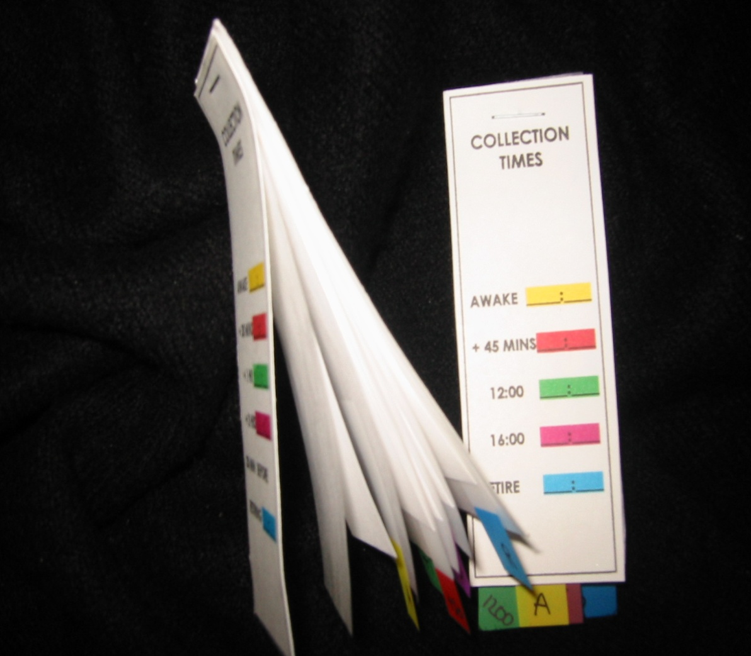

This innovation made possible the ability to determine cortisol and DHEA at various timepoints during spaceflight. This has allowed studies on the effects of spaceflight (short and long) on cortisol and DHEA levels and on the circadian rhythm in this unique environment [6, 7]. Five saliva specimens are collected by using the innovative SPIT booklet. Steroid hormones are then measured using commercially available, high sensitivity kits from Salimetrics, LLC. 1) Subjects moisten a filter paper immediately after waking, 2) 30 min later, 3) before lunch, and 4) 10 hours after waking and 5) before sleeping at night. After drying the booklets will be placed in a Ziploc™ baggie and returned via mail. Filter extractions have been described previously [19]. Storage of dried filters at room temperature for over six months do not affect measurements of CORT or DHEA. This is a novel method of collection of saliva samples that is non invasive, inexpensive, does not require trained medical personnel, and can be stored at room temperature for at least 6 months without compromising with the quality of the samples stress hormone assessment. The results are very reliable, consistent and corelate very well with the blood measurements.
Cortisol and dehydroepiandrosterone (DHEA) are glucocorticoid steroid hormones released by the adrenal glands in response to stress. Cortisol is anti-inflammatory and immunosuppressive, but DHEA is an important antagonist to cortisol. For that reason, the molar ratio of cortisol to DHEA [C]/[D] is an important indicator of immune regulation. In recent flight studies, the regular diurnal release of these hormones was tracked in saliva samples to evaluate any changes/trends occurring through the various phases of flight; launch/pre-flight, flight, and return [7]. Salivary cortisol was present in significantly higher concentrations in samples taken before and during flight. Salivary DHEA followed its normal daily decline kinetics in the samples taken before, during and after flight, but has been found to have significantly lower waking concentrations during the flight phase in comparison to samples taken before and after flight. Altogether, diurnal patterns of salivary cortisol were significantly higher during flight while DHEA was significantly lower. The cortisol area under the curve relative to ground (AUCg) did not change significantly during flight relative to baseline whereas DHEA AUCg significantly declined during flight relative to baseline. Ultimately, this results in an increased [C]/[D] molar ratio during spaceflight (Figure 2) which potentially indicates immune challenge, and has been linked to immune modulation [20] including the increased inflammatory cytokine response and the TH2 shift observed in earlier spaceflight studies [21, 22].

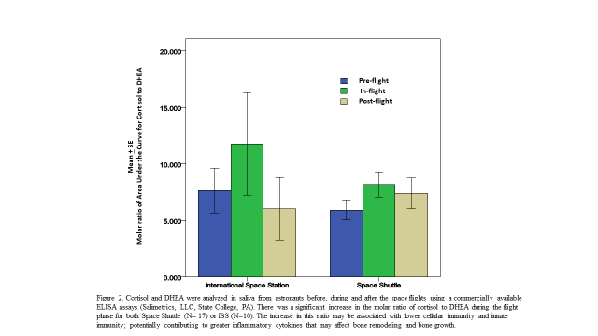

Saliva for Cytokines: On the upcoming ‘Artemis’ moon missions, we have expanded ‘dry’ saliva collection to afford investigation of other relative markers such as cytokines, stress hormones [6, 17]. Dry saliva is uniquely suitable for deep space mission constraints, due to low volume, no processing requirement, and no conditioned storage. Recent proteomic studies revealed that 20–30% of the salivary proteome mirrors the plasma proteome, indicating that saliva could represent a potential alternative approach for systemic disease diagnosis.

References
1. Shang, Y.F., et al., Progress in salivary glands: Endocrine glands with immune functions. Front Endocrinol (Lausanne), 2023. 14: p. 1061235.
2. Mandel, I.D., Salivary diagnosis: more than a lick and a promise. J Am Dent Assoc, 1993. 124(1): p. 85-7.
3. Mehta, S.K., et al., Reactivation and shedding of cytomegalovirus in astronauts during spaceflight. J Infect Dis, 2000. 182(6): p. 1761-4.
4. Payne, D.A., et al., Incidence of Epstein-Barr virus in astronaut saliva during spaceflight. Aviat Space Environ Med, 1999. 70(12): p. 1211-3.
5. Pierson, D.L., et al., Epstein-Barr virus shedding by astronauts during space flight. Brain Behav Immun, 2005. 19(3): p. 235-42.
6. Mehta, S.K., et al., Latent virus reactivation in astronauts on the international space station. NPJ Microgravity, 2017. 3: p. 11.
7. Mehta, S.K., et al., Multiple latent viruses reactivate in astronauts during Space Shuttle missions. Brain Behav Immun, 2014. 41: p. 210-7.
8. Cohrs, R.J., et al., Asymptomatic reactivation and shed of infectious varicella zoster virus in astronauts. J Med Virol, 2008. 80(6): p. 1116-22.
9. Mehta, S.K., et al., Varicella-zoster virus in the saliva of patients with herpes zoster. J Infect Dis, 2008. 197(5): p. 654-7.
10. Hato, N., et al., Ramsay Hunt syndrome in children. Ann Neurol, 2000. 48(2): p. 254-6.
11. Mehta, S.K., et al., A Case Report: PCR-Assisted Diagnosis of Varicella in an Adult. Open J Med Microbiol, 2012. 2(3).
12. Nagel, M.A., et al., Persistence of varicella zoster virus DNA in saliva after herpes zoster. J Infect Dis, 2011. 204(6): p. 820-4.
13. Ricklin, M.E., et al., T-cell response against varicella-zoster virus in fingolimod-treated MS patients. Neurology, 2013. 81(2): p. 174-81.
14. Gilden, D., et al., Neurological disease produced by varicella zoster virus reactivation without rash. Curr Top Microbiol Immunol, 2010. 342: p. 243-53.
15. Pollak, L., et al., Varicella-zoster DNA in saliva of patients with meningoencephalitis: a preliminary study. Acta Neurol Scand, 2015. 131(6): p. 417-21.
16. Mehta SK, D.D., Rooney BV, Krieger SS,, et al., Antiviral treatment with valacyclovir reduces virus shedding in saliva of Antarctic expeditioners. Front. Virol., 2023. 3: p. 1157659.
17. Laudenslager, M.L., et al., Diurnal patterns of salivary cortisol and DHEA using a novel collection device: electronic monitoring confirms accurate recording of collection time using this device. Psychoneuroendocrinology, 2013. 38(9): p. 1596-606.
18. Gupta, K. and R. Mahajan, Applications and Diagnostic Potential of Dried Blood Spots. Int J Appl Basic Med Res, 2018. 8(1): p. 1-2.
19. Neu, M., et al., Salivary cortisol in preterm infants: Validation of a simple method for collecting saliva for cortisol determination. Early Hum Dev, 2007. 83(1): p. 47-54.
20. Christeff, N., et al., Serum cortisol and DHEA concentrations during HIV infection. Psychoneuroendocrinology, 1997. 22 Suppl 1: p. S11-8.
21. Crucian, B.E., et al., Plasma cytokine concentrations indicate that in vivo hormonal regulation of immunity is altered during long-duration spaceflight. J Interferon Cytokine Res, 2014. 34(10): p. 778-86.
22. Mehta, S.K., et al., Reactivation of latent viruses is associated with increased plasma cytokines in astronauts. Cytokine, 2013. 61(1): p. 205-9.

