Altitudinal Trends on Seasonal and Geographic Contrail Persistent Regions Over CONUS

Jimin Park
National Aeronautics and Space Administration
Ames Research Center
Moffett Field, California 94035

Abstract
Addressing contrail formation and avoidance will play a large part in the aviation sector’s fight against climate change. Most research has focused on looking at contrail trends below 40,000 ft, the altitude range typically flown by commercial aircraft. The Sustainable Flight Demonstrator (SFD)’s Transonic Truss-Braced Wing (TTBW) has a cruise altitude of 43,000 ft, much higher than that of its replacement, the Boeing 737-Max (B737). We use the Schmidt-Appleman criterion with annual weather data from the National Oceanic and Atmospheric Administration to take a closer look at contrails’ altitude dependent seasonal and geographical trends over the Continental United States. The results compare the contrail persistent regions the TTBW would fly through to that from the B737.

Introduction
With the aggressive commitment made by the US aviation sector to reach net-zero carbon emissions by 2050 and the US Aviation Climate Action Plan, there has been a rising level of interest in contrails and their impact on global climate change. Contrails are line shaped clouds that form behind aircraft when flown at certain atmospheric conditions [1]. Water vapor emitted from aircraft cool and condense onto particulate matter in the local atmosphere. The particulate matter may be from the same aircraft or already present. Most contrails do not have a long time span, but in ice supersaturated regions (ISSR), persistent contrails may last up to 18 hours[4] and eventually merge with other clouds already present.
Contrails have a significant impact on global radiative forcing- in 2018, contrail cirrus clouds contributed 111 (high and low estimates of 33 and 189) mWm⁻² to global radiative forcing, as compared to 34 (high and low estimates of 31 and 38) mWm⁻² from CO₂ with a 95% confidence interval [6]. However, the warming effects from contrails are more temporal than those from CO₂ and are contained to localized areas. Regional atmosphere, seasons, and time of day all have a large impact on contrail formation and consequence. Thus, in addition to aircraft technology development, air traffic rerouting is an area that is being widely considered as a potential solution for contrail prevention. One such study from Teoh et. al [8] looked at diverting less than 2% of the fleet over the Japanese airspace above or below contrail persistent regions to reduce contrail energy forcing by 59% for a 0.014% increase in fuel consumption.
The Electrified Powertrain Flight Demonstration (EPFD) and Sustainable Flight Demonstrator (SFD) projects aim to demonstrate the implementation of two distinct sustainable aircraft concepts with a predicted entry into service in 2035. In particular, the SFD Transonic Truss-Braced Wing (TTBW) represents the next generation narrow body single aisle aircraft and targets to replace the currently flying Boeing 737-MAX (B737). The B737, like many commercial aircraft, generally flies at altitudes of 30,000 - 40,000 ft- a significantly lower altitude than the TTBW’s target cruise altitude of 43,000 ft. Thus, making the same assumptions for the TTBW as those from current commercial aircraft to conduct contrail avoidance would be ill advised, seeing that the TTBW will be flying under very different atmospheric conditions.
Historically, contrail trends have been most often looked at over Europe and at the lower altitudes flown by most currently flying commercial aircraft. Dischl et. al [2] studied at the seasonal variation in persistent contrails above Europe at around 30,000 – 39,000 ft. Minnis et al [7] investigated contrails forming over select locations in the continental United States (CONUS). Since the work was conducted using observed contrails, the data is sparse and only shows contrails that were formed due to the aircraft from that generation. Contrail patterns at higher altitudes, where the TTBW will fly at, and over the entirety CONUS are not well understood.
In this paper, contrail patterns over CONUS have been analyzed to identify any geographical or seasonal trends at altitudes between 30,000 and 50,000 feet. By looking at this wider region, we hope to identify the contrail hotspots for next generation aircraft and prevent air traffic over-management for future implementations of contrail avoidance rerouting.

Methods and Data
Schmidt-Appleman Criterion
The main methodology used in this paper to assess persistent contrail regions is the Schmidt-Appleman criterion along with ice super-saturation regions (ISSR) for contrail persistence[3]. The Schmidt-Appleman criterion is a widely used model to find the threshold atmospheric conditions that would allow for contrail formation. If the atmosphere an aircraft flies through has a low enough temperature with high humidity, a contrail is formed due to liquid saturation[5].
Meteorological Data
The National Oceanic and Atmospheric Administration (NOAA) publishes hourly atmospheric data made from a numerical forecast model for public use. For this paper, temperature and RH_{w} Rapid Refresh (RR) data from 2018 at altitudes 30,000, 35,000, 40,000, 45,000, and 50,000 ft are used. RR has a horizontal spatial resolution of 13 km, vertical isobaric pressure level resolution of 25 hPA, and one hour temporal resolution. NOAA covers the CONUS region with longitude and latitude data of -139.9◦ to -57.3◦ and 16.2◦ to 59.0◦ respectively.

Results
Contrail persistent regions over CONUS are calculated using the Schmidt-Appleman criterion with NOAA RR data as described in Section 3. To view temporal trends throughout the year, total persistent area is summed from data points taken every 3 hours for every other day. Datapoints are filtered through a Savitzky-Golay filter for trend clarity, and the plotted results are shown in Figure 1.

Contrail persistent regions over CONUS in 2018 at 30,000 to 50,000 ft are shown in Figures 2 through 5. At the lower altitudes there are more contrail persistent regions overall, with a higher concentration in the northern section of CONUS. There is a particularly high concentration in the northwest section during spring and winter. The formation of these regions is driven by the temperature threshold, where only northern regions are cold enough to sustain persistent contrails. The RH_{w} is generally lower than the critical relative humidity r_{cont} in the south, also contributing to less contrails in southern lower altitudes. However, as the altitude increases, the contrail persistent regions become sparser and shift towards the south, with the summer and autumn seasons having more contrail persistent regions covering CONUS territory due to a constraint in RH_{i}.

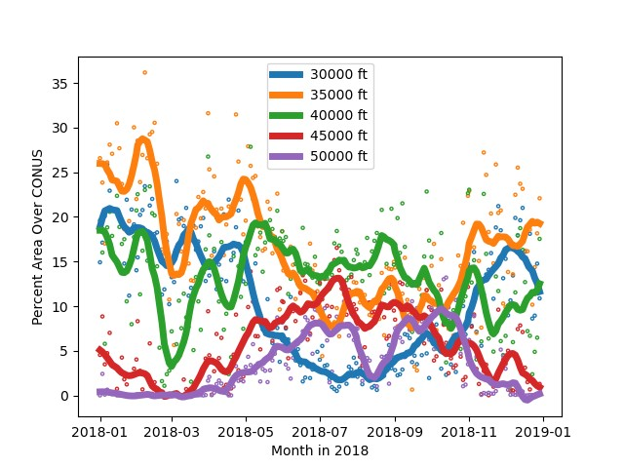
Figure 1: Percent of CONUS covered by persistent contrail regions through 2018, split by altitude

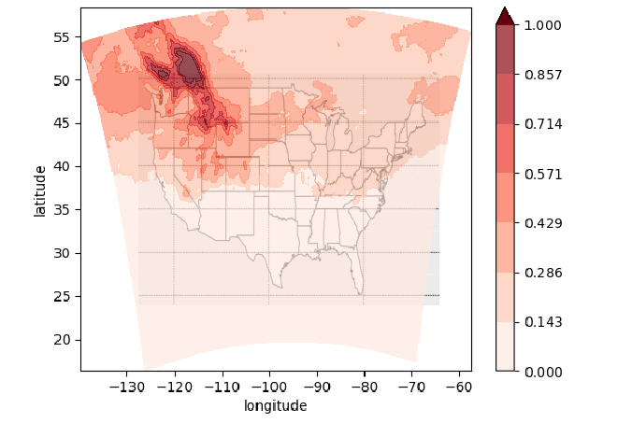
- 2018 Spring, FL 300

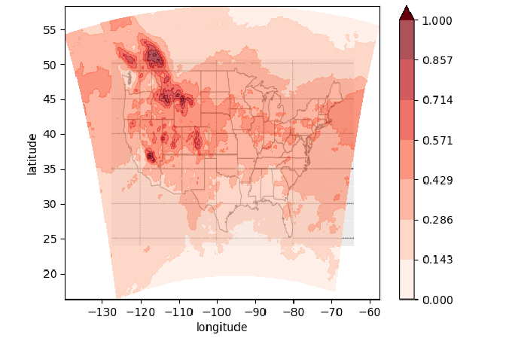
- 2018 Spring, FL 350

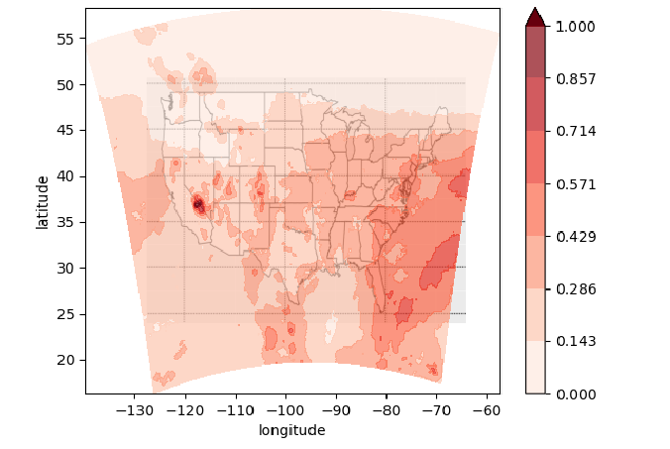
- 2018 Spring, FL 400
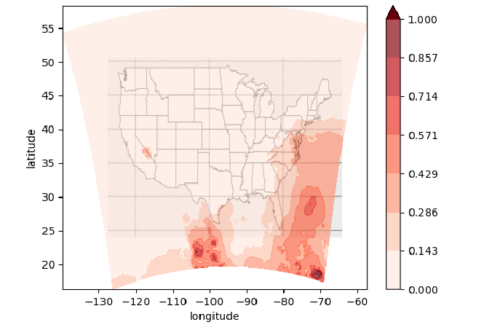
- 2018 Spring, FL 450

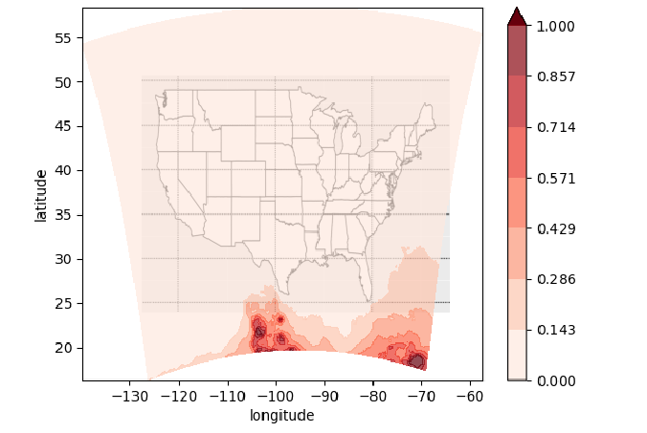
- 2018 Spring, FL 500

Figure 2: Contrail persistent regions over CONUS at flight levels 300-500 during spring

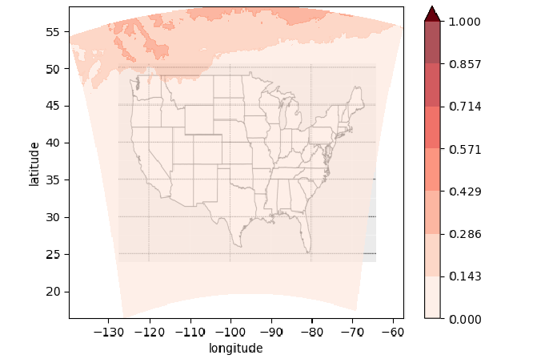
- 2018 Summer, FL 300

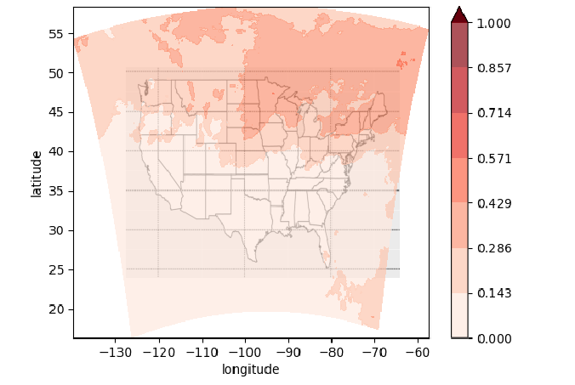
- 2018 Summer, FL 350

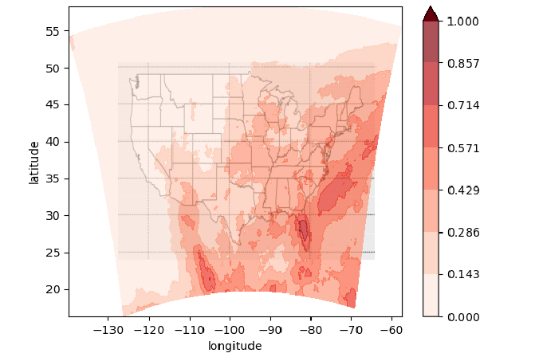
- 2018 Summer, FL 40
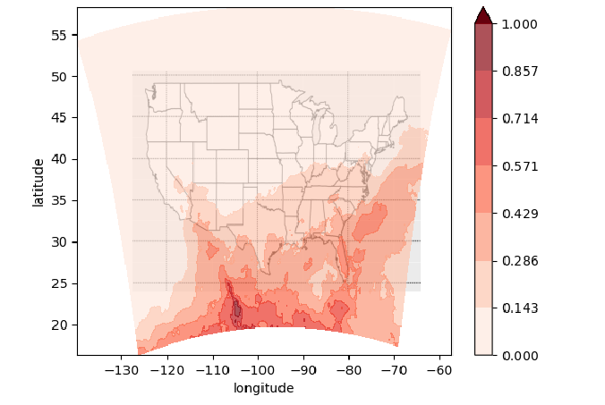
- 2018 Summer, FL 450

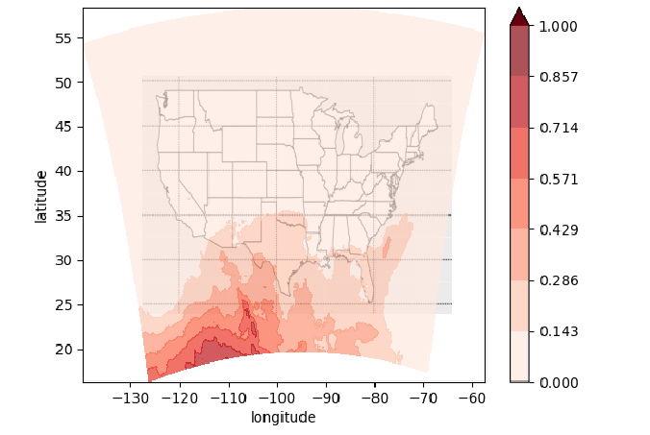
- 2018 Summer, FL 500

Figure 3: Contrail persistent regions over CONUS at flight levels 300-500 during summer

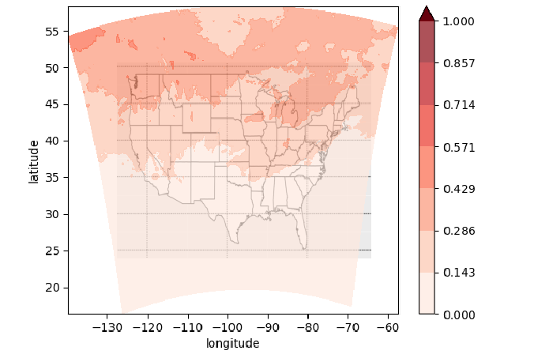
- 2018 Autumn, FL 300

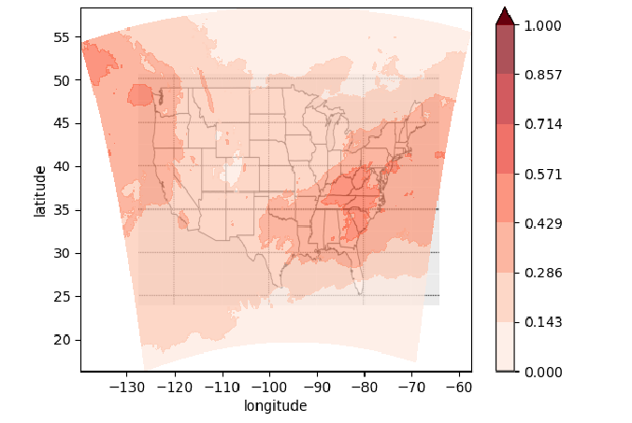
- 2018 Autumn, FL 350

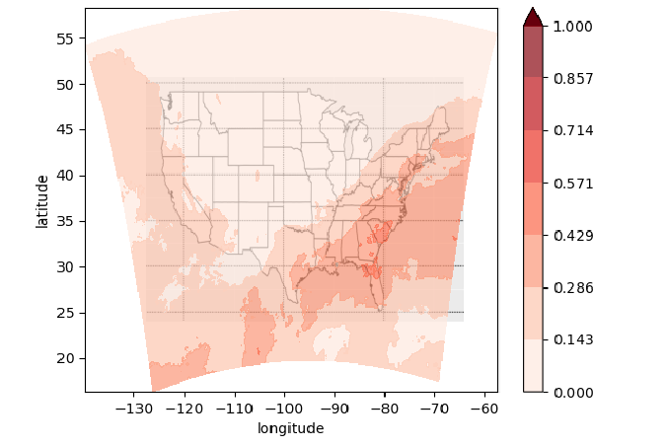
- 2018 Autumn, FL 400

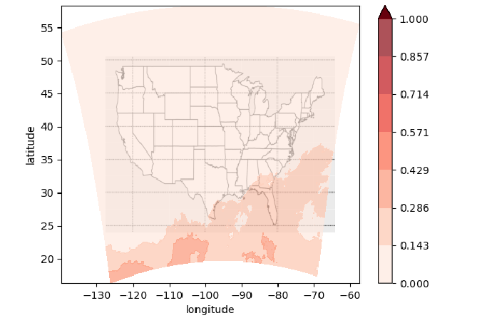
- 2018 Autumn, FL 450

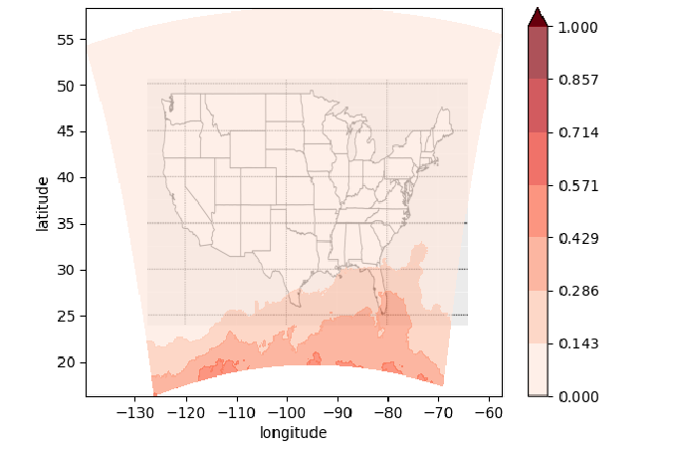
- 2018 Autumn, FL 500

Figure 4: Contrail persistent regions over CONUS at flight levels 300-500 during autumn

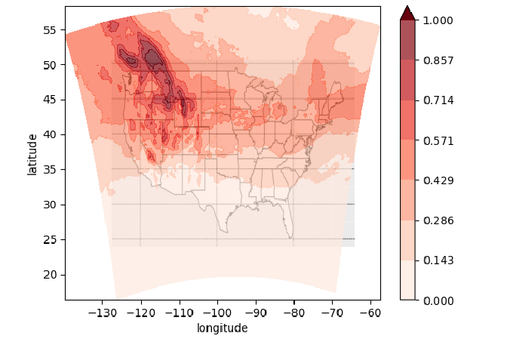
- 2018 Winter, FL 300

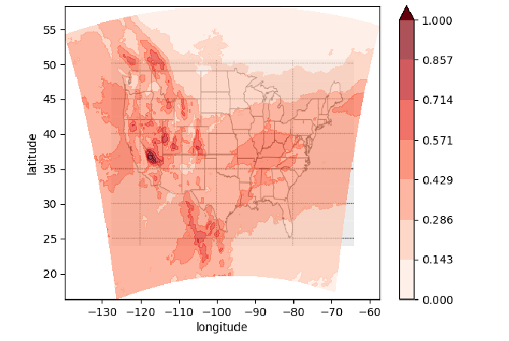
- 2018 Winter, FL 350

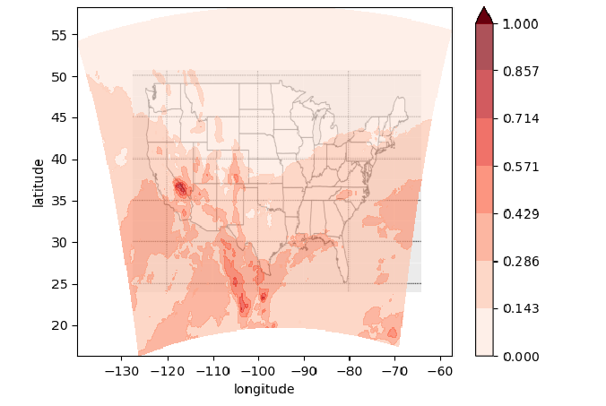
- 2018 Winter, FL 400

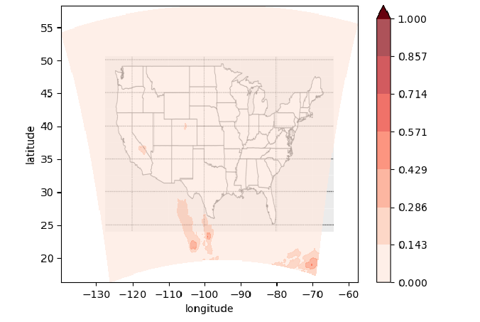
- 2018 Winter, FL 450

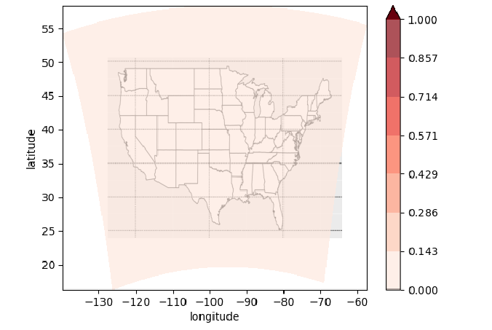
- 2018 Winter, FL 500

Figure 5: Contrail persistent regions over the CONUS at flight levels 300-500 during winter

Summary
This paper looks at the seasonal and geographical trends of contrail persistent regions 30,000 to 50,000 ft above CONUS. NOAA rapid refresh data is used with the Schmidt-Appleman criterion and ice super-saturation to determine contrail persistence.
The B737 aircraft typically cruises at around 30,000 to 40,000 ft. At this altitude range, a significant portion of CONUS is covered in contrail persistent regions. The TTBW’s preference towards higher cruise altitudes of allows it to avoid more contrail persistent regions over the entire year than the B737. For further contrail avoidance, air traffic control within CONUS would only need to focus on redirecting the TTBW around contrail persistent areas in the south and could entirely avoid redirecting the aircraft in the autumn and winter months.
To take a closer look at the difference in contrail generation between the TTBW and B737, an ongoing study replaces B737 flights from the past with the TTBW using the NAS Digital Twin (NDT)[9]. NDT is an environment that simulates past, current, and future airspace operations. NDT uses the Schmidt-Appleman criterion as well, but is being expanded to use the methodologies from the Contrail Cirrus Prediction Tool (CoCip) from DLR through pycontrails, a python package for contrail modeling.

References

[1] Kärcher, B. (2018) ‘Formation and radiative forcing of contrail cirrus’, Nature Communications, 9. doi:10.1038/s41467-018-04068-0.
[2] Dischl, R., Kaufmann, S. and Voigt, C. (2022) ‘Regional and Seasonal Dependence of the Potential Contrail Cover and the Potential Contrail Cirrus Cover over Europe’, Aerospace, 9(9), p. 485. doi:10.3390/aerospace9090485.
[3] Appleman, H. (1953) ‘The Formation of Exhaust Condensation Trails by Jet Aircraft’, Bulletin of the American Meteorological Society, 34(1), pp. 14–20. doi:10.1175/1520-0477-34.1.14.
[4] Haywood, J.M. et al. (2009) ‘A case study of the radiative forcing of persistent contrails evolving into contrail‐induced cirrus’, Journal of Geophysical Research: Atmospheres, 114(D24). doi:10.1029/2009jd012650.
[5] Chen, N.Y., Sridhar, B. and Ng, H.K. (2012) ‘Tradeoff between contrail reduction and emissions in United States National Airspace’, Journal of Aircraft, 49(5), pp. 1367–1375. doi:10.2514/1.c031680.
[6] Lee, D.S. et al. (2021) ‘The contribution of global aviation to anthropogenic climate forcing for 2000 to 2018’, Atmospheric Environment, 244. doi:10.1016/j.atmosenv.2020.117834.
[7] Minnis, P. et al. (2003) ‘Contrail frequency over the United States from Surface Observations’, Journal of Climate, 16(21), pp. 3447–3462. doi:10.1175/1520-0442(2003)016&lt;3447:cfotus&gt;2.0.co;2.
[8] Teoh, R. et al. (2020) ‘Mitgating the Climate Forcing of Aircraft Contrails by Small-Scale Diversions and Technology Adoption’, Environmental Science & Technology, 54(5), pp. 2941–2950. doi:10.1021/acs.est.9b05608.
[9] Lauderdale, T., Thipphavong, D. and Park, J., ‘Exploratory Contrail Studies: Transonic Truss-Braced Wing (TTBW) Contrail Assessment & National Airspace System (NAS) Impacts from Contrail Avoidance,’ Presentation [Online], Nov 2023. Available: https://ntrs.nasa.gov/citations/20230015962.

