Tracing NASA Contributions toward Aviation Safety Stakeholder Guidance

Vidrine, D.^{I}, Infeld, S.^{I}, Agyemang, D.^{II}, Vincent, M.^{I}, Ellis, K.^{I}, Brandt, S.^{III}, Okolo, W. ^{III}

^{I}Langley Research Center, Hampton, VA
^{II}Booz Allen & Hamilton, Inc., McLean, VA
^{III}Ames Research Center, Mountain View, CA

Abstract/Summary
The System-Wide Safety project at NASA is developing the concept and a subset of supporting technologies for evolving safety management from a post-accident iterative improvement on safety performed by large commercial operators only to predictive and increasingly autonomous safety functions that are performed during operations across vehicles, airports, and services. The system of interest is the In-time Aviation Safety Management System (IASMS), recommended by the National Academies for NASA to develop the concept in coordination with the broad and diverse community of stakeholders in aviation safety. Because the system context is the airspace and aviation industry, it is important to create and maintain traceability from the research work and system architecture elements developed at NASA to community-created roadmaps and aviation agency guidance.

I. Introduction
NASA’s System-Wide Safety (SWS) project was created in response to the aviation industry’s need for more proactive, predictive, and integrated safety management as more diverse, dense, and automated aerial operations emerge in our shared airspace. This need was described, and recommendations made in a National Academies report in 2018 [1] for NASA to develop an In-time Aviation Safety Management System (IASMS) concept. The SWS project was formulated to bring together several threads of aviation operational safety and assurance of automation research at NASA with goals of
- developing and maturing IASMS Services, Functions, and Capabilities (SFCs) [1] for traditional commercial aviation and the merging of new Advanced Air Mobility operations into the existing infrastructure,
- developing and maturing validated assurance methods to inform certification paths for autonomous functions,
- and developing functional requirements for IASMS applications addressing varying risk levels and complexity.
The SWS project addresses these goals through sub-project teams that focus on
- the research and testing of software to implement IASMS capabilities for emerging operations and assurance of autonomous functions for traditional and emerging operations,
- the testing and evaluation of integrated IASMS services and capabilities utilizing those capabilities,
- and the project-level effort to develop the overarching concept of operations and architecture that clearly address stakeholder needs and flow to the operational evaluations as examples.
As a research and technology project, System-Wide Safety is working in the early “System Design Process” of Concept and Technology Development”, or “Phase A”, with the goal of creating, along with many research, design, and operations partners, a system concept of the IASMS with recommended system-level requirements, recommended technology applications per use-case, and recommended technology development for the continuing evolution of in-time safety assurance as the national (and international) airspace usage evolves . The systems engineering process starts with defining the needs, goals, and objectives (NGOs) of the IASMS from stakeholder input, which is used to develop relevant use-case scenarios and the Concept of Operations [3] in collaboration with the Federal Aviation Administration (FAA) and to inform new regulations, standards, and certification processes. In Figure 1 IASMS Needs, Goals, and Objectives below, the NGOs lay the foundation connecting the aviation community guidance to the recommended requirements for the IASMS concept and supporting research. The IASMS goals are derived from the ICAO Safety Management System framework for Safety Assurance [4], which recommends (1) safety performance monitoring and measurement, (2) the management of change, and (3) continuous improvement of the SMS in conjunction with the overarching Intime System Wide Safety Assurance need derived from the Strategic Thrust 5 in the NASA Aeronautics Research Mission Directorate Strategic Implementation Plan [5].
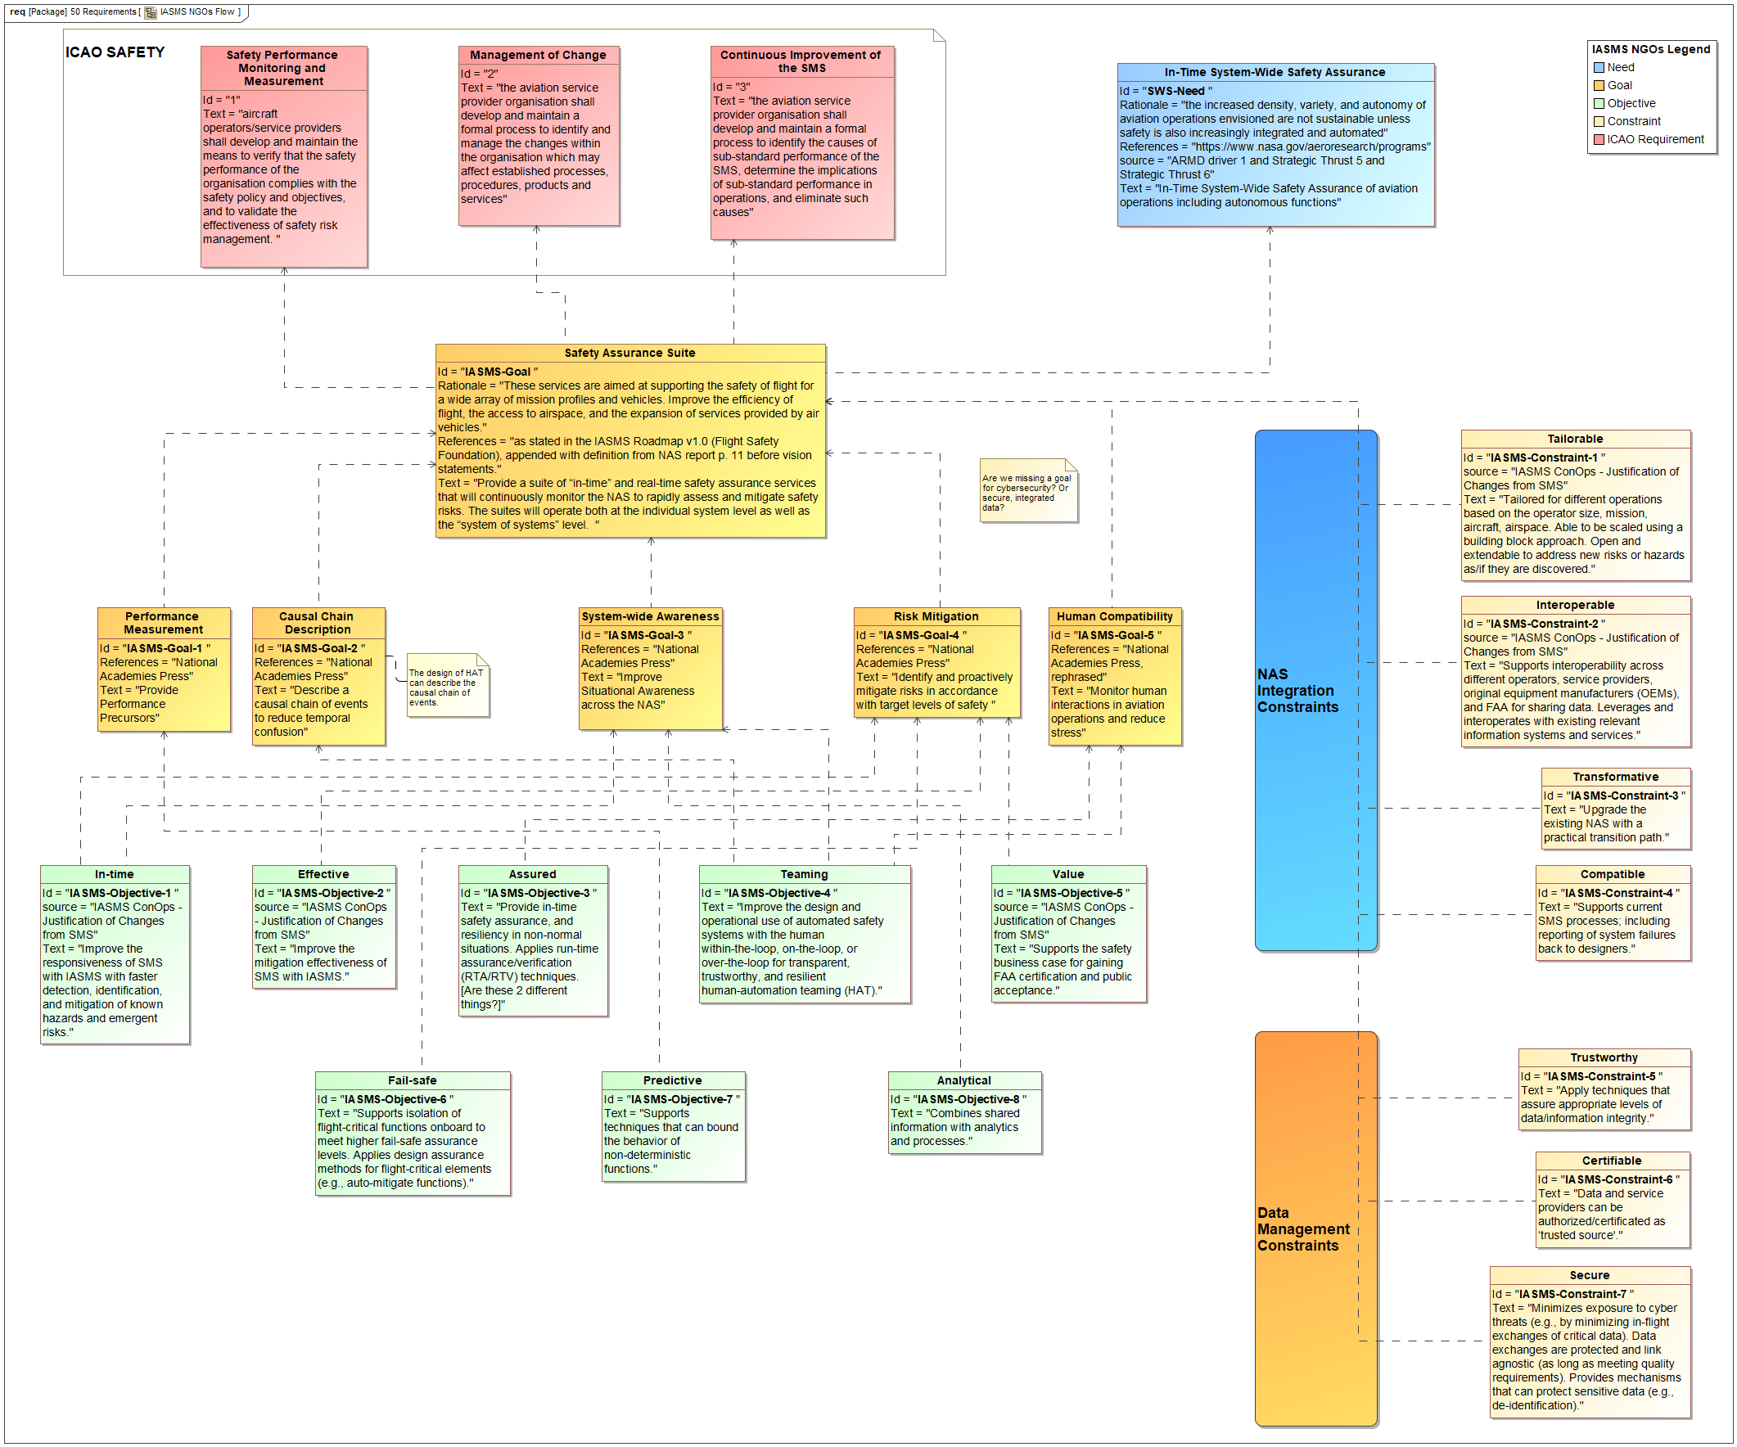
Figure 1 IASMS Needs, Goals, and Objectives

The overarching goal is a statement of IASMS purpose from the Flight Safety Foundation to introduce the IASMS Research Roadmap [6], sponsored by NASA, and created through literature research, community workshops, tabletop discussions, and stakeholder interviews. The National Academies report [1] is the source for additional particular goals in moving Safety Management Systems (SMS) toward predictive technology use for in-time management integrated across a system of systems. These are captured as goals because they are describing “what” the IASMS could be. The System-Wide Safety project Concept of Operations team developed a list of justifications for changes suggested from current commercial operator SMSs to the types of operations described in draft IASMS Concept of Operations documents and conference papers [8]. This team’s work to derive objectives for the IASMS was based on previous work by the research groups in SWS, starting before project formulation. These statements justify changing from the safety management system requirements on commercial operators and design guidelines for in-time safety management and assurance describe the “how” of IASMS implementation and behaviors and are more measurable than the goals, and thus were captured as the IASMS objectives, and traced to the relevant goals. This is a continuing process to clarify the objectives’ rationale and trace to project goals or stakeholder needs captured in external references; there are several objectives that do not trace to one of the functional IASMS goals but may be put in the context of a constraint necessary to move toward the overall IASMS goal of a suite of safety services tailored to the scope of operations from a small fleet to some shared across the entire airspace.
This paper describes the overarching IASMS conceptual architecture development method as background information. Then we show some examples of the approach to trace the system concept research and architecture to references that represent the broad and diverse stakeholder needs so that the project progress and accomplishments may be continuously and thoroughly validated. Finally, we discuss the impact of this traceability so far, and plans for future traceability work.

II. IASMS Conceptual Architecture
The flow from needs and founding references for in-time integrated aviation safety to goals and objectives for evolving safety management systems inform the architecture framework and recommended requirements for an IASMS. The architecture is envisioned as the system performing the general system behaviors of “monitor”, “assess”, “mitigate”, and “assure” allocated to it as in Figure 2 IASMS Architecture View: System behaviors performed by the IASMS. The system functions are one way to categorize the menu of potential IASMS behaviors, or general capabilities, as in Figure 3, showing the specialization of the system behaviors to IASMS capabilities. Another way these capabilities are organized is by hazard type they may manage. The potential IASMS behaviors are composed of sets of services and functions (SFCs) and data interfaces for the inputs and outputs of those services and functions hosted across agents, depending upon the details of the aviation operation in which they will be implemented. The SFCs hosted and accessed by any agent will depend on the operation, operator, autonomy involved, etc.

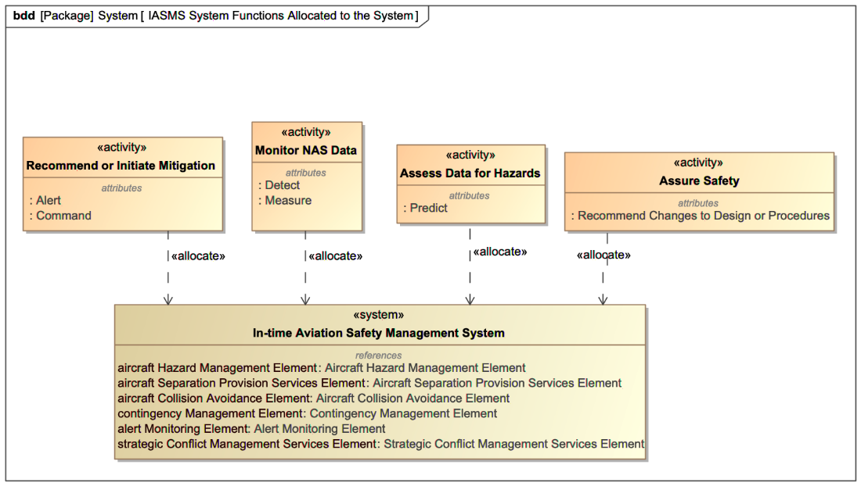
Figure 2 IASMS Architecture View: System behaviors performed by the IASMS
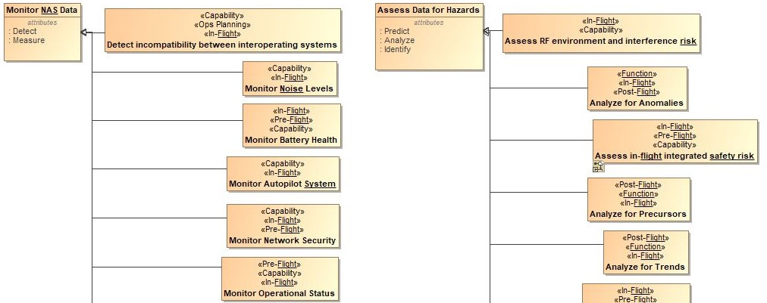
Figure 3 IASMS Architecture View: Section of IASMS potential behaviors connected to system functions

III. Descriptive Modeling of Roadmaps and Agency Guidance

IASMS Research Roadmap [6]
“The NASA-Flight Safety Foundation In-Time Aviation Safety Management System roadmap is divided into six major sections (or swim lanes) capturing various research areas associated with IASMS which are Safety Data and Resilience Analysis, Strategic Conflict Management, Tactical Separation Management, Tactical Separation Management, Aviation Weather, and Cross-Cutting Research and Development. Each section captures a set of capabilities anticipated to be available within a given time frame. In addition, each research area identifies a set of activities during the same time frame which are expected to be required in a future five-year time frame. Sections are further divided into subsections, each focusing on a five-year period between now and 2045.” [6]
The capabilities identified in the IASMS Research Roadmap were created as “Capabilities” and the time periods were created as “Actual Strategic Phases” in the Unified Architecture Framework (UAF) in a model-based systems engineering (MBSE) environment (we used the UAF plug-in with Dassault MagicDraw). UAF models provide a means to enable the analysis of organizations, systems, and system-of-systems and to develop an understanding of the complex relationships that exist between these systems [10]. As a first step to using modeled content for ease of communication, in the matrix shown in Figure 4 the Actual Strategic Phases, representing the enterprise phases in the roadmap, were traced to the Capabilities.

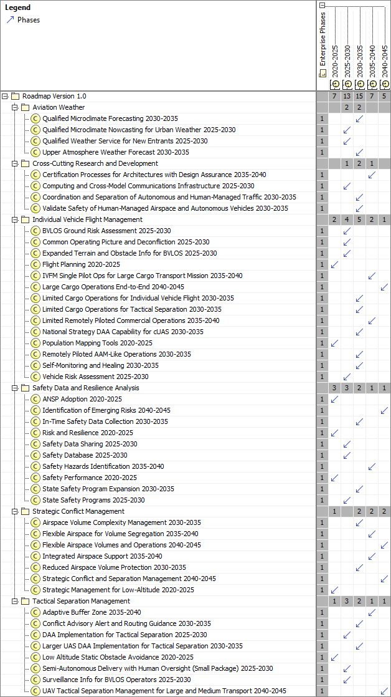
Figure 4 Actual Strategic Phases to Capabilities Mapping Matrix
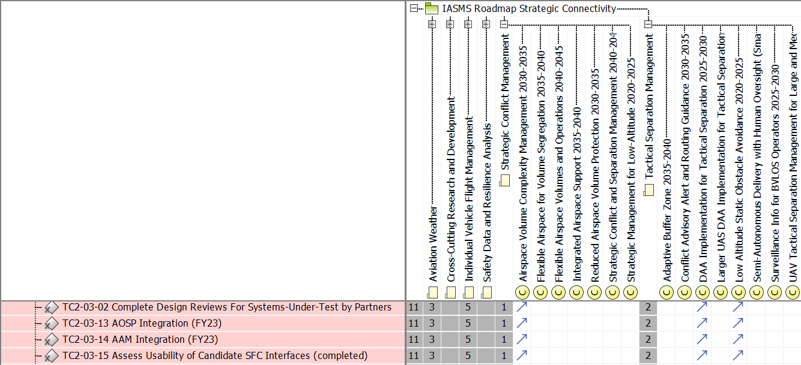
Figure 5 IASMS Research Roadmap Traceability

By modeling the capabilities listed in the roadmap, we can highlight the research activities of the System-Wide Safety project at NASA which will assist the aviation industry to develop each capability, and elements of the conceptual IASMS architecture (also modeled through MBSE) that exhibit or use those capabilities.
Through interviews with the managers of the subprojects, we found that the Level 1 SWS milestones they had defined in their areas did not align to Roadmap Capabilities, being more spread across capabilities such as completing a suite of tests of an architecture, closing a subproject, or defining gaps in commercial safety management systems. Therefore, we traced all the milestones that move the set of functions and services in the test architecture forward in development to the roadmap capabilities they address within the test scenarios. As in Figure 5 above, in which SFC are tested and integrated within Technical Challenge 2 (TC2) and those SFCs include functionality for managing airspace, detect-and-avoid separation, and obstacle avoidance applied to an urban scenario with small UAS, there is an impact to the aviation community in confirming each TC is conducting research that addresses several of the needed capabilities identified across the industry. Also, it impacted the project by highlighting the limited transparency in defining project progress only thorough milestones that grouped the capabilities or objectives addressed together and did not identify them specifically in the milestone or activity definition. This was both a useful insight for project management and systems engineering that resulted from applying more rigor through model-based traceability, but also a roadblock for doing direct tracing from the project to the roadmap. As a result, we decided to create a milestone attribute for traceability to an appropriate roadmap or project objective to be applied to the future milestone approval procedure. Additionally, we set a potential close-out activity for current subprojects to trace tasks or groups of tasks that were completed to the capabilities defined in research roadmaps, so they could display the subproject impacts in a formal manner without using the milestones as the objects of alignment.
We can also use the model to identify the gaps where more development or advocacy is needed to achieve the roadmap’s timeline. This helps to plan and communicate to our stakeholders the purpose, value, and effectiveness of the project’s research and outreach work. System-Wide Safety Systems Engineering is applying this model-based traceability to other research roadmaps and agency guidance. Here, we describe the some of the other modeling, and implications of the traceability of System-Wide Safety work and IASMS conceptual architecture.

Autonomy Verification & Validation Roadmap and Vision 2045 [11]
The Autonomy Verification and Validation Roadmap and Vision 2045 is comprised of six key technical areas. These technical areas are autonomy use cases, verification techniques, human-autonomy interaction, runtime techniques, new applications and techniques, and autonomy software certification. With the support of the Technical Challenge 4 (TC4) manager, we refined these technical areas into four categories of research initiatives for better tracking of the SWS milestone activities to the challenges presented by autonomous aircraft. These four categories are autonomy use cases, areas of new autonomy in aviation that must be assured, gaps in technologies using Artificial Intelligence for automation assurance that need V&V techniques developed, and gaps where clear paths to certification of autonomous technology is needed. Each of these four categories of research initiatives contain advanced capabilities from the roadmap that enable autonomy. These capabilities were modeled as UAF “Capabilities” but as they are research areas, they are exhibited by the project itself, SWS, rather than the IASMS (see Figure 6). Leveraging MBSE to trace the SWS milestones to these capabilities will help with project planning and communication with autonomy stakeholders. These traces convey the research initiatives that either are or could be addressed through specific SWS research and advocacy work.
An internal workshop on assurance topics was held in June 2024. Among many ideas generated about how to collaborate on assurance work, one conclusion was that run-time assurance may be integrated into an IASMS service implementation, but it is not part of the general definition of a safety service. Therefore, these capabilities will not trace to IASMS behaviors, instead tracing to project activities and recommendations for assuring operations and certification of IASMS behaviors. For example, the conclusion of Technical Challenge 4 work was rolled up through Level 2 and 3 milestones into the Level 1 milestone reporting on a recommended certification process for systems using machine-learning components (see Figure 7). This fills some of the cross-cutting gaps in the certification paths. The activities conducted by this subproject, and the activities being planned for the next assurance research subproject, will be traceable to these capabilities because they were redefined to the layers of research and development needed from the original modeling to the sections of the Roadmap. The traces of each other activities completed is being completed with the subproject managers as part of the close out of the subproject in early 2025.

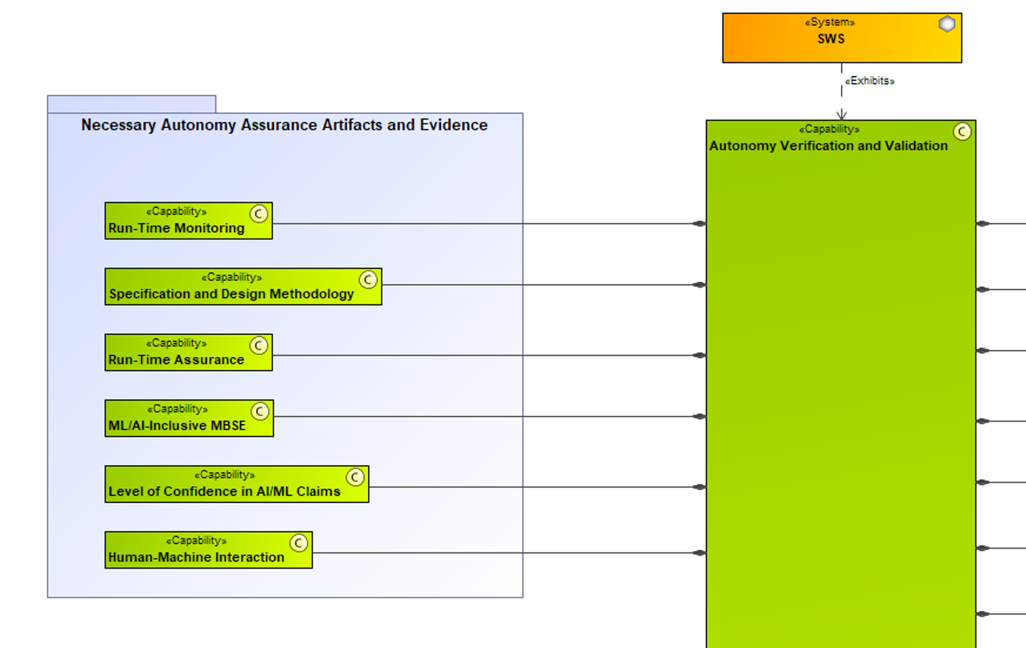
Figure 6 Capabilities to support Autonomy V&V from the Roadmap

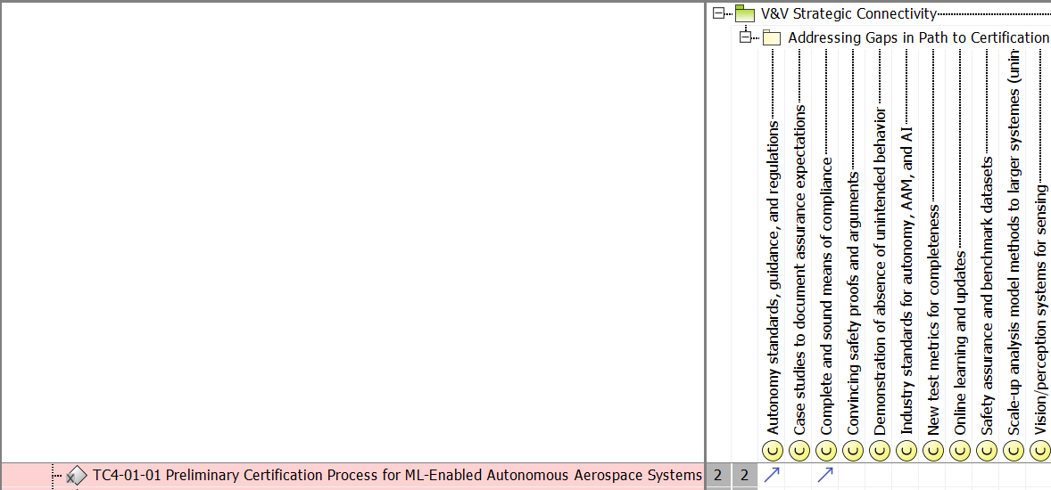
Figure 7 Autonomy V&V Roadmap Traceability

FAA Order 8040.6A “Safety Risk Management Policy” [12]
There is a table in the appendix of FAA Order 8040.6A listing hazards for uncrewed aerial systems, and some mitigations in the form of infrastructure, training, procedures, and automated safety functions. The project is showing alignment of perspective with FAA Safety Risk Management Policy by tracing IASMS Hazard Management Strategic Capabilities to the hazards in the FAA table through descriptive modeling, also tracing the automated safety function “Mitigations” in the FAA table to the IASMS behaviors that are or contain these functions (see examples in Figure 8 and Figure 9). This supports a gap analysis for future project research directions, and a direct path from FAA priorities to NASA-developed or funded software that implement the prioritized safety functions.

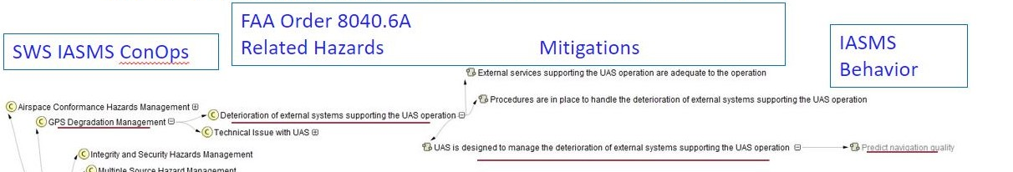
Figure 8 UAS Safety Risk Mitigations for potential hazard of external service degradation from FAA traced to Hazard Management capabilities in the IASMS strategic ConOps and to one of the applicable IASMS behaviors the system performs

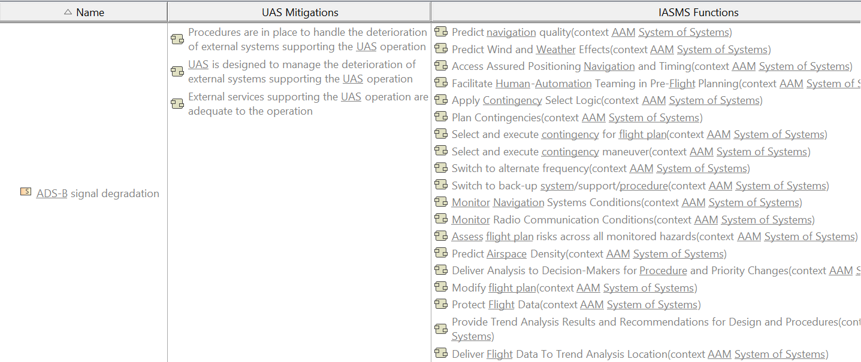
Figure 9 UAS Safety Risks and Mitigations for potential hazard of ADS-B signal degradation from FAA traced to the applicable IASMS behaviors

NASA-FAA Advanced Air Mobility Research Transition Team
The FAA identified goals for AAM in the form of a roadmap. The SWS project is one of the projects participating in the joint NASA and FAA Research Transition Team for AAM. The project would like to express its alignment with some of these goals to SWS subproject tasks and research areas. Creating formal traces from the SWS research areas to the AAM goals (see Figure 10) aids further communication in this team and starts a traceability flow for the AAM mission to research products and IASMS architecture elements that will help meet the AAM goals.

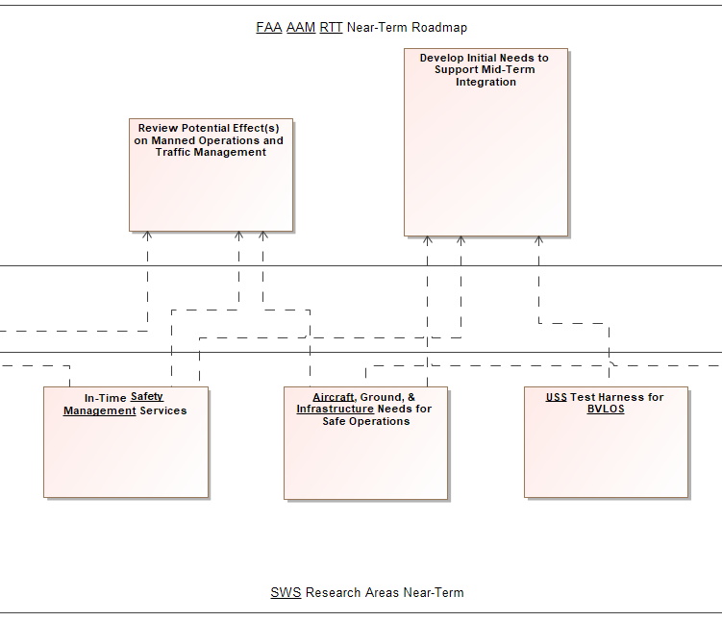
Figure 10 Some of the SWS Research Areas trace to the NASA-FAA AAM team’s roadmap goals
IV. Conclusion
Traceability methods were established to connect the research work and system architecture elements developed at NASA to community-created roadmaps and aviation agency guidance from the FAA. The process ran into obstacles because project milestones were not decomposition the problem solving along the same dimensions as the roadmaps. Although this meant the traceability activities were slowed, the process was beneficial to inspire some rethinking of project activity planning. The traces established so far in the SysML model of the IASMS make it easy to record and show the traceability information in several visual ways and several of information. The visualization is helpful to share the impact of the project and its alignment to society’s needs with NASA management and our industry and organizational partners.

Acknowledgments

The SWS ConOps team developed the vision for the IASMS concept of operations, including the statements used as IASMS objectives. This includes especially Kyle Ellis, Lance Prinzel, Paul Krois, Jim Ackerson, Michael Vincent, Misty Davies, Nikunj Oza, Robert Mah, Chad Stephens, Wendy Okolo, and Joe Coughlan.
The main authors of the IASMS Roadmap [6], developed in coordination with the System-Wide Safety project at NASA, include Flight Safety Foundation Contributors Deborah Kirkman, Jan de Regt, Kaleb Gould, Debra Moch-Mooney, and Jessie Mooberry.
The authors of the Autonomy Verification and Validation Roadmap [11] include SWS team member Guillaume Brat, who assisted in developing the framework of autonomy V&V capabilities and areas relevant to use for SWS research and IASMS architecture validation.
SFCs developed and tested by NASA are described in multiple publications by the research group under SWS team member Steve Young, including most recently a Technical Memo describing the software and test results [13]. Steve contributed to the functional architecture with his foundational knowledge of the IASMS concept, consulting on generalizations of SWS software to capabilities terms, and approving additions to the needed IASMS behaviors identified by the systems engineering team.

References
- National Academies of Sciences, Engineering, and Medicine. 2018. In-time Aviation Safety Management: Challenges and Research for an Evolving Aviation System. Washington, DC: The National Academies Press. https://doi.org/10.17226/24962
- Ellis, K., Krois, P., Koelling, J., Prinzel, L., Davies, M., Mah, R., and Infeld, S. 2021. Defining Services, Functions, and Capabilities for an Advanced Air Mobility (AAM) In-time Aviation Safety Management System (IASMS). 2021 AIAA Aviation. https://doi.org/10.2514/6.2021-2396
- Section 2.2 An Overview of the SE Engine by Project Phase, NASA Systems Engineering Handbook, February 6, 2019. https://www.nasa.gov/reference/systems-engineering-handbook/
- International Civil Aviation Organization, “Safety Management Manual,” ICAO Doc 9859, Fourth Edition, 2018. https://www.icao.int/safety/safetymanagement/pages/guidancematerial.aspx
- National Aeronautics and Space Administration, “NASA Aeronautics Strategic Implementation Plan,” 2023. https://www.nasa.gov/directorates/armd/armd-strategic-implementation-plan/
- Flight Safety Foundation, “IASMS Research Roadmap Version 1 2025-2045”. 2023. Under NASA Grant 80NSSC21M0187.
- Section 4.1 Stakeholder Expectations Definition, NASA Systems Engineering Handbook, February 6, 2019. https://www.nasa.gov/reference/systems-engineering-handbook/
- Ellis, K., Krois, P., Koelling, J., Prinzel, L., Davies, M., & Mah, R. 2021. A Concept of Operations and Design Considerations for an In-time Aviation Safety Management System (IASMS) for Advanced Air Mobility (AAM). 2021 AIAA Sci Tech Virtual Event. Reston, VA: AIAA.
- International Council on Systems Engineering (INCOSE). 2023. Model-based systems engineering (MBSE). Guide to the Systems Engineering Body of Knowledge (SEBoK). https://sebokwiki.org/wiki/Model-Based_Systems_Engineering_(MBSE)
- The Object Management Group (OMG). 2023. Unified Architecture Framework. Object Management Group. https://www.omg.org/uaf/index.htm
- Brat, G., Yu, H., Atkins, E., Sharma, P., Cofer, D., Durling, M., Meng, B., Alexander, C., Borgyos, S., Fan, C., Garg, K., Topcu, U., and Bakirtzis, G., “Autonomy Verification & Validation Roadmap and Vision 2045,” NASA/TM-20230003734, 2023. https://ntrs.nasa.gov/citations/20230003734.
- Federal Aviation Administration Order 8040.6A, “Unmanned Aircraft Systems Safety Risk Management Policy”, 2023.
https://www.faa.gov/regulations_policies/orders_notices/index.cfm/go/document.information/documentID/1042092

- Moore, A. et al, “Testing of Advanced Capabilities to Enable In-time Safety Management and Assurance for Future Flight Operations”. NASA/TM-2023-0018665, Hampton, VA, 2024

Intern, NASA System-Wide Safety Project.
Lead Systems Engineer, NASA System-Wide Safety Project. AIAA Associate Fellow.
System Model Manager, NASA System-Wide Safety Project.
Associate Project Manager, NASA System-Wide Safety Project.
Project Manager, NASA System-Wide Safety Project.
Deputy Project Manager, NASA System-Wide Safety Project.
Associate Project Manager, NASA System-Wide Safety Project.
NASA’s Advanced Air Mobility (AAM) research will transform our communities by bringing the movement of people and goods off the ground, on demand, and into the sky. This air transportation system of the future will include low-altitude passenger transport, cargo delivery, and public service capabilities. Source: https://www.nasa.gov/mission/aam/
Throughout the life cycle of a system, MBSE supports and facilitates the execution of Systems Engineering (SE) tasks by employing formalized representations of systems, known as models (INCOSE SEBoK, 2023).

