Uncrewed Aerial System Traffic Management Beyond Visual Line of Sight Multi Operator Technology Assessment Simulation

Bryan J. Petty
National Aeronautics and Space Administration Langley Research Center, Hampton, VA, 23681, USA
Rania W. Ghatas²
National Aeronautics and Space Administration Langley Research Center, Hampton, VA, 23681, USA

UAS Traffic Management (UTM) is a rapidly evolving space with increasing demand for regulation surrounding more complex operations. Beyond Visual Line Of Sight (BVLOS) operations are among these complex operations. The NASA UTM BVLOS sub-project is focusing on enabling more routine BVLOS operations through data collection for support of standards formulation. The Multi Operator Technology Assessment (MOTA) simulation is one of these activities that collects data on BVLOS operations within the same geographical area while sharing operational intents through a USS. Data collected includes workload, situation awareness, and usability on nominal and off-nominal operations. Results of this study are intended to provide recommendations for standards as well as provide insight on improvements to the systems under test. NASA intends to incorporate those improvements into their operations to support and update the BVLOS waiver from the FAA’s Near-Term Approval Process (NTAP).
- Introduction
Commercial Uncrewed Aerial System (UAS) technology has advanced over recent years to enable more complex operations, including beyond visual line of sight (BVLOS). One major enabler of more complex UAS operations is UAS Traffic Management (UTM) [1, 2], which allows different UAS operators to coordinate their airspace to reduce chance of collision between UAS, improving the safety cases for BVLOS operations. In addition to UTM, other support UTM services have also been developed, such as Command and Control (C2) technology, airspace surveillance, detect and avoid (DAA) of aircraft, and weather data suppliers. Currently, the Federal Aviation Administration (FAA) authorizes BVLOS operations through a waiver process centered around the operator’s concept of operations and safety case [3]. This method is suitable for small scale operations but lacks scalability that some operators desire for routine BVLOS operations. To address this, the FAA has begun formation of rules and regulations for BVLOS operators [4]. In the short term, the FAA has initiated the Near-Term Approval Process (NTAP) to help provide safety credit for UTM services used in new BVLOS waivers through a letter of acceptance (LOA). This allows for the UTM service provider to use their LOA in future wavier reviews to expedite the approval of the operator. If the service is used in a different location or with updated requirements, only the deviations require review. NASA’s UTM BVLOS subproject intends to work with the FAA and UAS industry partners to enable routine and scalable BVLOS operations at altitudes at 400ft above ground level (AGL) or lower. One component of this effort includes the Multi Operator Technology Assessment (MOTA) simulation to collect operational data on a representative BVLOS operation.
- Background
NASA’s UTM BVLOS subproject is part of the Air Traffic Management Exploration (ATM-X) project under the Aeronautics Research Mission Directorate. The subproject builds upon NASA’s UTM project, which developed technologies for airspace management of UAS. One product of the UTM project was the UAS Supplier of Services (USS), which allows for operators to share operational intentions with four dimensional polygons using latitude, longitude, altitude, and time. The USS receives positional data of the connected UASs and monitors the conformance of their position against their approved operational intents to ensure they stay within their strategically deconflicted airspace. This provides increased situation awareness multiple vehicle operations within the same geographical area. This technology has spurred BVLOS concept of operations for things such as package delivery [5], medical supply delivery and infrastructure inspection [6]. In addition to USSs, these operations require other ground-based services such as C2 to their vehicles, airspace surveillance capabilities to detect and avoid crewed aircraft, and weather data for flight planning. BVLOS waivers typically require more review from the FAA than normal visual line of sight operations and provide very little flexibility for scaling. The FAA is currently working on formal rulemaking for BVLOS operations, but current BVLOS operations are based on waivers to the current UAS rules, which include part 91, part 107, and part 135. NTAP allows for a service to be reviewed by the FAA and given a LOA as part of the current BVLOS waiver process until formal rulemaking has been finalized. This allows for future operators to reuse services within their waivers if it is in the same geographical area allowing for more scalability for services between operators. Part of the UTM BVLOS sub project work is for NASA to act as a public operator to start bringing services through the NTAP. This allows the FAA to capture operational data from BVLOS operations conducted by NASA and receive feedback on the NTAP to help mature future rulemaking. NASA Ames is bringing the NASA USS through the NTAP while NASA Langley works with a surveillance service provider through the NTAP. The scope of this report focuses on simulation testing at NASA Langley during MOTA to support a representative BVLOS flight test capability that can support simultaneous operations on NASA Langley's City Environment for Range Testing of Autonomous Integration and Navigation (CERTAIN) flight range. These operations capture data for surveillance, DAA, C2 and weather services used to by NASA to operate UAS. The simulation and follow on flight test will provide operational data to inform NASA Langley’s concept of operations required for the NTAP targeting BVLOS operations beyond the CERTAIN range bounds.
- Simulation Evolution
MOTA expands on the simulation capabilities used in the High Density Vertiplex (HDV) simulation setup [7]. The capabilities include Hardware in the Loop (HITL) vehicles, onboard autonomous software, and operational facilities, such as ROAM (Remote Operations for Autonomous Missions) [8]. MOTA simulation augments this setup by expanding to seven available HITL vehicles, conducting operations out of multiple facilities, upgrading the onboard autonomous software and ground control station, and coordinating operations through a USS. The increased the number of available HITLS allows for vehicles to operate in multiple operational facilities with operations at a higher density. This helps represent a real-world situation where different operators may be operating within the same geographical area. Data produced during these operations capture both nominal operations and off-nominal operations.
In addition to the use of the ROAM facility, MOTA simulation plans to add in an operational facility from NASA Langley called MOSAIC (Mission Operations & Autonomous Integration Center). These facilities can be seen in figure 1. ROAM consists of two rooms, ROAM-I and ROAM-II, each with six workstations and a forward video wall. For MOTA Simulation, ROAM-I is used for data collection. ROAM serves as a research-based facility that can perform rapid prototyping of technologies for remote UAS work while being able to capture relevant human factors data for the roles involved. MOSAIC is an operations focused facility, with its configuration more tightly controlled based on NASA’s standard procedures for remote UAS operations. MOSAIC is a single room that offers six workstations and a forward monitor wall for situation awareness. Both operational facilities are equipped with a voice over IP communications solution to allow for voice communications between personnel to coordinate simulation activities.
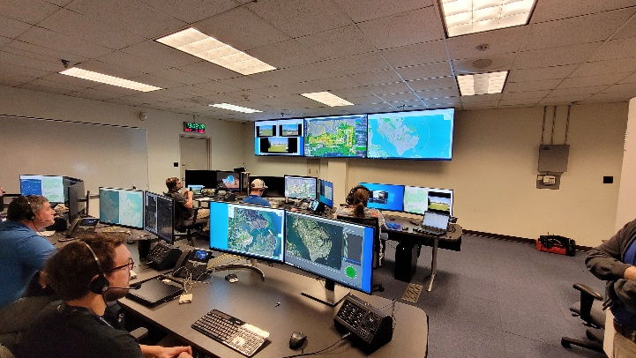 | 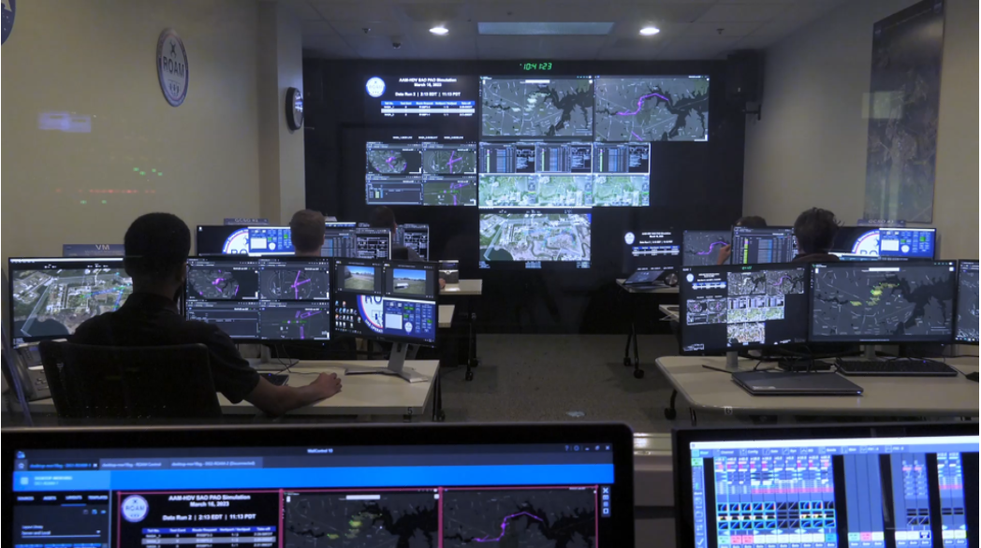
- MOSAIC | (b) ROAM-I
Fig. 1 MOTA Operational Facilities
The MOTA simulation team updated several of the onboard autonomy to mature the capabilities from HDV. The onboard software of ICAROUS [9] and Safe2Ditch [10] went through improvements which include an updated status messages for ICAROUS, decoupling of dependencies between the ICAROUS and Safe2Ditch, and automatic geofence re-routing during return to launch (RTL) commands. The status of updates allowed the remote pilot in command (R-PIC) to more clearly understand when the onboard software is in passive mode, active mode, or deactivated mode. Passive mode allows ICAROUS to detect traffic conflicts based on other vehicle positions and provide warnings, but not act. This mode only occurs when ICAROUS has a valid flight plan and has reached the first waypoint. Active mode allows for ICAROUS to send direct control commands to the vehicle to avoid a potential airspace collision or near mid-air collision. The R-PIC can deactivate ICAROUS at any time after it has been activated, which puts ICAROUS back into passive mode and can no longer be activated. Safe2Ditch allows for the vehicle to be autonomously landed at a nearby landing spot during off-nominal events. During the previous implementation of the onboard autonomy, Safe2Ditch was only able to be engaged when ICAROUS was activated, causing some limitations when ICAROUS was in passive or deactivated mode. With the updates for MOTA, Safe2Ditch can be engaged while ICAROUS is in any mode to allow for more flexibility on the capability. All functionality of the onboard autonomy can be fully disabled by the R-PIC at any time, allowing the R-PIC to maintain control over the vehicle. When disabled, neither ICAROUS nor Safe2Ditch can send commands to the vehicle. The final improvement to the onboard software is ICAROUS now being able to detect keep out zone, or geofence, conflicts within the RTL path to the takeoff location. ICAROUS computes a path around the geofences and issues control commands to the vehicle to honor the geofence during the vehicle’s RTL. This allows for operations around a geofenced area without the need to maintain a clear path home.
To match the improvements to the onboard autonomy, the ground control station software used, MPATH (Measuring Performance for Autonomy Teaming with Humans) [11], went through multiple updates. These include updated onboard autonomy status messages, addition of widgets for vehicle motor status and USS interaction, and increased ground control station command send rate. The MPATH’s ICAROUS widget was updated to match the status of ICAROUS during operation, allowing for better understanding of what mode ICAROUS is in. The updated widget indicates when ICAROUS is running, when it switches to passive mode, when it has been activated by the R-PIC and when it has been deactivated or if the onboard autonomy has been disabled entirely. This widget update allowed for more clarity on the onboard system for the R-PIC and can be seen in figure 2. The motor widget was added to display the PWM values coming through the C2 connection with the goal of assisting the pilot to identify off-nominal motor behavior. This widget became desired after feedback from the R-PIC trainees during initial HDV BVLOS training [12] due to the difficulty of spotting motor failures. The USS widget allows the R-PIC to connect to a USS and share operational intents of their operations. While connected to a USS, MPATH automatically forms a 4D operational intent around the loaded flight plan. The widget allows the user to submit this volume to be checked against the currently accepted operational intentions. The R-PIC can then schedule their operation to select a future start or use the fly now option to have the operational intent start on submission. If no conflicts in request airspace are detected, the operation becomes accepted by the USS and visible to other connected operators in the area. Once the R-PIC has started their mission they can activate their operation through this widget, notifying other of their status change and providing position reports of the aircraft. Figure 3 shows vehicle position reports with their active operations as well as approved but not currently active operations. After the flight has concluded, the R-PIC then closes their operation, removing it from the system. The final upgrade to MPATH involved how often the R-PIC's commands were sent to the vehicle per command issued. MPATH now sends commands every quarter of a second until an acknowledgement is received, up to four maximum resends. This ensures that commands from the R-PIC are received and processed by the autopilot on board and not lost in transmission.
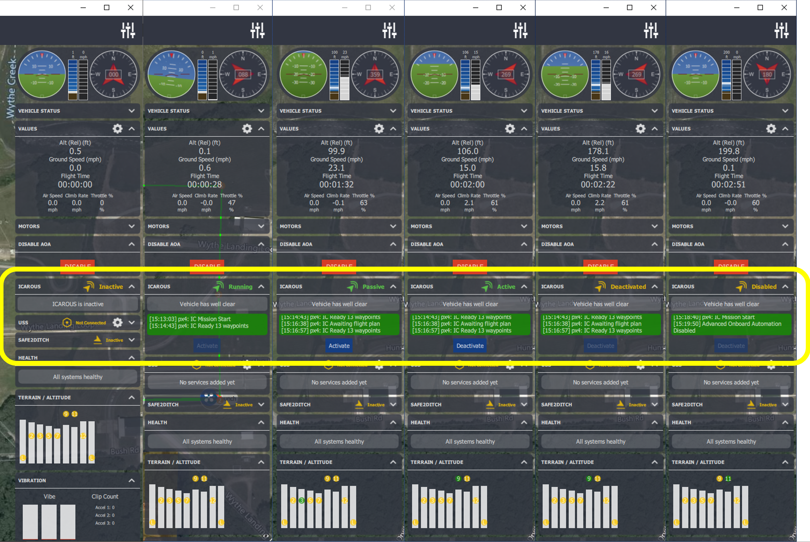
Fig. 2 ICAROUS Status Messages
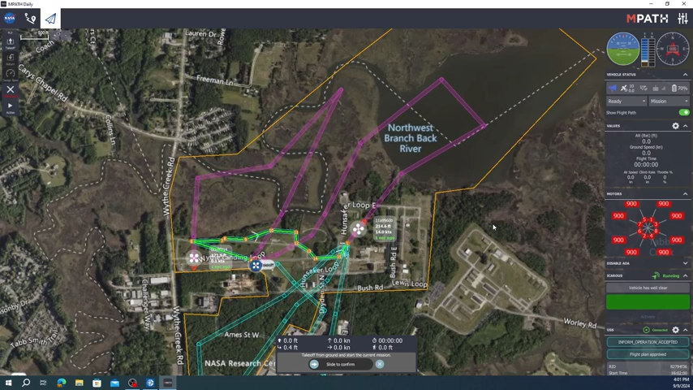
Fig. 3 MPATH USS and Motor Display Widget Upgrades
- Simulation Setup
The HITL setup is hosted within the Simulation Integration and Testing Lab (SIVL) and is managed by a simulation operations engineer (SOE). The implementation uses PX4 autopilot software running on a Pixhawk cube to send PWM outputs to a representative physics model of an octo-rotor UAS. A flight computer running the onboard software is connected to the Pixhawk. The selected flight computer is an Nvidia Orin Nano or an Nvidia Xavier AGX, which represent flight computers that can be integrated onto live flight vehicles. The SOE can simulate crewed and uncrewed aerial traffic, including the other HITL vehicles, that are visible to the onboard autonomy. This allows for ICAROUS avoidance to be tested and utilized in a HITL simulation. ICAROUS is configured to avoid traffic conflicts through altitude resolutions, where the vehicle will maintain its mission path but will climb or descend based on the surrounding traffic. Once the SOE has the HITL vehicles setup for operations, they forward the telemetry stream through a UDP connection to each individual ground control station.
Each ground control station runs MPATH to connect to the HITL vehicle assigned to that station. This provides an interface for participants that represents what they would see during live flight operations. Once connected, participants connect into the NASA USS through their USS widget. The provided flight plans are opened into MPATH and upload to the vehicle and the onboard autonomy. Each participant confirms their flight plan is loaded onto the vehicle and ICAROUS through the status messages on MPATH. The participants are provided with takeoff times that will allow their operations to be accepted into the USS based on the scenario being executed. This ensures that the scenario encounters occur as designed as they would if it were a live flight operation. Participants were instructed to activate ICAROUS when they were departing the takeoff and landing areas, called vertiports, and disable it as they were on approach, allowing for ICAROUS to maneuver the vehicle during operations.
Participant selection included NASA personnel who have completed the simulation portion of the HDV BVLOS training were selected. This ensured participants were familiar with the systems in use, such as ICAROURS, MPATH, and Safe2Ditch, while only requiring brief training on the new features, such as the USS Widget. Each participant had control of one UAS at a time with five participants for each data collection run. The R-PIC participants are split between the operations facility with three in ROAM and two in MOSAIC, as seen in figure 4. Five scenarios are run per day over two weeks with participants switching to a different ground control station each day. This allows for participants to see the scenarios from different perspectives and for the research team to capture responses on multiple perspectives.
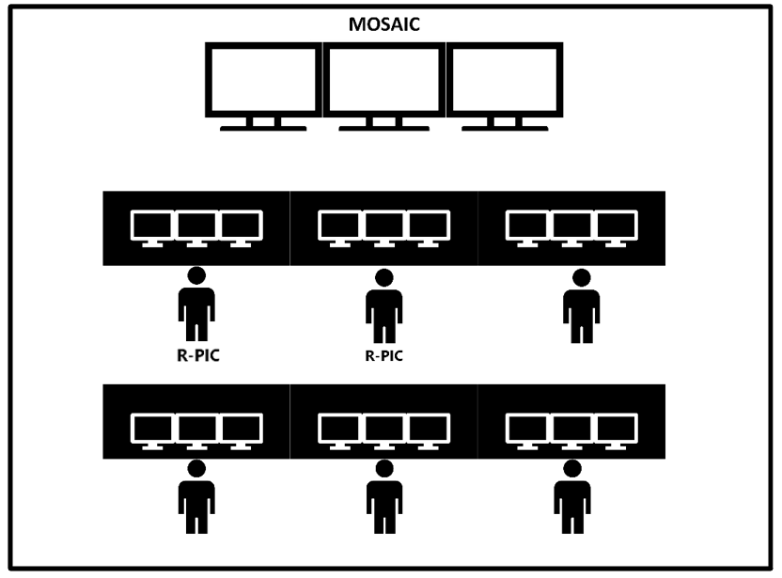 | 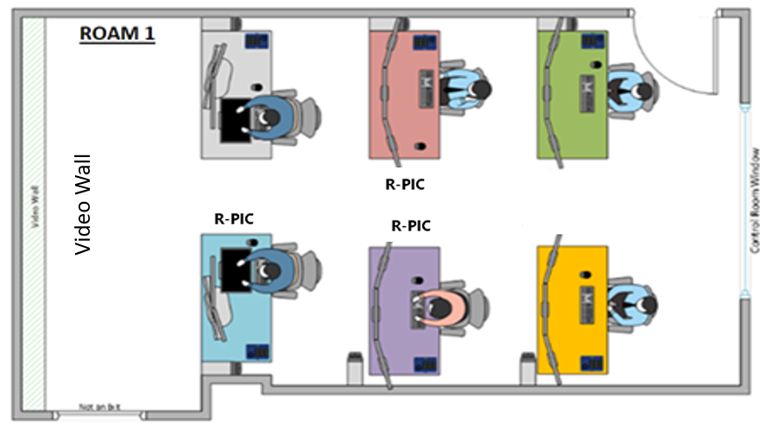
- MOSAIC | (b) ROAM
Fig. 4 Location of R-PICs in Operational Facilities
- Scenarios
Scenarios within MOTA range from nominal to off-nominal operations with high amount of non-conformance to airspace operational intent. Nominal scenarios include all GCSOs submitting their operational intents to the USS, getting approval, and flying their mission to match their operational intent. Off nominal scenarios occur when GCSO’s operational intents are approved, but the vehicle is not able to follow those intents due to contingencies, such as unplanned RTL or intruder traffic avoidance. During these situations, the vehicle will become non-conforming, which may adversely affect other vehicles operating within the same area. In the nominal case, airspace deconfliction of UAS to UAS is handled through strategic means with the USS, but when a vehicle becoming non-conformant, human intervention or onboard autonomy with vehicle-to-vehicle position communications may be the required to maintain separation. Table 1 shows an overview of the scenarios tested in MOTA. The following are the scenarios that were selected for MOTA simulation:
Table 1. Scenario Overviews
Scenario Number | Name | Event Tested
1 | Nominal, Nonoverlapping Flight Paths | Nominal Segregated Operations
2 | Nominal, Overlapping Flight Paths | Nominal Overlapping Operations
3 | Off Nominal, Overlapping Flight Paths: Safe2Ditch Landing | Off-Nominal Emergency Landing in Overlapping Operations
4 | Off Nominal, Overlapping Flight Paths: Immediate RTL | Off-Nominal Return to Home through a Geofence in Overlapping Operations
5 | Off Nominal, Overlapping Flight Paths: Safe2Ditch Landing and Immediate RTL | Multiple Off-Nominal Scenarios in Overlapping Operations

Scenario 1 – Nominal, Nonoverlapping Flight Paths
The first scenario uses flight plans that do not overlap when the vehicles have departed their takeoff and landing locations. This simulates a case where operators may be operating close to each other but are spatially deconflicted during operations. This is a nominal scenario because all operations are accepted by the USS with full conformance and no automated actions from the onboard software are expected. Flight paths used for this scenario are shown in figure 5 with the yellow and blue arrows. The red circles in figure 5 show the location of the Vertiport 1, 2, 3 and 6 that are used during these operations. This is a lower complexity scenario due to the lack of spatial overlap in flight plans between operations. Participants located in ROAM conducted their operations at 200ft AGL while participants in MOSAIC flew at 150ft and 250ft AGL. These mission altitudes do not change between the scenarios.
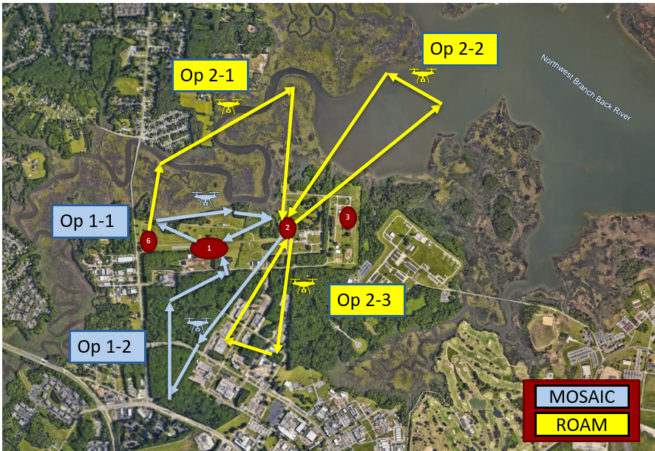
Fig. 5 Scenario 1 Flight Plans

Scenario 2 – Nominal, Overlapping Flight Paths
The next scenario is another nominal scenario because all vehicles fly their intended plans without deviation, but with flight paths that start to overlap geographically. Figure 6 shows how the flight plans overlap between the two operational facilities. This scenario demonstrates a more complicated operational area with operators from different facilities conducting operations in the same geographical area. The USS strategic deconfliction enables this type operations by validating the intended flight path of vehicles against approved operations before they depart their takeoff location. If the USS identifies a conflict with an existing approved flight plan, the submitted plan will be rejected and require the operator to replan. This ensures that two vehicles do not occupy the same airspace if they are both using a USS and conform to their operational intents.
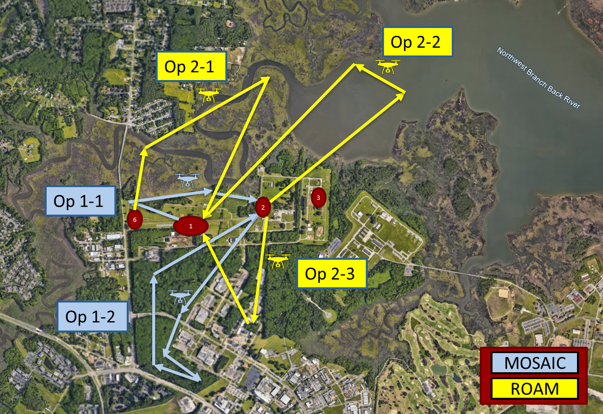
Fig. 6 Scenario 2 Overlapping Flight Plans

Scenario 3 – Off Nominal, Overlapping Flight Paths: Safe2Ditch Landing
This scenario is the first of three off nominal scenarios of this simulation. The flight plans and timing of the takeoff and landings are the same as Scenario 2 to provide the overlapping nature envisioned routine operations. During the nominal flight paths, participant 1 from ROAM is required to engage an emergency Safe2Ditch landing to vertiport 3, which can be seen by the red vehicle in Figure 7. This vehicle becomes non-conformant to their operation and goes directly through the path of participant 2 in ROAM, causing an airspace conflict. Since ICAROUS is active during the operation it will detect this conflict and take action to resolve it. For participant 2 in ROAM, ICAROUS will utilize an altitude resolution. While in the Safe2Ditch landing, the vehicle controlled by participant 1 in ROAM performs a lateral resolution to maintain the proper separation from the other vehicles while on its way to the landing point. This avoidance can be seen in Figure 8 by the red vehicle path as it transitioned off its intended mission to the alternative landing site.
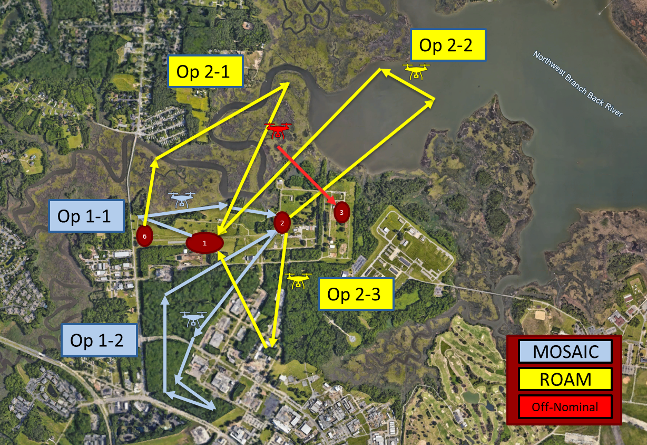
Fig. 7 Scenario 3 Flight Plans with Off-Nominal Ditch
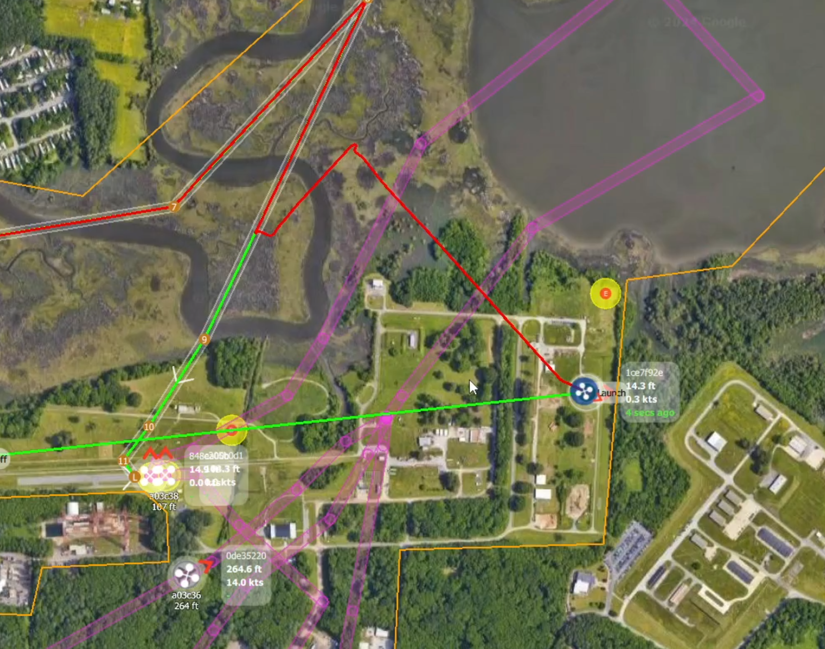
Fig. 8 Off-Nominal Vehicle Transition to Ditch Site

Scenario 4 – Off Nominal, Overlapping Flight Paths: Immediate RTL
The next off nominal scenario follows the same setup as Scenario 3 with a different off nominal event occurring. During operations, participant 2 in MOSAIC is required to return to home immediately by putting the vehicle into RTL mode. The vehicle will RTL in a direct line home through a geofence and may violate the approved area of operations. During MOTA, ICAROUS detects the geofence conflict and calculates a new return path for the vehicle to remain within the geofence. Figure 9 shows the difference between a return without ICAROUS re-route and with ICAOUS re-route. This RTL has the chance to interfere with other USS approved paths, like participant 3 from ROAM seen in figure 10. If the return path causes an airspace conflict, ICAROUS on both vehicles would resolve that conflict with altitude resolutions.
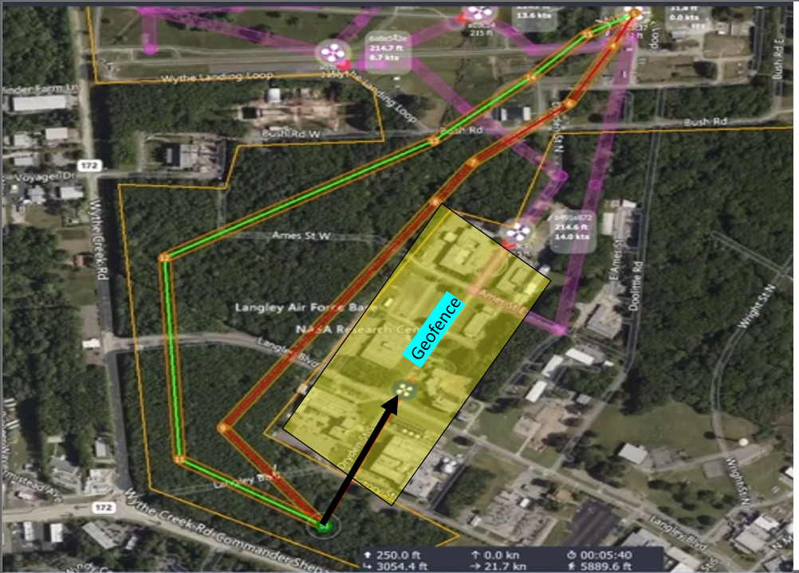 | 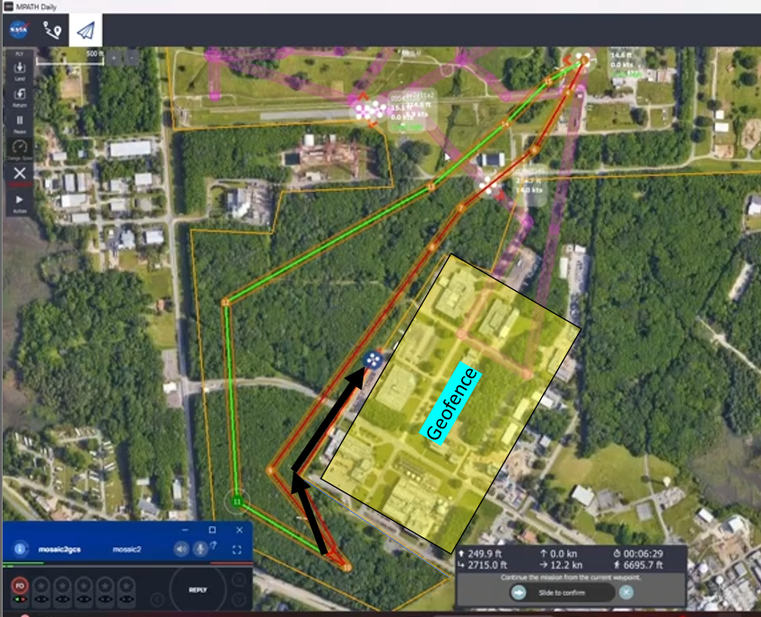
- Path without ICAROUS re-route | (b) Path with ICAROUS re-route
Fig. 9 ICAROUS Re-route comparison.
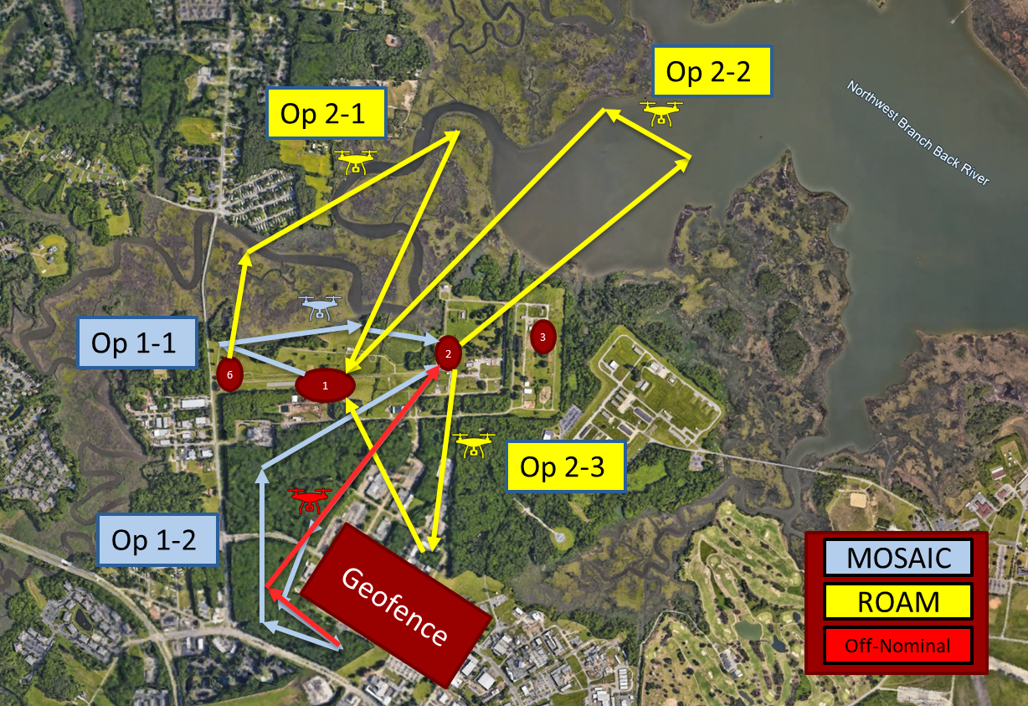
Fig. 10 Scenario 4 Flight Plans with Off-Nominal RTL Through Geofence

Scenario 5 – Off Nominal, Overlapping Flight Paths: Safe2Ditch Landing and Immediate RTL
The final scenario includes multiple off nominal events by combining Scenario 3 and 4. This represents a worst-case scenario with multiple failures at one time around the same airspace. This results in multiple aircraft performing avoidance maneuvers to avoid other aircraft who did not keep their original operational intentions. Figure 11 shows how multiple non-conforming operations can overlap into other conforming volumes. This may result in a loss of acceptable separation between UAS, but ICAROUS provides autonomous onboard DAA to maintain the appropriate separation of these vehicles based on their position and velocity at a given time.
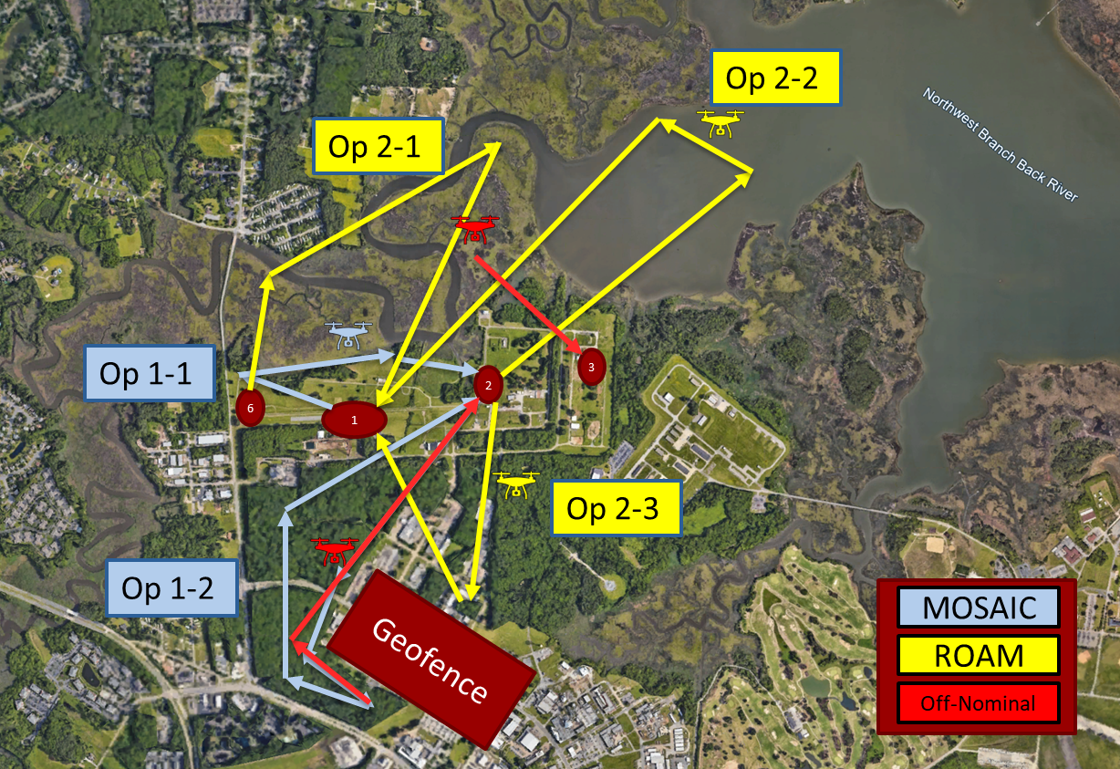
Fig. 11 Scenario 5 Flight Plans with Multiple Off-Nominal Events
- Human Factors and Analytical Approach
MOTA captured human factors subjective data for all participants. All participants in this study were recruited from NASA Langley Research Center. Prior to participating on the first day, participants were provided with an informed consent form and privacy act notice. If participants chose to voluntarily continue with the study, then they were asked to sign each form and answered a demographic questionnaire. Upon arrival to the operational facilities, participants were informed of emergency locations and protocols and given the opportunity to address any questions or concerns prior to data collection. Each participant acted as a GCSO in five simulated 40-minute scenarios. After each scenario, participants filled out a post-scenario questionnaire, which elicited their subjective feedback on several aspects of the GCSO role during nominal and off-nominal flight operations. Data was collected on the participant’s perceived workload [13], situation awareness [14], and perceived risk of the given scenarios. This data helps understand how the technologies, like the USS and DAA software, affect workload, situation awareness and perceived risk during representative UAS operations. At the end of each day, participants completed an end-of-day questionnaire that gathered feedback concerning their overall experience. At the conclusion of their final simulation day, a “catch-all” post-experiment questionnaire was administered to participants, which included several questions regarding the usability of the GCS and its accompanying features. All questionnaires during data collection were administered via Microsoft Forms and displayed on each GCS.

Method of Data Collection
Human in the loop experiments benefit from randomized, controlled trials as randomization helps to minimize bias in data collected from human subjects. Although participants in this study rotated to a new GCS each day during their four-day participation, this study did not employ randomized trials. As such, bias in the data can occur due to several learning effects caused by experiencing the same scenarios each day in the same order. Additionally, a limited number of participants were unable to participate in all scenarios each day due to conflicting schedules or illness, which led to missing data in a limited number of scenarios. When participants missed the day, research team members stepped in to operate those GCS. Although the research team members were not participants, they were requested to fill out the post-scenario questionnaires as their experience provided a unique perspective during data collection scenarios. This provided a unique perspective regarding the topics covered in the questionnaire. For these reasons, the results in this section are not considered statistically sound and should be viewed as exploratory. The purpose of the subjective data collected is to provide researchers with an initial overview regarding perceived workload of GCSOs during high volume BVLOS operations with other operators.
The following sections provide high-level summaries of the combined data collected for Groups 1 and 2 from the post-scenario and post-experiment questionnaires.

Post-Scenario Questionnaire
The post-scenario questionnaire was given to each participant after every scenario. These elicited responses across a range of topics, including general perceptions of what went right or wrong during the scenario, workload measures, situation awareness, perceived risk, and usability of the GCS and its accompanying features. Each topic within the questionnaire consisted of Likert-scale ratings that ranged from 1 to 7, with 1 being “strongly disagree” and 7 being “strongly agree.” Likert-scale ratings are used to measure the opinions, attitudes, and motivations of participants. These ratings use a “range of answer options ranging from one extreme attitude to another, sometimes including a moderate or neutral option” [15]. Open-ended questions followed each Likert-scale rating to encourage additional feedback and comments from participants. These open-ended questions are used to supplement the scale ratings by providing additional insight into how the participant perceived a particular topic area.
This section will focus on the results of workload and participant comments regarding situation awareness, perceived risk, and general perceptions of what occurred during the scenario. The results for usability are discussed based on responses received from the post-experiment questionnaire.
- Workload
Workload data was collected using NASA’s Task Load Index (TLX), which is a tool that provides researchers with a means to assesses a participant’s subjective workload by measuring six different categories. Table 2 provides a description of each TLX category.
Table 2. NASA TLX Category Descriptions
TLX Category | Endpoints | Descriptions
Mental Demand | Low / High | “How much mental and perceptual activity, was required (e.g., thinking, deciding, calculating, remembering, looking, searching, etc.)? Was the task easy or demanding, simple or complex, exacting or forgiving?”
Physical Demand | Low / High | “How much physical activity was required (e.g., pushing, pulling, turning. controlling, activating, etc.}? Was the task easy or demanding, slow or brisk, slack or strenuous restful or laborious?”
Temporal Demand | Low / High | “How much time pressure did you feel due to the rate or pace at which the tasks or task elements occurred? Was the pace slow and leisurely or rapid and frantic?”
Performance | Poor / Excellent | “How successful do you think you were in accomplishing the goals of the task set by the experimenter (or yourself)? How satisfied were you with your performance in accomplishing these goals?”
Effort | Low / High | “How hard did you have to work (mentally and physically) to accomplish your level of performance?”
Frustration Level | Low / High | “How insecure, discouraged, irritated, stressed and annoyed versus secure, gratified, content, relaxed and complacent did you feel during the task?”

A scale ranging from 1 through 10 was used in the post-scenario questionnaire with 1 being “low” and 10 being “high” for all categories except for “performance,” where 1 was labeled as “poor” and 10 was “excellent.”
Table 3 shows the overall mean and standard deviations from all participants for each of the five scenarios. Figure 12 shows a visual representation of the mean scores.
Table 3. Overall Mean and Standard Deviations (SD) for NASA TLX Workload Ratings
 | Scenario 1 |  | Scenario 2 |  | Scenario 3 |  | Scenario 4 |  | Scenario 5
 | Mean | SD | Mean | SD | Mean | SD | Mean | SD | Mean | SD
Mental Demand | 3.85 | 2.07 | 4.08 | 2.36 | 3.97 | 2.11 | 3.95 | 2.16 | 3.81 | 2.05
Physical Demand | 2.44 | 1.59 | 2.43 | 1.48 | 2.58 | 1.57 | 2.62 | 1.64 | 2.68 | 1.63
Temporal Demand | 3.46 | 2.35 | 3.75 | 2.11 | 3.74 | 2.23 | 3.49 | 1.84 | 3.51 | 2.02
Performance | 7.69 | 1.88 | 7.20 | 1.92 | 7.50 | 1.69 | 7.57 | 1.82 | 7.68 | 1.73
Effort | 3.15 | 1.83 | 3.28 | 1.78 | 3.32 | 1.80 | 3.41 | 1.62 | 3.19 | 1.60
Frustration | 2.38 | 2.17 | 2.38 | 1.50 | 2.53 | 1.75 | 2.51 | 1.68 | 2.46 | 1.83

Fig. 12 NASA TLX Mean Scores for all Participants.
Overall, results showed that participants perceived their workload to be relatively low and rated their performance closer to the “excellent” endpoint. These ratings indicate that participants found their respective piloting tasks as workable and did not exude enough mental, physical, or temporal demand to cause them any workload issues. Similarly, participants felt at ease during the scenarios and rated their level of effort and frustration as relatively low. Although there were instances that required additional attention from the participants, those instances did not rise to the level in which it impacted their overall workload. Additionally, participants perceived their performance as high achieving. Workload increased and performance dropped slightly as scenarios became more complex but remained within the same range for each scenario. In situations where participants felt their performance was not as high, they noted it was due to anomalies in the simulation and its respective safety features, which are discussed later in this section.
- Situation Awareness
Situation awareness plays a pivotal role in any given individual’s overall decision-making process. A model of situation awareness is portrayed in Figure 13. According to Endsley [16], this model interprets the basis of situation awareness as being acquired through “a person’s perception of relevant elements in the environment, as determined from system displays or directly by the senses.” The three hierarchical phases and primary components of situation awareness include: perception of the elements in the environment within a volume of time and space, comprehension of the current situation, and projection of future status.
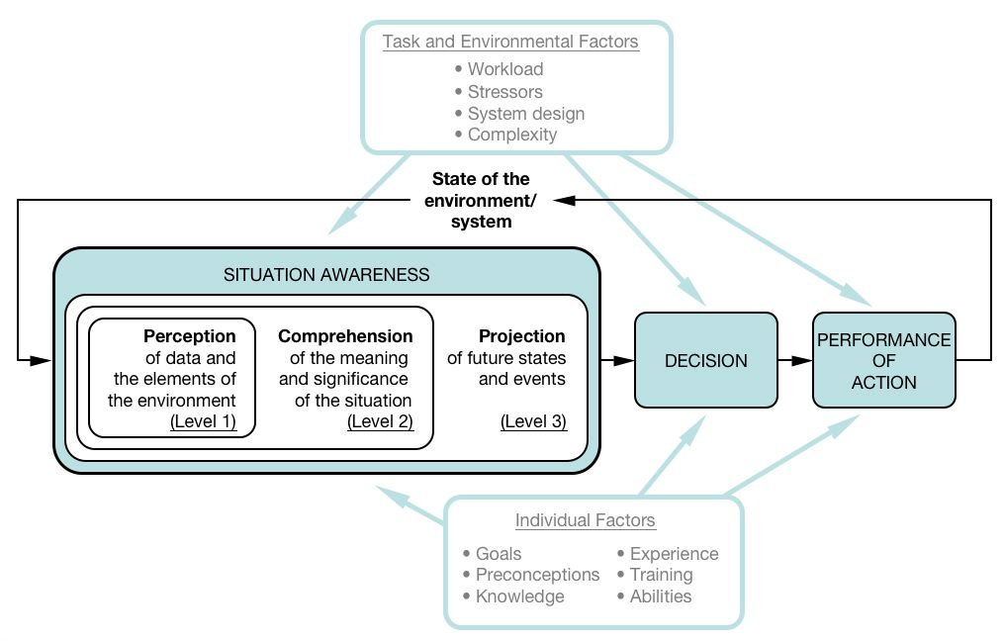
Fig. 13 Endsley’s Model of Situation Awareness in Dynamic Decision-making
Situation awareness becomes even more crucial in situations where an individual’s senses are removed from the environment, such as in remote operations in which the GCSO is controlling an aircraft that is beyond their visual line of sight. In these situations, alternate methods for acquiring accurate and timely information becomes pertinent to the success and safety of any mission. Alternate methods include GCS displays and radio or digital communications with other team members. As such, it is imperative that systems are designed with the end-user in mind to mitigate the innate situation awareness risks associated with remote operations.
The post-scenario questionnaire included seven questions that focused on situation awareness and if they had sufficient information and time to make decisions. Six of those questions were Likert-scale questions with ratings from 1 to 7, with 1 being “strongly disagree” and 7 being “strongly agree.” The seventh question was an open-ended question that elicited feedback from participants regarding their overall thoughts on if they had adequate situation awareness during the preceding scenario.
The first question under this topic area gauged the participant’s perception of whether they had good situation awareness of the aircraft in their control. Table 4 provides an overview of the mean and SD from all participant’s response for this question. The results show the mean scores range from 5.62 to 5.82, indicating participants believed they had good situation awareness of their aircraft. The low SD scores for situation awareness shows that there was a minimal degree of variability among participants’ ratings.
Table 4. Mean and SD for situation awareness of UAS aircraft in GCSO’s control.
Question: “I had good situation awareness of all UAS aircraft in my control.”
Scenario 1 |  | Scenario 2 |  | Scenario 3 |  | Scenario 4 |  | Scenario 5
Mean | SD | Mean | SD | Mean | SD | Mean | SD | Mean | SD
5.79 | 1.20 | 5.69 | 0.86 | 5.62 | 1.04 | 5.86 | 0.80 | 5.82 | 1.01

The second question asked participants about all other aircraft in the surround area. Overall, participants believed they had good situation awareness of other aircraft. The mean scores and SD for this question are shown in Table 5.
Table 5. Mean and SD for situation awareness of other surrounding aircraft.
Question: “I had good situation awareness of all other aircraft in the surrounding area.”
Scenario 1 |  | Scenario 2 |  | Scenario 3 |  | Scenario 4 |  | Scenario 5
Mean | SD | Mean | SD | Mean | SD | Mean | SD | Mean | SD
5.77 | 0.78 | 5.67 | 0.98 | 5.56 | 1.02 | 5.58 | 1.00 | 5.68 | 0.90

As noted earlier, having sufficient information is an important facet to having adequate situation awareness along with having sufficient time to properly interpret that information. As such, participants were asked to rate whether they had the information and time needed to complete their respective tasks and make good, informed decisions. A consensus among participants was observed based on their high-score ratings, indicating they had sufficient information and time to perform their required action, which positively impacted their overall situation awareness. Additionally, the responses from the Likert-scale questions were verified by the positive comments provided by participants in the open-ended question concerning their overall situation awareness. Although participants believed their situation awareness was good overall, some negative impacts to situation awareness occurred. Impacts to scores included the lack of simultaneous secondary or tertiary tasks during the scenarios, previous familiarity with the GCS simulation and display, and the activation of certain safety features, such as Safe2Ditch and ICAROUS, which have their own unique set of benefits and suggested improvements. Among the comments received from participants, suggestions were made concerning desired display features to improve situation awareness. Common trends and themes were observed in the feedback, which included redesign of GCS display features, such as adding tail numbers for ownship aircraft and surrounding aircraft, awareness of non-conforming aircraft, and having additional information regarding the behaviors of Safe2Ditch and ICAROUS when activated.
- Perceived Risk
Like workload and situation awareness, the perception of risk is based on subjective judgment. Perceived risk depends on many individual characteristics, such as “emotion, contextual factors, and personal experiences” [17]. Given that perceived risk is based on subjective judgment and is different for everyone, it should be noted that perception does not always align with actual risk and cannot be calculated as an absolute value. Additionally, subjective judgment of perceived risk in a simulation environment could be skewed due to the assumed safety of the controlled environment. After each scenario, participants were asked to rate exploratory questions from 1 to 7, with 1 being “strongly disagree” and 7 being “strongly agree,” concerning the events simulated and their perceived risk of them occurring in real-world operations.
The first question concerning perceived risk sought the participant’s judgement as to the probability of real-world operations like the last scenario going poorly. A rating of 1 indicated that participants believed it would go poorly, whereas a rating of 7 indicated that they believed it would not go poorly. Table 6 provides an overview of the mean and SD from all respondents for this first perceived risk question. The results show the mean scores range from 5.00 to 5.29, indicating participants believed there is a relatively low probability of events that occurred in each respective scenario would go poorly in similar real-world operations.
Table 6. Mean and SD for perceived risk (low probability of real-world operations going poorly).
Question: “'The probability of real-world operations like the last scenario going poorly is low.”
Scenario 1 |  | Scenario 2 |  | Scenario 3 |  | Scenario 4 |  | Scenario 5
Mean | SD | Mean | SD | Mean | SD | Mean | SD | Mean | SD
5.03 | 1.74 | 5.21 | 1.38 | 5.03 | 1.60 | 5.00 | 1.53 | 5.29 | 1.35

The second question asked participants about negative ramifications for the future if the events that occurred in each scenario were to be introduced in real-world operations. Overall, participants believed that introducing similar scenario events in real-world operations would not have any negative ramifications for the future. The mean scores and SD for this second perceived risk question are shown in Table 7.
Table 7. Mean and SD for perceived risk (negative ramifications for the future).
Question: “'Introducing real-world operations like the last scenario will not have negative ramifications for the future.”
Scenario 1 |  | Scenario 2 |  | Scenario 3 |  | Scenario 4 |  | Scenario 5
Mean | SD | Mean | SD | Mean | SD | Mean | SD | Mean | SD
5.62 | 1.31 | 5.36 | 1.35 | 5.13 | 1.54 | 5.33 | 1.39 | 5.11 | 1.62

It is important to reiterate that contextual factors play a role in individual perceived risk, such as the surrounding environment in which an individual is located (e.g., simulated GCS and airspace vs live operations) and previous experience with similar tasks or scenarios. As such, there are many explanations concerning the participants’ perception of minimal to no risk with the events in the scenarios simulated. Some of these include the perceived safety of the simulation environment and previous experience from past studies that simulated similar scenarios. The design of the scenarios themselves also has an impact on the perceived risk measure, such as having a relatively low number of surrounding aircraft compared to the future real-world operations and the simulated geographical location of each scenario.
Finally, an open-ended question concerning perceived risk was also asked. There was a consensus among participants during each of the five scenarios on all days of participation that their perceived risk was low, which coincides with their Likert-scale ratings. However, some participants did note that risk increases with more autonomous actions around the vertiport, when there are overlapping operations (i.e., multiple drone operations in the close vicinity), and when there are unpredictable aircraft in the surrounding environment, especially when near the vertiport.
- General Scenario Perceptions
To understand the perceptions of participants concerning each scenario, participants were asked open-ended questions regarding what went right and what went wrong. These questions not only provided an overall perspective of the participants’ perceptions, which provided insight into their overall experience, but it also provided the research team with a unique perspective of what was done well and what augmentations should be considered for future simulation studies. This section provides a quick-look summary of the common trends/themes observed based on participants’ subjective responses. Although participants were generally pleased with how well the scenarios went, which is complimentary to their subjective ratings concerning workload, situation awareness, and perceived risk, the participants did note some aspects of the scenarios and simulation that need to be addressed for future studies. Among the feedback received, three main trends/themes were identified that include the GCS user interface design, safety features, and simulation anomalies.
Overall, participants noted that the GCS display felt cluttered due to the presence of the USS flight path information. Participants who provided feedback about this noted that they would prefer the USS screen to disappear when not needed. Participants also noted the desire to have the tail numbers of aircraft in the surrounding vicinity as that would simplify pilot-to-pilot coordination. Other comments focused on the desire to have an indication regarding which aircraft was non-conforming, which would also increase situation awareness. Although some participants made similar comments regarding these display issues, others did not mind, which is to be expected given individual preferences. As with many user interface designs, the goal of MPATH is to have as much information as possible that is easily accessible by the end-user while allowing customizability of that information may address some aspects of the display comments. However, additional user interface design research needs to be conducted with end-users to address primary and secondary display features, and customizability of critical and non-critical display elements.
Participants also commented on anomalies with the Safe2Ditch and ICAROUS safety features. Although most participants had previous experience with these features from previous studies and had positive comments regarding the feasibility of the safety features, some participants did express issues. Some of these issues were concerned with flying into the boundaries of the geofence when Safe2Ditch is activated. Although there were limited instances of this occurring, the comments provided the researchers with input into improving the feature. There were similar comments made concerning ICAROUS not appropriately avoiding the geofence boundaries. While these software capabilities can provide autonomous avoidance of hazards, they are still being actively developed for research, therefore non-intended behaviors may occur. Simulations, like the MOTA simulation, allow for researchers to gather representative operational data on their software to apply fixes for these non-intended behaviors to make flight ready versions. Lastly, general simulation anomalies were noted by participants, such as the autopilot skipping waypoints when returning to land and, to a lesser degree, a small number of participants noted some issues in communication when receiving callouts.
Overall, participants believed that the scenarios went well most of the time; however, during a limited number of circumstances, some issues arose. All feedback received from participants is taken into consideration for the improvement of the overall system for future research studies, including the usability feedback, which is discussed in the following section.
- Post-Experiment Questionnaire
Systems that are designed with the end-user at the forefront ensure effective and efficient usability. This is especially true for systems that are essential for operations, such as a GCS. In essence, usability is “a measure of how well a specific user in a specific context can use a product/design to achieve a defined goal effectively, efficiently and satisfactorily” [18]. Given the significance of usability, the post-experiment questionnaire focused primarily on the usability of the GCS and its accompanying capabilities, including Safe2Ditch, ICAROUS, the USS with a secondary focus on overall situation awareness and exploratory trust questions.

Safe2Ditch and ICAROUS
Seven out of ten participants used the Safe2Ditch capability throughout data collection, whereas all ten participants used ICAROUS. Although participants who used Safe2Ditch agreed that having this feature was important and that it worked well to land their aircraft safely, a common theme concerning functionality improvements was observed among the participants. This common theme focused on the transparency and predictability of Safe2Ditch. Participants noted that they prefer knowing what Safe2Ditch was doing and where it was going when activated, including the path that it intends to take to the ditch site. Additional comments were made by two of the seven participants concerning the feature’s user interface design, which focused on suggestions for easier access in the display menu.
The same usability questions were also asked regarding ICAROUS, which elicited feedback from participants concerning the feature’s positive and negative design elements, its overall functionality, and suggested improvements. Participants noted that ICAROUS was useful in avoiding surrounding aircraft based on ownship parameters; however, like Safe2Ditch, participants prefer to know more about what ICAROUS was doing, including which surrounding aircraft it was avoiding and the path it intends to take. Additionally, participants noted that they would prefer to understand more about the parameters and algorithms ICAROUS uses to make its avoidance decisions.
Overall, it is evident from the open-ended feedback that participants found these onboard systems to be useful and helpful in completing their missions safely. However, there was a consensus among the participants that they preferred additional design features to increase their situation awareness regarding the functionality of these capabilities and what parameters they base their decisions on to either safely maneuver to a ditch landing site or maneuver to avoid surrounding traffic, respectively.

USS
Open-ended usability feedback regarding the USS was consistently positive among all participants. There was a consensus among the comments received that the USS provided great situation awareness. Participants noted that it was simple to use and understand, and that it provided plenty of useful information about surrounding traffic, including the flight path of other aircraft and whether that flight path was nominal. Although most of the feedback was positive, a few improvements were suggested. Participants noted that the warning messages received from the USS interfered with the ability to control their aircraft. As a result, the placement of these warning messages and their interference caused participants to acknowledge the warning quickly with little time to read and understand the accompanying message. Even though the USS already provides a lot of useful information, some participants noted that they would like to have additional information such as knowing when another aircraft is going into a contingency plan and what that plan entails. Participants also shared their preference for having some features only activating when necessary, such as the flight volumes of other aircraft, which include start time and flight duration. Overall, the comments received by participants suggest that the USS provided them with a user-friendly interface and provided them with important information necessary to maintain situation awareness.
- Conclusions and Follow-on Work
Throughout the simulation, the team capture data on the system used to operate UAS. This testing helped the team identify bugs within the software that would cause skipping of waypoints in the mission or breach of geofences during RTL. The team plans to patch these issues and prepare a flight ready version of the software for live flight. This software will be used to support the concept of operations for operations in an NTAP submission with NASA Langley as the operator for BVLOS operations. The simulation development also enables USS operations directly from MPATH, allowing the R-PIC to reduce the number of screens required to operate since the USS interaction is no longer through a separate screen. The R-PIC can now use the extra screen available to augment situation awareness with displays such as surveillance or weather displays. MOTA simulation has allowed NASA Langley to expose their pilots to operations with the USS more tightly integrated, which will enable future operations in airspaces with other UAS operators utilizing USS capabilities.
Subjective data collected from participants, through the administration of several questionnaires, helped inform the human factors of the various scenarios. These questionnaires elicited feedback from participants concerning their workload, situation awareness, perceived risk, general feedback concerning the overall scenarios, and overall usability of the GCS in ROAM and MOSAIC, including the user interface display design. Participants were also asked over 100 questions regarding their trust, performance, and perceived knowledge of Safe2Ditch and ICAROUS safety feature processes and their impact on providing adequate situation awareness. Based on the responses received from NASA TLX ratings, Likert-scale ratings, and open-ended questions, the overall takeaway from participants was that they experienced low workload during each of the scenarios and had good overall situation awareness based on having sufficient information and time to complete tasks. While there are slight increases in workload and decrease in performance as the complexity of the scenario increased, the changes were low compared to the nominal scenario. This is likely due to the level of automation on the vehicle, strategic coordination with the USS and repeated exposure to the scenarios throughout the experiment. Participants also reported low perceived risk if these scenarios were introduced in real-world operations, which may have been affected by the data being collected as part of a simulation opposed to a live flight operation and a non-randomized order of scenarios. Although feedback was mostly positive concerning the scenarios and participants rated their performance as high, there were notable issues that were documented in the questionnaires. The main three common trends/themes that were observed were related to the GCS user interface display design, issues with the Safe2Ditch and ICAROUS safety features, and general simulation anomalies. However, given that this study did not employ randomized trials, the results from this study should not be considered statistically sound and should be viewed as exploratory.
The MOTA simulation has gathered operational data on vehicle interactions within the nominal and off-nominal scenarios. The next steps include MOTA flight operations to gather workload, performance, and risk data of the scenarios during live operations, which provide more relevant human factors. The data gathered will help improve the capabilities used for BVLOS operations and inform review boards to ensure that the team is ready to submit their NTAP concept of operations. While simulation operational data is helpful to the FAA for evaluation BVLOS operations, the live flight operations offer data that the simulation does not provide, such as C2 evaluations, and provides more representative data for things such as surveillance and weather data services. When NASA Langley completes their NTAP application and gains a BVLOS waiver, the team will look to execute simultaneous BVLOS operations with a USS with operations beyond the current boundary of the CERTAIN range.

Bibliography

[1] | M. Johnson and J. Larrow, "Unmanned Aircraft System (UAS) Traffic Management (UTM)," 2020.
[2] | Federal Aviation Administation, "Unmanned Aircraft System (UAS) Traffic Management (UTM)," 2022.
[3] | M. Coldsnow, L. Glaab, J. Revesz, L. Kagey, R. McSwain and J. Schaefer, "Safety Case for Small Uncrewed Aircraft Systems (sUAS) Beyond Visual Line of Sight (BVLOS) Operations at NASA Langley Research Center," Hampton, 2023.
[4] | Federal Aviation Administration, "Unmanned Aircraft Systems Beyond Visual Line of Sight Aviation Rulemaking Commitee," 2022.
[5] | C. Roche, S. Oakes, K. Bender, S. Magyarits and J. R. Homola, "Unmanned Aircraft System Traffic Management (UTM) Research Transition Team (RTT) Concept Working Group - Concept & Use Cases Package #2 Addendum: Technical Capability Level 3," NASA, 2018.
[6] | N. Rymer and M. A. J, "A Review of Unmanned Aerial Vehicle," NASA, 2020.
[7] | B. Petty, J. Unverricht, B. Buck, L. Glaab, Q. Dao and J. Homola, "High Density Vertiplex: Scalable Autonmous Operations Prototype Assessment Simulation," in AIAA SciTech, Orlando, 2024.
[8] | B. K. Buck, E. T. Chancey, M. S. Politowicz, J. R. Unverricht and S. C. Geuther, "A remote vehicle operations center's role in collecting human factors data," in AIAA SciTech, National Harbor, MD, 2023.
[9] | M. Consiglio, C. Munoz, G. Hagen, A. Narkawacz and S. Balachandran, "ICAROUS: Integrated configurable algorithms for reliable operations of unmanned systems," in 2016 IEEE/AIAA 35th Digital Avionics Systems Conference (DASC), 2016.
[10] | L. J. Glaab, P. C. Glaab, P. C. Lusk, B. J. Petty, R. W. Beard, C. V. Dolph and R. G. McSwain, "Safe2Ditch autonomous crash management system for small unmanned aerial systems: Concept definition and flight test results".
[11] | M. S. Politowicz, E. T. Chancey, B. K. Buck, J. R. Unverricht and B. J. Petty, "MPATH (Measuring Performance for Autonomy Teaming with Humans) Ground Control Station: Design Approach and Initial Usability Results," in AIAA SciTech 2023 Forum, National Harbor, MD, 2023.
[12] | J. T. Revesz, J. T. Unverricht, B. J. Petty, B. K. Buck and L. J. Glaab, "Advancements in Remote Ground Control Station Operator Pilot in Command Training Program for Beyond Visual Line of Sight Flight Operations," in American Institute of Aeronautics and Astronautics Aviation, Las Vegas, NV, 2024.
[13] | S. G. Hart and L. E. Staveland, "Development of NASA-TLX (Task Load Index): Results of empirical and theoretical research," in Advances in Psychology, North-Holland, 1988, pp. 139-183.
[14] | R. M. Taylor, "Situational Awareness Rating Technique (SART): The Development of a Tool for Aircrew Systems Design," in AGARD Conference Proceedings No. 478, Situational Awareness in Aerospace Operations, Copenhagen, 1990.
[15] | SurveyMonkey, "What is a Likert scale? Definition, examples, and tips," SurveyMonkey, [Online]. Available: https://www.surveymonkey.com/mp/likert-scale/.
[16] | M. R. Endsley, "Toward a theory of situation awareness in dynamic systems," Human Factors, vol. 37(1), pp. 32-64, 1995.
[17] | Proxxi Voltage, "The Risk of Perceived Risk - Part 1: What is Perceived Risk?," June 2021. [Online]. Available: https://www.proxxi.co/blog/what-is-perceived-risk#:~:text=Perceived%20risk%20is%20a%20subjective,vending%20machines%20than%20shark%20attacks.
[18] | Interaction Design Foundation, "Usability," Interaction Design Foundation, [Online]. Available: https://www.interaction-design.org/literature/topics/usability#:~:text=Usability%20aims%20to%20ensure%20that,t%20necessarily%20make%20something%20accessible.

Aerospace Engineer, Aeronautical Systems Engineering Branch, NASA Langley Research Center, bryan.j.petty@nasa.gov 2 Human/Machine Systems Research Engineer, Crew Systems and Aviation Operations Branch, NASA Langley Research Center, rania.w.ghatas@nasa.gov

