NASA’s Exploration and In-Space Services (NExIS) Division OSAM-1 Propellant Transfer Subsystem Progress through FY 2024
Graham K. Webster, and Peter Knudtson
NASA Goddard Space Flight Center, Greenbelt, Maryland, 20771
Thomas J. Aranyos, Brian M. Nufer, Amy M. Felt and Syrus Jeanes
NASA Kennedy Space Center, Florida 32899
The National Aeronautics and Space Administration (NASA) Exploration and In-Space Services (NExIS) Division of Goddard Space Flight Center (GSFC) has been developing technology to robotically refuel both heritage and recently developed satellites on-orbit funded through NASA’s Space Technology Mission Directorate (STMD). The On-orbit Servicing, Assembly, and Manufacturing 1 (OSAM-1) mission, formerly known as Restore-L, developed a system to refuel a satellite in space and assemble a communications antenna. By demonstrating these capabilities, the mission would advance never-before tested technologies for use in future missions (by NASA, other government organizations, and private industries). The purpose of this paper is to capture the lessons learned from the hardware development of the OSAM-1 Propellant Transfer System (PTS) that are highly relevant for the ISAM community.
This paper covers a review of in-space servicing extensibility and critical technologies that were being developed within NExIS, focusing on the fluid transfer refueling technology within the framework of the OSAM-1 PTS. An overview of the technology demonstration servicing mission via the OSAM-1 Space Vehicle is provided as an extension of the technology development progress reported in 2018^{[1]}, 2019^{[2]} and 2020^{[3]}. The general objectives, challenges, and key technologies are presented as an introduction to the context of the OSAM-1 mission, and a precursor to the OSAM-1 PTS specific development status. Final assembly, qualification, and functional tests along with installation and acceptance testing of the Hose Management Assembly (HMA) and Propellant Transfer Assembly (PTA) are discussed. Technology development, challenges, lessons learned, along with installation and testing results are discussed, with particular focus on the OSAM-1 assemblies including the PTA and HMA. In addition, testing utilizing the integrated flight simulator test setups will be summarized. The OSAM-1 PTS made great strides in advancing in-space refueling technology; however, there are unfinished development efforts remaining. This paper concludes with a brief summary of the technology shortfalls (gaps) that remain in the key areas of in-space fluid transfer.

Nomenclature

AIAA | American Institute of Aeronautics and Astronautics
APMC | Agency Program Meeting Council
AXCIS | Advancement of Exploration Components for In-Space Servicing
BSA | Box Subassembly
CCW | Counterclockwise
CDR | Critical Design Review
CDRL | Contract Data Requirements List
CFC-113 | Trichlorotrifluoroethane
CM | Configuration Management
cm/s | Centimeters per Second
CMCE | Common Mode Conductive Emissions
CoECI | Center of Excellence for Collaborative Innovation
CONFERS | Consortium for Execution of Rendezvous and Servicing Operations
ConOps | Concept of Operations
COSMIC | Consortium for Space Mobility and ISAM Capabilities
CSA | Clamshell Subassembly
CSV | Cooperative Service Valve
CT | Computed Tomography
CV | Check Valve
CW | Clockwise
CY | Calendar Year
DARPA | Defense Advanced Research Projects Agency
DC | Direct Current
DoD | Department of Defense
DOF | Degrees of Freedom
DOORS | Rational Dynamic Object-Oriented Requirements System
eCDR | Engineering Critical Design Review
ECI | Early Career Initiative
EDU | Engineering Development Unit
EGSE | Electrical Ground Support Equipment
EIDP | End Item Data Package
EMI/EMC | Electromagnetic Interference / Electromagnetic Compatibility
ETU | Engineering Test Unit
EVA | Extravehicular Activity
FDV | Fill and Drain Valve
FLT | Flight
FM | Flow Meter
FMEA | Failure Mode and Effects Analysis
FS | Factor of Safety
FTS | Fluid Transfer System
GEO | Geosynchronous Earth Orbit
GHe | Gaseous Helium
GN2 | Gaseous Nitrogen
GPM | Global Precipitation Measurement
GRC | NASA Glenn Research Center
GSE | Ground Support Equipment
GSFC | NASA Goddard Space Flight Center
HFCS | Hybrid Flight Computing System
HLS | Human Landing System
HMA | Hose Management Assembly
HRT | Hypergol Refueling Tool
HSA | Hose Subassembly
HTSA | Hydrazine Transfer Subassembly
HW | Hardware
I&T | Integration and Test
ICD | Interface Control Document / Drawing
IMS | Integrated Master Schedule
IR&TD | Independent Research and Technology Development
ISAM | In-Space Servicing, Assembly, and Manufacturing
ISS | International Space Station
JPL | NASA Jet Propulsion Laboratory
JSC | NASA Johnson Space Center
KSC | NASA Kennedy Space Center
LaRC | NASA Langley Research Center
LEO | Low Earth Orbit
LV | Latch Valve
MEL | Materials and Equipment List
MMH | Monomethyl hydrazine
MSFC | NASA Marshall Space Flight Center
N2H4 | Hydrazine
NASA | National Aeronautics and Space Administration
NCR | Non-Conformance Report
NDE | Non-destructive Evaluation
NExIS | NASA’s Exploration and In-Space Services Division
NTO | Nitrogen Tetroxide
NTR | New Technology Report
ORS | Orbital Refueling System
OSAM-1 | On-Orbit Servicing, Assembly and Manufacturing Mission 1
PDR | Preliminary Design Review
PFU | Protoflight Unit
PMD | Propellant Management Device
PPE | Power and Propulsion Element
psia | Pounds per Square Inch Absolute
PSU | Payload Services Unit
PT | Pressure Transducer
PTA | Propellant Transfer Assembly
PTS | Propellant Transfer Subsystem
QD | Quick Disconnect
R/I | Receiving Inspection
RDSA | Roller Drive Subassembly
REU | Robot Electronics Unit
RF | Radio Frequency
ROC | GSFC Robotics Operations Center
RRM | Robotic Refueling Mission
SBIR | Small Business Innovation Research
SEMP | Systems Engineering Management Plan
SIR | Systems Integration Review
SPINT | Servicing Payload Integration and Test
SPIDER | Space Infrastructure Dexterous Robot
SSP | Space Shuttle Program
SSPD | Satellite Servicing Projects Division
STB | Servicing Testbed
STMD | Space Technology Mission Directorate
SV | OSAM-1 Space Vehicle
SV | Solenoid Valve
TDMS | Technical Data Management System
TRL | Technology Readiness Level
TVAC | Thermal Vacuum
U.S. | United States
VAB | Vehicle Assembly Building
VDC | Voltage Direct Current
VTSA | Vent Thruster Subassembly
WOA | Work Order Authorization
Xe | Xenon

Introduction
On-orbit propellant transfer between a servicing vehicle and legacy spacecraft is a technical field of great practical interest, as evident from the studies, development, and testing efforts expended over the past thirteen years as documented in NASA’s Exploration and In-Space Services (NExIS) Division Propellant Transfer Subsystem (PTS) progress^{[1-3]}. The NExIS Division, formally known as the Satellite Servicing Projects Division (SSPD), at NASA’s Goddard Space Flight Center (GSFC) has developed technologies to robotically refuel a legacy satellites with funding from NASA’s Space Technology Mission Directorate (STMD). The primary goal of the NExIS Division during this timeframe was to conduct trade studies and advance in-space servicing technology through ground and flight demonstrations to the point where the technologies could easily be adopted into space system architectures to enable the growth of in-space assembly and manufacturing.
The benefits of the OSAM-1 satellite refueling technology, including both hardware and concepts of operation, are of direct interest to commercial and related government satellite servicing efforts, including start-ups in the space industry and component-level aerospace manufacturers. Specifically, the OSAM-1 mission development efforts align with the goals of the current Executive Office of the President In-Space Servicing, Assembly, and Manufacturing National Strategy^{[4]}, National In-space, Assembly, and Manufacturing Implementation Plan^{[5]}, and Critical and Emerging Technologies List^{[6]}.
The OSAM-1 mission concepts were developed to demonstrate and enable the robotics and capabilities for transferring hypergolic propellant to a legacy or unprepared satellite that was not designed to be refueled. The target vehicle for the OSAM-1 mission, Landsat 7, is in a polar low earth orbit (LEO), but the lessons learned and technologies developed for OSAM-1 are applicable to all legacy satellites in-space including those in Geosynchronous Earth Orbit (GEO). Servicing via an unprepared fluid interface is a unique feature for the OSAM-1 SV. There are no current satellite manufacturers that have adopted prepared refueling interfaces, so these technologies and techniques will be the only relevant way to refuel satellites for the foreseeable future unless a satellite owner chooses to do life extension via the emerging docked propulsion system technology offered by industry.
Legacy satellites were not originally designed for propellant replenishment and have no specific designated on-orbit cooperative refueling port (interface). The OSAM-1 Space Vehicle (SV) was designed to supply propellant to a client satellite for mission extension via the client’s existing set of propulsion subsystem ground servicing fill and drain valves, whereas new program architecture designs could incorporate a cooperative servicing valve, including a quick disconnect system. However, there are many technologies (refueling system-related and otherwise) that were developed by OSAM-1 that are applicable to the spacecraft-to-spacecraft fluid interface type, e.g., cooperative vs. non-cooperative.
An overview of the OSAM-1 Space Vehicle including the client is shown in Fig. 1. The Space Vehicle was equipped with a suite of robotically manipulated tools to enable a leak-tight seal to the client servicing valve interface along with the cooperative fluid interfaces to enable servicing of the OSAM-1 Space Vehicle. With the intended servicing interface and servicing valves, the OSAM-1 Space Vehicle would meet the cooperative servicing criteria for its hydrazine system, as established in the American Institute of Aeronautics and Astronautics (AIAA) S-157 In-Space Storable Fluid Transfer^{[23]} standard document, which has completed the public comment and disposition period. Final release of the document is planned by end of CY24.
The OSAM-1 mission architecture consists of three elements: the Space Vehicle, ground control, and launch vehicle. The Space Vehicle element is further divided into two main systems: Spacecraft Bus and Servicing Payload. In addition to the Servicing Payload, the SPIDER payload attached to the Spacecraft Bus was planned to demonstrate on-orbit assembly.
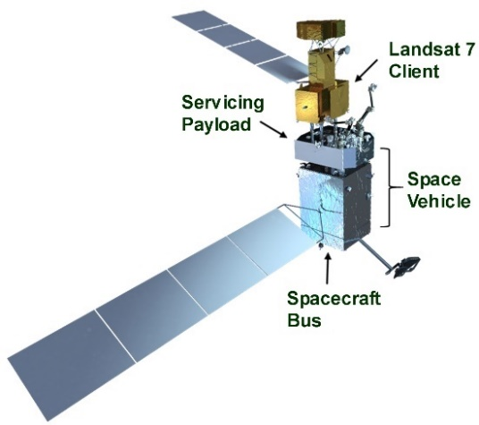
Fig. 1 Servicing satellite concept conducting propellant transfer.
There are five critical areas with the servicing of legacy satellites that OSAM- 1 developed technologies demonstrate as shown in Fig. 2:
- Rendezvous and proximity operation systems,
- High-speed, fault-tolerant computing,
- Dexterous robotics,
- Robotic tools and tool drives,
- Fluid transfer systems (FTS).
These core technologies extend to a vast number of space system architectures (Fig. 3) including government fleet management, national security assets, commercial enterprise, human exploration of the solar system, space infrastructure inspection and maintenance, asteroid redirection for planetary defense, the Artemis Program, the Moon to Mars architecture, the Gateway lunar space station, on-orbit assembly, exquisite observatory servicing, propellant depots, and orbital debris mitigation, to name a few.
Fig. 2 Critical technologies for satellite servicing.
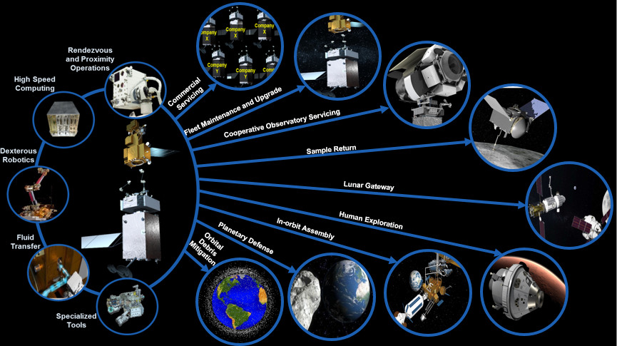
Fig. 3 Representation of servicing extensibility.
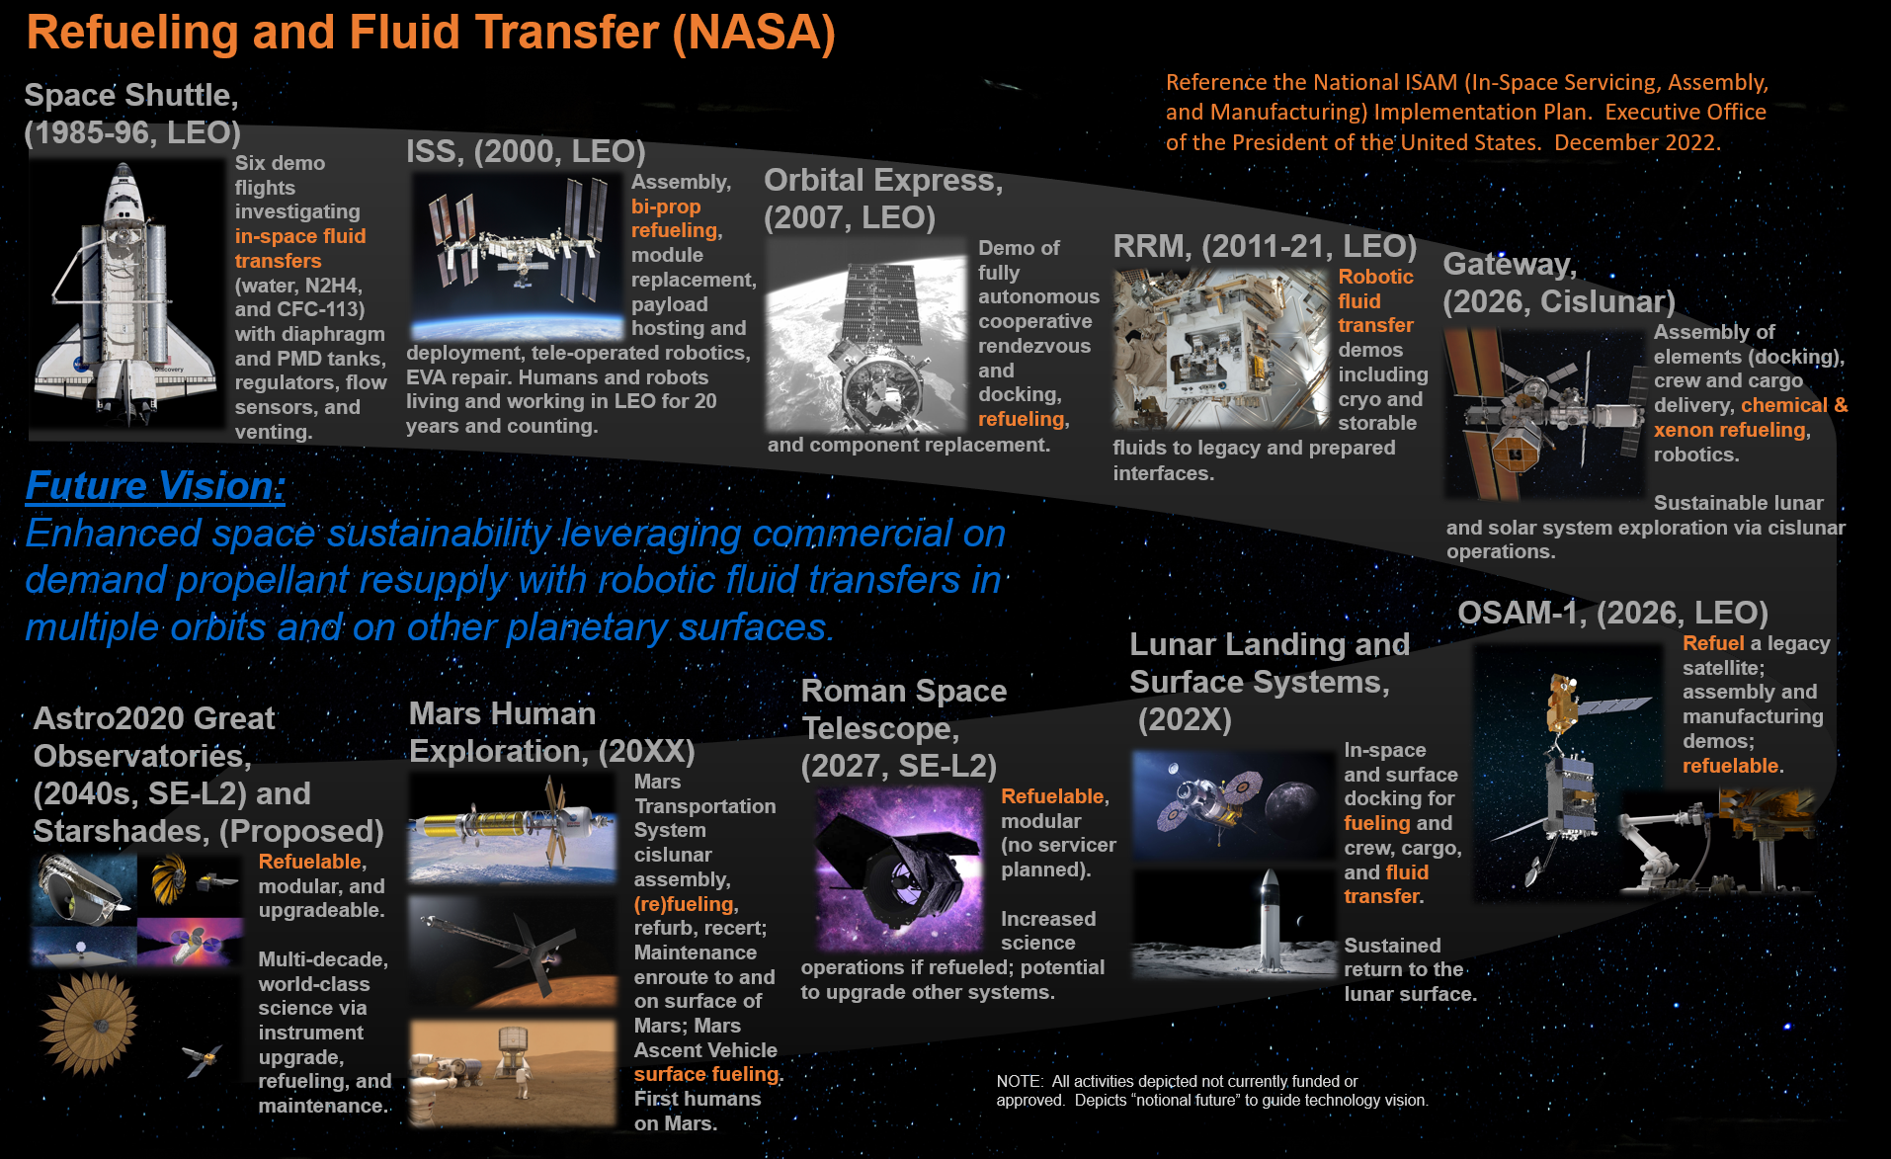
Fig. 4 Past and future in-space servicing missions.
This paper focuses on the development of fluid transfer technologies in connection with satellite refueling and the OSAM-1 mission as shown in Fig. 4 in context with other historic and potential future servicing missions. A summary of the OSAM-1 PTS development will be presented, including key milestones. Principal accomplishments, challenges, and key technological developments regarding the PTS will be discussed, highlighting the recent progress since 2020.

Propellant Transfer Subsystem.

General Description
The primary objective of the OSAM-1 PTS, specifically the Servicing Payload portion, was to safely transfer storable (hypergolic) propellant to a legacy or a newly designed cooperative satellite in orbit. A generic rendering of a satellite servicer spacecraft (like OSAM-1) and the client satellite is shown in Fig. 5, highlighting the fluid transfer line robotically connected to the client.
The propellants include reactive and corrosive commodities, specifically hydrazine (N2H4) for OSAM-1, with major concepts and hardware extensible to monomethylhydrazine and nitrogen tetroxide for other missions. Some of the principal challenges of a generic PTS development include on-orbit propellant transfer to non-cooperative legacy spacecraft, clients with varying mission profiles, potentially low residual pressure levels, types of propellant tanks (diaphragm or surface tension type propellant management devices or PMDs), and fill and drain valve interfaces (three general designs for typical United States satellites). The key technologies required to successfully transfer propellant on-orbit are the specific processes and procedures along with the associated fluid system architecture. Two of the key (unique) OSAM-1 hardware elements that enable a refueling capability are the Hose Management Assembly (HMA) and a precision fluid flow meter that both function nominally in a microgravity and vacuum environment. The PTS incorporates a flexible architecture for potential multi-client servicing and provides some extensibility for spin-off technologies to other fluid systems such as xenon, helium, and cryogenics.
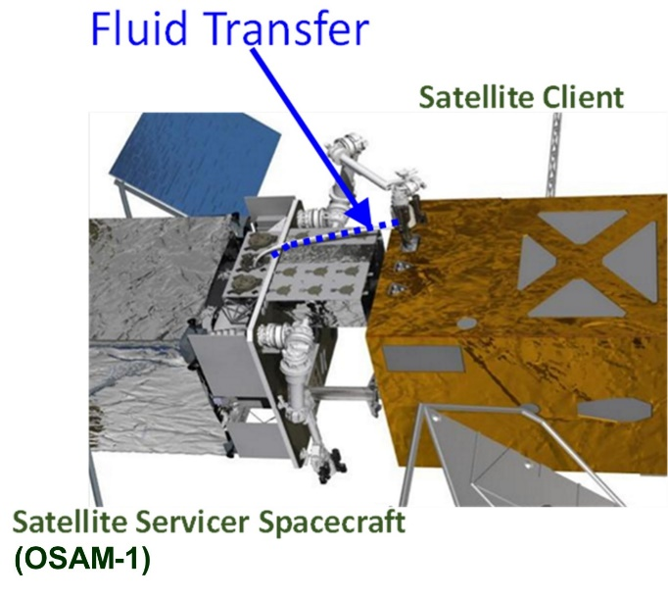
Fig. 5 Propellant transfer system with transfer line highlighted.
The illustration in Fig. 6 shows the on-orbit servicing concept of OSAM-1. To outline and define the servicing subsystems, the Space Vehicle is analogous to a fuel truck that delivers propellant and provides OSAM-1 with six degree of freedom control using its unique thruster arrangement for client rendezvous and docking. The Servicing Payload portion of the PTS contained the HMA (maneuvered using one of the two robotic arms for connection to the client fluid interface) and the Propellant Transfer Assembly (PTA), completing similar tasks to the standard gas station pumping, metering, and control systems. The Hypergol Refueling Tool (HRT) with a Quick Disconnect (QD) was developed to interface with existing client propulsion systems currently operating on-orbit. The tool can be likened to a liquefied natural gas type automobile refill end effector, but robotically mated. For the OSAM-1 mission, the primary focus was on a hydrazine propellant transfer, although the developed technologies are extensible with modification kits and delta-qualification to other storable hypergolic propellants.
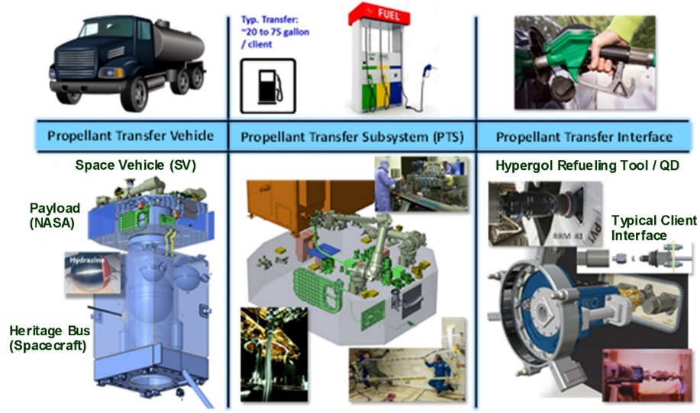
Fig. 6 On-orbit propellant servicing concept.

Basic Architecture
A notional high-level block diagram visually depicting a generic PTS architecture is shown in Fig. 7. The architecture consists of two major sections: the Spacecraft Bus propulsion subsystem and the government provided payload. The PTS is joined at an interface between the propellant tanks and the transfer modules. The Spacecraft Bus propulsion system houses the propulsion components including thrusters (with six degree of freedom vehicle control), tanks, plumbing, valves, valve drivers, etc. for different commodities. The government provided section is comprised of propellant transfer assemblies for each commodity, associated hose management assemblies, and nozzle tools that interface with the client satellites. In future missions, the servicer-to-client interface could be made cooperative (including automated coupler devices) assuming some form of cooperative servicing valves (CSV) are implemented or standardized per commodity type on future spacecraft.
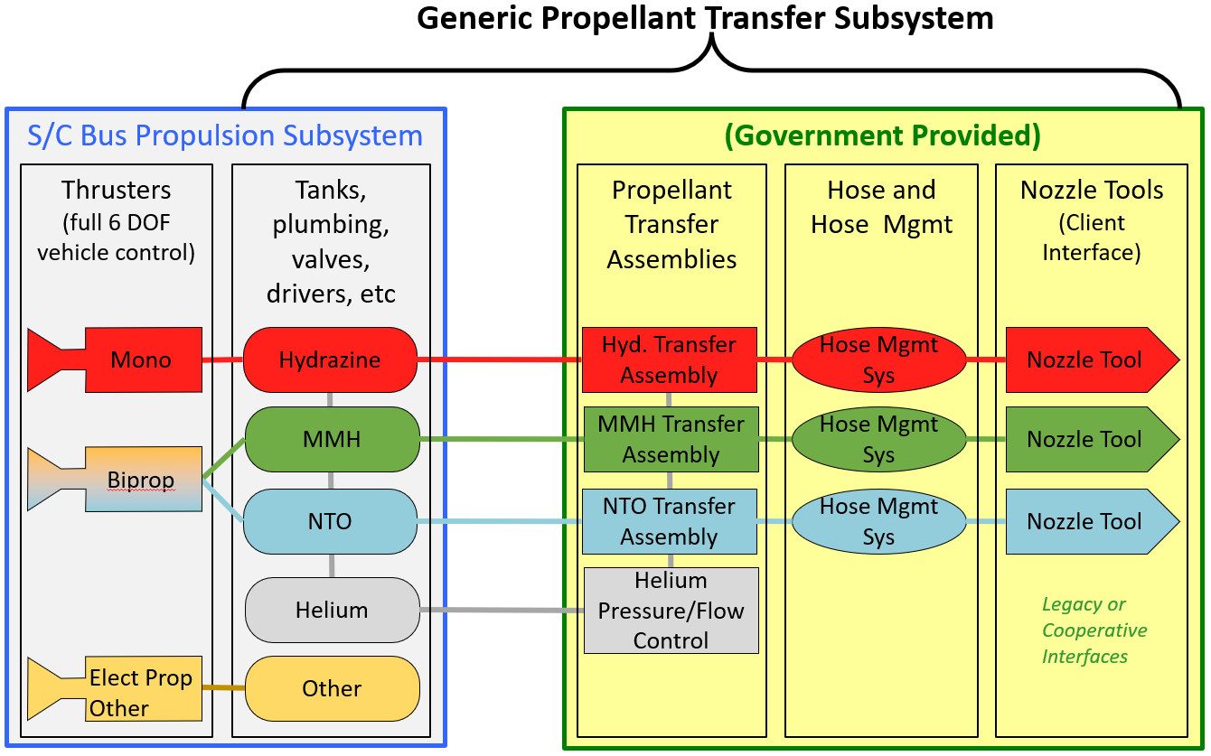
Fig. 7 Generic propellant transfer system basic architecture.
The OSAM-1 PTS development as detailed in section V and shown in Fig. 8 is a simplified version of the generic system previously shown in Fig. 7 with removal of the MMH and NTO PTS elements along with the electric propulsion system. Note the OSAM-1 spacecraft is equipped with CSV’s for potential on-orbit servicing of the hydrazine storage tanks. Following the initial development of this OSAM-1 architecture in 2018, no major subsystem changes occurred.
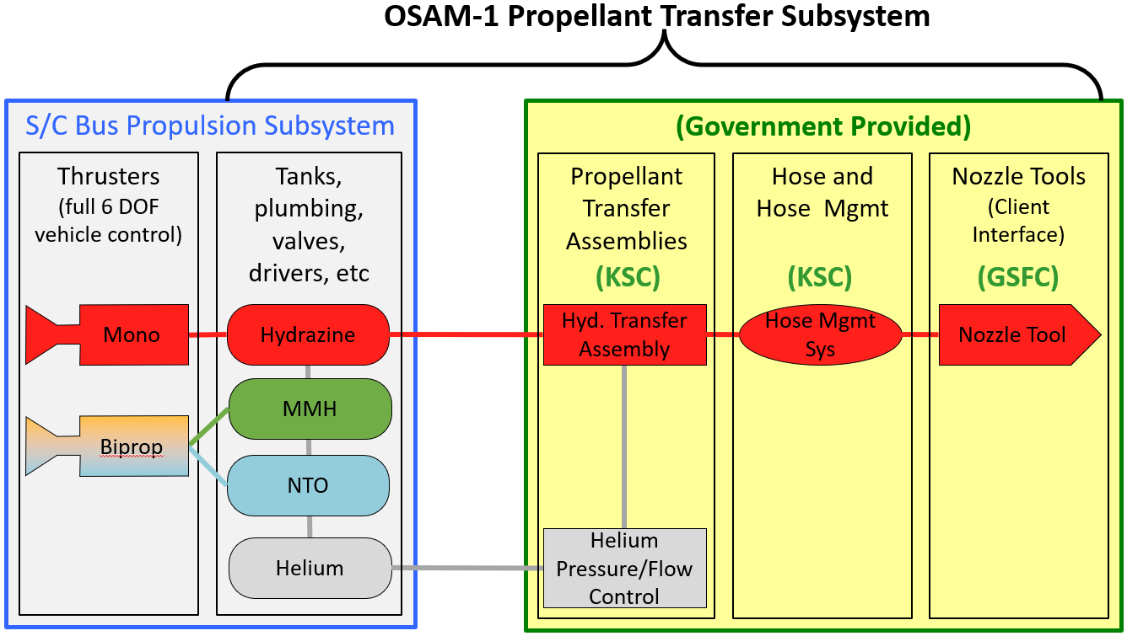
Fig. 8 OSAM-1 Propellant Transfer Subsystem overview.

OSAM-1 PTS ConOps and Architecture
The PTS for the OSAM-1 mission was designed to demonstrate refueling services to a government-owned client satellite located in LEO, Landsat 7. This section and section V focus on the functional performance, design, and requirements verification for the portion of the PTS located on the Servicing Payload. The integrated system is described in section VI.
The OSAM-1 PTS was designed to transfer propellant safely and reliably from the servicer satellite to a client satellite. It was designed to manage pressures, propellant flow, and deliver high purity grade propellant (approximately 30 gallons) to a client spacecraft such as Landsat 7. It also minimized uncontrolled propellant released to space (to reduce the risk of contamination), maintained the hydrazine within pre-determined temperature constraints, and performed leak checks within the PTS and at the client fluid interface connection. The basic layout of the PTS housed within the Servicing Payload is shown in Fig. 9. The PTS consisted of two major assemblies, namely the PTA and the HMA, which are further broken down into six subassemblies. The PTA comprised the Hydrazine Transfer Subassembly (HTSA) and the Vent Thruster Subassembly (VTSA), while the HMA included the Roller-Drive Subassembly (RDSA), Hose Subassembly (HSA), Clamshell Subassembly (CSA), and the Box Subassembly (BSA). This unique Servicing Payload PTS architecture used modified legacy spacecraft propulsion system hardware and technology coupled with safe and efficient, detailed conceptual operations.
The PTS design is considered robust and reliable, with proven legacy components extensively delta qualification tested for the OSAM-1 operational environment and ConOps applications. This excludes the flow meter and HMA which were uniquely developed and spaceflight qualified. The pressure-driven fuel transfer operations were primarily guided by legacy flight operations demonstrated on the NASA Johnson Space Center (JSC) Orbital Refueling System (ORS) Experiment^{[7,8]} along with the DARPA Orbital Express Mission. The PTS was designed to refuel an existing client spacecraft and provide the capability for cooperative refueling of itself. In the OSAM-1 PTS configuration, hydrazine and helium are supplied by the Spacecraft Bus side of the interface to the Servicing Payload PTS.
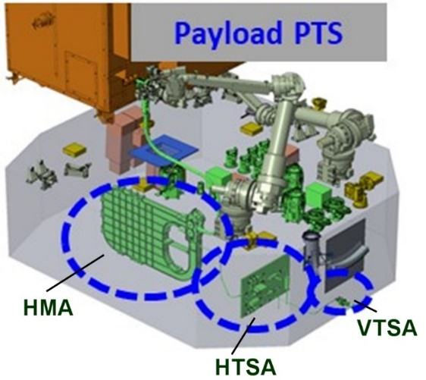
Fig. 9 Propellant Transfer Subsystems positioned within the Servicing Payload.

Propellant Transfer Subsystem Technology Developments
The PTS development for OSAM-1 is shown in Fig. 10. In the five years following the 2019 engineering Critical Design Review (eCDR)^{[9]}, the team primarily focused on fabrication, qualification, installation into the OSAM-1 Servicing Payload, and acceptance testing of the Servicing Payload PTS flight components and subassemblies along with additional risk reduction modeling and testing efforts. These efforts include the following:
- Extensive fluids testing to anchor mathematical models for the client interface liquid removal operation via an evacuation venting process,
- Pressure surge testing for the initial vacuum priming of the PTS with propellant,
- Simulated client interface leak testing,
- Propellant transfer simulations including timing of key manifold isolation valve cycles,
- HMA engineering test unit (ETU) and controller development that supported the following:
  - HMA thermal vacuum testing,
  - 200 abrasion cycle deployments of the HSA,
  - Electromagnetic interference/electromagnetic compatibility (EMI/EMC).
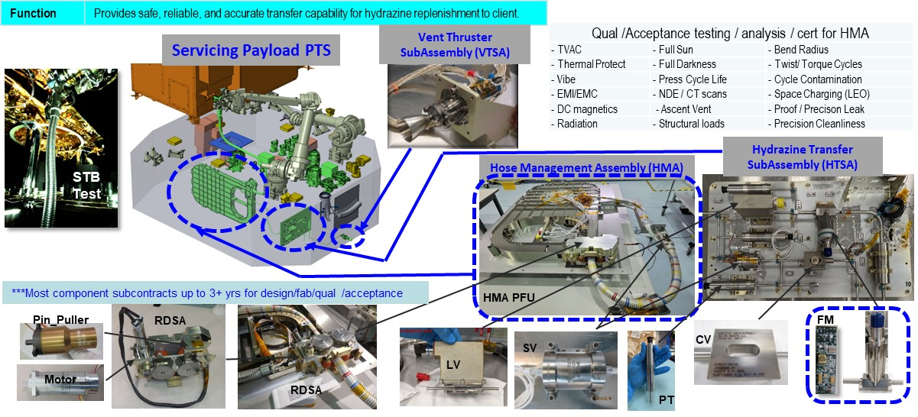
Fig. 10 Propellant Transfer Subsystem development.
The PTS Integrated Master Schedule (IMS) was updated monthly at a minimum with the details of the tasks required to fulfill the scope of work for implementation of the PTS into the mission plan. The earned value management system was used to track the progress. The final total cost of the Servicing Payload PTS for development and testing was approximately 25% over the original concept estimate at start of project, caused by extended schedule delays due to unexpected test anomalies with component suppliers along with and pandemic-related challenges.
The PTS Materials and Equipment List (MEL) was also updated monthly at a minimum. Computer-aided design and ETU weights were reconciled and input into the OSAM-1 master MEL which was refined for as-built flight component accuracy levels. The mass of the as-built PTS exceeded expectations compared to the itemized mass best estimates. Design phase mass margins were easily met.
The long lead procurements were all received (albeit with some delays due to pandemic/supplier issues) in support of the ETU test and flight hardware integration to the Servicing Payload PTS. The list of long lead components is as follows: flexhose, flow meter, pressure transducer, solenoid valve, check valve, latch valve, pin puller, motor, heaters, temperature sensors and mechanical fittings. All items were received with full end item data package (EIDP) contract certifications and records meeting the NASA technical specifications and statements of work. The flexhose and flow meter were unique designs for OSAM-1, whereas other components utilized heritage proven designs and suppliers with test qualification verified within the OSAM-1 mission parameters. The flexhose production, qualification testing, and flight unit fabrication was completed in January of 2020.
Flow meter development was met with some initial challenges with regard to manufacturing techniques for internal GFE electronic circuit boards rated for the space environment. Flight unit fabrication was completed with testing showing excellent flow rate accuracy over the required flow rate and viscosity ranges (before and after environmental testing). The flow meter ETU and flight units met the required delivery schedule to support ground ConOps testing and flight assembly integration needs. All other heritage long lead components also met the realigned mission integration schedule delivery dates. Some minor fabrication and test delays resulted in early risk reduction ETU testbed delays compared to the original mission schedule plan. The pressure transducer final acceptance and installation were delayed due to EMI issues that were resolved using stand-alone integrated component filters external to the transducers.
Along with the long lead component procurement progress, medium or shorter lead time components were procured and all received. This medium lead time procurement progress ensured hardware availability during the flight fabrication phase and finalized many mechanical and electrical subassembly interfaces. These procurements included both flight and supporting critical GSE, as well as any critical flight development and test contractor support services.
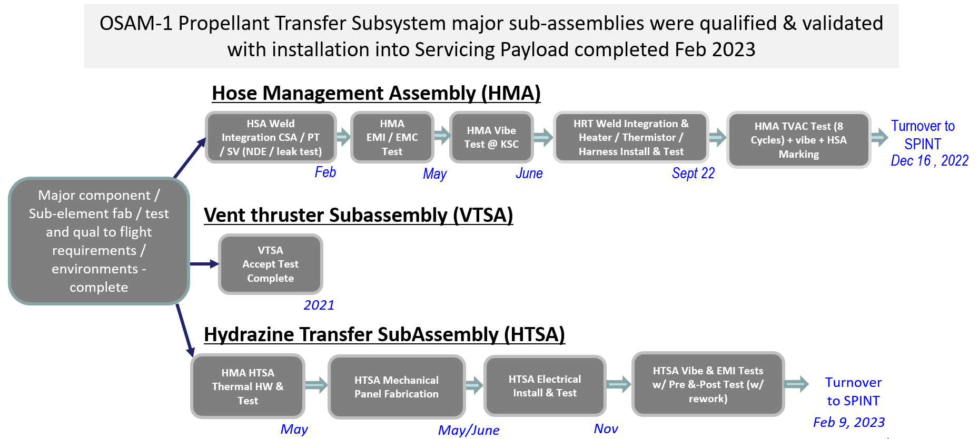
Fig. 11 High-level Servicing Payload PTS integration schedule.
The collaborative KSC and GSFC OSAM-1 PTS team successfully completed the certification turnover reviews for each major subassembly (HTSA, VTSA, and HMA) by February 2023 as summarized in Fig. 11. These reviews verified all the relevant requirements had been met and were auditable. Over 2,000 configuration management records were created corresponding to the design, fabrication, and acceptance testing of the PTS, including but not limited to drawings, analysis, procedures, work authorization records, major review packages, statements of work, technical specifications, Contract Data Requirements List (CDRLs), problem reports, deviations, waivers, and test reports for engineering development units (EDU) and flight articles.
The PTS installation into the Servicing Payload and integrated testing of the flight hardware assemblies was performed at GSFC in February 2023. The PTS was the first OSAM-1 subsystem to be installed into the Servicing Payload, enabling the remaining serial subsystems installation work to follow. The HMA, HTSA, and VTSA installations started on February 14th, 2023 and continued over a two week period with mechanical integration, interconnecting automated tube welds with non-destructive evaluation (NDE), proof and precision leak testing, and component electrical testing. Thermal closeout work then followed. Subsequent efforts of the PTS support team included integration and testing with flight avionics and Spacecraft Bus integration work starting in early 2024 while also upgrading and performing ConOps console operator training with the PTS simulator in the GSFC Robotics Operations Center (ROC). The sections that follow will discuss in more detail the specific development, installation, and testing efforts unique to the three main pieces of the Servicing Payload PTS (HMA, HTSA, and VTSA).
An OSAM-1 PTS documents summary index is available upon request (NASA document ID 20240003575) and is also stored in the GSFC configuration management (CM) system, TDMS, as OSAM1-PTS-LIST-0181^{[10]}. This index list of PTS documents is available to U.S. based commercial providers along with other government agencies.

A. Hydrazine Transfer Subassembly
The HTSA major components are as follows: propellant filter, latch valve (LV), check valve (CV), solenoid valve (SV), pressure transducers (PT), flow meter (FM), and gas orifice. The key functions of the HTSA are:
- Isolate hydrazine supplied from the Spacecraft Bus
- Measure hydrazine flow rate and totalized transfer mass after hybrid flight computing system (HFCS) processing
- Provide an interface for gaseous helium (GHe) needed for client fluid interface leak check
- Provide an interface between the HMA and VTSA needed to depressurize and evacuate propellant manifolds (including client interface).
Technical progress in some of the areas related to HTSA has been previously reported with some updates^{[11-18]}.
The drawings, ICDs, procedures, reference documents, analyses and controls were developed and released in TDMS. The as-fabricated subassembly master equipment list for the HTSA showed positive weight margin. Lessons learned, non-conformance reports (NCRs), waivers, and requirement verification items were documented. The HTSA weld plan and acceptance testing plan were successfully executed. Associated ground support equipment (GSE) and electrical ground support equipment (EGSE) development was completed and utilized to support the flight unit assembly and acceptance testing.
Following receiving inspection and integrated bench level Payload Servicing Unit (PSU) control system testing of all major flight components (see Fig. 12), the HTSA started Work Order Authorization (WOA) efforts for assembly and testing of the subassembly in May 2022. This process started with HTSA mechanical fabrication, including welding of tubing lines and fitting components (23 fluid welds and radiographic non-destructive evaluation) as shown in Fig. 13a along with thermal hardware installation and testing. This was followed by electrical integration and checkouts completed in early November 2022, vibration testing (shown in Fig. 13b), and EMI testing.
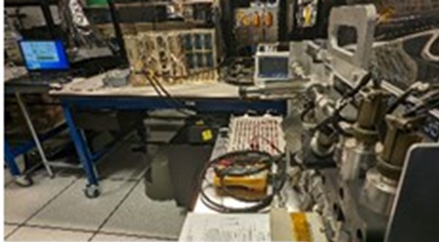
Fig. 12 PSU to LV testing.
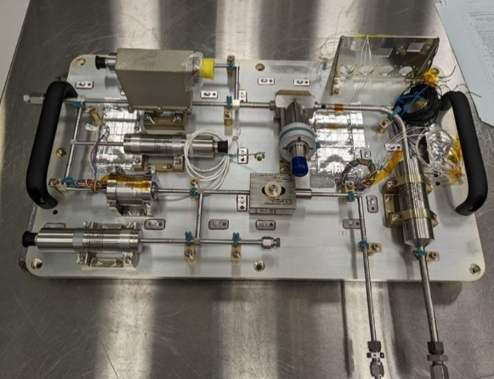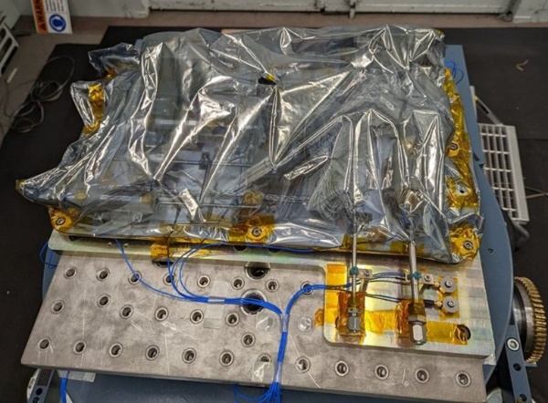
b)
a)
Fig. 13 a) Welded HTSA; b) HTSA vibration testing
HTSA EMI testing was completed in January of 2023 with the test setup shown in Fig. 14. This testing evaluated the CE03, CS114 (common and differential mode), CMCE, and in-rush EMI/EMC performance of the HTSA. These tests verified that the flight HTSA met the EMI/EMC requirements called out in the OSAM-1 Space Vehicle EMI/EMC & RF Compatibility Control Plan (OSAM1-SYS-PLAN-0009)^{[9]} with two exceptions. The questionable EMI results of one particular test led to the addition of an enhanced panel-level EMI filter (requiring minor connector wiring rework). Additionally, one of the pressure transducers was determined to be defective thus requiring weld cutout and replacement.
Following acceptance testing completion, a formal certification turnover review was conducted for approval to install the HTSA into the Servicing Payload in early February 2023 (reference OSAM1-PTS-REVW-0663, Hypergol Transfer Subassembly (HTSA) Turnover Review and OSAM1-SPINT-LIST-0125, PTS HTSA Turnover to SPINT Checklist^{[9]}).
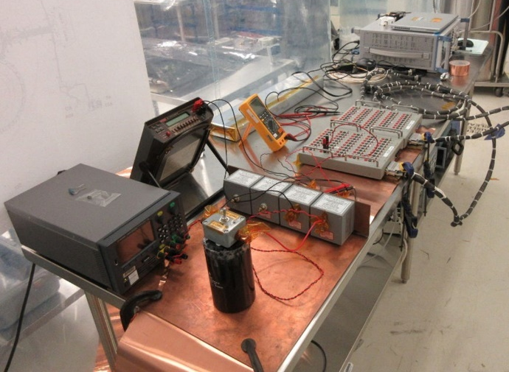
Fig. 14 HTSA EMI testing at GSFC.

Vent Thruster Subassembly
The VTSA is comprised of a legacy mono-propellant thruster with electrical and mechanical mounting brackets. The key function of the VTSA is to allow GHe and N2H4 / GHe mixtures to be vented to space (and catalytically decomposed) as part of nominal and off-nominal OSAM-1 ConOps.
The legacy thruster is a spare flight unit from the NASA Global Precipitation Measurement (GPM) mission. There is extensive flight heritage for this thruster model including GPM and the Lunar Reconnaissance Orbiter. The VTSA has series-redundant single seat solenoid valves and a bracket with four electrical connectors (primary and secondary power along with primary and secondary signal) that interface with the Servicing Payload harness. Performance information for the thruster was shown to meet all of the PTS unique vent requirements.
The as-fabricated subassembly master equipment list for the VTSA showed positive weight margin as required. Lessons learned, NCRs, waivers, and requirement verification items were documented in TDMS. All documents, flight hardware, and GSE required for the VTSA fabrication and subassembly-level testing were released in support of the start of fabrication and acceptance test efforts.
Fabrication of the VTSA was performed at the GSFC Code 597 propulsion work center. Mechanical fabrication, transition tube welding, electrical assembly and acceptance testing were completed by February 2020. The first PTS flight weld that was completed on the VTSA is shown in Fig. 15. Overall VTSA assembly and testing was completed in February 2020.
In April of 2022, additional work was completed to repeat the original GPM receiving testing for the thruster such as electrical, DC magnetics, and valve leak testing. There were no impacts noted from long term storage of the unit. Following this, a formal certification turnover review was conducted for approval to install the VTSA into the Servicing Payload as shown in Fig. 16 (reference OSAM1-PTS-REVW-0650, Vent Thruster SubAssembly (VTSA) Turnover Review and OSAM1-SPINT-LIST-0124, PTS VTSA Turnover to SPINT Checklist^{[9]}). The VSTA was welded into the Servicing Payload and acceptance tested with GSE in February 2023.
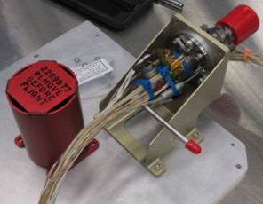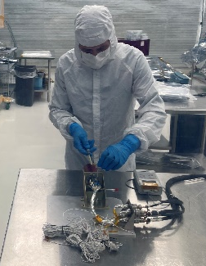
Fig. 15 PTS VTSA weld.
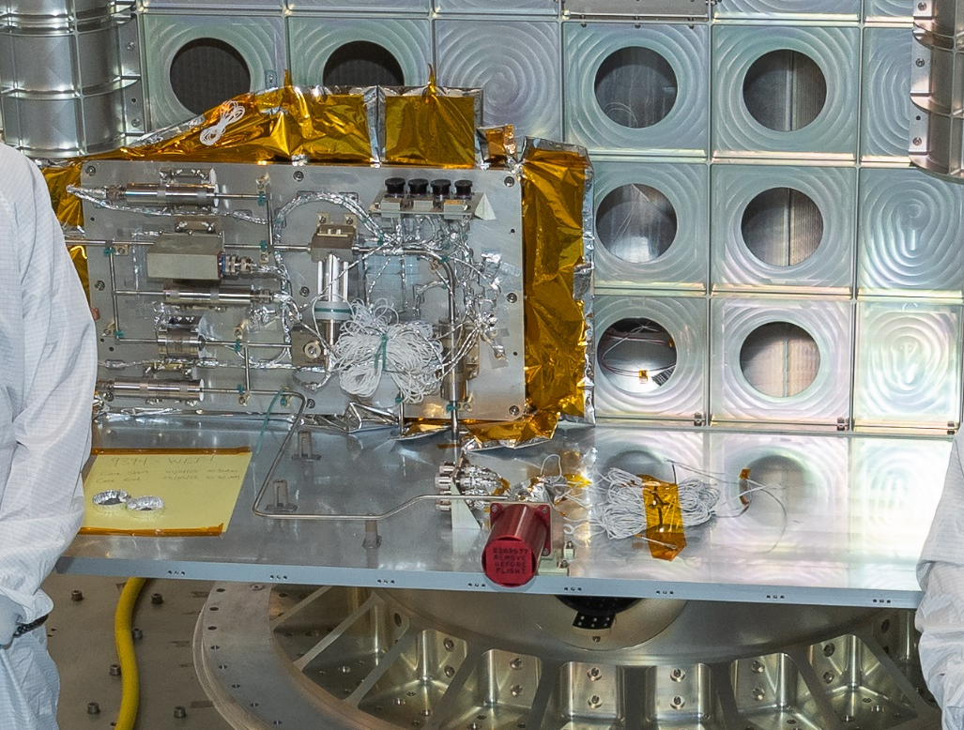
Fig. 16 VTSA installed in Servicing Payload.

Hose Management Assembly
The key functions of the HMA, comprising RDSA, HSA, CSA, and BSA, are:
- Enable the PTS to transfer hydrazine propellant to client as part of nominal ConOps ,
- Maintain fuel at required temperature range in both full shadow and full sunlight when deployed,
- Deploy and retract (stow) the flexible refueling hose (HSA) in a controlled, repeatable manner that does not damage any component of the HSA,
- Interface with HTSA and HRT,
- Be single-fault tolerant in a manner that precludes Loss of Mission.
An image of the HMA ETU (cover removed) with labels is shown in Fig. 18.
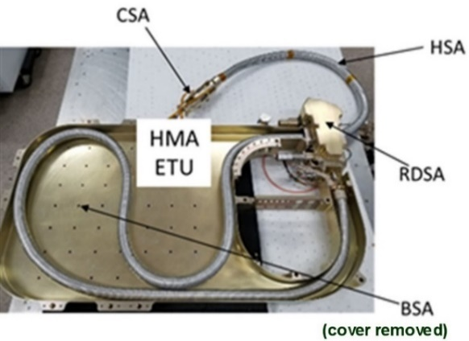
Fig. 17 HMA ETU (cover removed) with labels.
The RDSA was primarily designed per NASA-STD-5017 w/Change 1^{[19]}, Design and Development Requirements and GSFC-STD-7000, General Environmental Verification Standard for GSFC Flight Programs and Projects^{[20]}. It included an emergency-use, remotely activated, pin puller which allowed contingency roller drive release (precluding a single-point failure as the HSA can also be pulled out of the containment box or BSA by the robotic arm in the event the RDSA becomes non-functional). The RDSA enabled variable, controlled deployment or retraction travel rates of approximately 0.35 cm/s (flight) or 0.5 cm/s (ground test), via a heritage flight motor drive (a procurement shared with another OSAM-1 subsystem).
The HSA (cutaway view shown in Fig. 19) was designed and qualified for the low earth orbit environment. It includes integrated heaters and temperature sensors for accurate thermal monitoring and control of the central metal hose. An early design of the HSA was EMI tested in August of 2017 (which led to a 28 VDC filter being added). The outer conduit included a thermal coating for protection during full sun exposure while filled with static hydrazine.
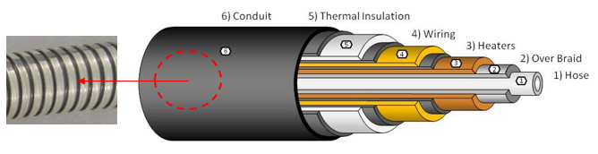
Fig. 18 HSA hose design.
The coated conduit concept underwent four rounds of abrasion testing with lessons learned and improvements to the BSA along with conduit coating, minor geometry, machine parts, and roller guide changes from October 2018 through November 2020. The final design iteration was flight qualified and met mission contamination requirements with minimal residual particulate generation. The thermal properties analyses were updated post-testing to ensure the end state of thermal coating properties met requirements with a 4x factor of safety on the required mission HSA deployment cycles.
The inner annealed stainless steel convoluted hose was 100% radiographically examined and verified to meet the 5x operating pressure to burst rating following testing to the worst case hose torque during the robotic arm maneuvering of the hose in flight. The hose was also verified to meet the performance requirements for hundreds of allowable mechanical twist, torque, and bend radius cycles. These uniquely developed specialty inner flex hose qualification tests along with the internal precision cleanliness processing certification were completed in June 2019 by a heritage aerospace hose manufacturer under a NASA development contract. The flight certified hoses were received in December of 2019.
The final HSA fabrication was initially performed at NASA on an ETU grade flight-like HSA with the inner stainless-steel hose surrounded by insulation layers, wiring, heaters, and an outer conduit. The HSA ETU was then qualification tested at the assembly level for allowable torque, twist, and bend cycles in December 2020 (summary shown in Fig. 20).
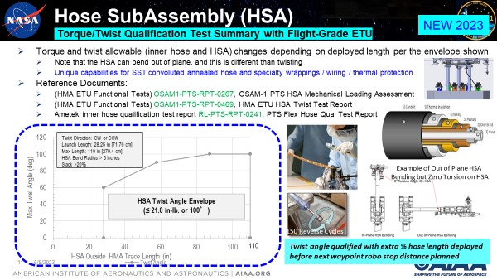
Fig. 19 HSA allowable torque and twist overview.
The CSA housed the pressure transducer and the solenoid valve. This subassembly had very stringent mass and size constraints. The primary purposes of the CSA were to link the HSA to the HRT and to house the hardware used to perform the client interface leak check, namely the pressure transducer and the solenoid valve. The total pressure measurement error for the interface leak check was determined to be less than three percent (component and avionics) for the small trapped volume between the closed client interface valve and the solenoid valve. This achieved a leak rate detection capability for the HRT to fill drain valve (FDV) volume of 5x10⁻³ sccs GHe (or better). With a notional 1% total error, the leak rate detection capability is 2x10⁻³ sccs GHe (or better).
Qualification-level vibration and shock testing of the CSA were completed in April of 2018 to validate the concept analysis and design. The HMA ETU vibration tests were completed in August of 2018. The HMA Protoflight Unit (PFU) was successfully vibration tested in June of 2022 at the KSC vibration laboratory. The final PFU results show the BSA has a maximum deflection of 0.032 inch under 3 sigma launch loads, which adequately protects the hose, and has a high factor of safety (FS) to yield. Additionally, the roller drive mechanism held the HSA in place during the worst case qualification vibration levels.
The BSA size and shape were optimized to enable storage of a connecting hose for multiple clients who may have different requirements such as reach and access, but could be tailored smaller or larger depending on the need for specific mission hose lengths. The BSA has a removable cover and vent holes for controlling the launch ascent depressurization rate. The launch environmental depressurization was tested on the HMA ETU (called the ascent vent risk reduction test) in July of 2019. The HSA ETU was installed within the HMA ETU for this ascent vent test. Both the HMA and HSA were proven to meet the subsystem level requirements (reference Fig. 23) for the launch depressurization environment.
The HMA drawings, ICDs, procedures, reference documents, analyses, and test reports were documented and archived in TDMS. Several additional details related to HMA ETU risk reduction and HMA PFU test campaigns are summarized in the following sections.

HMA Motion Operations
The HMA motion conceptual operations were investigated. Moving the HRT was a cooperative process between the robot team and PTS with alternating movements of the HSA and the robot arm to predetermined trajectory way points for specific client interface needs. High margins to movement were incorporated to prevent HSA damage such that precision accuracy of waypoint stops are not required (except for the minimum hose deployment confirmation before the next robotic arm motion). At no point were the robotic arm and RDSA motor planned to operate at the same time. During flight operations, the SV operator would command the HMA motor to either extend or retract the HSA depending on the next planned robotic arm position based on PTS team inputs. The PTS then visually verifies the HSA displacement. Following the hose waypoint movement, the Vision Subsystem provides lighting and exposure adjustment of views allowing conduit ink marks (Fig. 21) to be identified with situational awareness cameras. This verifies that the desired deployed hose length was achieved. The HFCS and PSU teams provided the control input to the brushless direct current motor on the HMA to spin the RDSA rollers for a specific time and speed. The ConOps are similar for retraction.
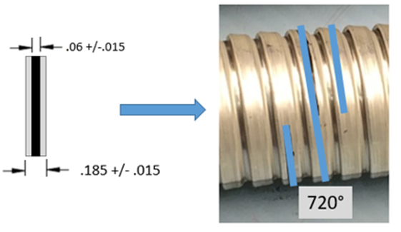
Fig. 20 HSA conduit ink marking (720°).
Test results from lights out demonstrations in the GSFC Robotic Operations Center validated the conceptual operations described above. The demonstrations successfully showed that the engineering prototypes of the subsystem assemblies can work together in a systematic trajectory-based operation to achieve the goals and objectives of maneuvering the HRT (with the attached HAS) via the robotic arm and attaching to the Landsat 7 work site (FDV area) where refueling operations are required. Visual indications were consistent with what was expected and defined in the test objectives.
An image of the Vision Subsystem situational awareness view of the HSA is shown in Fig. 22. The HSA is shown on the left side of the image coming from the HMA and goes to the top center where it interfaces with the CSA and HRT. A mockup of Landsat 7 in the background appears as a golden color due to the thermal blankets that are on its exterior. Note that the flight hardware is designed to accommodate multiple clients with different interface valve positions, and requires unique ConOps waypoint planning for each client. HMA demonstration testing for other typical clients was completed in September of 2021 under a separate generic study program called FuSeD (Future Serviceability Demonstration), which is funded by sources other than the OSAM-1 mission. The draft summary report ExISAD-FUSED-REVW-0001^{[9]} is available upon request.
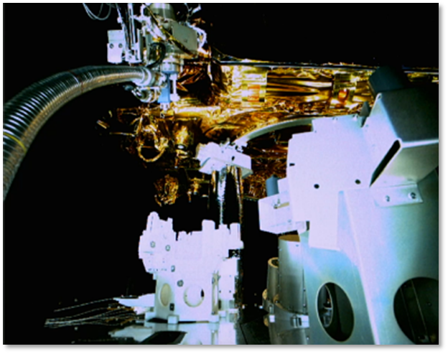
Fig. 21 Vision Subsystem Situational Awareness camera view of the HSA.

HMA Ascent Vent Testing (July 2019 at KSC VAB Test Facility)
An image of the ascent vent HMA ETU risk reduction test setup is displayed in Fig. 23. This test was performed using a specialized pressure vessel that can accurately simulate the atmospheric depressurization of a launch by depressurizing from 2 atm to 1 atm (simulating depressurizing from 1 atm to vacuum). All components performed nominally. No noticeable change in the mechanical characteristics were identified for the approximately four meter HSA after the test. In addition, a 1-m reference HSA was tested in TVAC following an ascent vent test to verify no change to the required thermal performance parameters (reference RL-PTS-RPT-0263, HMA ETU HSA Ascent Vent Formal Test Report^{[9]}).

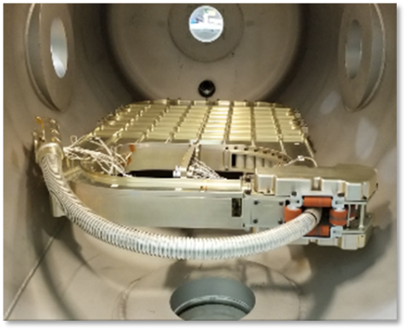
Fig. 22 Ascent vent ETU risk reduction test setup.

HMA ETU Thermal and Abrasion Cycle Testing
The HMA ETU was disassembled to apply a harder coat finish to the BSA and add minor surface contours to the exit bracket of the BSA. This reduced the likelihood of potential contamination from abrasion of the HSA conduit coating during a deployment and retraction on-orbit. An updated flight-like HSA with a flight-like ETU internal flexible hose was fabricated to support integration into the HMA ETU. The HMA ETU was assembled and the accompanying controller was built to facilitate risk reduction testing of the HMA. The ETU thermal and abrasion cycle testing was performed to evaluate the RDSA’s ability to deploy and retract the HSA (motor activation), performance of the RDSA’s contingency release mechanism (pin puller), performance of the HSA thermal conduit coating, and evaluate performance of the BSA hardened coating.
The HMA ETU was subjected to TVAC testing in December of 2019 at qualification levels for 12 cold and hot cycles followed by 50 HSA abrasion cycles (see Fig. 24). The test was conducted at GSFC Building 7, Facility 239. The objectives were to perform functional testing of the HMA ETU’s components, particularly the RDSA, after thermal soaking at each cold and hot cycle and to evaluate the performance of newly enhanced BSA (hardened) coating and RDSA roller guides to minimize abrasion-induced contamination. This testing was followed in January of 2020 by an additional 150 informational extensibility abrasion cycles at ambient temperature and pressure cycles for RDSA evaluation. Once the cycle testing was completed, powered and unpowered pull testing of the HSA was performed to confirm RDSA drive margin in excess of a factor of two.
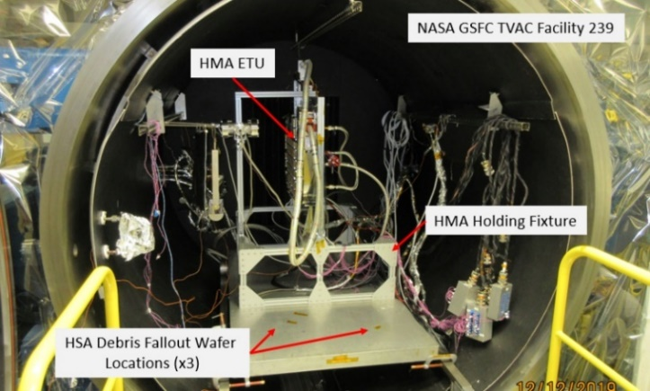
Fig. 23 HMA ETU during TVAC and HSA abrasion cycle testing.
The successful execution of these abrasion tests (final test shown in Fig. 25) by November of 2020 validated the HSA conduit design, BSA coating design, and the RDSA’s ability to provide nearly slip-free motion of the hose. Analysis of the minor level and size of particulates generated during the extended cycle testing was deemed acceptable (exceeded the cycles needed for OSAM-1) and provided some higher levels of cycle contamination data useful for future mission planning and possible further extended life cycle designs. This test also characterized the static side load experienced by the pin puller by measuring the force required to press down on the upper RDSA roller “wishbone” bracket, which was used to determine pin puller margin calculations summarized in OSAM1-PTS-RPT-0336^{[9]}.
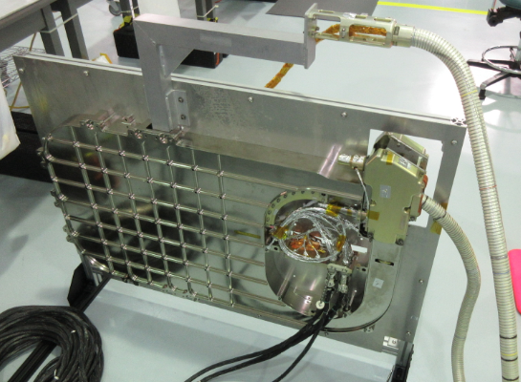
Fig. 24 HMA ETU in SSPF for abrasion test.

HMA Vibration Testing of PFU (completed June 2022 at KSC Vibration Lab)
An image of the HMA PFU vibration test setup is shown in Fig. 26 and Fig. 27. All components performed nominally with functional checks verified against performance parameters before and after vibration testing (reference OSAM1-PTS-RPT-0584, HMA PFU Vibration Test Report^{[9]}).
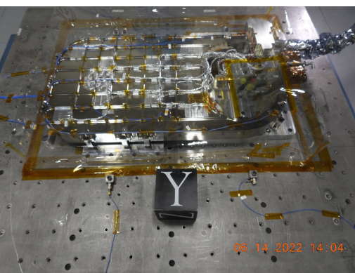
Fig. 25 HMA PFU installed on the vibration table.
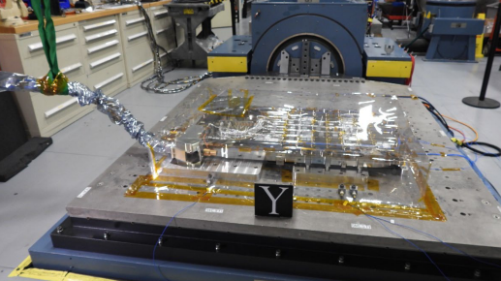
Fig. 26 HSA on vibration table with CSA suspended.

Weld Integration of Clamshell SubAssembly (CSA) to HSA
Following receipt inspection, integration of HMA PFU (shown in Fig. 28), and bench PSU control testing of all major flight components (PT, SV, and RDSA motor), the HMA team began the authoring of WOAs for integration and test of the PFU HMA in May of 2022. The clamshell end of the HSA was welded to the CSA PT and SV (shown in Fig. 29). The welds subsequently passed all NDE and precision helium leak tests. When the Tools subsystem team finished acceptance testing and successful turnover review of the HRT, this assembly was welded to the CSA tube in September of 2022.
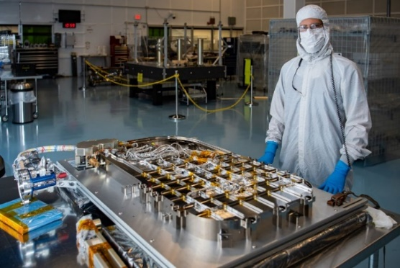
Fig. 27 HMA post checkout.
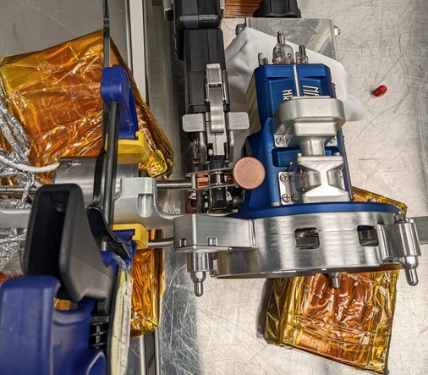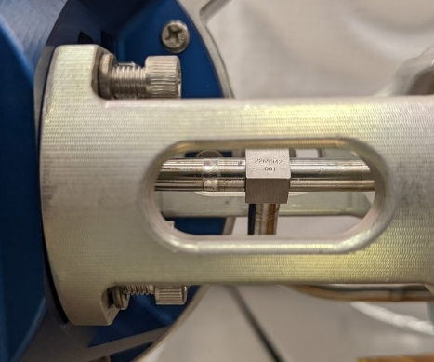
Fig. 28 Weld of HRT to CSA in GSFC building 11.

HMA PFU EMI/EMC Testing (May 2022 to January 2023)
Integrated HMA PFU EMI/EMC testing (shown in Fig. 30) was performed at GSFC. This testing verified the need for power filter integration into the HMA and HTSA PT circuits. The projected risk from early HMA EDU level testing was confirmed and retired with the addition of these filters. HMA EMI/EMC testing (ref OSAM1-PTS-RPT-0696, HMA PFU EMI/EMC Quick Look Test Report^{[9]}) included the following: CS101, CE101, CS06, CS114 common and differential modes, CE03, in rush current, RE101, RE102, DC Magnetics, and RS103.
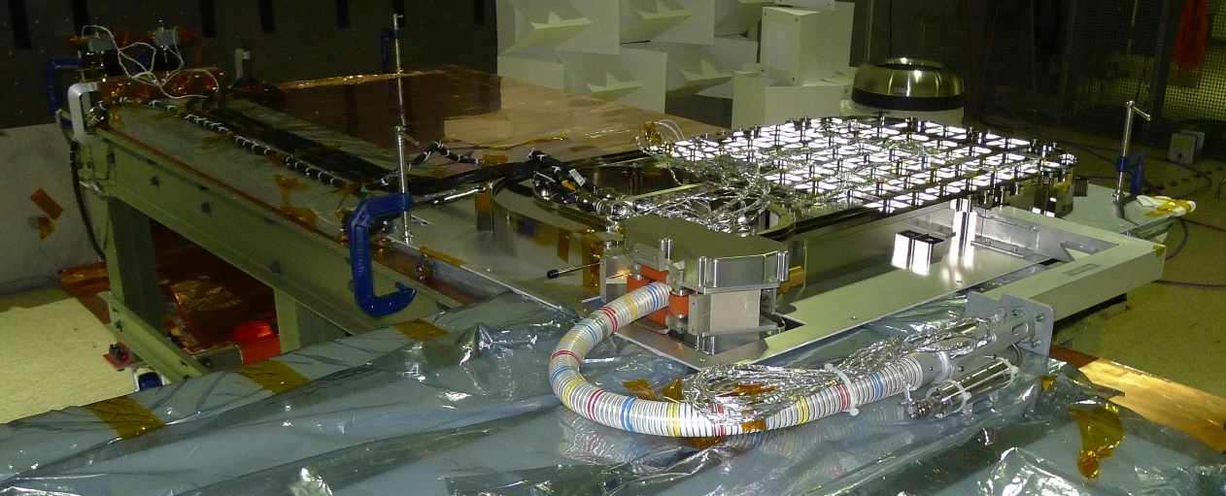
Fig. 29 HMA PFU EMI testing at GSFC building 7 test setup with capacitor network on left.

HMA PFU Thermal Vacuum testing (October 2022)
The last remaining HMA PFU acceptance test was TVAC which was performed in GSFC Facility 237 (as shown in Fig. 31 and Fig. 32). Eight thermal cycles were completed by mid October of 2022 and were followed by the final HSA conduit marking. The TVAC test was performed to evaluate the flight HMA performance when subjected to the thermal and pressure environments as specified in OSAM1-SYS-SPEC-0026, OSAM-1 Environmental Test Matrix^{[9]}. Successful test completion validated the HMA design and manufacturing. Testing was divided into two segments: 1) thermal soak and 2) thermal cycle: one chamber break took place to reconfigure the hardware from segment 1 to segment 2 (reference OSAM1-PTS-RPT-0744, HMA PFU TVAC Test Report^{[9]}). Some of the data from the TVAC test is shown in Fig. 33.
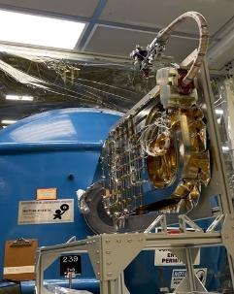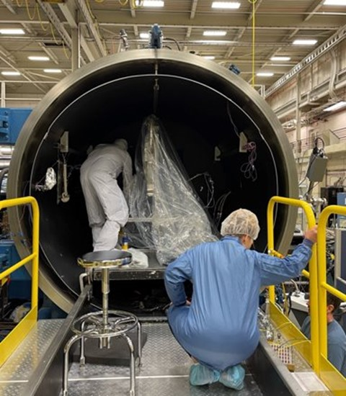
Fig. 30 HMA PFU installation in TVAC chamber.
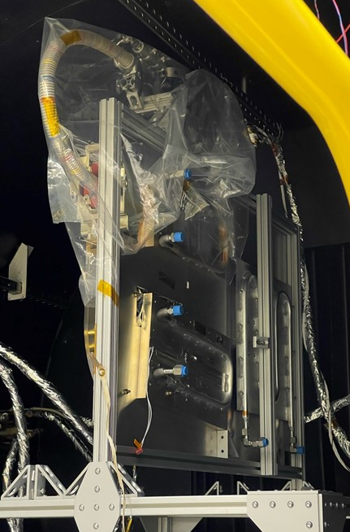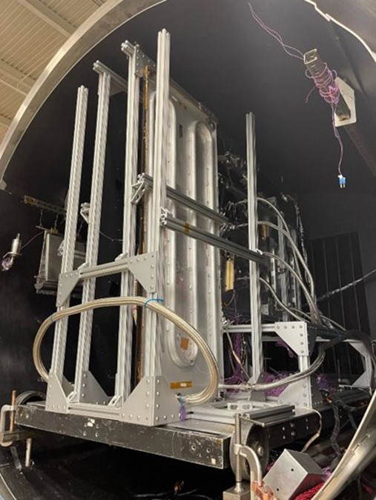
Fig. 31 HMA PFU TVAC preparation.
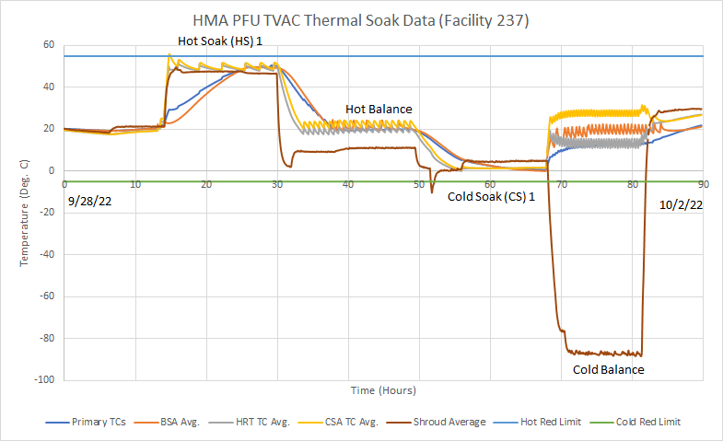
Fig. 32 HMA PFU TVAC thermal soak data.
After all acceptance testing was completed, a formal certification turnover review was conducted for approval to install the HMA into the Servicing Payload (shown in Fig. 33) by mid December of 2022 (reference OSAM1-PTS-REVW-0649, Hose Management Assembly (HMA) Turnover Review and OSAM1-SPINT-LIST-0128, PTS HMA Turnover to SPINT Checklist^{[9]}).

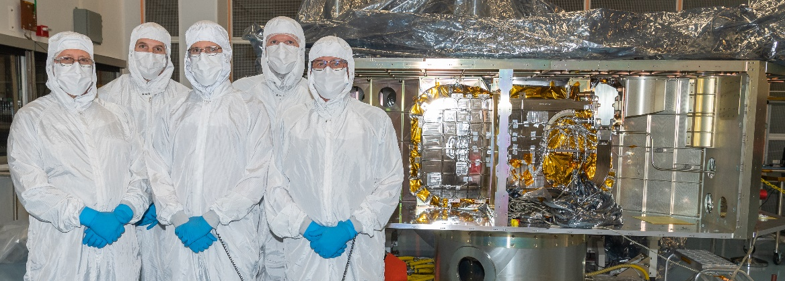
Fig. 33 HMA installed in Servicing Payload

Subsystem-Level Testing
Parallel to the support of the HTSA, VTSA, and HMA design and development, several key tests were performed in separate 2D testbeds simulating the flight article performance as well as anchoring of supporting analyses. The overhead photographic view shown in Fig. 34 of the water test setup used for the investigation of depressurization and evacuation of water from the transfer system shows the small volume and large volume regions^{[15]}. Major typical transfer subsystem component locations are also shown. The large volume is about 25 times larger than the small volume. This test setup yielded the dispersion characteristics (initial burst due to pressure differential, and a subsequent slow discharge due to evaporation) of the large volume and the small volume, correlating with the analysis model. Reference 15 presents further details of the external depressurization and evacuation testing efforts, results, and conclusions.
Another major effort investigated the flow rate and pressure drop of the PTS. This was performed using water as a close simulant fluid for hydrazine. The maximum flow rate was controlled by a cavitating venturi. The pressure drop in each of the PTS components was measured and correlated as a function of the flow rate. The performance of the venturi in both the cavitating and non-cavitating modes was characterized and compared with existing test data for water. Additionally, pressure surge testing was performed to characterize the venturi performance and the system response during a vacuum priming event. The photograph shown in Fig. 35 includes a closeup of the water flow test setup primary components. The water test data was scaled to hydrazine flow for the flight application.
The performance of the OSAM-1 PTS cavitating venturi was discussed in the public paper On the Performance of Small-Sized Venturi Flowmeters in Cavitating and Non-Cavitating Flow Regimes^{[18]}. Using the water test data for the non-cavitating regime, a correlation for mass flow rate through the venturi as a function of pressure drop was developed along with a discharge coefficient correction factor as a function of the throat Reynolds number. For cavitating flow, the critical mass flow rate through the venturi depends on the supply pressure, downstream back pressure, and a discharge coefficient.
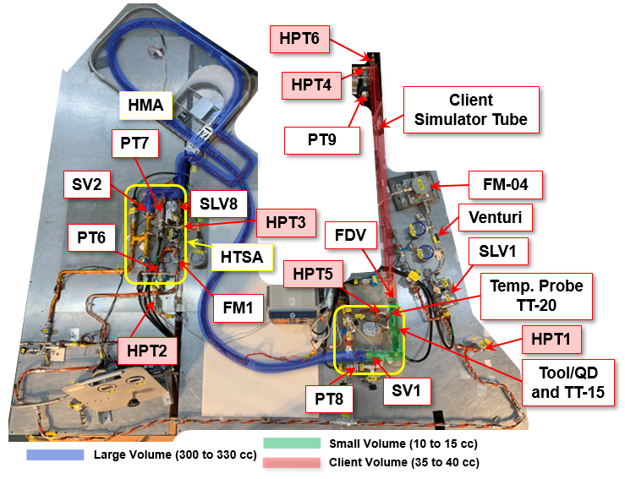
Fig. 34 Photographic view of the water evacuation test setup.
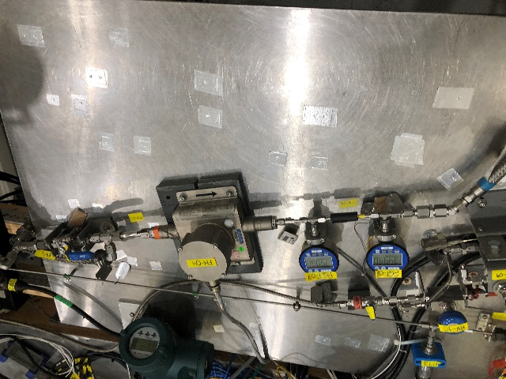
Fig. 35 Photographic view of the water flow and pressure drop test setup.
Previous work on GHe leak check investigations^{[14]} (test and analysis) focusing on the on-orbit leak test of the client interface was expanded upon. Additional investigations were carried out to determine equivalent water leak rates for a known GHe leak rate with arbitrary leak sizes. The leak test for GHe utilized the setup shown in Fig. 36a, and for water utilized the setup shown in Fig. 36b, both of which were performed with the aid of needle valve custom caliper dial mechanism. The measurements were correlated with analytical models over a wide range of precision GHe and water leak flow rates for typical credible hypergol components and mechanical connections. The water leak rate data was scaled to hydrazine for the flight application. The scaled data agreed reasonably well with data from a source that previously performed similar testing as discussed in [14]. This test data established the leak detection range of the PTS design and greatly informed the client interface leak rate requirements.
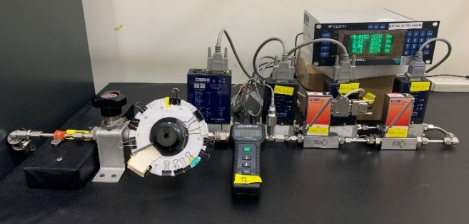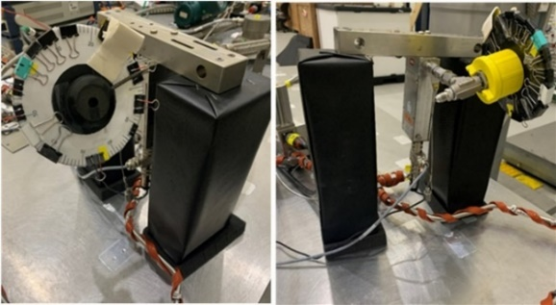
b)
a)
Fig. 36 a) GHe leak test setup photograph; b) water leak test setup photograph
The PTS team continued to support the system level testing in the Servicing Testbed following the subsystem eCDR^{[9]}. The PTS portion of the STB was upgraded with flight-like ETU HMA, LV, FM and CSA (SV and PT). Software was upgraded to mimic the flight HFCS controls. The STB re-established functionality in late 2023 to perform further integrated ConOps testing and operator training for flight as shown in Fig. 37. The STB was also available for use as an excellent tool if any on-orbit troubleshooting workarounds require evaluation.
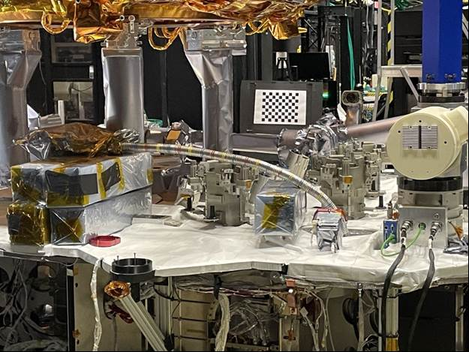
Fig. 37 Upgraded HMA ETU in the STB.

Propellant Transfer Subsystem Integration into Servicing Payload
Servicing Payload level integration and testing documentation was all issued prior to the hardware installation and test (by March 2023). The PTS integration and test flow through the Servicing Payload handover to the SV is shown in Fig. 38.
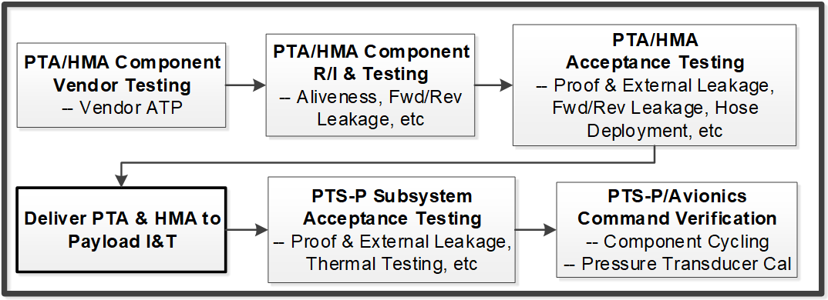
Fig. 38 Servicing Payload PTS integration and test flow through Servicing Payload handover to SV.

Integration and Test to Servicing Payload (Feb 2023)
All three of the Servicing Payload PTS subassemblies (HMA, VTSA and HTSA) were mechanically installed into the Servicing Payload in February of 2023. Proof pressure and leak testing followed the installation (reference WOA-OSAM1-SPINT-3387 PTS-P Welding & Inspection [Mechanical] [Electrical] [Propulsion] and WOA-OSAM1-SPINT-3390 PTS-P SP-Level Acceptance Testing [Mechanical] [Electrical] [Propulsion]^{[9]}). Integration and checkout with the flight PSU avionics was completed in early 2024. Multiple HMA installation practice runs were performed in the Servicing Testbed (STB) using the HMA ETU. This provided valuable insights and enabled a seamless installation of the flight hardware to the Servicing Payload.
During the PTS Servicing Payload integration, the PTS assemblies were welded together and tested. Weld head and x-ray device clearances were checked and verified to the designed manifold standoff height. The fully assembled PTS as it would mount to the Servicing Payload is shown in Fig. 39 (with the Servicing Payload structure hidden for clarity). The VTSA is also shown with the protective cover used during the integration and test campaign to prevent accidental damage. A photograph of the HTSA and VTSA installed in the Servicing Payload is shown in Fig. 40.
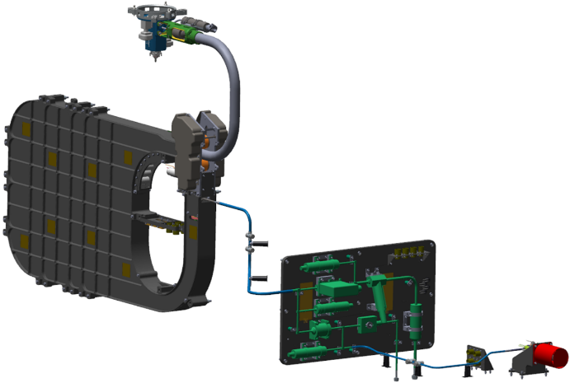
Fig. 39 Integrated PTS at the Servicing Payload level.
A structural analysis of the interconnecting lines was performed and the acceptance testing was documented including the procedure for the electrical mate to the flight avionics. All functional telemetry was checked with specialty EGSE including valve cycles, pin puller actuation, and the hose deployment and retraction. A special reset procedure was developed for the pin puller and some additional detail of tools and ConOps were documented because of the complexity of the operation.
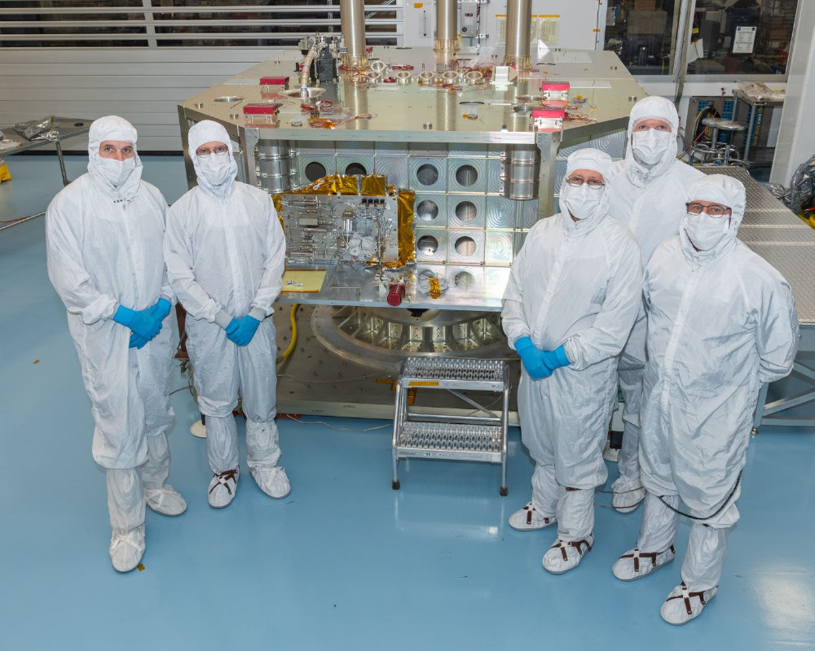
Fig. 40 HTSA and VTSA installed in the Servicing Payload.
In summary, the PTS Servicing Payload I&T activities were implemented per the nominal plan. There were no changes to the overall risk summary in Mantis (mission risk database). The risks were mitigated to green (acceptable) or closed, and any remaining residual items designated as highly unlikely risks were acknowledged for the flight certification of the as-built hardware. The acknowledged risks are related to single point failures documented in both the PTA and the HMA. The risks have been accepted as highly unlikely as documented in two engineering memorandums summarizing the risks and resolution by the robust design, test margins, and conceptual operational backup techniques.
Major changes and trades since the PDR were reported in two categories, namely, ConOps changes and trades and remain as part of the mission design baseline that was implemented. The ConOps changes comprised the following:
- The pressures across the client FDV was no longer fully balanced before valve opening (verified acceptable by testing with water).
- Initial Landsat 7 priming sequence performed with the OSAM-1 N2H4 tanks at launch pressure (lower than nominal transfer pressure) to protect against excessive adiabatic compression in the Landsat 7 lines. Once the Landsat 7 manifolds are wetted (primed), the SV N2H4 tanks would be pressurized to the nominal transfer pressure.
- Prior to disconnecting from the Landsat 7 FDV, the PTS would vent and evacuate the transfer manifolds through the VTSA for several hours (based on water testing correlated to N2H4) enabling internal system filter element bubble point breakdown and vaporization of the remaining liquid propellant. This minimized the N2H4 volume that is released upon disconnect from the client FDV.
The trades included the following:
- A decision was made to rely on software inhibits for the PTS component actuations in lieu of enable plugs (HMA pin puller is the sole exception).
- Selection of reliable and proven fluid interface line mechanical connection between the Servicing Payload PTS and Spacecraft Bus PTS. A heritage connection type was procured, along with a backup fluid interface connector.
- A decision was made to rely on the Vision Subsystem cameras to detect N2H4 leakage while flowing rather than qualify and implement a leakage detection device such as a derivative of an ammonia detector (similar to the one used on the ISS).
The propellant transfer methodology includes a PTS and HFCS transfer script that enables on-board calculation of mass flow rate and mass totalization. The on-board transfer script stops flow when a limit (transfer duration, mass totalization, or maximum pressure) was reached or a fault is detected. If the flow meter or totalizer fails, the backup plan would utilize discrete commands sent from the ground to flow for conservative time durations. Transferred mass was to be estimated on the ground while the flow was stopped (prior to restarting).

Propellant Transfer Subsystem Requirements Verification
The design of the Propellant Transfer Subsystem for the Servicing Payload was driven by the Level 4 OSAM-1 Servicing Payload Propellant Transfer Subsystem Requirements, OSAM1-PTS-REQ-0013 (as noted in the OSAM-1 Mission Requirements Tree, OSAM1-SYS-TREE-0001^{[9]}). Tankage and helium distribution systems located on the spacecraft side of the interface between the spacecraft and the Servicing Payload form part of the spacecraft requirements flow down provided directly by the spacecraft supplier, Maxar.
The Level 4 Servicing Payload PTS requirements were derived from higher-level requirements and were linked with these parent requirements in the Rational Object Oriented Requirements System (DOORS). In addition, auditable closure evidence of 132 of the 173 total PTS requirements was documented. The majority of the remaining PTS requirements were closed out with auditable evidence following the installation into the Servicing Payload in June of 2023 and interface line connections in May of 2024. For robust propellant transfer systems, final verification of requirements is completed after fuel loading at the launch site.
A verification plan was developed that followed the mission systems engineering process including NPR 7123.1B^{[21]} and the OSAM-1 Mission Systems Engineering Management Plan (SEMP), RL-SYS-PLAN-0003^{[9]}. A flow chart was prepared indicating the steps for verification activities and how those items were tracked in the configuration management system of the OSAM-1 project and within DOORS. The verification burndown plan (shown in Fig. 41) was presented at the eCDR^{[9]} and set the expectations for how and when the verification of the activities would be completed with milestone events serving as the drivers including the Mission CDR, completion of the HMA fabrication, turnover of the subassemblies to the Servicing Payload, and some of the requirements that are anticipated to be verified after Servicing Payload integration.
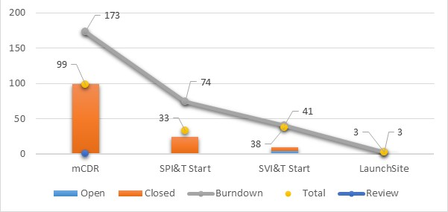
Fig. 41 Servicing Payload PTS requirements closure burndown plan.
At the completion the PTS assembly fabrication and testing, a serial incremental hardware acceptance review of each subassembly (VTSA, HTSA and HMA) was completed in January 2023 and followed the baseline acceptance review process and checklists defined in OSAM1-SYS-PLAN-0064 Propellant Transfer Subsystem Integration into Servicing Payload^{[9]}.
The PTS requirement verification plan was incrementally updated and shows detailed verification methods, events, specific plans, and evidence for each PTS requirement. All of the verification event evidence was documented in the configuration managed TDMS and tracked in DOORS (reference OSAM1-CCR-1070, Verify PTS Requirements Post Hardware Install to Servicing Payload for detail latest requirements V&V update to OSAM1-PTS-REQ-0013 – OSAM-1 Servicing Payload Propellant Transfer Subsystem Requirements, Oct 2023^{[9]}).

Integration of Servicing Payload Propellant Transfer Subsystem into Space Vehicle
Progress continued in the area of SV-level integration and testing, documentation, and the general flow is presented in Fig. 42.
Fig. 42 PTS integration and test flow through SV.
The Maxar-built Spacecraft arrived at GSFC in September of 2023. Once the Spacecraft completed a post-shipment health and safety check (including commanding, leak and functional testing of the bipropellant subsystem and Spacecraft PTS), the NASA-built Servicing Payload was mechanically installed onto the Spacecraft in April of 2024. Following fit checks of the Servicing Payload PTS to Spacecraft PTS interface lines, the lines shown in Figure 42 were mechanically installed utilizing flight-proven threaded mechanical fittings (selected due to their high reliability, and low leakage heritage) and supported using bonded standoffs. These mechanical fittings were primarily selected to preclude welding of tubes near sensitive flight electronics. In June of 2024 proof pressure and external leak testing of the PTS interface lines was successfully completed, marking the first time both the Spacecraft PTS and Servicing Payload PTS were operated and tested together.
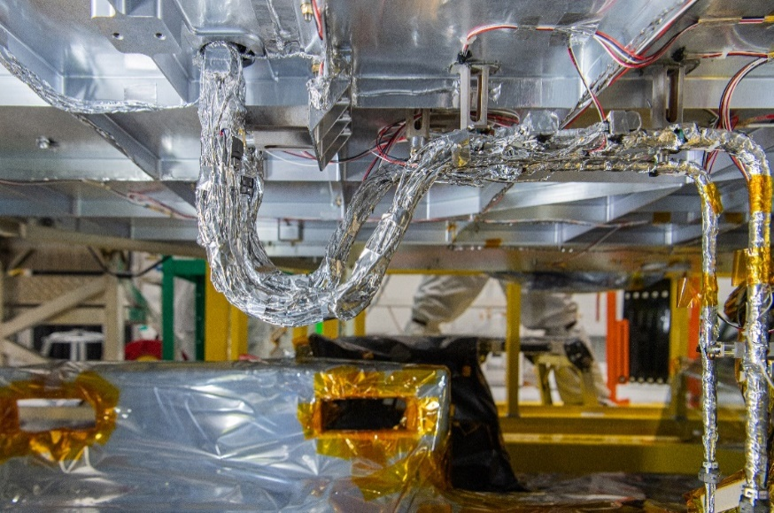
Fig. 43 Servicing Payload PTS to Spacecraft PTS interconnects.
The activities through launch site operations along with supporting GSE and EGSE development and fabrication have been documented. Some of the historical testing activities include pressure surge testing and evacuation testing conducted at KSC with ETU functional simulators. Propellant and power budgets have been updated. Similar to the interconnecting lines on the Servicing Payload, the stress analysis for lines from the Servicing Payload to the spacecraft was completed. Fault management and software requirements were summarized along with the data rates and budget. Extensive analysis and testing were performed on the integrated PTS design showing positive margins and test results. The PTS propellant transfer methodology (both primary and backup methods) enables a high-accuracy, low-risk operation. The PTS reliability analysis was conducted per the OSAM-1 mission assurance requirements and critical items were identified. PTS-specific range safety compliance documentation was produced and partnered with the relevant range safety representatives. Overall the integrated PTS installation and acceptance testing has been completed successfully and is ready for environmental testing and the launch site operations.
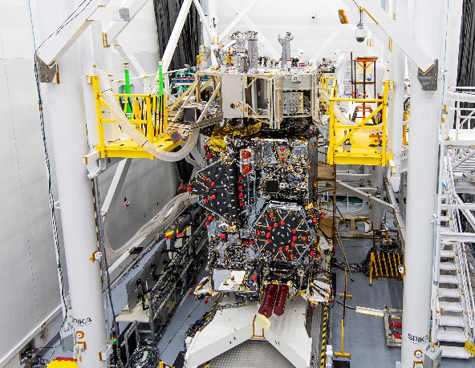
Fig. 44 Servicing Payload integrated with the Spacecraft Bus.

OSAM-1 PTS Summary
The OSAM-1 PTS development was completed to meet the revised mission IMS plan, with readiness for Servicing Payload installation several weeks in advance of the original date. Final mechanical installation, welding and acceptance testing within the Servicing Payload were completed in February of 2023, while integration, acceptance testing and thermal hardware closeout with the Spacecraft Bus PTS was completed in September of 2024.
NExIS on-orbit fluid transfer technology development and test efforts performed from 2011 to date are applicable to assist related potential commercial, government, or other U.S. space-related endeavors. A master index of all propellent transfer documentation (over 2,000 documents) was created and placed into configuration management^{[10]}. The list includes initial studies of GEO bipropellant servicing and tanker depot concepts up through the detailed OSAM-1 design and development (analysis, drawings, procedure, test reports, and ConOps documents).
A master requirements verification from subcomponent level through Level 4 Servicing Payload PTS installation was completed with the records held in the configuration management system (TDMS) with auditable evidence captured. Key intellectual property from testing and analysis efforts may be applied to various clients and multiple fluid commodities. The OSAM-1 technology demonstration focused on a hydrazine transfer in accordance with the mission specific requirements; however, functionality, safety, and reliability are extensible including the intellectual knowledge related to the ConOps and controls unique to particular clients. The OSAM-1 and generic PTS technologies are largely extensible to other NASA goals including advanced pre-staged depots or servicers, Artemis program architectures, Human Landing System (HLS), refueling of lunar, mars, or other deep space missions, and enabling servicing from in-situ propellants. Examples of the NExIS fluid transfer hardware technology, which is available and cataloged, include the following: Propellant Transfer Assembly, Hose Management Assembly, hydrazine flow meter, and cooperative servicing valves. Applications for further information may be requested by U.S. companies or interested parties by contacting the representative listed later in section XIII.

OSAM-1 PTS Conclusions
The NExIS Division of Goddard Space Flight Center in collaboration with Kennedy Space Center lead the development of technology to robotically refuel a satellite on-orbit. The OSAM-1 mission was designed to demonstrate the restoration of a heritage on-orbit satellite, extending its (or other similar client) productive operable life via demonstration of on-orbit refueling technologies and ConOps. Several key technologies relating to the Propellant Transfer Subsystem were developed, tested, and demonstrated up through integration, acceptance testing and thermal closeout with the Spacecraft Bus, as discussed in this paper.
A large body of work (analysis, testing, and development) conducted on the OSAM-1 Propellant Transfer Subsystem that was well documented (in AIAA papers and numerous Engineering Memos) is directly applicable to prepared (cooperative) refueling. The OSAM-1 mission was designed to refuel Landsat 7 via a multi-cycle adiabatic compression/cooling process with meticulous consideration to heat transfer, mass flow measurements, leak (size) detection and propellant leak rate estimation, vent dispersion (related to contamination) and depressurization, water hammer and adiabatic compression (during propellant priming), etc. This sophisticated concept of operations to service Landsat 7 took many years of development informed by the specific OSAM-1 analysis and ground test results to minimize the technical risk to the client spacecraft. High-level results reported in technical papers summarizing STS-41G testing were also used to initially develop the OSAM-1 analytical models. ConOps for prepared clients would require many similar operations and modeling to successfully transfer fluids in space.

Technology Shortfalls and Investments for Storable In-space Fluids
The OSAM-1 development effort advanced several hydrazine-based commodity transfer challenges (technology shortfalls) with some applicability to other in-space fluid transfer efforts (in addition to other technology development such as rendezvous and proximity operations, robotics, and assembly). However, there are several unique technology shortfalls and operational challenges that remain (such as those in Fig. 45 and Fig. 46) for other present and future in-space servicing with other propellant commodities.
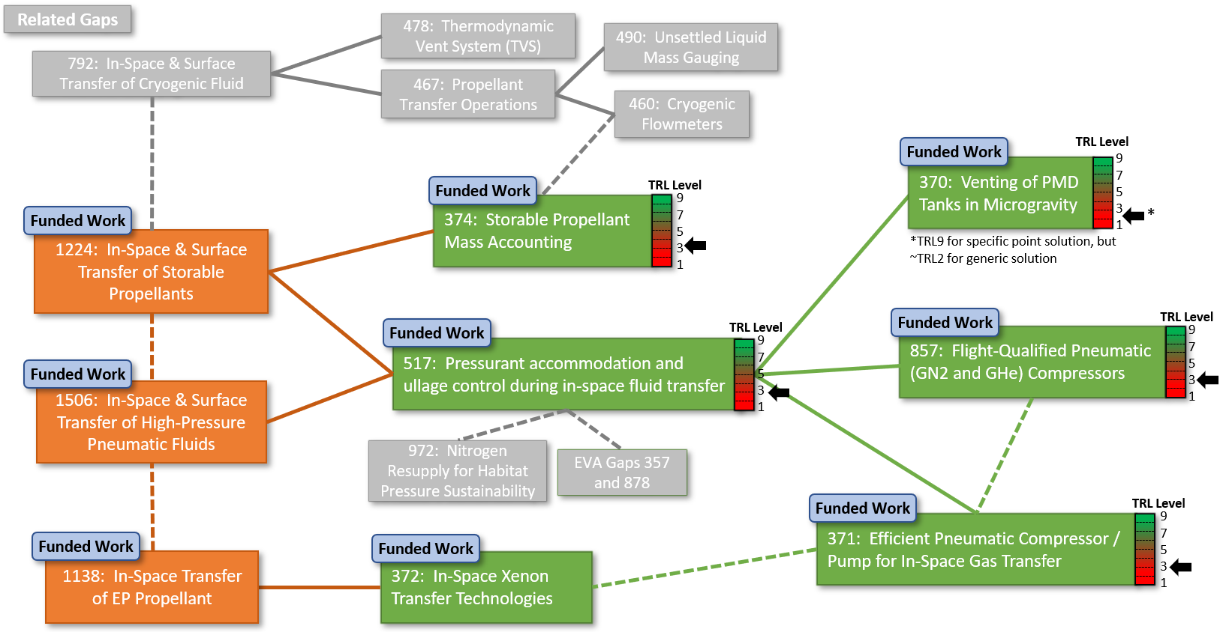
Fig. 45 Current in-space servicing technology shortfalls.
Spacecraft programs typically do not have the resources (namely schedule) for research and development efforts. The technologies shown in Fig. 45 are current shortfalls and are critical for infusion into future in-space servicing missions. Artemis, Gateway/PPE, and the Lunar/Mars HLS are all planning to perform in-space propellant resupply with Artemis, Gateway/PPE, and the Lunar/Mars HLS also planning to perform helium and/or xenon resupply. A relative scale of the difficulty of these servicing systems is shown in Fig. 47. It can be deduced from Fig. 47 that there is a large amount of advancement required to support the future in-space servicing challenges. For supporting evidence on servicing shortfalls, reference NASA/TM-2020-5007997^{[22]} from MSFC, GRC, KSC, and GSFC along with the list shown in Fig. 46. Several U.S. commercial companies are also proposing to offer on-orbit propellant services to other commercial or government customers. These commercial companies would also benefit from the development of these technologies. With NASA, Department of Defense (DoD), and commercial companies setting their sights on refueling, in-space servicing, and Lunar/Martian surface operations, the need for these technologies and optimized servicing systems are imminent.
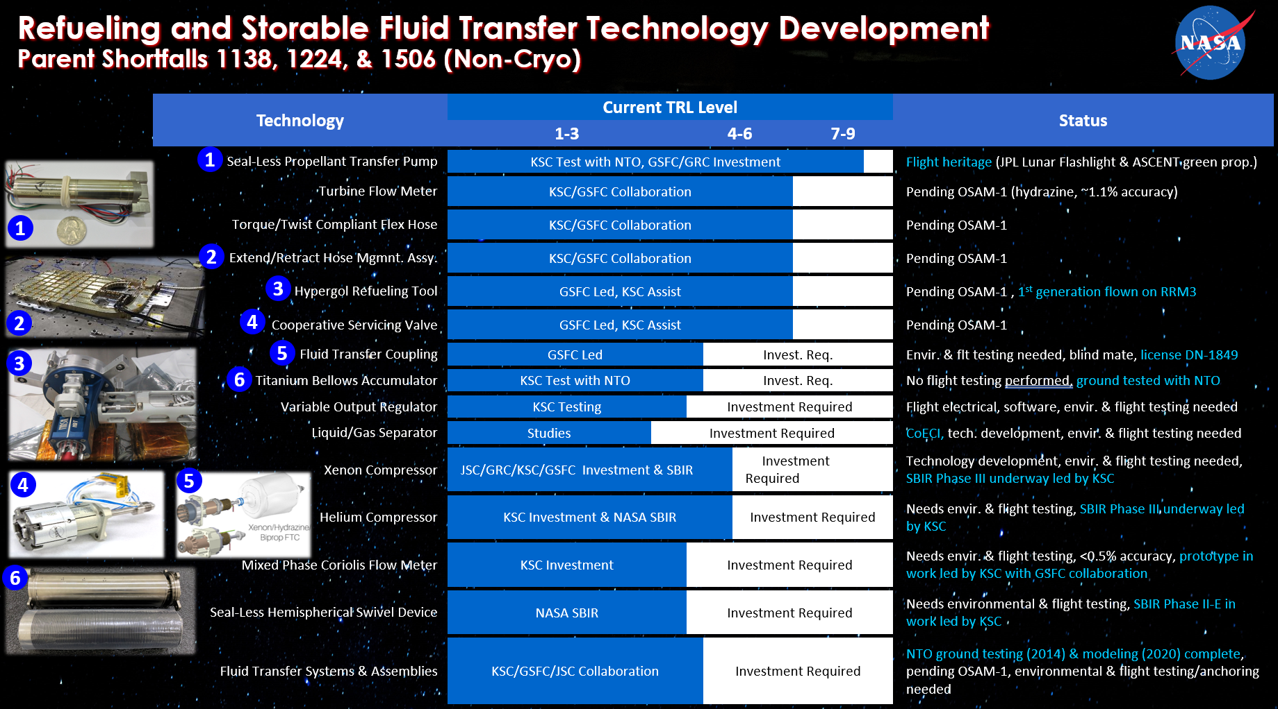
Fig. 46 Summary of NASA in-space servicing technology shortfalls and development.
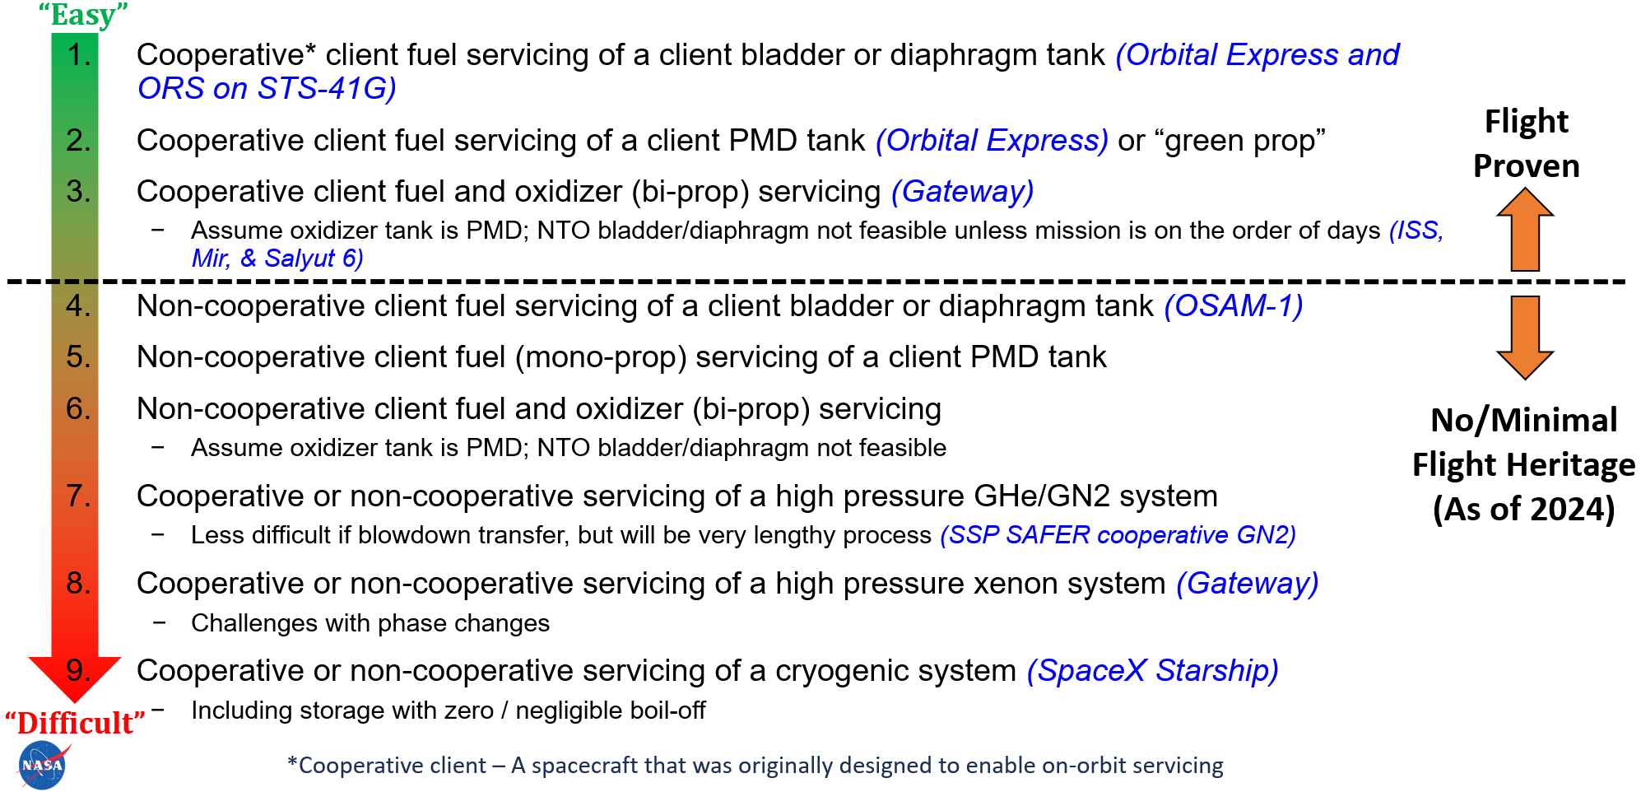
Fig. 47 In-space servicing system relative difficulty scale.
The “Critical and Emerging Technologies List Update” report^{[6]}, issued in February 2022 by the National Science and Technology Council, Executive Office of the President of the United States, declares that “On-orbit servicing, assembly, and manufacturing” is a “Critical and Emerging Technology” in the “Space Technologies and Systems Subfield.” Furthermore, the April 2022 In-Space Servicing, Assembly, and Manufacturing (ISAM) National Strategy report^{[4]} from the same Council highlights six strategic goals, with three worth noting here: “(1) advancing ISAM research and development… (3) accelerating the emerging ISAM commercial industry… and (6) inspiring a diverse future workforce as a potential outcome of ISAM innovation.” The ISAM report clearly states that development efforts should be a priority to advance this emerging sector to maintain the “United States [as the] pre-eminent leader in space exploration, development, and operations...”
The White House, DoD, commercial spacecraft providers, and NASA have all recognized the importance of the nascent on-orbit servicing industry. Current in-space fluid servicing system designs are constrained to utilize less than ideal (even inadequate) flight qualified propulsion system technologies, which often have a negative impact on efficiency, accuracy, risk, or other performance measures. Development of these technologies would resolve this issue and initiate efficient capabilities while opening new lines of business with U.S. vendors to provide new products to other interested customers.

Fluid Transfer Technology Development Effort for Storable In-space Fluids
A NASA internal Early Career Initiative (ECI) project called Advancement of Exploration Components for In-Space Servicing (AXCIS) aims to complete the design of an optimized servicing system needed for near future servicing missions by rapidly developing a suite of gap technologies with commercial partners followed by component and system level environmental testing to raise the technologies to a readiness level of 6.
The AXCIS ECI team will achieve the project goals by partnering with industry-leading vendors to design and fabricate flight-like EDUs that mimic flight designs. The first year of the project will be focused on technology development, with hardware delivery to NASA targeted for the first and second quarter of fiscal year 2025. During the second year of the project, the AXCIS ECI team will perform component level environmental testing followed by the integration of all the AXCIS ECI technologies into an optimized servicing system simulator and performing system level environmental testing, all at NASA facilities. The AXCIS ECI team is comprised of NASA engineers and mentors with specialized experience in technology development, procurement, electrical design, and environmental testing, making the team highly qualified to take on the challenges associated with completing the AXCIS project goals. Additionally, the AXCIS ECI team will leverage OSAM-1 lessons learned as well as the results from Small Business Innovation Research (SBIR) Phase I, SBIR Phase II, and IR&TD research and development efforts prior to initiating further technology development under the AXCIS ECI project, therefore providing the team with a strong design foundation, making the aggressive milestone schedule achievable.
As NASA, DoD, and commercial companies set their sights on refueling, in-space servicing, and Lunar/Martian surface operations, the need for the AXCIS technologies and optimized servicing systems are imminent. The AXCIS ECI project conclusion at the end of fiscal year 2025 will allow the developed AXCIS technologies to be infused in future missions just prior to their design freezes and assist in bringing them to the U.S. commercial market.

Technology Description
The creation of an optimized servicing system will require the rapid development of five gap (shortfall) technologies. The technology development will begin with establishing partnerships with leading vendors to design and fabricate flight-like EDUs that mimic flight designs, followed by environmental testing at NASA facilities. The AXCIS ECI team will be imbedded with the industry partners, working collaboratively on the design solutions while ensuring lessons learned about flight hardware development are incorporated. At the conclusion of the project, the team will pursue infusion of the relevant components onto a microgravity or ISS test article for further Technology Readiness Level (TRL) advancement (not funded under the ECI).

Seal-Less Mechanically Compliant Fluid Adapter
The seal-less (no dynamic seal), mechanically compliant fluid adapter is an additively manufactured, leak-proof joint technology, and is currently being developed by the Quadrus Corporation (reference Phase II SBIR Z3.05-6476, contract 80NSSC21C0500). Under the Phase II SBIR award, a prototype is being built and delivered to NASA to withstand hypergolic oxidizer (nitrogen tetroxide). It has no seals or soft goods, can move along any vector within a full hemisphere about the hinge for pitch, roll, and yaw, and could be adapted for use with any fluid interface or flexible joint under 500 psig. There is currently no dynamic seal-less mechanically compliant (small footprint) component for use with a hypergolic interface device or flexible joint such as a robotic arm. The Phase II SBIR advanced the design to at TRL 3, which AXCIS will advance to TRL 6 through a SBIR Phase II E with Quadrus and environmental testing at both the component and system level.

High Accuracy Coriolis Mass Flow Meter
A Coriolis flow meter measures mass flow rate using motion mechanics. It is highly reliable, accurate, and robust, as proven with its extensive service in the pharmaceutical, petroleum, chemical, and aerospace industries; however, these flow meters are not (yet) used on spacecraft. Due to this proven ground heritage, Coriolis flow meters are the logical choice for flow measurement during a liquid or gas fluid transfer between spacecraft. There is currently no capability for high accuracy fluid mass flow rate measurement with space-rated electronics, although many exist for ground use along with other flow meter technologies that have moderate to poor accuracy for flight use. A KSC Independent Research & Technology Development (IR&TD) project was completed with Chase Defense Partners (reference contract 80NSSC22PA670), a distributor for Emerson Micro Motion, to develop a prototype flight-like Coriolis flow meter. The project concluded in the summer of 2023. The IR&TD effort provided a prototype at TRL 3, which AXCIS is advancing to TRL 6 through a firm fixed price contract with Chase Defense Partners. The contract procures revised flight-rated EDUs for liquid flow, another for high pressure pneumatic gas flow, and a third for high pressure supercritical fluid flow. NASA will be performing the design, development, fabrication, and testing of the electrical transmitter that pairs with each sensor from Chase Defense Partners.

Helium Compressor
High-pressure helium plays a critical role in spacecraft propulsion, due to its almost exclusive use for pressurization of propellant tanks. Several different designs for helium compressor technologies have been developed for use on Earth; however, significant design changes are required to meet the power, thermal/heat dissipation, vacuum, vibration/shock, size, mass, reliability, life, and efficiency requirements needed for space and launch environments. Currently, no capability exists for mass efficient on-orbit high pressure gaseous helium transfer, nor has it ever been attempted. Flight Works, Inc. recently completed a SBIR Phase I project (reference contract 80NSSC22PB026) design and analysis effort of a flight multi-stage piston compressor. The SBIR Phase I project will be leveraged by the AXCIS ECI team to advance the component to TRL 6 with the procurement of a flight-like EDU using a SBIR Phase III contract. Due to high development costs, the helium compressor design requirements will be formulated such that the compressor design is compatible with both helium and xenon.

Xenon Compressor
Similar to helium, a high-pressure xenon transfer (including the supercritical phase) using a compressor has never been attempted in space. This ECI will enable the development of the xenon compressor technology for the eventual use of performing an in-space xenon fluid transfer (for use with solar electric propulsion). Due to the rising cost of xenon, the viable alternative propellant, krypton, will also be studied. This effort will start with a lower TRL of 2 and end at TRL 6, in-line with the other AXCIS components.

Variable Output Regulator
Variable output pneumatic gas regulators are currently utilized in launch vehicle ground processing and the petroleum industry, as well as several other industries, to control flow rate and thus downstream pressure. Typically spacecraft regulators are set on the ground and fixed for the duration of the mission. The advantage of a space-rated variable output regulator allows for the set pressure to be adjusted in flight, therefore allowing multiple clients to be serviced. This component remains underdeveloped for spaceflight and is essential for adaptability with future in-space propellant and pneumatic gas servicing systems. AXCIS will perform a NASA internal development effort to design and build a variable output regulator technology in partnership with Premier Industries (a leading regulator vendor selected via an open government contract solicitation). This component will begin at TRL 3 and will end at TRL 6.

TRL Advancement Summary
The AXCIS ECI team will rapidly advance these gap technologies and usher them through the flight hardware development “valley of death” via environmental testing to take them from a prototype to a flight qualified design. The depth of knowledge and lessons learned by the OSAM-1 collaborative team’s similar component development (shown in Fig. 46) will be utilized to guide the AXCIS team. Furthermore, industry leaders for each technology will be leveraged while using NASA test facilities to validate the designs.

AXCIS Environmental Testing Summary
Once the commercial partners deliver the hardware to NASA, testing will begin using the hands-on skills of the AXCIS ECI team, along with NASA test facilities/equipment such as TVAC facilities, EMI/EMC facilities, shock and random vibration facilities, and facilities to perform rigorous functional testing such as mechanical cycling, thermal cycling, high pressure, and flowing simulant propellants. At the completion of all testing, the lessons learned and potential design changes required for the flight units will be summarized in a final report. The specific approach/process for each technology is displayed in Fig. 48.
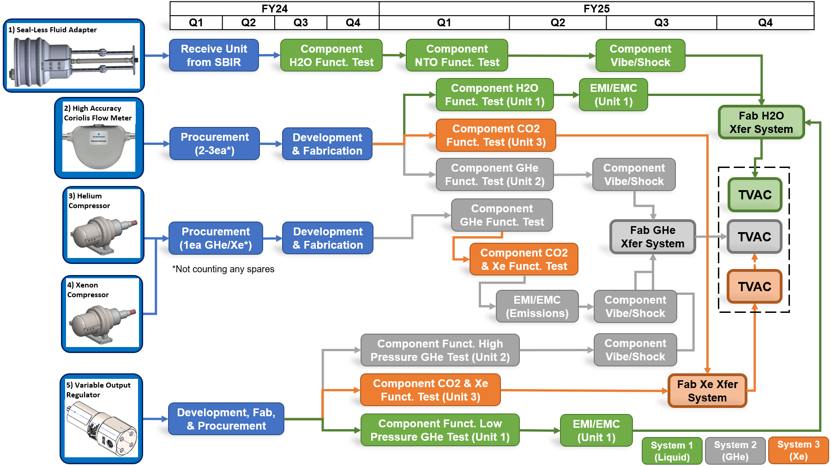
Fig. 48 AXCIS ECI project development and test plan.
All vibration, TVAC, and EMI testing will follow the GSFC environmental standard, GSFC-STD-7000^{[20]}. For cost savings, vibration and shock testing will be performed with all components at one time or via two separate tests (depending upon the delivery schedules). Vibration and shock mechanical fixtures will be designed by AXCIS ECI team members and fabricated at KSC. For the xenon compressor, the quality of the xenon and krypton are of paramount importance to spacecraft operators; therefore, any impacts from the compressor operation and/or environmental testing to the propellant purity will be given extreme scrutiny.
Three separate on-orbit servicing simulation systems (liquid transfer, helium transfer, and xenon transfer) will be designed and built by the AXCIS ECI team to perform a simulated on-orbit fluid transfer test in TVAC. These systems will enable advancement of the AXCIS components to TRL 6 within a relevant environment.

Conclusion
Routine in-space fluid servicing is coming soon with the commercial sector and U.S. government picking up where missions such as ORS and Orbital Express left off. The OSAM-1 project development was a large technological step forward in the advancement of ISAM technologies. However, there are still many low TRL technologies that remain as shortfalls for the nascent field of in-space fluid transfer that NASA has recently focused on for advancement.
With the current renaissance of commercial spaceflight and the extremely rapid pace of commercial space development, the ISAM community must remain focused and participate as members of consortiums such as CONFERS and COSMIC to keep the communication lines open and flowing. These two ventures have been chartered to carry the ISAM torch forward to achieve the goals set out by the National In-space, Assembly, and Manufacturing Implementation Plan^{[5]} and Critical and Emerging Technologies List^{[6]}. With the ingenuity, innovation, and dedication of the U.S. commercial and civil space industry, achievement of these ambitions goals is on the horizon.
Acknowledgments
This work was funded by STMD and managed at NASA GSFC NExIS under the OSAM-1 Project. Thanks are extended to the entire PTS team, including several members who contributed in the past to the OSAM-1 development.

References
[1] Coll, G. T., Webster, G. K., Espinosa M. R., Aranyos, T. J., Nufer, B. M., Valle, J. B., and Kandula, M., “Satellite Servicing Projects Division and Restore-L Propellant Transfer Subsystem Progress,” AIAA-2018-4942, 2018.
doi: 10.2514/6.2018-4942.
[2] Coll, G. T., Webster, G. K., Pankiewicz, O. K., Schlee K. L., Aranyos, T. J., Nufer, B. M., Valle, J. B., Tamasy G. J., and Kandula, M., “Satellite Servicing Projects Division and Restore-L Propellant Transfer Subsystem Progress,” AIAA-2019-4435, 2019.
doi: 10.2514/6.2019-4435.
[3] Gregory T. Coll, Graham K. Webster, Oliver K. Pankiewicz, Keith L. Schlee, Thomas J. Aranyos, Brian M. Nufer, Jenna B. Fothergill, Gabor J. Tamasy, Max Kandula, Amy M. Felt, and Neil G. Hicks, “NASA’s Exploration and In-Space Services (NExIS) Division OSAM-1 Propellant Transfer Subsystem Progress 2020”, AIAA-2020-3795, 2020.
doi: 10.2514/6.2020-3795.
[4] Executive Office of the President of the United States, “In-Space Servicing, Assembly, and Manufacturing National Strategy,” In-Space Servicing, Assembly, and Manufacturing Interagency Working Group, National Science and Technology Council, April 2022.
[5] Executive Office of the President of the United States, “National In-space, Assembly, and Manufacturing Implementation Plan,” In-Space Servicing, Assembly, and Manufacturing Interagency Working Group, National Science and Technology Council, April 2022.
[6] Executive Office of the President of the United States. “Critical and Emerging Technologies List,” Fast Track Action Subcommittee on Critical and Emerging Technologies, National Science and Technology Council, February 2022.
[7] Boyd, W.C., “Orbital Refueling System STS 41-G Quick-Look Report,” Propulsion and Power Division, NASA Lyndon B. Johnson Space Center, October 1984.
[8] Griffin, J., “NASA-JSC ORS (Orbital Refueling System) Experiment,” NASA/USAF Interchange on Spacecraft Maintenance, October 1-2, 1985.
[9] Various NASA internal documents as follows (typically with EAR 9E515 or ITAR export control protections thus requiring U.S. company requests through GSFC NExIS technologies office for release of redacted copy without any supporting company proprietary information):
- “Propellant Transfer Subsystem (PTS) Engineering Critical Design Review (eCDR),” RL-PTS-REVW-0201, July 18-19, 2019.
- “OSAM-1 Space Vehicle EMI/EMC & RF Compatibility Control Plan,” OSAM1-SYS-PLAN-0009, July 2021.
- “Hypergol Transfer Subassembly (HTSA) Turnover Review,” OSAM1-PTS-REVW-0663, February 2023.
- “PTS HTSA Turnover to SPINT Checklist,” OSAM1-SPINT-LIST-0125, May 2023.
- “Vent Thruster SubAssembly (VTSA) Turnover Review,” OSAM1-PTS-REVW-0650, November 2022.
- “PTS VTSA Turnover to SPINT Checklist,” OSAM1-SPINT-LIST-0124, May 2023.
- “HMA Demonstration Testing Report,” Future Serviceability Demonstration (FuSeD), ExISAD-FUSED-REVW-0001, 2021.
- “HMA ETU HSA Ascent Vent Formal Test Report,” RL-PTS-RPT-0263, May 2020.
- “HMA ETU 200 Cycle Mechanical Assessment Test Report,” OSAM1-PTS-RPT-0336, December 2020.
- “HMA PFU Vibration Test Report,” OSAM1-PTS-RPT-0584, August 2022.
- “HMA PFU EMI/EMC Quick Look Test Report,” OSAM1-PTS-RPT-0696, July 2022.
- “OSAM-1 Environmental Test Matrix,” OSAM1-SYS-SPEC-0026, November 2023.
- “HMA PFU TVAC Test Report,” OSAM1-PTS-RPT-0744, March 2023.
- “Hose Management Assembly (HMA) Turnover Review,” OSAM1-PTS-REVW-0649, November 2022.
- “PTS HMA Turnover to SPINT Checklist,” OSAM1-SPINT-LIST-0128, May 2023.
- “PTS-P Welding & Inspection [Mechanical] [Electrical] [Propulsion],” WOA-OSAM1-SPINT-3387, June 2023.
- “PTS-P SP-Level Acceptance Testing [Mechanical] [Electrical] [Propulsion],” WOA-OSAM1-SPINT-3390, June 2023.
- “Level 4 OSAM-1 Servicing Payload Propellant Transfer Subsystem Requirements,” OSAM1-PTS-REQ-0013 (as noted in the OSAM-1 Mission Requirements Tree, OSAM1-SYS-TREE-0001, December 2022.
- “OSAM-1 Mission Systems Engineering Management Plan (SEMP), RL-SYS-PLAN-0003, November 2023.
- “Propellant Transfer Subsystem Integration into Servicing Payload,” OSAM1-SYS-PLAN-0064, June 2024.
- “Verify PTS Requirements Post Hardware Install to Servicing Payload,” OSAM1-CCR-1070, November 2023.
- “OSAM-1 Servicing Payload Propellant Transfer Subsystem Requirements,” OSAM1-PTS-REQ-0013, December 2022.
[10] NASA ExIS / OSAM Team, “Fluid Transfer Documents ‐ Summary Index,” NASA document ID 20240003575, March 25, 2024. Also listed in NASA GSFC TDMS as “OSAM-1 PTS Team Document Summary Index List,” OSAM1-PTS-LIST-0181, January 2024.
[11] Espinosa, M.R., Webster, G.K., Coll, G.T., Nufer, B.M., Kandula, M., and Aranyos, T.J., “Internal Depressurization of Hydrazine with Application to In-Orbit Satellite Refueling,” AIAA-2018-3913, 2018.
doi: 10.2514/6.2018-3913.
[12] Kandula, M., and Nufer, B. M., “Characteristic Pressure Rise with Temperature Increase in Liquid-Locked Hydrazine Systems for Satellite Refueling,” AIAA-2018-3912, 2018.
doi: 10.2514/6.2023-3912.
[13] Webster, G. K., Coll, G. T., Kandula, M., and Nufer, B. M., and Aranyos, T.J., “Compressibility Effects on the Discharge Coefficient of Small Diameter Ratio Sharp-Edged Orifices with and without Downstream Chamfer,” AIAA-2019-3651, 2019.
doi: 10.2514/6.2021-3651.
[14] Kandula, M., Nufer, B. M., Felt A. M., Hicks, N. G., Aranyos T. J., Webster, G. K., and Coll, G. T., “Compressibility, Reynolds Number and Thermal Effects in Pressure-Decay Based Leak Detection Systems,” AIAA-2019-3437, 2019.
doi: 10.2514/6.2023-3437.
[15] Kandula, M., Nufer, B.M., Hicks, N.G., Aranyos, T.J., Webster, G.K., and Coll, G.T., “External depressurization and evacuation of water from a typical transfer subsystem,” AIAA-2020-3036, 2020.
doi: 10.2514/6.2020-3036.
[16] Kandula, M., Nufer, B., Webster, G.K., “Thermal Effects of Pressure Surge and Adiabatic Compression in the Priming of Propulsion and Propellant Transfer Systems”, AIAA-2022-4094.
doi: 10.2514/6.2022-4094.
[17] Kandula, M., Nufer, B., “On the Equivalence of Gas and Liquid Leak Flow Rates for Application to Propulsion and Propellant Transfer Systems,” AIAA-2024-1351.
doi: 10.2514/6.2024-1351.
[18] Kandula, M., Nufer, B., “On the Performance of Small-Sized Venturi Flowmeters in Cavitating and Non-Cavitating Flow Regimes, AIAA-2024-0059.
doi: 10.2514/6.2024-0059.
[19] Office of the NASA Chief Engineer, Design and Development Requirements for Mechanisms,” NASA Technical Standard, NASA-STD-5017A w/change 1, May 31, 2016.
[20] Harper, Abigail, Michael Ryschkewitsch, Arthur Obenschain, and Richard Day, “General Environmental Verification Standard (GEVS) for GSFC Flight Programs and Projects,” GSFC-STD-7000, NASA Goddard Space Flight Center, Greenbelt, Maryland 20771, April 2005.
[21] Office of the NASA Chief Engineer, “NASA Systems Engineering Processes and Requirements,” NPR 7123.1B, April 18, 2013.
[22] Pierce, Charles W. et. al, “A Review of In-Space Propellant Transfer Capabilities and Challenges for Missions Involving Propellant Resupply,” NASA/TM−2020-5007997, NESC-WP-17-01293, September 2020.
[23] “In-Space Storable Fluid Transfer,” AIAA S-157 (to be published).

NASA Satellite Servicing Technology Catalog
In addition to the OSAM-1 PTS master index^{[10]} of all propellent transfer documentation (over 2,000 documents), NASA has compiled this technology catalog to support the direct transfer of a rolling portfolio of on-orbit servicing, assembly and manufacturing (OSAM-1) technologies (hardware and software) through commercial licenses and/or other agreements, such as software usage agreements. Various NASA field centers including Goddard Space Flight Center (GSFC) Exploration & In-Space Services Division (NExIS), Langley Research Center (LaRC), and Marshall Space Flight Center (MSFC) will assist with this transfer of technology to industry, universities, other Government Agencies, and non-governmental organizations. To learn more about the NASA Technology Transfer Program and how it facilitates collaborations between NASA researchers and external parties for mutual benefit, visit https://technology.nasa.gov/network. To arrange further technical discussion of specific on-orbit servicing technologies, contact Tammy Brown (301-286-5753; tammy.l.brown@nasa.gov) of GSFC, Danette Allen (757.864.7364; danette.allen@nasa.gov) of LaRC, or Jeramie Broadway of MSFC (256.961.1372; jeramie.w.broadway@nasa.gov).
This catalog describes the capabilities and maturities of technologies developed or being developed, specifies the environments for which the various technologies will be qualified, any New Technology Reports (NTRs) or patents issued for the technology, and overall target timeframe for technology maturity. Note that the suite of in-space manufacturing technologies are at a nascent state of maturity. Accordingly you will not find individual manufacturing technologies listed by name in this release of the catalog. That will change in the future as technologies mature.
OSAM-1 technologies fall into the following groups:
- Relative Navigation System: Sensor suite (visible, infrared, lidar), Rendezvous and Proximity Operations algorithms (range, bearing, pose)
- Reconfigurable Avionics & Software: SpaceCubeTM processor, Video Distribution & Storage Unit
- Robotic Systems: NASA Servicing Arm, Robot Electronics Unit (REU), robot flight software
- Tools and Mating Systems: Advanced Tool Drive System, sophisticated servicing tools (gripper, blanket cutter, wire cutter, cap removal, & nozzle tool) and adapters, astronaut tools
- Fluid Transfer System: Propellant Transfer Assembly, zero-g fluid flow meter, hose management system, seal-less pumps and associated intellectual property of overall subsystem development.
- Cooperative Servicing Aids: Rendezvous decals, Cooperative Service Valve
- In-space Assembly: Resident space object inspection, life extension and anomaly recovery, persistent platforms, very large observatories, human exploration of the Moon and Mars, lunar surface excavation and construction, sample collection and return from near-earth objects, orbital debris mitigation/remediation, etc.
- In-space Manufacturing: Cutting, joining, and machining processes, manufacturing process, in-process inspection, repair, verification and validation, material manipulation for manufacturing.

Aerospace Technologist Aerospace Propulsion Systems, Propulsion, Mail Stop 597, Member, AIAA.
Aerospace Technologist Aerospace Propulsion Systems, Propulsion, Mail Stop 597.
Former PTS Product Development Lead, Technical Integration Manager (2010 thru 2023), Exploration Payloads, Mail Stop NE-L5, presently Commercial LEO Destination Program Deputy Chief Engineer, Mail Stop NE-TF
Propellant Transfer Assembly Lead, Exploration Payloads, Mail-Stop NE-L5.
Aerospace Technologist, Fluid Systems Test, Exploration Payloads, Mail-Stop NE-L5.
Aerospace Technologist, Fluid Systems Test, Experimental Facility Development, Mail-Stop NE-XY.

