Validation and Development of a Fast-Running CFD Model for the No-Vent Fill of Liquid Propellant Tank
H. Q. Yang¹, Jacob M. Brodnick², and Brian Richardson²
¹CFD Research Corporation, Huntsville, Alabama, 35806, USA
²NASA Marshall Space Flight Center, Alabama, USA

Cryogenic fluids, while offering higher energy density than storable propellants, present several handling challenges, including gradual boil-off and tank self-pressurization. Transferring these propellants between tanks can be problematic, as the receiving tank's temperature and pressure often lead to flashing and rapid boil-off upon injection. The No-Vent Fill (NVF) technique mitigates these risks by preventing liquid fuel from being expelled overboard. By controlling tank pressure and ensuring appropriate condensation in the ullage region, the NVF process avoids exceeding vent pressure limits. In this study, Loci/STREAM-VOF simulations were compared with data from NASA K-site test runs on a 2.1 cubic meter tank with a bottom orifice under various no-vent fill conditions, including different wall temperatures, flow rates, and inlet liquid temperatures. The effort demonstrated that Loci/STREAM-VOF is capable of quantitatively capturing the important physics of NVF with submerged jets: (1) validation of the liquid-vapor interface turbulence velocity using previous experimental data showed good agreement at different fill levels; (2) validation of the CFD Stanton number for mass transfer provided an adequate mass transfer coefficient range; (3) consistent pressure agreements were found in the pressure history for both cold and warm conditions; and (4) the variations of final pressure with flow rate and inlet liquid temperature were well predicted by the CFD simulation. The application of NVF for low-gravity conditions will be studied in future work.

Nomenclature
A area, and Antoine equation constant
c_{p} heat capacity at constant pressure
C_{m} mass transfer coefficient
e internal energy
F volume of fluid
g gravity vector
h enthalpy
k thermal conductivity
L latent heat
m interfacial mass flux
p pressure
R gas constant
Q surface heat flux
S surface
T temperature
t time

_____________________________________________________________________________________________
Chief Scientist, Aerospace and Defense Solutions, CFD Research Corporation, 6820 Moquin Dr. NW, Huntsville, AL, 35806, USA, AIAA Associate Fellow.
² Fluid Dynamics Branch-ER42, George C. Marshall Space Flight Center, AL 35812, AIAA Member
v velocity
V volume

Greek
β thermal expansion coefficient
κ compressibility
ρ density
Φ dissipation

Subscript
b turbulence velocity at the interface
face surface
g gas phase
i component in x,y, and z direction
jet jet
l liquid phase
ref reference
sat saturation

I. INTRODUCTION

Cryogenic propellants, such as hydrogen and methane, and oxidizers, like oxygen, provide high specific impulse, are non-toxic, and can be produced in situ on the Moon or Mars. Within NASA's Artemis program, which aims to return humans to the Moon, long-term cryogenic fluid management technologies are crucial for establishing a sustainable lunar presence and enabling crewed missions to Mars. Key capabilities include long-term storage in space and on planetary surfaces, as well as the transfer of propellants between spacecraft and depots. These depots can be launched empty or partially filled and refilled in space.

Transferring cryogenic propellants between operational spacecraft and storage depots is vital for future space exploration missions. Benefits of orbital refueling include rescuing space vehicles with depleted fuel, increasing payload capacity, and extending mission durations. On Earth, cryogenic tanks are filled with an open vent valve to prevent pressure build-up, as the liquid and gaseous phases are easily located in 1g conditions [1]. However, in microgravity, the unknown location of these phases can lead to the wasteful and potentially hazardous venting of liquid propellant, which could alter the spacecraft's trajectory [2].

Several methods have been proposed to refuel hot, empty receiver tanks. One such method, "chill and fill," uses the cooling capacity of the propellant itself. Cold fuel is injected into the tank in "charges," absorbing energy through boiling and convection heat transfer. After sufficient residence time, the gas is vented, and the process is repeated until the tank walls reach a target temperature. Once adequately chilled, a no-vent fill (NVF) can be initiated, transferring fuel with the vent valve closed.

The NVF technique is considered less risky because it eliminates the danger of dumping liquid fuel overboard. Controlling the tank pressure ensures that the pressure does not exceed the vent pressure limit during the no-vent filling process, thanks to the appropriate condensation in the ullage region under suitable conditions. Additionally, this technique requires minimal additional tank hardware, making the tank easier to handle and more cost-effective to launch into orbit. Modeling the NVF process highlights the importance of ullage condensation, which is enhanced by agitation or mixing of the tank contents. During the no-vent fill operation, this mixing is induced by an axial jet of incoming liquid.

At NASA Glenn Research Center (formerly Lewis Research Center, LeRC), Chato [3,4] conducted hydrogen-based no-vent filling tests on lightweight tanks with volumes of 2.01 m³ and 4.96 m³, successfully verifying the feasibility of the no-vent filling method for cryogenic fluids. The tests revealed that the saturation temperature was the most influential parameter, as the final pressures of all successful tests were close to the saturation pressures corresponding to the incoming liquid temperatures. Concurrently, Moran et al. [5,6] performed ground tests for the no-vent filling of liquid hydrogen in smaller tanks. They evaluated three injection techniques: top spray, upward pipe discharge, and bottom diffuser. Various factors, including liquid inlet temperature, initial tank wall temperature, and inlet flow rate, were tested. The data indicated that the top spray was the most efficient among the tested inlet structures.

For the analysis of no-vent fill, Chato [7] developed analytic models in 1989 to estimate the performance of two spray systems. The first system uses an array of 13 nozzles spraying through the ullage space, while the second system employs a single nozzle spraying upward from the tank bottom, quickly flooding and producing a submerged jet. Later, Taylor and Chato [8] created a new model based on equilibrium thermodynamics, which aligned well with experimental results from large-scale tanks. Majumdar et al. [9] analyzed the chill and fill of a cryogenic tank using a finite volume-based computational method for network flow analysis. Their numerical predictions of tank pressure, filling rate, and wall temperatures were compared with test data and one-dimensional (1D) model predictions, demonstrating that the axisymmetric 2D model provided more realistic predictions than the 1D model.

Recently, Pesich et al. [10] conducted a CFD validation study by modeling a liquid hydrogen no-vent fill experiment. They considered three commercial CFD codes: STAR-CCM+, Fluent, and Flow3D. All three codes successfully captured the induced slosh mode due to the upward liquid jet perturbation, comparing well with experimental data. Fluent and Flow3D predicted the initial pressure rise reasonably well, while STAR-CCM+ predicted a slower pressure rise and a lower evaporation rate due to differences in the interface capturing scheme. However, none of the CFD codes accurately captured the ullage compression at the end of the fill [10].

II. PROCESS

The principal aim of this work is to validate the Loci/STREAM-VOF CFD code and the physics models implemented for cryogenic fluid management (CFM) and propellant tank dynamics applications, specifically for predicting the no-vent fill process. The experimental data from Chato et al. [3] on ground testing of a 2.1 cubic meter cryogenic tank will be used for this validation study. Additionally, a fast-running 1-D VOF model will be developed to establish an efficient simulation of the filling process.

2.1 Experimental Description
The no-vent fill tests were conducted at the LeRC Plum Brook Station Cryogenic Propellant Tank Facility, also known as K-Site [3]. This facility is equipped to safely handle liquid hydrogen and provides the necessary vacuum for multilayer insulation systems. During the tests, the tank was filled with liquid nitrogen to create a uniform 160 R ± 10 R radiant environment for the test tank, as shown in Figure 1 [3]. Figure 2 provides a cutaway view of the test tank, showing the two filling methods: spray bar and bottom orifice. The internal instrumentation mounted from the tank lid can also be seen.

The test tank is ellipsoidal, with a major semiaxis of 0.8806 m and a minor semiaxis of 0.6228 m. It is constructed from 2219 Aluminum, chemically milled to a nominal thickness of 1.65 mm, with thicker sections where required for manufacturing, primarily at weld lands. In the no-vent fill testing modeled in this study, liquid hydrogen (LH2) entered the tanks through the bottom caps, forming a liquid jet as it passed from the inlet pipe through a nozzle orifice into the tanks (shown in Figure 2). The nozzle orifice, with a single sharp edge and a diameter of 9.5 mm, is mounted near the bottom of the tank. This setup allows the tank to fill with a jet of liquid, which becomes submerged shortly after the liquid begins to accumulate in the tank.

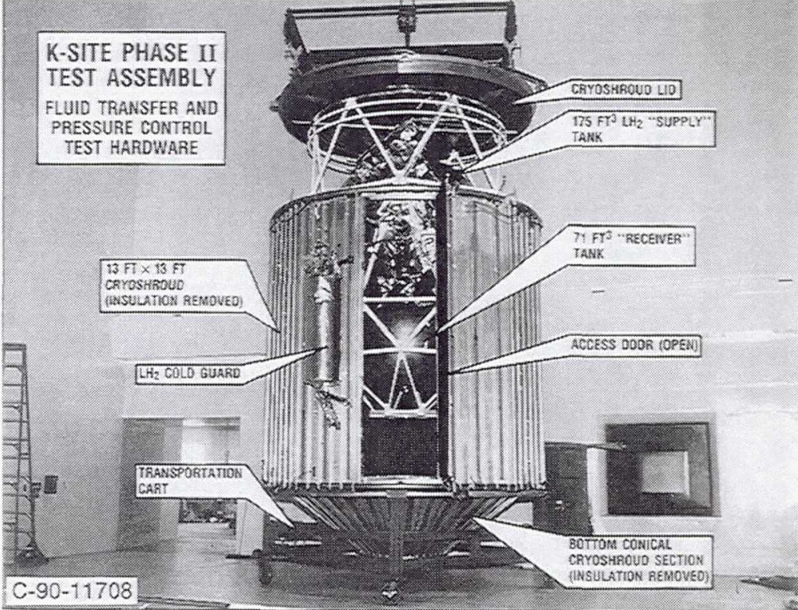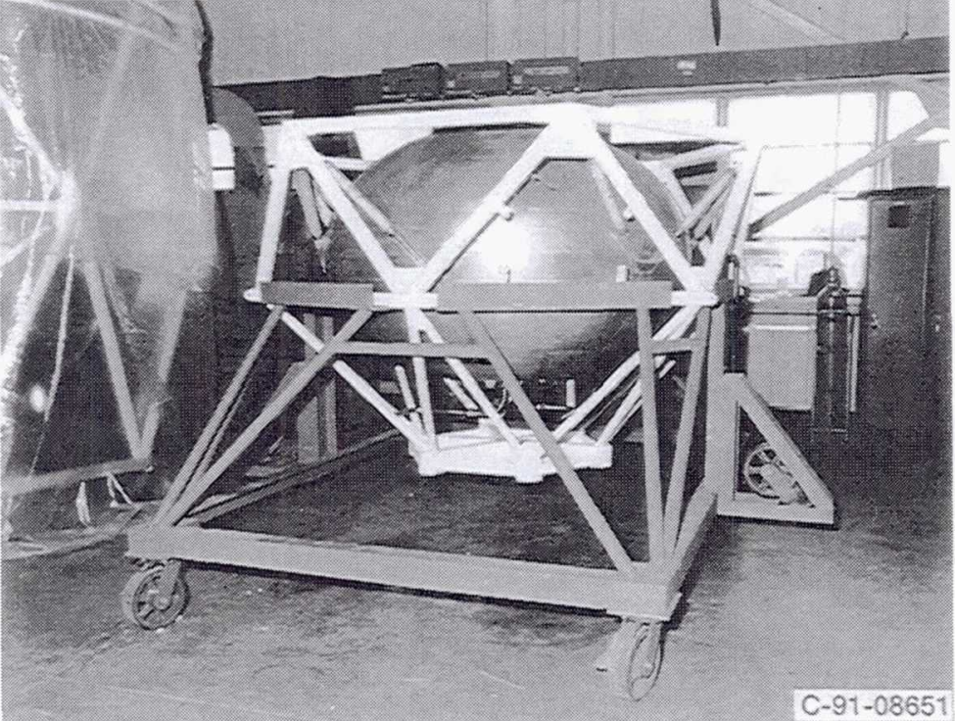
Figure 1. K-site test facility used for this validation study.

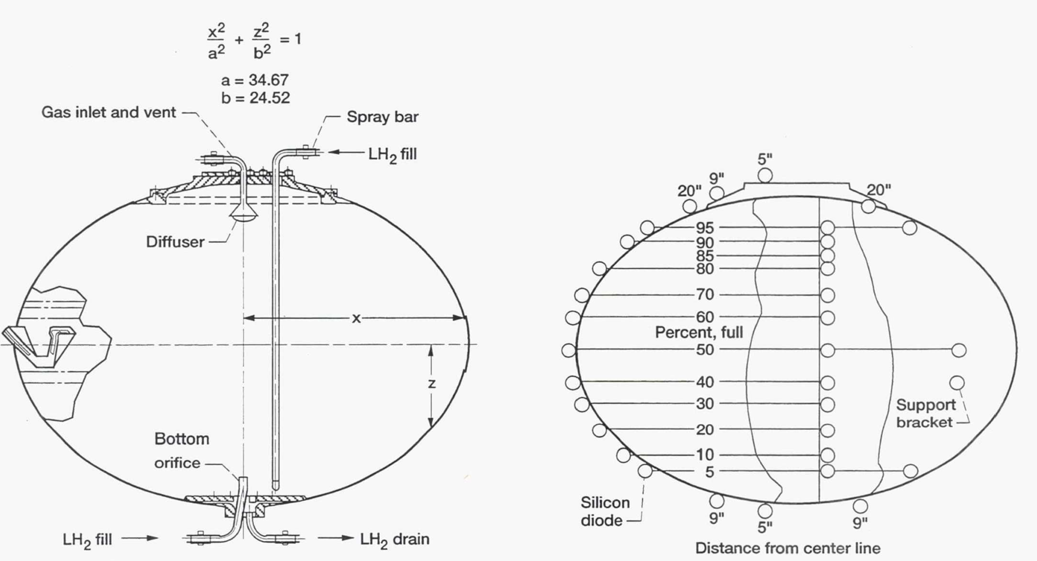
Figure 2. Receiver tank cutaway showing spray bar and bottom orifice locations (left), and instrument locations(right).

2.2 Computational Tool
The Volume of Fluid (VOF) method is a powerful and robust technique for simulating free-surface and gas-liquid interfacial flows, such as those encountered in cryogenic fluid management (CFM). The geometric algorithms used to track the interface are more accurate than other methods for simulating free-surface flows and provide excellent conservation properties when properly implemented. The Fluid Dynamics Branch (ER42) at Marshall Space Flight Center (MSFC) has developed a VOF module to enhance the general-purpose CFD program Loci/STREAM. This product, Loci/STREAM-VOF, has been applied to practical rocket propulsion-related VOF applications and has demonstrated significant parallel scalability [11-12]. The VOF solver has been used in CFM analyses and tank dynamics applications, such as propellant slosh, to extract engineering metrics like slosh frequency and damping, which are essential for system-level design and analysis [13-16].

Governing Equations and Solution Methodology
The governing equations for mass, momentum, and energy implemented in Loci/STREAM-VOF are accompanied by an additional transport equation for the Volume of Fluid (VOF). First, the governing equations for mass, momentum, and energy are:

$\frac{∂ρ}{∂t}+\frac{∂ρu_{j}}{∂x_{j}}=0$ (1)

$\frac{∂ρu_{i}}{∂t}+\frac{∂ρu_{j}u_{i}}{∂x_{j}}=-\frac{∂p}{∂x_{i}}+\frac{∂τ_{ij}}{∂x_{j}}+ρg_{i}$ (2)

$ρc_{p}\frac{DT}{Dt}-\frac{DP}{Dt}=\frac{∂}{x_{i}}\left(k_{eff}\frac{∂T}{∂x_{i}}\right)+$ (3)

where all the variables are defined in the nomenclature. The above equations are for single-phase fluids. Next, we will discuss the incorporation of two-phase fluids.

VOF Module
An additional equation for volume fraction is solved in the VOF module to consider the liquid phase and track its location. The volume fraction represents the local fraction of the cell volume occupied by the liquid of interest. All cells where the volume fraction is between 0.0 and 1.0 are interface cells in which both fluids and the interface between them exist. The spatial and temporal evolution of the liquid volume fraction is given by the following Equation:

$\frac{∂F}{∂t}+u_{i}\frac{∂F}{x_{i}}=0$ (4)

where $u_{i}$ is the velocity field.

The above Equation is nothing but a scalar transport equation; however, the advection of the VOF field using conventional finite-volume discretization techniques is highly diffusive and leads to "smoothing" and destruction of the sharp interface between the gas and liquid. To keep the interface sharp for a very long period of time, the initialization and transport of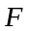 are carried out using purely geometric constructions.

The simulation of two-phase flows with VOF methods consists of three main aspects:

- VOF initialization, interface construction, and advection of liquid phase.
- Evaluation of body forces due to gravity and surface tension; and
- The coupling of body forces and density changes to the solved pressure, momentum, and energy equations.

A detailed description can be found in Reference [12].

Coupling between VOF Module and Flow Solver
For two-phase flow with gas-liquid interfaces, the density is not constant in space, and therefore, the total continuity equation has to be solved. It is given by

$\frac{∂ρ}{∂t}+∇∙\left(ρu\right)=\frac{∂ρ}{∂t}+\sum_{S}{\left(ρ_{f}u_{f}\right)}∙n_{f}=0$. (5)

In order to maintain consistency between the VOF module and Loci/STREAM flow solver, appropriate face density values are required. The face densities cannot be modeled with the STREAM implementation, which uses inverse distance weighted values from the cell centers. Instead, a new implementation of the face densities was introduced as

$ρ_{f}=\frac{ρ_{g}V_{g}+ρ_{l}V_{l}}{V_{g}+V_{l}}$ (6)

where V_{g} and V_{l} denote the gas-volume and liquid-volume fluxes across the face at a given time step. This approach is expected to provide a consistent formulation between the explicit VOF advection and the implicit STREAM time-step advances.

STREAM utilizes the cell densities based on the advected VOF and the new face densities. This provides it with the information to calculate mass fluxes into and out of each cell to solve the pressure correction and then the momentum equations.

Based on the previous work by Lowry and Yang [17], the formulation for the pressure correction equation was modified so that it uses ln(ρ) for the source term of the p' equation as recommended by Pericleous et al. [18] using a total derivative form of ln(ρ) for free surface problems as shown below:

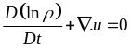. (7)

Energy Conservation Equation Modifications
Regardless of the liquid or gas phase, the original energy conservation equation is derived based on total energy conservation:

$ρ\frac{De}{Dt}-∇k∇T-+p∇.u=0$. (8)

The first term represents the internal energy increase, the second is heat conduction, the third term is dissipation, and the fourth term is the pressure work. The internal energy can be expanded as follows:

$e=h-\frac{p}{ρ}$ (9)
with the use of equations (8) and (5), we have:

$ρ\frac{Dh}{Dt}-\frac{Dp}{Dt}-∇k∇T-=0$. (10)

Using the thermodynamic relation, we have:

$dh={\left(\frac{∂h}{∂T}\right)}_{p}dT+{\left(\frac{∂h}{∂p}\right)}_{T}dp=c_{p}dT+\frac{1}{ρ}\left(1-βT\right)dp$. (11)

For an ideal gas, $βT=1$, and $dh=c_{p} dT$. Combining equations (10) and (11), one gets:

$ρc_{p}\frac{DT}{Dt}-βT\frac{Dp}{Dt}-∇k∇T-=0$. (12)

In comparison to the gas phase energy equation, the difference is the Dp/Dt coefficient. Combining the gas phase (g) and liquid phase (l) equations and weighting by the VOF volume fraction, one gets:

$\left(1-F\right){\left(ρc_{p}\frac{DT}{Dt}-\frac{DP}{Dt}-∇k∇T-\right)}_{g}+F{\left(ρc_{p}\frac{DT}{dt}-βT\frac{Dp}{Dt}-∇k∇T-\right)}_{l}=0$. (13)

After rearranging, the final Equation becomes:

$\left[\left(1-F\right){\left(ρc_{p}\right)}_{g}+F{\left(ρc_{p}\right)}_{l}\right]\frac{DT}{Dt}-\left[1-F+F{\left(βT\right)}_{l}\right]\frac{Dp}{Dt}-∇k∇T-=0$. (14)

Mass Transfer Rate
The mass transfer rate between the gas and liquid phase, $\dot{m}$, is based on the kinetic theory of the Hertz-Knudsen equation,

$\dot{m}=C_{m}{\left(\frac{1}{2πR_{g}T_{in}}\right)}^{1/2}\left(p_{sat}-p_{g}\right)A_{in}$. (15)

where $\dot{m}$is mass evaporation rate in kg/s, C_{m} is the mass transfer coefficient that lies between 0 and 1, R_{g} is the gas constant, T_{in} is the interfacial temperature, p_{sat} is the saturation pressure based on the interfacial temperature, and p_{g} is the gas phase pressure. The Clausius-Clapeyron or Antoine equation can be used to compute the saturation pressure based on the local temperature. The Antoine equation is given by:

$\log_{10}(P)=A-\frac{B}{T+C}$. (16)

where P is vapor pressure (bar), and T temperature (K). For hydrogen, the constants in Equation (16) are A=3.54314, B=99.395, and C=-7.726. The mass flux in Equation (15) is subtracted from the liquid phase equation (VOF equation) and is added to the condensable gas species equation. The associated latent heat (m*L) is added to the gas phase energy and subtracted from liquid energy.

2.3 Simulation Model
Our simulation mesh, shown in Figure 3, is a 2-D axisymmetric model. The baseline mesh consists of 8.6K cells covering the domain. A butterfly mesh is used to maintain uniform cell size and orthogonality. The tank wall mesh for solid conduction is also included in Figure 3, though it is barely visible due to the wall's thinness. In the experiment, the tank wall in the middle section is slightly thicker due to manufacturing variations. However, this variation was not detailed in reference 3, and its effect is neglected in this study. The average cell size in the fluid domain is approximately 7 mm, with a minimum cell size of 1.0 mm located in the solid domain and the orifice. A refined mesh was also generated, consisting of 19.6K cells, with an average cell size of 5.2 mm and a minimum size of 0.6 mm. The tank wall region is included for conjugate heat transfer.

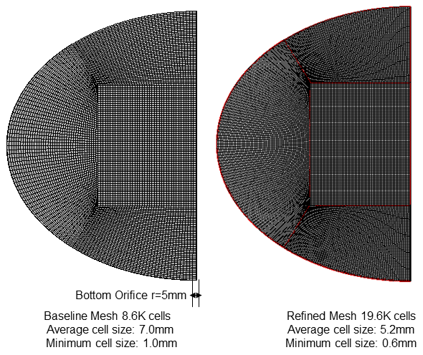
Figure 3. CFD simulation model and mesh

  - Boundary and Initial Conditions
The applied boundary conditions are such that all the walls are non-slip and adiabatic. The bottom orifice inlet is specified as a fixed mass flow rate based on the experimental condition.

2.5 Fluid/Material Properties
Fluid and material properties were extracted from the National Institute of Standards and Technology (NIST) databases [19]. The liquid-related properties and solid conduction properties are listed in Table 1. The gas properties are taken from the existing thermodynamic table in Loci/STREAM.

Table 1. Thermodynamic Properties of LH2 and Solid Alumiunz Used in the Simulation
Parameters | Description | Value
$$ρ_{l}$$ | Liquid density | 70.42 kg/m³
$${\left(c_{p}\right)}_{l}$$ | Liquid-specific heat at constant pressure | 9516.0 J/Kg K
$$k_{l}$$ | Liquid thermal conductivity | 0.1037 W/m K
$$μ_{l}$$ | Liquid dynamic viscosity | 1.35x10⁻⁵ Kg/m s
β | Liquid volume expansion coefficient | 0.0168 /K
L | Latent heat | 4.458x10⁵ J/kg
σ | Surface tension | 0.0020 N/m
$$ρ_{s}$$ | Solid density | 1200 kg/m³
$${\left(c_{p}\right)}_{s}$$ | Solid-specific heat at constant pressure | 400.0 J/Kg K
$$k_{s}$$ | Solid thermal conductivity | 0.14 W/m K

As the liquid density is assumed to be constant, the buoyancy force in the liquid phase is taken into account by the Boussinesq approximation. The liquid density is considered as a linear function of temperature in the gravity term:

$F_{g}=ρ_{l}g-ρ_{ref}g=\left[ρ_{ref}-β_{l}ρ_{ref}T-ρ_{ref}\right]g=-β_{l}ρ_{ref}T$. (17)

The k-ω shear stress transport turbulence model (k-ω-SST) will be used in this validation. The initial time step size for the simulation was set to dt=1e-5 sec. for all cases. For the calculation of a stable time step for the VOF module, a CFL number of 0.2 was chosen.

III. RESULTS

The following section presents the simulation efforts for validating Loci/STREAM-VOF using the experimental data from Chato et al. [3] for the no-vent fill of a 2.01 cubic meter cryogenic tank.

Figure 4 illustrates the various conditions tested by Chato et al. [3] during the bottom orifice filling experiments. These conditions are categorized based on the initial wall temperature into three main groups:
- Cold wall
- Warm wall
- Hot wall

The measured pressure histories for different cases are shown in Figure 4.

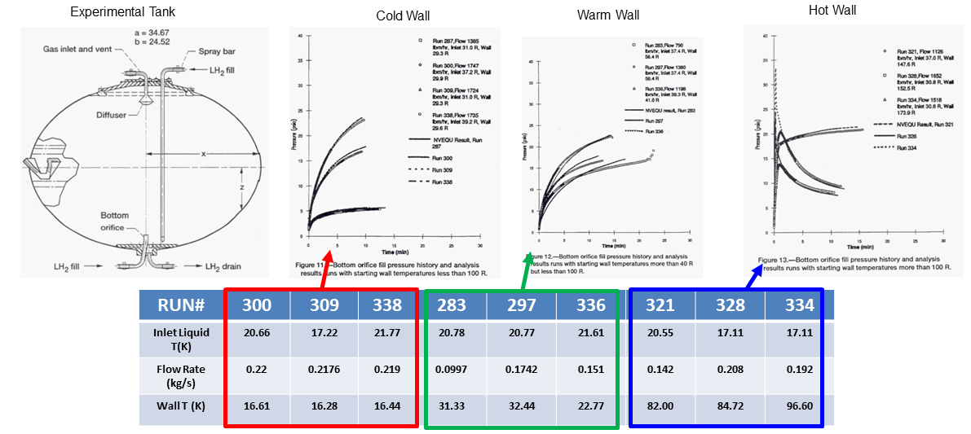
Figure 4. Test conditions conducted in [3].

Since the filling process involves a bottom orifice, the tank mixing induced by an axial jet is highly turbulent and significantly influences the interface heat and mass transfer. We will first validate our CFD model against the condensation of pure vapor on a subcooled, turbulent liquid with a shear-free interface.

3.1 Validation of Liquid Surface Turbulent Velocity and Vapor Condensation in a Mixing Tank
Ullage condensation in the no-vent fill process is promoted by the agitation or mixing of the tank contents. During the tank fill operation, this mixing is induced by an axial jet of incoming liquid. It is crucial to validate the CFD model's capability to capture the mass transfer in the mixing tank. Sonin et al. [20] investigated the condensation of pure steam on a shear-free water interface, where calibrated turbulence was imposed from below, as shown in Figure 5 on the left. They found that vapor condensation into the liquid surface was closely tied to the turbulence structure near the interface and concluded that the condensation rate could be correlated using a constant Stanton number based on the liquid-side turbulence intensity. Using their measurement data, they developed a correlation to predict surface heat and mass transfer [20]. This correlation was further refined by Brown et al. [21,22] through additional experiments and by Lin and Hassan [23] using CFD k-ε turbulence modeling. Based on Lin and Hassan's work, the area-averaged value of the interfacial turbulence can be expressed as:

$v_{b}=v_{jet}(2.39-\frac{0.645z}{D})\frac{d}{D}$ (18)

where v_{b} is the area-averaged turbulent velocity at the interface, v_{jet} is the jet velocity, z is the liquid fill height, d is the jet diameter, and D is the tank diameter, as defined in Figure 5 on the right. The above relationship is valid for jet Reynolds number of 10 < Re < 60,000; 15 < D/d < 70, and 0.5 z/D < 2.5. Lin and Hasan further showed that the interface area-averaged mass transfer is

$\overline{m}=\frac{ρC_{p}St\left(T_{s}-T_{out}\right)v_{b}}{h_{fg}}$; $St=\frac{0.0198}{{Pr}^{0.33}}(1-\frac{Ja}{2})$ (19)
were ρ liquid density, C_{p}, the liquid special heat, T_{s} and T_{out}, the saturation, and liquid temperature. St is the Stanton number. Ja is the Jakob number.

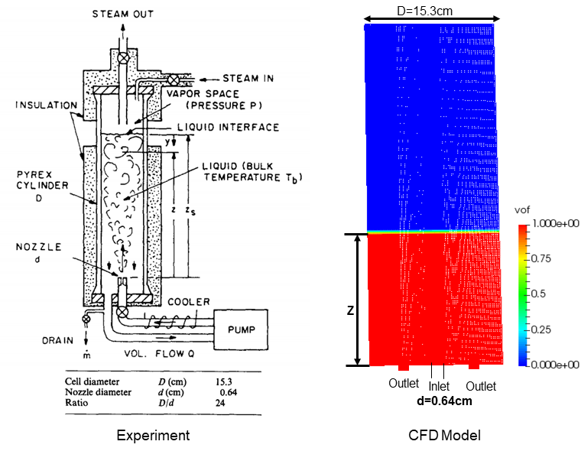
Figure 5. Scheme of experimental test cell (left) and CFD model for the condensation of pure vapor on a subcooled liquid with jet mixing.

Validation of Turbulence Velocity on Interface
The CFD model is shown in Figure 5 on the right. We used the same tank size as the experiment (on the left of Figure 5), with a tank diameter of D=0.153m and jet diameter of 0.0064m. As stated by Brown et al. [21], the correlations (8) and (9) are in the universal dimensionless form, and they will, in principle, yield a prediction tool for the condensation rate in any system with any working fluid. As such, we used the liquid hydrogen and gaseous hydrogen as our working fluids. The top surface is modeled as a constant pressure condition with entrainment, allowing gaseous hydrogen flow in at a saturation temperature of Pa=1.0356e5 Pa pressure, which is 20.35K. The subcooled liquid comes in at a temperature of 19.35 K. The flow rate is such that the jet velocity is at 0.934m/s. Figure 6 shows the distribution of VOF, velocity magnitude, turbulence kinetic energy, and viscosity ratio inside the tank. To determine the interface turbulence velocity to compare to the correlation of (8), we use the approach suggested by Lin and Hasan [23] to compute the area averaged turbulence energy.

$v_{b}={\overline{{k_{s}}^{*}}}^{1/2}$; ${\overline{{k_{s}}^{*}}}^{}=\int_{0}^{R}{k}rdr/(πR^{2})$ (20)

Figure 7 shows the distribution of interfacial turbulence kinetic energy along the tank's radial direction. Integrating this using the above Equation results in the area-averaged RMS turbulence velocity. The comparison of the non-dimensional turbulence velocity along the interface at three fill levels (0.5, 0.967, and 1.5) is plotted in Figure 7. The experimental correlation (solid black line), Lin and Hasan's CFD results, and the current CFD results are shown together. The agreement between the three is reasonable.
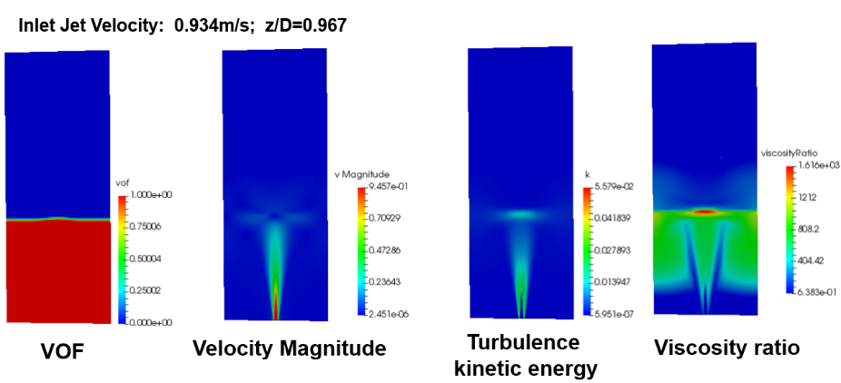
Figure 6. The distributions of liquid volume, jet velocity, turbulence kinetic energy, and viscosity ratio in a tank with a submerged jet at a fill level of z=0.967D.

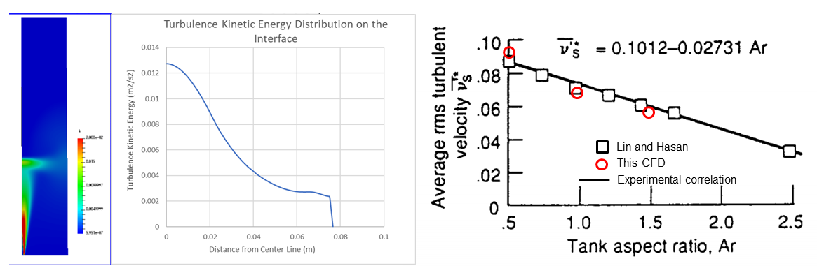
Figure 7. Distribution of turbulence kinetic energy from CFD at z/D 0.967, and comparison of averaged rms turbulence velocity between CFD, previous CFD of Lin and Hasan [23], and experimental correlation of Brown et al. [22].

Validation of Condensation Stanton Number
Based on the large number of tests [22], the condensation Stanton number has been correlated as:

$St=\frac{0.0198}{{Pr}^{0.33}}(1-\frac{Ja}{2})$ (21)

From our CFD simulations, one can obtain the mass transfer rate for the above jet mixing and then compute the equivalent Stanton number as (from Equation (19):

${St}_{CFD}=\frac{\dot{m}h_{fg}}{ρC_{p}\left(T_{s}-T_{out}\right)v_{b}}$ (22)

The value of v_{b} is derived from Equation (8). Figure 8 shows the comparison of the Stanton number between experimental correlation and CFD simulations at different mass transfer coefficients C_{m} in Equation (15) for the same tank with (z/D = 0.967 ). As observed, the CFD Stanton number increases with the mass transfer coefficient from C_{m}=1.0e-5 and then converges when C_{m} is above 1.0e-3, which aligns with our previous findings. However, the converged solution over-predicts both the Stanton number and the condensation rate. Conversely, a C_{m} value of 1.0e-4 provides a reasonable prediction of the Stanton number. We will use this value as our baseline for the mass transfer coefficient. The sensitivity to this parameter will also be explored in the subsequent no-vent fill study.

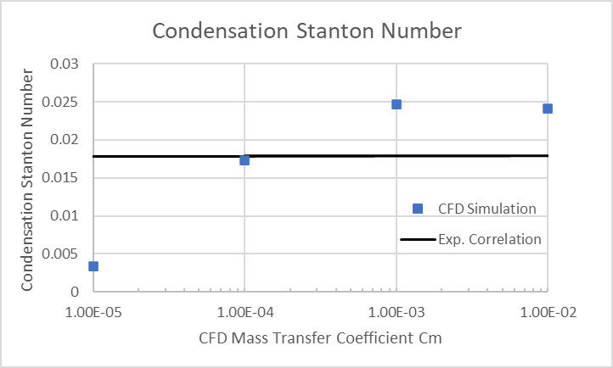
Figure 8. Sensitivity of condensation Stanton number to the mass transfer coefficient in CFD

The problem of the no-vent fill of an LH2 tank using the baseline model case for test run 338 by Chato [3] will first be evaluated with different mesh sizes. After that, an analysis of the orifice filling for all three cold walls and all three warm walls will be presented.

3.2 Validation of NVF Run 338
We will first use run 338 to build our best approach to effectively model the non-vent fill process. The experimental conditions are listed in Table 2. The tank filling method is by bottom orifice with a diameter of 9.5mm. Here, the tank is initially filled with gaseous hydrogen at 16.44 Kelvin (K), with a pressure of 2.50x10⁴ Pa. The tank wall temperature is also at 16.44 K. The inlet liquid temperature is 21.77 K.

Our baseline simulation conditions are:
- Uniform initial temperature distribution inside the tank and tank wall at 16.44K
- Conjugate heat transfer enabled
- Implicit treatment for phase change in the energy equation
- Mass transfer coefficient of C_{m}=1.0e-4 as baseline. C_{m}=1.0e-3 and C_{m}=1.0e-2 evaluated.
- Turbulence model: k-ω SST model.

Table 2. Experimental Conditions for Test Run 338
Filling Method | Initial Wall Temperature | Liquid Inlet Temperature | Inlet Mass Flow Rate | Final Pressure | Final Fill Percentage
Bottom Orifice | 16.44 K | 21.77 K | 0.219 kg/s | 1.58x10⁵ Pa | 97%

The fluid dynamics of the bottom orifice fill from the CFD simulation are shown in Figure 9. The VOF values are provided at different times during the filling process. Initially, the liquid jet shoots up inside the tank and hits the top. The filling liquid then flows along the tank wall. Quickly, the liquid accumulates at the tank bottom, and the jet becomes submerged after 10 seconds. The jet height decreases as the fill level increases. During the tank fill by the bottom orifice, the gas-liquid interface is not flat but rather curved due to the fluid jet.

Figure 10 shows the temperature distribution during the fill. The temperature inside the tank is almost uniform. The predicted ullage pressure history during filling compares very well with the experimental measurements, as shown in Figure 11. The temperature probe comparison at 18.9 inches from the tank bottom and 1 inch from the tank centerline is also shown in Figure 11. The predicted temperature shows a quick rise to near the injecting liquid temperature of 21.77K, while the experiment shows a much lower temperature, indicating that flashing leads to the breakup of the jet into drops. Resolving the smaller drops would require a much finer mesh, which can be prohibitively expensive and time-consuming. However, the temperature field approaches the experimental value at later times and agrees well with the test data during the second-half filling stage beyond 300 seconds.

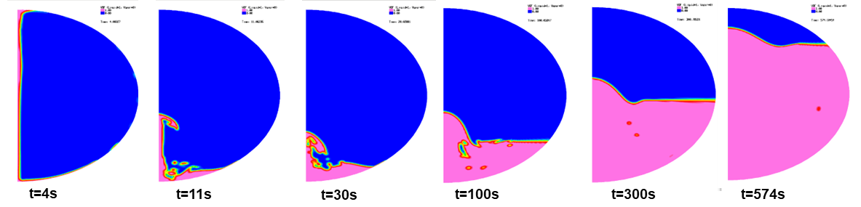
Figure 9. The motion of interface during no-vent fill by bottom orifice for run 338.

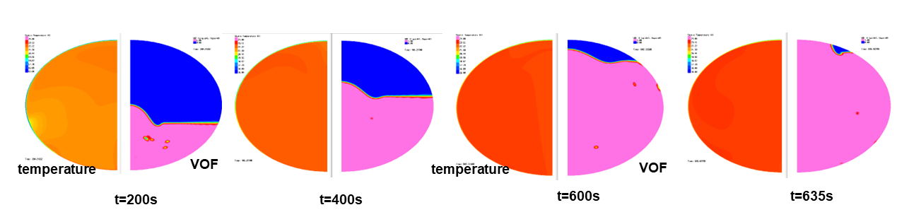
Figure 10. Temperature and VOF distribution during the bottom orifice filling.

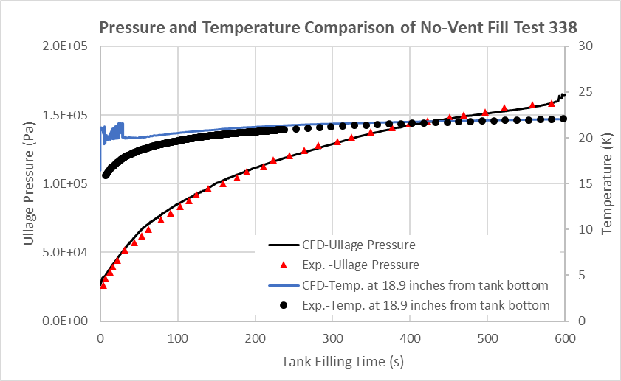
Figure 11. Comparison of ullage pressure history and temperature probe at 18.9inch from the tank bottom between CFD and experiment for run 338.

During the initial no-vent fill, the initial pressure inside the tank is lower than the saturation temperature of the filling liquid, causing a flash. As the pressurized cryogenic liquid is released, it exists in both liquid and vapor phases. The depressurization process causes the liquid to fragment mechanically and rapidly vaporize. This phase change is triggered by the spontaneous nucleation of microscopic vapor bubbles that grow and coalesce, creating a spray of fine droplets. Simulating the flash process from first principles requires a very fine mesh to resolve the breakup and droplets.

Pesich et al. [10] implemented an approach where the inlet void fraction and temperature are time-dependent variables until the simulated tank pressure reaches saturation. With this approach, the inlet velocity is the mixture velocity, which can be very high under the same mass flow rate compared to using pure liquid. This can become very expensive for VOF, with the CFL limit being less than one. The validity of this approach has yet to be determined when the jet is submerged.

Since our simulation suggests less sensitivity of the pressure history to the initial transient, we are seeking a technique to accelerate the simulation during this phase. One of the approaches is to use a bottom diffuser, which has a ring shape fitting the tank contour, with an inner diameter the same as that of the nozzle and an outer diameter between 5 to 15 times the nozzle diameter. For the first 5%-10% fill, the tank is filled by both the nozzle and the bottom diffuser. After that, when the jet is fully submerged, the diffuser is removed, and only the nozzle is used. We find that this approach can significantly reduce simulation time for the initial filling period.

Figure 12 shows the comparison of fluid dynamics during the initial transient. The pressure history shown in Figure 13 indicates that using the initial bottom diffuser approach can not only speed up the simulation but also reasonably represent the ullage pressure. In the following validation study, we will use this approach to simulate the initial filling stage.

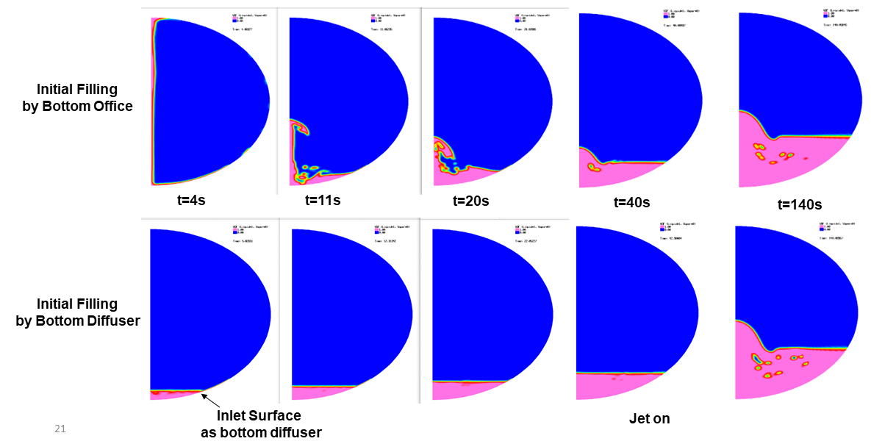
Figure 12. Initial filling using a jet model and a bottom diffuser model (with jet turned on at 60s)

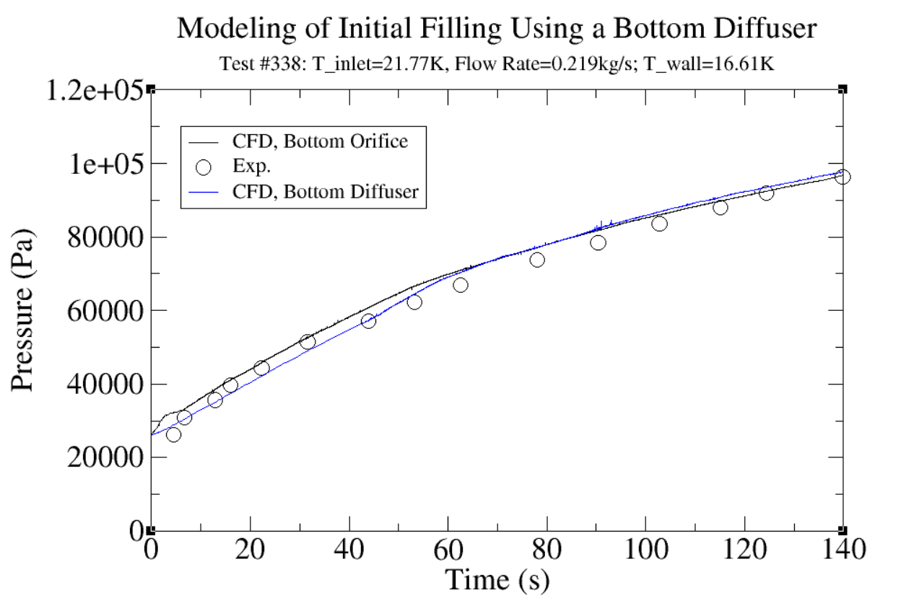
Figure 13. Pressure and temperature history with bottom orifice and bottom diffuser for the initial filling.

3.3 Mesh Sensitivity Study
Using the bottom diffuser approach, we conducted simulations for both the baseline mesh and the refined mesh (see Figure 3). The baseline mesh consists of 8.6K cells covering the domain, with an average cell size in the fluid domain of approximately 7 mm and a minimum cell size of 1.0 mm, located in the solid domain and the orifice. The refined mesh consists of 19.6K cells, with an average cell size of 5.2 mm and a minimum size of 0.6 mm.

The pressure histories using the baseline and refined meshes are shown in Figure 14. Except for some small variations in the initial transient state, the refined mesh provides almost the same pressure prediction as the baseline mesh.

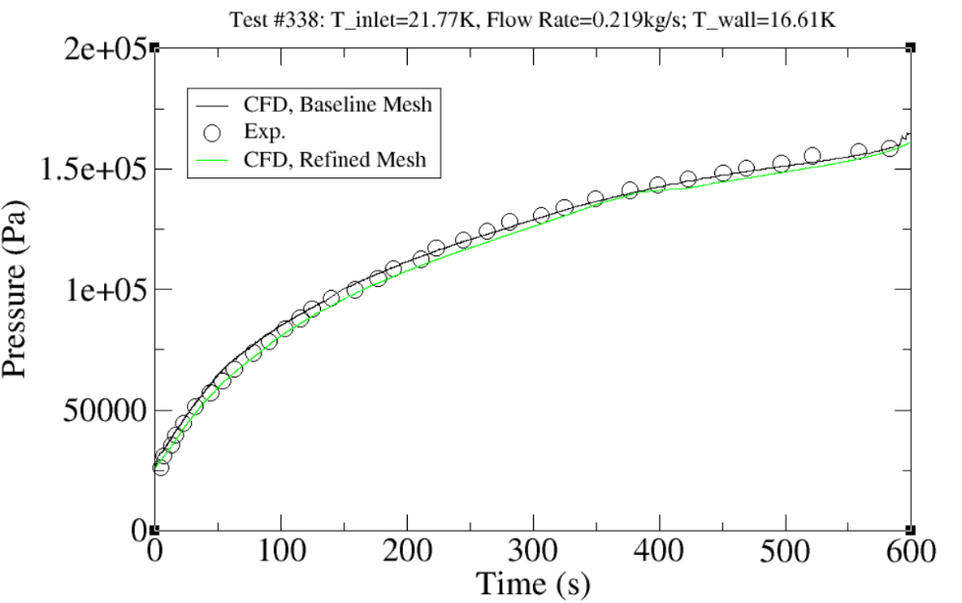
Figure 14. Comparison of ullage pressure history between CFD and experiment for run 338 with baseline mesh and the refined mesh.

3.4 Validation for Cold Wall Runs
In Chato's experiment [3], the runs were categorized based on the starting wall temperature into three sets: cold wall runs (starting wall temperature below 22.20K), moderate wall temperature runs (starting wall temperature between 22.22K and 55.6K), and elevated wall temperature runs (starting wall temperature above 55.6K). The principal determining factor of the final pressure appeared to be the inlet temperature. With different initial wall temperatures, the conjugate heat transfer played varying roles. Chato [3] found that the elevated wall temperature runs produced an initial pressure peak but collapsed back to near saturation by the end of the filling process. In this section, we will present the results of the cold wall runs. The experimental conditions for all three cold wall runs are listed in Table 3.

Table 3. Experimental Conditions for Cold Wall Runs with Bottom Orifice
Test ID | Initial Wall Temperature | Liquid Inlet Temperature | Inlet Mass Flow Rate | Final Pressure | Final Fill Percentage
300 | 16.61 K | 20.66 K | 0.22 kg/s | 1.158x10⁵ Pa | 96%
309 | 16.27 | 17.22 K | 0.180kg/s | 3.86x10⁴ Pa | 93%
338 | 16.44 K | 21.77 K | 0.219 kg/s | 1.58x10⁵ Pa | 97%

Run 300: Effect Inlet Jet Temperature
Run 300 has a similar flow rate to run 338, around 0.220 kg/s. However, run 300 had a lower inlet liquid jet temperature at T_{inlet} = 20.66K. The predicted ullage pressure history during the filling is shown in Figure 15, along with the experimental measurements. In comparison to run 338, the final pressure increases with the increase in inlet jet velocity. As with run 338, the CFD simulation consistently shows good agreement with the experimental data throughout the filling process.

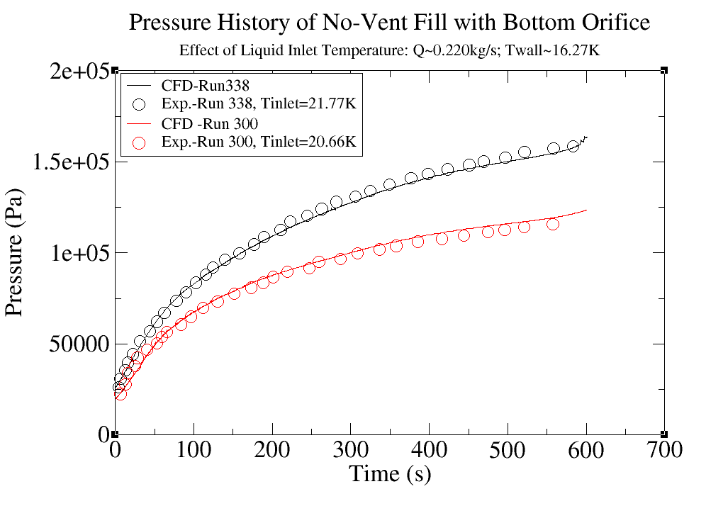
Figure 15. Pressure history of no-vent fill with bottom orifice: effect of jet inlet temperature for run 300

Run 309: Cold Wall Summary
Run 309 has a slightly lower flow rate compared to runs 338 and 300: 0.180kg/s vs. ~0.220kg/s. The jet temperature is also the lowest of the three at 17.22K. The pressure histories for all three cases are shown in Figure 16. Comparisons between the CFD predictions and experimental measurements are also provided in Figure 16. Consistent good agreement can be observed between the predictions and the experimental data for all three test runs with different inlet fluid temperatures.

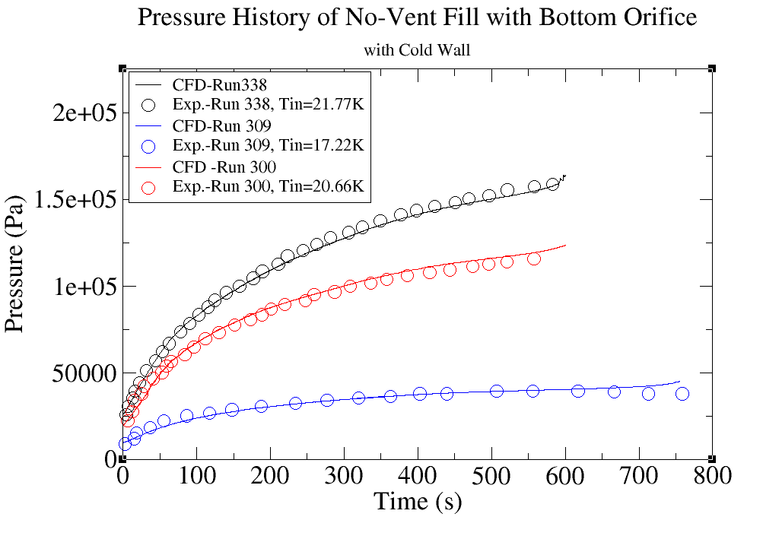
Figure 16. Pressure history of no-vent fill with bottom orifice: summary of all three runs with cold wall.
3.5 Validation for Warm Wall Runs
As in Chato's experiment [3], moderate wall temperature runs are the ones where the wall temperature was above 22.22K but below 55.6K. We will call them warm wall runs. The test conditions for the warm runs are given in Table 4.
Table 4. Experimental Conditions for Warm Wall Runs with Bottom Orifice
Test ID | Initial Wall Temperature | Liquid Inlet Temperature | Inlet Mass Flow Rate | Final Pressure | Final Fill Percentage
283 | 31.33K | 20.78 K | 0.0997 kg/s | 1.37x10⁵ Pa | 97%
297 | 32.44 K | 20.77 K | 0.174kg/s | 1.15x10⁵ Pa | 96%
336 | 22.77 K | 21.61 K | 0.151 kg/s | 1.53x10⁵ Pa | 96%

Run 283: Mass Transfer Coefficient Effect
Based on our validation study for pure vapor condensation, as described in the previous section, the mass transfer coefficient C_{m} of 1.0e-4 was used in the baseline runs. For run 283, the sensitivity of pressure history to the mass transfer coefficient is conducted. Figure 17 shows the response of pressure transient to different C_{m} values from 1.0e-4, 1.0e-3, and 5.0e-3. As the ullage collapse is dominated by turbulent jet mixing, the results are not sensitive to the mass transfer coefficient.

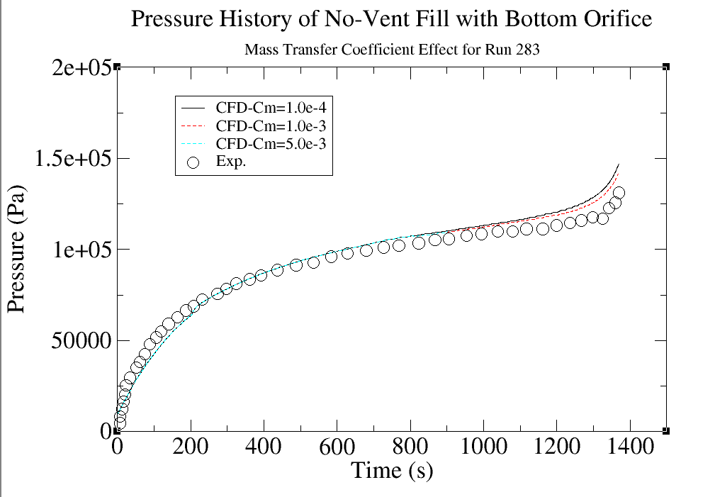
Figure 17. Sensitivity of pressure history to the mass transfer coefficient in the CFD model

Runs 283 and 297: Effect of Jet Flow Rate
Run 28 and run 297 have similar inlet jet temperatures of 20.78K and similar initial wall temperatures of 31K. The flow rate is very different: 0.0997 kg/s for run 283 vs. 0.174 for run 297. The pressure history from the experiment for both runs is shown in Figure 18. For run 297, the flow rate is somewhat lower than the previous cold wall run 338; the pressure response is very similar: it increases monotonically with time. For run 283, there is a slow increase period of the pressure, and then as the ullage is compressed during the late stage, the jet-induced turbulence is not strong enough to collapse the ullage; one can see a rapid increase in the pressure at the end. The pressure histories from CFD for both cases are also shown in Figure 18 for comparison. One can see that the simulations follow the experimental data very well. The raid increase in the pressure is captured. To visualize the flow dynamics at the end of fill (96%), the VOF and temperatures field are given in Figure 19 for both runs. For run 297, the jet effect is visible, and the ullage has an almost uniform temperature due to the jet mixing. For run 283, the jet is only half, the interface is almost flat, and the ullage is stratified, leading to higher average temperature and high ullage pressure.

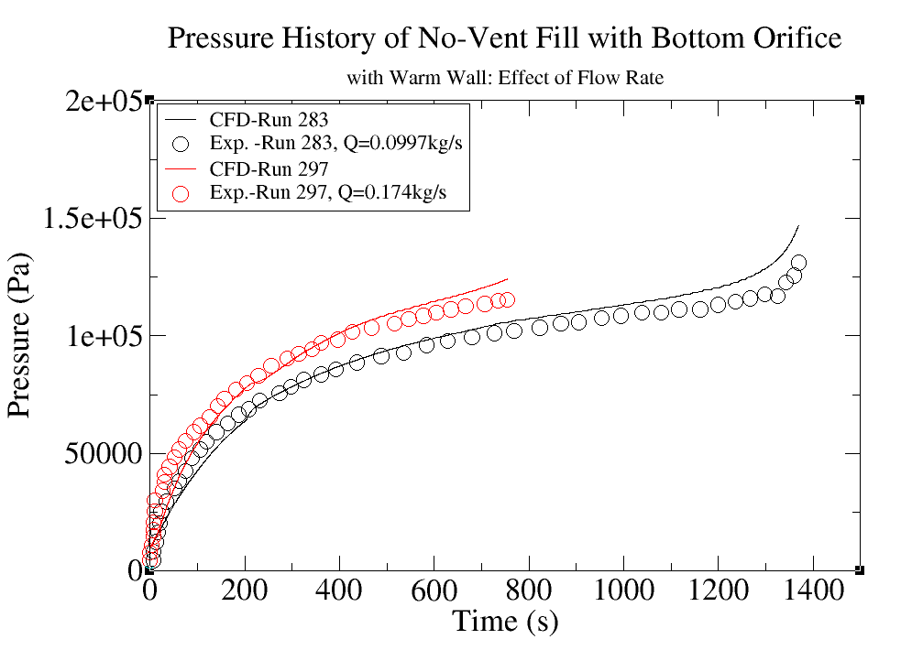
Figure 18. Pressure history of no-vent fills with bottom orifice with a warm wall: effect of flow rate.

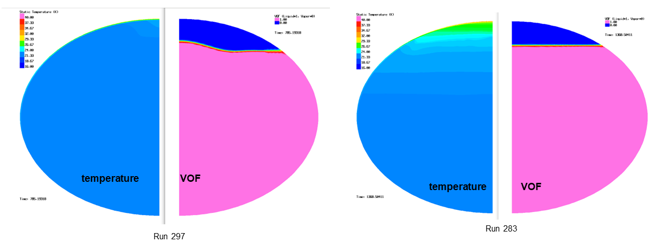
Figure 19. Temperature and VOF distribution at the end of tank fill (around 96%) for runs 297 and 283

Run 336: Summary of Warm Wall Runs
As shown in Table 4, run 336 has a similar flow rate as run 297 but with a higher inlet temperature. The end result is that the final pressure for run 336 is higher than run 297, as seen from Figure 20. For all three warm wall runs, CFD predictions show consistent agreements with the experiment.
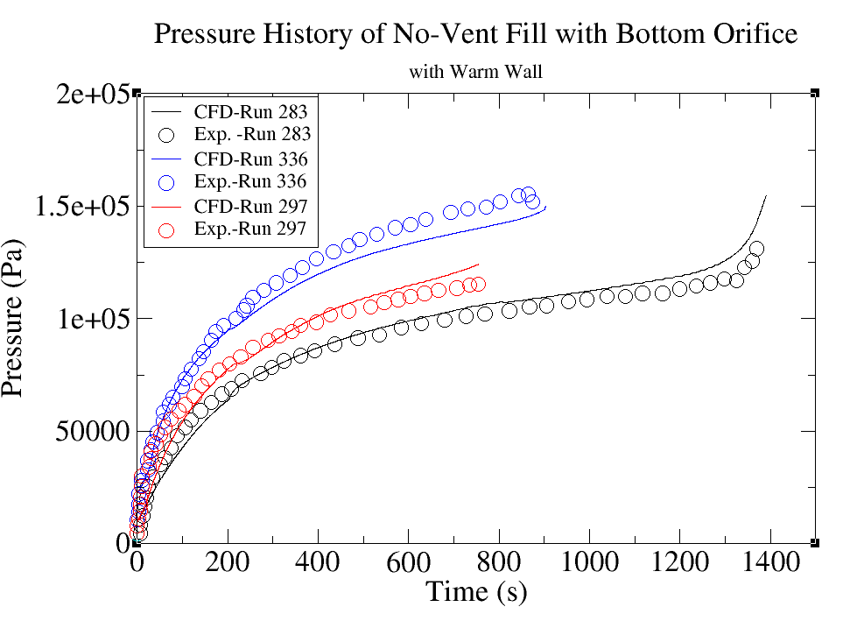
Figure 20. Pressure history of no-vent fill with bottom orifice: summary of all three runs with cold wall.

  - Development of 1D Fast-Running CFD Model
The above full transient simulations can be very time-consuming. Here, we have developed a fast-running reduced-dimension CFD model to model the no-vent fill. The idea is to reduce the 2-D problem into the 1-D problem, as shown in Figure 21. Here, one can use the same input file, preserve the original tank geometry, and reduce the number of unknown variables. With this simplification, one can obtain a solution within a few hours with a single processor. With the use of the 1-D model, parametric study can be quickly accomplished.

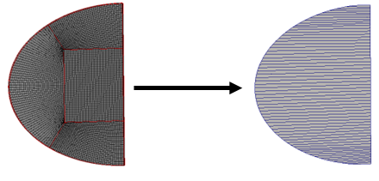
Figure 21. Reduced dimension CFD model for no-vent fill simulation

In our model, the heat transfer between fluid and solid is by natural convection correlation developed for propellent tanks by Yang and West [24]. Yang and West [24] found that existing horizontal and vertical plate correlations in both laminar and turbulent regimes (as determined by the Rayleigh number) over-predicted the Nusselt number. They proposed a representative length scale for different fill levels, as shown in Figure 22. This length scale is the wetted vertical height inside the tank. With this characteristic length, the following conversion for Nusselt and Rayleigh numbers were proposed:
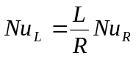 , 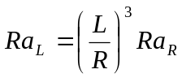. (23)

Using the above definition, the resultant Nusselt number and Rayleigh number for different fill levels are plotted in Figure 23. It is clearly seen that all the data collapse into a single curve. This curve can be fitted into the following correlations:
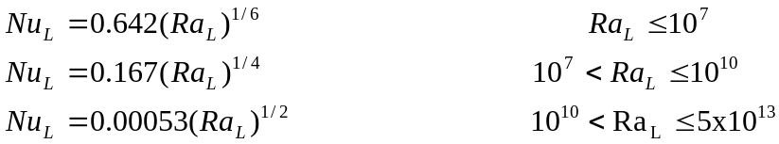 (24)

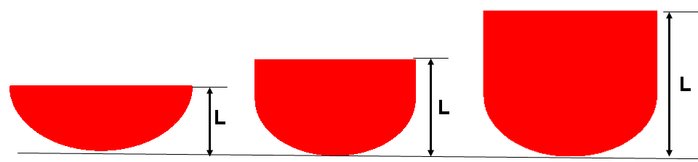
Figure 22: Representative length scale for different fill levels in the liquid tank [24]

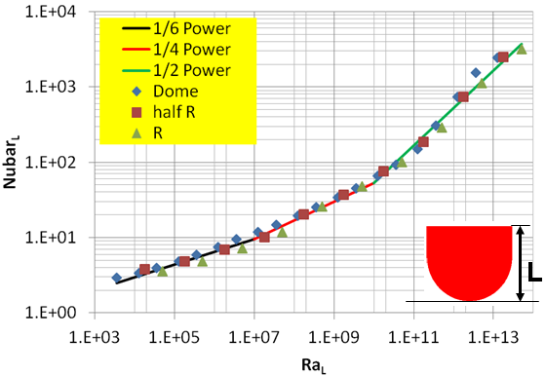
Figure 23: Curve fit using wetted liquid height as the characteristic length [24].

The above correlation is used in the 1D model.

One of the shortcomings of this 1D model is that it lacks the turbulence mixing of the jet. This can be compensated by increasing mass and transfer coefficient. The effect of the mass transfer coefficient has been conducted using this model, as shown in Figure 24. As we have shown previously, for different CFM applications, a mass transfer coefficient of 1.0e-3 is essentially converged.

Figure 25 shows the comparison of a 1-D fast-running CFD model with an experiment for cold wall cases. Figure 26 shows the comparison of a 1-D fast-running CFD model with the experimental data for warm wall cases. The predictions are accurate and show good agreement with test data.

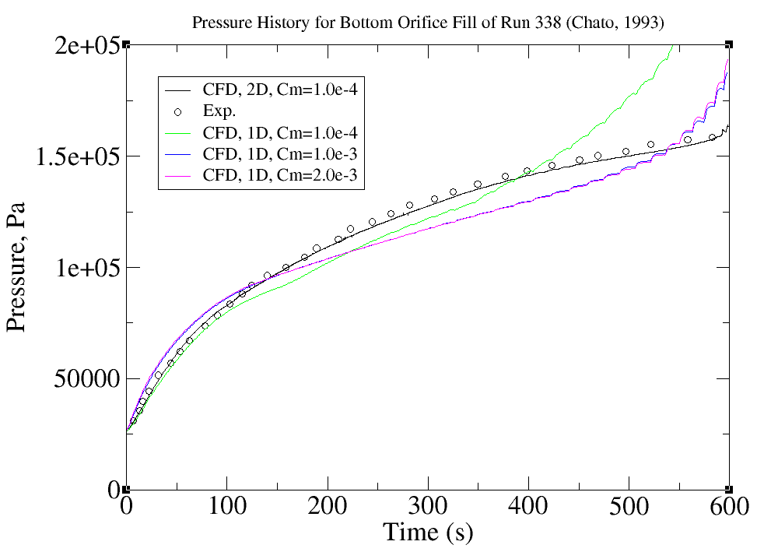
Figure 24. Effect of mass transfer coefficient for run 338 using 1-D CFD model.

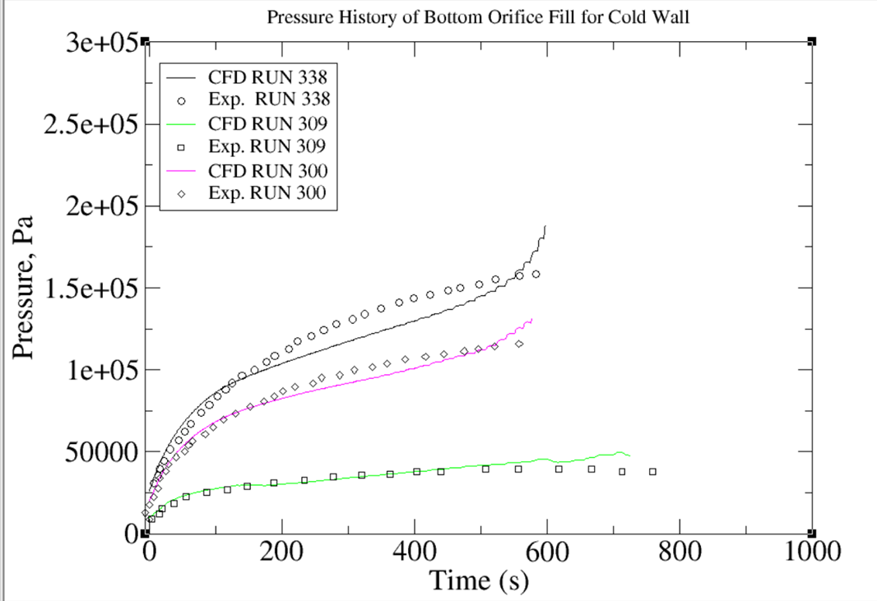
Figure 25. Comparison of fast-running 1-D CFD model with experiment for cold wall cases.

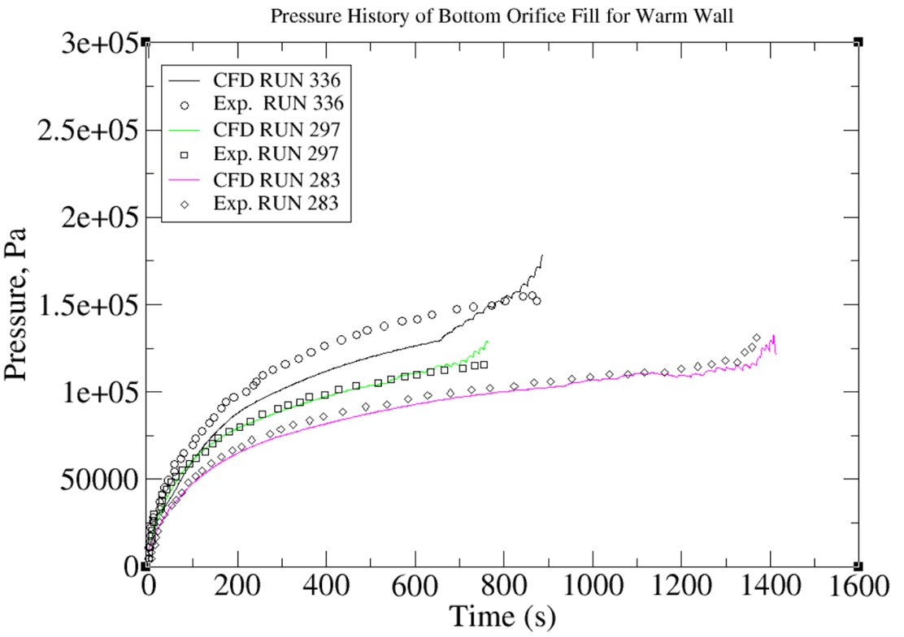
Figure 26. Comparison of fast-running 1-D CFD model with experiment for warm wall cases

- CONCLUSIONS

No-vent fill is a method to enable the transfer of cryogenic propellants without the need to vent. Transferring propellants in microgravity environments is necessary to support long-duration space missions. A key developmental milestone to developing this capability fully is the simulation and experimentation of NVF in 1-g settings. This paper documents our CFD model validation effort for predicting no-vent fill of cryogenic propellant tanks under normal gravity. The MSFC Propulsion Fluid Dynamics Branch has extensively validated and utilized the Loci/STREAM-VOF code for propellant slosh applications. In contrast, CFM applications necessitate accurate modeling of heat transfer and thermodynamics. Therefore, detailed validation of these physical processes is crucial for ensuring simulation accuracy and success.

In this study, Loci/STREAM-VOF simulations were compared with data from NASA K-site test runs on a 2.1 cubic meter tank with a bottom orifice on various no-vent fill conditions, including different wall temperatures, different flow rates, and different inlet liquid temperatures. The investigation focused on several parametric sensitivities and made comparisons with experimental measurements. The effort demonstrated that Loci/STREAM-VOF is capable of quantitatively capturing the important physics of NVF with submerged jets: (1) validation of the liquid-vapor interface turbulence velocity using previous experimental data showed good agreement at different fill levels; (2) validation of the CFD Stanton number for mass transfer provided an adequate mass transfer coefficient range; (3) consistent pressure agreements were found in the pressure history for both cold and warm conditions; and (4) the variations of final pressure with flow rate and inlet liquid temperature were well predicted by the CFD simulation. The application of NVF for low-gravity conditions will be studied in future work.

Based on these results, the Loci/STREM-VOF model is expected to provide accurate predictions for propellant non-vent fill when following the recommended simulation methodology from the above observations. More validation efforts are underway for other injection techniques, such as top spray and bottom diffuser.

Acknowledgments
This study was performed by a Task Order of NASA MSFC Amentum Contract 80MSFC18C0011. Dr. Ram Ramachandran was the Amentum Task Lead. Helpful discussions with Vinod Venugopalan of CFDRC are greatly appreciated.

REFERENCES
- Clark J. and Hartwig, J. W., "Assessment of prediction and efficiency parameters for cryogenic no-vent fill," Cryogenic, Vol 117, July 2021, Page 103309.
- Hartwig, J. W. Liquid Acquisition Devices for Advanced In-space Cryogenic Propulsion Systems (Elsevier Academic Press, 2016).
- Chato D. J. "Ground testing for the no-vent fill of cryogenic tanks: results of test for a71 cubic foot tank", NASA-TM-106293, 1993.
- Chato, D.J. “Cryogenic fluid transfer for exploration”. Cryogenics 2008, 48, 206–209.
- Moran ME, Nyland TW, Driscoll SL. "Hydrogen No-Vent Fill Testing in a 1.2 Cubic Foot (34 Liter) Tank" NASA-TM-105273 October 1991.
- Moran, M.E.; Nyland, T.W. "Hydrogen No-Vent Fill Testing in a 5 Cubic Foot (142 Liter) Tank Using Spray Nozzle and Spray Bar Liquid Injection"; Semantic Scholar: Seattle, CA, USA, 1992
- Chato D.J. Analysis of the nonvented fill of a 4.96-cubic meter lightweight liquid hydrogen tank. NASA TM-102039, 1989.
- Taylor WJ, Chato D.J. Comparing the results of an analytical model of the no-vent filling process with no-vent fill test results for a 4.96 m3 (175 ft3) tank. AIAA 92-3078. 1992.
- Majumdar, A., LeClair, A., and Hartwig, J.W., "Axisymmetric Two-Dimensional Modeling of No Vent Filling of a Cryogenic Tank using Generalized Fluid System Simulation Program" AIAA-2023-0848, 2023 SciTech Conference, National Harbor, MD, January 23 – 27, 2023.
- Pesich, J.M., Hauser, D.M., Yamashita, K.G., Baker, M.C. and Sakowski, B.A., 2024, May. Liquid hydrogen tank chill and no-vent fill prediction using computational fluid dynamics. In IOP Conference Series: Materials Science and Engineering (Vol. 1301, No. 1, p. 012065). IOP Publishing.
- West, J., Yang, H.Q., and Liever, P. A., "Development, Verification, and Validation of Parallel, Scalable Volume of Fluid CFD program for Propulsion Applications," JANNAF Conference paper, 2014.
- Mehta, R. S., Venugopalan, V., and Yang, H.Q., Wright, J., and Thakur, S., "Development of a Highly Scalable Volume of Fluid Solver for Arbitrary Polyhedral Grids," JANNAF Conference paper, 2015.
- Yang, H. Q., and West, J., "Nonlinear Slosh Damping Model Development and validation," JANNAF 62nd JPM/ 10th MSS /8th LPS /7th SPS Joint Subcommittee Meeting, Nashville, TN, June 1-4, 2015.
- Yang, H. Q., and Williams, B., "Validation of Ullage Collapse Due to Violent Lateral Slosh," AIAA SciTech 2023 Forum 23-27 January 2023, National Harbor, MD, AIAA 2023-1413
- Yang, H.Q., Patel, C., and Williams, B., "Validation of Cryogenic Propellant Tank Self-Pressurization," AIAA SciTech 2023 Forum 23-27 January 2023, National Harbor, MD, AIAA 2023-1411
- Yang, H.Q. and Williams, B., 2024. Validation of Thermodynamics Behaviors Liquid Propellant Under Sloshing and Draining. In AIAA SCITECH 2024 Forum (p. 0548).
- Lowry, S., Yang, H.Q., Numerical Model of the Fluid-Structure Interaction in the Space Shuttle External LOX Tank for Modified Baffle Configurations. CFD Research Corporation; 1996.
- Pericleous, K., Cross, M., Moran, G., Chow, P., Chan, K., Free surface Navier-Stokes flows with simultaneous heat transfer and solidification/melting, Advances in Computational Mathematics; Vol. 6, No. 1 pp. 295-308. 1996.
- Linstrom, P., Mallard, W., Editors. NIST Chemistry WebBook, NIST Std. Ref. Database Number 69, NIST, 2005, http://webbook.nist.gov.
- Sonin, A.A., Shimko, M.A., and Chun, J.H., Vapor Condensation onto a Turbulent Liquid - I. The Steady State Condensation Rate as a Function of Liquid-Side Turbulence. Int. J. Heat Mass Trans., vol. 29, no. 9, pp. 1319-1332, 1986.
- Brown, J.S., Helmick, M.R., and Sonin, A.A., Vapor Condensation at a Turbulent Liquid Surface in Systems with Possible Space-Based Applications. AIAA Paper 89-2846, July 1989.
- Brown, J.S., Khoo, B.C., and Sonin, A.A., Rate Correlation for Condensation of Pure Vapor on Turbulent, Subcooled Liquid. Int. J. Heat Mass Trans., vol. 33, no. 9, pp. 2001-2018, 1990.
- Lin, C.S. and Hasan, M.M. "Effect of Liquid Surface Turbulent Motion on the Vapor Condensation in a Mixing Tank," NASA TM 105555, 1991.
- Yang, H. Q. , and West, J. (2015). CFD Extraction of Heat Transfer Coefficient in Cryogenic Propellant Tanks. 51st AIAA/SAE/ASEE Joint Propulsion Conference. American Institute of Aeronautics and Astronautics Inc, AIAA.

