Assessment of a Surface Propellant Transportation System Concept for Operations on Mars

Jared F. Congiardo, Mark E. Lewis , Carey M. McCleskey, Christopher T. Reeves, Adam M. Swanger, Gabor Tamasy
Kennedy Space Center, Merritt Island, Florida, 32899, USA

Paul Bielski, Zu Qun Li, Paige A. Whittington , Collin W. Blake, Keaton C. Dodd, Stephen J. Hoffman, Taylor Phillips-Hungerford
Johnson Space Center, Houston, Texas, 77058, USA

Michael Chappell, Andrew J. Choate, James E. Owens
Marshall Space Flight Center, Huntsville, Alabama, 35812, USA

NASA is working to define the architecture needed for a Mars exploration campaign. One potential architecture option allows for pre-deployment of essential cargo and equipment to support a crew landing, including the pre-positioning of a Mars Ascent Vehicle (MAV). This MAV is likely to represent the largest single payload that must be landed on the Martian surface. Its size would be influenced by the amount of mass that state-of-the-art Entry, Descent, and Landing (EDL) systems would be capable of placing on Mars. One possible method of increasing the usable size of the MAV without exceeding available EDL capabilities is to land the MAV without its ascent propellant on board. Following such a method may necessitate a strategy to acquire sufficient ascent propellant to allow a crew to safely depart the Martian surface. This paper describes a conceptual return propellant strategy that uses a liquid transportation skid, or pallet, to be used in conjunction with a rover mobility system to transfer cryogenic propellant, consisting of oxygen and methane, across the Martian surface from a delivery lander to the MAV to enable its launch. Design considerations, concept of operations, and rover energetics will be discussed in this paper.
- Nomenclature
MAV = Mars Ascent Vehicle
EDL = Entry, Descent, and Landing
ISRU = In-situ Resource Utilization
CO2 = Carbon Dioxide
MALV = Mars Ascent and Landing Vehicle
HMA = Hose Management Assembly
FSP = Fission Surface Power
DTAU = Dust Tolerant Automated Umbilical
QD = Quick Disconnect
HSA = Hose Subassembly
RDSA = Roller Drive Subassembly
MLI = Multi-Layer Insulation
IPEx = ISRU Pilot Excavator
SBC = Single Board Computer
UHF = Ultra High Frequency
I/O = Input/Output
LED = Light Emitting Diode
TIR = Total Internal Reflector
EDS = Electrostatic Dust Shield
MT = Mobility Transport
- Introduction
NASA is working to define architecture areas that require development in order to facilitate decisions related to human deep-space exploration of and Mars. Many options for the development of an architecture for a human Mars exploration campaign, as outlined in the Moon-to-Mars Architecture Definition Document released by NASA in April 2023[1], allow for the use of multiple landers to deliver and pre-deploy the cargo and equipment needed to support a crew landing. This may include pre-positioning a Mars Ascent Vehicle (MAV). This MAV would likely represent the largest indivisible payload that would need to be placed on the Martian surface. This makes the size of the MAV very closely coupled to the capability of Entry, Descent, and Landing systems developed for Mars landings. Due to this relationship, it may be advantageous for the MAV to be landed without the propellant it needs to return to orbit at the time of its arrival. Such a situation would likely create a need to develop a strategy to acquire sufficient ascent propellant to safely return a crew to orbit prior to that crew’s arrival on the surface of Mars.
The acquisition of this propellant may be accomplished in a number of ways depending on the characteristics of other architecture elements, particularly MAV engine design and the amount of surface power available. Previous studies have evaluated the surface transfer of liquid oxygen delivered from Earth for a LOX/methane MAV [2] and nitrogen tetroxide delivered from Earth for a storable propellant MAV [3]. In both cases, the MAV was landed with the fuel preloaded. With an increase in available surface power assumed, other studies have evaluated a partial in-situ resource utilization (ISRU) concept by generating oxygen from atmospheric CO2, then liquefying it using broad area cooling within the MAV propellant tank, which, again, was landed preloaded with methane. [3] Such ISRU oxygen generation was recently tested by the MOXIE payload on the Perseverance rover. [4] A MAV completely depleted of fuel and oxidizer necessitates an acquisition strategy that provides both propellants. Previous work evaluated an ISRU system capable of generating both oxygen and methane propellants in the quantities needed for the MAV, with transportation of liquid water feedstock across the surface [5].
The surface return propellant strategy concept described in this paper represents one set of architecture permutations that are believed to represent a corner of the trade space: utilizing large, cryogenically propelled landers capable of landing up to 75 metric tons of payload; a MAV that uses one of these landers for both descent and ascent; and the availability of plentiful surface power. This provides a useful reference point for evaluation against other potential architecture permutations, such as smaller payload-to-surface capability or limited surface power capabilities.
- Major Elements
The following section briefly describes major architectural elements used in support of this study as part of the possible tradespace for Martian surface operations.
- Mars Ascent and Landing Vehicle
This study makes use of several oxygen/methane-propelled Mars Ascent and Landing Vehicles (MALVs) capable of landing up to 75 metric tons of payload to the Martian surface, or approximately three times the landed payload capacity studied previously. [6][7] One of these MALVs would be equipped to serve as the Mars Ascent Vehicle in order to return the crew to orbit, and must be resupplied with an estimated 300 metric tons of combined propellant via delivery from supply landers. A rendering of a MALV is shown in Fig. 1a.
- Fission Surface Power System
For the purposes of this study, power for surface elements is assumed to be provided by a number of 40 kWe fission surface power (FSP) systems. This is in keeping with a joint NASA/US Department of Energy Request for Proposals to develop preliminary designs for a 40 kWe FSP system.The Compass team at Glenn Research Center performed a notional design exercise for a 40 kWe FSP system that evaluated additional needs such as cabling, power conversion, and deployment methodology. [8] A rendering of an FSP system is shown in Fig. 1b.
- Surface Propellant Transportation Pallet
Propellant must be provided to the ascent vehicle. A Propellant Transportation Pallet mounted aboard the Mobility Transport chassis will be used to transport this propellant from a supply point in five cubic meter increments. The pallet may be dismounted from the Mobility Transport chassis in order to release the chassis for other tasks if needed. The design of this pallet is detailed in this paper. A rendering of a Propellant Transportation Pallet is shown in Fig. 1c.
- Mobility Transport Chassis
The Mobility Transport chassis is used to transport surface system elements to their deployment location, and, using a manipulator arm, is capable of making electrical, fluid, and other connections as needed. It is also used to transport Propellant Transportation Pallets between the propellant supply landers and the Ascent Vehicle. For the purposes of this study, the chassis is derived from the Chariot mobility concept. [9] Other lunar rover vehicle concepts will be assessed for extensibility to this type of mobility application. A rendering of the Mobility Transport chassis and manipulator arm is shown in Fig. 1d.

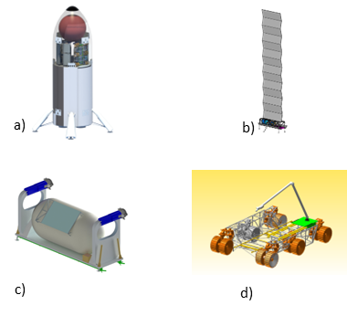
Fig. 1 Major architecture elements; a) MALV; b) FSP; c) Surface Propellant Transportation Pallet; d) Mobility Transport Chassis.
- Concept of Operations

ConOps Assumptions for this Analysis
No landing site selection for a human Mars landing has been made by NASA, nor does this study endorse a particular site. In keeping with the Compass team assumption of a generic mid-latitude site, Viking II landing site environmental data [14] is used for thermal assessments of the Propellant Transportation Pallet and Mobility Transport chassis. In order to characterize traverse energetics, Jezero Crater terrain data are used as notional representative conditions.
300 metric tons of combined propellant must be delivered to Mars in order to fully supply the MAV. The propellant will be assumed to have been loaded at the launch site at the same conditions as the MALV (100K, 2.55 bar for oxygen; 124K, 2.55 bar for methane). These conditions are maintained for ease of propellant handling.
Two propellant supply MALVs are assumed to launch to Mars at each 26-month launch opportunity in order to maintain the same overall 8.5-year timeline as the water delivery study. A single supply launch at each Mars launch opportunity expands the timeline to 182 months (approximately 15 years).
Landing sites of individual MALV landers should be at a minimum one-kilometer radius distance from previous landers to mitigate the risk of damage to critical surface hardware due to rocks or other debris liberated by the engine blast generated by the arriving lander.
It is assumed that minimal mission-specific design modifications to the cargo MALVs are made. Modifications would be to connect the existing MALV fill/drain infrastructure to the payload tank, allowing payload fill simultaneous to propellant load at the launch site, as well as allowing the Propellant Transportation Pallet to utilize the existing umbilical plate structure to connect to the delivery lander. Additionally, the cryocoolers utilized to maintain vehicle propellant conditioning are assumed to be repurposed to maintain payload conditioning after landing.
Because of the required timeframe to complete propellant transfer and the significant communications lag between Earth and Mars, it is assumed that the operations described are performed autonomously to the greatest degree possible.

ConOps
A notional site plan laid out to attempt to minimize the distance between delivery landers and the MAV is given in Fig. 2. Two MALVs would depart Earth during each 26-month launch opportunity, with the first pair landing approximately 104 months prior to the planned crew surface departure date. The first two landers in this concept are methane delivery landers, for convenience designated LCH4-1 and LCH4-2, that land at -104 months. Because of methane’s low density, sufficient payload downmass capacity exists that these landers will also each deliver a Fission Surface Power unit, a mobility chassis, and a Propellant Transportation Pallet. The mobility chassis will immediately deploy the FSP units and connect them to the landers to provide power to the cryocoolers that will maintain the propellant at liquid temperatures. These delivery payloads remain largely quiescent.
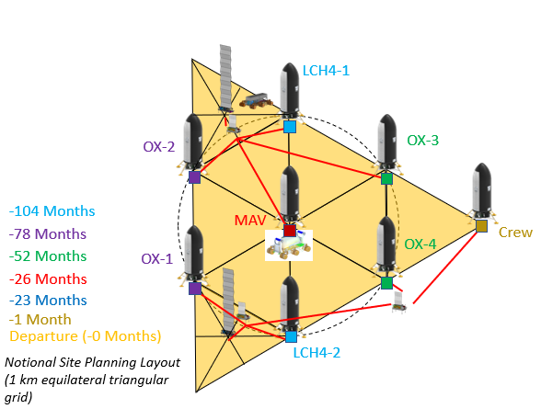
Fig. 2 Notional Mars landing site layout plan.

At -78 months, the first pair of oxygen landers (designated OX-1 and OX-2) arrive. Upon landing, these are connected to the landing site power system to power the onboard cryocoolers. This operation is repeated at -52 months, with the arrival of OX-3 and OX-4.
At -26 months, the MALV designated as the Mars Ascent Vehicle arrives. This may also deliver a spare Propellant Transportation Pallet if one was not manifested on the methane landers. It is estimated that overall propellant transfer operations will take 88 days, with one transport operation per day conducted for each propellant. This translates to 48 operations for oxygen transfer and 40 days for methane transfer.
Propellant transfer operations are largely identical, regardless of species. Under nominal conditions, each species uses a dedicated Propellant Transportation Pallet to avoid cross-contamination. Transfer operations are as follows:
- Propellant Transportation Pallet mounted to Mobility Transport chassis approaches a propellant delivery lander.
- One pallet Hose Management Assembly (HMA) is mated to the lander mating interface, using the Mobility Transport chassis manipulator arm. The HMA provides a connection for propellant, pressurant gas, and power.
- Perform leak check.
- Commence transfer of propellant using pallet-mounted pumps.
- Evacuate transfer line.
- Demate HMA from delivery lander using Mobility Transport chassis manipulator arm.
- Mobility Transport chassis traverse to MAV.
- Chassis approaches/conducts proximity operations at MAV.
- Mobility Transport chassis manipulator arm mates pallet HMA to MAV umbilical plate assembly.
- Perform leak check.
- Begin propellant transfer to MAV tanks.
- At end of transfer operation, evacuate transfer line.
- Demate HMA from MAV.
- Move away from MAV.
- Traverse back to delivery lander.

Propellant transfer must be completed prior to a crew being given a GO to land on the surface. Once transfer is complete, the mobility chassis would move the propellant transportation pallets to a safe distance from the MAV. The crew would then land and perform their surface activities. Approximately one month after landing, the crew would enter the MAV and depart the surface.
- Propellant Transportation Pallet Design Concept
The Propellant Transportation Pallet is derived from the Water Transportation Pallet described in [5]. The 5 cubic meter fluid capacity is retained, as is the general 2t dry mass allowance, however actual payload masses differ due to propellant density relative to water.
. An isometric view of the Propellant Transportation Pallet is shown in Fig. 3.
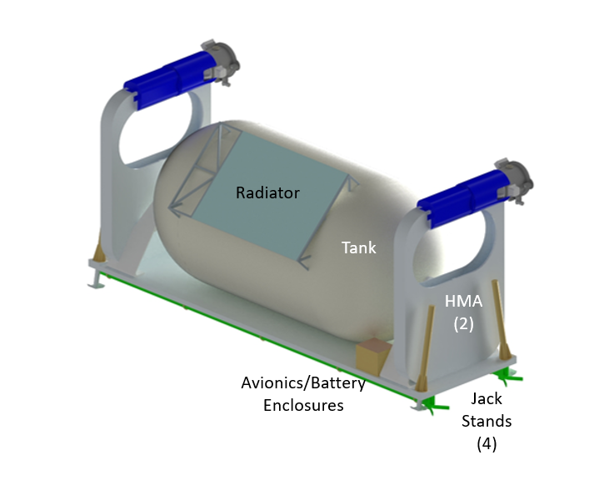
Fig. 3 Propellant Transportation Pallet isometric view.

Major Structural Elements
The propellant tank is a 5000L cylindrical tank, 3.3m long and 1.5m in diameter, with hemispherical ends, and is structurally supported at either end. The tank is covered in 5.1cm of BX-265 spray-on foam insulation coated with aluminized Kapton. It is constructed of 6061 aluminum and is designed to operate at 1 bar internal pressure. The tank is supported at either end by bipod-shaped structural supports in order to withstand launch loads. These supports could be panel type, as depicted, or truss based. These supports are intended to provide support during the landing and surface ops phase. It is anticipated that they would be driven and sized by the Earth launch phase loads.
The structural base of the Propellant Transportation Pallet is an aluminum 6061 panel with a flat top and orthogrid bottom surface, with dimensions of 4.6m x 1.3m x 0.05m. It provides support for all components of the Propellant Transportation Pallet mounted to its top surface. On the bottom surface, it attaches to a mating interface rail system between the pallet and the Mobility Transport chassis. Using this universal mating interface rail system, the Propellant Transportation Pallet can be autonomously loaded/unloaded from the Mobility Transport chassis. The mating interface also has passive alignment and locking features to aid in the mating process and to secure the pallet during transport. At the four corners of the structural base it has electric linear actuator legs to support and level the pallet without the presence of the chassis. The legs are retracted during traverse and deployed while free standing or being loaded/offloaded from the chassis. This same structural base and mating interface could also be utilized for other pallets, particularly the FSP and associated systems, that need to be moved and deployed by the Mobility Transport chassis.

Fluid Handling and Pressurization Elements
Aside from the propellant tank itself, fluid handling is accomplished via a network of tubing, assumed to be approximately 7.62m in length, of 1-inch NPS (25.4mm) Schedule 5 stainless steel vacuum jacketed pipe. Pumps were sized from commercially available pumps to be able to transfer up to 22 gallons per minute (83.3 liters/minute).
Tank pressurization is accomplished autogenously via a 2.3 kW electrical heater/vaporizer. This eliminates the need to carry a consumable pressurant from Earth, reducing system mass and increasing the reusability potential of the pallet. It is assumed that 5% of the propellant volume consists of ullage and 5% consists of unrecoverable residuals. While some optimization of these values may be possible, reducing the number of round trips by one or two, the number of required delivery landers does not change.
A number of latching and solenoid valves and filters, as well as pressure transducers, thermocouples, and other instrumentation, are also specified for this system. A representative schematic of the Propellant Transportation Pallet fluid handling systems mated to a propellant delivery lander is shown in Fig. 4.

Fig. 4 Fluid system schematic.

Connections between the Propellant Transportation Pallet, the MALV propellant delivery landers, and the MAV would be made via an umbilical system consisting of two HMAs, each with a Dust Tolerant Automated Umbilical (DTAU) connector. The HMAs are derived from the On-orbit Servicing, Assembly, and Manufacturing 1 (OSAM-1) project, and are scaled up to accommodate 1-inch (25.4 mm) nominal flex hose. [10] Each assembly has a flexible hose sub-assembly (HSA) consisting of a conduit, sleeve, Kapton sock, multi-layer insulation (MLI), modified flex hose ending, Kapton heaters, thermistors, wires, and hose clamps. The roller-drive sub-assembly (RDSA) is mounted on the opening of the box subassembly and has motor-driven pinch rollers to extend/retract the HSA. The DTAU is attached to the end of the HSA and consists of three Quick Disconnects (QDs) (propellant, pressurant gas, and electrical power for battery charging). The DTAU also has mechanisms for alignment, latching, and QD mating/demating, and dust protection covers and seals to keep dust out of the interface during transfer operations and inactive periods. The umbilical HMA and components are shown in Fig. 3, and an example connection between the Propellant Transportation Pallet and the MAV is shown in Fig. 5.

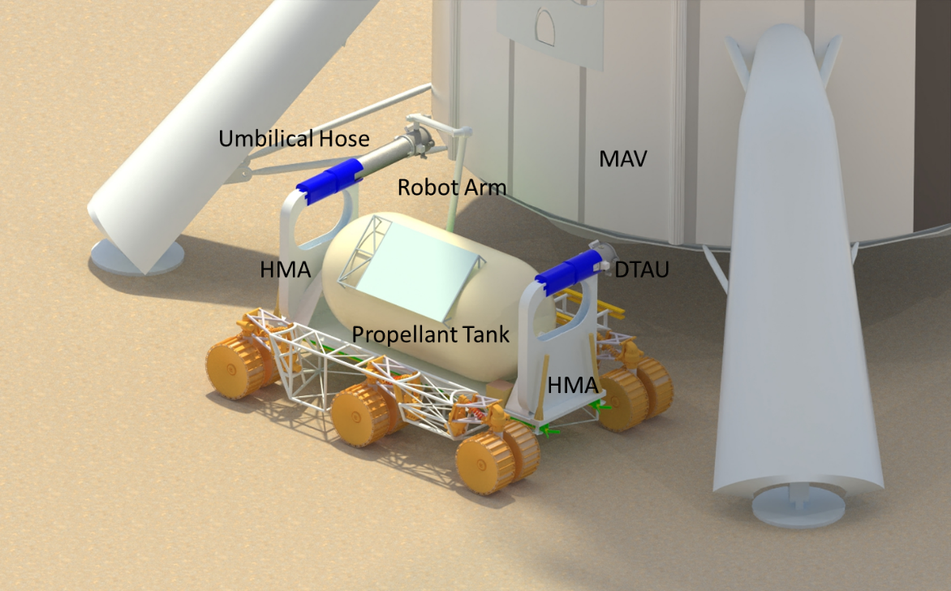
Fig. 5 Umbilical connection to lander.

Electrical and Communications Elements
A notional block diagram of the Propellant Transportation Pallet electrical system was developed for the study (see Fig. 6). It provides an initial design concept and identifies the major electrical subsystems and interfaces to estimate the size, mass, and power usage of the system.
The electrical power subsystem operates at a nominal input voltage of 120 VDC and provides power conditioning, storage, and distribution functions. Power conditioning includes filters that reduce noise and voltage ripple and provide surge protection. Circuit breakers provide over-current protection for the electrical system. The battery charging and discharging subsystem controls the charging rates and depth of discharge of the batteries to maintain optimal performance. Lithium-ion batteries, using LG Chem 18650 MJ1 cells, were selected for their high energy density and because of their intended use on future NASA exploration missions (e.g., Europa Clipper). The nominal battery voltage assumed was 122.4 VDC, and the battery capacity margins of 20% for aging [12] and 80% depth of discharge were used to calculate a total battery energy storage need of 10 kWh. A conservative battery energy to mass ratio of 0.09 kWh/kg was assumed based on the ISRU Pilot Excavator (IPEx) Space Technology Mission Directorate (STMD) Game Changing Development (GCD) project [11] battery pack development. This ratio also includes the battery thermal management system. Multiple DC-DC converters distribute power from the batteries to the loads with varying regulated secondary power voltages. The tank heaters, scroll compressors and pumps, solenoid valves, and communications equipment use 28 VDC of electrical power, while the cameras use 24 VDC. Other equipment, such as the jack stands, motor controllers, and the digital and analog I/O boards, use 12 VDC, and the sensors and the single board computer (SBC) use 5 VDC and 3.3 VDC, respectively. Power and general-use cables use space-grade electrical connectors (e.g., MIL-DTL-38999), and Micro-D connectors (e.g., MIL-DTL-83513) are used for instrumentation and data. All the cable assemblies use Teflon insulated (Type PTFE) wire, and they were sized and derated per Table 4A of NASA EEE-INST-002: Instructions for EEE Parts Selection, Screening, Qualification, and Derating for bundled wires [13].

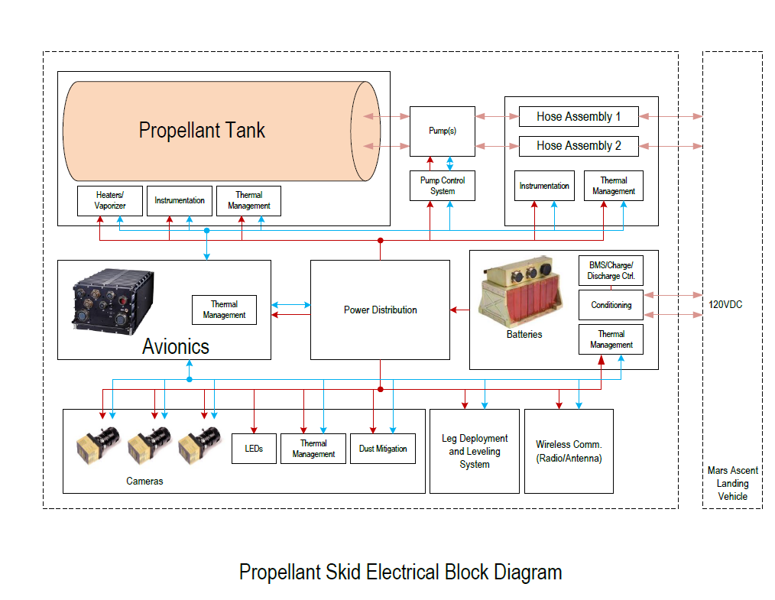
Fig. 6 Notional propellant pallet electrical system block diagram.

The avionics subsystem consists of a space-grade radiation-hardened SBC (i.e., RAD750®) with memory, solid-state storage, external I/O (e.g., USB, Ethernet, etc.), and motor controller boards to control and monitor the electrical subsystems and acquire data from the various sensors on the water pallet.
Wireless communications for the pallet use UHF transceivers, antennas, and Wi-Fi systems. The UHF proximity communications are for command/telemetry links up to 300 km, while the Wi-Fi links (IEEE 802.11a/b/g/n) are for controlling the pallet up to 300m range. The data rate of the UHF transceivers is up to 10 Mbps (Rx) and 12 Mbps (Tx). Omnidirectional antennas with medium gain (15.5dB) were assumed.
Three camera subassemblies (Fig. 7) are located on the pallet for optimal visual coverage. They are derived from IPEx cameras using an 8.8MP sensor and have integrated LEDs and TIR optics for supplemental lighting (3000 Lumens of white light), 15W survival heaters, and a low power integrated Electrostatic Dust Shield (EDS) for dust mitigation.

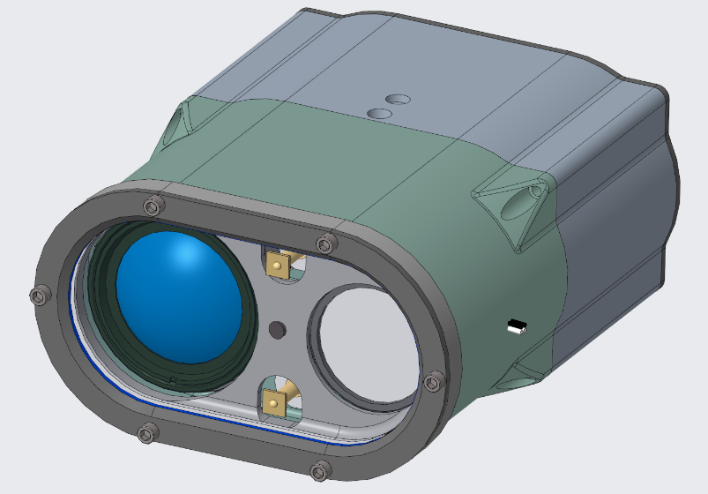
Fig. 7 Propellant pallet camera subassembly.

Thermal Design
The tank is coated with 5.1 cm of BX-265 spray on foam insulation covered in a layer of aluminized Kapton with α=0.12 and ε=0.03. Thermal management of electrical and other heat-generating equipment is accomplished via a 1.75 m² radiator consisting of a 6061 aluminum plate coated with white paint with assumed 40% dust coverage, α=0.4 and ε=0.85. The radiator is designed to reject heat at 310K.
It can be shown that for both a nominal traverse as shown in Fig. 8 and Fig. 9 as well as a 24-hour contingency, as shown in Fig. 10, a cryocooler is not required aboard the pallet to manage heating and thermal expansion. Peak pressure in the LOX tank after 24 hours is approximately 365 kPa (53 psia). Peak pressure in the LCH4 tank is approximately 345 kPa (50 psia).
Radiator thermal design is shown in Fig. 11. A nominal operation of an approximately one hour traverse, two hours of pump operation, and three hours of cooldown time are shown in the first case. In the second case, worst case heat loading representing 6 hours of continuous pump operation is demonstrated. The radiator surface exceeds the target heat rejection temperature by no more than 2K.
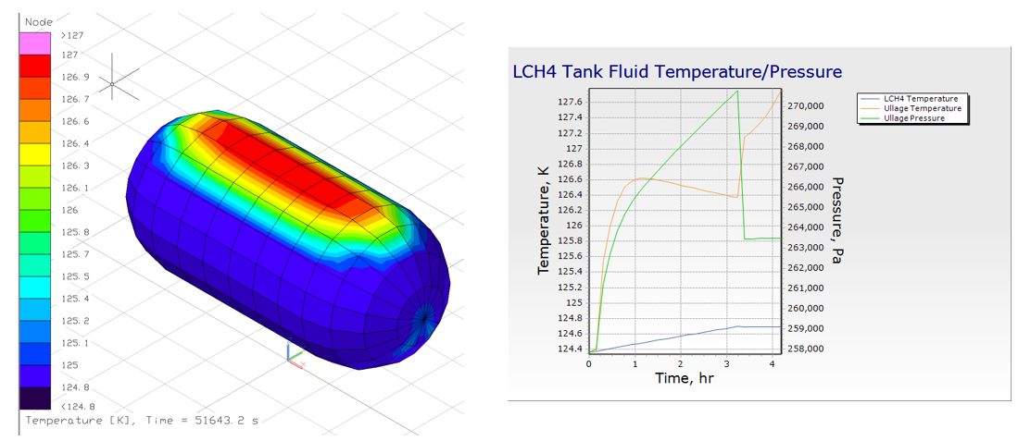
Fig. 8 Methane pallet tank thermal analysis.
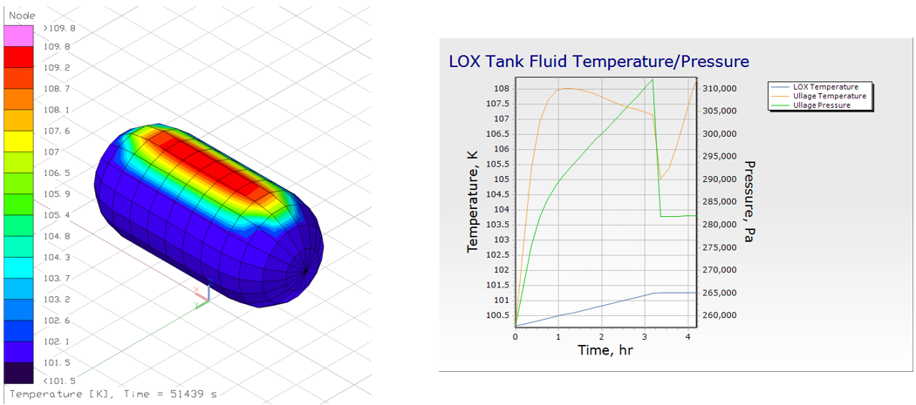
Fig. 9 Oxygen pallet tank thermal analysis.
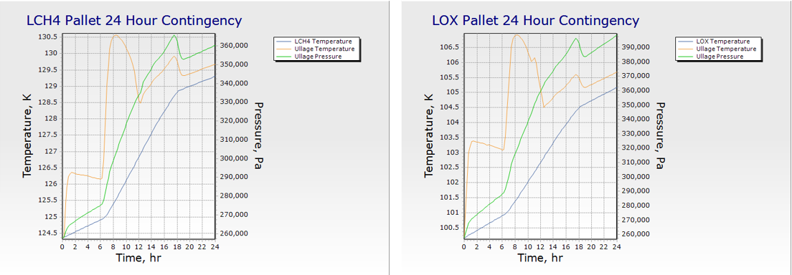
Fig. 10 24 hour contingency tank thermal analysis.
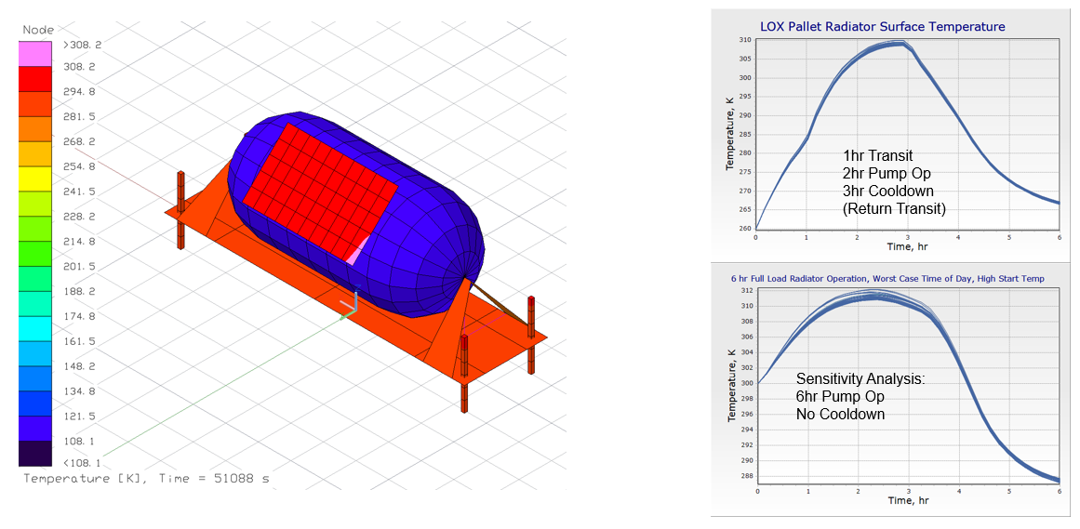
Fig. 11 Radiator sizing analysis.

Mass Analysis
The mass estimate for the Surface Propellant Transportation Pallet, broken down by functional category, is given in Table 1. The gross mass (with margin) of 1609 kg is within the 2000 kg dry mass allowance.

Table 1 Surface Propellant Transportation Pallet mass estimate.
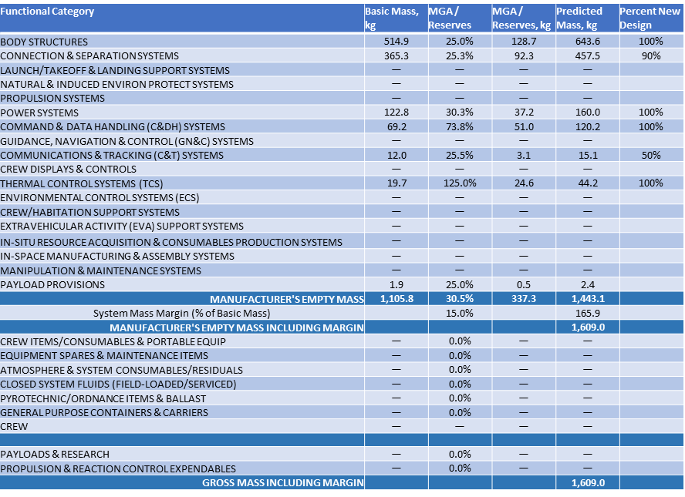
- Mobility Transport Chassis Design Concept
An isometric view of the Mobility Transport chassis is shown in Fig. 12. A full description of the design of the mobility transport chassis can be found in [5].

Payload Capacity and Energetics
The Mobility Transport chassis (MT) is derived from the Chariot mobility system studied for lunar exploration. In Martian gravity, the payload capacity of the chassis is estimated to be 7100 kg, or 7.1 metric tons. The onboard batteries have 34.6 kWh of energy capacity. It is estimated that, in this configuration, the chassis would be able to operate for approximately 3.8 hours before requiring recharging. The MT is estimated to be able to traverse the surface autonomously at speeds up to 1.8 km/hr. IPEx-derived avionics and cameras were assumed to allow for this capability.
Speed and energy consumption are highly dependent on payload mass and the terrain traversed. The 1 km distance between landing sites would be the minimum distance traversed by the MT, due to the need to navigate around terrain features that cannot be negotiated by the MT. To that end, energetics analysis was conducted to evaluate the capability of the chassis to transport a propellant pallet across the surface and to estimate the actual distance traveled based on terrain data from a known location.

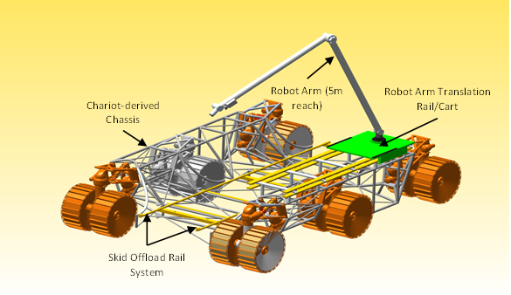
Fig. 12 Mobility Transport chassis isometric view.

An assessment of the MT was completed using a physics-based rover simulation built in the Trick Simulation Environment. [15] This simulation includes terramechanics modeling with Martian soil characteristics. [16] Candidate traverse routes are integrated into the simulation framework and traversed in a loaded and unloaded tanker state. Unconstrained energy storage was allowed to determine traverse energy costs and to better assess the energy storage needs. The traverses were simulated end-to-end with no dwell times for charging or detanking.
The energetics simulation utilized Jezero Crater terrain data due to availability of high-resolution data and its use in previous human landing studies. A 1 meter per pixel High-Resolution Imaging Science Experiment (HiRISE) Digital Terrain Model (DTM) of Jezero Crater [17] was employed for terrain contact modeling and graphics in the rover simulation as well as traverse generation in the open-source QGIS software [18]. To enable traverse generation, two MALV landing sites were selected to be approximately 1 km from a common MAV location. A slope raster was derived from the Jezero Crater DTM, shown in Fig. 13, and then a least cost path algorithm, which considers slope and distance, was used to calculate the two traverses shown in Fig. 14.
Preliminary results were gathered for the MT in multiple traverses in both a loaded and unloaded state. Housekeeping power loads of 2 kW were assumed along the traverses and added to the total power consumption at the end of the traverse. The Lander-2 to MAV traverse was determined to be more challenging for the given configuration. Fig. 15 shows the energy usage for both commodities and an empty tanker across the entire traverse route. Fig. 16 shows estimated per-kilometer consumption. Power consumption is seen to increase on inclines and with higher payloads, as expected.

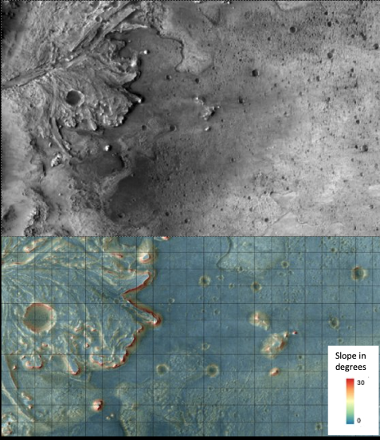
Fig. 13 Jezero Crater terrain and corresponding slope raster used in traverse calculation for energetics simulations.

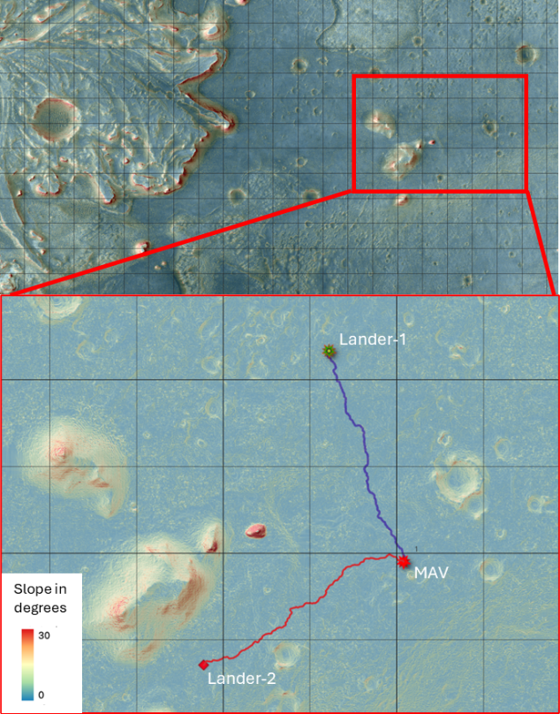
Fig. 14 Represented sites and traverses calculated using a least cost path algorithm.

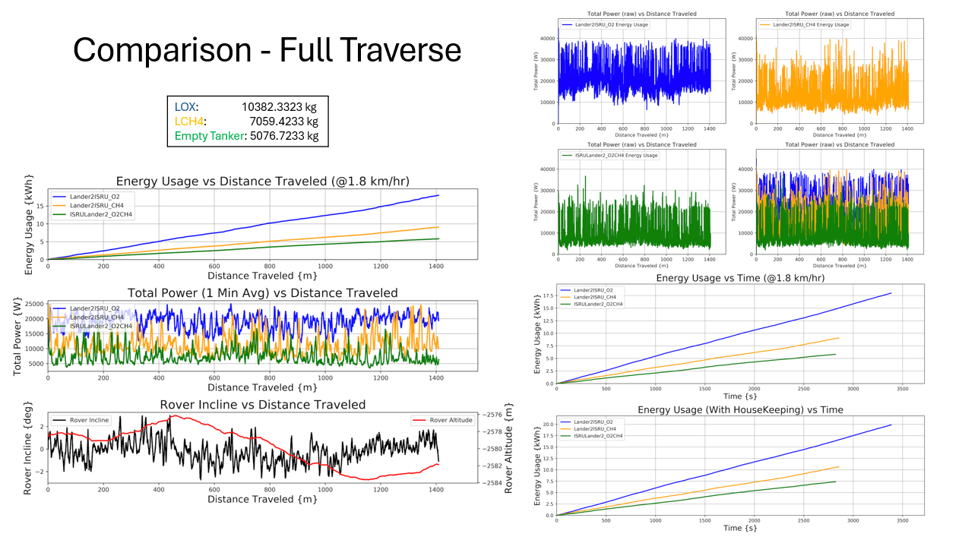
Fig. 15 Mobility Transport chassis energetics calculations for Lander-2 traverse.

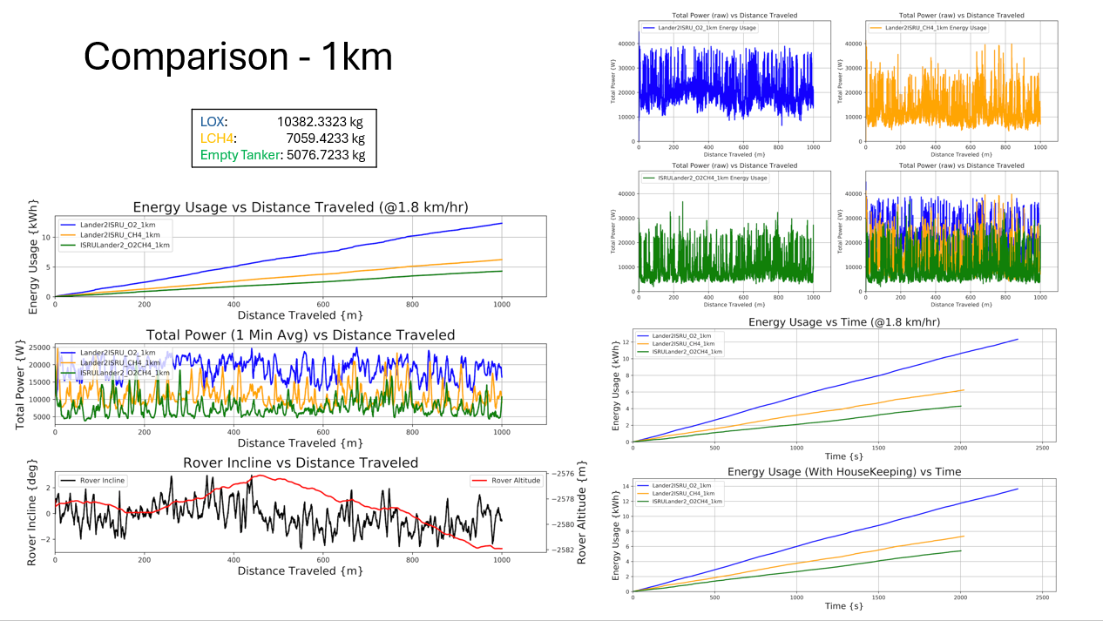
Fig. 16 Per-kilometer Mobility Transport chassis energetics calculations for Lander-2 traverse.

Mass Analysis
The mass estimate for the Mobility Transport chassis, broken down by functional category, is given in Table 2.
Table 2 Mobility Transport chassis mass estimate.
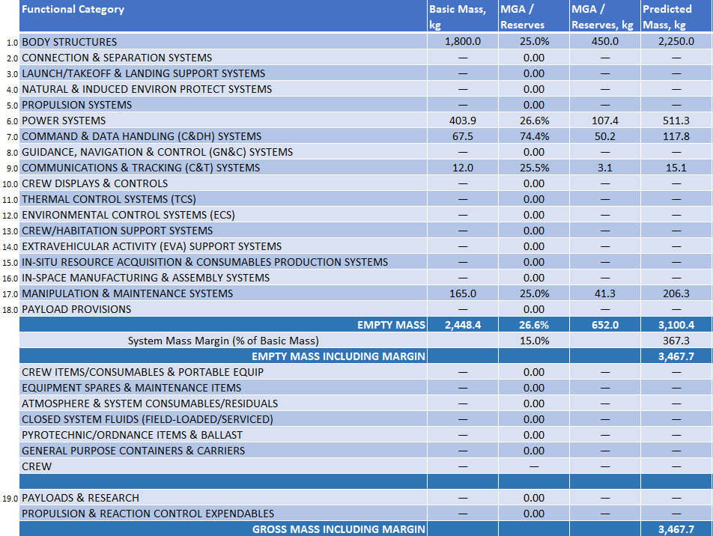

- Propellant Delivery Tanker Design Concept
Liquid methane will be delivered from Earth in two tanks, each with an approximately 40t payload capacity. Liquid oxygen arrives in four tanks, each with a capacity of approximately 65t. This provides sufficient propellant to supply the MAV while accounting for losses due to chilldown, pressurization, and trapped volume. A summary of estimated losses is given in Table 3.

Table 3 Estimated propellant mass loss allocation.

Each tank is assumed to be spherical. The tanks for the LCH4 are 5.8m in diameter; the LOX tanks are 4.9m in diameter. They are 6061 aluminum spheres located in the MALV payload volume. The LCH4 tanks are assumed to be mounted in the nose ogive to allow for additional payloads to be carried with the methane landers. The LOX tanks are mounted with the tank bottom approximately equal to the floor of the payload compartment. These tanks are considered to be connected to the existing MALV fill/drain system, as well as to the 90K cryocoolers operating the MALV’s broad area cooling system.
The tanks are assumed to be coated with 7.6 cm of BX-265 spray-on foam insulation, with a surface layer of aluminized Kapton. The payload ogive interior is also coated with a layer of aluminized Kapton for beneficial radiation conditions. Free convection of CO2, representative of the Martian atmosphere, is also presumed to take place. Given these assumptions, two MALV cryocoolers each with 150W thermal lift on approximately 1.3 kW power consumption can be shown to be sufficient to maintain thermal conditioning of both species for long durations. The MALV provides one spare cryocooler, if needed. These results are shown in Fig. 18 and Fig. 19.
In the event of a contingency that requires inert purging, such as changeover of a Propellant Transportation Pallet from one fluid service to another, a small supply of nitrogen (10 kg at 138 bar) is provided on each tanker lander.
The dry mass estimates for the storage tanks are given in Table 4 and Table 5.
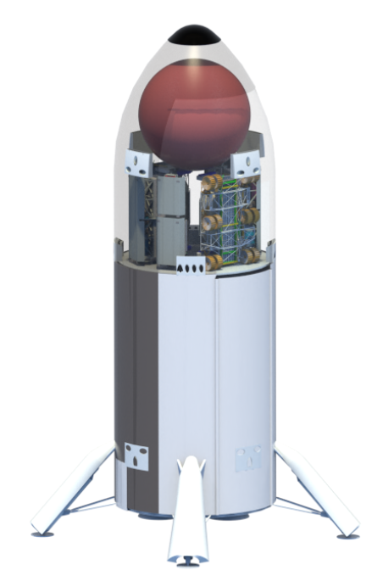
Fig. 17 MALV propellant lander concept (Methane configuration).

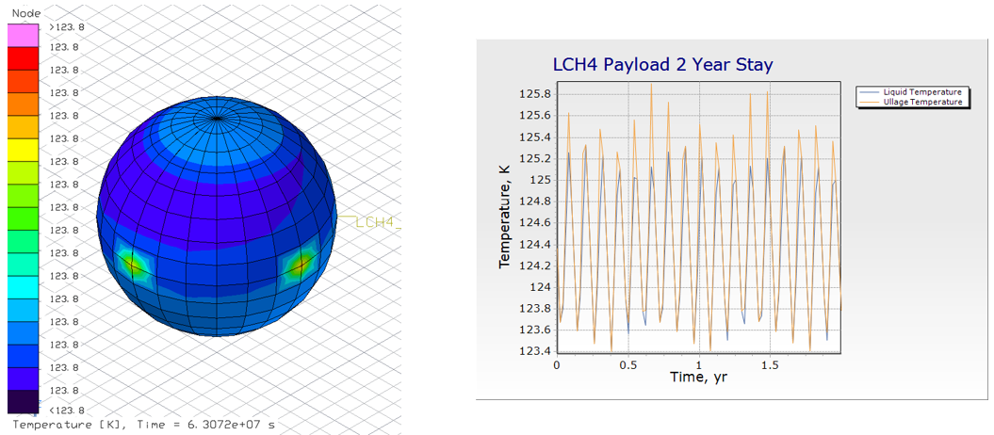
Fig. 18 LCH4 delivery tank thermal analysis.
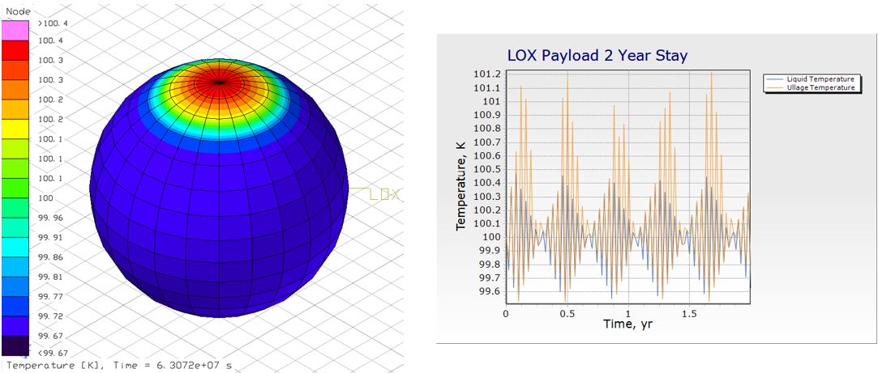
Fig. 19 LOX delivery tank thermal analysis.

Table 4 Methane payload tank mass estimate.
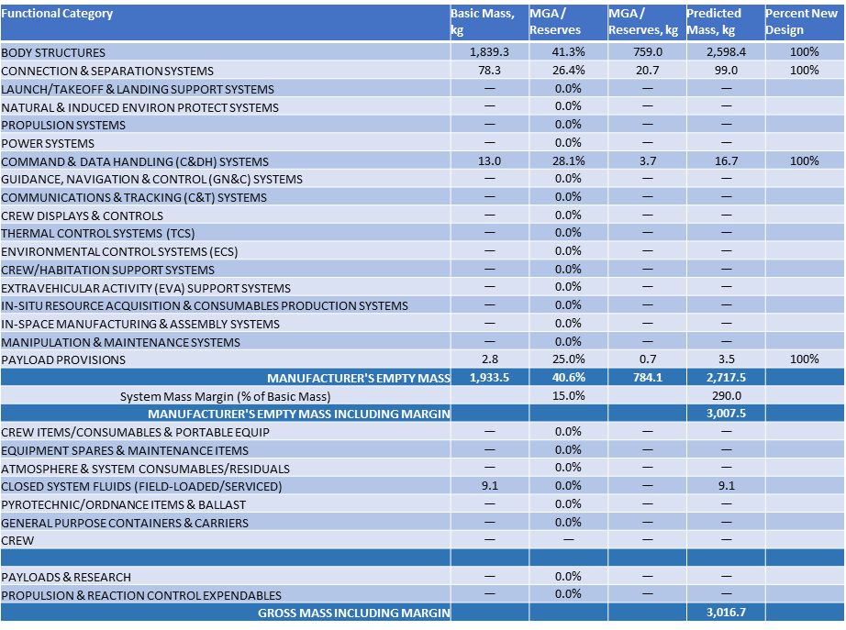

Table 5 Oxygen payload tank mass estimate.
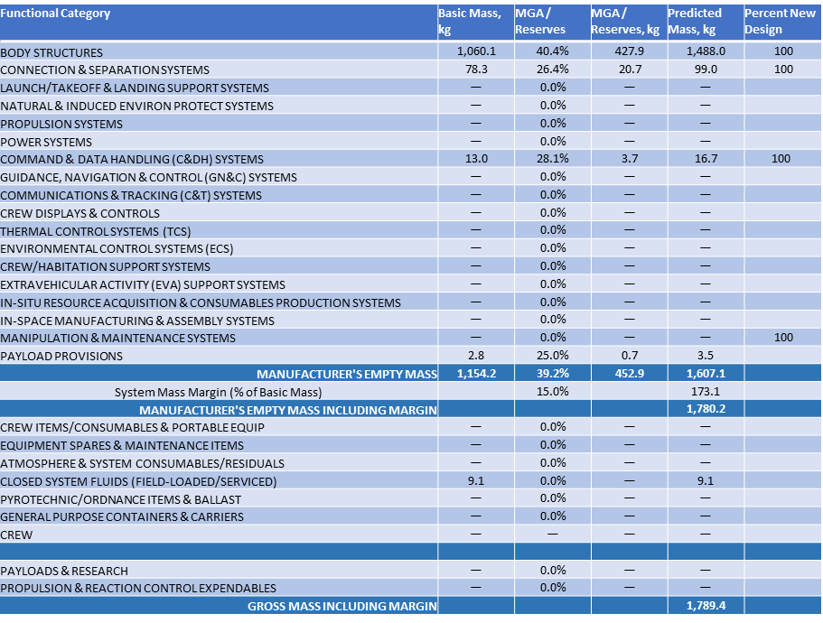

- Technological Needs
Wherever possible, components for the Surface Propellant Transportation Pallet concept, the Mobility Transport Chassis concept, and the Propellant Delivery Tanker concept were derived from items that are either currently commercially available or in development for other flight projects, as noted above. Because these systems would be intended to operate in a Martian environment and would be critical for a successful crew return, the development of certain new technologies are required. In all cases, new technologies to enhance system reliability, and provide fault detection, isolation and recovery may be needed. For the Propellant Transportation Pallet, new technologies to enable autonomous cryogenic fluid transfer operations, and enable repeated, reliable, high integrity umbilical mating/demating may be essential. For the Mobility Transport Chassis, technologies to enable autonomous robotic mobility may be needed. Of particular necessity may be developments in autonomous rover navigation and maneuvering capabilities, autonomous path planning, task processing, scheduling, and autonomous manipulator system operations. For the Propellant Delivery Tanker, technologies for autonomous operations, in particular, developments in autonomous task processing and scheduling, may be necessary.
- Conclusion
The surface transportation of a bulk liquid commodity, whether a pre-delivered propellant or an ISRU feedstock, from a source location to a utilization location has been featured as a component of several studies that encompass the strategy for propellant acquisition to fuel a MAV to return a crew to orbit from the surface of Mars. Repeated, reliable, and autonomous mating and demating of fluid and electrical connections and autonomous transfer of the commodity may be required to successfully perform this task, as may autonomous navigation. The ability to independently recover from off-nominal situations may also be vital. Many of these concepts and technologies have broad applicability for space and surface systems. Indeed, many components of the Propellant Transportation Pallet and chassis are derived from concepts initially developed for other projects.

References
[1] Goodliff, K., Merancy, N., Bhakta, S., Rucker, M., Chai, P., Ashurst, T., Troutman, P., and Stromgren, C., “Moon-to-Mars Architecture Definition Document,” NASA/TP-20230002706, 2023.
[2] Congiardo, J., Krenn, A., Martinez, J., Dupuis, M., and Swanger, A., “Development of a surface cryogenic propellant transfer concept for Martian operations,” IOP Conference Series: Materials Science and Engineering, Vol. 1240, 2022.
doi: 10.1088/1757-899X/1240/1/012011
[3] Krenn, A., Trent, D., Sanders, G., Hoffman, S., Chai, P., and Hinterman, E., “Architectural impacts of in-situ resource utilization production of oxygen for use as propellant in a Mars ascent vehicle,” IOP Conference Series: Materials Science and Engineering, Vol. 1240, 2022.
doi: 10.1088/1757-899X/1240/1/012010
[4] Carreau, M., “MOXIE Demo Extracts Oxygen from Mars Atmosphere, NASA Says,” Aviation Week, published online 11 September, 2023, URL: https://aviationweek.com/defense-space/space/moxie-demo-extracts-oxygen-mars-atmosphere-nasa-says [retrieved 19 October 2023].
[5] Congiardo, J., et. al., "Assessment of a Surface Water Transportation System Concept for ISRU Operations on Mars," AIAA 2024-2541. AIAA SciTech 2024 Forum. AIAA, Orlando, FL, January 2024.
doi: 10.2514/6.2024-2541
[6] Trent, D., Edwards, S., Chappell, M., “Design of a Family of Mars Chemical Transportation Elements,” AIAA 2024-2713. AIAA SciTech 2024 Forum, AIAA, Orlando, FL, January 2024.
doi: 10.2514/6.2024-2713
[7] Rucker, M., et. al., "NASA's Strategic Analysis Cycle 2021 (SAC21) Human Mars Architecture," 2022 IEEE Aerospace Conference (AERO), Big Sky, MT, USA, 2022, pp. 1-10.
doi: 10.1109/AERO53065.2022.9843237.
[8] Oleson, S., et. al., “A Deployable 40 kWe Lunar Fission Surface Power Concept,” ANS Nuclear and Emerging Technologies for Space 2022, American Nuclear Society, Downers Grove, IL, 2022, pp. 519-527
[9] Harrison, D. A., Ambrose, R., Bluethmann, B., and Junkin, L., "Next Generation Rover for Lunar Exploration," 2008 IEEE Aerospace Conference, Big Sky, MT, USA, 2008, pp. 1-14.
doi: 10.1109/AERO.2008.4526234.
[10] Coll, G. T., et. al., "NASA’s Exploration and In-Space Services (NExIS) Division OSAM-1 Propellant Transfer Subsystem Progress 2020," 2020 AIAA Propulsion and Energy Forum, USA, 2020.
doi: 10.2514/6.2020-3795.
[11] Schuler, J. Nick, A. Leucht, K., Langton, A., and Smith, D., "ISRU Pilot Excavator: Bucket drum scaling experimental results," 18th Biennial International Conference of the ASCE - Earth and Space 2022, Denver, CO, 2022.
doi: 10.1061/9780784484470.037.
[12] Pesaran, A., Roman, L., and Kincaide, J., “Electric Vehicle Lithium-Ion Battery Life Cycle Management,” NREL/TP-5700-84520, 2023.
[13] Sahu, K., Leidecker, H., and Lakins, D., “EEE-INST-002: Instructions for EEE Parts Selection, Screening, Qualification, and Derating,” NASA/TP-2003-212242, 2008.
[14] Millour, E., et. al., “The Mars Climate Database (Version 5.3),” Scientific Workshop: “From Mars Express to ExoMars”, ESAC, Madrid, Spain, 2018.
[15] National Aeronautics and Space Administration, Johnson Space Center, Software, Robotics & Simulation Division, Simulation and Graphics Branch (ER7), “Trick simulation environment: Documentation,” URL: https://nasa.github.io/trick/documentation/ Documentation-Home, September 2023.
[16] Trease, B, Arvidson, R, Lindemann, R, Bennett, K, Zhou, F, Iagnemma, K, Senatore, C, and Van Dyke, L. "Dynamic Modeling and Soil Mechanics for Path Planning of the Mars Exploration Rovers." Proceedings of the ASME 2011 International Design Engineering Technical Conferences and Computers and Information in Engineering Conference. Volume 6: 35th Mechanisms and Robotics Conference, Parts A and B. Washington, DC, USA. August 28–31, 2011. pp. 755-765.
doi: 10.1115/DETC2011-47896
[17] Fergason, R. L., Hare, T. M., Mayer, D. P., Galuszka, D. M., Redding, B. L., Smith, E. D., Shinaman, J. R., Cheng, Y., and Otero, R. E., “Mars 2020 Terrain Relative Navigation Flight Product Generation: Digital Terrain Model and Orthorectified Image Mosaics,” 51st Lunar and Planetary Science Conference, no. 2326, 2020.
doi: 10.5066/P9REJ9JN
[18] QGIS.org (2023). QGIS Geographic Information System. Open Source Geospatial Foundation Project. URL: http://qgis.org.

Lead Aerospace Technologist, Engineering Directorate, Kennedy Space Center
Aerospace Technologist, Technical Management, Exploration Research and Technology Programs Directorate, Kennedy Space Center
Aerospace Technologist, Theoretical Simulation Techniques, Exploration Research and Technology Programs Directorate, Kennedy Space Center
Aerospace Technologist, Engineering Directorate, Kennedy Space Center
Aerospace Technologist, Gas and Fluid Systems, Engineering Directorate, Kennedy Space Center
Aerospace Technologist, Automation and Robotics Systems, Engineering Directorate, Johnson Space Center, Retired
Aerospace Technologist, Automation and Robotics Systems, Engineering Directorate, Johnson Space Center
Software Engineer, CACI
Aerospace Corporation
Aerospace Technologist, Technical Management, Science and Technology Office, Marshall Space Flight Center
Aerospace Technologist, Technical Management, Habitation Systems Development Office, Marshall Space Flight Center
Engineer, ESSCA, Jacobs Engineering Group, Marshall Space Flight Center
NASA, “NASA Announces Artemis Concept Awards for Nuclear Power on Moon”, URL: https://www.nasa.gov/news-release/nasa-announces-artemis-concept-awards-for-nuclear-power-on-moon/ [retrieved 9 November 2023]
RELiON Batteries, “Lithium Battery Depth of Discharge, State of Charge & Capacity”, URL: https://www.relionbattery.com/blog/tech-tuesday-depth-of-discharge [retrieved 8 November 2023]
Akin, D., “Planetary Surface Robotics: Terramechanics 1,” URL: https://spacecraft.ssl.umd.edu/academics/788XF20/788XF20L06.terramechanics1x.pdf, 2020, Accessed: 10/05/2020.
Akin, D., “Planetary Surface Robotics: Terramechanics 2,” URL: https://spacecraft.ssl.umd.edu/academics/788XF20/788XF20L07.terramechanics2x.pdf, 2020, Accessed: 10/05/2020.

