Sensing Small Uncrewed Aerial Vehicles with Distributed Radars for Advanced Air Mobility Surveillance
Federica Vitiello Flavia Causa Roberto Opromolla and
Giancarmine Fasano
University of Naples “Federico II”, Piazzale Tecchio 80, Naples, 80125, Italy
Chester Dolph and Todd Ferrante
NASA Langley Research Center, 1 Nasa Dr, Hampton, VA, 23666, USA
Thomas Lombaerts and Corey A. Ippolito
NASA Ames Research Center, Moffett Field, CA, 94035, USA
In the context of Advanced and Urban Air Mobility major attention is being reserved to the development of sensing strategies for small Uncrewed Aerial Vehicles (sUAVs) to enable their safe operations in and around urban areas. Such strategies should rely on non-cooperative distributed sensors to strengthen the surveillance solution towards the unreliability of Global Navigation Satellite System (GNSS) positioning information, which is typical for low-altitude-flying platforms in urban regions, and increase the monitored airspace volume. To this aim, this paper proposes a fusion solution for a network of distributed ground-based radars, which can be exploited to not only increase the coverage over large airspace volumes but also improve the overall detectability and traceability of sUAVs by leveraging on multiple views over the same area. The solution exploits a centralized fusion scheme in which measurements collected by each radar are shared with a Fusion Center where Kalman Filtering is exploited to build a unique, fused track. Tests conducted on experimental data collected using two sUAVs as flying targets and three distributed radars showed that the proposed solution can produce an increase in coverage from about 20 % (single radar configuration) to about 80 % of the targets’ flight path, as well as a finer accuracy yielding meter and meter-per-second root mean square error values on position and velocity components.
- Introduction
Technological advancements in the field of Uncrewed Aerial Vehicles (UAVs) and electrical Vertical Take Off and Landing (e-VTOL) vehicles have generated novel concepts of operations foreseeing an ever-increasing exploitation of such platforms in and around urban areas. Advanced and Urban Air Mobility (AAM/UAM) can be listed among such concepts and represent innovative on-demand transportation paradigms for both people and goods. While the concept of urban aviation is not new, with helicopter-based passengers’ transportation carried out in American cities as early as in the 1950s and 1980s [1], the contemporary UAM vision extends the service to a larger slice of the population exploiting UAVs and E-VTOLs as air-taxis. This will promote an efficient and sustainable relief to ground traffic congestion, which is typical of modern cities, while also creating a competitive alternative to other ground-based transportation means such as railways [2]. Nevertheless, the high flexibility, scalability and rapidity in deployment of UAVs, proven to be crucial for fast response applications such as disaster management [3], coupled with the high autonomy levels reached, are a significant advantage in the framework of AAM/UAM where missions involving door-to-door package deliveries and emergency responses are envisioned as well.
Although the latest years have seen an increasing interest of AAM/UAM both on research and industry levels, their operations still face various challenges which range from aircraft-based aspects, whose design needs to respect strict constraints on reliability and noise levels, to infrastructure-based aspects, which need to enable the expected high volumes of operations and their co-existence with the well-established manned aviation traffic. These different aspects need to converge to achieve the final maturity level of the UAM Maturity Level (UML) scale defined by NASA in Ref. [4], i.e., UML-6, where ubiquitous UAM operations are forecasted. Such a stage of maturity can only be achieved by innovating communication, navigation and surveillance capabilities of UAVs.
Compared to the well-assessed manned aviation systems scenarios, surveillance strategies in the AAM/UAM environment need to detect smaller platforms flying at lower altitudes against cluttered backgrounds in dense airspace. To cope with these issues, distributed sensing solutions can be used to leverage on multiple, interconnected sensing nodes placed, ideally, at regular intervals along flight corridors and with higher density around critical areas such as vertiports [5]. To overcome the limits of cooperative traffic surveillance, which relies on the broadcasting of information from the flying platforms, the sensing nodes should be equipped with non-cooperative sensors such as radars, instead. This choice yields the opportunity of collecting three-dimensional positioning measurements, with radial velocity estimates if Doppler radars are used, independently from the cooperativeness of platforms while enhancing surveillance robustness under all-time-all-weather conditions.
The use of networks of radars for surveillance purposes is a widely investigated research topic encompassing a large variety of application fields which share common focal points, such as association strategies for measurements from different devices and the algorithmic architecture suitable for their fusion. The most flourishing field is the automotive one, in which networks of collocated radars are used to increase the safety of operations of autonomous, “self-driving” cars. In such context, references such as Refs. [6-8] focus on the development of association and tracking strategies when multiple low Size Weight and Power (SWaP), 77 GHz Frequency Modulated Continuous Wave (FMCW) are used. In Refs. [6, 7], a set of four such radars installed onboard a car are used to collect measurements which are then integrated into a multilateration problem to estimate the cartesian state of surrounding targets. The association is thus performed either using frequency or range measurements. Reference [8] uses a similar setup, though not specifically intended for automotive applications, to demonstrate lower probability of track losses when multiple radars are used. The design and prototyping of a network of three 122 GHz radars is discussed in Ref. [9], instead, in which a cooperation-based approach is exploited and all radars within the network process both monostatic and bistatic distance measurements thus increasing the robustness of the target detection phase.
While in the automotive sector research primarily focuses on short-range radar networks, achieving detection ranges of hundreds of meters at most, and to extended targets detection, in the air surveillance sector the operational ranges considered are much larger and can involve targets with smaller dimensions. In this applicative domain, the repurpose or replacement of existing radar networks, devoted to weather surveillance, to air traffic monitoring services (or their use for both) has been suggested by works such as Refs. [10, 11]. However, if the application is narrowed down to the survey of the low-altitude airspace near urban areas for the detection and tracking of small UAVs (sUAVs), the operational considerations regarding radar sensors must be shifted to account for power and infrastructural constraints. The body of work in this area is not as extensive as in the automotive sector and mostly deals with simulations. An example can be found in Ref. [12] which discusses the use of an aerial network of distributed radars installed onboard UAVs for UAV-to-UAV monitoring. The strategy proposed collects measurements from all onboard radars along with the position of the UAV at the measurement time to track any potential target with a higher continuity with respect to ground-based fixed radars. Although showing promising results, this work does not address the real-world challenges of deploying airborne radars in urban areas which can be paid in terms of interference between the devices as well as clutter within the measurements, arising from both fixed targets and multi-path reflections [13].
The exploitation of a network of sensors to collect information on sUAVs is an active area of research in the initial stages of investigation. In these regards, the NASA Revolutionary Aviation Mobility (RAM) subproject of the Transformational Tools and Technology (TTT) project is researching the development of distributed sensing architecture for UAM and sUAVs in the AAM context [14] with research works such as Refs. [15-17] aiming at developing sensing strategies for sUAVs observed by ground-based networks of distributed sensors.
Following this research thread, this paper proposes a data fusion solution tailored for a network of distributed ground-based radars to track sUAVs during flight. The strategy is an upgraded version of the work discussed in Ref. [18] where a hierarchical leader-helper approach is used to increase the lifespan of the leader’s firm tracks leveraging on the exchange of measurements from a helper radar. The aim of the proposed paper is to go beyond such implementation by exploiting a fusion solution where each radar can independently contribute to the generation of unique firm tracks of all sUAVs, thus not only increasing the track coverage due to the augmentation of the monitored area, but also improving the accuracy of the final solution, which benefits from the availability of measurements collected in different locations where the flight of the sUAVs appears under different perspectives. Furthermore, the use of more than two radars can drastically strengthen the solution towards single sensor failures.
The approach is designed in a centralized fashion thus having each radar independently monitoring their Field of Views (FOVs) and sharing their processed measurements with a Fusion Center (FC). The task of the latter is to collect multiple measurements and perform their fusion within a multi-target Kalman filtering tracking logic where sequential track correction is performed based on the available measurements. Compared to track-to-track fusion approaches, this measurement-to-track strategy results in more long-lasting tracks as it does not depend on generating tracks from all sensors prior to attempting their fusion. The strategy assumes that a data link between the sensors and the FC can be established and can be generalized to accommodate more than three radars.
The strategy is tested in a real-world scenario using experimental data collected during flight campaigns performed at the National Aeronautics and Space Administration (NASA) Langley Research Center (LaRC) during flight operations of the High Density Vertiplex Subproject [19]. In the experiments considered for this paper, a network of three ground-based sensing nodes, equipped with visual cameras and radars, was deployed to collect data of two sUAVs flying on the same route.

The remainder of the manuscript is organized as follows. Section II provides a detailed discussing of the methodology used to fuse the data from the radars within the network. Section III presents the experimental tests carried out to collect measurements for strategy testing and validation while Section IV discusses the experimental results achieved. Finally, Section V outlines the conclusion and future developments of the work.
- Distributed Radar Fusion Methodology
The strategy proposed in the paper exploits a centralized fusion scheme which is summarily depicted in Fig. 1 for the case of a number (n) of radars (“RAD”). The architecture foresees the use of a local processing unit at each sensing node site to collect and process sensors’ measurements before sharing them with the FC. The latter is thus devoted to the association of all received measurements for further use in a linear Kalman filtering tracking logic that starts from first track attempts, i.e., one-plot tracks, and evolves to reliable tracks, i.e., firm tracks, using sequential corrections of all associated radar measurements. Before detailing the association and tracking strategies used at FC level (Section II.B), an overview of the measurements collected and shared by the radars is provided in Section II.A.
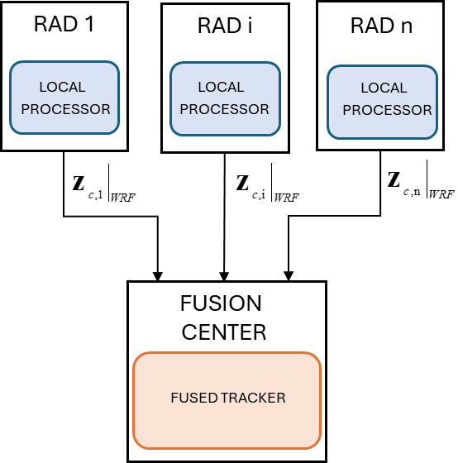
Fig. 1 Scheme of the proposed centralized fusion logic exploiting a number of n radars.

Radar measurements
Radars used for the development of this strategy are FMCW radars collecting spherical positioning measurements of objects within their FOVs expressed in terms of range (R), azimuth (az), and elevation (el) in the Radar Reference Frame (RRF). Such devices also collect measurements of range rate (Ṙ), i.e., velocity of targets in the radial direction with respect to the radar, which is used within the measurement pre-processing phase in this study. As discussed in a previous work [18], such phase is needed to mitigate the effects of clutter and interference which arise in structured environments where multiple devices operate with overlapping FOVs. The measurement pre-processing phase is designed to occur locally at the radar site and foresees the use of sequential filtering stages. First, measurements corresponding to a range rate smaller than a threshold (Ṙ_{th,low}) are labelled as static clutter and thus removed from the list of available measurements. Then, the Radar Cross Section (RCS) estimate, which is also an output of the radars used during tests, is used to narrow down the detection phase to UAV targets, thus only retaining measurements which meet the condition RCS_{th,low}<RCS< RCS_{th,up} where the extremal thresholds are set accordingly to the expected RCS signature of sUAVs. Given the fixed ground-based location of radars, additional filtering can also be applied on the R, az and el measurements to restrict the spatial domain to the region where the flight of the UAV is expected to occur. Once pre-processed, an interference mitigation strategy is applied on the measurements of those radars in the network which appear to be affected the most. The strategy used in this work is the same as in Ref. [18] and involves detecting interference-affected measurements as those that exhibit large variations in range for the same radar pointing direction, defined by the az-el pair.
Pre-processed measurements can be shared with the FC once transformed in cartesian expression. Let z_{i}=[R,az,el] be the pre-processed measurement vector for the i-th radar, then its cartesian expression can be obtained using Eq. (1) where the symbol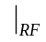 is used to identify the reference frame (RF) in which the vector is defined (RRF in this case).
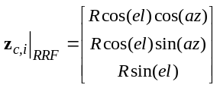 (1)
In order to be used by the FC, the measurements of all radars need to be referred to the same reference frame, namely World Reference Frame (WRF), which is oriented using the North-East-Down (NED) convention and centered at a pre-defined location in the scene. Therefore, measurement z_{c,i} undergoes rotation and translation transformation as expressed in Eq. (2).
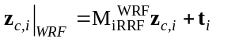 (2)
In the latter, 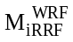is the rotation matrix from the RRF of the i-th radar to the WRF and t_{i} is the vector containing its position (x_{R},y_{R},z_{R} along North, East and Down direction) with respect to the location of the WRF, thus t_{i}=[x_{R},y_{R},z_{R}]. A graphical representation of the considered geometry with the previously defined vectors is provided in Fig. 2.

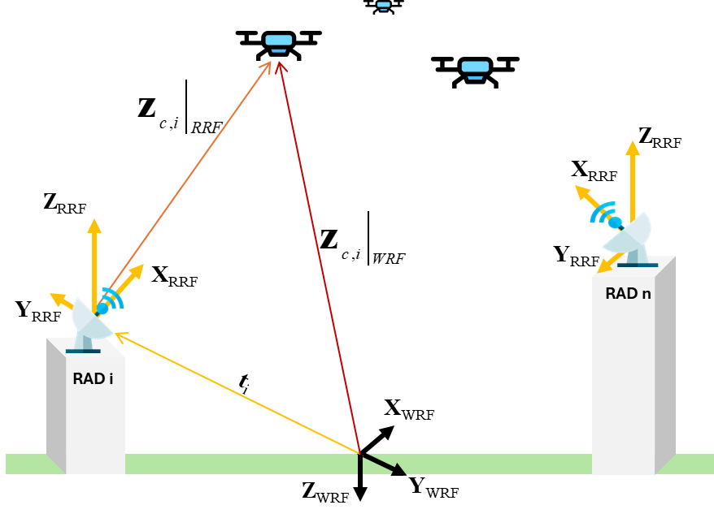
Fig. 2 Graphical representation of the considered geometry.

Fusion Center
The primary task of the FC is to generate a unique track of the targets detected by the radars within the network using an evolutive multi-level tracking logic, depicted in the scheme of Fig. 3. Tracks are estimated through linear Kalman filtering using a Nearly Constant Velocity (NCV) dynamic model with state vector x=[x,y,z,ẋ,ẏ,ż], which contains the WRF cartesian components of the position (x,y,z) and velocity (ẋ,ẏ,ż) of targets. The filter uses the processed measurements shared by the radars in the network contained in the union Z={z_{c,1,…,} z_{c,n}}, which is thus the input to the FC tracker. In the following, the subscript previously used in Section A to indicate the reference frame in which measurements are defined will be omitted as all quantities used in this section are referred to the WRF.
The logic of the FC tracker is based on the evolution of low reliability tracks, i.e., One-Plot Tracks (OPT), to the highest reliability level, i.e., Firm Tracks (FT), passing through a medium phase, i.e., Tentative Tracks (TT). Each of such phases is triggered only if a track for the corresponding block, numbered in n_{FT}, n_{TT} and n_{OPT} for firm, tentative and one-plot tracks respectively, was generated at the previous time step. To evolve from lower to higher reliability tracks, measurement-to-track association criteria need to be verified using the Mahalanobis distance (ξ). The dimensions of union Z can thus decrease when moving from the firm to the one-plot tracker since the associated measurements used for track evolution and correction (Z_{USED}) are removed from the pool of potential candidates for association in the other blocks. The measurements remaining after firm and tentative tracking, numbered in n_{meas}, can then be used to generate new OPTs.
To reduce the time needed to reach the firm tracking stage, given the expected higher density of measurements from the network as opposed to a typical standalone radar configuration, a tentative track can be generated in two different ways: either using measurements from different radars directly, by first verifying their mutual association, or through measurement-to-track association with a previous OPT as described in the following. The latter association strategy is the same for tentative and firm tracking as well.
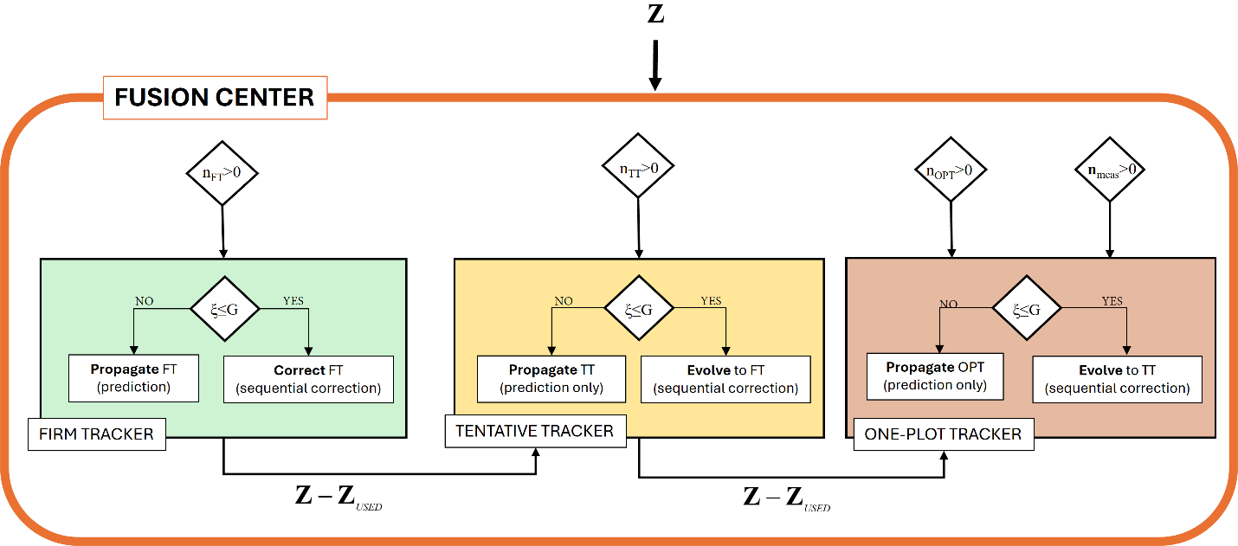
Fig. 3 Scheme of the tracker within the Fusion Center.

Measurement-to-measurement association
If measurements from more than one radar are received by the One-Plot tracker, their association is attempted to generate novel tentative tracks. Let i and k be the radars whose measurements are received, then their association is evaluated using the Mahalanobis distance of Eq. (3) which must be smaller than a threshold G set according to the chi-square distribution with three degrees of freedom at the .99 percentile probability [20]. In Eq. (3), the superscript T is used to indicate the transpose matrix operator.

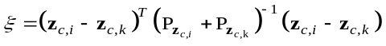 (3)
In such equation, the covariance of each measurement (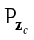) is computed by propagating the error form of Eq. (2) which yields the covariance formulation of Eq. (4) accounting for the radar covariance matrices on its measurement (R_{z}) and estimated attitude and position in WRF (P_{ρ} and P_{t}, respectively). The symbol [] is used to indicate the skew-symmetric matrix operator.
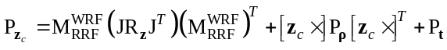 (4)
Specifically, P_{ρ} and P_{t} are the diagonal matrices with the squared uncertainty in the RRF-WRF attitude error estimation, i.e., ρ=[ε_{N},ε_{E},ε_{D}], and the squared uncertainty in the radar location, i.e., σ_{t}=[σ_{XR},σ_{YR},σ_{ZR}], along their diagonals, respectively. R_{z} is the diagonal matrix with the measurement squared uncertainty σ_{z}=[σ_{R},σ_{az},σ_{el}] along its diagonal, instead. The latter is transformed in a cartesian expression using the Jacobian matrix J which expresses the linearization of Eq. (2) as 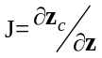.
If a set of measurements from one radar only is received by the block, a tentative track cannot be generated and a one-plot track is generated instead.

Measurement-to-track association
Measurement-to-track association is used to either attempt the evolution of tracks from one-plot to firm or correct a firm track. Similarly to the measurement-to-measurement association, the Mahalanobis distance is used in a slightly different expression provided in Eq. (5) which formulates the association between the measurement from the i-th radar and the predicted measurement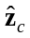whose covariance is expressed as the product of the measurement matrix H and the predicted state covariance matrix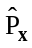. Given the linearity of the problem, the former is a 3 x 6 identity matrix.
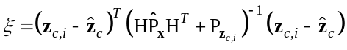 (5)
The association is deemed successful using the same threshold as in the measurement-to-measurement association case. The Mahalanobis distance of Eq. (5) is computed for all measurements available at the tracking block (either the whole union Z or a subset Z-Z_{USED}). When measurements of different radars verify association to a given track, they are all used to correct the track in a sequential correction fashion thus providing a more accurate estimate of the state vector.
If association lacks, all tracks are predicted using the NCV dynamic model. In this case, to avoid tracking error divergences, tracks are deleted if prediction-only propagation has been carried out for a time of δt_{keep,OPT}, δt_{keep,TT}, δt_{keep,FT} for firm, tentative and one-plot tracks, respectively. Given the expected large volumes of measurements collected by the whole radar network, such times can be relaxed with respect to a tracker processing at single node level.
- Experimental setup
Data used to develop this research was collected during one campaign carried out at the NASA LaRC City Environment Range Testing for Autonomous Integrated Navigation (CERTAIN) flight space [21]. During such experiments, two sUAVs (Alta-8 platforms manufactured by Freefly) were flown on a circular pattern starting from and getting back to their respective vertipad location.
As far as the sensing nodes are concerned, these are configured with the sensors and companion computers described in Table 1. All nodes, mounted at their respective location as shown in Fig. 4, are equipped with visual cameras, which are not used in the scope of this paper, and have an Echodyne Echoflight FMCW radar. To enable their remote access, cellular modems (RUTX11) were also installed on each node. The first sensing node (R1), shown on the top-left in Fig. 4, was mounted on a deployable tripod and located on a concrete platform a few meters above ground level. The second sensing node (R2) was directly attached to the Landing and Impact Research Facility (LIRF) structure at a height of approximately 60 m as shown on the top-right in Fig. 4. Lastly, the third node (R3) was installed on a deployable tripod located on top of a rooftop, approximately 10 meters above ground.
The radars configurations are listed in Table II where the dimensions of the Horizontal FOV (HFOV) and Vertical FOV (VFOV) are reported. Given its height, the R2 radar was the only one using the maximum FOV dimensions of 120° by 80° in the horizontal and vertical directions. The VFOV of R1 and R3 were reduced to mitigate the effects of ground clutter, instead. Furthermore, the HFOV of R1 was also halved down to avoid the collection of measurements arising from the surrounding tree-line.
Table I Configurations of radars on sensing nodes.
Node | GNSS receiver | Computer
R1 | Sparkfun GPS-RTK-SMA ZED-F9P (Ublox) | 3 Xaviers with Contech Rogue breakout Board
R2 | Sparkfun GPS-RTK-SMA ZED-F9P (Ublox) | Xaviers with Contech Rogue breakout Board
R3 | Sparkfun GPS-RTK-SMA ZED-F9P (Ublox) | NUC 11 Performance Mini Desktop Computer

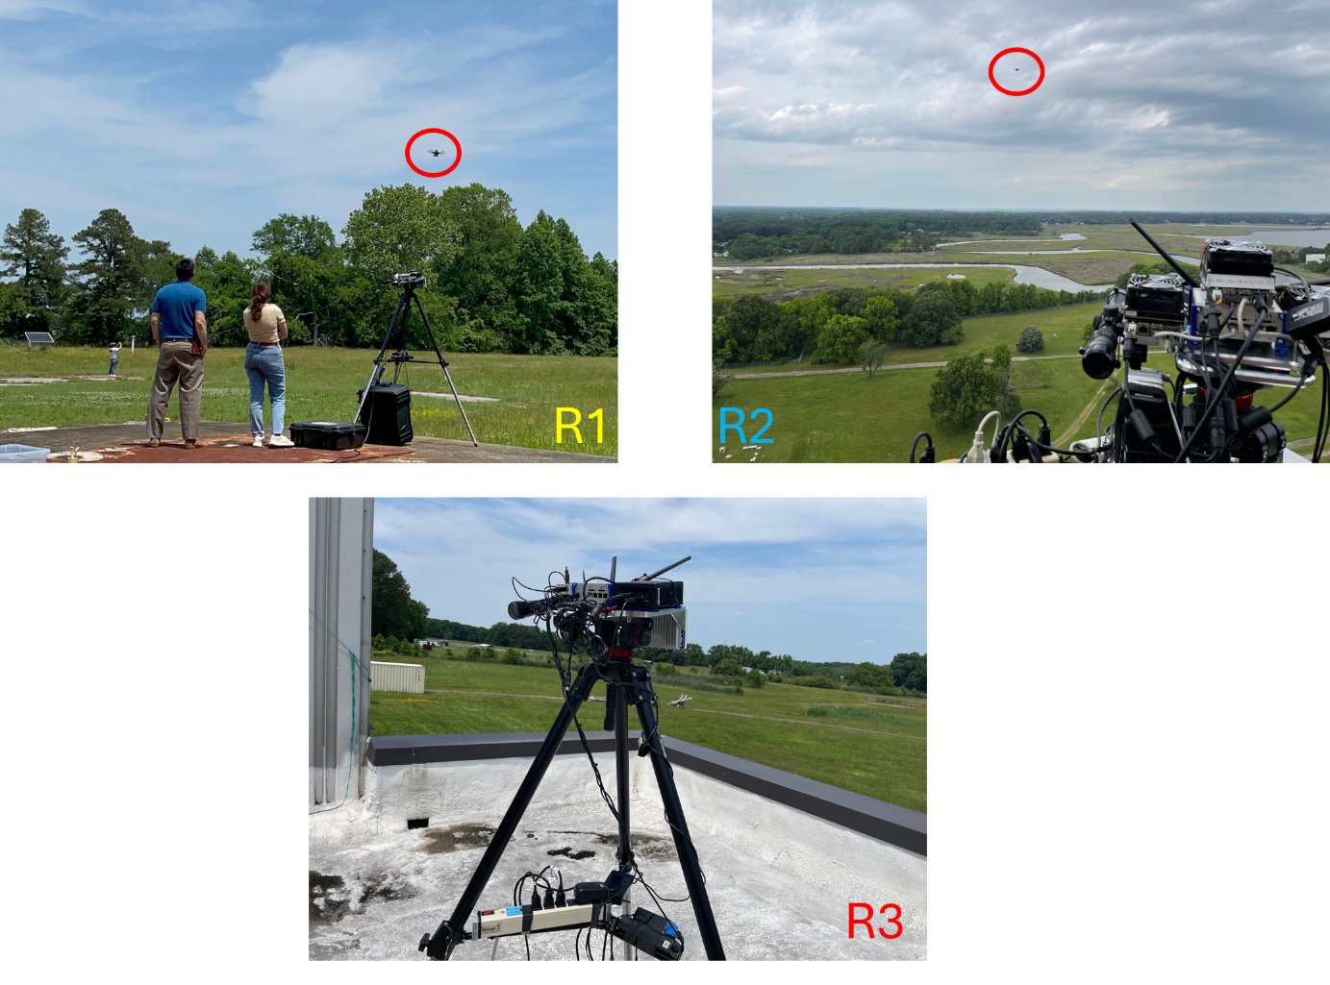
Fig. 4 Sensing nodes mounted at their locations and used for experimental data collection.

Table II Configurations of radars on sensing nodes.
Radar | HFOV | VFOV
R1 | 60° | 50°
R2 | 120° | 80°
R3 | 120° | 46°

Fig. 5 shows the geometrical configuration of the network of radars on a satellite map of the CERTAIN Range flight area at LaRC. The figure also reports the location of the radars along with their FOV (shaded triangles) and the location of the designated origin of the WRF (grey cross). The latter was chosen as the initial point of the trajectory of UAV N556NU since its position could be precisely accessed by the GNSS positioning information logged by the onboard autopilot.

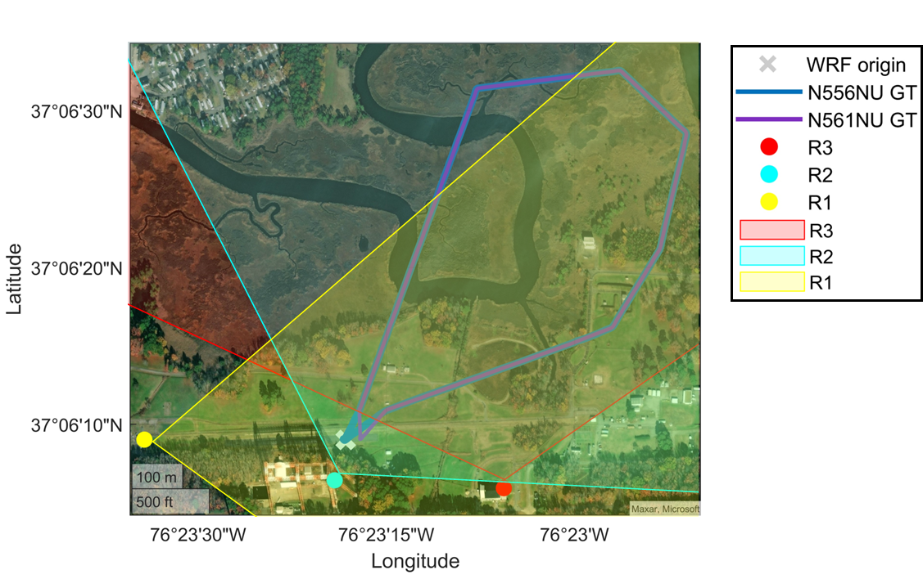
Fig. 5 Satellite map of the flight area highlighting the trajectory flown by the two UAVs along with the location (dots) and FOVs (shaded triangles) of the radars within the network.
- Experimental results
In this section the results achieved using the proposed fusion strategy are discussed by dividing the analyses in three different cases depending on the number of radars considered to be active within the network. Specifically, case 1 discusses the case when the R1 radar, being at the head of the field, is the only active sensor within the network. Then, in the other cases the number of active radars is incrementally increased by first activating R2 (case 2) and then adding R3 (case 3). To analyze the results, two main parameters are used: accuracy with respect to the GNSS-based benchmark and coverage over the UAVs’ trajectory. The former is evaluated by computing the difference between the firm tracking estimates and the benchmark, generated using the GNSS positioning information logged by the drones’ autopilots and the node’s receiver. To compute the coverage, the ratio between the number of time instants when a firm track is present and the total number of time instants when the benchmark is available.
The measurements collected by all radars undergo a similar filtering procedure which uses the thresholds: Ṙ_{th,low}=0.9 m/s, RCS_{th,low}=-25 dBsm and RCS_{th,up}=0 dBsm. The threshold used for the evaluation of the association is set to G=11.3 while tracks are maintained in prediction-only state using the time spans δt_{keep,OPT}=δt_{keep,TT}=0.5 s and δt_{keep,FT}=4 s. The tracker used at FC level exploits a 10 Hz temporal frequency.
As far as the uncertainties described in Section II.B are concerned, while the measurement and attitude uncertainties are set equally for all radars, so that σ_{R}=3 m, σ_{az}=2°, σ_{el}=3° and ε_{N}=ε_{E}=ε_{D}=1°, the uncertainty in the positioning information contained within σ_{t} varies with the considered radar. The values within the latter are provided by the GNSS receiver installed on the sensing node which shows the expected meter-level uncertainty in the horizontal positioning and a slightly larger value in the vertical positioning uncertainty. In the R2 radar case, such uncertainty increases to about 9 meters likely due to the challenging location of the GNSS antenna installed on the R2 node.
The results of case 1, case 2 and case 3 are shown in Figs. 5, 6 and 7, respectively. All figures show the firm tracking estimates (“FT”) for N556NU and N561NU on the left and right plots, respectively, along with the radar measurements used for their correction and the relative Ground Truth (“GT”) estimated using GNSS information. The final subplot indicates the number of nodes (radars) actively used for firm track correction.
The comparison between the three figures provides a clear view over the effectiveness of the proposed strategy. The results shown in Fig. 5 clearly depict a challenging condition where the radar R1, being the most affected by the effect of interference from radar R2, does not provide enough measurements for a continuous track of the sUAVs to be generated. The achieved coverage for case 1 reflects this issue, reaching values of 24.3% and 20.2% for the two UAVs, respectively. This results in the R1 radar achieving the worse performance in terms of root mean square error (rmse) of the estimated track in the horizontal and vertical planes. Such values, listed in Table III, exceed 10 meters in the North and Down directions for both sUAVs’ tracks.
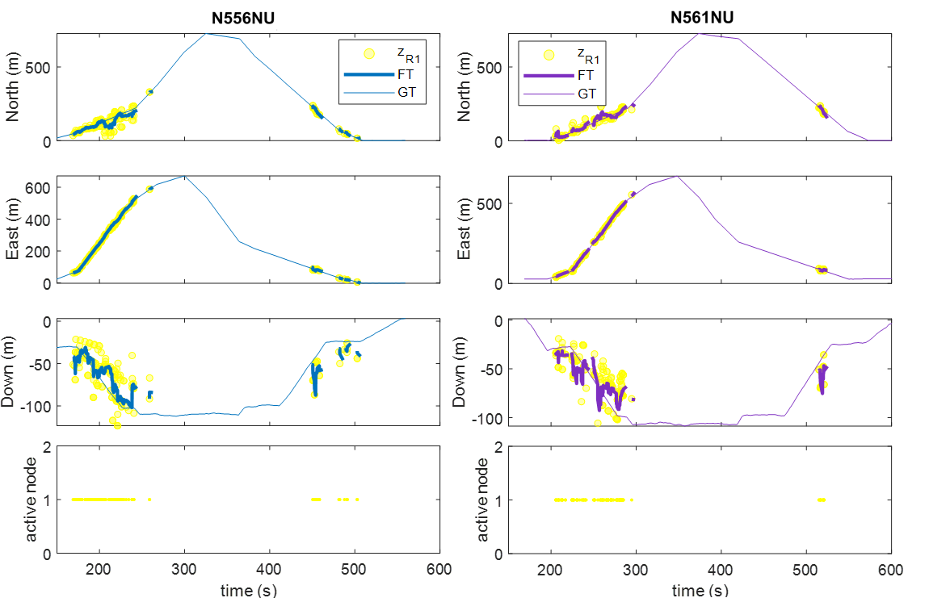
Fig. 5 Firm tracking estimates (thick colored lines) and measurements used for track update (colored dots) for case 1. R1 is the only active radar.

The results achieved with the activation of the second radar (R2 in case 2) are much more promising. While in the previous case about six different tracks belonging to the UAVs were generated, in this case the number is reduced down to four showing a more continuous tracking solution. Measurements from radar R2 appear to be denser thus providing the needed information to maintain firm tracks for a longer time. Therefore, the achieved coverage increases drastically with respect to case 1, reaching values of 66.7% and 72.02% for N556NU and N561NU. Regardless of this encouraging result, the accuracy achieved in the vertical (Down) direction is still comparable to the previous case. This outcome can be traced back to the vertical extension of the R2 radar’s FOV, which was the only one to retain the overall dimension of 80° thus challenging the retrieval of an accurate positioning estimate in the vertical direction. This is clearly visible in the Down trajectory plot of Fig. 6 where measurements of the R2 radar (depicted with light blue circles) appear to be widely distributed around the GT line.

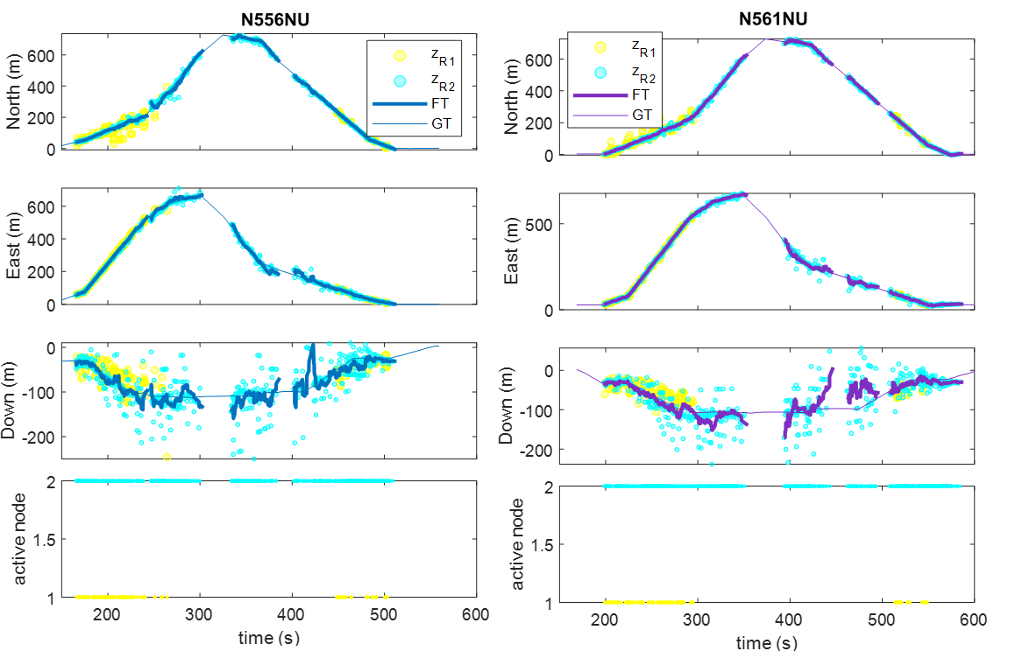
Fig. 6 firm tracking estimates (thick colored lines) and measurements used for track update (colored dots) for case 2. R1 and R2 radars are both active.

The results achieved in case 3, shown in Fig. 7, meet the expectations by proving a continuous, single track of the two sUAVs with coverages of 77.1% (N556NU) and 86.3% (N561NU), thus achieving a +10% increase with respect to the previous case. The two targets are thus tracked starting from a minimum distance of about 42 meters up to the maximum distance they reach during flight, approximately 910 meters. The plot in the Down direction now shows a much dissimilar behavior with respect to the previous case, with measurements from R3 being the most accurate also in the elevation field. This provides an extremely favorable accuracy outcome, with rmse values settled on the meter level for all the position components.
The velocity estimated during firm tracking is shown on the left in Fig. 8 where the firm tracks generated for the sUAVs are also shown together (on the right) to highlight the multi-target nature of the tracker. The GT reported in the velocity plot is computed using a two points numerical derivative scheme on the GNSS positioning GT and a moving mean to smooth the data. The accuracy achieved on the velocity estimates reflects the highly accurate positioning estimate, with rmse values of about 0.7 m/s, 1 m/s and 1.2 m/s for the two sUAVs along North, East and Down, respectively.
Fig. 9 provides a visualization of the three-dimensional trajectory estimated by the firm tracking solution and highlighting with different colors the number of radars used to correct the track. From this figure, as well as from the fourth sub-plot of Fig. 7, it is clearly visible that the initial departure and final approaching phases of the trajectory are the only regions where the complete three radars configuration is used at firm tracking. This is due to the low density of measurements of radar R1 which, as shown in Fig. 5, lacks measurements belonging to the central region of the trajectory. The firm tracks are thus mostly maintained by either a two-radars configuration, exploiting R2 and R3, or by a single radar configuration. Regions of the trajectory colored in black represent the prediction phases of the Kalman filter where no radar information is used. In such phases, measurements from all radars either lack or do not verify association, thus yielding to the propagation of a predicted track instead. However, the large amount of valid measurements collectively acquired by the radars in the network enables frequent corrections of the predicted solution, preventing undesirable track dropouts.

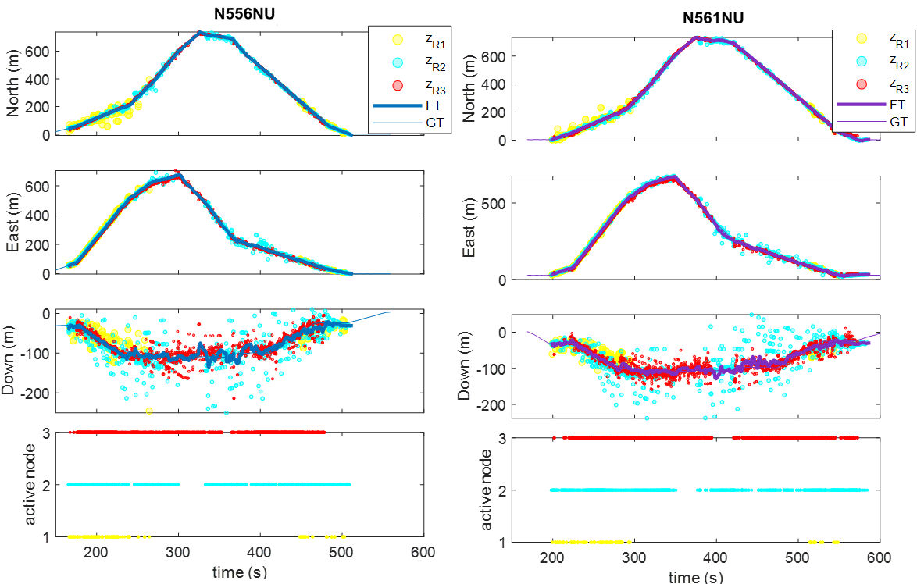
Fig. 7 Firm tracking estimates (thick colored lines) and measurements used for track update (colored dots) for case 3. R1, R2 and R3 are all active.

Table III Performance of the proposed fusion solution for the three analyzed cases.
case | North rmse (m) |  | East rmse (m) |  | Down rmse (m)
case | N556NU | N561NU | N556NU | N561NU | N556NU | N561NU
1 | 19.14 | 17.04 | 5.92 | 4.96 | 15.93 | 16.06
2 | 8.93 | 5.13 | 11.21 | 8.24 | 17.12 | 22.16
3 | 3.55 | 3.96 | 5.16 | 5.81 | 8.99 | 8.23

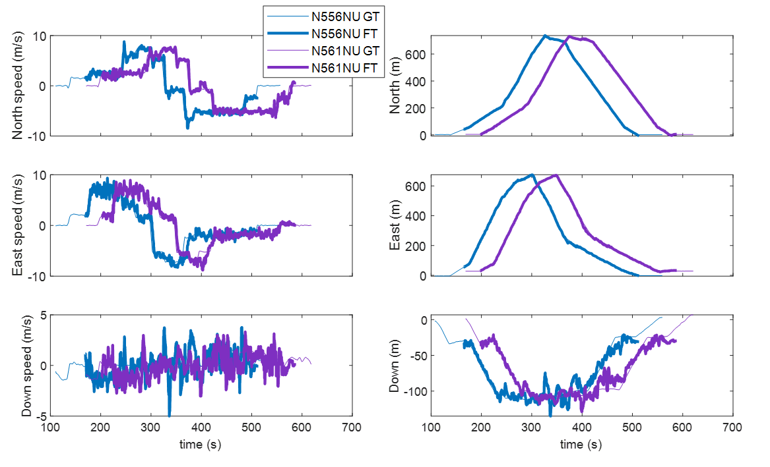
Fig. 8 Firm tracking estimates (thick colored lines) in the velocity components (left) and position components (right).

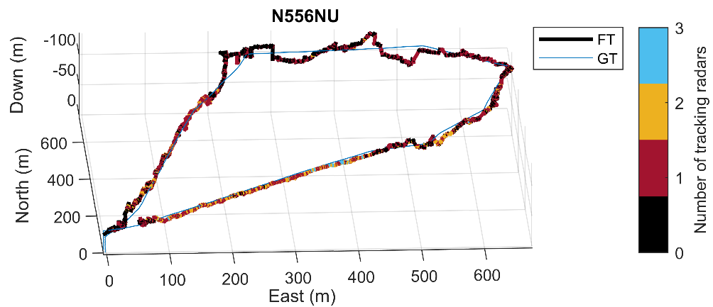
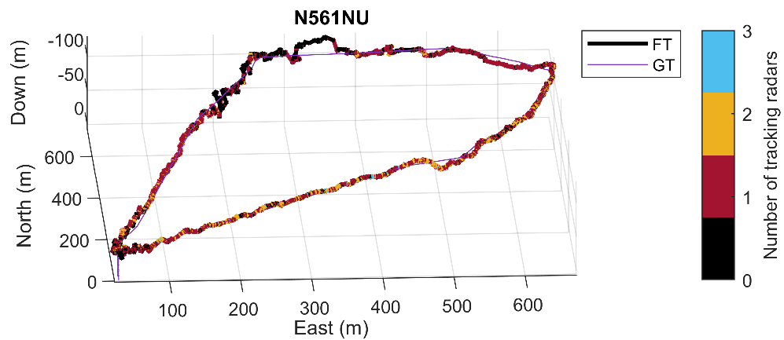
Fig. 9 Three-dimensional trajectory estimated at firm tracking during case 3. Colorbar indicates the number of radars used to generate the tracking solution.

Finally, Fig. 10 provides the variation of tracking error for N556NU over time. Such evolution is divided in two phases: departure phase, during which the UAV takes-off and reaches the maximum distance point, and return phase, which reverses the trajectory from maximum distance to landing site. This analyses is intended to highlight any potential variation of the error with the distance (range) from the WRF origin while also enabling the comparison of regions where the tracking estimate is carried out by one, two or three radars. Such variation remarks interesting outcomes and is here analyzed by dividing each trajectory phase in three different sub-phases: short-range (range below 200 meters), medium-range (range between 200 meters and 500 meters) and far-range (range above 500 meters). The statistics of the errors in terms of mean and standard deviation (std) are reported in Table IV.
In both departure and return phases, the far-range region shows higher error variation with std values which increase with respect to the other regions. Interestingly, a variation between the results achieved in the departure and return phases can be noticed for the error in the vertical direction. While during departure such error respects the behavior of the horizontal components, with noticeable std increase at the beginning of the far-range region, during the approaching return phase the decrease when moving from far to short range region is not as evident. This effect is likely generated by the influence of the measurements of R2 that are used in the final phases of the trajectory. As already mentioned, such measurements verify a noisier nature in the vertical plane as opposed to those of R3, thus causing a noisier behavior of the error as well.

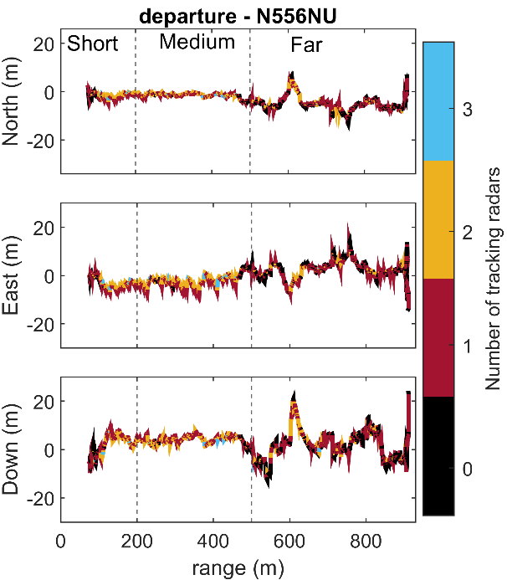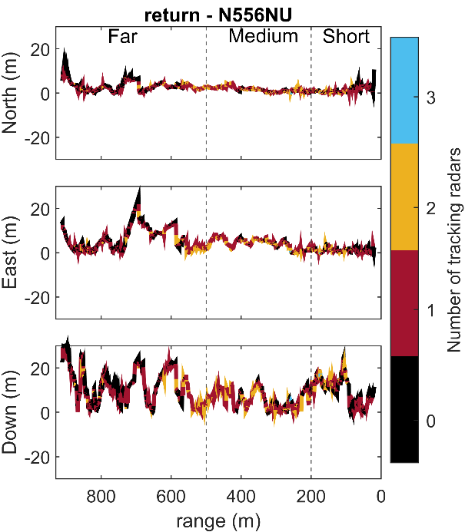
Fig. 10 Firm tracking error for N556NU during departure (left) and return (right) phases of the trajectory. Colorbar indicates the number of radars used to generate the tracking solution.

Table IV Firm tracking error statistics for N556NU during departure and return.
 | Range region | [N, E, D] average (m) | [N, E, D] std (m)
DEPARTURE | Short | [-1.37, -2.49, 1.23] | [0.96, 2.24, 4.16]
DEPARTURE | Medium | [-1.53, -2.14, 4.02] | [0.98, 2.54, 1.62]
DEPARTURE | Far | [-5.05, 2.62, 1.87] | [2.87, 3.34, 5.81]
RETURN | Short | [-1.91, 0.015, -8.11] | [1.63, 1.39, 5.63]
RETURN | Medium | [1.31, -4.20, 3.42] | [1.38, 2.20, 6.10]
RETURN | Far | [2.57, -5.01, 2.97] | [2.24, 5.34, 13.01]
- Conclusion
This paper presents a fusion strategy for a network of distributed ground-based radars operated to monitor the low altitude environment which will be populated by sUAVs and e-VTOLs in the framework of UAM and AAM. The proposed solution is structured in a centralized fashion, thus, each radar is used to independently collect measurements of all targets within its FOV that are locally processed before being transmitted to a Fusion Center. Within the latter, tracking with linear Kalman filtering is exploited to build a unique reliable track of all flying targets. Each track is updated using sequential correction exploiting the measurements of the different radars. To do so, association is first performed to determine if a measurement can be used for track correction. The solution is tested on data acquired during experimental tests where three ground-based radars dislocated along a flight area are used to collect data of two sUAVs flying sequentially on the same route. The experimental results show that not only can a three radars solution increase the coverage of the monitored area, +10% with respect to a two-radars implementation, but also drastically improve the accuracy of the final firm tracking solution, which reaches meter and meter-per-second levels on the position and velocity estimates.
Further developments will focus on the implementation of an Extended Kalman Filter accounting for the range rate measurement collected by the radars. Furthermore, given the presence of visual cameras installed on each node, its data will also be integrated into a final fusion solution which will benefit from the significantly higher accuracy of cameras in the angular domain. Finally, once validated, such fusion strategies can be implemented in real-time.

Acknowledgments
Research performed by the University of Naples “Federico II” was carried out in the frame of project “4IPLAY”, funded within Programme PRIN by the Italian Ministry of Education, University and Research. NASA’s contribution was completed in support of TTT project milestones. The authors would like to thank Lou Glaab and Jacob Shaeffer for facilitating the HDV+TTT joint activity, Matt Coldsnow for his help with safety reviews, Zackary Mitchell for his assistance in data acquisition, Greg Howland for initial CAD work (AMA), SUAS pilots Mark Motter, Jody Miller, and Brayden Chamberlain, Range Safety Officers Mark Frye and Jennifer Fowler, and interns Yajvan Ravan and Aref Malek.

References
[1] A. P. Cohen, S. A. Shaheen, and E. M. Farrar, “Urban Air Mobility: History, Ecosystem, Market Potential, and Challenges,” IEEE Transactions on Intelligent Transportation Systems, vol. 22, no. 9, pp. 6074–6087, Sep. 2021, doi: 10.1109/TITS.2021.3082767.
[2] X. Sun, S. Wandelt, and E. Stumpf, “Competitiveness of on-demand air taxis regarding door-to-door travel time: A race through Europe,” Transp Res E Logist Transp Rev, vol. 119, pp. 1–18, Nov. 2018, doi: 10.1016/j.tre.2018.09.006.
[3] M. Erdelj, E. Natalizio, and I. F. Akyildiz, “Help from the Sky: Leveraging UAVs for Disaster Management,” IEEE Pervasive Computing , vol. 16, no. 1, pp. 24–32, 2017, doi: 10.1109/MPRV.2017.11.
[4] K. H. Goodrich and C. R. Theodore, “Description of the NASA Urban Air Mobility Maturity Level (UML) Scale,” in AIAA Scitech 2021 Forum, Jan. 2021. doi: 0.2514/6.2021-1627.
[5] G. E. Gorospe, C. Ippolito, and K. Hashemi, “Distributed Sensing and Reasoning for Advanced Air Mobility Health Management and Mission Assurance,” in AIAA AVIATION 2023 Forum, San Diego, CA, USA, Jun. 2023. doi: 10.2514/6.2023-3323.
[6] F. Folster, H. Rohling and U. Lubbert, "An automotive radar network based on 77 GHz FMCW sensors," IEEE International Radar Conference, 2005., Arlington, VA, USA, 2005, pp. 871-876, doi: 10.1109/RADAR.2005.1435950.
[7] F. Folster and H. Rohling, "Data association and tracking for automotive radar networks," in IEEE Transactions on Intelligent Transportation Systems, vol. 6, no. 4, pp. 370-377, Dec. 2005, doi: 10.1109/TITS.2005.858784.
[8] Kim, DB., and Hong, SM. “Multiple-target tracking and track management for an FMCW radar network”. EURASIP J. Adv. Signal Process. 2013, 159 (2013). https://doi.org/10.1186/1687-6180-2013-159.
[9] A. Frischen, J. Hasch and C. Waldschmidt, "A Cooperative MIMO Radar Network Using Highly Integrated FMCW Radar Sensors," in IEEE Transactions on Microwave Theory and Techniques, vol. 65, no. 4, pp. 1355-1366, April 2017, doi: 10.1109/TMTT.2016.2647701.
[10] M. E. Weber, J. Y. N. Cho. J. S. Herd, J.M. Flavin, W. E. Benner and G. S. Torok, “The Next-Generation Multimission U.S. Surveillance Radar Network.” Bull. Amer. Meteor. Soc., 88, 1739–1752, https://doi.org/10.1175/BAMS-88-11-1739.
[11] D. Pepyne, D. McLaughlin, D. Westbrook, E. Lyons, E. Knapp, S. Frasier, and M. Zink, “Dense radar networks for low-flyer surveillance "," 2011 IEEE International Conference on Technologies for Homeland Security (HST), Waltham, MA, USA, 2011, pp. 413-418, doi: 10.1109/THS.2011.6107905.
[12] A. Guerra, D. Dardari and P. M. Djuric, "Dynamic Radar Networks of UAVs: A Tutorial Overview and Tracking Performance
Comparison With Terrestrial Radar Networks," in IEEE Vehicular Technology Magazine, vol. 15, no. 2, pp. 113-120, June
2020, doi: 10.1109/MVT.2020.2979698.
[13] D. Tahmoush, J. Silvious and B. Bender, "Radar surveillance in urban environments," 2012 IEEE Radar Conference, Atlanta,
GA, USA, 2012, pp. 0220-0225, doi: 10.1109/RADAR.2012.6212140.
[14] C. A. Ippolito et al., “Concepts for Distributed Sensing and Collaborative Airspace Autonomy in Advanced Urban Air
Mobility,” in 2023 AIAA SciTech Forum, National Harbor, MD, USA, Jan. 2023.
[15] C. V Dolph et al., “Distributed Sensor Fusion of Ground and Air Nodes using Vision and Radar Modalities for Tracking
Multirotor Small Uncrewed Air Systems and Birds,” in AIAA SCITECH 2024 Forum, Orlando, FL, USA, Jan. 2024. doi:
10.2514/6.2024-1781.
[16] T. Lombaerts, E. Kawamura, K. Kannan, C. Dolph, V. Stepanyan, G. Gorospe and C. Ippolito, “Development and Field Test
Results of Distributed Ground-Based Sensor Fusion Object Tracking,” in AIAA SCITECH 2024 Forum, Orlando, FL, Jan.
2024. doi: 10.2514/6.2024-1389.
[17] C. A. Ippolito and T. Lombaerts, “Adaptive Sensor Registration Across Distributed Airspace Surveillance Networks,” in AIAA SCITECH 2024 Forum, Orlando, FL, Jan. 2024. doi: 10.2514/6.2024-1779.
[18] F. Vitiello, F.Causa, R. Opromolla, G. Fasano, C. Dolph, T.Ferrante, T. Lombaerts and C. Ippolito, “Experimental testing of data fusion in a distributed ground-based sensing network for Advanced Air Mobility”. In AIAA SCITECH 2024 Forum (p. 2008), doi: https://doi.org/10.2514/6.2024-2008
[19] L. J. Glaab, M. A. Johnson, R. G. McSwain, S. C. Geuther, Q. V. Dao and J. R. Homola, “The High Density Vertiplex Advanced Onboard Automation Overview,” in AIAA/IEEE Digital Avionics Systems Conference - Proceedings, Portsmouth, VA, USA: Institute of Electrical and Electronics Engineers Inc., Sep. 2022. doi: 10.1109/DASC55683.2022.9925834.
[20] R. Altendorfer and S. Wirkert, "Why the association log-likelihood distance should be used for measurement-to-track
association," 2016 IEEE Intelligent Vehicles Symposium (IV), Gothenburg, Sweden, 2016, pp. 258-265, doi:
10.1109/IVS.2016.7535395.
[21] J. Brown, “CERTAIN City Environment Range Testing for Autonomous Integrated Navigation”. Available online:
https://ntrs.nasa.gov/citations/20160009254, 2016.

Postdoctoral Research fellow, Department of Industrial Engineering, University of Naples “Federico II”.
Postdoctoral Research fellow, Department of Industrial Engineering, University of Naples “Federico II”.
Assistant Professor, Department of Industrial Engineering, University of Naples “Federico II”.
Associate Professor, Department of Industrial Engineering, University of Naples “Federico II”.
Aeronautics Systems Engineering, NASA Langley Research Center. AIAA Senior Member.
Analytical Mechanics Associates, Inc. NASA Langley Research Center. 7 KBR Wyle Services, NASA Ames Research Center. 8 Aerospace Scientist, Intelligent Systems Division. NASA Ames. AIAA Senior Member.
The mention of a company or product does not constitute an endorsement by the National Aeronautics and Space Administration (NASA).

