A Comparative Assessment of Evolvable Martian ISRU Propellant Production for Future Human Missions
Stephen J. Hoffman, Ph.D.
The Aerospace Corporation, Houston, Texas, 77058, USA
Michael B. Chappell
Marshall Space Flight Center, Huntsville, Alabama, 35812, USA
Steven R. Oleson, Elizabeth R. Turnbull
NASA Glenn Research Center, Cleveland, Ohio, 44107, USA
Jared F. Congiardo
NASA Kennedy Space Center, Merritt Island, Florida, 32899, USA
In 2022, NASA released its “Moon to Mars Strategy and Objectives Development” document, containing top-level goals and objectives designed to create a blueprint for sustained human presence and exploration throughout the solar system. One objective in this “blueprint” calls for the demonstration of “…Mars ISRU capabilities to support an initial human Mars exploration campaign.” NASA is looking at both the benefits and liens of this concept, as one of several trade space aspects under consideration, for inclusion in the overall architecture of the human exploration of Mars. This paper summarizes results from a series of Martian ISRU-focused trade studies from 2023 and 2024. These studies cover five different approaches to providing propellants for returning crew and equipment from the surface of Mars, using several different combinations of propellants delivered (from Earth) and produced from Martian feedstock material. For comparison purposes, the same ISRU infrastructure elements were used across all options wherever possible. The equipment mass, power, operational complexity, and time needed to produce some or all of these propellants have been quantified and compared when used in a common mission scenario. Analysis results for each option are discussed. Performance parameters for these options are compared side-by-side and observations made, including the positive and negative aspects of each case. The possibility of evolving from a simpler ISRU case to more complex cases that would potentially lead to more sustainable operations are also discussed. While no single case emerged as “better” in all aspects when compared to the others, there are distinct advantages and disadvantages that did emerge when comparing the results generated from a common set of assumptions for all cases. Consequently, specific mission objectives may determine which of these advantages or disadvantages are important for choosing among the cases that could benefit any particular mission or campaign.
- Nomenclature
ACO = Advanced Concepts Office
CCF = Concentric Crater Fill
CH₄ = Methane
CO = Carbon Monoxide
CO₂ = Carbon Dioxide
CRISM = Compact Reconnaissance Imaging Spectrometer for Mars
DAN = Dynamic Albedo of Neutrons
DTAU = Dust Tolerant Automated Umbilical
EDLA = Entry, Descent, Landing, and Ascent
ESA = European Space Agency
FSP = Fission Surface Power
HiRISE = High Resolution Imaging Science Experiment
HMA = Hose Management Assembly
ISRU = In Situ Resource Utilization
LDA = Lobate Debris Apron
LOX = Liquid Oxygen
LVF = Lineated Valley Fill
MAT = Mars Architecture Team
MALV = Mars Ascent/Lander Vehicle
MARSIS = Mars Advanced Radar for Subsurface and Ionospheric Sounding
MOXIE = Mars Oxygen In-situ Resource Utilization Experiment
MRO = Mars Reconnaissance Orbiter
MSFC = Marshall Space Flight Center
N₂ = Nitrogen
NASA = National Aeronautics and Space Administration
Ne = Neon
O₂ = Oxygen
OMEGA = Observatoire pour la Minéralogie, l'Eau, les Glaces et l'Activité (Visible and Infrared Mineralogical Mapping Spectrometer)
RSL = Recurring Slope Lineae
RASSOR = Regolith Advanced Surface Systems Operations Robot
RASSORX= Enlarged RASSOR
SHARAD= Shallow Subsurface Radar
SWIM = Subsurface Water Ice Mapping
WER = Water Extraction Rig
- Introduction
In 2022, NASA released its “Moon to Mars Strategy and Objectives Development” document, containing top-level goals and objectives designed to create a blueprint for sustained human presence and exploration throughout the solar system. NASA has now embarked on a systematic process, following systems engineering methodologies, to explore translation of these goals and objectives into one or more architectures to achieve this vision.
One objective in this “blueprint” calls for the demonstration of “…Mars ISRU capabilities to support an initial human Mars exploration campaign” [1]. A long history of studies using Martian resources for propellant production to provide this benefit to robotic and human Mars missions began in earnest not long after the Viking landers began returning data from the Martian surface and continues to the present time [2, 3, 4, 5].
While beneficial mass savings are generally acknowledged, they can only be realized after certain ISRU-related capabilities are established on Mars. The equipment mass, power, operational complexity, and time needed to produce some or all of these propellants can be quite substantial; the mass of this surface infrastructure can rival the mass of the propellant manufactured for a single launch of an ascent vehicle. But use of this equipment to produce propellant for multiple launches can quickly lead to a positive return on this investment.
Currently, as one of several trade space aspects under consideration, NASA is looking at both the benefits and liens of this concept for inclusion in the overall architecture of the human exploration of Mars.
This paper will summarize results from a series of Martian ISRU-focused studies from 2023 [5, 6, 8, 9] as well as results from two additional ISRU studies from 2024 [see Section V in this paper, 6]. These studies were not meant to imply that ISRU will or will not be included in the eventual architecture used during any segment of human Martian exploration. Nor is it meant to rule out any particular ISRU concept in general or its use in a particular mission scenario. The intent is to illuminate the impact of ISRU in a quantitative manner across a common scenario and set of assumptions.
These studies cover five different approaches to providing propellants for returning crew and equipment from the surface of Mars, using several different combinations of propellants delivered (from Earth) and produced from Martian feedstock material. Because of the focus on use of Martian resources, all these studies assume the use of methane and oxygen as propellants – propellants that can be produced from material known to exist on Mars. The five options included in the analysis described in this paper, in order of increasing reliance on Martian resources and ISRU complexity, include:
- Deliver all CH₄ and O₂ propellant, to be used in the Mars ascent vehicle, as cargo from Earth. These propellants are then transferred across the Martian surface and loaded into this ascent vehicle. [9]
- Deliver CH₄ propellant as cargo from Earth to the surface location of the Mars ascent vehicle. This propellant is then transferred across the surface and loaded into this ascent vehicle. Oxygen is manufactured from Martian atmospheric CO₂ using surface ISRU infrastructure and then loaded into this ascent vehicle. [Details described in this paper.]
- Deliver water as cargo from Earth to the surface location of the Mars ascent vehicle. This water is transferred to surface ISRU infrastructure where it is used, along with atmospheric CO₂, to manufacture CH₄ and O₂ propellants that are loaded into the ascent vehicle. [5,8]
- Water is mined from buried ice and transferred across the surface to ISRU infrastructure where it is used, along with atmospheric CO₂, to manufacture CH₄ and O₂ propellants that are loaded into the ascent vehicle. [5,8]
- Water is mined from loose surface regolith and transferred across the surface to ISRU infrastructure where it is used, along with atmospheric CO₂, to manufacture CH₄ and O₂ propellants that are loaded into the ascent vehicle. [5,8]
To provide a framework for comparison of these options, this paper will first discuss assumptions applied to all analyses along with background regarding Martian feedstock sources relevant to sizing the ISRU infrastructure for the scenario in which it is used. Next, characteristics of ISRU infrastructure needed for each option is discussed. For comparison purposes, the same ISRU infrastructure elements are used across options where possible, although the number of individual infrastructure elements may be scaled to meet the needs of a particular option. A summary description of these elements will be discussed. Finally, analysis results for each option will be presented, highlighting performance factors such as numbers of ISRU infrastructure elements and the total mass of these elements, power and time needed to manufacture propellants, number of landers needed to deliver this infrastructure, etc. These performance parameters are compared side-by-side and observations made.
These results will then be used to explore more evolutionary approaches to build an ISRU capability on Mars, and confidence in that capability, by using some or all of these five options as steps in a phased deployment of propellant manufacturing on Mars. Such a phased deployment would allow a more gradual investment of development resources and incorporation of lessons learned from earlier phases – an important consideration given the “unknown unknowns” of the Martian environment, state and location of feedstock materials, and operational impacts. The results and findings documented in this paper delineate these considerations for a capability that has great potential in building toward a more sustainable human exploration architecture.
- Assumptions
All cases discussed in this paper assume the use of the Mars Ascent/Lander Vehicle (MALV) as the common vehicle to deliver crew and cargo to the Martian surface. The MALV was designed as part of a separate study and is shown in Fig. 1 [6]. This single-stage vehicle enters Mars’ atmosphere hyperbolically, performs aero-deceleration, and lands using methane/oxygen retro propulsion on the Mars surface. An all-cargo variant and a crew-plus-cargo variant of this MALV are assumed in these cases. This vehicle, which uses all of its on-board propellant for landing, can then return the crew (and some cargo) to the assumed 5-sol Mars parking orbit of the Earth return vehicle, if refueled on the surface. For this ascent to orbit, this MALV concept requires 300 t of CH₄ and O₂ (66 t of CH₄ and 234 t of O₂).
A cadence of one MALV launch per Mars trajectory opportunity (approximately once every 26 months on average) is assumed in all scenarios. This cadence defines the amount of time needed to deliver all the surface infrastructure needed to establish a capability to refuel the ascent vehicle, which is also assumed to be a MALV, for each of the five scenarios discussed in this paper.
For all cases, the ascent vehicle is assumed to be fully loaded with propellant before the crew lands. Consequently, two crew-capable MALVs are required for these mission scenarios. But it should be noted that for those cases in which the crew returns to the same landing site, the MALV that delivers the first crew is refueled by the surface infrastructure and becomes the ascent vehicle for the next crew – a pattern that repeats for as long as the site is used for exploration missions.
Any surface infrastructure assumed for a particular scenario is assumed to be deployed, integrated, operated, and maintained entirely by robotic means, but under supervision from Earth. Additionally, it is assumed in each of the scenarios that all surface infrastructure will have arrived and been fully integrated one launch opportunity (~26 months) prior to crew arrival. Production of any Martian-derived propellants was presumed to be completed within 20 months (six months being held for commissioning of the entire system and for contingency down time due to dust storms at the production site).
Finally, ISRU infrastructure elements are sized using typical characteristics of the Martian feedstock material (e.g., atmospheric pressure, percent water by weight in regolith material, etc.). No assumptions were made about use of a specific surface site for ISRU operations, although certain feedstock materials are known to be constrained to certain regions on Mars. Once sized, each element of the ISRU surface infrastructure was then broken into several common element sizes (mass and volume), constrained by the physical dimensions of the MALV cargo bay and the surface mobility system (discussed below).
- Martian Resources
The propellants assumed in these studies – methane and oxygen – requires that the Martian source of carbon, hydrogen, and oxygen must be specified and both the potential location as well as the characteristics of feedstock material (e.g., concentration within otherwise unusable source material) for propellant production must be identified. Eventually, sufficient reserves of these feedstocks for the projected lifetime of the production infrastructure must also be confirmed before setup of surface infrastructure begins [10], but site selection was not a step performed in any of the analyses described below.
- Atmospheric Resources
“Typical” Martian atmospheric composition is made up of approximately 95% carbon dioxide (CO₂) and approximately 2.8% nitrogen (N₂), with several other gases present at much lower percentages. Atmospheric CO_{2,} available anywhere on the globe, is likely the primary source of carbon and oxygen used for propellant production. The Perseverance rover – currently exploring Jezero Crater on Mars – carried the Mars Oxygen In-situ Resource Utilization Experiment, or MOXIE, and has demonstrated technology that is able to acquire Martian atmosphere even at the extremely low pressures found at the surface, filter out unwanted components like dust particles, and split the CO₂ into carbon monoxide (CO) and oxygen (O₂) for direct use in manufacturing propellant. This technology can be scaled up to make these propellants in quantities useful for human missions.
In contrast, the water (H₂O) content in the Martian atmosphere is quite low, averaging about 1 kg of H₂O for every 170,000 m³ of atmosphere (an optimistic estimate). In other words, if NASA’s Vehicle Assembly Building at the Kennedy Space Center (KSC) was filled with this “typical” Martian atmosphere, only six gallons of H₂O could be condensed from it. However, because the atmosphere is so thin, relative humidity can be quite high, reaching near saturation levels, which can lead to frost appearing on the surface. So, even though the Martian atmosphere can be found at every candidate landing site, collecting H₂O directly from it (e.g., through condensation or gathering frost) does not appear attractive for ISRU applications.
But H₂O remains an important resource for propellant production – as a source of both hydrogen and oxygen. So, finding sources of H₂O that can be acquired reasonably requires looking in other places and in other forms.
- The North and South Poles
We know of very large deposits of relatively pure H₂O ice on the surface of Mars: both the north and south Martian poles have permanent caps of H₂O ice at greater than 80° latitude. But these caps are covered by CO₂ ice during the respective winters. The CO₂ fully sublimes at the North Pole during summer, revealing a permanent cap approximately 100 km in diameter consisting of H₂O of greater than 90% purity, estimated to be 3 km thick on average. At the South Pole, winter’s frozen CO₂ deposits never fully sublime, leaving approximately 8 m of CO₂ ice covering most of the cap during summer, which means the size of the H₂O ice deposit is not well known. In addition to these seasonal challenges in acquiring this essentially pure H₂O, these regions are not generally considered favorable for long duration human exploration due to extended periods of complete darkness and extremely cold temperatures – cold enough to form CO₂ ice during winter, and the dynamic, low visibility conditions due to subliming CO₂ in summer.
- Water-Containing Minerals
The Mars Reconnaissance Orbiter’s (MRO, a NASA spacecraft) Compact Reconnaissance Imaging Spectrometer for Mars (CRISM) instrument and the Mars Express’s (an ESA spacecraft) Infrared Mineralogical Mapping Spectrometer (OMEGA) instrument have detected minerals that are thought to have formed in ancient times when Mars is thought to have had a much wetter climate [11]. These hydrous minerals are localized (around 3% of the Martian surface) but widespread, consisting mostly of phyllosilicates (clay minerals), chlorites and sulfates. As mixtures of these minerals exist, water content may vary considerably from around 2% to 9% by weight. While soil excavation and transport would be necessary to harvest the water bound in these minerals, such engineering studies have been performed [12] and are used in one of the ISRU options discussed in this paper.
- Groundwater
“Recent” presence of Martian groundwater (<10 million years ago) has been inferred by outflow channel formations observed from orbit. It has been assumed that subsurface liquid water in the form of aquifers was located below a thin cryosphere and had “burst through” occasionally to form these features.
The Mars Express Mars Advanced Radar for Subsurface and Ionospheric Sounding (MARSIS) and the MRO Shallow Subsurface Radar (SHARAD) instruments were designed to specifically detect such subsurface liquid water that could be the source for outflow channels or recurring slope lineae (RSLs) as well as aquifers with no visible indicators at the surface. However, to date, MARSIS and SHARAD have failed to detect any indication of liquid water within 200-300 meters of the surface anywhere on Mars [13]. It may be that the outflow channel formations are older than initially thought, so the groundwater is gone or is locked up in the subsurface cryosphere and the flooding was caused by infrequent localized crustal heating and cryosphere melting. In any event, the prospects of easily accessible subsurface liquid water on Mars appear unlikely.
Much more recently, dark, narrow (0.5 to 5.0 m) markings have been observed on steep (25° to 45°) slopes. MRO’s High Resolution Imaging Science Experiment (HiRISE) images show incremental growth during warm seasons and fading during cold seasons [14]. These RSLs have been interpreted as intermittent flows of briny liquid water which was confirmed by the MRO CRISM spectrometer. However, the water source was unclear, and some interpreted this as more evidence of aquifers exposed by these slopes, but radar data has shown to be unlikely. Atmospheric water vapor may be the “feedstock” for absorption by salty minerals (perchlorates and other hygroscopic salts), resulting in temporary muddy flows.
Atmospheric water vapor absorption is not limited to just salty minerals; the upper layers of Martian “typical” regolith [15] also absorbs water vapor. The Dynamic Albedo of Neutrons (DAN) instrument is an experiment carried by NASA’s Mars Science Laboratory's Curiosity rover. Its purpose is to measure hydrogen or ice and water at or near the Martian surface. Measurements made by DAN indicate that the top layer of Martian regolith (i.e., the top 15-20 cm) could contain between approximately 1.5% and 2.0% water by weight. Although the entire surface of Mars has not been similarly measured, other data gathered from orbit indicates that this result is likely representative of other “typical” regolith at any location on Mars.
- Shallow Sequestered Water Ice
Certain Martian terrain features suggest evidence for large-scale mid-latitude glaciation (a strong theory explaining mid-latitude glaciation is periodic changes in the tilt of Mars’ rotation axis (i.e., obliquity changes)). These “viscous flow” features, including lobate debris aprons (LDAs), lineated valley fills (LVFs), and concentric crater fills (CCFs), all bear similarity to terrestrial glaciation features and are widely distributed in the Martian mid-latitudes – approximately 30° to 50° latitude in both hemispheres.
Large features of exposed ice have been observed in HiRISE images to be associated with these “viscous flow” features. Recent publications [16] have shown visual evidence, in the form of images of exposed ice scarps measuring 10s to 100s of meters in height, indicating the likely presence of significantly more extensive ice sheets buried within these terrain features. Spectral data from these scarps, gathered by the CRISM instrument, have shown that these exposed features are almost pure water ice. In addition, the SHARAD radar gathered sounding data of LDAs in both the northern and southern mid-latitudes and obtained results completely consistent with massive layers (100’s of meters thick) of relatively pure (>90%) water ice covered by a relatively thin (0.5 to 10 m) debris layer [17].
Even though the number of examples of these exposed ice scarps are relatively few and their locations are at relatively high latitudes, their significance for future human missions rests in the fact that we now have a clearer picture of what lies buried at the dozens of other similar terrain features located in a wide swath in both the northern and southern hemispheres.
Unfortunately, the two radars mentioned above were designed to look deep under the surface, and consequently cannot resolve near-surface features (i.e., from the surface down to ~10 m depth) with much resolution – data from shallower depths would greatly assist in planning for the possible use of this resource. As an interim approach, researchers have used visual data they gathered, along with other sources, to postulate a vertical profile of these ice sheets. This profile indicates that the overlying debris layer is likely just a few meters thick at the latitudes (i.e., approximately 50° latitude north and south) where these ice scarps have been seen. The same theory that predicted the icy soils at the Phoenix landing site suggests that this debris layer will likely get thicker for terrain features that are closer to the equator [18]. But these estimated depths are not so great that drilling through the debris layer would be considered unreasonable for the mid-latitude band.
As a further line of evidence for ice in this mid-latitude band, fresh impact craters in these suspected glacial regions, detected by the HiRISE imager [19], show excavated clean ice, verified by the CRISM spectrometer (<1% regolith mixed with the ice). The excavated material has been observed to sublime away over several months’ time in subsequent images. The excavation depths are estimated to be less than two meters.
Finally, recent work by the NASA-funded Subsurface Water Ice Mapping (SWIM) project (https://swim.psi.edu/) has used many of these individual data sets in combination, integrating them to generate a map of likely locations of subsurface Martian water in its various forms across the entire globe. This map – and future improved versions of it – can be used for preliminary identification of promising resource feedstock sites where more detailed investigations can be made. It can also be used to determine the relative proximity of potential landing sites driven by interests other than resources and these promising feedstock locations, which is likely to be a significant consideration as architecture alternatives are considered.
- System and Infrastructure Characteristics
To allow for a reasonable comparison of the new results with previous results, the work described in the proposed paper makes use of several key vehicles, systems, and elements from recently completed studies [5, 6, 8]. The ISRU surface infrastructure used in all of the scenarios discussed below are broken down into the following functional groupings:
- Mobility – used to relocate other elements away from the landing vehicle that delivers them and for moving liquids (e.g., water, cryogenic propellants, etc.).
- Power – used to support MALV power needs while on the surface as well as all other surface infrastructure elements.
- Propellant production – depending on the scenario, this element uses Martian feedstock to produce CH₄ and/or O₂.
- Cryogenic liquid for use in the MALV. It also maintains those products in their cryogenic state once that state is achieved.

The following sections describe the common key elements used in the five ISRU scenarios.
- Mars Ascent/Lander Vehicle (MALV)
The MALV concept [6] is nominally designed to deliver at least 75,000 kg of payload to the Martian surface in a single landing. This target was identified as a lower bound of landed payload mass required to support initial human missions to Mars under specific assumptions [6]. The MALV is 8.4 m in diameter and stands 27 m tall.
The crew-capable version of the MALV has a forward docking port to allow for crew ingress/egress with other orbital assets, such as the Mars Transit Habitat. This configuration of the vehicle also has an integrated crew compartment designed for short term crew habitation. It is this configuration of the MALV that delivers the crew – along with some of its surface exploration payload, such as science experiments, crew mobility, etc. – and is then used to return the crew to a waiting interplanetary transit vehicle parked in at least a 5-sol orbit. To reach the parking orbit, the MALV will need an estimated 300 t of methane and oxygen.
For a dedicated cargo MALV, the crew compartment and associated subsystems can be removed to allow for additional payload support. In the figure below, the crew cabin is the primary payloads bay, which has an integrated lift system to support payload deployment to the surface. [Additional details can be found in Ref. 6.]

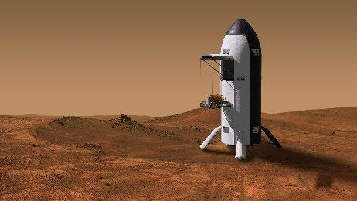
Fig. 1. Notional Mars Ascent/Lander Vehicle (MALV) (NASA image).

- Surface Transportation System for Liquid Commodities
The Mobility Transport chassis (Fig. 2) is used to transport surface system elements (e.g., the fission surface power (FSP) system described below) to their deployment location, and, using a manipulator arm, is capable of making electrical, fluid, and other connections as needed. It is also used to transport liquid commodity transportation pallets between the supply point and the use point. For the purposes of this study, the chassis is derived from the Chariot mobility concept with a payload carrying capability of ~7.1 t [7].
Two different types of liquids will need to be transported across the Martian surface in the five scenarios examined: water, either delivered from Earth or mined locally – and cryogenic propellants (CH₄, O_{2,} or both). Two liquid commodity transport pallets – one for water and the other for cryogens – were developed during these studies (Fig. 3). Both pallets had similar configurations and used common subsystems wherever possible.
For three of the previously studied scenarios [5, 8], feedstock water needs to be provided to the propellant production plant to generate CH₄ and O₂. These studies assume a Water Transportation Pallet mounted aboard the 6-wheel Mobility Transport Chassis will be used to transport this water from a supply point in 5 t increments. The pallet is capable of being dismounted from the Mobility Transport chassis to release the chassis for other tasks if needed.
For the remaining two scenarios a similarly configured Propellant Transportation Pallet was developed to move either CH₄ or O₂ from the cargo MALV that delivered them to the MALV used for ascent. In the scenario in which both CH₄ and O₂ are being moved, two separate pallets will be used to prevent mixing of residuals of one commodity when the other commodity is being moved.

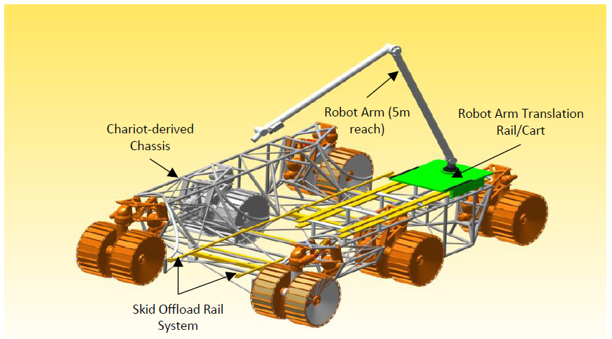
Fig. 2. Mobility Transport Chassis (Isometric View) (NASA image).
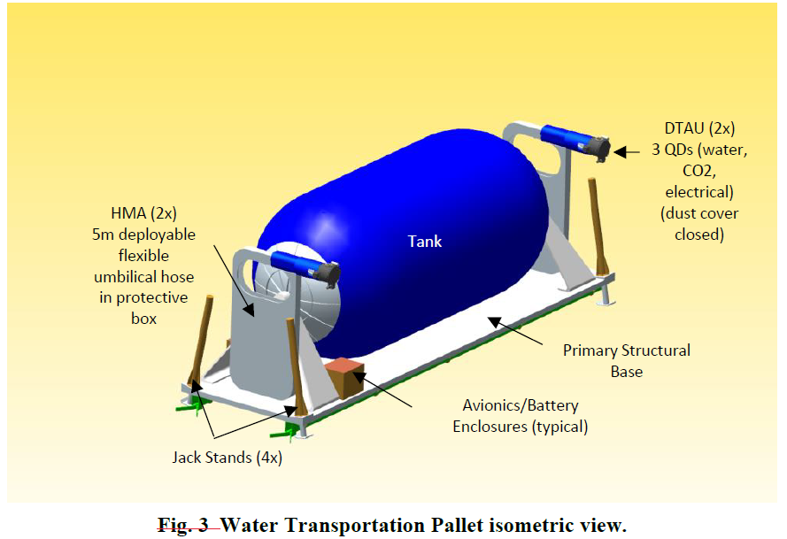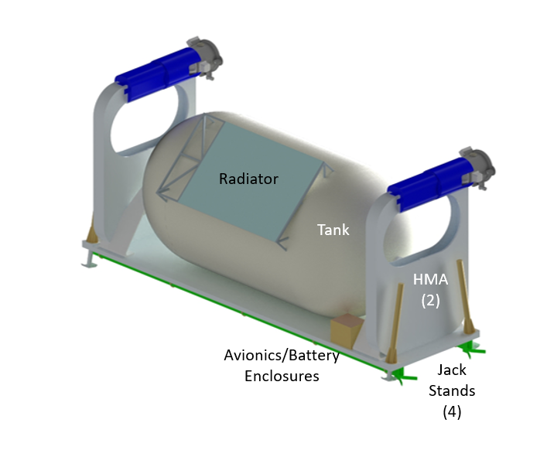
Fig. 3. Liquid Transportation Pallet – Water (above), Cryogen (below) (Isometric View) (NASA image).
- Fission Surface Power (FSP)
Power to support all the elements discussed in this section will be provided by Fission Surface Power systems [25]. For purposes of this study, it is assumed that multiple copies of a common FSP unit, each capable of providing 40 kWe, will be delivered to meet the total power demand of each scenario. Launch and delivery of the FSP is assumed to be achieved by a cargo MALV. The FSP is designed to be deployed to a desired surface location away from the lander that delivers it. The FSP is divided into three components that are each mounted on a “sled” – for transport by, and eventual off-load from – a 6-wheel Mobility Transport chassis.
The three separate main elements of the FSP are the reactor system, the reactor control system, and the 1 km cable and spool system with an incorporated power conversion system to convert the reactor power to the parameters required by the end user. This split is necessary not only due to the large size of the components, but also because the combined mass of the three elements (~12 t) exceeds the limit that the Mobility Transport chassis can carry (~7.1 t). In addition to the size and mass limitations, the components were divided by the need for the elements to be in different locations during operation. Once at their operational locations, the FSP components – on their individual “sleds” – are off-loaded and the Mobility Transport chassis is available for other activities.
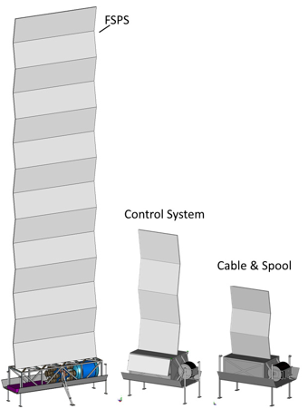
Fig. 4. Main FSP Elements (NASA image).
- Liquefaction Pallets
In four of the five cases discussed in this paper (Cases 2-5), some portion of the ascent propellant must be cooled from a gaseous state, it’s condition as it leaves the production pallet, to a cryogenic liquid state after it has been loaded into the ascent vehicle’s propellant tanks, in which broad area cooling technology will have been installed. For these four cases, the liquefaction pallets’ only job is to produce cold neon (Ne), using cryocoolers producing 90K Ne gas, to liquify and then maintain the cryogenic O₂ and CH₄ propellants on the crew’s ascent MALV. The cryocooler systems in this design are based on current development and testing [22, 23].
For Case 2, the cooling system used to liquify the gaseous O₂, using broad area cooling technology in the MALV propellant tanks, in 20 months and then maintain both the O₂ and CH₄ in their cryogenic state. This cooling system is broken into two pallets due to volume constraints. The liquefication pallet is shown in Fig. 5. Each pallet has ten 90 K cryocoolers to convert gaseous O₂ into liquid O₂ and cool the cryogenic CH₄ from 124K to 105K. Each 2.7 t liquefaction pallet uses a total of ~14 kWe providing 90K Ne to the broad area cooling systems on the MALV’s main propulsion tanks. The thermal system design specified a cryocooler radiator of ~45 m² and an electronics radiator of approximately 6 m². Mechanical, power, and command/communication systems similar to those in the propellant production pallet are used.
For Cases 3-5, the cooling system, used to liquify the 300 t of gaseous O₂ and gaseous CH₄, using broad area cooling technology in the MALV propellant tanks, in 20 months on Mars. This cooling system is broken into two pallets due to the limits of the 6-wheel autonomous chassis (discussed above). The liquefication pallet is shown in Fig. 5. Each pallet has fourteen 90K cryocoolers to convert a combined system total of gaseous O₂ (~15 kg/hr) and CH₄ (~4 kg/hr) into liquid. Each 3.5 t liquefaction pallet uses a total of ~21 kWe, providing 90K Ne to broad area cooling systems in the main propulsion tanks on the MALV. The thermal system design specified multiple radiators, each offering an effective area of about 40 m², to serve the needs of the cryocoolers and switchgear. As in Case 2, mechanical, power, and command/communication systems that are similar to those in the propellant production pallet are used.
In the fifth case (Case 1), both O₂ and CH₄ are delivered in their cryogenic state and the analysis of this case [9] determined that the MALV’s on-board propellant management system, that kept these propellants in their cryogenic state during the transit to Mars, would be sufficient to keep it in that state so long as sufficient power is supplied by the Mars surface power infrastructure.
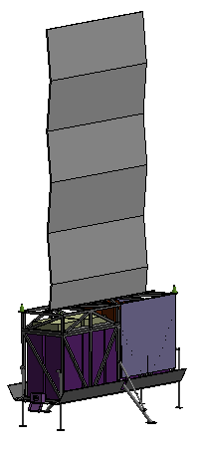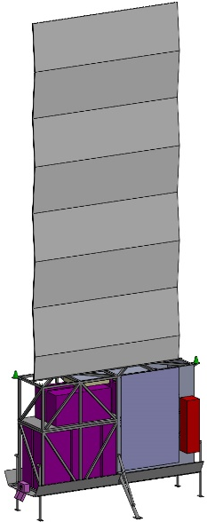
Fig. 5. Liquefaction Pallets: O₂ Only (left), O₂ plus CH₄ (right) (NASA image).

- Methane/Oxygen Production Pallet
In four of the five cases discussed in this paper (Cases 2-5) some portion of the ascent propellant is produced on the surface of Mars using feedstock that is either delivered from Earth (Case 3) or is obtained from Martian sources (Cases 2, 4, 5).
The propellant production pallets used in Case 2 to produce 233 t of gaseous O₂ from the Martian atmosphere is shown in Fig. 5. The ISRU systems were based on an optimized design from past modeling work [27]. The core of the ISRU processing string for extracting O₂ from CO₂ is the electrolysis unit, which is optimized to a ~2 psi system taken from the referenced system (i.e., operating at a pressure well above the ambient atmospheric pressure). Five ISRU strings distributed across two pallets (resulting from payload mass limitations of the Mobility Transport chassis) are needed to produce the 233 t of gaseous O₂. A complete sixth string is carried for added fault tolerance. The full system can process atmospheric CO₂ into gaseous O₂ at a rate of 3.24 kg/hr. Each 4.6 t pallet uses a total of ~66 kWe continuous, with a peak power of ~78 kWe. Each ISRU pallet can process this amount of power from the FSPs, and each requires a switchgear for high power loads. The thermal system requires multiple radiators for the pumps and electronics and for cooling the O₂ stream in multiple stages for a total of ~20 m² effective area per pallet. The mechanical system uses a cage for the ISRU components and integrates it into a common pallet to be moved by the 6-wheel Mobility Transport chassis. Control strings for the plant operations communicate by either an orbiter ultra-high frequency (UHF) or a surface Wi-Fi system.
The production pallets used in Cases 3-5 to produce 300 t of both gaseous O₂ and gaseous CH₄ from water and atmospheric CO₂ are shown in Fig 6. The core of the conversion process from CO₂ and water to gaseous O₂ and gaseous CH₄ is an electrolysis unit based on recent technology development work, albeit at a smaller scale [5]. Each 5 t pallet uses a total of ~75 kWe continuous power for production at rates of ~9 kg/hr for gaseous O₂ and ~2.3 kg/hr gaseous CH₄. Multiple copies of this pallet are assumed, due to payload mass limitations of the Mobility Transport chassis, to meet the total propellant production quantity in the 20 months available for production. The thermal system requires multiple radiators for the electrolyzer, methanators, condensers, and support equipment for a total of ~20 m² effective area.
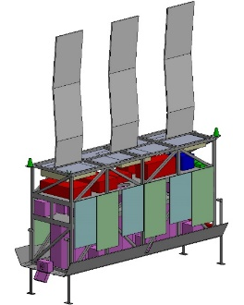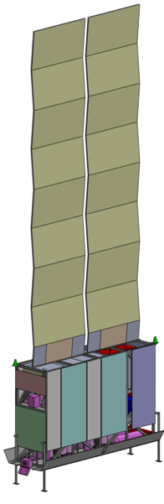
Fig. 6. Oxygen-only (left) and Methane/Oxygen (right) Production Pallets (NASA image).
- “Borehole” Water Production Pallet
Case 4 examines a scenario in which water is acquired from buried ice sheet (see discussion in Section IV). A system is required that can drill through the overburden that protects the ice from sublimation and then extracts water without collapsing that protective overburden. For this function, a system – dubbed the “Borehole” pallet – was designed and tested by Honeybee [22, 23]. It is based heavily on a Small Business Innovation Research design and relies on terrestrial tube mining processes [24]. The design is shown in Fig. 7. It combines the tube process with a cutting head to penetrate the expected ~2 m of mineral overburden. It then transitions to the use of ~10 kW of heaters all along the tube to melt the required 150 t of water into a 15 m reservoir. The water is stored in this cavity until it can be pumped into the water tanker in 5 t portions for delivery to the propellant production pallets. This approach also keeps the water mine as shallow as possible.
A 500 W hammer drill would cut through the overburden soil. A motor is added to push the coil tube down into the borehole. Once ice is reached, the 10 kW of heaters are used to continue boring by melting and, once at a depth sufficient to support the overburden layer, to melt the storage reservoir. While this design requires a continuous 10 kW of power to keep the melted water from refreezing, it is deemed simpler than either constructing large water storage tanks on the surface or using the MALV’s former O₂ propellant tanks for storage, which would entail moving the water twice by the water tanker. An additional 10 kW is allocated for water processing, mainly needed to boil the water for planetary protection concerns. Factoring in a 30% growth in power needs, the total peak power is projected to be around 27.5 kW. For the thermal design, heaters and thermocouples are distributed along roughly 20 m of coiled stainless-steel tubing and the probe, enabling temperature control throughout the system. This allows the heating at the top of the water storage chamber to be turned off so the top of the water cavity can freeze and seal the chamber. This in turn permits the build-up of a few pounds per square inch to prevent sublimation of the subsurface water.
At the surface, a cooling mechanism is facilitated by multiple radiators with a collective effective area of about 17 m², designed to cool the equipment and condense the extracted water vapor. The fluid systems utilize CO₂ compressed gas (gathered from the Martian atmosphere) to clear the cuttings from the drilling process. Additionally, a water pump is employed to elevate the ullage gas of the water to the necessary pressure for condensation and subsequent transportation. From a mechanical standpoint, the drilling system incorporates coiled tubing attached to a cutter probe, all of which is mounted on a common pallet. This pallet is transported by the Mobility Transport chassis, ensuring mobility and stability across the Martian terrain. Command and data handling operations are centralized in a control rig, which is in turn managed via UHF and Wi-Fi communications, allowing for remote control of the entire system.
Based on terrestrial experience, a second complete borehole rig is added to this scenario in case the first drill fails or gets stuck in the ice.
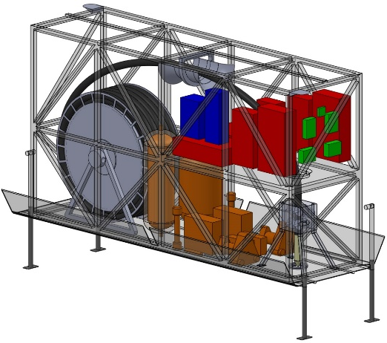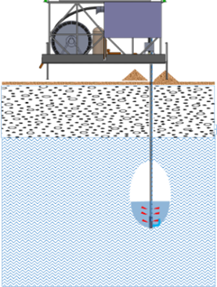
Figure 7. Borehole Water Production Pallet (NASA image).
- Surface Mining Water Production Pallet and Regolith Collection Devices
Case 5 examines a scenario in which water is acquired from “average” regolith that is typical of any location on Mars (see Section IV). Based on the discussion in Section IV, this analysis made a conservative assumption that “average” regolith found anywhere on Mars would contain 1% by weight of water. With this assumption, this would be the most challenging in-situ propellant production approach of the five cases studied, requiring the most soil excavated (e.g., about 29,000 t of soil feedstock to extract the required 150 t of water) and the most equipment.
The concept evaluated for Case 5 involved a comprehensive mining operation, estimated to span 78 months to build up all surface infrastructure, with power infrastructure staged at levels of 25 percent, 50 percent, and 100 percent over three of the cargo MALVs used in this concept. The system was sized to accumulate 150 t of water within 44 months under full power operations. The approximately 29,000 t of “average” regolith would need to be excavated from an area covering around 220,000 m² (equating to over 50 acres). This operation would be distributed across four surface mines, each with a diameter of 220 m and a depth of 12.5 cm, that could be excavated in a single pass.
In this scenario, a single mobile excavating device is required. Termed RASSORX; (see Fig. 8), its design is based on the current Regolith Advanced Surface Systems Operations Robot (RASSOR) design under consideration for the Moon [26] but would need to be scaled up by 2.5 times in each physical dimension to allow for carrying larger loads. Additionally, the concept includes a single Water Extraction Rig (WER; see Fig. 8) at each mine. The excavating units were envisioned to deposit the gathered ore into a loader, likely incorporated into the WER, but which remained to be designed. This loader would include a “grizzly” – a structure designed to filter out large stones from the ore and facilitate loading the ore into the WER at a minimum rate of 4 kilograms per minute.
Also, over the 78-month operation of this ISRU system, the approximately 28,800 t of tailings from the mining process would be collected by the same excavation device and transported back to the mining area following ore deposition. Options for the disposal of these tailings included spreading them across the already mined surface or forming piles.
The water extraction process used in the WER design begins with the generation of water vapor by moving the regolith ore through auger dryers, using heaters with a capacity of around 35 kW integral to the auger mechanism to raise the ore temperature to 575 K. The vapor is then pressurized to 7 psi using a multi-stage compressor. This compressor is in turn cooled by an electronics radiator. The water vapor is subsequently condensed within a roughly 2 m² radiator, bringing the temperature down to 353K under the same pressure. Following condensation, undissolved dust particles are removed in a drop-out tank. The filtered water is then transferred to a storage tank integral to the WER with a capacity of approximately 600 kg. This tank is designed to accumulate three weeks' worth of water production, estimated at 29 kg per day, and the ullage gas is then pumped up to 14 psi to be compatible with the water tanker. This tanker is scheduled to off-load the water every three weeks, filling sequentially eight times at the mining sites (two times per site) before delivering the water to the first cargo MALV, since its O₂ propellant tanks are capable of storing water. Once the 150 t of water is produced and stored in the MALV, and the ISRU production plant arrives, the surface water transportation pallet will remove the water from the tanks and transport it to the propellant production pallets.
For power requirements, each WER operates with peak power demands of around 35 kW for heaters and approximately 7 kW for water processing; with an added 30 percent for power growth, the total power requirement is estimated at about 55 kW.
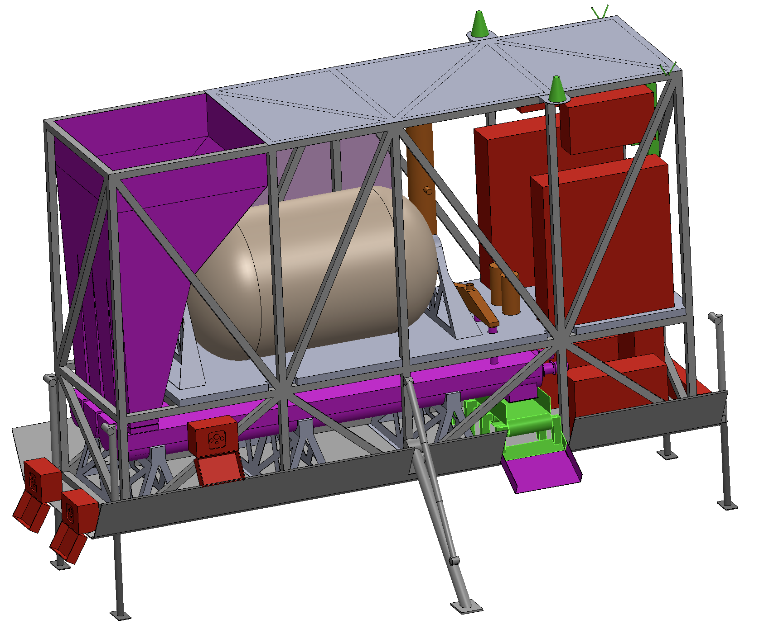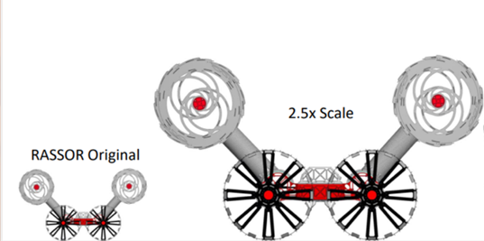
Fig. 8. Surface Mining Water Production Pallet and Regolith Collection (NASA image).
- Results and Discussion
Teams assembled from NASA’s Glenn Research Center, Johnson Space Center, Kennedy Space Center, and Marshall Space Flight Center conducted several studies over the past two years examining the five ISRU cases described in Section II. Results from these studies are summarized in Table 1.
  - Individual Case Assessments
Looking across all the cases, there is significant investment to establish an initial capability for any of the cases: at least three cargo MALVs are needed in addition to the MALV that delivers the crew; at least two FSPs are required to support surface infrastructure; and it will be at least 78 months (6.5 years) before the first crew can use the capability.
While there is no single case that emerges as “better” in all aspects when compared to the others, there are distinct advantages and disadvantages that arise when comparing results generated from a common set of assumptions for all cases. Consequently, specific mission objectives may determine which of these advantages or disadvantages are important when choosing among the options that benefit any particular mission.
Case 1 requires the least amount of surface infrastructure – essentially no ISRU infrastructure – to refuel a crew-capable MALV for ascent to orbit. All the needed surface infrastructure could be delivered in a single cargo MALV. And this represents the least amount of infrastructure invested should this landing site be used only one time. But this case also requires the most cargo MALVs to deliver the ascent propellant – six out of the seven MALVs needed to establish the capability – and six additional MALVs for each additional crew visiting the site if it is to be reused. Figure 9 illustrates how these cargo MALVs are arrayed around the ascent MALV in this scenario [9]. In addition, the MALV launch cadence assumed for all these cases makes this option the most time consuming to ready a MALV for launch. Assuming a steady cadence of one MALV per Mars transit trajectory opportunity is devoted to refueling, it would take 184 months to launch the first MALV used for ascent and at least 156 months before the next MALV is ready for ascent. As a stand-alone case, there does not appear to be a technological or operational benefit to this Case; other options are likely to provide a more practical implementation (see, for example, Ref. 28). However, this Case is included as one end of the spectrum of cases examined in this trade study.

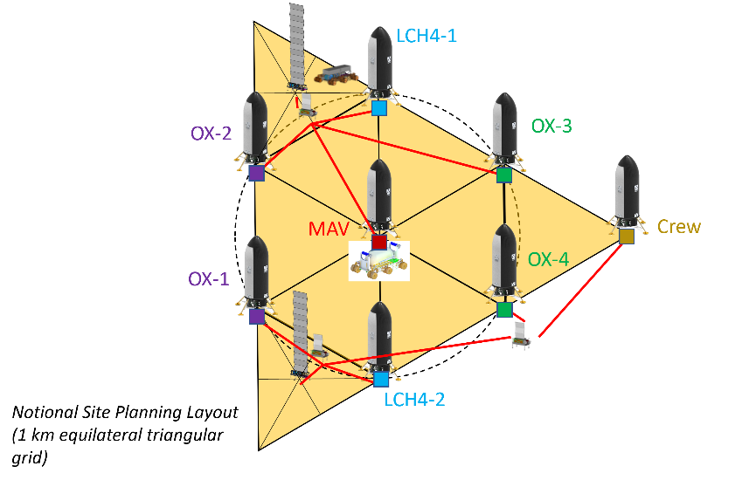
Fig. 9. Notional Mars landing site layout plan for Case 1 [9] (NASA image).
Case 2 shows a substantial improvement over Case 1 by cutting by more than half the number of cargo MALVs needed to establish the initial capability to refuel an ascent MALV. Because of this reduction in the required number of MALVs, the time to establish this capability is reduced by more than half, from 184 months to just 78 months. But these benefits come at the expense of increasing the power required for this capability, which is manifested in needing three times as many FSPs for this case. If this site is reused, then another significant reduction is attained – only one cargo MALV, delivering approximately 66 t of CH₄, is required for each additional crew visiting this site (assuming all surface infrastructure has sufficient lifetime for these additional activities) and at least 78 months (deliver two cargo MALVs plus time to move the propellant; O₂ production can be scheduled as appropriate) for that CH₄ cargo to arrive so the next MALV is ready for ascent.
Cases 3, 4, and 5 all use the same surface infrastructure to convert water and atmospheric CO₂ into CH₄ and O₂. The difference between these three options is in the source for the H₂O used in the propellant production process: either delivered from Earth or gathered – by two different methods – from sources on Mars. The largest fraction of power needed by these three options is associated with the common processes to convert water and atmospheric CO₂ to propellants and to cool those propellants to cryogenic temperatures. Consequently, there is not a significant difference in the total power need, and the number of FSPs to deliver this power, among these options. The amount of surface infrastructure associated with these common processes is substantial, likely requiring two cargo MALVs to deliver all the mass associated with just this portion of the overall infrastructure. This amount of infrastructure makes it difficult to justify its use for a single crewed mission. The difference in mass for these three cases lies in the means of delivering H₂O to the propellant production process, further discussed below. But the difference in total mass delivered for establishing an ISRU capability in these three cases is not substantially different despite the significant difference in the means of collecting and delivering water to the propellant production and cryogenic cooling elements. The total delivered mass for these three options is also similar to Case 2, a case that relies on less ISRU surface infrastructure. So, looking at the number of recurring cargo MALV flights needed by each of these cases provides insight into most beneficial scenario for their use.
Case 3 differs from Cases 4 and 5 in that it relies on delivery of 150 t of water from Earth to make all the ascent propellant. This requires at least two MALV landers in an ongoing basis for each MALV ascent vehicle launch should crews revisit a site with this surface infrastructure. This also implies at least 52 months between opportunities for a crew to revisit this site due to the launch cadence for cargo MALVs delivering the water.
Case 4 relies on acquiring 150 t of water from buried ice deposits. The mass of the elements needed to access and produce water from this ice – including a dedicated FSP located at the remote water acquisition site –was estimated to fit within a single cargo MALV. So, this case became one of the options requiring the least number of cargo MALVs, and therefore one of the shortest amounts of time, to establish an ISRU capability and refuel a crew-capable MALV to return the crew to orbit. Once this ISRU capability is functioning, this case also has the shortest period of time of any of the five Cases – 26 months – needed for a crew to return to the surface site. This is the result of the concept of operation for crew arrival and departure: in any of these scenarios, a crew-capable MALV is fully fueled and ready to depart before any crew lands, meaning that there are two crew-capable MALVs at the landing site while the crew is carrying out their surface mission. When the crew departs in the ISRU-fueled MALV, the MALV in which the crew arrived can then be refueled beginning as early as crew departure from the surface. Because of the sizing guidelines for the ISRU system, refueling can be completed in as little as 26 months.
Case 5 relies on acquiring 150 t of water by heating surface regolith to liberate water trapped in this material. This case was perhaps the most operationally complex – as illustrated in Fig. 10 – of the five cases examined. The mass of the elements needed to gather this regolith and liberate the water was estimated to fit within two cargo MALVs. But the power needed for this case requires some additional explanation. Because of the cadence at which the surface mining equipment and ISRU production equipment was delivered, this scenario leveraged the early arrival of surface mining equipment and the power needed to operate it to gather all 150 t of water from surface regolith and store it in unused MALV propellant tanks. This was followed by delivery and setup of the ISRU production elements and use of the power no longer required for surface mining to make the propellant need for the MALV ascent. Following this serial process made productive use of all 104 months needed to deliver all four cargo MALVs and reduced the maximum power requirement to make all 300 t of ascent propellant. However, if the ISRU infrastructure at this site is to be used by more than one crew, then a choice must be made to deliver more FSP systems so that mining and propellant production can occur simultaneously, or additional time between arriving crews, likely 52 months or more, must be allowed so that mining and production can be performed serially and remain within the power limits of the original power infrastructure. But in neither case would additional cargo MALVs be required except to replace failed elements from the initial delivery.

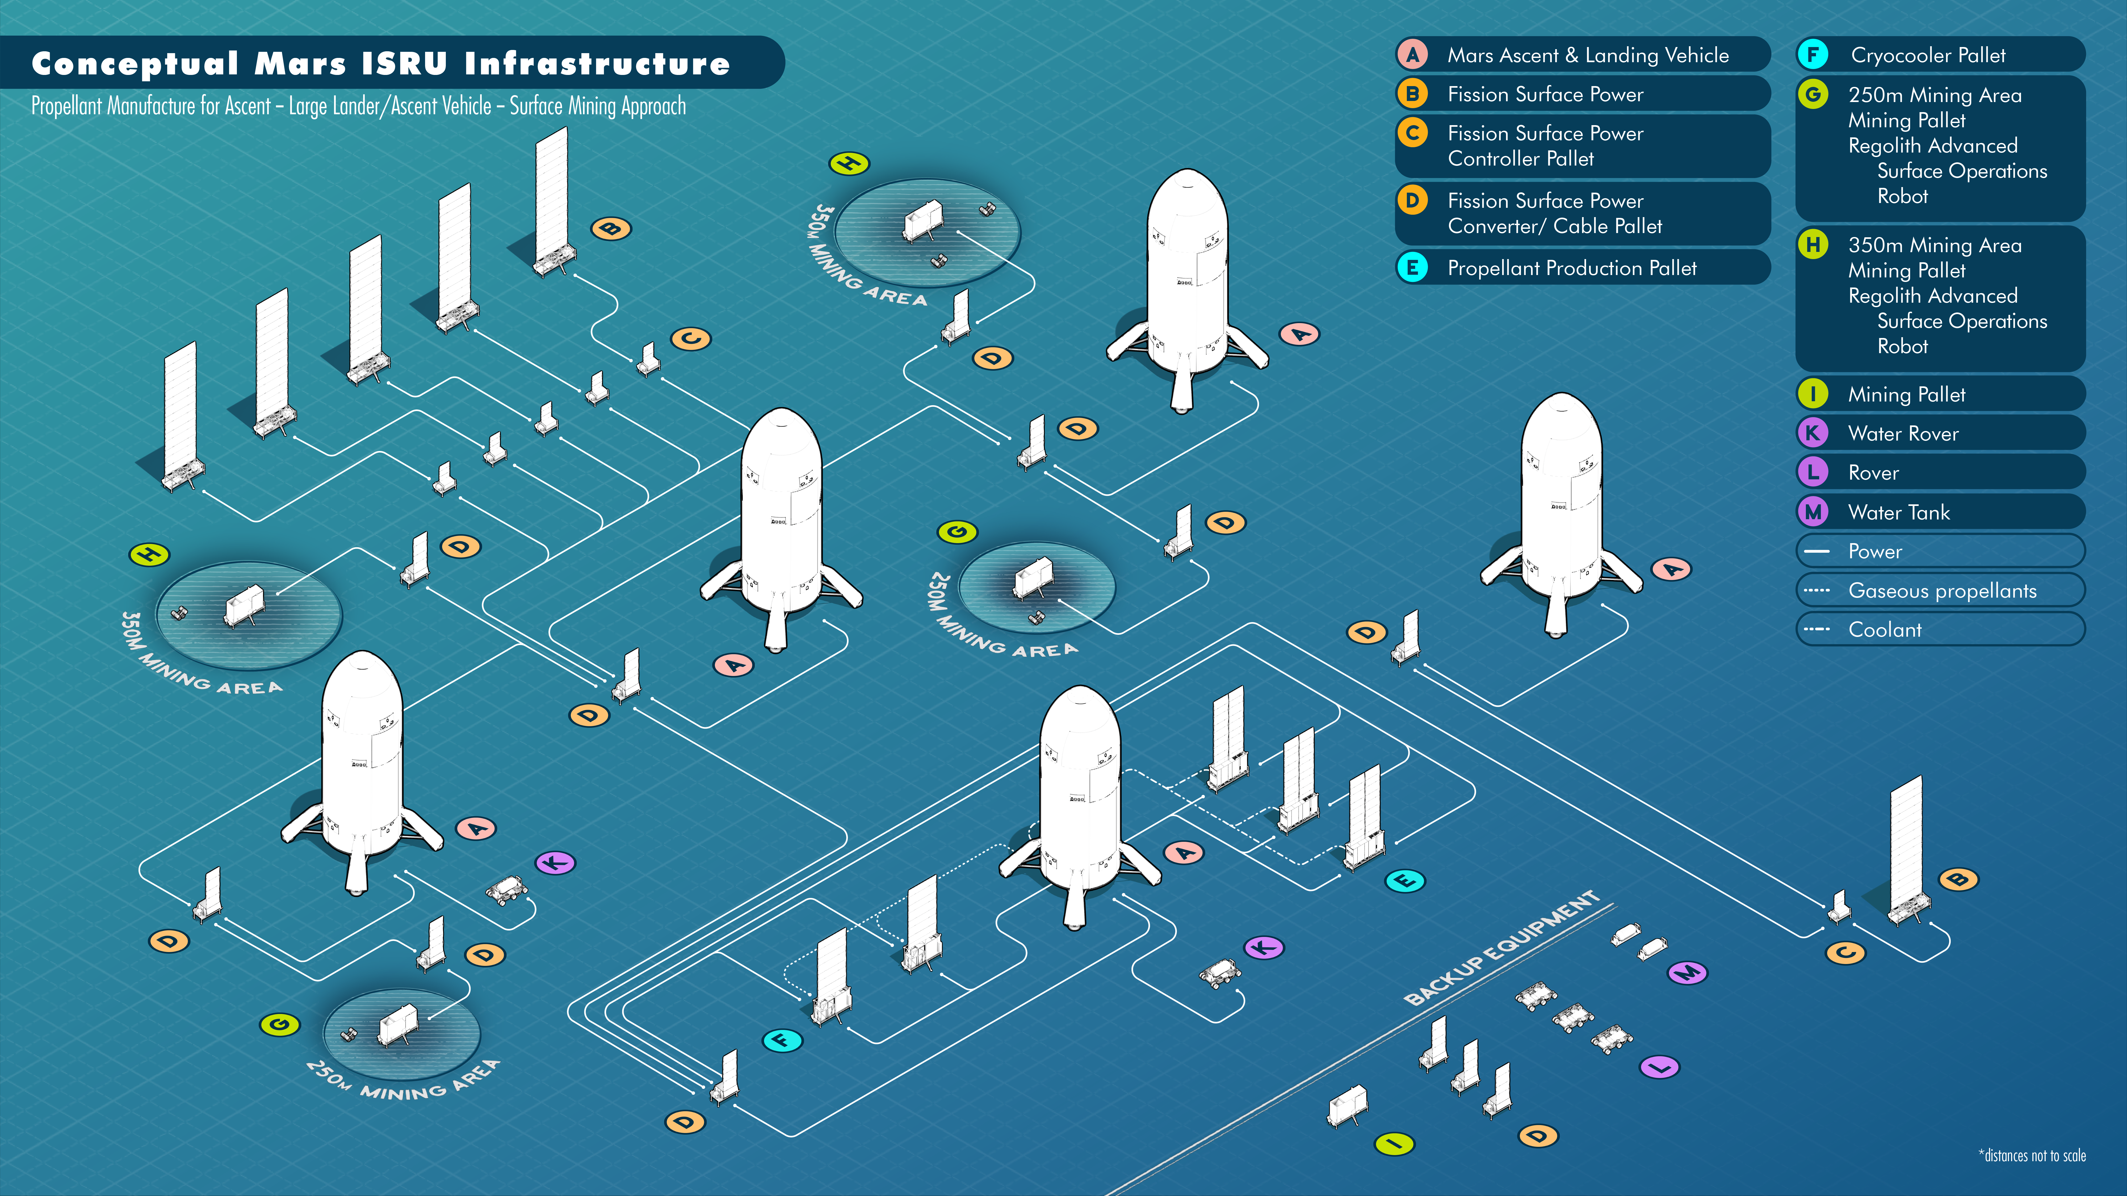
Fig. 10. Conceptual ISRU infrastructure configuration prior to crew arrival for Case 5 (NASA image).

In addition to the above considerations, if applicability to the broadest range of surface sites is a primary consideration when examining these Cases for mission applicability, then four of the five cases (Cases 1, 2, 3, and 5) do not have any dependency on feedstock that can only be obtained in certain locations on the Martian surface. Case 4 relies on accessible water ice, which, as discussed in Section IV, is likely to be found only in mid latitude regions (approximately 30 to 50 degrees north and south latitude) and only at certain locations in these latitude bands.
B. Capability Evolution
As these five Cases were being evaluated, it became apparent that there were potential evolutionary paths from simpler to more complex capabilities. Such an evolution is particularly attractive to spread the development cost of the surface infrastructure over a longer period of time as well as building confidence in operations in an incremental fashion for an infrastructure of this complexity.
For example, even though Case 1 has the least amount of surface ISRU infrastructure, the elements used are common across all the other cases (see Table 1). The FSP, common power source across all cases, must be deployed robotically by the Mobility Transport chassis. This same chassis is used to move liquids from various locations to the ascent MALV, making and breaking both fluid and electrical connections dozens of times, another common feature across all cases. Case 1 also features the delivery of propellants from Earth and transferring them to the ascent MALV, indicating a possible evolutionary path from Case 1 into a more ISRU-advanced Case 2.
It was initially thought that this evolutionary path from Case 1 to Case 2 could continue to the group of Cases 3-5. But as work proceeded through the assessment of Case 2, an underappreciated aspect of Case 2 became more apparent. All four of the Cases 2-5 use atmospheric CO₂ to make O₂ for ascent propellant. In Case 2, this is accomplished by electrolysis, splitting the CO₂ into CO and O₂, and this is the sole source of O₂ for this case. But in Cases 3-5, CO₂ is used with H₂O to make both CH₄ and O₂, so CO₂ gives up both of its oxygen atoms plus contributions of O₂ from the water as it is processed to make methane, meaning much less CO₂ needs to be gathered from the atmosphere while still producing the required amount of O₂ ascent propellant. This led to a significant difference in the propellant production and cooling pallets for Case 2 compared to Cases 3-5, as described in Section V, making an evolutionary path from Case 2 to any of the group of Cases 3-5 much less straightforward.
This analysis of the propellant production pallet for Case 2 also resulted in a better appreciation for the amount of power used by pumps in the very low-pressure Martian atmosphere. The engineering study team began looking for a more power efficient pump in an attempt to improve the performance of Case 2 and such a pump was identified. Use of this pump improved the overall power requirement for Case 2 from 212 kWe to 175 kWe, as shown in Table 2, and this was sufficient to drop the number of FSP units from six to five. But unfortunately, this savings was not sufficient to change the number of cargo MALVs for this case. With the level of power savings, Cases 3-5 were re-evaluated using the more power-efficient pumps, with a noticeable drop in required power from 236 kWe to 209 kWe (also shown in Table 2). Although this was a noticeable power savings for these cases, it was not sufficient to change the number of required FSP units or the number of MALVs to deliver the infrastructure.
The final evolutionary path worthy of note in these cases is the path from Case 3 to either Case 4 or 5 (with the possible inclusion of Case 1, but at the cost of a significant amount of time to complete a single Case 1 mission). Case 4 allows for the establishment and operation of a significant ISRU surface infrastructure while developing and gaining operational confidence in the option chosen for acquiring Martian water – either from mining regolith or accessing buried ice (the implications of which were discussed above).
.
Table 1. Summary of Results for Cases 1 through 5.
 |  | 1. Send All Return Propellant | 2. Send Methane | 3. Send 150 t of Water to Mars | 4. Borehole Mining (Ice) | 5. Surface Mining (Regolith)
Total Number of non-Crew MALVs |  | 7 | 3 | 4 | 3 | 4
Maximum Average Power  (Excavation/Prop. Production) |  | NA /~40 kWe | NA /212 kWe | NA / 236 kWe | 28 kWe / 236 kWe | 224 kWe / 236 kWe
Total Mission Duration  (Limited to 1 SLS per 26 months) |  | 184 months  (104 months if sending 2 SLS/ opportunity) | 78 months | 104 months | 78 months | 104 months
Number of FSPs  (Determined based on available time, SLS limitations) |  | 2  (due to spread of landers) | 6 | 6 | 7  (due to spread of landers) | 6
Unique Elements | Water Tanker |  |  | 2 (30 trips) | 2 (30 trips-longer dist) | 4 (60 trips)
Unique Elements | ISRU Pallet |  | 2 (modified) | 3 | 3 | 3
Unique Elements | Liquefaction Pallet |  | 2 (modified) | 2 | 2 | 2
Unique Elements | Cryo Tanker | 3 (88 trips) | 2 (40 trips)
Unique Elements | Borehole Pallet |  |  |  | 2
Unique Elements | Pallet for Extracting Water |  |  |  |  | 5
Unique Elements | RASSORX |  |  |  |  | 5
Unique Elements | Loaders |  |  |  |  | 5
Unique Elements | FSP/Controller/Cabling | 2 | 6 | 6 | 7 | 6/6/12
Unique Elements | Autonomous Chassis | 2 | 4 | 3 | 4 | 5

Table 2. Summary of Results for Cases 1 through 5 using more efficient atmospheric pumps.
(Differences from values in Table 1 indicated with italics.)
 |  | 1. Send All Return Propellant | 2. Send Methane | 3. Send 150 t of Water to Mars | 4. Borehole Mining (Ice) | 5. Surface Mining (Regolith)
Total Number of non-Crew MALVs |  | 7 | 3 | 4 | 3 | 4
Maximum Average Power  (Excavation/Prop. Production) |  | NA / ~40 kWe | NA / 175 kWe | NA / 209 kWe | 28 kWe / 209 kWe | 224 kWe / 209 kWe
Total Mission Duration  (Limited to 1 SLS per 26 months) |  | 184 months  (104 months if sending 2 SLS/ opportunity) | 78 months | 104 months | 78 months | 104 months
Number of FSPs  (Determined based on available time, SLS limitations) |  | 2  (due to spread of landers) | 5 | 6 | 7  (due to spread of landers) | 6
Unique Elements | Water Tanker |  |  | 2 (30 trips) | 2 (30 trips-longer dist) | 4 (60 trips)
Unique Elements | ISRU Pallet |  | 2 (modified) | 3 | 3 | 3
Unique Elements | Liquefaction Pallet |  | 2 (modified) | 2 | 2 | 2
Unique Elements | Cryo Tanker | 3 (88 trips) | 2 (40 trips)
Unique Elements | Borehole Pallet |  |  |  | 2
Unique Elements | Pallet for Extracting Water |  |  |  |  | 5
Unique Elements | RASSORX |  |  |  |  | 5
Unique Elements | Loaders |  |  |  |  | 5
Unique Elements | FSP/Controller/Cabling | 2 | 5 | 6 | 7 | 6/6/12
Unique Elements | Autonomous Chassis | 2 | 4 | 3 | 4 | 5

- Conclusion
This paper has summarized results from a series of Martian ISRU-focused trade studies from 2023 [5, 6, 8] and 2024 [described in this paper, and 9]. These studies cover five different approaches to providing propellants for returning crew and equipment from the surface of Mars, using several different combinations of propellants delivered from Earth and those produced from Martian feedstock material. For comparison purposes, the same ISRU infrastructure elements are used across options where possible, although the number of individual infrastructure elements may be scaled to meet the needs of a particular option. The equipment mass, power, operational complexity, and time needed to produce some or all of these propellants have been quantified and compared when used in a common mission scenario.
Analysis results for each option were discussed, highlighting performance factors such as the number of ISRU infrastructure elements and the total mass of these elements, the power and time needed to manufacture propellants, the number of landers needed to deliver this infrastructure, etc. These performance parameters were compared side-by-side and observations made, including the benefits and liens of each case for inclusion in the overall architecture of the human exploration of Mars. The possibility of evolving from a simpler ISRU case to more complex cases – that would potentially lead to more sustainable operations by reducing the number of flights from Earth to support the same number of crewed missions – was also discussed.
While no single case emerged as “better” in all aspects when compared to the others, there are distinct advantages and disadvantages that did emerge when comparing the results generated from a common set of assumptions for all cases. Consequently, specific mission objectives may determine which of these advantages or disadvantages are important for choosing among the cases that could benefit any particular mission or campaign.
- Acknowledgements

The authors would like to thank the Compass Team at the Glenn Research Center, a special engineering study team assembled from several Directorates at the Kennedy Research Center, the Advanced Concepts Office at the Marshall Space Flight Center, and numerous Space Technology Mission Directorate-sponsored ISRU research teams across NASA who supported all the studies mentioned in this paper over the past two years that provided results and other important information contributing to the options and conclusions discussed in this paper.

References
[1] Anon., “NASA’s Moon to Mars Strategy and Objectives Development,” NP-2023-03-3115-HQ, 2023, p26.
[2] Ash, R. L., Dowler, W. L., and Varsi, G., “Feasibility of rocket propellant production on Mars,” Acta Astronautica, Vol. 5, pp. 705-724, 1978.
[3] Duke, M. B. and Budden, N. A., ed., “Mars Exploration Study Workshop II,” NASA Conference Publication 3243, 1993.
[4] Drake, B. G., ed., Human Exploration of Mars Design Reference Architecture 5.0, NASA-SP-2009-566, 2009.
[5] Oleson, S. R. et. al., “Kiloton Class ISRU Systems for LO2/LCH4 Propellant Production on the Mars Surface,” AIAA Paper 2024-2536, AIAA SciTech Conference, Orlando, FL, January 2024.
[6] Trent, D. J., Edwards, S. J., and Chappell, M. B., “Design of a Family of Mars Chemical Transportation Elements,” AIAA Paper 2024-2713, January 2024.
[7] Harrison, D. A., Ambrose, R., Bluethmann, B., and Junkin, L., "Next Generation Rover for Lunar Exploration," 2008 IEEE Aerospace Conference, Big Sky, MT, USA, 2008, pp. 1-14.
[8] Congiardo, J. F., et. al., “Assessment of a Surface Water Transportation System Concept for ISRU Operations on Mars,” AIAA Paper 2024-2541, January 2024.
[9] Congiardo, J. F., et. al., “Assessment of a Mars Surface Cryogenic Transportation System,” proposed paper for SciTech 2025, in preparation.
[10] Beaty, D. W., et al, “Some Strategic Considerations Related to the Potential Use of Water Resource Deposits on Mars by Future Human Explorers,” ASCE 16-0748, 15th Biennial ASCE Conference on Engineering, Science, Construction, and Operations in Challenging Environments, Orlando, Florida, April 11-15, 2016.
[11] Carter, J., Poulet, F., Bibring, J. P., Mangold, M., Murchie, S., “Hydrous Minerals on Mars as seen by the CRISM and OMEGA Imaging Spectrometers: Updated Global View,” Journal of Geophysical Research: Planets Vol. 118, 831-858, 2013.
[12] Abbud-Madrid, A., Beaty, D. W., Boucher, D., Bussey, B., Davis, R., Gertsch, L., Hays, L. E., Kleinhenz, J., Meyer, M. A., Moats, M., Mueller, R. P., Pas, A., Suzuki, N., van Susante, P., Whetsel, C., Zbinden, E. A., “Report of the Mars Water In-Situ Resource Utilization (ISRU) Planning (M-WIP) Study,” http://mepag.nasa.gov/reports.cfm, April, 2016.
[13] Clifford, S. M., Lasue, J., Heggy, E., Boisson, J., McGovern, P., Max, M. D., “Depth of Martian Cryosphere: Revised Estimates and Implications for the Existence and Detection of Subpermafrost Groundwater,” Journal of Geophysical Research, Vol. 115, 2010.
[14] McEwan, A. S., Dundas, C. M., Mattson, S. S., Toigo, A. D., Ojha, L., Wray, J. J., Chojnacki, M., Byrne, S., Murchie, S. L., Thomas, N., “Recurring Slope Lineae in Equatorial Regions of Mars,” Nature Geoscience 7, 53-58, 2014.
[15] Vaniman, D. T., et. al., “Mineralogy of a Mudstone at Yellowknife Bay, Gale Crater, Mars,” Science, 343(6169), 1243480, 2014.
[16] Dundas, C. M., Bramson, A.M., Ojha, L., Wray, J. J., Mellon, M. T., Byrne, S., McEwen, A. S., Putzig, N. E., Viola, D., Sutton, S., Clark, E., and Holt, J. W., “Exposed subsurface ice sheets in the Martian mid-latitudes,” Science 359, 12 Jan 2018, pp. 199-201. doi: 10.1126/science.aao1619.
[17] Holt, J. W., Safaeinili, A., Plaut, J. J., Head, J. W., Phillips, R. S., Seu, R., Kempf, S. D., Choudhary, P., Young, D. A., Putzig, N. E., BiccaRi, D., Gim, Y., “Radar Sounding Evidence for Buried Glaciers in the Southern Mid-Latitudes of Mars,” Science 322, 1235-1238, 2008.
[18] Clifford, S. M., Lasue, J., Heggy, E., Boisson, J., McGovern, P. and Max, M. D., “Depth of Martian Cryosphere: Revised Estimates and Implications for the Existence and Detection of Subpermafrost Groundwater,” Journal of Geophysical Research, Vol. 115, 2010.
[19] Dundas, C. M., Byrne, S., McEwan, A. S., Mellon, M. T., Megan, R. K., Daubar, I. J., Saper, L., “HiRISE observations of new impact craters exposing Martian ground ice,” Journal of Geophysical Research: Planets, 10.1002/2013JE004482, 2014.
[20] Hauser, D., Johnson, W., and Sutherlin, S., "Liquefaction and Storage of In-Situ Oxygen on the Surface of Mars," in AIAA SciTech 2016 Symposium on Space Resource Utilization, San Diego, CA, 2016.
[21] Johnson, W., Dimston, A., Smith, J., Stalker, A., Giddens, P., and Tesny, E., "Cryogenic Insulation Solutions for the Surface of Mars with Its Unique Environments," in Virtual Symposium on Performance, Properties and Resiliency of Thermal Insulations, Orlando, FL, 2021.
[22] Mellerowicz, B., Zacny, K., Palmowski, J., Bradley, B., Stolov, L., Vogel, B., Ware, L., Yen, B., Sabahi, D., Ridilla, A., and Nguyen, H., "RedWater: Water Mining System for Mars," New Space 10(2), pp. pp.166-186, 12 May 2022.
[23] Palmowski, J., Zacny, K., Mellerowicz, B., Vogel, B., Bocklund, A., Stolov, L., Yen, B., Sabahi, D., Ware, L., Faris, D., and Ridilla, A., "RedWater: Extraction of Water from Mars’ Ice Deposits," Earth and Space 2022, pp. pp. 355-362, 5 January 2023.
[24] Leising, L., and Newman, K., "Coiled-tubing drilling," SPE drilling & completion 8(04), pp. pp. 227-232., 1 December 1993.
[25] Oleson, S., Turnbull, E., Colozza, A., Schmitz, P., Klefman, B., Tian, l., Barth, C., Wilson, S., Packard, T., and Fittje, J., “40 kW Fission Surface Power System (FSPS) Deployability,” NASA/TM-20220012395, November 2022.
[26] Schuler, J., Nick, A., Leucht, K., Langton, A. and Smith, D., "ISRU Pilot Excavator: Bucket Drum Scaling Experimental Results," Earth and Space 2022, pp. 394-407, 5 January 2023.
[27] Hinterman, E. D., Multi-objective system optimization of a Mars atmospheric ISRU Plant (thesis). Massachusetts Institute of Technology, Cambridge, MA, 2022.
[28] Trent, D. J., Edwards, S. J., Chappell, M. B., Lugo, R. A., and Andreini, M. J., “Expanding a Family of Mars Chemical Transportation Elements with a Large Vertical Lander Concept,” proposed paper for SciTech 2025, in preparation.

****

Senior Engineer Specialist, The Aerospace Corporation, AIAA Associate Fellow.
Aerospace Technologist, Technical Management, Science and Technology Office, Marshall Space Flight Center.
Lead, Compass Team, NASA Glenn Research Center, AIAA Senior Member.
Lead Systems Engineer, Compass Team, NASA Glenn Research Center, AIAA Young Professional Member.
Lead Aerospace Technologist, Engineering Directorate, Kennedy Space Center.

