Framework for Technical Performance Uncertainty in Hybrid-Electric Aircraft Development

ABSTRACT
For projects working on new and cutting-edge technologies, it is essential to understand the state of the project as testing and modeling progresses and recognize how technical changes may impact the end product. This is especially true for hybrid-electric aircraft, where the implementation and operations of the electric propulsion systems have many impactful variations on the overall system performance. This paper proposes a framework for uncertainty evaluation of a hybrid-electric vehicle where the design of the hybrid-electric propulsion is fixed. This framework is developed to evaluate the model prediction of hybrid-electric aircraft and is applied to a hybridized De Havilland Canada Dash 8-400 (Dash 8) aircraft with the PW150A engine. This proposed framework is currently being used at NASA to track uncertainty in hybrid-electric technology development and informs the generic plots in the extended abstract. Specific quantitative analysis and plots will be included in the final paper for the Dash 8 case study.

INTRODUCTION
NASA has set aggressive performance goals for next-generation aircraft as a potential solution to future environmental concerns. As a part of this effort, there has been a higher level of interest in developing electrified aircraft propulsion (EAP) technologies through projects such as R-R LibertyWorks EVE and UTRC hGTF[1]. When working at the cutting edge of technology development, it is essential to understand the state of the technical performance as project testing and modeling progresses to recognize how system changes may impact the end product. This is especially true for hybrid-electric aircraft, where the implementation and operations of the electric propulsion systems have many impactful variations on the overall system performance. However, as hybrid-electric propulsion is in a new frontier, it is difficult to assess the technological progress of the project and predict how improvements to the electrical system will impact future aircraft concepts. Being able to visualize the range of performance outcomes from a system model or test can bring valuable insights for technology development.
This paper proposes a framework for uncertainty evaluation of a hybrid-electric vehicle where the design of the hybrid-electric propulsion is fixed. This framework is developed to evaluate the model prediction of hybrid-electric aircraft and is applied to a mildly-hybridized De Havilland Canada Dash 8-400 (Dash 8) aircraft with the PW150A engine. This proposed framework is currently being used at NASA to track uncertainty in hybrid-electric technology development and informs the generic plots in the extended abstract. Specific quantitative analysis and plots will be included in the final paper for the Dash 8 case study.

FRAMEWORK OVERVIEW
This section will give a brief overview of the framework developed to look at the hybrid-electric propulsion system uncertainty impact on aircraft performance. Figure 1 shows a diagram of the framework. The flight or high fidelity model data(blue) is fed into the vehicle and aircraft synthesis modeling tools (black).
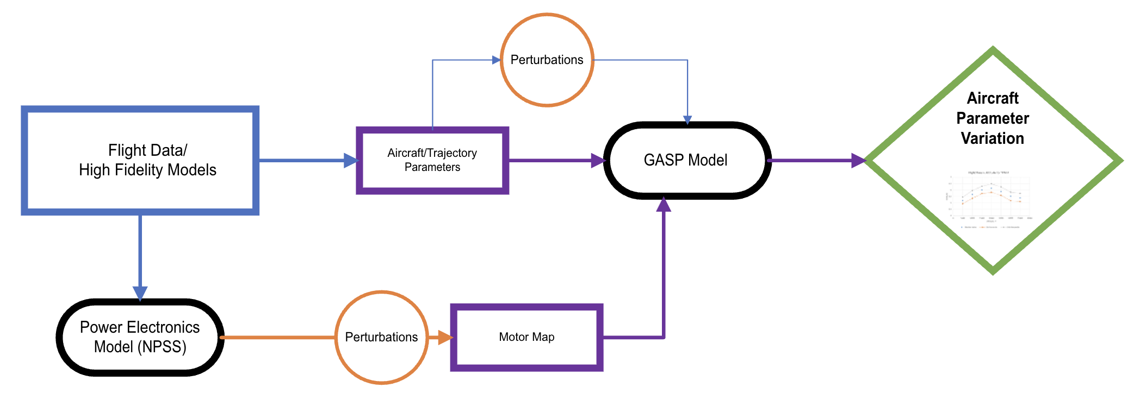
Figure 1. Workflow of proposed framework
The propulsion model is then perturbed for select parameters and the resulting total efficiencies at specified torques and shaft speeds are fed into the vehicle analysis tool GASP (black) as a motor map. A range of aircraft flight parameters, with select parameters being perturbed, are fed to GASP as well. The output of the GASP model is finally formulated into potential ranges of mission performance parameters (green). The model performance is compared against lab and ground test data. As testing progresses, the models are updated and recalibrated, and the level of model uncertainty decreases.

MODELING TOOLS
This section will go over the tools used within the framework for propulsion and aircraft modeling.

Numerical Propulsion System Simulation (NPSS)
NPSS is an engine simulation tool that allows for design and analysis of propulsion systems[5]. Recent development to NPSS allows for the modeling of hybrid-electric propulsions systems.

General Aviation Synthesis Program (GASP)
GASP is an in-house aircraft synthesis code that was developed at NASA Ames Research Center [6]. This program was created to perform tasks associated with early-stage aircraft design such as vehicle sizing, allowing for rapid parametric studies during the conceptual design phase. In recent years, GASP has been updated to support EAP mission analysis. The Flight Optimization System (FLOPS)[7] is a common software tool that could be used as an equal alternative to GASP.

VEHICLE AND ENGINE MODEL
This section will cover details on the aircraft and engine model used within the framework for this paper. For vehicle analysis, a Dash 8 aircraft with two PW150A engines will be used as the baseline vehicle. Hybrid-electric propulsion will be utilized for part of climb and cruise, with the rest of the mission being solely powered by the PW150A engine. Analysis is done to see the flight time and range available for hybrid-electric cruise for a range of hybrid-electric climb start altitudes and thrust splits between the engine and motor.

SYSTEM UNCERTAINTY AND PERFORMANCE RANGES
Perturbations in the baseline vehicle and hybrid-electric propulsion system are made and fed into GASP using a Monte Carlo method. The parameters chosen for perturbation are shown in Table 1. For the baseline vehicle, the specific power and fuel flow of the engine are the main elements that would bring uncertainty into vehicle performance. For the electrical system, the component efficiencies and power factor would bring in uncertainties that can be tracked and improved upon with testing. These parameters would be normally assessed and determined during testing, but for the purposes of this paper, generic ranges with a normal distribution will be used.
To consider the effect of decreasing battery voltage on the efficiencies, the sensitivity of the performance parameters to the battery voltage will be determined as well.
Specific power of the battery is a parameter that has a significant impact on aircraft performance [2][3], but for the purposes of this study will be treated as a constant. Since this framework is designed to study a fixed design, it is expected that the weight and power of the battery chosen is fixed, and the variation in battery power would be reflected in the efficiency uncertainty.

Table 1. Uncertainty parameters chosen for Monte Carlo inputs
Parameter Source | Parameter | Uncertainty Range
Baseline Vehicle Propulsion | Specific Power | +/- 3.5%
Baseline Vehicle Propulsion | Fuel Flow | +/- 7.5%
Electrified Components | Power Factor | +/- 6.5%
Electrified Components | Battery efficiency | +/- 3%
Electrified Components | Converter 1 efficiency | +/- 3%
Electrified Components | Motor Generator efficiency | +/- 3%

RESULTS
This section of the paper will cover the results from the vehicle and electrical component perturbations on the aircraft performance parameters. Example plots and results are shown. These generic plots will be replaced with results using the openly available data for the Dash 8 aircraft and a generic mission profile.
Figure 2 shows an example of the spread in cruise time and range with cruise altitude of the baseline aircraft without electrification. The spread in time and range is due to the uncertainty in specific power and fuel flow. Figure 3 shows an example of the spread of results due to the Monte Carlo inputs for two thrust splits.

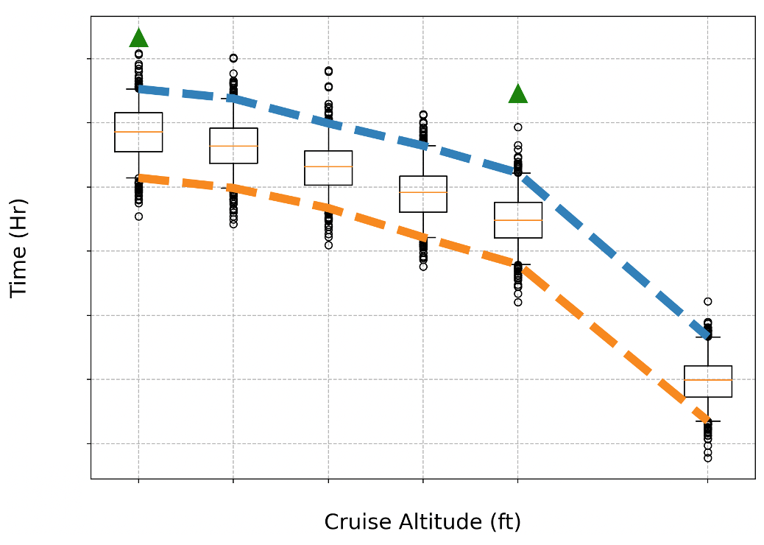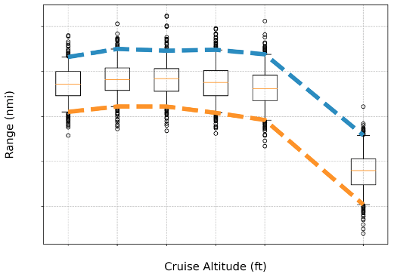
Figure 2. Spread in cruise time and range v. cruise altitude for the non electrified vehicle

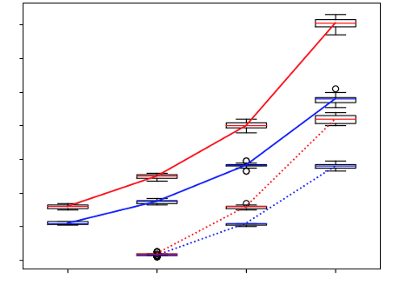
Figure 3. Spread from uncertainty in fuel used in cruise v. starting altitude of hybrid climb, for two engine-motor thrust splits

CONCLUSIONS and FUTURE WORK
This paper will outline the framework used to find the impact of uncertainties in hybrid-electrical aircraft performance. The intention of this framework is to be used during the development of hybrid-electric technologies to continuously track the progress and understand the full range of possible technical performance outcomes. Thus, this process is repeatedly conducted as testing and aircraft refinement is done, narrowing the spread of the uncertain parameters. For the final paper, the placeholder information and plots will be replaced with a quantitative assessment example case using the open data available for the Dash 8 vehicle.

REFERENCES
[1] National Aeronautics and Space Administration. (n.d.). Hybrid Electric. NASA. https://www1.grc.nasa.gov/aeronautics/eap/airplane-concepts/hybrid-electric/.
[2] Pham, D. et al. (2024) ‘Parametric Modeling and Mission Performance Analysis of a True Parallel Hybrid Turboprop Aircraft for Freighter Operations’, AIAA AVIATION FORUM AND ASCEND 2024. doi:10.2514/6.2024-3581.
[3] Diamantidou, D. et al.(2025) ‘Navigating Technological Risks: An Uncertainty Analysis of Powertrain Technology in Hybrid-Electric Commuter Aircraft’. ASME. J. Eng. Gas Turbines Power, 147(4). doi: 10.1115/1.4066528.
[4] National Aeronautics and Space Administration. (2024) ‘Electrified Powertrain Flight Demonstration (EPFD) Project Technical Measures of Effectiveness’.
[5] Stauber, L. (2002) ‘Numerical Propulsion System Simulation (NPSS): An Award Winning Propulsion System Simulation Tool’. NASA-TM-2002-211333.
[6] Hague, D. (1978) ‘GASP – General Aviation Synthesis Program. Volume 1: Main Program. Part 1: Theoretical Development’. Tech. Rep. NASA-CR-152303-VOL-1-PT-1, National Aeronautics and Space Administration.
[7] McCullers, L. A. (1984) “Aircraft Configuration Optimization Including Optimized Flight Profiles, Multi-disciplinary Analysis and Optimization Part 1”, NASA CP-2327.

