VIPER’s Mass Spectrometer observing lunar operations (MSolo)

Roberto Aguilar Ayala,, Janine E. Captain², James T. Smith², Matthew L. Hancock², Alexander W. Jarnot, Kevin E. Smith², Prital J. Johnson², Christopher S. Johnson², Rodolphe Carro, Rolando J. Nieves² , Christopher N. Bond², John Trautwein², Kenneth C. Wright, Jaime L. Winfield⁵, Peter Santariello, Amy Mcadam, Doug P. Archer, Gregory Kreinheder, Jorge A. Diaz⁸, Parvathy Prem, Kathleen E. Mandt⁶, Aleksandra Gawronska⁶, Barbara A. Cohen⁶, & Jaqueline W. Quinn²

Abstract
The Volatiles Investigating Polar Exploration Rover (VIPER) is a lunar volatiles detection and measurement mission that will land on Mons Mouton near Nobile crater, close to the Moon’s south pole. One of the analytical instruments embedded within the rover is the Mass Spectrometer observing lunar operations (MSolo) instrument. VIPER’s data will ultimately be used to create lunar water resource maps that may enable a sustained presence on the lunar surface. As VIPER navigates several kilometers of terrain, its onboard analytical instrumentation will characterize the presence of volatiles along the traverse path and identify candidate locations for drilling. Upon selection of a drilling site, the rover will position itself and deploy an auguring, percussive drill down to a meter depth. Upon extraction, regolith cuttings captured by the auger are deposited on the surface; an activity that will initiate the release of any volatile gases that are subsequently detected and quantified by MSolo. MSolo is designed to identify low-molecular-weight volatiles (between m/z 1-100) with unit mass resolution. Volatiles of interest include D/H and O18/O16 bearing species, including possible water contained within the lunar regolith. MSolo is a modified, commercial off-the-shelf (COTS) system, meaning the instrument is based on a commercially available unit that has been ruggedized for space applications.

INTRODUCTION

LUNAR ICE

To date, the Moon is the only celestial body other than our own planet that humans have physically explored. Initial telescopic observations by Galileo in 1609 and the following centuries of studies by other astronomers have allowed for detailed topographic information to become available. Yet it wasn’t until the USA-led Apollo and USSR-led Luna missions in the 1960-70s that scientists were able to analyze rock and soil samples collected directly from the lunar surface- all of which continue to be of great importance to the scientific community. Aside from studies that utilized collected samples(Barnes et al., 2019; Boyce et al., 2010; Hauri et al., 2011; McCubbin et al., 2015; Ni et al., 2019; Saal et al., 2008; Stephant et al., 2019), various remote sensing observations have provided important information regarding volatile compounds that exist on the Moon(Honniball et al., 2021; Li et al., 2018; Li & Milliken, 2017; Lin et al., 2022; Pieters et al., 2009). The Clementine mission, which was launched in 1994, signaled early indications through its bistatic radar that ice may be present at the lunar poles(Nozette et al., 1996), though subsequent radar analysis suggested that these unusual radar properties could also be attributed to surface roughness(Stacy et al., 1997). Then in 1998 the Lunar Prospector mission used a neutron spectrometer to provide evidence of enhanced hydrogen concentrations at the lunar poles, further supporting the theory of ice near the lunar poles(Feldman et al., 1998), although the physical form and composition of hydrogen-bearing material remains to be fully characterized. Then in 2009, the Lunar Crater Observation and Sensing Satellite (LCROSS) confirmed the presence of water ice in a permanently shadowed region (PSR)(Colaprete et al., 2010). Water was further confirmed to exist in detectable quantities across much of the lunar surface using data from the Moon Mineralogy Mapper (M3) onboard ISRO’s Chandrayaan-1 lunar orbiter(Pieters et al., 2009), the Deep Impact High-Resolution Instrument-infrared spectrometer during a lunar flyby(Sunshine et al., 2009), and the Visual and Infrared Mapping Spectrometer onboard Cassini during a lunar flyby(Clark, 2009). LCROSS also reported that sufficient quantities of these volatiles may be present for a viable path to in situ resource utilization (ISRU). However, LCROSS provided only a single lunar surface location data point to correlate with orbital observations, and more information is needed to understand the distribution of the volatile resources across the polar regions. VIPER aims to address these knowledge gaps.

IN SITU RESOURCE UTILIZATION (ISRU)

In the initial age of lunar exploration, all mission-critical equipment was sent along with the astronaut crew to successfully accomplish mission goals. This approach limited the capabilities and mission durations due to limitations in mass of materials needed. The purpose of ISRU is to harness and utilize resources available at the site of exploration. By having the ability to harness space resources, explorers would not need to carry all necessary consumables with them from Earth. Therefore, production of mission critical consumables via ISRU approaches could help reduce the overall mass of payloads along with the costs and risks of future missions, as well as push for a self-sufficient and long-term base of operations.
The confirmation of lunar volatiles such as water ice is one primary interest of ISRU goals, as this potential resource can be used for various applications such as propulsion, power, and life support(Sanders & Larson, 2013). However, prior to implementing an ISRU architecture we must first gather an advanced understanding of the form, concentration, distribution, and accessibility of the available lunar volatiles.

THE MOON AND MASS SPECTROMETRY

The advancement of commercial instrumentation used for gas analysis provides a commercial approach for the growing interest in lunar exploration that has been recently excited by the creation of the Commercial Lunar Payload Services (CLPS) initiative. Mass spectrometry is and has been the primary approach for characterizing volatile compounds located on our Moon and other planetary bodies. It can provide qualitative and quantitative measurements of the chemical composition of volatile compounds, including isotopic, elemental, and molecular abundances. While missions such as the Lunar Atmosphere and Dust Environment Explorer (LADEE) Neutral Mass Spectrometer (NMS)(Mahaffy et al., 2014) have analyzed the lunar exosphere utilizing mass spectrometry, Apollo 17 Lunar Atmospheric Composition Experiment (LACE)(Hoffman, 1975) provided the only surface-acquired mass spectrometry measurement on the Moon.

INSTRUMENT DESCRIPTION

MSolo is a modified commercial off-the-shelf (COTS) quadrupole mass spectrometer; its specifications are summarized in Table 1. The base instrument is the commercially available Transpector® MPH residual gas analyzer (RGA) from INFICON (Syracuse, NY). The COTS unit was ruggedized to allow the instrument to survive the environments endured for spaceflight applications. MSolo is composed of the sensor, avionics, and a calibration gas system (CGS). The sensor is assembled from three parts: the ionizer, the single quadrupole mass filter, and the detector. The avionics consist of the instruments’ modified commercial electronics and a radiation tolerant computer and power controller known as the Instrument Interface Unit (IIU). The avionics are housed in a ruggedized chassis. MSolo’s control and data handling utilizes a custom software architecture developed at Kennedy Space Center (KSC) for this payload.

Table 1: MSolo Instrument General Specifications
MSolo Specifications
Ion Source | Electron Impact Ionization
Ion Energy | Standard: 70eV electron energy  Low: 40eV electron energy
Mass analyzer type | Quadrupole Mass Filter
Mass Range | m/z 1 to 100
Detector Systems | Faraday Cup (FC)  Continuous Dynode Electron Multiplier (EM)
Sensitivity | ~4E-5 A/Torr for Nitrogen, FC mode
Dimensions | 18 x 21 x 48 cm
Instrument Mass | 4.8 Kilograms
Power Usage | Nominal: 30 Watts (at 28V)  Peak: 40 Watts
Input Voltage | 22 Volts to 33.6 Volts
Data Rate | Variable depending on instrument mode, Average 16 kbps
Thermal Conditions | Survival: -40 °C to 75 °C (233 to 348 K)  Operational: -10 °C to 45 °C (263 to 318 K)
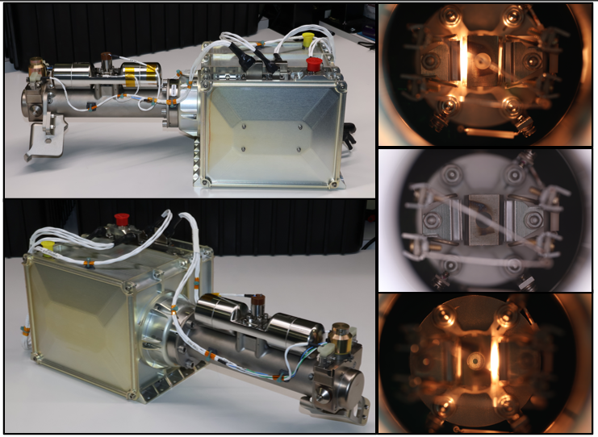
Figure 1: Fully assembled MSolo (left) and a representation of the dual filament design of the sensor (right).

SENSOR

MSolo utilizes a crossbeam (XB) ion source configuration ( Figure 1), which consists of a redundant set of linear yttrium oxide coated iridium filaments used to ionize gas phase molecules traveling perpendicular to the direction of the electron beam. The geometric configuration of the crossbeam ion source design allows for a higher density of electrons to be introduced into the ionization region. This higher electron density thus results in a higher ionization/sensitivity to molecules traveling through the anode cage while also minimizing the effects from any molecules traveling around the ion source. Once the molecules are ionized, they are directed by a series of focusing rings through an aperture into the mass filter.
MSolo’s mass filter is a typical quadrupole configuration composed of four metallic rods set in a square array. Each rod is isolated from the others by ceramic insulators/spacers. However, opposite rods are electrically connected. The rod pairs are then alternately charged with one pair of rods having a radio frequency (RF) and a positive direct current (DC) potential while the other pair of rods is applied with the same RF and DC amplitude but 180° out-of-phase. The resulting electrical field generated by the RF frequency and RF/DC amplitude will filter desired ions of a specific mass-to-charge (m/z) ratio as the ion stream travels down the quadrupole assembly towards the detector.
Once ions of interest have been successfully filtered through the quadrupole, they are introduced into the detector region of the sensor. MSolo utilizes a Faraday Cup (FC) / Continuous Dynode Electron Multiplier (EM) detector, which allows for operation of only the FC, or the EM if higher sensitivities are required. The FC is a metallic, cup-shaped electrode held at a virtual ground potential. Incident ions are neutralized as they strike the FC, and the resulting current is detected via circuitry monitoring the FC. The simple construction of the FC limits its current detection to the limits of the electrometer. If the signal is below this threshold, then the EM can be activated to increase the signal by a set amount. The continuous dynode EM acts as an in-situ preamplifier, in which the filtered ions are accelerated into the inlet of the EM by a strong negative voltage. Upon striking the surface of the resistive glass, secondary electrons are emitted/accelerated to the opposite surface where they strike and continue down the dynode channel. This process is repeated continuously, which produces a cascade of electrons, effectively turning one ion into millions of electrons. These electrons then impact a collector where they are neutralized in a similar manner as with the FC, which results in a higher current and therefore an increased signal for the respective ion.

AVIONICS

RESIDUAL GAS ANALYZER (RGA) ELECTRONIC CIRCUIT CARD ASSEMBLIES

The commercial residual gas analyzer contains six circuit card assemblies: a power supply (MS-PS), a Central Processing Unit (MS-CPU), a radio frequency (RF) generator, a pair of boards that constitute the electrometer, and a motherboard. Two of MSolo’s circuit card assemblies (the RF card, the electrometer) are purchased directly from the commercial unit vendor and are then modified for space applications during assembly at KSC. The modifications that are implemented include the replacement of several capacitors and the application of additional staking material. Two circuit cards (the motherboard and the MS-CPU card) have kept the original vendor design but were refabricated in-house by NASA using components more tolerant of the space environment. The fifth card (the MS-PS) was completely redesigned by NASA maintaining the digital front-end (interface) of the original vendor design but replacing the digital power supply circuits with analog circuits. The components used on the NASA-designed power supply have undergone radiation testing and the power supply card is considered better than radiation tolerant. All six of the circuit cards are form, fit and function equivalent to the original vendor circuit cards. With the appropriate firmware loaded in the single board computer, the COTS circuit cards can be mixed in with the modified and redesigned circuit cards as needed for diagnostic testing.

INSTRUMENT INTERFACE UNIT (IIU)

In addition to those six circuit cards, MSolo is unique in that it also contains an Instrument Interface Unit (IIU), which is an electronic subsystem within MSolo’s avionics. The IIU serves as the power, command, and data front end for the instrument. The IIU is comprised of two single board computers and an electromagnetic interference (EMI) filter. The power front end of the IIU is a single board computer called the IIU MSolo Adapter Card (IMAC) and is based on the Microsemi SmartFusion2 (SF2) system on a chip (SoC). The SF2 contains both programmable logic and a processing system running a bare metal monolithic C program. The IMAC receives unregulated 28 VDC power from a host (such as the VIPER rover) and switches that power directly to MSolo’s MS-PS. The IIU also supplies conditioned power to the second single board computer called the Space Hybrid Computer (SHC). Additionally, the IMAC energizes a calibration gas valve and contamination cover, as well as provides temperature sensor feedback.
The SHC design is based on the National Science Foundation (NSF) Center for High-Performance Reconfigurable Computing (CHREC) Space Processor using the Xilinx Zynq 7020 system on a chip (SoC). The SHC Zynq hosts a Linux operating system with an application suite composed of distributed C++ executables communicating via a publish/subscribe software message bus. The SHC and IMAC are electrically connected via a stack-through connector that carries both power and communication signals. As mentioned previously, the SHC receives conditioned power from the IMAC and is powered on anytime the IMAC is powered by the host. The SHC and IMAC communicate with each other across the stack-through connector using a Controller Area Network (CAN) bus. The same connector also allows the SHC and IMAC to share general purpose input/output signals that are used to monitor and command discrete signals (on/off) from external sensors and effectors. The SHC is electrically connected to the MS-CPU card via an Ethernet connection over which all mass spectrometer commands and data are transmitted. The SHC is also electrically connected via an RS-422 asynchronous serial interface to a MS-CPU card Joint Test Access Group (JTAG) programmer module. Finally, the SHC is electrically connected to the host via an RS-422 asynchronous serial interface. All MSolo commands and telemetry pass through this host interface. In summary the IIU allows MSolo to plug into practically any CLPS host that provides a 28VDC electrical bus and a RS-422 serial data connection, where the maximum data rate is set by the CLPS host and their mission phase.

MSOLO INSTRUMENT INTERFACE UNIT (IIU) SOFTWARE

As previously mentioned, MSolo’s IIU runs Linux on a radiation tolerant single board computer known as the Space Hybrid Computer (SHC). The design of the SHC was closely based on the National Science Foundation’s Center for High-Performance Reconfigurable Computing (CHREC) Space Processor or CSP. The circuit schematic is nearly identical, and the CSP has been used on the ISS several times(George & Wilson, 2018; Wilson & George, 2018). Various data interfaces were added on the SHC so that a single board could be designed, thus simplifying mechanical requirements. The embedded software running under Linux has a distributed architecture of executable components that communicate with each other via an open-specification publish-subscribe patterned middleware known as Data Distribution Services (DDS). The communications middleware, while open specification, is a proprietary implementation known as CoreDX (Twin Oaks Computing, Castle Rock, CO).
The CoreDX DDS middleware creates a “software bus” where the different components of the embedded system publish information and subscribe to information. The information available on the software bus is strictly enforced at software compile time by a data dictionary known as the Interface Description Language (IDL). Compile time enforcement of the IDL allows the work to build the embedded components to be distributed among multiple developers and assures that the components will exchange data correctly.

BOUNDARY LINK

Commands accepted by MSolo as well as the telemetry generated must pass through the boundary link embedded application. The boundary link transcodes commands from Consultative Committee for Space Data Systems (CCSDS) space packets(Recommendation for Space Data System Standards: Space Packet Protocol, 202 C.E.) into the DDS software message bus format and publishes them onto the software bus. Telemetry generated by MSolo is received by the boundary link from the software bus and transcoded into CCSDS space packets which are transmitted to the host via a physical RS-422 connection. Various forms of transmitting and receiving the CCSDS space packets are used between MSolo and its host such as raw serial framing, Serial Link Internet Protocol (SLIP) and the newer Point-to-Point Protocol (PPP). The embedded application boundary link has a peer application in the MSolo Ground System also known as the boundary link. The two boundary links complement each other serializing and deserializing the software bus while keeping the embedded software bus and the ground system software bus nearly equivalent in data content.

MS AGENT

The purpose of a “software agent” is to translate data bi-directionally across a physical data link device into the MSolo distributed applications. All specific device information is encapsulated in the agent, freeing all other distributed applications from requiring any specific instrument information and only requiring that they comply with the well-known software message bus data dictionary. In the case of MSolo, the mass spectrometer (MS) serves as the primary command and control interface, which is implemented across an Ethernet physical link using an HTTP data protocol, thus behaving in the same manner as the COTS systems communicate to a standard computer system. The Mass Spectrometer agent (MS Agent) knows how to receive software message bus commands and translate them into the commercial instrument’s format and transmit it across the Ethernet interface. The MS Agent also knows how to receive data from the MS in HTTP format and translate it into the software data bus. The design of the MS Agent encapsulates all the specific COTS data protocol information into a single software application.

EXPAND COMMANDS & CONDENSE COMMANDS

Midway through MSolo development it was discovered that to accommodate smaller than the standard expected limit for a command size (in the case that specific missions required this), that a process needed to be implemented in which data could be managed to accommodate various telemetry limits. Therefore, the EXPAND and CONDENSE commands applications were created to compress a command in the ground system before transmitting it to the MSolo Instrument in mission. Followed by the expansion of the command to the original format and size once on the embedded software message bus, all while maintaining data integrity. For reference, the CCSDS standard states that the payload command packet may be as large as 65536 bytes. The VIPER design limits the payload command packet size to 87 bytes.

MECHANICAL CONFIGURATION

CHASSIS AND SENSOR SHROUD

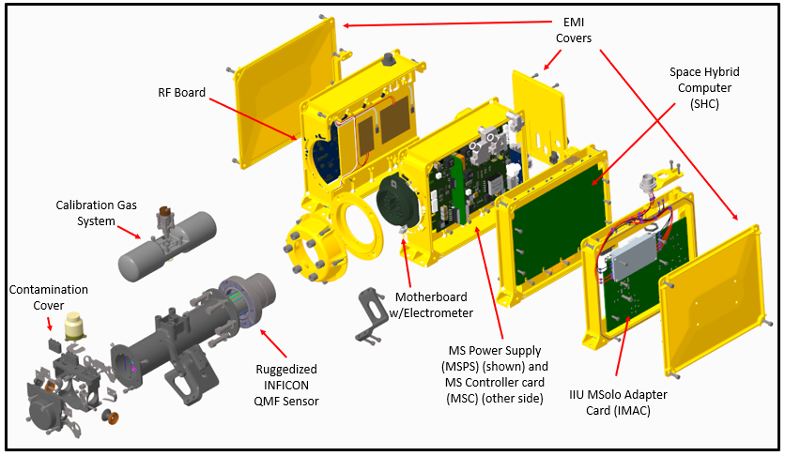
Figure 2: Exploded 3-D model of MSolo.

Several modifications to the COTS-style mechanical housings were made to accommodate the heritage format cards as well as the modified-COTS RGA cards and IIU. Components such as thermal gap pads and board edge clamps are used to conduct heat away and to mitigate impacts of vibration. Cable tie anchors are mounted on the chassis to also help mitigate cable vibration. Some elements such as gaskets and filters are strategically sized and placed to reduce electromagnetic interference (EMI). An exploded 3-D model of MSolo can be seen in Figure 2 showing how all the mechanical components come together into one final unit. Most of the housing components are manufactured from 6061-T651 aluminum and treated with a Mil-DTL-5541 Type 1 Class 3 chromate conversion (Alodine) coating. A general Magnaplate NEDOX PR-F coating is used for the sensor shroud. The sensor shroud replaces the commonly utilized stainless steel ConFlat (CF) nipple and allows for a sturdy aluminum mount to be used instead of the COTS plastic nut. The sensor shroud also provides a mount and injection port for the Calibration Gas System (CGS) as well as a mounting location for the contamination cover. The construction of the shroud allows for the final position of the CGS to be adjusted in 120-degree increments, if necessary, which helps prevent interferences during final rover integration. Nearly all fasteners have at least two locking features for vibration mitigation – either torquing, lock nuts/inserts, and/or staking compound. The staking compound is used as minimally as possible and is de-gassed in a chamber prior to application to minimize contamination from outgassing. The compound used is EC 2216 GRAY B/A W/2% CAB-O-SIL and was chosen for its low outgassing properties.
The chassis and sensor shroud also contain survival, operational, and bakeout heaters. The survival heater is an automatic system internal to MSolo that is controlled by a mechanical thermal switch, while the operational and bakeout heaters are controlled by the rover. The operational heater serves to bring the instrument to operational temperatures before turning on, while the bakeout heaters bake the instrument out in-transit to the Moon to minimize contamination from outgassing.

CALIBRATION GAS SYSTEM (CGS)

Environmental conditions, contamination, vibration, and shock during launch, transit, and landing may necessitate the need to verify the tuning and calibration of the instrument. The CGS was designed by NASA Kennedy Space Center (KSC) MSolo engineers using techniques learned from the COTS calibration standard equipment. The flight hardware assembly includes a stainless steel (SST) manifold weldment, a mechanically fastened latching solenoid valve, and a screw-on flow restrictor weldment. The manifold is a three-part SST 304/ 304 L weldment which includes a central port to receive the microvalve and a 100-cc tank divided equally into two on either side of a Mindrum microvalve (Mindrum Precision, Rancho Cucamonga, CA). The CGS construction can be seen in Figure 3. The flow restrictor cartridge is a weldment comprised of a proprietary gland designed and manufactured by Mindrum and encapsulates a specifically calibrated porous flow restrictor (also called a frit) from Mott (Mott Corporation, Farmington, CT) between two 1-micron screens. The screens ensure that the frit does not contaminate the system, as it was found that small particles may break loose from the frit due to vibration and shock. The flow restrictor cartridge is fastened directly to the internally threaded microvalve port via Mindrum’s gland screw and a gland washer and is removable and interchangeable. A single-use metallic crush-ring provided by Mindrum ensures nearly “zero-leakage” between the gland and the microvalve. Prior to flight, the CGS supply tank is evacuated, baked-out and filled (pressurized) with the calibration gas mixture to approximately 2 PSIG at room temperature. The slight positive tank pressure prevents air and contaminant intrusion into the CGS while minimizing gas leakage out of the system prior to flight. The calibration gas standard is composed of 3% hydrogen, 10% krypton, 10% xenon, and a balance of nitrogen. The CGS gases were selected to allow for isotopic isolated molecules at various mass ranges to be available to the instrument/operator, but different gases could be used for other missions if needed. In service, the calibration gas mixture is stored within the tank onboard MSolo and will be delivered on demand via the latching solenoid valve at a controlled rate dictated by the frit and current tank pressure and temperature. In the case of a sudden loss of power to the instrument, the Mindrum valve will close, thus saving the gas for later use. Based on laboratory testing, CGS is calculated to provide about 3,600 minutes of continuous optimal calibration flow (sufficient to meet the required calibrations for the VIPER mission), any usage afterwards requires that parameters such as the EM gain be adjusted to enhance the signal and thus allow for more calibration time until the gas has ultimately decayed to an undetectable value.
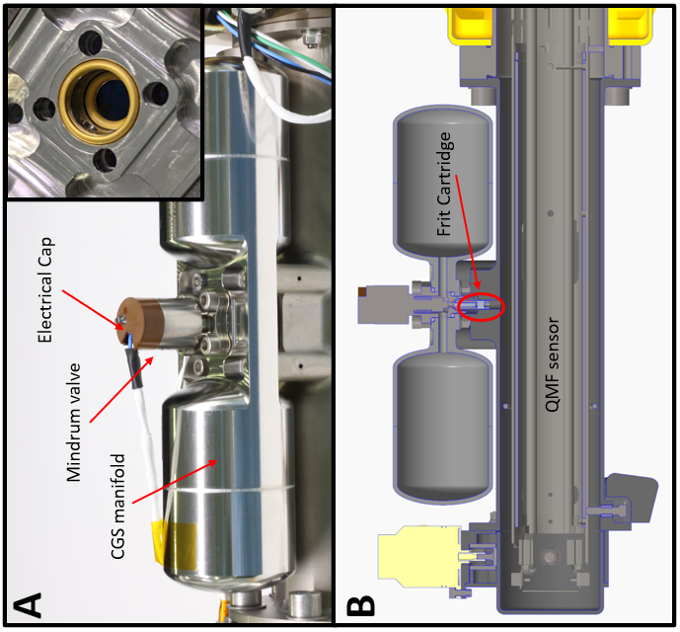
Figure 3 - A) Assembled CGS manifold showing the Mindrum valve (left), and the upper and lower C-seals used to fix the CGS microvalve onto the CGS weldment (upper-right). B) 3-D model sectioned view showing the frit location and its proximity to MSolo’s sensor.

CONTAMINATION COVER

To protect the ion source from contamination prior to the mission, a non-hermetic contamination cover was designed to attach to the front end of the sensor shroud. The contamination cover consists of a non-pyrotechnic TiNi Pin Puller (Ensign-Bickford Aerospace & Defense, Denver CO) that actuates in the open position when the trigger mechanism is activated via a command from the SHC. The pin puller has a redundant triggering circuit to be fault tolerant. While the system is a one-time actuation in flight, it can be manually reset when the instrument is powered off to reduce contamination during systems testing on the ground. The contamination cover protects the inlet and outlet of the sensor shroud, where molecules are introduced into the sensor for ionization/detection. While MSolo is not hermetically sealed, the contamination cover provides a tortuous path to the sensor from potential contaminating particles.

MASS SPECTROMETER EMBEDDED SOFTWARE

The MS-CPU card contains all the available information for the instrument to operate as a standard COTS mass spectrometer, allowing for the instrument to be used within the operational parameters set by the manufacturer. The software builds upon the commercial code that comes with the COTS instrument, thus allowing the team to operate the instrument in the same manner regardless of configuration.

MASS SPECTROMETRY RECIPES

MSolo has an operational m/z 1-100 (also known as amu) range, with adjustable dwell times of 1 to 16384 (214) milliseconds (allowable values in the powers of 2). The number of data points that are collected between each amu (points-per amu, ppamu) can also be selected, where a 1 ppamu will generate a bar chart with the data at each integer m/z and anything greater than 1 ppamu will generate an “analog” scan showing peak shapes, a representation of this can be seen in Figure 4. Each of these conditions as well as detection mode (such as FC only or FC/EM) must be established for the instrument to operate what is known as a “recipe” or “method”. The operator has the flexibility to choose a full scan (1-100 amu), a partial scan, or even a single amu scan at a desired dwell time with corresponding ppamu. To minimize the number of commands sent to the rover, approximately 9000 auto-generated recipes have been pre-loaded into MSolo’s non-volatile memory. This allows for the operator to select a pre-generated method with all parameters established instead of sending individual commands to design a single recipe. However, the operator does still retain the ability to design and upload new recipes during the mission, if needed.
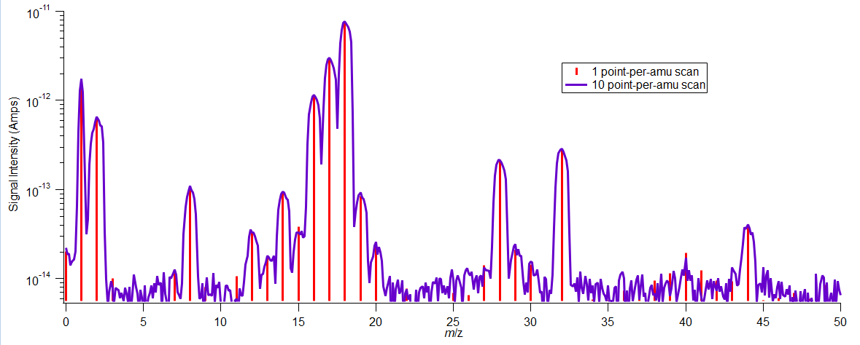
Figure 4: Spectra representation of an analog scan using a 1ppamu method (red) vs a 10ppamu method (purple).

SEQUENCE OF RECIPES (SOR)

During data collection operations, MSolo may run a continuous recipe with the same dwell, ppamu, mass range, and instrumental conditions (e.g., EM state). This set of scan parameters operating continuously is the nominal method for collecting data. However, MSolo has the added capability of running multiple recipes one after another for as many cycles as the operator desires. This process is called a sequence of recipes (SoR). The SoR is a useful tool for collecting data during high-complexity or time-sensitive operations. It may also be used in scenarios where it is imperative to collect as much data as possible, with limited time to start, stop, or adjust parameters on the fly. The SoR was designed to reduce the need for human operation by removing the manual commands required to stop, select new parameters, and start each recipe, all while trying to minimize human error within a finite time window. The SoR can be programmed before flight to collect a specified number of scans with one set of parameters, and then seamlessly switch to a recipe with a different set of parameters without stopping data collection, thereby reducing the number of commands being sent to the instrument from the ground. However, the operator does still retain the ability to design and upload new SoRs during the mission if needed, while also providing the option for the newly formed SoR to be saved to either the volatile or non-volatile memory.

GROUND SUPPORT EQUIPMENT (GSE)

CONSOLE NAVIGATION SYSTEM (CNS)

The Console Navigation System (CNS) serves as the operator interface to the MSolo instrument, an example of the operator point of view can be seen in Figure 5. CNS allows for real-time monitoring of the instrument while also providing the ability to directly send all commands for operation. CNS allows for the operator to command everything from power up, through operations, and ultimately powering down the instrument. While some commands are intended to be sent only once (such as with opening the contamination cover), all other commands can be manually delivered to the instrument at any desired point during operations. CNS also functions as a monitoring interface that displays all science and engineering data coming from MSolo, thus allowing for operational and thermal monitoring during operations. Because its design is based on a modified COTS system, CNS can be used with either flight hardware or any standard COTS system. This in turn allows for operators to become comfortable with the flight-forward operation of the instrument without the need to operate the flight hardware itself.
Aside from science and engineering data, CNS allows for situational awareness to be maintained by the operator through a series of indicators that display the status of the instrument. Operational factors such as scan information, emission, and sensor indicators all help the operator be aware of the operational status of the instrument. When faults or errors happen a system of secondary indicators is present. When a non-optimal parameter is first detected a WARNING indicator will appear. If this instance occurs 3 consecutive times, then the code will be promoted to an ERROR. Certain critical errors to MSolo (such as temperature and power related issues) can induce a response from the instrument flight software at which in many instances will cause the instrument to undergo a safing sequence to preserve itself, some of these conditions can be manually adjusted/ignored if needed (i.e., component is reading an improbable value while operating correctly). The automatic safing sequence comes from the commercial firmware, but it is beneficial for the flight instrumentation.
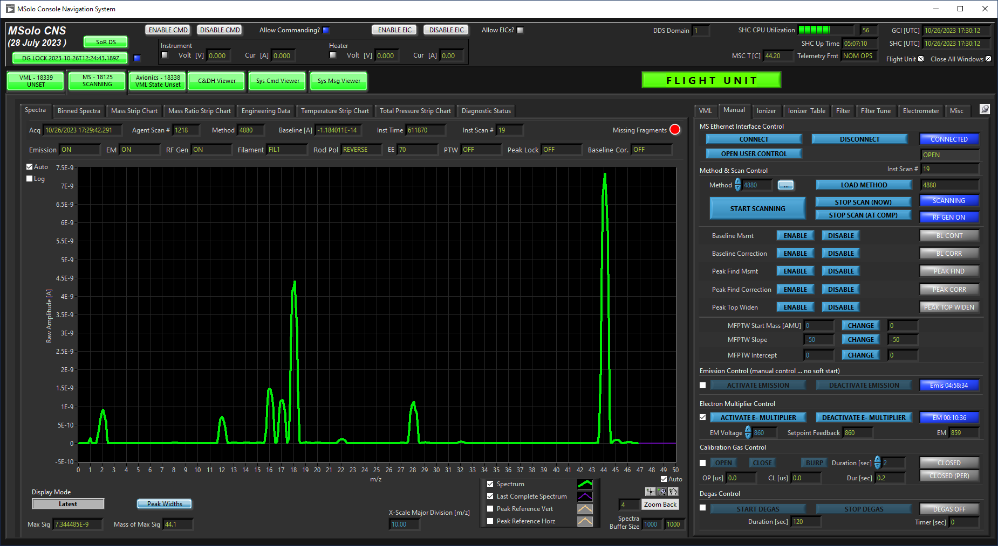
Figure 5: Screenshot of CNS window showing a mass spectrum of a CO₂ standard.

SOR DESIGN STUDIO

The Sequence of Recipes (SoR) design studio serves as the interface that allows for an SoR to be generated, compiled, and uploaded to the instrument. All methods that are contained with the instrument’s memory can be utilized to generate an SoR program, which provides an effective method for on-the-spot changes to sequences for adaptation to changes in mission operations. The SoR design studio was conceived with the goal of giving individuals that are not well versed in Computer Science (CS) the ability to create SoR programs that meet their requirements. To achieve this goal, the SoR design studio leveraged the Google Blockly library(Google Blocky, n.d.). Blockly’s goal of introducing programming to beginners fit in quite nicely with the SoR design studio goal of not requiring CS experience. In addition, the library is for use in browser-based applications, so the SoR design studio is a zero-install application that instrument scientists can use through any modern web browser. As of this writing, mission scientists have been able to craft and maintain SoR programs within the SoR design studio with little to no help from the MSolo software team. In addition to creating and maintaining SoR programs, the SoR design studio lets scientists upload new and updated SoR programs to the instrument, estimate the impact of running an SoR program in terms of running time and bandwidth utilization, and monitor the progress of an SoR running on MSolo.

FILE TRANSFER SERVICE USER INTERFACE (FTSUI)

The File Transfer Service User Interface (FTSUI) program allows for operators to generate new MSolo methods that may be desired for special circumstances. As stated before, ~9000 methods have been preloaded onto the instrument. However, specialized ranges, ppamu, or dwells and even a mixture of these modifications throughout one scan may be needed to analyze behaviors of volatiles (such as those of a specific range or isotopic distribution) during the mission. An operator can use FTSUI to generate and upload a compatible method file that translates to a new method for MSolo. Once this has been completed the operator is able to utilize that method alone or use it as part of an SoR.

DATAGUARDIAN

The MSolo DataGuardian environment is a two-part system used to record all data observed in the control room and retrieve such data upon request. The data recorded includes both instrument telemetry as well as commands issued by instrument operators. The environment’s two parts includes: (1) a background system service and (2) a browser-based user interface for scientists and operators. The primary job of the background system service is to record any data observed in the MSolo control room. In addition, the system service also services requests for data reports via a REST HTTP API. Care was taken during architecting and design of the system service such that servicing report requests did not impact the primary task of data recording. The browser-based user interface gives operators the ability to start and stop the recording of data and assess the overall health of the data recording system. The user interface also lets scientists request reports from previously recorded data interactively. Being browser-based, the DataGuardian user interface is zero-install, thus easing access for scientists and operators. DataGuardian can be used with both flight and COTS instruments.

TUNE CALCULATOR

Though MSolo undergoes a final calibration prior to integration with a rover, variations in environmental conditions (i.e., changes in CPU temperature) means that MSolo may require a mass tune while on mission. Mass tuning (also referenced as mass calibration) depends on the adjustment of digital-to-analog converter (DAC) values to the RF card saved to the non-volatile memory. Adjusting the DAC values will subtly change the voltages applied to the RF rods, which will alter the trajectory of ions in the mass filter. Adjusting the DAC values in small increments and monitoring the resulting mass peaks allows for mass alignment to be performed manually. This adjustment can also be done through the commanding of preset, larger adjustment values or by manually inputting the DAC values themselves. Since these adjustments each account for a single command sent to the spacecraft/instrument, ultimately hundreds of commands can be sent during tuning if performed via the incremental adjustment approach. Thus, a tune calculator program was created to calculate the DAC values for the RF and DC rods at a given temperature. The values are calculated using a fitting routine based on previously measured DAC values at various operating temperatures. This provides a method to calculate the DAC value that will place a peak in tune for each peak used at any operating temperature. The calculator reports all the DAC values for each peak, which can then be sent to the instrument in one batch of eight to ten commands.

VACUUM CHAMBERS

CALIBRATION STAND

To assist with the initial calibration and determination of instrument performance after modifications and/or construction, a custom vacuum chamber was constructed from various ConFlat UHV flanges. The housing itself sits on a Hicube300 pumping system (Pfeiffer Vacuum, Asslar, Germany) that provides a suitable base pressure in the 10⁻⁹ Torr range. The calibration stand is configured for continuous monitoring via a COTS RGA system (INFICON, Syracuse, NY) as well as a BPG450 vacuum gauge (INFICON, Syracuse NY). The calibration stand is configured to house two sensors (in addition to the COTS RGA) at a time, but this can be adjusted if needed. The system can be dosed with either a calibration gas mixture, or with nitrogen through an electronically controlled gas-dosing valve (VAT Group AG., Sennwald, Switzerland).

TEST CHAMBER

MSolo requires a vacuum environment to operate. A thermal vacuum chamber was prepared to hold the MSolo instrument, along with the necessary wiring fixturing, and secondary components (such as a quartz-crystal microbalance) and subcomponents. The test chamber (Figure 6) is a 30 x 24 x 24-inch rectangular chamber (Kurt J. Lesker, Jefferson Hills, PA), which utilizes a 12.5 inch CF top port that holds the TG1100F turbo pump (Osaka Vacuum, Osaka, Japan). The chamber is also constructed with six 2.75”, two 6”, and two 8” CF ports, all of which are used for various electrical feedthroughs, chiller lines, leak valves and any monitoring hardware (RGAs and ion gauges). On the bottom of the chamber, a 4.5” CF port is used for the liquid feedthroughs for the chiller/platen.
Within the inside of the chamber, a thermally isolated 1-in thick aluminum platen located on the base of the inner chamber is used as a thermal sink for a thermo-electric cooler (TEC) system (Arroyo Instruments, San Luis Obispo, CA), which is used to control the temperature of any instrumentation mounted on it. The combination of the chiller, platen, and TEC allow for operational temperatures of the chamber system to range from -46 °C to 100 °C without a payload attached.
The test chamber is also equipped with a gas dosing system which allows for a variety of gases to be introduced into the chamber at various leak rates using an electronically controlled gas dosing valve (VAT Group AG., Sennwald, Switzerland), which is directly connected to a central manifold that integrates a variety of gas standards. A series of pneumatic valves (Swagelok, Solon, OH) allow for fine control of a single gas or mixture to be introduced into the chamber.
The chamber, along with all the supporting hardware, provides continuous vacuum pumping to maintain base pressures of less than 5E-9 torr while also allowing for a wide operational range of thermal control. Its ability to maintain a high vacuum and finely control temperature (+/- 0.01 C) allowed for this chamber to be used for thermal vacuum (TVAC) testing.
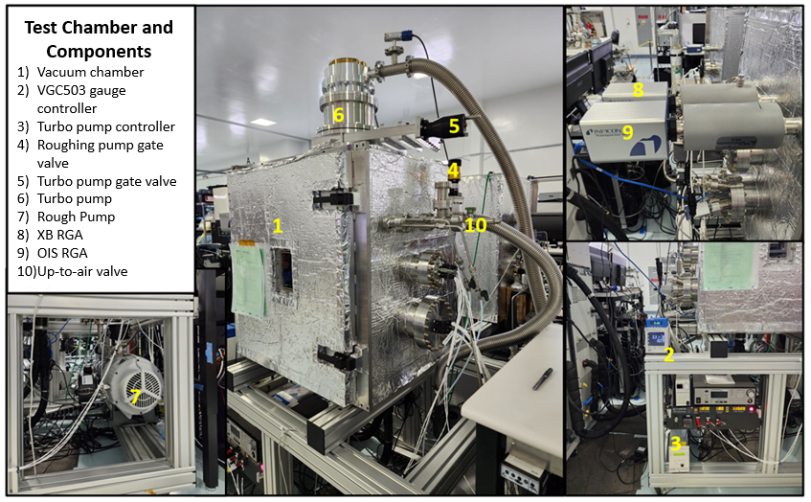
Figure 6: Test chamber and some of its subcomponents.

BAKEOUT CHAMBERS

To assist with the preparation of the individual MSolo components to meet contamination requirements, two vacuum ovens (Cascade TEK Solutions, Cornelius, OR) were used to bake out the components to reduce outgassing levels prior to instrument final assembly.

TEST UNITS

AVIONICS FLATSAT

A flat satellite (commonly known as FlatSat) serves as a high-fidelity electrical module that represents components and connections of the flight units. The avionics FlatSat units serve as platforms for testing avionic components, firmware, and other aspects of MSolo by fully operating the instrument in a non-flight lab environment. The avionic components are downgraded circuit card assemblies (CCAs) from the same batch of flight CCAs. However, a COTS chassis is used to allow for simple removal of the CCAs and access to test points, as well as a COTS crossbeam sensor sealed into a custom getter tube, which provides a permanent vacuum to simplify testing operations. A non-flight microvalve and pin puller are also sometimes used to simulate the CGS and contamination cover, respectively.

SOFTWARE FLATSAT

The purpose for the software FlatSat is to have a platform for testing both software and hardware on a fully operating instrument in a non-flight lab environment. The mass spectrometer avionics cards and chassis are COTS, but the IIU CCAs are non-flight CCAs from the same batch of flight CCAs. The sensor is a COTS crossbeam sensor inside a small vacuum pumping system. This FlatSat serves as the initial testing point to any changes to the flight software.

ENGINEERING DESIGN UNIT

The MSolo engineering design unit (EDU) serves as a platform for final testing of software, avionics, firmware, and other aspects of MSolo by fully operating the instrument in a non-flight lab environment prior to deployment to the control and flight instruments. The EDU also serves as a stand-in for the flight unit during integration testing with host partners. The sensor is a COTS crossbeam sensor sealed into a custom getter tube that provides a permanent vacuum to simplify testing operations. The chassis includes all the connectors, RF Gaskets, and any other hardware needed to make the instrument as close to a final flight configuration as possible. However, the sensor shroud, CGS, and contamination cover are not included due to the physical constraints when using the getter tube. The getter tube and flight-like chassis allow the EDU to be used for things like EMI testing, which is not performed in a cleanroom but requires a vacuum to operate MSolo for testing. All the avionics CCAs and chassis components (not including the sensor shroud, CGS or contamination cover) are non-flight but from the same batch of equivalent flight components. A non-flight microvalve and pin puller are also sometimes used with this unit, as with the other FlatSats.

MSOLO CONTROL (QUALIFICATION UNIT)

MSolo Control is the nomenclature used for the qualification unit, which is built identical to the flight instrument. The primary purpose of the unit is to have a flight-identical unit on the ground during mission operations to act as an experimental “control” and treated as flight. This unit is sometimes used for certain qualification tests during Verification and Validation (V&V) to buy down risk.

INSTRUMENT VERIFICATION AND VALIDATION (V&V)
A Comprehensive Performance Test (CPT) was performed using the flight instrument before the start of environmental testing to baseline the instrument performance. The data from this test is used to compare the data with a post-V&V CPT and to provide the status of the instrument’s performance throughout each step of the V&V process (Figure 7).
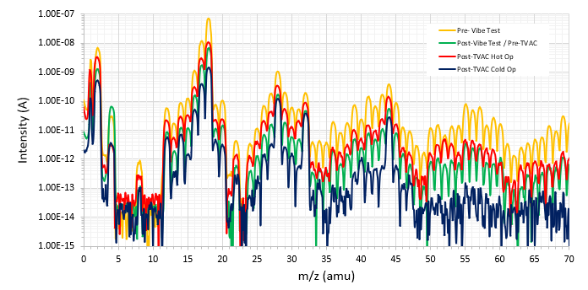
Figure 7: Mass Spectra collected at various CPTs throughout V&V
MSolo passed all required EMI/EMC testing requirements for the VIPER mission. Vibration testing was performed on MSolo using two different approaches, where qualification random vibration testing was performed on a dedicated qualification unit and acceptance random vibration testing on the flight unit in accordance with the General Environmental Verification Standard (GEVS), GSFC-STD-7000. Upon the completion of vibration testing, the instrument started Thermal Vacuum (TVAC) cycling testing. For this test the instrument experienced eight thermal cycles to verify full functionality of MSolo under various environmental conditions.
While there were some final deviations in the signal intensities from pre-V&V till the final CPT (Figure 7), it was concluded that these differences were due to environmental conditions (lower baseline, bakeout, pump time prior to testing, etc.) and not due to instrument changes themselves. All values met or exceeded the commercial specifications.

INSTRUMENT FLIGHT OPERATIONS

OVERVIEW OF MSOLO DEPLOYMENT

Once the instrument reaches the lunar surface and is ready for initial operation, the rover applies power to the instrument; this action powers up the IIU. Initial telemetry will begin to flow back to the ground operator within approximately 3 minutes and commands are then able to be sent to the instrument. Once commanding to the instrument is available the opening of the contamination cover can then be performed, it must be mentioned that once opened the contamination cover cannot be closed again. This is followed by the activation of the modified COTS circuit card assemblies, where a series of programed commands are required to activate MSolo and start collecting science data.
Several troubleshooting procedures have been created to account for any non-optimal operations while on mission. These are the result of hours of testing and operation training performed on the COTS units as well as the flight unit. While some parameters are limited in their operational time (i.e., EM aging based on applied voltage), the instrument has sufficient flexibility to achieve the desired data collection within the constraints of operation.

IN SITU CALIBRATION AND INITIAL CHARACTERIZATION

Upon power up and opening of the contamination cover, MSolo is ready to collect science data. The operator can initiate a warmup sequence that will activate emission and begin to exercise the electrical components on the instrument, bringing the entire system to a stable operating temperature. Depending on the final operating temperature, the operator may choose to perform a mass calibration using CGS in order to ensure that mass peak shapes are at the correct values and that resolution settings are appropriate.
If desired, many of the tests which are performed in the CPT could also be performed once on the lunar surface. These tests gather details such as signal-to-noise ratios, electron multiplier voltage for specified gain, and other instrument details that can help verify instrument health.
MSolo may begin to collect measurements related to the chemistry produced/introduced during the decent landing burn as the rover begins to move away from its landing site. These measurements will play a crucial part in understanding the environment after descent of the lander. Factors such as the measurement of localized chemistry due to lander activity and how this chemistry may change over time and distance from the landing site as the rover progresses will be able to be analyzed by MSolo. The initial local environment of the rover and the overall local exosphere will be of importance, as this may set up an initial baseline signal that could be used to benchmark model predictions of the expected distribution of lander exhaust gases.

SCIENCE OPERATIONS

Once VIPER mission operations begin and MSolo has been properly checked for nominal operation, the operator will select a method that will command the mass spectrometer to collect scans at a desired range, dwell, spectra resolution (ppamu), and detection mode (FC or EM). The instrument is configured to run for as long as it is powered up, so unless there is a manual command or a SoR is running, the desired recipe will continue to run throughout the duration of the mission phase. If a change in recipe is needed, the ion source does not need to be deactivated, and other components such as the detector mode can remain as is. Continuous monitoring of the available spectra provides an overall overview of the mass range, but other tools such as the mass trace is also available to the operators. The mass trace involves the display of each m/z intensity values (Amps) scanned over time. Note that for the VIPER mission, MSolo is currently limited to an operational scanning range of m/z 0-70, due to the current limitations in its thermal environment. While an increased range will be used when calibrating the instrument, all other methods and SoRs only account for the m/z 0-70 operational range. Depending on in-mission thermal conditions there is the flexibility to adjust the operational range if needed.

PROSPECTING/RAILS

Currently, there is limited information on what volatiles will be detectable on the polar regions of the Moon, so flexibility for instrumental operation will be key to the mission’s success(Landis et al., 2022; Zhang & Paige, 2009). The freedom in selection of scanning parameters allows for the instrument operator to adjust for possible in-mission changes where possible environmental conditions could affect the detection of volatiles, but also allows for the fine adjustment of parameters to maximize the detection of volatiles on the surface of the Moon, most importantly water-ice. Although approximately 9000 different recipes with various scan parameters have already been installed into the instrument for easy access, the ability to create and upload new recipes during operations allows for another layer of analysis that MSolo can provide. From estimated speeds and requirements for rover movement, the initial SoR for when the rover is in movement consists of one scan capable of providing peak shapes (0-70amu, 10ppamu, 16ms dwell), followed by six repetitive scans with a higher dwell time but a single point-per-amu (0-70amu, 1ppamu, 64ms dwell). This SoR will continue to run indefinitely until the operator sends a command to stop the SoR. The SoR scans were selected to provide a full analog scan, capable of providing chemical information while simultaneously providing some status on the mass alignment of the instrument and overall health of the instrument, the secondary scan can perform a full scan as well but focuses solely on the m/z integers and their corresponding signal intensities, while increasing the dwell time to improve signal-to-noise ratios. The combination of the two methods allows MSolo to maximize its data collection as the rover traverses the lunar surface.

DRILLING

VIPER’s mission will not only perform surface operations, but it is also focused on understanding sub-surface volatile compositions. Thus, drilling operations with VIPER will take place within specially selected areas, where sub-surface cuttings will be extracted up to the surface for analysis via The Regolith and Ice Drill for Exploring New Terrain (TRIDENT) drill (Kris Zacny, submitted this issue). As volatiles are released from these drilling operations MSolo will play an important role in the analysis of the detected gases, as its mounting configuration is located directly underneath the VIPER rover with a direct line of sight to the location where the drilled material will be deposited. Several SoRs have been prepared to accommodate for the main volatile of interest (water) but also allow for other volatiles within MSolo’s operating range to be detected during drilling. As of now, MSolo will operate in a continuous 3 method SoR which will continue to run until VIPER is ready to drill, during this time the data collected by MSolo will provide a baseline signal prior to the introduction of any other volatile compound within the lunar regolith. The initial method of the SoR will perform a full scan (0-70amu) at 1ppamu, the dwell time for all amu values except for water will be 32ms, where for m/z 18 the dwell is 256ms. Once a peak profile is seen in the m/z 18 signal (meaning we see a maximum signal for water and continue to monitor its decay until back to baseline), the operator will send a command to move the SoR onto the next two scans, which will scan 0-70amu, 10ppamu, 16ms dwell once, followed by 6 repetitions of the method that increases the dwell for m/z 18 only (same method as the initial one for this SoR). The key difference here will be that the two methods will infinitely repeat until VIPER is ready for another drill bite. The simple steps for the SoR being used for drilling operations allows for flexibility for any changes to drill retraction time or off-nominal scenarios. Furthermore, isotope focused SoRs/methods for increased sensitivity to hydrogen and/or oxygen bearing volatiles are available. For example, a method with increased dwell time (e.g., 256 ms) on the m/z values of the main isotopologues of water (m/z 18, H2¹⁶O; and m/z 20, dominated by H2¹⁸O) and of H2 (m/z 2, H2 and m/z 3, DH) could be utilized as part of the SoR used during drilling to increase signal-to-noise on the signal for the minor isotopologues, after a peak profile is seen in the m/z 18 signal. MSolo’s ability to create new SoRs can further assist in understanding other volatiles, its isotopes, and abundance ratios to truly understand the scientific information detected throughout drilling operations.

SCIENCE EXPECTED PERFORMANCE

Although real-time data will be provided to operators and VIPER Mission Science Center (MSC) personnel, some information will need to be carefully analyzed post collection. One of these will be the determination of limits of detection (LOD). MSolo’s LOD will be dependent on various parameters currently known (such as EM gain and dwell time) and unknown (base pressure, background signal, and/or operational constrains not currently accounted for). Currently the only information available is test data from the V&V test, where we can calculate the minimum detectable change in signal from a scan operating at 256ms dwell with an EM signal gain of 3000. Based on the operational chamber pressure of 2.99x10⁻⁸ Torr we determine that a minimum detectable signal would be that of 5.29x10⁻¹⁴ Amps, this in correlation to the instrument’s sensitivity results in an estimated minimum detectable partial pressure (MDPP) of 9.04x10⁻¹³ Torr. By converting this value to 3.95x10² molecules/cm³ we can determine that based on lab results and at nominal parameter settings that we have instrumental performance in line with those published for the LACE experiment(Hoffman, 1975). Furthermore, MSolo is able to increase the gain obtained by the EM in order to provide additional capabilities to lower quantities of volatiles.
The D/H isotope ratio of water detected by MSolo can help provide information regarding its origins. The range of D/H ratio in the solar system varies from depleted deuterium protosolar nebula values to cometary values that may be a factor of 2 or more to the values of terrestrial water(Saal et al., 2013). Mass resolving power of a quadruple mass filter is often limited to unit-mass resolution, which in turn results in interferences of isobaric compounds when dealing with isotopic analysis. However, MSolo will focus on the bulk differences between hydrogen and oxygen isotopic differences. Initial assessments of the viability for detecting isotopic ratios indicate favorable results, showing that when analyzing background chamber conditions both the H2/HD and H₂¹⁶O/H₂¹⁸O compositions showed isotope ratios (~200ppm and ~2100ppm respectively) that are reproducible (STDEV = ~1-3%) after averaging, and close to expected terrestrial values(Saal et al., 2013). These tests provided high confidence that MSolo has the necessary sensitivity to differentiate between the specific D/H ratios found within the potential sources for lunar water, the expected lower base pressure of the lunar surface will also aid MSolo in providing a lower baseline signal and thus improve the instrument’s LOD.
The detailed in situ knowledge enabled by MSolo measurements of the identity, abundances, and vertical and horizontal distribution of water and other volatiles that are evolved from several different areas of drilled regolith, in the context of the other rover instrument measurements, will be revolutionary for informing ISRU goals. It will help enable testing of models for lunar polar water and other volatiles necessary to ultimately support possibly finding a water reserve, in sites investigated by VIPER or elsewhere, that can be characterized and utilized. In addition, as indicated also by other in situ analyses of planetary volatiles by mass spectrometry (MS), MSolo analysis of VIPER drilled materials should be particularly well-suited to detecting, and potentially also quantifying, even very trace amounts of non-water volatiles that may impact ISRU water resource extraction and processing approaches.
Furthermore, concurrent measurements from other VIPER payloads such as those detected by the Near Infrared Volatile Spectrometer Subsystem (NIRVSS) for the detection of adsorbed volatile abundances, as well as NIRVSS temperature measurements(Roush et al., 2018), can provide important insight into the energetics of gas-surface interactions ( Anthony Colaprete, submitted this issue). Allowing for better models of volatile transport across the lunar surface. Another VIPER payload, the Neutron Spectrometer System (NSS)(Peplowski et al., 2023) will identify locations of enhanced hydrogen at concentrations down to 0.5 wt. % to depths of tens of cm(Peplowski et al., 2011); comparisons of NSS readings can be made to MSolo water abundances determined from scanning during drilling, as well as any MSolo detection of other non-water H-bearing volatiles that could contribute to NSS WEH detections (Richard Elphic, submitted this issue). Overall, the results of these comparisons would have implications for further understanding the distribution and speciation of lunar subsurface H-bearing volatiles.

- SUMMARY

MSolo provides a significant scientific capability for upcoming CLPS missions such as VIPER, and any other mission where mass spectrometry analysis may be desired (e.g., MSolo is also part of the Polar Resources Ice Mining Experiment, PRIME-1). VIPER’s mission objective to directly analyze ice on the surface and subsurface of the Moon will be met with the help of MSolo. MSolo’s ability to detect volatile species within its mass range enables the analysis of not just water, but most other expected volatile species on the Moon. Thus, MSolo will provide ample information that will assist with the selection of future landing locations. The modified COTS approach for the development of the instrument has allowed for a top-down technique to the design of MSolo, and its easily available COTS replacement parts allow it to be more flexible in terms of production. Furthermore, the ability to incorporate the COTS units to behave in a flight-like manner allow for the operators to become fully disciplined in the operation of the instrument, without risking usage time on the actual flight instrument. Ultimately, the MSolo instrument is ready for the analysis of volatiles at the lunar surface.

- ACKNOWLEDGEMENTS
The authors would like to extend their gratitude to the entire MSolo team and to the many contributions from members of the prototype design laboratory, the vibration laboratory, and all other members who worked in the development of the MSolo instrument. We acknowledge the support from NASA’s Science Mission Directorate (SMD) as well as support from NASA’s Planetary Science Division Lunar Discovery and Exploration Program (PSD/LDEP) in the Science Mission Directorate. Furthermore, authors Prem, Mandt, and Cohen acknowledge support from the Volatiles Investigating Polar Exploration Rover Co-Investigator Program (NNH21ZDA001N-VIPER).
- REFERENCES

Barnes, J. J., Franchi, I. A., McCubbin, F. M., & Anand, M. (2019). Multiple reservoirs of volatiles in the Moon revealed by the isotopic composition of chlorine in lunar basalts. Geochimica et Cosmochimica Acta, 266, 144–162. https://doi.org/10.1016/j.gca.2018.12.032
Boyce, J. W., Liu, Y., Rossman, G. R., Guan, Y., Eiler, J. M., Stolper, E. M., & Taylor, L. A. (2010). Lunar apatite with terrestrial volatile abundances. Nature, 466(7305), 466–469. https://doi.org/10.1038/nature09274
Clark, R. N. (2009). Detection of Adsorbed Water and Hydroxyl on the Moon. Science, 326(5952), 562–564. https://doi.org/10.1126/science.1178105
Colaprete, A., Schultz, P., Heldmann, J., Wooden, D., Shirley, M., Ennico, K., Hermalyn, B., Marshall, W., Ricco, A., Elphic, R. C., Goldstein, D., Summy, D., Bart, G. D., Asphaug, E., Korycansky, D., Landis, D., & Sollitt, L. (2010). Detection of Water in the LCROSS Ejecta Plume. Science, 330(6003), 463–468. https://doi.org/10.1126/science.1186986
Feldman, W. C., Maurice, S., Binder, A. B., Barraclough, B. L., Elphic, R. C., & Lawrence, D. J. (1998). Fluxes of Fast and Epithermal Neutrons from Lunar Prospector: Evidence for Water Ice at the Lunar Poles. Science, 281(5382), 1496–1500. https://doi.org/10.1126/science.281.5382.1496
George, A. D., & Wilson, C. M. (2018). Onboard Processing With Hybrid and Reconfigurable Computing on Small Satellites. Proceedings of the IEEE, 106(3), 458–470. https://doi.org/10.1109/JPROC.2018.2802438
Google Blocky. (n.d.). [Computer software]. Google. https://developers.google.com/blockly
Hauri, E. H., Weinreich, T., Saal, A. E., Rutherford, M. C., & Van Orman, J. A. (2011). High Pre-Eruptive Water Contents Preserved in Lunar Melt Inclusions. Science, 333(6039), 213–215. https://doi.org/10.1126/science.1204626
Hoffman, J. H. (1975). Lunar atmospheric composition experiment (No. NASA-CR-150946).
Honniball, C. I., Lucey, P. G., Li, S., Shenoy, S., Orlando, T. M., Hibbitts, C. A., Hurley, D. M., & Farrell, W. M. (2021). Molecular water detected on the sunlit Moon by SOFIA. Nature Astronomy, 5(2), 121–127. https://doi.org/10.1038/s41550-020-01222-x
Landis, M. E., Hayne, P. O., Williams, J.-P., Greenhagen, B. T., & Paige, D. A. (2022). Spatial Distribution and Thermal Diversity of Surface Volatile Cold Traps at the Lunar Poles. The Planetary Science Journal, 3(2), 39. https://doi.org/10.3847/PSJ/ac4585
Li, S., Lucey, P. G., Milliken, R. E., Hayne, P. O., Fisher, E., Williams, J.-P., Hurley, D. M., & Elphic, R. C. (2018). Direct evidence of surface exposed water ice in the lunar polar regions. Proceedings of the National Academy of Sciences, 115(36), 8907–8912. https://doi.org/10.1073/pnas.1802345115
Li, S., & Milliken, R. E. (2017). Water on the surface of the Moon as seen by the Moon Mineralogy Mapper: Distribution, abundance, and origins. Science Advances, 3(9), e1701471. https://doi.org/10.1126/sciadv.1701471
Lin, H., Li, S., Xu, R., Liu, Y., Wu, X., Yang, W., Wei, Y., Lin, Y., He, Z., Hui, H., He, H., Hu, S., Zhang, C., Li, C., Lv, G., Yuan, L., Zou, Y., & Wang, C. (2022). In situ detection of water on the Moon by the Chang’E-5 lander. Science Advances, 8(1), eabl9174. https://doi.org/10.1126/sciadv.abl9174
Mahaffy, P. R., Richard Hodges, R., Benna, M., King, T., Arvey, R., Barciniak, M., Bendt, M., Carigan, D., Errigo, T., Harpold, D. N., Holmes, V., Johnson, C. S., Kellogg, J., Kimvilakani, P., Lefavor, M., Hengemihle, J., Jaeger, F., Lyness, E., Maurer, J., … Edmonson, C. (2014). The Neutral Mass Spectrometer on the Lunar Atmosphere and Dust Environment Explorer Mission. Space Science Reviews, 185(1), 27–61. https://doi.org/10.1007/s11214-014-0043-9
McCubbin, F. M., Kaaden, K. E. V., Tartèse, R., Klima, R. L., Liu, Y., Mortimer, J., Barnes, J. J., Shearer, C. K., Treiman, A. H., Lawrence, D. J., Elardo, S. M., Hurley, D. M., Boyce, J. W., & Anand, M. (2015). Magmatic volatiles (H, C, N, F, S, Cl) in the lunar mantle, crust, and regolith: Abundances, distributions, processes, and reservoirs. American Mineralogist, 100(8–9), 1668–1707. https://doi.org/doi:10.2138/am-2015-4934ccbyncnd
Ni, P., Zhang, Y., Chen, S., & Gagnon, J. (2019). A melt inclusion study on volatile abundances in the lunar mantle. Geochimica et Cosmochimica Acta, 249, 17–41. https://doi.org/10.1016/j.gca.2018.12.034
Nozette, S., Lichtenberg, C. L., Spudis, P., Bonner, R., Ort, W., Malaret, E., Robinson, M., & Shoemaker, E. M. (1996). The Clementine Bistatic Radar Experiment. Science, 274(5292), 1495–1498. https://doi.org/10.1126/science.274.5292.1495
Peplowski, P. N., Elphic, R. C., Fritzler, E. L., & Wilson, J. T. (2023). Calibration of NASA’s Neutron Spectrometer System (NSS) for landed measurements of hydrogen content of the lunar subsurface. Nuclear Instruments and Methods in Physics Research Section A: Accelerators, Spectrometers, Detectors and Associated Equipment, 1049, 168063. https://doi.org/10.1016/j.nima.2023.168063
Peplowski, P. N., Evans, L. G., Hauck, S. A., McCoy, T. J., Boynton, W. V., Gillis-Davis, J. J., Ebel, D. S., Goldsten, J. O., Hamara, D. K., Lawrence, D. J., McNutt, R. L., Nittler, L. R., Solomon, S. C., Rhodes, E. A., Sprague, A. L., Starr, R. D., & Stockstill-Cahill, K. R. (2011). Radioactive Elements on Mercury’s Surface from MESSENGER: Implications for the Planet’s Formation and Evolution. Science, 333(6051), 1850–1852. https://doi.org/10.1126/science.1211576
Pieters, C. M., Goswami, J. N., Clark, R. N., Annadurai, M., Boardman, J., Buratti, B., Combe, J.-P., Dyar, M. D., Green, R., Head, J. W., Hibbitts, C., Hicks, M., Isaacson, P., Klima, R., Kramer, G., Kumar, S., Livo, E., Lundeen, S., Malaret, E., … Varanasi, P. (2009). Character and Spatial Distribution of OH/H 2 O on the Surface of the Moon Seen by M 3 on Chandrayaan-1. Science, 326(5952), 568–572. https://doi.org/10.1126/science.1178658
Recommendation for Space Data System Standards: Space Packet Protocol (Version CCSDS 133.0-B-2). (202 C.E.). https://public.ccsds.org/Pubs/133x0b2e1.pdf
Roush, T. L., Colaprete, A., Cook, A. M., Bielawski, R., Fritzler, E., Benton, J., White, B., Forgione, J., Kleinhenz, J., Smith, J., Paulsen, G., Zacny, K., & McMurray, R. (2018). Volatile monitoring of soil cuttings during drilling in cryogenic, water-doped lunar simulant. Advances in Space Research, 62(5), 1025–1033. https://doi.org/10.1016/j.asr.2018.06.024
Saal, A. E., Hauri, E. H., Cascio, M. L., Van Orman, J. A., Rutherford, M. C., & Cooper, R. F. (2008). Volatile content of lunar volcanic glasses and the presence of water in the Moon’s interior. Nature, 454(7201), 192–195. https://doi.org/10.1038/nature07047
Saal, A. E., Hauri, E. H., Van Orman, J. A., & Rutherford, M. J. (2013). Hydrogen Isotopes in Lunar Volcanic Glasses and Melt Inclusions Reveal a Carbonaceous Chondrite Heritage. Science, 340(6138), 1317–1320. https://doi.org/10.1126/science.1235142
Sanders, G. B., & Larson, W. E. (2013). Progress Made in Lunar In Situ Resource Utilization under NASA’s Exploration Technology and Development Program. Journal of Aerospace Engineering, 26(1), 5–17. https://doi.org/10.1061/(ASCE)AS.1943-5525.0000208
Stacy, N. J. S., Campbell, D. B., & Ford, P. G. (1997). Arecibo Radar Mapping of the Lunar Poles: A Search for Ice Deposits. Science, 276(5318), 1527–1530. https://doi.org/10.1126/science.276.5318.1527
Stephant, A., Anand, M., Zhao, X., Chan, Q. H. S., Bonifacie, M., & Franchi, I. A. (2019). The chlorine isotopic composition of the Moon: Insights from melt inclusions. Earth and Planetary Science Letters, 523, 115715. https://doi.org/10.1016/j.epsl.2019.115715
Sunshine, J. M., Farnham, T. L., Feaga, L. M., Groussin, O., Merlin, F., Milliken, R. E., & A’Hearn, M. F. (2009). Temporal and Spatial Variability of Lunar Hydration As Observed by the Deep Impact Spacecraft. Science, 326(5952), 565–568. https://doi.org/10.1126/science.1179788
Wilson, C., & George, A. (2018). CSP Hybrid Space Computing. Journal of Aerospace Information Systems, 15(4), 215–227. https://doi.org/10.2514/1.I010572
Zhang, J. A., & Paige, D. A. (2009). Cold‐trapped organic compounds at the poles of the Moon and Mercury: Implications for origins. Geophysical Research Letters, 36(16), 2009GL038614. https://doi.org/10.1029/2009GL038614

Corresponding author Roberto.aguilar-ayala@nasa.gov
NASA Kennedy Space Center, Brevard, Florida
NASA Langley Research Center, Hampton, Virginia
Aetos Systems Inc., Huntsville, Alabama
IMI Adaptas, Palmer, Massachusetts
NASA Goddard Space Flight Center, Greenbelt, Maryland
Jacobs, Houston, Texas
INFICON, Syracuse, New York
Johns Hopkins Applied Physics Laboratory, Laurel, Maryland

