Establishing an in-space joining ecosystem at NASA Marshall via laser beam welding
Andrew O’Connor, Jonathan M. Bonebrake, Thomas C. Bryan, Zachary S. Courtright, Charles T. Cowen, Ellis R. Crabtree, William C. Evans, Emma K. Jaynes, John C. Ivester, Louise S. Littles, Christopher S. Protz, Benjamin L. Rupp, Parker D. Shake, Raju Subedi, and Jeffrey W. Sowards
NASA Marshall Space Flight Center, Huntsville, AL, 35812, USA
NASA Marshall is establishing an ISAM technology development ecosystem leveraging investments in laser beam processing to enable in-space joining via laser beam welding. A number of ground and flight experiments are being performed to develop laser beam welding as a mature process for use in space. These experiments access varied combinations of reduced gravity, reduced atmospheric pressure, and extreme temperatures to simulate relevant space environments. The associated instrumentation needed to exquisitely understand fundamental mechanisms during laser beam welding and to provide adequate validation datasets for computational models is also being developed and/or integrated.
- Nomenclature
3DOF = three degree-of-freedom
ACO = Advanced Concepts Office
APF = Adaptive Project Framework
CAD = computer-aided design
COTS = commercial off-the-shelf
EBW = electron beam welding
EMAT = electromagnetic acoustic transducer
ICME = integrated computational materials engineering
ISAM = in-space servicing, assembly, and manufacturing
ISMAC = In-Space Manufacturing Advancement Center
ISS = International Space Station
ISW = in-space welding
LBW = laser beam welding
NDE = non-destructive evaluation
SWAP-C = size, weight, power, and cost
TVAC = thermal vacuum

- Introduction
Though welding is critical to durable goods manufacturing, the in-space servicing, assembly, and manufacturing (ISAM) sector does not yet rely on in-space welding (ISW). Prospective use cases of ISW include metal repairs on long-duration lunar surface missions and assembly of large structures that do not fit within available launch vehicle envelopes such as telecommunications arrays, tall lunar towers, and free-space transit vehicles powered by nuclear propulsion. Welding offers numerous advantages over fasteners, rivets, and other mechanical joining techniques (Table 1) [1]. Efforts to mature ISW for use in commercial, defense, and other aerospace applications require both fundamental understanding of the method and development of relevant process parameters. High-energy beam welding has in-space heritage. Soviet and NASA astronauts used electron beam welding (EBW) on orbit decades ago [2], [3] and US & Canadian scientists performed laser beam welding (LBW) during parabolic flights in the late 1980s through early 1990s although their lasers were low power and inefficient [4], [5]. Recently, LBW has matured into a much more powerful and efficient technology now suitable for development into a mature ISW method and which offers several advantages over EBW including less electromagnetic interference, less ionizing radiation, and delivery of the beam across substantial distance to any geometry of workpiece and joint through optical fibers [1], [6], [7].
Table 1: Relative benefit of in-space welding over mechanical fastening techniques for joining
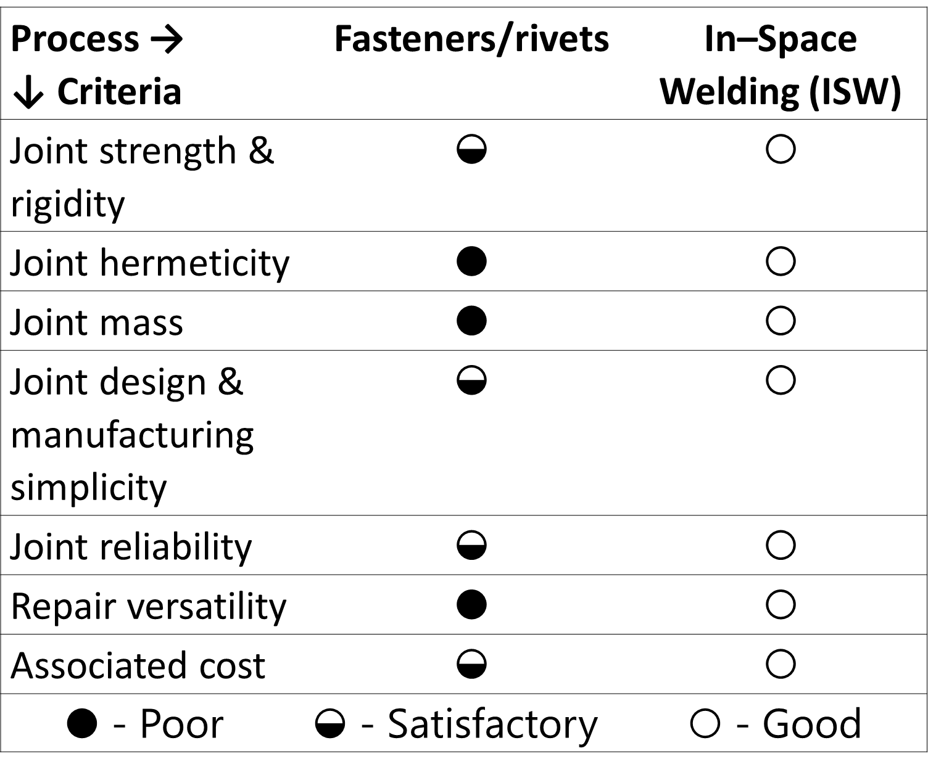

The Effects of Space Environmental Conditions on ISW
The complexity of welding is readily apparent when one considers that fusion welding involves temperature gradients of thousands of degrees, over distances of less than a centimeter, occurring on a time scale of seconds, involving multiple phases of solids, liquids, gases, and plasma. ~Thomas Eagar from [8]
Equations and dimensionless numbers that govern the physical phenomena of welding are directly affected or dependent on gravity, pressure, and temperature. Extreme variances in these conditions will occur during ISW and must be fundamentally understood to qualify joints for critical applications. Some of the fundamental phenomena in ISW are shown in Figure 1. In the near- to medium-term mission space environment, one can expect reduced gravity anywhere from Mars (0.38 g) to micro-gravity (<10⁻⁶ g). Porosity is one such phenomenon affected specifically by gravity. Besides Marangoni convection, gas bubbles can be moved by a rising force computed via Stokes law and by a buoyancy-induced convective force [9]. Numerous aspects of weld bead morphology are expected to be affected by reduced gravity conditions. Both the rising force and buoyancy are directly affected by gravity, reducing to almost zero with micro-gravity. Thus, the reduced convection may result in increased entrapment of gas bubbles by the solidification front, resulting in greater porosity and reduced weld performance.
Other weld morphological characteristics are also affected by gravity. A previous parabolic flight using low-power LBW found increased rippling, reduced weld bead width, and greater penetration depth in lower gravity [4] which comported well with an understanding of both the buoyant (gravity-induced) and Marangoni (surface tension-induced) convection as being influential on weld bead morphology [10]. With reduced gravity, the surface tension is no longer counterbalanced by buoyant convection and thus the weld bead is expected to have higher curvature [4], which aligns with the reduced width but increased penetration depth found in previous parabolic flights of LBW.
Thermal, and thus solidification, behavior will also be altered by reduced convection brought on by reduced gravity, affecting weld microstructure as well [2], [4]. For example, the Skylab in-space welding studies found a transition from columnar to more equiaxed grains structure in micro-gravity [2]. In the space environment, reduced pressure – often extremely high vacuum much harder than even ultra-high vacuum at 10⁻⁵ Pa – and/or altered atmospheric composition – for example, the largely CO₂ mixture of the Martian atmosphere – are present in various combinations.
For LBW, the penetration depth in the keyhole mode is the most obvious change when moving from Earth ambient pressures to vacuum; penetration greatly increases with reduced pressure, even when the laser beam is not tightly focused [11], [12]. However, this effect is not seen in high travel speed regimes [13] that would seemingly induce conduction mode welding. Heat transfer is also greatly influenced by reduced pressure and changes in atmospheric composition, where a reduction or elimination of convective heat transfer will lead to increased heat build-up in the region surrounding the weld and slower cooling and thus solidification rates. Alterations in solidification rate may lead to transition between various solidification structures and resulting weld microstructure [14]. Ostensibly, the reduced gravity- and pressure-induced changes in weld morphology and microstructure will lead to changes in properties and thus weld performance.
Reduced pressure can also affect plume evolution form the weld bead & its interactions with the laser, alter or reduce spatter formation, and alter metal vaporization from the melt pool & subsequent deposition on nearby or line-of-sight surfaces [15]. These effects are not uniformly positive or negative and have implications beyond the weld itself – for example, metal vapor deposition on optical components may reduce transmitted laser power.
In the space environment, specifically the Lunar surface, ambient temperatures can range from 40 K in permanently shadowed regions to 400 K under direct solar irradiance. Workpiece temperature, ostensibly equilibrated with the ambient temperature prior to welding, can greatly alter the melt pool morphology in fusion welding, with follow-on consequences for weld microstructure and properties such as hardness. Recent computational work using a Skylab-like experimental setup indicated that the widths of both the fusion and heat-affected zones were substantially affected by workpiece temperature [16]. More fully understanding the individual and combined effects of these environmental conditions – reduce gravity, reduced pressure, and extreme temperatures – on ISW will reduce unfruitful experimentation and de-risk technology demonstrations.
Figure 1: Laser beam welding shown in terrestrial conditions (left) and in-space conditions (right) [7]
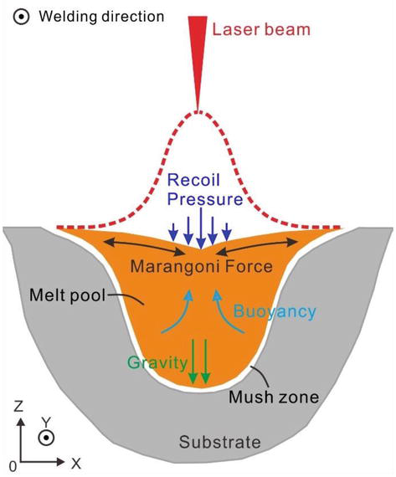
Figure 2: Detailed view of convective flows within the melt pool during LBW; licensed under CC BY 3.0 from [17]

An Accelerated Approach to Maturing ISW
The Edisonian trial-and-error approach used to qualify terrestrial welds is too complex, costly, and time-consuming for use in qualifying in-space welds. A progression of experiments from ground to flight will generate the fundamental understanding and datasets necessary to mature LBW for ISW [1], [6]. Ground experiments have been conducted on the NASA Marshall Flat Floor to demonstrate how positioning of joints and welder occur in a three degree-of-freedom (3DOF) environment. Additional ground experiments are being conducted to assess the effect of combined vacuum and non-ambient temperatures on LBW. Parabolic and suborbital flight experiments will elucidate relevant physics during LBW: 1) reduced gravity (10⁻⁶ g to 1 g), 2) reduced pressure (10⁻¹⁰ to 10⁴ Pa), and 3) extreme temperature (40 – 400 K) [7]. Table 2 provides an overview of the environmental conditions expected in various space locales and what conditions should be emulated in computational and experimental efforts to qualify ISW. Post-flight materials diagnostics and in-flight instrumentation will generate validation datasets for computational models that capture both the terrestrial and space environments, accelerating the infusion of LBW as an ISW technique [16].
Table 2: Environmental conditions encountered during in-space welding [7]
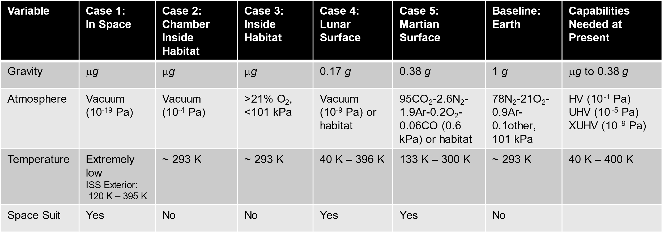

NASA Marshall has several past and current projects to mature ISW, specifically LBW. These follow a logical progression from ground analogues to flight experiments to understand the influence of reduced gravity. Reduced pressure – typically high vacuum – is simultaneously in these flight experiments to demonstrate the combined effect on LBW. Extreme temperatures, far more difficult to consistently achieve during flight, are instead investigated through ground experiments in concert with reduced pressure. As shown by Figure 3, the notional progression of experiments for ISW generally tracks with that followed by both the Soviet Union and United States in the 20th century. However, the instrumentation to collect validation datasets for the infusion of computational modeling into ISW sets this current effort broadly apart from previous campaigns. The advances in in situ and post-flight characterization over the past decades now allow the collection of vital data on weld processing, microstructure, and properties by instrumentation within the size, weight, power, and cost (SWaP-C) limitations of such flight experiments and in reasonable time and expense from ground-based materials diagnostic facilities. Additionally, the notional progression now includes a technology demonstration on other planetary bodies such as the Moon or Mars. This would be as part of an integrated ISAM system to show how ISW can provide reliable joining for structures on planetary surfaces.
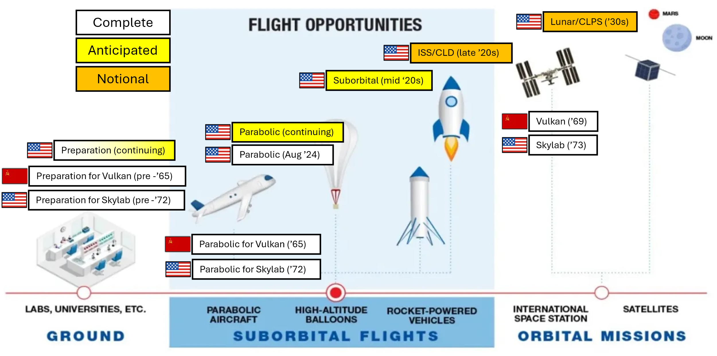
Figure 3: Notional progression of past and present experiments to mature ISW; underlying graphic without ISW-specific experiments adapted from [18]
Data collected from such ground and flight experiments can be used to anchor computational models and thereby build up a Digital Twin of ISW (Figure 4). The Digital Twin includes both the instrumented physical system and its virtual representation, joined by the information flow between them [19]. Past performance and future predictions can be connected through the present structured information flows enabled by collected datasets and validated computational models.

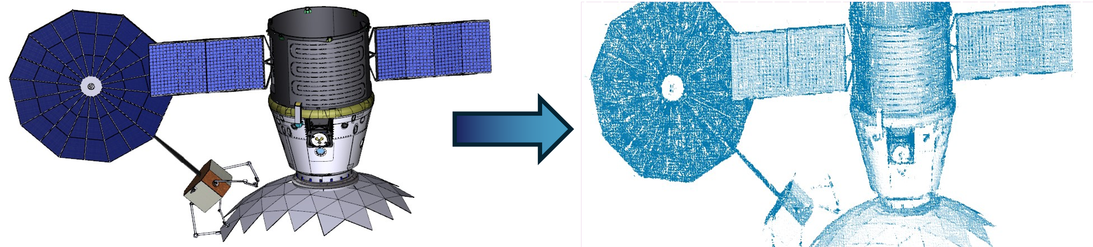
Figure 4: Representative Digital Twin of geometry determination required for proper joint fit-up for ISW

Ground Experiments for ISW

Flat Floor Welding Experiments
Ambient LBW trials on the NASA Marshall Flat Floor were conducted to understand how joints and a LBW apparatus could be positioned by 3DOF mobile robots to roughly simulate joint fit-up in the space environment. This project involved: Manipulating a laser and weld a truss-like structure under three degree of freedom, zero-resistance ISAM conditions; informing the digital twin to determine fit-up/precision requirements; and documentation of experiments with high-end photography and videography. See Figure 5 and Figure 6.

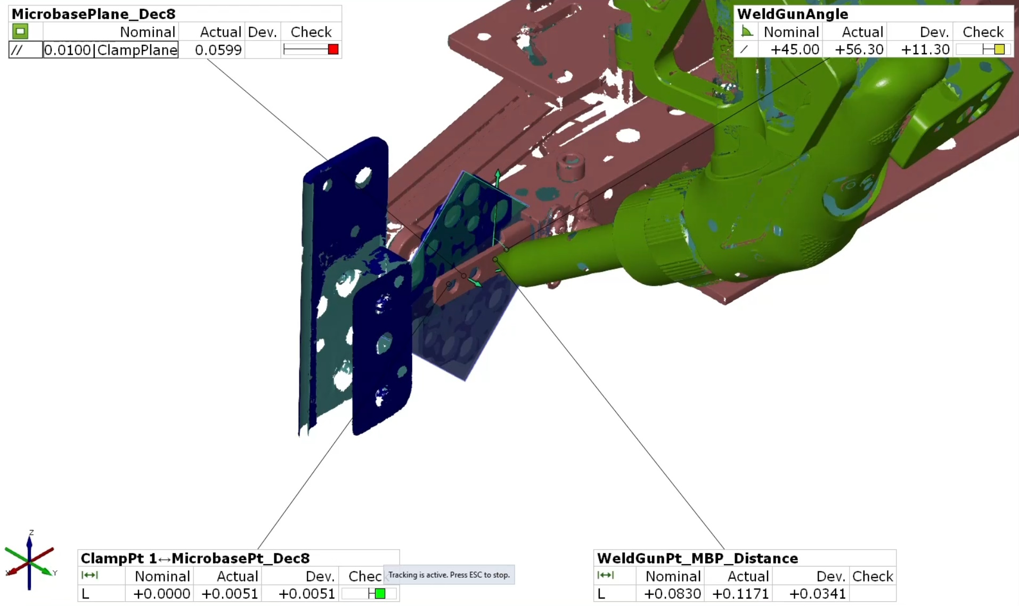
Figure 5: Structured light scan of fit-up between two halves of a joint (blue) held by 3DOF fixturing (mauve) and laser beam welder (green)
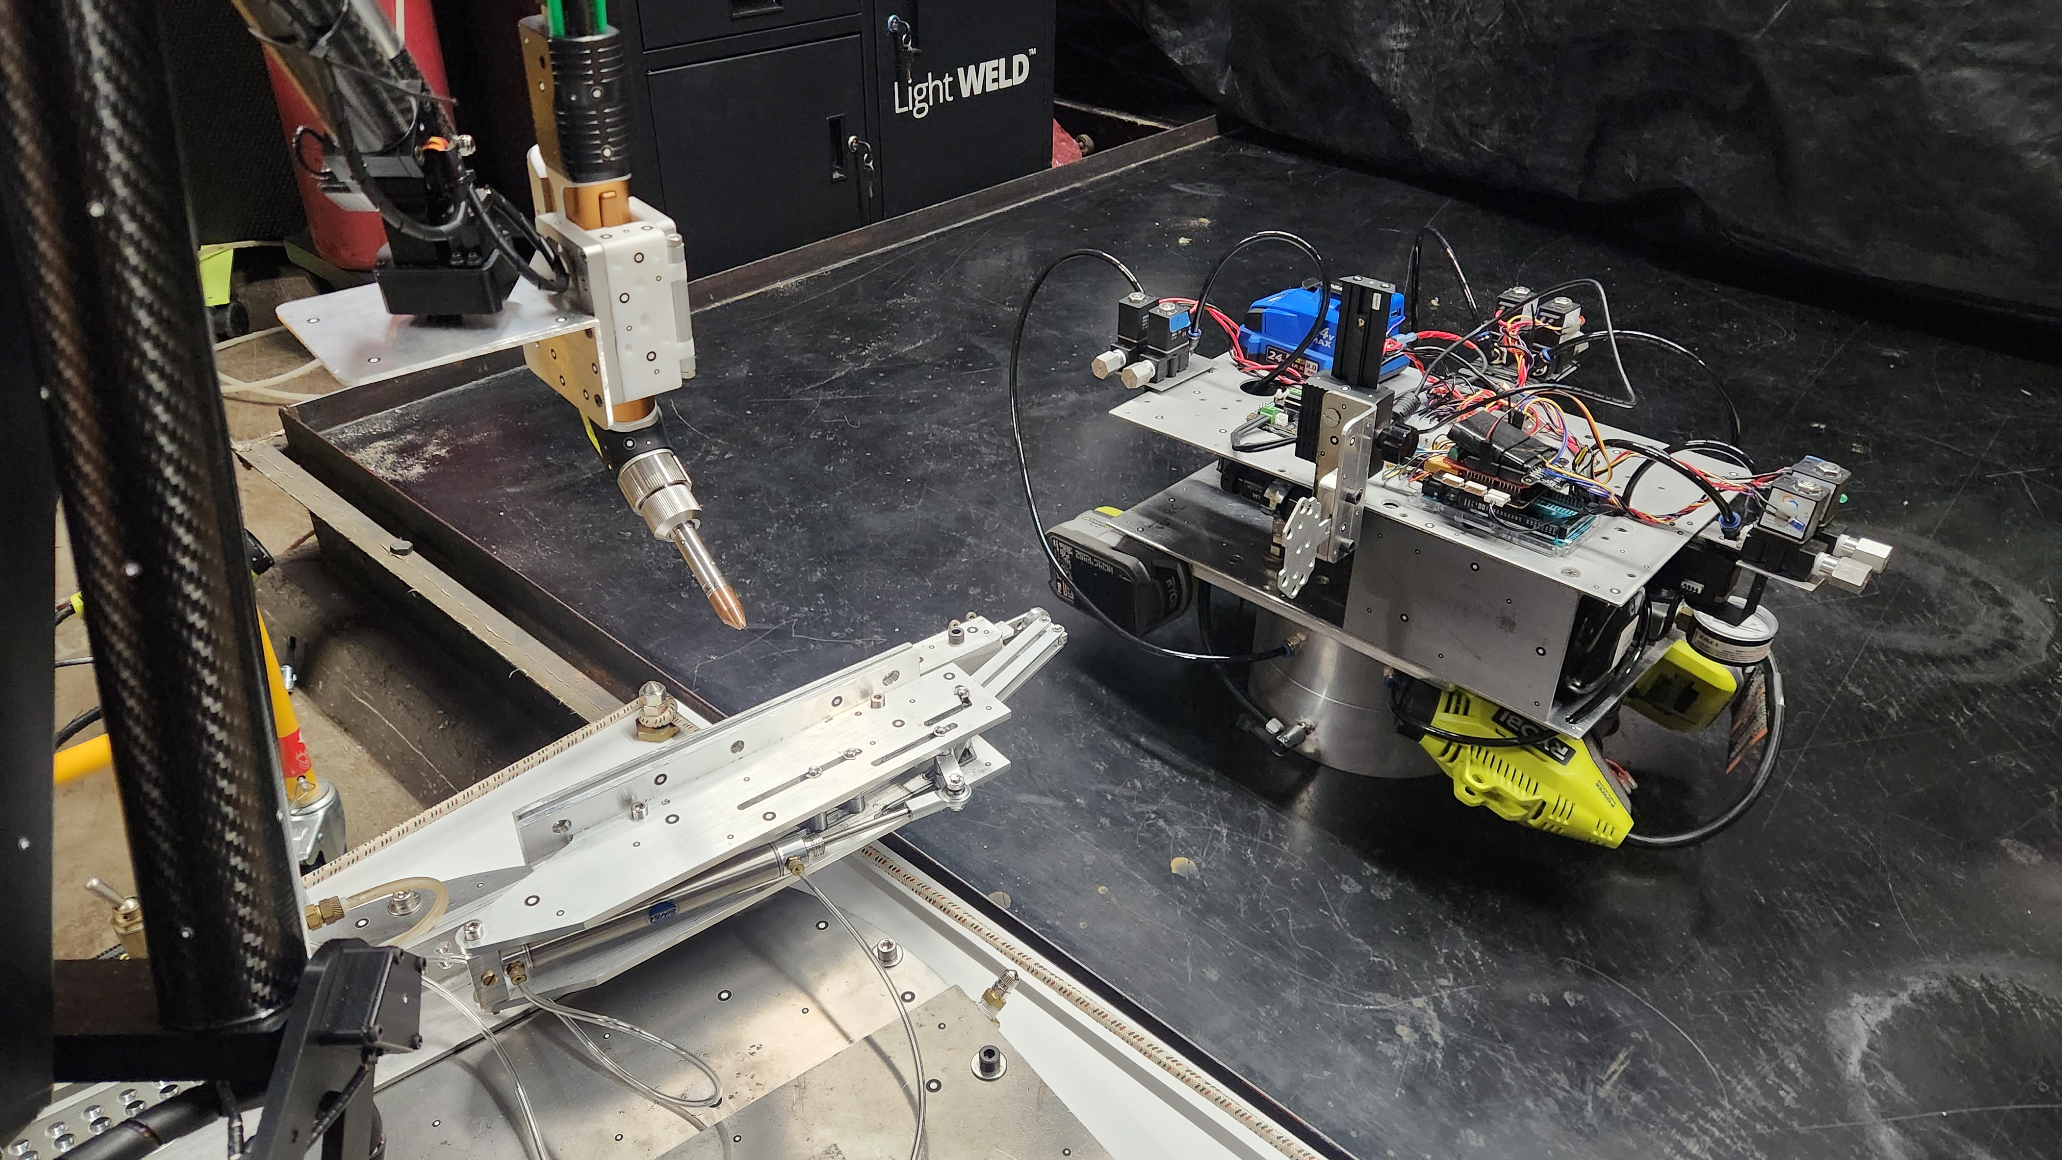
Figure 6: The Flat Floor experimental setup prior to fit-up; laser beam welder and one half of joint on left and mobile base with second half of joint on right

Variable Atmosphere and Pressure Enclosures
Two different enclosures to simulate different atmospheric compositions and pressures are being integrated at NASA Marshall. The first, part of the In-Space Manufacturing Advancement Center (ISMAC) in the Materials & Processes Laboratory, is a glovebox that can simulate various atmospheric compositions – notably Martian, which is primarily carbon dioxide – and allows the use of regolith simulant. Despite operation only at Earth ambient pressure, the combined effects of different atmospheric composition and regolith on ISW can be explored in this glovebox. Initial work on a similar system (not employing regolith) revealed that arc welding of common aerospace alloys of aluminum and titanium was possible in an atmosphere approximating that at the Martian surface despite some changes in parameters [20], [21]. The second, at the NASA Marshall Flat Floor, is a small vacuum chamber which has been modified to allow the mounting of laser optics and is being modified to support backfilling with inert gases (Figure 7). This expands ISW development capabilities to include reduced pressure in addition to variable atmospheric composition. A boon to ISW development using these systems is that both have large optical viewports, enabling rapid iteration and visual inspection. Notably, both systems will be capable of hosting LBW equipment with the appropriate laser safety precautions involved.
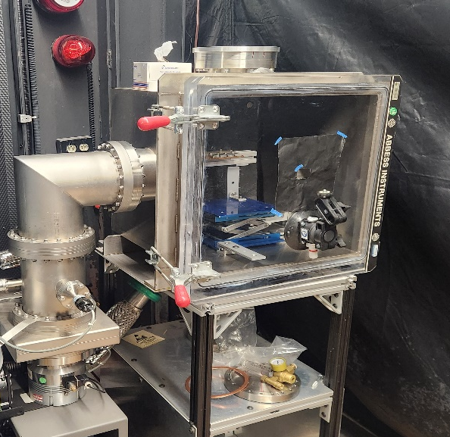
Figure 7: Small cubic vacuum chamber with roughing and turbo pumps, originally designed for testing of guidance, navigation, and controls (GN&C) hardware under vacuum

Lunar Assembly and Servicing by Autonomous Robotics (LASAR) – Early Career Initiative
Ground experiments for LBW are now progressing into thermal vacuum (TVAC) environments. The LASAR project will develop a laser manufacturing platform that can be positioned autonomously via a robotic arm; its utility will be demonstrated by LBW and repairing structural joints for Lunar surface installation—Tall Lunar Tower (TLT) joints. Such robotic LBW enables not only joining but also repair and/or reinforcement of structures. The laser manufacturing platform demonstrated by LASAR is also extensible to perform ablating, bending/forming, cleaning, cutting, drilling, and additive manufacturing. An advanced joint geometry is suitable to a multitude of different structures. The robotic arm will employ supervised autonomy by flight-forward computers to precisely position for welding. These sub-systems will be space-rated to enable scalable operation on the Lunar surface. The laser manufacturing platform demonstrated by LASAR is also extensible to perform ablating, bending/forming, cleaning, cutting, drilling, and additive manufacturing (Figure 8). Ultimately, a demonstration of supervised autonomous robotic LBW on an innovative joint geometry within a TVAC chamber (Figure 9) at NASA Marshall under a range of temperatures will be performed.

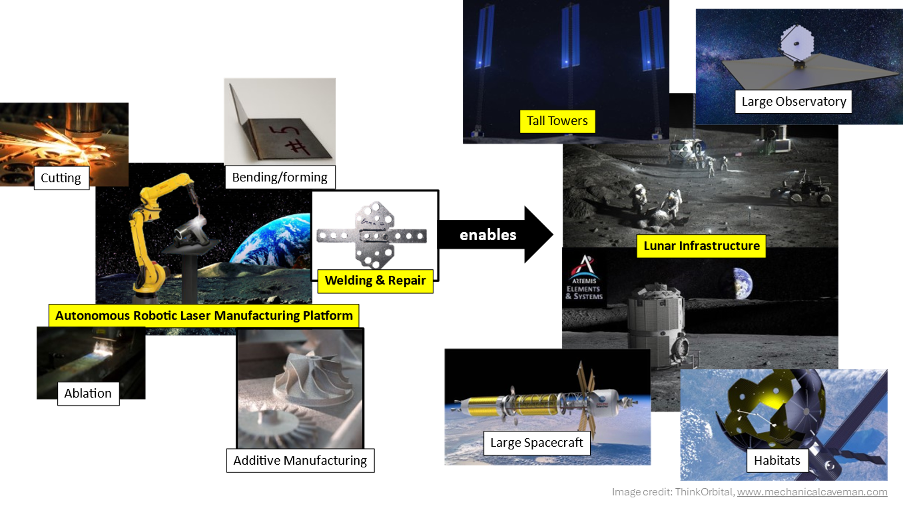
Figure 8: LASAR seeks to mature an autonomous robotic laser manufacturing platform suitable for ISW by first demonstrating LBW in TVAC

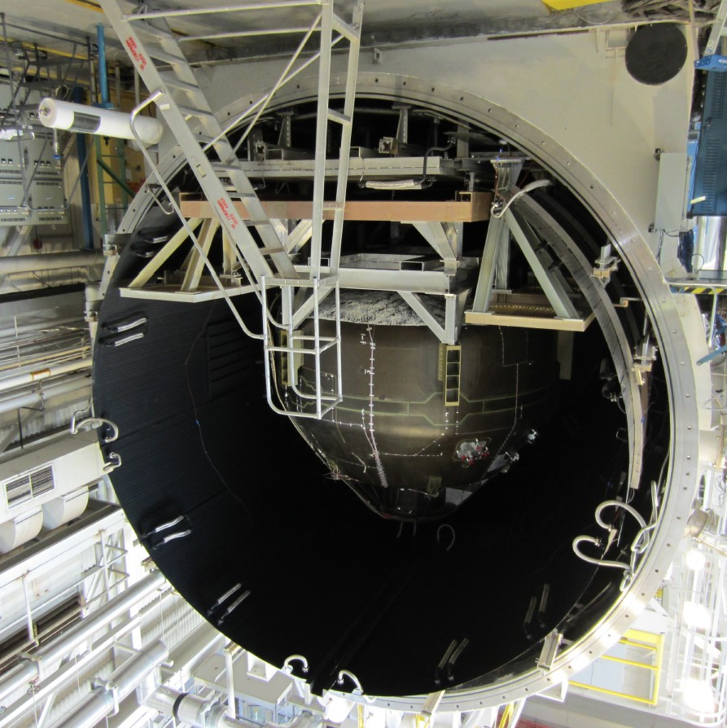
Figure 9: V-20 thermal vacuum chamber at NASA Marshall

Innovative Project Management Approach
To enable flexibility and agility throughout the maturation of laser ISW, a hybrid project management approach is followed. This approach involves a standard waterfall methodology to actively manage milestones and maintain knowledge of the interactions of different ISW efforts so a slip in critical path tasks may be avoided. In ISW projects, unforeseen opportunities or issues are quite likely, so a more flexible approach to adapt in real-time is crucial to success. To address this challenge, the inclusion of waterfall tools, such as Gantt charts and risk registers, is accompanied by an Adaptive Project Framework (APF) approach. The APF allows Agile teams to work with optimal flexibility. The approach is based on the principle of learning by doing. In the traditional waterfall approach, the scope, requirements, technologies, solutions, and engineering path needed to achieve the goal must be clear upfront. While this may be the best approach for projects that are familiar, routine, or seeking incremental improvements over previous technologies, it alone does not provide sufficient flexibility for new technology development. For new technology, the solutions to achieve the scope are typically not well-defined at the beginning. Requirements must mature as the development matures, solutions must adapt, and the engineering path must be flexible. Sometimes teams must improvise their systems and protocols as they work, due to the outcomes. The APF framework best suits unique challenges that do not call for one-size-fits-all solutions. This approach enables team creativity to result in highly innovative solutions. In this model, the customer may work directly with teams to select the exact features they need in finished solutions. This is essential for NASA Tech development as end users (missions) need complete solutions that fill all their needs if the mission is to be successful. The core APF practices that NASA ISW projects apply are: 1) Maintain clear project objectives (constant time and costs), though final products may change as the work proceeds (through down selection and/or modifications of materials and process), 2) Work in iterative cycles, constantly evaluating results in “sprints” or mini-projects, 3) Optimize deliverables to meet customer needs, and 4) Collaborate continuously with each other, stakeholders, and customers. This adaptation of the project scope makes this approach differ from traditional project management and makes it appropriate for ISW projects that require innovative solutions that are unforeseen at the project outset. As the project progresses in sprints, and experimental data is analyzed and digested during each sprint, strengths or weaknesses of assembly approaches, end-effector designs, welding parameters, and NDE methods are discovered. In the case of laser ISW projects, this leads to selecting specific fixturing designs for weld joint member assembly and repair demonstrations, NDE approaches, and plans for integrating subsystems for space environment testing to address any issues found during each sprint. Although decisions related to NDE methodology and plans for subsystem testing and integration were carefully chosen, the technologies are unproven, providing an excellent opportunity for innovation, particularly with respect to testing in extreme simulated Lunar environments. The sprints consist of activities in which subsystem and integrated system designs are evaluated and initial mock-ups are made to provide insight as system design and system demonstration plans are modified to incorporate knowledge gained as the project progresses. Design evaluation and planning meetings are held in a stand-up fashion to minimize meeting time while maximizing the chance for discovery of problems or opportunities. To manage sprints, facilitate decisions, and accomplish other management tasks, Microsoft Teams is used to identify specific due dates and hold short weekly meetings to make sure the team is synchronized. Our hybrid project management approach, with a milestone-driven waterfall methodology integrated with the evaluation of data and decision-making at each sprint, allows us to manage project risks as part of the process. Additionally, a hierarchical management structure is applied to provide authority at multiple levels of the project team (e.g. Project Manager, Principal Investigator, Sub-team leads, etc.) based on monetary thresholds for decision-making. The ISW organization chart can be seen in Figure 10. For decisions that require Project Manager or Principal Investigator concurrence, a Project Control Board is established and includes sub-team leads as voting members to enable transparency and ownership up, down, and across the project team.
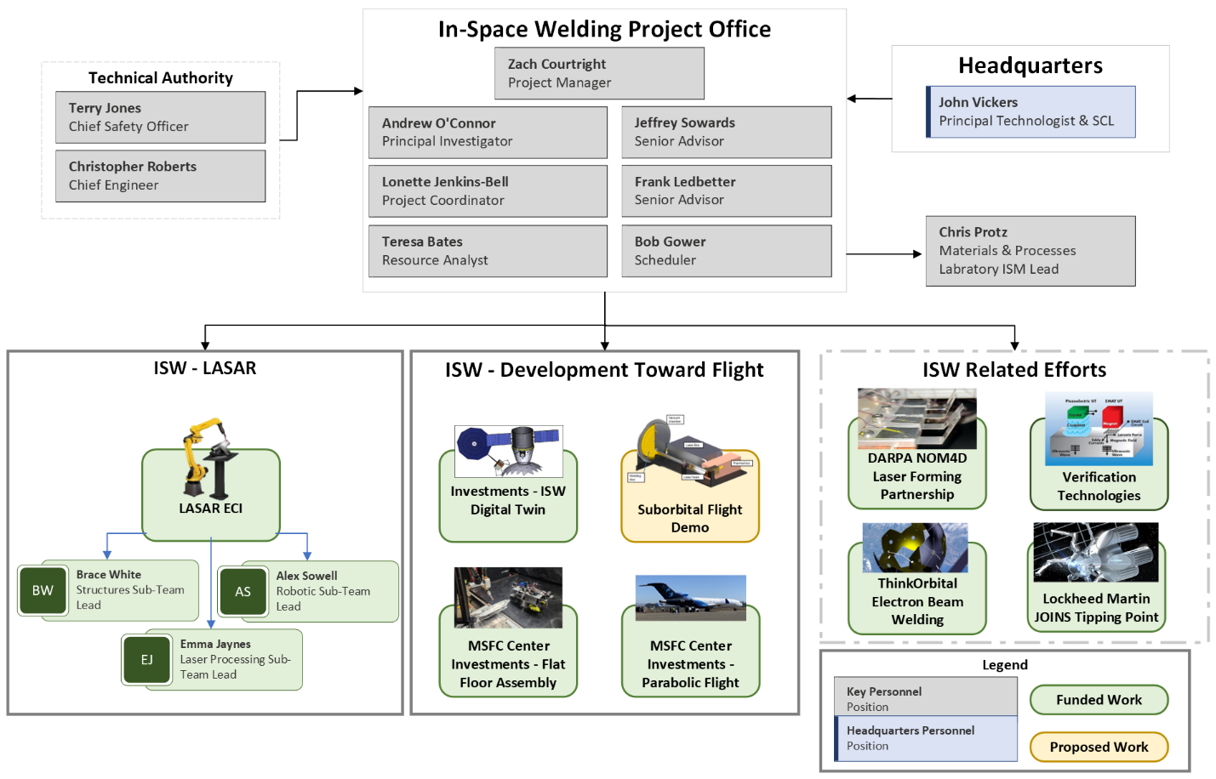
Figure 10: Organization chart for ISW at NASA Marshall

Laser Processing Sub-team (NASA Marshall)
The Laser Processing sub-team is based out of MSFC, partnering with Laserline Inc. Laserline is tasked with delivering a ruggedized laser system, including its optics for beam delivery and optical fiber connecting to the laser diode generator. This laser system must be built to survive the thermal vacuum environment. Expanding the operating temperature range will involve adjusting the laser wavelength to ensure thermally induced shifts do not push the wavelength out of the ideal range for propagation in the optical fiber, ensuring the thermal expansion mismatch between the optics and their housing does not exceed tolerable limits by selecting alternative materials or providing active cooling/heating, adding insulation where appropriate and not deleterious to vacuum compatibility, and exploring active heating/cooling for the optical fiber to avoid excessive embrittlement at low temperature and coating loss at high temperatures. Vacuum compatibility will require removing any materials prone to outgassing or otherwise unstable in vacuum environments – particularly the optical fiber coating and adhesive or potting epoxies – and cavities that could entrap air. MSFC has tremendous experience in TVAC compatibility and will collaborate regularly with Laserline to achieve ruggedization for the laser system, allowing expanded thermal and vacuum operational ranges. Tests are currently being conducted to test the leak rate of the existing, commercial off-the-shelf (COTS) fiber optic design (Figure 11); the results from these tests are being used to inform modifications to the fiber optic design.
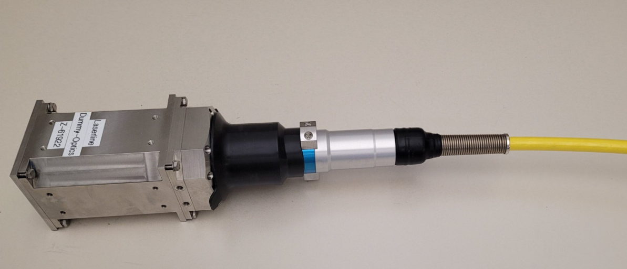
Figure 11: Test fiber and optics used for air leak testing at MSFC
The Laser Processing sub-team is also tasked with the integration of the laser system and the Electromagnetic Acoustic Transducer (EMAT) onto the Motiv robotic arm. Power delivery and communication must be purposefully designed to allow for proper integration; requirement verification and iterative testing will be required. An early integration controls document is already in development.
The laser manufacturing platform will need to be thoroughly tested in ambient conditions before entering TVAC. This will be used to optimizer LBW parameters, and understand interactions between Snowflake joint geometry, weldability, and mechanical properties of the joint. The Structures sub-team is already conducting analysis to determine the amount and placement of laser welds to reach the desired strength modulus for a Snowflake joint on the lunar surface. Weld trials of the Snowflake joint have been performed (Figure 12), to inform how the laser welder can be commanded to reach all the weld surfaces effectively. This will be used to inform the weld schedule, fixturing, and positioning of platform components to achieve the desired strength. Ambient testing will be performed with a Universal Robots UR10e robotic arm, as this arm can utilize similar development tools as the Motiv arm, and each involved NASA center (MSFC, JSC, and LaRC) has a UR10e available for use. After ambient trials are complete, operating conditions will be expanded via the TVAC environment, with the ruggedized Motiv and Laserline systems. The optimized parameters from ambient conditions will be used as a starting point for optimization in TVAC. The performed welds will be analyzed metallographically to determine their quality with joint efficiency and stiffness proven by tensile testing; the Structures sub-team will qualify the mechanical properties of the entire welded Snowflake joint.

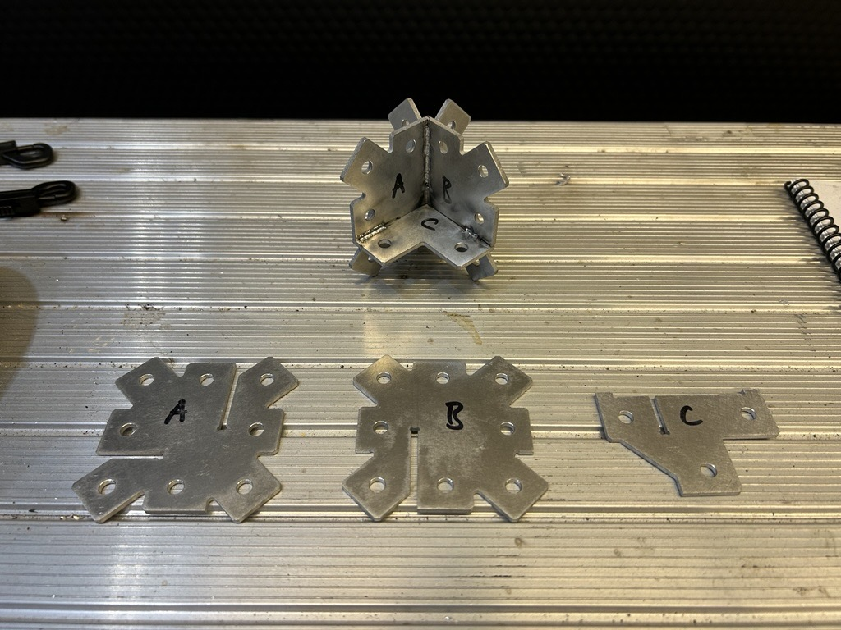
Figure 12: Hand-welded Snowflake joint design
Extreme temperatures, high radiation, and near-vacuum conditions pose significant challenges for NDE testing in space. The EMAT technology [22] offers key advantages for space applications, as it provides non-contact ultrasonic testing without the need for coupling media, making it ideal for harsh environments such as vacuums and extreme temperatures. EMAT can inspect electrically conductive materials during fabrication, repair, and maintenance of critical hardware in space, without requiring direct surface contact or extensive surface preparation—an advantage in the difficult conditions of space. NASA Marshall is developing an EMAT-based inspection technique for space applications, having recently completed vacuum chamber tests and ongoing sensors evaluations across temperatures ranging from -130°C to +150°C. An EMAT system has also been integrated onto the end effector for a UR10e robotic arm (Figure 13), easing access for inspection of complex part geometries.

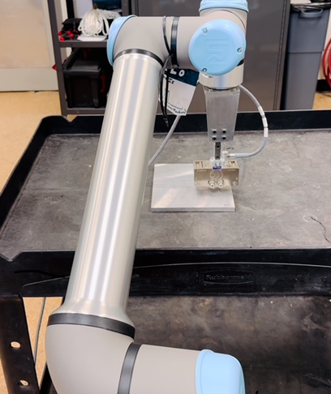
Figure 13: EMAT integrated to UR10e for automated weld inspection

Robotics and Structures Sub-teams
The Robotics sub-team is based at NASA Johnson Space Center and is partnered with Motiv Space Systems and PickNik Robotics. This sub-team will advance supervised autonomous robotics in a thermal vacuum environment using path planning and positioning routines running on flight-forward compute hardware. The Structures sub-team is based at NASA Langley Research Center. This sub-team will iterate on the innovative “Snowflake” joint geometry for truss structures, originally designed for fastening and riveting, to increase it suitability for joining by LBW.

Parabolic and Suborbital Flight Experiment Hardware Development
One environmental condition not readily accessible on the ground is reduced gravity. While drop-towers can provide high-quality micro-gravity – especially when evacuated of air, the length of the reduced gravity period is typically insufficient to sustain reduced gravity conditions for linear welds or to be confident in complete weld solidification prior to resumption of nominal gravity conditions. And fully in-space demonstrations such as on an orbiting space station are notably expensive with limitations on returned mass and slower iteration times. Thus, parabolic, and suborbital flight are more attractive platforms for early developmental ISW experiments. There are several considerations and trade-offs with respect to the various experimental platforms as expressed in Table 3. Considering that parabolic and suborbital flights can provide the required length of reduced gravity, the motivation to proceed to suborbital flight is predicated on longer duration, higher quality reduced gravity. This will enable a more reliable, deeper understanding of reduced gravity effects on ISW. However, the expense of suborbital flight encourages parabolic flight for initial, rapid development and to de-risk hardware and operations for suborbital flights.
Table 3: Experimental platforms emulating reduced gravity conditions assessed by relevant criteria
Experimental platform →  ↓ Criteria | Drop tower | Parabolic flight | Suborbital flight
Length of reduced gravity [s] | <5 | 10-20 | >180
Gravity (quality) [g] | 10⁻⁵ | 10⁻³-10⁻²  (up to ~1.8) | 10⁻⁴
Mass allowed [kg] | 10² | 10² | 10¹
Cost [$] | $ | $$ | $$$

Similar to previous ISW development efforts [3], [4], the current experimental campaign seeks to combine both reduced gravity and reduced pressure (vacuum) conditions during flight experiments (Figure 14). The combined effects of these simultaneous conditions – as aforementioned separately – may lead to new understandings of the fundamentals of ISW and welding in general. More fully emulating the space environment will also enhance confidence and de-risk further ISW technology demonstration and development.

Figure 14: The combination of microgravity and vacuum conditions enables a new understanding of LBW under conditions relevant to the space environment.
NASA Marshall is developing hardware in-house for ground, parabolic, and suborbital experiments of LBW. These developments began with a proof-of-concept study and are now progressing into integration of a protoflight unit capable of both parabolic and, eventually, suborbital flight.

NASA Marshall Advanced Concepts Office Study of Suborbital LBW Feasibility
The Advanced Concepts Office at NASA Marshall was engaged early in the current hardware developmental efforts to ensure that a suborbital LBW flight experiment was feasible given the capabilities of the current suborbital flight platform and their associated SWAP-C limitations. They, in consultation with the NASA Marshall ISW team, produced a Level 0 conceptual design as depicted in Figure 15. This concept employes a conformal vacuum chamber around a disc-like specimen carousel to allow ready access to multiple weld coupons of varying geometries during the suborbital flight period. The LBW weld head, non-contact instrumentation (weld camera, thermography, etc.), controls, and other hardware are held in the normal atmosphere of the suborbital flight platform to reduce integration expense and risk. The laser beam and non-contact instrumentation access the specimens through an optical passthrough window capable of withstanding vacuum. The vacuum window is mounted at a distance from the specimens to reduce the solid angle subtended by the metal vapor plume and thus reduce deposition on the glass; this forms a sort of “stovepipe” geometry from the conformal vacuum chamber. A small vacuum pumping system is provided to ensure maintenance of a high vacuum condition during the flight. Initial structural, thermal, and electrical analyses were conducted and revealed no fatal flaws.
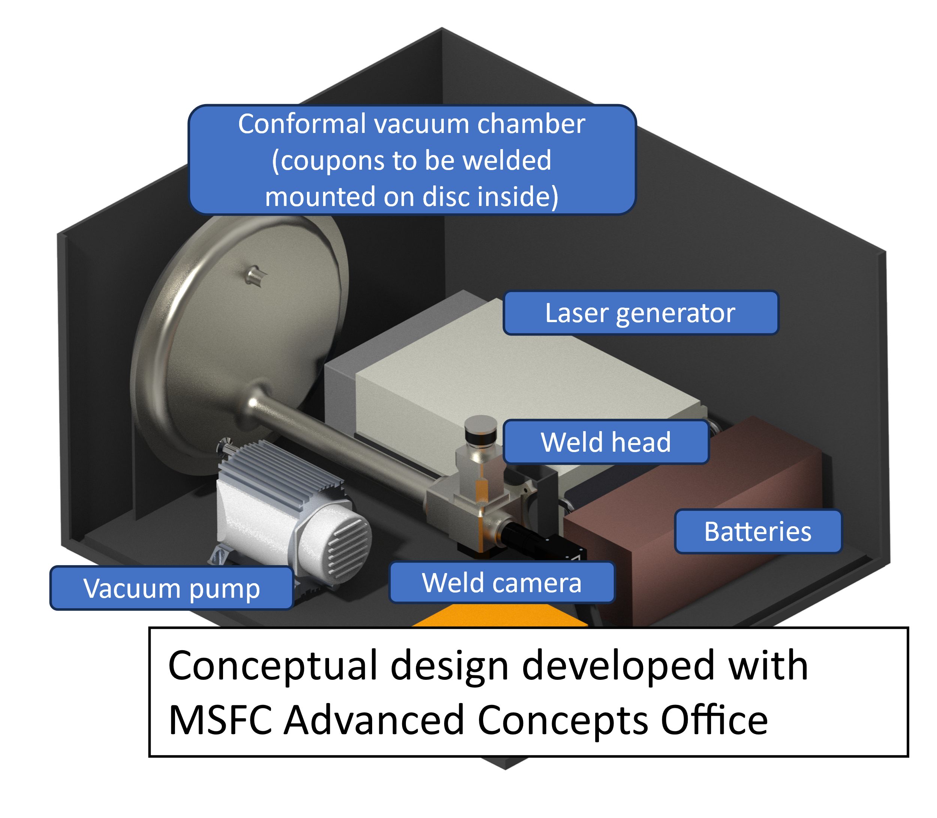
Figure 15: CAD model from NASA Marshall ACO study of suborbital LBW experiment; Level 0 concept, not to scale

Multi-purpose Protoflight Unit
The DIsk-Shaped Configurable and Modular vAcuum uNit (DISCMAN) is a small, cylindrical vacuum chamber designed to support ground, parabolic, and suborbital flight testing. Both CAD and photographs of the developmental, protoflight unit are shown in Figure 16. A rotary turntable within the chamber allows mounted components to rotate about the chamber’s center – this allows laser welding to be performed, with the laser fired through an optical passthrough. Toroidal spacers can be used to increase the height of the chamber, adding volume and additional space for instrumentation ports. The outer diameter of the cylinder allows it to be mounted on MSFC’s 3-axis rate table, enabling ground tests at different orientations.
The suborbital unit includes several features to enhance its capabilities and reusability. In additional to interchangeable spacers, a sacrificial cover glass is located just below the laser viewport window, which captures debris generated from the welding process. This allows the contaminated glass to be easily replaced between operations, as well as a simple way to analyze the off gassed materials. Initial test welds have been performed on the ground to test functionality and vacuum capabilities of DISCMAN. Soon this development will include a motorized turntable, integration of this turntable with control of the laser welder, and integration of thermocouples to support temperature measurements on individual samples and the walls of the chamber.
In the future, heating and cooling can be integrated into the chamber. Its small form factor can also support “dirty” vacuum chamber tests, such as those with Lunar regolith, by either cleaning the chamber after use or building a new “shell” to be used exclusively for regolith activities. This chamber has an incredible range of applications – with a weight and form factor small enough to move between laboratories, the chamber can accommodate GNC and other sensor suite testing, science experimentation, dusty cell/regolith activities, etc. This has already been done to support stereo camera testing for the LASAR ECI.

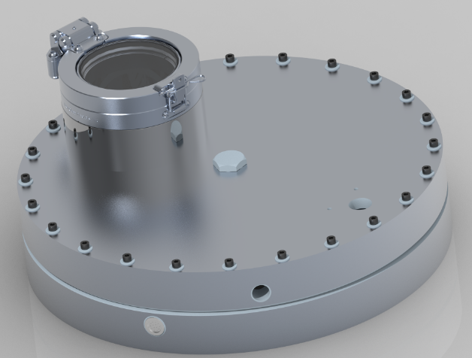 | 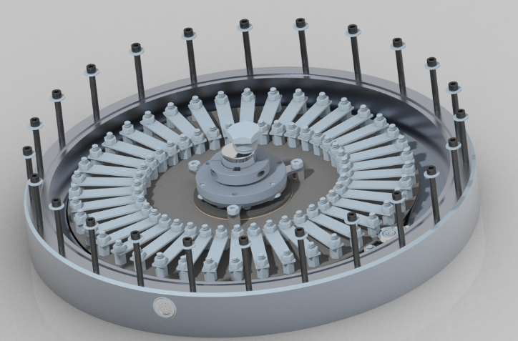
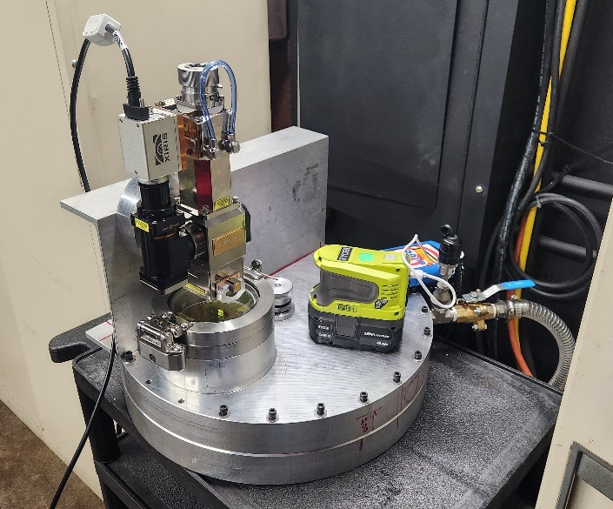
Figure 16: CAD model and hardware of multi-purpose suborbital LBW protoflight unit (DISCMAN)

Maturation to Flight Unit
Parabolic flight can provide lower cost, rapid turn-around experimentation and serve as technical de-risking for suborbital LBW flights. NASA Marshall partnered with the Ohio State University to perform LBW during a parabolic flight in August 2024 using a flight-capable vacuum chamber owned by NASA Langley. The effort was successful in performing welds during 69 out of 70 parabolas, and materials diagnostics are being performed and technical communications are being written now. The experience gained during this effort is accelerating maturation of the multi-purpose protoflight unit.
To prepare the multi-purpose protoflight unit for parabolic flight, a new skid system will be designed for the chamber and other hardware to mount to the parabolic plane. Power specifications for the vacuum pumps and the payload control system will be designed to meet parabolic flight specifications. The vacuum system may need to be replumbed to properly function in all flight configurations. The chamber will need to be laser-tight to meet tended payload safety requirements, potentially including a larger enclosure. Other considerations, such as structural analysis, will be required for final safety approval.
Between parabolic and suborbital flight, changes will need to be made to meet the requirements of the suborbital flight provider. Mechanical and electrical interface requirements change between providers – once a provider is chosen, these designs can be accounted for. A major change is also the automation of the entire system, as suborbital flight will be untended. The on-board computer and software must be robust enough to meet flight requirements and ensure mission success. Many of these changes or concerns, when properly considered throughout the design and protoflight process, can be minimized or their impact mitigated. The suborbital flight unit, with instrumentation mounted and automation & motorization achieved, is depicted in Figure 17.

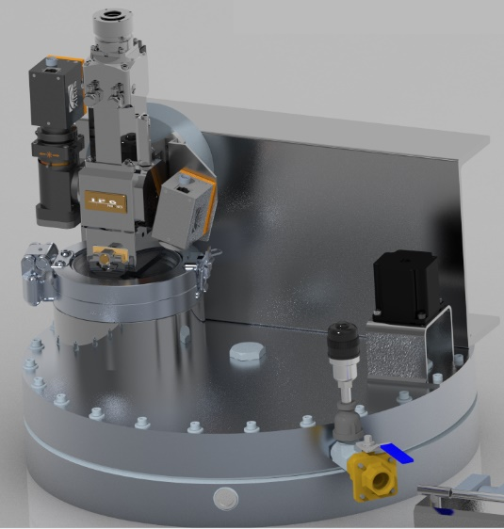 | 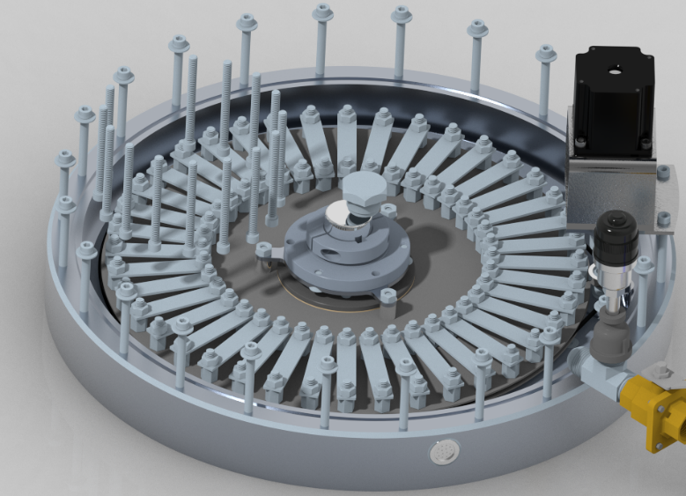
Figure 17: CAD model of suborbital LBW flight unit after maturation from protoflight unit
- Instrumentation Development
Beyond post-flight materials diagnostics typical of welding development (metallography, radiography, NDE, and many more), to truly understand the mechanisms involved in ISW as they unfold, suitable instrumentation is required – thermal, plume, chemical, laser beam diagnostics, and beyond. The ground and flight experiments will host a variety of instrumentation, including:

Welding and Thermal Cameras
Cameras suitable for imaging the welding process and thermography are being employed. An optical spectrum (~400-750 nm) camera with high dynamic range (>140 dB) is capable of observing the weld bead over a range of processing conditions without interference from the laser light (1064 nm), This camera is currently mounted coaxially on the weld head of the protoflight suborbital unit where it can also provide visual feedback on the platen and workpiece positions. The thermal camera currently employed is sensitive to short-wave infrared (900-1700 nm), where the plume and metal vapors are less obscuring and where emissivity shifts due to melting are reduced – thereby increasing confidence in the thermography. It additionally has a high dynamic range (>120 dB) that improves weld bead and surrounding workpiece observability. Each of these cameras is under 200 g, minimizing their impact on overall system mass.
Future weld bead imaging may include high-speed cameras for observing spatter formation and detachment dynamics and keyhole morphology & stability.

Plume Imaging
A variety of weld plume imaging techniques, including Schlieren optics [23] and mid-wave/long-wave infrared thermography [24], [25], are being explored for use in imaging the plume arising from welding including how it changes with respect to atmospheric pressure (or lack thereof) and laser beam interactions.

Spectrometry
Chemical composition of the weld plume via optical emission spectrometry can elucidate how species evolve off the molten surface with respect to atmospheric pressure, temperature, and welding parameters [26]. A spectrometer over the range 350 to 550 nm with a resolution under one nanometer has been procured and will be integrated into the protoflight suborbital unit for ground testing. Initial setup is envisioned to be aimed roughly perpendicular to the workpiece surface, allowing collection of spectral data from the laser-excited plume. Concepts for later investigation include mounting the spectrometer coaxially on the weld head to view the real-time chemical composition of the weld bead – providing that the plume does not overwhelmingly interfere – and mounting the spectrometer to view re-vaporization from the cover glass protecting the laser passthrough window.

Laser Beam Diagnostics
Offline but in situ laser beam diagnostic hardware is being developed and procured. A focus monitor capable of analyzing the laser caustic is being ruggedized to operate in a thermal vacuum environment through replacement of incompatible greases and other modifications. When delivered, this system will be able to determine vital optical metrics such as the laser beam quality and spot size not only as the laser is transmitted through optical passthroughs into a chamber but also as that chamber itself is under vacuum, which leads to focus-altering deflection of the chamber itself and the mounted laser optics. Power monitors and other equipment suitable for understanding the beam delivery and optical path are also being procured.

ISW Digital Twin Development
An eventual ISW Digital Twin is envisioned to consider geometry, materials, and qualification as paramount in considerations. A vital element of the Digital Twin is the geometry determination and tracking that will allow for proper joint fit-up. Especially for high energy density welding processes such as LBW, precise joint fit-up – on the order of hundreds of microns – is necessary for proper fusion of the weld and thus structural ability of the resulting joint. Several means to accomplish this are being investigated, including structured light scans, vision tracking systems, and real-time virtual kinematic models (see Figure 4).
Another critical element of an ISW-specific Digital Twin is that of the newly coined materials-information twin tetrahedra [27]; this concept links the traditional materials tetrahedron of processing-structure-properties-performance linkages [28] with similar concepts from information science also placed in a tetrahedral arrangement. One implementation of this approach is that of integrated computational materials engineering (ICME), which employs both experimental and computational tools in a closed-loop, mutually reinforcing virtuous cycle for materials discovery and optimization [29], [30]. ICME and ISW development are synergistic as the data collected during ISW flight experiments – solidification behavior, fluid flow, thermophysical properties, etc. – can anchor computational models – that predict solidification, grain growth, precipitation, etc. – which in turn help to optimize further experimentation (Figure 18).
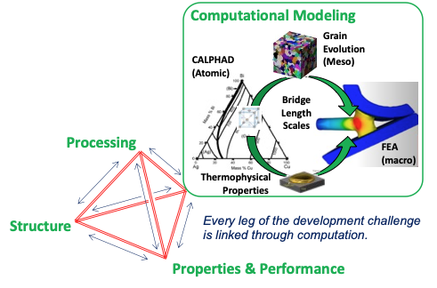
Figure 18: Depiction of ICME as could be applied to ISW
An emerging element in the Digital Twin realm is that of artificial intelligence/machine learning (AI/ML) techniques. With the inability to perform numerous experiments and tests traditionally required to mature and qualify welding processes for ISW due to the difficult and expense involved in performing such activities in space, methods to apply data gathered from ground experimentation to expand upon flight experimental and in-service data are highly desired. One example could be transfer learning, in which a model trained on one data set is able to apply this training, weighting, “knowledge”, etc. to other data sets with different features [31]; as such, ground welding experiments could be used to train a model that can make predictions based on in-space welding conditions. A related concept to link ground-based to space-based ISW is few-shot learning – where a meta-model is trained on a large dataset (base) but the specific model implementation is provided only limited examples (novel) [32].These approaches represent only a few of the emerging AI/ML methods that could be applied to ISW in order to reduce the need for expensive, time-consuming space-based experimentation and to eventually enable one-shot welds in space.

Complementary In-Space Welding Developmental Efforts Through External Partnerships

JOINS Tipping Point with Lockheed Martin
Lockheed Martin is preparing a demonstration of ISW at the International Space Station (ISS) as part of the JOining demonstrations IN-Space (JOINS) Tipping Point award from NASA’s Space Technology Mission Directorate [33]. NASA Marshall is collaborating with Lockheed Martin on aspects of this effort.

Space Act Agreement with ThinkOrbital
ThinkOrbital performed an EBW demonstration in space as part of a SpaceX Falcon 9 launch in May 2024 [34]. NASA Marshall is characterizing the returned material to enhance understanding of ISW via analysis of microstructural and microscale materials property differences compared to ground analogues [35].

Future In-Space Welding Developmental Efforts
Despite a burgeoning ISW ecosystem at NASA Marshall and its partners, there remains substantial work in maturing ISW, and specifically LBW, into a mission-ready technology. The current slate of Flat Floor experiments, TVAC experiments, and protoflight unit integration are being swiftly executed. Ostensibly, further TVAC testing and reduced gravity flight experiments (suborbital flight especially) will be needed to build up the datasets required for a complete Digital Twin. Long-duration microgravity experiments to further enhance fundamental understanding of welding and its solidification may be conducted on orbiting space stations to complement existing technology demonstration efforts there. Ultimately, a demonstration of LBW on the Lunar or even Martian surface would be desired to prove that ISW is a mission-ready technology critical to a sustainable presence in a variety of space environments.
Complementary opportunities to in-house ISW development at NASA Marshall include continued partnering with academia and industry, investigating other manufacturing techniques enabled by laser such as laser forming of sheet metal (the subject of an ongoing partnership between the DARPA NOM4D program and NASA Marshall), and holding technical interchanges or other knowledge transfer activities like technical publications and presentations.

Acknowledgments
These efforts received funding from NASA Marshall’s Research and Development funds, the Biological and Physical Sciences Division of the agency’s Science Mission Directorate, and NASA’s Space Technology Mission Directorate, including NASA Flight Opportunities.

References
[1] A. O’Connor et al., “Maturation of In-Space Welding in Reduced Gravity and Reduced Pressure Environments through Progression to Suborbital Flight Experiments,” in AWS Professional Program, Orlando, FL: American Welding Society, Oct. 2024.
[2] R. M. Poorman, “Skylab M551 metals melting experiment,” NASA-TM-X-64960, May 1975. Accessed: Oct. 30, 2023. [Online]. Available: https://ntrs.nasa.gov/citations/19760003076
[3] G. M. Mladenov, E. G. Koleva, and D. N. Trushnikov, “Welding in space and in vacuum chambers,” E+E, vol. 54, no. 5–6, pp. 111–121, Jun. 2019.
[4] G. L. Workman and W. F. Kaukler, “Laser Welding in Space,” NAS 1.26:185638, Oct. 1989. Accessed: Oct. 30, 2023. [Online]. Available: https://ntrs.nasa.gov/citations/19910018227
[5] G. L. Workman and W. F. Kaukler, “Laser welding in a reduced gravity environment,” Jan. 1992. doi: 10.2351/1.5058386.
[6] E. Choi et al., “Laser beam welding for in-space joining demonstrated under vacuum on the ground and by parabolic flight experiments,” presented at the TechConnect World 2024, National Harbor, MD, Jun. 18, 2024. [Online]. Available: https://ntrs.nasa.gov/citations/20240007238
[7] J. Sowards, “Welding in Space: Past, Present, and Future,” presented at the 2023 AWS Professional Program, Chicago, IL, Sep. 11, 2023. Accessed: Oct. 30, 2023. [Online]. Available: https://ntrs.nasa.gov/citations/20230012815
[8] T. H. North and International Institute of Welding, Eds., Advanced joining technologies: proceedings of the International Institute of Welding Congress on Joining Research, July 1990, 1. ed. London: Chapman and Hall, 1990.
[9] S. Sinha and T. Mukherjee, “Mitigation of Gas Porosity in Additive Manufacturing Using Experimental Data Analysis and Mechanistic Modeling,” Materials, vol. 17, no. 7, Art. no. 7, Jan. 2024, doi: 10.3390/ma17071569.
[10] T. R. Anthony and H. E. Cline, “Surface rippling induced by surface‐tension gradients during laser surface melting and alloying,” J. Appl. Phys., vol. 48, no. 9, pp. 3888–3894, Sep. 1977, doi: 10.1063/1.324260.
[11] S. Jakobs and U. Reisgen, “Laserstrahlschweißen im Vakuum,” Stahlbau, vol. 84, no. 9, pp. 635–642, 2015, doi: 10.1002/stab.201510306.
[12] U. Reisgen, S. Olschok, S. Jakobs, and C. Turner, “Laser beam welding under vacuum of high grade materials,” Weld. World, vol. 60, no. 3, pp. 403–413, May 2016, doi: 10.1007/s40194-016-0302-3.
[13] C. Börner, K. Dilger, V. Rominger, T. Harrer, T. Krüssel, and T. Löwer, “Influence of ambient pressure on spattering and weld seam quality in laser beam welding with the solid-state laser,” presented at the ICALEO 2011: 30th International Congress on Laser Materials Processing, Laser Microprocessing and Nanomanufacturing, AIP Publishing, Oct. 2011, pp. 621–629. doi: 10.2351/1.5062302.
[14] C. A. Brice and N. Dennis, “Cooling Rate Determination in Additively Manufactured Aluminum Alloy 2219,” Metall. Mater. Trans. A, vol. 46, no. 5, pp. 2304–2308, May 2015, doi: 10.1007/s11661-015-2775-x.
[15] M. Jiang, W. Tao, and Y. Chen, “Laser Welding under Vacuum: A Review,” Appl. Sci., vol. 7, no. 9, Art. no. 9, Sep. 2017, doi: 10.3390/app7090909.
[16] J. W. Sowards, E. R. Crabtree, A. O’Connor, and C. S. Protz, “Computational and physics-based modeling for the development of in-space welding technology,” in AWS Professional Program, Orlando, FL: American Welding Society, Oct. 2024.
[17] X. Xiao et al., “Progress on Experimental Study of Melt Pool Flow Dynamics in Laser Material Processing,” in Liquid Metals, IntechOpen, 2021. doi: 10.5772/intechopen.97205.
[18] J. W. Kelly et al., “A Decade of Space Technology Maturation through NASA’s Flight Opportunities Program,” in ASCEND 2020, Virtual Event: American Institute of Aeronautics and Astronautics, Nov. 2020. doi: 10.2514/6.2020-4135.
[19] B. Piascik, J. Vickers, D. Lowry, S. Scotti, J. Stewart, and A. Calomino, “Materials, Structures, Mechanical systems, and Manufacturing Roadmap: Technology Area 12,” NASA, Apr. 2012.
[20] Z. S. Courtright, “Mars Atmosphere Effects on Arc Welds: Phase 1,” NASA/TM-2016-218231, Dec. 2016. Accessed: Dec. 02, 2024. [Online]. Available: https://ntrs.nasa.gov/citations/20170005174
[21] Z. S. Courtright, “Effects of Mars Atmosphere on Arc Welds: Phase 2,” M–1453, Mar. 2018. Accessed: Dec. 02, 2024. [Online]. Available: https://ntrs.nasa.gov/citations/20180002398
[22] M. Hirao and H. Ogi, EMATs for Science and Industry. Boston, MA: Springer US, 2003. doi: 10.1007/978-1-4757-3743-1.
[23] U. Reisgen, S. Olschok, T. Twiehaus, and C. Frey, “Schlieren methodology for laser beam welding under vacuum,” Vacuum, vol. 206, p. 111508, Dec. 2022, doi: 10.1016/j.vacuum.2022.111508.
[24] M. Mehta, D. E. Gaddy, P. M. Danehy, J. A. Inman, R. Parker, and A. T. Dufrene, “Optical Diagnostic Imaging of Multi-Rocket Plume-Induced Base Flow Environments,” presented at the American Inst. of Aeronautics and Astronautics, Reston, VA, United States, Jun. 2017. Accessed: Dec. 04, 2024. [Online]. Available: https://ntrs.nasa.gov/citations/20180003486
[25] R. P. Moran and J. D. Houston, “Infrared Imagery of Solid Rocket Exhaust Plumes,” presented at the Department of the Navy, Washington, DC, United States, Dec. 2011. Accessed: Dec. 04, 2024. [Online]. Available: https://ntrs.nasa.gov/citations/20120002972
[26] B. J. Simonds, J. W. Sowards, and P. A. Williams, “Laser-induced fluorescence applied to laser welding of austenitic stainless steel for dilute alloying element detection,” J. Phys. Appl. Phys., vol. 50, no. 32, p. 325602, Jul. 2017, doi: 10.1088/1361-6463/aa7836.
[27] M. E. Deagen, L. C. Brinson, R. A. Vaia, and L. S. Schadler, “The materials tetrahedron has a ‘digital twin,’” MRS Bull., vol. 47, no. 4, pp. 379–388, Apr. 2022, doi: 10.1557/s43577-021-00214-0.
[28] National Research Council, Materials Science and Engineering for the 1990s: Maintaining Competitiveness in the Age of Materials. Washington, D.C.: National Academies Press, 1989. doi: 10.17226/758.
[29] W. Xiong and G. B. Olson, “Cybermaterials: materials by design and accelerated insertion of materials,” Npj Comput. Mater., vol. 2, no. 1, p. 15009, Feb. 2016, doi: 10.1038/npjcompumats.2015.9.
[30] Committee on Integrated Computational Materials Engineering, National Research Council of the National Academies, Integrated Computational Materials Engineering: A Transformational Discipline for Improved Competitiveness and National Security. Washington, DC: National Academies Press, 2008. doi: 10.17226/12199.
[31] S. J. Pan and Q. Yang, “A Survey on Transfer Learning,” IEEE Trans. Knowl. Data Eng., vol. 22, no. 10, pp. 1345–1359, Oct. 2010, doi: 10.1109/TKDE.2009.191.
[32] H.-J. Ye, L. Ming, D.-C. Zhan, and W.-L. Chao, “Few-Shot Learning With a Strong Teacher,” IEEE Trans. Pattern Anal. Mach. Intell., vol. 46, no. 3, pp. 1425–1440, Mar. 2024, doi: 10.1109/TPAMI.2022.3160362.
[33] “2023 NASA Tipping Point Selections - NASA.” Accessed: Dec. 01, 2024. [Online]. Available: https://www.nasa.gov/general/2023-nasa-tipping-point-selections/
[34] “Launch of world’s first autonomous in-space welding system – ThinkOrbital.” Accessed: Dec. 01, 2024. [Online]. Available: https://thinkorbital.com/news/launch-of-first-welding-system/
[35] “Seven US Companies Collaborate with NASA to Advance Space Capabilities - NASA.” Accessed: Dec. 04, 2024. [Online]. Available: https://www.nasa.gov/news-release/seven-us-companies-collaborate-with-nasa-to-advance-space-capabilities/

Materials Scientist, NASA/MSFC-EM31
AST Aerospace Flight Systems, NASA/MSFC-ET20
Manager/Senior Engineer for Flat Floor Robotics Lab, NASA/MSFC-ES31
In-Space Manufacturing Portfolio Manager, NASA/MSFC-ST23
Equipment Specialist, NASA/MSFC-ET20
NASA Postdoctoral Program Fellow, NASA/MSFC-EM30
Welding Engineer, NASA/MSFC-EM32
Engineer for Flat Floor Robotics Lab, NASA/MSFC-ES31
3D Processing/Scanning Engineer, NASA/MSFC-EM42
Materials Scientist, NASA/MSFC-EM31
Associate Director for Technical Management (detail), NASA/MSFC-ED01
Materials Engineer, NASA/MSFC-EM31
AST Structural Materials, NASA/MSFC-EM42
Materials Engineer, NASA/MSFC-EM22
Assistant Division Chief, NASA/MSFC-EM30

