LARGE IMPACT FEATURES ON GANYMEDE AND CALLISTO AS REVEALED BY GEOLOGICAL MAPPING AND MORPHOMETRY

Oliver L. White^{a,b}, Jeffrey M. Moore^{b}, Paul M. Schenk^{c}, Donald G. Korycansky^{d}, Andrew J. Dombard^{e}, Martina L. Caussi^{e}, and Kelsi N. Singer^{f}.

ªSETI Institute, 339 Bernardo Avenue, Suite 200, Mountain View, CA 94043
^{b}NASA Ames Research Center, MS 245-3, Moffett Field, CA 94035
^{c}Lunar and Planetary Institute, 3600 Bay Area Blvd., Houston, TX 77058
^{d}Department of Earth and Planetary Science, University of California, Santa Cruz, CA 95064
^{e}Dept. of Earth and Environmental Sciences, University of Illinois at Chicago, 845 W. Taylor St., Chicago, IL 60607
^{f}Southwest Research Institute, 1050 Walnut Street, Suite 300, Boulder, CO 80302

Manuscript pages: 68
Figures: 6
Tables: 3

Present address of corresponding author: Oliver White
MS 245-3
NASA Ames Research Center
Moffett Field
CA 94035
owhite@seti.org
281-309-8152 (Cell)

Abstract. The icy Galilean satellites are host to a broad range of impact feature morphologies. Hypotheses seeking to explain the diversity of these impact features consider the effects of impact melt, the physical state of the subsurface at the time of impact, and the impactor characteristics. As part of a larger effort to assess the role of these factors in the formation and evolution of these impact features, we have performed topographic and geological mapping of 19 large impact features on Ganymede and Callisto. These are divided into two main morphological groups: craters (subdivided into pit, dome, and anomalous dome craters), and penepalimpsests/palimpsests. The transitions from pit, dome, to anomalous dome craters appear to be size-dependent up to diameters of ~170 km. The morphologies of pit and dome craters appear to be independent of their age or geologic context. The impacts that formed them only affected a cold, rigid ice layer, with the development of pits and raised annuli on their floors possibly stemming from the evolution of a pocket of impact melt. The subdued rims and floors of anomalous dome craters indicate the increasing effect of a weak, warm ice layer on impact feature morphology with increasing size, but their prominent annuli and pits indicate that mobilization of impact melt is also a factor. The very low topographic relief of older penepalimpsests and palimpsests indicates that their impacts penetrated the ice shell to mobilize very large volumes of pre-existing liquid from a subsurface layer, with little contribution to the final feature morphology from impact melt. Penepalimpsests are distinguished from palimpsests by the higher frequency of concentric ridges within their interiors, indicating a generally more robust state of the subsurface that could better support the rotation and uplift of solid material during impact, even if a crater-like depression could not be supported. A few impact features seem to be transitional between anomalous dome craters and penepalimpsests, and the overlap of anomalous dome craters, penepalimpsests, and palimpsests in terms of diameter as well as age indicates that impactor size and subsurface properties over time are major factors in determining which of these morphologies emerges.

- Introduction

The icy Galilean satellites (Europa, Ganymede, and Callisto) are host to a variety of large impact features that are rarely encountered on other solid surfaces in the Solar System. These features are morphologically diverse and include impact craters with central pits and domes that transition to larger, so-called "penepalimpsests" that themselves transition to "palimpsests", which appear as circular albedo features with negligible topographic relief and absent crater rims (Passey and Shoemaker, 1982; Moore and Malin, 1988; Schenk and Moore, 1998; Schenk et al., 2004a). The particular circumstances leading to such morphological variety may be influenced by several factors including the target composition, structure, and gravity. The present study forms part of a larger effort to evaluate testable hypotheses about the role of each of these factors in the formation and evolution of large impact features on Ganymede and Callisto. We perform topographic and geological mapping of 19 impact features on Ganymede and Callisto to quantify how the morphometric relations between components of these features vary with changing impact feature size. In addition, we have performed crater counts for all the mapped impact features that we use to estimate crater ages based on comparison to R-plots for young impact features and terrains on Ganymede and Callisto presented in Schenk et al. (2004) for which Zahnle et al. (2003) have derived age estimates based on modeled impact rates at the two satellites. We interpret our results in terms of their implications for how the state of the ice shell, in particular its thickness above an internal liquid layer or melt pocket (whether pre-existing or formed by the impact event), responds to the impact process for differently-sized impacts and how variation in impact feature morphology within a certain size class can indicate evolution of the ice shell over the historical courses of these satellites. By achieving as comprehensive a view as possible of the structures of these selected impact features, our maps also serve as the primary ground-truth for numerical modeling of the impact process and long-term evolution of impact features (Korycansky et al., 2022a,b; Caussi et al., 2024; Moore et al., 2024).

- Background

There is a canonical sequence of crater properties as a function of diameter that reflects the physics of the impact process on planetary bodies (Pike, 1988; Melosh, 1989). The smallest craters are “simple”: bowl-shaped features in the landscape with a typical ratio of depth d to diameter D of ~1 to 6. As craters increase in size, a transition occurs to “complex” craters that are shallower in relation to their sizes, with flatter floors, and which develop a central peak as crater size continues to increase. Increasing size brings a transition from the central peak to a ring around the center (so-called “peak-ring” craters). The largest impacts give rise to “multi-ring” features that are hundreds to thousands of kilometers in diameter. The sequence described above (simple to complex to peak-ring, etc.) is most clearly visible on bodies with rocky surfaces like the Moon, Mercury, Mars, and Vesta, although it also manifests on icy bodies such as Ceres and outer Solar-System satellites (e.g. Schenk et al., 2021).
However, detailed examination of the three Galilean satellites with icy surfaces (Europa, Ganymede, and Callisto) reveals a number of more complicated and unique features on the surfaces of these bodies (Schenk et al., 2004a), particularly on the latter two. The characteristics of these impact features provide clues to the physical state of the target near surface. First identified in Voyager observations (Passey and Shoemaker, 1982; Moore and Malin, 1988), a small number of these impact features have been imaged at better resolution by the Galileo mission. These features exhibit shallower depth-to-diameter ratios compared to craters of similar diameter on rocky bodies (Schenk, 1991) and contain either pit-like or dome-like central structures. While central pits have Martian analogs (Wyrick et al., 2004; Barlow, 2006), central domes are not seen elsewhere, including on the icy satellites of Saturn, Uranus, or Neptune (Schenk et al., 2021). Older, larger structures have a very flattened profile with little or no distinctive relief (Schenk et al. 2004a). We designate these impact formations as “Large Impact Features”. The present study focuses on Ganymede and Callisto, as Europa’s surface is young (~108 Myr) (Greeley et al., 2004, Bierhaus et al., 2009, Schenk and Turtle, 2009) and exhibits a sequence that is similar to those on Ganymede and Callisto but shifted to a smaller size range and with its own unique morphologies (Schenk, 2002; Schenk et al., 2004a). Ganymede and Callisto have many more of these features, over a much wider size range, and all of which fit into a shared classification scheme.
As described by Schenk et al. (2004a), smaller craters on Ganymede and Callisto (with diameters <35 km) follow the traditional sequence of simple to complex, with a transition at D ~3 km. Compared to the more familiar lunar population, simple craters have similar depth-to-diameter ratios of ~0.3, while complex craters are ~40% to ~70% shallower than lunar ones (Schenk, 1991, 2002). Craters in the size range ~35 < D < ~75 km diverge from the lunar taxonomy and exhibit central pits, as seen in Figure 1a. More complex and unique features are found for diameters above 75 km on Ganymede and Callisto. Five different types with overlapping size ranges have been identified (Passey and Shoemaker, 1982; Schenk and Moore, 1998; Schenk et al., 2004a), including dome craters, anomalous dome craters, penepalimpsests, palimpsests, and multi-ring features (panels (b) to (f) of Figure 1).
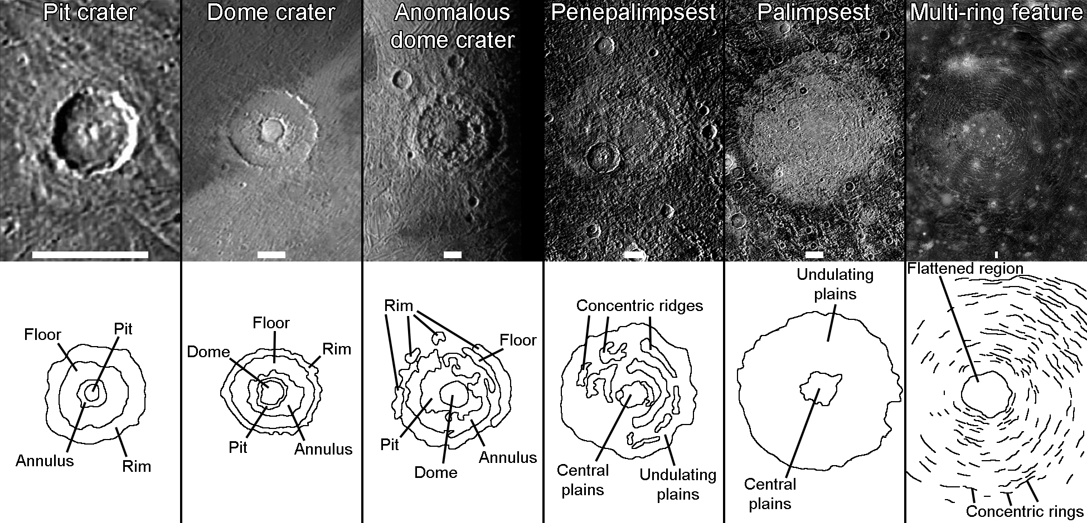
Figure 1. Morphological classification scheme for Large Impact Features on the icy Galilean satellites. Top row of panels shows Galileo imaging of an example of each feature type. From left to right, examples shown are an unnamed pit crater at 2.4°S, 132.0°W on Ganymede; Enkidu, a dome crater at 26.5°S, 34.8°E on Ganymede; Serapis, an anomalous dome crater at 12.2°S, 43.9°W on Ganymede; Nidaba, a penepalimpsest at 17.6°N, 123.0°W on Ganymede; Memphis Facula, a palimpsest at 14.2°N, 131.8°W on Ganymede; and Valhalla, a multi-ring feature at 15.2°N, 55.6°W on Callisto. The scale bar at the bottom of each panel is 40 km long. The bottom row of panels shows schematics of each impact feature, with major components labeled.
Dome craters (Figure 1b) are seen over diameter ranges of ~75 to >100 km and are distinguished by simple (i.e. non-terraced) but steep rim scarps and circular central domes with rounded relief flanked by a narrow annular scarp, ridge, or ring of massifs. Anomalous dome craters (Figure 1c) range from >100 km to ~250 km in diameter, showing prominent, central domes surrounded by a ring of rugged massifs, but with severely muted or absent rim scarps. Counts of superposed craters suggest that anomalous dome craters may be generally older than dome craters, but not as old as palimpsests (Schenk et al., 2004a). Penepalimpsests and palimpsests are large, circular, typically bright patches seen on Ganymede and Callisto, ranging from >150 to ~350 km in diameter. Crater rims in the traditional sense are lacking in these impact features, but low, nested sets of concentric, arcuate ridges can be seen, such as for the penepalimpsest in Figure 1d. Palimpsests (Figure 1e) are distinguished from penepalimpsests by their relative lack of concentric, positive relief features, which are more prevalent at penepalimpsests as well as other concentric structures including ejecta and secondary impact craters (Schenk et al., 2004a). As with dome and anomalous dome craters, the distinction between penepalimpsests and palimpsests is likely relative age – palimpsests occur on older terrains than penepalimpsests (Schenk et al., 2004a). Finally, a few formations, including Gilgamesh on Ganymede and Valhalla on Callisto, have been classified as multi-ring features, with Gilgamesh qualitatively resembling multi-ring basins like Orientale on the Moon (Schenk et al., 2004a). The inferred rim diameters of Valhalla (Figure 1f) and Gilgamesh are ~350 and ~590 km in diameter respectively, although their ring diameters are larger. These multi-ring features have numerous graben and inward-facing scarps surrounding a flattened central region.
Impact formations on icy satellites have characteristics that are ultimately governed by the interplay of several factors: 1) the presence or absence of liquid water (pre-existing at depth below the surface, or generated during the impact) vs. warm ice (again, either pre-existing or impact-generated) (Croft, 1983; Moore and Malin, 1988; Schenk, 1993, 2010; Senft and Stewart, 2011); 2) the lithospheric temperature gradient (Bray et al., 2014); 3) surface gravity (as compared to significantly smaller gravity on mid-sized icy satellites, where these types of impact features are not found) (Pike, 1988); and 4) the characteristics of the impactor, specifically its size, velocity, density, and the angle of impact. For the size scale of impact feature that we are interested in – the so-called “gravity regime” – the immediate consequences (such as the size of the crater formed soon after the impact) are largely governed by the impactor mass (or its diameter), the surface gravity of the target, and the impactor velocity. In hypervelocity impacts (where the impact velocity far exceeds the sound speed within the impactor or target), these characteristics are more determinant of crater features than the exact composition or material strength of the impactor, particularly for multi-km diameter impactors. The longer-term (and ultimately final) evolution of a crater or other impact feature is dependent on characteristics of the target substrate: the gravity, thermal profile, composition, and material properties all play vital roles. The impact itself sets the initial conditions for the long-term evolution that unfolds on timescales ranging from hours to millions of years. Specific processes, like melting/freezing of the substrate, heat transport (by conduction or subsurface liquid transport), and viscous relaxation all have characteristic timescales.
Particularly relevant is the presence of liquid water in the subsurface of the target. The water may be pre-existing layers at depth, or melt pockets created by the deposition of energy by the impact. Post-impact flow and re-freezing potentially exert a strong influence on the ultimate shape of the craters, and impact melt/substrate evolution may be complex. In addition to the obvious process of freezing (with important effects due to latent heat release and expansion from the phase change), there is also the question of melt diffusion into the substrate via percolation, with concomitant mixing and/or melting of substrate ice. Zahnle et al. (2014) also raised the possibility, in connection with impact-generated lakes on Titan, of Rayleigh-Taylor instability due to melt: melt-water is denser than ice, and heat generated in the impact, or diffused from the melt, might induce sufficient reduction of the ice viscosity to enable overturn of the ice below the pocket. Understanding the production and distribution of melt by impacts and its subsequent evolution and effects is likely key to explaining the appearance of Large Impact Features on the Galilean satellites.
The studies of Bray et al. (2008, 2012, 2014) have focused on what the morphologies of pit craters reveal about the circumstances of their formation. These studies have also employed a combination of morphometry and impact modeling in an effort to constrain substrate properties; for instance Bray et al. (2014) were able to reach conclusions about the thickness of the cold, rigid surface ice layer on Europa (about 7-10 km) with the concomitant subsurface temperature gradient (0.025 K m⁻¹) based on comparing the topographic profiles of simulated and observed craters as a function of size and layer depth. Our investigation, the observational results of which are reported in this paper, with modeling contributions contained in Korycansky et al. (2022a,b), Caussi et al. (2024), and Moore et al. (2024), applies these techniques to an expanded Large Impact Feature size range that covers all impact feature morphologies between pit craters and palimpsests.
When interpreting the results of our mapping and morphometry in terms of how the different Large Impact Feature types formed, we consider various working hypotheses that have been suggested since the Voyager flybys to explain their appearances, involving either warm ice or melt produced by the impact, or pre-existing warm ice or liquid water in the target substrate. In Hypothesis 1, stemming from the impact simulations of Senft and Stewart (2011), the impact feature’s characteristics are determined by a “warm plug” of surface ice produced by the impact, with little or none of the initially emplaced warm ice extending farther than the central regions of the impact feature. In Hypothesis 2, an extensive subsurface lens of warm ice is produced by the impact, diapiric ascent of which results in dome formation on the crater floor upon reaching the surface (Moore and Malin, 1988). In Hypothesis 3, pockets of impact melt of greater or lesser extent are created in the subsurface below each crater; on freezing, the expansion and subsequent relaxation of the features produce their forms (Croft, 1983). In Hypothesis 4, the response of pre-existing, warm subsurface ice drives the impact feature’s evolution (Schenk, 1993, 2010), while in Hypothesis 5, a liquid layer underlying a warm, shallow ice layer is the main driver (Squyres, 1980; Greeley et al., 1982).

- Generation of Geological Maps, Digital Elevation Models, and Morphometric Statistics

Interpreting Large Impact Features is a challenge, partly due to incomplete data from the Galileo mission and Sun angles that were not always favorable for producing elevation maps. We have produced new digital elevation models (DEMs) and geologic maps that facilitate the interpretation of these features. We use these products to map the common facies that form our selected impact features (which vary for features in different size classes), and to obtain morphometric measurements of these facies. These statistics are then used to quantitatively compare impact feature morphology and to gauge how certain morphometric relationships of the impact features change with varying feature size. In addition, our crater age estimates of these impact features provide some indication of how impact feature morphology may not only depend upon size, but also on the state of the ice shell at the point during the satellite’s history when impact occurred. Our geologic mapping establishes the real-world constraints for modeling, and so our maps and measurements form the observational basis for our hydrocode and finite element modeling, the results of which are reported in the concurrent studies of Korycansky et al. (2022a,b), Caussi et al. (2024), and Moore et al. (2024). Together, these endeavors offer explanations for the morphologies of these features in terms of the geological processes during and after the impact, and why there are the transitions among impact feature types from pit craters through to palimpsests.
We have selected 19 Large Impact Features on Ganymede and Callisto (16 on Ganymede and 3 on Callisto) for mapping and morphometry, which span the full range of morphological classes. Our taxonomy and analyses are based on the foundational overview of Schenk et al. (2004a). Selection of features is contingent on them being covered by sufficiently high-quality imaging that resolves their major components: better than 2 km/pixel in the case of palimpsests, penepalimpsests, and the larger anomalous dome craters, and better than 1 km/pixel for the pit craters, dome craters, and smaller anomalous dome craters. The selection of features belonging to classes that display high topographic relief (specifically pit, dome, and anomalous dome craters) is also dependent on them having DEM coverage that permits morphometry. Localized mosaics assembled from Voyager and Galileo images have been generated for each one of these features using the USGS ISIS3 image processing package. We use these mosaics as cartographic bases for our geologic mapping of these features, which are listed in Table 1 and are representative of five of the six impact feature morphologies shown in Figure 1. We omit the largest impact feature class, multi-ring features, from our survey as these would entail a regional-scale mapping project far in excess of the local-scale mapping that was performed for the other classes. We specify the pixel scale of the highest resolution imaging that covers each impact feature. Where peripheral portions of the impact features (often ejecta blankets) are seen to extend beyond this high resolution imaging, we overlay this imaging onto the Ganymede and Callisto global mosaics (both projected at 1 km/pixel, although the source imaging used to make the mosaics is often coarser than this) and extend mapping into these less well-imaged areas.
For most of the impact features we have generated DEMs using two techniques separately or in combination: stereo photogrammetry (Schenk et al., 1997; Schenk and Bulmer, 1998) and photoclinometry (or shape-from-shading) (Schenk, 2002). Our stereo method is an automated photogrammetry package based on scene-recognition algorithms, which match albedo patterns in finite-sized patches in each of the two stereo images, from which parallax and the corresponding difference in elevation can be determined. Our photoclinometry method derives from that described in Schenk et al. (2004b) and Schenk and Williams (2004), and involves calculating a slope for each location on the surface based on a photometric model of the brightness variation with solar elevation. The slope values are then integrated along parallel lines to produce a map of elevation differences. Where needed, low solar incidence angle (and often lower resolution) images are used to remove brightness variations due to intrinsic albedo variations. Photoclinometry DEMs resolve topographic features at the pixel scale of the original imaging, but they are affected by topographic undulations on regional scales. Controlling photoclinometric DEMs using coincident stereo-derived elevation data preserves high-resolution information while effectively eliminating the long-wavelength imprecision that can affect photoclinometric topographic mapping, and so provides robust topographic information at both low and high spatial frequencies (e.g. Schenk, 2002). We have generated photoclinometric DEMs for 16 of the 19 impact features and stereo DEMs for four of them (Table 1). Three of these stereo DEMs have been used to control the photoclinometric DEMs that also cover the relevant impact features. Data dropouts can afflict some of the DEMs, either due to gaps in imaging coverage or the presence of long shadows that obscure the terrain. We have co-registered our DEMs with the image mosaics used as base maps. Generation of neither stereo nor photoclinometric DEMs is viable for the three largest impact features in our survey (Zakar, Epigeus, and Memphis Facula), on account of the lack of stereo imaging that can resolve the minimal topographic relief of these features, as well as the lack of imaging with appropriate illumination for photoclinometry.

Table 1. The 19 Large Impact Features on Ganymede and Callisto (those on the latter indicated by asterisks) for which geological and (where possible) topographic mapping has been performed. Impact features are listed in order of increasing diameter. Stereophotogrammetric (PG) and photoclinometric (PC) DEMs have been produced for most impact features, with PG DEMs being used to control PC DEMs in three cases (PC-PG). We also list the terrain type that each impact feature superposes: either dark, cratered terrain or bright, grooved terrain (the latter specific to Ganymede).
Name | Feature class | Center coordinates | Feature diameter (km) | Pixel scale of high resolution imaging (km) | Stereophotogrammetric (PG) or photoclinometric (PC) DEM | Terrain type superposed
Achelous | Pit crater | 61.9°N, 11.8°W | 40 | 0.18 | PC | Bright, grooved
Lugalmeslam | Pit crater | 23.7°N, 166.1°E | 64 | 0.15 | PC | Dark, cratered
Isis | Pit crater | 67.3°S, 158.8°E | 75 | 1 | PC-PG | Bright, grooved
Tindr* | Pit crater | 2.3°S, 4.5°E | 76 | 0.14 | PC | Dark, cratered
Eshmun | Dome crater | 17.5°S, 167.9 °E | 101 | 0.5 | PG | Bright, grooved
Melkart | Dome crater | 9.9°S, 173.9°E | 104 | 0.185 | PC | Dark, cratered
Osiris | Dome crater | 38.0°S, 166.3°W | 107 | 0.775 | PC | Bright, grooved
Har* | Anomalous dome crater | 3.5°S, 2.0°E | 110 | 0.14 | PC | Dark, cratered
Doh* | Anomalous dome crater | 30.6°N, 141.4°W | 128 (inferred) | 0.085 | PC | Dark, cratered
Neith | Anomalous dome crater | 29.5°N, 7.0°W | 170 | 0.14 | PC | Dark, cratered
Hathor | Penepalimpsest | 66.9°S, 91.3°E | 173 | 0.5 | PC-PG | Bright, grooved
Teshub | Palimpsest | 68.3°S, 80.7°E | 188 | 0.5 | PC-PG | Dark, cratered
Anzu | Anomalous dome crater | 63.5°N, 62.7°W | 193 | 2 | PC | Bright, grooved
Buto | Penepalimpsest | 13.2°N, 156.5°E | 235 | 0.19 | PC | Dark, cratered
Serapis | Anomalous dome crater | 12.4°S, 44.1°W | 253 | 2 | PC | Bright, grooved
Nidaba | Penepalimpsest | 17.8°N, 123.4°W | 265 | 0.8 | PC | Dark, cratered
Zakar | Palimpsest | 31.3°N, 26.3°E | 265 | 1.9 | - | Bright, grooved
Epigeus | Palimpsest | 23.0°N, 179.4°E | 349 | 0.95 | - | Bright, grooved
Memphis | Palimpsest | 14.1°N, 131.9°W | 354 | 0.8 | - | Dark, cratered

Our geologic mapping follows the principles of the mapping of extraterrestrial bodies as outlined in Wilhelms (1972, 1990) and Skinner et al. (2022). We have created our maps in ArcMap, using standardized mapping conventions. We have used the DEMs iteratively with the base maps to define facies, which constitute the major structural components of the impact features. Where the locations of the contacts separating these facies have been determined confidently, they are mapped as solid lines, but where there is some ambiguity in the exact location (which is often a consequence of low image resolution as in the cases of Isis, Eshmun, and some of the larger palimpsest impact features), the contact is marked with a dashed line.
This mapping is performed primarily to reduce these impact features to their recurring genetic elements for which morphometric statistics and relationships can be measured and compared to those of other impact features in different size classes. Linear dimensions of the impact features and their constituent landforms that we measure include the diameters of the impact features and their annuli, pits, domes, and central plains; the heights of crater rims, annuli, and domes; and the depths of crater floors and pits. “Impact feature diameter” is the rim crest-to-rim crest diameter for pit, dome, and anomalous dome craters, and the diameter of the outer boundaries of penepalimpsests and palimpsests. We make these measurements by calculating spheroidal areas for the polygons that represent the various mapped facies using ArcMap. These areas can be used to calculate mean diameters for each facies, where each facies is idealized as being circular in planform. In addition, we can use ArcMap to calculate the mean elevation of certain facies using the DEMs, which can then be used to calculate the vertical relief and volumes of other facies relative to it. These include rim heights, floor depths, and crater volumes relative to the mean elevation of the surroundings; annulus heights, pit depths, annulus volumes, and pit volumes relative to the mean elevation of the floor; and dome heights and volumes relative to the mean elevation of the pit (Figure 2). We define the “surroundings” as the plains to the exterior of the rim, or if the impact feature has identifiable ejecta, to the exterior of the portion of the ejecta blanket that is identifiable in the DEM. In the case of Osiris, the DEM barely covers Osiris out to its rim and does not extend beyond the immediate ejecta blanket, so the surroundings are instead defined as the small portion of the ejecta blanket contained within the DEM.
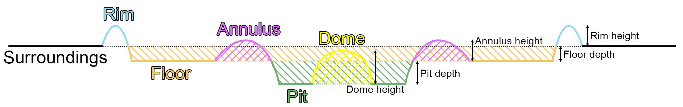
Figure 2. Topographic profile (solid line) of an idealized dome crater that illustrates how our volume and relief measurements are made. Different colors indicate the locations of different facies along the profile, corresponding to those used for the same facies in Figure 3 (excepting the surroundings, which are not depicted in Figure 3 but are included in the ArcMap versions of the maps). The levels of the surroundings, floor, and pit represent their mean elevations. Dotted lines represent extrapolations of these mean elevations to interior facies. Colored diagonal lines represent the regions for which volume measurements are made for each facies relative to these mean elevations: orange = crater volume relative to surroundings; purple = annulus volume relative to crater floor; green = pit volume relative to crater floor; yellow = dome volume relative to pit floor. Arrows in the right-hand half of the profile indicate relief measurements for the different facies.

- Mapping and Morphometry Results

Figure 3 presents our geologic maps overlain on the base maps and shown alongside the unannotated base maps and the DEMs. The maps are cropped closely around the rims of the impact features and so do not extend to cover the entirety of facies mapped farther outwards, specifically ejecta blankets. The complete ArcMap versions of the maps, as well as cube files of the mosaics and DEMs used to perform mapping, are contained within a zipped folder on the figshare repository (White and Schenk, 2024). We have defined 14 facies across all of our geologic maps, most of which are shared between multiple impact features, but a handful of which are unique to a single feature. The following text lists each of the facies we have defined and describes their characteristics.
Dome: Steep-sided edifice rising from the plains of a central pit that shows an equidimensional, often square-like, planform. The profile of the edifice tends to be curved and mound-like at lower diameters, becoming more flat-topped at higher diameters. At high image resolutions, the surface often presents a vaguely lineated, “breadcrust” texture (best seen at Doh and Neith). Domes are universally seen in dome craters and anomalous dome craters, and the elevated plains seen at the center of Hathor have also been mapped as a dome.
Pit: Smooth to slightly hummocky plains surrounded by and depressed below the annulus, as well as the floor, of the impact feature. For most impact features there is a single, central pit, but for some pit craters there are multiple small, often elongate pits distributed within the annulus (as at Achelous and Tindr). The outer boundaries of pits abut cliffs of the surrounding annulus, and this boundary ranges from relatively smooth, as at Isis and Har, to highly angular, as at Doh and Neith where valleys branch from the pit and extend into the annulus. Pits are universally seen in pit craters, dome craters, and anomalous dome craters.
Annulus: A ring of rugged, hilly terrain, often displaying a distinctive hummocky texture, that rises from the floors of impact features. The annulus typically slopes gently upwards from the floor and drops sharply to form cliffs that surround the central pit(s). The elevated zone defining the annulus ranges from contiguous around its entire circumference (seen at pit and dome craters) to fragmented, with valleys extending from the central pit separating the annulus into isolated segments as at the anomalous dome craters Doh and Neith. The annulus crosscuts the contact between the rim and floor, while Melkart’s dome crosscuts its annulus (the only instance of a dome contacting an annulus), confirming that annuli are established prior to dome formation. Annuli are universally seen in pit craters, dome craters, and anomalous dome craters.
Floor: Plains surrounded by and depressed below the rim that form the floor of the impact feature. They are generally smooth and slightly undulating when viewed at high resolution. With the exception of Har and Doh, floors are universally seen in pit craters, dome craters, and anomalous dome craters.
Rim: A circular, raised ridge forming the rim of the impact feature. In some cases, particularly for the smallest impact features, the rim displays a semi-continuous, sharp crest, but it more commonly appears as a ring of rugged, hilly terrain. Rims tend to be narrow and high for pit and dome craters, but become wider and lower for anomalous dome craters (most obviously in the case of Neith). With the exception of Har and Doh, rims are universally seen in pit craters, dome craters, and anomalous dome craters.
Outer platform: This facies is unique to Har and forms rugged, hilly terrain surrounding the annulus. It is elevated above surrounding terrain, and a bounding scarp is commonly visible where it is covered by high resolution imaging. As discussed in below, the outer platform may represent both the floor and rim, with these individual facies being undistinguishable on account of being obscured by ejecta and secondaries from the adjacent Tindr impact.
Bounding trough: Forming discontinuous troughs surrounding portions of the crater rim, this facies does not present a distinct texture in even high resolution imaging, but rather is only really apparent in the DEMs. Partial bounding troughs ~500 m deep are only observed for the anomalous dome craters of Neith and Anzu, and may represent a transition to palimpsest-like impact features, in which the outer bounds of the undulating plains are sometimes seen to dip down by a few hundred meters, as along the northern boundary of Hathor.
Ejecta: Rough terrain surrounding an impact feature that is interpreted as an ejecta blanket on account of it displaying a texture and albedo that is distinct from that of surrounding terrain, being elevated above surrounding terrain and bounded by a lobate scarp, and/or displaying a fabric that is radial to the impact feature. This facies is commonly seen surrounding pit and dome craters.
Impact crater: Craters formed by subsequent impacts that are superimposed on the impact feature. The rims and floors of these craters are mapped as this facies, as well as ejecta where the ejecta has a distinct morphologic and topographic signature as seen in the imaging and the DEM. At Epigeus, several superimposed impact craters reaching tens of km across have associated bright and diffuse ejecta blankets, but these have been mapped with a crosshatched overlay symbol rather than as the impact crater facies. For each impact feature we map all craters above a certain minimum diameter as this facies, and use these mapped craters for our crater age statistics (see section 5). The smallest mapped craters are normally at least 7 pixels across, but for the impact features of Har, Doh, Neith, and Buto that are both large and well-resolved and which feature >100 overlying craters that are 7 pixels across and larger, we have raised the minimum diameter above 7 pixels (9 for Har, 10 for Doh, and 13 for Neith and Buto) in order to generate counts comparable to the highest counts for other less well-resolved impact features (i.e. a few dozen to several dozens). Impact craters superimpose most impact features across all size classes, but no superimposed craters are mapped for Isis and Anzu (likely owing to low resolution imaging) and Osiris (likely owing to its very young age as implied by its very bright and prominent ejecta rays which superpose all terrains in contact).
Crater chain: This facies is unique to Har, and consists of linear chains of impact craters reaching 50 km long that are radial to the neighboring Tindr impact feature and are secondaries stemming from that impact. Individual craters within these chains cannot be distinguished, so they are mapped collectively and are not included in the crater age analysis.
Central plains: Expanse of flat plains reaching up to 100 km across that exists at the centers of most penepalimpsests and palimpsests. The plains are generally smooth, but can display a slightly knobby texture at high resolution (as seen at Buto Facula), reminiscent of “small chaos” on Europa (Greenberg et al., 1999). They are separated from the surrounding, higher-relief undulating plains by a low, inward-facing scarp, and superpose the undulating plains and concentric ridges.
Concentric ridges: Arcuate ranges of low hills reaching several tens of kilometers long and up to 500 m high, which are seen in all penepalimpsests and palimpsests, with the exception of Memphis Facula. They are situated within undulating plains and together form concentric rings at varying distances from the center of the impact feature. The ridges can be common and densely spaced, as at Buto Facula or Nidaba, or infrequent and sparse, as at Teshub and Epigeus.
Undulating plains: This facies dominates penepalimpsests and palimpsests and consists of plains that gently undulate with amplitude of a few hundred meters. They extend from the outer, scarp-defined boundary of the central plains to (in most cases) beyond the concentric ridges by a few tens of kilometers. The boundary between the undulating plains and the surrounding terrain is often subtle, with no distinct topographic rim, and is inferred based on a transition in the albedo as seen in the imaging (most apparent in the case of Memphis Facula) and surface texture as seen in the imaging or DEMs (when available); there is no distinct “rim” to the undulating plains.
Dark, undulating plains: This facies is unique to Memphis Facula. The majority of this impact feature is composed of regular undulating plains with an albedo that is high compared to the surrounding terrain, but towards the margins of the feature (typically within ~50 km of its boundary), portions of these plains display a lower albedo, but which is nevertheless still slightly higher that that of the surrounding terrain. Where they form large expanses, these dark, undulating plains appear to display somewhat less surface contrast at a scale of several kilometers compared to the regular undulating plains, and exhibit a vaguely concentric configuration.
To illustrate the transition in impact feature morphology with increasing feature size, we have taken multiple (at least 5) profiles across each impact feature for the majority of those that have DEM coverage, and used these to produce a single averaged, symmetrical, ‘idealized’ profile for each. The raw and averaged profiles are shown in Figure 3, along with the number of raw profiles that were used to make the averaged profile. We have declined to take profiles across Teshub and Nidaba, even though they have DEM coverage, as about a third of Teshub has been obliterated by the young, bright grooved terrain of Bubastis Sulci, and the photoclinometry DEM of Nidaba shows too much fluctuation across regional scales, presumably due to variations in intrinsic albedo. A high quality DEM is available for Buto Facula, and we regard the averaged profile that we have obtained for this feature to also be broadly representative of those of Teshub and Nidaba.
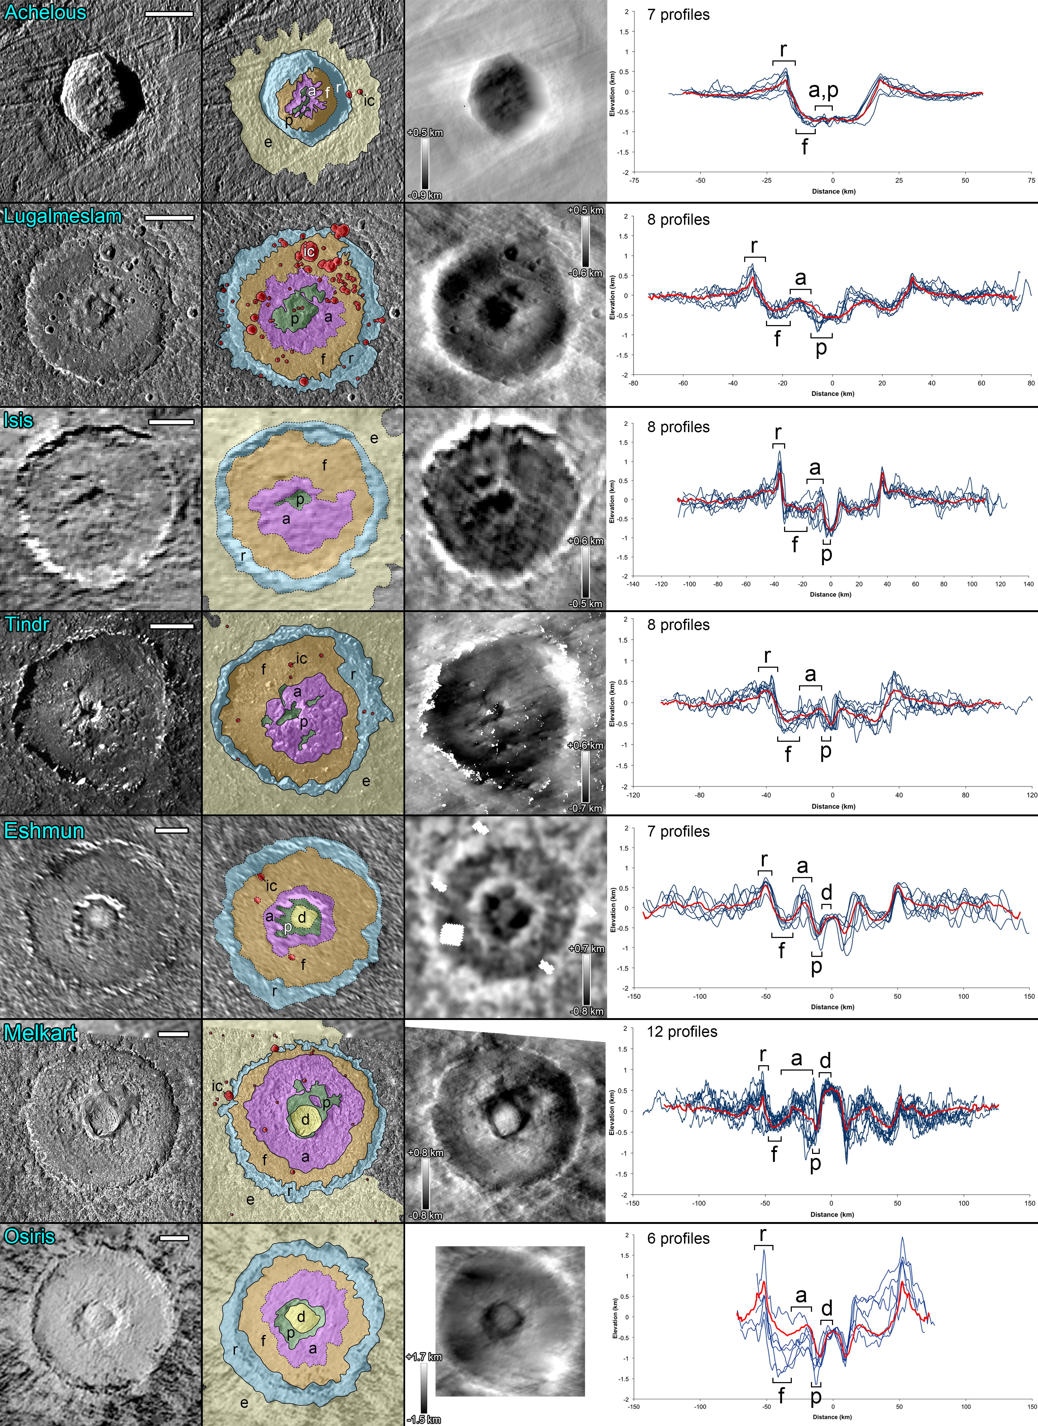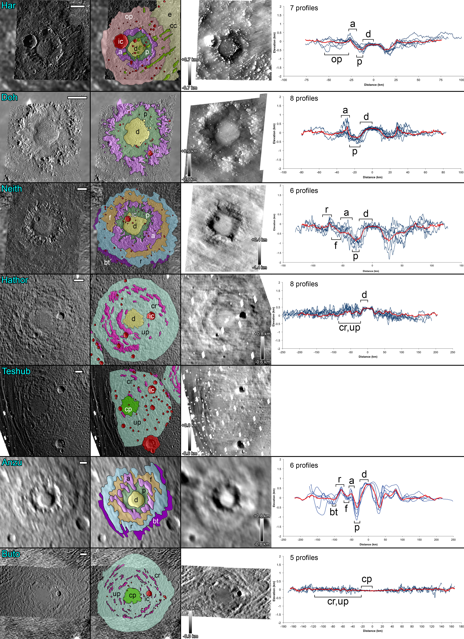
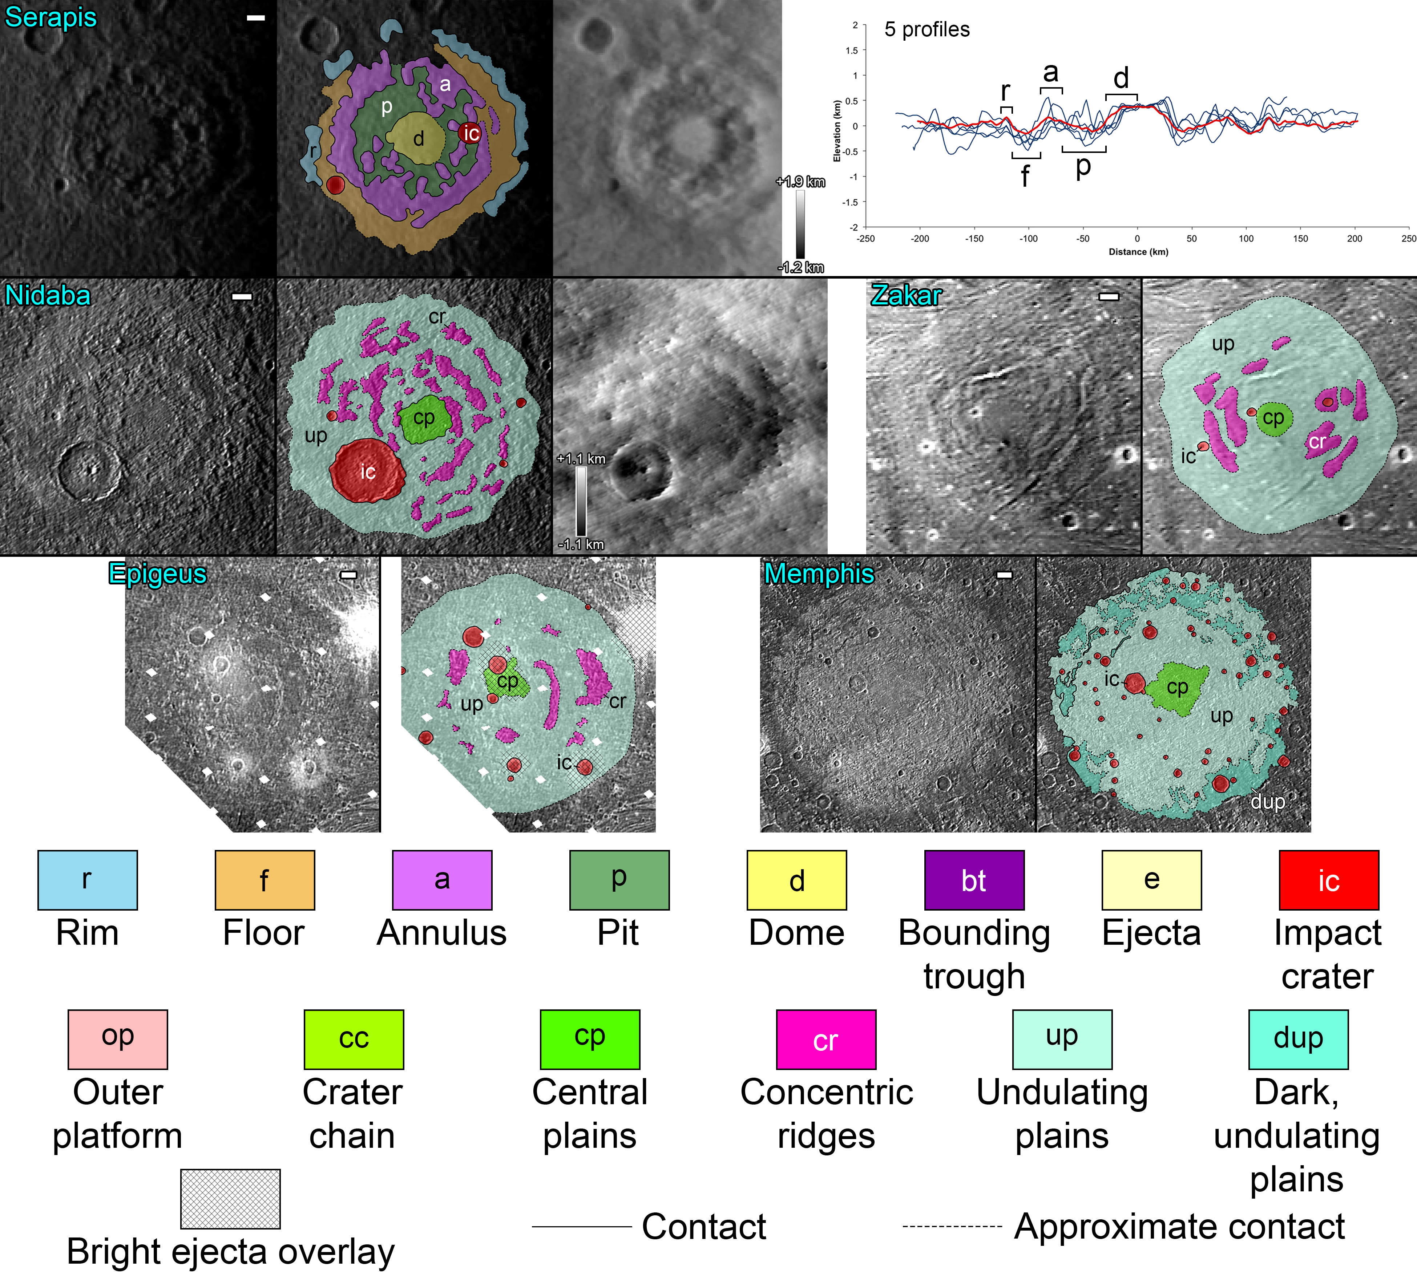Figure 3. Maps of the 19 Large Impact Features on Ganymede and Callisto, arranged in order of feature diameter. For each one, at left is the imaging used as the base map for geologic mapping, at center is the geologic map overlain on the base map, and at right is the corresponding DEM (available in most cases, but not for Zakar, Epigeus, and Memphis Facula), accompanied by an elevation scale. Scale bar at the top right of each base map measures 20 km. For 14 of the impact features with associated DEMs, multiple topographic profiles across the feature have been drawn (blue lines) and used to generate an average profile (red line). Profiles are all shown at the same elevation scale. Brackets in the left half of each profile indicate the radial extents of major facies within the averaged profiles (which are symmetrical about 0 km). In some instances where two facies cannot be distinguished in the profile, both are listed in the same bracket.

We present morphometric statistics measured for each impact feature in Table 2, and plots that show how these statistics vary with increasing impact feature diameter in Figure 4. The quantities plotted against impact feature diameter include facies diameter, the ratio of facies diameter to impact feature diameter, facies relief, and facies volume.
Two of the anomalous dome craters are notable in that they are “missing” some facies: Har and Doh. While both of these craters are covered at least in part by high resolution imaging, assessing their morphologies is inhibited for different reasons. Har has no obvious crater rim surrounding its annulus (the topographic relief of which is the most muted compared to all other dome and anomalous dome craters), but rather an outer platform that is raised slightly above the surrounding terrain (this is the measurement shown in the rim height column for Har in Table 2). Schenk et al. (2004) note that annular plateaus or pedestals surround many impact craters on Ganymede and Callisto, and suggest that they may have formed by radial flow or plastic deformation of a thicker inner portion of an ejecta deposit (e.g. Horner and Greeley, 1982; Moore et al., 1998), forming a convex snout as flow or creep halted. However, unlike these pedestals, which surround the rim of a crater, this facies is located where the crater floor and rim would normally be expected, but these individual facies cannot be distinguished. It is possible that the topographic relief and morphologies of these facies were obscured due to ejecta coverage and impact by secondaries from the neighboring Tindr impact. In addition, massive sublimation erosion unique to Callisto (e.g. Moore et al., 1999; White et al., 2016) may play a role in the absence of a rim.
Doh, located near the high albedo center of the Asgard multi-ring feature, is covered by the highest resolution imaging of any impact feature in our study, but this only covers the impact feature as far out as its annulus in its entirety. While high resolution imaging does extend far beyond the annulus to the south, as well as a short distance beyond the annulus in other directions, and while the terrain immediately surrounding the annulus must logically represent the floor of the crater, no definable rim or contact with one can be confidently identified anywhere in either the high resolution imaging or the lower-resolution global mosaic beyond. As such, Doh remains unmapped beyond the annulus and we have inferred its rim diameter of 128 km by fitting linear relationships to the plots of pit and annulus diameter against impact feature diameter in Figure 4a. A consequence of these limitations is that neither floor depths nor crater volumes have been measured for either Har or Doh.

Table 2. Morphometric statistics measured for the 19 Large Impact Features, which are displayed graphically in Figure 4. Diameters are mean values determined from the measured areas of the facies. Definitions of heights, depths, and volumes are shown in Figure 2.
Name | Impact feature diameter (km) | Annulus diameter (km) | Pit diameter (km) | Dome diameter (km) | Central plains diameter (km) | Rim height (km) | Floor depth (km) | Annulus height (km) | Pit depth (km) | Dome height (km) | Crater volume (km³) | Annulus volume (km³) | Pit volume (km³) | Dome volume (km³)
Achelous | 40 | 15 | 6 | - | - | 0.78 | 0.47 | 0.05 | 0.18 | - | 307 | 0.05 | 4 | -
Lugalmeslam | 64 | 34 | 18 | - | - | 0.81 | 0.29 | 0.64 | 0.17 | - | 720 | 100 | 46 | -
Isis | 75 | 36 | 12 | - | - | 1.44 | 0.14 | 0.71 | 0.29 | - | 538 | 43 | 36 | -
Tindr | 76 | 38 | 12 | - | - | 1.05 | 0.32 | 0.74 | 0.07 | - | 1002 | 123 | 9 | -
Eshmun | 101 | 43 | 26 | 15 | - | 0.83 | 0.23 | 0.85 | 0.40 | 0.44 | 1567 | 197 | 235 | 39
Melkart | 104 | 76 | 32 | 21 | - | 1.17 | 0.30 | 1.24 | 0.21 | 1.36 | 2227 | 1069 | 226 | 226
Osiris | 107 | 63 | 33 | 21 | - | 2.07 | 0.34 | 1.00 | 0.50 | 0.63 | 3076 | 426 | 407 | 57
Har | 110 | 56 | 39 | 25 | - | 0.96 | - | 0.52 | 0.48 | 0.47 | - | 46 | 560 | 87
Doh | 128 (inferred) | 71 | 52 | 28 | - | - | - | 0.97 | 0.16 | 0.77 | - | 314 | 336 | 182
Neith | 170 | 108 | 69 | 45 | - | 0.96 | 0.05 | 0.96 | 0.70 | 1.15 | 1372 | 288 | 2556 | 952
Hathor | 173 | - | - | 40 | - | - | - | - | - | 0.64 | - | - | - | 338
Teshub | 188 | - | - | - | 51 | - | - | - | - | - | - | - | - | -
Anzu | 193 | 109 | 75 | 47 | - | 0.85 | -0.09 | 0.80 | 0.47 | 1.26 | - | 559 | 1814 | 1242
Buto | 235 | - | - | - | 50 | - | - | - | - | - | - | - | - | -
Serapis | 253 | 180 | 140 | 60 | - | 0.67 | -0.05 | 0.74 | 0.13 | 0.73 | - | 2174 | 1336 | 1003
Nidaba | 265 | - | - | - | 52 | - | - | - | - | - | - | - | - | -
Zakar | 265 | - | - | - | 40 | - | - | - | - | - | - | - | - | -
Epigeus | 349 | - | - | - | 56 | - | - | - | - | - | - | - | - | -
Memphis | 354 | - | - | - | 76 | - | - | - | - | - | - | - | - | -

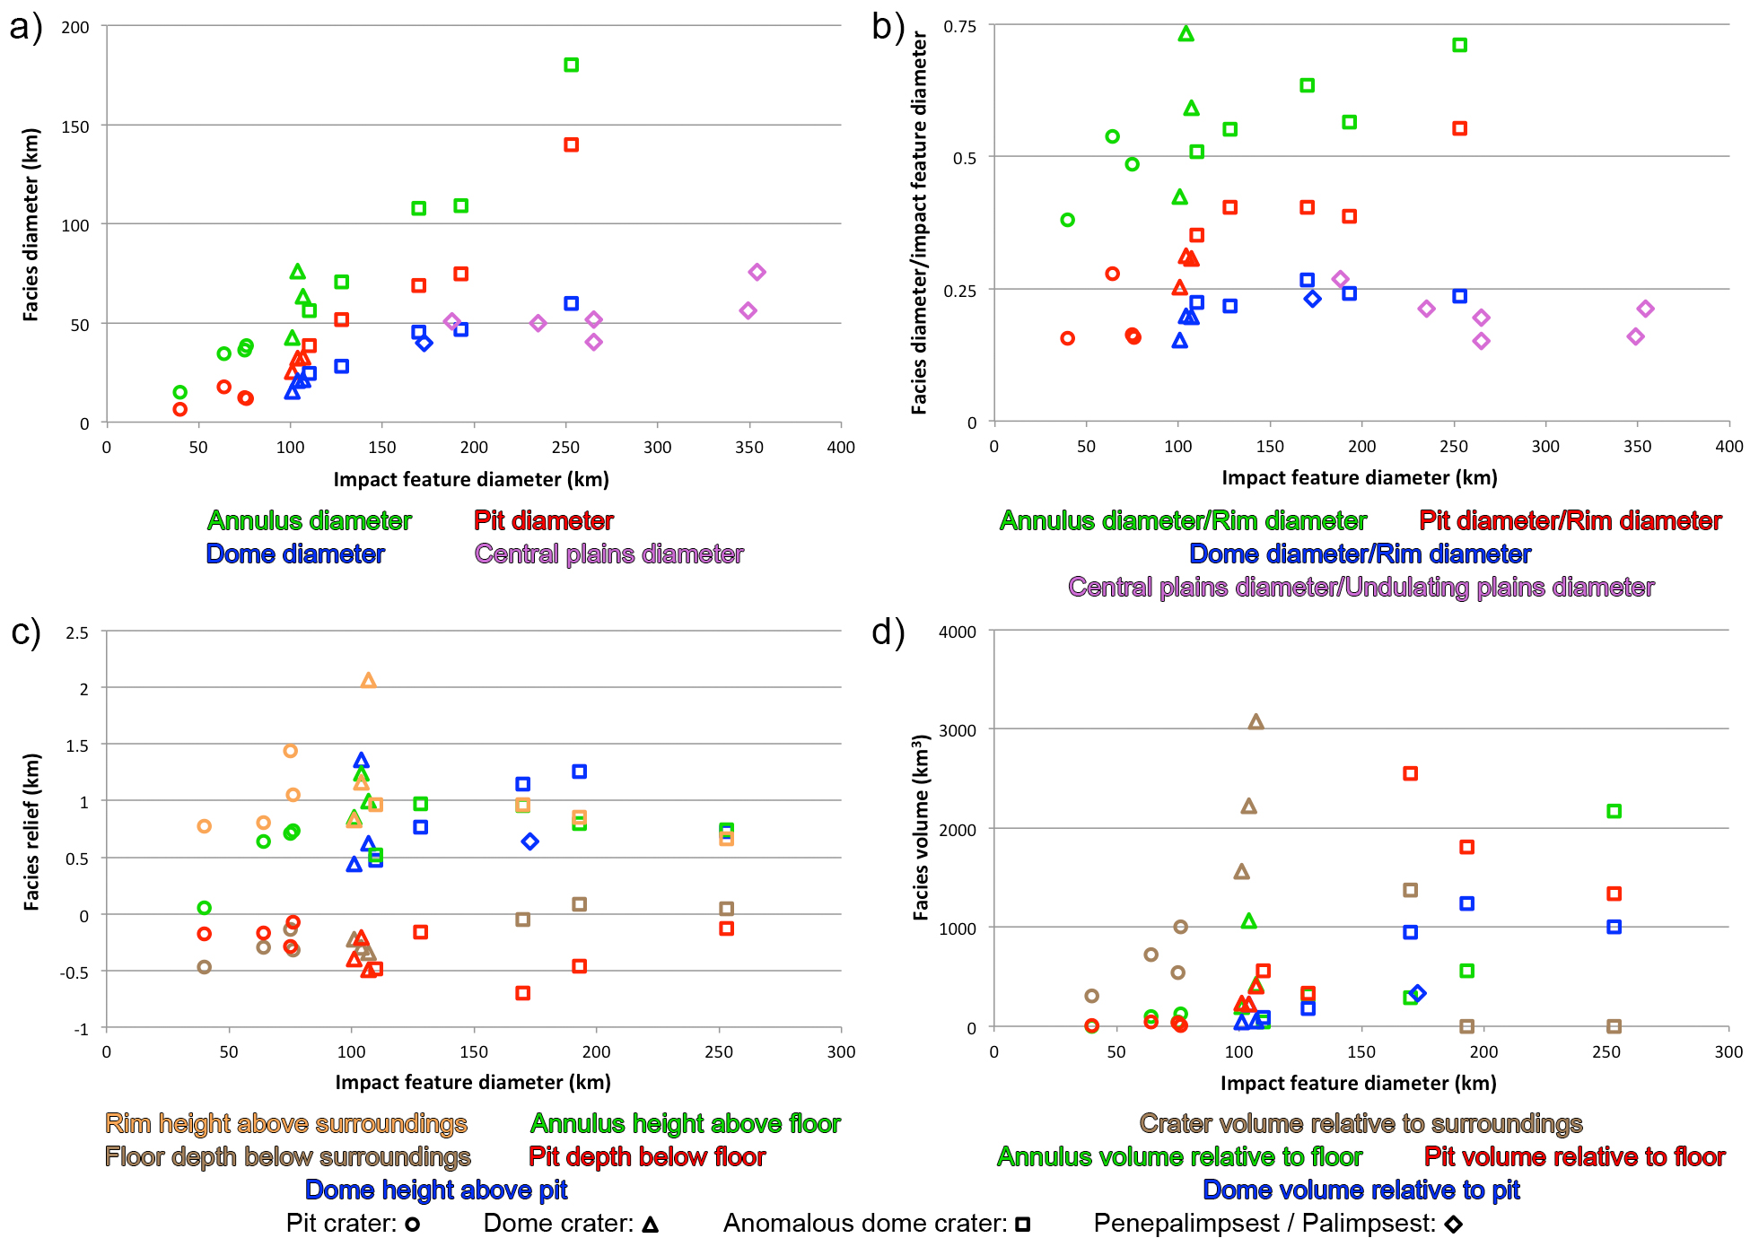
Figure 4. Morphometric statistics measured for each mapped facies as listed in Table 2, plotted against impact feature diameter. Different facies are represented by different colors, with the specific measured quantity in each plot defined by the corresponding colored text beneath. Different impact feature classes are indicated by different symbols as defined in the legend at bottom.

Figure 4a shows that facies diameter increases fairly linearly with impact feature diameter, but with the slopes of these trends decreasing in the order of annulus, pit, dome, and central plains. This is reflected in Figure 4b, which shows that while the ratio of facies diameter to impact feature diameter scales positively with impact feature diameter for annuli, pits, and domes in crater-type impact features, there is little corresponding increase (and perhaps even a slight decrease) in the diameter of the central plains relative to the diameter of the undulating plains of penepalimpsests and palimpsests. Domes start to appear on the floor of the central pit as the ratio of pit diameter to rim diameter exceeds ~0.25. Melkart has an exceptionally wide annulus, the diameter of which is ~73% that of the crater’s.
Figure 4c indicates that the topographic relief of most facies displays a fairly flat trend with increasing impact feature diameter, although the maximum relief of certain facies tends to be attained for dome craters. Osiris displays the highest rim with relief exceeding 2 km, which stands in contrast to Neith’s highly muted rim, essentially a broad, irregular annulus varying between 30 and 40 km wide, raised above the floor by up to 1 km, and displaying no crest. Melkart has the highest dome and annulus, rising 1.36 km and 1.24 km above their bases respectively, while Neith displays the deepest pit, 0.7 km below its crater floor. There does appear to be a slight trend of decreasing floor depth with increasing diameter across all morphological classes, culminating in Anzu and Serapis actually displaying mean floor elevations that are elevated above the surrounding terrain by 50 to 100 m (making them effectively level with the surrounding terrain).
Figure 4d shows that both crater and pit volume increase with impact feature diameter across the pit and dome feature classes, sharply so in the case of crater volume. Crater volume drops off for the three largest features in the anomalous dome feature class, with Anzu and Serapis, the largest such features, having crater volumes of zero owing to the fact that their floors are essentially level with the surrounding terrain. Crater volumes are not calculated for Har and Doh as crater floors are not identified for either of these features. Pit volume displays a flat trend for pit craters, increasing thereafter from dome to anomalous dome craters. For pit craters that show several small pits distributed within the annulus (Achelous and Tindr), the ratio of pit volume to crater volume is small (less than 0.014), increasing to ~0.065 for those pit craters with a single pit surrounded by the annulus (Lugalmeslam and Isis), and then increasing further to 0.1 to 0.14 for dome craters. Neith is the only anomalous dome crater for which crater and pit volumes could be measured, and its pit is much more voluminous than the crater itself, with a ratio of pit volume to crater volume of almost 2. Dome volumes tend to increase with increasing impact feature diameter. The ratio of dome volume to pit volume tends to be towards the lower end of the range of 0.14 to 0.75, but the great height of Melkart’s dome means that it has essentially the same volume as its pit. Annulus volume shows little increase with impact feature diameter up to and including Neith, above which it shows a dramatic increase for the largest anomalous dome craters, mostly on account of their much larger areas rather than showing particularly high topographic relief. An exception is the very high volume of Melkart’s annulus due to its unusually high relief and wide diameter.

- Crater Statistics and Ages

Schenk et al. (2004a) highlighted the apparent association of the morphologic classes of Large Impact Features on Ganymede and Callisto described above with increasing age, a finding we confirm here. While size is clearly an important factor in determining an impact feature’s morphology, gauging the relative ages of our impact features allows us to assess whether the timing of an impact feature’s formation correlates with its morphology, which in turn might illuminate how the thermal and physical state of the ice shells of these satellites have changed over time. Impact gardening and landslides associated with seismic shaking will also modify impact feature morphology over time (Costello et al., 2021; Mills et al., 2023), but the effect of these processes is minor at the scale that would affect our morphometry (hundreds of meters to kilometers). Determining ages for these impact features relies primarily on counting the craters superposed on each one, and using these counts, in combination with the total areas of the impact features as calculated using our mapping, to derive the crater spatial densities for each one. As noted in section 4, our mapping of the impact crater facies is used to derive crater counts for each impact feature. In nearly all cases this facies is mapped such that it covers a single superposing crater out to its rim, so the mean rim-to-rim diameter of the crater can be calculated based on its area. Exceptions to this routine are where a single polygon of the impact crater facies covers multiple superposing, adjacent craters, and where the impact crater facies also includes any ejecta that surround a superposing impact crater, in which case we measure the rim-to-rim diameters of each individual crater manually in ArcMap. For those impact features for which there is a steep decline in resolution from the high-resolution imaging that covers them to the surrounding global mosaic, we only perform crater counting for the portions of the impact features that are contained within the high resolution imaging. Our crater counts include craters superposed on any ejecta blanket that an impact feature may possess.
Table 3 presents crater count statistics for the 19 impact features, including the slopes of the cumulative and differential size-frequency distribution (SFD) plots shown in Figure 5. The slopes were fit by linear regression to either the cumulative or differential data points. Of the 16 impact features for which superimposed craters were observed, less than five craters were counted for Achelous, Eshmun, Serapis, Nidaba, and Zakar, and those few that were counted typically cover a narrow diameter range of a few km or less (Nidaba being a notable exception). We therefore regard the slopes of the SFD plots for these impact features to have a higher uncertainty relative to those of the others. These plots include potential secondary craters, the effect of which we will discuss on an individual basis in the following section. The differential slopes shown in Table 3 correspond to the plots exactly as shown in Figure 5b, with the exception of those for Melkart, Har, Doh, Neith, Teshub, and Memphis Facula. The data points for the lowest crater diameter ranges within the differential SFD plots for each of these impact features plot much lower than the trend defined by the other data points. This is a consequence of only a fraction of the craters within the smallest diameter range being identified due to the range overlapping with the resolution limit of the imaging, so for these impact features we discard the first data point (the smallest diameter bin) of their differential plots in order to obtain more accurate values for their differential slopes.

Table 3. Crater count statistics for the 19 Large Impact Features. No superimposed impact craters above the minimum diameter were observed for Isis, Osiris, and Anzu. Impact features with more than 1 and fewer than 5 superimposed craters that are above the minimum diameter are indicated in italics. Cumulative and differential slopes are for the size-frequency distributions in Figs. 5a and 5b. The distribution for Achelous is only a single point in the differential plot, so no differential slope is shown for it.
Name | Minimum diameter of counted craters (km) | Crater count | Crater diameter range (km) | Crater counting area  (×10³ km²) | Cumulative slope | Differential slope
Achelous | 1.27 | 2 | 2.22 - 2.75 | 3.14 | -3.28 | -
Lugalmeslam | 1.06 | 73 | 1.17 - 8.07 | 3.82 | -2.11 | -2.55
Isis | 7.04 | 0 | - | - | - | -
Tindr | 1.27 | 17 | 1.27 - 3.55 | 20.59 | -1.99 | -0.95
Eshmun | 3.52 | 3 | 3.94 - 4.33 | 8.72 | -10.42 | -3.00
Melkart | 1.17 | 47 | 1.17 - 6.23 | 38.58 | -2.47 | -3.26
Osiris | 5.46 | 0 | - | - | - | -
Har | 1.28 | 77 | 1.32 - 21.47 | 7.77 | -2.02 | -2.41
Doh | 0.89 | 20 | 0.91 - 5.65 | 3.89 | -1.86 | -2.55
Neith | 1.91 | 46 | 1.91 - 12.92 | 22.28 | -2.58 | -2.84
Hathor | 3.52 | 9 | 4.19 - 17.42 | 25.04 | -1.41 | -1.80
Teshub | 3.52 | 50 | 3.81 - 27.39 | 29.20 | -2.17 | -2.52
Anzu | 14.1 | 0 | - | - | - | -
Buto | 2.50 | 29 | 2.50 - 17.66 | 32.38 | -2.02 | -2.28
Serapis | 14.1 | 2 | 20.48 - 25.68 | 43.30 | -3.07 | -1.00
Nidaba | 5.63 | 4 | 8.12 - 71.37 | 55.27 | -0.55 | -1.78
Zakar | 10.12 | 3 | 10.12 - 11.78 | 53.76 | -7.11 | -3.00
Epigeus | 6.69 | 9 | 7.74 - 29.56 | 86.75 | -1.29 | -0.90
Memphis | 5.26 | 55 | 5.26 - 29.62 | 94.25 | -2.33 | -2.99

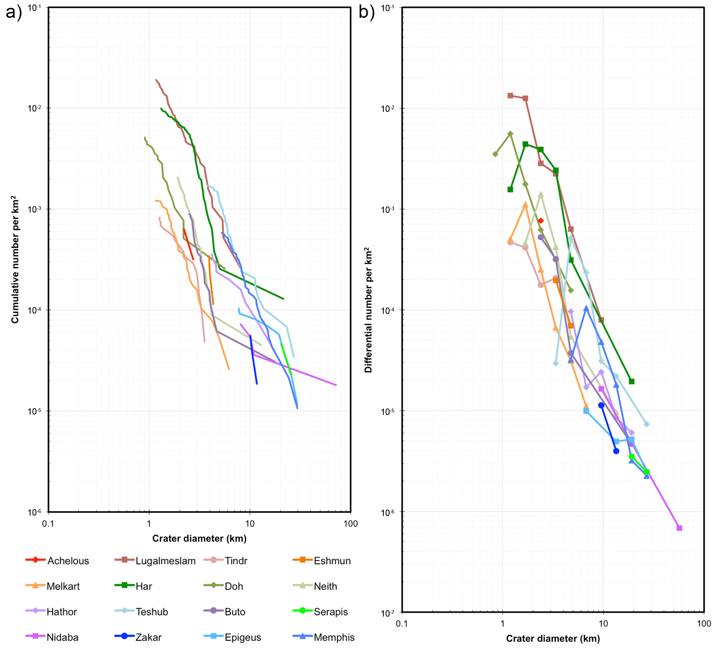
Figure 5. Cumulative (a) and differential (b) crater SFD plots for the 16 Large Impact Features for which superimposed impact craters were observed. The cumulative SFD plot contains data points for each individual counted crater but is shown as a line plot for clarity; each crater diameter bin in the differential SFD plot is indicated with a marker.

Figure 6 shows the crater densities for the 16 impact features individually in the relative or R-value format, in which a differential crater density represented by a power law with a slope of q is normalized by a size distribution with q = -3 (dN/dD ∝ D^{q}/D⁻³) (Crater Analysis Techniques Working Group, 1979). Error bars on the points are the R-values divided by $\sqrt{N}$, where N is the number of craters mapped for that feature. We have omitted the R-value data points for the smallest crater diameter ranges of the aforementioned impact features that display abnormally low values. We also group the R-plots together according to parent satellite, and juxtapose them with R-plots created by Schenk et al. (2004) for young surface features (including the Gilgamesh multi-ring feature and the bright terrain on Ganymede, and the Lofn crater and Valhalla multi-ring feature on Callisto), as well as for nearly global crater counts on both satellites that consider craters larger than 30 km and 50 km diameter on Ganymede and Callisto respectively. Zahnle et al. (2003) have estimated the age of Ganymede’s bright terrain to be ~2 Ga, and that of Gilgamesh to be 700 Ma to 1 Ga depending on whether the impact feature postdates or predates nonsynchronicity. Zahnle et al. (2003) have also assigned nominal ages of ~2 Ga to both Lofn and Valhalla on Callisto, although the young age is very uncertain for Valhalla, which is more densely cratered. Because Valhalla is near the apex of motion on Callisto’s leading hemisphere, cratering rates are high so that dense cratering does not in itself imply great age (Schenk et al., 2004).
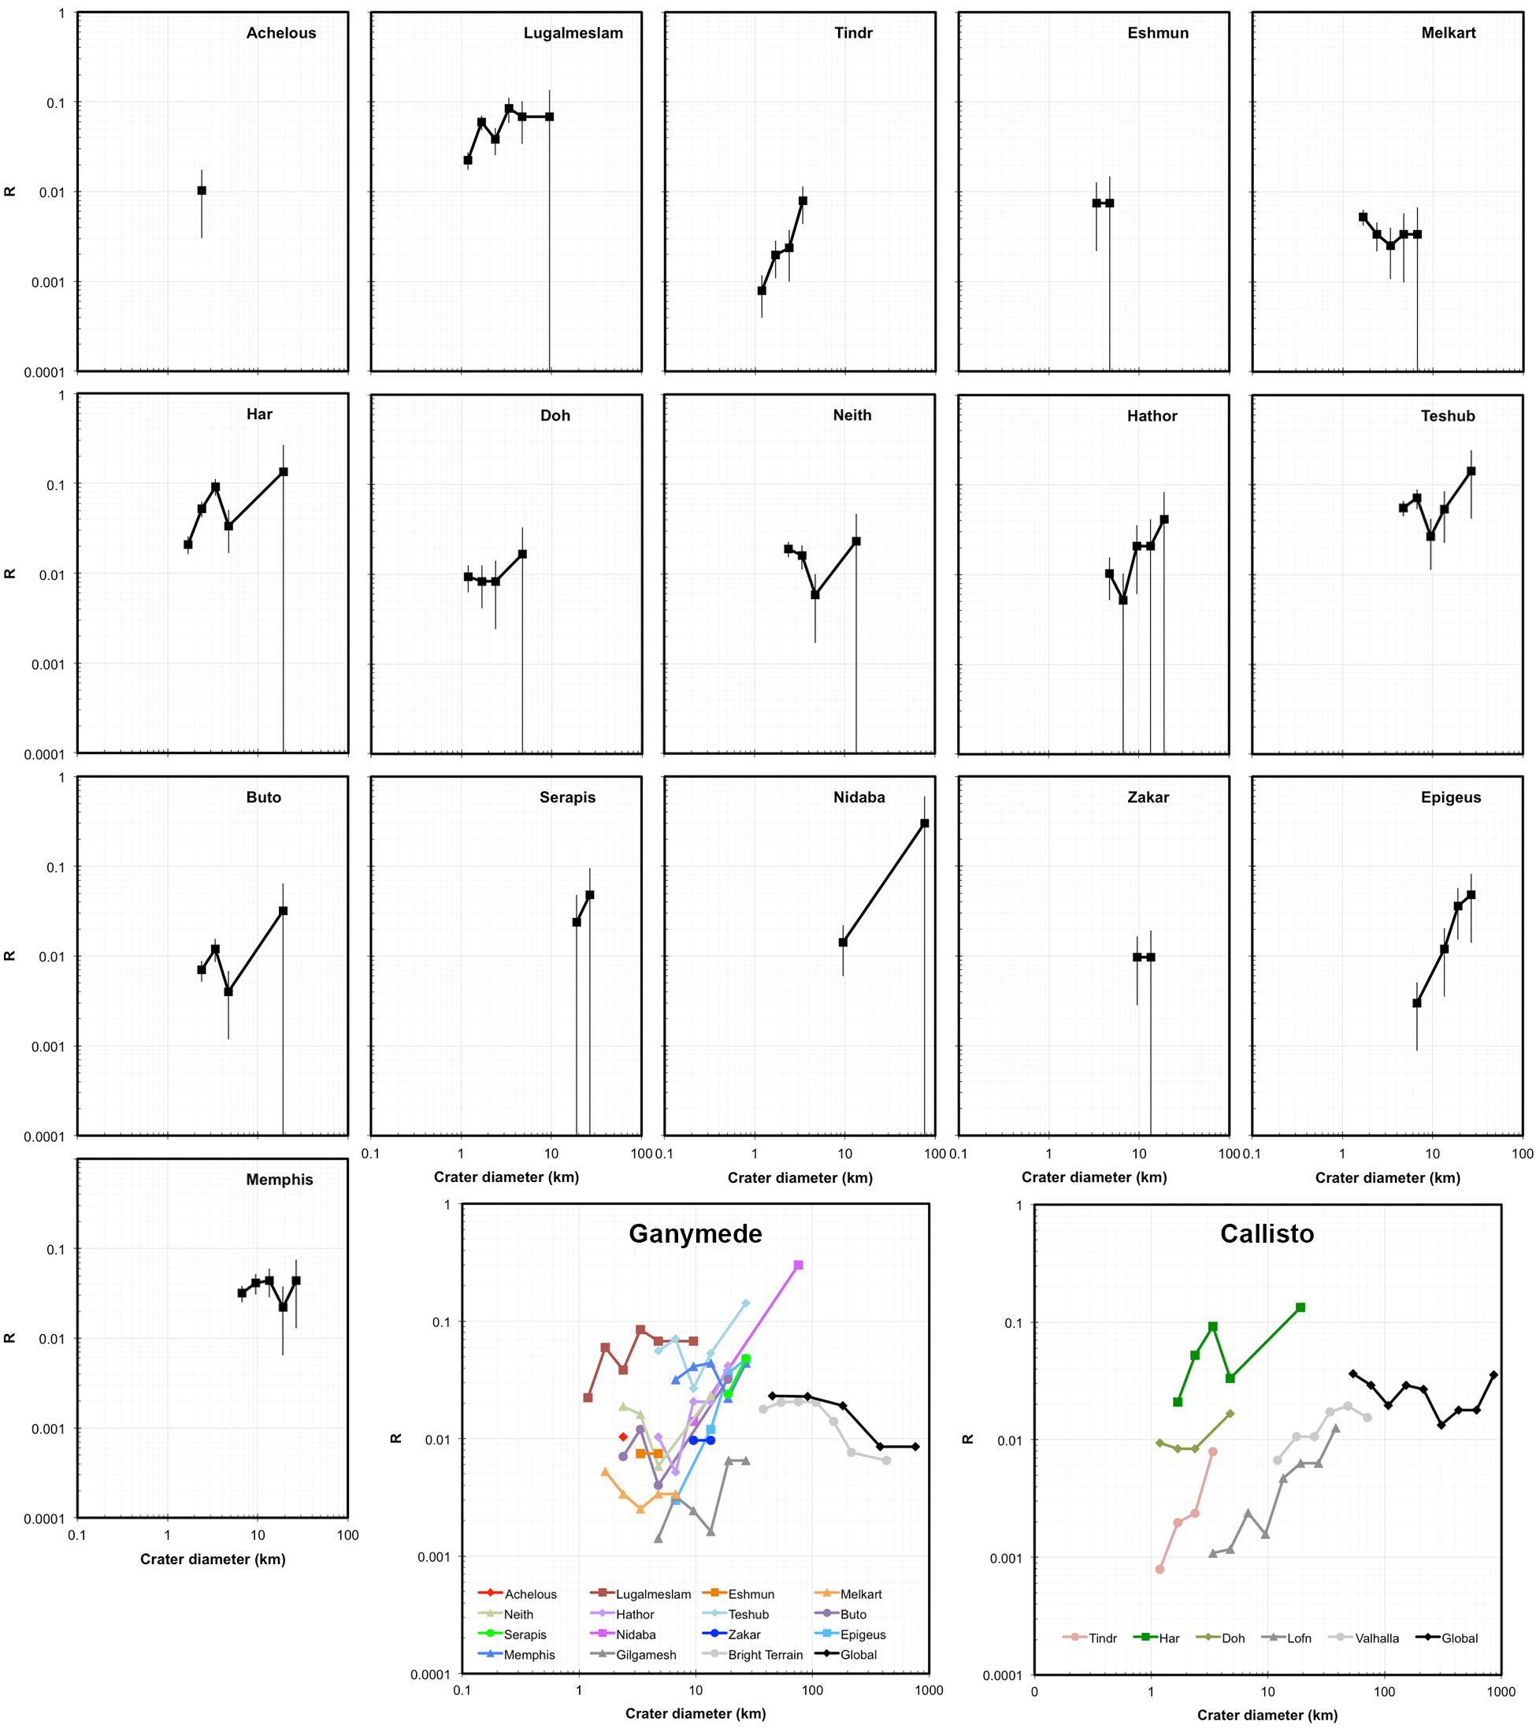
Figure 6. Individual R-plots, with error bars, for the 16 impact features for which superimposed impact craters were observed. Collective plots for impact features on Ganymede and Callisto are shown at the bottom, with different colored plots for the different impact features. The gray R-plots on the collective plots are for crater counts of young terrains and features, while the black R-plots are for nearly global crater counts, as presented in Schenk et al. (2004).

Three of the four pit craters that we have examined are on Ganymede (Achelous, Lugalmeslam, and Isis), with the fourth (Tindr) being on Callisto. Achelous and Tindr are both relatively well resolved in imaging and topography and display few, small craters within their rims and on their ejecta blankets, with consequentially low to middling values in their R-plots (Figure 6). The dense fields of secondary craters that surround them are also indicative of their relative youth. Singer et al. (2013) mapped 630 secondaries beyond the ejecta blanket of Achelous, the largest of which is 2.7 km across. It is likely that the majority of the ~2 km-sized craters on Gula, a relatively degraded central peak crater that is the same diameter as Achelous and located just 70 km from it, are also secondaries from Achelous. High resolution imaging does not extend beyond Tindr’s ejecta blanket as it does for Achelous’s, but the majority of the ~2 km-sized craters that we have mapped on Har, located just ~30 km southwest of Tindr, are Tindr secondaries, as are the northeast-southwest-oriented crater chains that mark Har. Based on their R-plots, Tindr may be roughly contemporary with Lofn at ~2 Ga (Zahnle et al., 2003). Isis, which displays a single large pit surrounded by the annulus, is the least well-resolved pit crater, with no craters larger than its resolution limit of 7 km having been mapped. This size is about the same as the largest superposing crater that we have mapped on any of the pit craters (8 km for Lugalmeslam), and so Isis may not be as young as it seems based on its total lack of craters. However, it does exist on bright terrain, which suggests that it may date to Ganymede’s middle age, as Zahnle et al. (2003) assigned an age of ~2 Ga to the bright terrain. Lugalmeslam is the most cratered of all the pit craters, and is amongst the highest plotting impact features on the R-plot. Several of its overlying craters that are 2 km across or less occur adjacent to each other in clusters or doublets, and so may be secondaries, although the source impact for them is uncertain as there are no large impacts within the vicinity of Lugalmeslam. However, 12 of Lugalmeslam’s 73 overlying craters are larger than a few km across, the impact feature as a whole has a quite degraded appearance, it has formed within Ganymede’s dark, cratered terrain, and its northeastern portion has been deformed by the young, bright grooved terrain of Mashu Sulcus, all of which point to it being the oldest of the four pit craters, likely older than the ~2 Ga isochron.
The three dome craters that we have studied all exist on Ganymede and are all relatively youthful based on their crater statistics and well-preserved morphologies. Osiris is one of the youngest large impact craters on Ganymede, as suggested by its prominent, very bright rays that extend more than 1000 km and its very high rim and crater volume. We have not mapped any craters larger than the minimum resolvable diameter of 5.46 km that superpose the crater or the ejecta in its immediate vicinity. Melkart also shows a bright ejecta blanket (albeit not nearly as bright as that of Osiris) and a low density of mostly <3 km diameter craters superposed on it and its immediate ejecta, giving it the lowest-plotting R-plot of any cratered impact feature we have measured on Ganymede, approximately contemporaneous with Gilgamesh. Eshmun shows only three superposing craters, all about 4 km across. Melkart is situated within dark, cratered terrain, and Eshmun, while located only 440 km away from Melkart, superposes bright, grooved terrain of Sippar Sulcus. Osiris superposes the grooved terrain of Mumu Sulci.
The two smallest of the five anomalous dome craters we have examined (Har and Doh) are located on Callisto, while Neith, Anzu, and Serapis are all located on Ganymede. The center of Har is located only 115 km from the center of the younger pit crater Tindr, the ejecta and secondary craters of which have modified Har’s appearance, and possibly obscured details of some of its facies. We interpret most of the 75 impact craters of 5 km diameter or less that are superposed on Har to be Tindr secondaries, as well as the crater chains that we have mapped. The high density of these secondaries alone places Har high on the R-plot, although its superposition by a non-secondary 21.5 km diameter crater suggests that Har may genuinely be an ancient crater. The portion of Doh that we have mapped is lightly cratered and plots between Tindr and Har on the R-plot, roughly contemporaneous with Valhalla. Like Doh, Neith’s superimposed craters mostly have diameters of a few km, with one larger than 10 km, giving it a middling position on the R-plot. No superimposed impact craters of 14 km diameter and above are resolved for Anzu, while only two are resolved for Serapis, making it plot fairly high on the R-plot. The inability to identify small craters like those superposing Har, Doh, and Neith, however, means that the ages of Anzu and Serapis cannot be constrained to the same degree based on crater statistics. Har, Doh, and Neith are situated in dark, cratered terrain while both Serapis and Anzu superpose bright, grooved terrain.
The three penepalimpsests Hathor, Nidaba and Buto Facula plot similarly on the R-plot, with all three nearly overlapping across the 9.5 to 22.6 km crater diameter range that they share, so are likely to be of similar age. Hathor is located on bright, grooved terrain of Bubastis Sulci while Nidaba and Buto Facula are both located within dark, cratered terrain. Two palimpsests, Teshub and Memphis Facula, are amongst the most ancient of all of the impact features we have examined, displaying high R-values especially in the 5 to 14 km crater diameter range. The other palimpsests, Zakar and Epigeus, are not as well resolved, and while they both plot lower than all the other palimpsests and penepalimpsests on the R-plot, we cannot constrain their ages as well based on crater statistics. However, both Zakar and Epigeus superpose bright, grooved terrain, while Memphis Facula exists within dark, cratered terrain and Teshub is crosscut by bright, grooved terrain, so the geologic contexts of Zakar and Epigeus appear to indicate support them being young palimpsests.

- Discussion

In this section we discuss the implications of our impact feature mapping, morphometry, and crater statistics results in terms of what they reveal about the conditions of impact and the subsurface structural and thermal environment that prevailed during and after the impacts that formed them, referring to modeling results of Caussi et al. (2024) and Korycansky et al. (2022a,b) where relevant. We focus on individual morphological classes in order of increasing size, with a separate section for those features that appear to be transitional between anomalous dome craters and penepalimpsests.

Pit craters: The modeling of Korycansky et al. (2022b) has simulated an impactor population with characteristics and parameters suitable for Ganymede, and calculated the resulting melt volume for every impactor that produces a crater of the size corresponding to the impact features that we have mapped. They then compared these volumes to pit volumes derived from our mapping and morphometry. They found that inferred melt volumes are, in general, much greater (typically one to two orders of magnitude) than our pit volumes, and suggested that a modest amount of melt drainage along with infiltration or re-freezing played a role in generating these features. In general, there is ample melt available to be mobilized, which may result in surface feature formation. This has been explored by others, e.g. Elder et al. (2012) who proposed similar ideas and suggested that drainage of melt through impact-generated fractures could account for crater pits on Ganymede and other bodies in the Solar System. Caussi et al. (2024) expanded on the hypotheses of Elder et al. (2012) and Korycansky et al. (2022a,b) by suggesting that a pool of melt at the center of an impact feature would be sealed by some of the water draining into fractures underneath it and then refreezing, while surface freezing of the melt pool would trap it as a subsurface lens of melt. The melt would cool, freeze, and expand over time, stressing the surrounding ice, which would eventually break the seal and lead to drainage of liquid into deeper cavities in the subsurface and subsequent roof collapse over the lens to form the pit at the center of the crater.
The hypothesis for pit formation of Caussi et al. (2024) has not yet been tested by modeling the evolution of a melt pocket, but we argue that the degree to which melt has drained into the subsurface can plausibly explain the differences in pit configuration that we observe. The single pit craters Lugalmeslam and Isis display higher pit volumes than the multiple pit craters Achelous and Tindr by a factor of at least 4. Efficient draining of a large volume of melt (relative to the size of the impact) beneath Lugalmeslam and Isis may account for their single, high volume pits, while smaller, disconnected volumes of melt may have been generated for Achelous and Tindr, the drainage of which formed small, irregular pits isolated from each other. The diameter range of the pit craters is quite narrow, from 40 to 76 km, and Achelous and Tindr are at opposite ends of this range, which would suggest that the development of a single large pit as opposed to multiple small pits does not seem to be dependent on crater diameter. The degree to which it is dependent on the age of the crater or the age of the target surface is also not obvious based on the crater statistics (see Table 3) and geologic contexts (see Table 1) of the four craters. Tindr and Achelous are both quite young but are located within older, dark, cratered terrain on Callisto and younger, bright grooved terrain on Ganymede respectively. Lugalmeslam is older and has impacted into dark, cratered terrain, while Isis is of uncertain age based on crater statistics but has impacted into bright, grooved terrain and thus is not extremely ancient.
If the pits do represent locations of impact melt drainage into the subsurface, then we hypothesize that the positive topographic relief of the annuli, which commonly display a hummocky, hilly morphology, may plausibly represent bulging of the surface resulting from the refreezing and expansion of the ponded melt lens prior to the breaking of the seal and the draining of the melt into the deeper subsurface, as hypothesized by Caussi et al. (2024). The simulations of Korycansky et al. (2022a) show that the final configuration of melt underneath impact features in the pit crater, dome crater, and anomalous dome crater classes forms a wide, shallow lens extending to approximately half the diameter of the crater itself, with a narrower column of melt extending deeper under the center of the crater. We find that the mean ratio of annulus to crater diameter is 55%, which corresponds well to the width of the shallow melt lenses that are formed in the simulations. Mean annulus relief above the crater floor ranges between 50 and 250 m, meaning that if this relief is due to the ~9% volumetric expansion caused by the freezing of a subsurface melt lens, then such a lens may range in thickness between 550 m and 2750 m (likely to be minimum values as some of the melt in the lens may also drain upon formation of the pit). Annuli are highly variable not only in terms of the ratio of their volumes to those of the pits (ranging between 0.01 and 13.79 across the four pit craters, which also happens to be the full range across all pit, dome, and anomalous dome craters), but also the ratio of their diameters to those of the pits (with pit craters, dome craters, and anomalous dome craters showing mean ratios of 2.6, 2.0, and 1.4 respectively). This implies high variability in the degree to which melt remains frozen in the shallow surface versus drains as a liquid into the subsurface, and also that the melt lens becomes less wide relative to the column with increasing crater diameter.
The pronounced rim heights and floor depths of pit craters (relative to their diameters) indicate that these impacts only penetrated to shallow depths within a rigid ice layer that could support the steep slopes of the resulting crater topography. Accordingly, the apparent independence of pit and annulus configuration on crater size, age, or geologic context suggests that the physical state of the shallow subsurface that these smaller impacts penetrate to is essentially the same for all geological contexts at all times in the satellite’s history. Hypotheses 4 and 5, whereby the impact penetrates to a weak subsurface layer, therefore do not likely explain the morphologies of pit craters. We also disfavor Hypothesis 1, offered by Senft and Stewart (2011), whereby shock-induced formation of dense high-pressure polymorphs concentrates a plug of warm ice on the center of the crater floor. While Senft and Stewart (2011) found that the ratio of plug diameter to crater diameter predicted by the simulations was in good agreement with measurements of the ratio of central pit diameter to crater diameter, they noted that development of the plug into a central pit or dome was beyond the scope of their work, and acknowledged that drain of melt into fractures in the crater floor (a process not modeled in their simulations) may contribute to formation of the pit. As such, it is not especially obvious to us how the evolution of a body of warm surface ice by itself can satisfactorily explain the existence of the central pits in addition to the surrounding, raised annuli. Instead, we favor Hypothesis 3, in which an isolated pocket of melt akin to those produced by the impact simulations of Korycansky et al. (2022a) is generated by the impact, the volume and configuration of which depends more on the velocity and angle of impact than the subsurface conditions at the time of impact. In turn, the volume and configuration of the melt pocket will influence the degree to which impact melt drains (causing subsidence that yields the central pit) versus remains and refreezes (expanding to produce the uplifted annulus), and therefore the final form of the pit crater. We do emphasize that the degree to which crater subsurface structure is at all permeable has never been demonstrated, however, nor has impact melt been unambiguously identified in any of the available Galileo imaging. In contrast, high resolution imaging by Cassini demonstrates that impact melt there is negligible (Schenk et al., 2020). An improved understanding of the role of impact melt on Ganymede and Callisto will have to await the arrival of the new mapping missions.

Dome craters: Dome craters are distinguished from pit craters in that the single, large pits on their floors harbor a steep-sided, flat-topped dome (Moore and Malin, 1988; Schenk, 1993). Pit diameter and the pit/crater rim diameter ratio must reach threshold values in order for dome formation to occur: the red plots in Figures 4a and 4b indicate a transition diameter of ~25 km and a transition ratio between ~0.25 and 0.28. The universality of single, large pits within the dome and anomalous dome crater morphological classes indicates that the phenomenon causing multiple small pits to form within the annulus in some pit craters is never replicated in the larger classes. We interpret this to be due to impacts large enough to produce craters in the dome morphological class invariably producing sufficient quantities of melt and fractures to result in the formation of a single, large pocket or plug of impact melt that drains efficiently into the subsurface – the pit craters with single pits, Lugalmeslam and Isis, have pit volumes of 46 and 36 km³ respectively, which the pit volumes of dome and anomalous dome craters exceed by a factor of at least 4.5. Dome craters arguably display the least variety in the configuration of their facies of any impact feature size class, always showing an outwards sequence of dome, single pit, annulus, floor, and rim with fairly consistent facies diameter ratios, with the exception of their annuli. It is harder for us to assess whether the timing of their formation is influential as all three of the dome craters we have examined are young. Yet the pronounced rims, deep floors, and large volumes indicate that, even though the dome craters are larger than the pit craters, these impacts still only penetrated within rigid material that could support the high topographic relief of the resulting craters, regardless of age or geologic context (Schenk, 2002).
Caussi et al. (2024) have addressed the issue of dome formation by using finite element simulations to model relaxation of crater topography, in which they use some of our averaged topographic profiles in Figure 3 to evaluate their results. Based on their simulation results, Caussi et al. (2024) argue that dome craters can evolve from pit craters through topographic relaxation, facilitated by the remnant heat from the impact, with the domes forming within ~10 to ~100 Myr after impact. Topographic relaxation acts to eliminate the stresses induced by the crater topography and restore a flat surface: ice flows downwards from the rim and upwards from the crater depression driven by gravity. Caussi et al. (2024) found that their simulation result that provided the closest match to our topographic profile of Osiris was obtained when the remnant heat was confined strictly below the pit. Notably, their simulations show that formation of a dome is always accompanied by relaxation of the crater as a whole, because enhanced uplift in the pit can only occur when the surrounding ice is soft enough to accommodate this extra flow. Longer wavelength topography relaxes more readily than shorter wavelength topography of the same amplitude, and dome formation is only viable for impact features in the dome crater size class and above. Simulations performed for craters in the pit crater size class (several tens of km diameter) show that while the crater can relax under a high heat flux, the pit sizes are too small to allow a dome to form within the pit via relaxation, regardless of heat flux. The simulations show that relaxation has reduced the floor depths of dome craters by as much as 45% and 65% over 100 Myr for heat fluxes of 3.5 mW m⁻² and 10 mW m⁻² respectively. This is reflected in our observation that the mean floor depth of the dome craters (0.29 km) is actually slightly less than that of the pit craters (0.31 km) despite the dome craters having larger diameters by tens of km.
While these simulations show that the bulk morphologies of these domes can be plausibly explained by relaxation of pit topography, their surface textures indicate that other factors may also contribute to their growth. A vaguely lineated “breadcrust” texture is identified on the better resolved domes, including those of Melkart, Har, Doh, and Neith, which may indicate fracturing of a rigid outer carapace that formed at their surfaces. Caussi et al. (2024) noted that some remaining liquid melt within the pocket beneath the pit might extrude through the collapsed roof of the pocket onto the floor of the pit, which they argued could “seed” an initial small dome that subsequently grows via relaxation; we consider it possible that ongoing extrusion of such melt might also supplement the relaxation and contribute to the expansion and fracturing of the dome’s cooled surface. We also note that dome formation via relaxation of pit topography is broadly consistent with Hypothesis 2, whereby Moore and Malin (1988) suggested that the impact would produce a subsurface lens of warm ice that ascends in a diapiric fashion, with the diapir manifesting as a dome once it reaches the surface. Moore and Malin (1988) noted that diapirs will tend to rise from sites of upward perturbation, which may be provided by the subsurface flow of material beneath a viscously relaxing crater. While we have argued that drainage and refreezing of a melt pocket under the crater is necessary to form the pit and annulus, and therefore that a warm ice lens is not immediately generated under the crater by the impact itself, residual heat of the impact would remain after the pocket has entirely frozen, leading to the same conditions hypothesized by Moore and Malin (1988) and modeled by Caussi et al. (2024), whereby the pit and crater topography relax together in the still warm ice.

Anomalous dome craters: Anomalous dome craters broadly display the same facies as dome craters, with their main distinguishing characteristics being that the craters are shallower than pit and dome craters, while their rims are much broader and less well defined than those of pit or dome craters, with rim scarps being nearly completely suppressed. Besides these differences, the depths of their pits and the heights of their annuli and rims are not appreciably different to those of the pits, annuli, and rims of pit and dome craters. Pit volumes and dome volumes, however, are much larger than those of pit and dome craters. They peak at Neith and Anzu, and decrease for Serapis, although annulus volume continues to increase as far as Serapis, indicating that any decrease in annulus relief is not compensated for by a corresponding decrease in area for the largest anomalous dome craters.
Caussi et al. (2024) performed relaxation simulations for a 145 km diameter crater in the anomalous dome class and used our averaged topographic profile of Neith in Figure 3 as the means to evaluate it. Note that our 170 km diameter for Neith refers to the distance to the outer bound of the topographically muted rim facies, while their simulated diameter of 145 km corresponds to the distance to the topographic rise in the middle of the rim as it appears in our averaged topographic profile, which is where a sharp rim crest separating the inner and outer walls of the rim would be expected for a dome or pit crater. For a low heat flux of 3 mW m⁻², a prominent dome rising ~1.1 km above the pit floor emerges in the simulation (very similar to the 1.15 km measured for the Neith dome), with the final crater rim showing relief above the floor of ~1 km, which matches the 1 km measured for Neith. For the high heat flux of 10 mW m⁻², all topography is relaxed within 10 Myr (with total crater relief of ~100 m). Such relaxed topography is not found in any of the anomalous dome craters that we have measured. This lack of relaxation appears to be consistent with our observation that the majority of the anomalous dome craters we have studied (with the exception of Har) are middle-aged or younger based on their crater statistics and/or their superposition of bright, grooved terrain, and therefore that they formed after the high heat fluxes that prevailed during the early histories of these satellites had subsided.
The subdued topographic relief of the floors and rims of anomalous dome craters is partly a consequence of relaxation of their topography, as demonstrated in the simulations in Figure 10 of Caussi et al. (2024). However, we hypothesize that the primary control on their morphology is that features in this size class are beginning to demonstrate sensitivity to the effects of a warm, weak, but still solid subsurface layer, whereby the impacts are large enough to penetrate as far as a warm subsurface ice layer (Hypothesis 4), but not as far as a liquid layer underneath such warm ice (Hypothesis 5). This vertical structure is broadly similar to the cold-to-warm ice layering proposed based on crater depth transitions by Schenk (2002). Penetration into a weaker subsurface layer would cause the mobilized material that defines the initial crater shape to behave more like a Bingham viscoplastic (i.e. behaving as a rigid body at low stress but flowing as a viscous fluid at high stress) than if only shallower, more rigid material had been penetrated (Schenk, 1993). This more plastic rheology means that the initial crater cannot support the same high topographic relief and steep slopes as for the smaller dome and pit craters, hence the decreasing floor depths and broader rims with increasing impact feature diameter. However, the fact that the annuli and pits of anomalous dome craters are still often topographically prominent (especially in the case of Neith) shows that, while the initial crater presents minimal topographic relief, the impact process is still accompanied by the production of large volumes of melt, some of which drains to form deep pits, and some of which remains in the shallow subsurface and refreezes to form the annulus. The melt volume calculations of Korycansky et al. (2022b) predicted that, as with the pit and dome craters, the pit volumes of anomalous dome craters should be smaller than the melt volumes produced by such impacts by a factor of 1-2 orders of magnitude, implying that only a small fraction of the produced melt contributes to the observed annulus and pit morphology.

Possible transitional features between craters and penepalimpsests: The largest impact feature class that we examine, comprising penepalimpsests and palimpsests, is unique in that nearly all of the facies that define it (excepting the dome that we have mapped for the raised central portion of Hathor) are unique to this class, exemplifying the profound morphological transition from anomalous dome craters. We note that the term penepalimpsest has been used somewhat flexibly in the literature, sometimes to describe features that are interpreted to be transitional between anomalous dome craters and palimpsests (Passey and Shoemaker (1982) even described what we call anomalous dome craters as “Type II penepalimpsests”), while other studies, such as Thomas and Squyres (1990) and Jones et al. (2003) have lumped penepalimpsests and palimpsests together. Schenk et al. (2004) describe several concentric structures in penepalimpsest interiors, usually inward-facing scarps or narrow low ridges several hundred meters high, in addition to the central smooth area. We do not place penepalimpsests and palimpsests in separate impact feature classes, but rather regard penepalimpsests as being those impact features within this single class (specifically Hathor, Buto Facula, and Nidaba) that display a higher proportion of concentric ridges within their interior, which also reach greater lengths, extend around a greater fraction of the impact feature’s circumference, and appear more developed than those in impact features that are better described as palimpsests (specifically Teshub, Zakar, Epigeus, and Memphis Facula).
The Large Impact Features of Ganymede and Callisto therefore essentially fall into two broad morphological classes: craters, where the impact forms a depression and a prominent central structure and (except in anomalous dome craters) an inward-facing rim scarp, and the penepalimpsests and palimpsests, where the impact does not form a measurable depression, and the overall topographic relief of the feature is minimal (few hundred meters). The morphological disparity between pit and dome craters is essentially governed by diameter, with domes emerging on pit floors above a threshold crater diameter. Yet while most of our measured impact features between 110 and 200 km in diameter are anomalous dome craters, the smaller penepalimpsests (the smallest being Hathor at 173 km diameter) and palimpsests also occur in this size range, while Serapis, the largest anomalous dome crater, is 253 km in diameter. This observation demonstrates that size becomes a less crucial factor in determining impact feature morphology above diameters of 150 km, with the physical state of the subsurface (which itself may be related to the timing of the impact) becoming increasingly important.
Serapis and Hathor are two impact features in this diameter range with morphologies that appear transitional between anomalous dome craters and penepalimpsests, and comparison of them is revealing for understanding this transition. The essential facies that form anomalous dome craters can be recognized in Serapis, but its annulus and rim have dissociated into a fragmented, concentric configuration. For Hathor, this transition has advanced such that it presents a set of concentric ridges surrounding an expanse of smooth plains at the center. The majority of the impact feature consists of undulating plains, with no identifiable rim, crater floor, or central pit. Interestingly, both of these features display what we have mapped as the dome facies at their center, although they may be more accurately described as raised central plains, since both feature the smallest height/diameter ratios of all domes that we have mapped (0.012 and 0.016 for Serapis and Hathor respectively compared to a mean of 0.028 across all domes). Hathor is the smallest feature in the penepalimpsest/palimpsest feature class that we have studied, and also the only one that shows such a dome, which is elevated by ~400 m above the undulating plains that surrounds it and which it superposes. Unlike the dome of Serapis, which is located within a broad central pit, as is characteristic of anomalous dome craters, the dome of Hathor is not situated within a pit. It is feasible that the domes of both impact features have formed via gravity-driven flow of warm, low-viscosity ice, the driving force of relaxation (Caussi et al., 2024), but in the case of Hathor, both the dome and any pit that it may originally have been situated in have since relaxed to their present low relief. Alternatively, the dome may represent an extrusion of material onto the surface, as with the central plains facies (see following section), but which is more viscous and so forms a scarp-bounded edifice rather than an expanse of plains. The 0.5 km/pixel imaging that covers Hathor is not sufficient to determine which of these hypotheses is better suited to explain Hathor’s dome.
The factors that determine why these impact features both display central domes are the same that govern why the largest anomalous dome craters and the smallest penepalimpsests and palimpsests overlap between 170 and 250 km diameter. Serapis has a diameter ~1.5 times that of Hathor and so its impact might be expected to be more energetic and to liquefy a higher proportion of the target material than Hathor’s, producing either a comparable penepalimpsest or even a palimpsest. However, we argue that any subsurface liquid layer underneath the site of the Serapis impact must have been deep enough such that the impact only penetrated into the overlying, thick, warm, viscous subsurface ice layer (Hypothesis 4), which was sufficiently rigid such that liquefaction of the target material was limited and the resulting impact structure organized into the radial sequence of somewhat fragmented but still recognizable facies, each with distinctive topographic relief relative to those neighboring it, causing it to form an anomalous dome crater. Due to the low resolution of the imaging of Serapis, its age cannot be well-constrained by crater statistics, but its occurrence in bright, grooved terrain indicates that it is relatively young and so impacted at a time in Ganymede’s history when heat fluxes were lower and its lithosphere was generally thicker, with fewer instances of near surface liquid layers. As we have noted in the previous section, all the anomalous dome craters we have mapped (with the exception of Har) appear to be relatively young, based either on crater statistics or them superposing young grooved terrain, and so it is more likely that they have formed in a thicker, more rigid lithosphere.
In Hathor’s case, while the energy of its impact was smaller than that of Serapis, we argue that the impact penetrated through a thin, overlying, warm ice shell into a subsurface liquid layer (Hypothesis 5), resulting in liberation of a substantial volume of this liquid, and precluding the organization of the impact structure into the ordered facies of an anomalous dome crater, with the low, concentric ridges distributed amongst the undulating plains being the only positive relief that the structure could support. The subsequent extrusion of a broad and flat dome at the center of the impact feature is likely a consequence of the fact that the impact energy associated with the Hathor impact was relatively small by the standards of penepalimpsests, with relatively little remnant impact heat being retained underneath the impact feature, which would cause the extruded material to have a higher viscosity (probably warm ice) than that forming the central plains facies of larger penepalimpsests and palimpsests (probably liquid water that freezes soon after emplacement, see following section). Hathor, like Serapis, is also located on bright, grooved terrain, in this case the periphery of Bubastis Sulci, a few of the grooves of which it crosscuts. But Hathor is covered by higher quality imaging than Serapis, making its crater statistics more robust, and it does plot slightly higher than Serapis on the R-plot (certainly for the 19 km crater diameter bin that they share). Hathor therefore does seem to be the older feature, and its impact site experienced a higher heat flux that permitted a subsurface liquid layer that was shallower than that at the Serapis impact. Schenk et al. (2004) noted that the superposed crater densities of penepalimpsests are very similar to those of bright terrain, suggesting that they are either coincident with or just postdate the bright terrain, which our observations and crater statistics support.

Penepalimpsests/Palimpsests: As with anomalous dome craters and penepalimpsests, there is no definite cutoff diameter separating penepalimpsests from palimpsests. In contrast to penepalimpsests, palimpsests display sporadic ranges of ridges that show a less obvious concentric fabric, and so possess even less positive topographic relief than the penepalimpsests. The largest impact feature that we have mapped, the 354 km wide Memphis Facula, is also the archetypal palimpsest, displaying no concentric ridges at all, and instead appearing as an albedo feature, with much of its expanse mapped as undulating plains of varying brightness. Our mapping shows that concentric ridges occupy a mean fraction of 13% of the total areas of the features that we have classified as penepalimpsests, while they occupy only 6% of the areas of the features that we have classified as palimpsests.
As noted in the previous section, we regard penepalimpsests and palimpsests to represent different ends of the morphological spectrum of a single impact feature class, with concentric ridges forming a higher fraction of penepalimpsests than palimpsests. We hypothesize that whether an impact forms a penepalimpsest or a palimpsest is largely dependent on the same factor that governs whether a penepalimpsest or an anomalous dome crater forms, i.e. the physical state of the subsurface at the time of impact. The nearly flat appearance of penepalimpsests and palimpsests, which consist mostly of undulating plains, and the total absence of a crater rim, suggests that the impacts that created these features penetrated through an overlying ice layer and liberated a large quantity of pre-existing subsurface fluid (Hypothesis 5), with a minor contribution from impact melt. Rather than form a crater with a raised rim surrounded by ejecta, the impact would instead fluidize the target surface out to a certain radius from the impact zone, particularly evident at Buto. This hypothesis is supported by the ejecta and impact modeling of features in the palimpsest size class performed by Moore et al. (2024), which demonstrates that simulated impact into a solid ice target produces a feature profile that resembles a classic impact crater, with an ejecta volume that is inconsistent with measurements made for Buto’s Undulating Plains material. However, simulated impact into a solid ice surface with a pre-existing, 5 km-thick fluid layer located at a depth of 5 km results in excavation of fluid material from that layer, producing a nearly flat final surface profile that is consistent with Buto’s overall topographic relief of less than a few hundred meters. The efficiency of this fluidization, and therefore whether a penepalimpsest or a palimpsest forms, would depend on the size of the impact and the thickness of the solid ice layer overlying the subsurface fluid layer: a smaller impact and a thicker ice layer would result in less fluidization, with the consequence that a higher proportion of solid material survives the impact process to be uplifted to form the concentric ridges.
Schenk et al. (2004) described palimpsests as having higher crater densities than penepalimpsests, and occurring only on older terrains while penepalimpsests occur on all terrain types, and so argued that the difference between the two is primarily related to age. This supports the hypothesis that palimpsest formation was more common during the early histories of these satellites, when the global heat flux was at its highest, and a subsurface liquid layer extended to generally shallower depths than was possible later. An impact of a given size would therefore be more likely to form a palimpsest in a thin ice shell earlier in a satellite’s history, and more likely to form a penepalimpsest in a thicker ice shell later in its history. Teshub and Memphis Facula, which are the oldest palimpsests we have mapped, also display the lowest proportion of concentric ridges within their interiors, indicating the ubiquity of low-viscosity fluid in defining the final morphologies of these features, with virtually no solid element being uplifted to produce the ridges. Hathor and Teshub represent a compelling case of the influence of the timing of impact on whether a penepalimpsest or a palimpsest is formed. These impact features are of comparable size (Hathor’s diameter is 173 km, Teshub’s is 188 km) and they are located proximal to each other, with their centers being only 200 km apart. Teshub, however, is very much a palimpsest, with very little positive topographic relief, and is very ancient as indicated not just by its high crater count, but also by the fact that its western portion has been crosscut and obliterated by the later forming Bubastis Sulci. Hathor stands in contrast by showing abundant and fairly well ordered concentric ridges, as well as its central dome rather than central plains like Teshub has. It shows a lower crater count than Teshub, with its R-plot being lower than Teshub’s across all crater diameters, and as we have noted earlier, it also crosscuts some of the fractures of Bubastis Sulci. So while these two similarly sized impact features have formed close to each other, the interval between the timing of their impacts, during which the heat flux in this part of Ganymede declined and a subsurface liquid layer deepened below a thickening ice layer, was the crucial factor in determining their different appearances.
The assertion that palimpsests are old and penepalimpsests are young is a generalization, and impactor size is still an important factor in determining impact feature morphology, albeit not to the extent that it is for smaller impact feature classes. Teshub and Memphis Facula are reasonably well resolved in the imaging that covers them, and we are confident in our crater statistics that mark them out as being ancient. Zakar and Epigeus, by contrast, plot lower on the R-plot, and while they are less well-resolved compared to Teshub and Memphis Facula, the observation that they both superpose bright, grooved terrain does support them being relatively young palimpsests. The palimpsests we have mapped are generally larger than the penepalimpsests, with mean diameters of 289 km and 224 km respectively, and for a given ice shell thickness over a pre-existing liquid layer, a larger impact will succeed in liberating a larger volume of liquid from this layer than a smaller one, meaning that even during quite late stages in Ganymede’s history when the ice shell has thickened, a very large impact is still sufficient to produce a palimpsest, even if smaller impacts can only yield anomalous dome craters and penepalimpsests. It is unsurprising that Memphis Facula is the only palimpsest for which we have mapped no concentric ridges, given that it is the largest of all the impact features we have studied with a diameter of 354 km, and is also very ancient based on displaying a high crater count and being located within dark, cratered terrain, meaning that its very large impact into a very thin ice shell overlying a liquid layer would have released the highest volume of liquid of any penepalimpsest or palimpsest.
Schenk et al. (2004) regarded the smooth central plains of penepalimpsests and palimpsests as being the equivalent of central domes, and our mapping of this facies shows that they do superpose the undulating plains that surround them, like the domes of the smaller impact feature classes. While penepalimpsests and palimpsests do not display pits, their central plains are bounded by low scarps separating them from the undulating plains, giving the central plains the appearance of a low viscosity flow that has spread across a depression at the center of the impact feature. They therefore arguably might represent late emplacements of viscous material into central depressions that are no longer apparent due to their volumes having been entirely occupied by this material. The very flat surface of these central plains and their lack of positive relief suggest a state of hydrostatic equilibrium, and cause us to hypothesize that emplacement proceeded via extrusion of a low-viscosity flow that filled the central region of the impact feature, rather than via relaxation of ice under the depression floor that was warmed by remnant impact heat, as Caussi et al. (2024) have hypothesized for dome formation. The low-viscosity material may be a combination of impact melt and fluid from the pre-existing subsurface liquid layer. Unlike the ~10 Myr that the simulations of Caussi et al. (2024) show is required for a dome to develop via relaxation in dome and anomalous dome craters, the infilling of any depression that is present at the center of a penepalimpsest/palimpsest with extruded, low-viscosity material would more likely occur in the incipient development stage, immediately following the impact.

- Conclusions

In this study we have applied geologic mapping, morphometry, and crater age dating to a set of Large Impact Features on Ganymede and Callisto to help answer the longstanding question of why these features are so morphologically diverse. The Large Impact Features of these satellites broadly fall into two morphological classes: craters (including pit, dome, and anomalous dome craters) and penepalimpsests/palimpsests. The volumes of the central pits that we have measured for all the crater classes are always small compared to the impact melt volumes predicted by the simulations of Korycansky et al. (2022b), causing us to conclude that any mobilization and evolution of melt following impact is only modestly influential in affecting Large Impact Feature morphology. It has been hypothesized (Elder et al., 2012; Korycansky et al., 2022b; Caussi et al., 2024) that some of the melt drains into the subsurface through fractures, causing surface collapse to form a pit. We interpret the raised annuli that surround the pits to be evidence that some of the melt that does not drain refreezes and expands to raise the crater floor. We do not identify any correlation of the morphologies of pit and dome craters with age or geologic context, indicating that the impacts that formed these craters did not penetrate deep enough to reach a weak subsurface layer (either warm ice or liquid water). Rather, these impacts only penetrated into cold, rigid ice that overlies any such weak layer, with their morphologies being dependent on the volume and configuration of the resulting impact melt pocket, which itself depends on the size of the impact. The simulations of Caussi et al. (2024), which have been evaluated using our averaged profiles, have shown that craters with diameters larger than ~100 km possess sufficiently large central pits such that they experience subsequent viscous relaxation of their pit topography (aided by remnant impact heat) that forms a dome within the pit. However, the vaguely radial lineated fabric that characterizes the best-resolved domes indicates that some extrusion of viscous material may also contribute to dome formation. We argue that Hypothesis 3 (impact feature morphology determined by the evolution of a pocket of impact melt) is the one that most likely pertains to the formation of the pits and annuli, while Hypothesis 2 (subsurface lens of warm ice that ascends diapirically) is well disposed to explain the formation of domes once the melt pocket has entirely frozen, and is consistent with the relaxation simulation results of Caussi et al. (2024). We interpret the large impacts that produced anomalous dome craters as having penetrated to a warm ice layer (Hypothesis 4), causing the resulting impact structure to be less able to support high topographic relief of the crater and rim compared to smaller craters. However, anomalous dome craters display prominent pits and annuli, indicating that the impacts did not penetrate to a liquid layer and that generation of a pocket of impact melt surrounded by solid ice, and its subsequent drainage and refreezing, is crucial in determining the final morphologies of these craters as it is for pit and dome craters.
The morphological transition from pit to dome to anomalous dome craters is essentially size-dependent, but for impact features with diameters above ~170 km, we hypothesize that morphology is dependent on whether the impact penetrated into warm ice or through the ice shell entirely into a liquid layer (Hypothesis 5), how thick the overlying ice shell was, and the size of the impactor. Since the physical state of the subsurface across these icy satellites has evolved as their interior heat fluxes have declined, the timing of these large impacts is more influential on their morphologies compared to smaller impacts. For penepalimpsests and palimpsests, which both display minimal relief, mobilization of a pre-existing subsurface liquid layer appears integral to determining their morphology, with impact melt being relatively minor in importance. Penepalimpsests tend to be smaller and younger than palimpsests, and concentric ridges compose a higher fraction of them. We interpret this to be due to the crustal material mobilized by impact that results in a penepalimpsest having a more viscous rheology than that which results in a palimpsest, on account of the ice layer above the liquid layer being thicker. The general absence of concentric ridges from palimpsests is the consequence of large impacts penetrating through a thinner ice shell overlying the liquid earlier in the satellite’s history, liberating a larger volume of liquid than the smaller impacts forming penepalimpsests that occurred once a reduction in heat flux has caused the overlying ice shell to thicken.
This study was based primarily on Galileo stereo imaging of Ganymede and Callisto, which covers only a small fraction of the Large Impact Features that have been identified on these two satellites. Consequentially, our view of the total range of Large Impact Feature morphologies on these two satellites remains far from complete. The data returned by the Jupiter Icy Moons Explorer (JUICE), which will perform multiple flybys of Callisto before entering orbit around Ganymede in the 2030s, will greatly supersede Galileo’s. The entirety of Ganymede and portions of Callisto are expected to be imaged at better than 400 m/pixel, with selected targets being investigated at better than 25 m/pixel, while a laser altimeter with a 20 m spot size and 10 cm vertical precision will be deployed upon orbital insertion around Ganymede. In addition, Europa Clipper will make approximately a dozen close flybys of Ganymede and Callisto and potentially acquire complementary observations. JUICE and Europa Clipper imaging, topography, and ground penetrating radar sounding will greatly expand the list of well resolved Large Impact Features on these two satellites, and will permit a similarly expanded investigation combining mapping, morphometry, subsurface sounding, and modeling that will further refine what conditions govern Large Impact Feature morphology.

Acknowledgements

We acknowledge the helpful and constructive comments provided by the two reviewers of the manuscript. Funding for this investigation was provided by the NASA Solar System Workings Program award 80NSSC19K0551.

References

Barlow, N.G. (2006) Impact craters in the northern hemisphere of Mars: Layered ejecta and central pit characteristics. Meteoritics & Planetary Science, 41, 1425-1436.

Bierhaus, E.B., Zahnle, K., and Chapman, C.R. (2009) Europa’s crater distributions and surface ages. In Europa (R.T. Pappalardo, W.B. McKinnon, K.K. Khurana, eds.), pp. 161-180, The University of Arizona Press, Tucson.

Bray, V.J., Collins, G.S., Morgan, J.V., and Schenk, P.M. (2008) The effect of target properties on crater morphology: Comparison of central peak craters on the Moon and Ganymede. Met. Plan. Sci., 43, 1979-1992.

Bray, V.J., Schenk, P.M., Melosh, H.J., Morgan, J.V., and Collins, G.S. (2012) Ganymede crater dimensions – Implications for central peak and central pit formation and development. Icarus, 217, 115-129.

Bray, V.J., Collins, G.S., Morgan, J.V., Melosh, H.J., and Schenk, P.M. (2014) Hydrocode simulation of Ganymede and Europa cratering trends – How thick is Europa’s crust? Icarus, 231, 394-406.

Caussi, M.L., Dombard, A.J., Korycansky, D.G., White, O.L., Moore, J.M., and Schenk, P.M. (2024) Dome craters on Ganymede and Callisto may form by topographic relaxation of pit craters aided by remnant impact heat. J. Geophys. Res. Planets, 129, e2023JE008258.

Costello, E.S., Phillips, C.B., Lucey, P.G., and Ghent, R.R. (2021) Impact gardening on Europa and repercussions for possible biosignatures. Nature Astron., 5, 951-956.

Crater Analysis Techniques Working Group (1979) Standard techniques for presentation and analysis of crater size-frequency data. Icarus, 37, 467-474.

Croft, S.K. (1983) A proposed origin for palimpsests and anomalous pit craters on Ganymede and Callisto. J. Geophys. Res. Solid Earth, 88, 71-89.

Elder, C.M., Bray, V.J., and Melosh, H.J. (2012) The theoretical plausibility of central pit crater formation via melt drainage. Icarus, 221, 831-843.

Greeley, R., Fink, J.H., Gault, D.E., and Guest, J.E. (1982) Experimental Simulation of Impact Cratering on Icy Satellites. In Satellites of Jupiter (Morrison, D., ed.), pp. 340-378, Univ. of Arizona, Tucson.

Greeley, R., Chyba, C.F., Head, J.W., McCord, T.B., McKinnon, W.B., Pappalardo, R.T., and Figueredo, P.H. (2004) Geology of Europa. In Jupiter: The Planet, Satellites and Magnetosphere (F. Bagenal, T. Dowling, W.B. McKinnon, eds.), pp. 329-362, Cambridge University Press.

Greenberg, R., Hoppa, G.V., Tufts, B.R., Geissler, P., and Riley, J. (1999) Chaos on Europa. Icarus, 141, 263-286.

Horner, V.M., and Greeley, R. (1982) Pedestal craters on Ganymede. Icarus, 51, 549-562.

Jones, K.B., Head, J.W., Pappalardo, R.T., and Moore, J.M. (2003) Morphology and origin of palimpsests on Ganymede from Galileo observations. Icarus, 164, 188-198.

Korycansky, D.G., Caussi, M.L., Dombard, A.J., White, O.L., Schenk, P.M., and Moore, J. M. (2022a) Melt volumes from impacts onto icy Galilean satellites. Lunar Planet. Sci. LIII, abstract #1309.

Korycansky, D.G., White, O.L., Caussi, M.L., Dombard, A.J., Schenk, P.M., and Moore, J. M. (2022b) Melt volumes and Galilean satellite impact features: Volume comparisons and infiltration modeling. Lunar Planet. Sci. LIII, abstract #1310.

Melosh, H.J. (1989) Impact cratering. New York: Oxford University Press, 245 pp.

Mills, M.M., Pappalardo, R.T., Panning, M.P., Leonard, E.J., and Howell, S.M. (2023) Moonquake-triggered mass wasting processes on icy satellites. Icarus, 399, 115534.

Moore, J.M., and Malin, M.C. (1988) Dome craters on Ganymede. Geophys. Res. Lett., 15, 225-228.

Moore, J.M., Asphaug, E., Sullivan, R.J., and 15 co-authors. (1998) Large impact features on Europa: Results of the Galileo Nominal Mission. Icarus, 135, 127-145.

Moore, J.M., Asphaug, E., Morrison, D., and 11 co-authors. (1999) Mass Movement and Landform Degradation on the Icy Galilean Satellites: Results of the Galileo Nominal Mission. Icarus, 140, 294-312.

Moore, J. M., White, O.L., Schenk, P.M., Korycansky, D.G., Dombard, A.J., and Caussi, M.L. (2024) Buto Facula, Ganymede: Palimpsest exemplar. Submitted to Icarus, https://doi.org/10.48550/arXiv.2408.13398.

Passey, Q.R., and Shoemaker, E.M. (1982) Craters and basins on Ganymede and Callisto – Morphological indicators of crustal evolution. In Satellites of Jupiter (D. Morrison, ed.), pp. 379-434, Univ. of Arizona, Tucson.

Pike, R.J. (1988) Geomorphology of impact craters on Mercury. In Mercury (F. Vilas, C. Chapman, M. Matthews eds.), pp. 165-273, Univ. of Arizona, Tucson.

Schenk, P.M. (1991) Ganymede and Callisto – Complex crater formation and planetary crusts. J. Geophys. Res. Planets, 96, 15,635-15,664.

Schenk, P.M. (1993) Central pit and dome craters: Exposing the interiors of Ganymede and Callisto. J. Geophys. Res. Planets, 98, 7475-7498.

Schenk, P.M., McEwen, A., Davies, A.G., Davenport, T., and Jones, K. (1997) Geology and topography of Ra Patera, Io, in the Voyager era: Prelude to eruption. Geophys. Res. Lett., 24, 2467-2470.

Schenk, P.M., and Bulmer, M.H. (1998) Origins of mountains on Io by thrust faulting and large-scale mass movement. Science, 279, 1514-1516.

Schenk, P.M., and Moore J.M. (1998) Geologic landforms and processes on icy satellites. In Solar System Ices (B. Schmitt, C. de Bergh, M. Festou, eds.), pp. 551-578, Springer.

Schenk, P.M. (2002) Thickness constraints on the icy shells of the Galilean satellites from a comparison of crater shapes. Nature, 417, 419-421.

Schenk, P.M., and Williams, D.A. (2004) A potential thermal erosion lava channel on Io. Geophys. Res. Lett., 31, L23702.

Schenk, P.M., Chapman, C.R., Zahnle, K., and Moore, J.M. (2004a) Ages and Interiors: The cratering record of the Galilean Satellites. In Jupiter: The Planet, Satellites and Magnetosphere (F. Bagenal, T. Dowling, W.B. McKinnon, eds.), pp. 427-456, Cambridge University Press.

Schenk, P.M., Wilson, R.R., and Davies, A.G. (2004b) Shield volcano topography and rheology of lava flows on Io. Icarus, 169, 98-110.

Schenk, P.M., and Turtle, E.P. (2009) Europa’s impact craters: Probes of the icy shell. In Europa (R.T. Pappalardo, W.B. McKinnon, K. Khurana, eds.), pp. 181-198, The University of Arizona Press, Tucson.

Schenk, P.M. (2010) Atlas of the Galilean Satellites, 394 pp., Cambridge University Press.

Schenk, P., Kirchoff, M., Hoogenboom, T., and Rivera-Valentín, E. (2020) The anatomy of fresh complex craters on the mid-sized icy moons of Saturn and self-secondary cratering at the rayed crater Inktomi (Rhea). Meteoritics & Planetary Science, 55, 2440-2460.

Schenk, P.M., Castillo-Rogez, J., Otto, K.A., and 21 co-authors (2021) Compositional control on impact crater formation on mid-sized planetary bodies: Dawn at Ceres and Vesta, Cassini at Saturn. Icarus, 359, 114343.

Senft, L.E., and Stewart S.T. (2011) Modeling the morphological diversity of craters on icy satellites. Icarus, 214, 67-81.

Singer, K.N., McKinnon, W.B., and Nowicki, L.T. (2013) Secondary craters from large impacts on Europa and Ganymede: Ejecta size–velocity distributions on icy worlds, and the scaling of ejected blocks. Icarus, 226, 865-884.

Skinner, J.A., Huff, A.E., Black, S.R., Buban, H.C., Fortezzo, C.M., Gaither, T.A., Hare, T.M., and Hunter, M.A. (2022) Planetary Geologic Mapping Protocol-2022, USGS, Flagstaff.

Squyres, S.W. (1980) Topographic domes on Ganymede: Ice volcanism or isostatic upwarping. Icarus, 44, 472-480.

Thomas, P.J., and Squyres, S.W. (1990) Formation of crater palimpsests on Ganymede. J. Geophys. Res. Solid Earth, 95, 19,161-19,174.

White, O.L., Umurhan, O.M., Moore, J.M., and Howard, A.D. (2016) Modeling of ice pinnacle formation on Callisto. J. Geophys. Res. Planets, 121, 21-45.

White, O.L., and Schenk, P.M. (2024) Ganymede and Callisto impact feature ArcMap files. figshare Journal contribution, https://doi.org/10.6084/m9.figshare.25199435

Wilhelms, D.E. (1972) Geologic mapping of the second planet. U.S. Geol. Surv., Interagency Report, Astrogeology, 55:36.

Wilhelms, D.E. (1990) Geologic mapping. In Planetary Mapping (R. Greeley and R.M. Batson, eds.), pp. 208-260, Cambridge University Press.

Wyrick, D., Ferrill, D.A., Morris, A.P., Colton, S.L., and Sims, D.W. (2004) Distribution, morphology, and origins of Martian pit crater chains. J. Geophys. Res. Planets, 109, E06005.

Zahnle, K., Schenk, P., Levision, H., and Dones, L. (2003) Cratering rates in the outer Solar System. Icarus, 163, 263-289.

Zahnle, K.J., Korycansky, D.G., and Nixon, C.A. (2014) Transient climate effects of large impacts on Titan. Icarus, 229, 378-391.

