NASA/SP-20250000273

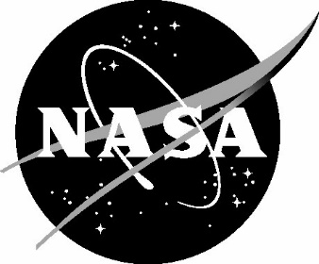

Astronaut physiological deconditioning and exercise prescription countermeasures in spaceflight

Sarah D. Taoufik, Office of the Chief Health and Medical Officer, JES Tech, Houston, Texas Kristin M. Coffey, Office of the Chief Health and Medical Officer, KBR Systems, Houston, Texas David R. Francisco, Office of the Chief Health and Medical Officer, NASA, Houston, Texas

NASA STI Program Report Series

|  |  |
| --- | --- |
| Since its founding, NASA has been dedicated to the advancement of aeronautics and space science. The NASA scientific and technical information (STI) program plays a key part in helping NASA maintain this important role.  The NASA STI program operates under the auspices of the Agency Chief Information Officer. It collects, organizes, provides for archiving, and disseminates NASA’s STI. The NASA STI program provides access to the NTRS Registered and its public interface, the NASA Technical Reports Server, thus providing one of the largest collections of aeronautical and space science STI in the world. Results are published in both non-NASA channels and by NASA in the NASA STI Report Series, which includes the following report types:   1. TECHNICAL PUBLICATION. Reports of completed research or a major significant phase of research that present the results of NASA Programs and include extensive data or theoretical analysis. Includes compilations of significant scientific and technical data and information deemed to be of continuing reference value. NASA counterpart of peer-reviewed formal professional papers but has less stringent limitations on manuscript length and extent of graphic presentations. 2. TECHNICAL MEMORANDUM.  Scientific and technical findings that are preliminary or of specialized interest,  e.g., quick release reports, working  papers, and bibliographies that contain minimal annotation. Does not contain extensive analysis. 3. CONTRACTOR REPORT. Scientific and technical findings by NASA-sponsored contractors and grantees. | 1. CONFERENCE PUBLICATION.  Collected papers from scientific and technical conferences, symposia, seminars, or other meetings sponsored or  co-sponsored by NASA. 2. SPECIAL PUBLICATION. Scientific, technical, or historical information from NASA programs, projects, and missions, often concerned with subjects having substantial public interest. 3. TECHNICAL TRANSLATION.  English-language translations of foreign scientific and technical material pertinent to  NASA’s mission.   Specialized services also include organizing  and publishing research results, distributing specialized research announcements and feeds, providing information desk and personal search support, and enabling data exchange services.  For more information about the NASA STI program, see the following:   1. Access the NASA STI program home page at http://www.sti.nasa.gov   . |

The use of trademarks or names of manufacturers in this report is for accurate reporting and does not constitute an official endorsement, either expressed or implied, of such products or manufacturers by the National Aeronautics and Space Administration.

Available from:

NASA STI Program / Mail Stop 050

NASA Langley Research Center

Hampton, VA  23681-2199

Astronaut physiological deconditioning and exercise prescription countermeasures in spaceflight

Sarah D. Taoufik, Kristin M. Coffey, and David R. Francisco

*NASA Office of the Chief Health and Medical Officer*

ABSTRACT

The human skeletal muscular and cardiovascular systems are adapted to the upright posture of Earth’s gravitational environment. Astronauts experience an altered gravity environment in spaceflight that leads to a number of physiological changes and decrements to these systems that can decrease overall crew performance. Countermeasures, including prescribed exercise during spaceflight, is vital for astronauts to maintain optimal health and performance. The degree of physiological deconditioning is dependent on a multitude of factors such as sex, age, mission duration, fitness level, and gravity environments experienced. Deconditioning begins immediately upon entering an altered gravity environment and physiological decrements of the skeletal muscular and cardiovascular systems are measurable among astronauts within a few days. Thus, to maintain their physical fitness, ability to perform mission duties, and be able to egress vehicles when needed, it is imperative that astronauts participate in exercise during all phases of flight. This is especially important for long duration flights where deconditioning effects can be more deleterious. The NASA Office of the Chief Health and Medical Officer 3001 Standards Team develops requirements utilized by commercial and international partners to better understand spaceflight-induced physiological changes and countermeasures and expected outcomes with or without exercise.

**INTRODUCTION**

There is a myriad of data on the changes that astronauts face when in microgravity. Research studies and occupational measures have been taken since the first spaceflight of humans. Systematic reviews have been performed (1) that separate the data by categories such as skeletal muscle responses to microgravity (μG) in humans, skeletal muscle responses to μG in animals, adaptation of the skeletal system to μG in humans, adaptation of the skeletal system to μG in animals, and effectiveness of exercise countermeasure on musculoskeletal system in spaceflight. All the studies (animal and human) corroborate that microgravity exposure leads to decrements in the muscle skeletal system, even with exercise (1). The goal of this paper is to utilize the data on the effectiveness of countermeasures on human physiology and determine an appropriate metric to measure the effectiveness. The metric must be non-invasive, repeatable, and easily measured. Based on this criterion, NASA focused on human studies that utilized and measured the effect of exercise systems in spaceflight on human physiology with non-invasive measures.

The physiological changes that astronauts face when entering an altered gravity environment, including fluid shifts to the head and torso, bone demineralization, decreases in aerobic capacity, and muscle mass loss (2,3). Sustained exposure to microgravity and body fluid redistribution is associated with cardiovascular changes leading to total blood volume reduction, changes in maximal heart rate, blood pressure, arteriovenous oxygen, decreased cardiac muscle mass, and reduced aerobic capacity (4,5). Past research has found that maximal oxygen uptake is decreased by as much as 22% during a short duration spaceflight mission of 9-14 days (5). Loss of muscle mass, volume, and strength during spaceflight is most influenced by the lack of gravitational loading on the muscles (6). Weightlessness in microgravity and reduced muscle loading leads to a reduction in the size of muscle fibers, decreased protein synthesis in the muscle fibers, and an overall increase in protein degradation (3). Extensor and flexor type muscles may lose up to 30% isokinetic torque during long duration spaceflight missions (6). Similarly, microgravity and weightlessness also leads to reduced loads on astronauts’ bones and accelerated bone turnover (7). Bone demineralization and bone loss during spaceflight results in calcium leaving the bones, with urinary calcium excretion increased by 60-70% within the first few days of exposure to the microgravity environment (2). Past research has suggested that bone mineral density reduction rates during spaceflight are as high as 0.5-1.5% per month (7,8). In sum, there is a great need for evidence-based guidelines and exercise countermeasures for astronauts to lessen the effects of microgravity deconditioning and improve overall astronaut health and mission outcomes.

*Historical exercise practices in spaceflight*

During the early days of human spaceflight, exercise and physical activity initially sought to observe the effects of physiological effects of a microgravity environment (9). Project Mercury was the first U.S. spaceflight program that made medical observations on crewmembers, where they performed basic exercise practices by pulling a bungee cord while in orbit (9). Upon their return to Earth, Mercury crewmembers were observed to have some postural hypotension which led to the NASA Aerospace Medical Operations Office in 1962 to make the statement that a *“prescribed inflight exercise program may be necessary to preclude symptoms in case of the need for an emergency egress soon after landing”* (9,10).

The Apollo program is the first spaceflight program to implement exercise countermeasures during spaceflight. Crewmembers utilized the ‘Apollo Exerciser’, which was a modified version of a commercially available variable resistance rope friction device. The Apollo astronauts performed exercises using the device at varying frequency and intensity without a prescribed exercise program (9). Pre-flight and post-flight exercise response testing of astronauts was conducted to observe any changes to cardiopulmonary status resulting from Spaceflight. Findings from the *Biomedical Results of Apollo* released by NASA in 1975 (11) found several significant changes immediately post-flight:

* Significant alterations in the relationship between heart rate and oxygen consumption.
* Significant decrease in systolic and diastolic blood pressure attained at a given heart rate level.
* Statistically significant decrease in cardiac output at a heart rate of 160 beats per minute.

The post-flight decline observed immediately after spaceflight and rapid normalization of the astronauts’ response to exercise was thought to be related to a decrease in plasma volume (12).

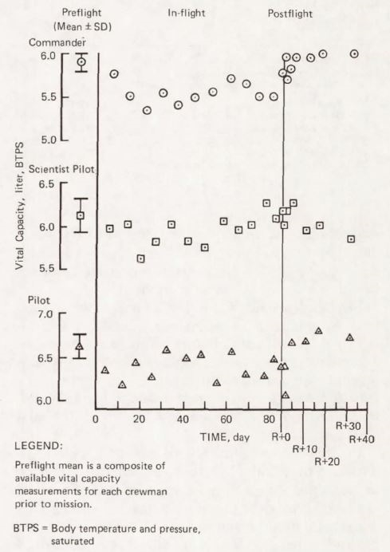The Skylab program ran from 1973 to 1974 and was the first long-duration spaceflight program at NASA. Skylab-2 introduced a prescribed exercise countermeasure for crewmembers to utilize the M171 cycle ergometer for 30 minutes per day. The following Skylab-3 increased this time to 60 minutes per day, and added a new isokinetic device referred to as the ‘Mini-Gym’. Skylab-4 further increased exercise allowance to 90 minutes per day and added a treadmill-like system (9). Results from the observations found that there was some BMD loss among crewmembers post-flight, but were not to levels of clinical concern (13). A reduction in leg extensor strength was observed in some of the Skylab missions with recovery to crew standing and walking without difficulty the day after landing/recovery (9,13). Clinical observations found no marked changes to the VO2max during flight and even concluded that VO2max slightly increased during flight in some crewmembers. Heart rate response to exercise was elevated immediately post-flight and returned to pre-flight levels by approximately 24 days post-landing (12,13). See Figure 1. Skylab 4 Vital Capacity Data for a summary of changes to aerobic capacity during the Skylab 4 mission.

The NASA Shuttle Program gathered historical physiological and exercise data throughout its 135 flights from 1981 to 2008. The primary exercise device on Shuttle was the cycle ergometer, with additional treadmills and a rower later added for evaluation. Flight rules included exercise countermeasures to be performed no less than every other day for the Commander, Flight Engineer, and Pilot, and every third day for Payload and Mission Specialists (9). A general summary of the results from numerous medical reports and observations of Shuttle astronauts found (14):

**Figure 1. Skylab 4 Vital Capacity Data**

*Summary of changes to aerobic capacity during the Skylab 4 mission*. *From: Biomedical Results from Skylab (1977)*

* Post-landing loss of isometric muscle strength by an average 10% decrease (14).
* Non-exercisers on Shuttle showed a significant 12-15% decrease in VO2max compared to crewmembers who utilized the treadmill (-3%) and rower (-6%); and crew who exercised >3 days vs. those who exercised <3 days during spaceflight had a lower heart rate response and maintained pulse pressure during post-flight orthostatic testing (9).
* The shorter duration of Shuttle missions were insufficient in detecting changes in bone density among crewmembers, but MRIs conducted pre- and post-flight provided data on regional bone response to post-flight loads (14).

*Head-down bed rest studies*

Research utilizing head-down bed rest (HDBR) methods have been implemented extensively to gather physiological data that can be translated to spaceflight practices. These methods are the closest terrestrially based research strategies that simulate the physiological changes the human body endures from the elimination of gravity during spaceflight, including fluid shifts to the head and upper torso, BMD loss, changes to the musculoskeletal system, cardiovascular changes, and sensorimotor degradation (15–20). During these studies, participants are placed on strict bed rest at a specified degree of head-down tilt where they must complete all daily activities while in bed for short (5 to 14 days), medium (15 to 59 days) or long (60+ days) duration timelines (21). Researchers have investigated potential countermeasures to address these physiological decrements during HDBR studies, including exercise protocols to mitigate BMD loss and muscle and cardiovascular changes (22–25). These countermeasures were overall effectives in maintaining, and in some cases improving, cardiovascular and aerobic health (22,24,25) and mitigating loss of muscular strength (23–25). Findings for BMD loss varies between the HDBR studies evaluated. In some studies, there were no changes in BMD observed which was attributed to the duration of the studies being too short to capture changes to BMD (25,26). Other studies observed minor changes in BMD during HDBR studies, with exercise countermeasures providing some level of protection to these changes (27,28).

*NASA-STD-3001 technical requirements*

The Office of the Chief Health and Medical Officer at the National Aeronautics and Space Administration (NASA) manages a set of documents called NASA-STD-3001, which are Agency-level spaceflight human system standards that are applicable to all human spaceflight programs (29). NASA-STD-3001 consists of two volumes, Volume 1: Crew Health and Volume 2: Human Factors, Habitability, and Environmental Health. These Agency standards enable human spaceflight missions through minimizing health risks, providing vehicle design parameters, and supporting the performance of the crew. Within each document are technical requirements that include a ‘shall’ statement that is required for consideration when developing program-specific human-rated system design requirements. Each technical requirement also includes a rationale that provides additional background information and evidence for the purpose of the technical requirement, and guidance on potential ways to verify the technical requirement is being met. Read the article entitled *NASA Space Flight Human-System Standard: enabling human spaceflight missions by supporting astronaut health, safety, and performance* for additional information (30).

During our systematic review of the literature, we included studies that contained full datasets of pre/in/and post-flight data, and those that collected data in a controlled environment (i.e., bed rest studies). There are a plethora of other studies that are relevant to the described topic and are important additions to this body of scientific knowledge (1,31,32). However, we did not include all these studies and articles in our body of work as they do not include the appropriate comprehensive and validated data that can be utilized to create NASA’s recommended 3001 technical requirements for the protection of human physiological performance and health.

*NASA-STD-3001 Volume 1: Crew Health*

As part of NASA-STD-3001 Volume 1: Crew Health, a set of spaceflight health technical requirements for human performance were developed to provide a declaration of acceptable medical risk from deleterious health and performance effects and support health maintenance of astronauts during spaceflight missions (33). NASA-STD-3001 Volume 1 includes ‘fitness-for-duty’ technical requirements for aerobic capacity. Aerobic capacity is defined as the maximum amount of oxygen that a person’s body is able to utilize at one time and represents an individual’s ability to efficiently use oxygen. A greater level of aerobic capacity means the body is able to perform more intensive physical work while continuing to use oxygen to produce energy. An astronaut’s aerobic capacity influences their ability to perform tasks at a given level of work; setting aerobic fitness-for-duty parameters ensures that astronauts can perform their required functions during all phases of a spaceflight mission. See Table 1 for the relevant NASA-STD-3001 Aerobic Capacity requirements.

**Table 1. NASA-STD-3001 Volume 1 Aerobic Capacity Fitness-for-Duty Technical Requirements**

|  |  |
| --- | --- |
| **Requirement Title** | **Requirement Shall Statement** |
| [V1 4001] Microgravity EVA Aerobic Capacity | Crewmembers shall maintain an in-mission VO2max at or above 32.9 ml/min/kg for missions with microgravity EVAs as determined by either direct or indirect measures. |
| [V1 4002] Extraterrestrial Surface EVA Aerobic Capacity | Crewmembers shall maintain an in-mission VO2max at or above 36.5 ml/min/kg for missions with extraterrestrial surface EVAs as determined by either direct or indirect measures. |
| [V1 4003] In-Mission Aerobic Capacity | The in-mission aerobic capacity shall be maintained, either through countermeasures or work performance, at or above 80% of the pre-mission capacity determined by either direct or indirect measures. |

In addition, there are technical requirements related to permissible outcome limits for muscle strength and bone mineral density (BMD) loss. Maintaining adequate strength during spaceflight is essential for astronauts to be able to perform the required tasks and potential emergency egress procedures from a vehicle. Pre- and in-mission muscle strength and function requirements are designed to provide sufficient strength to complete in-flight and post-flight mission tasks while maintaining operational efficiency and preserving muscle strength for off-nominal events. When astronauts experience BMD loss, they are at increased risk for bone fracture. Additional concern surrounds the fact that not all BMD lost during spaceflight is regained, thus increasing an astronaut’s risk for early onset osteoporosis and fracture risk later in life. Pre- and in-mission BMD requirements are established to ensure astronauts begin a spaceflight mission at an appropriate BMD level and mitigate as much loss of BMD as possible throughout the duration of that mission. See Table 2 for the relevant NASA-STD-3001 Muscle Strength and Bone Mineral Density requirements. See Table 3 for the relevant NASA-STD-3001 Pre-Mission Muscle Strength requirements.

**Table 2. NASA-STD-3001 Volume 1 Muscle Strength and Bone Mineral Density Fitness-for-Duty Technical Requirements**

|  |  |
| --- | --- |
| **Requirement Title** | **Requirement Shall Statement** |
| [V1 4023] Pre-Mission Muscle Strength and Function | Pre-mission muscle strength and function shall be per the values in Table 4.6-1 Pre-Mission Muscle Strength Technical Requirements.1 |
| [V1 4024] In-Mission Skeletal Muscle Strength | Countermeasures shall maintain in-mission skeletal muscle strength at or above 80% of baseline values. |
| [V1 4026] Pre-Mission Bone Mineral Density | Crewmembers’ pre-mission bone mineral density (BMD) T-scores for total hip and lumbar spine (L1-L4), as measured by mass dual energy X-ray absorptiometry (DXA) shall be consistent with an age, sex, gender, and ethnic-matched population. |
| [V1 4027] In-Mission Bone Countermeasures | Countermeasures shall maintain bone mineral density of the hip and spine at or above 95% of pre-mission values and at or above 90% for the femoral neck. |
| 1See Table 3. NASA-STD-3001 Volume 1: Pre-Mission Muscle Strength Technical Requirements Pre-Mission Muscle Strength Technical Requirements | |

**Table 3. NASA-STD-3001 Volume 1: Pre-Mission Muscle Strength Technical Requirements Pre-Mission Muscle Strength Technical Requirements**

|  |  |  |  |  |
| --- | --- | --- | --- | --- |
|  | **Minimum** | **Microgravity EVAs** | **Extraterrestrial Surface EVAs** | **Unaided Terrestrial Egress** |
| Deadlift | 1.0 x Body Weight | 1.3 x Body Weight | 1.6 x Body Weight | 1.3 x Body Weight |
| Bench Press | 0.7 x Body Weight | 0.8 x Body Weight | 1.0 x Body Weight | 0.7 x Body Weight |

The technical requirements presented in Tables 1 and 2 are based on scientific and clinical evidence and research, lessons learned from previous spaceflight missions and analogue environments, current medical practice, risk management data, and expert recommendations. They are to be considered in conjunction with the technical requirements from NASA-STD-3001 Volume 2, discussed later in this article, to support astronaut health and performance.

*NASA-STD-3001 Volume 2: Human Factors, Habitability, and Environmental Health*

While NASA-STD-3001 Volume 1 focuses on human physiological functioning, NASA-STD-3001 Volume 2: Human Factors, Habitability, and Environmental Health (34) focuses on human-systems integration and defines the requirements for spacecrafts, internal environments, ground processing, facilities, payloads, and hardware and software systems while considering human health, safety, and capabilities and limitations. NASA-STD-3001 Volume 2 includes technical requirements that necessitate a vehicle/system to provide the capability for crewmembers to engage in physiological countermeasure activities as needed based on individual program and mission design to attain the fitness-for-duty requirements in NASA-STD-3001 Volume 1. See Table 4 for the physiological countermeasures technical requirements from NASA-STD-3001 Volume 2.

**Table 4. NASA-STD-3001 Volume 2 Physiological Countermeasures Technical Requirements**

|  |  |
| --- | --- |
| **Requirement Title** | **Requirement Shall Statement** |
| [V2 7038] Physiological Countermeasures Capability | The system shall provide countermeasures to meet crew bone, muscle, sensorimotor, thermoregulation, and aerobic/cardiovascular requirements defined in NASA-STD-3001, Volume 1. |
| [V2 7040] Physiological Countermeasure Operations | The physiological countermeasure system design shall allow the crew to unstow supplies, perform operations, and stow items within the allotted countermeasure schedule. |

*Current exercise practices in spaceflight*

Based on the historical exercise practices described above, scientific evidence gathered through decades of spaceflight and HDBR studies, and the NASA-STD-3001 fitness-for-duty technical requirements, NASA scientists have developed an exercise prescription for astronauts during their missions to the ISS to mitigate decrements to their cardiovascular system, musculoskeletal system, and bone density. In addition, exercise in-flight improves overall crew health and performance, maximizes reconditioning post-flight, and prevents injury. These exercise practices are monitored and updated as needed, as well as implemented in real-time with currently deployed astronauts, by a group of Astronaut Strength, Conditioning, and Rehabilitation specialists (ASCRs) at NASA (35). The schedule consists of a recommended 2.5 hours a day/6 days a week of exercise with 30-60 minutes of resistive training and average 27 minutes of metabolic/aerobic training, with the remaining time allocated for crew setup and cleanup. Table 5 summarizes these current exercise practices.

**Table 5. Current Spaceflight Exercise Protocol**

|  |  |  |
| --- | --- | --- |
| **Type of Exercise** | **Protocol Guidelines** | **Equipment** |
| Metabolic/Aerobic | Average 27 minutes of interval or steady-state training. Based on a pre-flight VO2peak of 70-100%. Increased intensity (watts) based on monthly fitness evaluation and changes in VO2peak. | CEVIS & T2 Treadmill |
| Resistance | Average 30-60 minutes of training. Nominally starting crew at their bodyweight or loads from preflight training sessions and increasing based on comfort and capability. Linear progression of loads for upper body; undulating volume for lower body. | ARED |

The ISS is equipped with hardware systems designed and engineered to support astronaut exercise countermeasures in microgravity. Over the years, this hardware has advanced and improved significantly. The first two exercise systems flown on the ISS were the treadmill with vibration isolation and stabilization (TVIS) system and the interim resistive exercise device (iRED) (36). From the installment of the TVIS on the ISS in May of 2000, crewmembers reported overall positive feedback on the physical and psychological aspects of utilizing the equipment, but performance issues were reported that led to the development and deployment of the second-generation treadmill referred to as the T2 in November 2009. See Figure 2. ISS Treadmill – T2 for an overview of capabilities.

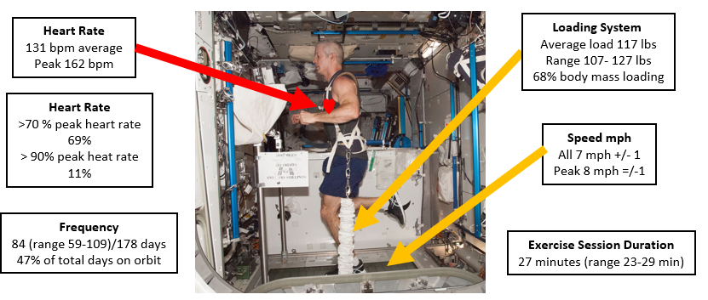

**Figure 2. ISS Treadmill – T2**

*Overview of ISS treadmill capabilities*

The iRED was initially developed as ‘interim’ hardware to meet initial resistive exercise requirements to counteract muscle and bone loss, and was utilized to gather research data that led to the development of the advanced resistive exercise device (ARED), which was installed on the ISS in 2008 (36). See Figure 3. ISS ARED – Squat for an overview of capabilities.

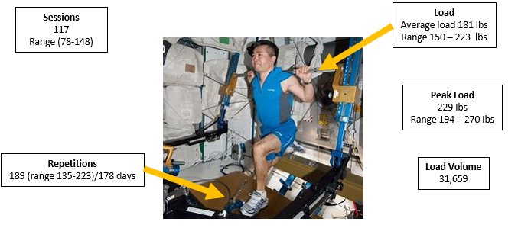

**Figure 3. ISS ARED – Squat**

*Overview of ARED capabilities*

In February of 2001, a new aerobic exercise device, the cycle ergometer with vibration isolation and stabilization (CEVIS), was added to expand to the exercise options on the ISS. The CEVIS is considered highly reliable and has been used extensively in-flight without experiencing any in-flight failures (36). See Figure 4. ISS CEVIS for an overview of capabilities.

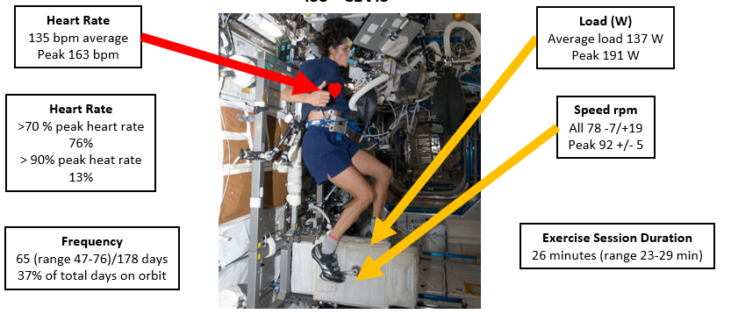

**Figure 4.** **ISS CEVIS**

*Overview of CEVIS capabilities*

Additional information regarding exercise practices, exercise hardware, and human performance in spaceflight can be found in the NASA OCHMO *Exercise Overview* technical brief (37).

*Results from current exercise practices on the ISS*

The use of the current exercise hardware combined with the recommended exercise prescriptions for astronauts on long-duration spaceflight missions to the ISS has been minimally changed in the past 15 years and has enabled researchers to gather data and make assumptions regarding the effectiveness of these practices. One study conducted by NASA is the Integrated Resistance and Aerobic Training Study – SPRINT (38). The objectives of this study were to assess astronaut physical fitness pre-, in-, and post-flight, and evaluate a new aerobic and resistance exercise protocol of higher intensity and lower frequency compared to the previous exercise prescription utilized on the International Space Station (ISS).

A myriad of tests was used to measure astronauts’ BMD, muscle strength and function, and cardiorespiratory fitness (VO2peak). The study confirmed that routine exercise practices during spaceflight are effective to mitigate muscle strength and function loss, and cardiorespiratory decrements, with greater intensity exercises providing the most protective effects. Declines in isokinetic strength about the knee were significantly lower than crewmembers who utilized the iRED device in earlier missions (39). BMD loss occurred at the expected rate among astronauts participating in exercise countermeasures, with crewmembers utilizing the ARED on average experiencing -2.6% change in the lumbar spine and -4.1% change in the femoral neck, compared to -3.7% lumbar spine and -6.1% femoral neck in crewmembers who participated in resistive exercises using the iRED (39). Cardiorespiratory performance was assessed using VO2peak, and the current study by English et al. (39) found approximately a 6% decrease in VO2peak from pre-flight to post-flight, compared to an average 15% decrease of aerobic capacity in earlier spaceflight missions.

A multi-national investigation conducted by NASA of astronauts assigned to ISS missions participated in a study which sought to evaluate the effects of ISS countermeasures on multiple system functions and predicted future performance deconditioning that astronauts may experience on future longer-duration missions (40). Of the studies summarized in this paper, Scott et al., 2023 (40) provides significant and reliable data results to the larger data pool of astronauts utilized across a vast timeframe. The results of the study found a significant decrease in average lower leg muscle strength, with no changes in mean upper body strength. Cardiorespiratory fitness (VO2peak) declined by 7.4% + 2.0% from pre-flight to post-flight; and mean BMD changes were moderate and ranged from -2.1% + 0.7% to -3.7% + 0.6% (40).

The results from Scott et al. (2023) can be compared to the NASA-STD-3001 technical requirements for exercise countermeasures described previously. For resistive exercise and muscular strength, NASA-STD-3001 Volume 1, Rev B requires that crewmembers maintain skeletal muscle strength at or above 80% of baseline values. Although the crewmembers from the study experienced some deficits in muscle strength, they remained within the required limit of overall muscular strength loss. See Figure 5. Estimates of mean percent change in muscle strength and size.

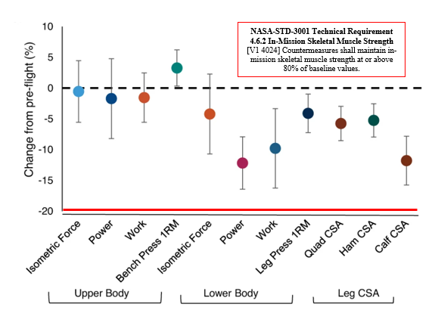

**Figure 5.** **Estimates of mean percent change in muscle strength and size**

*Adapted from: Scott et al. (2023) Effects of exercise countermeasures on multisystem function in long duration spaceflight astronauts*

For cardiorespiratory fitness, NASA-STD-3001 Volume 1, Rev B requires crewmembers to maintain their aerobic capacity at or above 80% of their pre-mission values. Similar to muscle strength, crewmembers from the study maintained their VO2peak well above the 20% cut-off. See Figure 6. Estimates of mean percent change in aerobic capacity.

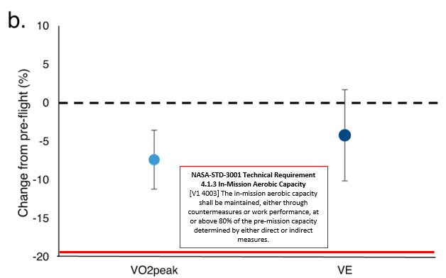

**Figure 6.** **Estimates of mean percent change in aerobic capacity**

*Adapted from: Scott et al. (2023) Effects of exercise countermeasures on multisystem function in long duration spaceflight astronauts*

Finally, NASA-STD-3001 Volume 1, Rev B limits BMD loss to at or above 95% of pre-mission values and at or above 90% for the femoral neck. Crewmembers from the Scott et al. (2023) study averaged less than the 5% cut-off for BMD loss and experienced on average a -3% decrease in the femoral neck bone density. See Figure 7. Estimates of mean percent change in bone mineral density.

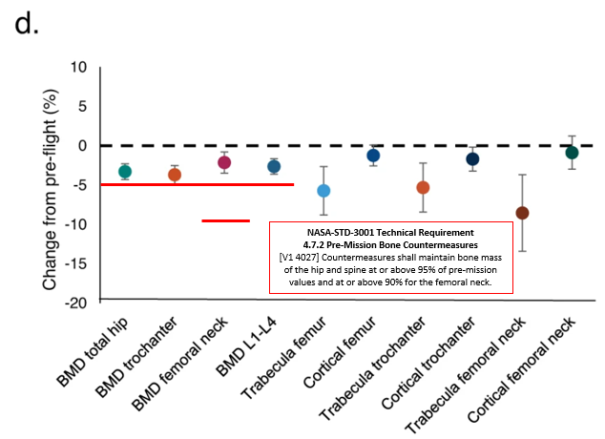

**Figure 7.** **Estimates of mean percent change in bone mineral density**

*Adapted from: Scott et al. (2023) Effects of exercise countermeasures on multisystem function in long duration spaceflight astronauts*

Overall, the results presented from both the NASA Sprint study and the study conducted by Scott et al. suggests that current exercise hardware and practices are sufficient in maintaining crewmember muscular strength, bone mineral density, and cardiorespiratory fitness as required by NASA-STD-3001 for spaceflight missions to the ISS.

**DISCUSSION**

Historical spaceflight experiences thus far have allowed us to gather data and analyze the effectiveness of exercise countermeasures in short-duration, medium-duration, and long-duration missions, with spaceflight missions to the ISS averaging 180 days of flight. See Table 6. Summary of Spaceflight Exercise Countermeasures, Duration of Flight, and Physiological Outcomes.

For the current environment, the NASA-STD-3001 technical requirements are sufficient to protect the crew from the predetermined levels of deficits allowed for muscular strength, BMD loss, and cardiorespiratory health. See Table 7. Summary of Exercise Standards and Physiological Outcomes for Different Mission Durations, for an overview of exercise practices, hardware capabilities, and physiological changes by mission duration.

NASA continues to gain momentum in efforts towards deep space exploration, with the Artemis program returning humans to the Moon and eventually to Mars. These missions will be longer duration than any NASA has experienced before, with the average mission to the lunar surface lasting up to a full year and Mars upwards of 1,200+ days. The functional requirements for human performance during each specific phase of these missions have not been sufficiently defined to determine whether current countermeasures will be adequate to meet the physical performance requirements.

In addition to the increased duration of future missions, there are other considerations that will need to be accounted for when designing requirements and countermeasures to support crew health and performance. Artemis lunar missions will require astronauts to inhabit multiple vehicle systems, including the Orion capsule which will take astronauts from the Earth to the lunar-orbiting Gateway vehicle. The Human Lander System (HLS) will then transport astronauts from Gateway to the lunar surface, where they will traverse the surface of the Moon and transfer between the HLS, lunar habitats, and extraterrestrial vehicles (41). The exercise requirements and capabilities for each of these vehicles will need to be considered synchronously to meet the needs of the crewmembers to prevent physiological decrements. Additionally, with the longer distance and time traveled for these missions, the limitations to vehicles and system capabilities such as mass and storage availability will play a large role in the types of exercise countermeasures that can be accommodated for the crew. The increased distance will also create communication delays with the ground support team, making it difficult to monitor the crewmembers’ activity and provide feedback and recommendations. Limited resupply to crew will create obstacles in the event of exercise hardware malfunction and the crew’s capability to receive replacement parts to make repairs. Additional information on mission duration considerations for future spaceflight can be found on the NASA OCHMO Mission Duration technical brief (42).

Future considerations for spaceflight exercise, physiological countermeasures, and NASA Standards need to determine if the current Standards need updating to be more stringent in requirements for acceptable decrements to muscle strength, BMD loss, and cardiorespiratory fitness for our crew enduring these longer-duration spaceflight missions. Mission operations will involve more high-tempo and stringent activity including frequent surface extravehicular activities (EVAs), which will influence the physical needs of the astronauts to perform mission goals.

Long duration spaceflight missions will benefit from novel exercise systems and countermeasures. Researchers have been working to develop new ways for astronauts to perform exercise and protect their physiological health, including the use of virtual reality games to boost motivation (43), advanced exercise devices (44), and artificial gravity (45). These new exercise approaches in combination with thoroughly researched and crafted Standards will enable future spaceflight to optimize human health and performance and support the overall successful accomplishment of long-duration spaceflight missions.

**Table 6. Summary of Spaceflight Exercise Countermeasures, Duration of Flight, and Physiological Outcomes**

| **Spaceflight Program** | **Duration** | **Exercise Practices** | **Outcomes** |
| --- | --- | --- | --- |
| **Apollo (1961-1972)** | 6-12 days | Apollo Exerciser resistance rope friction device; varying frequency and intensity | -Decrements to cardiovascular health |
| **Skylab (1973-1974)** | 28-84 days | M171 cycle ergometer  Isokinetic ‘Mini-Gym’  Treadmill system | -Non-significant BMD loss  -Minor reduction in musculoskeletal strength  -No changes to VO2max |
| **Shuttle (1981-2008)** | 2-16 days | Cycle ergometer  Treadmills  Rower  Exercise countermeasures performed every other day or every third day depending on crewmember | -Loss of isometric muscle strength  -VO2max decreased approx. 67% more among non-exercisers vs. exercisers  -Minimal changes to BMD |
| **ISS** | Average 182 days | 6 days a week of exercise; 27 minutes aerobic and 30-60 minutes resistive training  CEVIS, T2 Treadmill, ARED | -Decreases in lower body strength  -VO2peak decline  -Moderate BMD loss |
| **Head-Down Bed Rest Studies** | | | |
|  | 14 days | iRAT exercise | -Effectively prevented cardiovascular and musculoskeletal deconditioning |
| 30 days | Supine treadmill exercise | -Decline in cardiovascular markers and VO2peak in non-exercise controls  -Mitigation of BMD loss in exercisers  -Maintenance of muscle strength and endurance in exercisers |
| 60-70 days | Resistive vibration or resistive only exercise  Flywheel and supine treadmill | -Minor differences in BMD among exercisers vs. non-exercisers  -Preserved muscle metabolic profiles in exercisers  -Maintenance of pre-bedrest VO2peak in exercisers |
| 90 days | Flywheel resistive exercise  Elastic resistance bands  Cycle ergometer exercises  Vertical treadmill | -Prevention of VO2max decline  -Mitigation of muscle strength loss  -No significant changes in BMD; some observed changes in urine amino-terminal peptides in non-exercisers |

**Table 7. Summary of Exercise Standards and Physiological Outcomes for Different Mission Durations**

|  |  |  |  |  |  |  |
| --- | --- | --- | --- | --- | --- | --- |
| **Aerobic Standard**   * Maintain 80% pre-flight VO2max | | | | | | |
| **Exercise Type & Mission Duration** | **Exercise Session Frequency** | **Exercise Session Duration** | **Equipment/Hardware** | **Hardware Capabilities** | **Crew Usage** | **Physiological Decrements** |
| **Very Short Duration**  **(< 10 days)1** | No exercise | No exercise | Shuttle upright ergometer | **Speed:** 50 to 120 RPM  **Load:** 0 to 350 Watts (25 W increments) | N/A | Average -11% VO2max |
| **Short Duration**  **(up to 14 days)1** | 3 days/week | 20 minutes/  session (variable) | Shuttle upright ergometer | **Speed:** 50 to 120 RPM  **Load:** 0 to 350 Watts (25 W increments) | 1. 3 sessions/week for >20 minutes; >70% peak heart rate 2. 3 sessions/week for >20 minutes; <70% peak heart rate 3. <3 sessions/week; variable session time and heart rate | 1. Average: -9.2% VO2max 2. Average: -15.3% VO2max 3. Average -22.6% VO2max |
| **Long Duration (180+ days)2** | 6-7 days/week | 30 minutes/  session | ISS Second-generation treadmill with vibration isolation and stabilization (T2)  ISS Cycle ergometer with vibration isolation and stabilization (CEVIS) | **Speed:** up to 12.7 mph  **Load:** up to 70% body mass  **Peak heart rate:** 70-90% max HR  **Speed:** up to 100 RPM  **Load:** peak 200 Watts  **Peak heart rate:** 70-90% max HR | **T2:** 47% of days on orbit for 27 minutes; 70% peak heart rate for 69% of sessions (162 peak bpm); 7-8mph; average 68% body mass loading  **CEVIS:** 37% of days on orbit for 26 minutes; 70% peak heart rate for 76% of sessions (163 peak bpm); 78-92mph; average load of 137 Watts | Average: -7.4% VO2max  Range: -2.35 to -11.21 VO2max |
| **Strength & Bone Standards**   * Maintain 80% of pre-flight muscle strength * Maintain 95% of pre-flight hip and spine and 90% femoral neck bone mineral density | | | | | | |
| **Short Duration**  **(up to 14 days)1** | No exercise | No exercise | Shuttle Treadmill only, no resistive exercise | **Load Capacity:** max 220lbs. | N/A | Muscle strength loss:  -12% to -19% in upper leg  -3% to -10% in lower leg  -2% to -23% in back  < 1.5% BMD loss |
| **Short Duration**  **(up to 14 days)1** | 3 days/week | Variable | Shuttle Treadmill only, no resistive exercise | **Load Capacity:** max 220lbs. | Continuous and interval exercise training at 60-85% of pre-flight VO2max | Muscle strength loss:  -2% to -9% in upper leg  -5% to +12% in lower leg  -15% to -38% in back  < 1.5% BMD loss |
| **Long Duration (180+ days)2** | 6-7 days/week | 60 minutes/  session | ISS Advanced resistive exercise device (ARED) | **600lb. load capability**  Critical Exercises:   * Rowing * Squat press * Squat * Deadlift * Shoulder raise * Cable chop (standing)   Additional Exercises:   * Kneeling chop * Bell swing * Leg abduction * Leg flexion | **Bench Press:** Average 44 repetitions; load range 98-153lbs.  **Squat:** Average 189 days; load range 150-223lbs.  **Heel Raise:** Average 207 repetitions; load range 198-293lbs.  **Deadlift**: Average 230 repetitions; load range 156-215lbs. | **Average:** -1% loss of upper body strength; -9% loss of lower body strength  **Range:** -1% to -3% loss of upper body strength; -4 to -12% loss of lower body strength  **Average:** -0.5 to 1.0% BMD loss per month  **Range:** -2.1% to -8.5% BMD loss |

**REFERENCES**

1. Ade C, Bemben D. Differential MicroRNA expression following head-down tilt bed rest: implications for cardiovascular responses to microgravity. *Physiol Rep*. 2019;7(9):e14061.
2. Advanced Exercise Concepts. 2022. Available at: <https://www1.grc.nasa.gov/space/human-research-program/advanced-exercise-concepts/>
3. Angerer O, Larina I, Cromwell R. Guidelines for standardization of bed rest studies in the spaceflight context. Sundbald P, Orlov O, eds. Published online 2014. Available at: <https://www.nasa.gov/sites/default/files/atoms/files/bed_rest_studies_complete.pdf>
4. Astronaut Strength, Conditioning and Rehabilitation. 2021. Available at: <https://www.nasa.gov/content/astronaut-strength-conditioning-and-rehabilitation>
5. Baran R, Wehland M, Schulz H, Heer M, Infanger M, Grimm D. Microgravity-related changes in bone density and treatment options: A systematic review. *Int J Mol Sci*. 2022;23(15):8650.
6. Belavy D, Beller G, Ritter Z, Felsenberg D. Bone structure and density via HR-pQCT in 60d bed-rest, 2-years recovery with and without countermeasures. *J Musculoskelet Neuronal Interact.* 2011;11(3):215-226.
7. Belavy D, Bock O, Borst H, et al. The 2nd Berlin BedRest Study: protocol and implementation. *J Musculoskelet Neuronal Interact.* 2010;10(3):207-219.
8. Childress S, Williams T, Francisco D. NASA Space Flight Human-System Standard: enabling human spaceflight missions by supporting astronaut health, safety, and performance. *npj Microgravity*. 2023;9(31).
9. Cromwell R, Scott J, Downs M, Yarbough P, Zanello S, Ploutz-Snyder L. Overview of the NASA 70-day Bed Rest Study. *Med Sci Sports Exerc*. 2019;50(9):1909-1919.
10. Diaz A, Heldt T, Young L. Cardiovascular responses to artificial gravity combined with exercise. In: IEEE; 2015. Available at: <https://ieeexplore.ieee.org/document/7118969/authors#authors>
11. English K, Downs M, Goetchius E, et al. High intensity training during spaceflight: results from the NASA Sprint Study. *npj Microgravity*. 2020;6(21)
12. Furukawa S, Chatani M, Higashitani A, et al. Findings from recent studies by the Japan Aerospace Exploration Agency examining musculoskeletal atrophy in space and on Earth. *Npj Microgravity*. 2021;7(1):18. doi:10.1038/s41526-021-00145-9
13. Gallo C, Ridolfi L, Scarsoglio S. Cardiovascular deconditioning during long-term spaceflight through multiscale modeling. *npj Microgravity*. 2020;6(27). <https://www.nature.com/articles/s41526-020-00117-5>
14. Hargens A, Macias B, Echon C, Brzezinski E, Hawkins A, Hawkins K. Testing exercise countermeasures during 30 days of simulated microgravity: lessons learned from studies of identical twins. *Gravitational and Space Biology*. 2006;19(2).
15. Human Spaceflight & Aviation Standards. 2020. Available at: https://www.nasa.gov/offices/ochmo/human_spaceflight/standards101
16. Iwase S, Nishimura N, Tanaka K, Mano T. Effects of Microgravity on Human Physiology. In: Reynolds R, ed. *Beyond LEO*. IntechOpen; 2020. <https://www.intechopen.com/chapters/70679>
17. Johnston R, Dietlein L, Berry C, Parker J, West V, Jones W. Biomedical Results of Apollo. 1975. Available at: <https://ntrs.nasa.gov/citations/19760005580>
18. Johnston R, Dietlein L. Biomedical Results from Skylab. 1977. Available at: https://ntrs.nasa.gov/citations/19770026836
19. Juhl O, Buettmann E, Friedman M, DeNapoli R, Hoppock G, Donahue H. Update on the effects of microgravity on the musculoskeletal system. *npj Microgravity*. 2021;7(28). https://www.nature.com/articles/s41526-021-00158-4
20. Keller N, Whittle R, McHenry N, et al. Virtual Reality “exergames”: A promising countermeasure to improve motivation and restorative effects during long duration spaceflight missions. *Front Physiol*. 2022;11(13). https://pubmed.ncbi.nlm.nih.gov/36304582/
21. Korth D. Exercise countermeasure hardware evolution on ISS: The first decade. *Aerosp Med Hum Perform.* 2015;86(12):A7-A13.
22. McNamara K, Greene K, Moore A, Lenchik L, Weaver A. Lumbopelvic muscle changes following long-duration spaceflight. *Front Physiol*. 2019;10:627.
23. Moore A, Lee S, Stenger M, Platts S. Cardiovascular exercise in the U.S. space program: Past, present and future. *Acta Astronautica*. 2010;66(7-8):974-988.
24. Moosavi D, Wolovsky D, Depompeis A, et al. The effects of spaceflight microgravity on the musculoskeletal system of humans and animals, with an emphasis on exercise as a countermeasure: A systematic scoping review. *Physiol Res*. 2021;70(2):119-151.
25. Murach K, Minchev K, Grosicki G, et al. Myocellular responses to concurrent flywheel training during 70 days of bed rest. *Med Sci Sports Exerc.* 2018;50(9):1950-1960.
26. NASA: Artemis. 2023. Available at: https://www.nasa.gov/specials/artemis/
27. NASA-STD-3001 Volume 1: Crew Health. 2023. Available at: <https://www.nasa.gov/wp-content/uploads/2023/03/nasa-std-3001-vol-1-rev-c-with-signature.pdf>
28. NASA-STD-3001 Volume 2: Human Factors, Habitability, and Environmental Health. 2023. Available at: <https://www.nasa.gov/wp-content/uploads/2023/03/nasa-std-3001-vol-2-rev-d-with-signature.pdf>
29. OCHMO-TB-007 Mission Duration. 2023. Available at: https://www.nasa.gov/sites/default/files/atoms/files/ochmo-tb-007_mission_duration.pdf
30. OCHMO-TB-031: Exercise Overview. 2023. Available at: https://www.nasa.gov/wp-content/uploads/2023/10/ochmo-tb-031-exercise-overview.pdf
31. Pavy-Le Traon A, Heer M, Narici M, Rittweger J, Vernikos J. From space to Earth: advances in human physiology from 20 years of bed rest studies (1986–2006). *Eur J Appl Physiol*. 2007;101:143-194.
32. Ploutz-Snyder L, Downs M, Goetchius E, et al. Exercise training mitigates multisystem deconditioning during bed rest. *Med Sci Sports Exerc.* 2018;50(9):1920-1928.
33. Ploutz-Snyder L, Downs M, Ryder J, et al. Integrated resistance and aerobic exercise protects fitness during bed rest. *Med Sci Sports Exerc.* 2014;46(2):358-368.
34. Ploutz-Snyder L. Integrated Resistance and Aerobic Training Study - Sprint. 2019. Available at: https://core.ac.uk/download/pdf/10556723.pdf
35. Results of the Third United States Manned Orbital Space Flight. 1962. Available at: https://ntrs.nasa.gov/api/citations/19630002114/downloads/19630002114.pdf
36. Risin D, Stepaniak P. Biomedical Results of the Space Shuttle Program. 2013. Available at: https://ntrs.nasa.gov/citations/20220010020
37. Schneider S, Lee S, Macias B, Watenpaugh D, Hargens A. WISE-2005: exercise and nutrition countermeasures for upright VO2pk during bed rest. *Med Sci Sports Exerc.* 2009;41(12):2165-2176.
38. Scott J, Feiveson A, English K, et al. Effects of exercise countermeasures on multisystem function in long duration spaceflight astronauts. *npj Microgravity*. 2023;9(11).
39. Scott J, Weber T, Green D. Introduction to the frontiers research topic: Optimization of exercise countermeasures for human space flight – lessons from terrestrial physiology and operational considerations. *Front Physiol*. 2019;10(173).
40. Shackelford L. Musculoskeletal Response to Space Flight. In: Barratt M, Baker E, Pool S, eds. *Principles of Clinical Medicine for Space Flight*. 2nd ed. Springer Nature; 2019.
41. Stuempfle K, Drury D. The physiological consequences of bed rest. *Journal of Exercise Physiology*. 2007;10(3):32-41.
42. Tanaka K, Nishimura N, Kawai Y. Adaptation to microgravity, deconditioning, and countermeasures. *J Physiol Sci*. 2017;67(2):271-281.
43. Wang L, Li Z, Liu S, et al. The Astronaut Center of China 90-d head-down bed rest: Overview, countermeasures, and effects. *Space: Science & Technology*. 2023;3.
44. Williams D, Kuipers A, Mukai C, Thirsk R. Acclimation during space flight: effects on human physiology. *CMAJ*. 2009;180(13):1317-1323.
45. Zwart S, Hargens A, Lee S, et al. Lower body negative pressure treadmill exercise as a countermeasure for bed rest-induced bone loss in female identical twins. *Bone*. 2008;40(2):529-537.